DEVELOPMENT OF AN OFFLINE EXAMINATION VERIFICATION SYSTEM USING BARCODE

BY

ALIU SULIAT TITILAYO
HND/23/COM/FT/0438

SUBMITTED TO THE DEPARTMENT OF COMPUTER SCIENCE, INSTITUTE OF INFORMATION AND COMMUNICATION TECHNOLOGY,
KWARA STATE POLYTECHNIC, ILORIN.

IN PARTIAL FULFILLMENT OF THE REQUIREMENTS FOR THE AWARD OF HIGHER NATIONAL DIPLOMA (HND) IN
COMPUTER SCIENCE

JUNE, 2025.

CERTIFICATION
This is to certify that this project was carried out by ALIU SULIAT TITILAYO with matriculation number HND/23/COM/FT/0438 in the Department of Computer Science, Institute of Information and Communication Technology, Kwara State Polytechnic, Ilorin, Kwara State.

…………………………………. ….………………………
MR. BOLAJI-ADETORO, D. F. Date
Project Supervisor

…………………………………. ….………………………
MR. OYEDEPO, F. S. Date
Head of Department

…………………………………. ….………………………
External Examiner Date

DEDICATION
I dedicate this project work to Almighty God who inspired me and directed my ways during my academic stay in the polytechnic.

ACKNOWLEDGEMENT
All praise is due to Almighty God the Lord of the universe. I praise him and thank him for giving me the strength and knowledge to complete my HND program and also for our continued existence on Earth.
I appreciate the utmost effort of my supervisor, Mr. Bolaji-Adetoro, D. F. whose patience, support, and encouragement have been the driving force behind the success of this research work. He gave useful corrections, constructive criticisms, comments, recommendations, and advice and always ensures that excellent research is done. My sincere gratitude goes to the Head of the Department Mr. Oyedepo F. S., and other members of staff of the Department of Computer Science, Kwara State Polytechnic, Ilorin, for their constant cooperation, constructive criticisms, and encouragement throughout the program.
Special gratitude to my parents, who exhibited immeasurable financial, patience, support, prayers, and understanding during the period in which I was busy tirelessly with my studies, special thanks go to my lovely siblings
My sincere appreciation goes to my friends and classmates.

TABLE OF CONTENTS
Title page i
Certification ii
Dedication iii
Acknowledgments iv
Table of Contents v
Abstract vi
CHAPTER ONE: GENERAL INTRODUCTION
1.1 Background to the Study 1
1.2 Statement of the Problem 2
1.3 Aim and Objectives 2
1.4 Significance of Study 2
1.5 Scope of Study 3
1.6 Organization of the Report 3
CHAPTER TWO: LITERATURE REVIEW
2.1 Review of Related works 4
2.2 Review of General Text 7
2.3 Concept of QRcode 8
CHAPTER THREE: RESEARCH METHODOLOGY AND
ANALYSIS OF THE SYSTEM
  - Research Methodology 11
  - Analysis of the Existing System 12
  - Problem of the Existing System 12
  - Analysis of the Proposed System 12
  - Advantages of the Propose System 13

CHAPTER FOUR: DESIGN, IMPLEMENTATION AND
DOCUMENTATION OF THE SYSTEM
  - Design of the System 14
    - Output Design 14
    - Input Design 15
    - Database Design 17
    - Procedure Design 18
  - Implementation of the System 18
    - Choice of programming language 19
    - Hardware support 19
    - Software Support 19
    - Changeover Techniques 20
  - System Documentation 20
    - Operating the System 20
    - Maintaining of the System 20
CHAPTER FIVE: SUMMARY CONCLUSION AND
RECOMMENDATION
5.1 Summary 22
5.2 Conclusion 22
5.4 Recommendations 22
References 23

ABSTRACT
Examination is one of the ways to assess the receptiveness of student to various class teachings in various schools or institutions from primary, post - primary and tertiary institutions. But this is not without problem like impersonation and exam malpractice. This research work was developed with the aim of solving the stated problems. The system did not only had the ability to take student examination attendance and screening before and after examination but it can also be used to verify whether such student is in debit to the institution or whether the student has paid required percentage of the tuition before being allowed to sit for the examination thereby reducing number of student in debit before examination begin. It was also developed to eliminate impersonation during examination and stress of manual examination attendance taking and record keeping. Barcode systems translate illuminated images into digital code for further software such as enrolment (registration) and verification (authentication or verification of registered users).Also avoids the writing of name of absent student unlike in manual process of examination attendance. The primary aim of this project was development of an examination monitoring and verification using barcode.

CHAPTER ONE
GENERAL INTRODUCTION
1.1 BACKGROUND TO THE STUDY
All academic institutions have certain criteria for admitting students into examination hall. That is why keeping the accurate record of attendance and fees payments are very important. In almost all institutions in the developing countries, attendance is usually done manually using paper sheets and old file system approach. Many organizations are trying to identify accurate, safe, and reliable techniques to protect access rights to their existing services or operations. Barcode is one of the best answer to these concerns. Student’s attendance during an examination is an essential as well as a time consuming and tedious process especially when classes are big. Most of the polytechnics in Nigeria are still using manual exam attendance system which requires the student to fill an attendance sheet in every exam. The invigilator needs to collect all the exam attendance sheets and records the attendance manually by checking each of the exam attendance sheets. Exam attendance record is important for lecturers to check who is absent in the exam and whose exam paper is missing. Exam attendance record of a polytechnics sometimes is too large and difficult to handled manually using papers. The manual verification, sorting out the invalid student and to compile exam attendance reports are inefficient tasks. This process may lose one and half hours of the instructor during an examination (Rehman, et al., 2018).
QR or Quick Response Codes are matrix barcodes that can be easily read by smartphones and dedicated QR reading devices. QR code was designed by Denso-Wave for the automotive industry in Japan, 1994. The inventor has made open source and free for human beings. Bar codes are optical machine-readable labels and have a wide range of applications such as attachment to text, emails, websites, phone numbers, magazines, brochures, leaflets and business cards as explained by Ramsden, he explained the following core types of content that a QR code can store: Uniform Resource Locators (URLs), which is a website on the internet; alphanumeric text information; automated Short Message Service (SMS) or text messages and telephone numbers which may be immediately dialed. QR codes are excessively used on products, and billboard advertisements due to its quick readability and greater storage capacity compared to standard UPC barcodes. The code consists of black square dots arranged in a square grid on a white background. The encoded information contains different types of data like binary, numeric, alphanumeric etc. QR code file may be in HTML, PNG, Tiff, SVG, or EPS file for-mat (Nitish, Ulhas & Shahanawaj, 2016).
The propose research is on Barcode based examination verification system to automate the process. Basically a client server architecture will be built in server which can be used to generate qrcode of students verification and attendance will be taken during the exam. A QR code (abbreviated from Quick Response code) is a type of matrix barcode (or two-dimensional code) first designed for the automotive industry. More recently, the system has become popular outside the industry due to its fast readability and comparatively large storage capacity. The code consists of black modules arranged in a square pattern on a white background. Although initially used to track parts in vehicle manufacturing, QR codes are now (as of 2011) used over a much wider range of applications, including commercial tracking, entertainment and transport ticketing, product marketing and in-store product labeling. Many of these applications target mobile phone users.

1.2 STATEMENT OF THE PROBLEM
The problems associated with face to face malpractice detection in examination hall are enormous, it is time consuming, stressful, requires physical identification and biasness. For these reasons, a secured barcode authentication system introduced to meet with the latest technology in security considering the rate at which examination malpractices is going.
1.3 AIM AND OBJECTIVES OF THE STUDY
The aims and objectives of this project is to design an offline examination verification using barcode and the objectives are to;
- examine the major barcode technologies of today i.e QRCode authentication.
- identify every student with a unique identity.
- propose the usage of barcodes, which has the capability of storing data, to assist in reducing the action of hardcopy forgeries.
1.4 SIGNIFICANCE OF THE STUDY
The system uses a barcode scanner that would help ensure that only registered student during registration with their id prints are allowed into the examination hall. The system would contribute in the area of stopping any activity of corruption in the educational sector among students, and student to lecturers. Hard work would be encouraged as every registered student knows he/she is going to write the exam by him or herself. The impersonation which has eating the educational system there by encouraging laziness among students would be eliminated and standard of student educational performance would be increased.
1.5 SCOPE AND LIMITATION OF THE STUDY
The proposed system is an examination monitoring system with security of barcode authentication model. It allows for adding of new student details with each person’s unique barcode ID. It as well has the ability to print an examination card that contains the details of the previously added details of such user.
1.6 ORGANISATION OF THE REPORT
This is the overall organizational structure of the work as presented in this project write-up. Chapter one of this project deals with the introduction to the general work in the project. It also entails the statement of the problem, aim and objectives of this project, the significance of the study, the scope of the study and organization of the report.
Chapter two focuses on the review related journals and books, revive of general text and concept of barcode, as well as computerization current state of the art.
Chapter three covers the methods used for new system, description of the current procedure, problems of existing system, description of the proposed system and the basic advantages of the proposed web based application.
Chapter four entails design, implementation and documentation of the system. The design involves the system design, output design form, input design form, database structure and the procedure of the system. The implementation involves the implementation techniques used in details, choice of programming language used and the hardware and software support. The documentation of the system involves the operation of the system and the maintenance of the system.
Chapter five contains with the summary, experience gained, conclusion, recommendation and references.

CHAPTER TWO
LITERATURE REVIEW
2.1 REVIEW OF RELATED WORK
Rehman, et al., (2018) studied mobile barcode based examination attendance system. Smartphone usage has revolutionized the world in many settings including that of the education system with numerous potential and realized benefits. While the functions of smartphones, such as text messaging, multimedia, and Internet connectivity, may seem purely recreational, they can be used within the academic institution to manage students attendance to speed up the process of taking attendance by academic instructors, hence reduces time, human errors and redundant works as compared to the manual attendance system. In their paper, that introduced an automatic examination attendance system on smartphones based on the Barcode to automatically capture student examination attendance. Although many existing systems (Sudha et al. 2015) have been proposed using smartphones for automatic student attendance, there is little study about a system that is specifically designed for capturing student examination attendance. The main difference among our system and existing systems is that existing systems are using extra hardware device Barcode reader while our system is using smartphone, which highly reduce the cost. Our experiment shows that our proposed student examination attendance system is better for capturing the student attendance information during the examination as compared to the general student attendance systems.

Dinesh and Kareemulla (2017) reviewed smart mobile attendance system for employees using QR scanner. Attendance is an important factor for both employees and students. There are different methods of maintaining attendance from manual system where attendance is marked in sheets to automate attendance such as biometrics. All the methods have some disadvantage in maintaining the attendance. The automated attendance is time concerned i.e. the employee should update their attendance before the time, else they will lose their salary. Many times, employee fails to update on time because of queue in front of the machine. The main aim of this paper is to use the smartphones for updating the attendance. This paper uses a mobile app which scans the QR code which acts as user ID and for user verification using fingerprint or voice recognition.
Naveen, et al., (2018) also opined that multi-factor authentication schemes have emerged as alternatives to single-factor authentication schemes with the aim of improving the security. Factors like passwords, biometrics smart/id cards have been used in combinations in addition to mobile OTPs for enhancing security. Conventional authentication schemes are inadequate for security critical applications like financial transaction, online examinations, etc. The paper focused on discussing a multi-factor authentication scheme specifically designed for securing online examination services without comprising user friendliness. The experimentation results clearly brought out the applicability of the scheme in real time with fine tuning of network related parameters.
Wielder, et al., (2016) wrote a report on validation and verification of examination procedures in medical laboratories. The current discourse on global education notes a shift in focus and the emergence of new challenges since the Dakar Global Education Forum. This warrants new impetus to periodic measurements of progress made in the education sector, including the diverse nature of the Education 2030 agenda that encompasses varying themes such as quality, gender, adult literacy, youth and skills, early childhood care and education, inequality and governance, marginalizedpopulations and armed conflicts. It is important to note in this context that the neweducation 2030 Framework for Action lays emphasis on developing and implementing a focused, evidence based and dynamic monitoring and evaluation system for the education sector in order to adequately meet the demands generated by the new challenges mentioned above.
Milon, et al., (2017) wrotes on development of smartphone based Student attendance system Student’s attendance tracking is a vital issue in order to monitor students’ performance in the classroom as well as in their studies. It becomes a key concern because the university authority maintains a rule that one student can only attend the exam if his/her attendance is higher or equal to several percentages (60%,70% or 80% etc.) otherwise not. The traditional attendance system needs student’s to physically sign the attendance sheet each time for the attendance of each class. This is unnecessarily time consuming to notice and mark student's name on the attendance sheet. This also happens that some students may accidentally or willingly mark the student's name like as proxy. The hard copy of attendance sheet may get lost. Using Smartphone like as Android Technology the course teacher will be able to take attendance easily by our designed mobile application and save the attendance in the phone as well as in server and can check percentage and also can print as hard copy. Using the stored information, this system is able to mark attendance, marking intruders’ entry, attendance percentage calculations, send emails, and send SMS to the guardian to keep them updated about their child’s attendance at the Institute. The designed system has an online access from any place and any moment which may extraordinarily assist the course teacher with keeping track of their student’s attendance.
Nitish, et al., (2016) wrote on automated examination using QR code. QR codes are developed by a Japanese company which has been around for over fifteen years. With the advent of smart and Web capable mobile devices, we witness a steady growth of interesting commercial applications using QR codes. It cannot be denied that documents in the form of hardcopy are still being used, especially important documents such as land titles, application forms, contracts and tickets. However, there are reports of forgery cases over the years and as such, it is imperative to have a mechanism for integrity verification of hardcopy document. The research proposed the usage of two-dimensional (2D) barcodes, which has the capability of storing data, to assist in reducing the action of hardcopy forgeries. We introduce an application for the automated examination using the QR code. In this, we make use of QR code to generate a question paper, the snap of the QR code is taken by every student and the required data is decoded and question paper is generated on the mobile phone.
Subbu (2018) presented Electrical and Electronic Systems Nowadays, as the supply of smart phones becomes dynamic and a variety of functions of smart phones and services based on internet is utilized, a wide range of applications are being developed and deployed. Smart phones are becoming more favourite companions to users than desktops or notebooks. Despite the speedy growth of smart phones and the application market, the exam hall plan which is currently being used is still in its primal forms. Previously developed exam hall plan check system uses a notice board which is placed in the college. This project proposes a system that is based on a QR code, which displays the exam hall details of the students before the beginning of each exam. The students will need to scan the code in order to confirm their exam hall. This helps to save the time and more easy to assemble in the scheduled manner.
Yong (2018) opined that smart attendance system using QR code for recording attendance is something repetitive and time consuming. The process of attendance taking is the same and repeated every day. However, the attendance system today is not automated. It requires a lot of manual workforce to accomplish it. An automated attendance system can save human labours, and increase efficiency of attendance taking. This will directly help lecturers to save time, and spend more time on academic, rather than attendance records. This project intended to automate the attendance recording. The adopted development methodology is evolutionary prototyping to cater for constantly user feedbacks and improvements. The project had conducted testing on 2 classes, for one lecture class and one practical class. The results were accurate and eliminated the needs of signing attendance on attendance sheets, the manual efforts to transfer data on attendance sheets to computer system. Some improvements have to be made before it is fully functional, for instance, the camera is not zoomable at the moment. This caused inconvenience on students who sit at behind or with poor smartphone camera quality. In conclusion, the project had achieved the objectives, which ultimately save lecturers’ time in managing attendance, bring convenience to students on attendance registration, and reduce the likelihood of fake attendance records.
Vandana, et al., (2018) also studied examination room guidance system using RFID and arduino. Aim of this project is guiding the student at the examination centres. Now a day’s 99% of the exams are held with jumbling system. In this process, so many students are facing problems in searching rooms. Most of the students feel tense before coming to exam and they still feel tense in searching for their place for exam. Their project is helpful in these cases. Each and every student will be issued an RFID card as their hall ticket. While they reaching the college premises and by showing their hall ticket to the RFID reader. That will automatically display the room number of that person. Their project mainly saved the time in searching for the room in examination centres.

2.2 REVIEW OF GENERAL TEXT
QR codes as a learning tools to assist student in the learning. He has explored the usefulness, acceptability and feasibility of QR codes in the learning process. A notable work has been done by Sudha et al. (2015) in Sies Graduate School Technology Navi Mumbai, India. They proposed a barcode-based attendance system which involves bar-code scanner, database server, and a graphical user interface in a computer to take attendance of students entering the lab. Each student in the respective college has a barcode number on the backside of his/her ID Card. The barcode contains unique data of the student such as roll number, faculty and year of study. Each student will scan their barcode at the end of the lab session and the display screen on the computer will display feedback upon the attendance confirmation. Teachers and administrator will access the attendance record by logging in into the system with their respective login IDs. According to Sudha et al. The attendance system is developed to improve the efficiency and effectiveness of the attendance information management system. They believe that computerized software system and hardware interaction can facilitate the attendance management system as well as the accuracy of the attendance information. The proposed system aims to re-duce the amount of professor’s works such as the needs to create a defaulters list manually whose attendance falls below 75%, the tedious attendance marking process in every lab session and the manual generation of attendance report. This system is also using extra barcode scanner which is not freely moveable like a smartphone and is an extra cost. The research provides an account of published work by academic scholars and accredited commentators on the subject of modern barcode. The intent is to provide the reader with the pros and cons of the knowledge and ideas established on the topic. The material selected for research should reflect the overall goals outlined in the aim and objectives for this project. Those overall goals are primarily intent on evaluating the current state of barcode technologies and their potential. Therefore, with this in mind and taking into account the Ashbourne definition of a modern barcode system, it is possible to discern the more relevant material for appraisal.

2.3 CONCEPT OF QR CODE
QR generator is used to generate the QR codes which are going to be pasted on ones id card. It is open source software and much user friendly. The Figure 1 shows after QR code after generating by QR code generator. It is made up of black squares and white squares. Each square is called as modules. Data present in QR code is represented in terms of Bytes. Three corners are the heart of QR code. Unlike the older, one dimensional barcodes that were designed to be mechanically scanned by a narrow beam of light, QR code is detected by a 2-dimensional digital image sensor and then digitally analyzed by a programmed processor. The processor locates the three distinctive squares at the corners of the QR code image, using a smaller square (or multiple squares) near the fourth corner to normalize the image for size, orientation, and angle of viewing. The small dots throughout the QR code are then converted to binary numbers and validated with an error-correcting algorithm. Above lists explains the approximate error correction capability at each of the four levels.
- Gray conversion: QR Code symbol is captured by embedded system with camera, and it is a colourful image. QR Code symbol is a set of dark and light pixels. It is needless to deal with colour information and the gray image calculated quickly with little space, so gray conversion is needed to do firstly.
- Binarization: Binarization of gray scale images is the first and important step to be carried out in pre-processing system. Selection of a proper binarization method is critical to the performance of barcode recognition system. In binarizing an image, a simple and popular method is thresholding. There are two types of thresholding methods: global and local thresholding. Among more than 20 thresholding methods, concluded that Otsu’s method is the best, which chooses the threshold that minimizes within-group variance. By using a global thresholding method, if an image has variable lighting conditions, the resulting binary image will be very bad. In this case, a local thresholding method performs better. A goal-directed performance evaluation of eleven popular locally adaptive thresholding algorithms was performed for map images. His experimental results indicated that Niblack’s method with post processing step appears to be the best. The main problems with a local thresholding method are hard to set a right window size, eliminate the block effect, and reduce the execution time. However, memory restrictions and embedded system requirements preclude the use of binarization algorithms that require a priori knowledge of the full image and large execution time, thus a number of well-known locally adaptive algorithms cannot be used.
- Filter: Standard opening and closing techniques are applied to the bitmap to remove noise .After the filter, edge detection is used in most recognition algorithm. But the QR Code has quick orientation. So the step of the edge detection is omitted in QR Code analysis phase. This will increase the recognition rate.
- Orientation: There are the three identical position detection patterns located at three of the four corners of QR Code. Three dark -light –dark squares are over palled in every finder pattern, and the dark-light ratio is 1:1:3:1:1. There is off chance of that similar graphic existed in barcode symbol. So the approximate ratio area should be quickly found. But when one of the finder patterns is partially dirty or damaged, we can use the timing pattern. The timing pattern provides the secondary information which can help us to locate the symbol; decide the ratio direction of symbol and width of module. Rotated images are handled after orientation in common. But the interpolation operation is used in rotation operation .The amount of calculation is great and is not accurate. So we skip this step. A modular distance offset algorithm was used without rotating symbol after located finder pattern, the module width and height and the angle of rotation were known. We get the grid moving along the line which connects the central of three finder patterns. This method avoids the rotation and interpolation, increases the computing speed.
- Alignment patterns Location In order to correct the contorted QR Code symbol, there are many alignment patterns in symbol. When version is 3, the number of alignment pattern is 1, but when version is 7, the number of alignment patterns is 6, when we link the central point of the alignment pattern and three position detected patterns, the small sampling grid is formed. The small sampling grid, distortion is omitted. Therefore, locating the central coordinate of alignment pattern is critical for recognition of barcode.
- Grid generation: When the finder patterns and alignment patterns were located successfully, the segment is easy to do, and the grid is easy to generate. Then the corresponding pixels are getting to ready for decoding.

CHAPTER THREE
METHODOLOGY AND ANALYSIS OF THE SYSTEM
3.1 RESEARCH METHODOLOGY
Code contains the registered number of an individual. Then the QR code is scanned by an image scanner that is nothing but the camera which is present on your mobile phone. The recognition process involves:
- Image binarization.
- Tilt correction.
- Geometric correction.
- Image normalization.
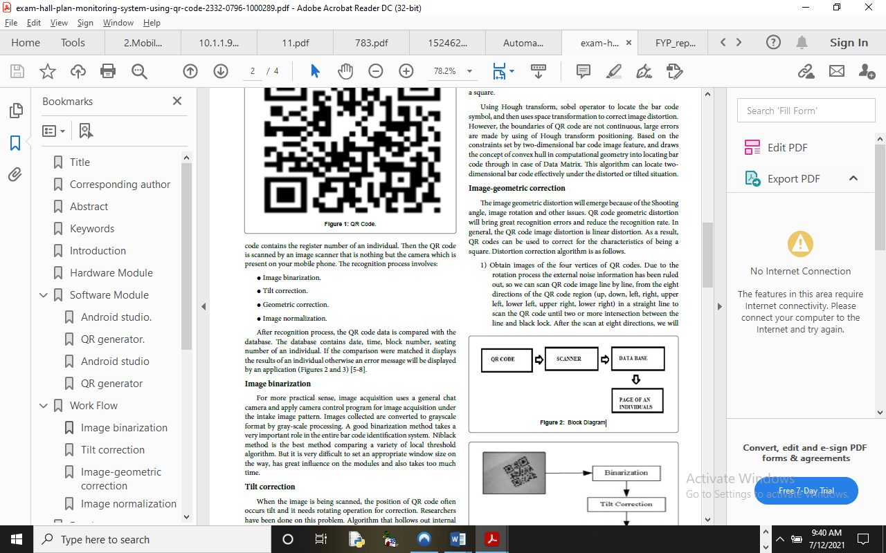

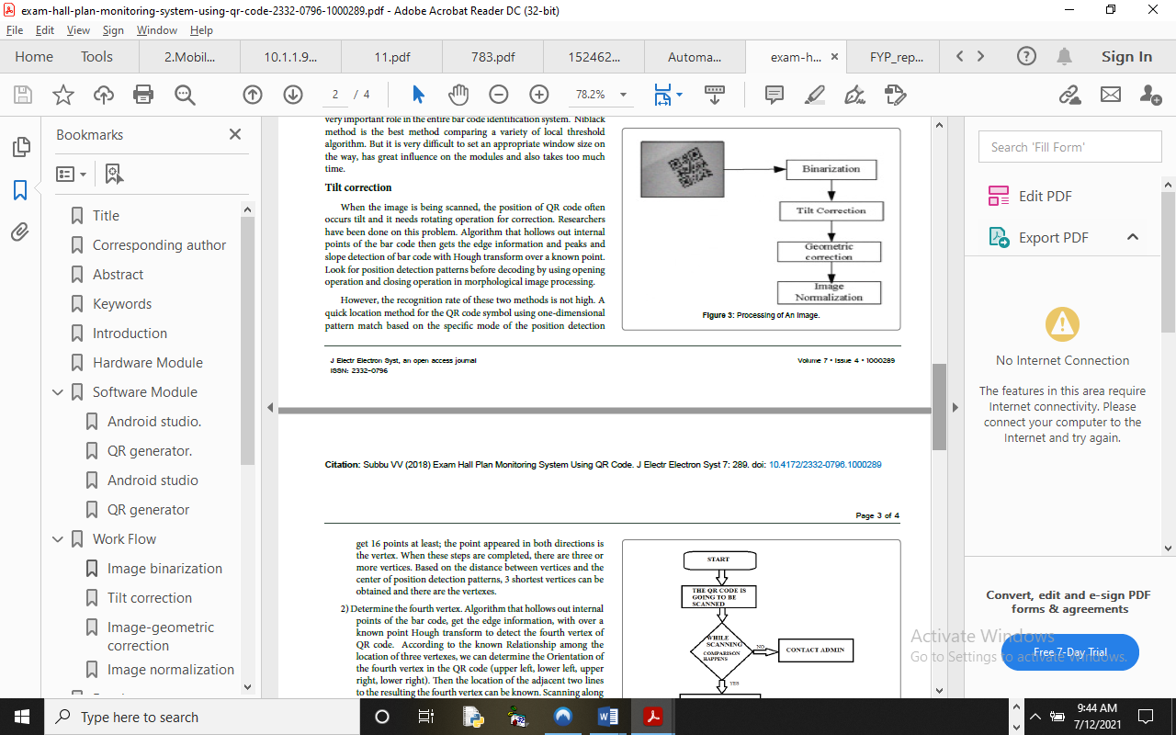
The method is achieved through the following steps:
- The study is proposed to develop an examination monitoring and verification using fingerprint and correlation based techniques.
- Eradication of malpractice and impersonation.
- The application is designed in C# (CSHARP) programming language with adaptation of fingerprint sensor, which involves the use of MYSQL for database management. Hence, the program testing simply involves running it directly from a C# (CSHARP) compiler on local host server provided by Apache 2.0 in WampServer 2.0 application.

3.2 ANALYSIS OF THE EXISTING SYSTEM
The traditional approach is a dedicated manual approach. The manual method of examination monitoring system involves supervisor having to check each student into the exam hall and confirms their examination card if valid to avoid any form of exam malpractice.
  - PROBLEMS OF THE EXISTING SYSTEM
The old system is a very traditional method and it involves many difficulties. Nowadays in this fast world of technology, it is very important to complete a work in a speedy manner. In the above mentioned method, collecting data takes a long time, discrepancies with the method of examination monitoring system threaten the very principles that make our society democratic and it is not free from biasness. This system has dual work of collecting the data on paper and then feeding it in computer. This also takes a vast amount of manpower into it. There is no proper security measure put in place for examination monitoring.
  - ANALYSIS OF THE PROPOSED SYSTEM
This work aim at developing examination monitoring and verification using barcode techniques to detect a wide variety of cheating behaviours during an online exam session. Our proposed online exam process includes two phases, the preparation phase and exam phase. In the preparation phase, the test taker has to authenticate himself before beginning the exam, by using a password and fingerprint authentication. This phase also includes calibration steps to ensure that all sensors are connected and functioning properly. Further the test taker learns and verbally acknowledges the rules of using the system, such as, no second person is allowed in the same room, the test taker should not leave the room during the exam phase, etc. In the exam phase, the test taker takes the exam, under the continuous “monitoring” of our system for real-time cheating behaviour detection.

3.5 ADVANTAGE OF THE NEW SYSTEM OVER THE EXISTING SYSTEM
The advantages of the new system over the existing system are listed below:
- The System is designed and developed in such way that it tries to overcome all the prescribed problem.
- The system being a computer-based system gives accurate information regarding the property which helps to view all the students’ information and validation.
- It provides accurate and a very responsive solution to the exam monitoring and verification system using barcode techniques.

CHAPTER FOUR
DESIGN AND IMPLEMENTATION OF THE SYSTEM
4.1 DESIGN OF THE SYSTEM
System design and specification is very important in every software development. At this stage, the developer puts every factor into consideration while making this design. In the course of the design, the system has to be designed in a way that there will be a close relationship between the inputs and outputs. Also, the design format must be made in a way that it will be acceptable to the end users.
4.1.1 OUTPUT DESIGN

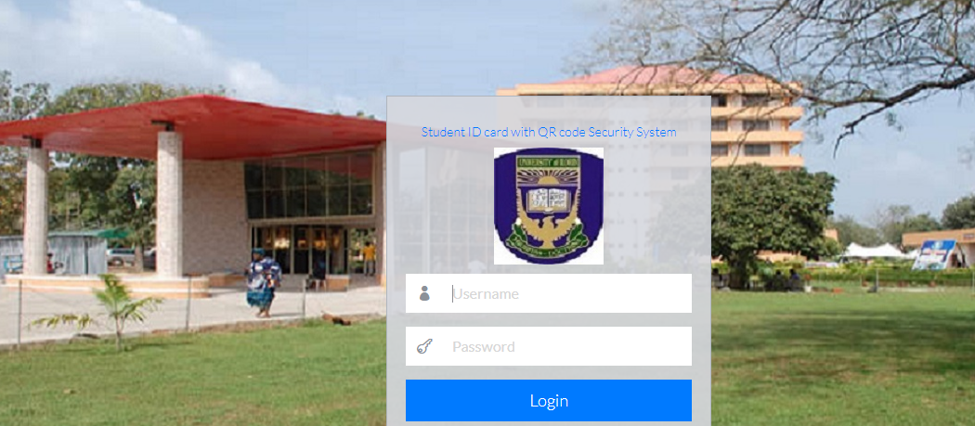
Figure 4.1: Dashboard Interface
Show information about the functionality of the system.

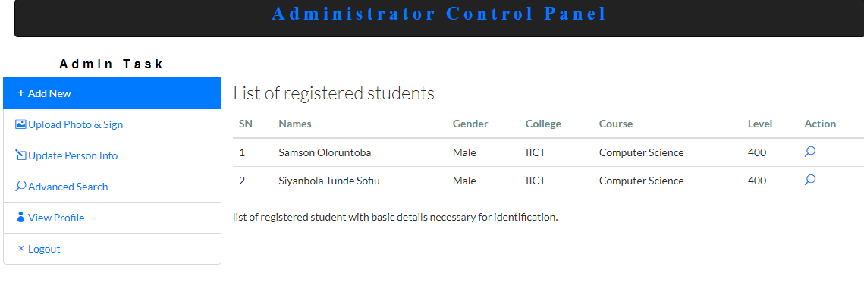
Figure 4.2: Add Module
Student Personal details are input for processing and verification

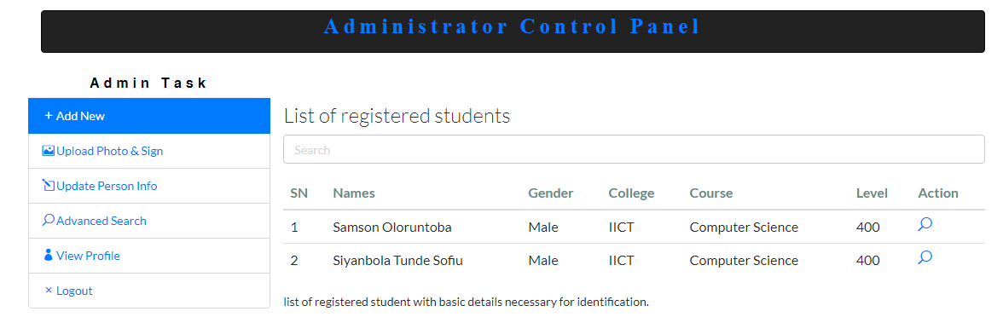
Figure 4.3: Verification Module
This is where student record are check for verification

4.1.2 INPUT DESIGN
It is also necessary to denote that data inputted in the computer for processing determines what the output will be. The inputs are used in collecting student information through the keyboard. Inputs are necessary information needed for processing so as to produce the expected outputs; which are supplied through the keyboard.

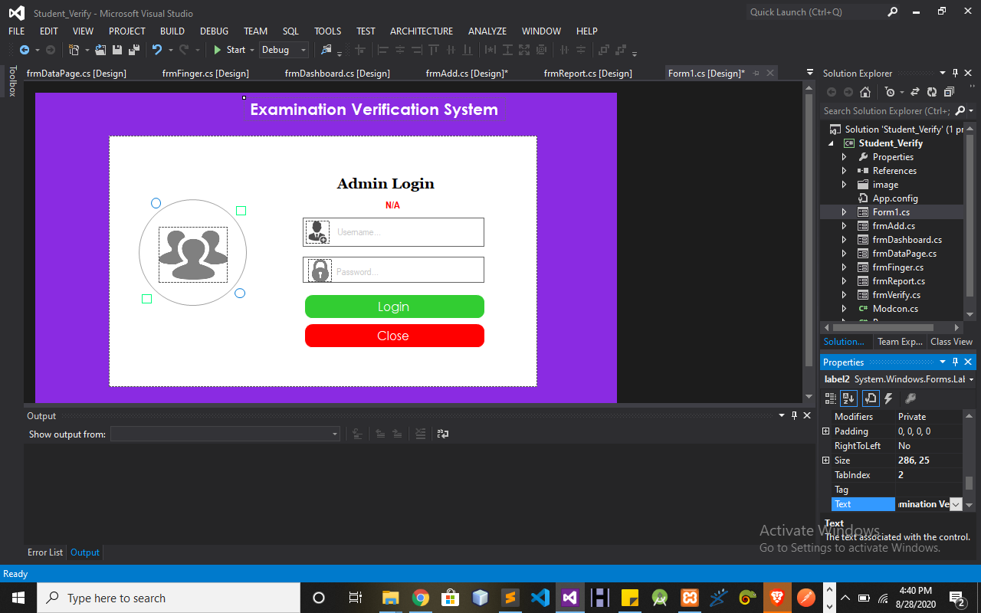
Figure 4.4: Input Interface for Admin login.
The login environment for users
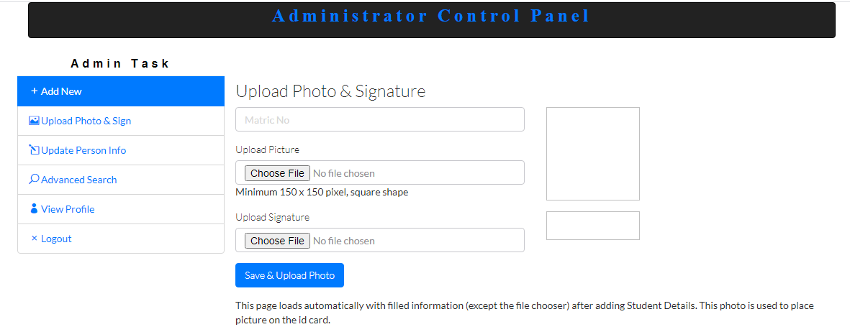
Figure 4.5: Student Add Details Page
This is where student personal details are entered.

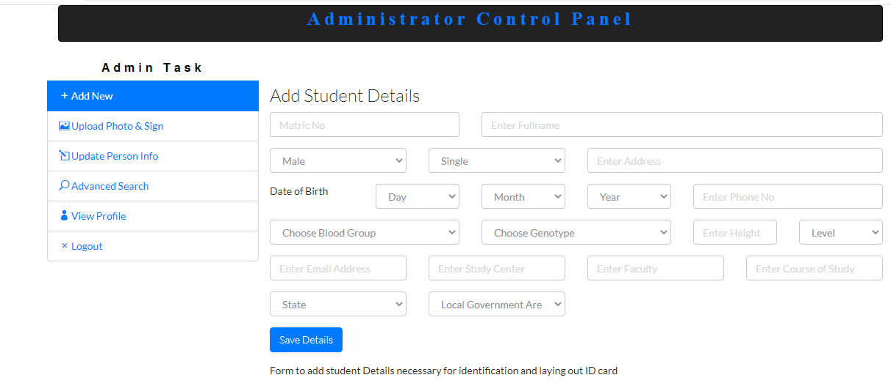
Figure 4.6: Student Details Page
This display verified student details.

Table 4.1: Table showing various Verification Process Time
RESULT
Numbers of Student | Front Code | Capturing Process Time | Back Finger | Capturing Process Time
Student 1 | Front Card 1 | 0.9654455444 | Back Card 1 | 0.5768645
Student 2 | Front Card 2 | 0.865898899 | Back Card 2 | 0.4998458
Student 3 | Front Card 3 | 1.9867376635 | Back Card 3 | 0.9876988
Student 4 | Front Card 4 | 0.7654321879 | Back Card 4 | 0.9674523
Student 5 | Front Card 5 | 1.9987654923 | Back Card 5 | 0.9765987

4.1.3 DATABASE DESIGN
A database table is used for storing information about the files. The database used for this application is mysql database. The files and their respective modes of access as well as information they hold are given below;
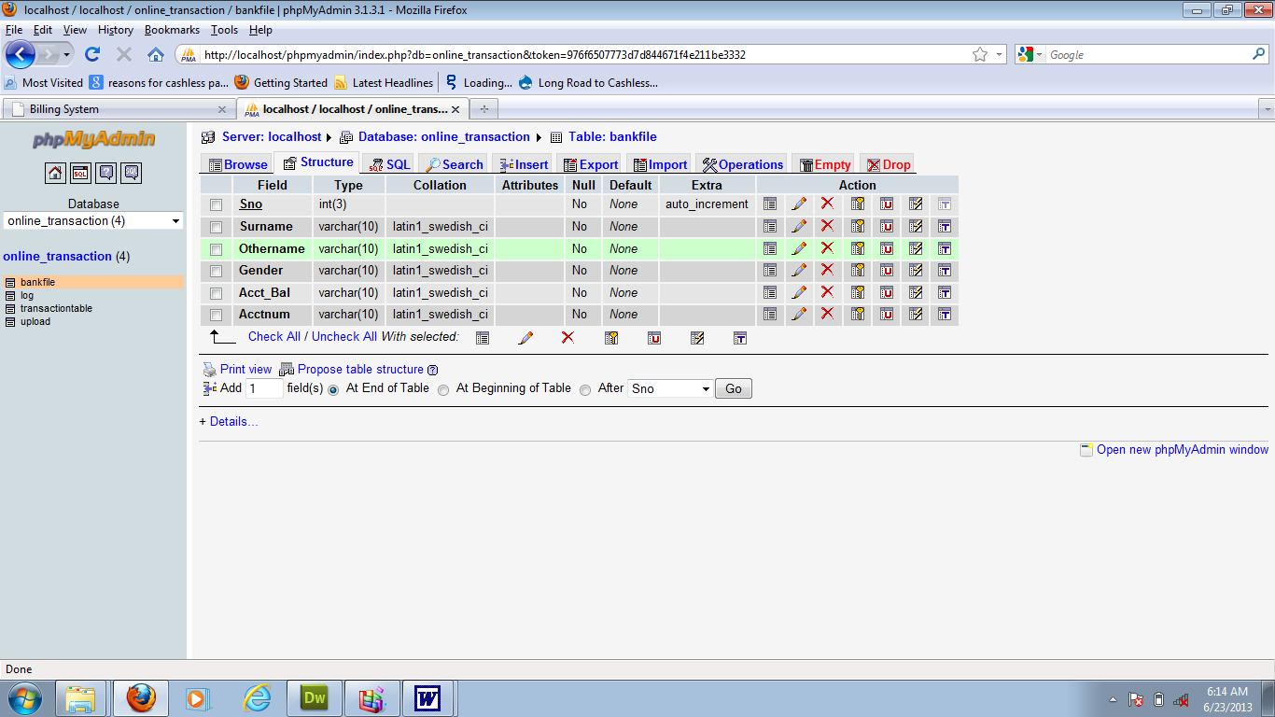

Table 4.1: Admin Datatable
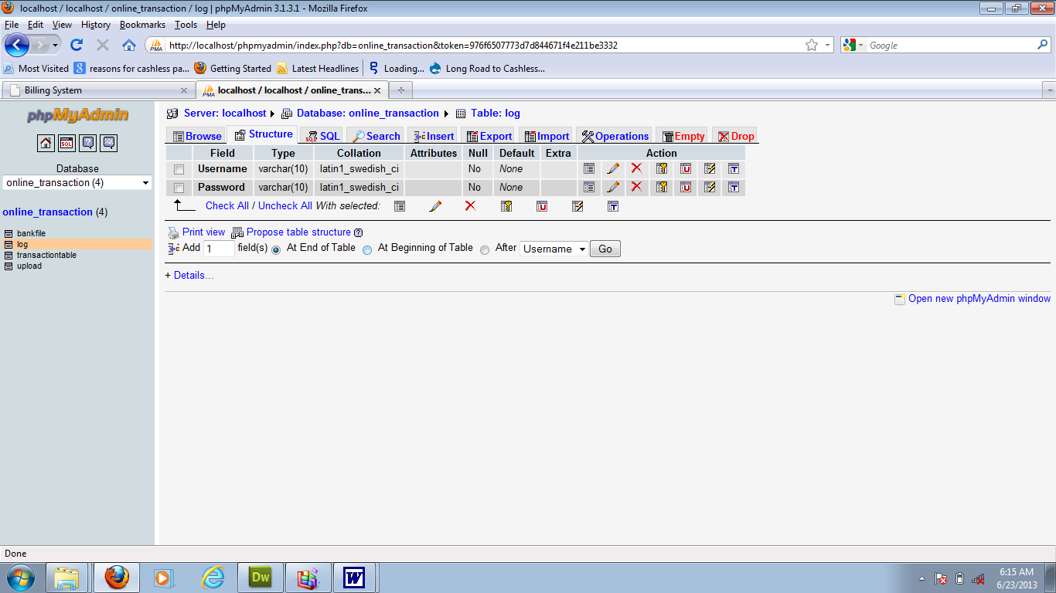
This is admins table where data are stored and retrieved
Table 4.2: Student Details Datatable
This is where student data are stored and retrieved
4.1.4 PROCEDURE DESIGN
Procedures are steps which verify the whole process i.e which are everything put together to produce the desired output. This involves the organization of the source document and end with the output result.
Documents are sent to various departments to be filled by the employees and later returned to the personnel department which are analyzed to determine which record goes into the computer.
After selecting the necessary data, this serves as input to the computer system.
4.2 IMPLEMENTATION OF THE SYSTEM
It is always good to develop new ideas, to implement them on a computer and eventually to relish the satisfaction of achieving a successful result. The implementation process involves converting the system design into a complete and tested EDP that is fully operational and that can be used by the system users to meet their business needs. During implementation phase, the hardware and the software must be implemented.

Implementation of a system can be explained in six steps:-
1. Review design specification
2. Code, test and document programs
3. Train users
4. Perform system test
5. Convert to new system
6. Evaluate and maintain the new system
4.2.1 CHOICE OF PROGRAMMING LANGUAGE
The application is designed using C# as the programming language and MYSQL for database management. Hence, the database testing simply involves running it directly from a Mozilla Firefox web browser on local host server provided by Apache 2.0 in WampServer 2.0 application.
In preparation for the installation of the new system, the method of changeover is given serious consideration to determine the success of the new system. Suitable changeover technique for this system is pilot changeover. The pilot changeover operates by applying the new system bit-by-bit until it covers the whole of the operations. The result obtained from using the pilot method on a small portion of the operations would be used in determining the suitability of the need system for the rest of the operations. This method is similar to testing small sample of a distribution; if the test yields a good result, then the whole system becomes fully operational and the manual/existing system is eliminated.
4.2.2 HARDWARE SUPPORT
The computer configuration required to run the software is;
Computer/memory processor PC with a 48dx, MHZ or Pentium, Intel or higher processor required.
Memory: 2GB of RAM
Cache memory: 512KB
Hard disk Minimum size 500GB
Recommended 200GB
Virtual Memory 32Bits
Cache memory 512KB
Fingerprint Scanner
4.2.3 SOFTWARE
I. Microsoft Visual Studio
ii. MY SQL Database Management Software
iii. Operating system window 07 professional
v. Graphic software paint shop and choosing these two formats GIF (Graphic Image Format)
vi. Scanner software, Mira scans
vii. Web browser software MOZILLA

4.3 PROGRAM DOCUMENTATION
4.3.1 OPERATING THE SYSTEM
Step 1: Boot your computer and click on start button on task bar
Step 2: Click on document
Step 3: Locate Visual Studio and click it
Step 4: Locate your application and click it
Step 5: Choose user and enter the password
Step 6: Click on Options
6.1 Click on Dashboard (to manage student)
4.3 Click on Verify (to verify a student)
4.4 Click on Report (to view student report)
4.5 Click on About (to view the about page)
Step 5: Logout

4.3.2 MAINTAINING THE SYSTEM
The use of the term maintenance for software is different from other references to maintenance. Unlike the tires on your car, software does not “wear out”. If this is the case, then why does software maintenance account for such a high percentage of the Total Cost of Ownership for software?
The software maintenance definition refers to changes for defect correction, performance improvements, or adaptations to a changed environment (enhancements). According to this definition, if we build software that is defect-free, performs well, and contains user-controlled parameters to adjust processing rules in response to changing requirements, then, most maintenance would not be necessary.
Why does this happen? There are many reasons but the most common reasons are time constraints and lack of experience. Adding validation logic takes time. So, people make assumptions about the quality of in-bound data. Assumptions are also made about the volume of transactions and the impact on performance and the stability of the automated business processes. Finally, it is common for new software to be developed by younger developers who don’t understand the maintenance impacts of their designs.
The reality is that business requirements change and most of these assumptions are flawed. Transaction volumes increase, changing business processes require new transactions or new validation criteria, and software users will use the software incorrectly. The cost of software maintenance and the total cost of ownership can dramatically be reduced if developers build software that adjust to changes in transaction volumes; validated all inbound data and provide user-configurable options for decision logic and data validation.

CHAPTER FIVE
SUMMARY, CONCLUSION AND RECOMMENDATIONS
5.1 SUMMARY
In this research work, the proposed system was developed to solve inaccuracy, insecurity and impersonation challenges of the current problem statement which is manual way of verifying student before going into examination hall. With the aid of a barcode authentication, impersonation of other students is eradicated. The device authenticates each student before granting access; ensuring that no student can take more than the required number of the exam per unit time. The proposed system has improved the existing system in the following ways: Provide electronic solution to the existing method of issuing to student which is manual based; discourage and prevent impersonation; Allow lecturer or invigilator to monitor each student in the exam hall. Eliminates the cost of making several copies of paper and allowing the department administrator to have a report of the student’s exam activities.

5.2 CONCLUSION
This project was conceived in an effort to provide a solution to the need for a faster and more effective way of taking and monitoring the attendance of students and the provision of a platform to handle and analyze data collected from such attendances in examination hall using the barcode scanner.

5.3 RECCOMENDATIONS
This work is recommended to the management of Kwara State Polytechnic, Ilorin to extend the system to capture and verify student before going to examination hall.

REFERENCES

Dinesh & Kareemulla (2017) smart mobile attendance system for employees using QR scanner. Asian Journal of Applied Science and Technology (AJAST) Volume 1, Issue 5, Pages 35-39,
Milon et al (2017) development of smartphone based Student attendance system IEEE Region 10 Humanitarian Technology Conference (R10-HTC) IEEE International Conference on Mechatronics, Kumamoto, P. 1-5,
Naveen, et al (2018) Multi-factor authentication schemes have emerged as alternatives to single-factor authentication schemes. International Journal of Pure and Applied Mathematics Volume 119 No. 15 2018, 1705-1712 ISSN: 1314-3395 (on-line version)
Nitish, Ulhas & Shahanawaj (2016) automated examination using QR code. International Journal of Engineering and Advanced Technology (IJEAT) ISSN: 2249 – 8958, Volume-2, Issue-3.
Rehman, et al., (2018) mobile barcode based examination attendance system. International Journal of Engineering and Technology · DOI: 10.14419/ijet.v7i3.22.17124 PP 1-6 https://www.researchgate.net/publication/333044740.
Subbu (2018) Electrical and Electronic Systems College of Engineering & Technology, India DOI: 10.4172/2332-0796.1000289 Volume 7 • Issue 4 • 1000289
Vandana, et al (2018) also writes on examination room guidance system using rfid and arduino. International Research Journal of Engineering and Technology (IRJET) e ISSN: 2395-0056 Volume: 05 Issue: 04 p-ISSN: 2395-0072

