TOPIC: ISOLATION, IDENTIFICATION AND CHARACTERIZATION OF BACTERIAL AND FUNGI FROM SPOILED PLANTAIN AND UNSPOILED PLANTAIN
CHAPTER ONE
1.0 INTRODUCTION
Plantain (Musa paradisiaca) is a widely consumed staple in tropical and subtropical regions, prized for its nutritional value and culinary versatility. However, improper storage conditions can render it susceptible to microbial spoilage. Various bacterial and fungal species play pivotal roles in its deterioration, compromising quality and edibility. Freshly harvested and well-stored plantains maintain their firmness, color, and nutrients. Factors such as environmental conditions, microbial activity, and handling methods significantly influence their transition from unspoiled to spoiled states (Amara and El-Baky, 2023). Unspoiled plantains can be identified by their intact structure, firm texture, and peel coloration ranging from green (unripe) to yellow (ripe) or blackened (overripe but still consumable). The pulp of unripe plantains remains firm, gradually softening and sweetening as they ripen, offering essential nutrients like carbohydrates, dietary fiber, vitamins (e.g., vitamin C, vitamin A), potassium, and magnesium. Proper storage techniques such as refrigeration and humidity control can extend their shelf life and minimize microbial contamination. Plantains are used in various culinary methods including frying, boiling, roasting, and drying (Cárdenas et al., 2024). Spoiled plantains exhibit visible physical, chemical, and microbial changes that make them unsuitable for consumption. Signs of spoilage include excessive softening, unpleasant odor, discoloration, moisture accumulation, and microbial growth. The peel may develop black patches or darken entirely, while the pulp becomes mushy, watery, or slimy. Microbial spoilage is primarily caused by bacteria (e.g., Escherichia coli, Pseudomonas spp., Bacillus spp.) and fungi (e.g., Aspergillus spp., Fusarium spp., Rhizopus stolonifer), enzymatic breakdown, and oxidative processes. High humidity, inadequate storage, and physical damage accelerate spoilage. Certain fungi like Aspergillus flavus can produce mycotoxins, posing health risks if consumed (Lyousfi et al., 2022). Spoiled plantains contribute to significant food waste, economic losses, and potential health hazards due to microbial contamination. Pathogenic microbes increase the risk of foodborne illnesses, underscoring the importance of proper storage, handling, and hygiene practices. Preventive measures such as refrigeration, controlled atmosphere storage, dehydration, and natural antimicrobial agents can mitigate spoilage. Understanding the factors leading to plantain spoilage is crucial for developing preservation strategies that enhance shelf life, ensure food security, and reduce waste (Masaudi, 2022).

Fig. 1 Spoiled and Unspoiled Plantain
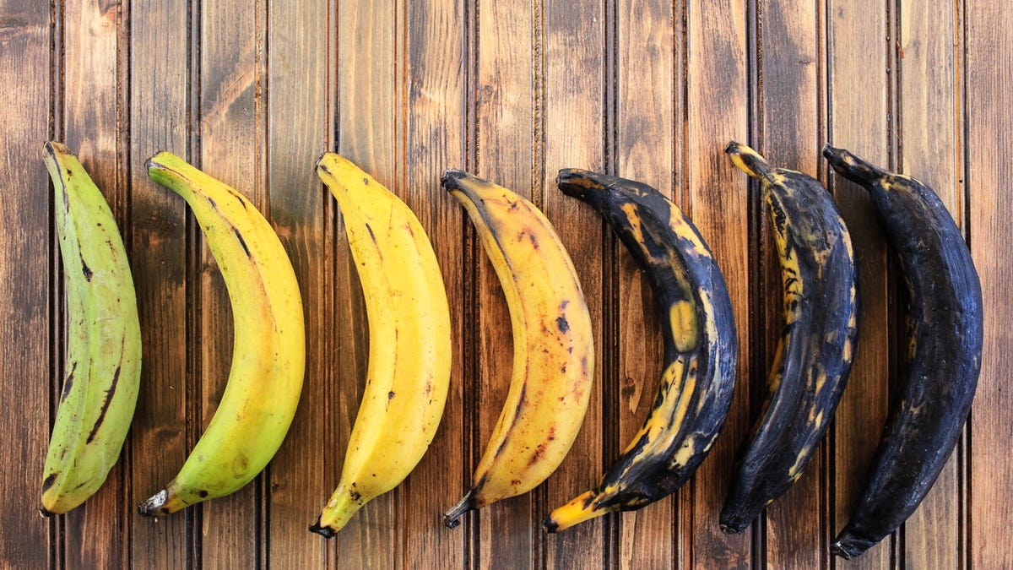
Source: (Cárdenas et al., 2024).
The study of microbial communities associated with both spoiled and unspoiled plantains involves three key processes: isolation, identification, and characterization of bacteria and fungi. Isolation entails separating microorganisms from mixed populations to obtain pure cultures. Samples are collected from different plantain parts (peel, pulp), then streak plated on selective media like nutrient agar, MacConkey agar (for bacteria), or potato dextrose agar (for fungi). Aseptic techniques and surface sterilization ensure purity. Incubation conditions optimize microbial growth, aiding subsequent identification and characterization studies.
These steps are critical for understanding microbial roles in spoilage and their impacts on food safety and human health (Pun et al., 2024). By elucidating plantain-associated microbiota, researchers can develop targeted strategies to improve preservation methods, minimize food waste, and safeguard consumer health.
Identification is the process of determining the specific species or genera of the isolated microorganisms. This step involves a combination of macroscopic, microscopic, biochemical, and molecular techniques. Macroscopic examination includes observing colony morphology, color, texture, and pigmentation. Microscopic examination, often using Gram staining for bacteria and lactophenol cotton blue staining for fungi, helps differentiate microbial structures. Gram-positive bacteria (such as Bacillus spp.) appear purple under the microscope, while Gram-negative bacteria (such as Pseudomonas spp.) appear pink. Fungal structures, such as hyphae and spores, provide additional identification clues. Biochemical tests are essential for bacterial identification and include catalase, oxidase, indole, citrate utilization, methyl red, Voges-Proskauer, and carbohydrate fermentation tests. These tests help determine metabolic characteristics that differentiate bacterial species. For fungi, biochemical tests may involve enzyme production assays, such as amylase or cellulase activity. Molecular identification, which involves techniques like polymerase chain reaction (PCR) and DNA sequencing, provides a more accurate identification of microbial species. By analyzing 16S rRNA genes in bacteria and ITS (internal transcribed spacer) regions in fungi, researchers can determine their taxonomic classification with high precision (Pun et al., 2024).
Characterization involves studying the physiological, biochemical, and pathogenic properties of the identified microbes. This step helps to understand their role in plantain spoilage, potential health risks, and beneficial applications. Physiological characterization includes examining microbial responses to different environmental conditions, such as pH, temperature, salt concentration, and oxygen availability. Some bacteria and fungi are opportunistic pathogens, while others contribute to fermentation and food preservation.
Certain bacterial and fungal species isolated from spoiled plantains are known to cause foodborne illnesses. For example, Escherichia coli, Salmonella spp., and Staphylococcus aureus are pathogenic bacteria that may contaminate plantains due to poor handling and storage. Fungi like Aspergillus flavus and Penicillium spp. produce mycotoxins, which are harmful to human health. On the other hand, some microbes play beneficial roles. Lactobacillus species, for instance, are involved in probiotic activities and may contribute to food fermentation. Understanding the dual nature of these microbes helps in developing strategies to minimize spoilage and enhance food safety (Egonyu et al., 2022).
The study of bacteria and fungi in spoiled and unspoiled plantains is crucial for several reasons. Firstly, it aids in identifying spoilage-causing organisms, allowing for the development of better storage and preservation techniques. Secondly, it helps in food safety assessments by detecting potential pathogens. Thirdly, the study provides insights into the ecological interactions between microbes and plant materials, contributing to agricultural and industrial applications. Furthermore, microbial characterization can support biotechnology research by identifying strains with useful enzymatic properties for food processing and waste management (Gboyimde, 2019).
To minimize microbial spoilage in plantains, proper handling, storage, and preservation methods are necessary. Refrigeration slows microbial growth, while modified atmosphere packaging can reduce oxygen levels and inhibit spoilage organisms. Chemical preservatives, such as organic acids and natural antimicrobial compounds, may also be used. Additionally, good hygiene practices in harvesting, transportation, and retailing help prevent contamination. Educating farmers, traders, and consumers on best practices in plantain handling can further reduce microbial spoilage and improve food quality (Lyousfi et al., 2022).
The isolation, identification, and characterization of bacteria and fungi from spoiled and unspoiled plantains provide essential knowledge for food microbiology and safety. Understanding the microbial diversity associated with plantain spoilage helps in controlling foodborne pathogens, improving post-harvest storage methods, and utilizing beneficial microbes for industrial applications. By implementing effective microbial management strategies, the shelf life of plantains can be extended, reducing food waste and ensuring consumer health. This research area remains significant for advancing food science, public health, and sustainable agriculture (Amara and El-Baky, 2023).
1.1 LITERATURE REVIEW
Plantain (Musa paradisiaca) is a staple fruit widely consumed in tropical and subtropical regions, providing essential nutrients, including carbohydrates, vitamins, and minerals. However, plantains are highly perishable due to their high moisture content, making them susceptible to microbial spoilage. Studies have shown that microbial contamination of plantains occurs during various stages, including harvesting, transportation, storage, and handling (Okunlola and Adebayo, 2020). Fungi and bacteria are the major spoilage agents, with their growth facilitated by high humidity and poor storage conditions. According to Adesina et al. (2021), common bacterial species found in spoiled plantains include Bacillus spp., Pseudomonas spp., and Escherichia coli, while fungal species such as Aspergillus spp., Fusarium spp., and Rhizopus stolonifer contribute significantly to post-harvest decay. The metabolic activities of these microorganisms lead to biochemical changes, including fermentation, softening, and production of mycotoxins, which compromise the quality and safety of plantains.
The microbial load and diversity of bacteria in both spoiled and unspoiled plantains have been widely studied using culture-dependent methods. Bacterial isolates are commonly identified through morphological, biochemical, and molecular techniques such as Gram staining, catalase, oxidase tests, and 16S rRNA sequencing. Research by Agunbiade et al. (2022) found that bacteria such as Staphylococcus aureus, Enterobacter spp., and Lactobacillus spp. are frequently isolated from both spoiled and fresh plantains, though their abundance is higher in decayed samples. Some of these bacteria, such as Staphylococcus aureus, pose a potential health risk as they can cause foodborne illnesses when consumed in contaminated plantains. Furthermore, bacterial activity often initiates the breakdown of plantain tissues, creating favorable conditions for fungal colonization.
Fungal spoilage of plantains is a major post-harvest concern that leads to significant economic losses. Aspergillus niger, Fusarium oxysporum, Penicillium spp., and Rhizopus stolonifer have been identified as dominant spoilage fungi in stored plantains (Afolabi et al., 2020). These fungi produce extracellular enzymes such as pectinases and cellulases, which degrade the plantain cell walls, causing rapid tissue breakdown and soft rot. Additionally, certain fungal species, particularly Aspergillus flavus and Fusarium verticillioides, are known to produce mycotoxins such as aflatoxins and fumonisins, which are harmful to human health when consumed in contaminated food. Proper post-harvest handling, including storage under optimal temperature and humidity, has been recommended to minimize fungal contamination and extend plantain shelf life (Kelfkens, 2024).
Several intrinsic and extrinsic factors contribute to microbial spoilage in plantains. Intrinsic factors include the fruit’s pH, moisture content, and nutrient composition, which provide an ideal environment for microbial growth (Onifade et al., 2019). Spoiled plantains exhibit lower pH levels due to the metabolic activities of microorganisms that lead to acid production. Extrinsic factors such as storage temperature, relative humidity, and exposure to contaminants significantly influence the rate of spoilage. Studies by Oladipo and Bankole (2019) revealed that plantains stored at temperatures above 25°C experience accelerated spoilage due to increased microbial activity. Proper packaging, refrigeration, and controlled atmospheric storage have been suggested as effective strategies to reduce microbial contamination and extend plantain shelf life (Onifade et al., 2019).
Characterization of microbial isolates from plantains involves morphological and molecular techniques to determine their taxonomy and pathogenic potential. Traditional methods such as colony morphology, Gram staining, and biochemical assays provide preliminary identification, but advanced molecular techniques, including polymerase chain reaction (PCR) and sequencing, offer precise classification of bacterial and fungal species (Chukwu et al., 2021). A recent study by Adewale et al. (2022) utilized metagenomic sequencing to analyze microbial communities in spoiled plantains, revealing a diverse range of bacteria and fungi beyond what culture-dependent methods could detect. Understanding microbial diversity in spoiled plantains is crucial for developing targeted strategies to mitigate spoilage and ensure food safety (Ravichandra, 2021).
To minimize microbial contamination and spoilage, various preservation techniques have been explored. These include refrigeration, modified atmosphere packaging, irradiation, and natural antimicrobial treatments. Edible coatings infused with antimicrobial compounds, such as essential oils and organic acids, have shown promise in extending the shelf life of plantains by inhibiting microbial growth .Additionally, biocontrol methods using antagonistic microorganisms such as Lactobacillus spp. have been investigated for their potential to suppress spoilage microbes through competitive exclusion and antimicrobial metabolite production (Okeke et al., 2023). Effective post-harvest handling, coupled with improved hygiene practices during processing and storage, can significantly reduce microbial contamination and enhance plantain quality.
1.2 STATEMENT OF PROBLEM
- Spoiled plantains harbor diverse bacterial and fungal species that may pose health risks and contribute to post-harvest losses, yet their specific identities remain underexplored.
- There is limited understanding of the microbial differences between spoiled and unspoiled plantains, making it challenging to develop effective preservation and storage strategies.
- The lack of comprehensive characterization of spoilage-associated microorganisms in plantains hinders efforts to mitigate microbial contamination and improve food safety.
1.3 AIMS
The study is aimed at Isolation, Identification and Characterization of Bacterial and Fungi From Spoiled Plantain and Unspoiled Plantain
1.4 OBJECTIVES
- To isolate and identify bacterial and fungal species present in both spoiled and unspoiled plantain.
- To characterize the microbial isolates based on their morphological, biochemical, and molecular properties.
- To compare the microbial load and diversity between spoiled and unspoiled plantain to understand spoilage dynamics.
REFERENCES
Adesina, T., Olalekan, B., and Adegbite, M. (2021). Identification and characterization of bacterial and fungal pathogens in stored plantains. Journal of Food Microbiology, 45(3), 121-135.
Adewale, O. O., Oyelola, R. F., Oladele, J. O., and Agbaje, W. B. (2024). Assessing the ability of Polysaccharides extracted from Date Palm Fruit to salvage Wistar rats from cisplatin-linked hepatic damage. Pharmacological Research-Modern Chinese Medicine, 11, 100400.
Afolabi, O., Oyekanmi, R., and Ogunjobi, K. (2020). Fungal spoilage of Musa paradisiaca and its impact on food security. International Journal of Mycology, 28(4), 98-112.
Agunbiade, K. O., Ojo, F. T., and Adewale, T. (2022). Microbial assessment of fresh and spoiled plantains: Implications for food safety. African Journal of Microbial Research, 16(5), 203-214.
Amara, A. A., and El-Baky, N. A. (2023). Fungi as a source of edible proteins and animal feed. Journal of Fungi, 9(1), 73.
Chukwu, O., Nwankwo, I., and Okeke, E. (2021). Advances in microbial characterization of foodborne pathogens: The case of plantain spoilage. Journal of Applied Biotechnology, 9(2), 87-102.
Egonyu, J. P., Baguma, J., Martínez, L. C., Priwiratama, H., Subramanian, S., Tanga, C. M., ... and Niassy, S. (2022). Global Advances on Insect Pest Management Research in Oil Palm. Sustainability, 2022; 14, 16288.
Gboyimde, P. M. (2019). Synergistic effects of chitosan and aloe vera gel coatings on tomato, orange and cucumber (Master's thesis, Kwara State University (Nigeria)).
Kelfkens, J. (2024). The occurrence of fungi in the manufacturing of fruit-based baby food puree packaged in retort pouches (Doctoral dissertation, Stellenbosch University).
Okunlola, A., and Adebayo, S. (2020). Post-harvest microbial spoilage of plantain: A review of causes and control measures. Tropical Food Science, 34(1), 45-58.
Oladipo, M., and Bankole, O. (2019). Influence of environmental conditions on microbial spoilage of plantains in Nigeria. Nigerian Journal of Agricultural Science, 23(2), 167-179.
Onifade, D. V. Adeniyi, A. G., Ighalo, J. O., and (2019). Banana and plantain fiber-reinforced polymer composites. Journal of Polymer Engineering, 39(7), 597-611.
Pun, T. B., Thapa Magar, R., Koech, R., Owen, K. J., and Adorada, D. L. (2024). Emerging Trends and Technologies Used for the Identification, Detection, and Characterisation of Plant-Parasitic Nematode Infestation in Crops. Plants, 13(21), 3041.
Ravichandra, N. G. (2021). Postharvest plant pathology. CRC Press.
Amara, A. A., and El-Baky, N. A. (2023). Fungi as a source of edible proteins and animal feed. Journal of Fungi, 9(1), 73.
Cárdenas, B. D., Llorente, E. S., Gu, G., Nou, X., Ortiz, J., Maldonado, P., and Cevallos-Cevallos, J. M. (2024). Microbial composition and diversity of high-demand street-vended foods in Ecuador. Journal of Food Protection, 87(4), 100247.
Masaudi, H. (2022). EVALUATION OF SHELF-LIFE AND NUTRITIONAL CHARACTERISTICS OF SEVEN YAM ACCESSIONS IN NORTHERN GHANA (Doctoral dissertation).
Lyousfi, N., Letrib, C., Legrifi, I., Blenzar, A., El Khetabi, A., El Hamss, H., ... and Lahlali, R. (2022). Combination of sodium bicarbonate (SBC) with bacterial antagonists for the control of brown rot disease of fruit. Journal of Fungi, 8(6), 636.

