ASSESSMENT OF THE EFFECT OF EGG-SHELL POWDER ON THE SETTING TIME OF CEMENT AND CONCRETE STRENGTH
BY
BABAYEMI MIRACLE AYODEJI
HND/23/CEC/FT/0069

SUBMITTED TO THE DEPARTMENT OF CIVIL ENGINEERING, INSTITUTE OF TECHNOLOGY, KWARA STATE POLYTECHNIC, ILORIN
IN PARTIAL FULFILMENT OF THE REQUIREMENT FOR THE AWARD OF HIGHER NATIONAL DIPLOMA (HND) IN CIVIL ENGINEERING
JUNE 2025.

DECLARATION

I hereby declare that this project work titled ASSESSMENT OF THE EFFECT OF EGG-SHELL POWDER ON THE SETTING TIME OF CEMENT AND CONCRETE STRENGTH, is a work done by me, BABAYEMI MIRACLE AYODEJI with matric number, HND/23/CEC/FT/0069 of the Department of Civil Engineering, Institute of Technology, Kwara State Polytechnic, Ilorin.

__________________ ______________
Signature Date

CERTIFICATION
I hereby certify that this project which involve, Assessment of the effect of egg-shell powder on the setting time of cement and concrete strength, underwent by the Civil Engineering student of the Kwara state polytechnic, Ilorin has been properly scrutinized read, well supervised and meeting the expectation and requirement of the Department for the Award of Higher National Diploma (HND)

___________________________ _____________________

Engr, DR. E. O. Ibiwoye Date
Project Supervisor

___________________________ _____________________
Engr, A. B. Na’Allah Date
Head of Department

_____________________ __________________

External Supervisor Date
DEDICATION
This project is dedicated solemnly to God Almighty, who is the sole inspiration of all things, without whom there would not be, and neither would this project.
Appreciation goes to my loving parents for their support in the fulfillment of my Higher National Diploma (HND) both orally and financially. May God allow them to eat the fruit of their labor (Amen)

AKNOWLEDGEMENT
ACKNOWLEDGEMENT

I express my deepest gratitude to the Almighty God, whose grace and guidance have sustained me throughout this academic journey. His unwavering support has not failed me, and I am truly thankful for the strength and favor He has shown me from the beginning to the completion of this project.
My sincere appreciation goes to my supervisor, Engr. Dr. E.O. Ibiwoye, for his invaluable guidance, fatherly support, and encouragement throughout the course of this work. I pray that God Almighty will continue to bless you and your growing family abundantly.
I am also profoundly grateful to my parents, Deacon and Deaconess Babayemi, for their steadfast financial and spiritual support. Your sacrifices and prayers have been instrumental in my success, and I remain forever thankful.
My appreciation extends to all the staff of the Civil Engineering Technology Department. I am especially grateful to the Head of Department, Engr. A. Na’Allah, for your leadership and support throughout my time in the department.
This acknowledgement would be incomplete without recognizing my siblings, friends, and course mates. Your encouragement, cooperation, and concern have played a significant role in the successful completion of this project. I say a heartfelt thank you to each and every one of you.

God bless you all!

TABLE OF CONTENTS
Title page
Declaration i
Certification ii
Dedication iii
Acknowledgement iv
Table of Contents v
Abstract vii
Table of Contents
CHAPTER ONE – INTRODUCTION
1.0 Introduction 1
1.1 Statement of the problem 6
1.2 Aim and objectives 6
1.3 Justification of the study 7
1.4 Scope of the study 8
CHAPTER TWO – LITERATURE REVIEW
2.0 Literature review 10
2.1 Cement 13
2.1.2 Pozzolan 17
2.1.3 Types of pozzolanic materials 18
2.1.4 Eggshell powder 19
2.1.5. Aggregates 24
2.1.6 Grading of Coarse Aggregate 26
2.1.7 Fine aggregates 27
2.1.8 Durability and permeability of concrete 35
2.1.9 Slump test 35
2.1.10 Compressive strength test 37
2.1.11 Setting time test 37
CHAPTER THREE – METHODOLOGY
3.0 Methodology 39
3.1 Collection of materials. 39
3.2 Purchase of cement 39
3.3 Collection of eggshell 40
3.4 Aggregates 41
3.5 Sieve analysis test on aggregates 41
3.6 Water 43
3.6.1 Mixing of concrete 43
3.6.2 Laboratory test 45
3.6.3 Slump test 46
3.6.4 Setting time test 48
3.6.5 Compressive strength test 52
3.6.6 Curing of concrete cubes 54
CHAPTER FOUR – RESULTS AND DISCUSSION
4.0 Result and discussion/ analysis 56
4.1 Laboratory test result 56
4.2 Setting time test 58
4.3 Slump test 60
CHAPTER FIVE – CONCLUSIONS AND RECOMMENDATIONS
5.0 Conclusion and recommendations 65
5.1 Conclusion 66
5.2 Recommendation 66
References 67

ABSTRACT
This research presents the experimental results of the effect of eggshell powder as a partial replacement of cement in concrete. The properties of concrete investigated include the compressive strength, workability and the setting time.
The cement in the concrete mix were partially replaced with egg powder at varying percentages which includes 0%, 5%, 10%, and 15%, using a mix ratio of 1:2:4 and a constant water cement ratio of 0.55. The specimen produced for the various percentages of eggshell ash were cured for 7, 14 and 28 days before carrying out the compressive strength test. The average compressive strength at 28days of curing for 0%, 5%, 10%, and 15% are 15.78N/mm2, 13.12N/mm2, 14.00N/mm2,and 14.45N/mm2 respectively. The results shows that increase in the percentage of Egg shell powder leads to decrease in the compressive strength.

CHAPTER ONE
1.0 INTRODUCTION
Cement is the second most important material consumed daily in human life next to water, and it is mandatory for socioeconomic growth and development of countries. The manufacture of cement is immensely energy intensive and it is also a major cause of environmental problems and it account for around 5% of global carbon dioxide emissions.
The control of wastes is also currently one of the challenges of countries, therefore the improper management of solid waste leads to public health and environmental problem. Olarewaju et al, (2011)
The entire construction industry is in search of a suitable and effective waste product that would considerably minimize the use of cements and ultimately reduces the construction cost. It is a common knowledge that agricultural waste constitutes a sizeable proportion of the accumulated solid waste in many cities of the world (Mehta, 2012).
Eggshells are part of agricultural wastes that litter the environment and there is an increasing attempt to covert waste to wealth, the efficacy of converting eggshells to beneficial use becomes an idea worth investigating (Mehta, 2012). The composition of the eggshells lends the effects of its ash on the cement to be articulated. It is scientifically known that the eggshell is mainly composed of compounds of calcium. Winton (2013) presented eggshell as being composed of 93.70% calcium carbonate, 4.20% organic matter, 1.30% magnesium carbonate, and 0.8% calcium phosphate. Calcium trioxocarbonate (iv), [that is calcium carbonate, (CaCO₃)], is the major composition of the eggshell, accounting for 93.70% of the total composition of the eggshell.
Odesina (2008), also presented calcium trioxocarbonate (iv), as an important constituent of eggshells and seashells. Similarly, calcium trioxocarbonate (iv), [calcium carbonate, (CaCO₃)], is the primary raw material in the production of cement. Ordinary Portland Cement (OPC) composed of four main calcium compounds in the forms of dicalcium silicates, (C₂S), tricalcium silicate, (C₃S), tricalcium aluminate, (C₃A), and tetra-calcium aluminoferite, (C₄AF)
Therefore, there is an indication that cement and eggshells have the same primary composition in calcium compounds. Eggshell ash can be considered to be a pozzolan since these materials can be blended with Ordinary Portland or as partially replace pure Portland cement commonly used in building materials such as concrete, masonry block, masonry mortar, bricks and other construction units.
In terms of low cost ,there are substantial advantages to be gained in performance if well chosen pozzolans are used in cement-based construction materials as they were found to improve workability of concrete, lower heat of hydration, lower thermal shrinkage, increase water tightness, improve sulphate resistance, seawater resistance, and reduce alkali-aggregate reaction. The disadvantages that can occur with their use is mainly the result of using an inferior pozzolan; these are:
slower rate of strength gain, slower rate of setting, increased drying shrinkage, increased water requirement, lower freeze-thaw resistance (Neville, 2013).
Using industrial byproduct and wastes as a partial replacement of cement will reduce the emission of carbon dioxide from the production of clinker, reduce energy consumption by producing less clinker, and help the management of wastes.
The use of supplementary cementitious materials (SCM₅) like fly ash will also help in ecological and technological aspects. Histon and Domone (2017) described how fly ash has an impact on the ecology by reducing problematic landfill sites, CO emissions into the atmosphere and the energy produced during cement production.
One of the wastes is eggshells from chicken factories, poultry farms and egg breaking plants .According to Nigerian poultry Association, about 10.3 billions of eggs are produced per annul in Nigeria and it also put the per capital consumption of egg at 65 per year. It is therefore evident that eggshell waste is available in abundant quantity.
Eggshells are one of the sources of calcium. carbonate (CaCO) ,which can replace limestone . It has been concluded that eggshells contain 96-97% of CaCO, in which 3-4% is organic matter(Mehta,2012)
Eggshells have a pure and more stable form of CaCO called calcite, whereas limestone may contain impurities such as sand, clay and other minerals. Limestone in the form of powder can be used in many applications such as a filler in cement, concrete, bricks, and for the removal of heavy metals from water.
Bonavetti et al (2020) studied the effect of limestone as a filler material in cement and showed an increase in the degree of hydration with a very low W/C (water/cement ratio) and high limestone filler content and the highest volume of hydration product occurred for high w/c ratio pastes.
However, the compressive strength at 28 days was reduced. Omar(2010) studied the effect of eggshells which were used as a replacement in Portland cement, and showed a decrease in the compression and flexural strength.
Mtallib et al.(2011) investigation on the effect of eggshell ash on the setting time of cement concluded that the higher the eggshell content, the faster the setting time rate. using fine CaCO as a filler can accelerate the cement hydration, especially tn-calcium silicate (C₃S) which is the major component of cement and provides a nucleation site for the hydration products to precipitate.
The presence of CaCO in cement produces calcium carbonaluminates when tn-calcium aluminate (C₃A) reacts with the calcium carbonate (CaCO).The advantage of using fine filler, like fine CaCO can lead to low capillary porosity and might also increase early strength.
Stark et al. investigated the addition of 6% limestone powder and found that it affected the products of cement hydration and the early strength of cement at four (4) days .On the other hand, the addition of limestone powder or calcium carbonate in the cement pastes apparently decreased the setting time.
There are lots of benefits of using blended cement both in environmental, economical and technical aspects.
The addition of CaCO to Portland cement is also beneficial as money- and energy-saving concepts. Few studies have investigated the use of eggshell wastes as a partial replacement of cement or as a filler material for cement. This study will evaluate the effects of eggshell powder (ESP) on the hydration of cement.
Using eggshell powder in engineering aspects will help to reduce solid wastes and environmental diseases.
1.1 STATEMENT OF THE PROBLEM
The growth in poultry production has contributed to the growth and development in Nigeria but despite the contributions of poultry to socioeconomic development in Nigeria, they also contribute to increase in the volume of wastes because of the disposed eggshell
The eggshell of poultry in some area are littered all over the place and thus becoming an eyesore.
Secondly, the increase in the current price of cement in Nigeria has resulted to high cost of producing concrete of sufficient strength thereby making people to economise the cost of producing concrete through the introduction of insufficient quantity of cement into concrete mix.
Hence there is an urgent need to replace cement with readily available materials so as to produce high strength concrete at minimum cost.
One of such materials that can be use to replace cement is eggshell.
1.2 AIM AND OBJECTIVES
The aim of this research is to investigate into the Effect of Eggshell Powder on the Setting Time of Cement and Concrete Strength.
Other specific objectives of the study are:
1. To ascertain the chemical composition of eggshell powder.
2. To produce concrete with eggshell powder, percentage replacement of 0%, 5%, 10% and 15%
3. To know the percentage replacement that can be used for construction purpose.
4. Carryout a comparative analysis on the compressive strength of concrete from cement and that from eggshell.
5. To examine the difference in relative strength development with age between the concrete from cement and that from eggshell.
1.3 JUSTIFICATION OF THE STUDY
As a result of technological advancement coupled with the prevailing demand for shelters in Nigeria, the increase in volume of construction materials at reduced cost cannot be over emphasized.
However, some industrial and agricultural activities have led to the deposition of waste materials into the environment.
Some of these materials include eggshell (from poultry), maize comb etc. Nevertheless, one of the ways of solving environmental hazard is by recycling these materials by employing them if suitable as construction materials.
The study on the partial replacement of cement using eggshell powder to test the compressive strength of concrete will be of immense benefits to the civil engineering department, the government (local, state and federal) and other researchers that desire to carryout similar research on the above topic as the findings of the study will educate the above populance on how to make concrete using cement and eggshell powder.
The study will also differentiate the compressive strength between the concrete produced from eggshell from the one produced cement and it will also discuss on the economic differences between concrete from eggshell.
Finally, the study will contribute to the body of existing literatures and knowledge in this field of study and it will provide basis for further research.
1.4 SCOPE OF THE STUDY
Concrete was produced by replacing Portland cement partially with eggshell powder (ESP).
Eggshell powder was used to replace cement by weight in varying proportion of 0%, 5%, 10%, and 15% in prepared concrete cubes of l50mmXl50mmXl50mm.
The mix ratio for the concrete were 1:2:4 and constant water/cement ratio of 0.55 and the cast concrete cubes was cured at 7, 14 and 28days.
Mechanical and durability properties (Compressive strength test, workability test and setting time test) of eggshell powder based concrete was determined and the slump test of fresh mix concrete.
Compressive strength test was carried out at curing ages of 7, 14, and 28days to find out the optimum percentage of replacement by eggshell powder in eggshell powder based concrete and compared with that of 0% that serves as control

CHAPTER TWO
2.0 LITERATURE REVIEW
Concrete is an artificial stone-like material obtained by mixing large and small stones and fine aggregates (sharp sand) with cement and enough water to permit full hydration and make the mix workable. Concrete (like the stone minerals from which it is made) is strong in compression but weak in tension.
Aside coarse and fine aggregates, there are many materials that can be added to concrete mix to improve the quality and consequently the durability of concrete. These materials are known as cement replacement materials.
Cement replacement materials are materials that are used as substitute or partial replacement of cement in concrete mix. These materials can also be referred to as cement extenders, cementation materials, mineral additives, latent hydraulic materials And supplementary cementation materials (Illson and Domone,2012)
The importance of using cement replacement materials is that they vary in quality and they can cause changes in concrete properties. These materials when compared with cement have similar features i.e they are involve in the hydration reaction and also their particle sizes is similar to or smaller than that of cement .
These materials can be added into concrete in two forms;-
The first method is known as preblended mixture or Portland composite cement.
It is mixed in a desired proportion with cement before hydration.
The second method involves the addition of the replacement materials to concrete at mixing. This method gives room for further addition of replacement material but it is mostly done at the batching plant.
The difference between the two methods is that in a preblended mixture, the quantity of materials added is fixed but in the second method, it is not fixed(Omar,2010)
According to Manzoor Ahmad Allie (2018), it was studied that quality of construction material is an important issue which enhances the stability of the structure, an attempt has been made to study the possibilities of using Eggshell powder in paver block.
Cement was partially replaced by Eggshell Powder at 5% intervals from 0% to 25% by the method of replacement by weight. The paver block Curing process is done for 7 days and 28 days, after curing it was checked for its Compressive Strength and flexural strength and it was noted that there was 13.4% increase of compressive strength at 10% replacement of Eggshell Powder and the Flexural strength was also 19.5% increased at the same 10% replacement of Eggshell Powder though the result showed that the Eggshell Powder can gives more strength if it was replaced as 10% of cement.
Olarewaju et al (2011) in his research observed that the creation industries are looking for alternative material that may lessen the Construction cost and he decided the very best excellent percentage of eggshell powder that is ideal for the partial replacement of cement in concrete production.
Over 5% of world CO₂ emissions can be credited to Portland cement manufacturing, therefore the demand to develop different eggshell powder concretes was established through replacing 4 to 16% of Eggshell powder for cement since concrete performs the most important function in structure and a large quantity of concrete is being implemented in every introduction exercise.
The egg shell which is commonly disposed as wastes, is used as an exchange for the cement for the reason that shell is manufactured from calcium. An egg shell is utilized in first rate combos to discover the feasibility of the use of the egg shells as an exchange to cement and the Intention of this task was to prevent the pollution of the environment through the use of the disposed Eggshell waste from restaurant, bakeries, homes and rapid food accommodations, and using it as an additive fabric in form of ash & powder in traditional concrete with grade M35.
2.1 CEMENT
Cement is a powdery substance which when mixed with water forms a paste that hardens with time. Concrete is formed when Portland cement creates a paste with water that binds with fine aggregates (sharp sand) and rock to harden. Portland cement is the most ordinary cement used in the world and it is often used in concrete and mortar respectively.
The Mix proportion of aggregates, sharp sand, water and cement form the concrete which is use in construction development of buildings, bridge, roads, and others structure but the hydration process of ordinary Portland cement (OPC) results in hardening and increase in strength gain when mixed with water.
The Quality of concrete produced depends on the quality of the raw materials used, such as cement, aggregate and water, the mixture, ways, the means of transportation and its compactions. If the raw materials used are of low quality, then the resulting concrete will have low standards and will result in concrete not strong and does not meet their specification.
Cement is manufactured through a closely controlled chemical combination of calcium, silicon, aluminum, iron and other ingredients. The Common materials used to manufacture cement include limestone, shells, and chalk or marl combined with shale, clay, slate, blast furnace slag, silica sand, and iron ore. These ingredients, when heated at high temperatures form a rock-like substance that is ground into the fine powder that we commonly think of as cement.
Bricklayer Joseph Aspdin of Leeds, England first made Portland cement early in the 19th century by burning powdered limestone and clay in his kitchen stove. With this crude method, he laid the foundation for an industry that annually processes literally mountains of limestone, clay, cement rock, and other materials into a powder so fine it will pass through a sieve capable of holding water (ask.com)
Cement plant laboratories check each step in the manufacture of Portland cement by frequent chemical and physical tests. The labs also analyze and test the finished product to ensure that it complies with all industry specifications.
The most common way to manufacture Portland cement is through a dry method. The first step is to quarry the principal raw materials, mainly limestone, clay, and other materials. After quarrying the rock is crushed. This involves several stages. The first crushing reduces the rock to a maximum size of about 6 inches. The rock then goes to secondary crushers or hammer mills for reduction to about 3 inches or smaller.
The crushed rock is combined with other ingredients such as iron ore or fly ash and ground, mixed, and fed to a cement kiln.
The cement kiln heats all the ingredients to about 2,700 degrees Fahrenheit in huge cylindrical steel rotary kilns lined with special firebrick. Kilns are frequently as much as 12 feet in diameter—large enough to accommodate an automobile and longer in many instances than the height of a 40-story building. The large kilns are mounted with the axis inclined slightly from the horizontal.
The finely ground raw material or the slurry is fed into the higher end. At the lower end is a roaring blast of flame, produced by precisely controlled burning of powdered coal, oil, alternative fuels, or gas under forced draft.
As the material moves through the kiln, certain elements are driven off in the form of gases. The remaining elements unite to form a new substance called clinker. Clinker comes out of the kiln as grey balls, about the size of marbles.
Clinker is discharged red-hot from the lower end of the kiln and generally is brought down to handling temperature in various types of coolers. The heated air from the coolers is returned to the kilns, a process that saves fuel and increases burning efficiency.
After the clinker is cooled, cement plants grind it and mix it with small amounts of gypsum and limestone. The cement is now ready for transport to ready-mix concrete companies to be used in a variety of construction projects.
Although the dry process is the most modern and popular way to manufacture cement, some kilns uses a wet process. The two processes are essentially alike except in the wet process, the raw materials are ground with water before being fed into the kiln.(http://www.google.com)
Cement is mixed with sharp sand to make mortar or render and with larger stones added it is known as concrete. The sharp sand and stones are there to reduce the shrinkage to which Portland cement is subject to and to reduce the amount of cement needed.
There are various grades of cement the usual one is called ordinary Portland cement (OPC) .Others that are commonly used are Rapid hardening and sulphate resisting cement.
Portland cement being the basic ingredient of concrete, is a closely controlled chemical combination of calcium, silicon, aluminum, iron and small amount of other ingredients to which gypsum is added in the final grinding process to regulate the setting time of concrete.
Since cement is the most active component of concrete and usually has the greatest unit cost, its selection and proper use are important in obtaining most economically the balance of properties desired for any particular concrete mixture.

Table 2.1 composition of Ordinary Portland Cement (OPC)
S. NO | OXIDE CONTENTS | PERCENTAGE (%)
1. | CaO. | 50.7
2. | SiO₂ | 0.09
3. | Al₂O₃ | 0.03
4. | MgO | 0.01
5. | Fe₂O₃ | 0.02
6. | Na₂O. | 0.19
7. | P₂O₅ | 0.24
8. | SrO | 0.13
9. | NiO | 0.001
10. | SO₃ | 0.57
11. | Cl | 0.219
Source: Amu and Salami,(2010)
2.1.2 POZZOLAN
Pozzolans are materials with siliceous and aluminous properties, possessing little or no cementitious value by themselves, but in finely divided form and in the presence of moisture react chemically with calcium hydroxide liberated on hydration of cement at ordinary temperature to form compounds, possessing cementitious properties (Neville, 2013)
Pozzolans are commonly used as an addition to Portland cement concrete mixtures to increase the long-term strength and other material properties of Portland cement concrete and in some cases reduce the materials cost of concrete.
Many pozzolans available for use in construction today were previously seen as waste products often ending up in landfills. The use of pozzolans can permit a decrease in the use of Portland cement when producing concrete.
This is more environmental friendly than limiting cementitous materials to Portland cement.
When the mix is properly designed, concrete can utilize pozzolans without significantly reducing the final compressive strength or other performance characteristics.
2.1.3 TYPES OF POZZOLANIC MATERIALS
Pozzolanic materials may be divided into two groups: Natural and Artificial pozzolnic materials.
1. Natural Pozzolanic Materials:
Under this group, the following materials can be grouped according to Mehta, P.K. (2012)
(i) Eggshell powder
(ii) Calcined diatomaceous earths
(iii) Volcanic ash, tuffs and pumicites
(iv) Opaline cherts
(v) Clay and Shales
Natural pozzolans need further grinding and calcining to activate them. Nowadays they have lost their popularity due to the availability of more active artificial pozzolcherts.

2. Artificial Pozzolanas:
Under this group, the following substances are grouped according to Mehta, P.K. (2012)
(i) Silica fume
(ii) Fly ash
(iii Blast furnace slag
2.1.4 EGGSHELL POWDER
Eggshell consists of several mutually growing layers of CaCO₃, the innermost layer-maxillary 3 layer grows on the outermost egg membrane and creates the base on which palisade layer constitutes the thickest part of the eggshell. The shell itself is about 95% CaCO₃ (which is also the main ingredient in sea shells) and the remaining 5% includes Magnesium, Aluminum, Phosphorous, Sodium, Phasssium, Zinc, Iron, Copper, Ironic acid and Silica acid. Eggshell has a cellulosic structure and contains amino acids; thus, it is expected to be a good bio-sorbent and it was reported that large amounts of eggshells are produced in some countries, as waste products and disposed in landfills annually whereas the top layer is a vertical layer covered by the organic cuticle and the eggshell primarily contains calcium, magnesium carbonate (lime) and protein.
Eggshell waste been evolved from poultry farms, restaurants and hotel can be dried and use as a source of calcium in animal feeds but the quality of lime in eggshell waste is influenced greatly by the extent of exposure to sunlight, raw water and harsh weather conditions. It is the fine grained powder (with suitable proportion which is sieved to the required size) that is use with concrete/mortar mixture.
Eggshell which is generally thrown away as a waste creates some allergies when kept for a longer time in garbage whereby the disposal becomes a problem and it can creates undesirable smell which can cause irritation.
The major reason why Eggshells is regarded as a natural pozzolan is because it can be grinded into powder since it rich in calcium oxide and can provide the required calcium hydride and enhance the pozzolanic reaction. Mehta P.K (2012).
Most good quality eggshells from commercial layers contain approximmixture2.2 grams of calcium in the form of calcium carbonate and about 95% of the dry eggshell is calcium carbonate weighing 5.5 grams. Also The average eggshell contains about 0.3% of magnesium, phosphorous, and traces of sodium, zinc, potassium, iron, copper and manganese.
There are many factors that influence the quality of eggshell which are nutrient adequacy, flock health problem, environmental condition and breeding. Apart from that, the controlling rate of egg weight also contributes to a good quality of eggshell and it does not mean that a thick eggshell is strong because sometimes, thinner eggshell is stronger than thicker eggshell. This fact is due to shape and organization of organic and inorganic component of the shell. (Olarewaju et al.(2011).
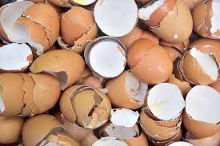
Figure 2.1 Egg shell

Table 2.2 Eggshell chemical composition
Chemical composition of Eggshell
S. No | Oxide contents | Percentage (%)
1. | SiO₂ | 0.070
2. | TiO₂ | 0.087
3. | Al₂O₃ | 0.300
4. | Fe₂O₃ | 0.543
5. | CaO | 49.02
6. | MgO | 0.015
7. | Na₂O | 0.230
8. | K₂O | 0.328
9. | ClO | 0.538
10 | SrO. | 0.493
11. | SO₃. | 0.400
Source: Oliveira et al. (2015)
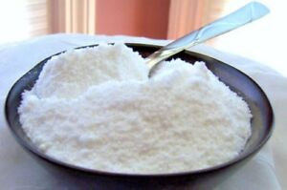
Figure 2.2 Egg shell powder
The chemical composition of Eggshell powder and cement were found to be similar. The main component of eggshell was calcium carbonate (around 51%).Eggshell ash has been established to be a good accelerator for cement bound material because of extra calcium oxide by addition of eggshell ash. Olarewaju et al.(2011) concluded that the increase in the eggshell ash content will increase the strength and properties of the cement stabilized matrix upto about 35% averagely and that show that the use of eggshell ash as an additive will increase the strength of the concrete.
In another hand, according to Mtalib et al. (2011) said that the addition of eggshell ash to the Ordinary Portland Cement will decrease the setting time of the cement. So they concluded that the eggshells ash is an accelerator in concrete because the higher its content, the faster the rate of the setting time. But this is different from the effect of eggshell to the soil, investigated that the eggshell powder could be good replacement in industrial lime because they have similarity in chemical composition and it can be a stabilizing potential of lime on an expansive clay soil. Stabilization is aimed at improving the properties of soil such as increasing the soil density and cohesion, frictional resistance and reduction of plasticity index such as lime, cement and fly ash. So they concluded that eggshell powder can be supplement in lime stabilization.
In conclusion, the chemical properties of the eggshell ash can have effect in concrete mix properties and for this reason, the eggshell properties will increase the strength properties of the concrete.
2.1.5. Aggregates.
According to Jackson and Dhir (2015), aggregates are granular materials such as sand and crushed stones and most aggregate have a specific gravities in the range of 2.6 to 2.7 whereas the role of aggregate is to provide much better dimensional stability and wear resistance and without aggregate, large castings of neat cement paste would essentially self-destruct upon drying
Aggregate is commonly considered inert filler, which accounts for 60 to 80 percent of the volume and 70 to 85 percent of the weight of concrete, so their properties have a large influence on the properties of the concrete (Hillson and Domone , 2017). Hence, the selection of aggregate is very important to the concrete mixture since it will affect the workability in the concrete.
The compressive aggregate strength is an important factor in the selection of aggregate and when determining the strength of normal concrete, most concrete aggregates are several times stronger than the other components in concrete and therefore not a factor in the strength of normal strength concrete.
Aggregate absorption is used for applying a correction factor for aggregates in dry condition and determining water demand for concrete in saturated surface dry condition. Aggregate can absorb water up to 2 % by weight when in bone dry state. However, in some cases, the aggregate absorption can be as high as 5%.
Aggregate is classified into two different types namely:
(i) Coarse and
(ii) Fine aggregates.
Coarse Aggregates
Coarse aggregate is one of the essential components of concrete and occupies the largest volume in the mix.
Coarse aggregates are the particles that are retained on 4.75 mm sieve.They can either be from primary, secondary or recycled sources and that is why it greatly affects the concrete mix design.
Its properties such as strength, maximum size, shape, and water absorption influence water demand, the quantity of cement and fine aggregate in concrete mixture.
It was reported that, high maximum coarse aggregate size leads to lower water demand in the mixture since such aggregate has lower surface area compare with small coarse aggregate size but as far as shape is concerned, rounded shape aggregate provides economical mix design for normal strength concrete.
However, angular coarse aggregate is desired in the case of high strength concrete. This possibility of segregation is minimized if coarser aggregate is properly graded. This explains how important is good grading for concrete mix design.
As far as strength is concerned, higher aggregate strength would produce higher concrete strength provided that other controlling factors have been dealt with properly.
Coarse aggregates may be round, angular, or irregular shape.
Rounded aggregates have lowest water demand due to lower surface area, and also have lowest mortar paste while flaky and elongated coarse aggregate particles not only increase the water demand but also increase the tendency of segregation. Flakiness and elongation also reduce the flexural strength of concrete.

2.1.6 Grading of Coarse Aggregate
Grading is the determination of the particle-size distribution for aggregate before they are use in construction since it has effect on the amount of cement and water requirements, workability, pumpability, and durability of concrete. The grading of coarse aggregate is important to get cohesive and dense concrete and the voids left by larger coarse aggregate particles are filled by smaller coarse aggregate particles.
Proper grading of coarse aggregate can minimize the possibility of segregation, especially for higher workability and improves the compatibility of concrete.
Material strength of coarse aggregate is indicated by crushing strength of rock, aggregate crushing value, aggregate impact value, aggregate abrasion value.
2.1.7 Fine Aggregates
Fine aggregate (Sand) Fills voids between aggregates. It forms the bulk and makes mortar or concrete economical.
The finer aggregates have a better positive effect on the properties of fresh concrete and hardened in high performance concrete as it provides resistance against shrinking and cracking .Thus, fine aggregates are playing an important role in the concrete mixture (Olarewaju et al., 2011).
It is naturally available.
Fine aggregates are classified base on:-
(i) Mode of Origin
(ii) Composition
(iii) Grain Size
Classification According to Mode of Origin: Pit Sand, River Sand and Sea Sand.
Pit sand is sharp and angular in outline. Translation and deposition are done by the wind. Such sand accumulation is sometimes covered by clay.
It will be desirable to wash and clean this type of sand before use
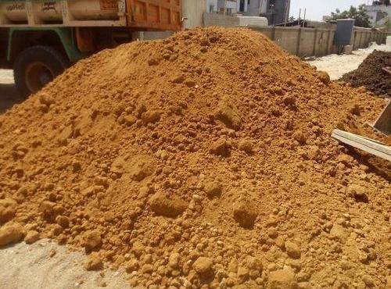
Plate 2.1: Pit Sand

River sand is found in the river bed in-plane area. Grains of river sand is round in shape. This sand is clean and free from salt encrustations.
No organic impurities are noticed. This sand is commonly for construction work.
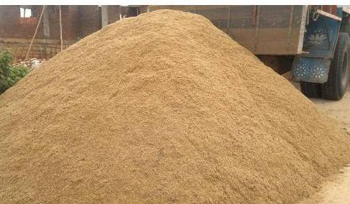
Plate 2.2: River Sand
Sea sand:-This type of sand is found on beaches and along sea-shore. These sand particles are round in shape. Grains are often found covered with salts that are not easily separated.
These salts, when coming in contact with binding material of mortar or concrete, create problems.
Further, these salts encrustations are hygroscopic. They absorb water from the atmosphere and delays setting.
They produce dampness and efflorescence. Hence the type of sand is not preferred. They should be thoroughly washed before use.

Plate 2.3: Sea Sand
Classification of Fine Aggregates According to Composition:
(i) Clean Sand
(ii) Silty Sand
(iii) Clayey Sand
Clean sand:-These are well-graded sand containing quartz particles in a wide range of grain sizes.
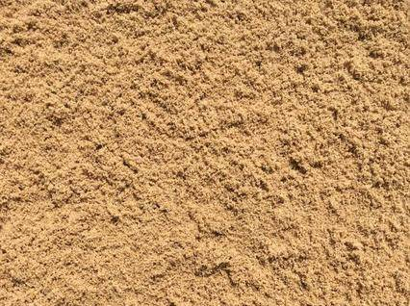
Plate 2.4: Clean Sand
Silty sand:-These are poorly graded, having a considerable proportion of silt and other non-plastic fines.
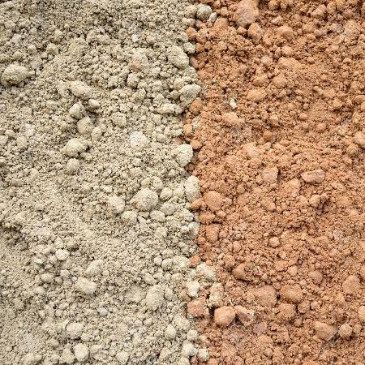
Plate 2.5: Silty Sand
Clayey Sand:-These are poorly graded sand that has a prominent clay fraction and also plastic fines.
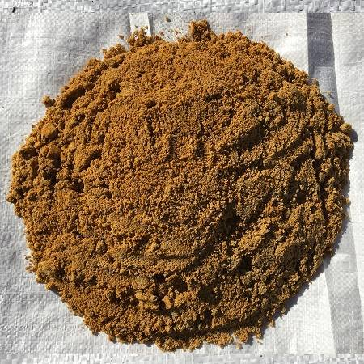
Plate 2.6: Clayey Sand
Classification of fine aggregates according to Grain size:-
According to this classification sands are classified as follows
Table 2.3
Grain Size | Type
2 – 1 mm | Coarse
1 – 0.25 mm | Medium
0.25 – 0.15 mm | Fine
Source. Salami (2012)

Water As concrete constituent:-
Water is the key ingredient, which when mixed with cement, forms a paste that binds the aggregate together and that is why water is regarded as an essential element to produce a good and quality concrete .Te water causes the hardening of concrete through a process called hydration.
Because concrete must be both strong and workable, a careful balance of the cement to water ratio is required when making concrete.
Thus it is important to ensure that the water used for concrete production should be free from deleterious substances namely oil, acid, alkali, salt, sugar, slit and organic matter. In general rule, if the water is drinkable, it is consider suitable for concrete production.
Mehta (2012), suggested that the water used for concrete should be clean, free from organic material and having pH ranging from 6 to 8

2.1.8 DURABILITY AND PERMEABILITY OF CONCRETE
Durability of cement concrete is defined as its ability to resist weathering action, chemical attack, abrasion, or any other process of deterioration. Durable concrete will retain its original form, quality, and serviceability when exposed to its environment.
According to Omar (2010) low permeability and shrinkage are two performance characteristic of concrete that can prolong the structure that is related to severe exposure condition to archive better way quantify durability. However, higher strength of concrete will provide more resistance to cracking due to durability mechanisms and will usually have a lower water cement ratio to give a positive impact of permeability.
Other researcher ( Amaranth,2014) agree that durability of concrete can fully function over an extended period under prevailing service conditions for the purpose of designed and the durability of concrete is related to its permeability by the aggressive agents that can penetrate to attack the concrete and the steel reinforcement.
Corrosion related to damage to the concrete structure cause a problem associated with high cost of repairs, sometimes replacement of structure.
2.1.9 SLUMP TEST
Manzoor (2018), stated that the purpose of slump test is to determine the workability of concrete. Workability is important for fresh concrete. If the workability of concrete is low, the concrete mixtures will be difficult to compact thereby increasing the risk of the structure.
The method for determination of slump test is according to British Standard 1881: Part 102. Slump cone ensured that the internal surface is clean. The fresh concrete is to be placed and filled by 3 layers in the slump cone, remove carefully, slowly and ensure that the fresh concrete are not touched. Next measured are the difference of the height of slump cone and the fresh concrete. The different in height is the slump of the fresh concrete which are categories as very low, medium and high.
The slump can be increase by increasing the amount of water for some mix that has already been set by a particular slump and it can be predicted by adding some amount of water that can increase the slump by inch. In relation for the other findings the slump test is use for the determinatin of the workability of concrete with difference in concrete grades. Compatibility, mobility and stability on fresh concrete are related to the workability of concrete.
In our research however, we carried out slump test to determine the workability of fresh concrete. Even increasing the water can be increase the slump, but the properties in the concrete will be affected by increasing the water. The higher workability does not show the higher properties the concrete. The addition of eggshell ash may affect the properties of concrete and at the same time, they will affect the workability of the fresh concrete mix.
2.1.10 COMPRESSIVE STRENGTH TEST
Jackson and Dhir (2015), stated that the addition of lime in unconfined compression test and undrained triaxial shear strength raised the properties strength on the stabilizing potential on an expansive Clay Soil. While the increases of eggshells ash content also increased the optimum moisture content but reduced the maximum dry density, thus considerably increased into strength properties of the soil cement eggshell ash. Research investigated proves also on the setting time of cement where the higher content of the eggshell ash, the greater strength of the properties in concrete. As a conclusion, all the additives or admixtures related to eggshell ash in concrete improve performance of strength properties in any materials involved.
2.1.11 Setting Time Test
The concrete setting time mostly depends upon the w/c ratio, temperature condition, type of cement, use of mineral admixture, use of plasticizer (regarding plasticizer).
The concrete setting time is determined by using a penetrator test and it is therefore essential to note that cement set neither too rapidly nor too slowly.
In this test, an apparatus used has a minimum lateral dimension about 150mm and depth 150mm. This test was performed using 6 plungers or penetration needle with bearing areas of 645,323, 161, 65, 32 and 16mm².
Each needle was placed at a distance of 25mm from the bearing area. A device with hydraulic force was provided to measure the force required to cause penetration of the needle.

CHAPTER THREE
3.0 METHODOLOGY
The materials that were used for this research are cement, Eggshell powder, coarse aggregates, fine aggregates and water and how this materials were obtained, where it was obtained and the steps involved in ensuring that these materials complied with specifications are explained in this chapter.
Furthermore the laboratory tests that were carried out on fresh and hardened concrete produced as well as the reasons for which they were carried out are also explained in this chapter.
3.1 Collection of Materials.
As a result of many trial mixes, high strength concrete has been achieved using ranges of quality materials that are well mixed together in the right proportion and taking other standard quality control into consideration.
3.2 Purchase of Cement
Ordinary Portland cement (Dangote Cement) being one of the materials to used for this research in order to produce concrete was purchased (i.e in sufficient quantity) within Ilorin environs.
The reason for choosing ordinary Portland cement is because it is the only type of cement that is most readily available in the market and its price was fairly affordable (as the time we purchased it) in Ilorin since the research work was carried out here in Ilorin so as to avoid travelling long distance to another place.
3.3 Collection of Eggshell
The eggshells used was obtained locally from (Abundant Grace Catering Services, film house area, Ilorin).Abundant Grace services do purchased the eggs laid by chickens from Alao farm in Tanks area ,Ilorin for the production of indomie, snacks, cakes etc and the reason why eggshell powder was used to partially replace cement during the production of concrete cubes was based on the review of literatures in the previous chapter where it was reported that eggshell and cement has some substances in common and that was the reason why I produced high strength and durable concrete at affordable cost.
After collecting the eggshells as by-product from Abundant Grace catering services when its initial content has been used for the intended purpose, it was cleansed so as to remove dirt and all the impurities that maybe present in it which may hamper the setting time of cement as well as the properties of fresh and hardened concrete.
The cleansed eggshells were then dried under the sun for 24hours purposely to remove the moisture that may be present in it due to water absorption from the atmosphere and after that, it was finally grinded into fine powder using blender and we also ensured that the blender was cleaned and dry before it was used for grinding the dried eggshells but after grinding into fine powder, there was a change in colour.
3.4 Aggregates
Coarse aggregates (Gravel) and fine aggregates (sharp sand) were used to produced concrete in the course of carrying out this research and both aggregates were sourced locally from Ilorin.
Sieve test analysis was also carried out on these aggregates to ensure that they complied with specification according to a section of the BS 812 series.
3.5 Sieve Analysis Test on Aggregates
Before concrete cubes were produced, sieve analysis of the aggregates used was carried out so as to determine the grade of samples which conform to the specified standard as follows
Apparatus:- weighing balance, sieve of various sizes, weighing pan, sieve Shaker machine, weight load in gram(g) and spatula.
Material: Aggregates
Procedure: Dry samples of aggregates were collected and the empty pan was weighed on the balance so as to know the weight (weight of empty pan) before the addition of sample.
Various empty sieve sizes were weighed according to their sizes and some aggregates were poured into the empty pan and weighed.
Samples from the empty pan were then poured into the empty sieves and it was placed on the sieve Shaker for proper shaking of samples for some minutes. The sieve sizes were then removed from the sieve Shaker machine with ease so as to avoid falling off of particles.
Finally, each sieve which contain the samples were weighed separately and the weighed value was recorded .
Sieve sizes | Weight of empty sieve (g) | wt of sieve+soil residue(g) | Wt of soil residue (g) | Cumulative of soil residue | % cummulative soil residue | %passing
Table 3.1 The analysis is tabulated as shown below
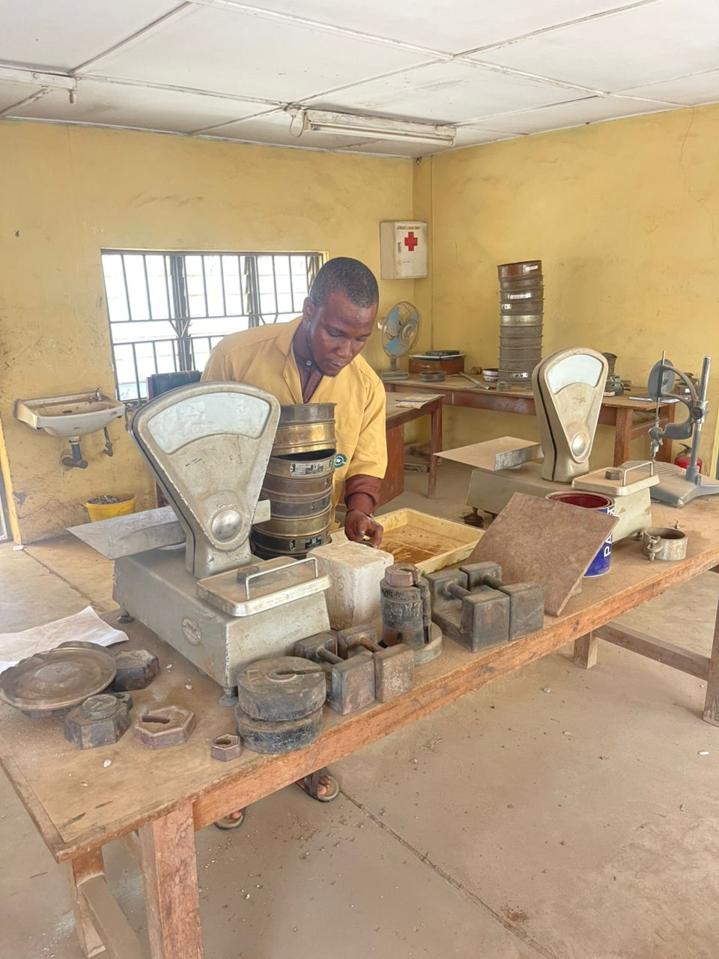
Plate 3.1: Sieve Analysis Test
3.6 Water:- The water used for the concrete mix was obtained in sufficient quantity with bucket within the institute of Technology, Kwara State Polytechnic, Ilorin. We also ensure that the water is clean and free from all forms of impurities.
3.6.1 Mixing of concrete
After the necessary test has been carried out on the aggregates used, concrete cubes (grade 1:2:4) were produced by replacing Portland cement partially with eggshell powder. Eggshell powder was used to replaced cement by weight in varying proportion of 0%,5%,10%,and 15% in prepared concrete mould of 150mmX150mmX150mm. We ensured that the mould was cleaned and oiled (for easy demoulding).
The mixing was done manually with the use of headpan, hand trowel and shovel using mix ratio 1:2:4 and water ratio of 0.55. The required sand, Eggshell powder and cement was firstly measured and it was also perfectly mixed and poured on the mixing pan.
The coarse aggregates were also introduced before mixing.
Furthermore, the measured water based on the water/Eggshell powder ratio was finally added and thoroughly mixed until a uniform mixture was achieved by ensuring good quality control.
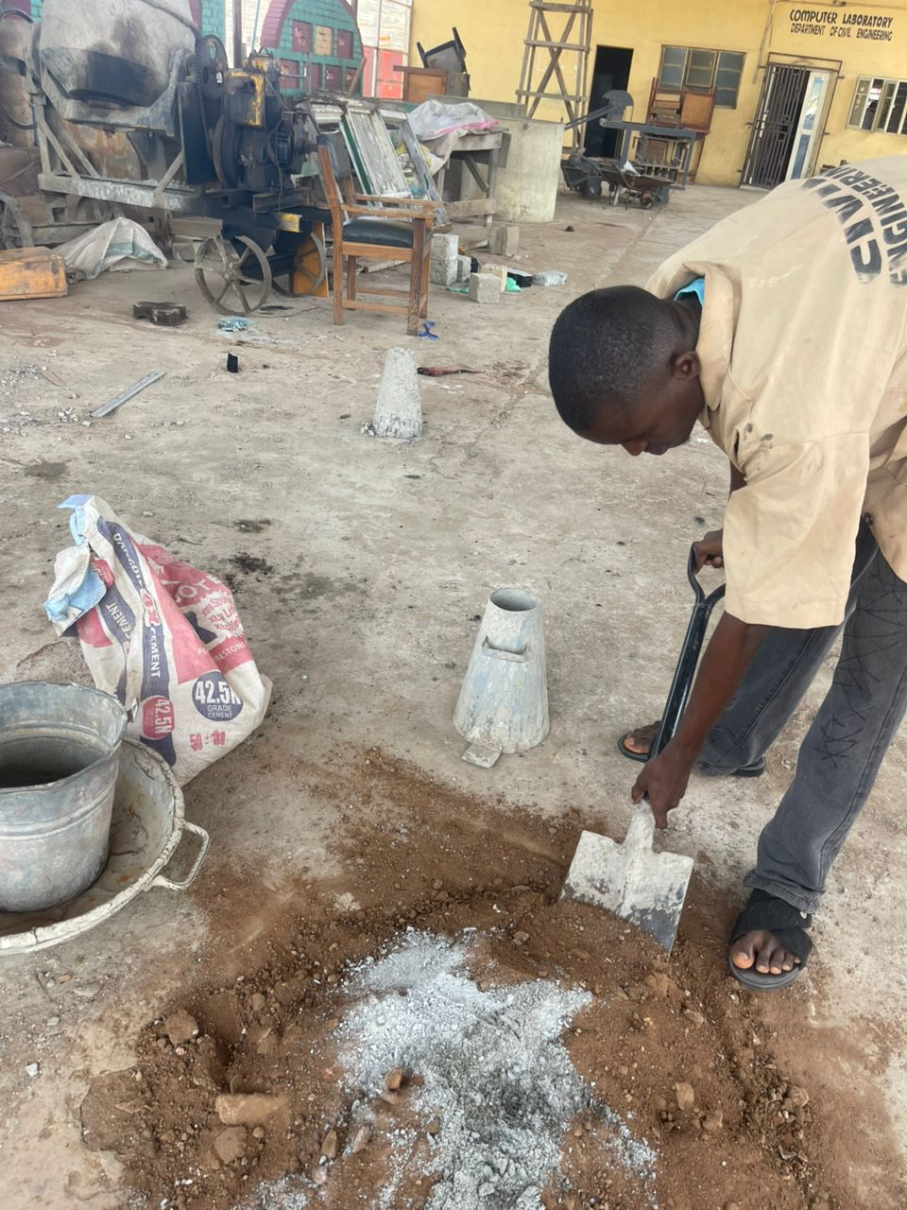
Plate 3.2: Concrete mixing
3.6.2 Laboratory Test
The tests carried out on the concrete are;-
(i) Slump test
(ii) Setting time test
(iii) Compressive strength test
The first two tests were carried out only on fresh concrete while the compressive strength test was only carried out on hardened concrete cubes that were subjected to water immersion during the process of curing.
After the concrete cubes were produced, it was allowed to stand in the mould for 24hours before we started demoulding it and it was wholly immersed in water for 7,14, and 28 days before we carried out the compressive strength test.
The procedure in which each test was carried out are also explained.
3.6.3 Slump Test
The concrete slump test is an empirical test that measures the workability of fresh concrete (BS1881:part 102)
Apparatus:-metal mould in the shape of the frustum of a cone, open at both ends and provided with the handle, top internal diameter 4 in 102mm and bottom internal diameter 8 in 20mm with a height of 1ft 305mm.
Purpose:- To measure the consistency of fresh concrete before it set
This test was carried out so as to check the workability of fresh concrete and the ease with which concrete flows and this test was used to ensure uniformity for different loads of concrete under field conditions.
Procedure:- The cone was placed on a hard nonabsorbent surface and it was filled with fresh concrete in three stages and it was tamped each time using a rod of standard dimension. At the end of the third stage ,concrete was strucked off and flush to the top of the mould and the mould was carefully lifted vertically upward so as not to disturb the concrete cone.
Concrete subsided .The subsidence was tamped as slump and it was measured and the value was recorded.
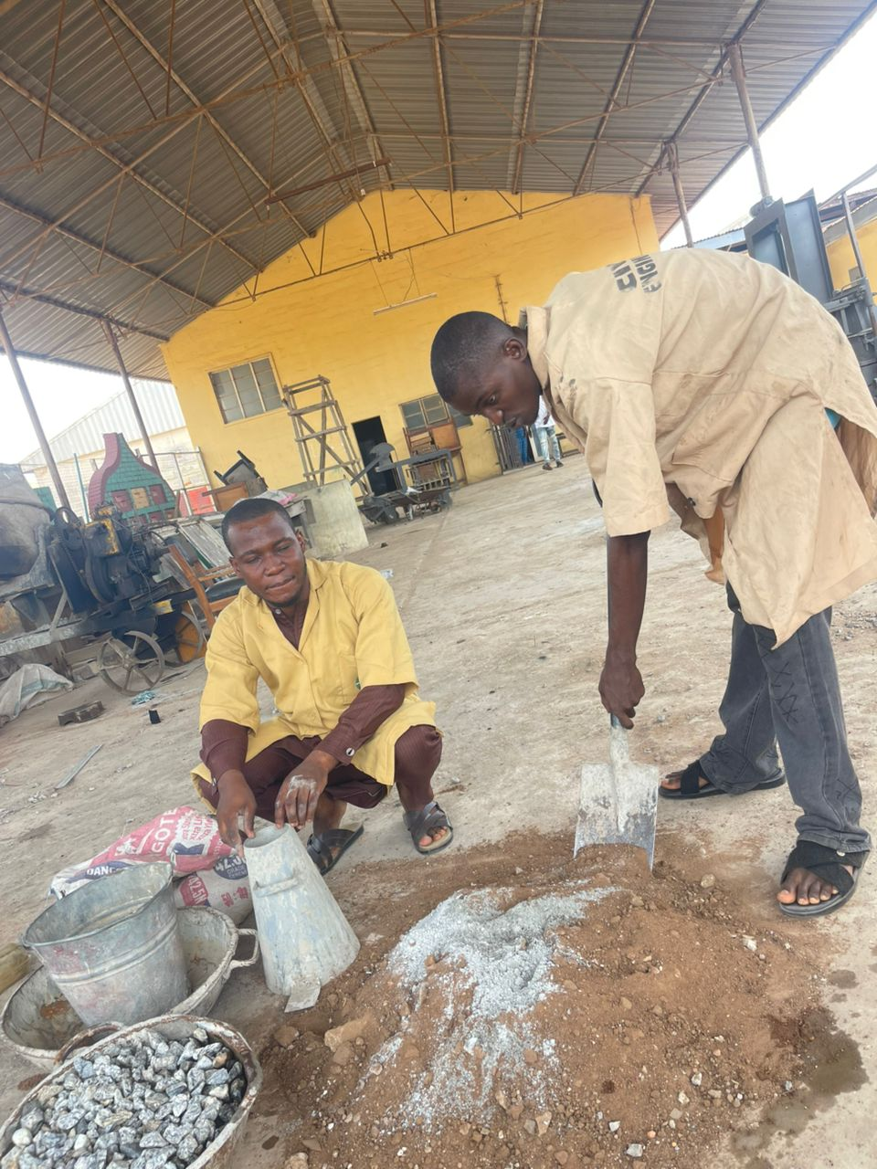
Plate 3.3: Slump Test

3.6.4 Setting Time Test
The concrete setting time mostly depends upon the w/c ratio, temperature condition, type of cement, use of mineral admixture, use of plasticizer (regarding plasticizer).
The concrete setting time is determined by using a penetrator test and it is therefore essential to note that cement set neither too rapidly nor too slowly.
Procedure for Setting Time of Concrete Test:-
The following steps were followed while carrying out the setting time test of concrete sufficient quantity of fresh concrete mix sample was taken and sieved through a 4.75mm sieve and the mortar sample that passed through the sieve was collected. The mortar was then compacted by tamping and we leveled the surface and we ensured that it was covered so as to prevent the loss of moisture.
Bleeding water was removed using pipette and a needle of appropriate size was inserted based on the degree of setting of the mortar by bringing the bearing surface of the needle in contact with the mortar surface and gradually and uniformly applying a vertical force downward on the apparatus until the needle penetrated to a depth of 25±1.5 as indicated by the scribe mark.
The time was recorded for the penetration of 25mm depth and the force that produced this depth was also recorded. The penetration resistance was obtained by dividing the recorded force by the bearing area of the needle and this is referred to as the penetration resistance.
Table shown setting time tests results
Test No | Ash content (%) | Water content (%) | Volume of water (ml) | Initial setting time (mins) | Decrease in final setting time (%) | Final setting time (mins) | Decrease in final setting time (%)
1 | 0 | 37 | 148 | 143 | _ | 247 | _
2 | 5.0 | 37 | 148 | 141 | 1.40 | 240 | 2.83
3 | 10. 0 | 37 | 148 | 129 | 9.79 | 221 | 10.53
4 | 15.0 | 37 | 148 | 118 | 17.48 | 203 | 17.82
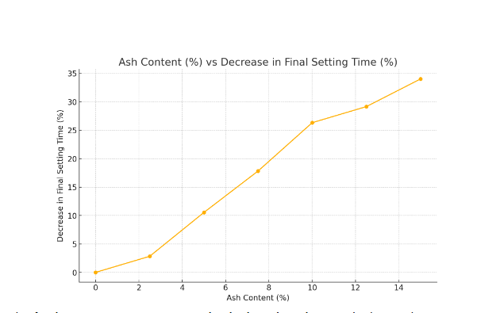

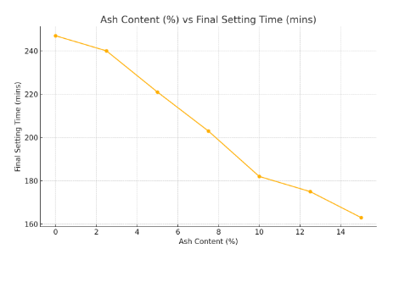

4.0. Discussion of Results
As shown in Table 1, the amount of water required to make a standard cement past of normal consistency is equal to 148ml. This is equivalent to 37% by weight of OPC used. This translated to 0.37 water/cement ratio, which was employed in constituting the CESA paste on which was conducted the setting time test. From the results of the setting time test in Table 2, and graphically illustrated in Figure 1, the CESA paste sets faster than the cement-paste alone. This indicated that the addition ESA to the cement decreases the setting time of cement. From the percentage decreases in the initial and final setting times presented in Table 2 and plotted in Figure 2, it can be seen that the higher the contents of ESA in the cement paste, the faster the setting of the cement. For all the percentage contents of ESA used, both the initial and final setting times satisfy the requirements of BS 12: 1991 [1]. It should be recalled that BS 12:1991 [1] requires that the initial and final setting times of OPC should not be less than 45 minutes, and not greater than 10 hours, respectively. It can also be observed that ESA has similar decreasing effect on the initial and final setting times of cement. This similar effect being that the decrease in the setting time of OPC between successive percentage additions of ESA is generally gradual for the initial setting time as well as for the final setting time. The decrease in the setting time of the OPC due to addition of ESA portrays ESA as an accelerator. Therefore, ESA can be used to advantage as an admixture in concrete.

3.6.5 Compressive Strength Test
Compressive strength is the ability of material or structure to carry the loads on its surface without any crack or deflection. A material such as concrete which is good in compression but weak in tension tends to reduce in size while it is being compressed.
The test was done so as to determine the compressive strength of concrete cubes after the curing ages of 7,14 and 28 days. The compressive strength of the concrete cubes test provide an idea about all the characteristics of concrete and by this single test, one can judge whether concreting has been done perfectly or not.
Compressive strength of concrete depends on many factors such as water-cement ratio, cement strength, quality of concrete material, quality control during the production of concrete etc
Apparatus:- 150mmX150mmX150mm hardened concrete cubes and compressive strength test machine.
Procedure:- The cured concrete cubes were firstly removal from water and allow to loose their moisture through placement under air and after removal of moisture, each cube was weighed and the dry weight was recorded.
The concrete cubes were placed under the compressive strength test machine one after the other and ensuring that each cube was centrally placed.
The compressive strength test machine was allowed to start compressing the cube placed underneath . The value of the load that compresses each cube was recorded as failure load.
This procedure was repeated for all the curing ages

Plate 3.4: Compressive Strength Test of Concrete Cube
3.6.6 Curing of concrete cubes
Curing of concrete is a method by which the concrete is protected against loss of moisture required for hydration and kept within the recommended temperature range.
A common practice of curing involves keeping the concrete damp or moist until the hydration of concrete is complete and until sufficient strength is attained.
Curing play an important role on strength development and durability of concrete. Curing takes place immediately after concrete placing and finishing and it involves maintenance of desired moisture and temperature conditions both at depth and near the surface for extended period of time.
Properly cured concrete has an adequate amount of moisture for continued hydration and development of strength, volume stability, resistance to freezing and thawing and abrasion and scaling resistance.
The length of adequate curing time is dependent on the following factors
i. Mixture proportion
ii. Specified strength
iii. Size and shape of concrete member
iv. Ambient weather conditions
v. Future exposure conditions
After loosening the cube mould, the concrete cubes were immersed wholly in water for different ages; 7, 14, and 28 days under good atmospheric condition.
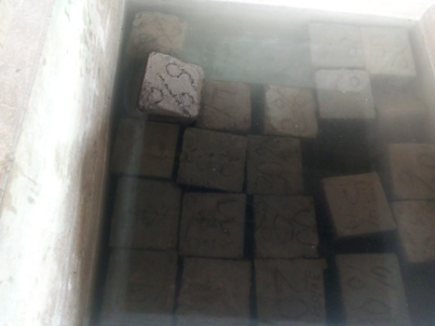
Plate 3.7: Curing of Concrete Cube

CHAPTER FOUR
4.0 Result and Discussion/ Analysis
4.1 Laboratory Test Result
Table 4.1 Sieve analysis test result of fine aggregates
S/N | Sieve size | Mass of empty sieve (g) | Mass of sieve + soil residue (g) | Mass of soil residue (g) | Cumulative of soil residue | % cumulative | % passing
1. | 6.7mm | 520 | 531 | 11 | 11 | 1.1 | 98.90
2. | 4.75mm | 535 | 555 | 20 | 31 | 3.1 | 96.90
3. | 3.6mm | 465 | 573 | 108 | 139 | 13.9 | 86.10
4. | 2.36mm | 430 | 832 | 402 | 541 | 54.1 | 45.90
5. | 1.00mm | 410 | 615 | 205 | 746 | 74.6 | 25.40
6. | 500$μ$m | 380 | 466 | 86 | 832 | 83.2 | 16.80
7. | 350$μ$m | 310 | 475 | 165 | 997 | 99.7 | 0.30
8. | 0.75$μ$m | 486 | 489 | 3 | 1000 | 100 | 0
Total weight of soil = 1000g
Mass of soil residue = (mass of sieve + soil residue)
M1, Mass of soil residue = 531-520=11
M2, mass of soil residue = 55-535 =20
M3, mass of soil residue =573-465 =108
M4, mass of soil residue =832-430 =402
M5 mass of soil residue = 615-410=205
M6, mass of soil residue=466-380=86
M7, mass of soil residue=475-310=165
M8, mass of soil residue=489-486=3
Cumulative of soil residue = summation of mass of soil residue
i.e 11,11+20,+11+20,11+108,11+20+108+402+11+20+108+402+205……………
% cumulative = $\frac{Cummulatve of Soil Residue}{Total Weight of soil}X 100\%$
% Passing = 100-% cumulative
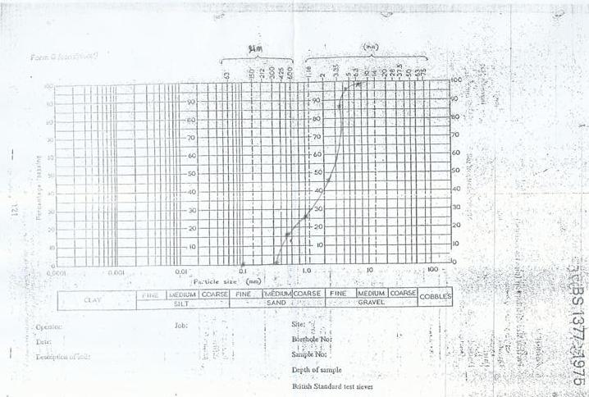
Figure 4.1 Sieve Analysis Graph
4.2 Setting time test
This test was used to determine the consistency of standard paste of cement and moisture cement which will produce the Fr required initial and final setting time of the cement
Approximately 400g of cement was weighed and mixed with a weighted quantity of water which range from 26-32% of the weighed cement.
The vicat mould was filled with cement paste and leveled with a trowel. The plunger was lowered gently (till it touched the cement surface) and released allowing it to sink into the paste.
The reading was noted on the gauge set stopwatch so as to determine the exact time of the experiment.
The above procedure was repeated taking sample of cement and different quantities of water until the reading on the gauge was 5-7mm
Calculation:
Quantity of water = $\frac{27}{100}$ x 400 = 108ml
Weight of empty pan = 886g
Weight of empty pan and cement = 1286g
Weight of cement = (weight of empty pan and cement)-weight of empty pan
= 1286-886
= 400g
Consistency percentage of cement used =33% of 400g =132g

Table 4.2 setting time test
Time | Penetration
2:02 | 4mm
2:07 | 7mm
2:58 | 10mm

Setting time test result of Dangote cement
Remark: The table shows that the cement used (Dangote cement) initial setting is 2 hr, 02 min at 4mm penetration and at 7mm penetration in 2 hrs, 58min the plunger needle was unable to penetrate the cement paste at 2 hrs, 58 minutes which means that the final setting time (is code 4031) thereby indicating stiffening of the cement paste.
4.3 Slump Test
The slump value for the control mix was higher that the slump value of Egg shell powder concrete.
It was also noted that the higher the percentage of egg shell powder, the lower slump.
The test gives a true slump for
i. The control mix sample had a slump of 30cm
ii. The 0% replacement of cement had a slump of 28cm
iii. The 5% replacement of cement had a slump of 27cm
iv. The 10% replacement of cement had a slump of 25cm
v. The 15% replacement of cement had a slump of 24cm
The mixes were within the standard limits of between 5.9-10cm
Weighing Balance machine results and crushing machine results from laboratory
Dimension of cube = 150mmX150mmX150mm
For volume
Length = 150mm
Breadth = 150mm
Height= 150mm
Volume = (150X150X150) mm
=3375, 000mm³
=0.003375m³
Area = LXB
= (150X150) mm²
=22500mm²
Figure 4.2 slump test
Table 4.3 Compressive strength Test Result for various percentage replacement at 7, 14 and 28 days
% replacement | Dry weight (kg) | Age of cube | Volume (m³) | Dry density (kg/m³) | Failure load (KN) | Compressive Strength (N/mm²) | Average compressive strength N/mm²
0% | 8.67  8.65 | 7 days | 0.003375  0.003375 | 2569  2563 | 220  240 | 9.78  10.67 | 10.23
 | 8.08  8.02 | 14 days | 0.003375  0.003375 | 2394  2376 | 280  300 | 12.44  13.33 | 12.89
 | 8.34  8.53 | 28days | 0.003375 | 2471 | 350  360 | 15.56  16.00 | 15.78
5% | 8.30  8.26 | 7days | 0.003375  0.003375 | 2459  2447 | 210  220 | 9.33  9.78 | 9.56
 | 7.91  7.82 | 14 days | 0.003375  0.003375 | 2344  2317 | 250  255 | 11.11  11.33 | 11.22
 | 8.01  8.07 | 28 days | 0.003375  0.003375 | 2373  2391 | 260  330 | 11.56  14.67 | 13.12
10% | 7.79  7.81 | 7 days | 0.003375  0.003375 | 2308  2264 | 195  205 | 8.67  9.11 | 8.89
 | 7.80  7.81 | 14days | 0.003375  0.003375 | 2311  2314 | 220  235 | 9.78  10.44 | 10.11
 | 8.52  8.00 | 28 days | 0.003375  0.003375 | 2524  2370 | 335  295 | 14.89  13.11 | 14.00`
15% | 7.31  7.42 | 7 days | 0.003375  0.003375 | 2166  2199 | 170  185 | 7.56  8.22 | 7.89
 | 8.23  8.22 | 14days | 0.003375  0.003375 | 2439  2436 | 185  190 | 8.22  8.44 | 8.33
 | 8.52  8.55 | 28 days | 0.003375  0.003375 | 2524  2533 | 320  285 | 14.22  12.67 | 13.45

Dry density = $\frac{Dry Weight}{Volume}$
Compressive strength =$\frac{Failure load X(1000N)}{Area (22500m{m)}^{2}}$

Figure 4.3 compressive strength result

CHAPTER FIVE
5.0 CONCLUSION AND RECOMMENDATIONS
5.1 CONCLUSION
It was observed that with this experiment that the eggshell powder can be replacement for cement, as it will reduces the problem of disposal of eggshells. And there was also a high difference between the control and result obtained from the tested samples.
From the preliminary studies and tests carried out on the properties of concrete made with eggshell Powder, the following conclusion has been reached;-
For a given mix, the water requirement decreases as the eggshell powered content increases (Due to the presence of eggshell powder, workability of mortar increases compared to an ordinary mixture with only ordinary Portland cement).
The eggshell ash contained high percentage combination of Silica (SiO₂), Iron (Fe₂O₃) Aluminum (Al₂O₃) and Calcium (CaO) of 70%.
There is a general increase in the compressive strength with increase in the curing ages of 7, 14, and 28 days.
The optimum replacement level of OPC with eggshell powder was 8%.
The maximum compressive strength of 15.56N/mm² was reached at 8% replacement at 28 days and 0% at 28 days curing.
The employment of eggshell powder in cement and concrete has gained considerable importance because of the requirements of environmental safety and more durable construction in the future. The use of eggshell ash as partial replacement of cement in mortar and concrete has been extensively investigated in recent years.
The literature review clearly demonstrates that eggshell powder is an effective pozzolana which can contribute to mechanical properties of concrete.
It can be concluded that the use of eggshell ash leads to enhanced resistance to segregation of fresh concrete compared to a control mixture with Portland cement alone.
Finally, the literature review showed that the Mechanical properties of concrete are enhanced when the substitution of Portland cement was done with eggshell powder.
5.2 RECOMMENDATION
i. It is recommended that eggshell powder should not be used as cement replacement material in the production of concrete at 100% replacement but 10% replacement can be used. However, other percentage replacement can be used depending on time availability
ii. Further research should be carried out at different level of replacement of cement with eggshell powder
iii. Further research should also be carried out to ascertain the prospect of using eggshell powder to replace cement in concrete at different level of replacement
REFERENCES
Amaranth Yerramala(2014),properties of concrete with eggshell powder as cement replacement: The India concrete Journal
Histon,J.M. and Domone,P.L(2017),construction materials their nature and behavior, first edition, Taylor and Francis e-library.
Illson and Domone(2012),Experimental Investigation of Eggshell powder as partial replacement with cement in concrete.International journal of Engineering Trends and Technology (IJETT)
Jackson, N., and Dhir,R.K.(2015). Civil Engineering materials. Macmillan Education Ltd, Hong Kong
Manzoor Ahmad Allie (2018),A Review study of Eggshell powder as a cement replacing material in concrete
Mehta,P.K(2012), Experimental study on usage of Eggshell as partial replacement for sand in concrete
Mtallib,O.,and Rabiu, M.A(2011),Effects of Eggshell Ash on the setting time of cement
Neville (2013),Estimation of The Residual Expansion of Concrete Affected by Alkali Silica Reaction
Olarewaju,A.J.,Balogun,M.Oband Akinlolu,S.O.(2011);Suitability of Eggshell stabilized lateritic soil as subgrade material for road construction
Omar (2010), The performance of Eggshell as filler in concrete mixtures. Proceedings of the 2013 international conference on industrial Engineering and operation management Bali, Indonesia
Praveen Kumar R. (2019), Experimental study on partial Replacement of cement with eggshell powder. International journal of innovations in Engineering and Technology, Volume 5,ISSN:2319-1058

