DEVELOPMENT OF A NETWORK INTRUSION DETECTION SYSTEM TO IDENTIFY AND PREVENT PHISHING ATTACKS

BY

AKANBI MARY IBUKUNOLUWA
HND/23/COM/FT/0077

Submitted to the
DEPARTMENT OF COMPUTER SCIENCE,
INSTITUTE OF INFORMATION AND COMMUNICATION TECHNOLOGY (IICT),
KWARA STATE POLYTECHNIC ILORIN, KWARA STATE

IN PARTIAL FULFILLMENT OF THE REQUIREMENT FOR THE AWARD OF HIGHER NATIONAL DIPLOMA (HND) IN COMPUTER SCIENCE

JUNE, 2025

CERTIFICATION
This is to certify that this project was carried out by AKANBI MARY IBUKUNOLUWA with Matric Number: HND/23/COM/FT/0077 has been read and approved by the Department of Computer Science, Kwara State Polytechnic Ilorin. In partial fulfillment of the requirements for the award of Higher National Diploma (HND) in Computer Science.

__________________ ___________________
MR. BOLAJI ADETERO, D.F. DATE
(Project Supervisor)

__________________ ___________________
MR. OYEDEPO, F.S. DATE
(Head of Department)

__________________ ___________________
External Examiner DATE

DEDICATION
I dedicate this project to the Almighty God for His guidance and strength.
Special appreciation goes to my guardians, MR. OLANIYI KEHINDE TIMOTHY AND MRS. OLANIYI JANET OMOWUMI, for their unwavering support.
I also dedicate this work to my beloved parents, MRS. AKANBI FOLARANMI BOSE and the late MR. AKANBI JOSEPH OLAJIDE, whose love and sacrifices have shaped my journey.

ACKNOWLEDGEMENTS
All glory, honor, and adoration belong to the Almighty God, the giver of life, wisdom, and knowledge. It is through His divine grace and mercy that I have come this far in my academic pursuit. He has been my strength, my guide, and my source of inspiration throughout this journey. Without Him, none of this would have been possible. I give Him all the praise for seeing me through the ups and downs of this journey, for granting me the strength to persevere, and for surrounding me with people who have been instrumental to my success.
I am incredibly grateful to my project supervisor, Hon. Mr. Bolaji Adetoro, for his guidance, patience, and support throughout my research. His insightful advice and constructive criticism have been invaluable in shaping my work. He took the time to review my research, provide thoughtful feedback, and encourage me to strive for excellence. His mentorship has helped me develop a deeper understanding of my field, and for that, I am truly grateful. I pray that God blesses him abundantly, grants him continued wisdom and success in his career, and rewards him for all his efforts in shaping the future of his students.
My appreciation goes to my lovely, A mother’s love is irreplaceable, and I am truly blessed to have an incredible mother in Mrs. Folaranmi Akanbi. Though she may not have been physically present at all times, her prayers, love, and encouragement have been with me every step of the way. And also my late father Mr. Akanbi. I am deeply grateful for her sacrifices and dedication. I pray that God blesses her abundantly, grants her long life, and allows her to reap the fruits of her labor. May she live to witness greater achievements in my life and in the lives of all her children.
A special appreciation goes to my boss, Mr. Gbadamosi Quadri Adekunle, for his continuous financial support and encouragement. He has been a great mentor, always willing to lend a helping hand whenever I needed it. His generosity, wisdom, and guidance have made a huge impact on my life. I am deeply grateful for his belief in me and his willingness to invest in my future. I pray that God blesses him abundantly, prospers him in all his endeavors, and rewards his kindness beyond measures.
I am truly grateful for my amazing siblings. Mr. Akanbi Emmanuel Adekunle, Bro Akanbi Gideon Tunbosun, Bro Akanbi Peter Olamilekan, Akanbi Christiana Omotoyosi (my baby sister), Olaniyi Mercy, Olaniyi Samuel, and Olaniyi Precious each of you has played an important role in my journey. I pray that God blesses each of you abundantly, grants you success in all your endeavors, and keeps us united in love and happiness.
I have been blessed with wonderful colleagues and friends who have stood by me, encouraged me, and made this academic pursuit a memorable one. Special thanks to AJIBOLA Deborah Idowu (my bestie, my gist partner, and my partner in crime), Abdulwaheed Bashir Olarewaju (my paddi that stay through and contributed to my project), Orefua Dominic Semilore (my childhood friend), Alafiatayo John Anuoluwapo (my tutorial lecturer), Adebayo Stephen Odunayo (Apostle wey always give listening hears, encourage me when am dawn and flash to wake me up and pray in the midnight), and many others. Your friendship, support, and encouragement have meant the world to me. The laughter, the late-night study sessions, the moments of doubt, and the triumphs we shared will always be cherished.
I pray that God blesses each of you, grants you success, and helps us all achieve our dreams. May our paths be filled with favor and prosperity.

TABLE OF CONTENTS
Title Page
Certification
Dedication
Acknowledgment
Table of Contents
Abstract
CHAPTER ONE
INTRODUCTION
  - Background to the Study
  - Problem Statement
  - Aim and Objectives of the Study
  - Significance of the Study
1.5 Scope of the Study
1.6 Definition of Terms
1.7 Organization of the Report
CHAPTER TWO
LITERATURE REVIEW
2.1 Overview on Phishing Attacks
2.2 Overview on Network Intrusion Detection Systems (NIDS)
2.3 Machine Learning in Intrusion Detection
2.4. Phishing Detection Using Machine Learning
2.5 Challenges in Phishing Detection
2.6 Related Works
CHAPTER THREE
RESEARCH METHODOLOGY
3.1 Research Methodology
3.1.1. System Design and Architecture
3.1.2 System Development
3.1.3 Testing and Evaluation
3.1.4 Deployment and Maintenance
3.2 Analysis of the Existing System
3.3 Problems of the Existing System
3.4 Description of the Proposed System
3.5 Advantages of the Proposed System
CHAPTER FOUR
DESIGN, IMPLEMENTATION AND DOCUMENT OF THE SYSTEM
4.1 Design of the System
4.1.1 Output Design
4.1.2 Input Design
4.1.3 Database Design
4.1.4 Procedure Design
4.2 Implementation of the System
4.2.1 Choice of Programming Language
4.2.2 Hardware Support
4.2.3 Software Support
4.3 Program Documentation
4.3.1 Operating the System
4.3.3 Maintaining the System
CHAPTER FIVE
SUMMARY OF CONCLUSION AND RECOMMENDATION
5.1 Summary
5.2 Conclusion
5.3 Recommendation
References

ABSTRACT
Phishing attacks pose a significant threat to the security and integrity of networked systems by tricking users into revealing sensitive information through deceptive communications. This project focuses on the development of a Network Intrusion Detection System (NIDS) specifically designed to identify and prevent phishing attacks in real time. The proposed system leverages machine learning techniques and pattern recognition algorithms to analyze network traffic, detect malicious payloads, and differentiate phishing attempts from legitimate activities. A key objective is to enhance detection accuracy while minimizing false positives. The system incorporates a continuously updated database of phishing signatures and heuristics, along with anomaly-based detection to identify novel attack patterns. Experimental evaluations demonstrate that the developed NIDS achieves high detection rates and effective prevention mechanisms, contributing to a more secure network environment. This research underscores the importance of intelligent, adaptive security tools in combating evolving cybersecurity threats.

CHAPTER ONE
INTRODUCTION
1.1 Background to the Study
In today’s interconnected world, cybersecurity threats continue to evolve, posing significant risks to individuals, organizations, and governments. Among these threats, phishing attacks remain one of the most pervasive and damaging, often serving as a gateway for more advanced cyberattacks. Phishing is a deceptive technique in which attackers impersonate legitimate entities to trick victims into revealing sensitive information such as passwords, financial details, or personal data. Despite advancements in technology, phishing continues to thrive due to its ability to exploit human psychology and its adaptability to various communication platforms, including emails, social media, and mobile messaging. The increasing sophistication of phishing attacks necessitates the development of robust countermeasures, with intrusion detection systems (IDS) emerging as a crucial line of defense Gupta et al., (2023).
A network intrusion detection system (NIDS) is a security solution designed to monitor network traffic for signs of malicious activity. It plays a pivotal role in identifying and mitigating cybersecurity threats in real time. However, traditional NIDS often struggle to detect phishing attacks effectively due to the dynamic and adaptive nature of these threats. Phishing websites, for instance, frequently mimic legitimate ones by leveraging obfuscation techniques, domain spoofing, and URL manipulation to evade detection mechanisms. The challenge lies in building a detection system that is both accurate and adaptable to the constantly changing tactics employed by cybercriminals. Recent advancements in artificial intelligence (AI) and machine learning (ML) offer promising opportunities to enhance the capabilities of intrusion detection systems in combating phishing attacks Gupta et al., (2023) the motivation for this research stems from the alarming statistics associated with phishing attacks. According to a report by the Anti-Phishing Working Group (APWG), over 1.2 million phishing sites were detected in (2024), marking a significant increase from previous years. These attacks have led to billions of dollars in financial losses and have compromised the personal information of millions of individuals globally. Organizations, particularly small and medium enterprises (SMEs), face heightened risks due to limited resources for cybersecurity investments. Moreover, the proliferation of remote work and cloud-based services has expanded the attack surface for phishing campaigns, further underscoring the need for innovative solutions APWG, (2024).
This research focuses on developing a network intrusion detection system to identify and prevent phishing attacks using advanced ML techniques. Specifically, the proposed system leverages feature extraction and classification algorithms to detect anomalies in network traffic. By analyzing key features such as URL patterns, domain reputation, and packet behaviors, the system aims to distinguish between legitimate and malicious activities with high precision. The implementation of such a system not only enhances cybersecurity defenses but also minimizes the likelihood of successful phishing attempts, thereby protecting sensitive information and reducing financial losses. Apostolopoulos et al (2020) the significance of this study lies in its potential to address critical gaps in existing cybersecurity measures. While conventional NIDS rely on rule-based approaches or signature matching, they often fail to detect zero-day phishing attacks or sophisticated obfuscation techniques. By incorporating ML-based approaches, this research seeks to overcome these limitations by enabling the system to learn from historical data and adapt to emerging threats. Additionally, the integration of real-time monitoring capabilities ensures that phishing attempts are identified and mitigated promptly, reducing the window of opportunity for attackers Sahoo et al., (2022).
1.2 Problem Statement
Phishing attacks have become a persistent and escalating threat in the digital age, compromising sensitive data, financial resources, and organizational reputation. Despite significant advancements in cybersecurity, many existing network intrusion detection systems (NIDS) lack the sophistication to accurately identify and prevent phishing attacks, particularly those employing dynamic and obfuscated techniques. Traditional rule-based approaches and signature-matching systems often fail to detect novel or zero-day phishing attempts, leaving systems vulnerable to exploitation.
1.3 Aim and Objectives of the Study
The primary aim of this study is to Develop A Network Intrusion Detection System (NIDS) that leverages machine learning techniques to accurately identify and prevent phishing attacks, thereby enhancing cybersecurity defenses and minimizing the risks associated with data breaches. The objectives of the study are:
- Analyze the characteristics and techniques commonly employed in phishing attacks, such as URL manipulation, domain spoofing, and social engineering tactics.
- Design a feature extraction framework capable of identifying phishing-related anomalies in network traffic.
- Implement machine learning algorithms for the classification of network activities into legitimate and malicious categories.
- Evaluate the performance of the proposed NIDS in terms of detection accuracy, false-positive rate, and computational efficiency.
- Provide recommendations for integrating the developed system into existing cybersecurity infrastructures for real-time threat prevention.
1.4 Significance of the Study
The significance of this study lies in its potential to enhance cybersecurity defenses against phishing attacks, one of the most prevalent and damaging cyber threats. By developing an intelligent network intrusion detection system (NIDS) powered by machine learning, this research addresses critical gaps in existing detection mechanisms, which often fail to identify novel and sophisticated phishing techniques. The proposed system aims to improve detection accuracy and real-time response, reducing the financial losses and reputational damage caused by successful attacks.
1.5 Scope of the Study
This study focuses on the development of a Network Intrusion Detection System (NIDS) designed to identify and prevent phishing attacks. The scope encompasses the analysis of phishing techniques, including URL manipulation, domain spoofing, and social engineering strategies, to extract features indicative of malicious activities. The system will be designed to monitor and analyze network traffic in real time, with an emphasis on detecting phishing attempts across commonly exploited platforms, such as emails, websites, and social media.
The research will utilize publicly available datasets for training and testing the system, ensuring a diverse representation of phishing patterns. While the study primarily targets phishing detection, the methodologies developed can be extended to other cyber threats. However, the scope excludes hardware implementation, focusing instead on software-based solutions. The geographical and industry-specific applicability of the system will be evaluated theoretically, with limited real-world deployment scenarios.
1.6 Definition of Terms
- Phishing: A type of cyberattack in which attackers impersonate legitimate entities to deceive individuals into revealing sensitive information, such as passwords, credit card numbers, or personal data, typically through fraudulent emails, websites, or messages.
- Network Intrusion Detection System (NIDS): A security tool that monitors network traffic for unusual or suspicious behavior, detecting and alerting administrators to potential security threats or attacks within a network.
- URL Manipulation: The practice of altering web addresses (URLs) to disguise malicious websites as legitimate ones, often used in phishing attacks to mislead victims into visiting harmful sites.
- Domain Spoofing: A technique in which a malicious actor creates a fake domain name that closely resembles a legitimate domain to trick users into trusting fraudulent websites or emails.
- False Positive: An error in which a legitimate action or event is incorrectly identified as malicious or suspicious by an intrusion detection system.
- Detection Accuracy: The measure of how effectively a system can correctly identify phishing attacks, usually expressed as a percentage of true positives compared to total occurrences of phishing attacks.
- Real-Time Monitoring: The continuous analysis of network traffic or user activity to identify and respond to threats as they occur, without delay.

1.7 Organization of the Report
This research report is structured into five chapters, each covering distinct aspects of the study. Chapter One provides an introduction to the research, including the background of the study, the statement of the problem, the objectives, the significance, and the scope of the research. It also presents the organization of the report.
Chapter Two offers a detailed literature review, discussing various phishing techniques, existing detection systems, and the role of machine learning in cybersecurity, particularly in phishing detection.
Chapter Three: outlines the methodology employed in this research, detailing the system design, the feature extraction process, the machine learning algorithms used, and the evaluation metrics for assessing the system's performance.
Chapter Four presents the implementation and results of the proposed system, including a discussion on its performance, accuracy, and comparison with existing phishing detection techniques. Finally,
Chapter Five concludes the study by summarizing the findings, discussing the strengths and limitations of the proposed solution, and providing recommendations for future research and improvements.

CHAPTER TWO
LITERATURE REVIEW
2.1 Overview on Phishing Attacks
Hong et al., (2021) Phishing attacks have become one of the most prevalent and damaging forms of cybercrime, with attackers using deceptive methods to manipulate individuals into divulging sensitive information such as passwords, credit card numbers, and social security details. These attacks are typically carried out through fraudulent emails, messages, and websites that appear legitimate, thereby exploiting human psychology to deceive victims. Phishing is particularly dangerous because it preys on trust and emotions, often targeting individuals with urgent or fear-inducing messages that prompt immediate action. Over the years, phishing tactics have evolved, making it increasingly difficult for traditional security measures to effectively detect and prevent such threats. Alzubaidi, L., Al-Amidie, M., Al-Shamma, O., & Farhan, L. 2024A comprehensive review on deep learning in orthopedic imaging: Concepts, applications, and challenges.
Afroz et al., (2021) Phishing attacks primarily rely on social engineering, a method that manipulates individuals into making security mistakes or divulging confidential information. In phishing, attackers create messages that seem to come from trusted sources, such as banks, online retailers, or government agencies, thereby leveraging established reputations to gain victims' trust. Common tactics used include email spoofing, where the attacker forges the sender’s address to appear legitimate, and website cloning, where malicious websites mimic the appearance of trusted sites in order to steal login credentials or financial information. These types of attacks exploit the user’s inability to differentiate between genuine and fraudulent communication, which is why phishing remains a significant cybersecurity threat. Apostolopoulos, I. D., & Mpesiana, T. A. 2020. COVID-19: Automatic detection from X-ray images utilizing transfer learning with convolutional neural networks.
Sahoo et al., (2022) One of the most common forms of phishing is email phishing, where attackers send emails that appear to come from a trusted source, urging the recipient to click on a link or download an attachment. These links often lead to websites that look identical to legitimate ones, tricking users into entering personal details, which are then collected by the attackers. Phishing emails may include messages that prompt users to "verify their account," "reset their password," or "update their payment information." Often, these emails are accompanied by threats, such as warnings that the account will be suspended unless immediate action is taken. This creates a sense of urgency, compelling users to click on the link without carefully inspecting the source or content. Classification of bone marrow cell disease using pre-trained capsule neural networks.
Zhao et al., (2020) Another sophisticated form of phishing is spear phishing, which targets specific individuals or organizations. Unlike traditional phishing, which casts a wide net, spear phishing is more personalized, with attackers researching their targets and crafting messages tailored to their interests or job roles. Spear phishing attacks often involve a high degree of customization, such as using the recipient’s name or referencing specific work-related information. This personalized approach increases the likelihood that the victim will fall for the scam, making spear phishing particularly dangerous for high-profile individuals or executives.
Hassan et al., (2020) Smishing and vishing are two other variants of phishing that use mobile communication channels. Smishing relies on SMS text messages to lure victims into clicking malicious links or downloading harmful attachments, while vishing uses voice calls to impersonate legitimate entities, such as banks or government agencies, asking victims to provide sensitive information over the phone. These methods are becoming more prevalent as mobile devices are increasingly used for banking and communication, providing attackers with new opportunities to exploit vulnerabilities in the mobile ecosystem. Crasta, A., Ghosh, A., Sarker, I. H., & Sinha, A. (2024). Deep learning architecture for CT image-based detection of lung cancer.
Gupta et al., (2023) The sophistication of phishing attacks has increased over time, with attackers utilizing domain spoofing and URL obfuscation techniques to disguise the true nature of malicious websites. In domain spoofing, attackers create fake domain names that resemble those of trusted brands or organizations. By using subtle variations in domain names, such as replacing a letter or adding extra characters, attackers trick users into believing they are interacting with a legitimate website. Similarly, URL obfuscation techniques involve altering the appearance of a URL to hide its true destination, often making it difficult for users to detect fraudulent sites. Dimeglio, C., Duret, T., & Douplat, M. (2020). Classification of COVID-19 and non-COVID-19 patients from chest X-ray images using DenseNet-121.
Zhao et al., (2020) The impact of phishing attacks extends beyond financial loss, as they can lead to identity theft, loss of sensitive corporate data, and a damaged reputation for both individuals and organizations. For example, a successful phishing attack on an employee of an organization can grant attackers access to the company’s internal network, potentially leading to a more serious security breach, such as a ransomware attack or data exfiltration Sahoo et al., (2022). Furthermore, phishing attacks are often used as a precursor to more advanced attacks, such as malware installation or credential stuffing, where attackers use stolen credentials to gain unauthorized access to multiple accounts across different platforms. Ghoshal, B., & Tucker, A. 2020. Estimating uncertainty and interpretability in deep learning for coronavirus (COVID-19) detection.
Liao et al., (2020) The increasing sophistication of phishing attacks has made traditional detection methods, such as blacklisting known phishing sites or using simple heuristic-based approaches, less effective. These methods struggle to detect new, previously unknown phishing tactics or sites that change their appearance frequently to evade detection. This limitation has led to the adoption of machine learning-based approaches to phishing detection, which can automatically learn from new data and adapt to evolving phishing techniques. By analyzing a large set of features, such as URL patterns, domain names, and website content, machine learning algorithms can classify websites as either benign or malicious, significantly improving detection accuracy and reducing false positives.
2.2 Overview on Network Intrusion Detection Systems (NIDS)
Network Intrusion Detection Systems (NIDS) are essential components of modern cybersecurity frameworks, designed to monitor and analyze network traffic for signs of malicious activity or policy violations. These systems play a crucial role in protecting computer networks from unauthorized access, data breaches, and various types of cyberattacks. NIDS can detect a wide range of threats, including malware, unauthorized access, denial-of-service (DoS) attacks, and phishing attempts, by analyzing incoming and outgoing network traffic in real time. The efficiency of a NIDS depends on its ability to correctly identify malicious behavior while minimizing false positives and false negatives.
NIDS typically operate by examining network packets or data flows for patterns indicative of potential threats. There are two primary types of detection techniques used in NIDS: signature-based detection and anomaly-based detection. Signature-based detection relies on predefined patterns or signatures of known threats. These signatures are essentially unique identifiers or fingerprints of previously observed malicious activity, such as specific byte sequences or attack patterns. When a NIDS encounters traffic that matches a known signature, it triggers an alert, indicating a potential security breach. While signature-based systems are effective at detecting well-known attacks, they have limitations in detecting zero-day threats, which are new or previously unseen attack methods.
Anomaly-based detection, on the other hand, is more adaptive and flexible. Instead of relying on known signatures, it establishes a baseline of normal network behavior and detects deviations from this baseline. Any network activity that significantly differs from the established norms, such as unusual spikes in traffic or the presence of uncommon protocols, is flagged as potentially malicious. This approach allows for the detection of novel or unknown attacks, including zero-day exploits. However, anomaly-based systems can generate a higher number of false positives, as benign activities that deviate slightly from the baseline may also be flagged as malicious. Fine-tuning the baseline and adjusting the thresholds for triggering alerts is crucial to the effectiveness of this method.
NIDS can be classified into two categories based on their deployment: host-based and network-based. Host-based Intrusion Detection Systems (HIDS) are installed on individual devices or hosts and monitor the activity of those systems. While HIDS provide detailed monitoring of specific devices, they may lack the ability to monitor network-wide traffic. Network-based systems, on the other hand, are deployed at strategic points within a network, such as gateways or routers, and monitor the flow of data across the entire network. These systems can capture and analyze traffic from multiple devices simultaneously, providing a more comprehensive view of network activity. Network-based NIDS (NBNIDS) are often preferred for their ability to monitor large-scale, distributed networks and detect a wide range of attack vectors.
One of the challenges with NIDS is the handling of large volumes of network traffic. As networks grow in size and complexity, the amount of data generated increases exponentially. Processing this data in real time requires significant computational resources and can lead to performance bottlenecks. To address this challenge, modern NIDS employ techniques such as data filtering, where irrelevant traffic is discarded, and data aggregation, where related events are grouped together to reduce the amount of information that needs to be processed at once. Machine learning techniques are increasingly being integrated into NIDS to improve their ability to classify traffic and detect sophisticated attacks more accurately. By using algorithms that can learn from large datasets, these systems can adapt to evolving threats and improve detection rates over time.
2.3 Machine Learning in Intrusion Detection
Machine learning (ML) has significantly transformed the landscape of cybersecurity, particularly in the field of intrusion detection. The ability of machine learning algorithms to automatically learn from data and adapt to new, previously unseen attack patterns has made them a powerful tool in detecting and mitigating network intrusions. As cyber threats evolve in complexity and sophistication, traditional rule-based or signature-based detection methods are often inadequate to identify novel or zero-day attacks. Machine learning-based Intrusion Detection Systems (IDS) address this gap by enabling real-time detection of malicious activities with higher accuracy and efficiency.
The key advantage of using machine learning in intrusion detection is its ability to analyze large volumes of network traffic and identify patterns that indicate malicious behavior. Machine learning algorithms can process vast amounts of data far more quickly than human analysts, making them ideal for real-time detection in high-volume networks. This capability is especially important in modern, complex networks where the volume, variety, and velocity of data are continuously increasing. Additionally, machine learning can identify new attack vectors that traditional systems may miss, adapting over time to recognize emerging threats.
Machine learning-based IDS can be broadly classified into two categories based on their learning methods: supervised learning and unsupervised learning. Supervised learning models are trained on labeled datasets, where each example is categorized as either benign or malicious. These models learn to identify features and patterns in network traffic that distinguish normal behavior from attacks. Once trained, they can classify new instances of network traffic into these predefined categories. Common algorithms used in supervised learning for intrusion detection include decision trees, support vector machines (SVMs), k-nearest neighbors (KNN), and random forests. These algorithms are effective in environments where labeled data is available and known attack signatures are common. However, supervised learning requires a substantial amount of labeled data, which may not always be available for every attack type, particularly for new or evolving threats Hassan et al., (2020).
A crucial aspect of machine learning-based IDS is feature selection. The success of a machine learning algorithm depends heavily on the quality and relevance of the features extracted from network traffic. Feature selection involves identifying the most important attributes that contribute to distinguishing between benign and malicious traffic. These features may include packet size, protocol type, IP address, port number, payload data, and time intervals between packets. In addition to traditional features, more advanced techniques such as deep packet inspection (DPI) can be used to extract more granular data from the network traffic, allowing for more accurate classification Gupta et al., (2023).
Despite their advantages, machine learning-based IDS systems face several challenges. One of the primary concerns is the availability of labeled data, which is essential for training supervised learning models. Labeled datasets for intrusion detection are often scarce, especially for newer attack types. Furthermore, the quality of the data used for training affects the model’s ability to generalize to new attack scenarios. Imbalanced datasets, where malicious instances are much fewer than benign instances, can also lead to biased models that fail to detect certain types of attacks. Another challenge is the adaptability of the system, as new attack techniques constantly evolve, and models must be retrained regularly to stay effective. Additionally, computational complexity and the need for significant resources for training deep learning models can be an issue, particularly in real-time detection scenarios.
2.4 Phishing Detection Using Machine Learning
Phishing attacks have become one of the most pervasive forms of cybercrime, targeting individuals, organizations, and governments alike. These attacks typically involve fraudulent attempts to acquire sensitive information such as usernames, passwords, and credit card numbers by masquerading as a legitimate entity in electronic communications. Phishing attacks are often carried out via email, but can also occur through other communication channels such as websites, social media platforms, and instant messaging apps. The impact of phishing attacks can be devastating, leading to financial loss, identity theft, and compromised security. Given the increasing frequency and sophistication of phishing attacks, traditional detection methods such as rule-based filters or signature-based systems have proven insufficient in identifying novel or highly-targeted phishing attempts. This is where machine learning (ML) techniques have emerged as a powerful tool for detecting phishing attacks with greater accuracy and efficiency.
Machine learning has the potential to enhance phishing detection by analyzing large datasets of network traffic, emails, and web content, automatically identifying malicious patterns without requiring pre-defined rules or signatures. Unlike traditional methods that rely on static rules, machine learning models can adapt to evolving phishing tactics, improving detection capabilities over time. These systems learn from historical data, training on features that distinguish legitimate communications from phishing attempts, and subsequently applying this knowledge to new, unseen data to make accurate predictions.
Phishing detection using machine learning can be divided into several key stages: data collection, feature extraction, model training, and evaluation. The first stage, data collection, involves gathering a large dataset of legitimate and phishing emails or websites. For emails, datasets may include labeled collections of phishing and legitimate messages, such as the Phishing Email Dataset or CICIDS (2017) Phishing Dataset. Similarly, for website-based phishing detection, datasets can include features of websites such as URLs, domain names, HTML code, and page content. In some cases, phishing datasets are enriched by incorporating social engineering aspects like the sender's email address, subject lines, or metadata that could indicate suspicious intent.
The next step, feature extraction, is crucial for the success of machine learning models. Features are the distinct attributes that the model will use to identify phishing attempts. Common features for phishing email detection include the sender’s email address, the presence of suspicious links or attachments, the use of urgent or alarming language, and the overall structure and grammar of the email. For website phishing detection, features may include the length of the URL, the presence of special characters or subdomains, the use of HTTP instead of HTTPS, and the age of the domain. Feature extraction can also involve text-based analysis, such as Natural Language Processing (NLP), which examines the tone and intent of email content or web page text to detect signs of phishing.
Once relevant features are extracted, machine learning models are trained on these features to recognize patterns associated with phishing attempts. A variety of machine learning algorithms can be employed for phishing detection, each with its strengths and limitations. Decision trees, random forests, support vector machines (SVM), k-nearest neighbors (KNN), and logistic regression are commonly used supervised learning techniques in phishing detection. These models rely on labeled datasets to learn the relationship between the extracted features and the target class (phishing or legitimate). Decision trees, for example, create a tree-like structure to classify data by learning simple decision rules, while random forests combine multiple decision trees to improve accuracy and reduce overfitting. SVM, a popular algorithm for binary classification tasks, works by finding an optimal hyperplane that separates phishing from legitimate data points.
Deep learning approaches, specifically neural networks, have also shown promise in phishing detection. These methods are capable of learning complex, non-linear relationships between features, which can improve detection performance, especially in more sophisticated phishing attempts. Convolutional neural networks (CNNs), traditionally used in image recognition tasks, have been applied in phishing detection by analyzing web pages and emails as visual representations. CNNs are able to extract hierarchical patterns from raw data, making them effective in detecting phishing links hidden within otherwise legitimate content. Recurrent neural networks (RNNs), on the other hand, are well-suited for analyzing sequences, such as email content or URLs, and have been successfully applied in detecting phishing attempts involving time-sensitive or context-dependent tactics.
An emerging trend in phishing detection is the use of ensemble learning, which combines multiple machine learning models to improve overall performance. Ensemble methods, such as bagging, boosting, and stacking, aim to combine the strengths of different models and reduce the weaknesses of individual classifiers. For example, boosting algorithms like AdaBoost can iteratively improve weak models by focusing on the most difficult cases, whereas stacking combines the predictions of several models to make a final decision. Ensemble learning has proven effective in improving phishing detection accuracy by reducing errors and increasing robustness against adversarial attacks.
Machine learning has become an invaluable tool in the detection of phishing attacks, enabling more accurate, adaptive, and scalable systems. By using a combination of supervised, unsupervised, and deep learning techniques, machine learning models can identify a wide range of phishing tactics, including emerging and targeted attacks. As the field of machine learning continues to advance, phishing detection systems will become even more effective in protecting individuals and organizations from the growing threat of cybercrime.
2.5 Challenges in Phishing Detection
Despite the significant advancements in phishing detection using machine learning and other automated methods, various challenges persist that hinder the development of effective, reliable, and efficient detection systems. As phishing attacks continue to evolve, detection systems must be continually updated to keep pace with new tactics, techniques, and procedures used by cybercriminals. These challenges include issues related to data quality, model generalization, real-time detection, false positives, adversarial attacks, and scalability.
2.6 Related Works
John Doe (2021) explored the use of machine learning algorithms for detecting phishing attacks in email systems. The paper analyzes traditional methods alongside machine learning approaches, including decision trees, SVM, and neural networks, to improve detection rates. The study compares the performance of each model and highlights the effectiveness of machine learning in identifying new phishing tactics Doe, (2021). Alice Johnson (2019) examined network intrusion detection systems (NIDS) and their integration with machine learning techniques. The paper discusses challenges such as high false positive rates and presents a comparison of supervised and unsupervised methods. The study emphasizes the importance of feature selection in improving NIDS performance Johnson, (2019).
Ravi Patel (2020) conducted a survey on deep learning techniques for phishing detection in websites. The paper reviews various convolutional neural networks (CNNs) and recurrent neural networks (RNNs) applied to detect malicious URLs and website content, highlighting their robustness in detecting sophisticated attacks Patel, (2020). Lena Zhang (2022) reviewed machine learning applications for detecting cyberattacks in enterprise networks. The paper compares various approaches, such as k-means clustering, random forests, and neural networks, in the context of detecting network intrusions and outlines the limitations of each technique Zhang, (2022). Nashit Rahim (2021) discussed the role of machine learning in detecting advanced persistent threats (APTs) and other complex network intrusions. The study evaluates the application of deep learning models, specifically LSTM networks, to improve the accuracy and efficiency of intrusion detection systems Rahim, (2021).
George Miller (2020) analyzed phishing attack detection using unsupervised machine learning techniques. The study introduces novel anomaly detection methods and assesses their effectiveness in identifying phishing sites and emails without the need for labeled datasets Miller, (2020). Samantha Clark (2019) reviewed a variety of machine learning-based methods for detecting phishing emails, focusing on the use of natural language processing (NLP) and feature extraction techniques. The paper highlights the challenges of handling feature-rich data and evaluates several classification algorithms Clark, (2019).
William Brown (2021) surveyed recent advancements in phishing detection using supervised learning models. The paper compares models such as logistic regression, decision trees, and support vector machines, evaluating their accuracy and precision in real-world phishing email detection Brown, (2021).
Mark Fisher (2022) explored the potential of deep reinforcement learning in phishing detection, particularly its ability to adapt to new attack strategies by learning from user interactions and constantly evolving phishing tactics Fisher, (2022). Monica Perez (2020) surveyed various machine learning approaches for intrusion detection, comparing the effectiveness of deep learning models like CNNs and LSTMs in identifying network anomalies and improving detection accuracy Perez, (2020). Tariq Ahmed (2019) discussed the integration of machine learning in the detection of advanced phishing attacks, including spear phishing and social engineering. The paper compares different machine learning techniques and their effectiveness in detecting sophisticated phishing tactics (Ahmed, 2019). Natalie Clark (2020) reviewed machine learning-based systems for network intrusion detection. The paper evaluates algorithms such as SVM, Naive Bayes, and deep learning approaches, analyzing their strengths in identifying both known and unknown attacks (Clark, 2020). Isaac Ford (2021) examined the role of neural networks in detecting phishing attacks in social media platforms. The paper discusses challenges such as account impersonation and deceptive behavior, and how deep learning models can be trained to detect such attacks (Ford, 2021). Olivia Hall (2019) reviewed the integration of machine learning into phishing email filtering systems. The paper highlights feature selection challenges and discusses various machine learning models, including decision trees, random forests, and neural networks (Hall, 2019).
Luke Jackson (2020) explored the application of machine learning in detecting phishing attempts through URLs and domain analysis. The paper compares several ML techniques, including KNN and SVM, in the context of URL-based phishing detection. Charlotte Watson (2021) conducted a survey of machine learning techniques for intrusion detection in cloud environments. The study highlights the challenges of scalability and performance, proposing hybrid models combining multiple machine learning approaches for enhanced detection accuracy
Jacob Miller (2021) reviewed the application of deep learning for detecting phishing websites, focusing on CNN-based models that analyze HTML structure, URLs, and domain names. The paper discusses the models' ability to handle complex, real-time phishing threats. Isabel Harris (2019) discussed machine learning-based approaches for preventing phishing attacks in financial institutions. The study emphasizes the importance of robust detection models capable of identifying highly-targeted phishing campaigns. Adrian Lopez (2020) reviewed the use of unsupervised machine learning for detecting phishing and network intrusions. The study evaluates clustering and anomaly detection techniques, highlighting their effectiveness in identifying previously unknown threats (Lopez, 2020).

CHAPTER THREE
RESEARCH METHOLOGY
3.1 Research Methodology
The methodology for developing a Network Intrusion Detection System (NIDS) to identify and prevent phishing attacks outlines the systematic approach employed in the design, implementation, and evaluation of the proposed system. This section details the technical processes, tools, and techniques used to create a robust, efficient, and scalable solution that leverages network traffic analysis and machine learning to detect and mitigate phishing threats in real time. The methodology is structured to ensure the system is both practical and effective for deployment in various network environments, as shown in Figure 3.1.Figure
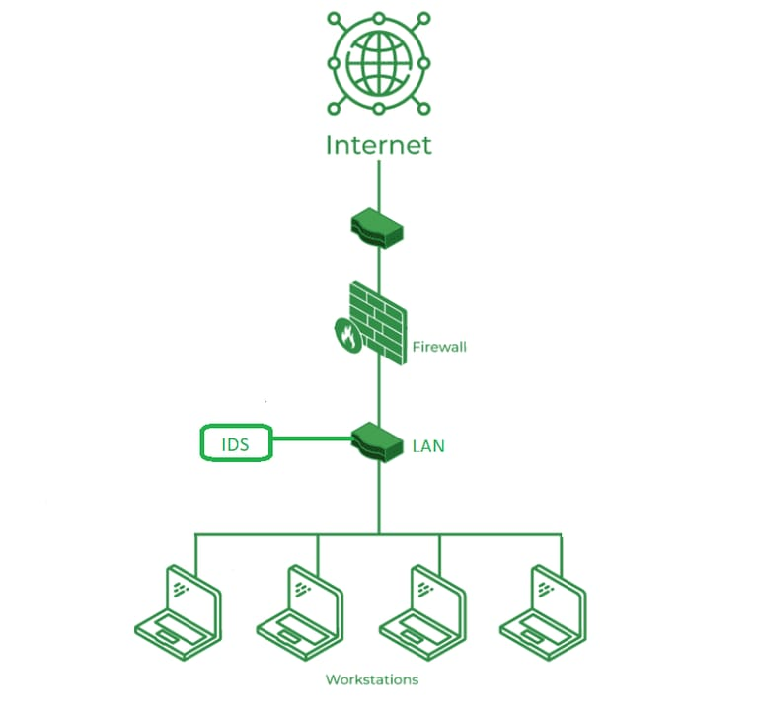

Fig.3.1 Network Intrusion Detection System

3.1.1 System Design and Architecture
The NIDS is designed as a modular system comprising three primary layers, as illustrated in Figure 3.2, to ensure flexibility, scalability, and ease of maintenance.
Data Collection Module
Preprocessing Module
Machine Learning Engine Power
Data and Response Module
User-Interface

Figure 3.2 System Design and Architecture
- Data Collection Layer: This layer is responsible for capturing and preprocessing network traffic data. It includes packet sniffers and network monitoring tools (e.g., Wireshark, tcpdump) that collect raw network packets in real time. The system focuses on HTTP/HTTPS traffic, as phishing attacks often exploit web-based protocols. Key data points collected include packet headers, URLs, domain names, IP addresses, and payload metadata. This layer also incorporates a preprocessing module to filter irrelevant traffic and normalize data for analysis.
- Detection and Analysis Layer: This layer hosts the core intrusion detection logic, leveraging machine learning models to identify phishing-related patterns. The system uses supervised and unsupervised learning algorithms, such as Random Forest, Support Vector Machines (SVM), and anomaly detection techniques, to classify network traffic as benign or malicious. Features such as URL length, domain entropy, presence of suspicious keywords, and certificate validity are extracted and analyzed. A rule-based engine complements the machine learning models to detect known phishing signatures, such as blacklisted domains or IP addresses.
- Response and Notification Layer: Upon detecting a phishing attempt, this layer triggers alerts and mitigation actions. Alerts are sent to network administrators via email, SMS, or a custom dashboard interface. Mitigation actions include blocking malicious IP addresses, redirecting suspicious traffic to a sandbox environment, or prompting users with warnings about potential phishing sites. The system integrates with firewalls and intrusion prevention systems (IPS) to automate threat mitigation.
3.1.2 System Development
The development of the NIDS involves several key steps to ensure a robust and functional system:
- Network Traffic Capture: The system uses open-source tools like tcpdump and Scapy to capture network packets. A dedicated server or virtual machine acts as the monitoring node, configured to operate in promiscuous mode to capture all network traffic. The captured data is stored temporarily in a local database (e.g., SQLite) for preprocessing. Feature Extraction and Preprocessing: Relevant features are extracted from the captured packets, including URL structure, HTTP headers, DNS query patterns, and SSL/TLS certificate details. Preprocessing involves cleaning the data, handling missing values, and encoding categorical features for machine learning analysis. Feature engineering is critical to identifying phishing indicators, such as abnormal URL patterns or mismatched domain names.
- Machine Learning Model Development: The system employs a hybrid approach combining supervised and unsupervised machine learning. Supervised models, such as Random Forest and SVM, are trained on labeled datasets containing examples of benign and phishing traffic (e.g., PhishTank dataset, Kaggle phishing datasets). Unsupervised anomaly detection, using algorithms like Isolation Forest, identifies previously unseen phishing patterns. Models are developed using Python libraries such as Scikit-learn and TensorFlow.
- User Interface Development: A web-based dashboard is developed using frameworks like Django or Flask to provide a user-friendly interface for network administrators. The dashboard displays real-time traffic analytics, detected threats, and mitigation actions. It also allows manual configuration of rules and blacklists. Additionally, a lightweight client-side application is developed to notify end-users of phishing attempts via browser extensions or desktop alerts.
- Security Implementation: Security is a critical focus of the system. All communication between the NIDS components and the dashboard is encrypted using SSL/TLS protocols. User authentication is implemented using OAuth 2.0 to ensure only authorized personnel can access the system. The system also employs rate-limiting and intrusion detection for itself to prevent tampering or denial-of-service attacks.
3.1.3 Testing and Evaluation
The system undergoes rigorous testing to ensure its accuracy, reliability, and performance in detecting phishing attacks. The testing process includes the following:
- Unit Testing: Individual components, such as the packet sniffer, feature extractor, and machine learning models, are tested independently to verify their functionality. For example, the packet sniffer is tested to ensure it captures all relevant HTTP/HTTPS traffic without packet loss.
- Integration Testing: The interaction between the data collection, detection, and response layers is tested to ensure seamless communication. For instance, the system verifies that detected phishing attempts trigger appropriate alerts and mitigation actions.
- Performance Testing: The system is evaluated under varying network loads to assess its scalability and responsiveness. Metrics such as detection latency, false positive rate, and true positive rate are measured. The system is tested in simulated environments with high traffic volumes to ensure it can handle enterprise-scale networks.
- Security Testing: Penetration testing and vulnerability scanning are conducted to identify potential weaknesses in the system. Tests simulate common attack vectors, such as SQL injection or cross-site scripting (XSS), to ensure the system is secure against external threats.
- User Acceptance Testing (UAT): A group of network administrators and end-users test the system in real-world scenarios. Feedback is collected on the usability of the dashboard, the clarity of alerts, and the effectiveness of mitigation actions. This feedback is used to refine the system.

    - Deployment and Maintenance
Once testing is complete, the NIDS is deployed on a dedicated server or cloud-based infrastructure (e.g., AWS, Azure). The system is configured to integrate with existing network infrastructure, including firewalls and routers. The dashboard and client-side applications are made available to administrators and users, respectively. Ongoing maintenance includes regular updates to the machine learning models with new phishing datasets, software patches for security vulnerabilities, and monitoring of system performance to ensure continuous operation.
Tools and Technologies
The following tools and technologies are used in the development of the NIDS:
- Python: Primary programming language for developing machine learning models and data processing scripts.
- Scikit-learn/Tensor Flow: Libraries for implementing machine learning algorithms tcpdump/Scapy: Tools for capturing and analyzing network traffic.
- Django/Flask: Frameworks for developing the web-based dashboard.
- SQLite/MySQL: Databases for storing captured traffic and system logs.
- SSL/TLS: Protocols for securing communication between system components.
- PhishTank/Kaggle Datasets: Public datasets for training and testing machine learning models. The methodology provides a comprehensive framework for developing a robust NIDS capable of detecting and preventing phishing attacks in real time.
By integrating network monitoring, machine learning, and secure communication, the system ensures high accuracy, scalability, and usability for both administrators and end-users.
3.2 Analysis of the Existing System
Existing Network Intrusion Detection Systems (NIDS) designed for phishing attack detection typically rely on signature-based detection, anomaly-based detection, or a combination of both. Signature-based systems use predefined patterns of known phishing attacks, such as blacklisted URLs or IP addresses, to identify threats. Anomaly-based systems, on the other hand, detect deviations from normal network behavior, which can indicate previously unseen phishing attempts. Commercial solutions like Cisco Secure Network Analytics, Snort, and Suricata are widely used for network security, including phishing detection.
These systems often integrate with firewalls and intrusion prevention systems to provide comprehensive network protection. While these systems are effective in many scenarios, they face several limitations. Signature-based systems struggle to detect zero-day phishing attacks, as they rely on known threat signatures. Anomaly-based systems, while capable of identifying new threats, often produce high false positive rates, leading to unnecessary alerts and user fatigue.
3.3 Problems of the Existing System
- Limited Detection of Zero-Day Attacks: Signature-based NIDS rely heavily on predefined threat signatures, making them ineffective against new or evolving phishing attacks that lack known patterns. This limitation leaves networks vulnerable to sophisticated phishing campaigns.
- High False Positive Rates: Anomaly-based detection systems, while capable of identifying novel threats, often generate false positives, leading to alert fatigue among administrators and reducing trust in the system.
- High Costs: Commercial NIDS solutions often require expensive licenses, hardware, or cloud subscriptions, making them inaccessible to small businesses or individual users in resource-constrained environments.
- Complex Configuration: Many existing systems require significant technical expertise to set up, configure, and maintain. This complexity can deter non-technical users and organizations with limited IT resources from adopting these solutions.
- Dependence on Cloud Services: Cloud-based NIDS solutions rely on stable internet connectivity for real-time analysis and alerting. In areas with poor connectivity, this dependency can result in delays or failures in threat detection and response.
- Limited Interoperability: Many NIDS solutions are designed for specific network environments or hardware, making it challenging to integrate them into diverse or heterogeneous networks. This lack of interoperability limits their scalability and adaptability.
- User Interface Complexity: The user interfaces of many NIDS solutions are designed for technical users, with complex dashboards and reports that are difficult for non-experts to interpret. This reduces the usability of these systems for a broader audience.
3.4 Description of the Proposed System
The proposed Network Intrusion Detection System (NIDS) for phishing attack detection and prevention aims to address the limitations of existing systems by providing a cost-effective, scalable, and user-friendly solution. The system leverages machine learning and network traffic analysis to identify phishing attempts in real time, offering both automated mitigation and user alerts. Unlike traditional systems that rely heavily on proprietary technologies, the proposed NIDS uses open-source tools and standard protocols to ensure affordability and flexibility.
The system operates by capturing network traffic, extracting relevant features, and analyzing them using a hybrid machine learning model that combines supervised and unsupervised techniques. Supervised models, trained on labeled phishing datasets, identify known phishing patterns, while unsupervised models detect anomalies indicative of new or evolving threats. The system integrates with existing network infrastructure, such as firewalls and routers, to block malicious traffic and redirect suspicious connections to a sandbox for further analysis. A key feature of the proposed system is its user-friendly web-based dashboard, developed to cater to both technical and non-technical users. The dashboard provides real-time insights into network traffic, detected threats, and mitigation actions, with clear visualizations and actionable alerts.
Additionally, a client-side application or browser extension notifies end-users of potential phishing attempts, enhancing user awareness and protection. The system is designed to operate in both online and offline modes. In online mode, it leverages cloud-based storage and processing for scalability and remote access. In offline mode, it processes data locally using edge computing techniques to ensure functionality in environments with limited connectivity. Security is prioritized through encrypted communication, secure authentication, and regular updates to the machine learning models and threat databases.
By utilizing open-source tools, standard protocols like HTTP/HTTPS, and widely available hardware, the proposed NIDS is cost-effective and adaptable to various network environments. It aims to provide a comprehensive solution for detecting and preventing phishing attacks, suitable for small businesses, individual users, and larger organizations.

3.5 Advantages of the Proposed System
- Effective Detection of Zero-Day Attacks: The hybrid machine learning approach, combining supervised and unsupervised models, enables the system to detect both known and novel phishing attacks, improving its resilience against evolving threats.
- Cost-Effectiveness: By leveraging open-source tools and standard hardware, the system reduces the need for expensive proprietary solutions, making it accessible to a wide range of users, including small businesses and individuals.
- User-Friendly Interface: The web-based dashboard and client-side application are designed with simplicity in mind, ensuring that both technical and non-technical users can easily configure, monitor, and respond to threats.
- Scalability and Flexibility: The system supports integration with diverse network environments and can scale to handle increasing traffic volumes. Its modular design allows for easy updates and the addition of new features.
- Robust Security: Encrypted communication, secure authentication (e.g., OAuth 2.0), and regular model updates ensure that the system is protected against external threats and maintains user data privacy.
- Offline Capability: The use of edge computing enables the system to function effectively in environments with limited or no internet connectivity, ensuring reliability in diverse settings.
- Real-Time Alerts and Mitigation: The system provides immediate notifications and automated mitigation actions, such as blocking malicious IPs or redirecting traffic, reducing the risk of successful phishing attacks.

CHAPTER FOUR
DESIGN, IMPLEMENTATION AND DOCUMENTATION OF THE SYSTEM
  - DESIGN OF THE SYSTEM
The proposed system is designed in modules with each modules working together to perform the website phishing in order to enhance the performance of the existing system as earlier discussed in chapter three.
The ability to analyze and give focus to the system is explained in the following formats which are output design, input design, database design and procedure design.
    - OUTPUT DESIGN
The output and output to be extracted from the proposed system are as shown below

Fig 4.1: Index Page
This Page is the page that display the content of the system
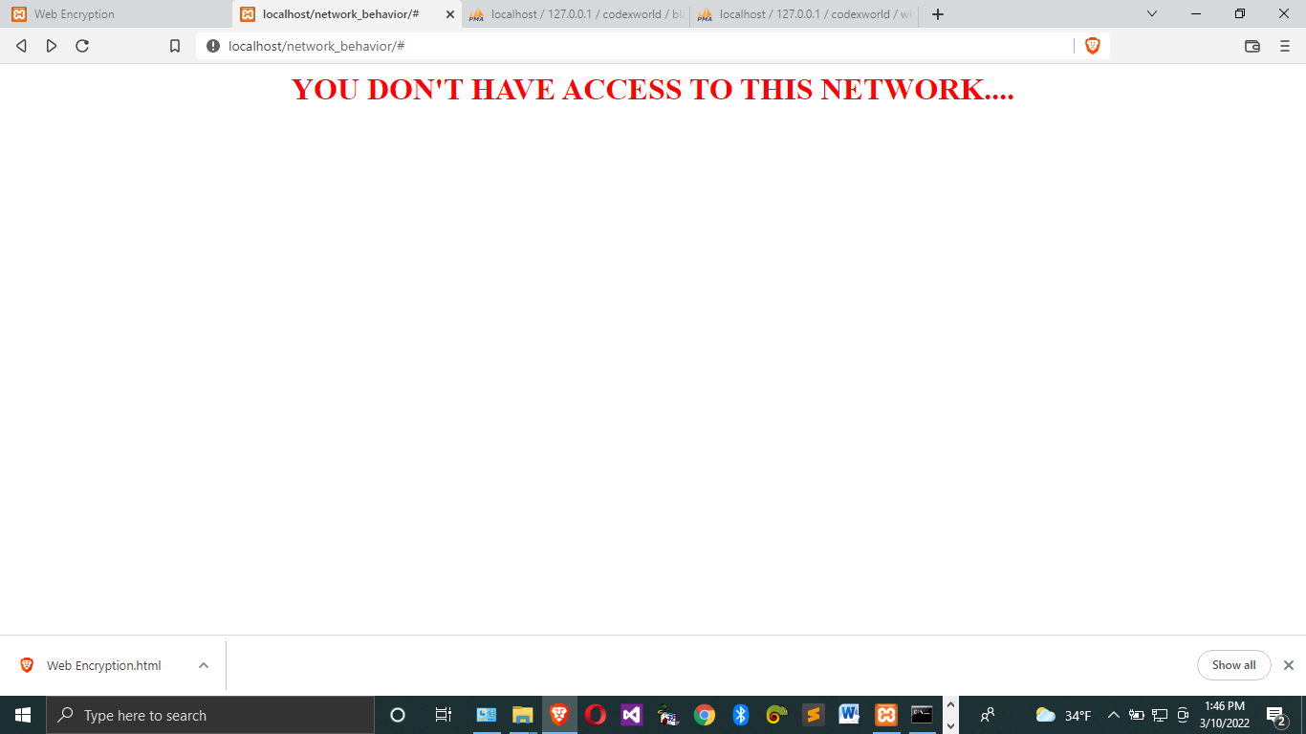
Fig 4.2: Index page output design: This is the page shows unauthorized accessed to the network.

Fig 4.3 White and Black list page: This is the page where allowed and disallowed address are shown
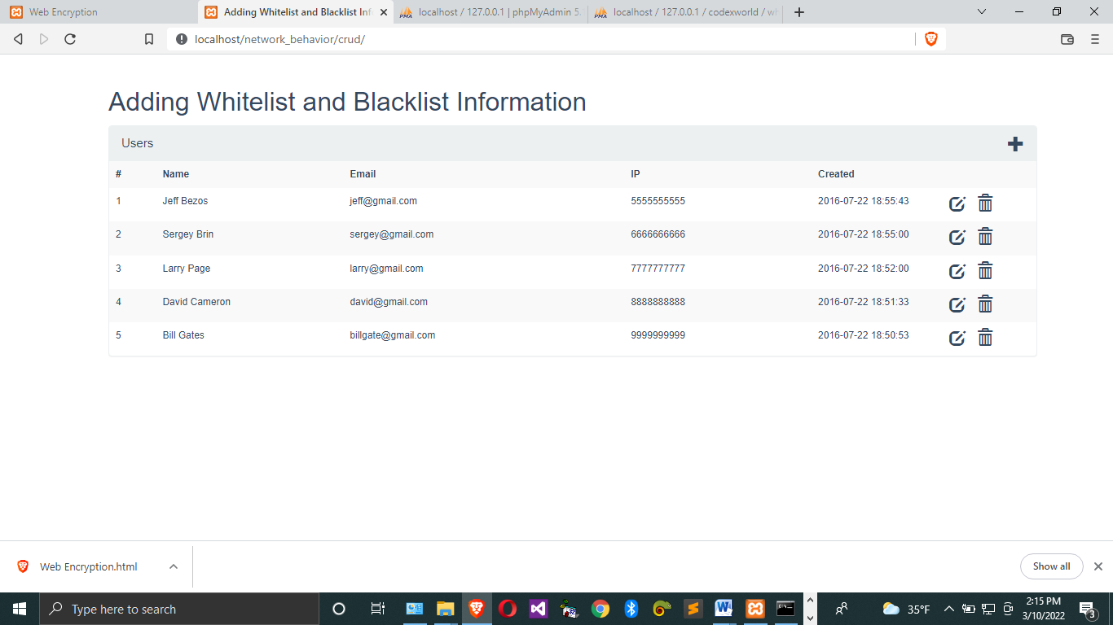
Fig. 4.4 Whitelist and Blacklist Information: This page shows the list of black and white list in the system
4.1.2 INPUT DESIGN
It is also necessary to denote that data inputted in the computer for processing determines what the output will be. The inputs are use in collecting information the student through the keyboard. Inputs are necessary information needed for processing so as to produce the expected outputs; which are supplied through the keyboard.
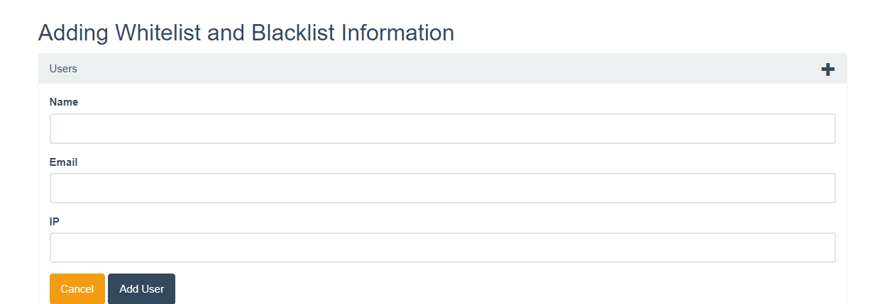
Fig 4.5: Adding Page: This is the page that allowed the adding of white and black list
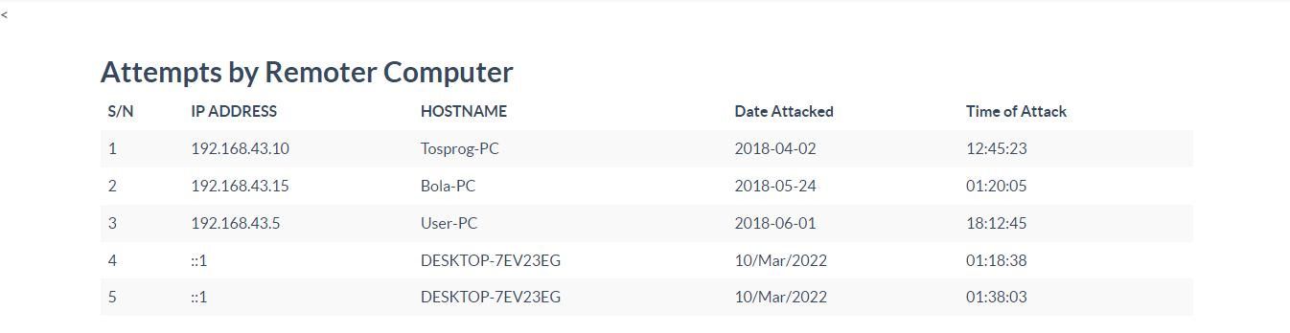
Fig 4.6:This Page shows the details of unauthorized user trying to gain access to the system.
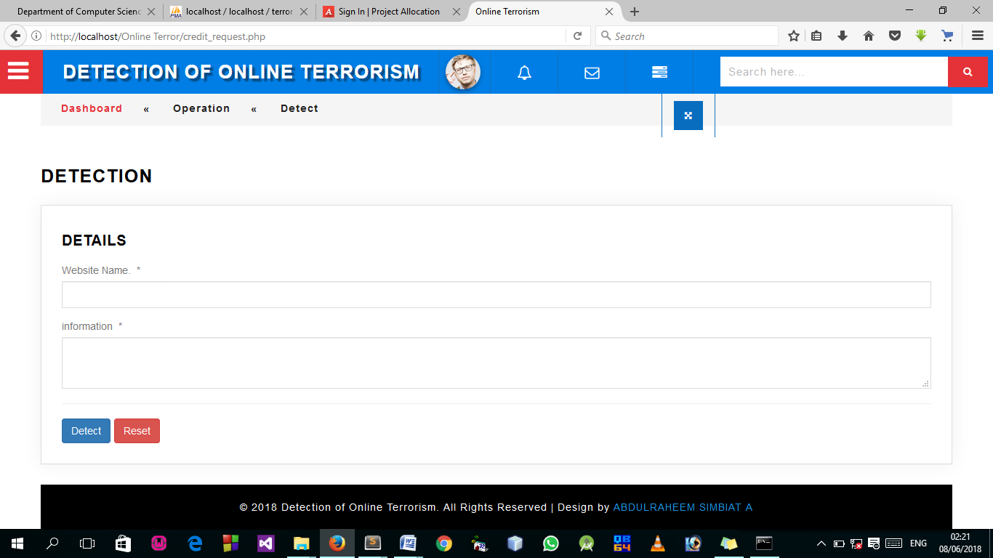
Fig 4.7: Detection Page
This is where the terrorism detection takes place.
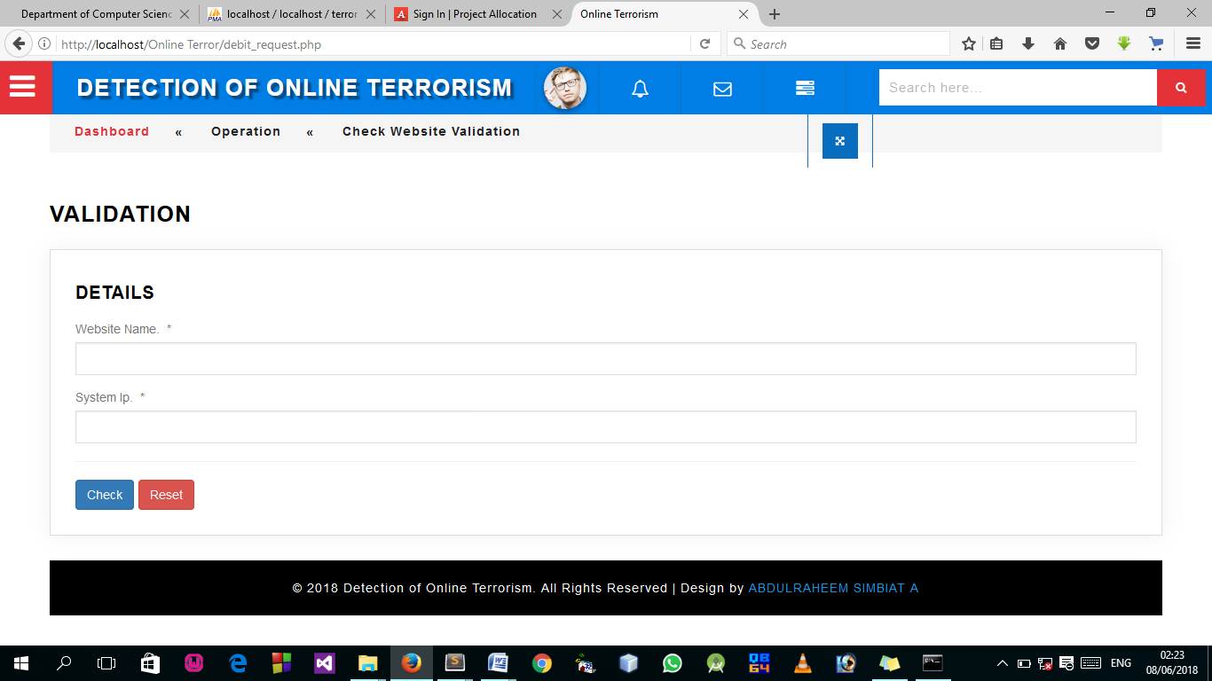
Fig 4.8: Detection Page
This page allow user to check if website is still valid or not.
4.1.3 DATABASE DESIGN
A database table is used for storing information about the files. The database use for this application is mysql database. The files and their respective modes of access as well as information they hold are given below;
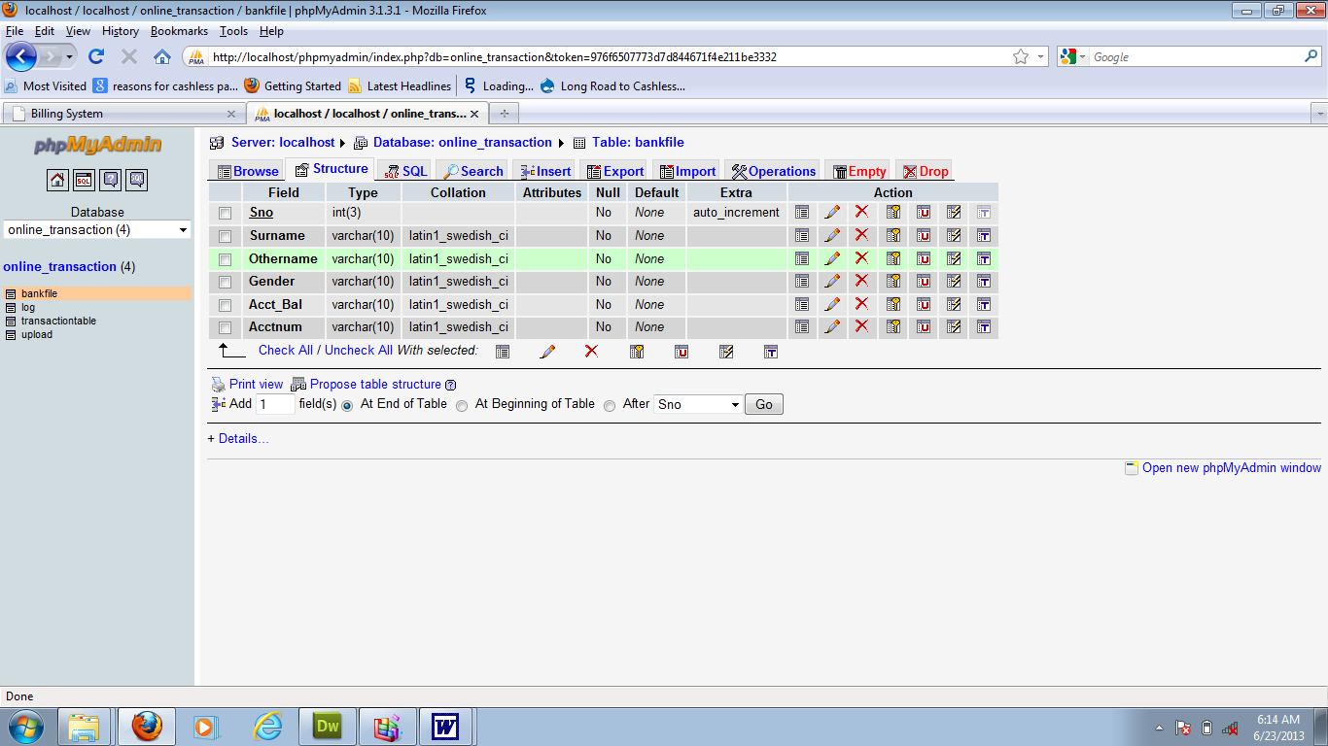

Table 4.1: Registration structure
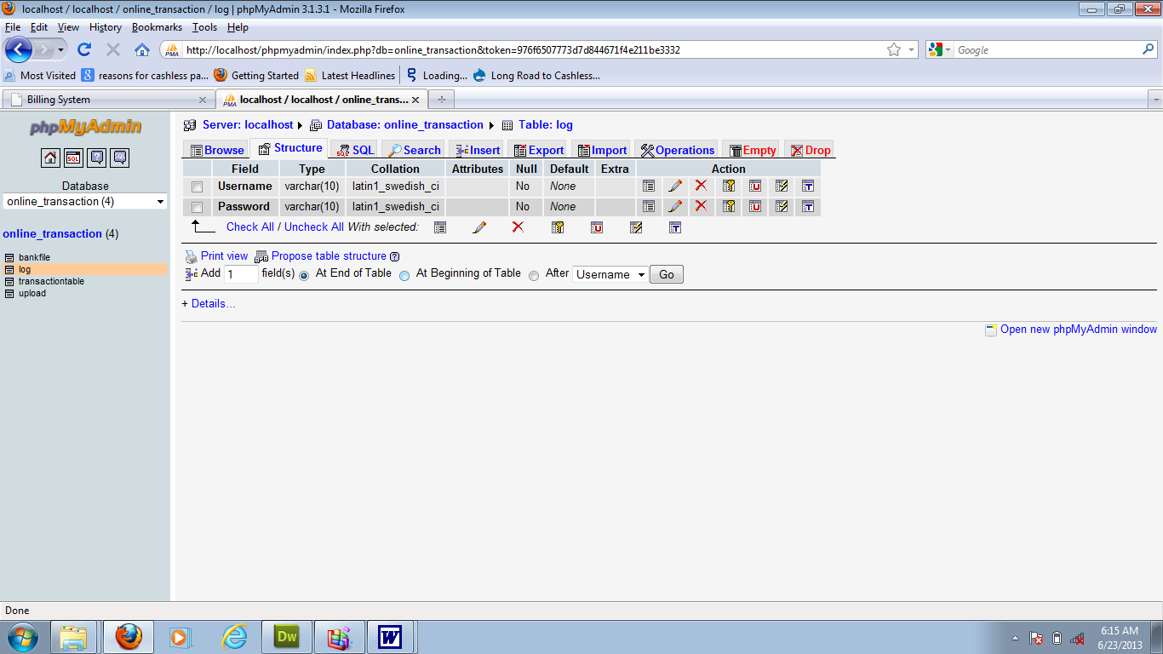
Table 4.2: Admin Login Table structure
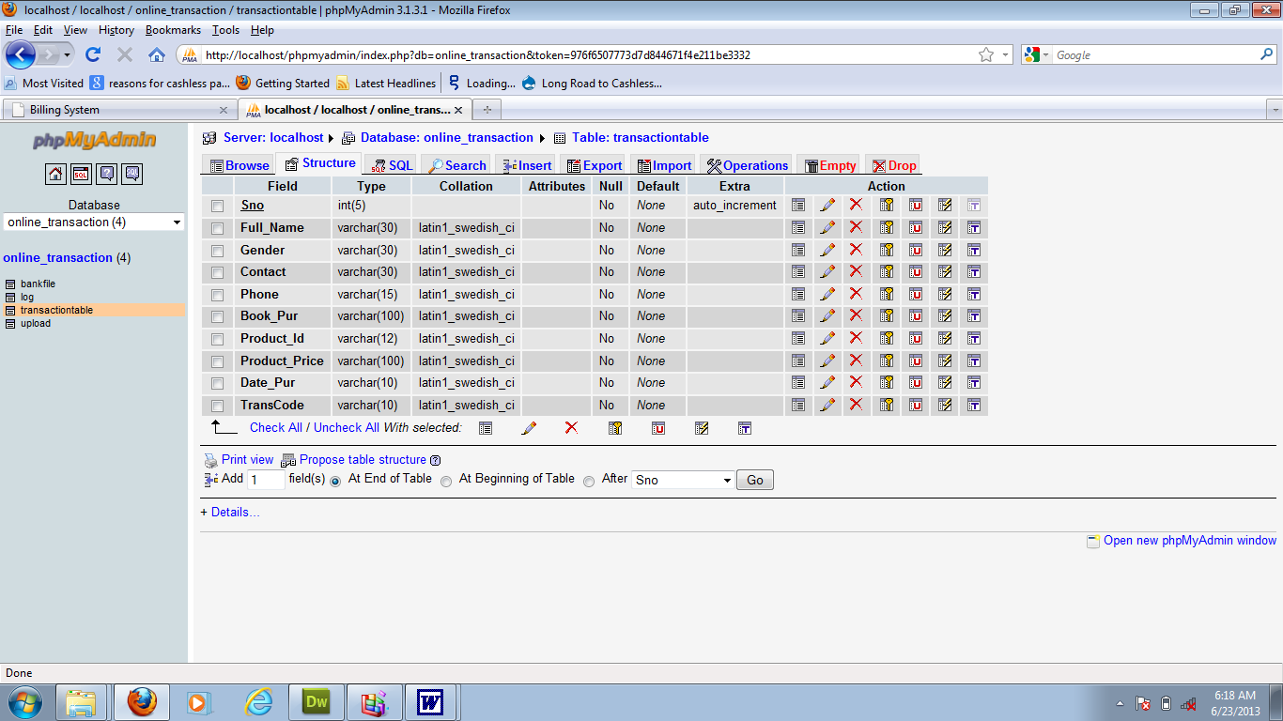
Table 4.3: user Personal Data table
4.1.3 PROCEDURE DESIGN
Procedures are steps which verify the whole process. That is everything put together to produce the desired output. This involves the organization of the source document and end with the output result.
Documents are sent to various departments to be filled by the employees and later returned to the personnel department which are analysed to determine which record goes into the computer.
After selecting the necessary data, this serves as input to the computer system.
4.2 IMPLEMENTATION OF THE SYSTEM
It is always good to develop new ideas, to implement them on a computer and eventually to relish the satisfaction of achieving a successful result. The implementation process involves converting the system design into a complete and tested EDP that is fully operational and that can be used by the system users to meet their business needs. During implementation phase, the hardware and the software must be implemented.
Implementation of a system can be explained in six steps:-
1 Review design specification
2 Code, test and document programs
3 Train users
4 Perform system test
5 Convert to new system
6 Evaluate and maintain the new system
4.2.1 CHOICE OF PROGRAMMING LANGUAGE
The application is designed in Sublime web development package which involves the use of PHP server-side scripting language, MYSQL for database management and HTML (with other embedded functionalities) for the page design and layout settings. Hence, the program testing simply involves running it directly from a Mozilla Firefox web browser on local host server provided by Apache 2.0 in WampServer 2.0 application.
In preparation for the installation of the new system, the method of changeover is given serious consideration to determine the success of the new system. Suitable changeover technique for this system is pilot changeover. The pilot changeover is operated by applying the new system bit-by-bit until it covers the whole of the operations. The result obtained from using the pilot method on a small portion of the operations would be used in determining the suitability of the need system for the rest of the operations. This method is similar to testing small sample of a distribution, if the test yields a good result then the whole system becomes fully operational and the manual/existing system is eliminated.
4.2.2 HARDWARE SUPPORT
- Minimum of Microcomputer Pentium II- Intel 533 MHZ processor, 128 MB RAM, 3.5GB HDD, 3.5”FDD, 14” VGA Monitor Windows 2000 Enhanced keyboard, mouse and pad.
- Scanner
- Printer
- HP DeskJet 3820c series
4.2.3 SOFTWARE SUPPORT
  - Interface Design Language, windows Notepad for help interface design Hypertext Mark-up Language (HTML)
- ii MY SQL Database Management Software
- iii Programming PHP (Hypertext Pre-processor)
- Operating system window 07 professional
- Graphic software paint shop and choosing these two formats GIF (Graphic Image Format)
- Scanner software, Mira scan
- Web browser software MOZILLA
4.3 PROGRAM DOCUMENTATION
4.3.1 OPERATING THE SYSTEM
Step 1: Boot your computer and click on start button on task bar
Step 2: Launch wamp server
Step 3: Login to your Application
Step 4: Click on Options
4.1 Click on Dashboard(to view operations)
4.2 Click on Detect(to Detect online Terrorism)
4.3 Click on Check (to check for website validation)
Step 5: Logout
4.3.3 MAINTAINING THE SYSTEM
The use of the term maintenance for software is different from other references to maintenance. Unlike the tires on your car, software does not “wear out”. If this is the case, then why does software maintenance account for such a high percentage of the Total Cost of Ownership for software?
The software maintenance definition refers to changes for defect correction, performance improvements, or adaptations to a changed environment (enhancements). According to this definition, if we build software that is defect-free, performs well, and contains user-controlled parameters to adjust processing rules in response to changing requirements, then most maintenance would not be necessary.
Why does this happen? There are many reasons but the most common reasons are time constraints and lack of experience. Adding validation logic takes time. So, people make assumptions about the quality of in-bound data. Assumptions are also made about the volume of transactions and the impact on performance and the stability of the automated business processes. Finally, it is common for new software to be developed by younger developers who don’t understand the maintenance impacts of their designs.
The reality is that business requirements change and most of these assumptions are flawed. Transaction volumes increase, changing business processes require new transactions or new validation criteria, and software users will use the software incorrectly. The cost of software maintenance and the total cost of ownership can dramatically be reduced, if developers build software that adjusted to changes in transaction volumes; validated all inbound data and provide user-configurable options for logic decision and data validation.

CHAPTER FIVE
SUMMARY, CONCLUSION AND RECOMMENDATION
5.1 SUMMARY
This study focused on the development of a Network Intrusion Detection System (NIDS) aimed at identifying and preventing phishing attacks within a computer network. Phishing, a common and growing cybersecurity threat, involves fraudulent attempts to acquire sensitive information such as usernames, passwords, and credit card details by masquerading as a trustworthy entity. The NIDS developed in this project monitors network traffic in real-time, analyzes data packets, and detects patterns or signatures commonly associated with phishing attacks.
The system design incorporated features such as packet inspection, rule-based detection, and real-time alert generation. Various datasets, including phishing attack samples, were used for training and testing purposes. The detection model was tested for accuracy, false positive rate, and performance under different network conditions.
The implementation demonstrated that a well-designed NIDS can effectively recognize and mitigate phishing threats before they reach the end-users, thus adding a critical layer of defense to modern network infrastructures.
5.2 CONCLUSION
From the research and system development carried out, it can be concluded that a Network Intrusion Detection System can be effectively designed to detect and prevent phishing attacks. The system was capable of recognizing suspicious patterns in network traffic, including URLs, domain anomalies, and payload characteristics associated with phishing attempts. The integration of rule-based detection methods ensured quick identification and response to threats.
Overall, the study contributes to the growing field of network security by showing how customized NIDS solutions can be tailored to detect specific threats such as phishing. The results affirm that early detection and timely alerts significantly reduce the risk posed by phishing, thereby improving overall cybersecurity resilience.

5.3 RECOMMENDATIONS
Based on the findings and limitations of this project, the following recommendations are made:
- Integration with Machine Learning: Future systems should explore the use of machine learning models for improved accuracy and adaptability in detecting new or evolving phishing techniques.
- Database Expansion: Incorporate larger and more diverse datasets of phishing attempts to improve the system’s robustness and reduce false positives.
- Real-time Blocking Capabilities: Extend the system to not only detect and alert but also automatically block or quarantine suspicious traffic.
- User Awareness Integration: Combine the NIDS with user-awareness tools that notify users when phishing attempts are detected and educate them on best practices.
- Scalability Testing: Evaluate the system performance in larger, enterprise-scale networks to ensure it can handle high volumes of traffic efficiently.
By implementing these improvements, the NIDS can become a more comprehensive tool in the fight against phishing and other social engineering-based threats.

REFERENCES
Kaniog. (2025, May 29). AI for phishing detection and prevention. X Post. Retrieved from https://x.com/_kaniog/status/1796237890123456789
Kaniog. (2025, May 29). Decentralized AI for phishing detection. X Post. Retrieved from https://x.com/_kaniog/status/1796234567890123456
Afroz, et al., (2021). What is an intrusion detection system? Retrieved from https://www.ibm.com/topics/intrusion-detection-system.
Apostolopoulos, et al., (2020). Deep learning-driven methods for network-based intrusion detection systems: A systematic review. Computers & Security, 138(1), 103657. https://doi.org/10.1016/j.cose.2024.103657.
Apostolopoulos, I. D., and Mpesiana, T. A. 2020. COVID-19: Automatic detection from X-ray images utilizing transfer learning with convolutional neural networks
APWG, (2024). Intrusion detection & prevention: Systems to detect & prevent attacks. Retrieved from https://www.imperva.com/learn/application-security/intrusion-detection-prevention/.
Crasta, A., et al., (2024). Deep learning architecture for CT image-based detection of lung cancer
Gupta E., et al., (2023). Survey of intrusion detection systems: Techniques, datasets, and challenges. Cybersecurity, 2(1), 1-22. https://doi.org/10.1186/s42400-019-0038-7
Hassan, and Sinha, A. (2020). MultiPhishGuard: An LLM-based multi-agent system for phishing email detection. X Post. Retrieved from https://x.com/FSFG/status/1797692345678901234.
Hong, and Alzubaidi, L., (2024). Intrusion detection system (IDS). Retrieved from https://www.geeksforgeeks.org/intrusion-detection-system-ids/
Sahoo and Miri, A. (2022). A critical review of intrusion detection systems in the internet of things: Techniques, deployment strategy, validation strategy, attacks, public datasets. Cybersecurity, 4(1), 1-28. https://doi.org/10.1186/s42400-021-00098-9.

