TAXIDERMY OF RABBIT

PRESENTED BY:

ADEWALE IYANUOLUWA TEMITOPE
ND/23/SLT/PT/0136

BEING A PROJECT REPORT SUBMITTED TO THE DEPARTMENT OF SCIENCE LABORATORY TECHNOLOGY, (ENVIRONMENTAL BIOLOGY UNIT) INSTITUTE OF APPLIED SCIENCES (IAS) KWARA STATE POLYTECHNIC, ILORIN.
IN PARTIAL FULFILLMENT OF THE REQUIREMENTS FOR THE AWARD OF THE NATIONAL DIPLOMA (ND) IN SCIENCE LABORATORY TECHNOLOGY.

JUNE, 2025
CERTIFICATION
This is to inform that this project was carried out and reported by ADEWALE IYANUOLUWA TEMITOPE with matric number ND/23/SLT/PT/0136. In the department of science laboratory Technology SLT, institute of applied science (IAS) and has been ready and approved as meeting the reward of National Diploma (ND).

___________________ ___________________
MR ALU, S.O DATE
(Project Supervisor)

___________________ ___________________
MR. LUKMAN, L.A. DATE
(Part Time Coordinator)

___________________ ___________________
DR. ABULKAREEM, USMAN DATE
(Head of Department)

____________________ ____________________
EXRERNAL EXAMINER DATE

DEDICATION
This reach work is solemnly dedicated to Almighty Allah and I also dedicated this project to my lovely parent.

ACKNOWLEDGEMENTS
All praise and gratitude to the Almighty God, the most merciful for bestowing upon me the strong, the knowledge, to embark on this journey and also the opportunity to complete this project with success. His guidance and blessing have been my constant.
I would like to empress my sincere appreciation to my supervisor (Mr. Alu Stephen) for guiding and seeing me through the successful completion project. His expertise, patience and encouragement are worthy of emulation are highly appreciated, may Almighty God continue to bless and assist him throughout his life. I'm deeply grateful to all my lecturers who have contributed to my academic development, their knowledge and insights have enriched my understanding and breaded my perspectives.
To my beloved parents (Mrs. Bunmi Mrs. Toyin and Mr. Rotimi), I extended my heartfelt gratitude for their unwavering support, love, support and prayers. Your sacrifices and guidance have been the foundation of my success, I'm forever indebted to you both. Also I extend my gratitude to my brothers and sisters, I appreciate your presence in my life. I'm also thankful to all my friends for their support, love and encouragement, I'm grateful to you all. May Almighty God bless and reward everyone abundantly that have contributed to my success. (AMEN).

TABLE OF CONTENTS
Title Page i
Certification ii
Dedication iii
Acknowledgements iv
Table of contents vi
Abstract viii
Chapter One
Introduction 1
Chapter Two
Materials and Methods 4
Chapter Three
Result 14
Chapter Four
Discussion 16
Conclusion 16
References 17

ABSTRACT
Despite Bangladesh being a small country on the world map, its wildlife, especially mammals, is highly diverse. Sometimes, due to road accidents, wild animals are killed. Additionally, the people of Bangladesh keep many domestic or exotic mammals like cats, dogs, rats, guinea pigs, and rabbits. If these animals die, the owners usually them. These animals, instead of being buried, could become more useful as taxidermied specimens. Road killed animals could be useful as well because data on habitat and their freshly killed condition can be excellent material in the museum. Until recently, Bangladesh has had a dearth of taxidermists. So now this scientific sector has a great demand for displaying many endangered or nearly extinct wild species as well as more common taxa. Zoos, veterinary hospitals and animal keepers are able to supply dead animals to authorized taxidermists. For mounting mammals in a laboratory, very few instruments and chemicals are required and all are available in Bangladesh. After fresh skinning, borax powder treatment or tanning with alcohol (overnight or 2-4 hours) followed finis powder (insecticide) is adequate to finalize a taxidermied animal. Moreover, small or medium-sized mammals are excellent subjects for taxidermy because they require only 1-3 days for completion. Knowledge about wildlife and their habitats with artistic creations could ensure life-like postures in dioramas.
Key words: Wildlife, taxidermy, conservation, mammal, Bangladesh.

CHAPTER ONE
INTRODUCTION
The art of skin preservation or tanning originated from cave dwelling human beings during the Palaeolithic Age. Egyptians, Indians, Babylonians and Chinese were expert taxidermists. On a 4000 year old sculpture in the Berlin museum there is a depiction of a man removing a tiger's skin while standing beside a bowl. From this depiction, it is clear that taxidermy was somewhat advanced even at that time. Ancient Egyptians preserved pet dogs, cats and birds of deceased people by applying many rare oils and spices. It has been recorded that in 500 BC a Carthasian sailor travelled to his own country Carthase (Spain) with an African gorilla after cleaning its flesh and filling its body with an unknown substance or substances. Some days after the sailor’s arrival, a dangerous fire erupted at Carthase and the gorilla was unfortunately destroyed by the flames. Hence the exact procedure of the mounting of the gorilla by the sailor is unknown. During the middle of the nineteenth century in Europe, America, France and Spain, the practice of taxidermy was enhanced by the invention of many new methods. “The Society of American Taxidermy”, established in 1880, was the first taxidermy club in the world. The “Father of Taxidermy”, Carl Akeley (1864-1926) applied a new method which was called 'Paper Mache' for the formation of the artificial animal body (Mondol & Khan, 2007).
Mammals are one of the groups of vertebrates which are most commonly preferred by taxidermists. They are a very diverse group of vertebrates which differ greatly in shape, size and texture. Their preparation techniques also differ greatly from species to species. Taxidermy is an advanced form of art in the preservation and restoration of dead specimens for long-term storage and display. A taxidermist needs to be both an artist as well as having an excellent knowledge about the morphology and anatomy of diverse species. Taxidermy represents very enduring work for the taxidermist because he/she must have patience to deal with the methodology in order to produce a fine end-product. It is important to have sufficient knowledge about theoretical aspects of undertaking science before undertaking the practical aspect. IUCN Bangladesh (2015) has declared 12 endangered mammalian species. If these animals die, it is possible to preserve them taxidermically when specimens become available. Some artists have called themselves the “Minnesota Association of Rogue Taxidermists” and they are dedicated to exploring the artistic possibilities of stuffing and mounting animals (Tipcik, 2005). Taxidermists are sometimes magicians in some respects, viz. they show people some “cool stuff”, but they do not always want to reveal how this is accomplished (www.wildlife.state.nh.us). There are some organizations which supply many taxidermy products such as total bodies, heads, noses, ears, eyes, etc. (www.selecttaxidermy.com). Natural bird models produced through taxidermy can fill this vacuum by better reaching and educating people (Basu & Zandi, 2015). The protection of nature and the rapid extinction of species has increased the value of museum collections for researchers and for society in general (Payne & Sorenson, 2003; Suarez & Tsutsui, 2004). From the very beginning, taxidermy continued to represent the assertion of human dominance over the natural world accordingly (www.academia.edu).
If any person shall engage in the business of taxidermy within the State of Illinois, they must first procure a license from the Department of Natural Resources. The annual fee for a state taxidermy license is $25.00. Illinois taxidermy licenses expire on January 31st of each year (www.illinois.gov). There are four pillars of conservation, namely ethical, aesthetic, scientific and economic (www.nmnh.nic.in). During 1967, Dr Salim Ali (2004) (the “Birdman of India”) performed taxidermy with Mary and Dillon Ripley under “Alfresco Taxidermy”. In Bangladesh, the practice of taxidermy has had excellent commercial and scientific impacts as a whole (Kabir & Hawkeswood, 2020). The objective of this study is to introduce the term “mammalian mounting” and how this can be practically undertaken.

CHAPTER TWO
MATERIALS AND METHODS
Equipment list for mammalian taxidermy: The following instruments can be used for mammal taxidermy (Table 1). Taxidermists also have access to commercial suppliers who trade in mass quantities of all kinds of strange products such as artificial eyes, noses, tongues, mouths and ears (www.wildnh.com).
Photography and body sketching: Taking suitable photographs can assist the taxidermist for providing a life-like posture and correct colour of such species. Taxidermy does not support the taxidermy of living mammals which are deliberately killed for the purposes of taxidermy (see also below). After detaching the body, a suitable sketch should be drawn in a notebook. This sketch will assist in defining the artificial body of the specimen. Then the sketch needs to highlight the joints of the forelimbs and hind limbs. If this could not be undertaken accurately it will create difficulties later when the limbs are to be attached to the artificial body. The shape of the limb muscles of the limb can next be drawn in order to facilitate the preparation of artificial limb muscles in the taxidermic specimen. The photographs and taxidermy comprising Bryndis Snaebjornsdottir and Mark Wilson’s quest to locate and photograph every mounted polar bear in Great Britain, resulted in a three-year journey which unearthed 34 bears (Poliquin, 2008).
Dead animals: For the purpose of taxidermy, only dead animals are allowed (either domestic or wild) (i.e. not deliberately killed specimens).
Measurements
Digital slide calipers should be used for measuring total length, tail length, the length between two eyes and length between the tip of the nose to mid of the eye, ear length, foot length and eye size (Figs. 1-2).
Table 1. Equipment for skinning and their uses in mammalian taxidermy.
Equipment Uses
Fridge Preservation, refrigeration
Drill Grinding machine Sharpening the object
Drill machine To make holes in base
Hair dryer and dust dryer Drying feathers and fur
Pliers Cutting wires
Hammers Striking, flattening, etc.
Knife Cutting
Thread Stitching
Forceps Holding
Scissors Cutting
Slide calipers Measurement
Beaker Store liquids
Measuring Measurements
Cotton, mud Placing inside specimens
Wood wool/straw Model
Plastic mug Pouring
GI(Galvanized iron) wire Posturing
Plastic bucket (20 L) Storing
Polybags Storing
Wood file Finishing
Water sprayer Spraying
Glue gun/super glue/powder glue Ligation
Saw dust Water soaking from skin
Syringe and Needle Pushing chemicals within the body
Screw Staging, securing mounts, etc.
Scalpel Cutting skin
Acrylic colours/ Colouring of the model/
Paint brushes Colouring
Wood/plywood/branches/artificial plants Natural habitat
Plastic marbles Artificial eyes

Skinning
Skinning is the first and foremost operational stage. Some theoretical knowledge is required before starting this process. It is very enduring work and requires much practice in skinning because mammalian skin possesses more fat than birds. Before starting skinning, some primary and precautionary steps should be followed. A dissecting box with sufficient kits/gear is the first requirement. Other necessary kits may include paint-brushes/air-brushes, plastic vials, polybags (normal and zipper), cotton, formalin and alcohol. Generally, skinning will begin from the ventral side of the body, starting from the mid of the rib-cage and ending 3 cm prior to the anus. Then the hind limbs will be cut from the joint of the pelvic girdle and femur. In the case of a tailed animal, the tail skin should be removed with special care. The humerus needs to be separated from the pectoral girdle. Then skinning will move very carefully towards the head; this skinning must be undertaken gently. Then the skin of the ears should be separated from the base. The skin around the eyes should be separated with special concern. After reaching the nose tip, skinning will cease and skin should now be completely detached from the body. During skinning, borax water can be used for maintaining skin moisture.
Table 2. Summary of chemicals and their uses in mammalian taxidermy.
Chemical name Uses
70% Alcohol/ ethyl alcohol/ ethanol/ Preservatives
Isopropyl alcohol
Formalin Preservatives
Borax powder Insecticide, Antifungal
Alginate Casting
Plaster of paris Template
Resin Model
Hardener Make resin harder
Fiberglass Model

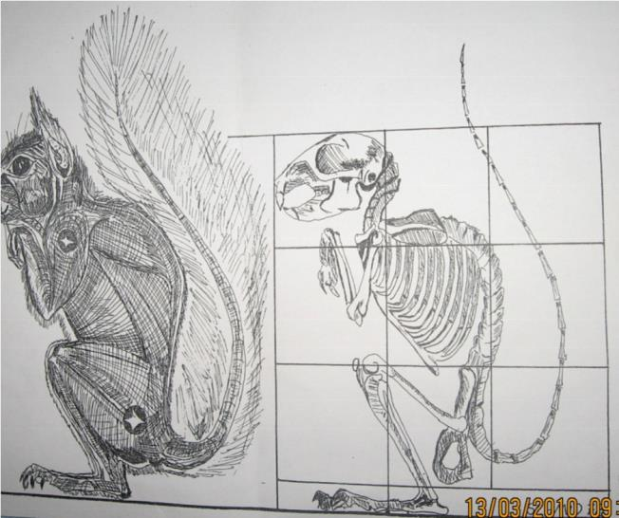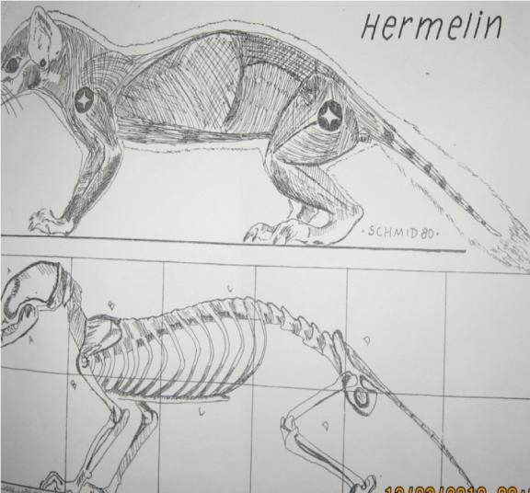
Fig. 1. Standing posture Fig. 2. Walking posture
Skin Cleansing
Skin cleansing is the most important part of taxidermy. Cleansing needs to be undertaken very carefully otherwise it can cause damage to skin. All fats, muscles and other debris attached to the skin should be removed with care. The ears, lips and base of the whiskers must be unfolded. Washing the skin carefully and scientifically, increases the longevity of the specimen and protects the skin from bacterial/fungal attack. Washing is undertaken step-wise and is a day-long process.
1st Step: This involves washing with cold water and NaCl2 (this cleansing washes the blood and prevents fur from falling). Pure NaCl2 should be used because it has better activity. The amount of NaCl2 required is 10g/L of water. The skin should be washed from the outside with care to wash each of the inner corners with the salt solution. Washing time is 10 minutes approximately; it should be noted that skin always moves during washing.
2nd step: This involves washing with normal water, hot water (45˚C to 55˚C), supralan (liquid soap) and detergent (washing powder). Cleansing by normal water is first taken for this step, then hot water, detergent and supralan should be mixed to create a foaming environment. Lastly, the skin is soaked in water for the next 30 minutes.
Gene-Data
A small piece of muscle can be preserved in the 70% alcohol (Table 2) for later DNA analysis of the specimen. The body should be preserved in a refrigerator covered with a polybag for further processing.
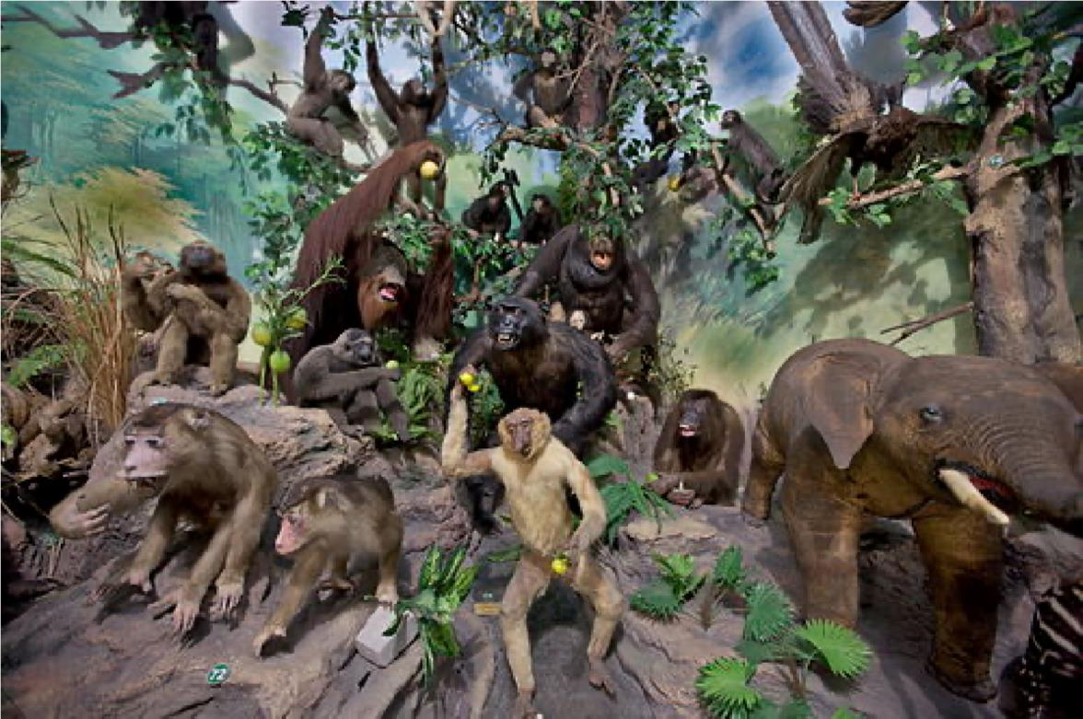
Fig. 3. Examples of primate and pachyderm taxidermy at Rahmat International Wildlife Museum and Gallery, Medan, Sumatra, Indonesia. (from Wikipedia, 2021a).
Head Cleansing
Before cleansing, the head needs to be photographed from different angles in order to determine the later proper placement of artificial muscles. The head, head muscles and brain must be cleaned thoroughly. The brain compartments should be cleansed with cotton. The lower mandible can be removed from the head for cleansing and later attached with super-glue.
Skin Drying
For drying the mammalian skin, a hairdryer can be omitted. In this case, wood dust is excellent for extracting water from the skin. After completing this stage, dust can be removed by using a dryer. It should be mentioned that skin should not be desiccated for a long time, otherwise, it could shrink or crimple and therefore suffer damage.
Artificial Body Making
Wood wool, jute fibre or straw can be used in constructing an artificial body of a particular animal which has been drawn on paper. Limb joints, head joints and the tail region should be highlighted at this step.
Preparing the Head
1st step: Preparing the mud and glue mixture.
2nd step: Preparing a wire of approximate size (depending on the specimen).
3rd step: Placing the wire (Table 1) from the top of the ear base of the left to right side of the head or vice-versa. Then the wire should be spirally bent with pliers. A U-shaped wire placed through the head-vertebral joint and then a mud-glue mixture is placed into the brain compartment and is left for few hours until it becomes hard.
4th step: Attaching mud-glue mixture with head, according to photographs. This should be of the same shape and size as the original head, otherwise it can cause problems during skin placement.
Setting Artificial Eyes
Clay is used to install glass eyes. At first, the glue-mud mixture is poured into the orbital fossa. Then the eyes are set on both sides of the head. After setting the eyes, the distance between the two eyes and the distance between the eyes to the nose tip should be checked. If it is not placed as measured, then it may not be possible to place the skin in the correct place. If commercial eyes are not available, taxidermists can cast their own forms.
Measurement of Wires and Artificial Body Setting
Before setting the wires (Table 1) it is important to choose the correct size and thickness of the wire. The wire used to construct the tail and limbs will not be the same in thickness and size. The wire should be 5 to 15 cm longer than the original size of the tail, limbs, etc. Both ends of the wire should be pointed as a needle, because this assists in placing the wire into the body.
Tail: Tail length + 5 cm.
Hindlimb: Original length + 15 cm.
Forelimb: Original length + 10 cm.
Firstly, the head is set to the body applying a mud and glue mixture or plastic glue. Secondly, an antibacterial/anti-fungal solution should be used inside the skin using a paint-brush. Thirdly, the limbs/tail wires are attached through the points of the limb joints.
After setting the wires they need to be tightly bent. After setting all wires in the body, the skin needs to be placed correctly. The skin can be manipulated with forceps and hands. If somewhere inside the body any shortage of muscle occurs, then the body must be filled with either cotton or wood wool or sawdust.
Sewing Techniques
Finally, sewing should be undertaken carefully otherwise the skin may not set in the correct position after closing.
Fixing specimen on a platform and finishing
The final task entails the specimen on a platform. In the case of a flat platform, at first four points should be indicated accurately then the required holes can be drilled using an electric/cordless drill machine (Table 1). The extended wires of the limbs are then threaded through the holes and bent at the required angle. Wherever possible, the fore and hind limbs should be bent in opposite directions for better placement (especially for large standing specimens). Lastly, for mammals it is required to pour formalin-water solution (1:1) carefully inside the feet. After the mammal is fixed on the platform, it should be placed in a fumigation chamber for 7-15 days. The real habitat (diorama) of the mounted animal must also be created, to complete the picture of its existence (see examples Figs. 3-5). Needless to say, this step requires extensive knowledge and knowledge of animal ecology. Great design, natural habitats and authentic poses always allow the mounts to relate a particular story (see Figs. 3-5). The end result will be an original piece of wildlife art design. Each habitat will have been individually designed to reflect attitude and behaviour as well as to enhance the mount's best features (Figs. 3-5).
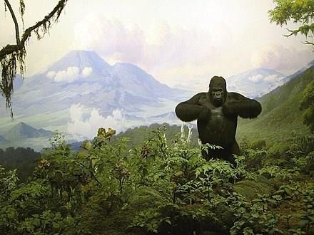
Fig. 4. Gorilla diorama in the American Museum of Natural History (from Wikipedia, 2021b).

CHAPTER THREE
RESULTS
At the time of skinning, the opposite side of the animal should be covered in order to maintain moisture. This time borax powder and water can be used for maintaining skin moisture. Semiprepared skins should be stored at 15°C in normal and 4°C in the deep portion of a refrigerator. Two hours is sufficient to allow working on them again. After removing the skin from the refrigerator, sawdust should be applied, then a wait for 2 hours, then blowing or air exposure will be adequate for softening the skin.
Since the moisture of the environment is high in Bangladesh, there are higher possibilities of taxidermied animals being infected by micro-organisms. The larvae of certain Coleoptera (e.g. Dermestidae) devour feathers and other tissues; the hair and skins of stuffed animals attacked by such beetles have been so severely infested, that the animals became featherless or hairless and were ultimately destroyed (Hasan et al., 2007). For any posturing, at first, a wireframe needs to be constructed in order to allow flexibility in posture for display. Some wild animals, especially rats, carry many pathogenic micro-organisms so there is a need for special care during mounting and preparation. Domestic animals have more fat content, so by using a fleshing knife, this fat can be properly removed from the skin. Within three days of work, the taxidermy of a single organism can be completed. Wood wool is better than cotton because this can be moulded in any shape easily, especially any flat shapes such as the thigh muscle. The orbital region and gullet should be completely filled by modelling clay, glue and sawdust. Thymol, formalin, and acetone are health hazards chemicals; these chemicals can be discarded and alternative ones used.
Modern technologies are now being adopted in taxidermy. It is necessary for all measurements pertaining to these dead animals to be recorded and retained (Hossain, 2016). Some bird and mammal specimens in North American collections have been damaged by rodents or insect pests such as clothes moths and dermestid beetles (Conserve O Gram, 2006). Browne (1896) was the first taxidermist to describe different methods of skinning and mounting birds. Hormann (1931) described various steps in the collection of birds, care of specimen tools/implements, preservation paste, skinning and especially fat removal. For that purpose, taxidermists utilize skinning, tanning, stuffing and mounting techniques which are completely different from mummification (Pequignot, 2002).
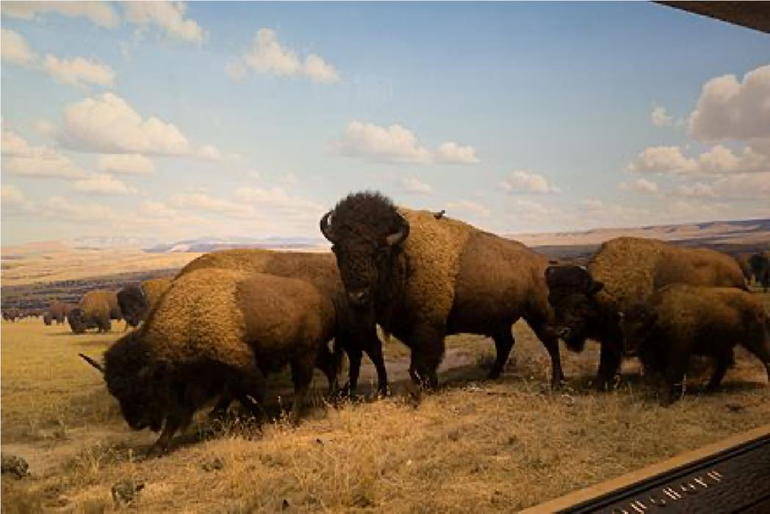
Fig. 5. Bison diorama, American Museum of Natural History (from Wikipedia, 2021c).

CHAPTER FOUR
DISCUSSION AND CONCLUSIONS
Each taxidermist adopts a preferred methodology; in addition, taxidermists often change their practices during their life-time (Pequignot, 2006). Of various preservation techniques, taxidermy is the best because through this methodology, the whole animal is able to be studied well over a long time period due to being preserved and therefore not being wasted after death. For stitching up small mammals such as microbats, taxidermic methodology is excellent; 3% formalin can be used on the lips, nose and feet (Koch, 2006). Specimen trays provide a convenient way to sort specimens by sex, locality, species, or subspecies (Conserve O Gram, 2006). All materials should be “Archival or Museum Quality”, a term connotating permanence and durability but for which there is no universally agreed-upon meaning (Cato et al., 2003). The cranium and mandible of the skull should not be stored with the teeth in direct contact because this can cause breakage of the teeth (Conserve O Gram, 2006).
If taxidermy’s value has been questioned within museums, animals have emerged as an edgy medium for contemporary artists. Contemporary animal studies, particularly aesthetic and philosophical discussions of taxidermy within art galleries, have something to offer museum studies (Poliquin, 2008). The ‘aesthetic of livingness’ challenges accepted animal-human relations and disrupts any possibility of a self-contained aesthetic, where the animal would be simply an art object “out three” in the gallery space (Burt, 2008). There is therefore a need to determine or describe the habitat of an animal, for then this we can know the exact information about the ecology and life of the animals (see Figs. 3-5). But this taxidermic knowledge should confine itself to only the displays in the museum and researches on animals. Otherwise, in the near future, wildlife hunters may apply this knowledge commercially and exploit to destroy the animal kingdom about which we may not be able do anything but regret (Mondol & Khan, 2007).
Conclusions
Innumerable animals die every year due to natural calamities or other causes in Bangladesh. Most of those dead animals are simply buried. Sometimes, when those skins are removed from them, little is accomplished except to utilize them like normal skin for clothes, hats and the like. However, it is possible to earn much foreign currency by making exact replicas or dry preservations of those dead animals with the assistance of taxidermy. Apart from that, in all Bangladesh educational institutions (school-college-university) where Zoology, Environmental Science and Ecology subjects are taught, there is an alarming lack of standard mounted animals. Therefore, it is also important to preserve animal samples for biodiversity research and teaching in Bangladesh.

REFERENCE
Ali, S. (2004). The Fall of a Sparrow. Oxford University Press, New Delhi. 265 pp. Association of Rogue Taxidermy (MART). Minnesota. (Retrieved November 6, 2011).
Basu, S. K. & Zandi, P. (2015). Taxidermy as an important tool in bird education, awareness and conservation. (www_birds_com_blog_taxidermy-as-an-important-tool-in-bird-educationawareness-and.pdf) (Accessed: 1 January 2021).
Browne, M. (1896). Artistic and Scientific Taxidermy and Modelling. Adams and Charles Black, London.
Burt, J. (2008). The aesthetics of livingness. Antennae, 5: 4-11.
Cato, P. S., Golden, J. & McLaren, S. B. (compilers and eds.). (2003). Museum Wise: Workplace Words Defined. Society for the Preservation of Natural History Collections, Washington, D.C.
Conserve O Gram. (2006). Handling and care of dry bird and mammal specimens. National Park Service, 11/9. 1-5.
Taxidermy_displays_and_the_construction_of_nature_From_the_Akeley_Hall_of_Mammals_to _Guy_the_gorilla [Accessed 20 December 2020].
Hasan, M.A., Hossain, M.D., Hasan, M.M. & Rahman, M.S. (2007). A pest of stuffed museum specimen Anthrenus scrophulariae (L.) (Coleoptera: Dermestidae). University Journal of Zoology, Rajshahi University, 26: 99-102.
Hormann, M.J. (1931). Taxidermy Lessons. The Blue Beaver Taxidermy School, Brooklyn.
Hossain, M.D. (2016). Modern Technologies in Taxidermy (in Bangla). Publisher Md. Delwar Hossain. 133 pp. How’d they do that (www.wildlife.state.nh.us).
Illinois Taxidermy Laws (2014). Illinois Department of Natural Resources. Office of Law Enforcement, May 2014 (https://www2.illinois.gov/dnr/LawEnforcement/Documents/TaxidermyHandbook.pdf).
IUCN Bangladesh. (2015). Red List of Bangladesh, 2 volume: Mammals. 250 pp.
Kabir, A. & Hawkeswood, T.J. (2020). A review on wildlife taxidermy: preservation for conservation. Calodema, 845: 1-8.
Koch, B. (2006). No fear of mounting small or micro-mammals. Breakthrough Magazine, (85): 61-69.
Mondol, N. & Khan, S.I. (2007). Taxidermy and preservation of dead birds in the National Museum (in Bangla). Newsletter July-September 22-26.
National Museum of Natural History. A brief guide, Ministry of Environment and Forests, FICCI Museum Building, Tansen, Marg, New Delhi- 110001 (www.nmnh.nic.in)
Payne, R.B. & Sorenson, M.D. (2003). Museum collections as sources of genetic data. Bonner Zoologische Beitrage, 51: 97-104.
Pequignot, A. (2002). Histoire de la Taxidermie en France de 1729-1928. Etude des facteurs deses evolutions techniques et conceptuelles et ses relations a la mise en exposition du specimen naturalise. PhD dissertation, Paris: Museum National d’ Histoire Naturelle.
Pequignot, A. (2006). The history of taxidermy: clues for preservation. A Journal for Museum and Archives Professionals, 2(3): 245-255.
Poliquin, R. (2008). The matter and meaning of taxidermy. Massachusetts Institute of Technology, Cambridge, Massachusetts, 6(2): 123-134 Select Taxidermy Products Ltd, 2015/2016 (www.selecttaxidermy.com).
Suarez, A.V. & Tsutsui, N.D. (2004). The value of museum collections for research and society. BioScience, 51(1): 66-74.
Topcik, J. (2005). "Head of Goat, Tail of Fish, More Than a Touch of Weirdness". The New York Times. January 3, Page 2.
Wikipedia (2021a). Taxidermy. (https://en.wikipedia.org/wiki/Taxidermy). (Accessed 25 January 2021).
Wikipedia (2021b). Carl Akeley. (https://en.wikipedia.org/wiki/Carl_Akeley). (Accessed 25 January 2021). Wikipedia (2021c). Conservation and restoration of taxidermy. (https://en.wikipedia.org/wiki/ Conservation_and_restoration_of_taxidermy). (Accessed 25 January 2021). www.wildnh.com/pubs/wj-magazine.html [Accessed 20 December 2020]. Date of publication: 20 January 2021 Copyright:
Kabir, A. M. Rani Das & T.J. Hawkeswood Editor: Dr T.J. Hawkeswood (drtjhawkeswood@gmail.com) PO Box 842, Richmond, New South Wales, Australia, 2753 (Published as hard paper copy edition as well as electronic pdf )

