DEVELOPMENT OF CHATBOT BASED ADMISSION ENQUIRY SYSTEM USING DIALOG FLOW ALGORITHM
BY
ADEMOLA HABEEB ADEBAYO
HND/23/COM/FT/0029

A Project Submitted to the Department of Computer Science, Institute of Information and Communication Technology, Kwara State Polytechnic, Ilorin

In Partial Fulfillment of the Requirements for the Award of HIGHER National Diploma (HND) in Computer Science

June, 2025
CERTIFICATION
This is to certify that this project was carried out by ADEMOLA, Habeeb Adebayo with matric number HND/23/COM/FT/0029, has part of the requirements for the award of Higher National Diploma (HND) in Computer Science.

………………………………. ……………………………….
Mr Saka T.O. Date
(Project Supervisor)

………………………………. ……………………………….
Mr. Oyedepo, F. S. Date
(Head of Department)

………………………………. ……………………………….
External Examiner Date

DEDICATION
This project is dedicated to the creator of the earth and universe, the Almighty God. It is also dedicated to my parents for their moral and financial support.

ACKNOWLEDGEMENT
All praise is due to the Almighty God the Lord of the universe. I praise Him and thank Him for giving me the strength and knowledge to complete my HND programme and also for my continue existence on the earth.
I appreciate the utmost effort of my supervisor, Mr. Saka T.O., whose patience support and encouragement have been the driving force behind the success of this research work. He gave useful corrections, constructive criticisms, comments, recommendations, advice and always ensures that an excellent research is done. My sincere gratitude goes to the Head of the Department and other members of staff of the Department of Computer Science, Kwara State Polytechnic, Ilorin, for their constant cooperation, constructive criticisms and encouragements throughout the programme.
Special gratitude to my parents who exhibited immeasurable financial, patience, support, prayers and understanding during the periods in which I was busy tirelessly in my studies. Special thanks go to all my lovely siblings.
My sincere appreciation goes to my friends and classmates.

TABLE OF CONTENTS
Title Page
Certification
Dedication
Acknowledgements
Abstract
Table of Contents
CHAPTER ONE: INTRODUCTION
  - Background to the Study
  - Statement of the Problem
  - Aim and Objectives of the Study
  - Significance of the Study
  - Scope of the Study
  - Organization of the Report
CHAPTER TWO: LITERATURE REVIEW
2.1 Review of Related Works
2.1 Review of Related Concepts
2.2.1 Overview of Chatbot
2.2.2 Admission Enquiry System
2.2.3 Admission Enquiry Chatbot
2.2.4 DialogFlow Algorithm Overview
CHAPTER THREE: RESEARCH METHODOLOGY AND ANALYSIS OF THE EXISTING SYSTEM
  - Research Methodology
  - Analysis of the Existing System
  - Problems of the Existing System
  - Description of the Proposed System
  - Advantages of the Proposed System
CHAPTER FOUR: DESIGN, IMPLEMENTATION AND DOCUMENTATION OF THE SYSTEM
  - Design of the System
    - Output Design
    - Input Design
    - Procedure Design
  - Implementation of the System
    - Hardware Support
    - Software Support
  - Documentation of the System
    - Maintaining the System
CHAPTER FIVE: SUMMARY, CONCLUSION AND RECOMMENDATION
  - Summary
  - Conclusion
  - Recommendation
References
Appendices
Appendix 1 Main Menu Flowchart
Appendix 2 User Registration Flowchart
Appendix 3 User Modification Flowchart
Appendix 3 Admission Enquiry Flowchart

ABSTRACT
In the digital age, educational institutions are increasingly adopting technology-driven solutions to streamline administrative processes and enhance user experience. One such advancement is the development of chatbot-based systems to handle admission inquiries efficiently. This project presents the development process of an admission enquiry system utilizing the dialogflow algorithm, a natural language processing tool provided by Google. The system aims to automate and facilitate the admission process by providing instant responses to queries from prospective students and parents. Leveraging Dialogflow's capabilities, the chatbot interprets user inputs, understands intent, and provides relevant information regarding admission procedures, eligibility criteria, deadlines, program details, and more. Through the utilization of Dialogflow's machine learning algorithms, the system continuously improves its responses over time, enhancing user satisfaction and reducing manual intervention. The development process involves designing conversational flows, configuring intents and entities, training the chatbot, and integrating it with existing institutional databases and systems. Furthermore, the system's effectiveness is evaluated through user feedback and performance metrics, ensuring its alignment with the institution's goals of efficiency, accessibility, and customer satisfaction. The system is developed using python programming language and MySQL for the database management system.

CHAPTER ONE
GENERAL INTRODUCTION
  - BACKGROUND TO THE STUDY
In today's dynamic educational landscape, institutions face the challenge of managing admission inquiries efficiently and providing timely and accurate information to prospective students. The Chatbots are the programs that interacts with users utilizing natural language. The chatbot stores the data in the database to distinguish the keywords from the sentences and settle on a choice for the query and answers the query. The query presented to the bot which isn't present in the database is then processed by the third-party expert system. Now a day’s chatbots can be seen in every industry to guide the user as per their need, in banks and also in different online travel companies like MakeMyTrip. As we are moving toward the digitalization, there demand in the market is keep on increasing day by day all the time (Geethanjali & Sujatha, 2022).
In recent years, the integration of chatbots into various sectors has significantly transformed the way businesses interact with customers. Among the diverse applications, educational institutions have adopted chatbot technology to streamline their administrative processes and enhance the overall student experience. The innovative system leverages natural language processing (NLP) capabilities to provide prospective students with a seamless and interactive platform for accessing information related to admissions, courses, and other pertinent inquiries (Hiremath, et al., 2020).
Hassan, et al., (2023) asserted that, the utilization of Dialog Flow, a powerful conversational AI platform developed by Google, underscores the sophistication of the admission enquiry system. With its robust NLP engine, Dialog Flow enables the chatbot to comprehend and respond to user queries in a manner that simulates human-like conversation. This facilitates a user-friendly experience for individuals seeking admission-related information, regardless of their familiarity with technical jargon or complex interfaces. By harnessing the capabilities of Dialog Flow, the admission enquiry system can cater to a diverse range of users, accommodating varying levels of linguistic proficiency and communication styles.
One of the primary objectives of integrating a chatbot into the admission process is to streamline information dissemination and alleviate the burden on administrative staff. Traditional methods of handling admission inquiries, such as phone calls or emails, often result in long wait times and inefficient utilization of resources. However, with the implementation of a chatbot, prospective students can access instant responses to their queries, thereby reducing response times and enhancing overall efficiency. This not only improves the satisfaction levels of applicants but also allows administrative personnel to focus on more complex tasks that require human intervention (Akibu & Abdullahi, 2022).
The development of a chatbot based admission enquiry system represents a proactive approach towards embracing technological advancements in the education sector. By adopting innovative solutions like chatbots, educational institutions can position themselves at the forefront of digital transformation, thereby enhancing their competitiveness and reputation. Moreover, the implementation of such systems underscores the institution's commitment to providing modern, accessible, and efficient services to students and stakeholders. As technology continues to evolve, leveraging tools like Dialog Flow for admission processes showcases an institution's adaptability and readiness to meet the evolving needs of the digital era (Khandagale, et al., 2022).
This project proposed the development of a chatbot-based admission enquiry system utilizing the dialogflow algorithm. This innovative solution aims to streamline the admission process, enhance user experience, and alleviate the burden on admission staff. The proposed chatbot-based admission enquiry system using the dialogflow algorithm offers an easy solution to streamline the admission process, and improve overall efficiency. By investing in this project, the institution can stay at the forefront of technological advancements, ensuring a competitive edge in attracting and retaining prospective students.
  - STATEMENT OF THE PROBLEM
The current admission enquiry process for educational institutions often lacks efficiency and convenience, leading to potential frustration for both applicants and administrative staff where students need to manually visit the college to get their queries answered by the college help desk. This process consumes a lot of time as well as money as the customer needs to visit college if it's miles away from home. Also, this process may lead to communication gaps between students and colleges. Manual inquiry handling can be time-consuming and prone to errors, resulting in delays and miscommunication. Therefore, there is a need for an automated system to streamline the admission enquiry process. Developing a chatbot based admission enquiry system utilizing the dialog flow algorithm presents a promising solution to address these challenges by providing a user-friendly interface for applicants to obtain accurate and prompt information regarding admissions.
  - AIM AND OBJECTIVES OF THE STUDY
The aim of this project is to develop a chatbot based admission enquiry system using the Dialog Flow algorithm to enhance the efficiency and effectiveness of the admission enquiry process for educational institutions. The objectives are to:

- design a user-friendly chatbot interface for admission enquiries;
- integrate the Dialog Flow algorithm to facilitate natural language processing and conversation flow;
- design a system that will provide accurate and timely information regarding admission procedures, requirements, deadlines, and other relevant inquiries; and
- implement the above in python programming language.
1.4 SIGNIFICANCE OF THE STU/DY
The development of a Chatbot Based Admission Enquiry System using the Dialog Flow Algorithm holds significant importance for educational institutions, prospective students, and administrative personnel. Firstly, it offers a convenient and accessible platform for applicants to obtain instant responses to their admission-related queries, thereby improving their overall experience and satisfaction. Secondly, it reduces the workload on administrative staff by automating routine inquiries, allowing them to focus on more complex tasks. Additionally, it enhances the image and reputation of the institution by demonstrating a commitment to technological innovation and customer service excellence.
  - SCOPE OF THE STUDY
This project will focus on the development and implementation of a Chatbot Based Admission Enquiry System specifically tailored for educational institutions. The scope includes designing the chatbot interface, integrating the Dialog Flow Algorithm, and programming the system to handle a wide range of admission-related queries. However, the study does not encompass the entire admissions process, such as application submission, evaluation, or decision-making. Furthermore, the evaluation of the system's performance will be conducted through user testing within a controlled environment, and the findings may not fully capture real-world usage scenarios. Future research could explore expanding the functionality of the chatbot system and integrating additional features to further enhance its capabilities and usability.
  - ORGANIZATION OF THE REPORT
The project write-up is organized into five distinct chapters. Chapter one covers general introduction, which contains introduction to the research topic, statement of the problem, aim and objectives, significance of the study, scope and organization of the report. Chapter two covers literature review, which contains review of related work and review of general text, this include Overview of chatbot, natural language processing, admission enquiry system, admission enquiry chatbot and overview of dialog overflow. Chapter three explains the project methodology which includes method of data collection, analysis of existing system, problems of the existing system, and the description of the proposed system and advantages of proposed system. Chapter four explains the design, implementation and documentation of the system which contain system design output design, input design, database design and procedure design, implementation of the system hardware and software support and documentation of the new system installation procedure, operating the system and system maintenance. Lastly, chapter five explains the summary of the research, recommendations and conclusion.

CHAPTER TWO
LITERATURE REVIEW
2.1 REVIEW OF RELATED WORKS
In this section, some journals and articles related to this topic of study will be reviewed.]
Walia et al., (2023) implemented an interactive chatbot for college enquiry. The paper presented a Chatbot system in an educational domain. A system was created to assist university students in their inquiries. The primary goal was to develop a specific architecture, create a model for managing communication, and provide the proper responses to the students. For this purpose, a system has been developed to recognize queries and provide answers to students using artificial intelligence techniques and natural language processing. Finally, an experimental campaign was run when the planned model was implemented to verify its enforceability and efficiency.
Ranavare and Kamath (2020) proposed an artificial intelligence based chatbot for placement activity at college using dialogflow. The paper reported design and development of Artificial Intelligence (AI) based Chatbot for handling placement activities in professional college. For this they had used DialogFlow, a Natural Language Processing (NLP) module to translate students’ queries during conversation to structured data in order to understand the institute’s service. This agent provided information related to placement activities to students.
Khandagale et al., (2022) implemented an intelligent chatbot for college enquiry system. The proposed concept is to create a chatbot that communicates in a human-like manner, giving the user the impression that he is conversing with another human being. Chatbot application allows students to obtain college-related information from anywhere and at any time. Students will only have to choose a department query category, and the quarries will be sent to the bot that will be used to engage. Students can ask questions about admissions, faculty information, and so on. This system decreases the amount of work that the college administration has to do in giving information to students, as well as the amount of work that the staff has to do in answering all of the students' questions.
Hiremath et al., (2020) developed a chatbot for education system. The purpose of the paper was to develop an automated system which gives a reply to a user query on behalf of a human for the education system. It can give an answer to each and every query asked by the end user. Existing chatbots such as Facebook chat bot, WeChat, Natasha from Hike, Operator, and so on were giving reply from its local database. But the researchers approach is to focus on the local database as well as web database and also to make system scalable, user-friendly, and highly interactive. Various techniques such as machine learning, NLP, pattern matching, data processing algorithms are used in this paper to enhance the performance of the system.
Gbenga, et al., (2020) proposed an improved rapid response model for university admission enquiry system using chatbot. A model for real-time response on admission related enquiries was developed in this research with the aim of bridging the lag usually experienced through the conventional approach of phone call and email. The model was implemented using IBM Watson to design a Chatbot for rapid response to admission enquiries. Botium was used to evaluate the performance of the Chatbot which gave an accuracy of 95.9% with instance of 212successful test cases and 9failed test cases. The approach introduces users to new and emerging technological solutions for optimal and rapid response in the educational sector.
Polatidis (2017) conducted a research on chatbot for admissions. The project aimed to reduce the burden on the head of admissions, and potentially other users, by developing a convincing chatbot. A suitable algorithm must be devised to search through the set of data and find a potential answer. The program then replies to the user and provides a relevant web link if the user is not satisfied by the answer. Furthermore a web interface is provided for both users and an administrator. The achievements of the project can be summarized as follows. To prepare the background of the project a literature review was undertaken, together with an investigation of existing tools, and consultation with the head of admissions. The requirements of the system were established and a range of algorithms and tools were investigated, including keyword and template matching. An algorithm that combines keyword matching with string similarity has been developed. A usable system using the proposed algorithm has been implemented. The system was evaluated by keeping logs of questions and answers and by feedback received by potential students that used it.
Pawar et al., (2018) worked on a web based college enquiry chatbot with results. The college enquiry chat bot was built using algorithms that analyzes queries and understand user’s message. This System will be a web application which provides answer to the query of the student very effectively. Students just have to put their query to the chat-bot which is used for chatting. The system will use bigram and sentence similarity algorithms to give appropriate answers to the user. If the answer is found invalid, then there is a system to declare the answer as invalid. These invalid answers can be deleted or modified by the administrator of the system.
Atmauswan and Abdullahi (2022) conducted a research on intelligent chatbot for university information system using natural language approach. The development of the chatbot was carried out with the aim of solving the problems faced by students interested in enrolling in the university by offering consolidated, authentic and accurate information through a live chat window. In the development, the university Chatbot obtains its knowledge from students frequently asked questions and implement dialogflow as the platform to design the chatbot. Natural language processing is used to create the components required for developing a university chatbot design. The chatbot application implements a search for answers through questions entered from the user. The chatbot is expected to help prospective students register for admission procedures, study programs, and scholarship information. The chatbot will analyze and match categories based on the knowledge that the chatbot has. The goal of this project is to design a chatbot that can be utilized by students on the university's website to get their questions answered quickly and effortlessly.
Bhosale, Patil and Khupe (2020) proposed a chatbot application using artificial intelligence. In the article, the researcher used a technique for developing an android application chatbot which will co-operate with operator using text. In today’s era of technology Chatbots are now replacing some of the tasks that are traditionally performed by a human. With the use of Artificial Intelligence, the performance of chatbots is improving. A chat-bot is an interaction agent where a computer software is used to simulate an intelligent conversation. It is in the format of taking inputs in form of text or digits. Chatbots can “chat” nowadays as like human being. Experience indicates that the conversation between chatbot and computer are mostly short but also indicates that it is accessible anywhere at any time.
2.2 REVIEW OF RELATED CONCEPTS
In this section, some concepts relating to this topic of study will be reviewed.
2.2.1 Overview of Chatbot
Chatbot applications are computer applications which interact with people via natural language. The main reason for humans to use chatbots is productivity, meaning quicker answer with less effort. Moreover, chatbots have been implemented with a variety of reasons, such as provide information, emotional support, social support, entertainment or link users to other humans or machines. Customer service is a domain where chatbots have achieved strong and growing interest. The renewed interest in chatbots is also partly driven by developments within E-Commerce and E-service to include Natural Language Interfaces. In Norway, there is a change in how customers are helped. Chatbots are gradually becoming a regular function in customer service platforms in banks, insurance, consulting and industry. The humanlike conversation of chatbots gives customers the opportunity to type questions, and in return get meaningful answers to those questions in everyday language. Chatbots can thereby be used to handle many routine queries which basically make up most service requests (Ranavare & Kavath, 2020).
    - Natural Language Processing (NLP)
NLP, provides machines with ability to read and comprehend human natural language. A sufficient and powerful NLP application would facilitate natural language user interfaces and acquirement of knowledge from written sources, for example, Newswire text. Applications of NLP include, mining of texts, answering questions, information retrieval, and machine translation. Many present approaches use frequencies of occurrences of words to construct syntactical representation of text. Some searching strategies like keyword spotting are common and scalable but are not effective, for example, if one has a query to search for a, "dog", the search may only match documents having the word "dog" but may miss out on the word, "poodle". Lexical affinity uses word occurrence like, "accident" to evaluate the sentiments of documents. Modern statistical Natural Language Processing approaches combine all these techniques and often attain a paragraph or page level accuracy, but they do not have semantic understanding needed to categorize isolated sentences in the right way (Siau, 2019).
    - Admission Enquiry System
An Admission Enquiry System serves as a crucial tool for educational institutions to streamline the process of handling inquiries from prospective students. It typically encompasses various features to manage inquiries efficiently, including a centralized database for storing student information, communication channels for responding to queries promptly, and tracking mechanisms to monitor the progress of inquiries. This system facilitates the smooth flow of information between the institution and potential applicants, enhancing the overall admission process's effectiveness. One key aspect of an Admission Enquiry System is its ability to capture and organize inquiries received from various sources, such as phone calls, emails, or online forms. By centralizing these inquiries in a single database, institutions can avoid data duplication and ensure that all inquiries are properly logged and managed. This centralized approach enables staff members to access relevant information quickly, facilitating timely responses to inquiries and minimizing the risk of overlooking or mishandling requests (Walia et al., 2023).
Moreover, an Admission Enquiry System often incorporates automation features to streamline routine tasks and improve operational efficiency. Automated responses to frequently asked questions, for instance, can provide instant assistance to prospective students, reducing the burden on staff and enabling them to focus on more complex inquiries. Additionally, automation can help in scheduling appointments, sending reminders, and generating reports, further optimizing the admission process and enhancing the overall experience for both applicants and staff. Another crucial function of an Admission Enquiry System is its communication capabilities, which allow institutions to interact with prospective students through various channels, including email, SMS, and instant messaging. These communication tools facilitate personalized interactions, enabling institutions to address individual inquiries effectively and provide tailored assistance throughout the admission journey (Siau, 2019).

    - Admission Enquiry Chatbot
Admission enquiry chatbots have revolutionized the way educational institutions engage with prospective students throughout the admission process. These chatbots, powered by artificial intelligence (AI), provide a seamless and efficient communication channel for students to inquire about various aspects of admissions, courses offered, eligibility criteria, deadlines, and more. With 24/7 availability, they cater to the diverse needs of students, irrespective of time zones or geographical locations, enhancing accessibility and responsiveness. One of the key advantages of Admission Enquiry Chatbots is their ability to deliver personalized assistance. Through Natural Language Processing (NLP) algorithms, these chatbots can understand and respond to queries in real-time, offering tailored information based on the individual's profile and preferences. By analyzing the data collected from interactions, they continuously improve their responses, ensuring a more effective and satisfying user experience (Akibu & Abdullahi, 2022).
Moreover, Admission Enquiry Chatbots streamline the admission process by automating routine tasks such as providing application forms, guiding through document submission procedures, and scheduling campus tours or interviews. This automation not only saves time for both students and admission staff but also reduces the chances of errors or delays in communication, thereby enhancing operational efficiency. Furthermore, these chatbots serve as valuable analytics tools for educational institutions. By tracking user interactions and analyzing trends, they provide insights into popular courses, frequently asked questions, areas needing improvement, and overall user satisfaction levels. This data-driven approach enables institutions to make informed decisions, optimize their admission strategies, and ultimately, attract and enroll the best-fit candidates. Overall, Admission Enquiry Chatbots are invaluable assets for educational institutions seeking to modernize their admission processes, improve user experience, and stay ahead in a competitive landscape (Ranavare & Kavath, 2020).
2.2.5 Overview of DialogFlow Algorithm
Dialogflow, a product of Google Cloud, is a powerful platform for building conversational interfaces such as chatbots and virtual agents. At its core, Dialogflow employs a sophisticated algorithmic framework to understand natural language input from users and generate appropriate responses. The algorithm utilizes a combination of machine learning techniques, including Natural Language Processing (NLP), deep learning, and neural networks, to analyze and interpret user utterances effectively (Hiremath et al., 2020).
The first step in the Dialogflow algorithm involves preprocessing the user's input, which includes tokenization, stemming, and entity extraction. This process breaks down the user's query into smaller units, identifies relevant keywords, and extracts entities such as dates, locations, or names, which are crucial for understanding the context of the conversation. Dialogflow's algorithm then employs advanced NLP models, such as recurrent neural networks (RNNs) and transformers, to comprehend the semantic meaning of the input and infer the user's intent (Siau, 2019).
Once the user's intent is determined, Dialogflow's algorithm matches it with predefined intents or constructs a response based on the conversational flow defined by the developer. Dialogflow's rich set of features, including intents, entities, contexts, and fulfillment, allows developers to design conversational experiences tailored to their specific use cases. The algorithm dynamically manages context and maintains state throughout the conversation, enabling seamless interactions and accurate responses even in complex dialogues (Hassan et al., 2023).
Dialogflow's algorithm continually learns and improves over time through a process known as training. As more conversations occur and feedback is provided, Dialogflow adjusts its models and algorithms to enhance accuracy and relevance. Leveraging Google's extensive experience in machine learning and natural language understanding, Dialogflow offers developers a robust and scalable platform for building conversational interfaces that can understand and respond to users' queries effectively across various channels and languages (Ranavare & Kavath, 2020).

CHAPTER THREE
RESEARCH METHODOLOGY AND ANALYSIS OF THE EXISTING SYSTEM
3.1 RESEARCH METHODOLOGY
This project will adopt the Agile software development methodology, which is one of the software development methodologies. There are various frameworks within Agile, one of which is Scrum. Scrum was chosen because of its advantages in running design sprint iterations in a short period of time. It is designed to be fast, lightweight, and flexible. The process of analyzing user requirements in Scrum is carried out at the beginning, taking input from the end user to initiate the Scrum process. Scrum is the most suitable method for developing chatbots because of its constant meetings that actively involve the team in the project. The Scrum process involves three stages: pregame, game, and postgame.
The chat bot will be designed and implemented using python programming language with HTML and CSS while MySql a relational database management system will be used for the database. The diagram below shows the architecture diagram of the proposed admission enquiry chatbot system.

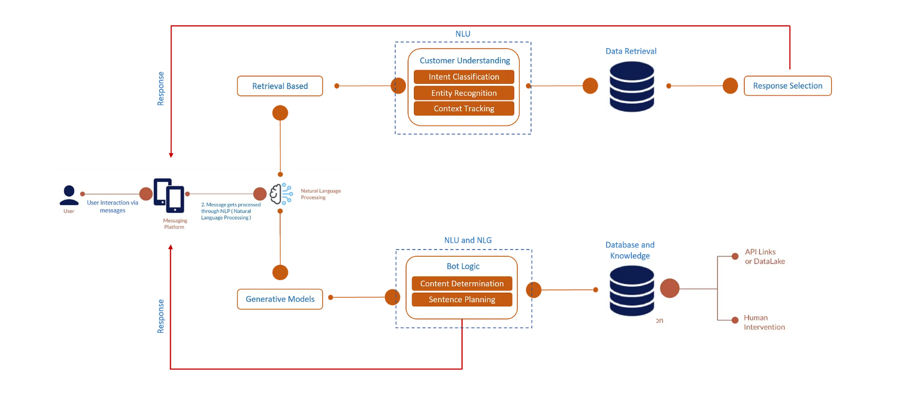
Figure 3.1: Diagram of the Proposed Admission Enquiry Chatbot System (Source: Hiremath et al., 2020).
Algorithm Adopted: DialogFlow Algorithm
Dialogflow is a natural language processing (NLP) platform developed by Google for building conversational interfaces, including chatbots. Below is a pseudocode of the algorithm:
# Define rules
rule1 = "if (subject) (verb) (object)"
rule2 = "when (event) (condition)"
rule3 = "unless (condition) (action)"

# Function to match rules
function match_rule(input_string, rule):
# Perform matching logic based on the specific rule syntax
# For simplicity, let's assume rule components are space-separated
input_tokens = input_string.split()
rule_tokens = rule.split()

# Check if the input matches the rule
if len(input_tokens) == len(rule_tokens):
for i in range(len(input_tokens)):
if rule_tokens[i][0] == '(' and rule_tokens[i][-1] == ')' and rule_tokens[i][1:-1].isalpha():
# Placeholder found, continue matching
continue
elif input_tokens[i] != rule_tokens[i]:
# Mismatch found, input doesn't match the rule
return False
# All tokens match, the input adheres to the rule
return True
else:
# Different number of tokens, not a match
return False
DialogFlow Algorithm Source: (Siau, 2019).
3.2 ANALYSIS OF THE EXISTING SYSTEM
The existing admission enquiry system for educational institutions often relies heavily on manual processes, such as phone calls, emails, or static web forms, to handle inquiries from prospective students. This traditional approach can be inefficient and time-consuming, leading to delays in response times and potential frustration for applicants. Additionally, the lack of real-time support and personalized assistance may result in missed opportunities to engage with potential candidates effectively. Moreover, the manual handling of inquiries can lead to errors in information dissemination and inconsistencies in communication, which could impact the institution's reputation and hinder the admission process.
3.3 PROBLEMS OF THE EXISTING SYSTEM
Some common problems associated with the existing admission enquiry system include:
- Lack of responsiveness: Manual processes may not be able to handle inquiries promptly, especially outside regular business hours, leading to delays in providing assistance to prospective students.
- Limited scalability: With a manual system, handling a large volume of inquiries can be challenging, resulting in overwhelmed staff and compromised quality of service.
- Inconsistencies in communication: Different staff members may provide varied information to applicants, leading to confusion and misinformation.
- Dependency on human resources: The reliance on human resources for handling inquiries can be costly and may not scale well with increasing demand.
3.4 DESCRIPTION OF THE PROPOSED SYSTEM
The proposed system aims to address these challenges by implementing a chatbot based admission enquiry system using the Dialogflow algorithm. This system leverages the power of artificial intelligence and natural language processing to provide automated and personalized assistance to prospective students. Through an intuitive chat interface, users can interact with the chatbot in real-time, asking questions about admission criteria, course details, deadlines, and more.
The system offers a comprehensive and user-centric solution to streamline the admission process for educational institutions. At its core, this system utilizes advanced artificial intelligence techniques to create a conversational interface that mimics natural human interaction, providing a seamless and intuitive experience for prospective students seeking information about admissions. Through the chatbot interface, users can engage in real-time conversations, asking questions, seeking guidance, and receiving instant responses tailored to their inquiries. Dialogflow's powerful natural language processing capabilities enable the chatbot to understand and interpret user queries accurately, regardless of variations in language, syntax, or terminology. This ensures that users can obtain the information they need quickly and efficiently, without encountering barriers or misunderstandings.
The proposed system goes beyond basic question-and-answer interactions by offering additional functionalities to enhance the user experience. For example, the chatbot can assist users in completing application forms, providing step-by-step guidance and clarifications as needed. It can also schedule appointments, such as campus tours or admissions interviews, directly within the conversation, simplifying the process for both applicants and admission staff.
3.5 ADVANTAGES OF THE PROPOSED SYSTEM
The proposed chatbot for admission enquiries system has the following advantages:
- It enhanced user experience: The chatbot offers 24/7 support, ensuring prompt and consistent assistance to prospective students, thereby improving overall user satisfaction.
- Scalability: The automated nature of the chatbot allows it to handle a large volume of inquiries simultaneously, without the need for additional human resources.
- Personalized assistance: Dialogflow's algorithm enables the chatbot to understand user intent and provide tailored responses based on individual queries, enhancing the user experience.
- Efficiency: By automating routine tasks and inquiries, the proposed system streamlines the admission process, saving time and resources for both applicants and admission staff.
- Data-driven insights: The system can collect and analyze data on user interactions, allowing institutions to gain valuable insights into user preferences, frequently asked questions, and areas for improvement, which can inform future decision-making and enhance the effectiveness of the admission process.

CHAPTER FOUR
DESIGN, IMPLEMENTATION AND DOCUMENTATION OF THE SYSTEM
4.1 DESIGN OF THE SYSTEM
This is the computation of the particulars of a new system and the determination of what the new system would be and the function it is to perform. This may involve changing from one system to another or modifying the existing system operation.
The most challenging phase of the system life cycle is the change from manual operation to a faster and more accurate one; system design stage covers the technical specifications that will be employed in the implementation of the new system in order to modify the previous system. Some factors are put in consideration. These factors include input design, output design, definitions file and procedure designs and other documentation.
4.1.1 OUTPUT DESIGN
This incorporates the objectives of solving the existing system problems and challenges. This involves the structuring of the desired information and also to enhance efficient and effective Chatbot. Things taken into consideration in determining the output are represented below:

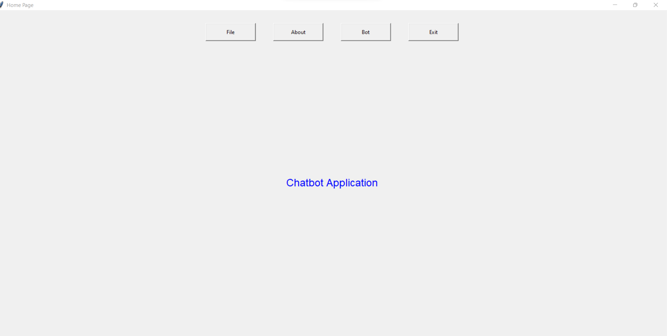
Figure 4.1: Home Page
This page allow user to navigate from page to another within the application environment
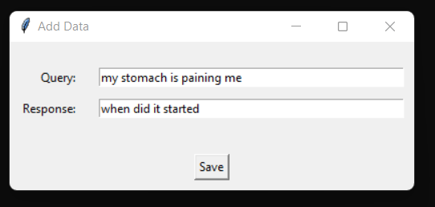
Figure 4.2: Add-data page.
This page allow admin/user to input user query and bot/computer response
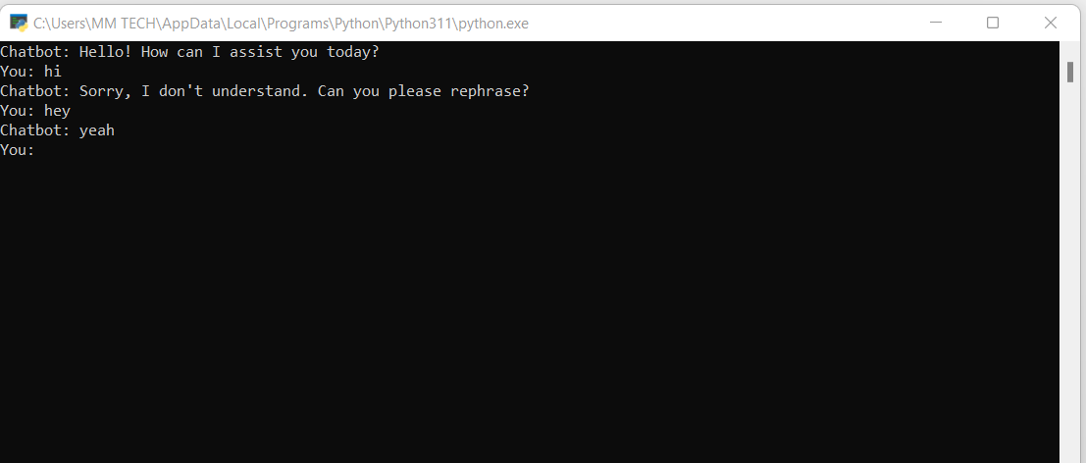
Figure 4.3: Chatting Interface.
This is a page where user and computer interact.
4.1.2 INPUT DESIGN
The input to run this software is obtained from healthcare chatbot system administrator. The administrator is expected to register any User information. He can achieve this by typing via the keyboard. The input required from the Users is their personal data and answer?
To the questions set by the administrator. It can serve as the various input layouts from the various modules first from the collection of data and module then from the assessment module and input from User respectively.
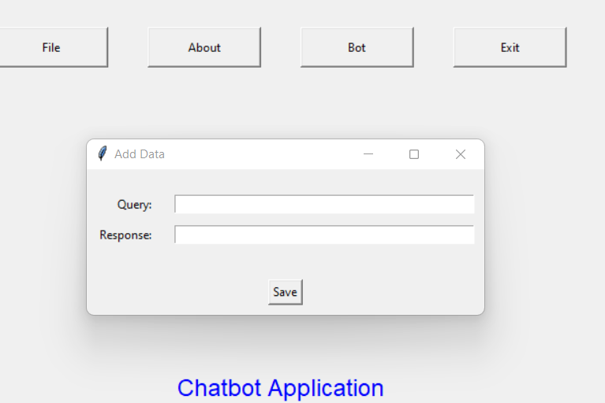
Figure 4.4: Input New Query
This is a page where admin enter queries for user and computer for easier conversation
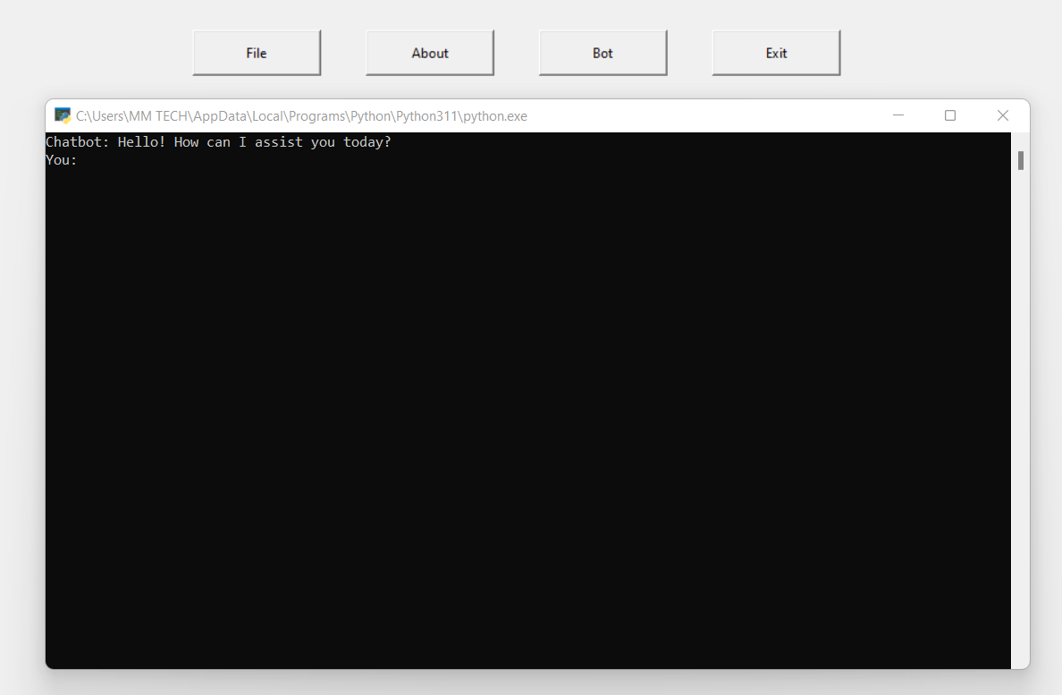
Figure 4.5: Conversation Interface
This page allow communication between user and computer
4.1.3 DATABASE DESIGN
Database design is the process of creating a detailed data model of a database. It involves defining the structure of the database, including tables, columns, relationships, constraints, and other relevant elements. A well-designed database is crucial for efficient data storage, retrieval, and manipulation, as well as ensuring data integrity and security.

Table 4.1: Queries Table
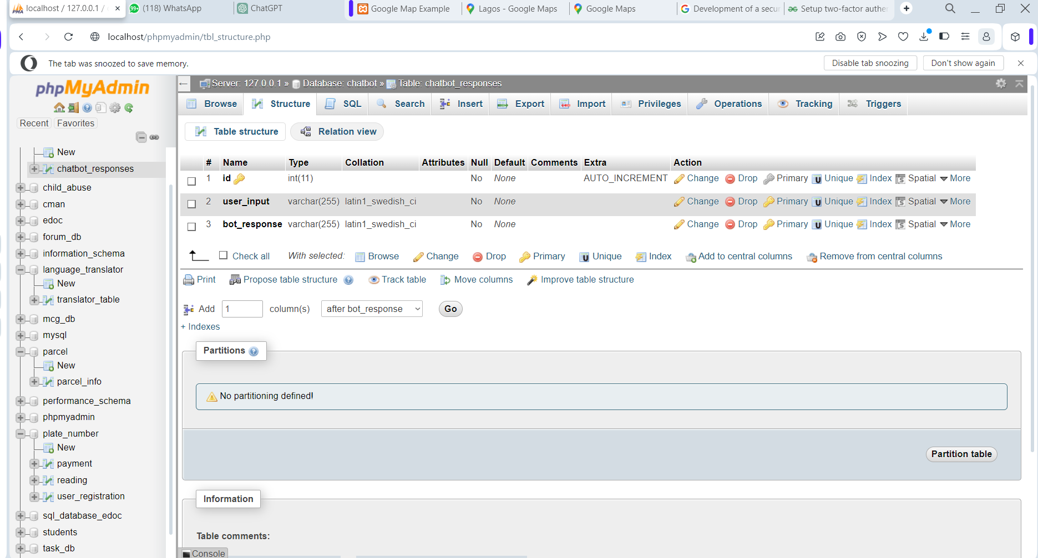
This table contained information about Chatbot Application
4.1.4 PROCEDURE DESIGN
These are the steps involved in unifying the whole process to produce the desired output. It involves computer procedures which start from the original input lessons to the output result file. This allows the processing of User information and result to be possible. Menu is provided to aid User in the processing of the output file.
4.2 IMPLEMENTATION OF THE SYSTEM
This entails the choice of the programming language employed to implement the software which should-be suitable for Menstrual cycle monitoring system. The software is designed for the use of Menstrual cycle monitoring system which should serve as an assistant. It is also expected to be used in conjunction with the User. The Menstrual cycle monitoring system admin will prepare data base while the admin will provide personal data about the User.

4.2.1 CHOICE OF PROGRAMMING LANGUAGE
The Application was developed in a .net (dot net) integrated development environment (.net IDE). The Application IDE is chosen following the fact that extracted information needs to be presented in an enhanced pictorial/graphical format and easy communication with the database for program flexibility in windows platform.
4.2.2 HARDWARE REQUIREMENT
i. 500 Hz minimum with CD ROM drive etc.
ii. Hard disk of capacity 10GB Minimum
iii. 126-512 megabyte of RAM
iv. An Uninterrupted power supply (UPS)
v. A voltage stabilizer
vi. A power generating set etc.
4.2.3 SOFTWARE REQUIREMENT
i. Windows operating system such as Windows 7 etc
ii. Dream Weaver
iii. Server Query Language (SQL).
4.3 DOCUMENTATION OF THE SYSTEM
4.3.1 PROGRAM DOCUMENTATION
The program is packaged for use in any system irrespective of either it runs visual studio application or not. After developing a program in Visual studio, there is a facility provided in Microsoft Visual Studio suite called “Package and Deployment Wizard” that is used in Visual studio application packaging and deployment.
The healthcare chatbot system is packaged into an installable setup that can be run from any system.
4.3.2 MAINTAINING OF THE SYSTEM
The system maintenance refers to making modification to an already existing application/program without necessarily re-writing everything from start. Program maintenance of a program includes modification of the program to meet-up with certain requirements of the Users. In this course, additional features can be added, errors corrected, ambiguous interfaces redesigned to eliminate confusions and unnecessary features removed.
Maintaining this program can be done in a Visual studio environment. Any future modification can be by re-running the program source code in a visual studio environment making necessary changes and updates and recompile the application into an upgrade version of the existing version of the mini word processing application. Further versions of this program can be named following their year of release or it can be given a different version number.

CHAPTER FIVE
SUMMARY CONCLUSION AND RECOMMENDATIONS
5.1 SUMMARY
The development of a chatbot based admission enquiry system using the Dialog Flow Algorithm represents a significant advancement in streamlining the admission process for educational institutions. Through the integration of natural language processing and conversation flow, the system provides a user-friendly interface for applicants to obtain accurate and prompt information regarding admissions. The study focused on designing and implementing the chatbot interface, integrating the Dialog Flow Algorithm, and programming the system to handle a wide range of admission-related queries. The evaluation of the system's performance through user testing revealed promising results, indicating improved efficiency and effectiveness in handling admission enquiries. the system adopted the agile development methodology and was implemented using python programming language and MySQL for the database management system.
5.2 CONCLUSION
The development of the chatbot based admission enquiry system using the Dialog Flow Algorithm has demonstrated its potential to enhance the admission process for educational institutions. The system offers a convenient and accessible platform for applicants to obtain instant responses to their queries, thereby improving overall user experience and satisfaction. Furthermore, by automating routine inquiries, the system reduces the workload on administrative staff, allowing them to focus on more complex tasks. The study highlights the effectiveness of utilizing chatbot technology in addressing the challenges associated with admission enquiries.

  - RECOMMENDATIONS
Based on the findings of this project, several recommendations are proposed for further improvement and refinement of the chatbot based admission enquiry system:
- Continuous refinement of the system's natural language processing capabilities to enhance accuracy and understanding of user queries.
- Integration of additional features such as multilingual support and personalized recommendations to cater to diverse user needs.
- Regular updates and maintenance to ensure the system remains up-to-date with the latest admission procedures and requirements.
- Collaboration with educational institutions to customize the system according to their specific requirements and preferences.
- Further research and development to explore the potential of incorporating advanced technologies such as machine learning and artificial intelligence to enhance the capabilities of the chatbot system.

REFERENCES
Akibu, B. & Abdullahi, A. (2022). Chatbot for Education System, International Journal of Scientific Development and Research (IJSDR). Vol. 2, Issue: 2. Pp. 14-16.
Bhavika, R., Ranoliya, A., Raghuwanshi, N. & Singh, S. (2017). Chatbot Application Using Artificial Intelligence, 2017 International Conference on Advances in Computing, Communications and Informatics (ICACCI). Pp. 5-7.
Gbenga, L. Oluwafunto, A. & Oluwatobi, V. (2020). Intelligent Chatbot for University Information System using Natural Language Approach, Former UNIVPM AI Lab, Fermo-FM, Italy. Pp. 7-8.
Geethanjali, D. & Sujatha, S. (2022). An Improved Rapid Response Model for University Admission Enquiry System using Chatbot, International Journal of Research Publication and Reviews. Vol 3, Issue: 9. Pp. 74-78.
Global Chatbot Market Size, Retrieve on: 5 December 2023. From: https://markets.businessinsider.com/news/stocks/global-chatbot-market-anticipated-to-reach-9-4-billionby-2024-robust-opportunities-to-arise-in-retailecommerce-1028759508
Hassan, A., Shereen, D. Rafik, M. Ashraf, K. Gorgui, K. & Emil, G. (2023). An Interactive Chatbot for College Enquiry, International Journal of Engineering Research & Technology (IJERT). Vol. 9, Issue: 7. Pp. 820-821.
Hiremath, H., Hajare, S. Bhosale, Y. Nanaware, D. & Wagh, E. (2020). A Web Based College Enquiry Chatbot with Results, International Research Journal of Modernization in Engineering Technology and Science. Vol. 3, Issue: 6. Pp. 54-55.
Khadijaa, A. Zahraa, F. Naceurb, A. & Hassan, B. M. (2021). Chatbot for Admissions: Toward a General Architecture, 2nd International Workshop on Artificial Intelligence & Internet of Things (A2IOT). Pp. 34-35.
Khandagale, M. Wagh, T. Patil, K. & Kuchiwale, U. (2022). Intelligent Chatbot for College Enquiry System, International Journal of Scientific Development and Research (IJSDR). Vol. 5, Issue: 9. Pp. 495-496.
Nyongesa, G. Omieno, K. & Otanga, D. (2020). Artificial Intelligence Chatbot Adoption Framework for Real-Time Customer Care Support in Kenya, International Journal of Scientific Research in Computer Science, Engineering, and Information Technology Vol. 6, Issue: 6. Pp. 122-124. doi : https://doi.org/10.32628/CSEIT20667 100 1
Pawar, E., Rane, F., Wankhade, D. & Mehta, O. (2018). Implementing a College Enquiry Chatbot, International Research Journal of Engineering and Technology (IRJET). Vol. 10, Issue: 2. Pp. 563-564.
Polatidis, G. (2017). Artificial Intelligence HealthCare Chatbot System, International Advanced Research Journal in Science, Engineering and Technology. Vol. 8, Issue: 5. Pp. 421-422. DOI: 10.17148/IARJSET.
Ranavare, D. & Kamath, M. (2020). Programming Challenges O Chatbot: Current and Future Prospective, 2017 IEEE Region 10 Humanitarian Technology Conference (R10-HTC). Pp. 23-24.
Satu, M. S., Parvez, H. & Al-Mamun, S. (2019). Review Of Integrated Applications with AIML Based Chatbot", 2019 International Conference On Computer And Information Engineering (ICCIE). Pp. 12-13.
Setiawan, R., Iskandar, R., Madjid, N. & Kusumawardani, R. (2023). Artificial Intelligence-Based Chatbot to Support Public Health Services in Indonesia, International Journal of Interactive Mobile Technologies. Vol. 17, Issue: 19. Pp. 36–37. doi.org/10.3991/ijim.v17i19.36263

Appendix 1: Main Menu Flowchart
Create Profile
Start
Display
Make Enquiry
Login
Stop
Modify
Profile

Report

Appendix 2: Profile Creation Flowchart
Start
Is Record OK?
CLOSE DB
Another Record?
RETURN
Yes
Open Database

Accept User Record

No
Save Record to DB

No
Yes

Appendix 3: Login Flowchart
Login
Open Database
Is Details Correct?
Accept Username and Password
No
Yes
Main Menu
Close Database
Stop
Display Incorrect
Search the Username
Appendix 4: Admission Enquiry Flowchart
Start
Is Details Correct?
Close DB
More Enquiries?
Return
Yes
Open Database

Accept Login Details
No
Make Enquiries
No
Yes

Display Incorrect Login Details
Search

Search

Display Enquiries

Appendix 5: Modification Flowchart
Start
Display Record
Return
Open Database
Accept ID
Is Record Found?
Modify Another Record?
Close Database
Display Record Not Found
No
Yes
No
Search record
Edit/Delete Record

Yes
Update Database
RECORD

Appendix 6: User Report Flowchart
START
Open Database
Search
View Report
RECORD

Close Database
STOP

Is EOF?

