DESIGN AND IMPLEMENTATION OF A ROBOTIC GRASS CUTTER

BY
NAME
HND/23/COM/FT/

A Project Submitted to the Department of Computer Science, Institute of Information and Communication Technology, Kwara State Polytechnic, Ilorin

In Partial Fulfillment of the Requirements for the Award of Higher National Diploma (HND) in Computer Science

July, 2025
CERTIFICATION
This is to certify that this project was carried out by Name with Matric Number HND/23/COM/FT/ as part of the requirements for the award of Higher National Diploma (HND) in Computer Science.

………………………………. ……………………………….
Dr. (Mrs.) Olusi, R. T. Date
(Project Supervisor)

………………………………. ……………………………….
Mr. Oyedepo, F. S. Date
(Head of Department)

………………………………. ……………………………….
External Examiner Date

DEDICATION
This project is dedicated to the creator of the earth and universe, the Almighty God. It is also dedicated to my parents for their moral and financial support.

ACKNOWLEDGEMENT
All praise is due to the Almighty God the Lord of the universe. I praise Him and thank Him for giving me the strength and knowledge to complete my HND programme and also for my continue existence on the earth.
I appreciate the utmost effort of my supervisor, Dr. (Mrs.) Olusi, R. T., whose patience support and encouragement have been the driving force behind the success of this research work. She gave useful corrections, constructive criticisms, comments, recommendations, advice and always ensures that an excellent research is done. My sincere gratitude goes to the Head of the Department and other members of staff of the Department of Computer Science, Kwara State Polytechnic, Ilorin, for their constant cooperation, constructive criticisms and encouragements throughout the programme.
Special gratitude to my parents who exhibited immeasurable financial, patience, support, prayers and understanding during the periods in which I was busy tirelessly in my studies. Special thanks go to all my lovely siblings.
My sincere appreciation goes to my friends and classmates.

TABLE OF CONTENTS
Title Page i
Certification ii
Dedication iii
Acknowledgements iv
Abstract v
Table of Contents vi
CHAPTER ONE: GENERAL INTRODUCTION
  - Background to the Study 1
  - Statement of the Problem 3
  - Aim and Objectives of the Study 3
  - Significance of the Study 4
  - Scope of the Study 4
  - Organization of the Report 5
CHAPTER TWO: LITERATURE REVIEW
2.1 Review of Related Works 6
2.2 Review of Related Concepts 10
2.2.1 Overview of Robotics 10
2.2.2 Overview of Artificial Intelligence 11
2.2.3 Overview Lawn Mowers 11
2.2.4 Sensors in Autonomous Grass Cutter 13
2.2.5 Overview of Robotic Grass Cutter 13
CHAPTER THREE: RESEARCH METHODOLOGY AND ANALYSIS OF THE EXISTING SYSTEM
  - Research Methodology 14
  - Analysis of the Existing System 15
  - Problems of the Existing System 15
  - Description of the Proposed System 16
  - Advantages of the proposed system 16
CHAPTER FOUR: DESIGN, IMPLEMENTATION AND DOCUMENTATION OF THE SYSTEM
  - Design of the System 17
    - Output Design 17
    - Input Design 21
    - Database Design 23
4.1.4 Procedure Design 25
  - Implementation of the System 25
    - Choice of Programming Language 25
    - Hardware Support 26
    - Software Support 26
  - Documentation of the System 27
    - Program Documentation 27
    - Maintaining the System 27
CHAPTER FIVE: SUMMARY, CONCLUSION AND RECOMMENDATION
  - Summary 28
  - Conclusion 28
  - Recommendation 29
References
Appendices

ABSTRACT
The present technology commonly uses manually operated devices to cut the grass, creating pollution and energy loss. In this project, we introduce the automatic robotic grass cutter for cutting grass. Robotic grass cutter can able to decrease the workload of cutting grasses in the field; also in this, the operating force is given by the rechargeable battery that is fixed to the cutter, sensors, and crane mechanism can able to find out the unwanted things and get around while in operation. The grass-cutter and motors used in the robot will be frontier with the Arduino mega2560, the entire motors' management. The vehicle will be in boundary with the ultrasonic sensor to identify the object. On obstacle detection, the ultrasonic sensor monitors it, and the Arduino thus stops the grass cuter motor to negotiate any damage to the object/human/animal, whatever it is. It consists of obstacle avoidance, android application, adjustable level of grass-cutter, and gear wire blade. Also, the design parameters are discussed in this project. This project aims to develop a robotic grass-cutting robot embedded with obstacle avoidance and grass level adjustments.
CHAPTER ONE
GENERAL INTRODUCTION
  - BACKGROUND TO THE STUDY
The grass is a very common plant that grows naturally on earth which covers up to 40% of earth‘s land surface. Grasses are highly beneficial to nature and to mankind. It provides food, fuel, medicine, shelter and transportation. It provides protection against soil erosion and improves air quality and filter pollution. While grasses improve both human and animal life it can also be a pest, invasive and bringer of death and destruction. Invasive grass species when dried can cause fire. Some grass species can kill plants by choking and displacing them and competing to the soil nutrients and water resources. The invasive and uncontrollable nature of some species of grasses can greatly impact the environment and the economy (Herrera & Luciano, 2020)
A robot is a machine that can communicate with its physical environment and which can be controlled or programmed electronically to perform specialized tasks. All robots have features of a mechanical and adjustable structure under some form of control, and they mainly have three separated phases: understanding, processing, and action. Commonly, the understandings are done by the sensors mounted on the robot, the onboard micro-controller or processor do processing, and lastly, the operation is performed using motors, engines or with some other actuators. Maintaining lawns is a common but labor-intensive activity that requires significant time and effort. Traditional grass-cutting methods involve manual or motorized mowers, which often contribute to noise pollution and environmental degradation. With advancements in robotics and artificial intelligence, autonomous systems have become viable solutions for automating routine tasks (Khan et al., 2019).
Ajibola et al., (2021) asserted that the demand for automated systems has surged in recent years due to their potential to reduce human labor and improve efficiency. Robotic lawn mowers have gained popularity as they offer hands-free operation and precision cutting. However, existing models, lawn maintenance workers generally spend about nine 9 hours exposed to sound levels above 85 dB, and only a few employees wear hearing protection. This has caused a lot of risk to the health of the workers working on different lawn maintenance machines. These health challenges are overcome by the use of autonomous grass cutters. It reduces human intervention to remote control mechanism, completely expunging a user from the hazardous noise, vibrations and possible fumes that manual machines produce.
Robotic machines have taken over the duties of dangerous and mundane jobs from humans, allowing greater productivity. Because robots are never tired, extra shifts have been added to factories. Farmers have taken advantage of new technology with automated harvesters; the waste disposal industry has implemented robots in some of its dirtier jobs. Grass cutting in gardens, lawns and play grounds is a boring and time-consuming task. By the conventional system, grass can be removed but this takes too much time and many other harmful effects are faced (Ghose & Islam, 2021).
This project focuses on designing and implementing a robotic grass cutter to provide an efficient, cost-effective, and environmentally friendly alternative to traditional grass-cutting methods.
  - STATEMENT OF THE PROBLEM
In the time where technology is merging with environmental awareness, consumers are looking for ways to contribute to the relief of their own carbon footprints. Pollution is manmade and can be seen in our own daily lives, more specifically in our own homes. Traditional grass-cutting methods present challenges such as high labor requirements, environmental pollution, and operational inefficiency. modern lawn mowers, though innovative, are often expensive and inaccessible to the average consumer. There is a need for a cost-effective, energy-efficient, and versatile robotic grass cutter that can cater to diverse user needs.
1.3 AIM AND OBJECTIVES OF THE STUDY
The aim of this project is to design and develop a grass cutter which would be powered by battery which is favourable to the environment.. The objectives are to:
- develop a robotic grass cutter with autonomous navigation;
- integrate ultrasonic sensors to detect and avoid obstacles, maintaining continuous and efficient operation;
- incorporate renewable energy sources for sustainable operation; and
- evaluate the performance and cost-effectiveness in comparison to traditional grass cutter systems.
  - SIGNIFICANCE OF THE STUDY
The significance of this study lies in its potential to redefine the landscape of energy wastage and environmental pollution. This project contributes to advancing automation in lawn maintenance by developing an accessible and sustainable solution. It offers potential benefits such as reduced labor costs, enhanced user convenience, and environmental conservation. The findings may also inspire further innovation in autonomous systems.

  - SCOPE OF THE STUDY
The project focuses on designing and implementing a robotic grass cutter capable of autonomous operation on small to medium-sized lawns. It includes hardware and software development, system integration, and performance evaluation. And also, it excludes large-scale commercial applications and specialized terrain management.
1.6 ORGANIZATION OF THE REPORT
The project write-up is organized into five distinct chapters. Chapter one covers general introduction, which contains introduction to the project topic, statement of the problem, aim and objectives of the study, significance of the study, scope of the study and organization of the report. Chapter two covers the literature review, which contains review of related past works, overview of robotic system, description robotic grass cutter and other related concepts. Chapter three explains the project methodology which includes analysis of existing system, problems of the existing system, the description of the proposed system and advantages of proposed system. Chapter four explains the design, implementation and documentation of the system which contain system designed output design, input design, database design, procedure design, implementation of the system hardware and software support and documentation of the new system installation procedure, operating the system and system maintenance. Lastly, chapter five explains the summary of the research, recommendations, and conclusion.

CHAPTER TWO
LITERATURE REVIEW
2.1 REVIEW OF RELATED LITERATURE
Ismail et al., (2019) designed and developed a smart solar grass cutter. The paper introduced a new development of grass cutter, named as smart solar grass cutter, the researchers used solar irradiance as a primary energy source with the presence of a solar panel. The grass cutter prototype was developed to reduce air pollutant and improve the current design specifically the blade position based on the previous studies. With current technology, the new prototype was designed as remotely controlled grass cutter using Arduino UNO. Smartphone was used as the remote controller. After developing an established prototype, the design analysis was carried out to be validate with the theoretical values to ensure that the prototype can be safely used. The smart solar grass cutter operated more than two hours when the used battery was fully charged. Based upon the results, the smart solar grass cutter is reliable with high efficiency of the system compared to the previous studies. Therefore, it can be concluded that the prototype is reliable and environmentally friendly.
Herrera and Luciano (2020) implemented an android-controlled grass cutting robot using RPA method. The study aimed to develop an android-controlled grass cutting robot to address the problems of cutting tall perennial grasses in uneven terrain, test the feasibility of controlling the robot using android devices and to explore the ideas attaching heat and thermal sensor as a safety measure. It was developed using Robotic Process Automation (RPA) utilizing the following stages: Gather, Analyze, Design, Execute and Improvise. The grass cutting robot was controlled through WI-FI by android app which can run in either Windows 10 with Bluestacks Emulator or Android operating system version 4.4.2 or higher. It is armed by a grass-cutting blade made of stainless steel and it is propelled by a brushed motor. Its heat and thermal sensor located in the front can detect humans, mammals and birds. This sensor stops the cutting blade once detection is triggered. Other safety feature is the ultrasonic sensor which was used to detect objects that will collide into the robot and stops the robot from moving. Its steering angle, forward and reverse speed can be adjusted using the Android app.
Shanmugaselvama et al., (2022) designed and implemented an android based robot for grass cutting. In the project, the researchers introduced the automatic grass cutter for cutting grass. In the paper, the operating force is given by the rechargeable battery that is fixed to the cutter, sensors, and crane mechanism can able to find out the unwanted things and get around while the operation. The grass-cutter and motors used in the vehicle was a frontier with the Arduino mega2560, the entire motors' management. The vehicle was in boundary with the ultrasonic sensor to identify the object. On obstacle detection, the ultrasonic sensor monitors it, and the Arduino thus stops the grass cuter motor to negotiate any damage to the object/human/animal, whatever it is. It consists of obstacle avoidance, android application, adjustable level of grass-cutter, and gear wire blade. Also, the design parameters were discussed in the paper. The study aimed to develop an autonomous grass-cutting robot embedded with obstacle avoidance and grass level adjustments.
Saji et al., (2021) worked on an intelligent lawn mower robot. The objective of the project was to design and implement all terrain lawn mower robotic vehicle that can be used to remove grass from lawns and play grounds intelligently and precisely. The controller uses intelligent approach to work in dynamic, unstructured and unknown terrain without having any inaccuracy. A set of concurrently running behaviors were defined to perform mowing operation. Various accelerometers were utilized to obtain the dynamics of the terrain. There was a master controller which used information from the sensors and modify the mechanics of the mower to cut away the lawn precisely. The controller was pretty much user friendly that any ordinary human users can control it. Effective utilization of energy was a prime concern for design.
Ramesh et al., (2023) designed an arduino based automatic grass cutting using robot In the paper, to cut grass, the authors presented the automatic grass cutter. The workload associated with cutting grass in the field can be reduced by using an automatic grass cutter. The device operated on a rechargeable battery that is fixed to the cutter, and sensors and a crane mechanism that can identify and avoid unwanted objects. The Arduino Mega2560 controlled every aspect of the motors in the vehicle, including the grass cutter. To identify the object, the used the ultrasonic sensor. The ultrasonic sensor detects obstacles and relays that sends information to the Arduino, which then stops the grass cutter motor to prevent damage to the object, person, or animal, whichever it may be. It included an Android application, an adjustable grass-cutter level, a gear-wire blade, and obstacle avoidance. The paper also discussed the design parameters. The goal of the project was to create an autonomous grass-cutting robot with built-in obstacle avoidance and grass-level adjustment capabilities.
Dilip et al., (2019) conducted a research on an automatic solar grass cutter. In the paper the researcher claimed that the automatic solar grass cutter will reduce the effort required for cutting grass in the lawns. Solar power was used to provide the driving force for the cutter and various sensors was used to detect and avoid the unnecessary objects in the field during operation. It consists of a microcontroller Arduino ATmega328p, IR sensors, LCD Display for better response and understanding to the user. The paper projected the operation and working principle of the automatic grass cutter. Also, the design parameters were discussed in the paper.
Man et al., (2022) developed a dual-mode grass cutter robot. The robot was designed to operate by a rechargeable battery and can be described as an intelligent robot because the micro-controller will receive information from sensors connected to it in avoiding obstacle to ensure a neat pattern of cut and use the information to actuate the left and right motors driving the wheels and the centre motor driving string trimmer and at the same time it obeys all parameters of work and its program database. As it is well known that random motion for a lawn mower would sometimes lead to uncovered spaced, it all depends on how random is random. Few features were added with more advanced option which allows the user to manually control the lawn mower with a PS2 controller. This, in fact, where the user can manually control the grass cutting robot that looks like a tank. The data analysis was listed in the table to test the development of grass cutter. The robot is safe to use, environmental friendly, easy to operate, and have various modes such as manual and automated mode.
2.2 REVIEW OF RELATED CONCEPTS
2.2.1 Overview of Robotics
Robotics is a multidisciplinary field that combines engineering, computer science, and artificial intelligence to design and build machines capable of performing tasks autonomously or with minimal human intervention. The field has its roots in automation and mechanization, evolving from simple mechanical devices to sophisticated systems that can perceive, analyze, and respond to their environment. Robots are widely used in industries such as manufacturing, healthcare, and agriculture, demonstrating their versatility and potential to revolutionize traditional practices (Wasif, 2022).
The development of robotics has been fueled by advancements in sensor technology, machine learning, and energy-efficient designs. Modern robots are equipped with capabilities such as vision, motion planning, and real-time decision-making, enabling them to operate in dynamic and unstructured environments. This progress has opened up new opportunities for automation in areas ranging from household chores to space exploration.
As robotics continues to advance, it plays a pivotal role in addressing global challenges such as labor shortages, environmental sustainability, and safety in hazardous environments. By leveraging cutting-edge technologies, robotics enhances productivity, reduces costs, and improves the quality of life. The integration of robotics into everyday applications signifies a shift towards a more automated and efficient future (Mandal et al., 2024).
2.2.2 Artificial Intelligence
Artificial Intelligence (AI) refers to the simulation of human intelligence in machines programmed to perform tasks that typically require human cognition. These tasks include learning, reasoning, problem-solving, perception, and language understanding. AI systems rely on algorithms and vast amounts of data to identify patterns, make predictions, and improve over time. AI can be broadly categorized into narrow AI, which focuses on specific tasks like facial recognition or voice assistants, and general AI, a theoretical concept where machines would exhibit human-like cognitive abilities across diverse tasks.
The applications of AI span various industries, revolutionizing how businesses and societies operate. In healthcare, AI aids in diagnosing diseases, analyzing medical images, and personalizing treatments. In finance, it enhances fraud detection and algorithmic trading. Autonomous vehicles, powered by AI, promise safer and more efficient transportation. Additionally, AI drives innovations in natural language processing, powering chatbots, virtual assistants, and translation tools. Its role in optimizing supply chains, improving customer experiences, and enabling predictive analytics underscores its transformative potential.
However, the rise of AI also presents challenges and ethical considerations. Issues like data privacy, bias in algorithms, and the potential for job displacement require careful attention. Ensuring transparency, accountability, and fairness in AI systems is crucial for building trust and preventing misuse. As AI continues to evolve, collaboration between policymakers, technologists, and ethicists will be essential to harness its benefits while mitigating risks, ensuring its responsible integration into society (Wasif, 2022).
2.2.3 Overview of Lawn Mowers
Lawn mowers are essential tools for maintaining lawns and gardens, providing an efficient way to trim grass to a uniform height. They come in various types, including manual reel mowers, electric mowers, gas-powered mowers, and robotic mowers, catering to diverse needs and yard sizes. Reel mowers are simple and eco-friendly, relying solely on human power, while electric mowers, available in corded and cordless versions, are quieter and easier to maintain than gas-powered models. Gas mowers, however, offer more power and are ideal for larger yards with tougher grass.
The choice of a lawn mower depends on factors like lawn size, terrain, and user preference. Push mowers are suitable for smaller, flat lawns, while self-propelled mowers ease the effort on uneven or sloped terrain. For expansive properties, riding mowers or zero-turn mowers provide speed and comfort, making large-scale mowing tasks manageable. Recent innovations include robotic mowers that operate autonomously, using sensors and GPS technology to navigate and mow lawns with minimal human intervention (Das et al., 2021).
Maintenance is crucial for ensuring the longevity and performance of a lawn mower. This includes regular blade sharpening, oil changes for gas-powered models, and battery care for electric ones. Proper storage, cleaning, and adherence to the manufacturer's guidelines can prevent common issues like engine problems or dull blades. With a wide range of options and technological advancements, lawn mowers continue to evolve, offering solutions for every lawn care need (Niazi, 2019).
Top of Form

2.2.4 Microcontroller and Sensors in Autonomous Grass Cutter
Microcontrollers and sensors are integral components of autonomous grass cutters, enabling them to operate independently and efficiently. The microcontroller acts as the brain of the system, processing data from sensors, controlling motors, and executing predefined algorithms for navigation and grass-cutting tasks. Popular microcontrollers like the Arduino Mega or Raspberry Pi Pico are often used due to their versatility, low power consumption, and ease of programming.
Sensors enhance the grass cutter’s awareness of its environment, ensuring safety, precision, and adaptability. Ultrasonic or infrared sensors detect obstacles, allowing the mower to avoid collisions. Boundary wire sensors or GPS modules define and constrain the cutting area, keeping the mower within the designated lawn boundaries. Additional sensors, such as gyroscopes and accelerometers, help maintain balance and stability, while rain sensors pause operation during wet conditions to prevent damage. Grass detection sensors can optimize cutting by adjusting blade height based on grass density.
The integration of microcontrollers and sensors enables advanced features like autonomous navigation and smart operation. For example, using real-time data, the microcontroller can compute optimal paths to minimize mowing time and maximize battery efficiency. Many autonomous grass cutters also feature connectivity options, allowing users to program and monitor the device remotely via smartphone apps. This combination of microcontrollers and sensors ensures reliable performance and precision, making autonomous grass cutters a practical and innovative solution for modern lawn care (Arunesh et al., 2021).
2.2.5 Overview of Robotic Grass Cutter
Robotic grass cutters, also known as robotic lawn mowers, are innovative devices that automate lawn maintenance using advanced technology. Equipped with sensors, GPS, and programmable features, these mowers navigate lawns independently, trimming grass to a consistent height without human intervention. They are battery-powered, making them eco-friendly and quiet compared to traditional gas-powered mowers. Their compact size and low profile allow them to reach tight spaces, ensuring comprehensive coverage of the lawn Ramesh et al., (2023).
The functionality of robotic grass cutters is tailored to user convenience. Many models feature customizable mowing schedules, enabling users to set specific times for operation. Advanced models can adjust cutting patterns based on the lawn’s growth rate or weather conditions, providing efficient and adaptive care. Safety is a priority, with sensors that detect obstacles and lift the blades automatically when the mower is lifted. Integration with smartphone apps or smart home systems allows users to monitor and control the mower remotely.
While robotic grass cutters offer significant benefits, they do require an initial setup and regular maintenance. Installation typically involves placing boundary wires to define the mowing area, ensuring the mower stays within designated zones. Routine maintenance includes cleaning, blade replacement, and battery care to sustain performance. Despite the upfront cost, their time-saving nature and precision make them a popular choice for homeowners seeking hassle-free lawn care with minimal environmental impact (Das et al., 2021).

CHAPTER THREE
RESEARCH METHODOLOGY AND ANALYSIS OF THE EXISTING SYSTEM
3.1 RESEARCH METHODOLOGY
The proposed robotic grass cutter can provide a new era of modern grass cutting. To design a robotic grass cutter system, some parameters need to be considered such as the components to be used in the project, the position of the components, the structure of the main body, the advantages and disadvantages of the design and the safety factors. The following are the materials needed to implement the system.
1. Arduino mega
2. Dc motor (1) (cutter)
3. Ultrasonic sensor
4. Dc motor (4) Servo motor
5. Bluetooth module
6. Servo motor
7. Transparent acrylic Case
8. Jumper wire
9. Aderid motor shield
In order to transform the idea into reality, developmental method of research was used in this project. The researchers examined and studied the different types of lawn mowers and grass cutting robots previously available in homes, sports fields and farms. Robotic Process Automation (RPA) approach was utilized in the design and development of the autonomous controlled grass cutting robot. Below is the schematic diagram of the robotic grass cutter.
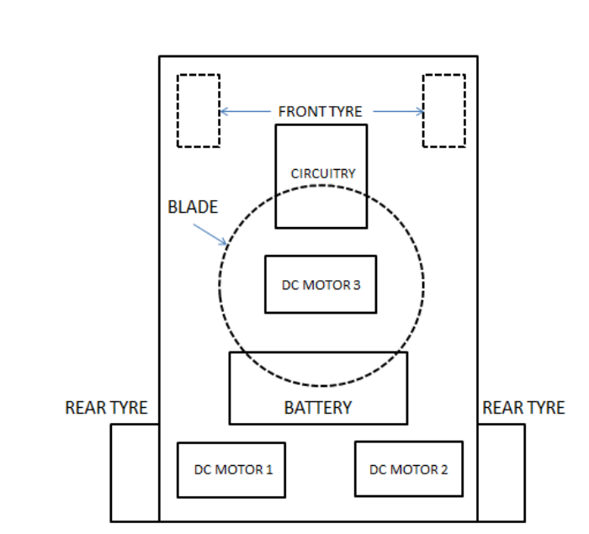
Figure 3.1: Schematic Diagram of the Robotic Grass Cutter
Source (Ajibola, 2021)
3.2 ANALYSIS OF THE EXISTING SYSTEM
The existing grass-cutting systems in traditional lawn mowers primarily rely on manual operation or basic automation to maintain lawns. Manual push mowers and gas-powered mowers dominate the market due to their simplicity and affordability. While these models are effective for small to medium-sized lawns, they require significant physical effort and user involvement. Gas-powered mowers, though powerful, contribute to environmental pollution through emissions and noise, making them less eco-friendly. Electric mowers, both corded and cordless, offer a quieter and greener alternative but often face limitations in battery life or mobility, particularly in larger or uneven terrains.
Automated systems like robotic grass cutter represent a significant advancement in grass-cutting technology. These systems address key shortcomings of traditional mowers by offering autonomous operation, lower environmental impact, and minimal user intervention.
3.3 PROBLEMS OF THE EXISTING SYSTEM
The existing system of grass cutting has numerous problems, these are:
- High initial and maintenance costs.
- Require a lot of man power
- Limited ability to navigate uneven or complex terrains.
- Dependence on conventional energy sources.
- Lack of robust safety features.
3.4 DESCRIPTION OF THE PROPOSED SYSTEM
The proposed robotic grass cutter is designed to operate autonomously using a combination of advanced sensors, renewable energy sources, and efficient cutting mechanisms. At its core, the system utilizes rechargeable batteries to power its operation, ensuring sustainability and reducing dependence on non-renewable energy. The navigation system integrates obstacle detection sensors and intelligent algorithms for path planning, enabling the device to move seamlessly across diverse terrains while avoiding obstacles. The cutting mechanism is built for durability and precision, offering consistent performance across small to medium-sized lawns.
The robotic grass cutter features a user-friendly interface that allows for easy operation and minimal maintenance. The design prioritizes affordability without compromising on essential functionalities, making it accessible to a wider audience. Its compact size and adaptability ensure that it can handle different lawn conditions effectively, from flat terrains to slightly uneven surfaces. The system also incorporates safety features using sensors to prevent accidents, making it reliable for household use.
3.5 ADVANTAGES OF THE PROPOSED SYSTEM
Using robots as grass cutters can offer several advantages, particularly in an open field. Here are some potential benefits:
- Cost-effective solution for lawn maintenance.
- Reduced environmental impact through renewable energy use.
- Enhanced safety with advanced obstacle detection.
- Autonomous operation for minimal user intervention.

CHAPTER FOUR
DESIGN, IMPLEMENTATION AND DOCUMENTATION OF THE SYSTEM
4.1 DESIGN OF THE SYSTEM
The design contains a microcontroller, multiple sensors, and a recharging battery system. Adding these elements together, we get our robotic grass cutter. The sensors are the eyes of the Robot Initially, the researchers had an idea what type of sensors they wanted to use. The researchers used only an ultrasonic sensor to detect if the robot was heading into an object. Safety is the main concern when designing a robot with blades. We wanted our robot not to start operating if it was being held in the air by the user. Knowing that the user would be randomly holding the robot we needed a sensor to detect orientation.
4.1.1 OUTPUT DESIGN
The robotic grass cutters was designed with two different cutting patterns. One is spiral and another is rectangular. The output design of the robotic grass cutter system are described in the diagrams below:
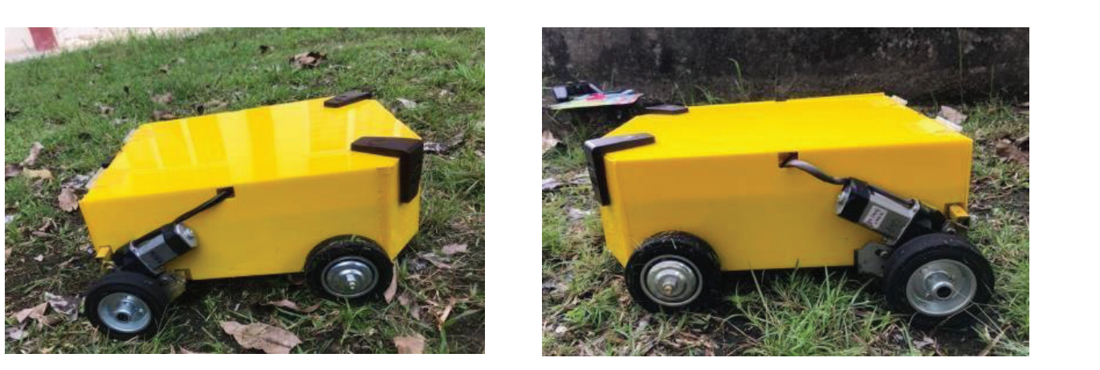
Figure 4.1: The Robotic Grass Cutter System Left and Right View
The image above is the Robotic Grass Cutter System which is automated device designed to cut grass efficiently without human intervention. It utilizes robotics, sensors, and programming to navigate lawns and perform mowing tasks.
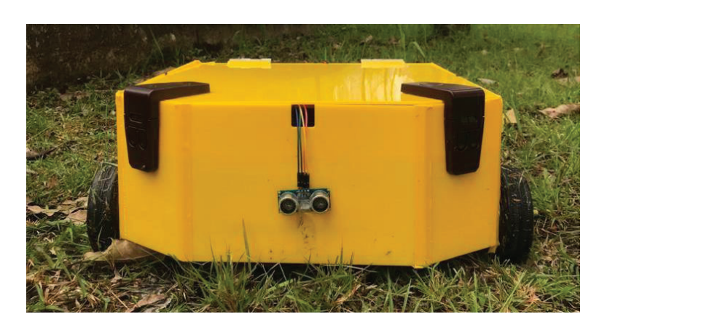
Figure 4.2: The Robotic Grass Cutter Front View
The image shows the front view of the robotic grass cutter.
4.1.2 INPUT DESIGN
In this section, the input design of the robotic grass cutter system are described. The implementation and functions of the grass cutter robot are tested before taking data
and making analysis of the robot performance. Below are the input used in designing the robot.
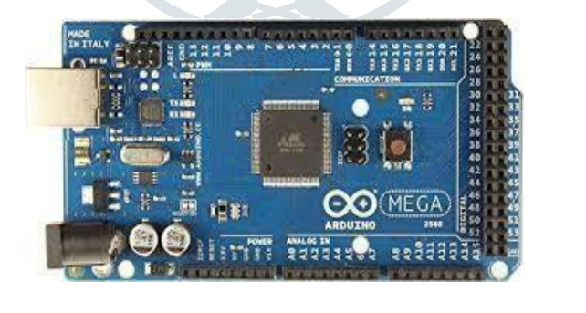
Figure 4.3: Arduino mega328
As seen in Figure 4.3, the Arduino Mega 328 microcontroller is primarily based on the ATmega328 (datasheet). In more detail, the PWM outputs are supported by 14 pins. It has four hardware serial ports, sixteen analog inputs, sixteen 16 MHz oscillators, an ICSP header, a USB port, a reset button, and a power jack.
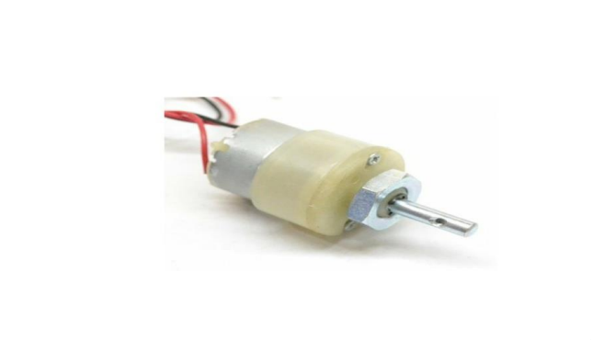
Figure 4.4: The Motor
Figure 4.4. shows the motor that was used in constructing the automated grass cutter. It can operate at a range of 12V to 24V. It has higher torque which made it easier. DC motor is a device that converts electrical form into mechanical form of energy. There are many kind of DC motor such as DC motor, separately excited DC motor and self-excited DC motor. DC motor will be powered by DC current.
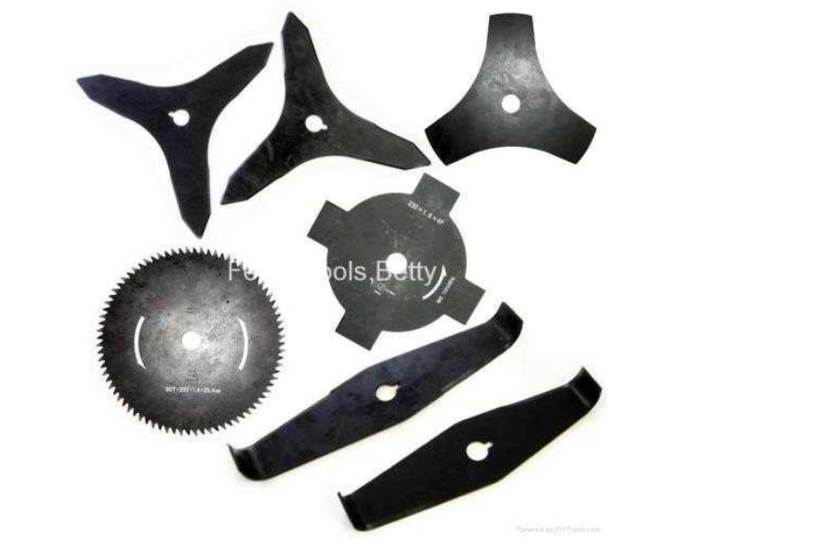
Figure 4.5: Cutters
This was used for the primary function of the mower that is to cut the grass. In the design, more than one cutter was used in synchronization as well. Also cutters with different shape and number of blades was used for the purpose of getting the required cutting speed.

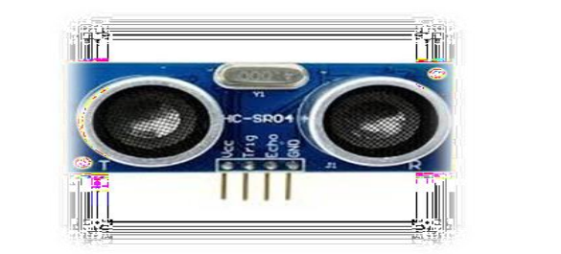
Figure 4.6: Ultrasonic Sensor HC-SR04
For identifying the distance of an object, this HC-SR04 ultrasonic sensor is used where this will be using sonar as the bats do. As it has high accuracy and stable reading, it can give non-contact range identification. These are easy to use. By the sunlight or by black objects like sharp rangefinders, the operations are not being interrupted. By the ultrasonic transmitter and receiver module, the entire module can get completed to detect 1" to 13" feet or 2cm to 400cm.
4.2 IMPLEMENTATION OF THE SYSTEM
The implementation of the system involves assembling the hardware components, developing and integrating software to control the system, checking the color sensors and ultrasonic sensor, cutters, and thoroughly testing the system to ensure it meets the desired specifications for efficient and dependable robotic grass cutter system.
4.2.1 CHOICE OF PROGRAMMING LANGUAGE
C++ program was chosen for the Microcontroller. The language was selected for its compatibility with hardware, ease of use, and availability of necessary libraries.
4.2.2 HARDWARE REQUIREMENT
1. Arduino mega
2. Dc motor (1) (cutter)
3. Ultrasonic sensor
4. Colour sensor
5. Dc motor (4) Servo motor
6. Bluetooth module
7. Servo motor
8. Transparent acrylic Case
9. Jumper wire
10. Aderid motor shield
4.2.3 SOFTWARE REQUIREMENT
The software that was used in this project are CATIA and Arduino 1.0.5 IDE. CATIA was used for designing the 3D model of the grass cutter. The Arduino 1.0.5 was used to program the microcontroller.
4.3 DOCUMENTATION OF THE SYSTEM
4.3.1 Program Documentation
The robotic grass cutter system's program documentation provides a comprehensive guide to understanding, configuring, and utilizing the system developed for the lawn mower. It includes setup instructions for the development environment, details on hardware configuration, an overview of the software structure, explanations of functionality, definitions of configuration parameters, usage instructions, and troubleshooting guidance. This documentation serves as a valuable resource for developers and users, ensuring smooth implementation, operation, and maintenance of the lawn mower system.
4.3.2 MAINTAINING OF THE SYSTEM
Maintaining the grass cutter system involves regular checks, updates, and occasional troubleshooting to ensure its continued functionality and efficiency. This entails inspecting hardware components for wear or damage, updating software to the latest versions, monitoring sensor data for irregularities, and conducting scheduled calibrations and battery replacements as needed. Troubleshooting efforts include diagnostic checks, component replacements, and meticulous documentation of maintenance activities to facilitate seamless operation and timely interventions.

CHAPTER FIVE
SUMMARY, CONCLUSION AND RECOMMENDATIONS
5.1 SUMMARY
This project offers a detailed approach to addressing the inefficiencies of traditional and existing robotic grass-cutting systems. By combining sustainability through rechargeable batteries, precision navigation, and safety enhancements, the proposed robotic grass cutter stands out as a cost-effective and eco-friendly solution. Its compact design and user-friendly interface make it adaptable for various lawn conditions, ensuring accessibility for a wider range of users.
The proposed system not only meets current demands for automation but also paves the way for future advancements in the field. By integrating renewable energy and intelligent algorithms, the design reflects a forward-thinking approach to sustainable automation. This project lays a foundation for improving the usability and versatility of robotic mowers, with significant implications for both residential and commercial lawn care industries. study presents a comprehensive approach to designing a robotic grass cutter that addresses the limitations of existing systems. By integrating renewable energy, advanced navigation, and safety features, the proposed system aims to deliver an efficient and sustainable solution.
5.2 CONCLUSION
The robotic grass cutter demonstrates the potential to revolutionize lawn maintenance by combining affordability, efficiency, and sustainability. It addresses key challenges such as high labor costs and environmental impact while offering an autonomous and user-friendly solution. The integration of renewable energy sources and intelligent navigation ensures that the system aligns with modern demands for eco-friendly and efficient technologies.
  - RECOMMENDATIONS
Based on the findings of this research, the following were recommended:
  - Collaboration with industry stakeholders is recommended to refine the prototype and facilitate mass production, paving the way for widespread adoption of robotic lawn maintenance solutions.
  - Future research should focus on enhancing adaptability to diverse terrains and incorporating advanced AI algorithms for improved performance.
  - Additional efforts should explore cost optimization to make the system more accessible to a broader audience.

REFERENCES
Ajibola, E., Olajide, S. & Osunde, O. O. (2021). Design and Fabrication of Self-Navigating Automated Lawn Mower, ABUAD Journal of Engineering Research and Development (AJERD). Vol. 4. Issue: 1. Pp. 1-4. DOI:10.1080/10447318.2016.1193350.
Arunesh, S., Arunesh, S., Nivetha, R. V. (2018). Design and Implementation of Automatic Lawn Cutter, International Journal of Science Technology & Engineering. Vol. 2. Issue: 11. Pp. 34-36. IOP Publishing.
Dilip, B. P., Wash, N. P. & Ma, P. S. (2017). Design and Implementation of Automatic Solar Grass Cutter, International Journal of Advanced Research in Electrical, Electronics and Instrumentation Engineering. Vol. 6, Issue: 4. Pp. 23-25. doi: http://www.ijareeie.com/volume6-issue-4
Herrera, N. G. & Luciano, R. G. (2020). Design and Development of Android-Controlled Grass Cutting Robot Using RPA Method, International Journal of Scientific & Technology Research. Vol. 9, Issue: 3. Pp. 67-69.
Ismail, F. B., Nizar, F. O. Al-Muhsen, O., Fuzi, F. A. & Zukipli, A. (2019). Design and Development of Smart Solar Grass Cutter, International Journal of Engineering and Advanced Technology (IJEAT). Vol. 9, Issue: 2. Pp. 122-124. ISSN: 2249 – 8958,
Khan, D. M., Mumtaz, Z. Saleem, M., Ilyas, Z., Ma, K., Ghaffar, S. & Ullah, S. (2019). Solar Powered Automatic Pattern Design Grass Cutting Robot System using Arduino, International Research Journal of Modernization in Engineering Technology and Science. Vol. 5, Issue: 4. Pp. 56-57. DOI: doi.org/10.5281/zenodo. 8036661
Mandal, S. & Borah, H. (2024). Design and Implementation of IoT-Integrated Wireless Solar Grass Cutting Robot, IEEE Robotics and Automation Letters. Vol. 2, Issue: 8. Pp. 12-13.
Niazi, A., Hafeez, M. Z., Abbas, A., Khan, S. Husnain, S. (2019) Design and Implementation of Automatic Solar Lawn grass cutter, MDSRIC - 2019 Proceedings. Pp. 14-16.
Vuthaluru, H. V., Pareek, V. K. & Vuthaluru, R. (2020). Multiphase Flow simulation of a simplified coal pulveriser, Fuel Processing Technology. Vol. 86, Issue: 11. Pp. 1195-1205. doi: https://doi.org/10.1016/j.fuproc.2004.12.003
Shanmugaselvama, P. Yogaraj, J. N., Ragul, P. & John, B. P. (2022). Design and Implementation of Android Based Robot for Grass Cutting, IOP Conference Proceedings. Pp. 56-57. doi: http://www.ijareeie.com/volume6-issue-4
Wasif, M. (2021). Design and Implementation of Autonomous LawnMower Robot Controller, International Research Journal of Modernization in Engineering Technology and Science. Vol. 5, Issue: 4. Pp. 56-57.
Yang, J., Chew, E. & Liu, P. (2020). Service Humanoid Robotics: Review and Design of a Novel Bionic-Companionship Framework, White Rose Research. Pp. 12-13.

