DESIGN AND IMPLEMENTATION OF CREDIT CARD FRAUD DETECTION SYSTEM

BY
KAYODE KOLAWOLE ANTHONY
HND/23/COM/FT/0181

SUBMITTED TO THE DEPARTMENT OF COMPUTER SCIENCE, INSTITUTE OF INFORMATION AND COMMUNICATION TECHNOLOGY,
KWARA STATE POLYTECHNIC, ILORIN

IN PARTIAL FULFILLMENT OF THE REQUIREMENTS FOR THE AWARD OF HIGHER NATIONAL DIPLOMA (HND) IN
COMPUTER SCIENCE

JUNE, 2025.

CERTIFICATION
This is to certify that this project was carried out by KAYODE KOLAWOLE ANTHONY with matriculation number HND/23/COM/FT/0181 in the Department of Computer Science, Institute of Information Communication Technology, Kwara State Polytechnic, Ilorin, Kwara State.

…………………………………. ….………………………
MRS. BOLAJI-ADETORO, D.F. Date
Project Supervisor

…………………………………. ….………………………
MR. OYEDEPO, F. S. Date
Head of Department

…………………………………. ….………………………
External Examiner Date

DEDICATION
I dedicate this project work to Almighty God who inspired me and directed my ways during my academic stay in the polytechnic.

ACKNOWLEDGEMENT
All praise is due to Almighty God the Lord of the universe. I praise him and thank him for giving me the strength and knowledge to complete my HND program and also for our continued existence on Earth.
I appreciate the utmost effort of my supervisor, Mrs. Bolaji-Adetoro D.F whose patience, support, and encouragement have been the driving force behind the success of this research work. She gave useful corrections, constructive criticisms, comments, recommendations, and advice and always ensures that excellent research is done. My sincere gratitude goes to the Head of the Department Mr. Oyedepo F. S., and other members of staff of the Department of Computer Science, Kwara State Polytechnic, Ilorin, for their constant cooperation, constructive criticisms, and encouragement throughout the program.
Special gratitude to my parents, who exhibited immeasurable financial, patience, support, prayers, and understanding during the period in which I was busy tirelessly with my studies, special thanks go to my lovely siblings
My sincere appreciation goes to my friends and classmates.

TABLE OF CONTENTS
Title page i
Certification ii
Dedication iii
Acknowledgments iv
Table of Contents v
Abstract vi
CHAPTER ONE: GENERAL INTRODUCTION
1.1 Background to the Study 1
1.2 Statement of the Problem 2
1.3 Aim and Objectives 2
1.4 Significance of Study 3
1.5 Scope of Study 3
1.6 Organization of the Report 3
CHAPTER TWO: LITERATURE REVIEW
2.1 Review of Related Pastworks 5
2.2 Review of General Studies 10
2.3 Overview of Fraud Detection in Credit Card Transaction 10
CHAPTER THREE: RESEARCH METHODOLOGY AND
ANALYSIS OF THE SYSTEM
  - Research Methodology 15
  - Analysis of the Existing System 16
  - Problem of the Existing System 17
  - Analysis of the Proposed System 18
  - Advantages of the Propose System 19

CHAPTER FOUR: DESIGN, IMPLEMENTATION AND
DOCUMENTATION OF THE SYSTEM
  - Design of the System 21
    - Output Design 21
    - Input Design 23
    - Database Design 26
    - Procedure Design 26
  - Implementation of the System 26
    - Choice of programming language 26
    - Hardware support 27
    - Software Support 27
    - Changeover Techniques 27
  - System Documentation 27
    - Operating the System 28
    - Maintaining of the System 28
CHAPTER FIVE: SUMMARY CONCLUSION AND
RECOMMENDATION
5.1 Summary 29
5.2 Conclusion 29
5.4 Recommendations 30
References 31

ABSTRACT
Credit card theft and fraud represent significant challenges in today's digital economy, threatening the security and trust of both consumers and businesses. This project aims to develop a comprehensive credit card theft detection system designed to effectively identify and prevent fraudulent activities in real-time. The proposed system integrates advanced encryption and tokenization to secure sensitive data, multi-factor authentication to enhance user verification, and machine learning algorithms to analyze transaction patterns for detecting anomalies. Emphasis is also placed on regulatory compliance with standards such as PCI DSS and GDPR, ensuring robust security controls and legal adherence. Additionally, consumer education initiatives and collaborative efforts among financial institutions, merchants, and cybersecurity experts are prioritized to strengthen the overall security framework. The implementation of this multi-layered approach not only aims to reduce the risk of credit card fraud but also seeks to improve operational efficiency and maintain consumer trust in digital payment systems. This abstract summarizes the key components and objectives of the project, highlighting its significance in addressing the evolving landscape of cyber threats and enhancing the security of credit card transactions.

CHAPTER ONE
GENERAL INTRODUCTION
  - Background to the Study
'Fraud' in credit card transactions is unauthorized and unwanted usage of an account by someone other than the owner of that account. Necessary Forestalment measures can be taken to stop this abuse and the gest of similar fraudulent practices can be studied to minimize it and cover against analogous circumstances in the future. In other words, Credit Card Fraud can be defined as a case where a person uses someone additional credit card for particular reasons while the proprietor and the card issuing authorities are ignorant of the fact that the card is being used (Maniraj, et al., 2020).
Credit card generally refers to a card that is assigned to the customer (cardholder) usually allowing them to purchase goods and services within the credit limit or withdraw cash in advance. Fraud in credit card transactions is the unbidden use of someone’s account without the owner being aware of it. Credit card frauds are easy targets. Fraudsters always try to make every fraudulent transaction legitimate, which makes fraud detection a very challenging and difficult task to detect (Cherif, et al., 2023).
Fraud discovery involves covering the conditioning of populations of druggies to estimate, perceive or avoid reprehensible geste, which correspond to fraud, intrusion, and defaulting. This is a veritably applicable problem that demands the attention of communities similar to machine literacy and data wisdom where the result of this problem can be automated. This problem is particularly challenging from the perspective of literacy, as it's characterized by colorful factors similar to class imbalance. The number of valid deals far outnumber fraudulent bones. Also, the sale patterns frequently change their statistical parcels over time. These aren't the only challenges in the perpetration of a real-world fraud discovery system, still. In real-world examples, the massive stream of payment requests is quickly scanned by automatic tools that determine which transactions to authorize (More, et al., 2022).
Machine learning algorithms are employed to analyze all the authorized transactions and report the suspicious ones. Machine Literacy algorithms are employed to assay all the authorized deals and report the suspicious bones. There are numerous machine literacy ways to overcome this problem. Our project aims to prevent such fraudulent practices by analyzing and studying these fraudulent transactions to avoid similar situations in the upcoming transactions, (Patel 2023).
  - Statement of the Problem
Credit card theft poses a significant threat to individuals, businesses, and financial institutions, leading to financial losses, identity theft, and erosion of trust in online transactions. Despite efforts to implement security measures, cybercriminals continue to exploit vulnerabilities in payment systems, perpetrating fraud and causing harm to consumers and businesses alike. The lack of comprehensive strategies and the evolving nature of cyber threats contribute to the persistence of credit card theft as a pressing issue in today's digital economy.
  - Aim and Objectives of the Study
The aim is to develop a comprehensive and robust framework that effectively identifies and prevents fraudulent credit card transactions in real-time and the objectives are to:
- Implement advanced encryption and tokenization techniques to protect sensitive credit card data during transmission and storage
- Utilize machine learning and artificial intelligence algorithms to continuously monitor and analyze transaction patterns and user behaviors in real-time,
- Integrate multi-factor authentication methods, including biometric authentication and one-time passwords (OTP),
  - Significance of the Study
Firstly, it directly impacts individuals and businesses by causing financial losses and potential identity theft, necessitating effective security measures to safeguard their interests. Furthermore, credit card theft disrupts the integrity of financial systems, leading to increased regulatory scrutiny and operational challenges for the financial industry. With evolving technological advancements, understanding credit card theft provides insights into emerging cyber threats and supports the development of proactive strategies to counteract them. Protecting credit card information is vital for maintaining consumer confidence in digital transactions, promoting broader adoption of digital payment methods, and ensuring regulatory compliance with data protection standards.
  - Scope of the Study
The scope of this study on credit card theft and security encompasses a comprehensive examination of various aspects related to fraud prevention and risk mitigation within digital payment systems. It will focus on understanding different types of credit card fraud, including card-not-present fraud and phishing scams, as well as analyzing existing security measures such as encryption, tokenization, and biometric authentication employed by financial institutions and merchants.
  - Organisation of the Report
This is the overall organizational structure of the work as presented in this project write-up.
Chapter one of this project deals with the introduction to the general work in the project. It also entails the statement of the problem, aims and objectives of this project, the significance of the study, the scope and limitation of the study and organization of the report.
Chapter two deals with the review related journals and books, historical background of of the study, as well as computerization current state of the art.
Chapter three covers the methods used for data collection, description of the current procedure, problems of existing system, description of the proposed system and the basic advantages of the proposed web based application.
Chapter four entails design, implementation and documentation of the system. The design involves the system design, output design form, input design form, database structure and the procedure of the system. The implementation involves the implementation techniques used in details, choice of programming language used and the hardware and software support. The documentation of the system involves the operation of the system and the maintenance of the system.
Chapter five deals with the summary, experience gained, conclusion, recommendation and references.

CHAPTER TWO
LITERATURE REVIEW
2.1 Review of Related Work
Maniraj, et al., (2019) Credit Card Fraud Discovery using Machine Literacy and Data Science. Credit card companies must be suitable to identify fraudulent credit card deals so that guests aren't charged for particulars that they didn't buy. similar problems can be dealt with in Data Science and its significance, along with Machine literacy, can not be exaggerated. This design intends to illustrate the modeling of a data set using machine literacy with Credit Card Fraud Detection. The Credit Card Fraud Detection Problem includes modeling once a credit card deals with the data of the bones that turned out to be fraud. This model is also used to determine whether a new sale is fraudulent or not. Our ideal then is to describe 100 of the fraudulent deals while minimizing the incorrect fraud groups. Credit Card Fraud Detection is a typical sample of brackets. In this process, we've concentrated on analyzing and pre-processing data sets as well as the deployment of multiple anomaly discovery algorithms similar to the Original Outlier Factor and insulation timber algorithm on the PCA-converted Credit Card Transaction data.
Patel, (2023) Credit Card Analytics A Review of Fraud Detection and Risk Assessment Ways. The fiscal sector, particularly the credit card assiduity, has witnessed a transformative shift with the integration of advanced analytics. This review delves into the multifaceted realm of credit card analytics, emphasizing its vital part in fraud discovery and threat assessment. As digital deals become ubiquitous, the challenges of icing secure and secure deals have surged. This paper offers a comprehensive overview of the methodologies and ways employed in detecting credit card fraud, pressing their effectiveness and limitations. coincidently, credit threat assessment remains a consummate concern for fiscal institutions, challenging robust models that can prognosticate implicit defaults and fiscal losses. The paper further explores the complications of data operation within credit card assiduity, emphasizing the significance of high-quality, formalized data for accurate modeling. Challenges in the sphere aren't meager; from data inconsistencies to evolving fraud ways, the assiduity grapples with multitudinous obstacles. still, with challenges come results. This review proposes several innovative approaches and stylish practices to navigate these challenges, emphasizing the eventuality of big data results acclimatized for the fiscal sector. As the geography of credit card analytics continues to evolve, this paper also sheds light on implicit unborn exploration avenues, icing that the assiduity remains in the van of technological advancements.
Cherif, et al., (2022) Credit card fraud discovery in the period of disruptive technologies A methodical review. Credit card fraud is becoming a serious and growing problem as a result of the emergence of innovative technologies and communication styles, similar to contactless payment. In this composition, we present an in-depth review of slice-edge exploration on detecting and prognosticating fraudulent credit card deals conducted from 2015 to 2021 inclusive. The selection of 40 applicable papers is reviewed and distributed according to the motifs covered (class imbalance problem, point engineering, etc.) and the machine learning technology used (modeling traditional and deep literacy). Our study shows a limited disquisition to date into deep literacy, revealing that further exploration is needed to address the challenges associated with detecting credit card fraud through the use of new technologies similar to big data analytics, large-scale machine literacy, and pall computing. Raising current exploration issues and pressing unborn exploration directions, our study provides a useful source to guide academic and artificial experimenters in assessing fiscal fraud discovery systems and designing robust results.
More, et al., (2022) Credit Card Fraud Detection System. Credit Cards are relatively useful for day-to-day life. The main end of this design is to describe fraud directly. With the increase in fraud rates, experimenters have started using different machine literacy styles to describe and dissect frauds in online deals.' Fraud' in credit card deals is the unauthorized and unwanted operation of an account by someone other than the proprietor of that account. Fraud discovery involves covering the conditioning of druggies as a whole to estimate, perceive or avoid reprehensible geste, which correspond to fraud, intrusion, and defaulting. The problem itself is more grueling concerning data wisdom since the number of valid deals far outnumber fraudulent bones. Also, the sale patterns frequently change their statistical parcels over time. still, the massive sluice of payment requests is snappily scrutinized by automatic tools that determine which deals to authorize. Also, dispatches are generated to confirm with the proprietor about the deals. Machine literacy algorithms are employed to dissect all the authorized deals and report suspicious bones. These reports are delved by professionals who communicate with the cardholders to confirm if the sale was genuine or fraudulent. This design also designs and develops a new fraud discovery system for Streaming Transaction Data, with the idea, to dissect the once-sale details of the guests and prize the behavioral patterns. To name a many ways in which we're going to apply are insulation timber Algorithm, Random Forest Algorithm, Logistic Retrogression, Confusion Matrix, and sliding window system.
Patil, and Khadare, (2023) Credit Card Fraud Detection. currently, detecting credit card fraud is a major social issue. Credit card operation one-commerce and banking websites have snappily expanded in recent times. The operation of credit cards in online deals has made it simple, but it has also increased the frequency of fraud deals. Modernization will have both salutary and negative goods. It's always encouraged for banks and e-commerce spots to have automatic fraud discovery systems as part of the operations taking place. Huge fiscal losses could be the outgrowth of credit card theft. Machine literacy approaches offer good answers when searching for ways to stop credit card fraud from occurring. When compared to other algorithms presently being used, the proposed system achieves lesser delicacy by using an arbitrary timber operation to break the issue.
Apapan and Liu, (2020) Prepared a journal on the project titled “Credit Card Fraud Detection using Deep Learning based on Auto-Encoder and Restricted Boltzmann Machine” Fraud shave no constant patterns. They always change their behavior; so, we need to use unsupervised learning. Fraudsters learn about new technology that allows them to execute frauds through online transactions. Fraudsters assume the regular behavior of consumers, and fraud patterns change fast. So, fraud detection systems need to detect online transactions by using unsupervised learning, because some fraudsters commit fraud once through online mediums and then switch to other techniques. This paper aims to 1) focus on fraud cases that cannot be detected based on previous history or supervised learning, 2)create a model of deep Auto-encoder and restricted Boltzmann machine (RBM) that can reconstruct normal transactions to find anomalies from normal patterns. The proposed deep learning based on auto-encoder (AE) is an unsupervised learning algorithm that applies backpropagation by setting the inputs equal to the outputs. The RBM has two layers, the input layer (visible) and the hidden layer. In this research, we use the Tensor flow library from Google to implement AE, RBM, and H2O by using deep learning. The results show the mean squared error, root mean squared error, and area under the curve.
Sivakumar and Balasubramanian, (2020) Prepared a journal on the project titled “Fraud Detection in Credit Card Transactions” Technological developments have changed the way we view money. ‘Buy now and pay later, enjoy today and pay when able’ with this in mind the Banks introduced the concept of credit cards. It provides cashless shopping at every shop in all countries. With the advancement in electronic commerce technology, the use of credit cards has increased and it becomes the popular mode of payment for both online and offline purchases. Despite this enormous popularity, the cards are not free of risk. Many FDS exist but the efficiency of this system are in question only because they detect fraudulent activity after the suspicious transaction is done. The role of banks and commercial organizations is important to develop an efficient FDS. This paper principally focuses on the classification, of numerous forms of fraud in credit card by fraudsters and therefore the direction used to find the fraud in an economical manner.
Krishna, (2021), Prepared a journal on the project titled “Fraud Detection Technique in Credit Card Transactions using Convolutional Neural Network” Cashless transactions such as online transactions, credit card transactions, and mobile wallets are becoming more and more popular in financial transactions nowadays. With the increased number of such cashless transactions, fraudulent transactions are also increasing. Fraud can be detected by analyzing the spending behavior of customers (users) from previous transaction data. If any deviation is noticed in spending behavior from available patterns, there may be a chance of fraudulent transactions. To detect fraud behavior, bank, and credit card companies are using various methods of data mining such as decision trees, rule-based mining, neural network, fuzzy clustering approach, hidden Markov model, or a hybrid approaches of these methods. In this paper, we have used a Convolutional neural network with SMOTE. We have transformed original features into new features.
Ali, et al (2021), Prepared a journal on the project titled “Credit Card Fraud Detection Based on Ontology Graph” Using graphs to extract and present data has a wide range of applications. Such applications may appear in detecting semantic and structural patterns and exploiting graphs toward such applications have steadily been growing. In this paper, we are going to display one of the most perilous abnormalities in credit the cards industry on such a concept basis. With advancing technology in the field of banking, the rate of use of credit cards has remarkably escalated. Correspondingly fraud frequency has increased in this area and to surmount such anomalies we model them by means of graphs. The prominent advantage of the proposed approach is the drop in system overload rate during running computations to detecting frauds and consequently accelerate of detection speed.
Massimiliano et. al., (2017), Prepared a journal on the project titled “Credit card fraud detection through par enclitic network analysis” The detection of frauds in credit card transactions is a major topic in financial research, of profound economic implications. While this has hitherto been tackled through data analysis techniques, the resemblances between this and other problems, like the design of recommendation systems and diagnostic/prognostic medical tools, suggest that a complex network approach may yield important benefits. In this contribution, we present the first hybrid data mining / complex network classification algorithm, able to detect illegal instances in a real card transaction data set. It is based on a recently proposed network reconstruction algorithm that allows creation of representations of the deviation of one instance from a reference group. We show how the inclusion of features extracted from the network data representation improves the score obtained by a standard, neural network-based classification algorithm; and additionally how this combined approach can outperform a commercial fraud detection system in specific operation niches. Beyond these specific results, this contribution represents a new example of how complex networks and data mining can be integrated as complementary tools, with the former providing a view of data beyond the capabilities of the latter.
2.2 Review of General Study
Credit Card Fraud is one of the biggest threats to business institutions these days. However, to combat the fraud effectively, it is vital to initially perceive the mechanisms of executing a fraud. Credit card fraudsters use a large variety of modus operandi to commit fraud. In simple terms, credit card Fraud is outlined as: when a private uses another individual’s credit card for personal reasons whereas the owner of the card and also the card issuer are not aware of the fact that the card is getting used. Further, the individual mistreatment of the card has no relation to the cardholder or establishment, and has no intention of either contacting the owner of the card or making repayments for the purchases created. So we are intended to look out for a way of getting things that needed to be done on this threat of credit card fraud.

2.3 Overview of Fraud Detection in Credit Card Transaction
A credit card is a plastic card issued by a bank or non-banking financial company (NBFC) ready to lend money (give credit) to its customer. It is a suitable alternative to cash payment. It is used to execute transactions that are compiled through electronic devices like a card swapping machine, computer with internet facility, etc. It is a synthetic card made from a laminated plastic sheet and other materials like paints, magnetic stripes, microchips (IC), gelatin, hologram, etc. It entitles (authorizes) the customers to buy goods and services, based on credit sanctioned to them. It shall be used among a prescribed credit limit. This limit relies on earning capability. It gives a customer a suitable choice to plan payments for goods and services that may be most necessary to him on a day-to-day basis. By using it, the customer promises the repayment of credit transactions executed by him. Such a repayment along with interest shall be paid to the bank or NBFC at a later agreed date. Generally, repayments along with an applicable interest are made either after 30-45 days or are done on a monthly billing basis.
Fraud detection in online shopping systems is the hottest topic nowadays. Fraud investigators, banking systems, and electronic payment systems such as PayPal must have an efficient and complex fraud detection system to prevent fraud activities that change rapidly. According to a Cyber Source report from 2019, the present fraud loss by order channel, that is, the percentage of fraud loss in their web store was 74 percent and 49 percent in their mobile channels. Based on this information, the lesson is to determine anomalies across patterns of fraud behavior that have changed relative to the past. A good fraud detection system should be able to identify the fraud transaction accurately and should make the detection possible in real-time transactions. Fraud detection can be divided into two groups: anomaly detection and misuse detection. Anomaly detection systems bring the normal transactions to be trained and use techniques to determine novel frauds. Conversely, a misuse fraud detection system uses the labeled transaction as normal or fraud transaction to be trained in the database history. So, this misuse detection system entails a system of supervised learning, and an anomaly detection system a system of unsupervised learning. What is the difference between supervised learning and unsupervised learning? The answer is that supervised learning studies labeled datasets. They use labeled datasets to train and render them accurately by changing the parameters of the learning rate. After that, they apply parameters of learning rate to the dataset, the techniques that implement supervised learning such as multilayer-perceptron (MLP) to build the model based on the history of the database. This supervised learning has a disadvantage, since if new fraud transactions happen that do not match the records of the database, then this transaction will be considered genuine. While unsupervised learning acquires information from new transactions and finds anomalous patterns from new transactions. This unsupervised learning is more difficult than supervised learning because we have to use appropriate techniques to detect anomalous behavior. Neural networks were introduced to detect credit card fraud in the past. Now, we focus on deep learning that is a subfield of machine learning (ML). Based on deep learning in the first period, they use deep learning to know about an image’s processing. For example, Facebook uses deep learning in the function to tag people and to know who the person is for subsequent reference. Further, deep learning in neural networks shave many algorithms for use in fraud detection, but in this paper, we selected the AE and RBM to detect whether the normal transactions of datasets qualified as novel frauds. We believe that some normal transactions in datasets that were labeled as fraud also show suspicious transaction behavior. So, in this paper, we focus on unsupervised learning.
2.3.1 Data Pre-Processing and Feature Engineering Techniques for Credit Card Fraud Detection
Data pre-processing and feature engineering are essential steps in designing a credit card fraud detection system. The quality of input data can significantly impact the performance of the detection system. This section reviews recent journal articles that focus on data pre-processing and feature engineering techniques for credit card fraud detection.
One study by Wang et al. (2022) proposed a novel data pre-processing method called the feature extraction method using deep belief networks (DBN). The authors used DBN to extract features from the raw data and then fed these features into a machine-learning algorithm for credit card fraud detection. The results showed that the proposed method outperformed several traditional machine learning models in terms of accuracy, precision, recall, and F1 score.
Another study by Wang and Zhang (2022) proposed a feature engineering technique that uses the frequency of each attribute value in credit card transactions. The authors showed that their proposed method achieved high accuracy in detecting credit card fraud compared to several traditional machine learning models.
In a study by Zhou et al. (2021), a feature selection algorithm based on the correlation analysis and mutual information theory was proposed for credit card fraud detection. The authors showed that the proposed method could effectively reduce the dimensionality of the input data while maintaining high accuracy in detecting fraudulent transactions.
2.3.2 Real-Time Detection of Credit Card Fraud
Real-time detection of credit card fraud is essential for preventing losses and protecting customers from financial harm. This section reviews recent journal articles that focus on real-time detection of credit card fraud. One study by Li et al. (2022) proposed a novel method called the real-time streaming credit card fraud detection system (RTS-FDS). The system uses a stream processing framework that can detect fraud patterns in real-time. The authors showed that their proposed method achieved high accuracy, precision, recall, and F1-score in detecting fraudulent transactions.
Another study by Fan et al. (2022) proposed a new method for real-time credit card fraud detection using a parallel random forest algorithm. The authors showed that their proposed method could effectively detect fraudulent transactions in real-time with high accuracy. In a study by Qin et al. (2021), a real-time credit card fraud detection system based on a deep neural network (DNN) was proposed. The authors showed that the proposed system could detect fraudulent transactions in real-time with high accuracy and low false positive rates.
2.3.3 Privacy and Ethical Considerations in Credit Card Fraud Detection Systems
Credit card fraud detection systems are subject to privacy and ethical concerns due to the collection and processing of sensitive personal information. This section reviews recent journal articles that focus on privacy and ethical considerations in credit card fraud detection systems.
One study by Ye et al. (2022) proposed a privacy-preserving credit card fraud detection system that uses a federated learning approach. The authors showed that their proposed method could effectively detect fraudulent transactions while protecting the privacy of customers' sensitive data.
Another study by Li et al. (2022) proposed an ethical framework for credit card fraud detection systems. The authors identified several ethical issues related to the use of these systems, such as discrimination, bias, and transparency. They proposed a set of guidelines to address these ethical issues and improve the fairness and transparency of credit card fraud detection systems.
In a study by Huang et al. (2021), a privacy-aware credit card fraud detection system based on a blockchain network was proposed. The authors showed that their proposed system could effectively detect fraudulent transactions while ensuring the privacy and security of customers' sensitive data.

CHAPTER THREE
RESEARCH METHODOLOGY AND ANALYSIS
3.1 Research Methodology
This system will be developed with Macromedia Dreamweaver as the text editor while MYSQL will be used as the back end with PHP as the server-side scripting language and JAVASCRIPT as the client-side scripting language for form validation and user input method. The system will be designed with Macromedia Dreamweaver as the text editor using HTML and CSS for interface design, PHP and JavaScript as scripting language, SQL for database provision for querying the database, and PHPMyAdmin as the database management system.
Literature Review
Data Collection

Analysis
Evaluation
Proposal Development
Awareness Campaign

Literature Review: Conduct a comprehensive review of existing literature, academic research, and industry reports to understand the landscape of credit card theft, including common tactics used by cybercriminals and current security measures.
Data Collection: Gather data from various sources, including cybersecurity reports, case studies, and interviews with industry experts, to analyze recent trends and patterns in credit card theft.
Analysis: Analyze the collected data to identify emerging threats, vulnerabilities in payment systems, and gaps in current security measures.
Evaluation: Evaluate the effectiveness of existing security measures, including encryption, tokenization, fraud detection algorithms, and user authentication methods, in preventing credit card theft.
Proposal Development: Based on the findings from the analysis and evaluation, develop proposals for innovative strategies and technologies to enhance credit card security, such as advanced encryption protocols, biometric authentication, and real-time transaction monitoring.
Awareness Campaign: Develop educational materials and outreach programs to raise awareness among consumers about the risks of credit card theft and provide guidance on how to protect their financial information.
3.2 Analysis of the Existing System
The manual credit card system, characterized by physical card imprinting and manual data entry, offers simplicity and accessibility but is plagued by notable vulnerabilities and limitations. In this system, customers present their credit cards to merchants who manually process transactions by swiping or imprinting cards and then entering payment details into point-of-sale terminals or paper slips. Transactions are verified through physical checks of card signatures, and paper receipts are issued as proof of purchase. While this method minimizes dependence on complex technology and electronic infrastructure, it suffers from inherent weaknesses. Manual data entry increases the risk of human error, leading to inaccuracies and potential disputes. Moreover, the system lacks robust security features such as encryption and real-time fraud detection, making it susceptible to data breaches and fraudulent activities. Verification through signature checks can be easily forged or manipulated, further exposing the system to fraud risks. Additionally, manual processing can be inefficient and prone to delays, particularly during peak transaction periods.
To address the shortcomings of manual credit card systems, businesses and merchants can implement electronic payment systems and integrate advanced security measures. Transitioning to electronic point-of-sale terminals and online payment gateways can streamline transaction processing and improve efficiency. Electronic systems enable the implementation of encryption, tokenization, and multi-factor authentication, enhancing data security and protecting against fraud. These technologies significantly reduce the risk of unauthorized access and data breaches associated with manual processing. Furthermore, comprehensive staff training on fraud detection, data security best practices, and proper handling of credit card transactions can minimize human errors and improve vigilance in detecting suspicious activities.
3.3 Problems of Existing Procedures
The existing procedures in credit card transactions, particularly in manual or less secure systems, are associated with several significant challenges and problems:
- Security Vulnerabilities: Manual credit card processing lacks robust security features such as encryption and tokenization, making it vulnerable to data breaches and unauthorized access. This exposes sensitive cardholder information to potential theft and fraud.
- Risk of Fraud: Manual verification methods, such as signature checks, are susceptible to forgery and manipulation by fraudsters. This increases the risk of fraudulent transactions going undetected and resulting in financial losses for both merchants and consumers.
- Human Error: Manual data entry increases the likelihood of human error, leading to inaccuracies in transaction records and potential disputes between merchants and customers. This can negatively impact customer satisfaction and trust.
- Inefficiency and Delays: Manual processing is slower and less efficient compared to automated systems. This can result in longer wait times for customers during peak transaction periods and may impact business operations.
- Compliance Challenges: Meeting regulatory standards, such as PCI DSS (Payment Card Industry Data Security Standard), can be more challenging with manual systems due to limited security controls and audit capabilities. Non-compliance can lead to penalties and reputational damage.
- Limited Fraud Detection: Manual systems lack real-time fraud detection capabilities, making it difficult to identify and prevent suspicious transactions promptly. This leaves merchants and cardholders exposed to higher risks of fraud.
3.4 Description of the Proposed System
The design and implementation of a credit card fraud detection system is crucial to prevent financial losses and protect customers from fraudulent activities. The system is designed to identify suspicious activities or transactions and alert the relevant authorities to take action. The new system involves the use of advanced machine learning algorithms and techniques to detect fraudulent activities accurately and efficiently. The system collects data from various sources, including transaction logs, user profiles, and other related information, and analyzes it using sophisticated algorithms to identify patterns and anomalies.
One of the key features of the new system is its ability to learn and adapt to new patterns and behaviors as they emerge. The machine learning algorithms used in the system are designed to learn from historical data and identify new patterns and trends in real-time. This ensures that the system can detect new fraud schemes and prevent them from causing further damage. Another critical aspect of the new system is its ability to provide real-time alerts to relevant parties, such as banks, merchants, and law enforcement agencies. The system generates alerts when suspicious activities or transactions are detected, allowing the relevant authorities to take prompt action and prevent financial losses.
The new credit card fraud detection system is a significant improvement over traditional methods. It leverages advanced machine learning techniques to provide accurate and efficient fraud detection, real-time alerts, and adaptive learning capabilities. By implementing this system, financial institutions and customers can protect themselves from fraudulent activities and prevent financial losses.
3.5 Advantages of the New System over the Existing System
The design and implementation of a credit card fraud detection system using advanced machine learning techniques provide several advantages over traditional methods. Some of the advantages of the new system are:
- Accurate Fraud Detection: The new system uses advanced machine learning algorithms to detect fraudulent activities accurately and efficiently. The system can identify patterns and anomalies in real-time, preventing fraudulent transactions and protecting customers from financial losses.
- Real-time Alerts: The new system provides real-time alerts to relevant parties, such as banks, merchants, and law enforcement agencies, when suspicious activities or transactions are detected. This enables prompt action and prevents further damage from occurring.
- Adaptive Learning: The machine learning algorithms used in the system are designed to learn from historical data and identify new patterns and trends in real-time. This allows the system to adapt to new fraud schemes and prevent them from causing further damage.
- Cost-effective: The new system is a cost-effective solution to credit card fraud detection. It requires minimal human intervention and can detect fraudulent activities accurately and efficiently, reducing the need for expensive manual reviews.
- Customer Satisfaction: The new system provides enhanced security for customers' financial transactions, which increases their confidence in the financial institution and promotes customer satisfaction.
- Regulatory Compliance: Financial institutions are required to comply with various regulations and standards related to fraud detection and prevention. The new system helps institutions to comply with these regulations and standards by providing accurate and efficient fraud detection.
- Reduced False Positives: The new system reduces false positives by accurately identifying fraudulent activities and minimizing the number of false alarms, reducing the number of transactions that require further review.

CHAPTER FOUR
IMPLEMENTATION AND DOCUMENTATION OF THE SYSTEM
4.1 Design of the System
System designs calls for the creativity of the analyst. Therefore, creating an acceptable design, the system analyst must exclude all prejudice.
The design of the system is the approach of work out how best computers together with other resources may be applied to perform data storage, management and retrieval for decision making.
4.1.1 Output Design

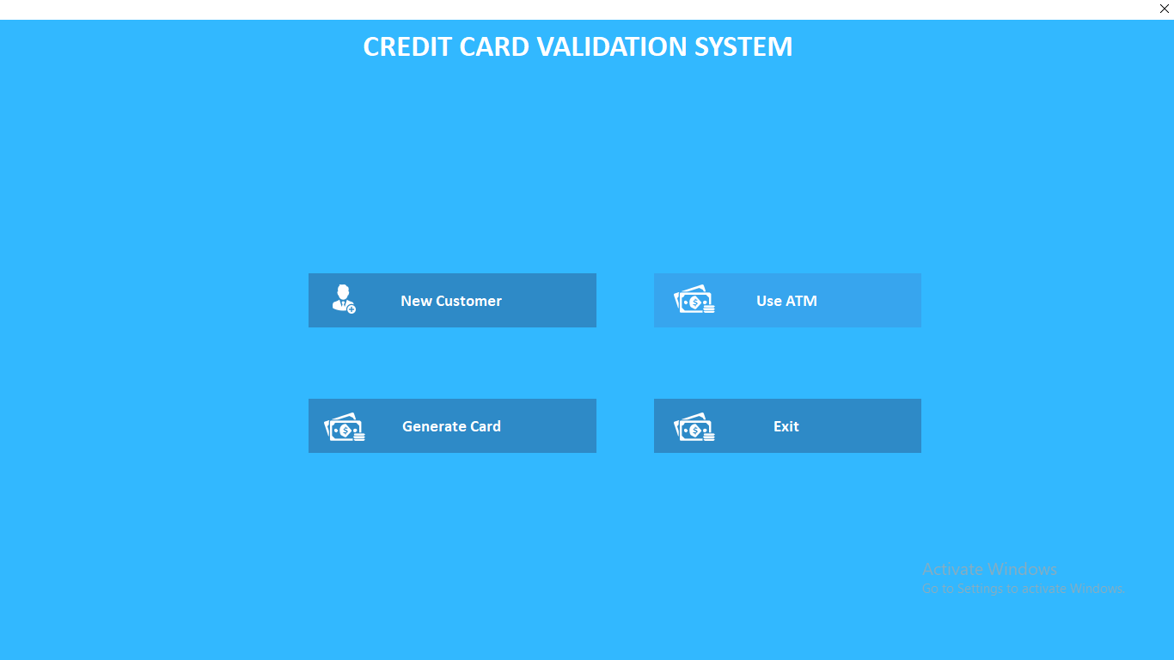
Figure 4.1: Main Menu Page Screenshot

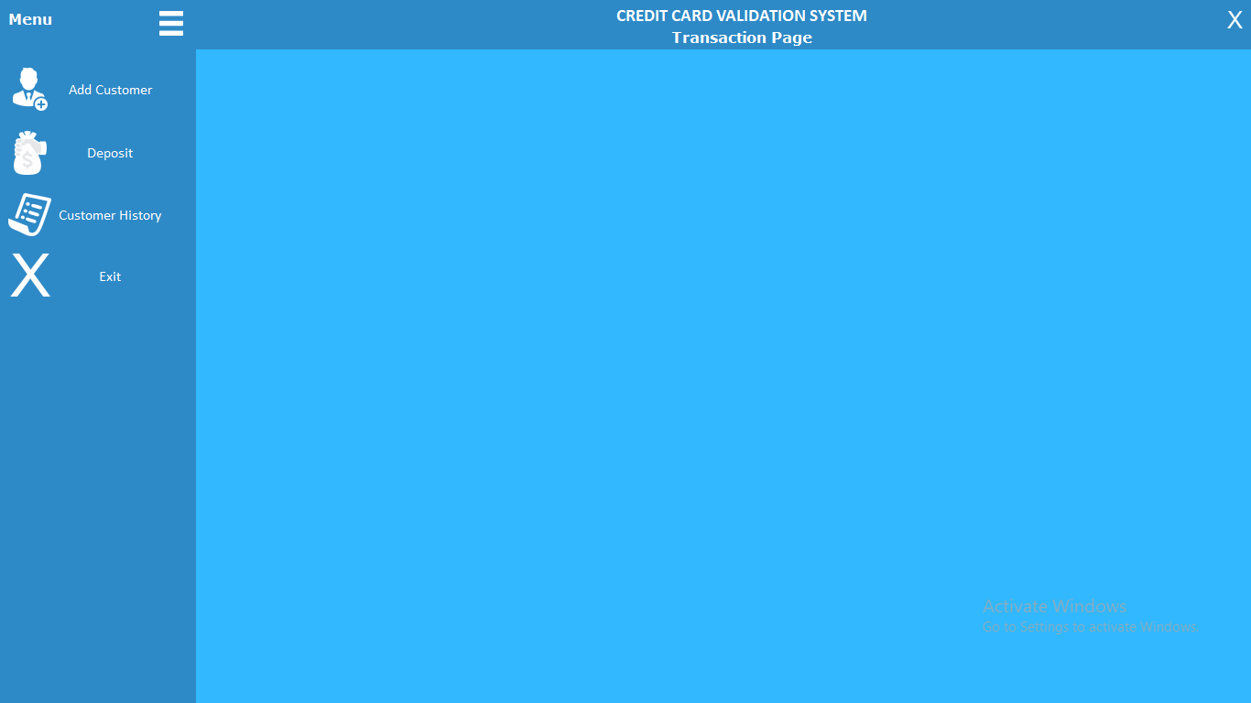
Figure 4.2: Customer Page Screenshot

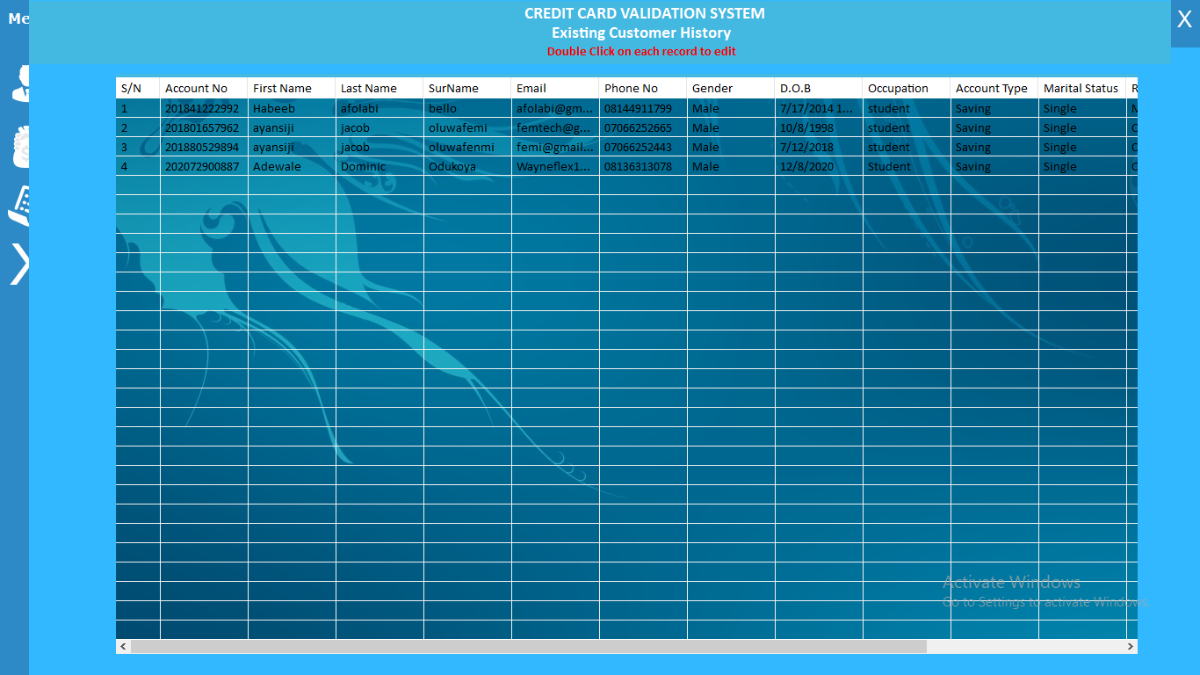
Figure 4.3: View Transaction Page Screenshot


Figure 4.4: Withdrawal Menu Page Screenshot

4.1.2 Input Design
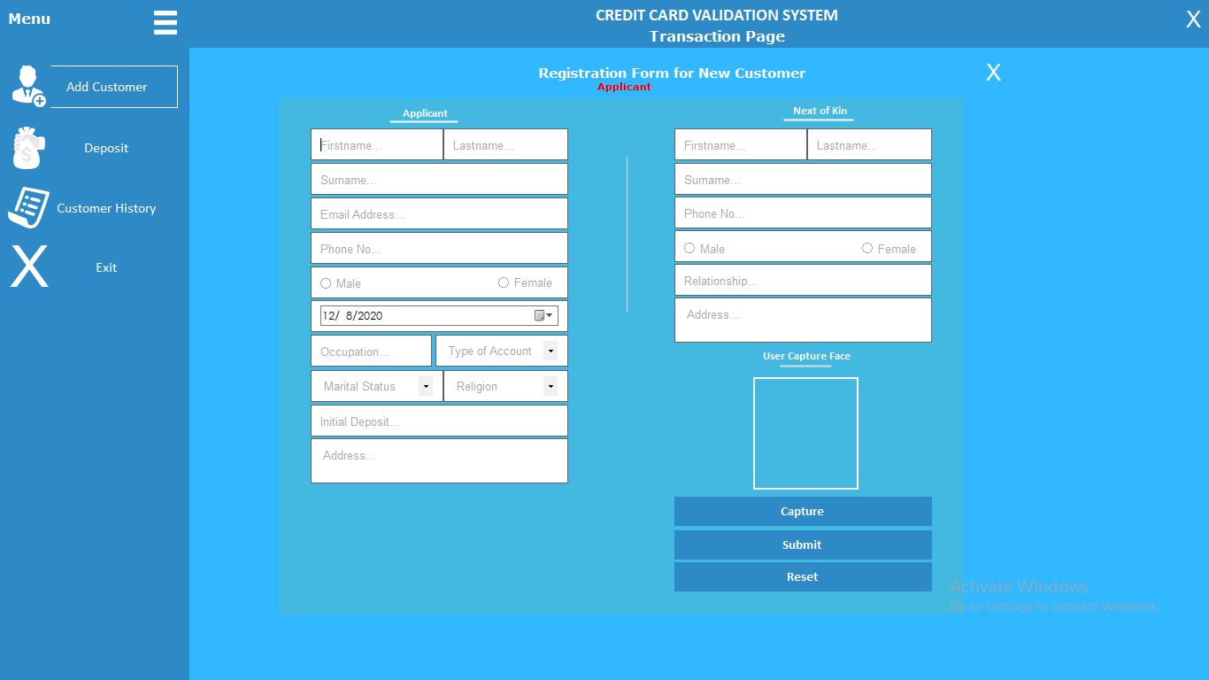

Figure 4.5: Add Customer Page Screenshot
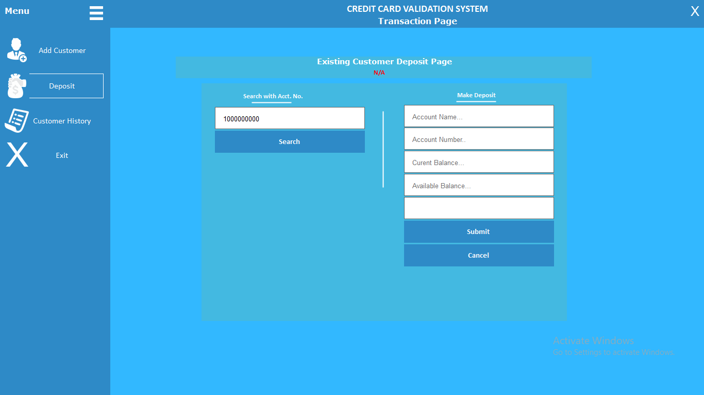

Figure 4.6: Deposit Page Screenshot.

Figure 4.7: Generate Page Screenshot
Figure 4.8: Card Validation Page Screenshot

4.1.3 Database Design

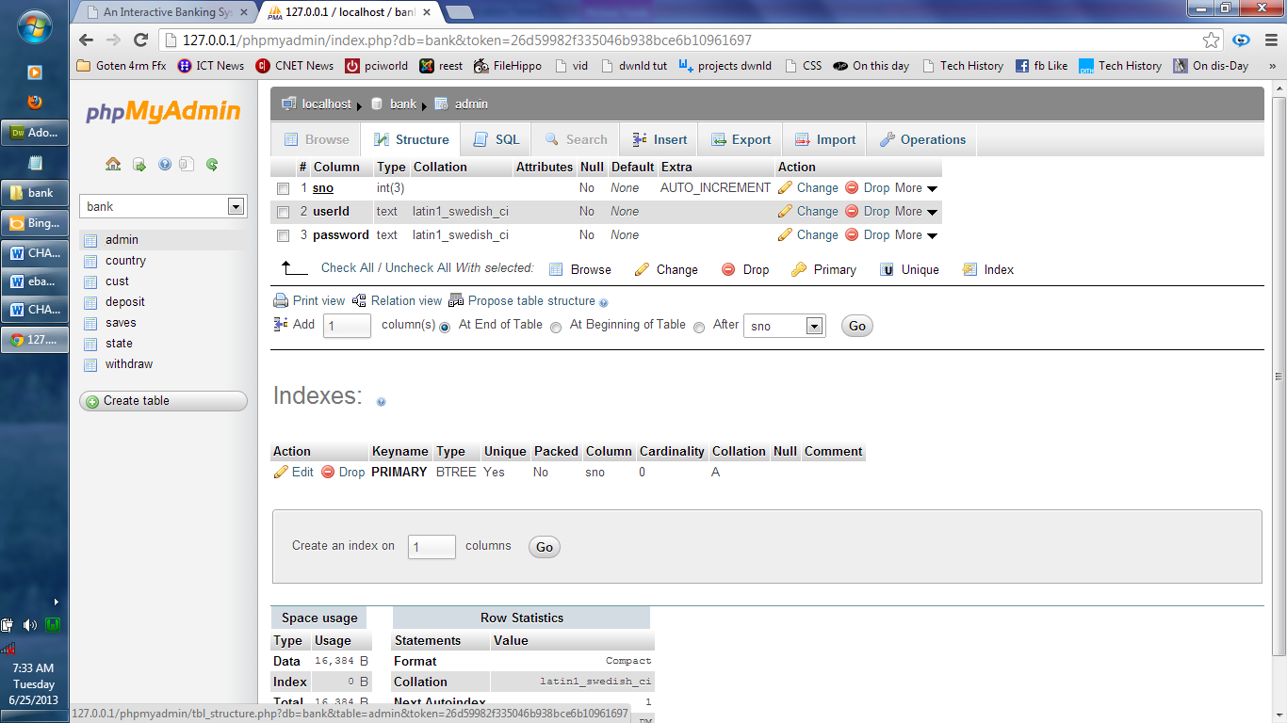
Table 4.1: The administrator table in phpmyadmin
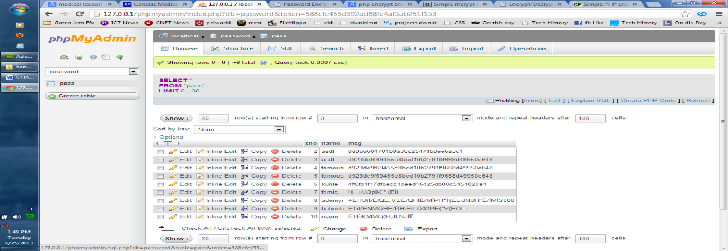
Table 4.2: The Customer Report Table Structure

4.1.4 Procedure Design
The procedural design describes the system generally. It describes the various main programs in the system as well as the relationship that exist between all subprograms included. The procedural designs in this new system are of 5 menus of which each menu has it sub menu.
The application also contains several modules of which each module has its own specific function. The purpose of dividing the program into modules is because it enhances maintainability, readability and easy debugging.
4.2 System Implementation
4.2.1 Choice of Programming Language
C# is the chosen programming language for the implementation of the proposed system because of its pedagogy and open source help when needed. As well it has a support for variety of database application like sql server, sqllite, mysql, and Microsoft access but Microsoft Access is selected.

4.2.2 Hardware Support
The computer configuration required to run the software is;
Computer/memory processor PC with a 48dx, MHZ or Pentium, Intel or higher processor required.
Memory: 512MB of RAM
Cache memory: 512KB
Hard disk Minimum size : 10.2GB
Recommended : 40GB
Virtual Memory : 32Bits
Cache memory : 512KB
Floppy disk drive : 1.44MB

4.2.3 Software Support
The software support for the design of the proposed system involves operating system, Microsoft visual studio, MYSQL as well as an anti-virus software which prevents the system from being infected by virus.

4.2.4 Implementation Techniques used in Details
The system will be implemented using the parallel approach. This approach is considered because it ensure that the new system is tested alongside with the old system to ensure the effectiveness and efficiency of the system.
4.3 System Documentation
4.3.1 Program Documentation
The system must be used as instructed according to the hardware and software supports so as to make optimal use of it.
4.3.2 Operating the System
- Click start on the computer desktop
- Select all programs
- Select any browser e.g internet Explorer, Mozilla Firefox, Google Chrome e.t.c
- Type the url (Uniform Resource Locator) of the system into the address bar (localhost/password/)
4.3.3 Maintaining the System
The following instructions must be strictly adhere to in other to make efficient use of the system. Install an anti-virus and always make sure it is usually updated to.

CHAPTER FIVE
SUMMARY, RECOMMENDATION, CONCLUSION
5.1 Summary
This study has investigated the complexities and vulnerabilities associated with credit card theft and security. It analyzed the limitations of manual credit card processing systems, highlighting issues such as human error, inefficiency, and susceptibility to fraud. The research underscored the need for enhanced security measures and more efficient transaction processing systems. It proposed a comprehensive new system incorporating advanced encryption, tokenization, multi-factor authentication, real-time fraud detection, and compliance with regulatory standards. The proposed system aims to mitigate security risks, enhance data protection, improve operational efficiency, and foster greater trust in digital payment transactions. By leveraging modern technologies and fostering collaboration among stakeholders, the proposed system addresses the key weaknesses of existing procedures and paves the way for a more secure payment ecosystem.
5.2 Conclusion
In conclusion, the existing manual credit card processing systems are inadequate in addressing the evolving landscape of cyber threats and fraud. The proposed system, with its multi-layered approach to security and efficiency, offers a viable solution to these challenges. Advanced technologies such as encryption, tokenization, and biometric authentication significantly enhance data protection and reduce the risk of fraud. Real-time monitoring and AI-driven fraud detection provide proactive measures to identify and prevent suspicious activities. Compliance with regulatory standards ensures robust security controls and legal adherence, further strengthening the system. Moreover, consumer education and stakeholder collaboration are critical components in fostering a secure and resilient payment environment. Implementing this comprehensive system will enhance the security of credit card transactions, protect sensitive financial information, and maintain consumer trust in the digital age.
5.3 Recommendations
Based on the findings and conclusions of this study, the following recommendations are proposed:
- Adopt Advanced Security Technologies: Financial institutions and merchants should implement advanced encryption, tokenization, and multi-factor authentication methods to protect credit card data and enhance transaction security.
- Invest in Real-time Fraud Detection: Organizations should utilize machine learning and AI-driven algorithms for continuous monitoring and real-time fraud detection to promptly identify and prevent fraudulent activities.
- Ensure Regulatory Compliance: Adherence to regulatory standards such as PCI DSS and GDPR is crucial for maintaining robust security controls and legal compliance. Regular audits and updates to security measures are recommended.
- Enhance Consumer Education: Implement educational programs to raise consumer awareness about safe online practices, phishing scams, and how to report suspected fraud. Informed consumers are better equipped to protect themselves against fraud.
- Promote Collaboration and Information Sharing: Encourage collaboration among financial institutions, merchants, law enforcement agencies, and cybersecurity experts to share threat intelligence and coordinate responses to emerging threats.
- Regularly Update and Evaluate Security Measures: Continuously monitor and evaluate the effectiveness of security measures to adapt to new threats and vulnerabilities. Regular updates to the system are essential for maintaining a high level of security.

References
Maniraj, et al., (2020) . "Bitcoin: Economics, Technology, and Governance." Journal of Economic Perspectives, 29(2), 213-238. doi:10.1257/jep.29.2.213
Herley, C., & Florêncio, D. (2022). "Nobody Sells Gold for the Price of Silver: Dishonesty, Uncertainty and the Underground Economy." Economics of Information Security and Privacy, 33-53. Springer, Boston, MA. doi:10.1007/978-1-4419-6967-5_3
Cherif, et al., (2023). "Introduction to Biometrics." Springer US. doi:10.1007/978-1-4419-6787-9
Ponemon Institute. (2020). "Cost of a Data Breach Report 2020." Retrieved from IBM Security
More, et al., (2022). "Information Security Management Standards: Problems and Solutions." Information & Management, 46(5), 267-270. doi:10.1016/j.im.2022.03.010
Patel (2023) "Cognitive and Physiological Processes in Fear Appeals and Attitude Change: A Revised Theory of Protection Motivation." Social Psychophysiology: A Sourcebook, 153-176. doi:10.1007/978-1-4615-6959-3_6
Patil, and Khadare, (2023). "General Data Protection Regulation (GDPR)." Retrieved from European Union GDPR Portal
PCI Security Standards Council. (2022). "Payment Card Industry Data Security Standard (PCI DSS) Version 3.2.1." Retrieved from PCI Security Standards Council
Apapan and Liu, (2020). "The Economy of Phishing: A Survey of the Operations of the Phishing Market." First Monday, 10(9). doi:10.5210/fm.v10i9.1272
Kaspersky Lab. (2021). "Financial Cyberthreats in 2020." Retrieved from Kaspersky Lab Reports

SYSTEM FLOWCHART
START

SPLASH SCREEN

LOGIN

MAIN MENU

REGISTER
MODIFY
ADMIN
ADD FRAUD
END
REPORT

REPORT
START

OPEN DATABASE
QUERY DATABASE FOR RECORD

NO
IS IT END OF FILE?

YES
DISPLAY REPORT

CLOSE DATABASE
RETURN

