DESIGN OF AN EFFICIENT SOLID WASTE MANAGEMENT AND DISPOSAL SCHEDULING SYSTEM: A CASE STUDY OF ENUGU METROPOLIS.

BY

Qamarudeen Idris Adebayo,
HND/23/ABE/FT/015

DEPARTMENT OF AGRICULTURAL AND BIO-ENVIRONMENTAL ENGINEERING INSTITUTE OF TECHNOLOGY, KWARA STATE POLYTECHNIC, ILORIN.
IN PARTITAL FULFILLMENT OF REQUIREMENT FOR THE AWARD OF HIGHER NATIONAL DIPLOMA (HND) IN AGRICULTURAL AND BIO-ENVIRONMENTAL ENGINEERING TECHNOLOGY.

AUGUST, 2025
DECLARATION

I hereby declare that this research project titled: “DESIGN OF AN EFFICIENT SOLID WASTE MANAGEMENT AND DISPOSAL SCHEDULING SYSTEM: A CASE STUDY OF ENUGU METROPOLIS. ” is my own work and has not been submitted by any other person for any degree or qualification at any higher institution. I we also declare that the information provided therein are mine and those that are not mine are properly acknowledged.

__________________ __________________
Name of Student Date and Signature

CERTIFICATION

This is to certify that this project titled: “DESIGN OF AN EFFICIENT SOLID WASTE MANAGEMENT AND DISPOSAL SCHEDULING SYSTEM: A CASE STUDY OF ENUGU METROPOLIS”was carried out by QAMARUDEEN Idris Adebayo with Matriculation Number (HND/23/ABE/FT/015), in partial fulfillment of the Award of Higher National Diploma (HND) in the Department of Agricultural and Bio-environmental Engineering, Institute of Technology (IOT), Kwara State Polytechnic, Ilorin.

______________________ _________________
Engr. Oyebanre, O.D Date
Project Supervisor

______________________ _________________
Engr. Oyebanre O.D Date
Project Co-ordinator

______________________ _________________
Engr. Dr. Dauda, K. Date
Head of Department

_____________________________ _________________
Engr. Fasasi Mikaila Babatunde Date
External Examiner

DEDICATION
I dedicate this project work firstly to Almighty Allah the unborn creator of every creature who has been there for me from my very first beginning till date. Also, to my caring and lovely parents Mr. and Mrs. Afolayan and my families for all they have done for me I pray that you will reap the fruit of your labour by the grace of God.

ACKNOWLEDGEMENT
I give my great thanks to Almighty God, the Lord of the whole universe, the sustainers who guided and provided me all I need to complete my HND (Higher National Diploma) Programme in good health.
My profound gratitude goes to my beloved parent Mr and Mrs. Qamarudeen may Almighty God grant health and bless them.
The next thank goes to my supervisor, a man of understanding honour and trust in person of Engr. Oyebanre, O.D. for being there and lenient with me. I pray may Almighty God reward you abundantly (Amen).
My appreciation also goes to the H.O.D of Agricultural and Bio-environmental Engineering Department in person of Engr.Dr.Dauda, and to all my departmental lecturers for the knowledge they have impacted in me throughout my Higher National Diploma Programme may God reward you abundantly.
Also my gratitude to my friends, stood by me. I remain disloyal if I drop my pen without appreciating my project partners . Thank you for the sincerely love we share during this research work. Also those people I am not opportune to mentioned one after the other, most especially all my course mate I appreciate you all, I will live to always remember your good deeds.
Am using this medium to pray Almighty God to bestow on me the utmost knowledge and understanding from now till eternity (Amen).

Abstract

The Design of an Efficient Solid Waste Management and Disposal Scheduling System in a metropolis is hereby presented. The design employed ten landfill sites in contrast to the existing one landfill site in the metropolis. The metropolis was divided into ten zones and a Hungarian mathematical model was used to get the optimal assignment of the proposed landfill sites to the zones. This model was applied to the field data obtained from the road net-work of Enugu metropolis and Enugu State Waste Management Authority. The result gave a 52% decrease in the total disposal cost of solid waste presently generated.

Table of Contents

Title Page………………………………………………………………………..... i Certification ii
Dedication iii
Acknowledgement………………………………………………………............. iv
Abstract………………………………………………………………………..... v
Table of contents……………………………………………………………......... vi
List of figures………………………………………………………………….... viii
List of Tables…………………………………………………………………….. ix
Nomenclature.....................................................................................................…. xi
CHAPTER ONE
1.1 Introduction…............................................................................................. 1
1.2 Solid Waste……………………………………………………………....... 2
1.2.1 Solid Waste Generation……………………………………………........... 3
1.2.2 Solid Waste Composition……………………………………………........ 6
  - The impact of solid wastes in human society………………………......... 8
  - Brief history of waste management in Enugu Metropolis………….......... 9
1.5 Statement of problem…………………………………………………....... 13
1.6 Objectives of thestudy……………………………………………............ 15
1.7 Significance of thestudy………………………….…………………....... 15
1.8 Scope of the research work…………………………….……………........ 16
1.8.1 Some Important Assumptions……………………………………............. 16
CHAPTER TWO – LITERATURE REVIEW
  - Different Approaches to solving solid waste Management problems....... 17
  - Fleet and Truck size Selection…………………………………………..... 18
  - Minimization of solid waste management……………………………...... 20
2.3.1 Compaction techniques……………………………………………........... 21
2.3.2 Incineration technique…………………………………………….......... 22
2.3.3 Shredding or Pulverizing……………………………………………........ 23
2.3.4 Component separation technique………………………………….......... 24
  - Integrated or combined solid waste management…………………......... 25
2.4.1 Landfill site………………………………………………………….......... 29
CHAPTER THREE – MATERIALS AND METHODOLOGY
  - Data Collection 32
  - The Proposed Solid Waste Management Design for Enugu Metropolis 44
    - Design Considerations for the Establishment of the Nine Landfill Sites 44
    - The Mathematical Model Used For the Scheduling System 46
3.3 The Matrix Equations 51
3.4 Data Presentation and Analysis 52
CHAPTER FOUR – RESULTS AND ANALYSIS
  - Results and Analysis 63
  - Tables of Results 63
  - Cost Analysis 66
    - Existing Scheduling System 66
    - New Scheduling System 67
  - Result of the Analysis 68
  - Discussions 73
    - Justification of the Additional Nine (9)Landfills Sites 73
CHAPTER FIVE – CONCLUSION AND RECOMMENDATION
  - Conclusion 74
  - Recommendation 74
  - Suggestions for Future Research 75
References 76
Appendix 81

ListofFigures. Page.

Figure 1.1: Composition of Solid Waste of Delhi-India……………………………… 7 Figure1.2: Road Net-Work of Enugu Metropolis………………………………….. 9
Figure 1.3: Proposed Draft Structure for ESWAMA 12

Figure 1.4: Map of Enugu Metropolis Road Network Showing
the Ten Zones and the Official Landfill Site (Ugwuaji LandFillSite) 13

Figure 2.1: Integrated waste Management…………………………………………. 27

Figure 2.2: Integrated waste Management: Flow chart of Waste collection,
Recovering, Processing and landfilling……………………………………………… 28

Figure 2.3: Dimensions of ESWAMA landfill site being used at Ugwuaji 31

Figure 3.1: Map of Enugu Metropolis road Net-work showing
the new proposed landfill sites…………………………………………………….. 33

ListofTables. Pages.

Table 1.1: Waste Generation Rates………………………………………………… 3
Table 1.2: Urban Waste Generation Rates……………………………………… … 4
Table 1.3: Municipal Solid Waste Daily Generation in Nigeria………………. …. 5
Table 1.4: Percentage waste bulks collected in the three zones…………………… 6
Table 1.5: General Composition of Waste………………………………………… 7
Table 2.1: Optimal and Existing Number of vehicles and containers……………… 20
Table 3.1: Distances from each Zone to each Landfill Site.(scale:1:35000cm)……. 34
Table 3.1a: The Ten Landfill Sites on the Map and their Symbols 35
Table 3.2: Distance from ESWAMA Office to Each Zone as in the Map……….. 36
Table 3.3: Important Data from ESWAMA Headquarter Office…………………… 37
Table 3.4: Important Data from ESWAMA Headquarter Office…………………… 38
Table 3.5: ESWAMA Bucket (Dump Sters) Distribution in the Metropolis…… … 39
Table 3.6: Summary of the Questionnaire(1)…………………………………….… 40
Table 3.7: Summary of the Questionnaire (2), Important
Averages for the Zones……………………………………………………………… 41
Table 3.8: 2006 National Population and Census Provisional Result……………….. 42
Table 3.9: Amount of Waste Generated in the Metropolis………………………. 43
Table 3.10: The Mathematical Model Table for the problem is as shown below…… 46
Table 3.11: Original Table…………………………………………………………. 53
Table 3.12: First Iteration…………………………………………………………. 54
Table 3.13: First Iteration Continued……………………………………………… 55
Table 3.14: First Iteration Continued……………………………………………… 56
Table 3.15: Table of Result for First Iteration…………………………………….. 57
Table 3.16: Optimality Test for First iteration…………………………………… 58
Table 3.17: Table of Result for First Iteration…………………………………….…. 59

Table 3.18: Optimality Test for Second iteration………………………………………
60
Table 3.19: Table of Result for Second Iteration…………………………………… 61
Table 3.20: Optimality Test for Third iteration……………………………………… 62
Table 4.1: Final Iteration Result……………………………………………………… 63
Table 4.2: Total Distance from Each Zone to a Landfill Site (Distance on Ground) 65
Table 4.3: The Variations between the Existing System and Proposed
Disposal system for the Metropolis…………………………………………………. 68
Table 4.4: The Comparison between the Existing Number of trips
and the proposed number of trips for the Metropolis 69
Table 4.5: Amount of Waste Generated in the Metropolis,
Number of Dumpsters and Compactors Required 70
Table 4.6: The Comparison between the Existing Schedule and
the New Proposed System………………………………………………………… 71
Table 4.7: Comparison of the Number of Compactors Required…………………… 72

Nomenclature
MT Metric Tonne.

WAI War Against Indiscipline.
ASESA Anambra State Environmental Sanitation Agency.
WBAP World Bank Assisted Project.
ENSEPA Enugu State Environmental Protection Agency.
ESWAMA Enugu State Waste Management Authority.
PSPS Private Sector Participations.
Kg Kilogram.
USD United States Dollars.
MWH Mega Watt Hour.
MW Mega Watt.
PVC Polyvinyl Chloride.
RDF Refuse Derived Fuel.
USEPA United States Environmental Protection Agency.
ISWM Integrated Solid Waste Management.
NPC National Population Commission.
ASPM Assignment Problem Scheduling Model.

CHAPTER ONE

  - Introduction.

For many decades now, different research institutes of many countries, private organisations as well as individuals have been trying to develop or design an effective method of handling the solid wastes generated in their environment. This is because of the conspicuous effects of these wastes which have become a matter of great concern locally, nationally and even globally. The desire to control or handle these solid waste and its attendant problems led to the different waste management methods which exist today.
According to Agunwamba (2003), the problem of solid waste management in Nigeria has become more complex in recent times due to high rate of population growth, urbanisation, and industrialisation. He also stated that increased amount of different kinds of wastes are now being generated. Ajagbe (2004) stated that changes throughout the urban centres in the country over the years, particularly in demographic expansion have brought about phenomenal increase in the volume and diversity of solid waste generated daily in the country (Nigeria). The result of this is that heaps of refuse and garbage are common sight in our cities, urban areas, state capitals and even the Federal capital Territory. Dayo, K (2011) stated that in spite of the people’s expectations, observers note that Abuja, like other cities in the country, still grapples with waste management problems; as some areas, particularly the satellite towns stink because of the refuse heaps by the streets and walkways. It is clear from the above statement that most cities in Nigeria as well as Enugu metropolis are not free from the menace of solid wastes being generated everyday in the metropolis. Also in most Nigerian cities, waste management is being carried out in a disorderly manner (fire-brigade approach) which poses a serious health hazards to their citizens (Osuji, 1994). The reason could be that most of these cities have not embraced modern engineering based approach to waste management. In Enugu metropolis, the trend is also the same.

  - Solid Waste.

A good number of great authors have defined waste based on their own perspectives. Tchobanoglous et al (1977), defined waste as any unavoidable material resulting from domestic activities or industrial operation for which there is no economic demand and which must be disposed off. According to Odocha (1994), wastes are those materials which though may no longer be needed here, may become feedstock or raw material elsewhere. It implies that what is a waste to someone may be a raw material for another person. Wastes do not, therefore, altogether apply to worthless substances around us. He also defines waste as those materials which are generated as a result of normal operations over which we have control in terms of their production, disposal or discharge. Ayaji, K (2008), stated that waste is anything that is no longer of use to the owner, which must be disposed off, of which the owner may not attach any economic value to it. Furthermore, Sridhar (1996), stated that waste is any unavoidable material resulting from domestic activities or industrial operations of which there is no economic demand and which must be disposedoff.
Wastes are generally categorized into solid, liquid and gaseous wastes. Solid wastes generated in a city or district is usually called municipal solid wastes (MSW). These wastes can be categorized as follows: hazardous or non-hazardous, combustible or non-combustible, decomposable or non-decomposable, reusable or non-reusable wastes etc. Solid wastes (SW) disposal is the disposal or careful removal of solid or semi-solid materials resulting from human and animal activities that are useless, unwanted or hazardous. Solid wastes (SW) may be classified as follows:
Garbage: Degradeable wastes from food remains.
Rubbish: Non-decomposable wastes; combustible (such as paper, wood, clothes, plastics, rubber, leader etc) or non-combustible (such as metals, glass, stones,
ceramics, bottles etc).
Ashes: Residues of the combustion of solid fuels.
Large wastes: Demolition and construction debris or trees.
Dead animals: Remains of bodies of animals.
Sewage-treatment solids: Material retained on sewage-treatment screens, settled Solids and biomass sludge.

Industrial wastes: Such as chemicals, paints and sand, computerparts, textile materials.
Mining wastes: Slag heaps and coal refuse piles.
Agricultural wastes: Farm animals manure and crop materials.

Solid WasteGeneration.
The rate at which solid wastes are been generated depends on a good number of factors which includes: the human population of the area under consideration, the living standards of the people, and their attitudes to waste prevention and control. According to Tehbanogolous, George, et al. (1977), solid waste products arise from our ways of life. Smart, N.U (2002), stated that when living standards rise, people consume more and waste increases. Cointreau- Levine, S (1999), in table 1.1 shows the waste generation (in kg/capital/day) of low-income, mid- income and high -income countries. The table 1.2 shows the solid waste generation rate of some cities/ countries of the world while table 1.3 shows the solid waste generation in Nigeria.

Table 1.1: Solid Waste Generation Rate of some Cities/ Countries.

 | Waste generation rates (in kg/capital/day)
 | Low-income  Country | Mid-income  country | High-income  Country
Mixed urbanwaste largecity  (>500000) | 0.50-0.75 | 0.55-1.1 | 0.75-2.2
Mixedurbanwastesmalltomediumcity  (<500000) | 0.35-0.65 | 0.45-0.75 | 0.65-1.5
Residential  wasteonly | 0.25-0.45 | 0.35-0.65 | 0.55-1.0
Source: Cointreau-Levine, S. (1999).

Table1.2: Urban Waste Generation Rates.

S/N | City or country | Kg/person/day
i) | Industrialized countries
1 | New Yoke city, USA | 1.80
2 | Hamburg ,Germany | 0.85
3 | Rome, Italy | 0.69
ii) | Middle- income countries
4 | Singapore | 0.87
5 | Hong Kong | 0.85
6 | Tunis, Tunisia | 0.56
7 | Medline, Colombia | 0.54
8 | Kano, Nigeria | 0.46
9 | Manila, Philippines | 0.50
10 | Cairo, Egypt | 0.50
iii) | Low-income country
11 | Jakarta, Indonesia | 0.50
12 | Surabaya, Indonesia | 0.60
13 | Bandung, Indonesia | 0.52
14 | Lahore, Pakistan | 0.55
15 | Karachi Pakistan | 0.60
16 | Calcutta, India | 0.50
17 | Kanpur, India | 0.50

Source: Sandra (Outreach, 1982)

Table 1.3: Municipal Solid Waste Daily Generation in Nigeria.

S/N | State | Metric Tonne
1 | Abia | 2000
2 | Adamawa | 800
3 | Anambra | 2500
4 | Akwa-ibom | 700
5 | Balyesa | 600
6 | Bauchi | 900
7 | Benue | 800
8 | Borno | 900
9 | Cross River | 750
10 | Delta | 850
11 | Ebonyi | 600
12 | Edo | 900
13 | Ekiti | 800
14 | Enugu | 1000
15 | Gombe | 500
16 | Imo | 1000
17 | Jigawa | 600
18 | Kaduna | 1000
19 | Kano | 2000
20 | Kastina | 800
21 | Kebbi | 700
22 | Kogi | 500
23 | Kwara | 700
24 | Lagos | 6000
25 | Nassarawa | 400
26 | Niger | 700
26 | Ogun | 1000
28 | Ondo | 800
29 | Osun | 700
30 | Oyo | 1100
31 | Plateau | 700
32 | Rivers | 1500
33 | Sokoto | 900
34 | Taraba | 400
35 | Yobe | 400
36 | Zamfara | 400
37 | FCT | 3000
Source: Johnson, E (2006)

    - Solid WasteComposition.
The composition of solid waste generated from any given area depends on what the people throw away as waste. Uchegbu, S.N (2002), stated that in industrialized countries, packaging of goods contributes about thirty (30) per cent of the waste and fifty (50) per cent of the volume of household waste, food and yard scraps account for the remainder. Furthermore, he stated that in Nigeria, the average mass of waste disposed in big cities is 46kg/person/day. Aliyu Baba Nabegu (2011), in his journal (Solid Waste and Its Implications for Climate Change in Nigeria) presented a table 1.4 of waste composition of some zones inNigeria.
In Delhi- India, Dass Ravi (2007) stated that the solid waste generated in Delhi is approximately 6,000–6,500 MT per day with a collection efficiency of 95%. The composition of solid waste in Delhi is shown in Figure 1.1. The chemical characteristics of solid waste are as follows: moisture (43.65%), silt/inert (34%), organic carbon (20.47%), nitrogen (0.85%), potassium (0.69%), and phosphorus (0.34%) (Dass Ravi (2007)).Table
1.5 shows the general composition of waste in Malaysia.

Table 1.4: Percentage waste bulks collected in the three zones

zone  waste | Nsukka | Lagos | Makurdi | Kano | Onitsha | Ibadan | Maiduguri
Putrescible | 56 | 56 | 52.2 | 43.0 | 30.7 | 76 | 25.8
Plastic | 8.4 | 4 | 8.2 | 4.0 | 9.2 | 4.0 | 18.1
Paper | 13.8 | 14.0 | 12.3 | 17.0 | 23.1 | 6.6 | 7.5
Textile | 3.1 | - | 2.5 | 7.0 | 6.2 | 1.4 | 3.9
Metal | 6.8 | 4.0 | 7.1 | 5.0 | 6.2 | 2.5 | 9.1
Glass | 2.5 | 3.0 | 3.6 | 2.0 | 9.2 | 0.6 | 4.3
others | 9.4 | 19.0 | 14.0 | 22.0 | 15.4 | 8.9 | 31.3

Source: Aliyu Baba Nabegu (2011),

Table 1.5: General Composition of Waste in Malaysia.

Materials | % by Weight
Organic | 47.0
Paper | 15.0
Plastics | 14.0
Wood, garden waste | 4.0
Metal | 4.0
Glass | 3.0
Textile | 3.0
Other | 10.0
Source: Huszain Huzin (2004).

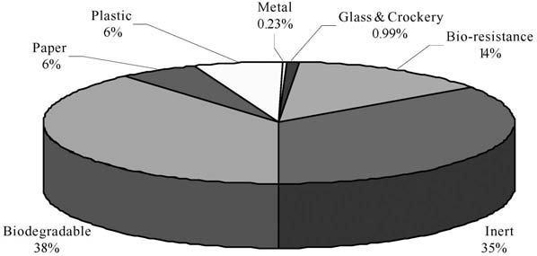

Figure 1.1: Composition of Solid Waste of Delhi-India. Source: Dass Ravi (2007)

  - The impact of solid wastes in humansociety.

The impact of solid wastes in human society cannot be over-emphasized. Land, water and air pollutions are all because of the accumulation of solid wastes, which also open doors for disease spread, with consequent suffering and hardship, stunted economic development and diminished productivity. Anupam Khajuria et al (2010) stated that in developing Asian countries, the municipal co-operations are unable to handle the increasing amount of municipal solid waste, which has led to the uncollected waste being spread on roads and in other public areas leading to tremendous pollution and destruction of land and negative impact on human health. Uchegbu (2002), in his research work stated that “Cholera out- breaks or spread in most part of Nigeria had been as a result of accumulation of solid wastes in our society”. According to him, the life expectancy in developing countries is fifty-three
(53) years while that of developed countries is seventy- five (75) years and the reason is that waste management is still very poor in our society when compared to that of developed countries. Most drainage gutters are being blocked with solid wastes; as a result flood now destroys many of our tarred roads, residential houses, farmlands, hospitals, schools etc. From observation, most streams in our society are no longer drinkable because of the poisonous liquid from solid wastes that filters into it. Dayo (2011), in his article stated that water sources near such waste dumps easily become contaminated and a consequence, explains Dr Ibrahim Idris, an expert in community health, is the spread of gastro-intestinal and parasitic diseases. The awful odour that comes out of these wastes is irritating to the members of the society. In spite of all these problems associated with solid wastes in our society, an appropriate waste management system if applied can handle these problems and make human environment decent and enjoyable.

  - Brief history of waste management in EnuguMetropolis.

Enugu metropolis in Enugu state was used as a case study in this research work because of the solid waste management problems it suffered in the last regime of the state. In 2006, Enugu was regarded as one of the dirtiest cities with over one thousand (1000) metric tonne of waste generated daily (Ezeanyanwu, 2006). Heaps of refuse were like mountains along the roads and streets exposing the environment to severe pollution.
Enugu metropolis is made up of three local government areas namely: Enugu North (State Headquarters), Enugu East and Enugu South. The metropolis occupies an important socio-economic position in Enugu state and Eastern zone of Nigeria. The human population of the metropolis during 2006 census was seven Hundred and twenty-two thousand, six Hundred and sixty-four (722,664). Figure1.2 below shows the road net-work of Enugu metropolis.
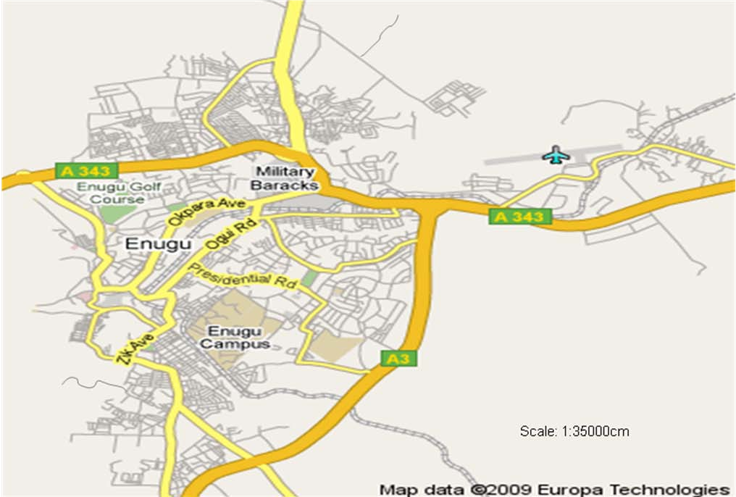

Figure1.2: Road Net-Work of Enugu Metropolis. Source: Map data Europa Technologies(2009).

According to Frank Egwu (2008), the history of waste management in Enugu and Nigeria at large can be traced by the Local Government administration on sanitation. Before creation of the taskforce in charge of sanitation, Local Government Areas were responsible for environmental cleanliness as entrenched in 1979 constitution of Nigeria. This continued until 1985 when the waste management leadership of Enugu changed baton. The then military governor of Anambra State, Navy Captain Monday Ikpeazu launched a taskforce on environmental cleanliness as a complementary to the decree of War Against Indiscipline (WAI) by Major General Buhari through Lt. Ideagbo, the then officer in charge of WAI. The people reacted negatively to the WAI because of the forceful and brutal nature of the military. This was a problem and solid waste management in the metropolis was still very poor. In 1985, the Anambra State Environmental Sanitation Agency (ASESA) was established by Edit No: 15 of 1985 and their activities were enhanced by the introduction of the World Bank Project in 1985 (Agunwamba, 2003). They were responsible for the collection and disposal of solid waste generated in Enugu metropolis using container trucks, tippers, side loaders and rear loading compaction trucks used for collection of wastes from bins placed at different positions, municipal containers and built-up dumps placed at strategic positions. Disposal of the solid waste was mainly at a sanitary landfill or controlled landfill site.
ASESA used the method of built-up temporary dumps which gave rise to indiscriminate dumping of wastes, environmental pollution and spread of diseases in the metropolis. ASESA also used a more civilized approach in their management which empowered the citizens to participate in the maintenance and cleaning of the environment. ASESA continued to be in charge of environmental sanitation in the metropolis until 1991 when Enugu State was created (Egwu, 2008). Assets and liabilities of ASESA were shared among Enugu and Anambra State. This affected the number of available solid waste management equipment for Enugu metropolis. The World Bank Assisted Project (WBAP) on sanitation based at Onitsha then, collected all their waste management equipment and this helped to compound waste management problem in Enugumetropolis.
As a result of this lack of equipment, Enugu state established a new agency (ENSEPA) that will be responsible for managing all the environmental problems including collection and disposal of solid wastes generated in the state. Enugu State EnvironmentalProtection

Agency (ENSEPA) procured new equipment which includes three compactors and some cubic-containers, but these were not sufficient for handling the volumes of wastes generated. As a result of this, the agency divided Enugu into zones and officers were recruited to man each zone. The agency made use of built-up refuse dumps or temporary transfer stations where wastes were gathered for a certain period of time and then, transferred to the sanitary landfill. ENSEPA also made use of managing director cum chief executive officer unlike ASESA that used general manager, and this actually gave boost to waste management in Enugu state as a whole. Enugu continued to suffer the lack of waste disposal equipment.
In 2004, there was a noticeable problem of waste management in the country, so, the federal government created the Ministry of Environment and Mineral Resources (Egwu, Frank (2008). This ministry will be in charge of managing environmental problems which include: land pollution, land degradation, erosion control, deforestation etc, while other environmental protection agencies will take care of solid and liquid wastes problems of the environment. It was at this period that Enugu State Waste Management Authority (ESWAMA), an off-shoot of ENSEPA, which now manages both solid and liquid wastes generated in Enugu state, was established.
ESWAMA was established in 2004 through Decree number 8 of 2004 constitution and was officially launched on 25th January, 2005 (Ayaji, 2008). This agency inherited both the assets and the liabilities of ENSEPA, but since then, a lot of innovations had been put in place to improve solid waste management in the state. ESWAMA started its innovation activities by first of all re-organizing its organizational structure as shown in figure 1.3. New offices were created and more staffs were recruited to man these offices. The agency also divided Enugu metropolis into ten (10) zones: (1) Abakpa, (2) GRA, (3) Trans-Ekulu, (4) New Haven/ Emene, (5) New Layout, (6) Ogui/Asata, (7) Coal Camp/Agbani Road, (8) Idaw River/Garriki, (9) Achara Layout, (10) Independence Layout zone (see figure 1.4 below). The operation bag your waste and Private Sector Participation (PSPs) were introduced. Bagging of waste was introduced because it is portable, hygienic, reduces litter and stops odour spread. The PSPs collect wastes from streets and zones assigned to them, sensitize the people in the area and collect revenue from the people residing in the area, street or zones. The PSPs no longer collect fees or revenues from the people because of some misappropriation of revenues collected. ESWAMA revenue unit handles thisexclusively.

The ESWAMA also procured one thousand (1000) waste collection buckets or dumpsters; nine hundred and thirty (930) of it was given to Enugu metropolis, while seventy (70) of it was distributed to other parts of the state. Fourteen compactors were procured, and one of them is being used at Nsukka Local Government Area (Greg, 2009). The responsibilities of waste management in Enugu state is now being shared by ESWAMA, the PSPs and the general public. According to Anyaegbudike (2009), ESWAMA is partly funded by the government and internally generated revenue, but eighty-five per cent (85%) of the money is gotten from the inhabitants of the metropolis.

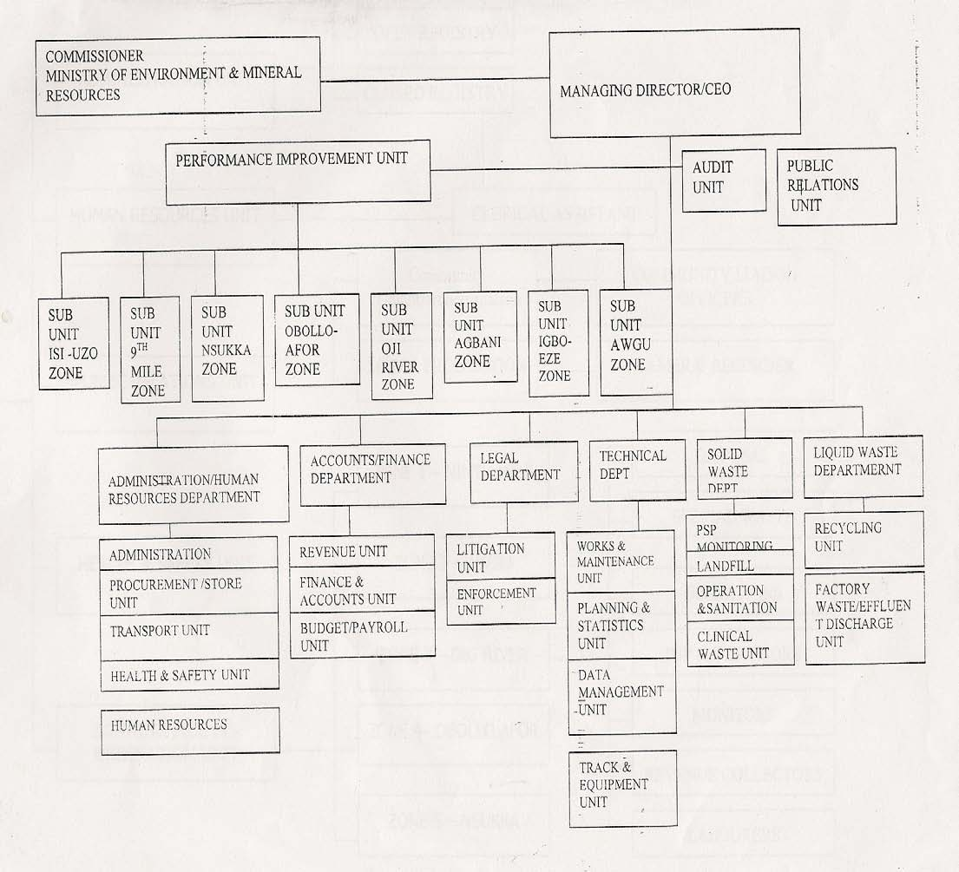

FIGURE 1.3: Proposed Draft Structure for ESWAMA
SOURCE: Egwu Frank (2008).

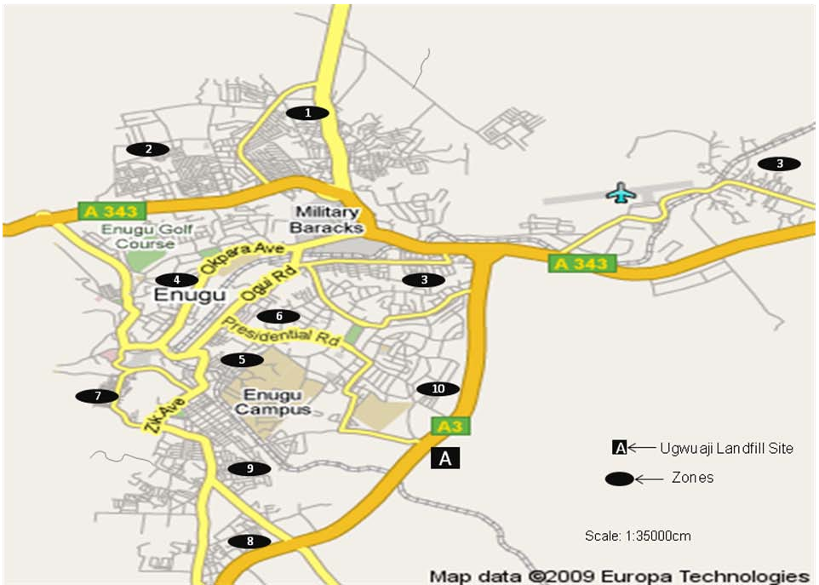
Figure 1.4: Map of Enugu Metropolis Road Network Showing the Ten Zones and the only Official Landfill Site (Ugwuaji Land Fill Site)

  - Statement ofproblem.

The chequered history of Enugu state waste management was briefly explained in the back-ground study of this research work. The management had suffered lack of waste management equipment, inadequate funding and man-power to handle the various activities of the agency. In an interview granted by the Public Relation Officer of the ESWAMA, Mr. Egwu Frank (2007), he stated that the major challenges facing the management are inadequate funding and operational logistics. In addition to these, he stated that the people’s negative attitude towards waste disposal contributes to the problems of the agency. The operational manager of ESWAMA, Ayaji (2008), in an interview stated that the problems of the agency include: lack of important waste management equipment like excavators,

bulldozers, pail-loader, tippers and compactors, insufficient buckets (dumpsters), insufficient funds and operational logistics. This problem of insufficient dumpsters is also prevalent in Accra, Ghana (See appendix 41). The available compactors cannot collect all the solid wastes being generated in the metropolis daily. He further stated that the welfare of the workers is not properly considered especially during the last regime of the former administrator of Enugu state (Ayaji,2008).
The Managing Director and Chief executive officer of the ESWAMA, Engr. Greg Anyaegbudike, stated that it costs the agency more than one hundred and forty million
(N 140,000,000) nairas to keep the Enugu metropolis clean in a year excluding staff salaries (Anyaegbudike, 2009). The agency at present has one thousand buckets; nine hundred and thirty are being used at Enugu and the other seventy are being used in other parts of the state, eleven compactors, one pay-loader and a tipper. One compactor is being used at Nsukka while the other ten are distributed to the ten zones of the metropolis.
Despite all these efforts made by the chief Executive Manager of ESWAMA, the agency still have logistic problems which causes in-efficiency in waste disposal in themetropolis.
One unique problem of the agency is that it has only one landfill site located at Ugwuaji (figure 1.4) along Port Harcourt road. Just as it is in Uganda, according to Michael
K. Nganda (2007) about half of the waste generated in Kampala, the capital city of Uganda, is collected and disposed of at the only landfill at Kiteezi and as a result of this, less than half of the waste were left in the open, which litters the city whenever the wind blows and whenever rain falls. This explains the incidence of the annual cholera outbreaks during the rainy seasons and the terrible stench from the city areas where the waste accumulated decays. This is the same for Enugu metropolis. All the compactors collecting waste in the metropolis will only empty its content at Ugwuaji landfill site. This had caused the inability of the compactors to collect all the solid wastes generated in the metropolis, which are evident by the open dumps here and there along the roads and filled-up dumpsters are not collected for more than three weeks. Some of these mountains of wastes are seen along major roads in Enugu (see appendix 11 - 53). In some areas, it causes partial or total blockage of main roads resulting to unnecessary traffic jams (appendix 42, 45, 51,52) and also blockage of drainage gutters (appendix 44) The odor oozing out of the wastes irritates inhabitantsofthemetropolis(appendix11,12).Someoftheriversthatflowthroughthe

metropolis are contaminated with solid wastes (appendix 23, 31, 32). Also, some good agricultural lands are impoverished by these solid wastes (appendix 24, 25).
The compactors are over-used which causes their constant breaks-down, worn-out tyres, burst hydraulic pipes and air pipes, and engine knock (appendix 4-10). The result would be high maintenance cost and inefficiency. Despite all these problems, a good solid waste management approach will help to improve the efficiency of the agency by reducing the long distances travelled by the compactors, thereby reducing maintenance and operational costs.

  - Objectives of thestudy.

The main objective of this research work is to design an effective waste management system that will reduce the operational cost of ESWAMA and improve its waste disposal efficiency. These specific objectives are:
- To establish nine more landfill sites other than the former one at Ugwuaji whichwill help to reduce the long distances travelled by thecompactors.
- To develop a solid waste disposal schedule that will minimize cost of transportingthe waste generated in the metropolis using a mathematicalmodel.
- To compare the result with the existing schedule with respect to efficiency andcost.
- To suggest the use of other waste management methods that will help to reduce the quantity or volume of solid waste that go into the landfillsites.

  - Significance of thestudy.

The rate at which solid wastes are beginning to accumulate in Enugu metropolis again is alarming and if nothing is done very fast, Enugu metropolis may become the dirtiest city in Nigeria. The deplorable state of these newly acquired compactors as a result of over-usage is alarming. This study if applied will go a long way in solving the problem of long distances travelled by these compactors in such a way that the operational (transportation) cost will be minimized and the life span of the compactors improved. In addition, this will help the Planning Department of ESWAMA to plan on how to schedule the transportation of the

waste generated in the metropolis in the future. Finally, this research work will demonstrate how industrial engineering knowledge can be used to solve solid waste disposal problems.

  - Scope of the ResearchWork.

This research work is designed for solid waste management in Enugu metropolis. It will examine the effect of the population of the metropolis with the waste generation of the area. It will also examine other solid waste management approaches that can help to reduce the amount of wastes that go into the landfillsites.
The work will examine the effect of creating nine more landfills on cost of transporting wastes and the efficiency of the new waste disposal method. An appropriate scheduling system will be used to analyse the cost effectiveness of this method from collecting sites to disposal sites. The average distance from the centre of each zone to the landfill site will be used.

    - Some ImportantAssumptions.

Inthecauseofthisresearch,someimportantassumptionsweremade.These assumptions include:
- A centre for each zone was chosen by observation from which measurements of distances (along the roads) were taken from each zone to each landfillsite.
- Also, the position of the landfill site in each zone was chosen after considering the factors affecting the establishment of a landfillsite.
- The compactors are working at its full capacity and the trucks are assumed tobe fully loaded upon leaving the waste collectionpoints.
- Each landfill site can take care of a zone in the metropolis for forty (40)years.
- A centre for each zone was chosen by observation from which measurement of distances were taken from each zone to each landfillsite..

CHAPTER TWOLITERATURE REVIEW.
  - Different Approaches to solving solid waste Management problems.
Solid waste management is borne out of the desire to control environmental
pollution with its attendant health hazards and this had stirred up great researchers (foreign and indigenous) to write on waste management. According to Smith S.E (2011), solid wastemanagement is a polite term for garbage management. As long as humans have been living in settled communities, solid waste, or garbage, has been an issue, and modern societies generate far more solid waste than early humans ever did. Daily life in industrialized nations can generate several kilograms of solid waste per consumer, not only directly in the home, but indirectly in factories that manufacture goods purchased by consumers. Solid waste management is a system for handling all of this garbage; municipal waste collection is solid waste management, as are recycling programs, dumps, andincinerators.
From the definition in BusinessDictionary.com, Solid waste management is a systematic control of generation, collection, storage, transport, source separation, processing, treatment, recovery, and disposal of solid waste. In the world today, many countries approach solid waste management problems differently due to the kind of wastes they generate and the type of waste management equipment available in their countries. Therefore, a broad literature is available on studies that deals with different methods used in solid waste management. Some of these literatures according to Toochukwu, O.C (2005) includes: Optimisation of solid waste collection system Agunwamba, J.C (2003), fleet and truck size selection (Ojiako and Nwosu, 1989), Solid wastes: Engineering Principles and Management Issues (Tehbanoglous et al, 1997), Waste generation and Management in a depressed Economy (Odocha, 1994). Other ones are Integrated Solid waste management (MacDonald and Vopni, 1994), Vehicle routing and Optimisation of solid waste collection routes (Chang, et al, 2002) etc. Solid Waste management practices differ for developed and developing nations, for urban and rural areas, and for residential and industrial producers. It is commonly observed that in most third world countries like Uganda, Nigeria (Enugu state) etc, are still battling with the problem of being able to evacuate or dispose all the solid wastes generated daily in their environment, while developed countries like America, Great Britain,JapanandGermanyareresearchingonhowtorecoveralltheusefulthingsfrom

their solid wastes. In support of the above statement, Anupam Khajuria et al. (2010) stated that the common problem faced by all developing Asian countries, is the disposal of municipal solid waste and availability of land fill site area. Based on the above statement, it is quite understandable that the waste management approach will be different for the two groups ofcountries.
This section will present some review of relevant literatures on approaches to solving waste management problems under the following sub-headings:
  - Fleet and Truck sizeSelection
  - Minimization of solid wastemanagement
  - Integrated or combined solid wastemanagement.

  - Fleet and Truck sizeSelection.

Wood (1986) had examined selecting the right vehicle for collection operation as the best way of optimizing the collection problem by considering these factors like total weight, length, and types of collections and operators productivity. Orjiako and Nwosu (1989), proposed a mixed integer-programming model to balance the crew size and the number of vehicles. The mixed integer-programming model was solved using a simplex algorithm instead of the branch and bound method. The model lacks the features of a modern crew selection method. According to Robert M. Clark (1972) collection of solid waste is much more expensive than its disposal. Most municipal collection fleets are made up of packer trucks that service areas with dissimilar topography, population density, and waste generation rates. When vehicles are selected for solid waste collection fleets there is usually very little consideration given to providing the required service at minimum cost. One possibility for minimizing collection costs is to select a fleet of various-sized packer trucks, while simultaneously satisfying the service constraints. To illustrate this approach, the waste collection system of a large metropolitan area is analyzed for proper fleet size and type of packer vehicle. Selection of the optimal fleet size and type of packer truck is formulated and solved as a linear programmingproblem.

Agunwamba, J.C (2003), did an excellent work on optimization of solid waste collection system in Onitsha, Nigeria. His focus was on the optimal combinations of collecting vehicles, containers and their distributions in each zone, which will ensure efficient collection at minimal cost. The work considered how best to assign different types of vehicles and containers to the six zones of Onitsha such that the waste disposal will be efficient and at a minimal cost. The problem was formulated as an integer problem with a cost objective function and constraints. The solution to the optimization problem formulated from the data collected was obtained using TORA Optimization System. His result showed that the existing distribution and combination of waste collection vehicles require alteration in order to achieve optimality. His optimality cost for effective and regular collection of waste was N 21,039,512.50. In the case of Enugu state, one type of vehicle is being used for waste collection in the metropolis (see appendix 5, 6). The table 2.1 shows one of his optimal tables.
Another excellent work on solid waste management was done by Otti (2010). His research paper was on a model for solid waste management in Anambra State, Nigeria. His research was aimed at determining which type of integrated solid waste management option or programme will be used to implement minimized cost and maximized benefit (benefit cost ratio) over a long period of planning period. He applied a linear programming model that takes into account the scheduling decision, benefit Over-time, budget constraints and constraints on the number of equipment available to effectively implement the project. According to Tomas et al (1979), Linear Programming is an objective function that optimizes cost or gain as it is subjected to the constraints and involves some decisions. His work also contains many innovative features and removes many limitation frequently encountered in most existing optimization modeling for waste management. His optimality cost for effective and regular collection of waste for Anambra state is N 426 Million =USD
2.84 Million.

Table 2.1: Optimal and Existing Number of vehicles and containers.

Zones  Vehicles/ containers | 1 | 2 | 3 | 4 | 5 | 6
Side- loader (1) Tippers  Manually loaded (2)  Mechanically loaded (3) | 6(3)  -  6(7) | (5)  5  - | (4)  -  - | 12 (3)  -  - | (2)  -  - | 6(4)  -  -
Container truck (4) Rear loadingcompactor Truck(5) | (1)  - | 3 (1)  - | 1 (1)  7(3) | (1)  - | 1 (1)  - | (1)  2 (2)
Bins (0.4m³)(6)  Bins (1.5m³)(7)  Container (16m³) (8) | 2 (2)  97  - | 353  - 24 | - 89  8 | 529  -  - | -  - 8 | 270  529  -

Source: Agunwamba (2003)

  - Minimization of solid wastemanagement.

Solid waste disposal can be very expensive especially in areas where the cost of purchasing a landfill site is very costly. The American Institute for Local Self Reliance in Washington, D.C, stated that “Zero waste is a philosophy and a design principle for the 21st Century; it is not simply about putting an end to land filling. Aiming for zero waste is not an end-of-pipe solution. That is why it heralds fundamental change. Aiming for zero waste means designing products and packaging with reuse and recycling in mind. It means ending subsidies for wasting. It means closing the gap between landfill prices and their true costs. It means making manufacturers take responsibility for the entire life cycle of their products and packaging. Zero waste efforts, just like recycling efforts before, will change the face ofsolid

waste management in the future. Instead of managing wastes, we will manage resources and strive toeliminatewaste.” The need to practice and apply some volume reduction techniques to the amount of solid waste that goes into the landfill site becomes necessary. These volume reduction techniques are refuse-processing techniques, which helps to improve on the efficiency of waste management operations, to recover useful resources and energy recovery from wastes. Some of these techniques include compaction, incineration, shredding, composting of organic wastes, component separation, drying and dewateringetc.

    - Compactiontechniques.

This is a mechanical volume reduction technique, which helps to increase the useful life of landfills. Here wastes are compacted with the help of high-pressure compacting systems to small volumes before disposing them into landfill sites. According to MarlaLS (2010), Compactors promote better housekeeping by providing a convenient place to dispose of trash. They reduce insect and rodent problems inside facilities by keeping pests out of trash and also allow retail companies to efficiently recycle paper and plastics by compressing them into bales that can be transported easily to recycling centres. Compacting equipment reduces large amounts of waste to smaller units by using powered rams to crush the garbage. It also makes waste disposal more efficient by compressing the waste so it requires less space in landfills, which reduces the garbage level in dump sites. Daniel P. Duffy (2006) stated that the municipal solid waste deposited at a landfill has a density of 326.30 kg/m³ to over 385.62 kg/m³. Costs and economics are the primary metrics for determining which method or methods should be used. In some cases, operating costs and market economics may decree that little if any compaction is warranted. Standard landfill compaction is done with specialized earthmoving equipment designed for operations in waste. More extreme waste compaction can be achieved with mechanical waste balers and dynamic compaction using impacts from heavy weights dropped from great heights. Counter-intuitive methods of airspace minimization include pre-shredding the waste (which initially fluffs up the waste and increases its volume) and mining the waste, an activity that reduces airspace without any compactionatall.MarlaL.S.(2010),inhisresearchworkstatedthatcompactingequipment

reduces large amounts of waste to smaller units by using powered rams to crush the garbage. Three types of these compactors were identified, they includes:
- Vertical compactors, which typically have material containers that are 4.587 m³or 6.1164m³, can handle a large volume of wastematerial.
- Stationary compactors, also called breakaway compactors, have a removable material container, which can be picked up by truck that usually ranges between 30.5822 m³and 31.1113 m³in size. Businesses use this type of compactor for solid waste or recyclable material.
- Apartment compactors for residents of high-rise apartment buildings dispose of solid wastes, such as metals, paper, cotton and cardboard boxes. Compactors compress these waste materials into bales that can be transported to disposal facilities or recycling centres. Although businesses ranging from manufacturing to retail use the majority of compactors, people also have them in their homes, according to the National Institute for Occupational Safety andHealth.

    - Incinerationtechnique.

According to Tchobanoglous et al (1977) incineration is the controlled process by which solid, liquid or gaseous combustible wastes are burnt and changed into gases, and the residue produced contains little or no combustible materials. This is a chemical reduction technique. It serves both for volume reduction and for power generation. According to Ramboll (2006), the heat produced by an incinerator in Denmark can be used to generate steam which may then be used to drive a turbine in order to produce electricity. The typical amount of net energy that can be produced per tonne municipal waste is about 2/3 MWh of electricity and 2 MWh of district heating. Thus, incinerating about 600 metric tonne per day of waste will produce about 400 MWh of electrical energy per day (17 MW of electrical power continuously for 24 hours) and 1200 MWh of district heating energy each day. In under-developed countries, most often, open air burning are usually in practice without any concern for air pollution and global warming. He also stated that the solid waste volume can be reduced to 80% of its original volume. This is what makes incineration very interesting butithasaseriouseffectontheenvironment(globalwarmingandairpollution).InWorld

Health Organization fact sheet N’ 281 (October 2011) stated that when wastes are incinerated at low temperatures or when plastics that contain polyvinyl chloride (PVC) are incinerated, dioxins and furans and other toxic air pollutants may be produced as emissions and/or in bottom or fly ash (ash that is carried by air and exhaust gases up the incinerator stack). Exposure to dioxins, furans and co-planar PCBs may lead to adverse health effects. Long-term, low-level exposure of humans to dioxins and furans may lead to the impairment of the immune system, the impairment of the development of the nervous system, the endocrine system and the reproductive functions. Short-term, high-level exposure may result in skin lesions and altered liver function. Exposure of animals to dioxins has resulted in several types of cancer. In Enugu metropolis, there is no incinerator and also the technical know-how on how to manage incinerators is not available. Now, looking the terrible effect of incineration, this option is not the best for themetropolis.

    - Shredding orPulverizing.

This is a mechanical size reduction technique, which helps to breakdown or shred the solid wastes into small pieces before disposing it. In shredding, organic materials can be grinded and used as manure, odour control of solid is improved and useful life of disposal landfill sites improved. According to High-Beam organization (1995), the processing of solid waste for size reduction and uniformity will adopt the accepted interchangeable use of shredding and pulverizing; however, it is noted that the end product of the process does differentiate between the shredded or cut and torn shape, and the pulverized or crushed and ground fine particle. There are four types of shredders used for the shredding or pulverizing of solid waste: hammer mills, drum pulverizers, crushers, and wet pulverizers. Each type of equipment has a variety of designs, advantages, and disadvantages. Major considerations in selecting a shredder are its capacity, speed, power requirements, maintenance needs, ability to produce the end product desired and, most importantly, reliability. These characteristics will differ significantly for various types of solid waste and differing end products. In choosing a type and particular design of a shredder, it is desirable to obtain information on the performance of the shredder in circumstances similar to those for which the machine is to beused.

Solid waste is shredded for several reasons, including volume reduction. Under certain circumstances, shredded refuse can be disposed of in a landfill without requiring as stringent compaction and cover procedures as would be applied to unprocessed refuse. If solid waste is to be converted to refuse derived fuel (RDF), shredding and/or pulverizing is an element of the RDF production process. Resource recovery plants that separate waste into recyclables often include one or more shredding operations to improve the mechanical separation characteristics of the waste. If solid waste is to be transported mechanically, pneumatically, or hydraulically, shredding is a desirable if not essential first step before transport. It is obvious that shredding and pulverizing of solid waste is a process with many uses.

    - Component separationtechnique.

This technique which can be mechanical or manual involves sorting of solid wastes into its different components. This will help to separate solid wastes into combustible, non- combustible, decomposable, non-decomposable, re-usable, non-reusable wastes etc. Each component will then be handled properly and this will help to reduce the amount of wastes that will be finally disposed off. Some scheduling models had been formulated for solid wastes disposal and recycling. Lund (1990) presented a linear programming model that can be used to investigate numerous recycling options that will help in minimizing the amount of solid wastes that goes into the landfill sites.
In addition to this, Diamadopoulous et al (1995) presented an integer linear programming model that takes into account all the costs related to the collection, transportation and promotion of recycled products, monitoring of the exhausted landfill and opening of new ones. His model was applied in Greece. The result showed that recycling produces a significant reduction in the mean annual cost of solid wastes management by 35% as well as an increase in the life of the landfill by six years.

  - Integrated or combined solid wastemanagement.

Manywastemanagementoptionshavebeenproposedandimplementedduringthelast
few years. Andrew Jones (2003), stated that integrated waste managementis a systemof
waste disposal that includes separating materials according to type, and finding the best used for discarded products, which may or may not include depositing in a landfill. In California, as one example, the goal of the state's integrated waste management is to find alternative destinations for at least half of the waste collected. These alternatives will include recycling some materials through an approved program, and reusing some materials as well. The benefits of the integrated waste management system are that those picking up the materials should know what they are picking up, if the consumer is in compliance with the rules. This not only helps sort things so that all discarded materials are not going to the landfill, it also helps keep the workers safe. Communities that do not have this system may find that everything is discarded into the same trash bags, including bio-hazardous materials. Furthermore, the pre-sorting of many materials makes the entire process easier and more efficient. It had been observed that none of these options mentioned above could solve the solid waste problems by itself. Therefore, intelligent combinations of these options help to improve the optimum solid waste management efficiency. This leads to a reduction in environmental and social impacts at an acceptable cost for the metropolis or community. United States Environmental Protection Agency (USEPA) defined Integrated Solid Waste Management (ISWM) as a comprehensive waste prevention, recycling, composting, and disposal program [see figure 2.1]. An effective ISWM system considers how to prevent, recycle, and manage solid waste in ways that most effectively protect human health and the environment. ISWM involves evaluating local needs and conditions, and then selecting and combining the most appropriate waste management activities for those conditions. The major ISWM activities are waste prevention, recycling and composting, and combustion and disposal in properly designed, constructed, and managed landfills.
According to MacDonald (1994), many cities are putting effort on waste diversion through an integrated solid waste management approach because of the increasing rate of consumption of landfill and the cost of citing new ones. Integrated solid waste management incorporates a number of factors with a general framework that includes collection

techniques to be used, facilities to be adopted, level of service to be offered, complex interactions among other variables etc that will provide a holistic analysis of the solid waste problem. Integrated solid waste management is like an umbrella that covers other waste management approaches in use. The option to be integrated for a particular kind of waste depends on the nature of the waste, the volume of the waste, the cost effectiveness of that option and its efficiency.
Another excellent work on integrated solid waste management was done by Otti (2010). His research paper was on a model for solid waste management in Anambra State, Nigeria. His research was aimed at determining which type of integrated solid waste management option will be used to implement minimized cost and maximized benefit (benefit cost ratio) over a long period of planning period. He applied a linear programming model that takes into account the scheduling decision, benefit Over-time, budget constraints and constraints on the number of equipment available to effectively implement the project. According to Tomas et al (1979), Linear Programming is an objective function that optimizes cost or gain as it is subjected to the constraints and involves some decisions. His model objective was to maximize benefit point, and his constrains were personal and sundry, equipment purchase and routine Maintenance. His work also contains many innovative features and removes many limitation frequently encountered in most existing optimization modeling for waste management. His optimality cost for effective and regular collection of waste for Anambra state is N 426 Million = USD 2.84Million.
Michael K. Nganda (2007) developed two mathematical models for the solid waste planners in decisions concerning the overall management of solid waste in a Ugandan municipality. The models allow to plan the optimal number of landfills and the treatment plants, and to determine the optimal quantities and type of waste that has to be sent to treatment plants, to landfills and to recycling [see figure 3 (b)]. It is also possible to determine the number and the type of trucks, as well as the number and the type of replacement trucks and their depots. In each of the model he used, there is one linear objective and linear constraints that cover waste flows among the sources-plants-landfills, capacity, site selection, environmental, and facility availability. The objective function in either model describes tipping fees, total investment and maintenance costs, costs for buying/hiringtrucks,transportationcostsaswellasoperationalcostsfromtheuseof

replacement trucks. The benefits from refused derived fuel, energy generation, compost, and recycling are also incorporated in the objective function. Validity and robustness tests conducted on the models, and applied on a hypothetical case study are promising; the models can be used in important tools for planners in municipal solid waste management in an urban environment. The models may as well be adapted for use in other areas of application like industrial warehouse location and product distributions among industry agents. The models were applied to Uganda and the total cost falls with an increase in the revenue generated fromwastes.

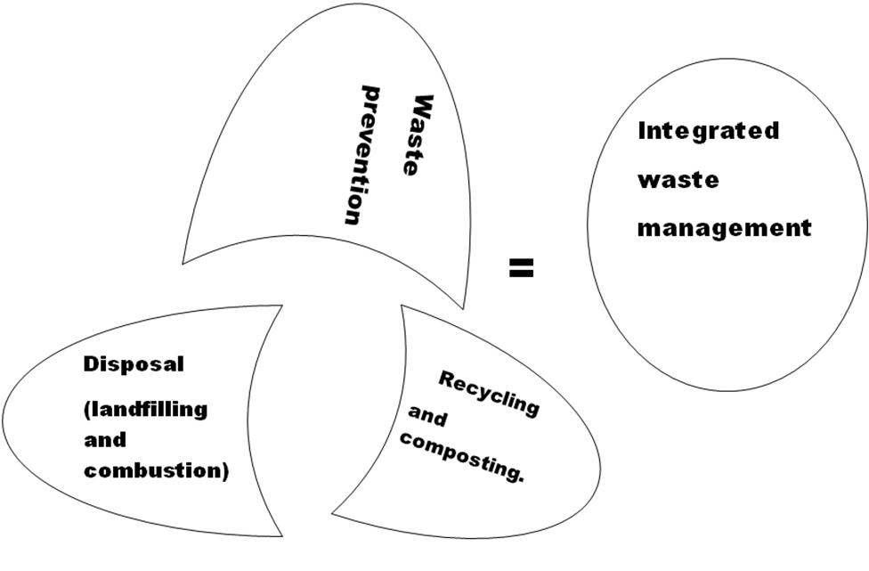

Figure 2.1: Integrated waste Management
Source: United State Environmental Protection Agency (2002)

Guido Maria Bazzani (1998) presented a multi-criteria approach to the integrated solid waste management of the Province of Ravenna, Italy figure 2.2. A mixed- integer programming model was used in his work and this was proved to be economically viable. The problem addressed by his model can be stated as follows:

- the location of sources and the generation of each type of waste from eachsource.
- the various types of collections ofwaste.
- a set of sites where facilities can belocated.
- a set of existing processing and land fillingtechnologies.
- a set of markets for energy, materials andcompost.
- the distances between the sources andlocations.
- a number of time periods and theirlength.
- same scenarioparameters.

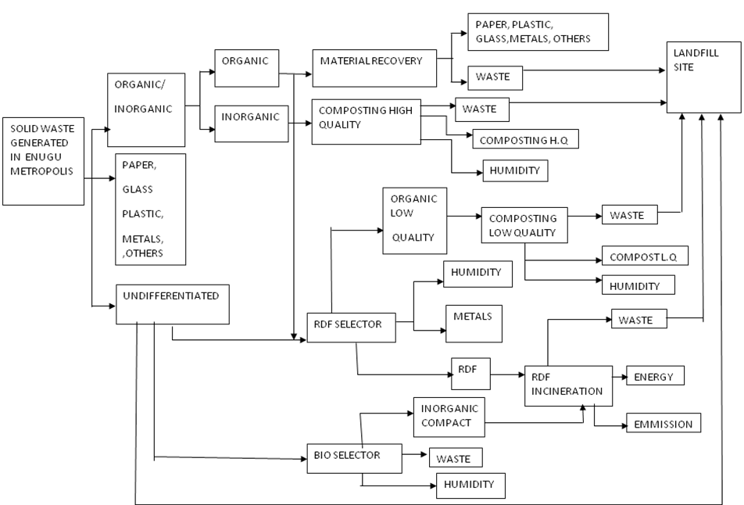

Figure 2.2: Integrated waste Management: Flow chart of Waste collection, Recovering, Processing and land filling.
Source: Guido Maria Bazzani (1998).

    - Landfill site.

In the history of man’s waste management, land disposal of waste has always been in practice and continues to be practiced as time has shown it to be a better method than others (Uchegbu, 2002). The disposal of solid wastes into the ocean or large water bodies as an alternative to land disposal had been rendered forbidden by international bodies because of its negative effects on aquaticlife.
Disposal of solid wastes on land is by far the most common method in the USA and probably accounts for more than 90% of the nation’s municipal refuse. Incineration accounts for most of the remainder, whereas composting of solid waste accounts for only an insignificant amount. Selecting a disposal method depends almost on cost, which in turn are likely to reflect local circumstances.
Sanitary landfill is the cheapest satisfactory means of disposal, but only if suitable land is within economic range of the source of the wastes. Typically, collection and transportation costs usually accounts for 75% of the total cost of solid waste management. In a modern landfill, refuse is spread in thin layers, each of which is compacted by a bulldozer before the next is spread. When about three metre (3m) of refuse has been laid down, it is covered by a thin layer of clean earth and compacted again.
Pollution of surface and groundwater is minimized by lining and contouring the fill, compacting and planting the cover, selecting proper soil, diverting upland drainage, and placing wastes in sites not subject to flooding or high groundwater level. Gases are generated in landfills through the anaerobic decomposition of organic solid wastes. If a significant amount of methane is present, it may be explosive; proper venting eliminates this problem.
According to Ayaji (2008), ESWAMA has only one landfill site at Ugwuaji, off Enugu- PortHarcourt Road. There are sets of activities that go on at the sanitary landfill. These activities include:
- Arrival of volumes of waste by the compactor truck. All the wastes collected from the Metropolis are transported to thesite.
- Separation of the solid wastes into different material components: plastics, rubbers, metal scraps, paper, cartons and bottles; biodegradable and polyethylene materials is being carried out. Some of these materials are packaged and sold to people asraw

materials for reuse or recycling. In Enugu, metal scraps are sold to Kano, plastics and rubbers are sold to Innoson Victory Company, papers are sold to Emenite Company for roofing-sheet production that is asbestos-free.
- Digging of the cell is carried out by the use of an excavator. The dimensions of the cell are; length (20m) X width (20m) X depth (2m) (figure 2.3 ). The cell is usually dug very close to the heap of refuse such that it will be easy for the bulldozer to push the wastes into thecell.
- Thin foil (water- proof material) is laidinsidethe cellbefore pushing the refuse into the cell. This is to ensure proper decomposition of the refuse and to prevent leachate (deadly fluid from wastes) from percolating into the underground water.
- Bulldozer will now compact the solid wastes to create room for more wastes. After, a thin layer of earth is used to cover the wastes and the bulldozer will compact itagain.
Finally, the cell will be covered completely with the heap of sand the excavator brought out during excavation such that there would be no room for water logging on top of the cell. This is the safest way of handling solid wastes.
According to one of the ESWAMA officials, some of the challenges facing the agency include lack of funds and important equipment; such as bulldozer, compactors, excavators, pay-loader, insufficient buckets, etc. He also stated that the welfare of the workers was not properly considered in the last administration. He stated that ESWAMA had achieved at least 60% efficiency in waste management of the state.
Some great waste management experts like Swallon and Opaluch (1993), proposed a model that will minimize the cost of citing a sanitary landfill.

Minimize FC (J) + EC (J), where J Ɛ Ф
Subject to HS (J) ≥ 0

Where J represents a vector of characteristics describing a site.
FC (J) represents the out of pocket costs for site development and operation, transportation inclusive.
EC (J) is the money measure of local and regional environmental damages associated with the choosing a site (J).

Ф represents the universe of possible sites.
HC (J) represents the technological, health and safety constraints. His model was found to be economically viable.

Also, Daskalopoulos et al (1998) have presented a mixed integer linear programming model for the management of municipal solid waste streams, taking into account their rates and compositions, as well as the adverse environmental impacts. Using the model, they identify the optimal combination of technologies for handling, treatment and disposal of municipal solid waste in a better economical and more environmentally sustainable way. The single objective is composed of cost per tonne of waste treated at the recycling, composting, incinerating plants, and landfill sites. The constraints of the objective functions are capacity of the plants and landfill sites. The model has been applied to the management of municipal solid waste in the UK. The findings have revealed that the current costs favour the landfill option of managing the municipal solid waste.

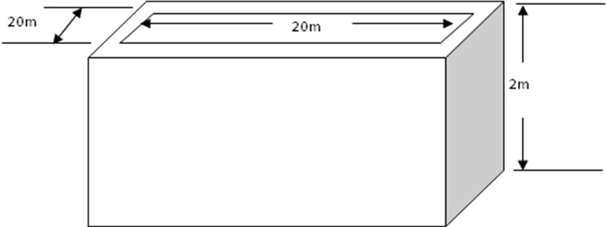

Figure 2.3: Dimensions of an ESWAMA landfill site being used at Ugwuaji. Source: Egwu Frank (2008).

CHAPTER THREE
MATERIALS AND METHOD.

  - DataCollection.

The data used in this research work were collected from both primary and secondary sources. Some tools of participatory appraisal techniques namely direct observations, semi- structured interviews, questionnaires and literature reviews were all employed. Direct interview method was used to obtain information from ESWAMA staff (table 3.3- 3.5) and NPC staff (table 3.8), while the questionnaire in appendix 55 was administered to some of the inhabitants of the ten zones in the city. Tables (3.6) and (3.7) show the summary of the questionnaire. Table 3.9 depicts the amount of waste generated in themetropolis.
In addition, a purposely-organized field tour to all the ten zones in the metropolis was carried-out. Pictures in appendix 3-53 excluding appendix 41 were taken during each trip to determine the level of waste accumulation in the metropolis. Some important census data were collected from the National Population Commission (NPC), Enugu office. These data were used to determine the population of Enugu metropolis and the average amount of solid waste generated there. Google was used to get the map and road network of Enugu metropolis. From this map in figure 3.1 the nine new landfill sites were proposed based on areas that favours the conditions needed before citing a landfill site. Also, the centre for each zone was chosen by observations and the average distances from each zone (centre) to each landfill site (table 3.1) were determined by measurement (using the scale: 1:35000cm on the map) along the road.
The numbers of ESWAMA dumpsters along the streets of the metropolis were obtained from the ESWAMA operation unit (table 3.5). The average maintenance costs of the compactors for one year were also obtained from the Maintenance Department. The ten zones of which Enugu metropolis were divided into were also obtained from the ESWAMA OperationUnit.

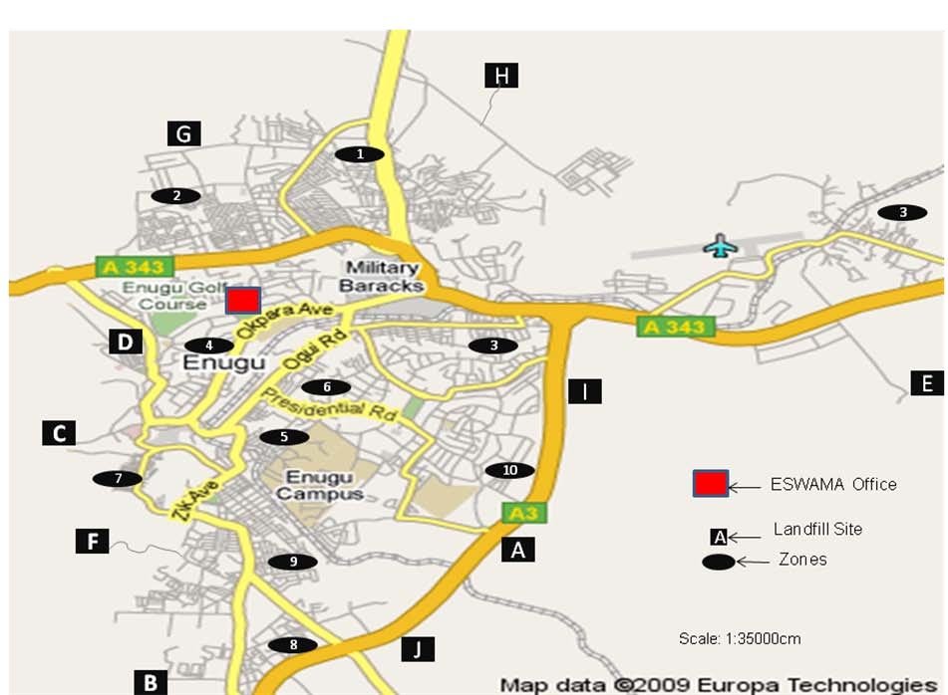

Figure 3.1: Map of Enugu Metropolis road Net-work showing the new proposed landfill sites.

From figure 3.1, the distances from each zone to each landfill site were measured along the road and average values recorded in table (3.1) below. The distance from ESWAMA Office to each zone were also measured and recorded (Table 3.2).

Table (3.1): Distances from each Zone to each Landfill Site.(scale: 1: 35000cm).

S/N | Landfill  Site  Zone | A | B | C | D | E | F | G | H | I | J
1. | Abakpa | 46 | 67 | 43 | 33 | 41 | 49 | 13 | 14 | 30 | 52
2. | Trans- Ekulu | 54 | 57 | 39 | 15 | 48 | 39 | 7 | 29 | 35 | 53
3. | New  Haven/Emene | 38 | 62 | 52 | 41 | 25 | 50 | 48 | 39 | 22 | 43
4. | G.R.A | 44 | 47 | 26 | 13 | 42 | 27 | 22 | 30 | 26 | 41
5. | Ogui /Asata | 29 | 34 | 29 | 24 | 40 | 25 | 33 | 33 | 20 | 30
6. | New Layout | 29 | 33 | 21 | 19 | 42 | 17 | 43 | 34 | 24 | 28
7. | Coal Camp  /Agbani Road | 30 | 27 | 15 | 18 | 58 | 10 | 39 | 46 | 41 | 26
8. | Idaw  River/Garriki | 27 | 16 | 32 | 39 | 60 | 19 | 60 | 61 | 37 | 14
9. | Achara  Layout | 17 | 19 | 24 | 27 | 51 | 15 | 48 | 54 | 27 | 17
10. | Independence  Layout | 12 | 35 | 36 | 35 | 33 | 36 | 42 | 38 | 12 | 15
 | Total  Distance from each Zone to a landfill site (cm). | 326 | 397 | 317 | 254 | 440 | 287 | 355 | 376 | 274 | 319

Note thatLandfillsite A,B,C,D,E,F,G,H,I,J on the table 3.1a, below represents Ugwuaji site, Idaw-River-site, Udi-siding site, Express way site, Emene site, Agbani Roadsite,
Trans-Ekulu site, Nike site, New Haven site and Gariki site respectively.

Table (3.1a): The Ten Landfill Sites on the Map and their Symbols.

S/N | LANDFILL SITE | SYMBOL
1 | Ugwuaji site | A
2 | Idaw-River-site | B
3 | Udi-siding site | C
4 | Express way site | D
5 | Emene site | E
6 | Agbani Road site | F
7 | Trans-Ekulu site | G
8 | Nike site | H
9 | New Haven site | I
10 | Gariki site | J

TABLE (3.2): Distance from ESWAMA Office to Each Zone as in the Map.

S/N | Zones | Distances from ESWAMA office to each ZONE  ( Scale=1:35000cm)
1 | Abakpa | 32
2 | Trans-Ekulu | 24
3 | New Haven/ Emene | 37
4 | G. R. A | 8
5 | Ogui- Asata | 13
6 | New Layout | 11
7 | Coal Camp / Agbani Road | 14
8 | Idaw River/ Garriki | 30
9 | Achara Layout | 21
10 | Independence Layout | 25

Table (3.3): Important Data from ESWAMA Headquarter Office.

S/N | DATA | COST (N)
1 | Annual Salary Cost | 84,000,000.00
2 | Annual Transportation Cost | 31,320,000.00
3 | Annual Maintenance Cost | 25,000,000.00
4 | Daily Transportation Cost of using a Compactor. | 12,000.00
5 | Cost of quarterly maintenance of Dump site. | 70,000.00
6 | Cost of digging new dump site. | 700,000.00
8 | Cost of a litre of Diesel | 150.00
9 | Cost of a compactor tyre | 75,000.00
10 | Cost of a compactor | 2,600,000.00
11 | Cost of dumpsters | 14,000.00
12 | Salary of a crew man | 20,000.00
13 | Salary of a Driver | 30,000.00
14 | Salary of a Technician | 50,000.00

Source: Egwu (2007)

Table (3.4): Important Data from ESWAMA Headquarter Office.

S/N | DATA | QUANTITY
1 | Volume size of dump sters | 1.10 m³
2 | Weight of Dump star with waste | 167 kg
3 | Number of Dump sters needed to fill-up a compactor. | 54
4 | Average weight of solid waste each compactor can carry per trip. | 1 trip={9 tonne}  3 trips={27 tonne}
5 | Number of newly acquired Dump sters. | 10( NOT IN USE)
6 | Number of compactors working. | {2 atNsukka}.  {11 atEnugu}.
7 | Number of newly acquired compactors. | 2

Source: Egwu (2008)

TABLE (3.5): ESWAMA Bucket (Dump Sters) Distribution in the Metropolis.

S/N | ZONES | AREAS INCLUDED | TOTAL NUMBERS OF  BUCKETS
1 | Abakpa | Federal housing/community estate area  Nike road Area Nowas junction Area  River-side estate Area etc. | 156
2 | Trans-Ekulu | Nike Lake Avenue Area Central Bank Quarters Area  Estate Avenue Area etc | 96
3 | New Haven/Emene | IMT Quarters Area  New Haven Primary School Area Psychiatric hospital junction Area  Emene market Area etc | 50
4 | G.R.A | Onoh quarters Area Army Barracks Garden Avenue Area  Abakiliki road Area etc | 197
5 | Ogui/Asata | Udi Road Area Ogui road Area Artisan Area  Onu-Asata Area etc | 39
6 | New Layout | City Girls Sport Area UNEC Gate Area  Nwosu terrace Area etc | 32
7 | Coal Camp/ Agbani Road | Akwata Area UNTH Area Mbanugo Area  Calabar Junction Area etc. | 48
8 | Idaw River/ Garriki | Awkunawnaw Area Maryland Estate Area Idaw River Area  Ebony Paint Road Area etc | 102
9 | Achara Layout | Uwani Area  Osumenyi Area Amechi Area etc | 106
10 | Independence Layout | Presidential Road Area  Prison Head Quarters JunctionArea Ebenano Estate Junction Area Nachi StreetArea  ESUT/ NTA Road Area etc | 104

GRAND TOTAL NUMBER OF ESWAMADUMPSTERS = 930
Source: Egwu (2008)

Table (3.6): Summary of the Questionnaire (1).

S/N | ITEMS ON THE  QUESTIONNAIRE | Abakpa | Trans- Ekulu | New Haven  /  Emene | G.R.A | Ogui  /Asata | New Layout | Coal camp/ Agbani  Road | Idaw River  /Garriki | Achara layout | Indepe ndence layout
1 | Respondents ( % of male) | 30 | 35 | 55 | 40 | 65 | 50 | 65 | 43 | 35 | 45
2 | Respondents (% of female) | 70 | 65 | 45 | 60 | 35 | 50 | 35 | 57 | 65 | 55
3 | Average number of times waste are being disposed per individual per week | 7 | 6 | 4 | 4 | 6 | 6 | 7 | 6 | 6 | 6
4 | Average mass of solid waste disposed in kilograms(Kg) per individual  /day for the ten zones | 1.2 | 0.8 | 1.2 | 0.8 | 0.6 | 0.4 | 1.4 | 1.8 | 0.7 | 0.9
5 | Average number of days before waste are collected from the dump stand | 20 | 5 | 14 | 6 | 9 | 10 | 20 | 20 | 8 | 15
6 | Average performance evaluation of ESWAMA in %  by respondent | 30 | 70 | 40 | 50 | 60 | 55 | 40 | 35 | 60 | 40
7 | Average number of buckets available in each zone | 156 | 96 | 50 | 197 | 39 | 32 | 48 | 102 | 106 | 104
8 | Average number of days it takes the ESWAMA buckets along the streets to get filled-up | 1 | 2 | 2 | 1 | 1 | 1 | 1 | 1 | 1 | 1
9 | Average number of dump sters needed in each zone | 50 | 10 | 35 | 12 | 30 | 30 | 40 | 80 | 15 | 19
10 | Average number of vehicles needed in each  zones | 8 | 2 | 6 | 3 | 3 | 4 | 6 | 8 | 3 | 4

Table (3.7): Summary of the Questionnaire (2).

S/N | ITEMS ON THE QUESTIONNAIRE | Averages  for the Zones
1 | Respondents (% of male). | 46.3%
2 | Respondents (% of female). | 53.7%
3 | Average number of times waste are being disposed per individual per week. | 5.8  times/week
4 | Average mass of solid waste disposed in kilograms (Kg) per individual /day for the  ten zones. | 0.98 kg/day
5 | Average number of days before waste is being collected from the dumpsters. | 12.7 days
6 | Average performance evaluation of ESWAMA in % by respondent. | 48%
7 | Average number of buckets available in  each zone. | 93
8 | Average number of days it takes the  ESWAMA buckets along the streets to get filled-up. | 1.2 days
9 | Average number of additional dumpsters needed in the metropolis. | 321  Dumpsters
10 | Average number of vehicles needed in each zones. | 4
11 | Total number of vehicles needed in the Metropolis. | 47

TABLE 3.8: 2006 National Population and Census Provisional Result.

S/N | ZONES | POPULATION OF ZONES
1 | Abakpa | 165,754
2 | Trans- Ekulu | 20,394
3 | New Haven/Emene | 92,394
4 | G.R.A | 48,846
5 | Ogui –Asata | 51,946
6 | New Layout | 101,625
7 | Coal Camp/Agbani Road | 42,964
8 | Idaw River/Garriki | 57,512
9 | Achara Layout | 98,247
10 | Independence Layout | 42,435
Total population of Enugu metropolis: 722,664.

Source: National Population commission (NPC) (2006) Census Data.

TABLE (3.9): Amount of Waste Generated in the Metropolis.

S/N | ZONES | HUMAN POPULATION OFZONES. | Mass solid of waste  generated (0.98kg/person/day)
1 | Abakpa | 165,754 | 162,438.92
2 | Trans- Ekulu | 20,394 | 19,986.12
3 | New Haven/Emene | 92,394 | 91,085.12
4 | G.R.A | 48,846 | 47,869.08
5 | Ogui –Asata | 51,946 | 50,907.08
6 | New Layout | 101,625 | 99,592.50
7 | Coal Camp/Agbani  Road | 42,964 | 42,104.72
8 | Idaw River/Garriki | 57,512 | 56,361.76
9 | Achara Layout | 98,247 | 96,282.06
10 | Independence Layout | 42,435 | 41,586.30
 | TOTAL | =722,664 | =708,213.66kg  =708.2137 tons

The mass of waste in kilogram based on the population of the metropolis is 708,213.66kg (708.2137 tonne).

  - The Proposed Solid Waste Management Design for EnuguMetropolis.

In the world today, the field of engineering had been very useful in the advancement of modern technologies. Most fields of learning (Arts, social sciences, medical sciences, environmental sciences etc) had been advanced through the knowledge of modern technologies; an off-shoot of Engineering. The fields of engineering have been so helpful in the provision of the basic needs of man (clothes, food and shelter), also solving his environmental and solid waste management problems. In this research work, Enugu metropolis was divided into ten (10) zones. These ten zones were also assigned to ten (10) landfill sites using an Assignment Problem Scheduling Model (APSM). Nine out of the ten landfill sites were established by design. In Enugu metropolis, Ugwuaji landfill is the only landfill site in use by the ESWAMA. There are some illegal open dump sites used by the agency (see appendix 22-23). The nine (9) (see figure 3.1) additional landfill sites include: Nike site, Trans-Ekulu site, Emene site, Express way site, New Haven site, Udi-siding site, Agbani Road site, Garikki site and Idaw-River site.

    - Design Considerations for the Establishment of the Nine LandfillSites.

- Land: This factor was carefully considered before these landfill sites were chosen. In each zone, locations where a large expanse of land that can take care of each zone at least forforty
(40) years were chosen.

- Accessible Roads: This design factor was carefully examined before these sites were chosen. If there are no access roads to the landfill sites, the compactors and other vehicles would not be able to access thesites.

- Proximity to the Target Zones: This particular factor was also examined critically. The landfill sites were chosen in such a way that it will be neither too close to the target zones in order to avoid pollution, nor too remote from the target zones in other to minimize transportationcosts.

- Drainage System: The drainage patterns of each of these sites were carefully examined from the map that shows the contour lines of Enugu metropolis and its drainage pattern. It was ensured that the sites were not established where there will be flooding nor water- logging. It was also ensured that the sites are not close to streams, rivers or wells to avoid water pollutionproblems.

- Wind Direction: This factor was also considered by observation because if the landfill sites are established upwind to a community or area, it will lead to air pollution problems and consequently lead to disease spread in thearea.

- Social and Psychological Factors: From the interview carried-out, it was gathered that most of the inhabitants of Enugu metropolis are ready to co-operate with the government to establish landfill sites in their area. Most of them are of the opinion that the government agency in-charge of waste disposal will compensate them properly, avoid littering of waste, and be ready to convert these sites to recreational centres afteruse.

- Cost: This is one the most important factors that were considered. The cost of the establishing each landfill site was properly analyzed and also the possible transportation costs associated with the positions of the landfill sites. All these factors were considered before each of the sites waschosen.

    - The Mathematical Model Used For The SchedulingSystem.

In this research work, an industrial engineering based mathematical model (Hungarian mathematical model) was used to schedule the waste disposal system of Enugu metropolis. This model is used in solving allocation problems where some activities are performed but there are limitations on the amount of resources or the methods of spending them. Under this model, one item each will be assigned to a system in such a way that the return or result from the distribution is optimal. The desired objective is usually to minimize cost and time required to perform a given task.

Table (3.10): The Mathematical Model Table for the problem is as shown below.

Landfill sites zone | A B C ni | CAPACITY (a_{i})
Zone1  Zone2  Zone3  , ,  , ,  , ,  Zonen | C₁₁ C₁₂C₁₃ C_{1n}  C₂₁ C₂₂ C₂₃ C_{2n}  C31 C 32 C33 C3n  , , , ,  , , , ,  , , , ,  C_{n1} C_{n2} C_{n3} C_{nn} | 1  1  1  ,  , 1  1
Requirement(b_{j}) | 1 1 1……….....1 | n

Now the problem lies in assigning each waste source (Zone) to one and only one dump centre (Landfill site). The measure of effectiveness here is to minimize the total distance travelled by the trucks which are directly proportional to the transportation cost. The cost of transportation of the refuse increases with increasing distance. The aim is to minimize the total distance covered in the disposal of the wastes from each zone to the landfill site. An easy method on how to find the optimal solution in an assignment problem can be done using the Hungarian mathematical model as shown below. This model is therefore adopted for thiswork.

Let X_{i} denote the assignment of i^{th} zone to j^{th} landfill sites such that X_{i} can either be one or zero; (1 or 0).

X_{i}= ;( X_{i}is one if zone i is assigned to landfill site j, and zero if zone i is not assigned to landfillsitej.) (3.1)

Then, the mathematical model can then be stated as follows:

Minimize,z= ij Xij (3.2)

And it is subjected to the following constraints,

ij =1 for all i(zoneavailable) (3.3)

ij = 1 for all j (landfillsiteavailable) (3.4)

Where C_{ij} represents the cost/distance variable of assigning waste bin i to dump centre j.
The matrix in table (3.1) is a square matrix (10x10). Also, the optimum solution for the problem would always be such that there would be only one assignment in a given row or column of the matrix. This method is therefore applied in this scheduling system.
Applying the data in table (3.1) into the equations 3.2, 3.3 and 3.4, the equations 3.5, 3.6and
3.7 were obtained.

Minimize (totaldistancetravelled) Z=

46 X₁₁ + 67X₁₂ + 43X₁₃ + 33 X ₁₄ + 41 X ₁₅+ 49 X ₁₆+ 13X₁₇ + 14 X₁₈ + 30 X₁₉

+52 X_{1,10} + 54 X ₂₁+ 57 X ₂₂ + 39X₂₃ + 15 X ₂₄ + 48 X₂₅ + 39 X ₂₆ +7 X₂₇

+ 27 X ₂₈ + 35 X ₂₉ + 53 X _{2,10} + 38 X ₃₁ + 62 X ₃₂ + 52 X ₃₃ + 41X ₃₄ + 25 X ₃₅

+ 50 X₃₆ + 48 X₃₇ + 39X₃₈ + 22 X ₃₉+ 43 X _{3,10.} + 44 X ₄₁ + 47 X ₄₂+ 26 X₄₃

+ 13 X ₄₄ +42 X ₄₅ + 27 X ₄₆ + 22 X₄₇ + 30 X ₄₈ + 26 X ₄₉ + 41 X _{4,10} + 29 X ₅₁

+ 34 X ₅₂+ 29 X ₅₃+24 X ₅₄ +40 X ₅₅ + 25X₅₆ + 33 X ₅₇+ 33 X ₅₈ + 20 X₅₉

+ 30 X _{5,10} +29 X₆₁ + 33 X ₆₂ + 21 X ₆₃ + 19 X ₆₄ + 42 X ₆₅ + 17 X ₆₆ + 43 X ₆₇

+ 34 X ₆₈ + 24 X ₆₉+ 28 X _{6,10} + 30 X ₇₁+ 27 X ₇₂ + 15 X ₇₃+ 18 X ₇₄ + 58 X₇₅

+ 10 X ₇₆ + 39 X ₇₇ + 46 X ₇₈ + 41 X ₇₉ + 26 X _{7,10} + 27 X ₈₁ + 16 X ₈₂ + 32 X₈₃

+ 39 X ₈₄+ 60 X ₈₅ + 19X₈₆ + 60 X ₈₇ + 61 X ₈₈ + 37 X ₈₉ + 14 X _{8,10} 17 X₉₁

+ 19 X ₉₂ + 24 X ₉₃+ 27X₉₄ + 51 X ₉₅+ 15 X ₉₅+ 15 X₉₆ + 48 X ₉₇+ 54 X₉₈

+ 27 X ₉₉+ 17X _{9,10} + 12 X _{10,1} 35 X _{10,2} + 36 X _{10,3} + 35 X _{10,4} + 33 X_{10,5}

+ 36 X _{10,6}+ 42 X _{10,7} + 38 X _{10,8} + 12 X _{10,9} + 15X_{10,10} (3.5)

Subject: TO:
- Waste bin /Zoneconstraints:
46 x ₁₁ + 67 x ₁₂ + 43 X₁₃ + 33 X ₁₄ + 41 X ₁₅ + 49 X ₁₆ + 13 X ₁₇ + 14 X ₁₈ + 30 X ₁₉ +
52X_{1,10} =1

54 X₂₁ + 57 X ₂₂ + 39 X ₂₃ + 15 X ₂₄ + 48 X ₂₅ + 39 X ₂₆ + 7 X ₂₇ + 27 X ₂₈ + 35 X ₂₉
+53X_{2,10} = 1

38 X ₃₁ + 62 X ₃₂ + 53 X ₃₃ + 41 X ₃₄ + 25 X ₃₅ + 50 X ₃₆ + 48 X ₃₇ + 39 X ₃₈
+ 22 X ₃₉+ 43X_{3,10} = 1

44 X ₄₁ + 47 X ₄₂ + 26 X ₄₃ + 13 X ₄₄ + 42 X ₄₅ + 27 X ₄₆ + 22 X ₄₇ + 30 X ₄₈
+ 20X₄₉ + 41 X _{4,10} =1

29 X ₅₁ + 34 X₅₂ + 29 X ₅₃ + 24 X ₅₄ + 40 X ₅₅ + 25X ₅₆ + 33 X ₅₇ + 33 X ₅₈ + 20 X ₅₉ +
30 X _{5,10} =1

29 X ₆₁ + 33 X ₆₂ + 21 X ₆₃ + 19 X ₆₄ + 42 X ₆₅ + 17 X ₆₆ + 43 X ₆₇ + 34 X ₆₈ + 24 X ₆₉ +
28X_{6,10} = 1

30 X ₇₁ + 27 X ₇₂ + 15 X ₇₃ + 18 X ₇₄ + 58 X ₇₅ + 10 X ₇₆ + 39 X ₇₇ + 46 X ₇₈
+ 61 X₈₈+ 37 X ₈₉+ 14 X_{8,10}=1

27 X ₈₁ + 16 X₈₂ + 32 X ₈₃+ 39 X ₈₄+ 60X₈₅ + 19 X ₈₆+ 60 X ₈₇ + 61 X₈₈
+ 37 X ₈₉ + 14X_{8,10} = 1

17 X ₉₁ + 19 X ₉₂ + 24 X ₉₃ + 27 X ₉₄ + 51 X ₉₅ + 15 X ₉₆ 48X ₉₇ + 54 X ₉₈ + 27 X ₉₉ +
17 X_{9,10} = 1

12 X 10,1 + 35X10,2 + 36X10,3 +35X10,4+33X10,5+36X10,6+42X10,7+38X10,8
+ 12 X _{10,9} + 15X_{10,10} =1 (3.6)

- Dump centre/ Landfill siteconstraints.
46 X _{11┼} 54 X ₂₁ + 38 X ₃₁ + 44 X ₄₁ + 29X ₅₁ + 29 X ₆₁ + 30 X ₇₁ + 27 X ₈₁ + 17X ₉₁ +
12 X _{10,1} = 1

47 X ₁₂ + 57 X ₂₂ + 62 X ₃₂+ 47 X ₄₂ + 34 X ₅₂ + 33 X ₆₂+ 27X₇₂ + 16 X ₈₂ + 19 X₉₂
+ 35 X_{10,2} = 1

43 X ₁₃ + 39 X ₂₃ + 52 X ₃₃ + 26 X ₄₃ + 29 X ₅₃ + 21 X ₆₃ + 15X₇₃ + 32 X ₈₃ + 24 X ₉₃ +
36X_{10,3} = 1

33 X ₁₄ + 15 X ₂₄ + 41 X ₃₄ + 13 X ₄₄ + 24 X ₅₄ + 19 X ₆₄ + 18 X ₇₄ + 39 X ₈₄ + 27 X ₉₄ +
35X_{10,4} = 1

41 X ₁₅ + 48 X ₂₅ + 25 X ₃₅ + 42 X ₄₅ + 40 X ₅₅ + 42 X ₆₅ + 58 X ₇₅ + 60 X ₈₅ + 51 X₉₅ 33
X10,5 =1

49 X ₁₆ + 39 X ₂₆ + 50 X ₃₆ + 27 X ₄₆ + 25 X ₅₆ + 17 X ₆₆ + 10 X ₇₆ + 19 X ₈₆ + 15 X ₉₆ +
36X_{10,6} = 1

13 X₁₇ + 7 X ₂₇ + 48 X ₃₇ + 22 X ₄₇ + 33 X ₅₇ + 43 X ₆₇ + 39 X ₇₇ + 60 X ₈₇ + 48 X ₉₇ +
42 X _{10,7} =1

14 X ₁₈ + 27 X ₂₈ + 39 X ₃₈ + 30 X ₄₈ + 33 X ₅₈ + 34 X ₆₈ + 46 X ₇₈ + 61 X ₈₈ + 54 X ₉₈ +
38 X _{10,8} = 1

30 X ₁₉ + 35 X ₂₉ + 22 X ₃₉ + 26 X ₄₉ + 20 X ₅₉ + 24 X ₆₉ + 41 X ₇₉ + 37 X ₈₉ + 27 X ₉₉ +
12 X _{10,9} = 1

52 X 1,10 + 53 X 2,10 + 43 X 3,10 + 41 X 4,10 + 30 X 5,10 28 X 6,10 + 26 X 7,10 + 14 X 8,10 +
17 X _{9,10} + 15X_{10,10} =1 (3.7)

  - The MatrixEquations.
The matrix for equations (5-7) in the order of their objective function and corresponding constraints are arranged and presented as shown below respectively:
Minimize (totaldistance travelled) Z=

46 | 67 | 43 | 33 | 41 | 49 | 13 | 14 | 30 | 52
54 | 57 | 39 | 15 | 48 | 39 | 7 | 29 | 35 | 53
38 | 62 | 52 | 41 | 25 | 50 | 48 | 39 | 22 | 43
44 | 47 | 26 | 13 | 42 | 27 | 22 | 30 | 26 | 43
29 | 34 | 29 | 24 | 40 | 25 | 33 | 33 | 20 | 30
29 | 33 | 21 | 19 | 42 | 17 | 43 | 34 | 24 | 28
30 | 27 | 15 | 18 | 58 | 10 | 39 | 46 | 41 | 26
27 | 16 | 32 | 39 | 60 | 19 | 60 | 61 | 37 | 14
17 | 19 | 24 | 27 | 51 | 15 | 48 | 54 | 27 | 17
12 | 35 | 36 | 35 | 33 | 36 | 42 | 38 | 12 | 15

SUBJECT TO:
- Waste bin/ Zoneconstraint:

46 | 67 | 43 | 33 | 41 49 | 1314 | 30 | 52 | 1
54 | 57 | 39 | 15 | 4839 | 7 29 | 35 | 53 | 1
38 | 62 | 52 | 41 | 2550 | 48 39 | 22 | 43 | 1
44 | 47 | 26 | 13 | 4227 | 22 30 | 26 | 43 | 1
29 | 34 | 29 | 24 | 4025 | 33 33 | 20 | 30 | 1
29 | 33 | 21 | 19 | 4217 | 4334 | 24 | 28 | 1
30 | 27 | 15 | 18 | 5810 | 3946 | 41 | 26 | 1
27 | 16 | 32 | 39 | 6019 | 6061 | 37 | 14 | 1
17 | 19 | 24 | 27 | 5115 | 4854 | 27 | 17 | 1
12 | 35 | 36 | 35 | 33 36 | 4238 | 12 | 15 | 1

- Dump centre/ Landfill siteconstraints.

49 39 50 27 25 17 10 19 15 36 1
13 7 48 22 33 43 39 60 48 42 1
14 29 39 30 33 34 46 61 54 38 1
30 35 22 26 20 24 41 37 27 12 1
52 53 43 41 30 28 26 14 17 15 1

46 | 54 | 38 | 44 | 29 | 29 | 30 | 27 | 17 | 12 | 1
67 | 57 | 62 | 47 | 34 | 33 | 27 | 16 | 19 | 35 | 1
43 | 39 | 52 | 26 | 29 | 21 | 15 | 32 | 24 | 36 | 1
33 | 15 | 41 | 13 | 24 | 19 | 18 | 39 | 27 | 35 | 1
41 | 48 | 25 | 42 | 40 | 42 | 58 | 60 | 51 | 33 | 1

Data Presentation andAnalysis.
Table 1: OriginalTable.
In the realization of this research work the data presented in tables (3.11) to (3.16) were actually used to perform the iteration shown in table 3.12, while tables 3.13 to 3.15 contain the. Table (3.11) which is the original table got from field work contains the basic data used in the analysis.

Table 3.11: Original Table.

S/N | Landfill  Site  Zone | A | B | C | D | E | F | G | H | I | J
1. | Abakpa | 46 | 67 | 43 | 33 | 41 | 49 | 13 | 14 | 30 | 52
2. | Trans- Ekulu | 54 | 57 | 39 | 15 | 48 | 39 | 7 | 29 | 35 | 53
3. | New  Haven/Emene | 38 | 62 | 52 | 41 | 25 | 50 | 48 | 39 | 22 | 43
4. | G.R.A | 44 | 47 | 26 | 13 | 42 | 27 | 22 | 30 | 26 | 41
5. | Ogui –Asata | 29 | 34 | 29 | 24 | 40 | 25 | 33 | 33 | 20 | 30
6. | New Layout | 29 | 33 | 21 | 19 | 42 | 17 | 43 | 34 | 24 | 28
7. | Coal Camp  /Agbani Road | 30 | 27 | 15 | 18 | 58 | 10 | 39 | 46 | 41 | 26
8. | Idaw  River/Garriki | 27 | 16 | 32 | 39 | 60 | 19 | 60 | 61 | 37 | 14
9. | Achara  Layout | 17 | 19 | 24 | 27 | 51 | 15 | 48 | 54 | 27 | 17
10. | Independence Layout | 12 | 35 | 36 | 35 | 33 | 36 | 42 | 38 | 12 | 15

Step 1: Subtract the least element in each row from all the elements of that row.

Table 3.12: First Iteration.

R1-13
S/N | Landfill  Site  Zone | A | B | C | D | E | F | G | H | I | J
1. | Abakpa | 46 | 67 | 43 | 33 | 41 | 49 | 13 | 14 | 30 | 52
2. | Trans- Ekulu | 54 | 57 | 39 | 15 | 48 | 39 | 7 | 29 | 35 | 53
3. | New Haven/Emene | 38 | 62 | 52 | 41 | 25 | 50 | 48 | 39 | 22 | 43
4. | G.R.A | 44 | 47 | 26 | 13 | 42 | 27 | 22 | 30 | 26 | 41
5. | Ogui –Asata | 29 | 34 | 29 | 24 | 40 | 25 | 33 | 33 | 20 | 30
6. | New Layout | 29 | 33 | 21 | 19 | 42 | 17 | 43 | 34 | 24 | 28
7. | Coal  Camp/Agbani Road | 30 | 27 | 15 | 18 | 58 | 10 | 39 | 46 | 41 | 26
8. | Idaw  River/Garriki | 27 | 16 | 32 | 39 | 60 | 19 | 60 | 61 | 37 | 14
9. | Achara Layout | 17 | 19 | 24 | 27 | 51 | 15 | 48 | 54 | 27 | 17
10. | Independence  Layout | 12 | 35 | 36 | 35 | 33 | 36 | 42 | 38 | 12 | 15

R2-7

R3-22 R4-13

R5-20 R6-17

R7-10

R8-14 R9-15
R10-12

Table 3.13: First Iteration Continued.

S/N | Landfill  Site  Zone | A | B | C | D | E | F | G | H | I | J
1. | Abakpa | 33 | 54 | 30 | 20 | 28 | 36 | 0 | 1 | 17 | 39
2. | Trans- Ekulu | 47 | 50 | 32 | 8 | 41 | 32 | 0 | 20 | 28 | 46
3. | New  Haven/Emene | 16 | 40 | 30 | 19 | 3 | 28 | 26 | 17 | 0 | 21
4. | G.R.A | 31 | 34 | 13 | 0 | 29 | 14 | 9 | 17 | 13 | 28
5. | Ogui –Asata | 9 | 14 | 9 | 4 | 20 | 5 | 13 | 13 | 0 | 10
6. | New Layout | 12 | 17 | 4 | 2 | 25 | 0 | 26 | 17 | 7 | 11
7. | Coal Camp/Agbani  Road | 20 | 17 | 5 | 8 | 48 | 0 | 29 | 36 | 31 | 16
8. | Idaw  River/Garriki | 13 | 2 | 18 | 25 | 46 | 5 | 46 | 47 | 23 | 0
9. | Achara  Layout | 2 | 4 | 9 | 12 | 36 | 0 | 33 | 39 | 12 | 2
10. | Independence Layout | 0 | 23 | 24 | 23 | 21 | 24 | 30 | 26 | 0 | 3

STEP: 2; Subtract the least element in each column from all the elements of that column

Table 3.14: First Iteration Continued.

S/N | Landfill  Site  Zone | A | B | C | D | E | F | G | H | I | J
1. | Abakpa | 33 | 54 | 30 | 20 | 28 | 36 | 0 | 1 | 17 | 39
2. | Trans- Ekulu | 47 | 50 | 32 | 8 | 41 | 32 | 0 | 20 | 28 | 46
3. | New  Haven/Emene | 16 | 40 | 30 | 19 | 3 | 28 | 26 | 17 | 0 | 21
4. | G.R.A | 31 | 34 | 13 | 0 | 29 | 14 | 9 | 17 | 13 | 28
5. | Ogui –Asata | 9 | 14 | 9 | 4 | 20 | 5 | 13 | 13 | 0 | 10
6. | New Layout | 12 | 17 | 4 | 2 | 25 | 0 | 26 | 17 | 7 | 11
7. | Coal  Camp/Agbani Road | 20 | 17 | 5 | 8 | 48 | 0 | 29 | 36 | 31 | 16
8. | Idaw  River/Garriki | 13 | 2 | 18 | 25 | 46 | 5 | 46 | 47 | 23 | 0
9. | Achara  Layout | 2 | 4 | 9 | 12 | 36 | 0 | 33 | 39 | 12 | 2
10. | Independence Layout | 0 | 23 | 24 | 23 | 21 | 24 | 30 | 26 | 0 | 3

C1-0
C2-2
C3-4 C4-0 C5-3 C6-0 C7-0
C8-1 C9-0 C10-0

Table 3.15: Table of Result for First Iteration.

S/N | Landfill  Site  Zone | A | B | C | D | E | F | G | H | I | J
1. | Abakpa | 33 | 52 | 26 | 20 | 25 | 36 | 0 | 0 | 17 | 39
2. | Trans- Ekulu | 47 | 48 | 28 | 8 | 38 | 32 | 0 | 19 | 28 | 46
3. | New  Haven/Emene | 16 | 38 | 26 | 19 | 0 | 28 | 26 | 16 | 0 | 21
4. | G.R.A | 31 | 32 | 9 | 0 | 26 | 14 | 9 | 16 | 13 | 28
5. | Ogui –Asata | 9 | 12 | 5 | 4 | 17 | 5 | 13 | 12 | 0 | 10
6. | New Layout | 12 | 15 | 0 | 2 | 22 | 0 | 26 | 16 | 7 | 11
7. | Coal Camp/Agbani  Road | 20 | 15 | 1 | 8 | 45 | 0 | 29 | 35 | 31 | 16
8. | Idaw  River/Garriki | 13 | 0 | 14 | 25 | 43 | 5 | 46 | 46 | 23 | 0
9. | Achara  Layout | 2 | 2 | 5 | 12 | 33 | 0 | 33 | 38 | 12 | 2
10. | Independence  Layout | 0 | 21 | 20 | 23 | 18 | 24 | 30 | 25 | 0 | 3

STEP: 3
A check for the optimal solution is done by crossing the zeros in the table with lines at least once. The optimal solution is not reached since the number of lines is not equal to the number of rows or columns.
The least element from all the uncovered elements will be identified. It will be subtracted from all the uncovered elements and added to the intersections of the lines. The least element here is one (1).

Table 3.16: Optimality Test for First iteration.

Landfill
Site
Zone
A
B
C
D
E
F
G
H
I
J
S/N
Abakpa
33
52
26
20
25
36
0
0
17
39
1.
2. Trans-Ekulu 47 48 28 8 38 32 0 19 28 46
3.
New Haven/Emene G.R.A
16
38
26
19
0
28
26
16
0
21
4.
31
32
9
0
26
14
9
16
13
28
5.
Ogui –Asata
9
12
5
4
17
5
13
12
0
10
6.
New Layout
12
15
0
2
22
0
26
16
7
11
7.
Coal Camp/Agbani Road
Idaw River/Garriki Achara Layout Independence Layout
20
15
1
8
45
0
29
35
31
16
8.
13
0
14
25
43
5
46
46
23
0
9.
2
2
5
12
33
0
33
38
12
2
10.
0
21
20
23
18
24
30
25
0
3

Table 3.17: Table of Result for First Iteration.

S/N | Landfill  Site  Zone | A | B | C | D | E | F | G | H | I | J
1. | Abakpa | 33 | 52 | 26 | 21 | 25 | 37 | 1 | 0 | 18 | 39
2. | Trans- Ekulu | 46 | 47 | 27 | 8 | 37 | 32 | 0 | 18 | 28 | 45
3. | New  Haven/Emene | 16 | 38 | 26 | 20 | 0 | 29 | 27 | 16 | 1 | 21
4. | G.R.A | 30 | 31 | 8 | 0 | 25 | 14 | 9 | 15 | 13 | 27
5. | Ogui –Asata | 8 | 11 | 4 | 4 | 16 | 5 | 13 | 11 | 0 | 9
6. | New Layout | 12 | 15 | 0 | 3 | 22 | 1 | 27 | 16 | 8 | 11
7. | Coal  Camp/Agbani Road | 19 | 14 | 0 | 8 | 44 | 0 | 29 | 34 | 31 | 15
8. | Idaw  River/Garriki | 13 | 0 | 14 | 26 | 43 | 6 | 46 | 46 | 24 | 0
9. | Achara  Layout | 1 | 1 | 4 | 12 | 32 | 0 | 33 | 37 | 12 | 1
10. | Independence  Layout | 0 | 21 | 20 | 24 | 18 | 25 | 31 | 25 | 1 | 3

STEP 4:
A check of optimal solution is carried-out again by crossing the zeros in the table above with lines at least once. If the optimal solution is not reached, the least element from all the uncovered elements in the table is used to subtract from all the uncovered elements and the same added to all the intersections of the lines. The least element here is one (1).

Table 3.18: Optimality Test for Second iteration.
.

S/N | Landfill Site  Zone | A | B | C | D | E | F | G | H | I | J
1. | Abakpa | 33 | 52 | 26 | 21 | 25 | 37 | 1 | 0 | 18 | 39
2. | Trans- Ekulu | 46 | 47 | 27 | 8 | 37 | 32 | 0 | 18 | 28 | 45
3. | New  Haven/Emene | 16 | 38 | 26 | 20 | 0 | 29 | 27 | 16 | 1 | 21
4. | G.R.A | 30 | 31 | 8 | 0 | 25 | 14 | 9 | 15 | 13 | 27
5. | Ogui –Asata | 8 | 11 | 4 | 4 | 16 | 5 | 13 | 11 | 0 | 9
6. | New Layout | 12 | 15 | 0 | 3 | 22 | 1 | 27 | 16 | 8 | 11
7. | Coal  Camp/Agbani Road | 19 | 14 | 0 | 8 | 44 | 0 | 29 | 34 | 31 | 15
8. | Idaw  River/Garriki | 13 | 0 | 14 | 26 | 43 | 6 | 46 | 46 | 24 | 0
9. | Achara Layout | 1 | 1 | 4 | 12 | 32 | 0 | 33 | 37 | 12 | 1
10. | Independence  Layout | 0 | 21 | 20 | 24 | 18 | 25 | 31 | 25 | 1 | 3

Table 3.19: Table of Result for Second Iteration.

S/N | Landfill Site  Zone | A | B | C | E | F | D | G | H | I | J
1. | Abakpa | 32 | 51 | 26 | 24 | 37 | 20 | 0 | 0 | 17 | 38
2. | Trans- Ekulu | 46 | 47 | 28 | 37 | 33 | 8 | 0 | 19 | 28 | 45
3. | New Haven/Emene | 16 | 38 | 27 | 0 | 30 | 20 | 27 | 17 | 1 | 21
4. | G.R.A | 30 | 31 | 9 | 25 | 15 | 0 | 9 | 16 | 13 | 27
5. | Ogui –Asata | 8 | 11 | 5 | 16 | 6 | 4 | 13 | 12 | 0 | 9
6. | New Layout | 17 | 14 | 0 | 21 | 1 | 2 | 26 | 16 | 7 | 10
7. | Coal Camp/Agbani Road | 12 | 13 | 0 | 43 | 0 | 7 | 28 | 34 | 30 | 14
8. | Idaw River/Garriki | 13 | 0 | 15 | 43 | 7 | 26 | 47 | 47 | 24 | 0
9. | Achara Layout | 0 | 0 | 4 | 32 | 0 | 11 | 32 | 37 | 11 | 0
10. | Independence Layout | 0 | 21 | 21 | 18 | 26 | 24 | 31 | 26 | 1 | 3

A check for the optimal solution is done again by crossing all the zero elements at
least once. If the number of lines crossed equals the number of rows or columns, the optimal solution is reached. Then, assignment of zones to landfill sites can be done using the original table of the matrix (10x10).

Table 3.20: Optimality Test for Third iteration.

S/N
Landfill Site
Zone
A B C D E
F G H I J

Abakpa 32

1.

Trans-Ekulu 46
51 26 20
47 28 8
24 37 0
37 33 ₀
0 17 38
19 28 45

  - New
Haven/Emene
  - G.R.A

16 38

30 31

27 20

9 ₀

0 30 27

25 15 9

17 1 21

16 13 27

  - Ogui–Asata 8
11 5
4 16 6
13 12 0 9

NewLayout

17 14 ₀
2 21 1
26 16 7 10

  - Coal
Camp/Agbani Road
  - Idaw River/Garriki
  - Achara Layout
12 13

13 0

0 0

0 7 43

15 26 43

4 11 32
0 28

7 47

0 32
34 30 14

47 24 0

37 11 0

Independence Layout
0 21

21 24
18 2631
261 3

CHAPTER FOUR

RESULTS ANDANALYSIS
  - Table ofResults.
The final result of the iterations obtained from chapter three for the land fill site and their corresponding zones is presented in table 4.1 as shown below:

Table 4.1: Final Iteration Result.

S/N | Landfill  Site  Zone | A | B | C | D | E | F | G | H | I | J
1. | Abakpa | 46 | 67 | 43 | 33 | 41 | 49 | 13 | 14 | 30 | 52
2. | Trans- Ekulu | 54 | 57 | 39 | 15 | 48 | 39 | 7 | 27 | 35 | 53
3. | New  Haven/Emene | 38 | 62 | 52 | 41 | 25 | 50 | 48 | 39 | 22 | 43
4. | G.R.A | 44 | 47 | 26 | 13 | 42 | 27 | 22 | 30 | 26 | 41
5. | Ogui –Asata | 29 | 34 | 29 | 24 | 40 | 25 | 33 | 33 | 20 | 30
6. | New Layout | 29 | 33 | 21 | 19 | 42 | 17 | 43 | 34 | 24 | 28
7. | Coal Camp  /Agbani Road | 30 | 27 | 15 | 18 | 58 | 10 | 39 | 46 | 41 | 26
8. | Idaw  River/Garriki | 27 | 16 | 32 | 29 | 60 | 19 | 60 | 61 | 37 | 14
9. | Achara  Layout | 17 | 19 | 24 | 27 | 51 | 15 | 48 | 54 | 27 | 17
10. | Independence  Layout | 12 | 35 | 36 | 35 | 33 | 36 | 42 | 38 | 12 | 15

Having reached the optimal solution after some iteration, it is now necessary to assign zones to Landfill sites.
Zone 1(Abakpa) H(Nike site) =14cm

Zone2(Trans-Ekulu) G(Trans-Ekulusite) = 7cm Zone 3(NewHaven/Emene) E(Emene site) = 25cm Zone 4(G.R.A) D ( Exprsswaysite) =13cm
Zone5(Ogui-Asata) I(Newhavensite) =20cm

Zone6(NewLayout) C(Udi-sidingsite) =21cm

Zone 7(CoalCamp/AgbaniRoad) F (AgbaniRdsite) =10cm

Zone8(IdawRiver/Garikki) J(Garikkisite) = 14cm Zone9(AcharaLayout) B(Idaw-River-site) =19cm
Zone10(IndependenceLayout) A(Ugwuajisite) =12cm

TotalDistancetravelled = 155cm
{ scale =1:35000cm}
≈ 54.25kilometres
Average Distance for the ten zones = 155 cm /10 =15.5cm.

Table 4.2: Total Distance from Each Zone to a Landfill Site (Distance on Ground).

LANDFILL SITES | Total distance from each zone to a landfill site.  (Distance on map) | Total distance from each zone to a landfill site.  (Distance on ground)
A (Ugwuaji site) B(Idaw-River site) C (Udi-siding site) D (Express waysite)  E (Emene layout site) F (Agbani Road site) G (Trans-Ekulu site) H (Nike site)  I (New Haven site) J (Garikki site) | 326cm 397cm 317cm 254cm 440cm 287cm 355cm 376cm 274cm 319cm | 114.10 km 138.95km  110.95km  88.90 km  154.00km  100.45km  124.25km  131.60km  95.90 km  111.65 km

The total distances travelled by compactors from the ten zones to the landfill sites if one landfill site is used at a given time are as shown above: {scale=1:35000cm}. From the above tables 3.1 and 4.2, it is obvious that the total distance travelled by all the compactors in the new proposed disposal scheduling system per day (54.25 km) is smaller than if only one landfill site is used.

  - CostAnalysis.

In the course of this research work, it was gathered that the only official landfill site for the Enugu metropolis is Ugwuaji landfill site. The total distance travelled by the compactors to the landfill site under this arrangement is 114.10 kilometres (see table 4.2 above) and the average distance is 11.41km.
In the present design, the total distance travelled by the compactors from each zone to each landfill site is 54.25 km and the average distance is 5.425km.
From the ESWAMA data table (3.3) above, the transportation cost per compactor per day is twelve thousand naira (N12, 000.00). The trucks (compactors) carry waste three times per day (two trips in the morning and one trip in the night) and the cost above includes when the truck is not carrying any solid waste. In this analysis, it is assumed that the ten (10) compactors serving the ten (10) zones are working to their full capacity.

    - Existing SchedulingSystem.

      - From the existing arrangement, the total distance travelled to Ugwuaji site is 114.10km.
      - The distance covered for the three trips per day; 3 X 114.10km = 342.30km
      - Daily transportation cost per daypercompactor = N12,000.00
      - Total cost per day for the ten (10) trucks = 10 X N12,000 = N120,000.00
      - Total cost for 365 working days per year = 365 x N120,000= N43,800,000.00 Fromproportionality;
342.30 km N120,000.
1 km x

Therefore;x = 1/342.30 x 120,000 = N 350.57/km
      - 1km N350.57 ( kmcost)

    - New SchedulingSystem.

- From the new transportation schedule design, the total distance travelledis

54.25 km

- The distance covered for the three trips per day; 3 x 54.25 km = 162.75km
(iii) Cost for 162.75 will be; 162.75 x N350.57/ km = N57,055.27 /day

(iv) Total cost for 365 working days per year

= 365 x N57,055.27 = N20,825,173.55

DailyCostdifference = { [ cost of the existing schedule] – [ cost of the new design] } DailyCostdifference = N ( 120,000.00 – 57,055.27) = N62,944.73

DAILY SAVED COST = N62,944.73/day

This amount (N62, 944.73) is the amount of money saved per day if the new transportation scheduling system is used or adopted.
For 365 days (working days of ESWAMA includes Saturdays andSundays)per year, the amount saved willbe: =365x N 62,944.73 = N22,974,826.45

Cost Reduction Percentage(%)= N(62,944.73 /120,000) x 100 =52%

  - Results of theAnalysis.

Table 4.3: The Variations between the Existing System and Proposed Disposal system for the Metropolis.

S/N | Particulars | Existing System | Proposed System
1 | Total amount of Waste generated  in the metropolis per day. | 708.2137 tonne | 708.2137 tonne
2 | Human Population of the  Metropolis. | 722,664 | 722,664
3 | Number of compactors working. | 10 | 22
4 | Weight of waste /  compactor/day. | 27 tonne ( for three  trips) | 45 tonne ( for five  trips)
5 | Number of trips per compactor per day. | 3 trips (i.e.)  2 trips - morning. 1 trip - evening | 5 trips (i.e.)  3 trips - morning. 2 trips - evening
6 | Average Weight of solid waste  collected per day. | 270 tonne | 945 tonne
7 | Total number of Dump sters in  use. | 930 | 4248
8 | Number of Landfill site in use. | 1 | 10
9 | Total distance travelled by  compactors from all the zones to Landfill site(s)/day. | 342.30 km | 162.75 km
10 | Daily mileage cost of disposing wastes to the Landfill site(s) per  day. | N120,000.00/day | N 57,055.27/day
11 | Daily saved cost. | --------------- | N 62,944.73/day
12 | Annual cost of disposing wastes to the Landfill site(s). | N31,320,000.00/yr | N14,891,425.00/yr
13 | Annual saved cost. | --------------- | N22,974,826.45
14 | Cost Reduction Percentage (%) | ………………. | 52 %

Table 4.4: The Comparison between the Existing Number of trips and the proposed number of trips for the Metropolis.
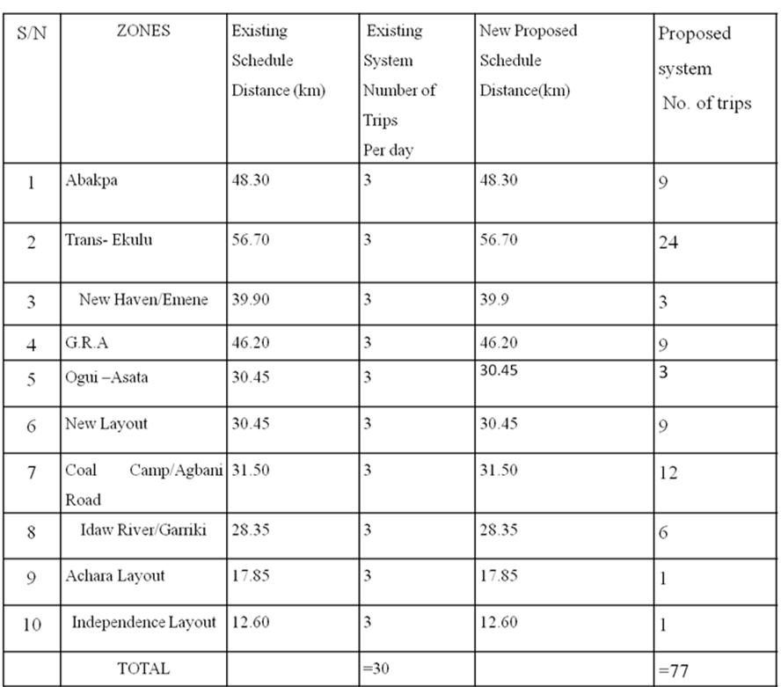

Table 4.5: Amount of Waste Generated in the Metropolis, Number Of Dump Sters And Compactors Required.

S/N | ZONES | HUMAN POPULATION  OF ZONES. | Mass solid of waste generated/ 0.98kg/person/day (Kg.) | No. of Dumpsters/  day(167 kg) | Number of compactors  /27tonne/day
1 | Abakpa | 165,754 | 162,438.92 | 975 | 7
2 | Trans- Ekulu | 20,394 | 19,986.12 | 120 | 1
3 | New Haven  /Emene | 92,394 | 91,085.12 | 546 | 4
4 | G.R.A | 48,846 | 47,869.08 | 288 | 2
5 | Ogui –Asata | 51,946 | 50,907.08 | 306 | 2
6 | New Layout | 101,625 | 99,592.50 | 597 | 4
7 | Coal Camp/  Agbani Road | 42,964 | 42,104.72 | 252 | 2
8 | Idaw River  /Garriki | 57,512 | 56,361.76 | 339 | 3
9 | Achara  Layout | 98,247 | 96,282.06 | 576 | 4
10 | Independence  Layout | 42,435 | 41,586.30 | 249 | 2
 | TOTAL | = 722,664 | = 708,213.66kg  = 708.2137 tonne | Total  = 4248 | Total = 31  compactors

TABLE 4.6: The Comparison between the Existing Schedule and the New Proposed System.

S/N | ZONES | Existing Schedule. Distances (km)/ day. | Actual Number  of Trips needed  per day | Existing System. Number of Trips  per day. | New Proposed Schedule. Distances  (km)/ day. | New Proposed  System number OfTrips  perday.
1 | Abakpa | 48.30 | 19 | 3 | 14.70 | 20
2 | Trans- Ekulu | 56.70 | 3 | 3 | 7.35 | 5
3 | New Haven  /Emene | 39.90 | 11 | 3 | 26.25 | 15
4 | G.R.A | 46.20 | 6 | 3 | 13.65 | 10
5 | Ogui –Asata | 30.45 | 6 | 3 | 21.00 | 10
6 | New Layout | 30.45 | 11 | 3 | 22.05 | 15
7 | Coal Camp/  Agbani Road | 31.50 | 5 | 3 | 10.50 | 5
8 | Idaw River  /Garriki | 28.35 | 7 | 3 | 14.70 | 10
9 | Achara  Layout | 17.85 | 11 | 3 | 19.95 | 15
10 | Independence  Layout | 12.60 | 5 | 3 | 12.60 | 10
 | TOTAL | =342.30 km | =84  Trips | = 30  Trips | = 162.75  km | =105 Trips

Table 4.7: Comparison of the Number of Compactors Required.

S/N | ZONES | Mass solid Ofwaste  generated/ 0.98kg/ person/  day( Kg) | Old System number of compactors Required  /27tonne/day | New Proposed System Number of compactors Required  /45tonne/day
1 | Abakpa | 162,438.92 | 7 | 4
2 | Trans- Ekulu | 19,986.12 | 1 | 1
3 | New Haven  /Emene | 91,085.12 | 4 | 3
4 | G.R.A | 47,869.08 | 2 | 2
5 | Ogui –Asata | 50,907.08 | 2 | 2
6 | New Layout | 99,592.50 | 4 | 3
7 | Coal Camp/  Agbani Road | 42,104.72 | 2 | 1
8 | Idaw River  /Garriki | 56,361.76 | 3 | 2
9 | Achara  Layout | 96,282.06 | 4 | 3
10 | Independence  Layout | 41,586.30 | 2 | 1
 | Total | = 708,213.66kg  =708.2137 tonne | Total = 31 compactors | Total=22  compactors

  - Discussions.

    - Justification of the Additional Nine (9) Land fillSites.

- From the annual saved cost of N22, 974,826.45, the additional nine landfill sites can be constructed and also six (6) extra compactors purchased (see Table3.3).

- In order not to disorganise the existing zoning of the metropolis by the ESWAMA, the nine additional landfill sites will argument the Ugwuaji landfill site such that each zone can be taken care of by one landfillsite.

- The optimal solution for the proposed waste disposal scheduling system was done using a Hungarian mathematical model. This model makes use of a square matrix in its optimization iterations. Therefore, an additional nine (9) landfill sites will balance the number of zones in themetropolis.

- From section (1.6.1) one of the important assumptions made was that each of the proposed landfill sites will take care of each zone for at least forty (40)years.

- The cost of acquiring the dump sites, developing the sites and ensuring good access roads to the sites had already been factored into ESWAMA maintenance cost as shown in table 3.3; containing the annual maintenance cost and quarterly dump site maintenance. Theenvironmental effects control had been reflected in page 45 under the social and psychological factors considered during the waste disposal schedulingdesign.

CHAPTER FIVE
Conclusion and Recommendation.
  - Conclusion
The management of solid waste is a herculean task as wastes are being generated by human activities, animals and plants on every passing minute. However, an attempt had been made in this work to present an efficient method for handling solid wastes in a metropolis ( Enugu metropolis).This design if correctly applied is capable of reducing the total cost of waste disposal in the metropolis under study by52%.

  - Recommendation.

These research findings are recommended to ESWAMA in particular and to any other organization with similar type of business. This methodology can easily be adapted to other state of the federation in taking care of their solid waste management, even though the original design was applicable to Enugu state waste management Authority.
Some of the specific recommendations are thus:
    - ESWAMA should purchase additional twenty (14) compactors as this will help to evacuate the solid waste generated in the metropolis eachday.
    - ESWAMA should maintain the five Trips arrangement per day for an efficient disposal of the solid wastes generated in the metropolis eachday.
    - ESWAMA should purchase additional three thousand three hundred and eighteen (3318) Dump sters to augment the nine hundred and thirty (930) dump sters already in use.
    - ESWAMA should establish nine (9) more landfill sites in addition to Ugwuaji landfill site.
    - ESWAMA should establish a branch office in each zone where the compactors will take offfrom.
    - From the annual saved cost of N22, 974,826.45, the agency can construct nine additional landfill sites at the cost of N6, 300,000; buy four compactors (N10, 400,000) recruitfourdrivers(N1,440,000)andtwelvecrewmen(N2,880,000)whichamounts

to N 21,020,000 leaving an excess of N 1,954,826.45 that can be used for miscellaneous expenditure such as site maintenance.
    - ESWAMA should use a differentiated coloured solid waste buckets placed at different locations with each bucket specified for a particular function. For an example, a red coloured waste bucket should contain radioactive or poisonous waste, green coloured bucket should contain biodegradable waste while yellow and white buckets should contain combustible waste and recyclable wastesrespectively.

  - Suggestions for FutureResearch

In light of the above analysis, it is important to suggest that future work can be carried out to improve the efficiency of ESWAMA.
- A good research work should be done on designing and constructing a recycler that can convert the wastes disposed in the landfill site into useful endproducts.
- Direct energy recovery converter such as digesters, bio-gas burners etc., that are affordable to low income earners should be researched upon to aid the preventive mechanism of wastedisposal.
- The concept proposed by Guido Maria Bazzani (1998) as shown in figure 2.2 should be researched on since it can enhance efficient solid Waste management of themetropolis.
- Also a good research work should be done on designing an efficient solid waste disposal scheduling system where differentiated coloured solid waste buckets placed at different locations with each bucket specified for a particularfunction.

REFERENCES.

Agunwamba, J.C, (2003).OptimizationofSolid Waste collection system in Onitsha,Nigeria:International Journal of Environmental Issues, Vol No 1, page 124-126.

Ajagbe, W.O, Agbede, O.A,(2004).Solidwaste Management in South-Western Nigeria:InternationalJournal of Environmental Issues, Vol 2 No 1&2, page92-100.
Aliyu Baba Nabegu (2011). Solid Waste and Its Implications for Climate Change in Nigeria Department of Geography, Kano University of Science and Technology, Wudil,Kano, Nigeria.

Andrew Jones(2003). What Is Integrated Waste Management? wiseGeek conjecture corporation.pp-1

Anupam Khajuria, Yugo Yamamoto and Tohru Morioka.( 2010) .Estimation of municipal solid waste generation and landfill area in Asian developing countries
Division of Sustainable Energy and Environmental Engineering, Graduate School of Engineering,Osaka University, 2-1 Yamada-oka, Suita, Osaka - 565-0871, Japan.

Anyaegbudike, G ( 26th April,2010). How sustainable is waste management in Enugu? www.thetidenewsonline.com, page-11320.

Ayaji, Kenneth (2008). A semi-structured interview administered to the ESWAMA Officials.
Chang, N.B., and Wei Y.L. (2002). “comparative studybetweenheuristics waste algorithm and optimization technique for vehicle routing and scheduling in the solid management system.,” civil Engineering and Environmental system, vol.19,No1,41-65.

Cointreau-Levine, S (1999). Urban waste generation and classification. Guidelines for municipal solid waste management in the Mediterranean Region.pp 3-10.
Daniel P. Duffy(2006). Landfill Waste Compaction Strategies - Tools and Techniques. http://www.mswmanagement.com/september-october- 2006/landfill-waste-compaction.aspx

Daskalopoulos, E., Badr, O., Probert, S.D., 1998. An Integrated Approach to Solid Waste Management. Resources, Conservation and Recycling - 24, 33-50.
Dass Ravi (Director-in-Chief Municipal Corporation of Delhi-India ) (2007): Solid Waste Management: Issues and Challenges in Asia ©APO 2007, ISBN: 92-833- 7058-9.Published by the Asian Productivity Organization 1-2-10 Hirakawacho, Chiyoda-ku, Tokyo 102-0093, Japan. Pp62-91.

Dayo Komolafe, Waste Management in Abuja: The Missing Links. The Tide online Newspaper, Friday, November 18, 2011.
Diamadopoulous, E; koutsanonakis,Y and Zanghara, V(1995). “Optimal design of Municipal solid waste recycling Systems”.Resource Conservation and Recycling. Page 20-35.

Egwu, Frank, (2008). A semi-structured interview administered to the ESWAMA officials.
Enugu State Waste Management Authority (ESWAMA) Headquarters. 7 Ridge Way
G.R.A . State Secretariat Complex.PMB 01194,Enugu. Phone : 042-250016

Frank Onwumelu, Coal City FM Newsbroadcast, 6.30 pm, Wednesday 16th March, 2011.

Guido Maria Bazzani.(1998). Integrated Solid Waste management: A Multicriteria Approach. Sixth Joint conference on Food, Agriculture and the Environment

(in honour of Professor Emeritus Philip M. Raup), Minneapolis, Minnesota.page 1-19.

High beam research. www.highbeam.com/doc/1G1-16886865.html
April 15, 1995Public Works Journal Corporation. This material is published under license from the publisher through the Gale Group, Farmington Hills, Michigan.
Huszain Huzin (2004). National Waste Recycling Program. Power-Point presentation at the Seminar for the Study on National Waste Minimization in Malaysia, Ministry of Housing and Local Government, 16 September 2004.

Isaac Alfred Tsiboe, Ernest Marbell (2004). A Look At Urban Waste Disposal Problems in Accra Ghana.

Johnson, N.E, (2006). Assessmentofmunicipal Solid waste potentials for generation of power in Enugu of Nigeria. page1-3.

Lund, J (1990). “Least cost scheduling of solid wastes recycling” Journal of Environment,Engineering.ASCE. page 170-194.

MacDonald and Vopni,P.(1994). “Policy Barriers to 50% diversion of Municipal solid waste”. Waste Management and Research, page .12.

MarlaLS (2010). Compacting Method of Waste Disposal. www.livestrong.com/article/207735-compacting-method-of-waste-disposal.

Michael K. Nganda. (January 2007), Mathematical Models in Municipal SolidWaste.
Department of Mathematical Sciences Chalmers University of Technology and G¨oteborg University SE-412 96 G¨oteborg, Sweden.

Ministry of Works, Land and Transport, Survey Division Enugu. page 257-260.
National Population Commission state office. 7 Ridge Way G.R.A,PMB01189. Tel : 042-257377, Enugu(2006).

Odocha, J.N.K (1994). “Waste Generation and Management in a Depressed Economy” a lecture delivered to students of the law and Environmental Faculty, UNEC.
Okoroigwe, C.E, Lecture Note on Engineering Design and Systems Analysis (2007 session). Page 25-35.
Orjiako, G.U and Nwosu, A.D. (1989). “Optimal strategy for solid waste collection in Nigeria urban towns-A case study,” proc.of Eng. Research for Develp. Sept.25- 28,pp38-43.

Otti V. I.( February 2011). A model for solid waste management in Anambra State, Nigeria. Journal of Soil Science and Environmental Management. http://www.academicjournals.org/JSSEM Vol. 2(2), pp. 39-42.
Ramboll. 2006. a b c d "Waste to Energy in Denmark".

Richard, J.Schonberger, (1985).Operations Management. Customer-
focused Principles. 6th Edition.Tabhrenzo publishers. Page 420-423.

Robert M. Clark(Chief, Urban Data Section, Base Data Branch, Solid Waste Mgmt.
Ofc., Envir. Protection Agency, Cincinnati, OH) and Billy P. Helms, (Grad. Student, Univ. of Tennessee, Knoxville, TN) (1972).Fleet Selection for Solid Waste Collection Systems Journal of the Sanitary Engineering Division, Vol. 98, No. 1, January/February, pp.71-78

Smith S.E ( 2011). What is Solid Waste Management? Copyright Protected: 2003-2011 Conjecture Corporation.

Sridhar,M.K.C(1996) “Women in waste management” A seminar papersponsored
by LHWP and the British Council for the Seminar on Educating Women for Sustainable Environmental Management, Owerri, Nigeria, March 5th-7th.
Swallon, S; Opaluch, J.J and Weaver, T.F (1993). “Citing noxious Facilities: An approach that integrates technical, economical and political considerations”. Land Economics, 68, page 284-303.
Tchobanoglous, George, H. Theisen and R. Eilassen. (1977). Solid waste, Engineering, Principles and Management Issues. NewYork: McGraw Hill
Book Co.
The Institute for Local Self Reliance in Washington, D.C. describes zero waste in the following terms:1.800.RECYCLING.COM- Americahttp Green://
www.ecocycle.org/zerowaste/

Tomas F, Jared C, David M (1979). The Mathematical Programming Sequencing Model, pp. 112-128.

Uchegbu, Smart, N. Environmental Managementand Protection: Enugu, Spotlite pulishers, 2002. page 45,51-53.
Ugwuh, Uchechukwu Solomon (2009). The State of waste
Management in Nigeria. Waste Management, Vol 29, Issue 10, Page 2415-2614.
United States Environmental Protection Agency
EPA530-F-02-026a (5306W) Solid Waste and Emergency Response May 2002. www.epa.gov/globalwarming
Wasteguide. Framework and strategies for waste management in European cities”. EPA copenhagen

Wood, K.S. (1986). “Specifying the right truck for your refuse operations,” World Waste, Vol.29,No 10,30-32.

World Health Organization fact sheet N’ 281 (October 2011) .

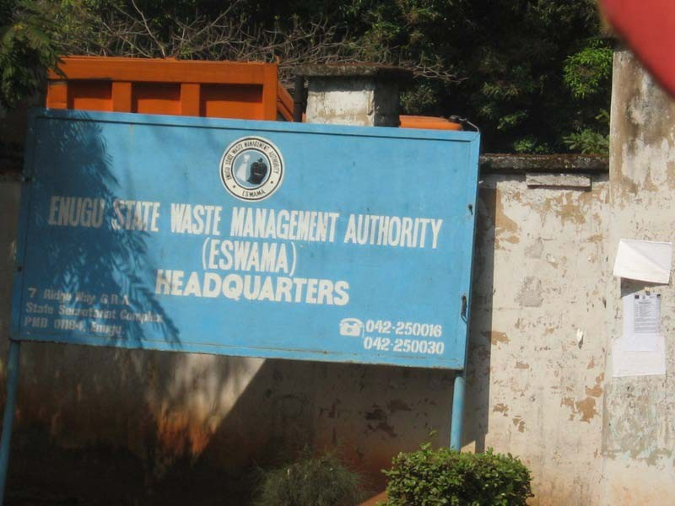

ESWAMA Headquarters Enugu.
………………………………………………………………………………………………...

APPENDIX 2

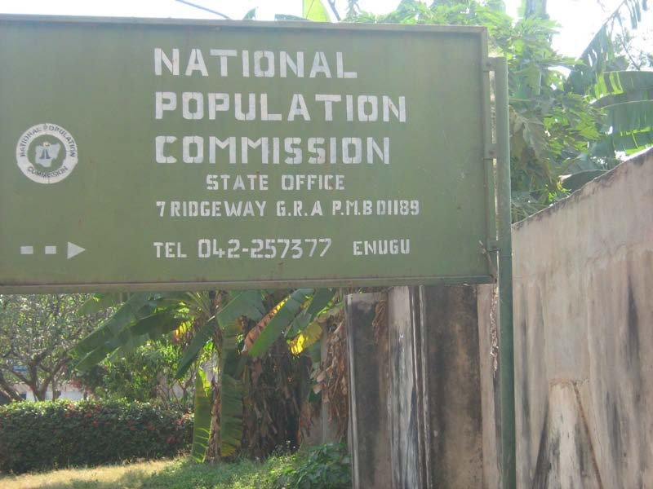

National Population Commission Headquarters, Enugu.

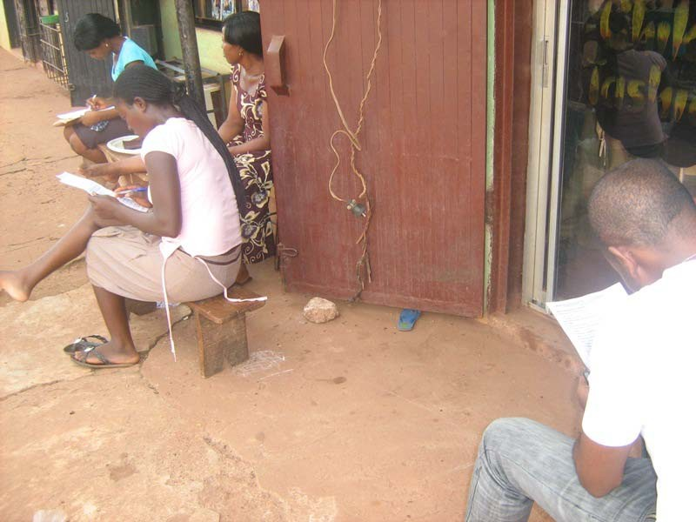
Respondants answering the questionnaire, Idaw River area.

……………………………………………………………………………………………

APPENDIX 4

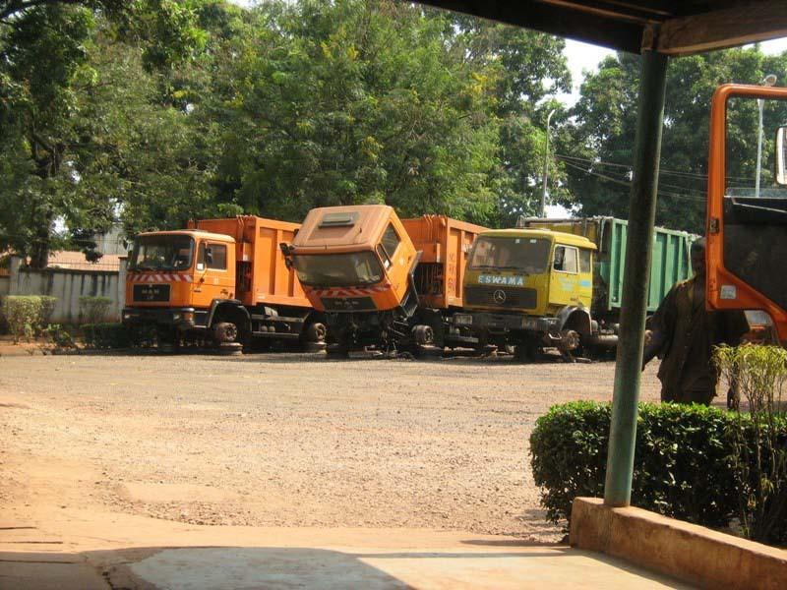

Some of the damaged compactors at ESWAMA Headquarters, Enugu

………………………………………………………………………………………………...

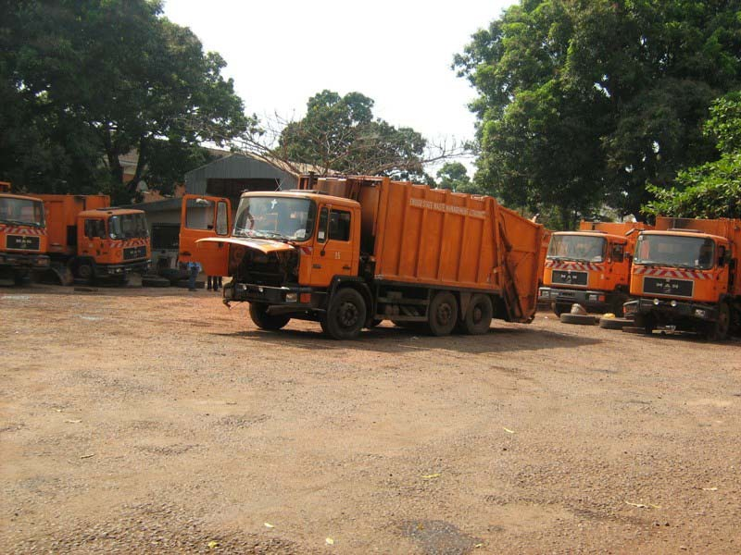

Some of the damaged compactors at ESWAMA Headquarters, Enugu.
………………………………………………………………………………………… APPENDIX 6

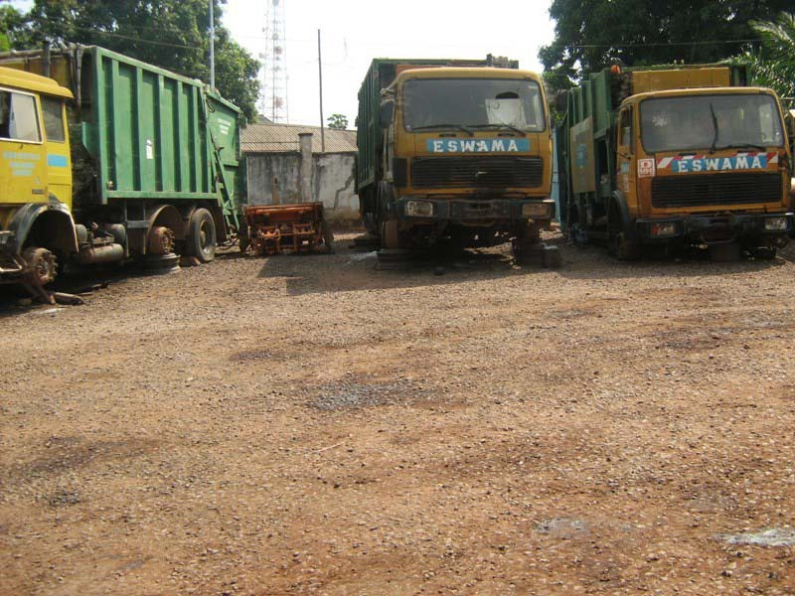
Deplorable state of some the compactors.

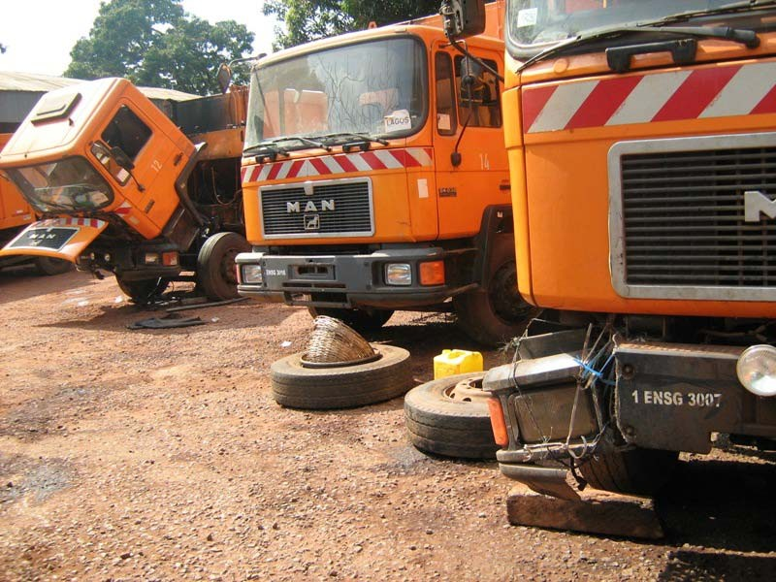
Spare parts are being removed from stand-by compactors to fix fairly good ones.

………………………………………………………………………………………………...

APPENDIX 8
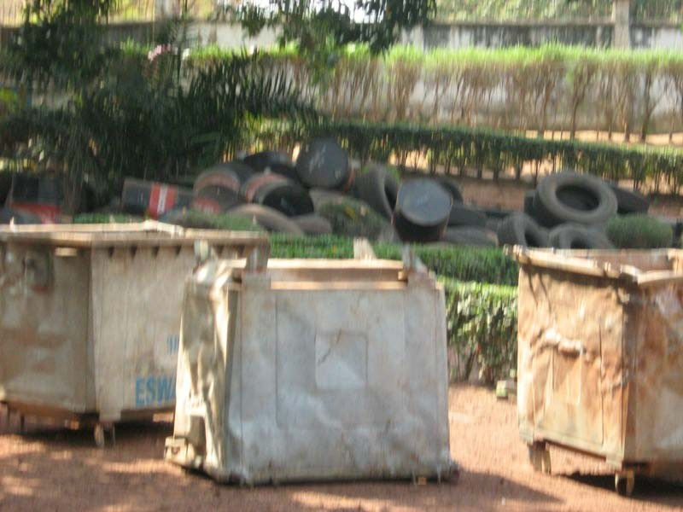
A heap of worn-out tyres as a result of over-usage of compactors and long distancestravelled.
………………………………………………………………………………………………………………..

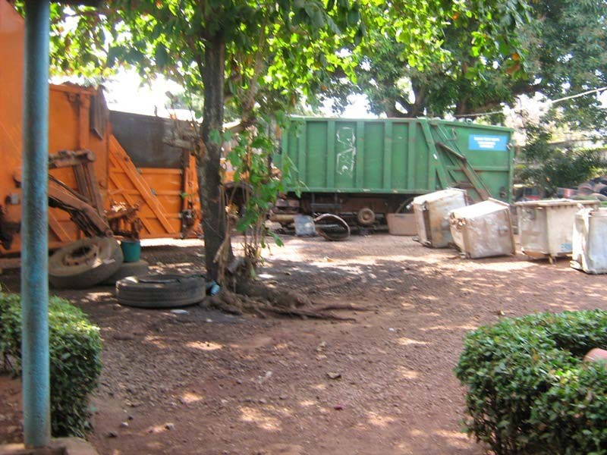

Picture of some damaged compactors and waste dumpsters.

……………………………………………………………………………………………

APPENDIX 10

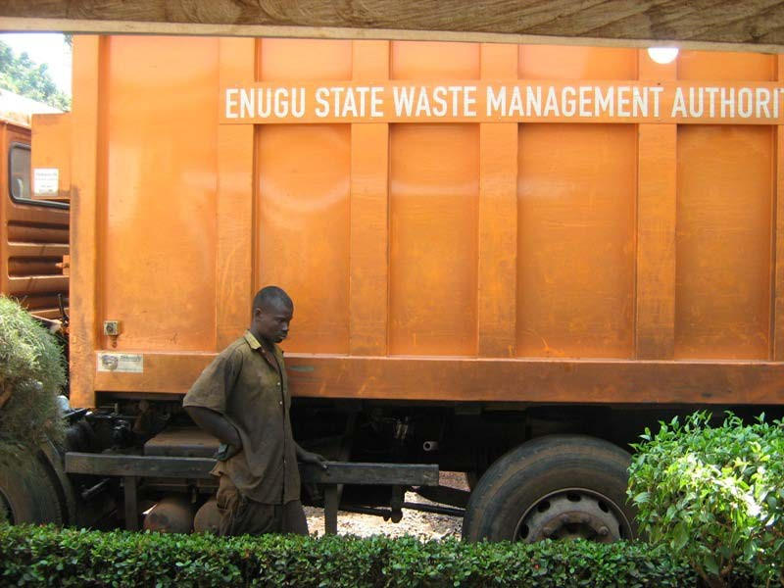

One of the technicians that repair the vehicles.

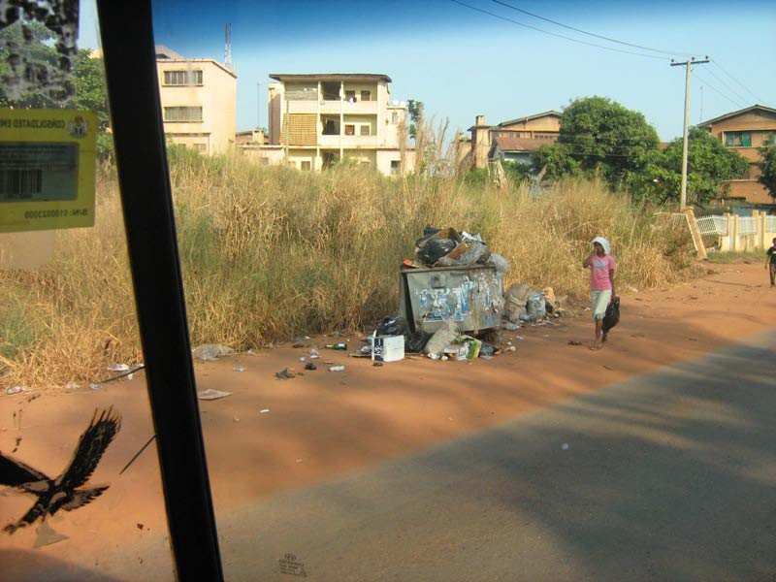

A girl closing her nose because of the odour coming from the waste
.……………………………………………………………………………………

APPENDIX 12

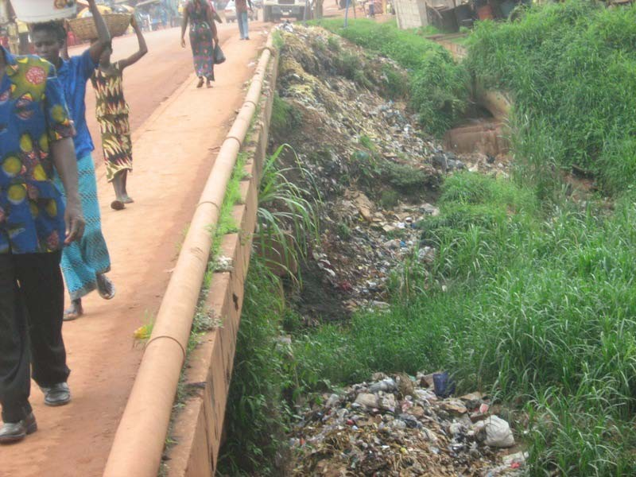

Passers-by inhale odour of the waste.

………………………………………………………………………………………………

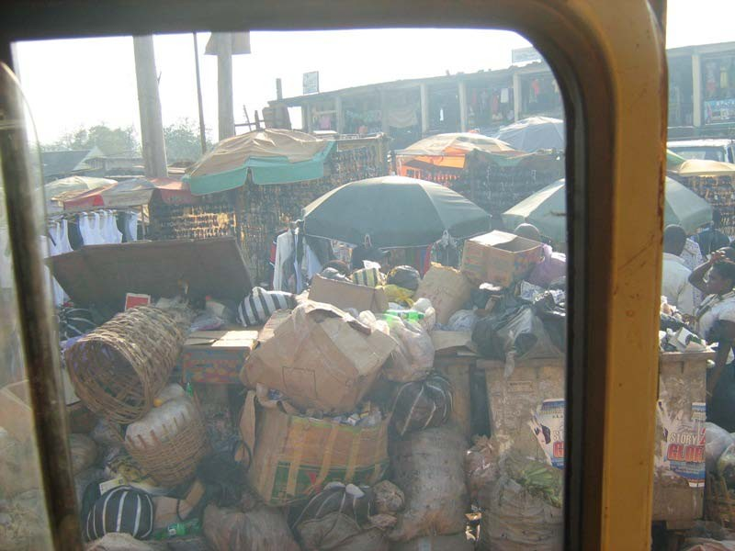

Mountain of solid waste along Okpara Avenue.

……………………………………………………………………………………….

APPENDIX 14
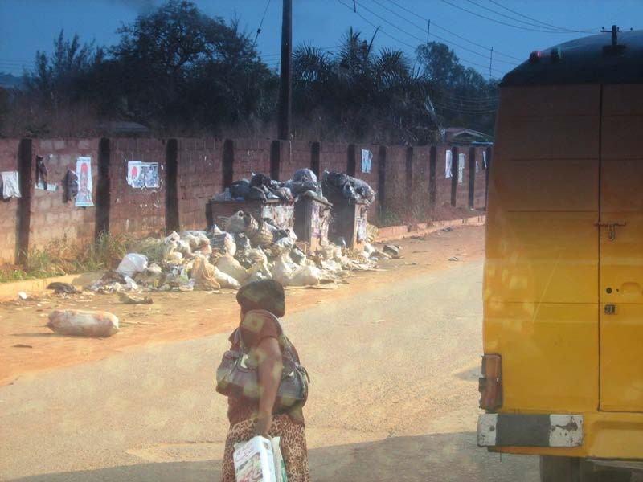

Heaps of waste along Agbani road.

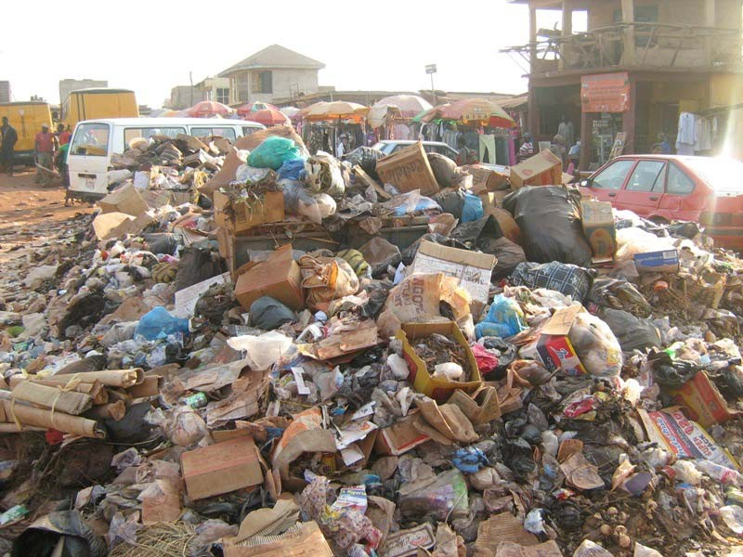

Large volume of waste at Garriki area.

………………………………………………………………………………………………………………...

APPENDIX 16

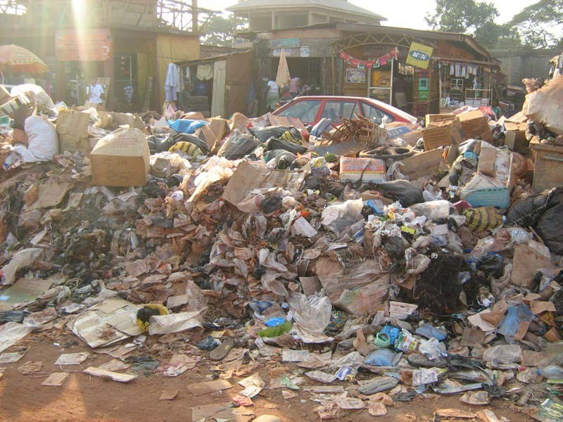

Open dump seen at Awkunanaw area.

APPENDIX 17

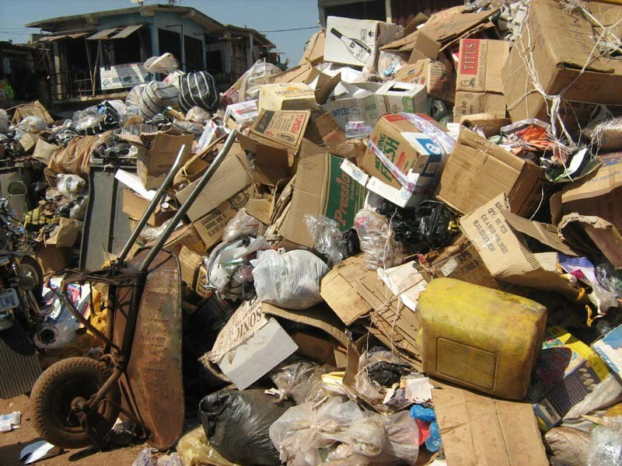

Great heap of solid waste at Ogbete area.
…………………………………………………………………………………………

APPENDIX 18
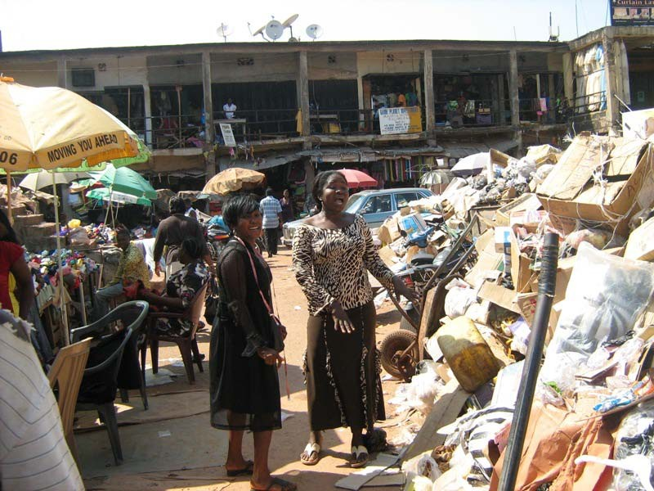
Traders complaining about the inefficiency of the ESWAMA.

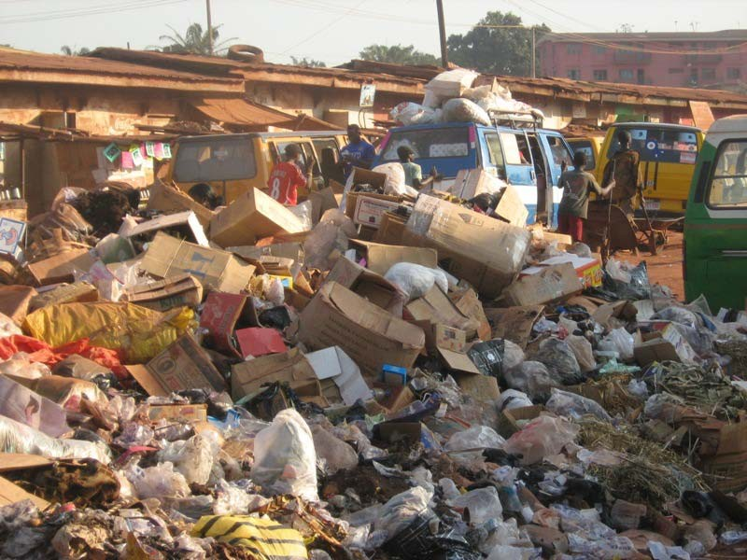

Another heap of waste seen at Garriki/Ebonny paint area.

………………………………………………………………………………………………

APPENDIX 20

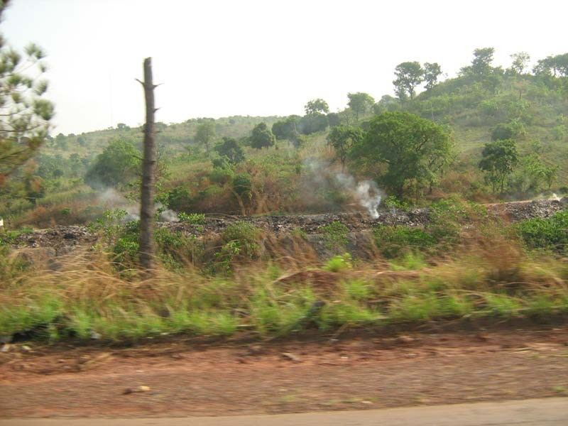

Illegal burning of an open dump alongEnugu/9th Mileroad.

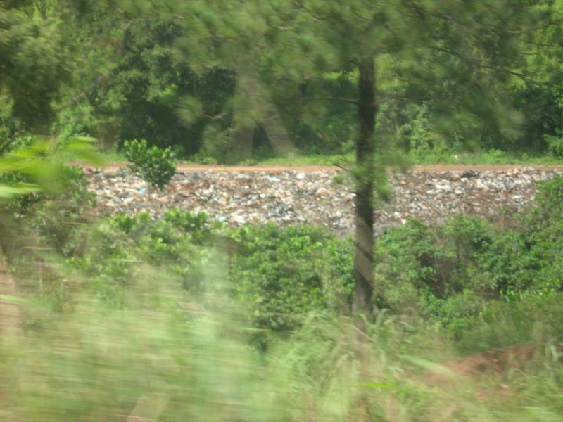

Another ugly sight of open dump beside Proda company.

………………………………………………………………………………………………………………

APPENDIX 22
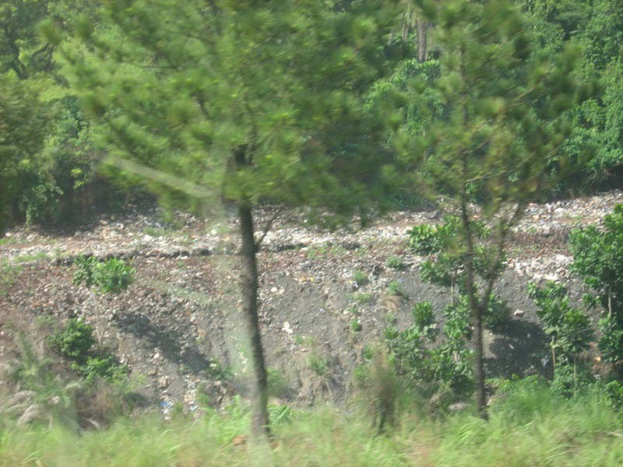

Another view of open dump beside Proda company.

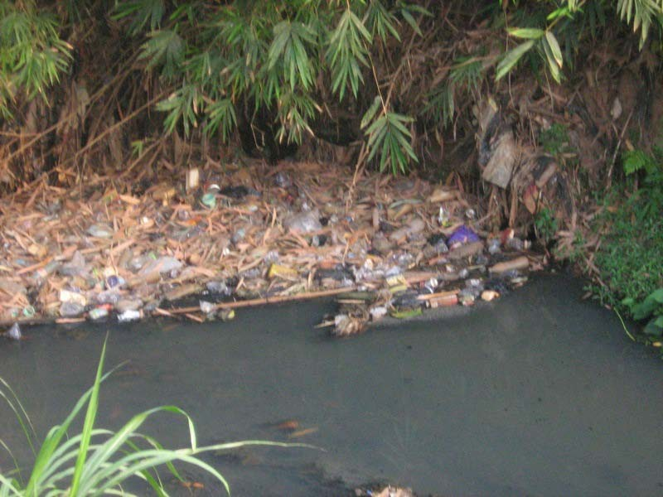

Solid wastes made this river water undrinkable; Asata/Ogui area.

…………………………………………………………………………………………..

APPENDIX 24

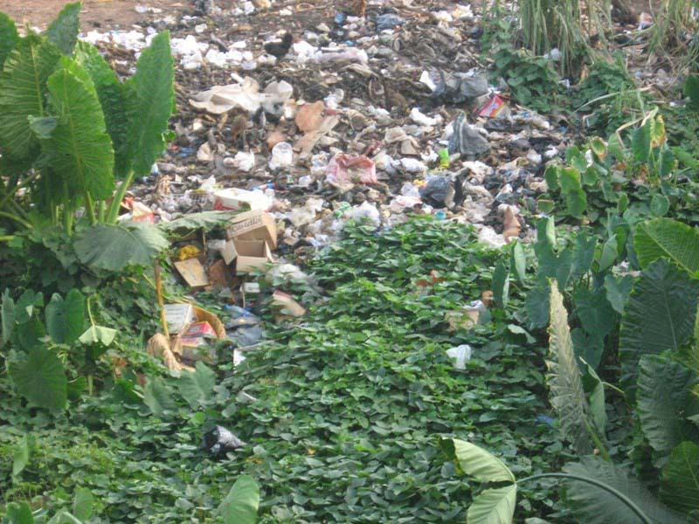

Wastes made this land infertile; Asata area.
………………………………………………………………………………………………

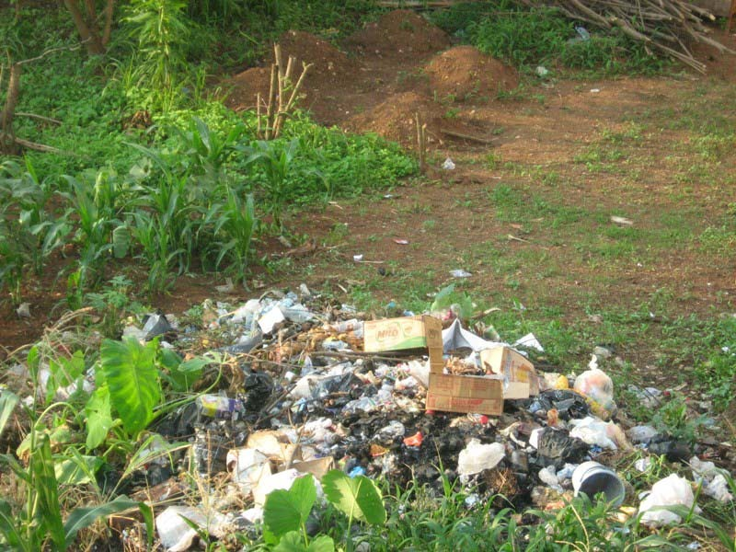

Wastes made this land infertile Independence Layout area.

…………………………………………………………………………………………………………

APPENDIX 26
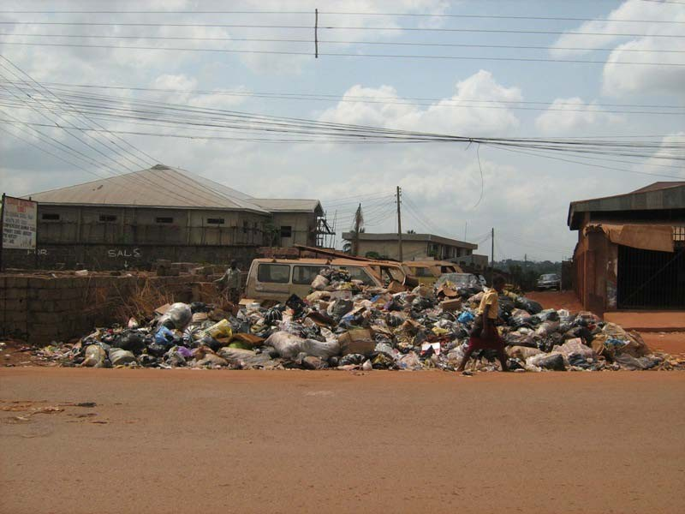
Open dump seen at Ugbo Odogwu.

………………………………………………………………………………………………

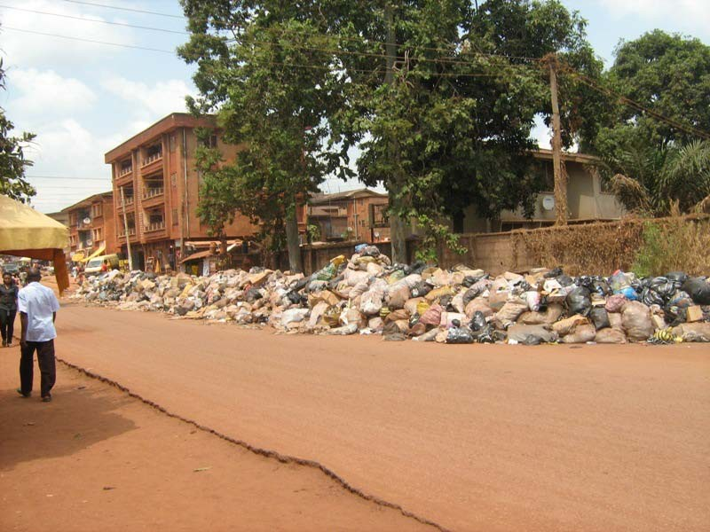

Open dump at Abakpa zone.

…………………………………………………………………………………………

APPENDIX 28

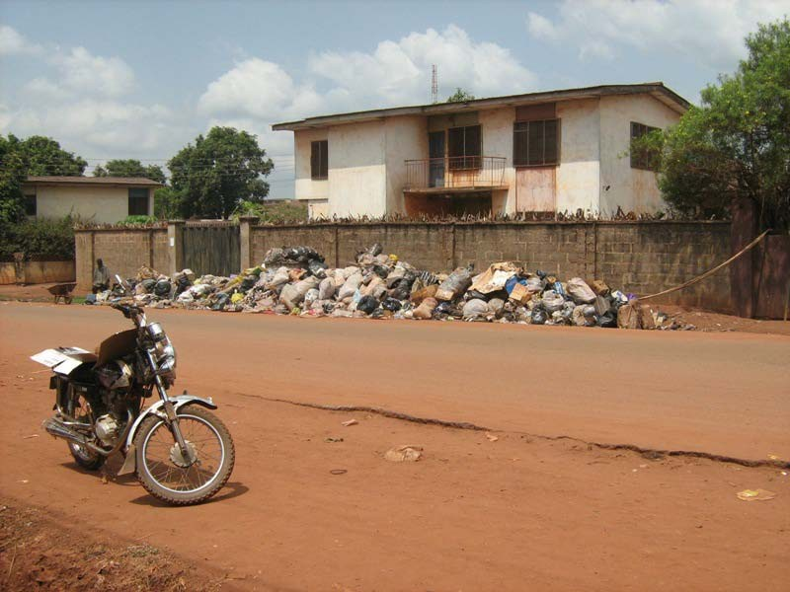
Another open dump at Nike area; a menance to the citizens.

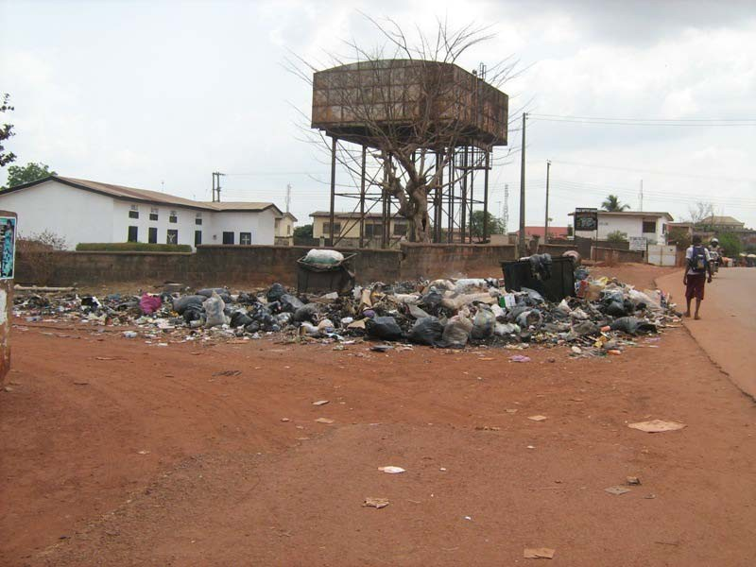

Mountain of solid waste seen at Abakpa area; a threat to source of drinking water.
…………………………………………………………………………………………

APPENDIX 30
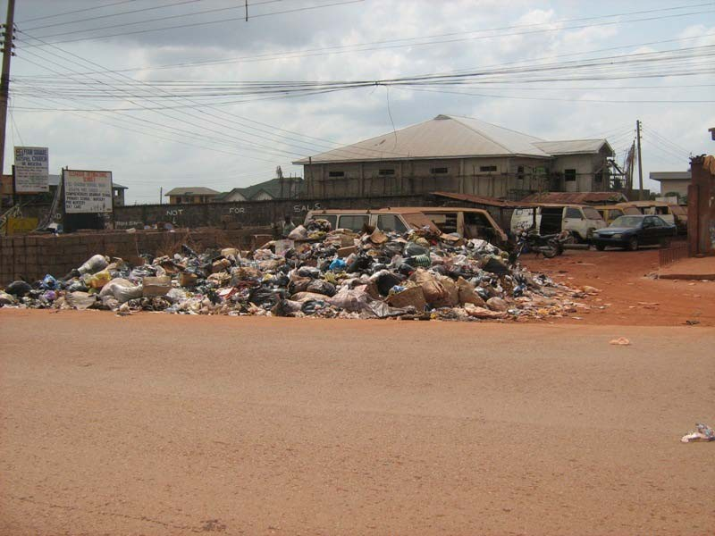
Open dump at Nike area

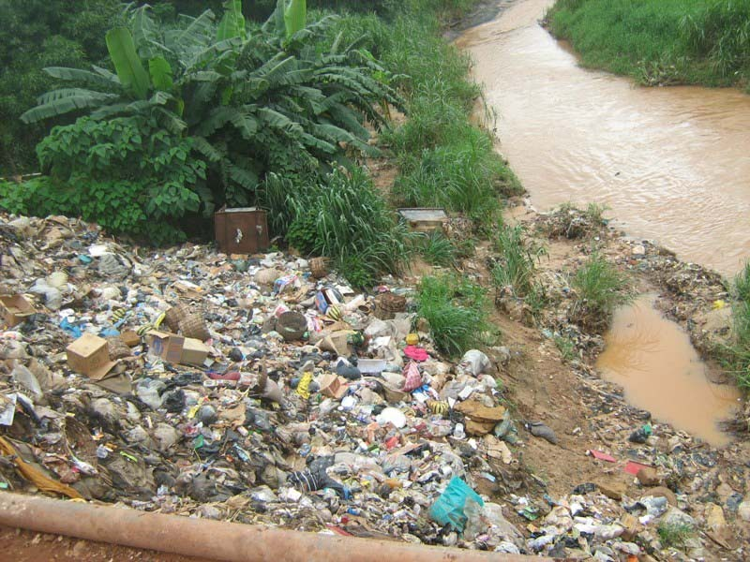

Illegal dumping of wastes into the river; Emene bridge area.
………………………………………………………………………………………

APPENDIX 32
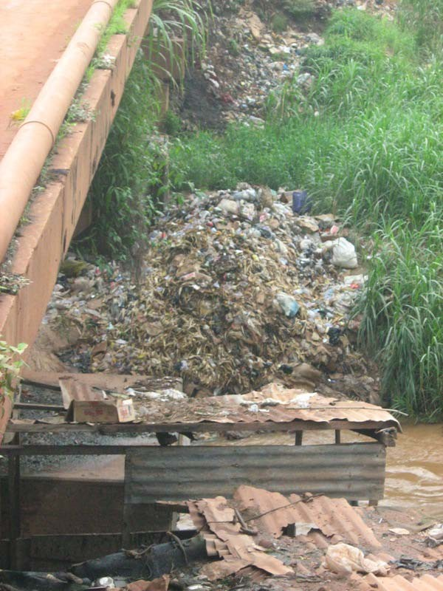

Solid wastes being dumped under Emene River Bridge.
………………………………………………………………………………………………

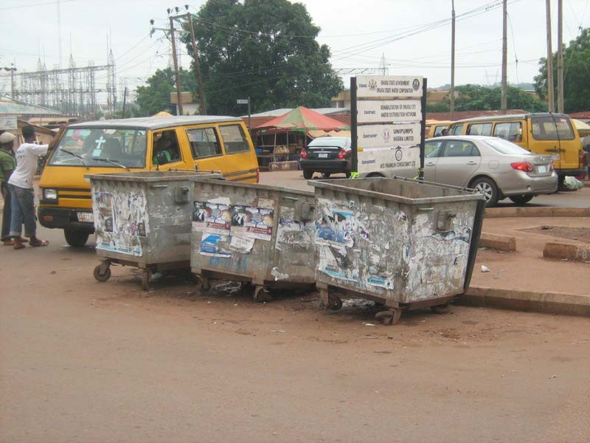

Empty dump stand seen at New Haven area.

………………………………………………………………………………………

APPENDIX 34

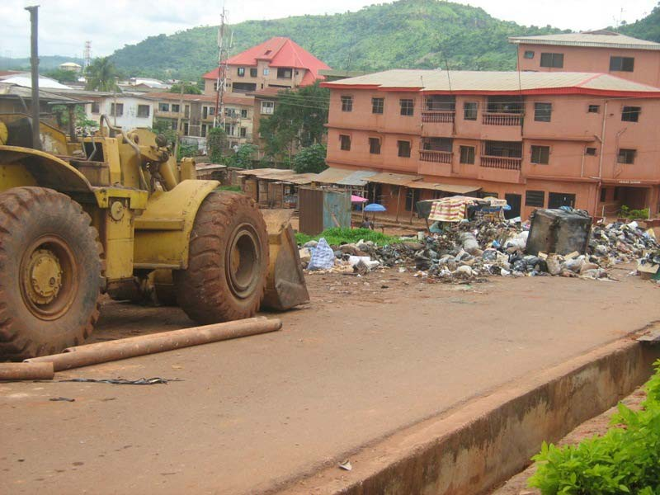

This caterpillar was hired to be able to remove the solid wastes; Idaw river.

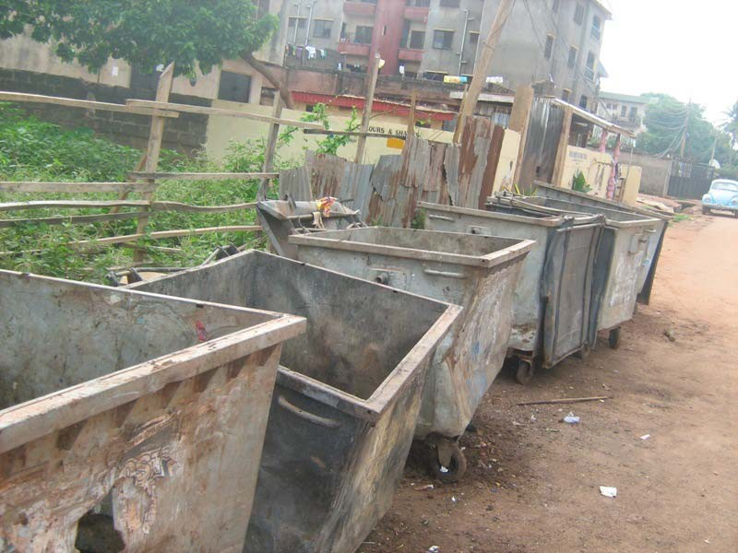

Empty dump stand seen at Achara Layout.

………………………………………………………………………………………………

APPENDIX 36

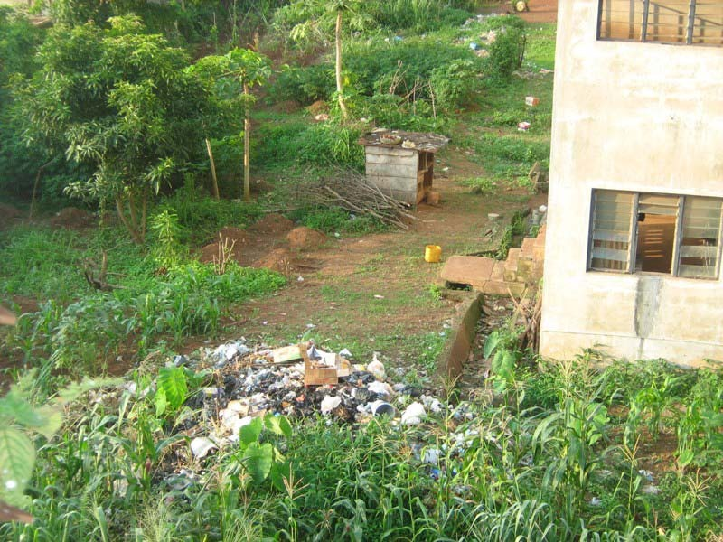
Reckless dumping of refuse due to lack of dumpsters; Independence Layout area.
………………………………………………………………………………………………

APPENDIX 37

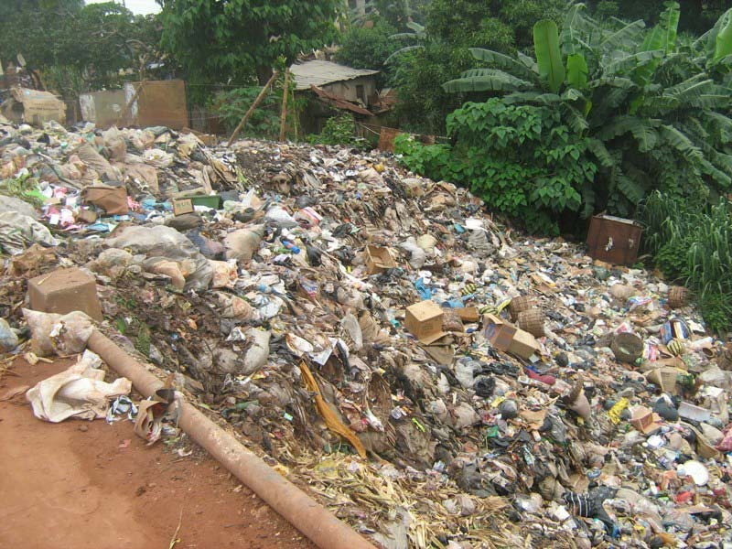

Heap wastes along Emene road.

……………………………………………………………………………………………

APPENDIX 38

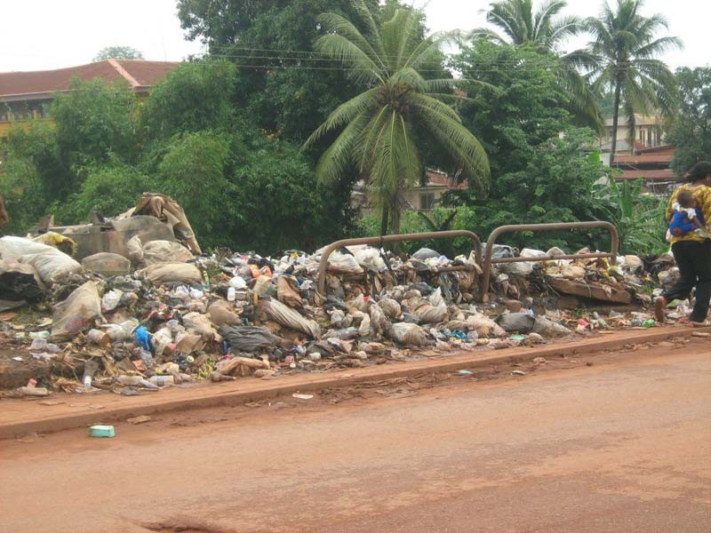

Another ugly sight of solidwaste along Enuguroad.

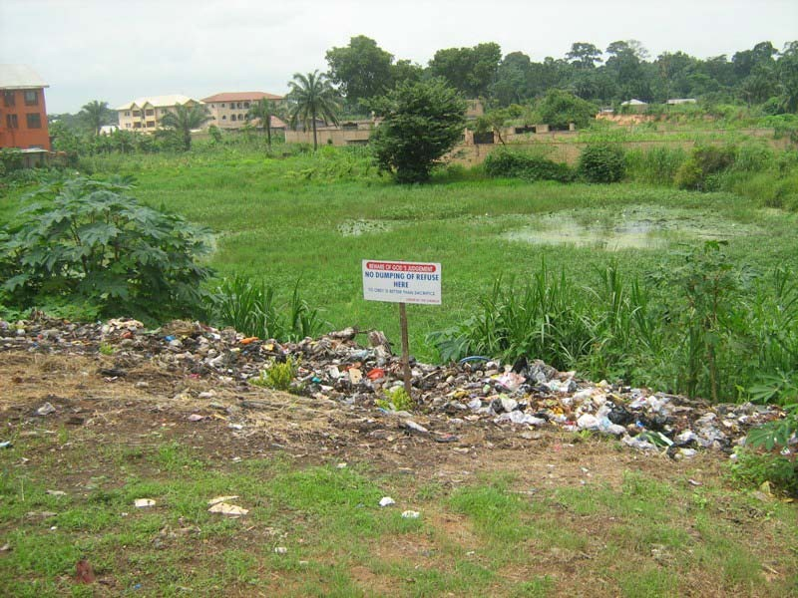

Open dump seen at Emene.

………………………………………………………………………………………………

APPENDIX 40

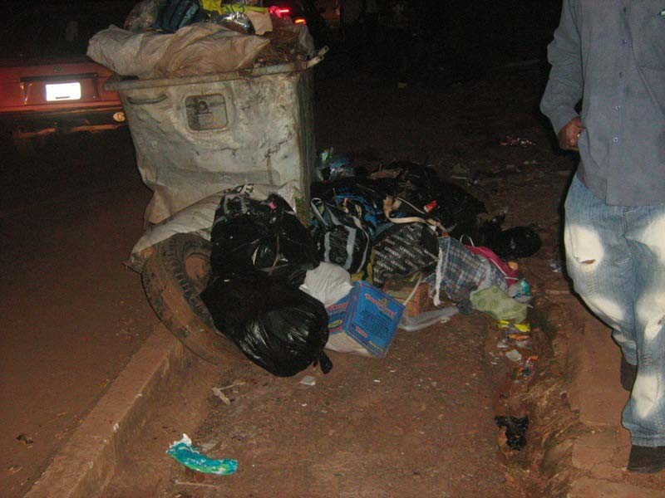

An evidence of insufficient buckets seen at Trans-Ekulu area.

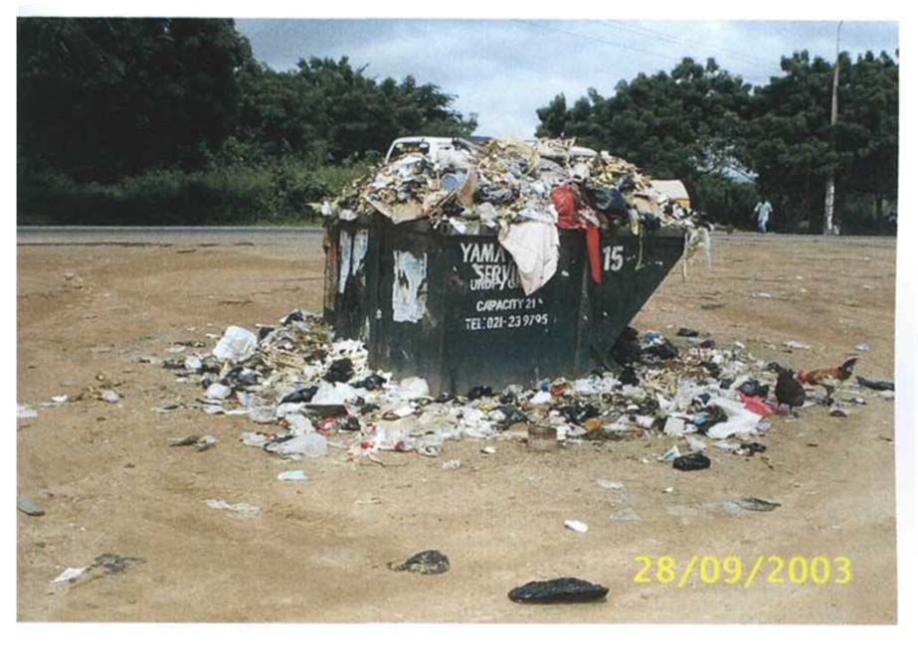
An evidence of insufficient waste bin seen at Accra, Ghana
SOURCE: Isaac Alfred Tsiboe And Ernest Marbell(2004).
……………………………………………………………………………………………

APPENDIX 42

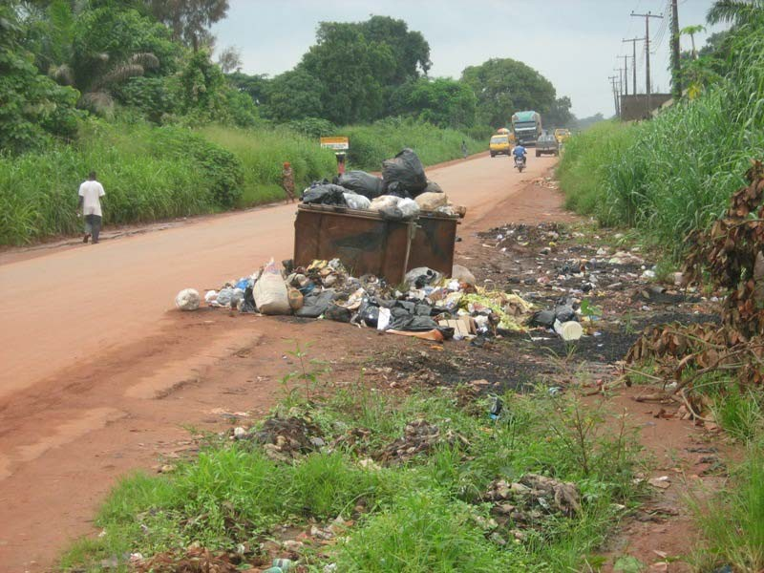

Solid wastes blocking pedestrian walk-way; Emene.

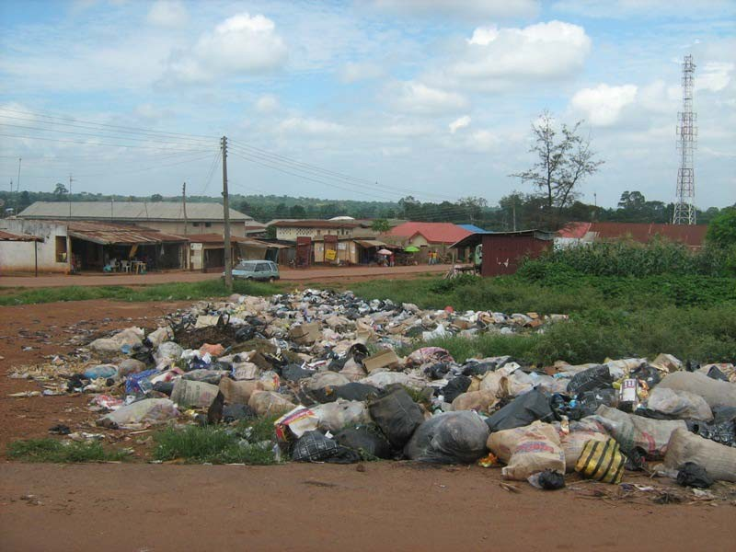

Another open dump along Nike resort hotels road.

………………………………………………………………………………………………

APPENDIX 44
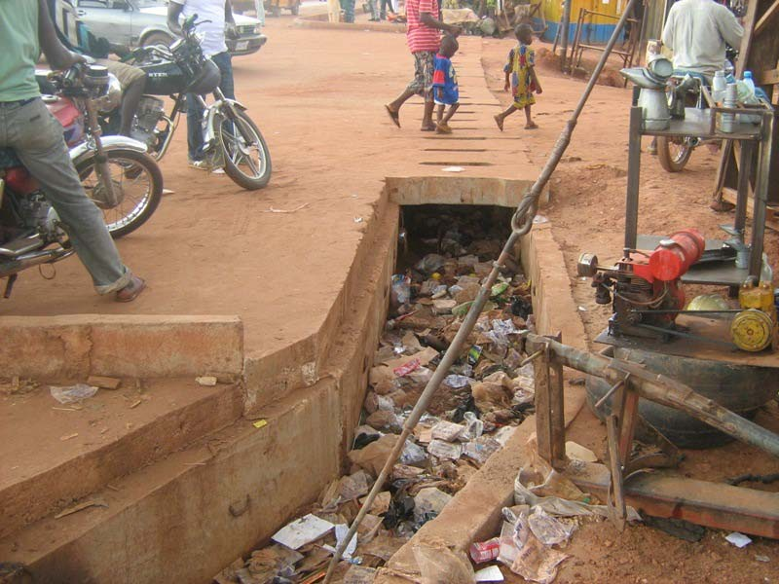

Solid wastes blocks drainage gutters Ebonny paint road.

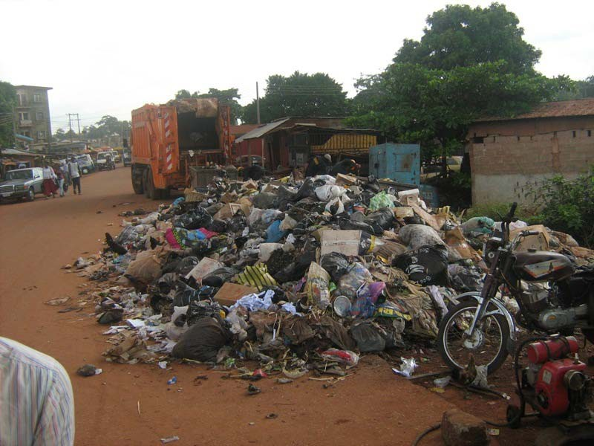
.

Heap of refuse along ebonny paint road.

………………………………………………………………………………………………

APPENDIX 46
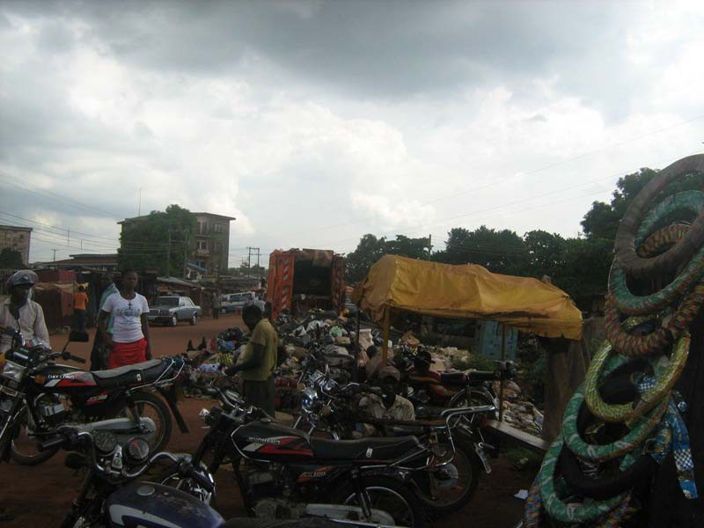

Road-side technicians complaining of the waste; Ebonny paint road.

……………………………………………………………………………………………….

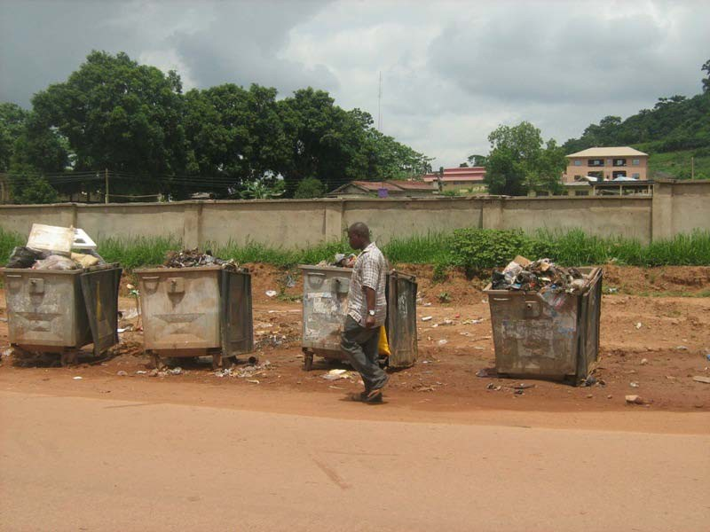

Dump stands already filled up before noon; Agbani road.

………………………………………………………………………………………………

APPENDIX 48

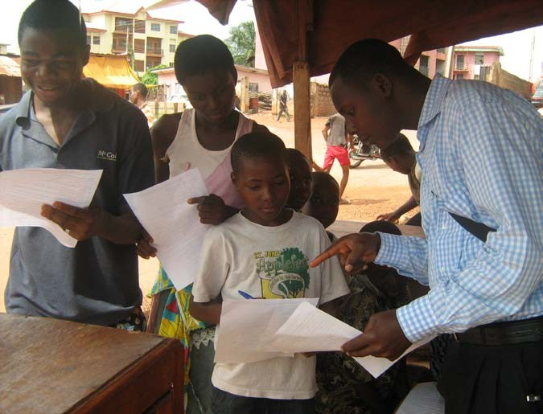
Respondants answering the questionnaire, Achara Layout area.

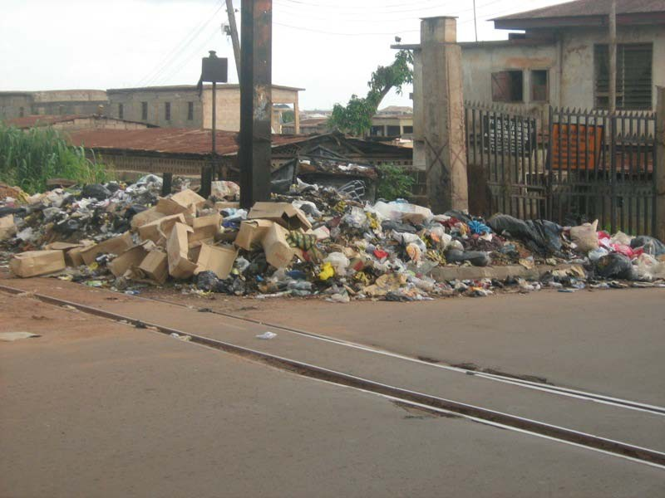

Open dump along new layout road .
………………………………………………………………………………………………

APPENDIX 50

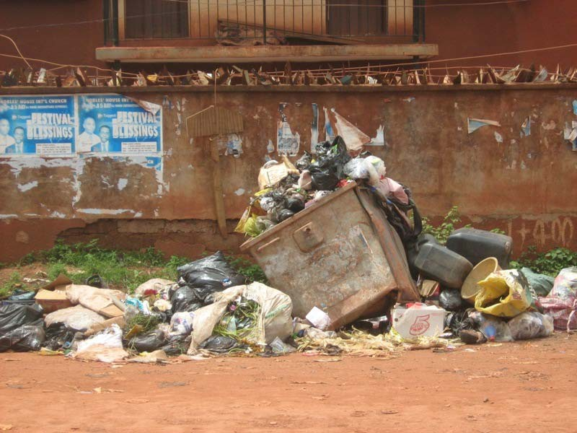

Over-filled bucket along Igbariam area; Achara layout.

……………………………………………………………………………………………….

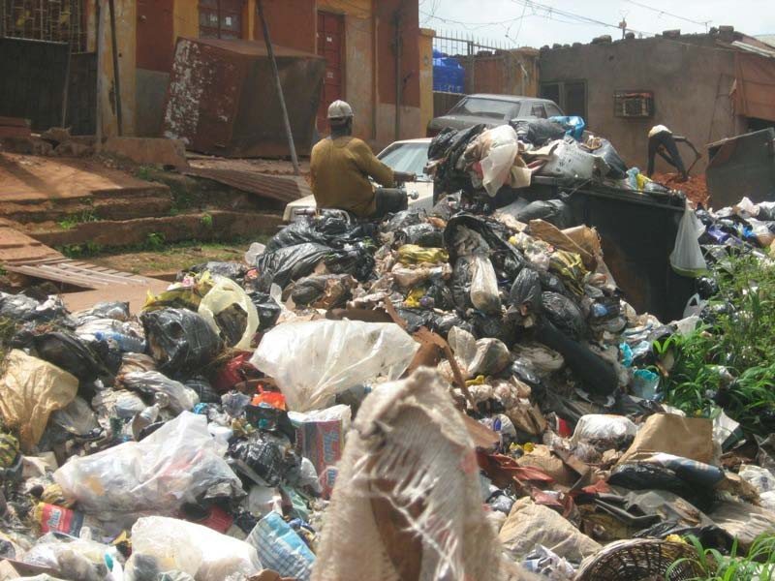

Solid wastes causing traffic jam; Idaw River area.

……………………………………………………………………………………

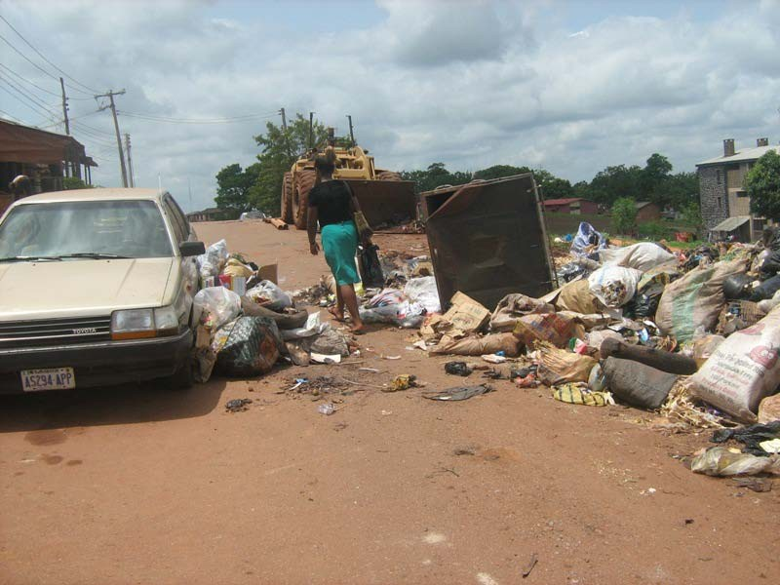
APPENDIX 52

.

Solid wastes obstructing movement of people and vehicles; Idaw River

Damaged dump sters as a result of over-usage.

……………………………………………………………………………………

APPENDIX 54
Integrated Solid Waste Management Approach Design.

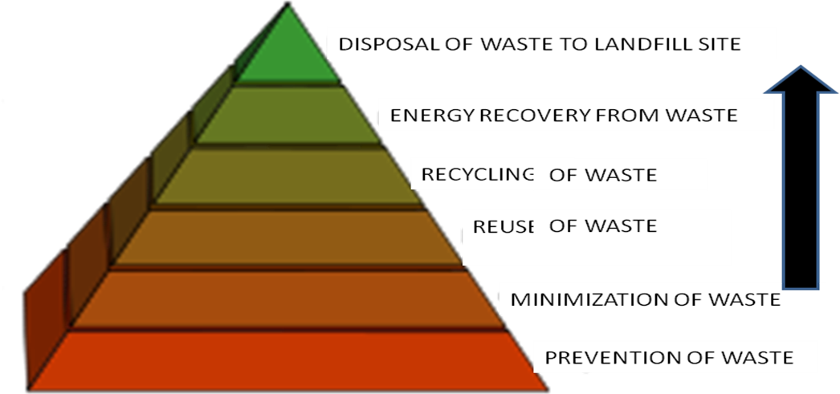

The Research Questionnaire.

RESEARCH TOPIC: DESIGN OF AN EFFICIENT SOLID WASTE MANAGEMENT AND DISPOSAL SCHEDULING SYSTEM: A CASE STUDY OF ENUGUMETROPOLIS.
Section A: Personal information of Respondents
Instruction: please tick (√) where appropriate.
- Sex; (a)Male { } (b)Female{ }
- Age group: (a)Children{ } (b)Youth{ } (c)Adult{ }

Section B: The rate at which wastes are being generated.

S/N | ITEMS
3 | Do you live here or around here? (a)Yes { } (b) No { }
4 | How do you dispose your waste? (a) ESWAMA{ } (b)Bush{ } (c)Burn  { } (d)Gutter{ } (e)Anywhere{ }
5 | Do you make use of ESWAMA dust stands or waste collection bucketsaround  your street? (a)Yes{ } (b)No { }
6 | How many times do you dispose your wastes into the ESWAMA bucket in a week? (a)once{ } (b)twice{ } (c)thrice{ } (d)Everyday{ }  (e) once in twoweeks { } (f) Once amonth{ }
7 | The waste you dispose each time, is it up to (a) a bathingbucket{ } (b)two  bathingbuckets{ } (c) three bathingbuckets{ } (d)Above { }
8 | Does everybody living in your yard make use of the ESWAMA waste collection buckets? (a)Yes{ } (b)No{ } (c) Noidea{ }
9 | Do you bag your waste before disposing it? (a)Yes{ } (b)No { }
10 | Whatkindofbagdoyouuse?(a)Polyethylenebag{ } (b) Baco bag{ }  (c) Rice bag{ } (d) Garribag{ }

11 | Do your neighbours bag their wastes also? (a)Yes { } (b)No{ }
12 | What kind of bag dotheyuse? (a) Polyethylenebag{ } (b) Bacobag{ }  (c) Rice bag{ } (d) Garribag{ }.
Section C: The perceived influence of ESWAMA on the inhabitants of Enugu metropolis.
S/N | ITEMS
13 | Do you think ESWAMA is doing a better job in this new administration than  the former administration? (a)Yes { } (b)No{ } (c) Noidea{ }
14 | How do you rate ESWAMA? (a)50%{ } (b)60%{ } (c)70%{ }  (d) Above70%{ } (e) below50%{ }
15 | When does ESWAMA vehicle collect the waste from the dumpsters nearyou?  (a)Everyday{ } (b) twodays{ }(c) once aweek { } (d) once amouth  { } (e) Noidea{ }
16 | How many days does it take the ESWAMA bucket near you to be filled up?  (a)oneday { } (b) Fourdays{ } (c) oneweek{ }  (d) twoweeks{ } (e) Onemonth{ }
17 | How does the environment look like if the waste is not collected by  ESWAMA? (a)Nasty{ }(b)Friendly{ } (c)Untidy{ }
18 | Do you need more ESWAMA buckets in your street? (a)Yes{ } (b)No{ }
19 | Do you need more ESWAMA vehicles in your street? (a)Yes { } (b)No { }
20 | Do you have any suggestion on how ESWAMA can improve on their work?

NOTE: ESWAMA is Enugu State Waste Management Authority.
Dust sters: The waste collecting containers of ESWAMA seen along the streets.
Compactor: ESWAMA Waste collecting vehicle

