Topic

The study of drugs’ medication within Nigeria students using Markov Chain

Abstract
The research work tend to study the use of drug(s) among students it is prescribed or not. In the course of the work using stochastic process, the following result was obtained : the initial state shows that 52% of students were on prescribed drug, while 48% are not.Transition to another
time of the state the proportion changes and become stable at equal chance for the two likely state (50%, 50%)

CHAPTER ONE
- INTRODUCTION

Self-medication is defined as getting and consuming drug without the guidance of physician for either diagnosis, treatment, or supervision of the treatment, generally involving over-the-counter (OTC) medications but also including prescription-only medicines (POM), at the same time it includes buying drug by reutilizing/resubmitting a previous prescription, taking medicines on advice of relative or others, or consuming leftover medicines already available at home.
Self-medication with OTC medication is a worldwide public health problem and is more experienced in developing countries. Self-medication patterns vary among different populations and are influenced by various features, such as age, gender, income and expenditure, self-care orientation, educational level, medical knowledge, satisfaction, and nonseriousness of illnesses.

Studies revealed that Self-medication represents a common problem among university students. Media exposure and the increase of pharmaceuticals advertisement pose a larger threat to this population as it was found that majority of college students used at lease one of the advertised products, without discussing it with their physicians. Other reason for Self-medication among university students were their previous experiences, advice of family or friend, their health problems being considered as to trivial, time saving, non-availability of transport, convenience, ability to self-mange the symptoms, urgency of the problem, doctor that was not available, and having sufficient information. Lack of time, low cost consultation, and trust in medical doctor were reported as main reasons in other studies.
Self-medication which practiced correctly reduces the load on medical services, reduced the time spent in waiting to see the physician, and saves cost especially in economically deprived countries with limited healthcare resources.

However, it has been found that Self-medication can slip towards Self-medication with prescription medication and/or improper drug use such as misdiagnosis, low or high doses, and/or treatment duration. Such practices may result in irrational drug use, delayed seeking of medical advice, and increased side effects and increase in pathogens resistance that result in wasting of resources.

Despite the importance of the problem of Self-medication among university students, to authors’ knowledge, only two Egyptian studies investigated that problem, one among medical students in Ain Shams University and the other among nonmedical studntsin Suez Canal University.

Research on addiction recovery often focuses on traditional and well-established groups such as Alcoholics Anonymous or SMART Recovery. Recently, another type of recovery group has emerged within communities. These groups are based around social activities and have not been studied in the literature. This stud qualitatively identified individuals’ experiences within these group. Semi-structured interviews were carried out with 10 abstinent members of social-based groups, who had previously experienced drug or alcohol dependence. Interpretative phenomenological analysis was employed on the transcripts to try and understand the individuals’ experiences of being involved in these groups. Four themes emerged from the participants’ experiences:

- group’s role in their recovery
- personal choice and flexibility in recovery experience
- group as an inclusive family unit and
- active involvement in the recovery group
These findings are discussed in relation to previous literature, and the value of these groups for recovering individual is highlighted.

Self-medication is a growing public health issue worldwide, defined as the use of a product without medical prescription or medical consultation in order to prevent or treat a disease or a symptom or to promote health; In many cases medicines are provided by other people, generally relatives, friends or colleagues, who share both the drug and the knowledge about their use, and who always lend old prescription to buy new medicine without consulting a doctor in order to know if the active principle is appropriate.

The reasons for this habit must be researched in both economic and social motivations this practice can be considered, indeed, as an aspect of the economic globalization with the consequent greater availability and variety of products. Furthermore, globalization facilitates the access to many kind of drugs and their misuse. In a developing country, this behavior could also be a consequence of the difficult access to health services and of the problem of lack control of pharmaceutical production and selling. In addition, promotional advertising through mass media of the over-the-counter drug (OTCs) probably has changed people’s attitude to use medication/drugs with a potential increase of drug consumption as an easy way to take care of personal health problems.

Moreover, it should be acknowledged that some governments encourages citizens self-medication of minor illnesses. Such a practice is seen indeed a san opportunity to take responsibility and to manage their own health. Other governments, instead, have recently started policies to discourage the misuse of drug, aiming to increase citizen; self-awareness and to reduce inappropriate self-medication that causes wastage of resources, increasing of bacterial resistance and adverse drug reactions.

Interestingly, a study conducted in 2008 in USA showed that 42% of population declared to use OTCs and that 4% were potentially at risk of having a major drug – drug interaction in Brazil, this percentage varies greatly between different regions, with a range from 17% to 60%. An Australian study confirmed an increase of self-medication habit in the last year from 17% of 2000-01 to 35.5% of 2003-04.

This drug-behavior regards also the adolescents, but this topic is not well discussed in literature, especially regarding the developed countries. In fact several teenagers, especially girls age 11 to 15 years declared to take different types of drugs, specially painkillers, and this behavior begin to expand to younger age. Furthermore, teenagers are not always known exactly how to use drugs and need more information about this topic to prevent side effects. The major reasons supporting self-medication are the quickness and the affordability of drugs.

The issue of self-medication among the adolescents represents an emerging topic in the scientific research. Therefore, an integration of all data available could be useful in order to obtain a single quantitative index estimation and to reach stronger conclusions than those drawn from individual studies. For this reason, a systematic review and meta-analysis were performed in order to investigate the prevalence and the adverse effects of the self-medication among the teenagers.

  - DRUG

Drug, substance that affects the function of living cells, used in medicine to diagnose, cure, prevent the occurrence of diseases and disorders, and prolong the life of patients with incurable conditions.

The availability of new and more effective drugs, such as antibiotics, which fight bacterial infections and vaccines, which prevent diseases caused by bacteria and viruses, helped increase the average improved the quality of life. During the 20th century, drugs enabled the eradication of smallpox, once a widespread and often fatal disease. By the early 21st century, vaccines had led to the near eradication.

Drug can be classified in many ways: by the way they are dispensed – over the counter or by prescription, by the substance from which they are derived – plant, mineral, or animal; by the form the take – capsule, liquid, or gas; and by the way they are administered – by mouth, injection, inhalation, or direct application to the skin (absorption). Drug are also classified by their names. All drugs have three names
A chemical name, which described the exact structure of the drug

A generic or proprietary name, which is the official medical name, assigned in the United States by the U.S Adopted Name Council (a group composed of pharmacists and other scientists).

A brand or trade name, given by the particular manufacturer that sells the drug. If a company holds the patent on a drug that is, if the company has the exclusive right to make and sell a drug – then the drug is available under one brand name only After the patent expires, typically after 17 years in the United State, other companies can also manufacture the drug and market it under the generic name, or give it a new brand name.

Another way to categorize drug is by the way they act against diseases or disorders: chemotherapeutic drugs attack specific organisms that cause a disease without harming the host, while pharmacodynamics drug alter the function of bodily systems by stimulating or depressing normal cell activity in a given system. The most common way to categorize a drug is by its effect on a particular area of the body or a particular condition.

  - ADMINISTRATION

Depending on the drug and its desired effect, there are a variety of administration methods. Most drug are administered orally that is, through the mouth. Only drugs that will not be destroyed by the digestive processes of the stomach or intestines can be given orally. Drug can also be administered by injection into a vein (intravenously), which assures quick distribution through the bloodstream and a rapid effect, under the skin (subcutaneously) into the tissues, which result in localized action at a particular site as with local anesthetic; or into a muscle (intramuscularly), which enables rapid absorption through the many blood vessels found in muscles. An intramuscular injection may also be given as a depot preparation, in which the drug is combined with other substances so that it is slowly released into the blood.

Inhaled drugs are designed to act in the nose or lugs. Generally anesthetics may be given through inhalation. Some drugs are administered through drug-filled patches that stick to the skin. The drug is slowly released from the patch and enters the body through the skin. Drug may be administered topically that is, applied directly to the skin, or rectally absorbed through an enema (an injection of liquid into the rectum) or a rectal suppository (a pellet of medication that melts when inserted in the rectum).

1.3 DOSE-RESPONSE RELATIONSHIP
The extent of the body’s response to a drug depends on the amount administered, called a dose. At a low dose, no response may be apparent. A higher dose, however, may produce the desired effect. An even higher dose may produce an undesirable or harmful response. For example, to relieve a headache most adults require two tablets of aspirin. A half tablet may provide no relief from pain while ten tablets may cause burning pain in the stomach or nausea.

The doses prescribed by physicians are those recommended by each drug’s manufacturer to produce the best therapeutic, or medically beneficial, responses in the majority of patients. However, doses may need to be adjusted in certain individuals. For example, a person may be born without the enzyme required to metabolize a particular drug while other individuals may suffer from lung disorders that prevent them from absorbing inhaled drugs. Factor such as alcohol consumption, age, the method of drug administration, and whether or not the individual has taken the drug previously can affect an individual’s response to a drug.

1.4 DRUG ABUSE
Drug abuse is characterized by taking more than the recommended dose of prescription drugs such as barbiturates without medical supervision, or using government-controlled substances such as marijuana, cocaine, heroin, or other illegal substances. Legal substances, such as alcohol and nicotine, are also abused by many people. Abuse of drugs and other substances can lead to physical and psychological dependence (see Drug Dependence)

Drug abuse can cause a wide variety of adverse physical reactions. Long –term drug use may damage the heart, liver, and brain. Drug abusers may suffer from malnutrition if they habitually forget to eat, cannot afford to buy food, or eat foods lacking the proper vitamins and minerals. Individuals who abuse injectable drugs risk contracting infections such as hepatitis and HIV from dirty needles or needles shared with other infected abusers. One of the most dangerous effects of illegal drug use is the potential for overdosing that is, taking too large or too strong a dose for the body’s systems to handle. A drug overdose may cause an individual to lose consciousness and to breathe inadequately without. Without treatment, an individual may die from a drug overdose

1.5 SIGNIFICANT OF THE STUDY
Drug substance that affects the function of living cells, used in medicine to diagnose, cure, prevent the occurrence of disease or disorder.

The use of drugs is a very important aspect of health which invariable deform in the health status of every individual. Some either use the drug without the doctor/medical officer prescription, while other complying. This study will so along way in showing the state and the likely risk associated to this aspect of medication.

1.6 SCOPE OF STUDY
The research work since it concerned with health and specific the use of drugs (medication), therefore, it covers all the populace who are t user of drugs and how the drug is being used.

1.7 LIMITATION OF STUDY
In the course of the study, some challenges were encounters such as access to data, non-response, how to collect the sample and the time constraint of the research work.

1.8 AIM & OBCJECTIVES
The general aim of the research work is to examine the likely state of drug medication
Objectives
- To obtain the sample space
- To obtain the transition matrix
- To obtain the chance of each state.
- To predict for the future

CHAPTER TWO

LITERATURE REVIEW
2.0 INTRODUCTION

Substance abuse is defined as a maladaptive pattern of substance use leading to clinically significant impairment or distress, wherein the person may also suffer from tolerance and withdrawal.
Substance abuse is not limited to mood altering or psychoactive abuse when inappropriately used (as an steroids for performance enhancement in sports). Therefore, mood altering and psychoactive substance are not the drugs of abuse. Some of the drug most often associated with this term includes alcohol, amphetamine, MDMA, barbiturates, benzodiazepines, cocaine mathquatone: and may lead to opioids. Use of these drug may lead to criminal penalty in addition to possible physical social and psychological harm. Substance abuse is a common problem worldwide. (Majidshafiqueetal). Alcohol is widely consumed by various sections of the society, most notably by the very tributary and the impoverished.
The epidemiology of drug addiction in a given society seems to be dependent on cultural values, beliefs and attitudes to drug use, which are quite variable across cultures and geographical regions (Emmanuel, Akhtar&Rahbaar et al).
It was not intended or using a drug in excessive quantities. All sorts of different drugs can be abused including illegal drugs (such as heroin and cannabis) prescription medicines (pain killers) and the other medicines that can be bought off the super market shelves (cough mixers)
Drug abuse is an intense and often willful misuse of drugs. The overdrew of substance of drugs leads to addiction in the eastern world the incidence shows a decline or a static pattern but the number of drug addict is still enormous. The major abusive drugs are heroin and marijuana but designer drugs (cannabinoids) have shown on the peak. The aim of the study is to determine the ratio of the drug abuse in student. For this purpose we were selected different institutes, including two private universities and two government universities and conducted survey in 500 students. High proportion of students was found abusing drugs. From this study, we came across multiple factors which are the main cause of drug abuse in medical student including depression, anxiety, peer pressure schizophrenia, as well as personality disorder. The most commonly abused drugs include stimutants, illicit and prescription drugs misuse among college student. Drug abuse regarded as a personality disorder, also be seen as worldwide epidemic with evolutionary genetic, physiology and environmental influences controlling and affecting human behavior. Globally, the use has reached all time high. The study showed males are more drug abuser as compared to females. The drug abuse ratio in students of private sector is more as compared to government sector. (Zamanne’tal 2015)

Self-medication is the use of drugs to treat self-diagnosed disorders or symptoms or the intermittent or continued use of prescribed drug for chronic or recurrent disease or symptom and it is mostly common in developing countries. This study therefore assessed the practice of self-medication among undergraduate students of a private university in Nigeria method. The study employed a descriptive cross sectional design. A pretested questionnaire was self-administered to 384 undergraduate students of the university.
Data were analyzed and summarized using descriptive and inferential statistics such as chi-square and Fisher’s exact tests. Results.Overall , 297 (81.8%)
Boys e’tal (2001) study uses a functional perspective to examine the reason young people cite for using psychoactive substances. The study sample comprised 364 young poly drug users recruited using snowball-sampling methods. Data on lifetime and recent frequency and intensity of use for alcohol, cannabis, amphetamines, ecstasy, LSD and cocaine are presented. A majority of the participants had used at least one of these six drugs to fulfill 11 of 18 measured substance use functions. The most popular functions for use were using to: relax (96.7%) enhance an activity (88.5%) an alleviate depressed mood (86.8%). Substance use functions were found to differ by age and gender. Recognition of the functions fulfilled b substance use should help health educators and prevention strategists to make health messages about drugs more relevant and appropriate to general and specific audiences. Targeting substances that are perceived to fulfill similar functions and addressing issues concerning the substitution of one substance for another may also strengthen education and preventing efforts.
Performance measurement is a process by which an organization monitors important aspects of its program, system, and care processes. Although the logic of looking at workers’ overall environment when analyzing productivity has been widely documented, there is need for empirical research exploring the relationship between worker performance and the performance factors. Sakaet’al 2019 study was to determine and compare the factors associated with healthcare provider performance. A cross sectional stud was carried out among eight hundred and sixty-six (866) health care providers randomly selected from primary, secondary and tertiary hospital. All respondents claimed to have received job description. Most of the respondents working at primary healthcare hospital (PHCHs) 193 (75.4), secondary healthcare hospitals (SHCSs) 178(68.5) and tertiary healthcare hospital (THCHs) 221(63.1) are not well motivated in term of bonuses or praise for good work, while some respondents working at PHCHs 35(13.7%), at SHCHs 48.0(18.5%) and (THCHs) 109 (31.1%) received non-monetary incentives from employers. There were provider’s working in PHCHs 61 (23.8%), SHCHs 87(33.5%) and THCHs 82(23.4%) respectively had not received training on quality of health care. On eth one-to-one relationship, 10 of the 15 variables tested had very high significant effect on performance of health workers which was independent of typeso health facilities. It is recommended that health manager or administrator in the hospital at any level should provie all the composite performance factors and combine monetary and non-monetary incentives with others performance interventions such as training and good feedback to healthcare providers.
As the first experience of substance abuse often starts in adolescence, and studies have shown that drug use s manly related to cigarette and alcohol consumption, an initial exploration of substance abuse prevalence, including cigarette and alcohol, seems to be the first step in preventing and controlling drug consumption. This study aimed to explore study on drug use among high school students by investigating articles published in the past decade in Iran.
In this study, the databases inside the country, were used to access articles related to substance abuse by student during 2001-2011, among which 7 articles on 14-19 years old high school students were studied.
The seven studied articles showed that the highest drug use prevalence pertained to cigarette and hookah, followed by alcohol, opium, ecstasy, hashish and heroin. Opium and heroin use in Kerman city were, respectively, about 4 and 5 of their use in other studied cities.
Drug use in relatively high in the adolescent and effective group of the society, which requires particular attention and prompt and immediate intervention.
Self-medication is a common practices in developed and developing countries. Objectives. To explore the prevalence of self-medication practices among university students, probable reasons, symptoms requiring self-medication and sources of advice, method, A descriptive cross sectional study was carried out in Mansoura University, Egypt, and included 1st and last year students of both medical and nonmedical faculties. Prevalence of self-medication was 62.9%, younger age, female, medical and ever-married students and those having home pharmacy tended to self-medicate more than their peers with significant difference between them. Being medical student, being from urban area, having good current health condition, being careless about health, and having drugs stored at home pharmacy, were independently associated with the likelihood of self-medicating. Prevalence of self-medication among university students’ is high which constitutes a health problem that needs intervention (H et’al&Elwafa, 2017).
This article presents a review on self-medication, which can be defined as the use of medicine without any professional supervision. It aims to find the reason of self-medication and make public aware about its effects and side effects. People use it for the treatment of any disease symptoms or minor ailment by their self initiative. The most commonly available OTC medications are pain killers, cough and cold remedies, anti-considered risk free and useful for the treatment of common health problems, their excessive use can also lead to serious side effects and unfavorable reaction. The percentage of self-medication might be changes with locality and region. Prevalence of journals on the self-medication were reviewed for their finding and report on different parameters. These are several drug stores, which provide the medicine without any prescription and its percentage is increasing day to day in India. Presently the frequency is high of self-medication by the young ones and literate people who do not have much time to go to physician. This review conclude the benefit (when drug is used in limit and its use, characteristics are known), drawback (when people have no idea about its use and limitations) of drug and their safe use. (Jain &Malvi 2011).
Gualanoe’tal2014, performed a systematic review and proportion meta-analysis in order to investigate the prevalence and the adverse effects of the self-medication among the teenagers. Method: We selected observational studies published from January 1990 until January 2014 that examined the use of self-medication in the adolescents (ages from 13 to 18 years). Keywords used on PubMed, ISI Web of knowledge and Scopus were self-medication; adolescent*; self-prescription; over the counter preparation and self-administration.
Finally, 15 articles met the inclusion criteria, for a total of 143 213 subject involved. Overall, 50% of adolescents use to take drugs without consulting a physician. Further analyses stratified by number of drug used demonstrated that in the studies reporting that adolescents use more than one type of drug to prevalence rise up to 63%. Only one study reported the possible adverse effects related to the inappropriate use of drug, which were experienced by 31.1% of the females and 19.6% of the male.
Self-medication use among adolescents is a widespread phenomenon, it would be advisable to give more attention on this public health concern and to promote initiatives, such as mass media campaigns and governmental actions, in order to make the citizen more aware to the risk related to the consumption of drugs without medical consultation. Further studies on adverse effects are urgently needed.

CHAPTER THREE
METHODOLOGY

3.0 INTRODUCTION

This chapter deals with the method in the collection of data and its data analysis. The use of Markova Chain (discrete state of Markova process) was applied in the course of the project.

3.1 METHOD OF DATA COLLECTION AND
PRESENTATION

3.1.1 SOURCE OF DATA
The source of data used in this project is primary source collected through the use interviews the population of interest is the Kwara State Polytechnic, Ilorin.

3.2 METHOD OF DATA ANALYSIS
The use of stochastic process was employed in the analysis which in involve Markov system, transition matrix, distribution vectors etc. the use of algebra mathematic matrix was also used.

3.2.1 STOCHASTIC PROCESS
The word stochastic is “Jargon” from random variable. A stochastic process is a system involves in time undergoing chance fluctuations in another word a “Stochastic” process is a random phenomenon in a manner controlling by a probability law.
We can describe such a system by defining a family of random variable (X_{t}) where (X_{t}) measure at time t, the aspect of the system is of interest on.
A stochastic process can also be defined to be simply an index collection of a random variable X where the index runs through, a given set T, often T is taken to be the set of non-negative (Xt) represent a measureable characteristics of interest at time e.g the stochastic process Xt, X₂, X₃…..Xn can represent the collection of weekly or monthly inventory levels of a given product.
Stochastic model are applicable to any system involving chance variability as time passes. In geography, they have been used for prediction of the size and were about of earth quake etc. by stochastic process we shall mean a family of random variable (Xt) where t is point in space T called the parameter space and Xt is the rarndom variable.

3.2.2 MARKOV SYSTEM
The markov system is a system that can be in one of several (numbered) states and can pass from one state to another each time step according to fixed probabilities. If a markov system is in state, there is affixed probability Pij, of its going into set J the next time step and “Pij” is called a transition probabilities.

3.2.3 STATE SPACE
The possible values in which Xt, can take is refer to as state space e.g. (Prescribe (P), Not Prescribe (N) )

Xt = (X₁, X₂)

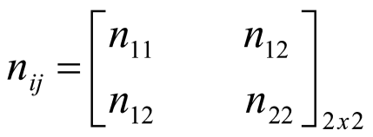

Where

= number of students who use prescribed drugs before and still using it now.
= number of students who use prescribed drugs before but are no more using it.
= number of students who do not use prescribed drugs before but are using it now.
= number of students who do not use prescribed drugs before and now.

The percentage stage space of each random variable is as:
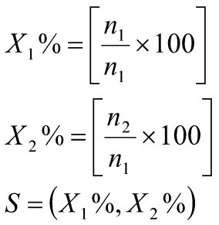

The initial distribution vector is now vector with one non negative for each state in the system for each state in the system denoted by 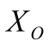
PROBABILITY VECTOR: A probability vector is now vector in which the entire are non-negative and add up 1 where
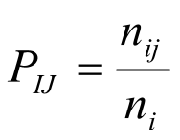

Where
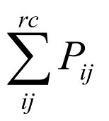

Where P_{ij} is called or know as transition probability the transition diagram showing the movement for state to the next state with a fixed probability P_{ij}

P P P

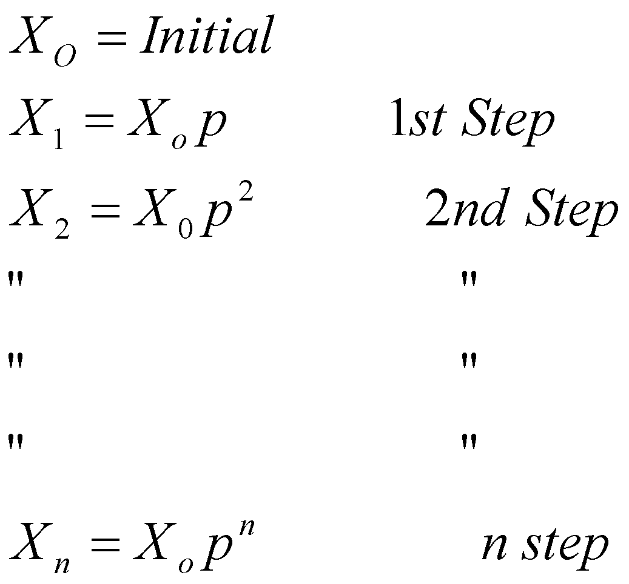

3.2.5 PROPERTIES OF MARKOV CHIN

- Define the probability of going from state, in the step as 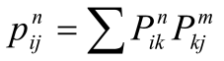n step transition satisfied the Chapman Kolmgrove

3.3 ALGERIA
The rate of stability in student process state that 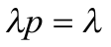
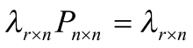

Where 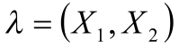 we have the following e.g. uniforms

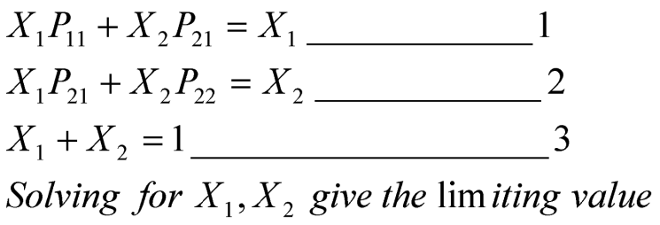

CHAPTER FOUR

DATA PRESENTATION AND ANALYSIS

4.0 INTRODUCTION
This chapter present the data used in the course of the analysis and also the analysis. In this course of the work, computer software was employed in the working for the analysis. The output of the result is display below

4.1 METHOD OF DATA COLLECTION
The data used was a primary date type, which was capture interview method using simple random sampling. A total of eighty five data was obtained (see appendix)

4.2 DATA ANALYSIS
The method used in the analysis was the use of Markov Chain, a stochastic process approach. In the course of the analysis computer package (MS Encarta) was used in the algebra, the result is as presented below in matrix form

SS = [P N]

Initial state
=(P = 52% , N = 48%)

`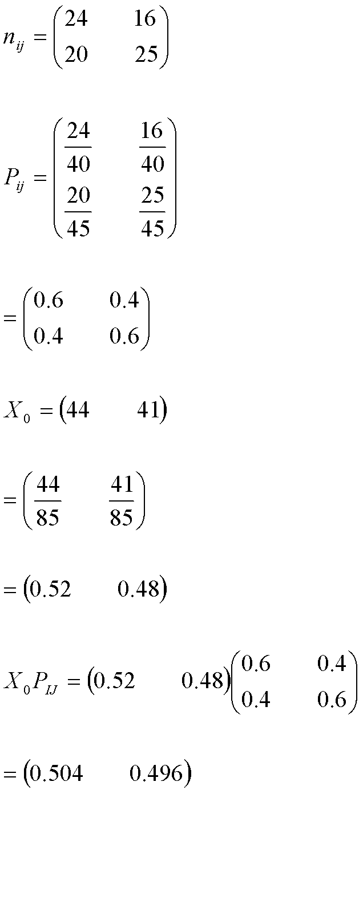
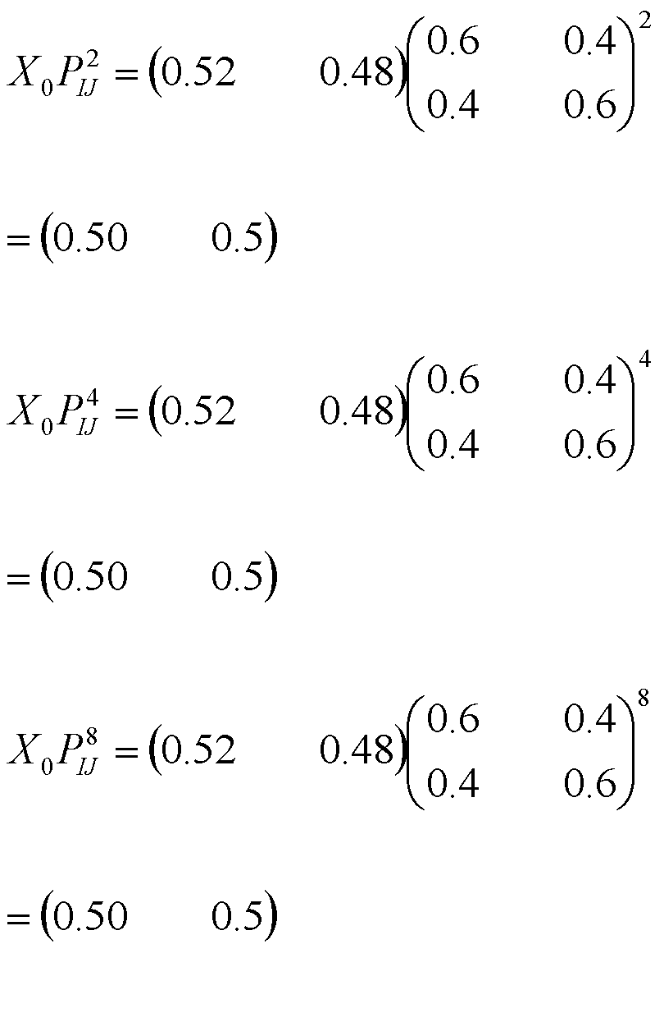
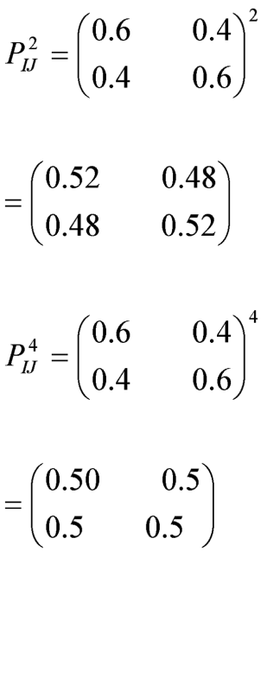
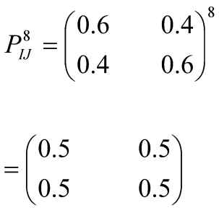
=( 52% , 48%)
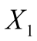=( 50% , 50%)
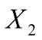=( 50% , 50%)
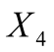=( 50% , 50%)
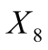=( 50% , 50%)

4.2.2 GRAPHICAL DISPLAY

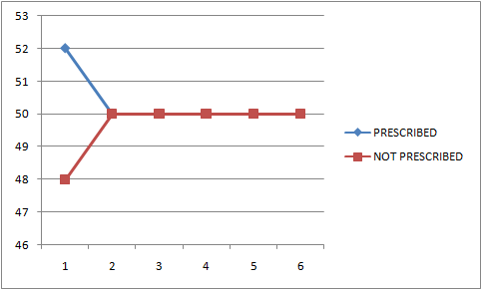

4.2.3 RESULT & INTEPRETATION
The result obtained from the Markov Chain algebra shows that initially the proportion of these that used prescribed/medicated drug were 52% while 48% are self medicated/non-prescribed.
The result further change as the time changes from 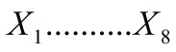having (50%, 50%) equal chance of either using prescribed or non-prescribed drug (50 – 50 chance)

CHAPTER FIVE

SUMMARY, FINDING, CONCLUSION & RECOMMENDATION

5.0 SUMMARY
The research work tend to study the use of drug(s) among students it is prescribed or not. In the course of the work using stochastic process, the following result was obtained.

5.1 FINDINGS
- The initial state shows that 52% of students were on prescribed drug, while 48% are not.
- Transition to another time of the state the proportion changes and become stable at equal chance for the two likely state (50%, 50%)

5.2 CONCLUSION
The results from the work indicate that each of the state (Prescribe and non-prescribe) are equally chance of occurring. This further show that any of the students can fall into these state.

5.3 RECOMMENDATION
The chance of equal occurrence clearly shows that students are prone to drug abuse (50%). Therefore, it is advisable to have a more enlightening and educated programme for the students to increase the proportion prescribe drug users.

References

Annabel Boys, John Marsden, John Strang (2001). Understanding reason for drug use amongst young people: a functional perspectice. Health education research, Volume 16, Issue 4, August 2001, pages 457-469
Deborah TolutopeEsanetal (2018): Assessment of Self-medication practices and its associated factors among undergraduates of a private university in Nigeria. Journal of environmental and public health/2018/Article. Volume 2018.
M.J Saka, T.M. Akande, A.O. Olarioye, H.O. Raji, A.O. Saka (2019). Comparative assessment of health workers performance and the performance factors at primary, secondary and tertiary hospitals in Kwara state, Nigeria. Journal of Family medicine. Volume 8
MahMoniret’al (2014).A review study of substance abuse status in high school students, Isfaha, Iran.International journal of preventive medicine. Int. J Prev Med. 2014 Dec, 5(Suppl 2): S72-S82
Maria R. Gualano, Fabrizio Bert, Stefano Passi, Michela Stillo, Veronica Galis, LambertoManzoli, Roberta Siliguini (2014). Use of self-medication among adolescents: a systematic review and meta-analysis. European Journal of Public Health, Volume 25, Issue 3, June 2015, Pages 444-450, https://doi.org/10.1093/eurpub/cku207
MuhammedZamanet’al (2015): Drug abuse among the students. paksitanjounal of pharmaceutical research, falculty of Pharmacy, BahuddinZakaryia University Multan, Pakistan, January 2015 Vol.01 Issue: 01
R.M. Helal and H.S. Abou-ElWafa (2017). Self-medication in university students from the city of Mansoura, Egypt
Sonam Jain, RiteshMalvi (2011). Self-Medication: A review. January 2011 with 4,537 reads.

APPENDIX
 | BEFORE |  | PRESENT |  |  | BEFORE |  | PRESENT
SN | 1 | 2 | 1 | 2 | SN | 1 | 2 | 1 | 2
1 | 0 | 1 | 0 | 1 | 46 | 1 | 0 | 0 | 1
2 | 1 | 0 | 1 | 0 | 47 | 0 | 1 | 1 | 0
3 | 1 | 0 | 0 | 1 | 48 | 1 | 0 | 1 | 0
4 | 0 | 1 | 1 | 0 | 49 | 1 | 0 | 1 | 0
5 | 1 | 0 | 1 | 0 | 50 | 0 | 1 | 0 | 1
6 | 1 | 0 | 1 | 0 | 51 | 1 | 0 | 1 | 0
7 | 0 | 1 | 0 | 1 | 52 | 0 | 1 | 0 | 1
8 | 1 | 0 | 1 | 0 | 53 | 1 | 0 | 0 | 1
9 | 0 | 1 | 0 | 1 | 54 | 0 | 1 | 0 | 1
10 | 1 | 0 | 0 | 1 | 55 | 1 | 0 | 0 | 1
11 | 0 | 1 | 0 | 1 | 56 | 1 | 0 | 1 | 0
12 | 1 | 0 | 0 | 1 | 57 | 0 | 1 | 0 | 1
13 | 1 | 0 | 0 | 1 | 58 | 1 | 0 | 1 | 0
14 | 0 | 1 | 1 | 0 | 59 | 0 | 1 | 1 | 0
15 | 1 | 0 | 0 | 1 | 60 | 1 | 0 | 1 | 0
16 | 0 | 1 | 1 | 0 | 61 | 1 | 0 | 1 | 0
17 | 1 | 0 | 1 | 0 | 62 | 0 | 1 | 0 | 1
18 | 1 | 0 | 1 | 0 | 63 | 1 | 0 | 1 | 0
19 | 0 | 1 | 0 | 1 | 64 | 0 | 1 | 0 | 1
20 | 1 | 0 | 1 | 0 | 65 | 1 | 0 | 0 | 1
21 | 0 | 1 | 0 | 1 | 66 | 0 | 1 | 0 | 1
22 | 1 | 0 | 0 | 1 | 67 | 1 | 0 | 0 | 1
23 | 0 | 1 | 0 | 1 | 68 | 1 | 0 | 0 | 1
24 | 1 | 0 | 0 | 1 | 69 | 0 | 1 | 1 | 0
25 | 1 | 0 | 1 | 0 | 70 | 1 | 0 | 0 | 1
26 | 0 | 1 | 0 | 1 | 71 | 0 | 1 | 1 | 0
27 | 1 | 0 | 1 | 0 | 72 | 1 | 0 | 1 | 0
28 | 0 | 1 | 0 | 1 | 73 | 1 | 0 | 1 | 0
29 | 1 | 0 | 0 | 1 | 74 | 0 | 1 | 0 | 1
30 | 0 | 1 | 0 | 1 | 75 | 0 | 1 | 0 | 1
31 | 1 | 0 | 0 | 1 | 76 | 1 | 0 | 0 | 1
32 | 1 | 0 | 0 | 1 | 77 | 0 | 1 | 0 | 1
33 | 0 | 1 | 1 | 0 | 78 | 1 | 0 | 0 | 1
34 | 1 | 0 | 0 | 1 | 79 | 1 | 0 | 1 | 0
35 | 0 | 1 | 1 | 0 | 80 | 0 | 1 | 0 | 1
36 | 1 | 0 | 1 | 0 | 81 | 1 | 0 | 1 | 0
37 | 1 | 0 | 1 | 0 | 82 | 0 | 1 | 1 | 0
38 | 0 | 1 | 0 | 1 | 83 | 1 | 0 | 1 | 0
39 | 1 | 0 | 1 | 0 | 84 | 1 | 0 | 1 | 0
40 | 0 | 1 | 0 | 1 | 85 | 0 | 1 | 0 | 1
41 | 1 | 0 | 0 | 1
42 | 0 | 1 | 0 | 1
43 | 1 | 0 | 0 | 1
44 | 1 | 0 | 0 | 1
45 | 0 | 1 | 1 | 0

