CHAPTER ONE
GENERAL INTRODUCTION
1.1 INTRODUCTION
Land is a very critical resource to the economic, social and cultural development of Nigeria. Land was also a key reason for the struggle for independence and land issues remain politically sensitive and culturally complex (National Land Policy, 2009). Right from the pre-colonial period, land has been perceived as more than a piece of earth upon which one exercises his/her rights. In Nigeria, it is viewed in many ways; as a factor of production, a show of economic status in the society, as well as cultural commodity owned by a community. These perceptions have made land a very emotive topic to many Nigerians. (Burrough, 2016)
The formulation of the National Land policy has sought to address critical issues on land administration, access to land, and resolution of historical injustices on land, environmental degradation, proper land use systems and unplanned proliferation of informal settlements in the urban areas. It recognizes all forms of tenure in Nigeria as well as fostering equal access to land for all Nigerians. It also seeks to keep an up to date inventory of all government and public land in the country. (Dale, 2016)
The policy has proposed the development of a Land Information Allocation System as a foundation upon which the policy will be implemented. Central to this development is the design, construction and maintenance of an up to date Land Information Allocation System (LIAS). LIAS is a computer based information Allocation system that enables input, management, analysis, output, and dissemination of spatially referenced, land parcel based data and information at mainly large mapping scale. It’s a database that stores all land related datasets as generated or acquired in the pursuit of proper land management and administration. These datasets include the cadastral, topological and boundary information. (Dale, 2016)
A Land Information Allocation System, once developed, plays an important role in land registration, land use planning, land valuation and taxation, tracking of all government and public land as well providing concrete analysis of data for timely decision making. (Enemark, 2014)
From about 1900 until 1978, Nigerian land tenure was governed by several disparate legal systems. These included: customary law in the south emphasizing collective ownership among family and social groups; Islamic law and custom in the north; and two separate systems of British colonial law—common law private ownership in the south and Crown ownership in the north. Nigerian opinion leaders believed that disparities among these systems, lack of a unified national property law system and antiquated aspects of both customary and colonial era law were impeding investment and preventing an equitable allocation of land among citizens. In 1977, a national commission was created by the government to study the land tenure question, and, in 1978, the Land Law was adopted. (Henssen, 2017)
The Land Law nationalized land, placing ownership in the hands of the state governors “in trust” for the benefit of all the Nigerian people. In urban areas, which may be delineated by the governor of each state, allocation of land rights is administered by the governor’s office, and in non-urban areas, by local governments. In urban areas, all pre-existing types of land rights were superseded and today, landholders may obtain only a statutory right of occupancy. In the nonurban areas, customary land rights are preserved under the law and “customary” rights of occupancy may be obtained. In practice, there appears to be little difference between the urban and rural variations—landholders in both areas are entitled to obtain a “certificate of occupancy” evidencing their rights, which is essentially a state lease of up to 99 years. (Adigun, 2018)
Land appears to be available to citizens and businesses in Nigeria, however, various degrees of scarcity may exist depending on location, and land may be relatively expensive. Although, scarcity and high prices may hamper access to land in some highly developed areas of the country, some argue that Nigerian land markets face more fundamental problems. These include: 1) inadequate infrastructure—electric power, in particular—and scarcity of serviced land; 2) widespread and increasing informality in the land market caused by cumbersome administrative procedures and high official transaction fees; and 3) an insufficient number of reliable land titles, another result of the conversion procedures of pre- 1978 rights. Cumbersome transaction procedures, high transaction fees and an insufficient number of reliable land titles can arguably be traced to certain aspects of the Land Law. (Adeniran, 2014)
While this overview is necessarily generalized, it is likely that each Nigerian state has experienced most of the issues discussed below. Nigeria is a federal system comprised of 36 states and a federal capital area. The Land Law and Constitution give the states significant discretion in setting the rules and procedures governing land relations. States set the level of their transaction fees and land charges and design the administrative procedures governing land transactions. Each state is responsible for developing and implementing a system for registration of land rights. States are progressing at different rates in addressing land issues. Some are making noteworthy efforts to implement new ideas and approaches in land administration, developing new management and registration systems as well as seeking ways to simplify and reduce the transaction costs of administrative procedures. Therefore we are proposed to the development of a computerized land information allocation system. (Adeyinka et al., 2016)
1.2 STATEMENT OF THE PROBLEM
Despite the fact that cadastral surveys in Nigeria started in 1903, most of the land records are still in paper form and operated manually. This system of manual record keeping and maintenance is both slow, cumbersome, inefficient and also time consuming during retrieval of information.
In Nigeria, as in most developing countries, it is difficult, time consuming and financially costly to identify what land is available, its ownership, rights therein and the conditions to its use and its value as compared to other parcels. Under such circumstances, necessary information is lacking, inadequate or contradictory. Therefore, the current systems cannot support legitimate and efficient transactions on land.
The cadastre is in a constant state of change. Parcel information is in analogue form with paper maps and conventional land registers giving information on location, tenure, use, encumbrances, ownership and distribution of land. The classical cadastral system has become insufficient owing to the fact that land records have greatly increased in volumes, they are in paper form thus the process of storage, access and retrieval is a great challenge.
Therefore, there is need to develop modern cadastral infrastructures that will facilitate efficient land and property markets, protect the land rights of all, and support long term sustainable development and land management. The development of Land Information Allocation System (LIAS) is a credible approach towards sound management of land and its resources. A LIAS creates a comprehensive data on land ownership, land use, land valuation, land taxation, land statistics and management. Such a system is easy to update, secure and facilitates quick retrieval of information.
1.3 AIM AND OBJECTIVES
The aim of this research work is to develop a computerized Land Information Allocation System. The objectives are listed below:
a. To identify suitable attributes about the land parcels that should be included in the database.
b. To study how information on registered land is retrieved for the purposes of supporting various operations such as search, transfer and valuation and how LIAS (Land Information Allocation System) can help stream line the procedure there in.
c. To compile some details of ownership record that is complete, up to date, and reliable,.
d. To implement and demonstrate the operation of the database in the study area.
1.4 SIGNIFICANCE OF THE STUDY
The importance of this study is that it helps land agents in automating every process of land information allocation.
1.5 SCOPE AND LIMITATION OF THE STUDY
The project involves development of a prototype Land Information Allocation System based on details of ownership survey with cadastral parcel as the fundamental unit and plot number as the primary key.
The scope of this study focuses mainly on the development of a computerized Land Information Allocation System. The study is limited to this only and does not go beyond this.
1.6 ORGANIZATION OF THE STUDY
This is the overall organizational structure of the work as presented in this project write-up. Chapter one of this project deals with the introduction to the general work in the project. It also entails the statement of the problem, aims and objectives of this project, the significance of the study, the scope and limitation of the study and organization of the report. Chapter two deals with the review related journals and books, historical background of the study, as well as computerization current state of the art. Chapter three covers the methods used for data collection, description of the current procedure, problems of existing system, description of the proposed system and the basic advantages of the proposed web based application. Chapter four entails design, implementation and documentation of the system. The design involves the system design, output design form, input design form, database structure and the procedure of the system. The implementation involves the implementation techniques used in details, choice of programming language used and the hardware and software support. The documentation of the system involves the operation of the system and the maintenance of the system. Chapter five deals with the summary, experience gained, conclusion, recommendation and references.
1.7 DEFINITION OF TERMS
Allocation: This is the action or process of allocating or sharing out something
Implementation: This is the process of putting a decision or plan into effect; execution.
Information: This is the facts provided or learned about something or someone.
Administration: This is the process or activity of running a business, organization, etc
Management: This is the process of dealing with or controlling things or people.
Methodology: This is a system of methods used in a particular area of study or activity.
Database: This is a structured set of data held in a computer, especially one that is accessible in various ways.
Implement: It is a tool, utensil, or other piece of equipment that is used for a particular purpose.
Visual Basic: Visual Basic (VB) is a programming environment from Microsoft in which a programmer uses a (Graphical User Interface (GUI) to choose and modify preselected sections of code written in the BASIC programming language.

CHAPTER TWO
LITERATURE REVIEW

2.1 REVIEW OF RELATED WORK
Elias and Joyce (2015), wrote an article on “Customary land allocation, urbanization and land use planning in Ghana: Implications for food systems in the Wa Municipality” Food insecurity remains persistent in the Global South due to constraints in food production capacities and intricate land tenure systems that stifle investment in agriculture. In the urbanized regions, uncontrolled urbanization and non-compliant land use systems have further worsened the potentials for urban food production. This research is based on a case study of the Wa Municipality in order to assess the influences of customary land allocation and peri-urbanization on land use planning and foods systems in Ghana using explorative and narrative research approaches. The study identified that customary stakeholders responsible for allocating such lands in the Wa Municipality were indiscriminately converting large tracts of hitherto agricultural lands to urban land uses. Statutorily prepared land use plans are hardly enforced and the planning priorities are on residential and commercial land uses that command higher land values to the detriment of agricultural lands. Weak institutional linkages also characterize the mandated planning and land administration institutions, with a planning system that is reactive rather than proactive in addressing development control challenges across the country. There is the need for planning authorities to adopt participatory land uses planning together with customary landholders and educating them on the essence of comprehensive land use planning approaches. Based on the findings, local governments need to partner landowners to identify and reserve high potential agricultural land for sustainable urban food production (Elias & Joyce, 2015).
Simon, Tshepiso, Sibonakaliso, Lusanda and Jennifer (2016), wrote an article on “Land allocation, boundary demarcation and tenure security in tribal areas of South Africa” This study investigates land allocation processes, boundary demarcation, and associated land tenure security in tribal areas of South Africa. The research design is that of a descriptive multiple-case study to interrogate indigenous knowledge in this area. Four themes related to customary land allocation processes in South Africa have emerged from the data: Applicant, Authority, Acceptance and Allocation. These themes are used as the basis for comparison across the cases. The case studies are also used to test a published conceptual model of land tenure security. The results suggest that tenure in the study areas is secure overall. The study concludes that the processes of land administration and the systems used to demarcate boundaries are (mostly) suitable to protect land rights and thus provide security of land tenure. Also the tested conceptual model of land tenure security can be used to indicate the state of tenure security for a particular case, though improvements are suggested (Simon, Tshepiso, Sibonakaliso, Lusanda & Jennifer (2016)
Sharifia, and Mesgarib (2011), wrote an article on “Modelling Land Allocation Process in Time and Space” Modeling land allocation for different land uses at regional level is a multi-dimensional problem, as it is influenced by spatial, temporal and dynamics of environmental and socio-economic factors in the complex process of land use change. It is therefore a challenge to develop a proper model that can handle these complexities. In this context, a new model has been conceptualized and developed. The model is considering the expert knowledge, the heuristics and human decision-making in modeling the process of land use change. This paper briefly presents the conceptual model, which is developed based on cellular automata concept and tested with the Borkhar and Meymeh township datasets in Esfahan, Iran (Sharifia, and Mesgarib, 2011).
Abdulrahman (2018), wrote an article on “Administration System: A Case Study of the Survey and Land Registration Bureau in Bahrain” Implementing good land administration functions are considered a key success factor for a country’s development. To achieve this, countries that have best practices in land administration conduct a regular assessment for their land administration systems. Different assessment frameworks are designed for this purpose from different dimensions. The organizational assessment is one of the crucial dimensions that took the place of discussions by many researchers over the last two decades. Land administration in Bahrain had started about 80 years ago and evolved through several stages. Recently, Bahrain is expecting to have major changes in the land administration sector due to the establishment of a Real Estate Regulatory Authority (RERA). Despite such drastic changes, no organizational assessment has been carried out to evaluate the current human resources, logistics and expertise of the Survey and Land Registration Bureau (SLRB), as to whether it is capable of dealing with these changes or not. Thus, the overarching aim of this research is to assess the current land administration system in Bahrain from an organizational perspective. Based on existing literature, an assessment framework is designed to assess the case of Bahrain as the primary case study and Dubai as a best practice from the region. This framework consists of five dimensions and sixteen indicators. Primary data for this assessment are collected through interviews and analyzed using thematic analysis. The analysis is segmented into three levels of the organization; policy level (which covers decision makers), management level (which covers middle management) and administrative level (which covers operational staff).. Findings from this research show that SLRB is supported by sufficient legislation, good strategic plans and an adequate ICT base. However, the land administration system needs improvements in the clarity of legislations that support the mandate of land administration, efficient execution of strategy, stakeholder’s policy and in the institutional stability. These recommendations include the provision of detailed interpretation of legislation, the creation of a planning and partnership directorate, adoption of standardized processes, transforming to a fully digital environment, set a business model, reform institutional support policies and adopting of the designed assessment framework to conduct an organizational assessment for land administration organizations. (Abdulrahman, 2018).
Barney, Laizer and Aurélie (2018), wrote an article on “Developing an Integrated Land Management Information System (ilmis) for tanzania” Tanzania has not been able to tap many opportunities presented by its land resources because most of the land is not yet planned, surveyed and registered. The process of land parcel registration is complicated and expensive. The Government is committed to land-related reforms and to economic and public sector change as a firm basis to achieve the envisaged strategic development objectives. The design, supply, installation, and commissioning of the Integrated Land Management Information System (ILMIS) project will fully integrate all aspects of land management in two stages: the Pilot Stage and the Development Stage. Service delivery will start with business units in the Eastern Zone and the Ubungo and Kinondoni Municipal Councils and the roll-out to the rest of the country will commence on completion of the pilot stage in July 2018. This paper and presentation will provide insights into the pilot implementation of ILMIS comprising land administration, survey and mapping, registration, valuation and planning (Barney, Laizer & Aurélie, 2018))
Edward (2014), wrote an article on “Digital Cadastres Facilitating Land Information Management” A nation’s natural resources form the basis of economic growth in most developing nations. Raw materials required for the manufacturing industry which drives the economy are extracted from the land resource. This renders good governance of land crucial in any country as it is also the basis of sustainable development. However, to achieve betterment in managing land, there is need for accurate, reliable and up to date information about land. Such proper land management policies however remain a challenge to most governments in African nations. Problems with land information differ case by case, but among the most common are the facts that land information is usually not coordinated or it is inadequate. In some cases, land information is available but largely inaccessible. The objective of this paper is to bring out the role of a digital cadastre towards improved land management and land administration. The paper discusses modernization of cadastral systems in municipalities through technological reforms as a facet to improved land governance and at the same time improving access to cadastral information which is public information (Edward, 2014)
Susheel (2012) wrote an article on “E-government Based Land Information System Architecture: A Case of Nepal” Government organizations use Information and Communication Technology to increase efficiency and effectiveness in the service delivery. e-Government can bring improvement in efficiency, easy availability and accessibility of service and information to the citizens, business organization, professional users as well as government organizations. The main aim of this research is to propose business architecture for Land Information System (LIS) integrated in an e-Government environment. Using “Technology Enactment Framework” as starting point in this research, the literature reviews firstly indicate a list of factors causing failure of e-Government systems particularly in leadership failure, political influence, financial inhibition, digital divide, poor coordination, poor technical design, lack of necessary infrastructure and insufficient experienced IT human resources. Investigation using literature also shows that policy and regulations, citizen centric approach, technology and infrastructure, actors, data and information, security and quality are dominant elements for e-Government environment. Considering those identified factors and elements, unstructured questions relating technology, organization structure and institutional arrangement were designed for interviewing different categories of actors in Nepal for designing LIS business architecture in the context of e-Government. Analysis identifies sixteen user requirements. Policy, rules and regulations for electronic services, directives for electronic transaction, epayment, e-conveyancing and assigning key registers are essentially the institutional aspects, while organizational requirements includes integration of land administration organizations, integration of government data into GIDC, provision of sufficient IT manpower, IT service management and coordination and flexibility of the organizations. Finally, technical requirements includes system adherence to NeGIF and GEA, provision of web-based system, provision of e-payment, use of NID, integration of LIS (spatial and attribute), data quality and security and availability of internet. Further analyzing these requirements bring a business architectures supported by the related information and system architecture as outcomes of enacted technologies. Business architecture shows the primary and secondary services provided by the land administration organizations and the security system to access these services through different customer service system like counter, mobile, phone, e-mail and the web portal. Primary services are those provided by the land administration organizations like ownership transfer, parcel sub-division, mortgage registration etcetera. Secondary services are the one necessary to support primary service and provided in coordination with other organization like, bank, municipality, district administration offices and deed writers. Thus, the architecture shows all the three models of e-Government i.e. G2G, G2B and G2C. Further, information architecture shows the access of users to the key registers through enterprise service bus and the management of their rights. System architecture shows the location and connectivity of the client and server on the basis of three tier client server concept. Although, the study of Dutch cadastral system provides further in-depth knowledge in the design of architecture, business architecture is tested by business workflow and discussion as a part of validation with a Cadastral Expert of Netherlands Kadaster office suggesting for conducting a risk analysis. The risk analysis identifies nineteen probable risks including reluctant government, passive leadership, and insufficient legal framework etcetera. Good governance of service delivery with attention to areas as finance, capacity, IT service, security; service support (service desk); ICT infrastructure management; application management are most important for the successful implementation of the system (Susheel, 2012).

2.2 OVERVIEW OF COMPUTERIZED LAND INFORMATION ALLOCATION SYSTEM
2.3.1 Land
Land is defined as an area of the surface of the earth together with the water, soil, rocks, minerals and hydrocarbons beneath or upon it and the air above it. It embraces all things which are related to a fixed area or point of the surface of the earth, including the areas covered by water, including the sea (Henssen, 1995).
2.3.2 Land Information
Land information consists of data for decision making in land administration and management. These include data on georeferencing, mapping, land ownership, land rights, land use planning, valuation and inventories of different categories of land. Land information is often referred to as “spatial information” because it relates to an object (land), which has a definite, fixed position geographically.
Land information is required by a wide range of users, ranging from government agencies at all levels through prospective or existing land owners to surveyors, lawyers, planners, valuers, real estate managers, and retailers. Access to this information is made possible by use of unique parcel reference numbers to identify each land and property unit.
2.3.3 Land Administration
Land administration refers to the process of determining, recording and disseminating information about ownership, value and use of land. An efficient land administration system guarantees the recording of land rights, promotes tenure security, and guides land transactions.
Further, it provides land users with appropriate forms of documentation to guarantee land rights and supports the processes of land allocation, land dispute resolution, and fiscal management of land.
The principal functions of land administration are:
a) Ascertainment and regulation of land rights.
b) Allocation and management of land.
c) Facilitating of efficient transactions in land.
d) Development and maintenance of an efficient and accurate Land Information System.
e) Establishment of mechanisms for the assessment of land resources for fiscal management and revenue collection; and
f) Establishment of efficient and accessible mechanisms for resolving land disputes.
The UN Economic Commission for Europe (1996), defines land administration as the processes of determining, recording and disseminating information about the ownership, value and use of land when implementing land management policies.
Dale and McLaughlin (1999), view land administration as a combination of routine processes that include “regulating land and property development and the use and conservation of land, the gathering of revenues from the land through sales, leasing, and taxation, and the resolving of conflicts concerning the ownership and use of land” Steudler et al. (2018) describe land administration In terms of its functions.
They divided the functions of land administration into four components:
- Juridical: Land ownership
- Regulatory: Land development control and land use planning
- Fiscal: Land taxation
- Information management: Integral component fulfilling the information requirements of the other three components.
All the three definitions mention the key components of land administration as land ownership, land use, land valuation and land information management.

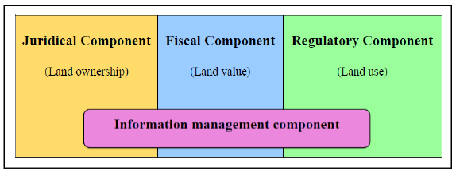

Fig 2.1 The Four Basic Components of Land Administration, Source: Steudler et al (2018).
The new approach to land administration system is to support land management and land markets. The key processes are those activities connected with the four fundamental functions in land management: land tenure, land value, land use and land development. The fundamental challenge for the land administrators is the management of the transcendental aspects of land to derive wealth out of the land-related interests and to manage these opportunities accordingly to sustainable development objectives (Wallace, Jude, 2017).
Efforts should be focused on land management processes for registration of land rights, indefeasible title, mortgage ability and compensation for compulsory acquisition. These reforms pose challenges to the land administration capacity to manage land holistically.
Land administration should focus on land management processes like adjudication, land transfer, subdivision, planning and valuation, rather than on institutions, legal and regulatory frameworks. The land administration system should incorporate a strategy for development reform in land administration according to global factors that can affect the processes. Furthermore, effective land administration systems need to manage the ever growing sophistication of rights, restrictions and ownership over land due to environmental and social pressures.

2.3.4 Land Management
According to Dale and McLaughlin (1988), land management is +98about decision making and the implementation of decisions about the use of land recourses. It entails the processes which allocate land resources “over space and time according to the needs, aspirations and desires of man and within the framework of his technological inventiveness, his political and social institution, and his legal and administrative arrangements”. It includes the formulation of land policy, the organization of land administration arrangements and the management of land information.
Drawing from this definition and business scheme described by Steudler and Williamson (2018), land management can be seen to play a coordinating role between land policy and administration. Its objectives are to fulfill the environmental, economic, and social goals of land policy by planning, promoting and controlling efficient land use through the process of land administration. The coordinating role of land management is depicted in Figure 2.2 below.

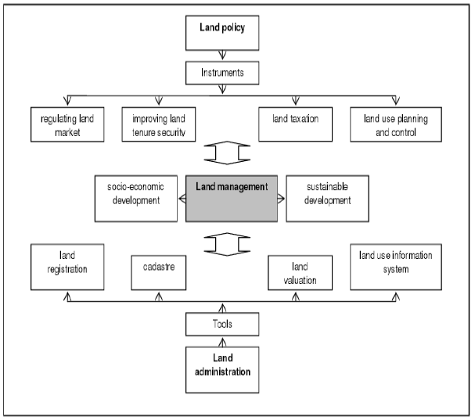

Fig. 2.2: The coordinating role of land management
Source: Steudler and Williamson (2018).
2.3.5 Land Administration System
Land administration systems are concerned with the social, legal, economic and technical framework within which land managers and administrators must operate (UN-ECE, 2018 cited in Enemark, 2014). Alongside the legal framework, land administration systems are the main instrument of land policy administration. They include organizations and procedures for the survey, demarcation and mapping of land, recording of land rights and transactions, provision of documentary evidence of land rights, as well as resolution of land disputes and competing claims. Land administration systems are generally managed by specialist formal land institutions, established by government. However, responsibilities for land allocation, documentation and the management of rights can be devolved to local, community or customary bodies and as some services may be delivered by the private sector (UN-Habitat, 2008). According to Enemark (2014) land administration systems support efficient land markets and are at the same time concerned with the administration of land as a natural resource to ensure its sustainable development.
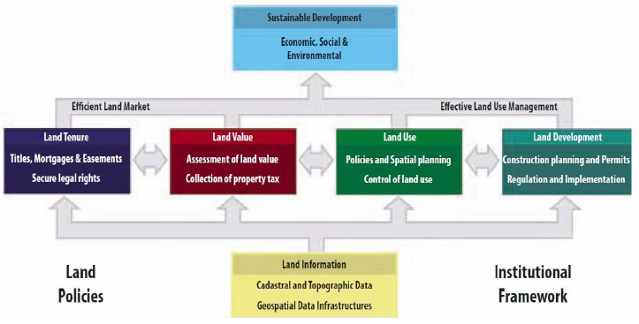

Fig. 2.3 A Global Land administration perspective
Source: Enemark (2014)
With reference to Figure 2.3, Enemark (2014) records that land administration comprises an extensive range of systems and processes to administer, which include the following:
Land Tenure: the allocation and security of rights in lands; the legal surveys to determine the parcel boundaries; the transfer of property or use from one party to another through sale or lease; and the management and adjudication of doubts and disputes regarding rights and parcel boundaries.
Land Value: the assessment of the value of land and properties; the gathering of revenues through taxation; and the management and adjudication of land valuation and taxation disputes.
Land-Use: the control of land-use through adoption of planning policies and land-use regulations at national, regional and local levels, the enforcement of land-use regulations and the management and adjudication of land-use conflicts.
Land Development: the building of new infrastructure; the implementation of construction planning; and the change of land-use through planning permission and granting of permits.
These four systems namely; land tenure, land value, land-use and land development, are interrelated. The actual economic and physical use of land and properties influences the land value. The land value is also influenced by the possible future use of land as determined through zoning and land-use planning regulations and permit granting processes. And the land-use planning and policies will of course determine and regulate the future land development. The information on land and properties permeates through the overall system and provides the basic infrastructure for running the systems within the four interrelated areas. Land information infrastructure is the integral component fulfilling the information requirements of land tenure, land value, land use and land development. The essence of land administration is its land information system. The completeness, accuracy and currency of the information in the system determine how well the land information system will serve the society. The main tools that are used to generate and maintain land information are cadastre and land registration. The Land Information area should be organized to combine the cadastral and topographic data and thereby linking the built environment (including the legal land rights) with the natural environment (including environmental and natural resource issues). Land Information should be organized as a spatial data infrastructure at national, regional and local levels.
based on relevant policies for data sharing, cost recovery, access to data, standards and the like (Enemark, 2014).
2.3.6 Land Information Allocation System
This refers to a computer based system that enables inputs, management, manipulation, output, and dissemination of land parcel based spatially referenced data and information at mainly large scale. It is, therefore, a subset of GIS.
The information relating to land may be acquired and held in alphanumeric form (e.g. surveyor’s field notes), graphically (e.g. maps and aerial photographs) or digitally by electronic media. The raw information needs processing to be meaningful to a decision maker. A LIS provides good support to land management by providing information about land, resources upon it and the improvement made on it. Land management refers to the taking and implementation of decision about the acquisition, development and conservation of land resources.
The operation of a LIAS includes the acquisition and assembly of data, its processing, storage, and maintenance. It also includes their retrieval, analysis, and dissemination. The optimal usefulness of this system largely depends upon it‟s up to datedness, accuracy, completeness, and accessibility, and upon the extent to which the system is designed for the benefit of the user rather than the producer of the information. Systems such as this should be designed largely to meet the users‟ needs which are normally identified beforehand.
LIAS provides information in form of products such as maps or certificates and services (such as professional advice). It can also supply attribute or textual data which may be presented in verbal or numerical form. Attribute data give the description of existing phenomena as well as the activities that take place upon the land.
The spatial (location) components of the datasets are stored in terms of points, lines or polygons. These datasets incorporate three types of spatial relationships:
- Geometrical- the various datasets forming layers are referenced to a precise spatial framework such as coordinates or grid cells.
- Cartographical- Data is generalized and symbolized by a set of cartographic rules to ensure smooth flow of information therein.
- Topological- This entails the definition of the relative location and non-metric spatial relationships of various data elements.

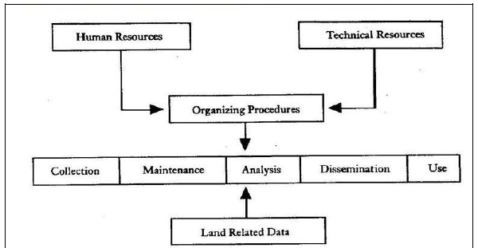

Fig 2.4 Components of a Land Information Alllocation System
2.3.7 Cadastre
The International Federation of Surveyors (IFS, 1995) defines a cadastre as a parcel based and up-to-date land information system containing a record of interests in land (e.g. rights, restrictions and responsibilities). It usually includes a geometric description of land parcels linked to other records describing the nature of the interests, ownership or control of those interests, and often the value of the parcel and its improvements. It may be established for fiscal purposes (valuation and taxation), legal purposes (conveyancing), to assist in the management of land and land-use planning (planning and administration), and enables sustainable development and environmental improvement.
The principal purpose of a cadastre is provision of information about land ownership, value and use. The information contained in the register is organized around a cadastral parcel i.e. the proprietary land unit but can be any tract of land that is part of an estate and has separable identity. This information is collected, stored, referenced, and retrieved primarily at the land parcel level. Referencing systems such as use of geo-codes and Unique Parcel Reference Numbers (UPRN) facilitate data access, manipulation and exchange with other users.
A cadastral vision of the future presented in the UN Bogor Declaration 1996, is to: “develop modern cadastral infrastructures that facilitate efficient land and property markets, protect the land rights of all, and support long term sustainable development and land management. The cadastral system is seen as the basic infrastructure to support the different systems in the area of land management.
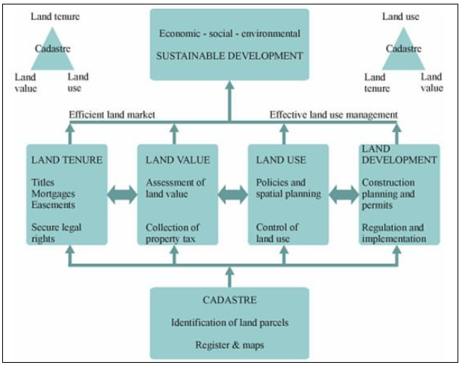

Fig 2.5 The role of the cadastre to facilitate efficient land market effective land use administration
Source: Enemark (2014).
The systems supported by the cadastral infrastructure are:
- Land Tenure System, to secure legal rights in land such as titles, mortgage and easements.
- Land Value Systems, to access the value of land and properties and to levy land taxes.
- Land-Use Control Systems, to enable comprehensive and detailed land use planning.
- Land Development System, to enable regulation and implementation in change of use.

These systems are interrelated. The actual economic and physical use of land and properties influences the land value. The land value is also influenced by the possible future use of land as determined through zoning and land-use planning regulations. And the land-use planning and policies will, of course, determine and regulate the future land development.

2.3.7.1 Component of a cadastre:
A cadastre comprises of the following components:
a) Cadastral parcel
This is the proprietary unit of land. It is defined as a continuous volume of land within which unique and homogeneous interests are recognized.
Land is finite in extent and permanent in nature. This quality of permanence is ideal for recording information (rights and interests) since the rights, owners, and usage may change but the land remains forever. Even when parcels are subdivided or amalgamated with adjoining parcels into larger Ones, the land which they cover remains unchanged.
The need to record details of land emanates from the need for better land administration and management since land is the ultimate resource from which all wealth comes.
b) Parcel identifier
This is a unique code that uniquely refers to specific parcel whose limits are defined. The parcel indicators also referred to as PID or Unique Parcel Reference Numbers (UPRN) identifies the parcel and allows for cross referencing with registers and any other filing systems. That’s to mean, with a parcel reference numbers is possible to access all the details of the parcel, including attribute information and its spatial description (from maps and plans). There is various parcel reference systems adopted by various jurisdictions depending on what is available. For instance, street index and parcel address cannot be used in an area where streets are not properly named. The system adopted should generate identifiers that easily link data related to parcels.
c) Parcel record
This is a combination of technical record of parcellation of the parcel through any given territory usually represented on plans of suitable scale and authoritative documentary record, whether of a fiscal or proprietary nature or of the two combined, usually embodied in appropriate associated registers (Dale and McLaughlin, 2016).

d) Cadastral index map
This is a map that depicts all parcels in a given region and associates each parcel with its unique property identifier. This graphic record has a recognized legal status for property description besides sewing as an index to other legal records.
2.3.7.2 Some forms of cadastres
a) Juridical Cadastres
This is the cadastre that underpins registration of land. Parcel registration cannot be effective without a form of cadastre. This cadastre has two vital components. First, is a written record containing parcel information such as name and address of the owner and the rights that exit in the parcel. The other part contains a detailed description of the parcel in form of maps, plans or survey measurements. To thoroughly achieve the requirements of a juridical cadastre, the following operations are undertaken:
Land adjudication process entails the official determination of rights to land as guided by the tenure systems in existence. This process establishes what rights exist, who is meant to exercise them and to what limitations if any they are subject. It does not create new rights or alter the existing ones.
Land demarcation entails actual marking of the limits of each land parcels on the ground by placing corner beacons and pegs in the ground or the construction of linear features such as walls and fences or growing of hedges.
b) Fiscal cadastre
This is an inventory of land parcels that produce information necessary to determine the value of the land and the tax due on it. J/therefore serves as an information base for property taxation, helps in monitoring and support of land market, land use development control, supporting financial allocation programs and provision of land information (McLaughlin, 2016).
The concept of property taxation emanated from the fact that laud forms the basis of all wealth and hence revenue from its administration should be derived from it. Revenue on land is raised through two principles; Property rating where government raise revenue by assessing and taxing improvements on land, such as building and the uses they are put. The other method is the land value taxation where value of the land itself as derived from its improved or unimproved state. Property valuation can be imposed on land, improvements on it or both. The taxation system adopted by authorities determines how land is used and made available for use. Normally there are two of taxes levied on land: Property and land taxes. Taxes can be based on the rental value or capital value of the property.
The operation of a fiscal cadastre requires the identification of all parcels that are to be valued, and the person(s) to pay taxes. It should be noted that not always that the owner of a parcel is also responsible for paying taxes on it. Parcels should be classified according to their uses and their values determined accordingly.
A fiscal cadastre entails identification and mapping of all properties that are subject to tax, classification of each property with respect to such factors as size, type, type of construction and improvement, collection and analysis of market data, valuation of each parcel/property, identification of persons responsible for paying taxes (property owner should also be determined in case the property is forfeited due to non-compliance to taxation rules), preparation of valuation rolls and then billing and collection of the appropriate taxes. This should also include prior notification of the taxpayer before actual collection. Appropriate appeal procedure should be put in place.
c) Multipurpose cadastre
As documented above, juridical cadastre support land registration, fiscal cadaster supports property valuation and taxation while other information systems support planning and enforcement of regulations. The concept of multi-purpose cadaster resulted from the recognition that these components share some common information requirements.
According to FIG (2008), a multi-purpose cadastre refers to large scale, community-oriented parcel-based information system designed to serve both the public and private organization and individual citizens. It is therefore a comprehensive set of land records, based upon the land parcel as its fundamental unit. Its distinguishing characteristics include: the use of cadastral parcel as the fundamental unit of organization; possibility referring related land records to this parcel; and provides a ready and efficient means of access to the data. It thrives upon a continued compilation, updating and maintenance of cadastral overlays.
It comprises of records relevant to land ownership, land valuation and other land related information. It therefore designed to support land transfer, land registration, land taxation and general land administration. Its primary components include geodetic reference framework, base maps, series of files relating various types of parcel related information and a linkage system to the various types of information to each parcel.
2.3.8 LIAS in Nigeria
For effective and efficient land administration, good land information allocation management is necessary. At the government and corporate level, effective planning, zoning and overall management of urban and rural land cannot be efficiently done. The following are some specific problems with our country’s land information management today:
i) There are no agreed standards to which land information, the systems that manage it or the people that handle it should conform;
ii) Most of the country’s accurately positioned survey points, which act as a foundation for mapping have been destroyed (The white cylindrical pillars on tops of hills were dug up by vandals when false word went around that mercury could be found beneath them.) There was no evidence of mercury found after the distractions.
iii) There are no policies or laws to deal with the legal issues associated with land information. Some of these issues include questions on whether it is right for the government to commercialize land information that has been collected using public funds, and if so, at what price; who should have access to land information in government custody; and whether this access should include personal information about other people, e.g., how many farms or urban plots so and so owns. It is worth noting that lately there has been a lot of debate on whether the Official Secrets Act, which is often used to restrict access to a lot of public information, should be repealed or not;
iv) The way land information is kept and handled manually makes it prone to tampering with and to enhanced wear and tear; even if it were computerized, the country is least prepared to deal with the computer and cybercrime that may be directed at such information;
v) The necessary infrastructure for computerizing land information and making it widely available (such as access to electricity, computers and telephones and internet) is still very limited;
vi) There are no adequate laws to protect those who might want to invest in the creation of land information allocation from piracy of their products;
vii) There is still a lot of unregistered land in Nigeria on which there are no records at all.
The prescriptions of the draft national land policy in respect of land information allocation management, to address some of the problems of our country’s land information management include:
a) Land information allocation to be computerized and made widely available in a language most citizens can understand and at an affordable price, to at least the divisional level;
b) Existing paper land records to be reorganized, updated and authenticated in readiness for their computerization;
c) Standards to be developed to guide the generation and dissemination of land information, the training of relevant professionals and awareness creation among citizens;
d) Land surveys, including the re-establishment of the framework of accurate survey points (control points), to be carried out more efficiently and accurately using modern technology and any necessary laws to be enacted or amended.
e) Nigerian’s land information management system to be in harmony with those of other countries in the region in order to facilitate regional trade in land information and execution of regional projects, e.g. those of the Lake Victoria basin.
f) A law to be enacted to provide for all aspects of land information access and management, including the protection of intellectual property rights;
g) The country to develop capacity for dealing with information technology and cybercrimes;
h) The National Spatial Data Infrastructure (NSDI), through which all agencies that produce and use land information will be networked, to be implemented without delay. With computerized land records it will also be feasible to have a one stop shop for land transactions since from any computer terminal on the network, all land information including valuation, planning, survey and registration will be accessible; even Nigeria Gazette announcements of public land to be allocated will be more accessible to more Nigerians this way. The problems of “lost” files will largely disappear in the computerized environment due to the increased security and options for making stand by copies. With the computerized LIAMS it will also be much easier to update records and maps once land transactions take place and there will also be increased possibilities for serving the blind through facilities such as computer voice prompts and braille keyboards. Lastly, the increased security and reliability of land information allocation that a computerized LIAMS will bring will result in Kenyans developing their land in confidence and in banks‟ lending money for such development without fear. This can be expected to result in job and wealth creation and alleviation of poverty.
With the systematic development of a computerized Land Information Allocation Management System (LIAMS), land information allocation will be efficiently made widely available for timely decision making; this will lead to more productive land and a better managed environment for all. When the National Spatial Data Infrastructure is implemented, it will be an infrastructure in the public domain, much like the road infrastructure or health infrastructure. An average citizen will be able to tap into the network from any designated point, much like you are now able to access your bank account information and withdraw money at any corresponding ATM countrywide. He/she will be able to obtain details of their land parcel, buy a map of an unfamiliar town, get directions to the nearest restaurant, and evaluate a piece of land for purchase, etc. all by him/herself at the touch of a computer button.

CHAPTER THREE
METHODOLOGY AND ANALYSIS OF THE SYSTEM
3.1 RESEARCH METHODOLOGY
The data used for this research were obtained from both primary and secondary sources. The Primary sources of data includes the use of questionnaires, interviews and observations while the secondary sources include review of existing literatures, system documentation manuals and the review of existing system source listing.
Interviews and personal observations were carried out for the purpose of finding facts about existing methods and to investigate how the ministry for lands handles land titles and acquisition. In most situations, existing documentation about land cases were reviewed. This helped in fact-finding about the existing system and problems faced. The use of these fact-finding techniques enables the researcher to understand the methods used to derive solutions to land information allocation problems.
The Structured System Analysis and Design Methodology (SSADM) which is a Software Engineering Methodology that involves system decomposition to sub-system and the systematic analysis of each sub-system were adopted. Flowcharts and Pseudo codes were drawn and written for the proposed solution.
The Expert System methodology, which involved knowledge engineering process of inference and knowledge-based, is also adopted.
DISCUSSION
A software development methodology or system development methodology in software engineering is a framework that is used to structure, plan, and control the process of developing an information system. There are the following methodologies.
Agile Software Development Methodology
Agile software development is a conceptual framework for undertaking software engineering projects. There are a number of agilesoftware development methodologies e.g. Crystal Methods, Dynamic Systems Development Model (DSDM), and Scrum.
Most agile methods attempt to minimize risk by developing software in short timeboxes, called iterations, which typically last one to four weeks. Each iteration is like a miniature software project of its own, and includes all the tasks necessary to release the mini-increment of new functionality: planning, requirements analysis, design, coding, testing, and documentation. While iteration may not add enough functionality to warrant releasing the product, an agile software project intends to be capable of releasing new software at the end of every iteration. At the end of each iteration, the team reevaluates project priorities.
Agile methods emphasize realtime communication, preferably face-to-face, over written documents. Most agile teams are located in a bullpen and include all the people necessary to finish the software. At a minimum, this includes programmers and the people who define the product such as product managers, business analysts, or actual customers. The bullpen may also include testers, interface designers, technical writers, and management.
Agile methods also emphasize working software as the primary measure of progress. Combined with the preference for face-to-face communication, agile methods produce very little written documentation relative to other methods.
The software for the implementation of the LIAS was developed using:
1. Visual Basic Programming language.
2. The database was implemented using Microsoft Access database.
3.2 ANALYSIS OF THE EXISTING SYSTEM
The existing system of land information and allocation is a manual method, the land records are still in paper form. This system of manual record keeping and maintenance is slow, cumbersome, inefficient and also time consuming during retrieval of information.
3.3 PROBLEMS OF THE EXISTING SYSTEM
The problems of the existing system are as follows:
- It is time consuming
- It is not reliable
- It is prone to so many errors.
3.4 ANALYSIS OF THE PROPOSED SYSTEM
Land is a platform of all forms of human activity. It is indeed the natural habitat of man. Its use is crucial for economic, social, political and environmental advancement of all countries of the world and indeed for human survival. Although, land is part of man’s natural heritage but access to land is controlled by ownership patterns. This ownership of land or acquisition has not been without tenural problems. It is therefore partitioned for administrative and economic purposes and used and transformed in a number of ways. Population growth, technological and social hazard and environmental degradation have all to be taken into greater account today be administrators, resource planners, policy makers who make decisions about the land. Therefore, the need to develop a computerized Land Information Allocation System will suit this kind of situation (Dale and McLaughlin, 2016).
A Land Information Allocation System (LIAS) is a computerized tool for legal, administrative and economic decision making. It is indeed an aid for planning and development and consists of a structured database with spatial referenced land related attribute and spatial data for a defined area and of procedures and techniques for the systematic collection, updating, processing and distribution of the data to provide solution to land management problems (Pindiga, 2012).
3.5 ADVANTAGES OF THE NEW SYSTEM OVER THE EXISTING SYSTEM
The advantages of the new system over the existing system are as follows:
- It is fast and reliable.
- It is user friendly.
- It is accurate.

CHAPTER FOUR
4.1 DESIGN OF THE SYSTEM
System designs calls for the creativity of the analyst. Therefore, creating an acceptable design, the system analyst must exclude all prejudice.
The design of the system is the approach of work out how best computers together with other resources may be applied to perform data storage, management and retrieval for decision making.

4.1.1 OUTPUT DESIGN
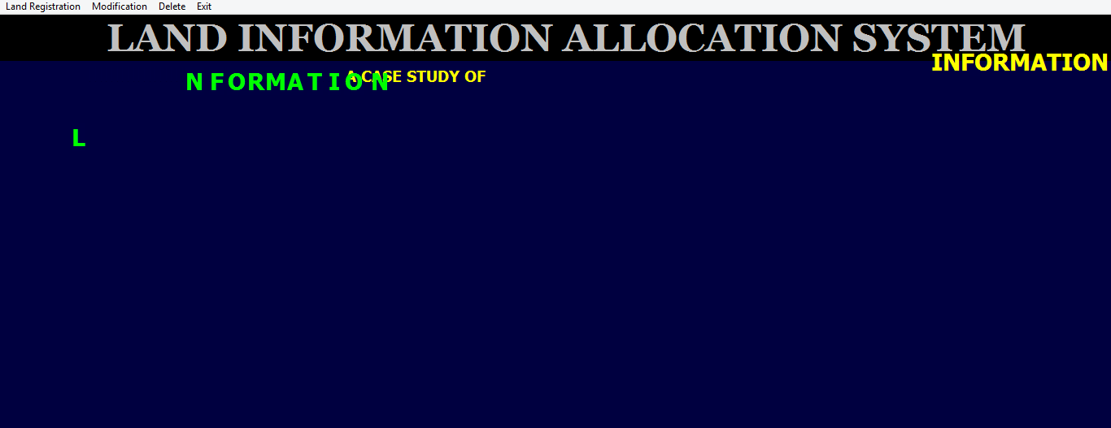
Figure 4.1: Welcome Menu: This is the first page that will show after the login page
4.1.2 INPUT DESIGN
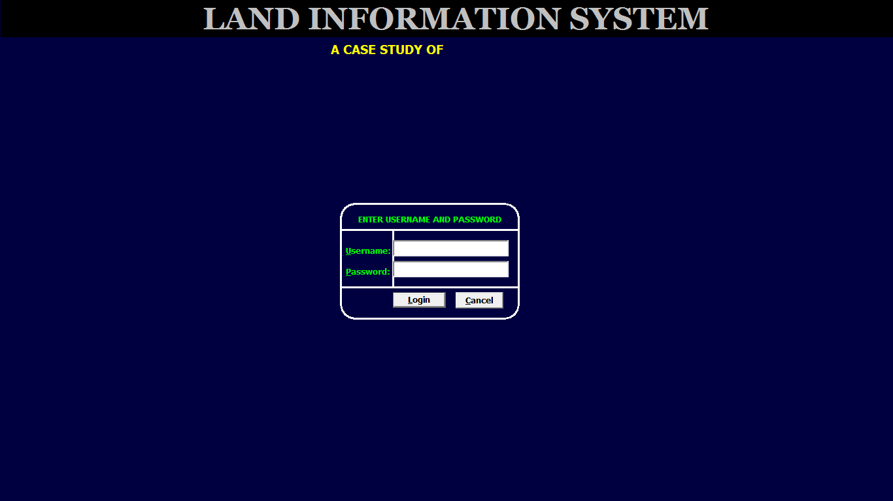
Figure 4.2: Login menu: This is where the admin enter his username and password
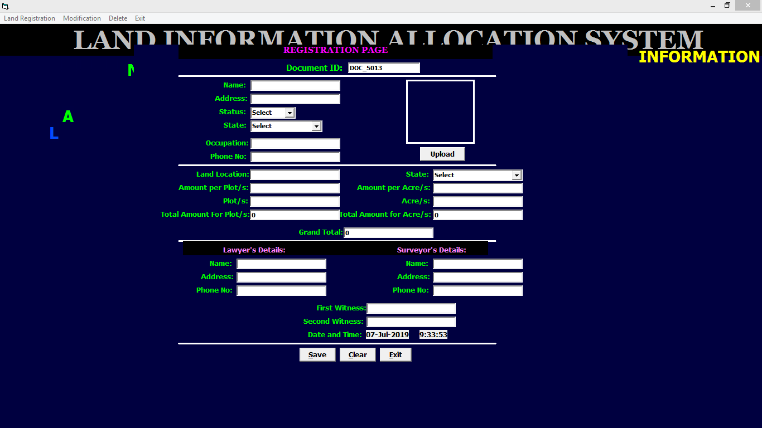
Figure: 4.3 Registration Page: This is where admin enter customer registration details.
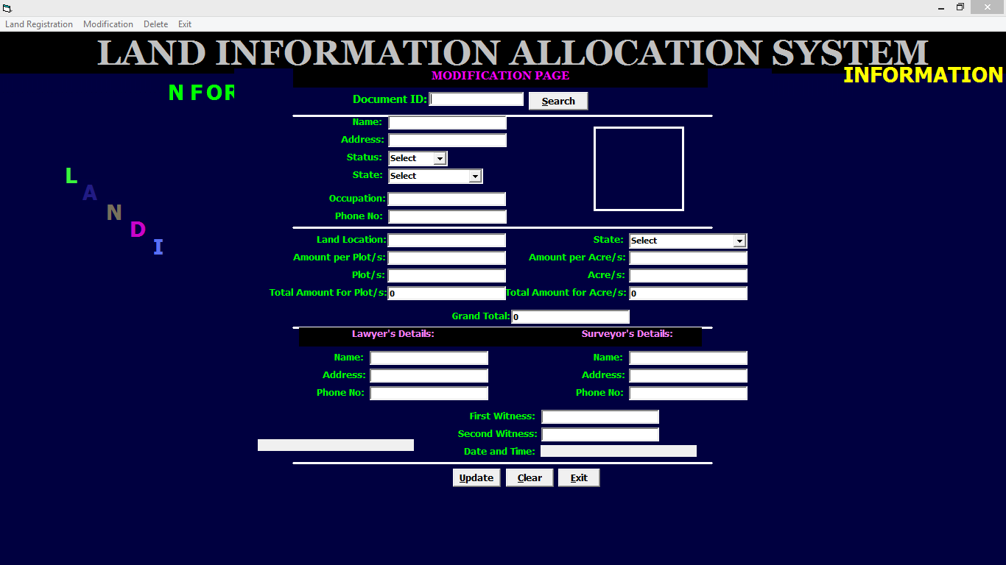
Figure 4.4: Modification Page: This is where admin modify customers’ details.
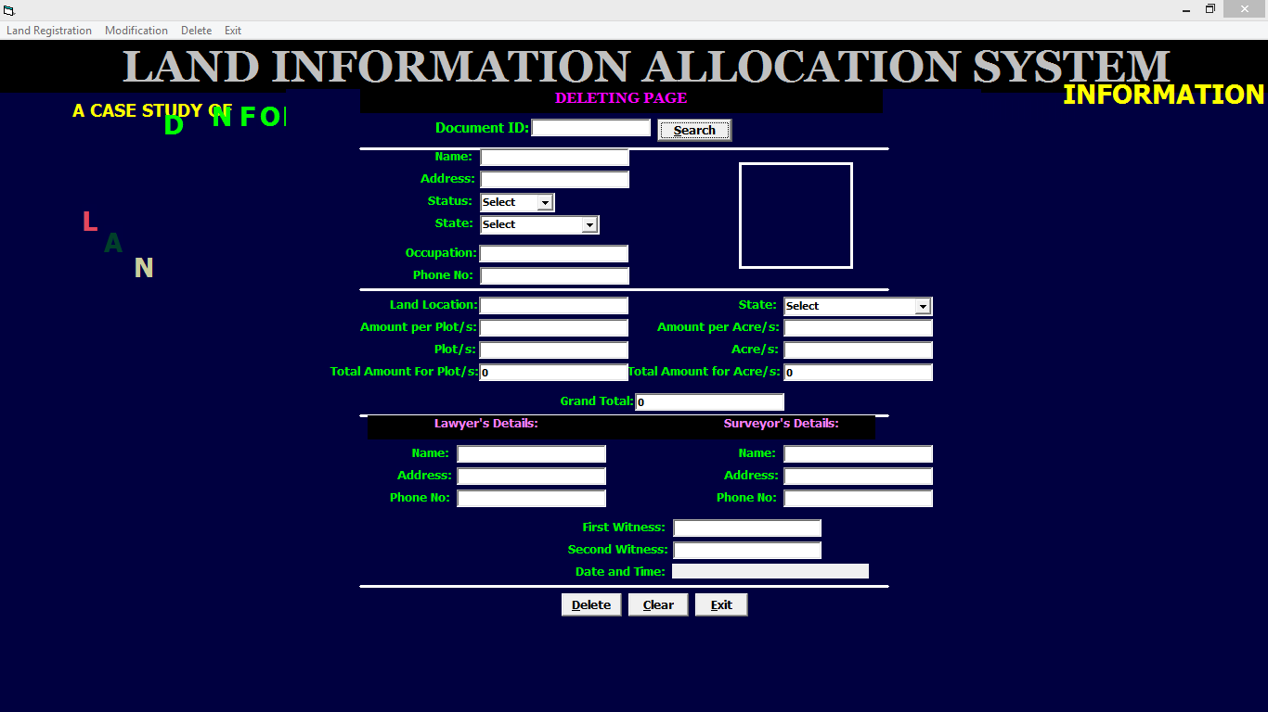
Figure 4.5: Deleting Page: This is where admin delete users’ details.

4.1.3 DATABASE DESIGN
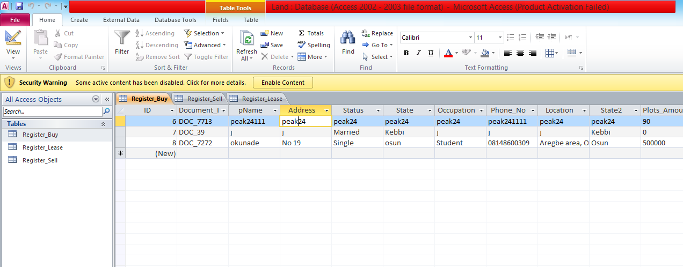
Figure 4.6: Registration Datatable: This is registration datatable where data are stored and retrieved.
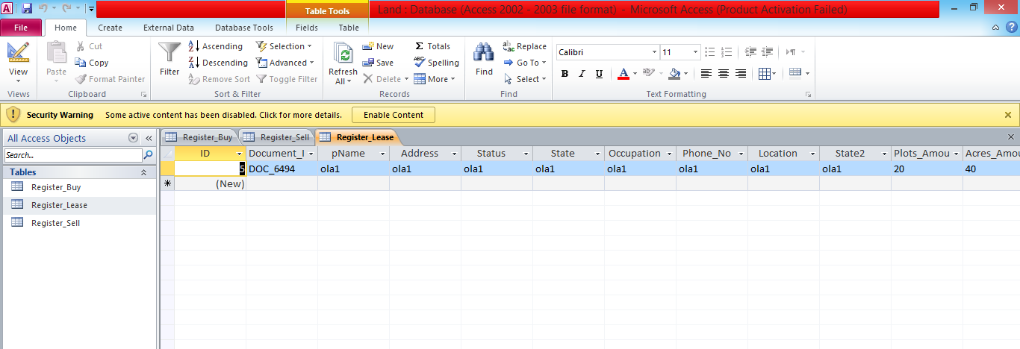
Figure 4.7: Lease Datatable: This is lease datatable where data are store and retrieved.
4.1.4 PROCEDURE DESIGN
The procedural design describes the system generally. It describes the various main programs in the system as well as the relationship that exist between all subprograms included. The procedural designs in this new system are of 5 menus of which each menu has it sub menu.
The application also contains several modules of which each module has its own specific function. The purpose of dividing the program into modules is because it enhances maintainability, readability and easy debugging.

4.2 SYSTEM IMPLEMENTATION
4.2.1 CHOICE OF PROGRAMMING LANGUAGE
Visual basic 6.0 is the chosen programming language for the implementation of the proposed system because of its pedagogy and open source help when needed. As well it has a support for variety of database application like sql server, sqllite, mysql, and Microsoft access but Microsoft Access is selected.
4.2.2 HARDWARE SUPPORT
The computer configuration required to run the software is;Computer/memory processor PC with a 48dx, MHZ or Pentium, Intel or higher processor required.
Memory : 512MB of RAM
Cache memory : 512KB
Hard disk Minimum size : 10.2GB
Recommended : 40GB
Virtual Memory : 32Bits
Cache memory : 512KB
Floppy disk drive : 1.44MB
4.2.3 SOFTWARE SUPPORT
The software support for the design of the proposed system involves operating system, Microsoft visual basic 6.0, Microsoft Access as well as anti-virus software which prevent the system from being infected by virus.
4.2.4 IMPLEMENTATION TECHNIQUES USED IN DETAILS
The system will be implemented using the parallel approach. This approach is considered because it ensures that the new system is tested alongside with the old system to ensure the effectiveness and efficiency of the system.
4.3 SYSTEM DOCUMENTATION
4.3.1 PROGRAM DOCUMENTATION
The system must be used as instructed according to the hardware and software supports so as to make optimal use of it.

    - OPERATING THE SYSTEM
Step 1:Locate where your VB application is (Land Information allocation system) and click it.
Step i: Click on Land Registration (to buy land, lease land and sell land).
Step ii: Click on Modification (to modify buy land, modify lease land and modify sell land).
Step iii: Click on Delete (delete bought land, delete lease land and delete sold land).
Step 2: Exit
4.3.3 MAINTAINING THE SYSTEM
The following instructions must be strictly adhere to in other to make efficient use of the system. Install an anti-virus and always make sure it is usually updated to.

CHAPTER FIVE
SUMMARY, CONCLUSION AND RECOMMENDATIONS
5.1 SUMMARY
In summary, land information and allocation system will be very helpful when it comes to getting information of a land that its details has already been entered into the system (Land Information And Allocation System)
5.2 CONCLUSION
The primary objective of this study was to develop a Land Information allocation System. In accomplishing the primary objective the specific objectives were set as follows:
i. To identify suitable attributes about the land parcels that should be included in the database.
ii. To study how information on registered land is retrieved for the purposes of supporting various operations such as search, transfer and valuation and how LIAS can help stream line the procedure there in.
iii. To compile some cadastral record that is complete, up to date, and reliable.
iv. To implement and demonstrate the operation of the database in the study area.
It can therefore be concluded that in this project:
i. Suitable attributes about land parcels for inclusion in the database have been developed.
ii. Retrieval of information on registered land to support operations such as search, transfer, valuation has been demonstrated and how LIAS streamlines the procedure there in.
iii. Cadastral record that is complete, up to date, and reliable has been compiled.
iv. Implementation and functioning of the database operation in the study area has been demonstrated.
In the introduction, the shortcomings of manual record keeping were highlighted as well as the growing need for a computerized LIAS as put forward in the National Land Policy. The search results from the LIAS was compared against the classical search from the 77 ministry of lands, housing and urban development, the results showed that the search is sufficient in support of land transactions in the town. Input from professionals such as lawyers, planners, valuers and surveyors was obtained on information they required from a computerized LIAS. Audits were carried out to determine whether the system provides the required information.
The results of the study has shown the importance of acquiring a computerized LIAS

5.3 RECOMMENDATIONS
From the results obtained from the study, it was recommended that:
i) Inclusion of payment module to the system.
ii) The LIAS to be made web based, where it can be accessed online without the need to access the standalone application before land information allocation can be processed.
iii) Security of the database to be enhanced through combination of security measures from 4 layers of security control i.e. hardware/software/data security systems, physical security, administrative controls and laws relating to data security and privacy.

REFERENCE

Abdulrahman, S., (2018). “Assessment of a land administration system: a case study of the Survey and Land Registration Bureau in Bahrain”. Unpublished Ph.d thesis, University of Bahrain.
Adeniran, D.D. (2014). “Evaluation of Land Administration Systems. Land Use Policy”, 24 (4): 371-380.
Adeyinka et al., (2016) “The Cadastral Template Project”. Proceedings of FIG Working Week 2004, Athens. 22-27 May. 15p
http://www.fig.net/pub/athens/paers/ts01/ts01_2_steudler_et_al.pdf
Adigun, A.B. (2018) “Setting Up a Land Information System: A Systematic Approach, Publication at Ad-hoc Expert Group Meeting on integrated geographic information systems with special attention to cadastre and land information systems for African decision-makers”, Addis-Ababa, Ethiopia, Nov 23-26.
Barney, L., Laizer, A., Aurélie, M., Carol, R. and Christopher, B., (2018). “Developing an Integrated Land Management Information System (ILMIS) for Tanzania paper prepared presentated at the“ 2018 World Bank conference on land and poverty”. The World Bank - Washington DC, March 19-23, 2018.
Bell, K. (2016). “Land administration and management: The need for innovative approaches to land policy and tenure security”. Expert Group Meeting on Secure Land Tenure, ESCAP. 2016.
Burrough, Peter A.; McDonnell, R.A. (2016): “Principles of Geographical Information Systems”. Oxford University Press.
Dale, P.; McLaughlin, J. (2016). “Land Administration”. Oxford University Press.
Dale, P.F and McLaughlin, J.D. (2016) “Land Information Management”, UK Clarendon Press, 266pp
Deininger, K., Augustinus C., Enemark S., and Munro-Faure P. (2010). “Innovations in Land Rights Recognition, Administration, and Governance.” Joint Organizational Discussion Paper, 25pp.
Edward, K. (2014). “Digital Cadastres facilitating land information management”. South African Journal of Geomatics, Vol. 3, No. 1, January 2014
Elias, D. K. and Joyce, A. E. (2015). “Customary land allocation, urbanization and land use planning in Ghana: Implications for food systems in the Wa Municipality. Unpublished Department of Real Estate and Land Management”, University for Development Studies, Wa-Campus,
Enemark, S. (2014), “Building land information policies, proceedings of Special Forum on Building Land Information Policies in the Americas”, 26-27 October, 2004, Aguascalientes, Mexico.
Henssen, J (2017) “Basic principles of the main Cadastral Systems in the world. Proceedings of the seminar. Modern Cadastres and Cadastral Innovations‟ in Delft, FIG Commission 7, p.5-10, Melbourne.
Kufoniyi, O. (1998) GIS Principles and applications - In C.U Ezeigbo (ed) – “Database design and Creation” pp (50 -67) Americas, 26-27 October, 2004, Aguascalientes, Mexico.
Sharifia, M.A, Karimib, M. and Mesgarib, M.S., (2011). “Modelling Land Allocation Process in Time and Space”, Vol. 38, Part II, 2 pgs
Simon, H., Tshepiso, S., Sibonakaliso, S., Lusanda, S. and Jennifer, W. (2016). “Land allocation, boundary demarcation and tenure security in tribal areas of South Africa”. South African Journal of Geomatics, Vol. 5, No. 1, February 2016. 32 pgs
Steudler, D., Williamson, I. Rajabifard, A., and Enemark, S. (2018): “The Cadastral Template Project”. Proceedings of FIG Working Week 2004, Athens. 22-27.
http://www.fig.net/pub/athens/paers/ts01/ts01_2_steudler_et_al.pdf retrieved on 23/06/2019
Susheel, D. (2012). “E-government Based Land Information System Architecture”: A Case of Nepal.
United Nations Economic Commission for Europe. “Land administration guidelines”. Geneva.
United Nation Organization(1996). “Land Administration guidelines”, New York and Geneva.
Wallace, J. (2009). Managing social tenures, comparative perspectives on communal land and Individual Ownership: Sustainable Futures, London: Routledgde
SYSTEM FLOWCHART
Stop
Register Land
Report
Delete Land
Modify Land
Logout
Main Menu
Login
Splash Screen

Start

LOGIN
Yes
Return
Main Menu
Close Database
Is Field Correct In Database ?
Is any field empty ?
Input Username, Password
Open Database
Start
No
No
Yes

SPLASH SCREEN
Open Database

Open Database

Return

Display Splash Screen
Start

MAIN MENU
Start
Open Database
Select option
Register Land
Modify Land
Delete Land
Report
Logout

Return

End Select
Close Database

REGISTER LAND
Close Database
All Field are Required to Proceed
Save to Database
Open Database
Display Land Details
Is any Field Empty
?
Return
Start
Yes
No
Enter Land Registration Details

MODIFY LAND
Open Database
Modify Land
Return
Start
Close Database

DELETE LAND
Delete Land
Return
Start
Close Database
Open Database

REPORT
Return
Start
Close Database
Display Land Report
Open Database

LOGOUT
Close Database

Main Menu
Welcome Page
Thank you for using this software
Click on Log out
Return
Are you sure You want to Logout?
Start
No
Yes
Open Database

