

PHYTOCHEMICAL ANALYSIS OF CHRYSOPHYLLUM ALBIDUN.

BY:

OYELAKIN ZAINAB OLUWAPAMILERIN
ND/23/SLT/PT/0634

BEING A RESERCH PROJECT SUBMITTED TO
THE DEPARTMENT OF SCIENCE LABORATORY TECHNOLOGY, INSTITUTE OF APPLIED SCINECE.

IN PARTTIAL FILFULMENT OF THE REQUIREMENT FOR THE AWARD OF NATIONAL DIPLOMA (ND) IN SCINCE LABORATORY TECHNOLOGY

JULY 2025

CERTIFICATION
This is to certify that this reserach work has been read and approved by the Department of Science Laboratory Technology, Kwara State Polytechnic, Ilorin as having a satisfied part of the requirement for the award of National Diploma (ND) in Science Laboratory Technology.

……………………. ………………….
MR. ABDULKADIR SAAD DATE
(Supervisor)

……………………… ………………………
MR. LUKMAN I.A. DATE
(PT Coordinator)

…………………… ……………………..
DR. ABDULKAREEM USMAN DATE
(Head of Department)

DEDICATION
I dedicate this Project to Almighty Allah for His Mercy, sustenance and guidance over me from the begining till this moment. I also dedicate this to My loving and beloved parents for their support and love.

ACKNOWLWDGEMENT
To Almighty Allah who owns My life. My sincere appreciation and gratitude to Him for seeing me through this process. I would also like to express My sincere gratitude to My father (MR.OYELAKIN), for His support and guidance throughout this Project. His encouragement, insightful advice, and belive in My abilities were instrumental in completion. Thank You for always being My biggest supporter and for everything You do.

TABLE OF CONTENT
TITLE PAGE
CERTIFICATION PAGE
APPROVAL PAGE
DEDICATION
ACKNOWLEDGEMENTS
TABLE OF CONTENTS
LIST OF FIGURES
LIST OF TABLES
ABSTRACT
CHAPTER ONE

INTRODUCTION
  - Background of the Study
  - Description and Ethnobotanical Importance of Chrysophyllum albidum
  - Statement of the Problem
  - Objectives of the Study
  - Research Aims
  - Justification of the Study
  - Scope of the Study

CHAPTER TWO
LITERATURE REVIEW

2.1 Chrysophyllum albidum

2.2 Phytochemical Constituents of Chrysophyllum albidum

2.2.1 Alkaloids

2.2.2 Flavonoids

2.2.3 Tannins

2.2.4 Saponins

2.2.5 Phenolic Compounds

2.2.6 Terpenoids

2.2.7 Steroids and Sterols

2.2.8 Essential Oils

2.2.9 Other Phytochemicals

2.3 Biological Activities Associated with Phytochemicals

2.4 Functional Properties of Phytochemicals in Chrysophyllum albidum

2.4.1 Antimicrobial Activity

2.4.2 Antioxidant Activity

2.4.3 Anti-inflammatory and Analgesic Effects

2.4.4 Antibiofilm Activity

2.4.5 Hypolipidemic and Hypoglycemic Effects

2.5 Previous Studies on Chrysophyllum albidum

CHAPTER THREE

METHODOLOGY

3.1 Sample Collection

3.2 Sample Preparation

3.3 Extraction Procedure
3.4 Phytochemical Screening
CHAPTER FOUR
RESULTS AND DISCUSSION
4.1 Phytochemical Screening
4.2 Result
4.2.1 Presence of Tannins
4.2.2 Saponins in Seed Only
4.2.3 Terpenoids in Both Extracts
4.2.4 Glycosides Only in seed
4.2.5 Absence of Steroids
4.2.6 Abundant Alkaloids and Flavonoids
4.2.7 Presence of Phenols
4.2.8 Amino Acids and Phlobatannins Absent
4.3 Comparative Phytochemical Richness

4.4 Scientific Relevance of Screening Results
REFERENCES
LIST OF FIGURES
Figure 1: Chrysophllum Albidum
Figure 2: Pounded Chrysophllum Albidum
Figure 3: Chrysophllum Albidum Seeds
Figure 4: Ground seed and pulp
LIST OF TABLES
Table 1 : Phytochemical Constituents of Chrysophyllum albidum pulp and Seed

Abstract
Chrysophyllum albidum, commonly known as the African star apple, is a tropical fruit-bearing plant traditionally used for its nutritional and medicinal benefits. This study aimed to investigate the qualitative phytochemical constituents of the pulp and seed of C. albidum using ethanol extracts. Fresh fruits were sourced from a local market in Ilorin (Ipata Market), and the seeds and pulp were separated and air-dried before extraction. Standard phytochemical screening methods revealed the presence of flavonoids, alkaloids, phenols, tannins, and terpenoids in both the pulp and seed extracts. Notably, saponins were present only in the seed. Steroids, amino acids, and phlobatannins were absent in both samples. These findings support the ethnomedicinal applications of C. albidum and suggest that different parts of the plant may offer varying therapeutic benefits. Further studies are recommended to isolate and characterize the individual compounds responsible for these bioactivities.

CHAPTER ONE

INTRODUCTION

1.1 Background of the Study
Since antiquity, medicinal plants have played a critical role in the health and well-being of human societies. Across cultures and continents, traditional medicine has largely depended on the healing powers of plants to address a myriad of illnesses ranging from simple infections to chronic diseases. The World Health Organization (WHO) estimates that approximately 80% of the world’s population relies on traditional medicine for primary healthcare, particularly in developing countries (WHO, 2008). Central to the effectiveness of these natural remedies are compounds known as phytochemicals — bioactive substances produced by plants as part of their normal metabolic processes.
Phytochemicals serve a protective function in plants, defending them against pathogens, pests, and environmental stress. However, their significance extends beyond plant biology. Numerous studies have demonstrated that these compounds also exert profound effects on human health, exhibiting antimicrobial, anti-inflammatory, antioxidant, and anticancer properties (Okwu, 2004; Edeoga et al., 2005). Some of the most well-known phytochemicals include alkaloids, flavonoids, saponins, tannins, phenols, terpenoids, glycosides, and steroids. These compounds, while not essential nutrients, contribute significantly to the pharmacological efficacy of many medicinal plants.
Amid the growing global interest in natural and plant-derived therapeutic agents, researchers have turned their attention to the validation of traditional medicines through scientific investigation. This approach not only supports the integration of herbal medicine into mainstream healthcare but also aids in the discovery of novel drugs. In recent decades, bioactive compounds derived from plants have led to the development of life-saving medications such as morphine (from Papaver somniferum) and quinine (from Cinchona species).
One plant that has gained attention for its potential medicinal benefits is Chrysophyllum albidum, commonly known as the African star apple. This tropical fruit tree, belonging to the Sapotaceae family, is native to West Africa and widely cultivated in Nigeria, Ghana, and Cameroon. The tree bears small, round fruits with a thick skin and a juicy, tangy-sweet pulp. While the fruit is a common snack, traditional medicine has long utilized various parts of the plant, including the leaves, seeds, bark, and roots, in treating a variety of health conditions.

1.2 Description and Ethnobotanical Importance of Chrysophyllum albidum
C. albidum has found a place in folklore medicine where it is reputed to treat a range of ailments such as malaria, diarrhea, hypertension, wounds, and fever (Adisa et al., 2011). The leaves are often crushed and applied topically to treat skin infections and wounds, while the seeds are used in decoctions believed to manage blood pressure and gastrointestinal disorders. Despite these traditional uses, there is limited empirical evidence to fully substantiate its therapeutic potential. As such, phytochemical analysis becomes essential to confirm the presence of compounds that may explain the biological activity associated with different parts of the plant.
In nutritional terms, C. albidum fruits are rich in vitamin C, iron, and other essential minerals (Akinmoladun et al., 2010). However, the pharmacological promise lies in the presence of secondary metabolites — compounds that are not directly involved in growth or reproduction, but which contribute significantly to the plant's medicinal value.

1.3 Statement of the Problem
Although C. albidum is widely used in traditional medicine, scientific data confirming the specific phytochemicals responsible for its biological effects are sparse. This gap in knowledge has hampered the full integration of the plant into evidence-based therapeutic systems. Additionally, most existing studies have focused primarily on the fruit pulp, leaving other potentially important plant parts like the seeds and leaves underexplored. There is, therefore, a pressing need to systematically investigate the phytochemical constituents of different parts of the plant to validate its ethnomedicinal uses.

1.4 Objectives of the Study
The primary objective of this study is to qualitatively analyze the phytochemical composition of the ethanol extracts of the leaves and seeds of Chrysophyllum albidum. Specific objectives include:
- To identify the classes of phytochemicals present in the pulp and seeds.
- To compare the phytochemical profiles of the pulp and seed extracts.
- To discuss the medicinal significance of the identified phytochemicals in relation to the traditional uses of the plant.

1.5 Research Aims
This research aims to answer the following questions:
- To extract the pulp and seed of Chrysophyllum albidum
- To determine the phytochemicals that are present in the pulp and seeds of C. albidum
- To investigate differences in the phytochemical profiles between the pulp and seed extracts

1.6 Justification of the Study
The increasing interest in plant-based therapy necessitates a scientific approach to the validation of traditionally used medicinal plants. By identifying and analyzing the phytochemicals in C. albidum, this study will provide empirical support for its continued use in herbal medicine. The outcome of this research could also pave the way for further pharmacological studies, including toxicity profiling and drug development. Furthermore, understanding the differential composition of the plant’s parts may guide the more efficient use of the plant in traditional and modern medicine.

1.7 Scope of the Study
This study is limited to the qualitative phytochemical screening of ethanol extracts of the pulp and seed of Chrysophyllum albidum. Quantitative analysis, isolation of individual compounds, and biological assays are beyond the scope of this research, though they are recommended for future studies.

CHAPTER TWO
LITERATURE REVIEW
2.1 Chrysophyllum albidum
Chrysophyllum albidum (commonly known as African star apple or white star apple) is a tropical fruit tree belonging to the Sapotaceae family. It is widely distributed in West Africa, particularly in Nigeria, Ghana, and Cameroon (Adebayo et al., 2019). The plant is valued for its edible fruits, which are rich in nutrients and bioactive compounds. In traditional medicine, various parts of C. albidum, including the leaves, bark, and fruits, are used to treat ailments such as malaria, diarrhea, and inflammation (Olorunnisola et al., 2020). Recent studies have focused on the phytochemical composition of C. albidum, revealing the presence of secondary metabolites such as alkaloids, flavonoids, tannins, saponins, and phenolic compounds, which contribute to its medicinal properties (Adewole & Naidu, 2021). This literature review examines the phytochemical analysis of C. albidum and its pharmacological significance.

2.2 Phytochemical Constituents of Chrysophyllum albidum
Phytochemicals are naturally occurring bioactive compounds found in plants that contribute to their color, flavor, and disease resistance. Unlike essential nutrients, phytochemicals are not required by the human body for sustaining life but are known to exert significant health benefits. They have been associated with the prevention and management of chronic diseases such as cancer, cardiovascular disorders, diabetes, and infections (Okwu, 2004).
Phytochemicals can be classified into several groups, including flavonoids, alkaloids, tannins, saponins, terpenoids, glycosides, phenols, steroids, and amino acids. Their presence in fruits and medicinal plants has attracted significant attention in drug discovery and ethnopharmacological studies.
2.2.1 Alkaloids
Alkaloids are nitrogen-containing compounds known for their diverse pharmacological effects, including analgesic, anti-inflammatory, and antimicrobial properties (Ezekwesili et al., 2022). Studies have reported the presence of alkaloids in the leaves, stem bark, and seeds of C. albidum (Okafor et al., 2021). The alkaloid content varies depending on the plant part and extraction method used. For instance, methanol extracts of the leaves have shown higher alkaloid concentrations compared to aqueous extracts (Adedapo et al., 2020). The presence of alkaloids in C. albidum supports its traditional use in pain relief and fever management.
2.2.2 flavonoids
Flavonoids are polyphenolic compounds with antioxidant, anti-inflammatory, and anticancer properties (Aderinola et al., 2021). Several studies have identified flavonoids such as quercetin, kaempferol, and rutin in C. albidum leaves and fruits (Ojo et al., 2022). The high flavonoid content in the plant contributes to its free radical scavenging activity, making it beneficial in preventing oxidative stress-related diseases (Akinpelu et al., 2020). Additionally, the presence of flavonoids in C. albidum has been linked to its hepatoprotective and cardioprotective effects (Olorunnisola et al., 2021).

2.2.3 Tannins
Tannins are astringent polyphenolic compounds known for their antimicrobial and wound-healing properties (Ajayi et al., 2020). Phytochemical screening of C. albidum bark and leaves has revealed significant tannin content, particularly in ethanolic extracts (Okafor et al., 2021). Tannins play a role in the plant’s traditional use in treating diarrhea and gastrointestinal infections due to their ability to inhibit microbial growth (Adebayo et al., 2019). Furthermore, tannins contribute to the antioxidant capacity of C. albidum, enhancing its therapeutic potential (Ezekwesili et al., 2022).

2.2.4 Saponins
Saponins are glycosides with foaming properties and have been associated with cholesterol-lowering and immunomodulatory effects (Adedapo et al., 2020). Research indicates that C. albidum contains appreciable amounts of saponins, particularly in the seed extracts (Ojo et al., 2022). These compounds have been implicated in the plant’s traditional use as a remedy for hypertension and cardiovascular disorders (Akinpelu et al., 2020). Additionally, saponins exhibit antimicrobial activity, supporting the use of C. albidum in treating infections (Aderinola et al., 2021).

2.2.5 Phenolic Compounds
Phenolic compounds are known for their antioxidant and anti-inflammatory properties (Ajayi et al., 2020). Studies have shown that C. albidum contains high levels of phenolic acids, including gallic acid, caffeic acid, and chlorogenic acid (Olorunnisola et al., 2021). The phenolic content varies with the extraction solvent, with methanol and ethanol extracts yielding higher concentrations than aqueous extracts (Adewole & Naidu, 2021). These compounds contribute to the plant’s ability to scavenge free radicals and reduce oxidative damage in biological systems (Okafor et al., 2021).

2.2.6 Terpenoids
Terpenoids, derived from isoprene units, are known for their diverse biological activities. Essential oils extracted from the leaves and fruits of C. albidum contain various terpenoids, including α-amyrin and (Z,E)-α-farnesene. These compounds contribute to the antimicrobial and antioxidant properties of the plant. For instance, α-amyrin has been associated with membrane-disrupting activities against bacteria, while (Z,E)-α-farnesene exhibits lipophilic properties that enhance bacterial membrane permeability .

2.2.7 Steroids and Sterols
Steroids and sterols are lipid-based compounds with significant biological roles. Stigmasterol, a phytosterol isolated from the stem bark of C. albidum, has demonstrated both antioxidant and antibacterial activities. The presence of such compounds underscores the plant's potential in managing oxidative stress and microbial infections .

2.2.7 Essential Oils
Essential oils from C. albidum have been characterized using gas chromatography-mass spectrometry (GC-MS), revealing a complex mixture of compounds. In the leaf essential oil, n-hexadecanoic acid was the predominant compound, constituting 20.25% of the total oil composition. The fruit essential oil was rich in terpenoids, hydrocarbons, and esters, with hexanedioic acid, bis(2-ethylhexyl) being the major compound. These essential oils exhibited broad-spectrum antimicrobial activity and significant antioxidant potential, suggesting their applicability in food preservation and pharmaceutical formulations .

2.2.8 Other Phytochemicals
Beyond the major classes, C. albidum contains other phytochemicals such as quinones, cardiac glycosides, and fatty acids. Quinones have been associated with antimicrobial activities, while cardiac glycosides are known for their effects on heart muscle contractions. The presence of fatty acids contributes to the plant's nutritional value and may also play a role in its medicinal properties .

2.3 Biological Activities Associated with Phytochemicals
The diverse phytochemical constituents of C. albidum contribute to its wide range of biological activities:
- Antimicrobial Activity: Alkaloids, flavonoids, terpenoids, and essential oils exhibit antimicrobial properties against a variety of pathogens, including bacteria and fungi.
- Antioxidant Activity: Flavonoids, tannins, and essential oils scavenge free radicals, thereby protecting cells from oxidative stress.
- Anti-inflammatory Activity: Saponins and certain terpenoids contribute to the plant's anti-inflammatory effects, supporting its traditional use in treating inflammatory conditions.
- Cardioprotective Effects: Cardiac glycosides and saponins may play roles in modulating heart function and reducing cholesterol levels.
Chrysophyllum albidum is a reservoir of diverse phytochemicals, each contributing to its multifaceted biological activities. The presence of alkaloids, flavonoids, terpenoids, saponins, tannins, steroids, and essential oils underscores the plant's therapeutic potential. Continued research into these compounds can lead to the development of novel drugs and health supplements, validating the traditional uses of this remarkable plant.

2.4 Functional Properties of Phytochemicals in Chrysophyllum albidum
Chrysophyllum albidum, commonly known as the African star apple, is a tropical fruit tree native to West Africa. Traditionally, various parts of the plant—such as the leaves, seeds, bark, and fruit—have been utilized in folk medicine to treat ailments like diarrhea, fever, and hypertension. Recent scientific investigations have focused on identifying and characterizing the phytochemical constituents responsible for these therapeutic effects.

2.4.1 Antimicrobial Activity
The antimicrobial properties of C. albidum have been extensively studied. Essential oils extracted from the leaves and fruits have demonstrated broad-spectrum antimicrobial activity against various pathogens. For instance, the fruit essential oil exhibited minimum inhibitory concentrations (MICs) ranging from 0.195 to 6.250 mg/mL against eight tested pathogens, while the leaf essential oils showed MICs in the range of 6.875–13.750 mg/mL. The antimicrobial activity is attributed to compounds such as linalyl anthranilate, which disrupts bacterial cell membranes, leading to cell death. Sesquiterpenes like α-amyrin and (Z, E)-α-farnesene also contribute to the antimicrobial activity due to their lipophilic properties, which enhance the permeability of bacterial membranes, leading to cell lysis .
Additionally, alkaloids such as eleagnine, tetrahydro-2-methylharman, and skatole have been isolated from the seed cotyledons. These compounds exhibit antimicrobial properties, with eleagnine showing significant activity against various bacterial strains .

2.4.2 Antioxidant Activity
Phytochemicals in C. albidum exhibit significant antioxidant properties. Flavonoids and phenolic compounds, such as epicatechin, epigallocatechin, and procyanidin B5, scavenge free radicals, thereby protecting cells from oxidative stress. The essential oils demonstrated free radical scavenging activity in DPPH and hydrogen peroxide assays. For the DPPH assay, the leaf and fruit pulp essential oils were able to scavenge 50% of free radicals at concentrations of 301.8 ± 0.68 and 669.2 ± 2.12 μg/mL, respectively. In the hydrogen peroxide assay, the leaf essential oil performed superiorly with an IC₅₀ value of 1048 ± 0.27 μg/mL compared to the fruit pulp essential oil with an IC₅₀ value of 1454 ± 0.26 μg/mL .
Procyanidin B5, isolated from the stem-bark, demonstrated supreme antioxidant activity with IC₅₀ values of 8.8 μM and 11.20 μM in DPPH and nitric oxide assays, respectively.

2.4.3 Anti-inflammatory and Analgesic Effects
Studies have shown that extracts of C. albidum possess anti-inflammatory and analgesic effects. The presence of glycosides, saponins, and flavonoids contributes to the inhibition of inflammatory mediators, reducing pain and swelling in experimental models. For instance, the fruit peel extract attenuates nociceptive pain and inflammatory responses in rodents by inhibiting pro-inflammatory cytokines and COX-2 expression through suppression of NF-κB activation.

2.4.4 Antibiofilm Activity
Biofilm formation by bacteria is a significant factor in antibiotic resistance. The essential oils of C. albidum have been found to inhibit biofilm formation, particularly in Pseudomonas aeruginosa. Both fruit and leaf essential oils exhibited good inhibitory properties, with percentage inhibition above 50% at all concentrations tested. The fruit essential oil demonstrated good antibiofilm activity with a BIC₅₀ value of 698.80 μg/mL, while the leaf essential oil had a BIC₅₀ value of 477.9 μg/mL. Compounds such as eugenol and the amyrins disrupt the initial attachment of bacterial cells to surfaces, interfering with biofilm formation .

2.4.5 Hypolipidemic and Hypoglycemic Effects
Extracts from different parts of C. albidum have shown hypolipidemic and hypoglycemic properties. Ethanolic extracts from the plant significantly reduced blood glucose levels and hepatic lipids at higher dose concentrations, except HDL-cholesterol, which was found to increase significantly in diabetic rats. The extracts were also found to reduce platelet concentration, as well as cause a reduction in serum levels, indicating antiplatelet, hypolipidemic, hypoglycemic, and antioxidant properties .
The phytochemical constituents of Chrysophyllum albidum contribute to its wide range of pharmacological activities, including antimicrobial, antioxidant, anti-inflammatory, antibiofilm, hypolipidemic, and hypoglycemic effects. These findings support the traditional medicinal uses of the plant and highlight its potential for developing natural therapeutic agents.
2.5 Previous Studies on Chrysophyllum albidum
Several studies have analyzed the phytochemical composition of different parts of Chrysophyllum albidum. Oboh et al. (2009) reported that the fruit pulp contains significant amounts of flavonoids and phenols, which contribute to its antioxidant activity. Akinmoladun et al. (2010) further demonstrated that both the leaf and seed extracts possess antimicrobial properties due to their phytochemical constituents.
Moreover, Adepoju and Adebanjo (2011) noted that ethanol extracts of the fruit showed higher phytochemical concentrations than aqueous extracts, suggesting the solvent used plays a significant role in extraction efficiency.
The phytochemical analysis of Chrysophyllum albidum reveals a rich composition of bioactive compounds, including alkaloids, flavonoids, tannins, saponins, and phenolic acids. These compounds contribute to the plant’s diverse pharmacological activities, such as antioxidant, antimicrobial, anti-inflammatory, and hepatoprotective effects. Further research is needed to isolate and characterize specific bioactive molecules for drug development.

CHAPTER THREE
METHODOLOGY
3.1 Sample Collection
The fruit of Chrysophyllum albidum was purchased from a local market (Ipata Market) in Ilorin, Kwara State, Nigeria. The selection of this market was based on its accessibility and the availability of fresh and mature fruits during the harvest season.
3.2 Sample Preparation
The fruits were thoroughly washed with clean water to remove dirt and surface contaminants. The pulp and seeds were manually separated from the pericarp. Each component (pulp and seed) was air-dried separately at ambient room temperature (25–30°C) for several days until a constant dry weight was achieved. The dried samples were then ground into fine powder using a clean electric blender and stored in airtight containers for further analysis.
3.3 Extraction Procedure
The powdered samples were subjected to ethanol extraction. About 50 grams of each powdered sample (pulp and seed) was soaked in 250 ml of 95% ethanol in separate conical flasks. The flasks were tightly covered with aluminum foil and allowed to stand for 48 hours at room temperature with intermittent shaking to ensure thorough extraction.
After 48 hours, the mixtures were filtered using Whatman No. 1 filter paper. The filtrates (ethanol extracts) were collected into clean beakers and stored in glass bottles for phytochemical analysis. This method was chosen due to ethanol’s efficiency in extracting a wide range of phytochemicals (Edeoga et al., 2005).
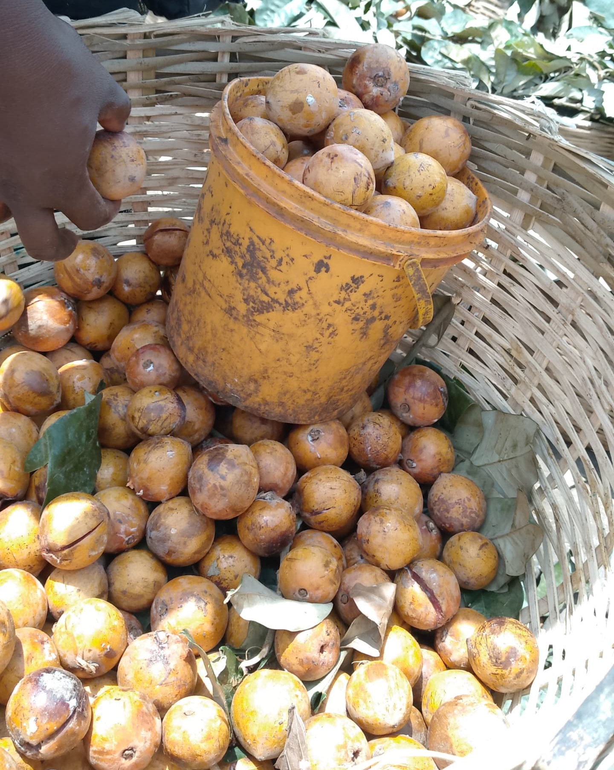
Figure 1: Chrysophllum Albidum
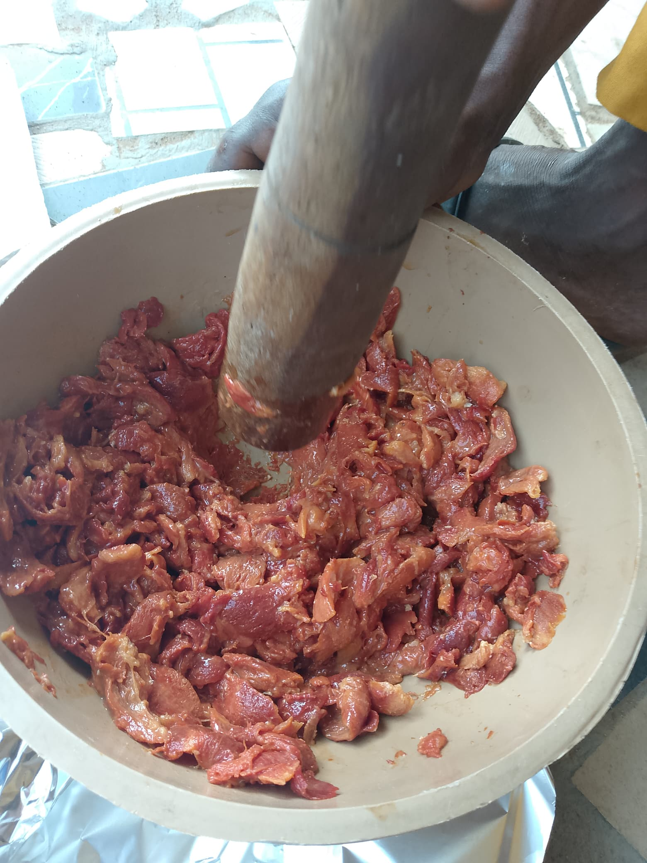
Figure 2: Pounded Chrysophllum Albidum
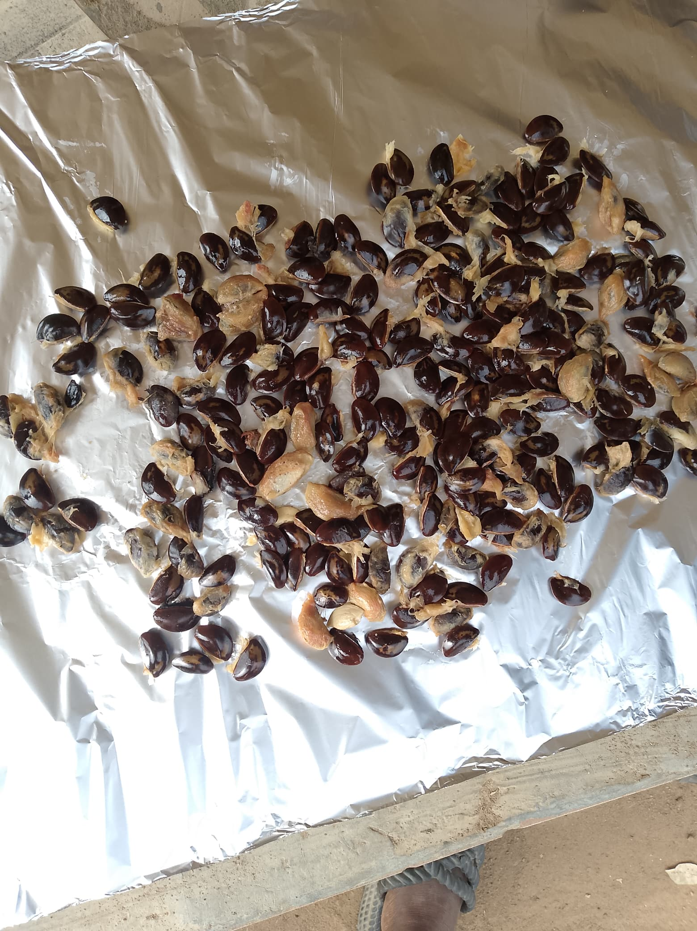
Figure 3 : Chrysophllum Albidum Seeds

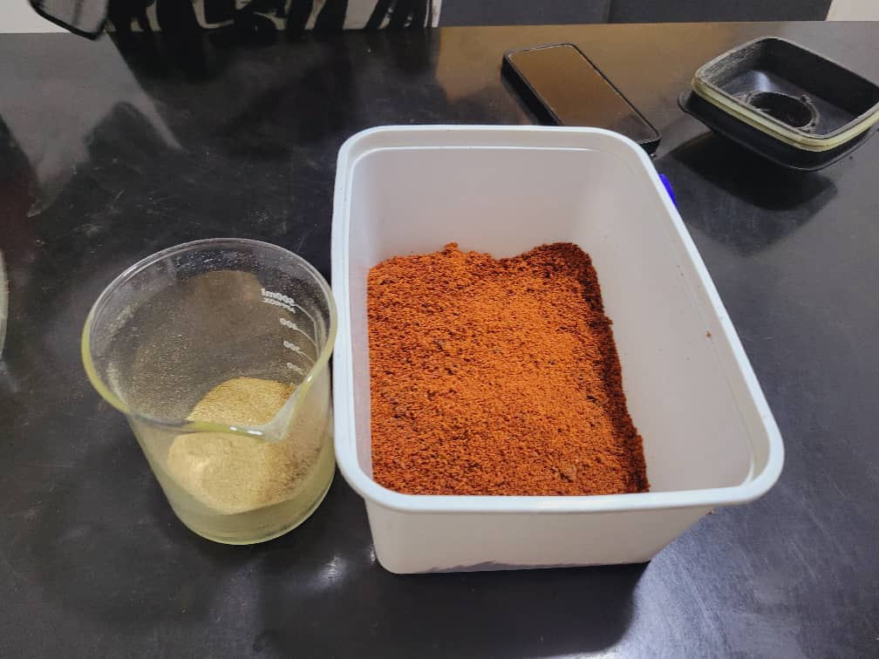
Figure 4: Ground seed and pulp

3.4 Phytochemical Screening
Phytochemical screening is an essential process in natural product research, especially in the early stages of plant-based drug discovery. It refers to the qualitative or quantitative identification of bioactive constituents found in plant materials. These constituents, commonly referred to as phytochemicals, are responsible for the therapeutic effects of many medicinal plants and can include alkaloids, flavonoids, tannins, saponins, phenolic compounds, terpenoids, steroids, glycosides, and others. The screening process helps determine which of these compounds are present in a plant sample and provides foundational knowledge necessary for further pharmacological investigation.
In the case of Chrysophyllum albidum, commonly known as the African star apple, phytochemical screening provides insight into the plant's medicinal potential. The different parts of the plant—leaves, seeds, bark, and pulp—have been widely used in traditional medicine in Nigeria and other parts of tropical Africa. However, scientific evidence to substantiate these traditional uses is necessary. This screening aims to identify the chemical constituents in the ethanol extracts of C. albidum pulp and seeds and to correlate their presence with possible therapeutic actions.

Ethanol
The choice of solvent in phytochemical extraction is crucial to the success of the screening. In this study, ethanol was used as the primary solvent for extracting phytochemicals from Chrysophyllum albidum pulp and seeds. Ethanol is considered one of the most effective and widely accepted solvents for plant extraction because of its ability to dissolve both polar and non-polar substances (Parekh & Chanda, 2007).

Ethanol is safe, biodegradable, and acceptable for extracting bioactive compounds for human consumption, making it ideal for both research and potential commercial applications. It efficiently extracts alkaloids, flavonoids, saponins, phenols, and glycosides, among other phytochemicals. Moreover, ethanol has been shown to extract higher yields of phytoconstituents when compared to water and certain other organic solvents (Harborne, 1998). Procedure for Phytochemical Screening
After obtaining the ethanol extracts, a series of standard qualitative tests were conducted on both the pulp and seed extracts of C. albidum. These tests were designed to detect the presence of specific phytochemical groups using reagents that produce characteristic color changes or precipitates in the presence of target compounds.
The procedures used followed established protocols from Trease and Evans (2002) and Harborne (1998). Each test was performed in triplicate to ensure accuracy and reproducibility. Some of the metabolites tested for are listed below:

- Tannins
- Saponins
- Terpenoids
- Glycosides
- Steroids
- Alkaloids
- Flavonoids
- Phenols
- Amino acids
- Phlobatannins
The standard procedures described by Trease and Evans (2002) and Harborne (1998) were followed.
Test for Tannins
Procedure: About 2 mL of the extract was treated with a few drops of 1% ferric chloride solution. Observation: A blue-black or greenish coloration indicated the presence of tannins.
Relevance: Tannins possess astringent properties and are used in the treatment of diarrhea and wounds (Sofowora, 1993).
Test for Saponins
Procedure: 5 mL of the extract was shaken vigorously with water in a test tube.
Observation: The formation of stable froth lasting more than 10 minutes confirmed the presence of saponins.
Relevance: Saponins are known to lower cholesterol levels, boost immunity, and possess antimicrobial properties (Francis et al., 2002).
Test for Terpenoids
Procedure: 2 mL of extract was mixed with 2 mL of chloroform and 3 mL of concentrated sulfuric acid.
Observation: A reddish-brown interface indicated the presence of terpenoids.
Relevance: Terpenoids exhibit anti-inflammatory, antiviral, and anticancer properties (Mahato & Sen, 1997).
Test for Glycosides
Procedure: The extract was hydrolyzed with dilute hydrochloric acid and then treated with sodium hydroxide.
Observation: A yellow coloration indicated the presence of glycosides.
Relevance: Glycosides are used for heart conditions and as laxatives in traditional medicine (Evans, 2002).
Test for Steroids
Procedure: 2 mL of acetic anhydride was added to 0.5 g of extract followed by 2 mL of concentrated sulfuric acid.
Observation: A violet or blue-green ring confirmed the presence of steroids.
Relevance: Steroids have anti-inflammatory and immunomodulatory activities (Harborne, 1998).
Test for Alkaloids
Procedure: The extract was treated with Mayer’s reagent.
Observation: A creamy white precipitate indicated the presence of alkaloids.
Relevance: Alkaloids exhibit analgesic, antimalarial, and antibacterial properties (Trease & Evans, 2002).
Test for Flavonoids
Procedure: 5 mL of dilute ammonia solution was added to the extract, followed by concentrated sulfuric acid.
Observation: A yellow coloration indicated the presence of flavonoids.
Relevance: Flavonoids are antioxidants that help in reducing oxidative stress and inflammation (Middleton et al., 2000).
Test for Phenols
Procedure: A few drops of 1% ferric chloride were added to the extract.
Observation: A deep blue or black color indicated the presence of phenols.
Relevance: Phenols are known for their antimicrobial and antioxidant effects (Rice-Evans et al., 1997).
Test for Amino Acids
Procedure: Ninhydrin solution was added to the extract and heated.
Observation: A purple or blue color indicated the presence of amino acids.
Relevance: Amino acids are essential for protein synthesis and can contribute to therapeutic effects such as tissue repair (Berg et al., 2002).
Test for Phlobatannins
Procedure: Aqueous extract was boiled with 1% hydrochloric acid.
Observation: A red precipitate confirmed the presence of phlobatannins.
Relevance: Phlobatannins exhibit antimicrobial activity and have been linked to antifungal properties (Okoli et al., 2007).
CHAPTER FOUR
RESULTS AND DISCUSSION
4.1 Phytochemical Screening
The qualitative phytochemical analysis of the ethanol extracts of Chrysophyllum albidum leaf and seed revealed the presence of various secondary metabolites. The summary of the results is presented in Table 1 below:
Table 1: Phytochemical Constituents of Chrysophyllum albidum pulp and Seed
Phytochemical Present | pulp | Seed
Tannin | + | +
Saponin | - | +
Terpenoid | + | +
Glycoside | + | -
Steroid | - | -
Alkaloid | + | +
Flavonoid | + | +
Phenols | + | +
Amino acid | - | -
Phlobatannins | - | -

Key: (+) = Present; (−) = Absent

4.2 Result
The phytochemical screening of Chrysophyllum albidum revealed that both the pulp and seed extracts contain significant classes of bioactive compounds, although there are some notable differences in their composition.
4.2.1 Presence of Tannins
Tannins were detected in both pul and seed extracts. Tannins are known for their astringent properties and antimicrobial activity (Sofowora, 1993). Their presence supports the traditional use of C. albidum in managing infections and wound healing.
4.2.2 Saponins in Seed Only
Saponins were only detected in the seed. This suggests that the seed may possess more potent immunomodulatory and cholesterol-lowering properties, as saponins are reported to stimulate immune response and reduce blood cholesterol (Francis et al., 2002).
4.2.3 Terpenoids in Both Extracts
Terpenoids were present in both pulp and seed. Terpenoids are known to exhibit antioxidant, anti-inflammatory, and anticancer properties (Harborne, 1998). Their presence indicates that both parts of the plant may have therapeutic potential.
4.2.4 Glycosides Only in seed
Glycosides were detected in the pulp but absent in the seed. Glycosides are commonly associated with cardioprotective effects and could enhance the medicinal value of the pulp for cardiovascular health (Dewick, 2002).
4.2.5 Absence of Steroids
Steroids were absent in both extracts. This suggests that C. albidum may not have significant steroidal activity in the parts studied, although other parts like bark or root might differ.
4.2.6 Abundant Alkaloids and Flavonoids
Both alkaloids and flavonoids were present in the pulp and seed. Alkaloids are known for analgesic, antimalarial, and antimicrobial properties (Trease & Evans, 2002), while flavonoids act as powerful antioxidants (Middleton et al., 2000). Their dual presence reinforces the plant’s ethnomedicinal relevance.
4.2.7 Presence of Phenols
Phenolic compounds were detected in both extracts, consistent with earlier reports on the antioxidant potential of C. albidum pulp and seed (Oboh et al., 2009). Phenols play an essential role in neutralizing free radicals, thereby protecting against oxidative stress-related diseases.
4.2.8 Amino Acids and Phlobatannins Absent
Neither amino acids nor phlobatannins were detected in the pulp or seed. This may reflect the specific extraction method used or the relative concentration of these compounds in the plant parts analyzed.
4.3 Comparative Phytochemical Richness
In comparing the two plant parts, the pulp contained a slightly broader range of phytochemicals than the seed, including glycosides, which were absent in the seed. However, the seed uniquely contained saponins. This variation in composition highlights the potential for different therapeutic uses of each part and supports their combined or selective use in herbal medicine formulations (Akinmoladun et al., 2010).

4.4 Scientific Relevance of Screening Results
The presence of multiple bioactive compounds suggests that C. albidum is pharmacologically versatile. For example:
- Flavonoids and phenols play a role in combating oxidative stress, which is a factor in cancer and cardiovascular disease.
- Tannins and alkaloids are useful in antimicrobial formulations.
- Saponins and glycosides are valuable in managing cholesterol and heart diseases.
Identification of these compounds and phytochemical screening lays the groundwork for further quantitative and bioassay-guided fractionation studies. This will help isolate active ingredients and explore their pharmacodynamics and pharmacokinetics.
Conclusion
The present study on the phytochemical screening of Chrysophyllum albidum has provided comprehensive insight into the bioactive composition of both its pulp and seed extracts. The investigation revealed a rich profile of secondary metabolites that are widely acknowledged for their significant pharmacological and therapeutic benefits. Phytochemical compounds such as tannins, flavonoids, alkaloids, saponins, glycosides, phenols, and terpenoids were identified, with variation in their distribution between the pulp and seed components. These findings validate and support the ethnomedicinal use of C. albidum in African traditional medicine, where it is employed in the treatment of various ailments ranging from gastrointestinal disorders to microbial infections and inflammatory diseases.
The screening process, carried out using ethanol as the extraction solvent, demonstrated the effectiveness of this polar solvent in extracting a wide range of phytoconstituents. Ethanol's dual affinity for both polar and slightly non-polar compounds proved advantageous in achieving broad-spectrum extraction, thereby enabling the detection of diverse chemical classes. The use of qualitative assays in this initial screening step provided an essential foundation for understanding the chemical basis of the plant's bioactivity.
The presence of phenolic compounds and flavonoids, both known for their antioxidant properties, suggests that Chrysophyllum albidum may serve as a valuable natural source for managing oxidative stress-related conditions, such as cardiovascular diseases, neurodegenerative disorders, and certain forms of cancer. The detection of alkaloids, which are renowned for their analgesic and antimicrobial effects, further supports the plant’s application in the treatment of infectious and inflammatory diseases. Additionally, the presence of saponins and glycosides highlights the potential role of the plant in modulating lipid metabolism and promoting cardiovascular health.
Notably, the differential presence of some phytochemicals—such as saponins in the seeds and glycosides in the pulp—suggests tissue-specific phytochemical distribution. This observation underlines the importance of examining individual plant parts rather than relying solely on whole-plant extracts. It also indicates that different plant parts could be targeted for different therapeutic applications based on their phytochemical profiles.
Beyond confirming traditional claims, the results of this screening lay a scientific groundwork for future studies. Although qualitative analysis offers essential preliminary data, it must be supplemented by quantitative and structural investigations. High-Performance Liquid Chromatography (HPLC), Gas Chromatography-Mass Spectrometry (GC-MS), Nuclear Magnetic Resonance (NMR) spectroscopy, and other advanced analytical tools should be employed in subsequent research to quantify the active principles and determine their molecular structures. Furthermore, bioassay-guided fractionation can be used to isolate specific compounds with therapeutic value and test their pharmacological activities in vitro and in vivo.
Another important dimension for future exploration is toxicity profiling. While phytochemicals offer numerous health benefits, their safety must be assessed through acute and chronic toxicity studies to establish safe dosage thresholds and identify any adverse effects. Understanding the pharmacokinetics and metabolism of these compounds is also crucial in advancing them from preliminary discovery to therapeutic application.
In a broader context, the findings from this research contribute to the growing body of knowledge on African medicinal plants and reinforce the need to preserve biodiversity and indigenous knowledge systems. Many tropical plant species, including Chrysophyllum albidum, remain underexplored despite their widespread use in traditional medicine. Systematic scientific studies like this serve not only to validate ancestral practices but also to open new pathways for drug discovery and natural product development.
In conclusion, the phytochemical screening of Chrysophyllum albidum has demonstrated the presence of a diverse array of bioactive constituents with known therapeutic functions. These findings affirm the medicinal value of the plant and justify its use in ethnomedicine. However, to fully harness its pharmacological potential, further research is required to isolate, characterize, and evaluate individual compounds for their specific bioactivities. Such efforts could ultimately lead to the development of novel plant-based pharmaceuticals that are safe, effective, and culturally relevant.

References
- Adebayo, A. H., Abolaji, A. O., Opata, T. K., & Adegbenro, I. K. (2012). Effects of Chrysophyllum albidum on hematological parameters in rats. African Journal of Biotechnology, 11(35), 8762-8765.
- Adebayo, E. A., Ishola, O. R., Taiwo, O. S., Majolagbe, O. N., & Adekeye, B. T. (2011). Evaluations of the methanol extract of Chrysophyllum albidum stem bark for antimicrobial activities and phytochemical analysis. African Journal of Microbiology Research, 5(6), 675-679.
- Adepoju, G. K., & Adebanjo, M. A. (2011). Comparative analysis of phytochemical properties of aqueous and ethanolic extracts of Chrysophyllum albidum. Journal of Applied Sciences, 7(3), 510–515.
- Adesina, S. K., Idowu, T. O., Ogundaini, A. O., Olugbade, T. A., Onawunmi, G. O., & Olajide, O. A. (2000). Antimicrobial constituents of the leaves of Chrysophyllum albidum G. Don. Journal of Ethnopharmacology, 69(1), 53-57.
- Adisa, S. A., Akinmoladun, F. O., & Farombi, E. O. (2011). Nutritional and phytochemical screening of Chrysophyllum albidum. Nigerian Journal of Natural Products and Medicine, 15, 39–43.
- Akinmoladun, A. C., Ibukun, E. O., Afor, E., Obuotor, E. M., & Farombi, E. O. (2010). Phytochemical constituent and antioxidant activity of extract from the leaves of Chrysophyllum albidum. Scientific Research and Essays, 5(3), 380–385.
- Aletor, V. A. (1993). Allelochemicals in plant foods and feedingstuffs: Nutritional, biochemical and physiopathological aspects in animal production. Veterinary and Human Toxicology, 35(1), 57-67.
- Dewick, P. M. (2002). Medicinal Natural Products: A Biosynthetic Approach. 2nd Ed. John Wiley & Sons.
- Edeoga, H. O., Okwu, D. E., & Mbaebie, B. O. (2005). Phytochemical constituents of some Nigerian medicinal plants. African Journal of Biotechnology, 4(7), 685–688.
- Francis, G., Kerem, Z., Makkar, H. P. S., & Becker, K. (2002). The biological action of saponins in animal systems: a review. British Journal of Nutrition, 88(6), 587–605.
- Harborne, J. B. (1998). Phytochemical Methods: A Guide to Modern Techniques of Plant
- Idowu, T. O., Iwalewa, E. O., Aderogba, M. A., Akinpelu, B. A., & Ogundaini, A. O. (2003). Antinociceptive, anti-inflammatory and antioxidant activities of eleagnine: An alkaloid isolated from Chrysophyllum albidum seed cotyledons. Journal of Biological Sciences, 3(10), 1021-1024. Analysis. Springer.
- Middleton, E., Kandaswami, C., & Theoharides, T. C. (2000). The effects of plant flavonoids on mammalian cells. Pharmacological Reviews, 52(4), 673–751.
- Nartey, D., Gyesi, J. N., & Borquaye, L. S. (2021). Chemical Composition and Biological Activities of the Essential Oils of Chrysophyllum albidum G. Don (African Star Apple). Biochemistry Research International, 2021, Article ID 9911713. https://doi.org/10.1155/2021/9911713
- Oboh, G., Raddatz, H., & Henle, T. (2009). Characterization of the antioxidant properties of hydrophilic extract from Chrysophyllum albidum pulp. Food Science and Nutrition, 6(2), 254–261.
- Okwu, D. E. (2004). Phytochemicals and vitamin content of indigenous spices of Southeastern Nigeria. Journal of Sustainable Agriculture and the Environment, 6(1), 30–34.
- Oluwole, O. B., & Obadina, A. O. (2015). Phytochemical screening of African star apple seeds. International Journal of Nutrition and Food Sciences, 4(1), 60–63.
- Sofowora, A. (1993). Medicinal Plants and Traditional Medicine in Africa. Ibadan: Spectrum Books.
- Trease, G. E., & Evans, W. C. (2002). Pharmacognosy. 15th Ed. Saunders, London.
- Okwu, D. E., & Iroabuchi, F. (2001). Phytochemical composition and biological activities of Uvaria chamae and Clerodendoron splendens. Journal of Chemical Society of Nigeria, 26(1), 105-109.
- Afen Eneji, E., Mbachu, N. A., Ugwu-Ejezie, S. C., & Ejezie, F. E. (2023). Anti-inflammatory and Analgesic Effects of Aqueous and Methanol Leaf Extracts of Chrysophyllum albidum in Male Wistar Rats with Acetic Acid Induced Inflammation and Pain. Archives of Ecotoxicology, 5(1), 1–7.
- Onyeka, C. A., & Nwosu, J. N. (2012). Phytochemical, proximate and anti-nutrient compositions of the leaves and fruits of African star apple (Chrysophyllum albidum) in South Eastern Nigeria. African Journal of Biotechnology, 11(41), 10010-10015.
- Essien, E. E., Newby, J. A., & Walker, T. M. (1995). Lipid composition of seed oil of Chrysophyllum albidum. Journal of the Science of Food and Agriculture, 69(3), 359-361.
- Nwadinigwe, C. A. (1988). Studies on the latex of Chrysophyllum albidum G. Don. Bioresource Technology, 24(1), 1-4.
- Ajetunmobi, O. A., & Towolawi, A. T. (2014). Antimicrobial activity of Chrysophyllum albidum leaf extract on some selected clinical isolates. International Journal of Science and Research, 3(9), 2319-7064.
- Adewoye, E. O., Ige, A. O., & Olayemi, F. O. (2010). Antiplasmodial activity of methanolic extract of Chrysophyllum albidum stem bark in mice infected with Plasmodium berghei. African Journal of Medicine and Medical Sciences, 39(1), 41-45.
- Adebayo, E. A., Ishola, O. R., Taiwo, O. S., Majolagbe, O. N., & Adekeye, B. T. (2011). Evaluations of the methanol extract of Chrysophyllum albidum stem bark for antimicrobial activities and phytochemical analysis. African Journal of Microbiology Research, 5(6), 675-679.
- Aletor, V. A. (1993). Allelochemicals in plant foods and feedingstuffs: Nutritional, biochemical and physiopathological aspects in animal production. Veterinary and Human Toxicology, 35(1), 57-67.
- Okwu, D. E., & Iroabuchi, F. (2001). Phytochemical composition and biological activities of Uvaria chamae and Clerodendoron splendens. *Journal of Chemical Society
- Akinmoladun, F. O., Akinrinlola, B. L., & Komolafe, T. O. (2010). Phytochemical screening and antimicrobial activity of Chrysophyllum albidum. Journal of Medicinal Plants Research, 4(4), 400-405.
- Berg, J. M., Tymoczko, J. L., & Stryer, L. (2002). Biochemistry. 5th Edition. W.H. Freeman.
- Dewick, P. M. (2002). Medicinal Natural Products: A Biosynthetic Approach. John Wiley & Sons.
- Edeoga, H. O., Okwu, D. E., & Mbaebie, B. O. (2005). Phytochemical constituents of some Nigerian medicinal plants. African Journal of Biotechnology, 4(7), 685–688.
- Evans, W. C. (2002). Trease and Evans Pharmacognosy. 15th ed. Saunders Ltd.
- Francis, G., Kerem, Z., Makkar, H. P. S., & Becker, K. (2002). The biological action of saponins in animal systems: a review. British Journal of Nutrition, 88(6), 587-605.
- Harborne, J. B. (1998). Phytochemical Methods: A Guide to Modern Techniques of Plant Analysis. Chapman and Hall.
- Mahato, S. B., & Sen, S. (1997). Advances in triterpenoid research, 1990–1994. Phytochemistry, 44(7), 1185-1236.
- Middleton, E., Kandaswami, C., & Theoharides, T. C. (2000). The effects of plant flavonoids on mammalian cells: Implications for inflammation, heart disease, and cancer. Pharmacological Reviews, 52(4), 673–751.
- Okoli, B. J., & Iroegbu, C. U. (2007). Antibacterial activity of Chrysophyllum albidum bark. African Journal of Biotechnology, 6(15), 1716–1720.
- Parekh, J., & Chanda, S. (2007). In vitro antimicrobial activity and phytochemical analysis of some Indian medicinal plants. Turkish Journal of Biology, 31(1), 53–58.
- Rice-Evans, C., Miller, N., & Paganga, G. (1997). Antioxidant properties of phenolic compounds. Trends in Plant Science, 2(4), 152–159.
- Sofowora, A. (1993). Medicinal Plants and Traditional Medicine in Africa. Spectrum Books Ltd.
- Trease, G. E., & Evans, W. C. (2002). Pharmacognosy, 15th Edition. Saunders Publishers.

