ENHANCING DIGITAL IMAGE SECURITY WITH ADVANCED ENCRYPTION STANDARD (AES) ENCRYPTION AND LEAST SIGNIFICANT BIT (LSB) APPROACH

BY

IBRAHIM LUKMON OLABANJI
HND/23/COM/FT/0117

A PROJECT REPORT SUBMITTED TO THE

DEPARTMENT OF COMPUTER SCIENCE
INSTITUTE OF INFORMATION AND COMMUNICATION TECHNOLOGY, KWARA STATE POLYTECHNIC ILORIN

IN PARTIAL FULFILLMENT OF THE REQUIREMENT FOR THE AWARD OF HIGHER NATIONAL DIPLOMA (HND) IN COMPUTER SCIENCE

2025
CERTIFICATION
This is to certify that this project was carried out by Ibrahim Lukmon Olabanji with Matriculation Number HND/23/COM/FT/0117in the department of Computer Science, Institute of Information and Communication Technology, Kwara State Polytechnic, Ilorin.

------------------------------------- ----------------------
MR. ISIAKA O.S. Date
(Project Supervisor)

--------------------------------- ----------------------
MR. OYEDEPO F.S. Date
(Head of Department)

----------------------------------- ---------------------
External Supervisor Date

DEDICATION
I dedicate this project to my beloved parents, MR&MRS IBRAHIM, whose love, support, and encouragement have always been my source of strength.
I also dedicate this work to my teachers, who have inspired me to do my best and helped me grow both academically and personally.
Lastly, I dedicate it to all my friends and classmates who made this journey enjoyable and memorable.

ACKNOWLEDGEMENT
I would like to express my sincere thanks to everyone who helped and supported me in completing this project successfully.
First and foremost, I am grateful to my teacher MR ISIAKA , for their guidance, encouragement, and valuable feedback throughout the course of this project. Their support helped me stay focused and motivated.
Finally, I am thankful to my family for their constant encouragement and for providing a positive environment that allowed me to complete this project with dedication.

TABLE OF CONTENT
TITLEPAGE i
CERTIFICATION ii
DEDICATION iii
ACKNOWLEDGEMENT iv
TABLE OF CONTENT v
ABSRACT vii
CHAPTER ONE: GENERAL INTRODUCTION
1.1 INTRODUCTION 1
1.2 STATEMENT OF THE PROBLEM 2
1.3 AIM AND OBJECTIVES 2
1.4 SIGNIFICANCE OF THE STUDY 2
1.5 SCOPE OF THE STUDY 3
1.6 ORGANIZATION OF THE REPORT 3
CHAPTER TWO:LITERATURE REVIEW
2.1 REVIEW OF RELATED PAST WORK 4
2.2 HISTORICAL BACKGROUND OF STEGANOGRAPHY 5
2.3 PRESENT STATE OF STEGANOGRAPHY 7
2.4 FUTURE OF STEGANOGRAPHY 8
2.5 DIFFERENT KINDS OF STEGANOGRAPHY 8
2.5.1 TEXT STEGANOGRAPHY 8
2.5.2 IMAGE STEGANOGRAPHY 9
2.5.3 AUDIO STEGANOGRAPHY 9
2.5.4 VIDEO STEGANOGRAPHY 9
2.5.5 PROTOCOL STEGANOGRAPHY 10
2.6 ADVANCED ENCRYPTION STANDARD 10
2.7 LEAST SIGNIFICANT BIT TECHNIQUES 12
CHAPTER THREE:METHODOLOGY AND ANALYSIS OF THE EXISTING SYSTEM
3.1 RESEARCHMETHODOLOGY 14
3.2 ANALYSIS OF DATA AND THE EXISTING SYSTEM 15
3.3 PROBLEMS OF THE EXISTING SYSTEM 15
3.4 DESCRIPTION OF PROPOSED SYSTEM 15
3.5 ADVANTAGES OF THE PROPOSED SYSTEM 16
CHAPTER FOUR: DESIGN AND IMPLEMENTATION OF THE SYSTEM
4.1 DESIGN OF THE SYSTEM 17
4.1.1 OUTPUT DESIGN 17
4.1.2 INPUT DESIGN 17
4.1.3 DATABASE DESIGN 18
4.1.4 PROCEDURE DESIGN 19
4.2 SYSTEM IMPLEMENTATION 19
4.2.1 CHOICE OF PROGRAMMING LANGUAGE 19
4.2.2 HARDWARE SUPPORT 19
4.2.3 SOFTWARE SUPPORT 19
4.2.4 IMPLEMENTATION TECHNIQUES USED IN DETAIL 19
4.3 SYSTEM DOCUMENTATION 19
4.3.1 PROGRAM DOCUMENTATION 19
4.3.2 OPERATING THE SYSTEM 19
4.3.3 MAINTAINING THE SYSTEM 19
CHAPTER FIVE: SUMMARY, CONCLUSION AND RECOMMENDATION
5.1 SUMMARY 21
5.2 CONCLUSION 21
5.3 RECOMMENDATION 21
REFERENCES 22
FLOWCHARTS 23
SOURCE CODE LISTING 33

ABSTRACT
The rapid advancements in digital communication have increased the need for robust data security techniques to safeguard sensitive information. This research focuses on enhancing digital image security by integrating Advanced Encryption Standard (AES) encryption with the Least Significant Bit (LSB) steganographic technique. The AES algorithm ensures that the embedded data remains encrypted, providing a strong layer of security, while the LSB method effectively conceals the encrypted information within the image pixels, making it imperceptible to unauthorized users. The proposed approach combines the strengths of cryptography and steganography to offer a dual-layered security system for digital image communication. Experimental results demonstrate that the technique maintains the visual integrity of the host image while achieving high security and data embedding efficiency. This study highlights the effectiveness of AES and LSB as a combined solution for secure data transmission in digital media, with potential applications in fields like secure communications, watermarking, and digital forensics. As a result, this system will be created with Microsoft Visual Basic 6.0 and Microsoft Access as the back end.

CHAPTER ONE
GENERAL INTRODUCTION
1.1 INTRODUCTION
Steganography is the study of techniques for imperceptibly embedding secret information into a cover medium for the purposes of security, protection, or covert communication (Bender, 2015). Users of the Internet frequently need to store, send, or receive sensitive information. The most common method is to convert the data into a different format. Only those who know how to restore the data to its original form can comprehend it. Encryption is a method of protecting information. One significant disadvantage of encryption is that the existence of data is not concealed. Although encrypted data is unreadable, it still exists as data. Someone could eventually decrypt the data if given enough time. Steganography is a solution to this problem.
The inability to detect hidden data, either perceptually or through computer analysis, is critical for covert operations (Brnudick and Marvel, 2010). Steganographic messages are frequently encrypted using traditional methods, and then a cover text is altered in some way to include the encrypted message, resulting in stego-text. For example, the letter size, spacing, typeface, or other characteristics of a cover-text can be manipulated to carry the hidden message; only the recipient (who must be aware of the technique used) can recover and decrypt the message.
This project introduces 'Steganography' as a method of protecting data transmission and storage. Important files containing sensitive information can thus be encrypted and stored on the server. Access to these files is restricted to specific authorized individuals, i.e. individuals who possess an access key. Transmission is also encrypted, ensuring that no intruder can obtain any useful information from the original file while it is in transit. Furthermore, before accessing critical files, the user must first login to the system with a valid username and password assigned to him by the system administrator.
In the modern era, e-commerce can be defined as the automation of business processes, such as the buying and selling of commercial services. There are numerous instances where organizations or individuals would want to share sensitive information. This secret information should be communicated over the network without interference, hacking, or damage to the packet data being sent. Over the network, Stegogramme can be used to accomplish this.
1.2 STATEMENT OF PROBLEM
File transfer applications developed previously and used by the organization still allow unauthorized users to access the file, resulting in file cost lust and a lack of security for the organization. To correct the flaws in the previous version, the proposed system will be implemented. As a result, steganography can be used to address these issues by providing privacy (information encryption), data integrity, authentication, and non-repudiation.
1.3 AIM AND OBJECTIVE OF THE STUDY
The aim of this project is to use the AES algorithm and least significant bit techniques to secure information in digital images. Only authenticated users should be able to use the application, and the platform should be network communicable. The following objectives will be pursued by the project:
- To create an application that will give more security to information using the two techniques.
- To create a tool that can be used to hide data inside a 24 bit color image.
- To create an easy to use, graphical user interface for e-commerce.
- To present a technique that fall under the category of secret key steganography where without the key, the message cannot be retrieved.
1.4 SIGNIFICANCE OF THE STUDY
With an increasing amount and variety of data to be stored and transmitted in various mediums, the security specifications that must be established at various levels of medium access, as well as the associated issues of authentication and authorization, have become critical factors. Various steganographic, watermarking, and data-embedding algorithms have typically manipulated the actual data in order to either conceal or provide some level of access control over the medium. Images, video, and audio are common mediums, with specific portions or the entire space corrupted with significant data.An attempt was made to highlight the significance of steganographic techniques used in information processing algorithms for data security. It addresses the issue of data security, with a focus on images, and attempts to state the various properties and characteristics that steganographic algorithms should have. We also highlight the masking technique used in traditional steganographic LSB algorithms and their variants.

1.5 SCOPEOF THE STUDY
The project's scope is to limit unauthorized access and improve security during message transmission. To meet the requirements, a simple and straightforward approach to steganography and digital water creation was used. In this project, the proposed approach identifies the best algorithm for embedding data in images using steganography, which provides a better security pattern for sending messages over a network. The VB.Net framework is used for application development and also for a well-defined user interface in order to practically implement the functions of the discussed algorithms.
1.6 ORGAINZATION OF THE REPORT
This project is divided into five chapters, with each chapter providing detailed information on each subject. The first chapter of this project provides an overview of the project, including the introduction of the study, the significance of the study, the statement of the study, the aim and objectives, the scope and limitations, the organization of the report, and the definition of technical terms. The second chapter is devoted to a review of the literature. It contains information and principles of an open source learning management system on a social network. In chapter three, the analysis of the existing system, description of the existing system, associated procedure and problem, coupled description of the proposed system, and its advantages are discussed. The fourth chapter discussed the proposed system's system design, system implementation, and system documentation. The final chapter, chapter five, includes a summary, recommendations, and conclusion.

CHAPTER TWO
LITERATURE REVIEW
2.1 REVIEW OF RELATED PAST WORK
Investigators in the field of computer forensics should be aware that steganography can be an effective method for concealing data and transferring it inside of seemingly innocuous carrier files. Knowing what software applications are commonly available and how they work increases the likelihood of forensic investigators detecting, recovering, and eventually denying access to data that malicious individuals and programs are openly concealing (Dickman, 2007).
According to Prakash, Manish& Singh (2014), data outsourcing in cloud computing is exponentially generating to scale up the hardware and software resources. The question of how to protect outsourced sensitive data as a service has emerged as a major data security challenge in cloud computing. To address these data security issues, we propose an efficient data encryption method that encrypts sensitive data before it is sent to the cloud server. This makes use of block-level data encryption with a 256-bit symmetric key and rotation. Furthermore, data users can use the shared secret key to reconstruct the requested data from the cloud server. We investigate the privacy protection of outsourced data by conducting an experiment on a repository of text files of varying sizes. The security and performance analysis show that the proposed method outperforms existing methods in terms of efficiency.
Eijk (2011) demonstrated that users share files in order to download music, movies, games, and software. This note examines the definition of file sharing, the legal and policy context, as well as enforcement issues. The economic and cultural implications are also briefly discussed. The conclusions and recommendations encourage prudence.
Saleh, Abdelmgeid& Omara (2016) discovered that while cryptography and steganography can be used to provide data security, each has a flaw. The problem with cryptography is that the cipher text appears meaningless, so the attacker will either interrupt the transmission or perform more careful checks on the data from the sender to the receiver. The problem with steganography is that once the presence of hidden information is revealed or even suspected, the message becomes public. The work in this paper proposes a merged technique for data security that uses Cryptography and Steganography techniques to improve the security of the information.To begin with, the Advanced Encryption Standard (AES) algorithm was modified and used to encrypt the secret message. Second, using method in, the encrypted message has been hidden. As a result, the proposed hybrid technique provides two levels of security. Furthermore, the proposed technique has a high embedding capacity and produces high-quality stego images.
According to Akanksha & Ajeet (2016), due to recent innovations in the internet and network applications, as well as the widespread availability of the internet and networks, it is now entirely possible to conduct electronic commerce on the internet or through local area networks, and the widespread availability of computer and communication networks encouraged many users to transfer files and sensitive information over the network; however, this sensitive data necessitates special handling. Based on the use of recently developed encryption algorithms such as AES, IDEA, and RSA, this work presents a security system that can provide privacy and integrity for exchanging sensitive information over the internet or communication networks. The goal of the project is to create a simple file transfer system that can ensure file transfer privacy, integrity, and authentication. The proposed system employs symmetric cryptography. End-to-end visibility, security, and compliance management must be provided by file transfer.
Navnish, Amitabh& Babloo (2011) used the poly-substitution method to describe information security in a linear manner. This method generates ASCII values from the given text before combining conversion and transposition with cryptographic features. Cryptography is the science of encrypting and decrypting data using mathematics. It allows you to store sensitive information or send it over insecure networks. The same plain text letters could be encrypted in different ways in different parts of the data using the poly-alphabetic substitution method. Poly alphabetic refers to the fact that more than one key and random keys with combinations can be used. In the case of two keys e1, e2, and assuming that the ASCII values of e1 are 1 and e2 are 2, take the text and add the ASCII values of e1 to the first character and the ASCII values of e2 to the second character, adding alternately to consecutive characters.
2.2 HISTORICAL BACKGROUND OF STEGANOGRAPHY
Steganography is derived from the Greek words Steganós (Covered) and Graptos (Secret) (Writing). Steganography has a biological and physiological origin. The term "steganography" first appeared in print in 440BC, following the publication of Trithemius' book "Steganography" (Bandyopadhyay et al, 2008). The ancient Greeks used wax to cover tablets and write on them. The tablets were made from wooden slabs. A layer of melted wax was poured over the wood and allowed to dry. Prior to covering the slab, hidden messages could be carved into the wood. When the melted wax was poured over the slab, the recipient discovered the now-hidden message when they re-melted the wax and poured it from the tablet (Herodotu, 2011).
Invisible inks were frequently used to conceal hidden messages from the first century to World War II. Initially, the inks were organic compounds that oxidized when heated. The hidden message was revealed by the heat reaction. Compounds and substances were chosen over time based on desirable chemical reactions. The hidden data was revealed when the recipient mixed the compounds used to write the invisible message with a reactive agent. Some commonly used compounds are now visible when exposed to ultraviolet light (Rigden& Richmond, 2013).
The concept and practice of concealing information have a long history. The Greek historian Herodotus writes in Histories about a nobleman named Histaeus who needed to communicate with his son-in-law in Greece. He shaved one of his most trusted slaves' heads and tattooed the message onto the slave's scalp. When the slave's hair grew back, he was sent with the hidden message (Silman, 2012). The Germans invented the Microdot technique during World War II. Information, particularly photographs, was shrunk to the size of a typed period. A normal cover message was sent over an insecure channel with one of the periods on the paper containing hidden information, making it extremely difficult to detect (Jamil, 2010). Steganography is now mostly used on computers, with digital data serving as the carriers and networks serving as the high-speed delivery channel.
According to an ancient Greek record, the practice of melting wax off wax tablets used for writing messages and then inscribing a message in the underlying wood. The wax was then reapplied to the wood, username, and password, with no way of verifying that the user is actually the card holder. Biometric finger print scanning, in conjunction with unique session IDs embedded in the fingerprint images via steganography, provides a very secure method of verifying open e-commerce transactions. Steganography, when combined with existing communication methods, can be used to carry out hidden exchanges. Governments are interested in two kinds of hidden communications: those that help national security and those that don't. Both types benefit greatly from digital steganography. Businesses may be concerned about trade secrets or new product information.
2.3 PRESENT STATE OF STEGANOGRAPHY
Currently, the focus is on various types of digital steganography. The community is typically concerned with a number of digital technologies, including text files, still images, video, and audio. The details of steganographic methods are beyond the scope of this project. Because people frequently send digital pictures via email and other Internet communication, the majority of today's steganographic systems use multimedia objects as cover media, such as images, audio, and video (Provos & Honeyman, 2012). Modern steganography schemes provide a complementary goal of security for digital data privacy: The overall security of steganography techniques is made up of three components: detection security, extraction security (which is equivalent to exhaustively searching the steganographic key), and classical cryptographic security.Experience has shown that a steganographer can choose to spend more time during the embedding step to improve detection security, whereas detector accuracy does not increase with time. Furthermore, the Internet contains a massive amount of data in a given format, and there are numerous steganography schemes for each format of cover media. Figure 2.1 depicts the modern concept of data hiding.
Figure 2.1:Steganography and steganalysis
Source:Steganography Wikipedia, 2015

2.4 FUTURE OF STEGANOGRAPHY
Hacking is a term that is commonly used in the world today. Hacking is nothing more than unauthorized access to data that can be collected during data transmission. This problem is frequently referred to as Steganalysis in the context of steganography (Ganguly, 2012) Steganalysis is the process by which a steganalyzer cracks the cover object to obtain the hidden data. So, whatever technique is developed in the future, the level of security associated with it must be kept in mind. It is hoped that Dual Steganography, Steganography, and Cryptography will be some of the future solutions to the aforementioned problem.
2.5 DIFFERENT KINDS OF STEGANOGRAPHY
Almost all digital file formats can be used for steganography, but those with a high degree of redundancy are preferable. Redundancy is defined as the bits of an object that provide far greater accuracy than is required for the object's use and display. According to, the redundant bits of an object are those that can be changed without being easily detected (Anderson & Petitcolas, 2010). Image and audio files, in particular, meet this requirement, but research has also revealed other file formats that can be used to conceal information. Depending on the nature of the cover object in a modern approach. Steganography is classified into five categories, as explained below.
2.5.1 TEXT STEGANOGRAPHY
Because everyone can read, encoding text in neutral sentences is unlikely to be effective. However, if you take the first letter of each word in the preceding sentence, you will see that it is possible and not too difficult. Hiding information in plain text can be accomplished in a variety of ways, according to (Robert Krenn, 2008). Many techniques involve changing the layout of a text, such as using every n-th character or adjusting the amount of white space after lines or between words (Budhiaa & Kundura, 2008). The final technique was successfully used in practice, and even after printing and copying a text ten times on paper, the secret message could still be retrieved.Another method for storing a secret message within a text is to use a publicly available cover source, such as a book or a newspaper, and a code, such as a combination of a page number, a line number, and a character number. As a result, no information contained within the cover source will lead to the hidden message. Discovering it is solely dependent on obtaining the secret key.

2.5.2 IMAGE STEGANOGRAPHY
Straight message insertion may encode every bit of information in the image or selectively embed the message in "noisy" areas that draw less attention, such as areas with a lot of natural color variation, to hide information. The message could also be strewn about the image at random. There are several methods for concealing information in digital media. Images are the most commonly used cover objects in steganography. Many different image file formats exist in the domain of digital images, the majority of which are designed for specific applications.
Kevin-Curran et al. (2010) proposed image-based steganography methods, which described a variety of steganography methods as well as their advantages and disadvantages. The least significant bit (LSB) insertion method is the most common and simplest method of image embedding. The LSB insertion embeds the message in the least significant bit of a subset of the cover image's pixels (Chadramouli et al, 2014). Today, the most common technique is to conceal secret messages within a digital image. This steganography technique takes advantage of a flaw in the human visual system (HVS). HVS is unable to detect variations in luminance of color vectors on the higher frequency side of the visual spectrum. In digital media, there are several methods for concealing information. Least significant bit insertion, masking and filtering, redundant pattern encoding, encrypt and scatter, and algorithms and transformations are all common approaches. Each of these methods can be used to varying degrees of success.
2.5.3 AUDIO STEGANOGRAPHY
Audio steganography's adaptability is what makes it so potentially powerful. The five methods discussed in this section give users a lot of options and make technology more accessible to everyone. A party wishing to communicate can prioritize factors such as data transmission rate, bandwidth, robustness, and noise audibility before selecting the method that best meets their needs. For example, two people who only want to send each other the occasional secret message could use the simple LSB coding method. A large corporation, on the other hand, that wants to protect its intellectual property from "digital pirates" may consider a more sophisticated method, such as phase coding or echo hiding.
2.5.4 VIDEO STEGANOGRAPHY
Because video files are typically a collection of images and sounds, the majority of the steganography techniques presented on images have the goal of concealing information. People will not accept visible changes in images, audio, or video files as a result of a watermark, so stenographic methods can be used to conceal this (Cox et al,2008). A video file is made up of both images and audio. As a result, video steganography is simply a combination of image and audio steganography (Johnson &Jajodia, 2105). As a result, the combined evaluations, i.e., the evaluations for image and audio steganography, can be used to evaluate video steganography. To achieve a secure communicating medium, the effect on video must be kept in mind while performing video steganography.
2.5.5 PROTOCOL STEGANOGRAPHY
The technique of embedding information within messages and network control protocols used in network transmission is referred to as protocol steganography (Budhiaa & Kundura, 2008). There are covert channels in the OSI network model that can be used for steganography (Handel & Sandford, 2015).
2.6 ADVANCED ENCRYPTION STANDARD
The Advanced Encryption Standard is made up of three block ciphers: AES-128, AES-192, and AES-256. AES has a fixed block size of 128 bits and a key size of 128, 192, or 256 bits. The maximum block size is 256 bits, but there is no theoretical maximum for key size. The cipher employs a number of encryption rounds to convert plain text to cipher text. Each round's output serves as the input for the next round. The final round produces encrypted plain text known as cipher text. The user's input is entered into a matrix known as the State Matrix, which is depicted in Figure 2.2.
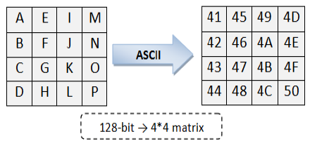

Figure 2.2: State Matrix
Source: AES Wikipedia (2017)
Following are the four steps.
- SubBytes Step: This step is the same as the AES algorithm's SubBytes step. Each byte in the matrix is reorganized using an 8-bit substitution box during the S-Box Substitution step. The Rijndael S-box is the name given to this substitution box. This operation is responsible for the cipher's non-linearity. The S-box employed is derived from the multiplicative inverse over GF (28), which is known to have good non-linear properties. The S-box is built to avoid attacks based on simple algebraic properties by combining the inverse function with an invertible affine transformation. The S-box is also chosen to avoid any fixed points (which is also a derangement), as well as any opposite fixed points. This step causes data in the matrix to become jumbled. LPT and RPT S-Box Substitution are handled separately. This is the first step in the iterative round transformation process. This round's output is passed on to the next round.
- ShiftRows Step: The ShiftRows step alters the rows of the state matrix. It cyclically shifts the bytes in each row by a fixed amount. The first row is unaltered. Each byte in the second row is shifted to the left by one position. The third and fourth rows are also shifted by two and three positions, respectively. The shifting pattern is the same for 128-bit and 192-bit blocks.
- MixColumns Step:In the MixColumns step, the four bytes of each column of the state matrix are combined using an invertible linear transformation. A 4*4 matrix is filled with a randomly generated polynomial. The same polynomial is used during decryption. Each column of the state matrix is XORed with the corresponding column of the polynomial matrix. The result is updated in the same column. The output matrix is the input to AddRoundKey.
- AddRoundKey: By performing various operations on the cipher key, a round key is generated. Each byte of the state matrix is XORed with this round key. Rijndael's key scheduling algorithm is used to generate a new round key for each round.
AES Algorithm Steps
Input: Secret files Message SM, Cipher Key K.
Output: Cipher Message CM.
- Make key expansion of K that produces two lists of all sub keys.
- Partition SM to blocks (B1, B2, B3 …. Bn) each block consists of 16 byte.
- For each Bi block do
- Convert each byte to MPK digits (two digits for each byte).
- Divide Bi to two state arrays (4*4).
- Filter two states.
- Make pre round AddRoundKey which is a simple bitwise XOR of the current two states with two sub keys
- Repeat
- Apply the four transformations (SubBytes, ShiftRows, MixColumns, and AddRoundKey) in two states.
- Until nine round.
- At final round implements SubBytes, ShiftRows, and AddRoundKey but MixColumns is deleted.
- Return the digits 9 and 8 in their place in each state.
- Mix two states to be one block.
- Convert block to characters by using MPK decoding (i.e. two digits represent character). The result represents cipher block
- End
- Concatenate the currently cipher block with the previous.
2.7 LEAST SIGNIFICANT BIT TECHNIQUES
The least significant bit (LSB) in computing is the bit position in a binary integer that determines whether the number is even or odd. Because of the positional notation convention of writing less significant digits further to the right BBBB, the LSB is sometimes referred to as the low-order bit or right-most bit. It corresponds to the digit in the ones (right-most) position of a decimal integer's least significant digit.
It is common practice to assign a position number to each bit ranging from zero to N-1, where N is the number of bits in the binary representation used. Normally, this is simply the exponent for the corresponding base-2 bit weight (as in 231... 20). Despite the fact that some CPU manufacturers assign bit numbers in the opposite order (which is not the same as different endianness), the term least significant bit remains unambiguous as an alias for the unit bit.
By extension, the least significant bits (plural) are the bits of the number closest to and including the LSB. The least significant bits have the advantage of changing quickly if the number changes even slightly. For example, if 1 (binary 00000001) is added to 3 (binary 00000011), the result is 4 (binary 00000100), and three of the least significant bits change (011 to 100). In contrast, the three most significant bits (MSBs) remain unchanged (000 to 000). Least significant bits are frequently used in pseudorandom number generators, steganographic tools, hash functions, and checksums.

Least significant bit in digital steganography
Sensitive messages can be concealed using digital steganography by manipulating and storing information in the least significant bits of an image or a sound file. If a user manipulates the last two bits of a color in a pixel in the context of an image, the value of the color will change at most +/- 3 value places, which is likely to be indistinguishable by the human eye. The user can later recover this data by extracting the least significant bits of the manipulated pixels in order to recover the original message. This allows for the concealment of digital information storage or transfer.
Least significant bit insertion
Least significant bit (LSB) insertion is a common and straightforward method for embedding information in an image file. In this method, the LSB of a byte is replaced with an M's bit. This technique is effective for image, audio, and video steganography. The resulting Image will appear identical to the cover object to the human eye.

CHAPTER THREE
METHODOLOGY AND ANALYSIS OF THE EXISTING SYSTEM
3.1 RESEARCH METHODOLOGY
Various modules are present in the framework are described below.
- Input Image
- Image Quality Selection
- AES Encryption
- 2LSB Algorithm
- Encoded and Encrypted Image
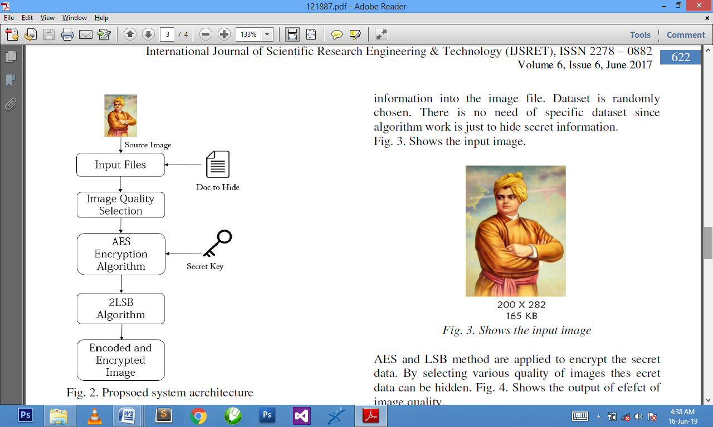

Figure 3.1:Proposed system architecture
A. Input Image: The image is chosen to conceal the secret information. The data could be stored in a text file. The length of the files is determined by the image quality.
B. Image Quality Selection: The image quality of the output image is chosen. The higher the image quality, the less data that can be concealed, and vice versa.
C. AES Encryption: AES encryption is used to encrypt the secret data. It provides a double layer of security. If the hacker decodes the text in the image file, he will not be able to decode the AES encrypted information.
D. LSB Algorithm: The LSB algorithm is used to conceal information in the image's lower bits. The LSB algorithm is efficient and capable of concealing a large amount of information.
E. Encoded and Encrypted Image: Image is now ready to be sent to a third party. Only the third party who has the secret key to open the AES algorithm can open it.
3.2 ANALYSIS OF EXISTING SYSTEM
Previously, security was as simple as locking the door or storing files in a locked filing cabinet or safe. Paper is no longer the only medium for housing information today. Files are kept in both computer databases and file cabinets. Many of our secrets are stored on hard drives and floppy disks. Security is a fairly simple concept in the physical world. The house is secure if the locks on its doors and windows are so strong that a thief cannot break in and steal your belongings. Security alarms may be installed to deter intruders from breaking through the locks.Similarly, if someone tries to withdraw money from your bank account fraudulently but the teller asks for identification and does not believe the thief's story, your money is safe. When you sign a contract with another person, the signatures serve as the legal impetus for both parties to keep their word.
3.3 PROBLEMS OF THE EXISTING SYSTEM
The problems of the existing system are as follows;
i. Lack of Privacy on personal data
ii. Inconsistency of data
iii. Lack of integrity
iv. Information been access by unauthorized user
3.4 DESCRIPTION OF THE PROPOSED SYSTEM
The proposed system is a computer-based data encryption system that operates in the Windows operating system environment. It is intended to accept text input and perform a series of transformations on the input text in order to produce encrypted text. The system is based on basic creaser substitution techniques, which involve shifting alphabets of a given plain text by a specified number of places in a specified direction, as discussed in the report's second chapter. The new system operates on a slightly different substitution principle, but the security is significantly higher than that of the traditional substitution method. The following is an analysis of the proposed system:
A variable length text of string is supplied either from keyboard or from disks file and the user selects one of five different encryption schemes. The scheme consists of all a list five different concentration of randomly generated number and characters, based on the system timer. Once a scheme is chosen, the user supplies an encryption key and calls for encryption process. Assuming the user type the plain text “Visual basic is here to stay forever” and supplies “dog” as the encryption key, system takes the first character of the plaintext which is V in this case and also take the first character of the key, which is d. it then find their ASCII codes and adds them together (86+100) to attain 186. This V is converted to the represented by ASCII code ║. Next, it takes ‘i’ in the plaintext and ‘o’ in the key and obtain (105+111) or the character ╬ then ‘s’ and ‘g’ yield (115+103) or the character ┌. ‘u’ and ‘d’ give 217 or ┘, ‘a’ and ‘o’ yield 208 or ð while ‘l’ and ‘g’ also give 208 or ð. In such, the word “Visual” can be converted to ASCII code ║╬┌┘ðð. The same process goes for other words in the sentence. The output will be embedded in the secret image to be transported over the network.
3.5 ADVANTAGE OF THE PROPOSED SYSTEM
A lot of benefits are derived from the proposed system, they include:-
- Data confidentiality: cryptography plays a critical role in ensuring data integrity. Hashing the data you receive and comparing it to the hash of the original message is a common method for protecting data integrity.
- Data integrity: Data integrity refers to the maintenance and assurance of the accuracy and consistency of data throughout its entire life cycle, and it is a critical aspect of the design, implementation, and use of any system that stores, processes, or retrieves data.
- Message authentication: Message authentication has two functions. It ensures message integrity and allows you to determine who sent the message. The sending application must set the authentication level of the message to be authenticated in order to request authentication.
- Data non-repudiation: Non-repudiation is the guarantee that someone cannot deny something. Nonrepudiation is typically defined as the ability to ensure that a party to a contract or communication cannot deny the authenticity of their signature on a document or the sending of a message that they originated.
- Preventing unauthorized access to the secret key: this refers to keeping the key for decryption out of the hands of unauthorized individuals.

CHAPTER FOUR
DESIGN AND IMPLEMENTATION OF THE SYSTEM
4.1 DESIGN OF THE SYSTEM
System designs necessitate the analyst's imagination. As a result, in order to create an acceptable design, the system analyst must eliminate all prejudice. The system design approach is the method of determining how best computers, in conjunction with other resources, can be used to perform data storage, management, and retrieval for decision making.
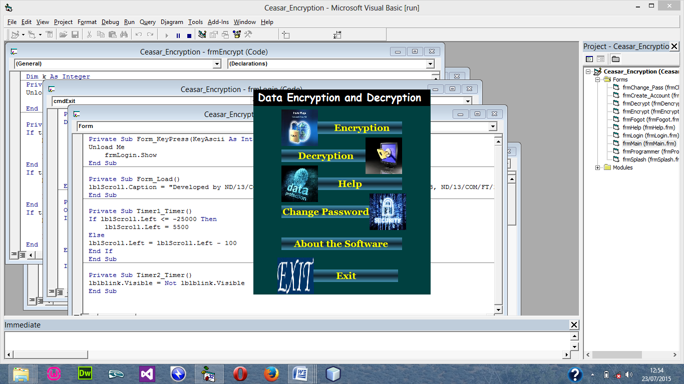
4.1.1 OUTPUT DESIGN

Figure 4.2: Main Menu
4.1.2 INPUT DESIGN
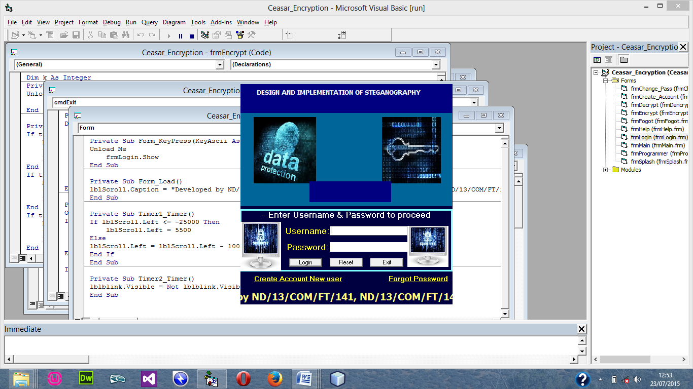
Figure 4.3: Login menu
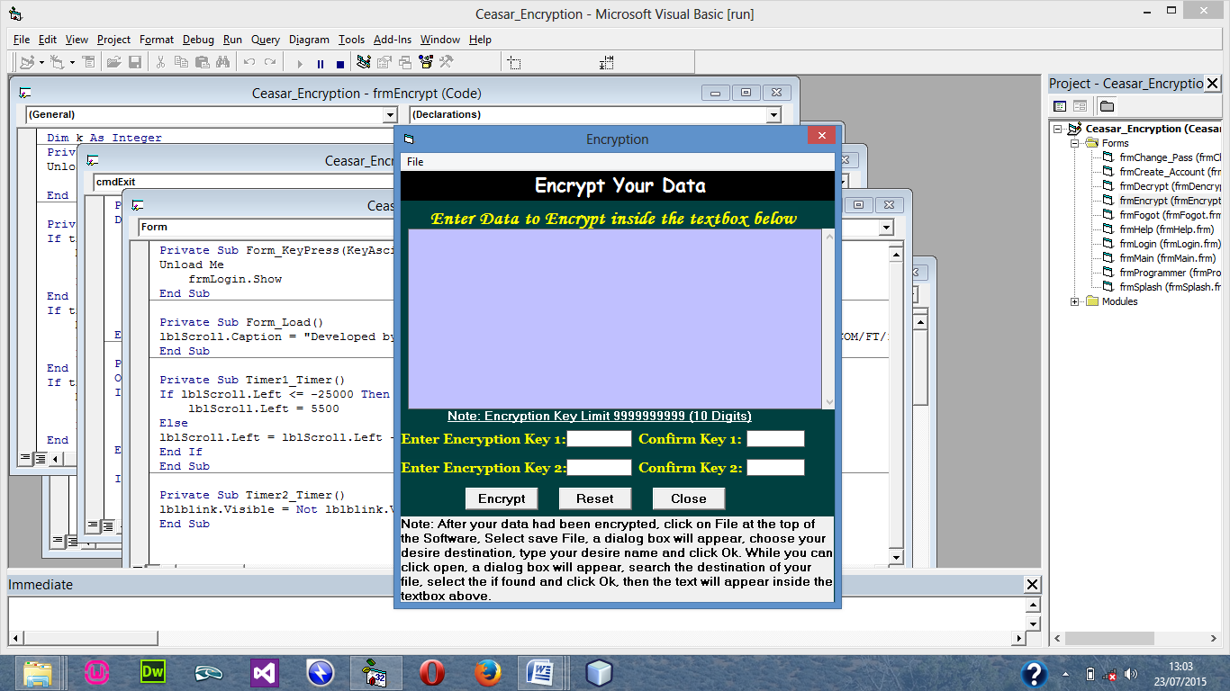
Figure: 4.4 Encryption menu
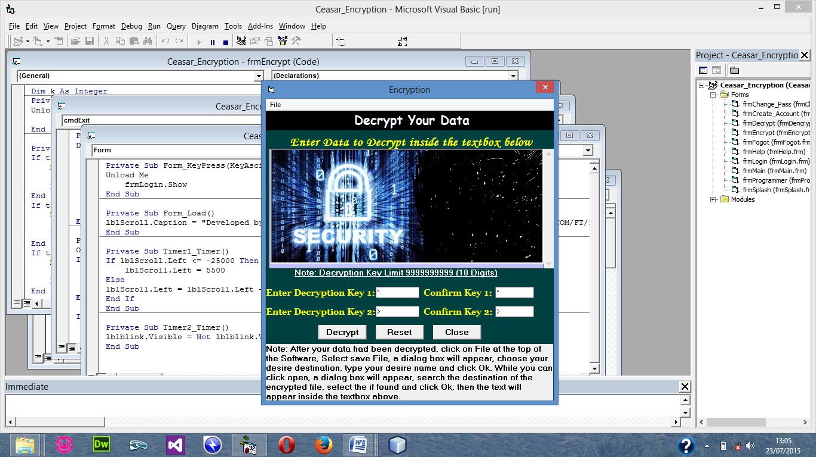
Figure 4.5: Decryption Menu
4.1.3 DATABASE DESIGN
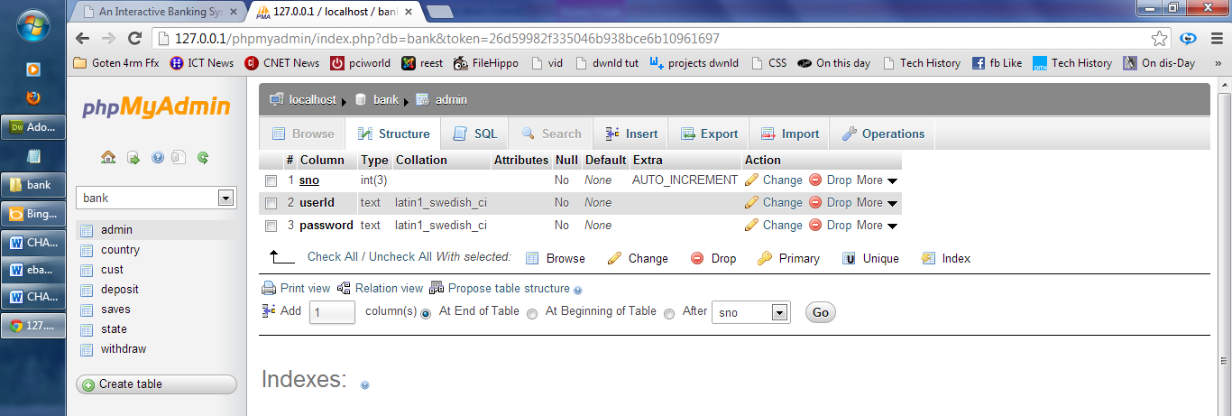
Figure 4.6: the administrator table in phpmyadmin

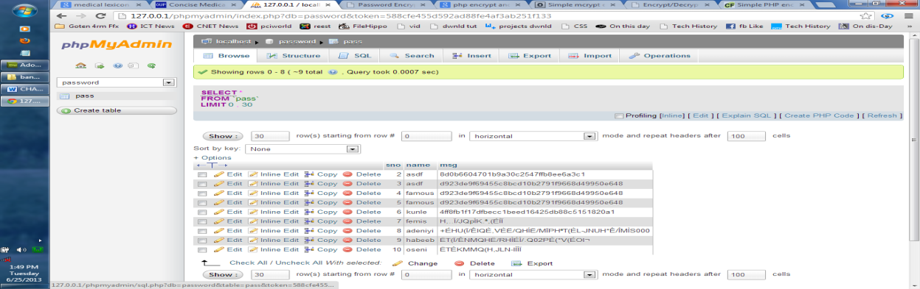
Figure 4.7: table view for all encrypted message

4.1.4 PROCEDURE DESIGN
The procedural design is a general description of the system. It describes the system's various main programs as well as the relationships that exist between all of the subprograms included. This new system's procedural designs consist of five menus, each with its own sub-menu. The application also includes several modules, each with its own distinct function. The goal of dividing the program into modules is to improve maintainability, readability, and debugging ease.
4.2 SYSTEM IMPLEMENTATION
4.2.1 CHOICE OF PROGRAMMING LANGUAGE
Because of its pedagogy and open source assistance when needed, Visual Basic 6.0 was chosen as the programming language for the implementation of the proposed system. It also supports a number of database applications, including SQL server, SQLite, MySQL, and Microsoft Access, though Microsoft Access is the default.
4.2.2 HARDWARE SUPPORT
Computer/memory processor PC with a 48dx, MHZ or Pentium, Intel or higher processor required to run the software.
- RAM: 2 GB
- 512KB cache memory
- Disk storage 128GB is the smallest size allowed.
- 256GB is a good starting point.
- 32 bits of virtual memory
- 512KB cache memory
- 1.44MB on the floppy disk drive

4.2.3 SOFTWARE SUPPORT
The software support for the proposed system's design includes
- Operating system.
- Microsoft Visual Basic 6.0.
- Microsoft Access.
- Anti-virus software, which protects the system from virus infection.
4.2.4 IMPLEMENTATION TECHNIQUES USED IN DETAILS
The parallel approach will be used to build the system. This approach is taken into account because it ensures that the new system is tested alongside the old system to ensure the system's effectiveness and efficiency.
4.3 SYSTEM DOCUMENTATION
4.3.1 PROGRAM DOCUMENTATION
To make the best use of the system, it must be used exactly as instructed by the hardware and software supports.
4.3.2 OPERATING THE SYSTEM
- Click start on the computer desktop
- Select all programs
- Select any browser e.g internet Explorer, Mozilla Firefox, Google Chrome e.t.c
- Type the url (Uniform Resource Locator) of the system into the address bar (localhost/password/)
4.3.3 MAINTAINING THE SYSTEM
The following instructions must be strictly followed in order to make effective use of the system. Install an anti-virus program and keep it up to date.

CHAPTER FIVE
SUMMARY, CONCLUSION AND RECOMMENDATIONS
5.1 SUMMARY
Encryption applications allow people all over the world to use a security technique known as encryption to send messages over the internet by creating an id or code name, and only authorized personnel will be able to view the message's content. The code name can be a phrase or clause that is communicated to others via various means of communication. For example, in 2009, a code name was communicated by using the headline on the front page of a national newspaper; to the general public, it was just a headline, but to authorize personnel, it was a decryption key to access sensitive information.
5.2 CONCLUSION
Many different steganography techniques exist and will continue to be developed. However, hackers have developed sophisticated methods for detecting hidden messages. Keeping this in mind, efficient steganography techniques like the one presented in this project work will be extremely useful. When passed over a computer network, the software is designed in such a way that the secret key will only point out parts of a cover source, leaving the message undetected because it contains no information about the secret message at all. Steganography may also face legal restrictions, as governments have claimed that criminals and terrorists use these techniques to communicate. However, restrictions on the use of steganography as a means of protecting vital information, such as the one presented in this project, are highly unlikely, particularly in this era of rampant identity fraud and other related e-commerce attacks.
5.3 RECOMMENDATIONS
This project centered on creating an application capable of hiding private information within an image in such a way that no one other than the intended recipient is aware of the message's existence. I believe that this research should be expanded because it has the potential to encourage banks, industries, public and private enterprises, and individuals to secure their vital information while transferring it over a computer network.

REFERENCE
Abrams, M. and Podell, H. (2001).Cryptography potentials.IEEE, 20(1),36 – 38.
Akanksha, S. and Ajeet, B. (2016). Design of secure file transfer over internet.International Journal of Advanced Research in Computer and Communication Engineering (IJARCCE)ISO 3297:2007 Certified,5(11).
Blakley,G.R (1999). Twenty years of cryptography in the open literature, security and privacy 1999, Proceedings of the EEE Symposium.
Bruce, S. (1996). Applied cryptography 2nd edition. John Wiley & Sons.
Eijk, N.V. (2011). File sharing. Manuscript completed in March 2011/rev May 2011. © European Parliament, Brussels, 2011. This document is available on the Internet at: http://www.europarl.europa.eu/studies.
Eskiciogiu, A. and Litwin L. (1999). Cryptography and network security.LOS Alamitos, CA: IEEE computer society press, 19.
Imai H., Hanaoka G., Shikata J., Otsuka A. and Nascimento A.C. (2002). Cryptography with information theoretic security, Information Theory Workshop, Proceedings of the IEEE, 20 – 25.
Menezes,J., van, P.C. and VanstoneS.A. (2000). Handbook of applied cryptography.National Institute of Standards and Technology, Advanced Encryption Standard, FIPS-197, http:// csrc.nist.gov/archive/aes/index.html. General References for Cryptography.
Navnish, S., Amitabh, L., and Babloo, E. (2011). Information Security: Encryption and Decryption with PolyalphabeticSubstitution Method. International Journal of Computer Science and Communication 2(1).
Prakash, G. L., Manish P. and Inder S. (2014). Data Encryption and Decryption Algorithms using Key Rotations for Data Security in Cloud System. International Journal Of Engineering And Computer Science ISSN:2319-7242,3(4), 5215-5223.
Saleh, M.E., Abdelmgeid, A.A. & Omara,F.A. (2016). Data security using cryptography and steganography techniques. International Journal of Advanced Computer Science and Applications(IJACSA), 7(6).

PROGRAM FLOWCHART

Stop
Start
Splash Screen
Login
Main Menu
Encryption
Decryption
Help
Change Password
About the Software
Exit

SPLASH SCREEN FLOWCHART
Start
Display Splash
Return
Open Database

Close Database

LOGIN FLOWCHART
No
Yes
Start
Enter Username and Password
Is any field empty?
Is Username and Password Correct?
Main Menu
Return
Invalid Username and Password
All field are required to proceed
Open Database

Close Database

No
Yes

Yes
No

MAIN MENU FLOWCHART
Return
Yes
Yes
No
No
No
No
Yes
Yes
Yes
Start
Select option
Is it option Encryption?
Encryption
Decryption
Help
Change Password
Is it option Decryption?
Is it option Help?
Is it option Change Password?
Open Database

End Select
No
Close Database

About the Software
Is it option About the Software?

ENCRYPTION FLOWCHART
Select File Name
Start
Open Database
Enter Username and Password
Display Original Message
Enter Encryption Key
Display Encrypted Message
Return
Close Database
Save Encrypted Message

DECRYPTION FLOWCHART
Select File Name
Start
Open Database
Enter Username and Password
Display Encrypted Message
Enter Description Key
Display Original Message
Return
Close Database
Save Original Message

HELP FLOWCHART
Start
Display Help
Return
Open Database

Close Database

CHANGE PASSWORD FLOWCHART
Start
Display Change Password
Open Database

Return
Close Database

Enter New Password
Re-enter New Password
Save New Password

ABOUT THE SOFTWARE FLOWCHART
Start
Display About the Software
Return
Open Database

Close Database

EXIT FLOWCHART
No
Yes
Start
Do you want to Logout?
Return
Click on Logout
Welcome Page
Main Menu
Open Database

Close Database

SOURCE CODE
Private Sub cmdFind_Click( )
On Error GoTo Mina
If txtCriminal_No.Text = Empty Then
MsgBox "Please Enter Criminal Number To Proceed", vbCritical, "Criminal Number"
Exit Sub
End If
txtCriminal_No.Text = UCase(txtCriminal_No.Text)
Call Crime
str = "select * from NewEntry where Crime_No='" & txtCriminal_No.Text & "'"
rec.Open str, con, adOpenDynamic, adLockOptimistic
With rec
txtname.Text = !Real_Name
txtalias.Text = !Alias
txtSex.Text = !Sex
txtage.Text = !Age
txtheight.Text = !Height
txtweight.Text = !Weight
txtplace_of_birth.Text = !Place_Of_Birth
cmbday.Text = Mid(!Date_Of_Birth, 1, 2)
cmbmonth.Text = Mid(!Date_Of_Birth, 4, 3)
txtyear.Text = Right(!Date_Of_Birth, 4)
Remand_date.Object = !Remand_date
txtaddress.Text = !Address
txtmothers_name.Text = !Mother_Name
txtwifes_name.Text = !Wife_Name
txtfathers_name.Text = !Father_Name
Txtkins_name.Text = !Kins_Name
txtkins_address.Text = !Kins_Address
txtbank.Text = !Bank
txtvehicle_no.Text = !Vehicle_No
txtphone.Text = !Phone_No
txtCriminal_No.Locked = True
mnuEdit.Visible = True
End With
Exit Sub
Mina:
MsgBox "The Particular Record You are looking For does Not Exist", vbCritical, "Incorrect Criminal no"
End Sub

Private Sub mnuclear_Click()
For Each Control In Me
If TypeOf Control Is TextBox Or TypeOf Control Is ComboBox Then
Control.Text = Empty
End If
Next
txtCriminal_No.Locked = False
cmbday.Text = "Day"
cmbmonth.Text = "Month"
txtyear.Text = "Year"
End Sub

Private Sub mnuEdit_Click()
For Each Control In Me
If TypeOf Control Is TextBox Or TypeOf Control Is ComboBox Then
Control.Locked = False
End If
Next
txtCriminal_No.Locked = True
End Sub

Private Sub mnuExit_Click()
If Sam = "Skado" Then
frmmainmenu.cmdAdd_New.Enabled = False
frmmainmenu.cmdEdit_Record.Enabled = False
frmmainmenu.cmdrelease.Enabled = False
Else
frmmainmenu.cmdReport.Enabled = False
frmmainmenu.cmdSecurity.Enabled = False
End If
Unload Me
frmmainmenu.Show
End Sub

Private Sub mnuUpdate_Click()
Dim g As Integer
g = 1
For Each Control In Me
If TypeOf Control Is TextBox Or TypeOf Control Is ComboBox Then
If Control.Text = Empty Then
g = 0
MsgBox "Please Fill all the Neccesary field", vbCritical, "Empty Field"
Exit Sub
End If
End If
Next
If g = 1 Then
Call Crime
str = "select * from NewEntry where Crime_No='" & txtCriminal_No.Text & "'"
rec.Open str, con, adOpenDynamic, adLockOptimistic
With rec
!Real_Name = txtname.Text
!Alias = txtalias.Text
!Sex = txtSex.Text
!Age = txtage.Text
!Height = txtheight.Text
!Weight = txtweight.Text
!Place_Of_Birth = txtplace_of_birth.Text
!Date_Of_Birth = cmbday.Text & "-" & cmbmonth.Text & "-" & txtyear.Text
!Remand_date = Remand_date.Object
!Address = txtaddress.Text
!Mother_Name = txtmothers_name.Text
!Wife_Name = txtwifes_name.Text
!Father_Name = txtfathers_name.Text
!Kins_Name = Txtkins_name.Text
!Kins_Address = txtkins_address.Text
!Bank = txtbank.Text
!Vehicle_No = txtvehicle_no.Text
!Phone_No = txtphone.Text
.Update
MsgBox "++++ Record Updated Successfully ++++", vbInformation, "Saving Record"
mnuclear_Click
Call Locky
txtCriminal_No.Locked = False

