Design of One-Time Password for Two Factors Authentication System

BY:

WAHAB BABATUNDE SANUSI
HND/23/COM/FT/0135

SUBMITTED TO THE
DEPARTMENT OF COMPUTER SCIENCE, INSTITUTE OF INFORMATION AND COMMUNICATION TECHNOLOGY KWARA STATE POLYTECHNIC, ILORIN.
IN PARTIAL FULFILLMENT OF THE REQUIREMENT FOR THE AWARD OF HIGHER NATIONAL DILOPMA (HND) IN COMPUTER SCIENCE.

MAY, 2025

CERTIFICATION
This is to certify that this project work was carried out by WAHAB BABATUNDE SANUSI with matriculation number HND/23/COM/FT/0135 in the department of Computer Science, institute of Information and Communication Technology, Kwara State Polytechnic Ilorin, Kwara State.

________________________ ______________________
MR SADIQ K. A. DATE
SUPERVISOR

________________________ ______________________
MR OYEDEPO F. S. DATE
(HEAD OF DEPARTMENT)

________________________ ______________________
EXTERNAL EXAMINER DATE

DEDICATION
This project is dedicated to God for his infinitive mercy on me and for making me see the end of this program, Higher National Diploma (HND) and for his divine wisdom, knowledge and understanding throughout the academic sessions.

ACKNOWLEDGEMENT
All praise goes to the almighty Allah for giving me strength, inspiration, guidance and knowledge to complete this Higher National Diploma (HND) programme, without him nothing would have been possible.
My sincere appreciation goes my lovely parent WAHAB for their immeasurable support and to my supervisor in person of Mr. Sadiq Kolawole who has been a great help through moral support and guidance to me throughout this project work, may God bless him, Ameen.
A big thank you is also said to all my lectures in the department of computer science for their effort on impacting knowledge on me and I also thank the non-teaching staff for helping me in one way or the other.

Abstract
One-Time Passwords are often preferred as stronger forms of verification such as Public-Key Infrastructure (PKI) or bio-metrics because an air-gap gadget does not require the installation of any user desktop software on the client machine, therefore allowing them to roam across various devices including home personal computers, kiosks, and personal digital assistants This study therefore propose combination of Time-Based and Hash based algorithms for one-time password on internet banking which will be difficult to decrypt, not even the sender which could be implemented by software developer to create interoperable verification gadgets and software agents. The combination of two algorithms are event-based that will be embedded to internet banking system and could be hybridized with proposed name called “Crypto-time algorithms”.

TABLE OF CONTENT
Title page
Certification
Dedication
Acknowledgement
Abstract
Table of content
List of table
List of figure
CHAPTER ONE: GENERAL INTRODUCTION
  - Background of the Study
  - Statement of the Problem
  - Aim and Objectives
  - Significance of the Study
  - Scope of the Study
  - Definition of Terms
CHAPTER TWO: LITERATURE REVIEW
2.1 Review of General Text
2.2 Internet Banking
2.3 Time Based Algorithm
2.4 One-Time Password
2.5 One-Time Password History and Applications
2.6 Historical Background
CHAPTER THREE: RESEARCH METHODOLOGY AND ANALYSIS OF
EXISTING SYSTEM
3.1 Research Methodology
3.2 Analysis of the Existing System
3.3 Problem of the Existing System
3.4 Analysis of the Proposed System
3.5 Advantage of the Proposed System
CHAPTER FOUR: DESIGN AND IMPLEMENTATION OF THE DESIGN
4.1 Design of the System
4.1.1 Output Design
4.1.2 Input Design
4.1.3 Database Design
4.1.4 Procedure Design
4.2 Implementation of the System
4.2.1 Choice of Programming Language
4.2.2 Hardware Support
4.2.3 Software Support
4.2.4 Implementation Techniques used in Details
4.3 System Documentation
4.3.1 Proposed Documentation
4.3.2 Operating the System
4.3.3 Maintaining the System
CHAPTER FIVE: SUMMARY, CONCLUSION AND RECOMMENDATION
5.1 Summary
5.2 Conclusion
5.3 Recommendation
Reference

CHAPTER ONE
GENERAL INTRODUCTION
  - INTRODUCTION
Today, deployment of two-factor authentication remains extremely restricted in scope and scale. Despite progressively larger amount of threats and attacks, most Web applications still depend on feeble verification schemes for policing end-user access. Lack of interoperability among hardware and software technology vendors has been a restricting factor in the adoption of two-factor verification technology. Specifically, the absence of open specifications has led to solutions where hardware and software components are hard coupled through proprietary technology, bringing about high-cost solutions, poor adoption, and limited innovation (Blum, 2015)
In the last decade, the rapid rise of network threats had revealed the inadequacies of constant passwords as the primary mean of verification on the Web (Seo 2005). At the same time, the recent approach that obliges an end user to convey a costly, single-function gadget (tokens) that is only used to verify to the network is clearly not the best answer and moreover newly approach is by making use of message one-time password algorithm which even more secure. One-time password algorithms which will be the most secure confirmation can be used with the ability to embed this same technology while ensuring broad interoperability obliges that it will be made freely readily available to the broad technical community of software developers. Only open-framework approaches will guarantee that, the basic two-factor authentication primitives can be incorporated into upcoming generation of consumer gadgets Floyd, R. (2008)
One-Time Password is certainly one of the easiest and most famous forms of two-factor authentication for securing network access which is most preferable than a constant password used to login to a network. For instance, in a big organization, Virtual Private Network access often oblige the utilization of One-Time Password tokens for remote user verification and in some aspects, message verification is used for one-time password.
One-Time Passwords are often preferred as stronger forms of verification such as Public-Key Infrastructure (PKI) or biometrics because an air-gap gadget does not require the installation of any user desktop software on the client machine, therefore allowing them to roam across various devices including home personal computers, kiosks, and personal digital assistants Tarjan, R. (2011)
This study therefore propose combination of Time-Based and Hash based algorithms for one-time password on internet banking which will be difficult to decrypt, not even the sender which could be implemented by software developer to create interoperable verification gadgets and software agents. The combination of two algorithms are event-based that will be embedded to internet banking system and could be hybridized with proposed name called “Crypto-time algorithms”.

1.2 STATEMENT OF THE PROBLEM
In the financial institutions, there are lot of frauds and other external hazards that happen to customers account because hackers are working hard to break peoples account, so financial institution are as well trying their possible best to cob hackers’ trick by giving customers tips on how to secure their account from phishers. One Time Password opens the possibility of an adversary who intend to break the cipher text, so far it does not expire until the user used it for authentication, so it give room for attacker to take their time how to break it, more so times base open the possibility of an adversary who intend to track the timestamp value generating the server, so far it appear in an understanding numerical format but expires after 10 seconds, so attacker will easily trace the timestamp before it expire
  - AIM AND OBJECTIVES
The aim is to implement one time password for two factor authentication system. The objectives are as follow:
- To produce a numeric or alphanumeric code to authenticate access to the system or transaction.
- To implement OTP security tokens software.
- Study one time password for two factor authentication system on internet banking.

1.4 SIGNIFICANCE OF THE STUDY
The benefit of this study is that it enhance the security measures it enhanced customer confidence on any transaction process that want to take place on transaction then it show them the information about the transaction before it is been processed, it also make it easier for customer to detect when intruder tends to hack their account. The researcher intends to protect customer’s bank account from vulnerabilities and hijacks by protecting each transaction and programs from cross site scripting and sequel injection by designing a new algorithms.
1.5 SCOPE OF THE STUDY
This scope concerns with designing one-time password on internet banking. It is limited to three (3) main part of internet banking which is money transfer, receive money and balance enquiry; the research work is not designed to handle other aspects of internet banking but rather provides a new system of making online banking more secure.
1.6 DEFINITION OF TECHNICAL TERMS
Distance Enquiry: This is a ways in which someone can query financial institution
Hardware: This is the physical component of a computer system which can be seen and touch
One Time Password: A one-time password, also known as one-time pin or dynamic password, is a password that is valid for only one login session or transaction, on a computer system or other digital device.
Internet Banking: This refer to an electronic payment system that enables customers of a financial institution to conduct financial transaction on a website operated by the institution such as a retail banks, credits union or building society which allow individual to perform banking activities at home or office, via the internet.
Money transfer: This is generally refers to one of the following cashless modes of payment or payment system. Electronic funds transfer, an umbrella terms, mostly used for bank card-based payment. Wire transfer an international expedited bank- to- bank funds transfer Giro also known as direct deposit.
Public key: This is a security access code for authentication that take place in cryptography system, used for securing information
Receive Money: This refers to one of the following cashless modes of receiving money electronically.
Software: This is basically (sets of instruction given to computer to performs a special in a Special in a specific way) which can be seen but cannot be touch.

1.7 ORGANISATION OF REPORT
This report is divided to five chapters as stated below. Chapter one deals with the general introduction and overview of the whole research. It also discusses the statement of the problem, aim and objectives of the proposed system, significance of the study, scope and limitations of the project as well as organization of the report.
Chapter two deals with the literature review, it reviews the related topics to the project, discussion of related aspect of the project topic relative to computer technology is also treated.
Chapter three deals with analysis of the system which include the data collection method employed, the description of the existing system and its problems and the description of the proposed system and possible advantages it will provide the will solve problems encountered in the existing manual system.
While chapter four deals with the design, implementation and the description of the proposed system. It also covers description of the output design, input design, database design and procedure design. The implementation techniques used, the programming language used in developing the new system and system requirements for running the system. And it talks about the program documentation as well user documentation.
Finally, chapter five presents a brief summary of the work done, experience gained and problems encountered in the course of the project, conclusion and recommendation.

\

CHAPTER TWO
LITERATURE REVIEW
2.1 REVIEW OF GENERAL TEXT
In this section, a detailed discussion of related work on one-time password (OTP) internet banking, Time based algorithms, Hash based algorithms are presented.
2.1.1 INTERNET BANKING
Online banking (OLB) is an electronic payment system that enables customers of a financial institution to conduct financial transactions on a website operated by the institution, such as a retail bank, virtual bank, credit union or building society (Volksbanken, 2016).
Online banking is also referred to as Internet banking, e-banking, virtual banking and by other terms. To access a financial institution's online banking facility, a customer with Internet access would need to register with the institution for the service, and set up some password (under various names) for customer verification. The password for online banking is normally not the same as for telephone banking. Financial institutions now routinely allocate customers numbers (also under various names), whether or not customers have indicated an intention to access their online banking facility. Customers' numbers are normally not the same as account numbers, because a number of customer accounts can be linked to the one customer number. The customer can link to the customer number any account which the customer controls, which may be cheque, savings, loan, credit card and other accounts. Customer numbers will also not be the same as any debit or credit card issued by the financial institution to the customer (Sparkasse, 2016).
To access online banking, a customer would go to the financial institution's secured website, and enter the online banking facility using the customer number and password previously setup. Some financial institutions have set up additional security steps for access to online banking, but there is no consistency to the approach adopted
(http://www.revolvy.com/main/index.php?s=Online%20banking).

2.1.2 TIME BASED ALGORITHMS
A time-based one-time password (TOTP) is a temporary code generated by an algorithms, for use in authentication access to computer system.
The algorithms that generates each password uses the current time of day as one of its factors ensuring that each password is unique. Time based one-time passwords are commonly used for –factors authentication and have seen growing adoption by cloud application providers. In factors authentication scenario, a user must enter a traditional static password and a TOTP to gain (Colin 2014).
There are various methods available for the user to receive a time based one-time password including.
- Hardware n security tokens which display the password on a small screen;
- Mobile apps such as Google authentication
- Text message sent from a centralized server.
Time- based one-time passwords provide additional security because even if a user’s traditional password is stolen or compromised an attacker cannot gain access without the TOTP, which change every 30 or 60 seconds. TOTP is an approved standard of the internet engineering task force (IETF).
The variant of the hash based one-time (HOTP) algorithms specific the calculator of a one one-time password value based on a representation of the counter as a time factors.
TOTP Algorithms notations
- X represents the time step in second (Default value X=30 seconds) and is a system parameter.
- To (T nut)is a UNIX time to start counting time steps(default values value is 0, that is the UNIX epoch) and is also a system parameter.
TOTP algorithms Description
Basically we define TOTP as TOTP =HMAC- Based one-time password algorithms denoted as HOTP(K,T) where T is an integrand represent the number of time steps between the initials counter time T0 and the current UNIX times
More specifically, T = (Current Unix time –To)/X where the default floor function is used in the computation. For example, with To=0 and Time Step X=30, T=1 if the current UNIX time is 59 seconds and T=2 if the current UNIX time is 60 seconds.
The implementation of this algorithms support a time value T larger than a 32-bit integer when it is beyond the year 2038, The value of the system parameter X and To are pre- established during the provisioning process and communicated between a prover. And verifier as part of the provisioning container specification (Colin 2016).

    - ONE–TIME PASSWORD
A one-time password (OTP) in banking system is a password that is valid for only one login session or transaction, on a computer system or other digital device.
OTPs avoid a number of shortcomings that are associated with traditional (static) password based authentication. A number of implementations also incorporate two factor authentications by ensuring that the one-time password requires access to something a person knows (Barkan et al., 2017).
It is a unique and time-sensitive password used as added security on internet banking. The password does not replace the constant password one use to log on to internet banking but provides a second layer of security. The password will be sent to you by email or SMS and is valid for one internet banking session only. The most important advantage that is addressed by OTPs is that, in contrast to static passwords, they are not vulnerable to replay attacks. This means that a potential intruder who manages to record an OTP that was already used to log into a service or to conduct a transaction will not be able to abuse it, since it will be no longer valid. A second major advantage is that a user, who uses the same (or similar) password for multiple systems, is not made vulnerable on all of them, if the password for one of these is gained by an attacker. A number of OTP systems also aim to ensure that a session cannot easily be intercepted or impersonated without knowledge of unpredictable data created during the previous session, thus reducing the attack surface further (Gueneysu et al., 2017).
OTPs have been discussed as a possible replacement for, as well as enhancer to traditional passwords (Nohl and Cris, 2009). On the downside, OTPs are difficult for human beings to memorize. Therefore they require additional technology to work (Nohl and Cris, 2009).
OTP generation algorithms typically make use ofpseudo random making prediction of successor OTPs by an attacker to be difficult and also hash function which can be used to derive a value but are hard to reverse and are therefore difficult for an attacker to obtain. This is necessary because otherwise it would be easy to predict future OTPs by observing previous ones (Banko, 2012). Concrete OTP algorithms vary greatly in their details. Various approaches for the generation of OTPs are listed below:
- Time-synchronization between the authentication server and the client providing the password (OTPs are valid only for a short period of time)
- Using a mathematical algorithm to generate a new password based on the previous password (OTPs are effectively a chain and must be used in a predefined order).
- Using a mathematical algorithm where the new password is based on a challenge (e.g., a random number chosen by the authentication server or transaction details) and/or a counter.
Bits of information = (For example a random number chosen by the authentication.
There are also different ways to make the user aware of the next OTP to use. Some systems use special electronic security tokens that the user carries and that generate OTPs and show them using a small display. Other systems consist of software that runs on the user's mobile phone. Yet other systems generate OTPs on the server-side and send them to the user using an out-of-band channel such as SMS messaging. Finally, in some systems, OTPs are printed on paper that the user is required to carry (Ericka, 2010).

2.1.4 HISTORY OF OTP
One time password systems provide a mechanism for logging on a network or service using unique password which can only be used as the name suggests in order to prevent some forms of identity theft by making sure that captured user name/password pair cannot be used a second time. Typically the users’ logon name stays the same and one time password are a form of so called strong authentication, providing much better protection to on-line bank account corporate network and other system containing sensitive data (Dimitriadi, 2014).
Today most enterprise networks e-commerce sites and online communities require only a user name and static password for logon and access to personal and sensitive data. Although this authentication method is convenient, it is not secure because online identify theft- using phishing, keyboard logging, man–in–the middle attacks and other method is increased throughout the world (Casalo, 2014).
Strong authentication system address the limitation of static passwords by incorporate an additional security credential. For example a temporary one time password (OTP), to protect network access and end users digital identities. This add an extra level of protection and makes it extremely difficult to access unauthorized information, network or online account (Casalo, 2014) One time passwords can be generated in several ways and each one has trade-offs in term of security, convenience, cost and accuracy. Simple methods such as transaction numbers lists and grid cards can provide as set of one-time passwords. These methods offer low investment costs but are slow, difficult to maintain, easy to replicate and share, and register the user to keep track of where they are in the list of passwords (Dimitriadi 2014)
A more convenient way for users is to use an OTP token which is a hardware device capable of generating one-time passwords, so most of these devices are PIN-protected that offered an additional level of security in which user enters the one-time password with other identity credentials (typically user name and password)and an authentication server validate the logon request. Although this is a proven solution for enterprise application, the deployment cost can make the solution expensive for consumer application. Because the token must be using the same method as the sever, a separate token is required for each sever login, so user need a separate token for each Web site or network they use (Langley, 2015).
More advanced hardware tokens use microprocessor-based smart cards to calculate one-time passwords. Smart cards have several advantages for strong authentication including data storage capacity, processing power, portability, and ease of use. They are more secure than other OTP tokens because they generate a unique, non-reusable password for each authentication event, store personal data, and they do not transmit personal or private data over the network(http:/www.gemalto.com/)
Smart cards can also include additional strong authentication capabilities such as PKI or public key infrastructure certificates. When used for PKI applications, the smarts card device can proved core PKI services, including encryption, digital signature and private key generation and storage. Gemalto smart cards support OTP strong authentication in both java and microsoft.NET environments .Multiple form factors and connectivity options are available so that end-user have the most appropriate device for their individual network access requirements. All Gemalto OTP device work with the same strong Authentication Server and are supported with a common set of administrative tools (http://www.gemalto.com/).

2.1.5 OTP AND ITS APPLICATION
"One-time password" describes a six-digit number shown on a screen using either a key-ring security token of a smartphone application know as software Token. one time password are only effective for a fixed period of time and become invalid once the user logs in, making them exceptionally useful against spyware such as key logging programs. By using a One-Time password in combination with Square Enix ID and password, administrative will be able to further secure to individual account.

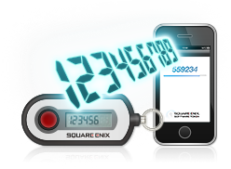
Figure 1.Diagram of a security token connected to a mobile phone
source: (http//www.square-enix.com/na/account/otp/retrieved 23/05/2012)
Security Token
A security Token device for displaying one-time passwords. Pressing the button will show a One-Time Password on the device's LCD screen using such as device will dramatically improve account security.
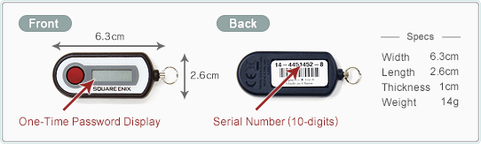
Figure 2.Sample diagram of a security token include the from and back
Source:(http:/www.square-enix.com/na/account/otp/retrieved 23/05/2012)

Software Token
The Software Token is a smartphone application designed to display One-Time Passwords. After registering for the services, a One-Time Password will be shown on screen every time the application is launched. Using this application will dramatically improve account security. The application will dramatically improve account security. The application itself is free to use http:/www.securenvoy.com/two factor/authentication/soft-token-explained.shtm). McAfree One Time Password: McAfree One Password enables you to rapidly deploy two factor authentication (OTP and password authentication),including soft tokens, so that remote and mobile employees can securely access critical information while maintaining compliance. The password security offering includes strong two-factor authentication and streamlined deployment and management, reducing operational effort and costs associated with traditional and legacy one time password solutions.

2.1.6 APPLICATION OF TIME BASED ONE TIME ALGORITHM
Time-based One-time password Algorithm(TOTP)is an algorithm that computes a one-time password from a shared secret key and the current time. It has been adopted as internet Engineering Task Force standard RFC 6238,is the cornerstone of initiative for Open Authentication (OATH)and is used in a number of two factor authentication system.The time typically increase in 30 second interval, so password generated close together in time from the same secret key will be equal. In a typical two-factor authentication application, user authentication proceeds as follows: a user will enter a username and password into a website or other server, generated a one-time password for the server using TOTP running locally on a smartphone or other device, and type that password into the sever as well. The sever will then also run TOTP to verify the entered one-time password.
For this to work, the clocks of the user's device and the sever need to be roughly synchronized (the sever will typically accept one-time password generated from time lamps that differ by +1 from the client timestamp).A single secret key, to be used for all subsequent authentication sessions, must have been shared between the sever and that user's devices over a secure channels ahead of time. If some more steps are carried out, the users can also authenticate the sever using TOTP (steven,2014).
Here are resources and application of TOTP which are as follow;
- initiative for Open Authentication(OATH) is the umbrella organization that published the HOTP/TOTP/PSKC technology
- The OATH Specifications page for list of published documents.
- Google Authenticator is an implementation for several mobile platforms
- Daniels Pocock maintains Dynalogin which is an open source two factor authentication suite.
- HMAC-Based One-Time Password Algorithm (HOTP)
- Time-Based One-Time Password Algorithm(TOTP)
- Portable Symmetric Key Container (PSKC)
During last BeGeistert, Jonathan Schaefer suggested to use OTP as secondary authentication method on baron, especially TOTP algorithm such that people logging in via secure socket shell (SSH)would have to produce the appropriate one-time-password, too. While this kind of two-factor-authentication seems too much hassleon thing like git.haiku-os.org,(that is the hypervisor machine is a piece of computer software, firmware or hardware that create and runs virtual machine) due to time interval of expiration secure socket shell is a UNIX-based command interface and protocol for securely getting access to a remote computer .It is widely used by network administration to control web and other kind of servers remotely.

CHAPTER THREE
METHODOLOGY AND ANALYSIS OF THE SYSTEM
3.1 RESEARCH METHODOLOGY
One time password will be generating random alphanumeric from the current timestamp of the transaction which when two or more transaction are perform on a network at the same time but different location or even the same location, the one time password will be different, because it will generate the same timestamp but different one time password.
The most important advantage that is addressed by our program is that, in contrast to static passwords, they are not vulnerable to replay attacks. This means that a potential intruder who manages to record an OTP that was already used to log into a service or to conduct a transaction will not be able to abuse it, since it will no longer be valid.

  - ANALYSIS OF THE EXISTING SYSTEM
The existing system of securing internet transaction users are done in a manual way where the users will have to keep their ATM pin to themselves without revealing it to anyone for security. This system is not that secure because hackers make use of some phishing method to get users details to debit their account without asking them face to face of their details.

  - PROBLEMS OF EXISTING SYSTEM
Modern hackers are sophisticated, but much of the technology to ward them off is not. One-time passwords (OTPs) over short message service (SMS) were introduced as a more convenient method of authenticating users, but it didn’t take hackers long to crack them. They are no longer considered secure because they’ve been heavily attacked in recent years.
One-time passwords sent over SMS (text messages) were designed to prevent replay attacks and add an additional layer of log on security. A unique password or code is sent to the user via text, and that code must be entered along with a traditional username and password combination to allow access to a site or authorize a transaction. That sounds secure in theory, but OTP over SMS is vulnerable.
3.4 DESCRIPTION OF THE PROPOSED SYSTEM
In order to secure the system. The generated OTP must be hard to guess retrieve or trace by hackers/phishers. Therefore, it is important to develop a new source algorithm with combination of two OTP algorithms, several factor can be used by the hybridized OTP algorithm to generate a difficult to guess password. Users seem to be willing to use simple factors such as their mobile number and PIN of timestamp with account number for services such as authorizing mobile micro payment, so a secure cryptographic algorithm is proposed. In order for the system to be secure the unique OTP should be difficult to predict by hackers, The Following elements will be used to general at the OTP.
4. Current Timestamp: This refers to the current date and time which can never be reversible in life and it valid for a short period of time.
5. Two digit number: This will be form the account number which will be dynamically picked.
6. Internet Banking Pin: It is the PIN given during internet banking registration and is a static password that is used to verify the logon of the internet banking.
How the combination of the OTP is been generated
The internet banking PIN, any two digit from account number of user is taking from the user and then concatenated with the current date and time (timestamp) for which the one time password is valid. This concatenated string is then given as input to secured hash algorithm (CRYPT) algorithm, CRYPT algorithm is a one way algorithm that
Return the message digest which is 34 byte value. These 34 byte are reduced to 7 converting the result to character string such as the following
Timestamp: 23-05-2015 8:38AM
Two digit number (from account no:) 45
Internet Banking PIN: 1234
Concatenated to the String:23-05-2015 8:38AM 45 1234 then following by
CRYPT (23-05-2015 8:38AM 45 1234) then
Result: $1$TU5.gR2.$pdZOID4fP92UZ67GAKxi71, Grouping into $1$TU.5. gR2, $pdZOID, P92UZ, 67GAK then it remain xi71 so the ASCII code of each character is as following
$+1+$+T+U=(int)36+49+36+84+85=290/4=>72
5+g+R+2=(int)63+46+103+82+50=334/4=>83
.+$+p+d+Z=(int)46+36+112+100+90=384/4=>96
O+I+D+4=(int)79+73+68+52+102=374/4=>93
P+9+2+U+Z=(int)80+57+50+85+90=362/4=>90
6+7+G+A+K=(int)54+55+71+65+75=320/4=>80
Then remaining x+i+7+1=120 +105 +55+49=329/4=>82
Finally by converting the ASCII values:72 83 96 93 90 80 82 to a character string:
HS'JZPR, then it is displayed as a one-time password to the user's mobile device
Step 1. Get current timestamp, two digit from the account no pin
Step 2 initialize svalue=timestamp +two digit +PIN
Step 3. Result =CRYPT (svalue)
Step 4 intiallize k=1, i=1
Step 5 Dowhile(k<=34)
Step 6 Ovalue =asc(Result k, 5)/4
Step 7, k=k+1
Step 8 i=i+1
Step 9.Enddo
Step 10.OTPValue=char(Ovalue)
Step 11. Stop

3.5 ADVANTAGES OF PROPOSED SYSTEM

i. Is safe from replay attacks: The biggest advantage offered by OTPs in contrast to standalone passwords is that they’re safe from replay attacks. In plain language, an adversary who uses trickery to capture your OTP can’t reapply it, since it’s no longer valid for future logins or sessions.

ii. Allows you to keep your emails safe: OTPs are generally received on mobile devices via SMS. This means you don’t need to have access to your email. Hence, you can avoid logging into your email account on public computers or while you’re connected to an unsecured Wi-Fi hotspot.

iii. Is convenient to use: Most individuals own a mobile phone, and SMS functionality exists on every device. SMS’s ubiquity means that one-time passwords are convenient to use. This is also beneficial for businesses that deliver the OTPs, as end users are already familiar with their phones and don’t need another device to receive the code. As a result, OTPs allow companies to not only enhance the user experience but also reduce their operational costs

CHAPTER FOUR

DESIGN AND IMPLEMENTATION OF THE SYSTEM

4.1 DESIGN OF THE SYSTEM
This is the process of designing the input, output and the processing steps to meet the user’s requirement identified in the system analysis. It starts with logical design, which produces a specification of major features of the system. These include the data, input, output, processing storage and other control requirements.
4.1.1 OUTPUT DESIGN
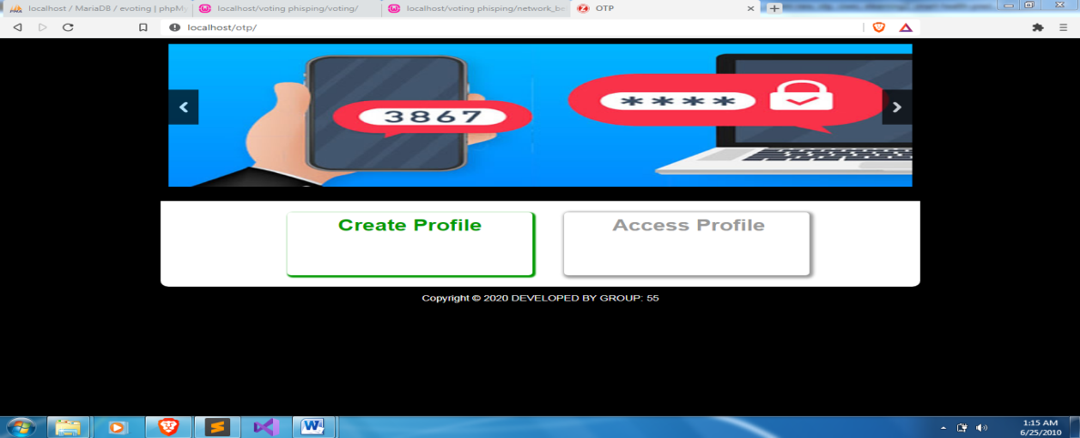
Figure 4.1: Homepage: A home page is generally the main web page a visitor navigating to a website from a search engine will see, and it may also serve as a landing page to attract visitors.
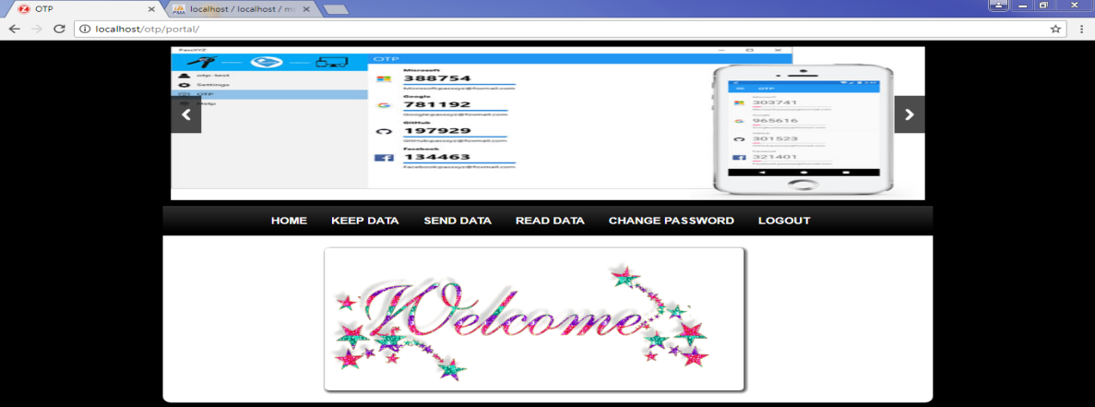
Figure 4.2: Welcome page: A welcome page is usually one or more web pages or modal overlays that appear the first time you open an app. The best welcome pages direct a user's focus to the welcome message, while also orienting them to the product.
4.1.2 INPUT DESIGN
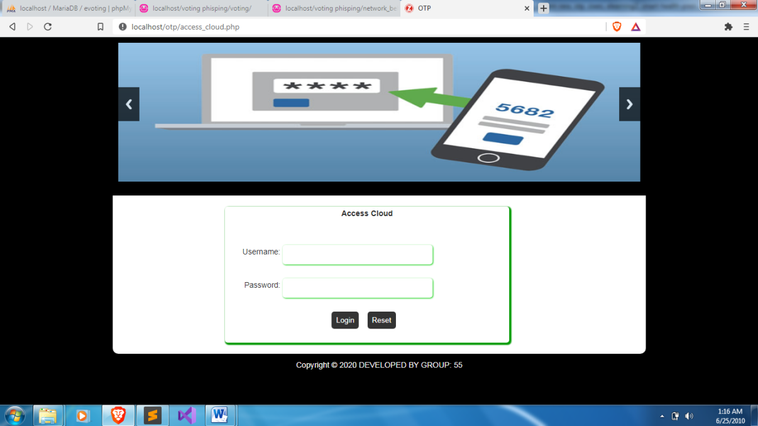
Figure 4.3: Admin Login: This is the admin login page, If you have the administrator credentials (e.g., your email address and a password), you can log into your website's administrator panel by entering them in the proper location.
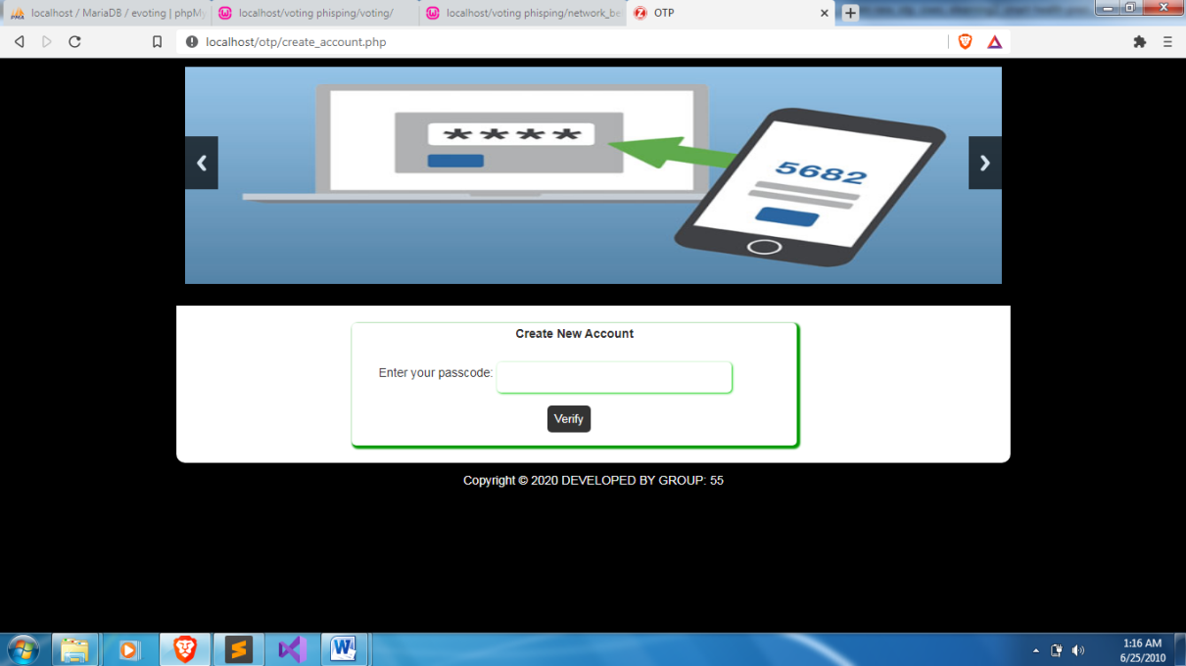
Figure 4.4: New account page: A registration form is a list of fields that a user will input data into and submit to a company or individual. There are many reasons why you would want a person to fill out a registration form. Companies use registration forms to sign up customers for subscriptions, services, or other programs or plans.
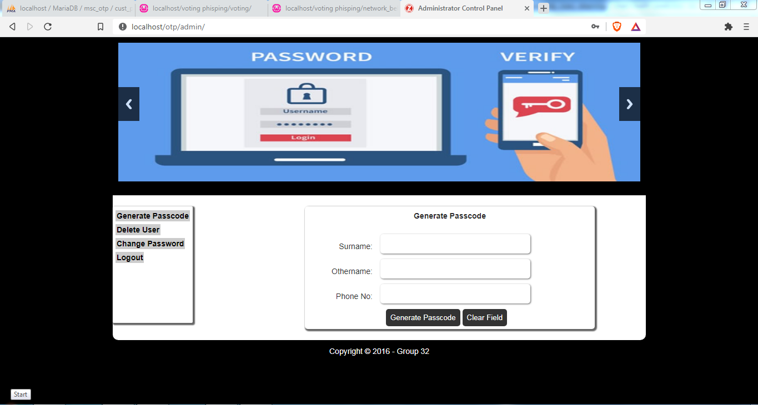
Figure 4.5: Generate passcode: This is where admin can generate passcode for the user.
4.1.3 DATABASE DESIGN
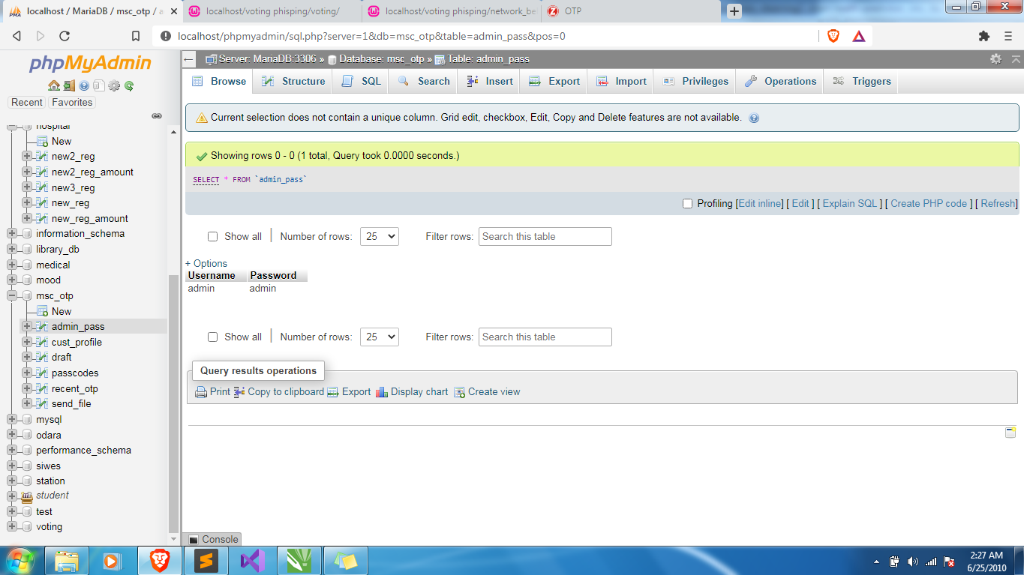
Figure 4.6: Admin Table: The table module that handle all the admin credentials.

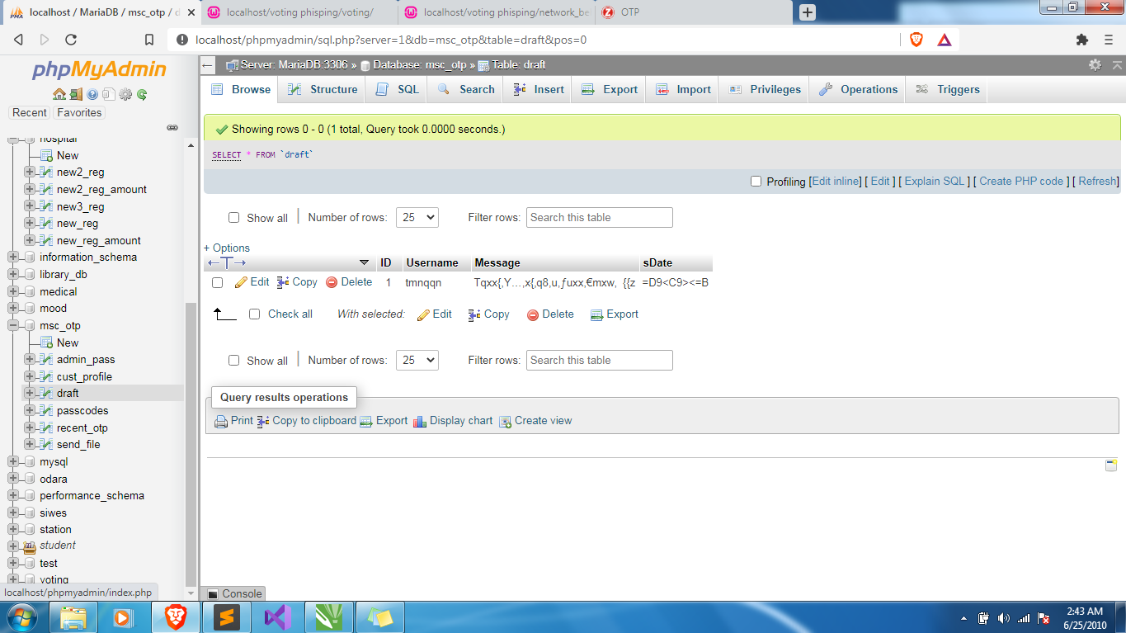
Figure 4.7: draft Table: This table store all the draft sent by the admin.
4.1.4 PROCEDURE DESIGN
This refers to the ways in which the proposed system will be used and the steps are as follows:
- Click start on the computer desktop
- Select all programs
- Select any browser e.g Morzilla Firefox , internet Explorer , Google Chrome e.t.c
- Type the url (Uniform Resource Locator) of the system into the address bar (http://localhost/otp/login.php)

4.2 SYSTEM IMPLEMENTATION
The design system depends on the capabilities and power of the computer on which the application system is installed. However, selecting a choice of application support (Hardware and Software) depends much on:
- How readily the user is to interfere with the computer
- Cost and benefits
- Managements support for changes
Hence, choosing the appropriate hardware and software will enhance the performance of the system.
A most important requirement on which the running of the program basically depends on is the provision of internet facility. So any system that must run this program must be internet ready.
4.2.1 CHOICE OF PROGRAMMING LANGUAGE
The programming language used in the proposed system is php. PHP meaning (PHP Hypertext Preprocessor) is a server-side programming language. It is an open source server-side scripting language that has taken web-based development to a new level of sophistication. The PHP scripting engine is well optimized for the response times needed on web applications, it can even be part of the web server itself improving the throughput even more.
If it were only a matter of improving the speed of the scripts, then PHP will be one of many solutions. But there is more to the PHP equation than that. There is the simplicity and robustness of the language and the scripting engine. There is the connectivity to an ever increasing number of database servers, the shorter development cycles and the ease (encouraged by the syntaxes and constructs) of creating modular and reusable components.
4.2.2 HARDWARE SUPPORT
The hardware that is required in the successful completion of this project includes monitor, CPU, keyboard, mouse, printer and an uninterrupted power supply (UPS) and an internet access.
- An appropriate hard disk storage of at least 120 GB (for the dynamically expandable database)
- A minimum of 1.0 GHz processor
- Random access memory (RAM) of at least 1 GB
- An effective display unit (VGA monitor)
- A suitable printer
- Standard input devices such as keyboard, mouse, etc.
- CD-ROM drive or DVD-ROM drive (since the installation would be made through this medium)
- An uninterrupted power supply (UPS) unit (to prevent abrupt interruption due to power failure)
- A network modem (for internet connection).

4.2.3 SOFTWARE SUPPORT
The software required are basically any web browser (internet explorer, Firefox and the likes), WampServer and a network service, be it wired or wireless.
- A network operating system windows NT from Microsoft, Novell Netware.
- A DBM either PhpMyAdmin
- MySQL as the query language to query the database.
- Wampserver
4.2.4 IMPLEMENTATION TECHNIQUES
The system will be implemented using the parallel approach. This approach is considered because it ensures that the new system is tested along side with the old system to ensure the effectiveness and efficiency of the system.

4.3 SYSTEM DOCUMENTATION
It has to do with the installation and usage of the new system.
After the program has been well tested with input that the output has already been known, the next is to install the software in to the computer system for use.
The process of installing are been stated below
- Insert the CD into the system through the CD-ROM after the computer is switch on
- Locate the CD drive directory in my computer and click it to open
- After open, locate setup.exe, and then click to install the program by following the necessary step in installing the program.
- Ensure full installing of the software for effective operation of the system.
After the program has been fully install. The next thing is to locate the package install to put it into operation, to locate the package for expiration purpose the following step are to be taking
v. Click on start menu from task bar. Then select all program
From the display sub option, select by locating the software installed named http://localhost/otp/ personality check to load the software.

4.3.1 PROGRAM DOCUMENTATION
- HOMEPAGE
- OTP VERIFY PAGE
- PASSCODE VERIFY PAGE
- REGISTER USER
- LOGOUT
4.3.2 OPERATING THE SYSTEM
- Click on the start button
- Click on control panel
- Click add/remove program
After the configuration, the folder called OTP will be created in the local disk.
4.3.3 MAINTAINING OF THE SYSTEM
- Keeping the system free from virus so as not to corrupt the program installed on the system.
- Having an updated anti-virus.

CHAPTER FIVE
CONCLUSION AND RECOMMENDATION
5.1 SUMMARY
The design and implementation of a two-factor authentication login system using OTP with SMS. The quest for the application of tighter security measures to web, desktop and mobile applications developed has been a major concern to a lot of people. Faced with the challenges of poor security and vulnerability of users, resulting to applications being hacked by unauthorized people, the researcher delved into developing a more secured login application that sends a secret passcode to the registered phone number of a user for identification purpose. In addition, hackers have the preference of using numerous techniques / attacks such as guessing attack, shoulder surfing attack, dictionary attack, brute force attack, snooping attack, social engineering attack etc. to steal passwords so as to gain access to their login accounts. Quite a few techniques, strategies for using passwords have been proposed but some of which are especially not easy to use and practice. To solve the password problem in banking sectors and also for online transaction two factor authentications using OTP and ATM pin / cards have been implemented.

5.2 CONCLUSION
Studies show that the use of two-factor authentication can enhance the data protection. The proposed approach eliminates the existing drawback of using two-factor authentication based on SMS messages, as the proposed method uses two types of two - factor authentication: application-authenticator and login verification using OTP based on client-server application work. The software implementation of the proposed method shows that the algorithm works correctly and corresponds to the above beliefs.
5.2 RECOMMENDATION
We recommend that this web based application should be adopted by an individual so has to become a highly demanded application utility due to the advantages of high computing function, high performance, and accessibility. It more reliable and user friendly.One time password using two-factor authentication environment is a kind of web based computing application that provides shared processing resources and data to computers and other devices on demand. It is a model for enabling ubiquitous, on demand access to a shared pool of configurable computing resources (e.g., networks, servers, storage, applications and services),which can be rapidly provisioned and released with minimal management effort.

REFERENCE
Antonio R. (2020). "Who Coined 'Cloud Computing'?". Technology Review (MIT).
Baburajan, R., (2020). "The Rising Cloud Storage Market Opportunity Strengthens endors".It.tmcnet.com.
Danielson, K. (2016). "Distinguishing Cloud Computing from Utility Computing". Ebizq.net. Retrieved 2020-08-22.
Farber, D.(2020). "The new geek chic: Data centers".CNET News.
Gruman, G. (2019). "What cloud computing really means". InfoWorld.
Haghighat, S., (2020). “CloudID: Trustworthy Cloud-based and Cross-Enterprise Biometric Identification”. Expert Systems with Applications,
Hassan, Q. (2020)."Software reuse in the emerging cloud computing era". In Yang, H; Liu, X. Understanding Cloud Computing. Hershey, PA: Information Science Reference.
Hassan,Q (2020). "Demystifying Cloud Computing".The Journal of Defense Software Engineering (CrossTalk) (Jan/Feb):
Heather Smith (2020). XeroFor Dummies. John Wiley & Sons.pp. 37 ISBN 978- 1-118-57252-8.
King, Rachael (2020). "Cloud Computing: Small Companies Take Flight". Bloomberg BusinessWeek.
Mohammad, F. (2020). Cloud Computing Uncovered: A Research Landscape. Elsevier Press. pp. 41–85. ISBN 0-12-396535-7.
Oestreich, K., (2020). "Converged Infrastructure". CTO Forum.Thectoforum.com.
Peter M. and Timothy G.; (2020).The NIST Definition of Cloud Computing (Technical report). National Institute of Standards and Technology.

FLOWCHART
Login/Upload
Start
Display login failed

Return
Enter user login
Are details correct?
Y
N
Upload

System Flowchart
Start
Home Page
Create Account
Access Cloud
Stop
Create Account
Start
Display all fields are required
Return
Enter user information
Is any field empty?
Y
N
Save to Database

Access the Cloud
Start
Enter Username and Password
Display invalid username or password
Is username & password valid?
N
Y
Generate OTP Code
Display invalid OTP code entered
Enter OTP Code
Is OTP Code Valid?
N
Y
Display Cloud Contents
Return

