DESIGN OF A WEB-BASED MEETING SCHEDULING SYSTEM

BY:

IWUOLAGBE SMART OHIOZOJE
HND/23/COM/FT/0043

SUBMITTED TO THE
DEPARTMENT OF COMPUTER SCIENCE, INSTITUTE OF INFORMATION AND COMMUNICATION TECHNOLOGY KWARA STATE POLYTECHNIC, ILORIN.
IN PARTIAL FULFILLMENT OF THE REQUIREMENT FOR THE AWARD OF HIGHER NATIONAL DIPLOMA (HND) IN COMPUTER SCIENCE

MAY 2025.
CERTIFICATION
This is to certify that this project work was carried out by IWUOLAGBE SMART OHIOZOJE with matriculation number ND/23/COM/FT/0043 in the Department of Computer Science, Institute of Information and Communication Technology, Kwara State Polytechnic Ilorin, Kwara State.

________________________ ______________________
MR SADIQ K. ABUBAKAR DATE
SUPERVISOR

________________________ ______________________
MR OYEDEPO, F.S DATE
(HEAD OF DEPARTMENT)

________________________ ______________________
EXTERNAL EXAMINER DATE

DEDICATION
This project is dedicated to God for his infinitive mercy on me and for making me see the end of this program, Higher National Diploma (HND) and for his divine wisdom, knowledge and understanding throughout the academic sessions.

ACKNOWLEDGEMENT
All praise goes to the almighty Allah for giving me strength, inspiration, guidance and knowledge to complete this National Diploma (ND) programme, without him nothing would have been possible.
My sincere appreciation goes my lovely parent Mr. and Mrs IWUOLAGBE for their immeasurable support and to my supervisor in person of Mr. Sadiq Kolawole who has been a great help through moral support and guidance to me throughout this project work, may Allah bless him, Amin.
A big thank you is also said to all my lectures in the department of computer science for their effort on impacting knowledge on me and I also thank the non-teaching staff for helping me in one way or the other.

TABLE OF CONTENTS
TITLE PAGE i
CERTIFICATION PAGE ii
DEDICATION iii
ACKNOWLEDGMENT iv
TABLE OF CONTENTS v
ABSTRACT vi
CHAPTER ONE: GENERAL INTRODUCTION
  - BACKGROUND TO THE STUDY
  - STATEMENT OF THE PROBLEM
  - AIM AND OBJECTIVES
  - SIGNIFICANCE OF THE STUDY
  - SCOPE OF THE STUDY
  - DEFINITION OF TERM
  - ORGANIZATION OF REPORT
CHAPTER TWO: LITERATURE REVIEW
2.1 REVIEW OF PAST WORK
2.2 REVIEW OF GENERAL TEXT
2.3 HISTORICAL BACKGROUND
CHAPTER THREE: METHODOLOGY AND ANALYSIS OF THE SYSTEM
3.1 RESEARCH METHODOLOGY
3.2 ANALYSIS OF DATA AND THE EXISTING SYSTEM
3.3 PROBLEM OF THE EXISTING SYSTEM
3.4 DESCRIPTION OF THE PROPOSED SYSTEM
3.5 ADVANTAGES OF THE PROPOSED SYSTEM
CHAPTER FOUR: DESIGN AND IMPLEMENTATION OF THE SYSTEM
4.1 DESIGN OF THE SYSTEM
4.1.1 OUTPUT DESIGN
4.1.2 INPUT DESIGN
4.1.3 DATABASE DESIGN
4.1.4 PROCEDURE DESIGN
4.2 SYSTEM IMPLEMENTATION
4.2.1 CHOISE OF PROGRAMING LANGUAGE
4.2.2 HARDWARE SUPPORT
4.2.3 SOFTWARE SUPPORT
4.2.4 IMPLEMENTATION TECHNIQUES
4.3 SYSTEM DOCUMENTATION
4.3.1 PROGRAM DOCUMENTATION
4.3.2 OPERATING THE SYSTEM
4.3.3 MAINTAINING OF THE SYSTEM
CHAPTER FIVE: CONCLUSIONS AND RECOMMENDATIONS
5.1 SUMMARY
5.2 CONCLUSION
5.3 RECOMMENDATION
REFERENCE
REFERENCES
Abstract
Available statistics proves that most meetings scheduled without prior agreement among the involved members of an organization suffer low turnouts. Moreover, highly ranked members and members with certain responsibilities in the organization are known to have tighter schedules and should hence be given some considerations while scheduling meetings. This research introduce a web-based system that provides a platform where meeting proposals and agenda are published by the executive for timely and easy visualization by members of the organization at remote locations. Besides, the system provides a mechanism that will enable the members to vote their favourable days and times for each meeting. The votes captured by the system are automatically assigned numerical values and are aggregated to realize the day and time that will yield the best turnouts. Furthermore, each member is assigned a weight based on his/her academic rank and appointment(s) in the organization. The designation weights of these members affect their vote scores. A working prototype of the system was achieved using a MySQL Database Management System (DBMS) for the data storage, PHP programming language for the system logic and control of information flow, HyperText Markup Language (HTML) and Cascaded Style Sheets (CSS) for the Graphic User Interface (GUI) design.

CHAPTER ONE
INTRODUCTION
1.1 BACKGROUND OF THE STUDY
The continuous advancement in the information and communication technology as contributed a lot to the universe, making life easier for individual, organization, and institution. Every field now see the importance of ICT as the world goes global and tend towards ubiquitous computing. The rate of time consuming task and tedious activities has reduced as a result of this advancement because many tasks can now be automated with the help of technologyby improving the manual way of processing, storing, accessing, communication and providing information. The role of information is inevitable in our daily lives, information is extremely important to the successful functioning of any organisation. The constant and steady stream of communication and information helps to build credibility and reflect a sense of transparency in our daily interaction. Various people assemble together for the purpose of communicating with one another towards achieving the organization's goal.
The workspace in our daily activities requires proper interaction as Meeting is considered as one of the frequent task in an organization. Meeting have the distinctive ability to bring people physically together, and to motivate and make them communicate in ways that cannot be easily copied by other means. Although meetings are important part of organization but the subject however, is poorly developed and there is need for proper enlightenment. (Malhotra,2002).
A meeting covers extensive functionality and many different contexts. It concept includes social gathering, sport, meeting, entertainment, festival etc and it has become a fashion to use the word Meeting for something that involve people and time in a particular place. It is seen as a functionality “primitive” meaning something that happens attached to a time frame. Meetings could be anything from an item in a personal schedule, such as informal gathering, a formal gathering. Meeting is a word that is generally used for an occurrence at a given place, a special circumstances, which can only occur ones. One key characteristic of a Meeting is that they are time limited, it is not a continuous process, each Meeting has a start and finish time and it is very difficult to replicate a Meeting no matter how one tries (Getz, 2007). Further study of this subject shows that beyond the ability to create a Meeting (time and scope), some functionality are also required such as registration of Meeting, email notification of Meeting updates, multiple Meeting administrators (with different level of authentication).
Though scheduling a Meeting within similar or different group is a very tedious work because it is very difficult to find suitable time between multiple individuals. Different techniques, tools, technology have been developed in time past to solve problems relating to how to properly manage an Meeting. The need for scheduling was birth with the question of how to manage time and execute plans in our daily life.
The context of Meeting flows includes multiple states and participation from different people such as Meeting registration, pending registration, cancelled Meeting, approved registration, attendees, and Meeting managers. The manual process of managing a Meeting is time consuming as man is prone to error.As the world goes through internet revolution, the demand for system that ease human from their daily work is increasing and there are lots of internet applications that provide support for organisations so as to help them achieve their goals. One of these applications is a web based application for proper Meeting management.

1.2 STATEMENT OF THE PROBLEM
Meeting involves bringing people together within a time frame in a particular place. The major problem is how information about the meeting is been communicated and how to secure a proper venue for each meeting. The manual way of conveying messages bring about certain restrictions such as non-availability of the proposed receiver, omission of vital details from the dispatcher, etc. Another problem is people forgetting about the meeting date or time, because there is no proper documentation about the meeting. Sometimes the purpose of the meeting is not well sent out, so lack of preparation for such meeting occurs.
1.3 AIM AND OBJECTIVES
The aim of this project is to design a web based meetings scheduling system in an organization. To achieve this, we shall be guided by the following specific objectives.
- Extensively carry out an analysis on how meetings is been managed in an organization.
- Improve on the existing method by automating the manual ways of scheduling a meeting.
- Develop and implement meeting scheduling system in an organization.

1.4 SIGNIFICANCE OF THE STUDY
In an organization, proper coordination of venues for a meeting and those that are to participate in such meeting is of high importance towards preventing clashes of venues and also uninvited personnel to a particular meeting. In this modern age where computing is becoming ubiquitous, organizations are being encouraged to have an information system that will assist them in the management of meetings.
The Meeting Scheduling System developed in this research work will be beneficial to the staff of a particular institution (Kwara State Polytechnic)The institution will benefit immensely from implementing this system as it will make the assigning of meeting venues and sending of notifications to attendees a seamless effort.The employee of the organization will also be able to get notification when a new meeting is created in which they are to be part of, also the System will send a reminder in form of SMS and Email to the attendee in some days or hours as it is being setup by the organization.Finally, the organization can generate frequent reports on meeting venues, date, time and those that are to attend a scheduled meeting

1.5 SCOPE OF STUDY
This project, will handle issues related to scheduling and management of meeting within the organization. It will be confined to creation of meetings by the administrator, online venue reservation and sending of information as regards to the meeting to employee, with detail meeting description such as time, duration, agenda and venue that will be needed for meeting via their email and mobile phone. This system will also send a remainder before the meeting, to enhance full awareness and preparation.

1.6 ORGANIZATION OF THE REPORT
This project work is divided into five chapters and below are the description of what each chapter contains.
Chapter One describes the background of the project, statement of the problem, project aim and objective, significance of the project, report outlines, definition of term.
Chapter Two talks about the review of the past work related to work, review of general test, comparison of system development process models, comparison of application manage used, comparison of relationship database management system, summary
Chapter Three deals with the research methodology, analyzing of the existing system, flowchart of the existing system, problem of the existing system, description of the proposed system, flowchart of the proposed system, advantages of proposed system, summary.
Chapter Four includes design of the system, output system, input system, database design, procedure design, implementation of the system, choice of programming language, hardware support, change over techniques, student documentation, documentation of the program, operating system, maintaining the system and summary.
Chapter Five deals with the conclusion, recommendation and reference
1.7 DEFINITION OF TECHNICAL TERMS
INFORMATION: Knowledge communicated or received concerning a particular fact or circumstance; news
EVENT: An occurrence, especially one that is particularly significant, interesting, exciting or unusual
SCHEDULING: Planning work that needed to be done, showing the order in which tasks are to be carried out and the amounts of time allocated to them.
ORGANIZATION: A group of people identified by a shared purpose or interest.
MANAGEMENT: The act of controlling or handling something successfully.
SYSTEM: An assembly of computer hardware and software peripheral working together.
MEETING: A meeting is when two or more people come together to discuss one or more topics, often in a formal or business setting, but meetings also occur in a variety of other environments.

CHAPTER TWO
LITERATURE REVIEW
2.1 REVIEW OF RELATED WORK
Oloruntoba (2017), worked on “Design and Implementation of a Patient Appointment and Scheduling System” the system was designed using Angular JS for the frontend, Ajax framework for handling client-server request and Sqlite3 and MYSQL for the backend which says Globally, health care sector is the pivot and integral part of human lives. Thus,any error committed in the clinical services might leads to defect or termination of life. Recently, information and Communication has been used extensively to improve the various operations and services in the field of the health care service. Patient appointment with the Doctor is one of the clinical services that have been automated. Healthcare providers are motivated to reduce operation cost while improving the quality of service. This has given rise to preventive medicine in order to avoid disease, lessening the demand for emergency department and hospital stays for sick people. The importance of Patient Scheduling cannot be underestimated in the health care delivery landscape. Patient scheduling is a complex process that perform a crucial role in health care. Patient scheduling performs several functions, from allocating resources to patients in need of exams and allocation of surgery rooms to on-demand appointment scheduling with Family Doctors working at Primary Care clinics. A good appointment scheduling system encourages patient and physician satisfaction, and as such, is an important component of healthcare. The efficiency of health care delivery hinged solely on the effectiveness of the Patient scheduling system. it reduces medical error among practitioner and also reduce the number of unsatisfied patient. Appointment systems have been extensively used to reduce patient waiting times and waiting-room congestion. Such systems have the potential to increase access to medical resources while reducing cost, as well as staff and patient dissatisfaction derived from unmet schedule constraints. The main aim of optimal patient scheduling is to determine an appointment technique for which a particular measure of performance is optimized under uncertain conditions.
Sachin (2018) proposed a system on “A study and implementation of event Management system using Smartphone” the system was developed using developed using android studio and the back end was managed using mySql database says Android have become popular among Smartphone users. This paper discuss about the intend to solve the problems of propagating news and information, and also alleviate the problem of traditional event managing procedures such as lots of paperwork, or long queue at the registration desk. The objective of this project is to develop an android application which will provide interesting news and events so that users will be able to manage their event smoothly. The objective of this project is to develop an android application which will provide interesting news and events so that users will be able to manage their event smoothly. Event organizers are continually appreciating the benefits of an online event management system such as an Event management application. Organizing an event is not an easy task, especially if the target audience is of a substantial size and if there are many teams involved during the execution phase. For this reason, automating the processes found in the event planning life cycle is a godsend to organizers who are still using old school methods. An online management system practically automates the organizing process and leaves lesser room for human error. This app is design which could effectively manage the event in an organization. This application contains the database which has the details of the participants, their name, and the events they are willing to participate, their registration ID, and event details like day, venue, time, etc. Instead of using paperwork, participant can simply use this mobile application to register. Events Management System is very helpful for events. This application being as a platform to know the events, to apply for the events. Event organizer is an application under project management for managing festivals or social events like gathering, colleges, events, conferences etc.Lastly, this application can be access everywhere, anytime as everybody have their own Smartphone.
Sharadha(2018) worked on “Event Management information system” in which the system was developed using php and my sql to manage the database says…. The Event Management Information system is a system which will be used to implement in the institutes, where it becomes easy for the users to view, register, and vote for events conducted during the fest. This web application helps the users to register, vote for events from anywhere. The users should be first approved by the admin only then they can login to their accounts. It provides a regular flow of information for managerial decision-making and control. This project deals with registering to the events online, where students as well as the staff can view the events list and register. It tracks all the events one user has registered displays those events only in that users account in a sub module called booked events. The users complete profile as in their student id (which the college has provided), phone number can be viewed. The fields such as email id and phone number can be edited. The design and implementation of EMIS system is to replace the current paper records. The admin has the rights to block and unblock the users. The system utilizes user authentication, displaying only information necessary for an individual.

2.2 REVIEW OF GENERAL TEXT
2.2.1 SCHEDULING
Scheduling can be described as the process of assigning jobs to resources for some duration. Scheduling problems are ubiquitous, ranging from computer systems and networks, to production factories and patient appointments. Many of such problems are either solved by manual operation or using heuristics specifically designed to the context.
According to Akinode,J.K (2017),Patient appointment scheduling can be classified into three:
Single Batch Process : In this Appointment scheduling process, decisions are delayed until after receiving all appointment requests for a given period. This model is commonly used in surgery starting times, and allows scheduling with complete information, so that a perfect or near perfect solution can be found through discrete optimization or heuristic methods.
Unit Process Appointments: In this appointment scheduling model, the processes are assumed to come one at a time and are scheduled at the time of the request arrival. Through this process, a perfect solution will unlikely be found, but may be approximated if the distribution of appointment request types is learned.This allows a better approximation to the optimal solution by considering optimal or near optimal solutions at each period.
Online Appointment Scheduling system
Online appointment scheduling system is a system through which a user or guest or simply, patients can access the website of the doctor, and through the online software, patients can easily make their appointments. In addition to that, patients can also provide additional information to the doctor, making the doctor aware of their situation and giving the doctor time to prepare the necessary information for when the patient’s arrives. An online scheduling system allows individuals to conveniently and securely book their appointments online. Compared to the usual queuing method, the web-based appointment system could significantly increase patient's satisfaction with registration and reduce total waiting time effectively.
Waiting Time
Waiting time refers to a period of time which a patient must wait in order for a specific action to take place, after that action is triggered or requested. it is defined as “the length of time from when the patient entered the outpatient clinic to the time the patient actually received his or her prescription. It is also described as the total time expended by a patient from registration until consultation with a doctor.

2.2.2 CPU SCHEDULING
CPU scheduling is a process which allows one process to use the CPU while the execution of another process is on hold(in waiting state) due to unavailability of any resource like I/O etc, thereby making full use of CPU. The aim of CPU scheduling is to make the system efficient, fast and fair. Whenever the CPU becomes idle, the operating system must select one of the processes in the ready queue to be executed. The selection process is carried out by the short-term scheduler (or CPU scheduler). The scheduler selects from among the processes in memory that are ready to execute, and allocates the CPU to one of them.
CPU SCHEDULING: DISPATCHER
Another component involved in the CPU scheduling function is the Dispatcher. The dispatcher is the module that gives control of the CPU to the process selected by the short-term scheduler. This function involves:
- Switching context
- Switching to user mode
- Jumping to the proper location in the user program to restart that program from where it left last time.
The dispatcher should be as fast as possible, given that it is invoked during every process switch. The time taken by the dispatcher to stop one process and start another process is known as the Dispatch Latency.

2.2.3 DISTRIBUTED MEETING SCHEDULING
When a user requests a meeting to be scheduled with other users, the associated meeting scheduling agent is designated as the host agent for that meeting; the agents corresponding to the other users attending the meeting are called invitee agents. A meeting is specified by a number of parameters:
- set of attendees,
- proposed length of the meeting,
- priority assigned to the meeting,
- a set of possible starting times on the calendar for the meeting (e.g., sometime next week, Friday afternoon, etc.),
- a scheduling deadline,
- any additional constraints
Space does not permit an enumeration of the constraints our system can handle. Some of the typical constraints that can be handled include scheduling a meeting before/after another meeting, scheduling a meeting only if another meeting is scheduled, scheduling with a subset of attendees or for a shorter length if a meeting time satisfying all the given parameters cannot be found, scheduling repeating events, etc. Our scheduling agents use contract-based negotiation to and mutually acceptable time slots for meetings. While the contracting framework does not capture some of the sophistication that people might employ in exceptional circumstances, it balances the need to have a flexible routine to handle a range of situations, while still keeping the routine understandable enough to be embraced by a user. We will use an example to illustrate the workings of our proposed scheduler. Let us consider a simple meeting scheduling scenario in which user A wants to meet with users B and C for an hour sometime in the next week. When user A instructs its meeting scheduling agent (in the following we name the agents after their user) to schedule this meeting, agent A will search the local calendar to and some hour-long free slots next week that does not Connect ict with user A's preferences (for example, no meeting before 9 or just after lunch hours). Some of these free slots are then proposed via electronic mail to agents corresponding to users B and C for a meeting (for example, agent A may propose to meet either at 10am on Monday or at 2pm on Wednesday). If agents B and C and some of these proposals agreeable (corresponding slots are free in the calendar of their respective users, and does not violate any constraints/preferences), they respond positively by electronic mail. Alternatively, they may propose some other hours as dictated by local calendars and user preferences. These negotiation cycles is repeated until a slot is found which is agreeable to all three agents, and the meeting is scheduled for that time slot.

CHAPTER THREE
METHODOLOGY AND ANALYSIS OF THE SYSTEM
3.1 RESEARCH METHODOLOGY
This research work is been developed using some web developing programming language like;
PHP: In the recent development, PHP has grown enough to fulfill the requirements of the clients, several web tasks can now be easily perform using PHP that was not possible earlier. Moreover, data handing has also been pretty handy in PHP in which the programmers can easily store data, serialize, and excellent file management system is seen.
MySQL: MySQL is a fast, easy-to-use RDBMS used for databases on many Web sites. Speed was the developers’ main focus from the beginning. In the interest of speed, they made the decision to offer fewer features than their major competitors (for instance, Oracle and Sybase). However, even though MySQL is less full featured than its commercial competitors, it has all the features needed by the large majority of database developers. It’s easier to install and use than its commercial competitors, and the difference in price is strongly in MySQL’s favor.
JavaScript: JavaScript is a versatile language. It can be used to create menus, validate forms, provide interactive calendars, post the current day's headlines, produce background effects on a Web page, track a visitor's history on your site, and play games, among many other things. That's probably why it's one of the most popular languages on the World Wide Web.
3.2 ANALYSIS OF THE EXISTING SYSTEM
The difficulty faced during meeting scheduling in an organization can be represented as a constraint satisfaction problem with loose parameters and many constraints. These constraints can be replicated in a format which can be managed by the scheduling algorithm in an organized manner. The scheduling involves allowing for a many a pair wise constraints using which tasks can be accomplished simultaneously. For example, while scheduling meeting in an organization, the same organization member cannot attend two meeting same time.
The following are steps in the manual scheduling;
- Determination and examination of meetingschedulei.e which day, which time
- Preliminary allocation of meeting is based on organization primacy and expected enrollment
- Communication with each department HOD concerning non fulfilled preferences, time schedule conflict
- Preparation of final meeting venue schedule
- Reallocation in problem cases

3.3 PROBLEMS OF THE EXISTING SYSTEM

Currently, at much organization, meeting scheduling is done manually as a coordinated effort between the representatives from the Departments (Called representatives from now for convenience) and the senior staffs of the organization. This manual process is time consuming and tedious as well as prone to human errors. In the manual approach currently used, each representative must submit information about their department. These requests may include some specific hall. Most departments are given a specific subset of classrooms that they can schedule. The manual process requires a lot of time and coordination before the meeting schedule is finalized. Despite this, the actual enrollment of a venue is not yet known until the beginning of a year; this is an important factor in the selection of a single venue for a meeting and hence a dynamic reallocation of venue often happens early on every year. Compounding this problem, there is no procedure in place to compare alternate scheduling strategies; therefore, in most cases the scheduling of venues is done based on previous year’ scheduled as well as the expertise of both the representatives and the Registration staff.

3.4 DESCRIPTION OF THE PROPOSED SYSTEM

This web application will allow you to gain access to the administrator, who will be asked for the corresponding password to enable him/her to navigate through. When the username and password are validated the user is to redirected to the home page called the Dashboard where there is an option to register each employee in the organization.

The following is a brief description of how to navigate through the application.
- User opens the application from a web browser by entering the url.
- The application asks the user to enter the username and the corresponding password.
- On a successful login, the user will be able to navigate to the next screen.
- This screen is called the ‘Dashboard’ which will have a menu which categorizes the app functionality.

It is desirable for meeting scheduling system to satisfy all strong and weak constraints. However, it is typically not easy for all these constraints to be satisfied. It is a must for the strong constraints to be met at all times, but the weak constraints can be abandoned in order to find convenient. On the allotment of meetings this will be done with the help of heuristic technique.

3.5 ADVANTAGES OF PROPOSED SYSTEM
Our developed application will make sure the following are taken care of:
- to provide efficient meeting scheduling system
- to provide efficient meeting rescheduling
- Eradicate error allotting a venue which is not sufficient for the staffs
- To provide utilization summary
- The issue of meeting clashes among different level is been eradicated
- Maintainability: The system can be maintained without any hindrance by the developer or any other professional and it shall respond as fast as possible in creating reports, thus generating the meeting schedules.

CHAPTER FOUR
DESIGN AND IMPLEMENTATION OF THE SYSTEM
4.1 DESIGN OF THE SYSTEM
This is the process of designing the input, output and the processing steps to meet the user’s requirement identified in the system analysis. It starts with logical design, which produces a specification of major features of the system. These include the data, input, output, processing storage and other control requirement.

4.1.1 OUTPUT DESIGN
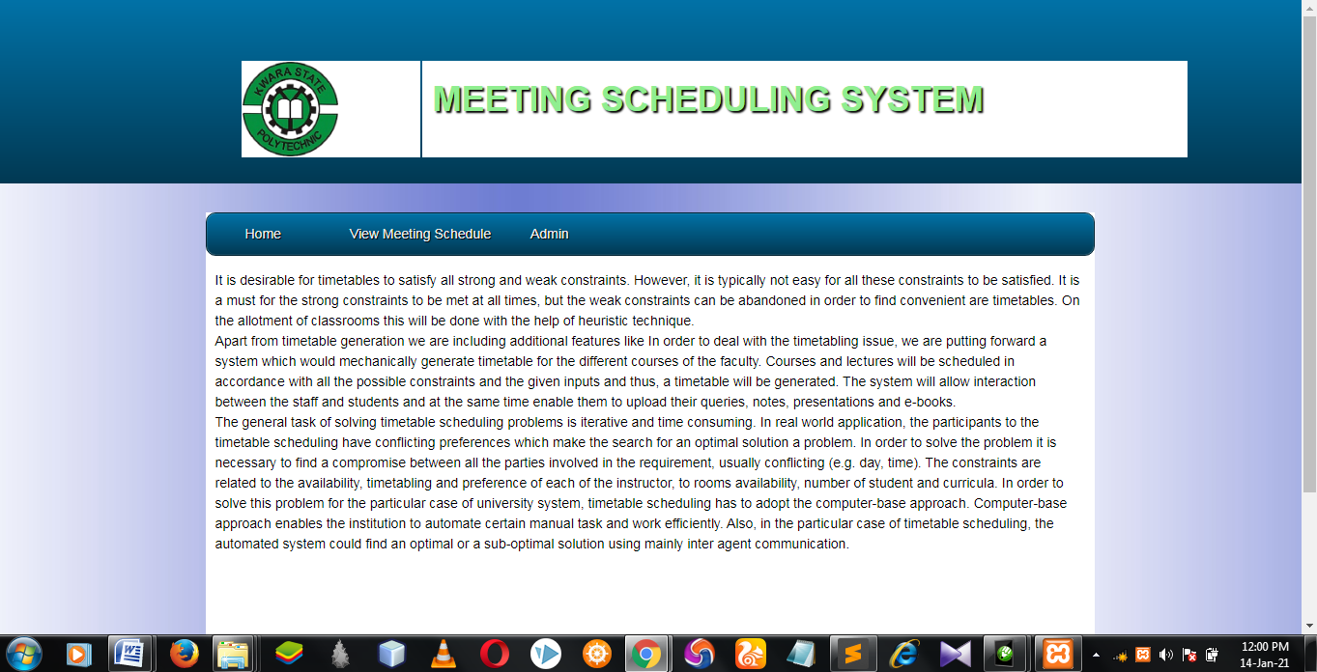
Figure 4.1: Homepage: this is the homepage of the meeting scheduling system
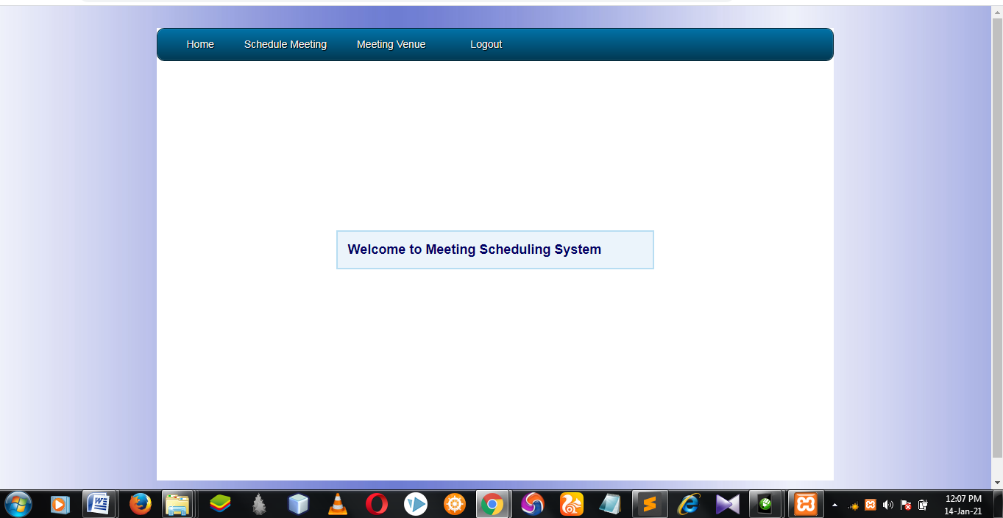
Figure 4.2: Meeting Schedule dashboard: This is the admin dashboard

4.1.2 INPUT DESIGN
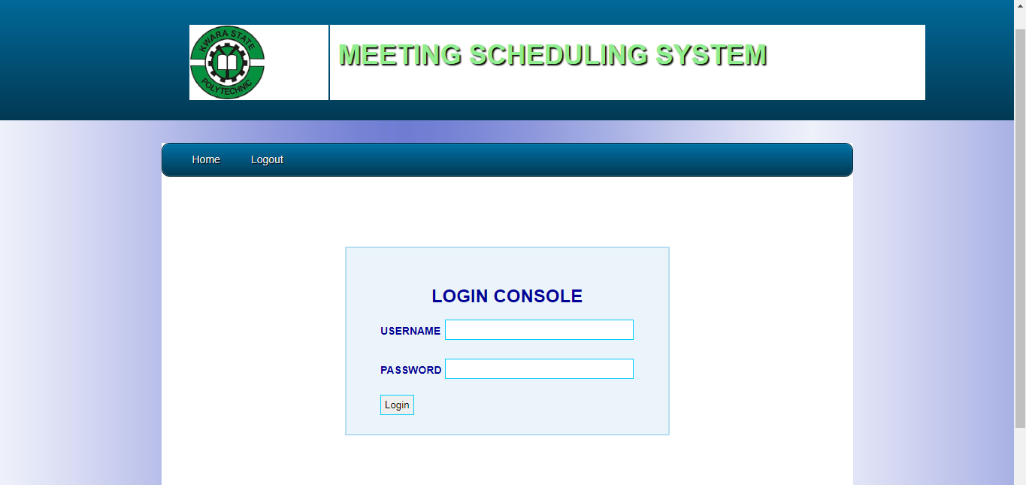
Figure 4.3: Login: This is the admin login page
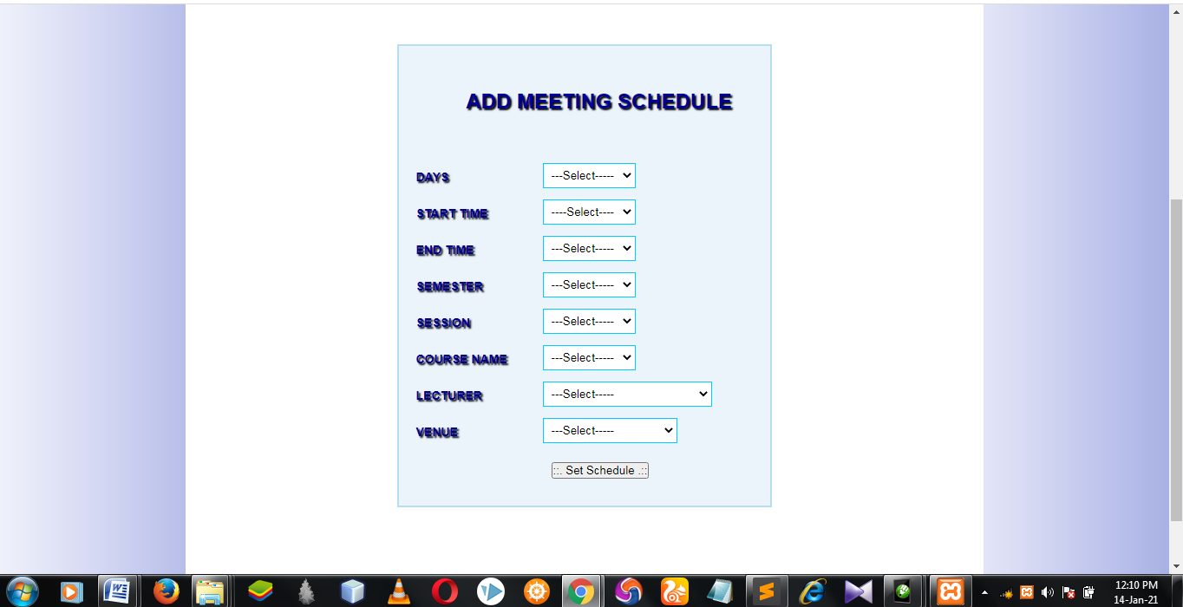
Figure 4.4: Add Meeting Schedule: This is where admin schedule meeting
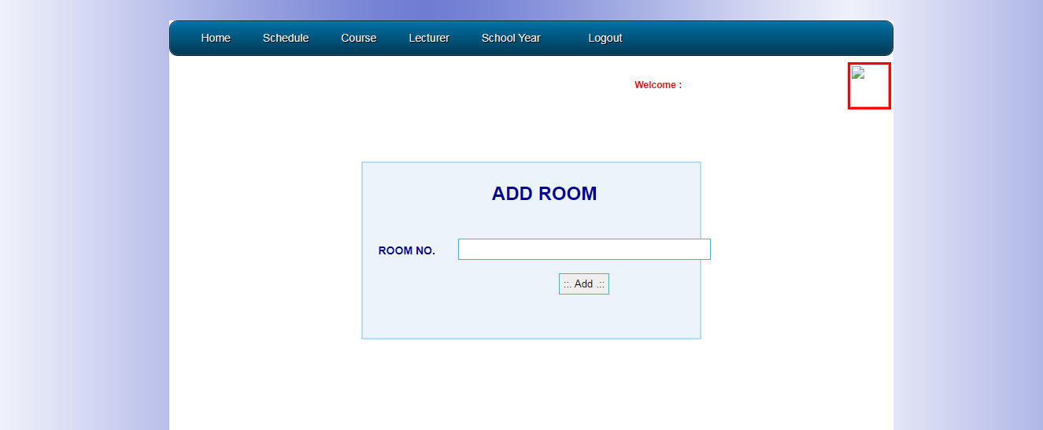
Figure 4.5: Add room: This is where admin add meeting venue into the database

4.1.3 DATABASE DESIGN
TABLE 4,1
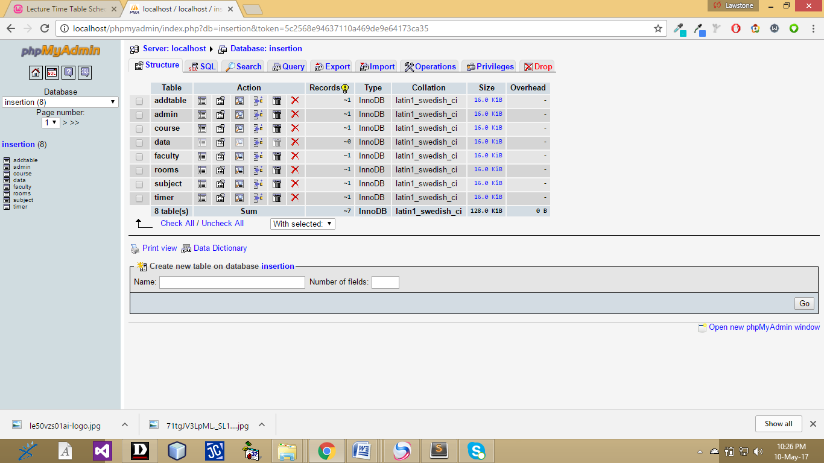
TABLE 4.2
Figure 4.7: Lecture_timetable Database
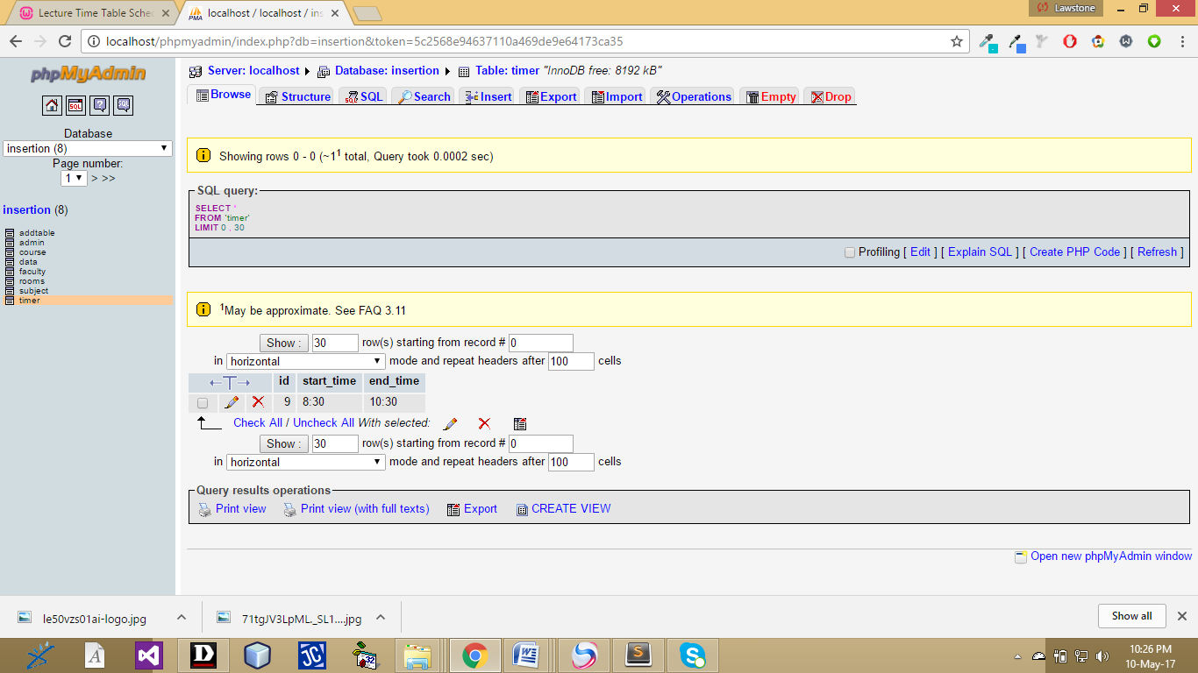
TABLE 4.3
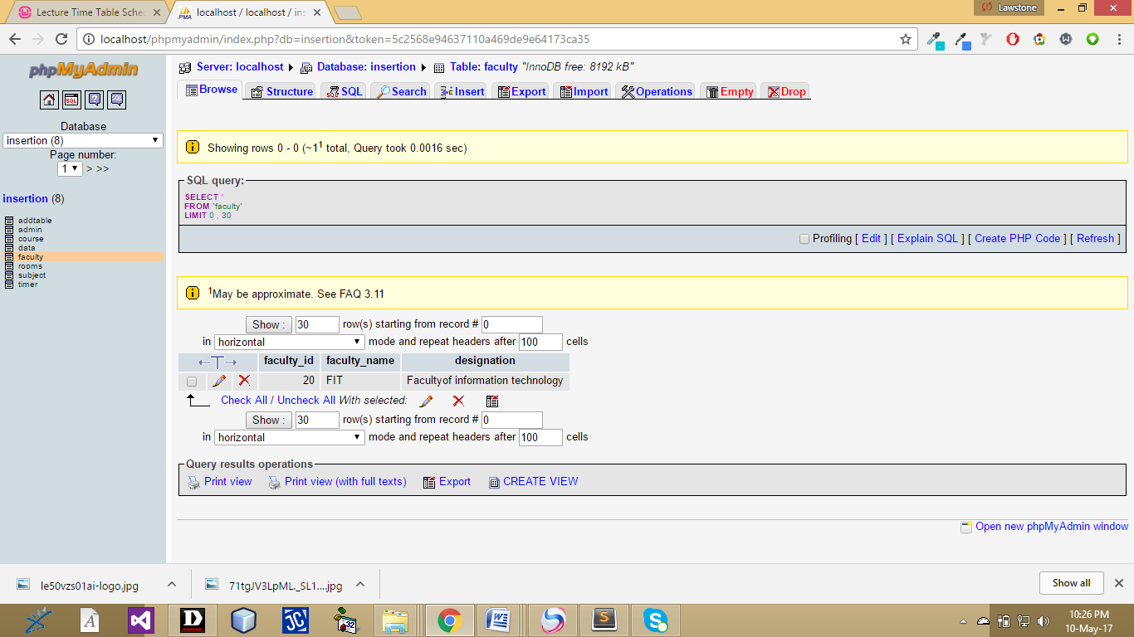

Figure 4.9: Faculty

4.1.4 PROCEDURE DESIGN
This refers to the ways in which the proposed system will be used and the steps are as follows:
- Click start on the computer desktop
- Select all programs
- Select any browser e.gMorzilla Firefox , internet Explorer , Google Chrome e.t.c
- Type the url (Uniform Resource Locator) of the system into the address bar (localhost/lecture_timetable /index.php)

4.2 SYSTEM IMPLEMENTATION
The design system depends on the capabilities and power of the computer on which the application system is installed. However, selecting a choice of application support (Hardware and Software) depends much on;
- How readily the user is to interfere with the computer
- Cost and benefits
- Managements support for changes
Hence, choosing the appropriate hardware and software will enhance the performance of the system. A most important requirement on which the running of the program basically depends on is the provision of internet facility. So any system that must run this program must be internet ready.

4.2.1 CHOICE OF PROGRAMMING LANGUAGE
The programming language used for this proposed system is an object oriented programming language running on a platform that exchanges data with a database programming language named PHP. The choice of PHP programming language is that the application will be available through the internet. PHP is used as the server side scripting language that enables scripts (embedded in web pages) to be executed by an internet server, JavaScript is used as the browser side scripting language and MySQL as the database engine used to store, update, validate and keep information about the type of operation to be carried out. Other software packages like the word processing package and graphic packages would be needed for clerical function of the division.

4.2.2 HARDWARE SUPPORT
The hardware that is required in the successful completion of this project includes monitor, CPU, keyboard, mouse, printer and an uninterrupted power supply (UPS) and an internet access.
- An appropriate hard disk storage of at least 120 GB (for the dynamically expandable database)
- A minimum of 1.0 GHz processor
- Random access memory (RAM) of at least 1 GB
- An effective display unit (VGA monitor)
- A suitable printer
- Standard input devices such as keyboard, mouse, etc.
- CD-ROM drive or DVD-ROM drive (since the installation would be made through this medium)
- An uninterrupted power supply (UPS) unit (to prevent abrupt interruption due to power failure)

4.2.3 IMPLEMENTATION TECHNIQUES

The term heuristic is used for algorithms which find solutions among all possible ones ,but they do not guarantee that the best will be found, therefore they may be considered as approximately and not accurate algorithms. These algorithms, usually find a solution close to the best one and they find it fast and easily. Sometimes these algorithms can be accurate, that is they actually find the best solution, but the algorithm is still called heuristic until this best solution is proven to be the best. The method used from a heuristic algorithm is one of the known methods, such as greediness, but in order to be easy and fast the algorithm ignores or even suppresses some of the problem's demands.

4.2.4 SYSTEM DOCUMENTATION
It has to do with the installation and usage of the new system.
After the program has been well tested with input that the output has already been known, the next is to install the software in to the computer system for use.
The process of installing are been stated below
- Insert the CD into the system through the CD-ROM after the computer is switch on
- Locate the CD drive directory in my computer and click it to open
- After open, locate setup.exe, and then click to install the program by following the necessary step in installing the program.
- Ensure full installing of the software for effective operation of the system.
After the program has been fully install. The next thing is to locate the package install to put it into operation, to locate the package for expiration purpose the following step are to be taking
v. Click on start menu from task bar. Then select all program
From the display sub option, select by locating the software installed named temperament/ personality check to load the software.
4.3.1 PROGRAM DOCUMENTATION
- HOME
- ADD VENUE
- ADD MEETING SCHEDULE
- ROOM
- TIME
- LIST
- TABLE
4.3.2 OPERATING THE SYSTEM
This contains information about the necessary steps that will be involved in setting this system up, and putting it into full use. The steps that will be involved in the setting up of this system are as follows:
1. Search for a web site
2. Determine a domain name
3. Register the domain name with the web host
4. Buy the necessary hosting space
5. Upload all the site’s files
In order for the proposed system to be used on any computer system it takes the following ways
- Boot the system
- Copy the folder to www inside wamp folder of the drive C: after WAMP server is installed onto the system.
- Open any browser on the system (Microsoft internet Explorer, Mozilla Firefox, Netscape Navigator, Opera, Flock, Safari e.t.c)
- Type http://localhost/meetingscheduling/index.php on the address bar and press the return key/ enter key

4.3.3 MAINTAINING THE SYSTEM
This refers to the changes that have to be, made to complete systems after having been delivered. This project takes care of two types of maintenance these are:
- Adaptive maintenance and
- Perfective maintenance
Adaptive Maintenance: This refers to the type of maintenance which will be done to the system to make it adjust to any changes occurring to it. An example of adaptive maintenance is the yearly updating of the customers database to change account code in database.
Corrective Maintenance: This is a type of maintenance which takes care of some parts of the system which have been omitted in the initial design. The need for this arises as the system is being put into use over a period of time.

CHAPTER FIVE
SUMMARY, CONCLUSION AND RECOMMENDATION
5.1 SUMMARY

This meeting scheduling system will allow you to gain access to the administrator, who will be asked for the corresponding password to enable him/her to navigate through. When the username and password are validated the user is to redirected to the home page called the Dashboard where there is an option to register each employee in the organization. It is desirable for meeting scheduling system to satisfy all strong and weak constraints. However, it is typically not easy for all these constraints to be satisfied. It is a must for the strong constraints to be met at all times, but the weak constraints can be abandoned in order to find convenient. On the allotment of meetings this will be done with the help of heuristic technique.

5.2 CONCLUSION
In this project, An attempt was made to effectively introduce the concept of meeting scheduling system already existing in the society. So then explain the concept of online event management systems which are already present. This project describe the proposed system and explain the features implemented by our proposed system .it also give a brief overview of the technologies used during the development of our proposed system. This project can be further refined and extended by introducing new and more innovative features.

5.3 RECOMMENDATION
During the real life operation of the new system, the following change over procedures are recommended during implementation. The training must be supervised by the system designer and presentation of the new system must be carried out. The old and the new system should be run completely and concurrently using of some input from the old system until the new system proves to be satisfactory by the coordinating committee.

REFERENCES
Aguilera, Jose Miguel and David W. Stanley. (2014) Microstructural Principles of Food Processing and Engineering. Springer, 1999. ISBN 0-8342-1256-0.
Campbell, Bernard G. (2011). Human Evolution: An Introduction to Man's Adaptations. Aldine Transaction: 1998.ISBN 0-202-02042-8.
Carpenter, Ruth Ann; Finley, Carrie E. (2012) Healthy Eating Every Day. Human Kinetics, 2005. ISBN 0-7360-5186-4.
Davidson, A. (2005) The Oxford Companion to Food. 2nd ed. UK: Oxford University Press, 2006.
Hannaford, S. (2009) Oligopoly Watch: Top 20 world food companies. Retrieved fromhttp://www.oligopolywatch.com/2005/10/06.html on 2006-09-23.
Howe, P. (2006) Famine Intensity and Magnitude Scales: A Proposal for an Instrumental Definition of Famine. 2004.
Jurgens, Marshall H. (2015) Animal Feeding and Nutrition. Kendall Hunt, 2001. ISBN 0-7872-7839-4.
Kripke, G. (2009) Food aid or hidden dumping?. Oxfam International, March 2005. Retrieved fromhttp://www.oxfam.org/en/policy/briefingpapers/bp71_food_aid_240305 on 2007-05-26.
Lawrie, S. (2008) Lawrie. Lawrie's Meat Science. Woodhead Publishing: 1998. ISBN 1-85573-395-1.
Magdoff, F. (2008) Hungry for Profit: The Agribusiness Threat to Farmers, Food, and the Environment. September 2000. ISBN 1-58367-016-5.
Mason, J. (2014) Sustainable Agriculture. Landlinks Press: 2003. ISBN 0-643-06876-7.
Merson, Michael H.; Black, Robert E.; Mills, Anne J. International Public Health: Disease, Programs, Systems, and Policies. Jones and Bartlett Publishers, 2005.

