AN ONLINE DRUG VERIFICATION AND MANAGEMENT SYSTEM
CASE STUDY FOR NATIONAL AGENCY FOR FOOD AND DRUG ADMINISTRATION AND CONTROL (NAFDAC)
BY
ABODUNRIN EMMANUEL SAMSON
ND/23/COM/PT/0072

A PROJECT SUBMITTED TO
THE DEPARTMENT OF COMPUTER SCIENCE, INSTITUTE OF INFORMATION AND COMMUNICATION TECHNOLOGY
KWARA STATE POLYTECHNIC, ILORIN

IN PARTIAL FULFILLMENT OF THE REQUIREMENTS FOR THE AWARD OF NATIONAL DIPLOMA (ND) IN COMPUTER SCIENCE

AUGUST, 2025
CERTIFICATION

This project work is carried out by ND/23/COM/PT/0072 and as part of the requirements for the award of National Diploma (ND) in Computer Science.

__________________________ _____________
MR. MURTALA, K. DATE
PROJECT SUPERVISOR

______________________ _____________
MR OYEDEPO, F.S. DATE
HEAD OF DEPARTMENT

______________________ _____________
EXTERNAL EXAMINER DATE

DEDICATION
I dedicated this project to the Almighty God, for He has given us the privilege to start successfully and end our programme here in Kwara State Polytechnic successfully, I also appreciated him. This project is also dedicated to our parents; for their full concern in terms of financial aspect, spiritual, moral and their prayer towards us, and lastly to our siblings, God bless you all.

ACKNOWLWDGEMENT
In gratitude say Shakespeare is worse than a traitor arm in light, it is necessary for us to place on record, a good number of people who either directly or indirectly made this National Diploma (ND) successful one. Our gratitude goes to my able and ever dynamic project supervisor MR MURTALA, K. who did a lot of work in reading through and making necessary correction in this project. May God Almighty crown your effort with everlasting success (Amen).

ABSTRACT

TABLE OF CONTENTS
Title page i
Certification ii
Dedication iii
Acknowledgement iv
Abstract v
Table of Contents
CHAPTER ONE
  - Introduction 1
  - Statement of Problem 2
  - Aim and Objectives 2
  - Significant of the Study 5
  - Scope of the Study 5
  - Organization of the Report 6
  - Definition of the Terms 6
CHAPTER TWO
2.1 Review of Related Work 9

2.2 Health and Economic Consequences of Drug Counterfeiting 6
2.3 Reasons behind the Successful Market of Counterfeit Drugs 6

2.4 Roles of Pharmacist in Preventing Distribution of Counterfeit Drugs 7

2.5 The Fight against Fake Drugs by NAFDAC in Nigeria 8

2.6 The New Drug Distribution Guidelines and Responsibilities 9

CHAPTER THREE
3.1 Research Methodology 11
3.2 Analysis of Data and the Existing System 11
3.3 Problem of the Existing 12
3.4 Description of Proposed System 12
3.5 Advantage of Proposed System 13
CHAPTER FOUR
4.1 Design of the System 14
4.1.1 Output Design 14
4.1.2 Input Design 15
4.1.3 Database Design 17
4.1.4 Procedure Design 19
4.2 Implementation of Techniques used in Details 19
4.2.1 Programming Language used with Reasons 19
4.2.2 Hardware Support 20
4.2.3 Software Support 20
    - Implementation Technique Used In Details 20
4.3 System Documentation 21
4.3.1 Program Documentation 21
4.3.2 Operating the System 21
4.2.3 Maintenance of the System 21
CHAPTER FIVE
5.1 Summary 22
5.2 Conclusion 22
5.3 Recommendation 22
Reference 24
Appendix 1 Flowchart 26
Appendix 2 Source Code 32

CHAPTER ONE
1.1 General Introduction
According to Koolmanojwong (2017). He proposed that the majority of the world’s population seeking medications for various illness and medical conditions, there is a need for appropriate pharmaceutical drugs. Counterfeited drugs are unauthentic drugs that have been manufactured using wrong quantities or wrong ingredients to either reduce the capacity or invalidate the capacity of drugs. This addition of harmful ingredients leads to drug counterfeiting. Drug counterfeiting has become an economic and social problem for decades as it directly affects human beings due to the unavoidable importance of drugs to life.
Drugs verification and reporting agencies and establishments like National Agency for Food and Drug Administration and Control (NAFDAC) require efficient and effective system for proper drugs management. Their main objective is to safe guard the public health by ensuring that only the right drugs and other regulated products are manufactured, advertised, sold and used. Hence, there is the need to build an application that will help achieve their objectives (National Agency for Food and Drug Administration and Control, 2013).
Drug reporting and verification Software easily automates the whole process of drug verification and reporting. Drugs Pharmaceutical Company are register on the system and verification code are generated for each drug production. System users are created by the system admin where each staff is able to login in with the provided authorization and manage his/her account. The system which will be made available to the general public provides a window in which users could type in a drug code to verify the authenticity of that drug. The admin has the sole authority over the system. (Rutherford. 2017)
1.2 Statement of the Problem
The major reason that gave rise to this project is the fact that fake drugs have led to treatment failures and death of so many citizens, hence, the need to resolve this by developing a secure and reliable system. It uncovers some of the problems with drugs reporting and access to registered pharmaceutical companies.
1.3 Aim and Objectives of the Study
The aim of this study is to develop an Online Drug Verification and Management System for National Agency for Food and Drug Administration and Control (NAFDAC).
These are the objectives to:
- Register every drug produced by every pharmaceutical company in Nigeria.
- Generate verification code.
- Properly register all pharmaceutical companies in Nigeria.
- Efficiently handling of fake drugs report and automate the process of drug verification
1.4 Significance of the Study
This project work will provide a more reliable and flexible way of drugs verification and report filing of fake drugs as well as fake pharmaceutical companies that are not authorize to produce and distribute drugs in Nigeria. Also, it will eliminate the lag time in file recovery with an inclusion of an asynchronous request incorporated on the system. Furthermore, it will aids structural document, representation and eliminates the tedious of performing monotonous transactions. This research will also contribute to existing literature in this area and will serve as a guide or blueprint for an undergraduate student.

1.5 Scope of the Study
This research work is to develop a system capable of handling all Drug agencies in Nigeria such as verification and reporting of fake drugs, drugs confirmation code using secure channel, drug enforcement agent .The system will also incorporate in its design a feedback layout between for drug confirmation. The system will not incorporate in its development all the functions of a drug verification and reporting system but will focus only on the aforementioned functionalities.

1.6 Organization of the Study
Organization of the report is stated as follows:
Chapter one introduces the project work by stating the Introduction, Statement of the problem, Aim and objectives, significance of the study. The scope and limitation together with the organization of the report.
The second chapter attempts to examine the current state knowledge on the subject matter through the use of journals, student project, textbooks etc.
The third chapter tries to analyze the existing system, which involve describing the current procedures. The proposed system is also alongside described.
In the fourth Chapter, stating the format and mode of output with reports from the system and the design of the system.
The last chapter which is Chapter 5 in the project will be a brief summary as well as the conclusion and experience gained and the problem encountered during the writing of the project as well as the limitation.
1.7 Definition of Terms
Database: A collection of related data that can be accessed managed and updated.
DBMS: Database Management System that enable the user to define, maintain and control the database.
Drug: It is referred to as a medicine or chemical substance that is administered to Patients for curative measures.
Pharmacy: A place where medicine or chemical substances are kept stored and prepared.
Relation: A relation is a named table with columns and rows.
PHP: Hypertext Preprocessor used as server-side scripting language to link the interface and the database.
MYSQL: A type of relational Database.
SDLC: System Development Life Cycle is a set of procedures which serve as a template for generating an individual design process.
CHAPTER TWO
2.1 Review of Related Works
Counterfeit products threaten public health and safety, reduce jobs and tax bases, and inhibit corporate innovativeness and profitability. The production, distribution, and consumption of counterfeit pharmaceuticals represent a particularly dangerous public health risk; estimates of the numbers of counterfeit pharmaceuticals range from 10 to 15 percent of the world drug supply. Counterfeit drugs indirectly and directly adversely affect health. Indirectly, false drugs hasten the illness and death of consumers who do not receive the appropriate active agent or dosage to treat their conditions, and sub-potent pharmaceuticals that do not kill a disease-causing pathogen can eventually lead to the development of drug-resistant strains, making even the authentic drugs useless. More directly, toxic ingredients in counterfeit pharmaceuticals can cause serious health problems (Landvogt, 2017).
Among the factors that encourage drug faking worldwide is corruption and conflict of interests. Corruption is a driving force for poor regulation, which encourages drug faking/counterfeiting. The Management of NAFDAC has resolved that counterfeit medicines must be brought to the barest minimum in the shortest possible time. They have a clear vision, goals and strategies. Their vision is to safeguard public health by ensuring that only the right quality products are manufactured, imported, exported, advertised, distributed, sold and used in Nigeria (Akunyili , 2015).
The World Health Organization (WHO) defines counterfeit drugs as “drugs that have been deliberately or fraudulently mislabeled with respect to identity and/or source” (Akinyandenu, 2013). Counterfeit medications have been defined as "products deliberately and fraudulently produced and/or mislabeled with respect to identity and/or source to make it appear to be a genuine product" (Fenoff& Wilson, 2016). Examples include medications that contain no active ingredient, an incorrect amount of active ingredient, an inferior-quality active ingredient, a wrong active ingredient, contaminants, and repackaged expired products (Fallon, 2016).

2.2 Health and Economic Consequences of Drug Counterfeiting
The problem of counterfeit drugs have embarrassed the Nigerian healthcare providers and denied the confidence of the public in the nation’s healthcare delivery system. The result of fake drug proliferation has led to treatment failures, organ dysfunction or damage, worsening of chronic disease conditions and death of many Nigerians. Even when patients are treated with genuine drugs, no response is seen due to resistance caused by the previous intake of fake drugs (Akunyili , 2015). Counterfeit drugs pose great threats to the attainment of the millennium development goals 4, 5 and 6 which hopes for a reduction in infant mortality, improved maternal health and combating HIV/AIDS, malaria and other diseases (Akinyandenu,2013).
It denies the Nigerian people the right to safe, effective and quality medicines. Counterfeit drugs rob the country of valued man power resources and economic benefits. It enables counterfeit drug producers sell their products cheap to vendors who in turn sell to the consumers. The major factors facilitating the preponderance of fake drugs in Nigeria have been reported to include: the ineffective enforcement of existing laws, non-professionals in drug business, lose control systems, high cost of genuine drugs, greed, ignorance, corruption, illegal drug importation, chaotic drug distribution network, demand exceeding supply amongst many others (Chinwendu, 2013).
2.3 Reasons behind the Successful Market of Counterfeit Drugs
The reason for why medicines are targeted by counterfeiters has a lot to do with the fact that fakes can now be made relatively easy. The profitability may therefore be at least as good as for narcotics, while the risk is lower due to lack of rules, law enforcement and global cooperation. Even in developed countries, however, the risk of prosecution and penalties for counterfeiting are still inadequate with the exception of the US. It is also relatively easy to sell the drugs on the internet, or in developing countries where the real drugs are expensive, potential consumers are plenty and there is limited regulation and enforcement.
The way medicines are traditionally sold also contributes to their potential to be targeted by counterfeiters. The end-user has little or no knowledge of the product and therefore entirely trusts pharmacies, companies and hospitals. The evolution of social security systems in the western world must also take some responsibility for the success of the market in counterfeit drugs (Wright,2016)
As states seek to reduce the cost of provision of social security services individuals, particularly those on lower income levels, can see themselves facing increasing drug bills for which they receive less than adequate support. It is almost inevitable that they turn to other, apparently more economical, sources to fulfill their pharmaceutical needs. The evolution of social security systems in the western world must also take some responsibility for the success of the market in counterfeit drugs (Wright, 2016).

2.4 Roles of Pharmacist in Preventing Distribution of Counterfeit Drugs
Although any product can be counterfeited, an increased ability to enter the supply chain drives counterfeiters to target high- demand, high-priced medications. Medications sold via non- traditional distribution channels such as the Internet, the gray market, and clinics have a higher risk of being counterfeit. Up to 60% of medications purchased online could be counterfeit or substandard (Jingzhi, 2017), and more than 50% of medications purchased online from sites that concealed their actual physical address were found to be counterfeit (Assembly and the Working Groups, 2006-2010).
Nonetheless, thousands of websites sell unapproved and/or counterfeit medications, including the sale of prescription medications without requiring a prescription (Report, Counterfeit Pharmaceutical Inter-agency Working Group, 2016). The National Association of Boards of Pharmacy (NABP) created a database (i.e., Verified Internet Pharmacy Practice Sites) of online pharmacies that are legitimately licensed and operating on the Internet.
A "perfect storm" exists when legitimate suppliers of a high demand, expensive medication are unable to supply the market needs and counterfeiters break into the supply chain because pharmacists are searching for alternative suppliers. Pharmacists can help to ensure the integrity of the supply chain by purchasing medications from known, reliable sources, warning patients of the dangers of purchasing medications over the Internet, affirming that distributors purchased the product from the manufacturer or another reliable source, and monitoring counterfeit product alerts. Pharmacists, technicians, student pharmacists, and patients need to be educated about counterfeit medications (Chambliss, 2016).

2.5 The Fight against Fake Drugs by NAFDAC in Nigeria
National Agency for Food and Drug Administration and Control (NAFDAC) is a Nigerian government agency responsible for regulating and controlling the manufacture, importation, exportation, advertisement, distribution, sale and use of food, drugs, cosmetics, medical devices, chemicals and pre-packaged water. Its creation was inspired by a 1988 World Health Assembly resolution requesting countries help in combating the global health threat posed by counterfeit pharmaceuticals and amidst growing Nigeria concerns about the growing problem of fake and poorly regulated drugs in. In December 1992, NAFDAC's first governing council was formed. In January 1993, supporting legislation was approved as legislative Decree No. 15 of 1993, and January 1, 1994, NAFDAC was officially established, as a “parastat of the Federal Ministry of Health”. NAFDAC replaced an earlier Federal Ministry of Health body, the Directorate of Food and Drug Administration and Control, which had been deemed ineffective, largely due to a lack of laws concerning fake drugs and political issues.
The objective of any drug regulatory agency is the protection and promotion of public health. The enforcement directorate arm of NAFDAC established under the provisions of the counterfeit and fake drugs (miscellaneous provision) act is charged with the responsibility of enforcing the provisions of the counterfeit and fake drug decree, which includes:
- Conducting surveillance on companies and persons suspected to be violating NAFDAC regulations and carrying out investigations on such persons and companies.
- Paying unscheduled visits to all ports of entry and border posts and interrogation of suspects.
- Sampling of NAFDAC regulated products to the laboratory and compilation of case files.
- Raiding of drug hawkers and destruction of fake and spurious regulated products.
- Coordination of activities of state taskforce.
The establishment of the task force in Nigeria was seen as a welcomed development for the fight against fake drugs (Gray, 2016).

2.6 The New Drug Distribution Guidelines and Responsibilities
The drug distribution guidelines have erected pillars and clearly delineated channels of distribution with roles and responsibilities. The manufacturers and importers occupy the apex of the ladder. Their role is to make drugs available and sell only to Mega Drug Distribution Centers (MDDC), State Drug Distribution Centers (SDDC), and National Health Programs. The next Level below this position is occupied by the MDDC and SDDC. While the MDDC is private sector-driven, the SDDC is meant to service the public sector at the state level. The SDDC will cater for all public health facilities in the state and is allowed to sell to National Health Programs (where indicated) and to wholesalers (Federal Ministry of Health, 2017).
The MDDC is allowed to sell to wholesalers only. Wholesalers occupy a pivotal position in the value chain. Purchases could be made from MDDC or SDDC but not from the manufacturers or importers. The wholesalers can sell to community pharmacies, public and primary healthcare facilities, and private health institutions. With this functions clearly spelled out, there is really no need for a wholesaler to engage in retailing as it is now. At the bottom of the distribution ladder, we have community pharmacies, public and private health institutions who sell directly to the consumers. The community pharmacies are allowed to sell to private health facilities. Other provisions that affect pharmacists directly include all drug retailing institutions and facilities.
The Pharmacist Council of Nigeria (PCN) is mandated to register private hospitals, local government clinics and any facility that directly or indirectly make use of drugs, poisons, and related products. The law to register and operate community pharmacy outlets mandates only pharmacists. It is a clear departure from the previous system where anything goes. To be a superintendent pharmacist, one must have at least five years post qualification experience to qualify for retail and ten years for wholesale. The position and importance of pharmacists are clearly spelled out in the new structure in addition to the operations of the MDDC and the SDDC. The guidelines are being operated based on the existing PCN and NAFDAC laws. This is necessary to bring sanity to the system plagued by activities of charlatans and non- professionals in the sector (Federal Ministry of Health,2015).
The current guideline will change the concept of distributors from glorified retailers with limited resources and coverage to big organizations with solid asset base, wide coverage and state of the art logistic information technology and management systems. It will make distributors to be specialized and formidable with huge capital and technology to meet the ever-increasing need for drugs and pharmaceuticals (Onyebuchi, 2015).

CHAPTER THREE
Methodology and Analysis of the Present System
3.1 Research Methodology
The specification of the procedures for the research work which entails data collection and analyzing in respect to define or solve the research problem(s) is called research methodology or methodology. According to Wikipedia.com, “Methodology is the systematic or theoretical analysis of the methods applied to a field of study (research works mainly). It comprises of the theoretical analysis of the body of methods and the principles associated with a branch of knowledge” (accessed on 20 May, 2018).
The implementation technique to be use in the system is parallels, a system that support the current system along-side with the proposed system. This means that for Nigeria to adopt the proposed system that is currently system in used will still be in existence so that a failure in the proposed system will not lead to total loss of information.
This is a description of methods chosen to achieve the objectives of the proposed system. It will go on to describe the techniques of data collection that will be employed in the research study of the proposed systems. The methods that will be applied to achieve the specific objectives are namely: Literature review, Oral interviews, system analysis, system design, Data modeling and Black box testing. The tools that will be used to implement the system are MySQL, HTML and PHP.
3.2 Analysis of Data and the Existing System
Conventional drug systems are generally limited to information and management systems. The systems consist of data entry, retrieval, monitoring the facility and generating of reports among others. The system only allows retrieval and review of decisions previously made on a drug item. Another system allows the user to browse for registered pharmaceutical drugs and also verify if the drug is authentic, the administrator has the admin window to sign in to the backend (Kester, Owusu, &Hatsu, 2015) but does not register pharmaceutical companies. A system was also developed to download as a file, which helps users to know when to take their drugs but it lets the user to order drugs which may promote addiction. Although the interface is fluid and fast, it may not be simple enough for users and it does not verify drugs for authentication (Onuiri, Oyebanji, Fayehun, &Chukwujioke, 2016). More efforts should be put into researching the safety of drugs. In daily practice, many signals of potential counterfeit drugs are not followed by a systematic process of verification. The medical literature is probably by far the most effective system for initial detection of fake drugs. The current emphasis on the costly procedures of mandatory reporting should shift towards studies for testing a hypothesis.
3.3 Problems of the Existing System
Lots of problems are associated with the present system. These problems are:
- Absence of a unified short code for authentication purpose.
- The short codes present aren’t manned by NAFDAC but the manufacturing/pharmaceutical company.
- Short codes can be faked by the counterfeiter since there is no one unique short code.
- There is no room or module to complaint and report a counterfeiter or a counterfeit product to the appropriate authority.
- The wholesaler/retailer cannot authenticate the product they buy to avoid taking the loss or blame.
3.4 Description of the Proposed System
The system will allow the Drug to be register, once a registered Drug is purchased by a consumer, he/she simply authenticate the genuineness of the Drug by inputting the unique code into the textbox and click on the enter button on the authenticate page of the system. Immediately the button is clicked, the system checks the database to know the availability of the code and the status of the code. If the code is not in the database, an invalid code response is given, but if it is in the database with the status as used, then the response is: unique code has been previously used. A unique code in the database that has not been previously used gives a response comprising of the Drug NAFDAC registration number, its manufacturing date and its expiry date.
3.5 Advantages of the Proposed System
The merit of this over the existing system is as follows:
- Cost effective – a single system for all the product standardization as against the multiple standardization systems.
- Response comes along with the genuine expiry date if the expiry date has been altered.
- Prompt and instantaneous response
- Users friendliness with simple GUI

CHAPTER FOUR

4.1 Design of the System
The proposed system is designed in modules with each modules working together to perform the goal of Online Drugs Verification and Management system in order to enhance the performance of the existing system as earlier discussed in chapter three.
The ability to analyze and give focus to the system is explained in the following formats which are output design, input design, database design and procedure design.
    - Output Design
The output to be extracted from the proposed system are as shown below
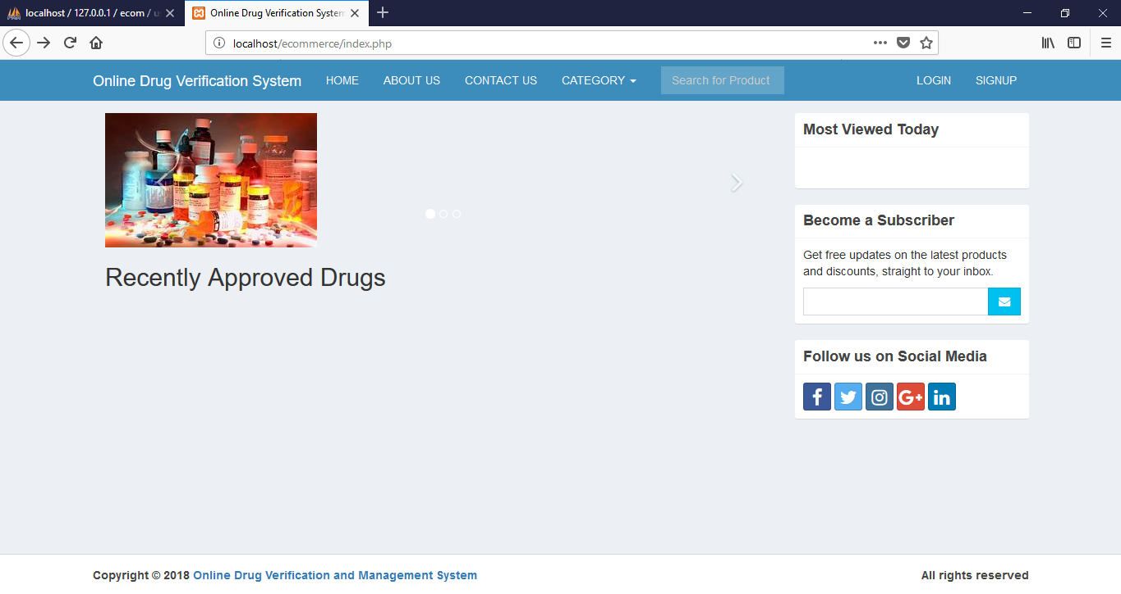
Fig 4.1: Home page

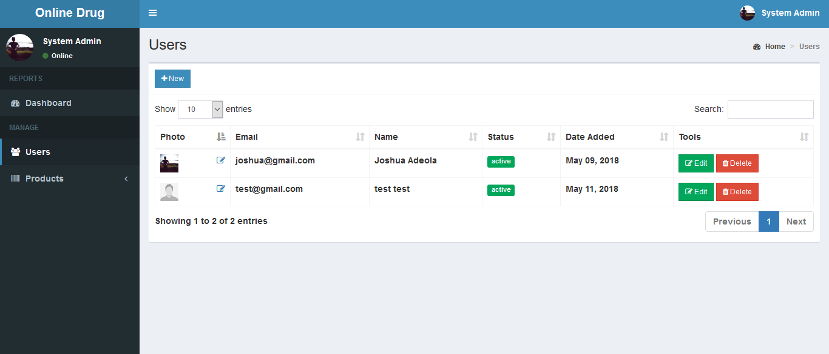
Figure 4.2: List of Users
    - Input Design
The input to be extracted from the proposed system areas shown below
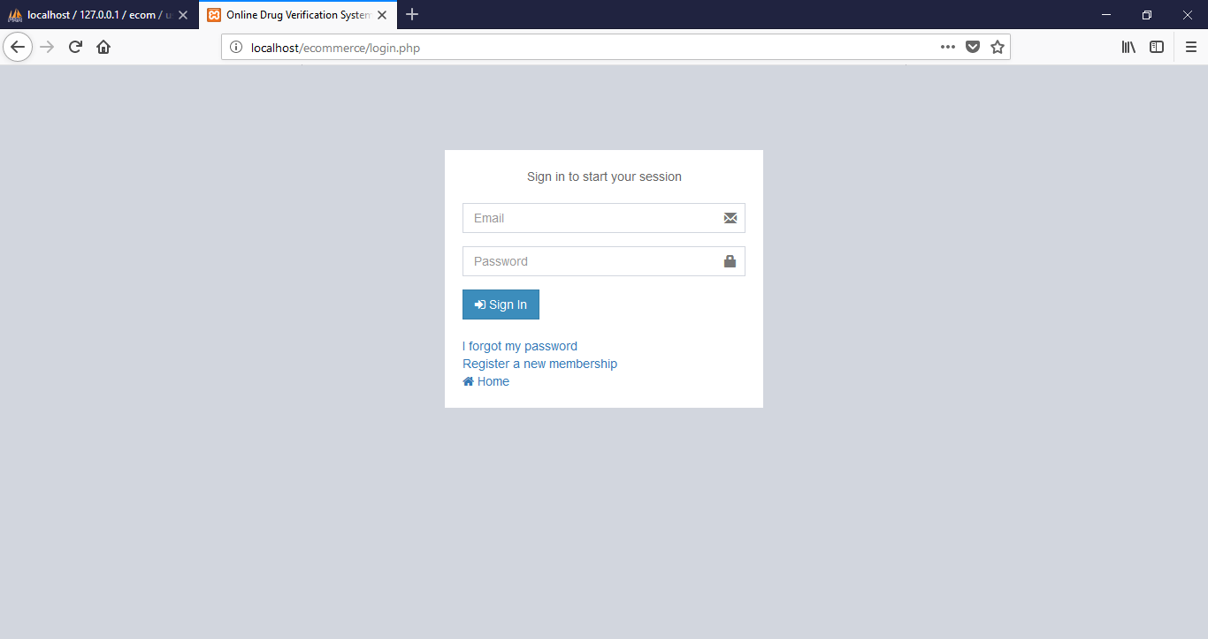
Fig 4.3: Login Page
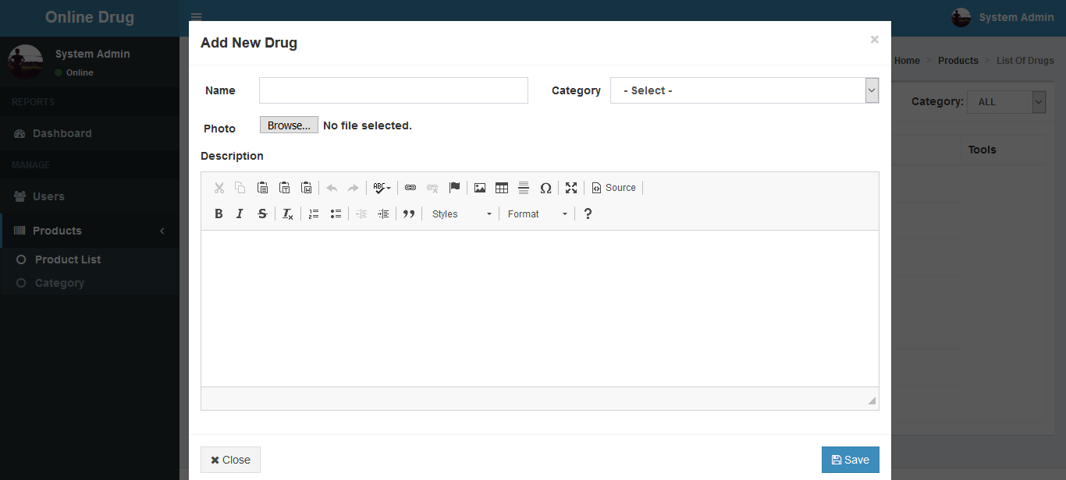
Fig 4.4 Add Drug page

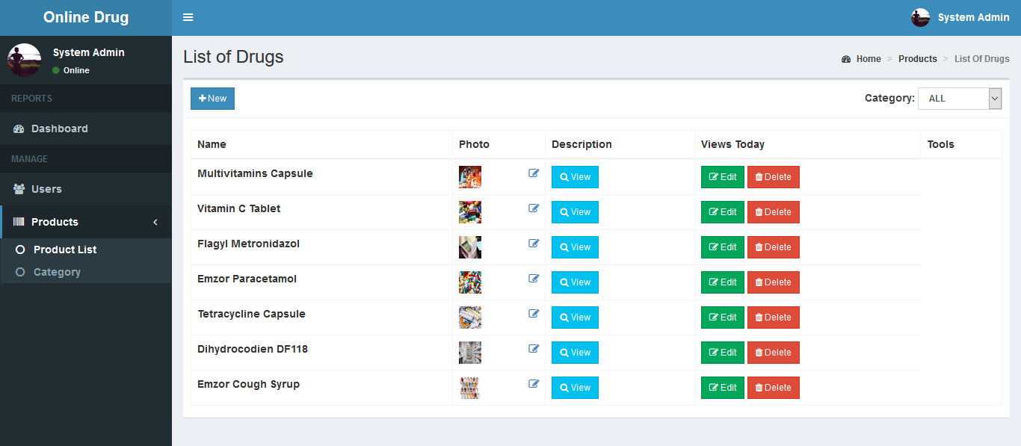
Fig 4.5 List of Drugs
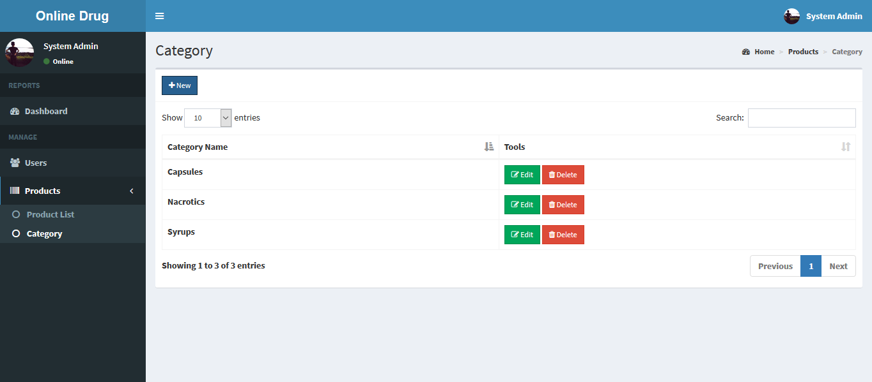
4.6 Drug Categories Page

    - Database Design
This refers to the back end of the proposed system. The following steps is employed in the development of the database.
- Click on start button and locate Wamp.
- Open any browser and type http://localhost/phpmyadmin
- Type the name of the database i.e “drug” and click on create new
- In few seconds the database is created.
- To create table is the next action.
- On a create table menu type the name of the table and click on ok.
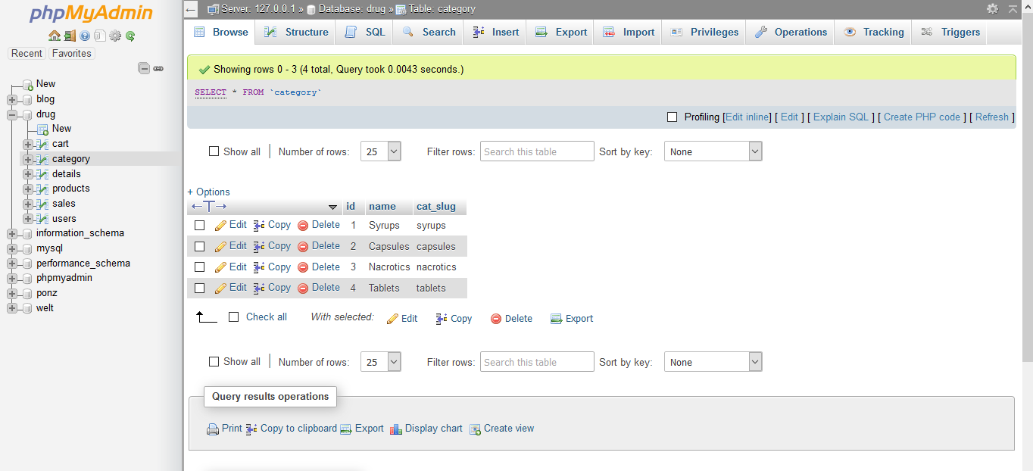
Fig 4.7: Drugs category database table

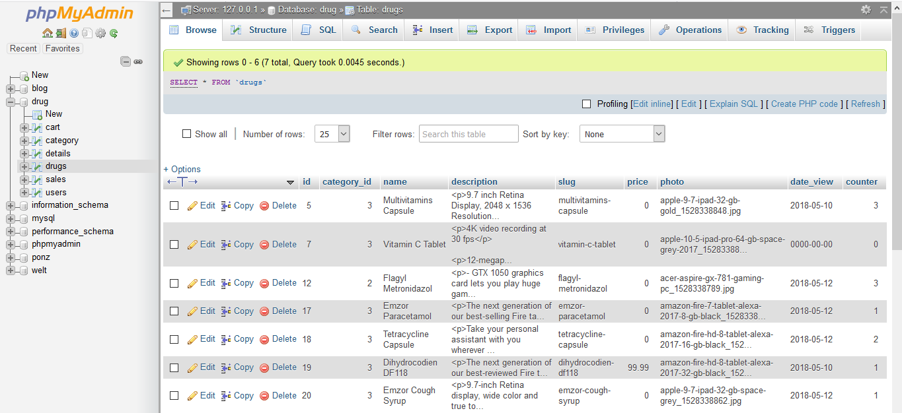
Fig 4.8: Drugs database table

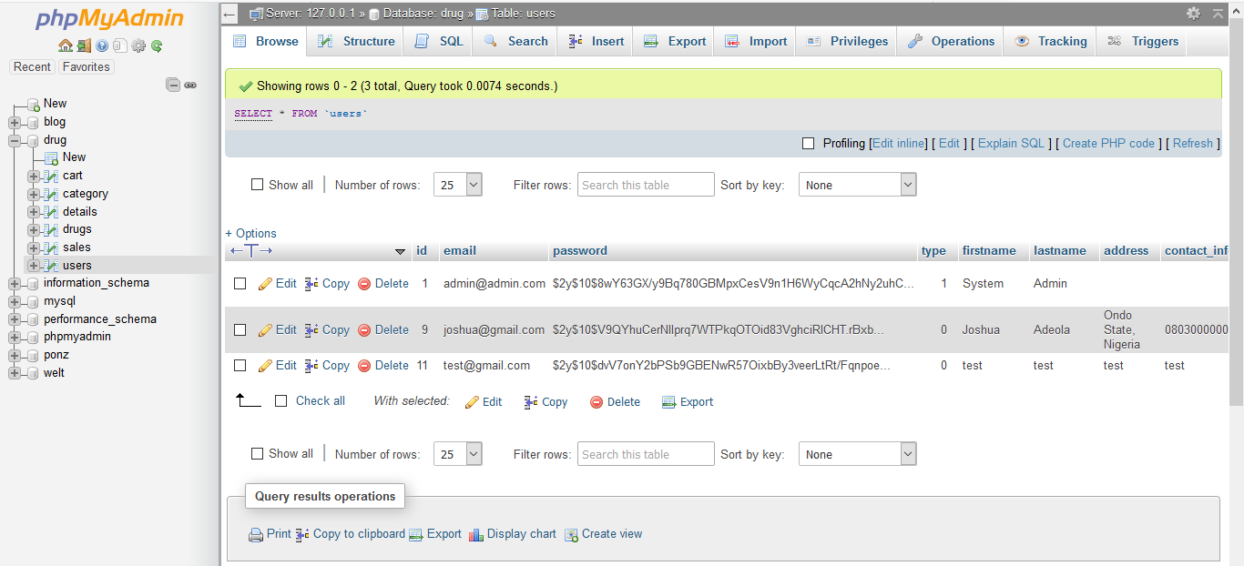
Fig 4.9: Users database table

    - Procedure Design
This refers to the step by step method of using the proposed system. The proposed system comprises of Home, Login, Sign Up, Contact Us, About Us and Category.
- On the address bar of any browser type http://localhost/drug/admin/
- You are prompted to supply the username and password this verifies that you are authorized user and has the privilege to add drugs.
- If the username and password supplied are correct as that of the admin you will be redirected to the admin panel.
- The website has two environments the general user and the administrator environment.
  - Implementation of the system
    - Choice of programming language
The reason for choosing PHP is that it is among the language of the web and as well it is an open source language in which help is readily available when needed and its level of pedagogy.
Advantages of PHP
The following are the advantages of using PHP
1. Learning curve –PHP is a very easy learning curve unlike Java or Perl.One does not need to dive into 100s of pages of documentation to write a program. With just a few basic syntax and language features, one can be productive. Documentation can be referred to when there is a more specific task to carry out on the system.
2. Database Integration – PHP can be compiled with functions to interact with lot of database. PHP with My SQL is a very popular combination.
3. Object Oriented Programming – PHP provides support for classes and objects. Support for object oriented programming is sufficient enough for most programming tasks related to the web. PHP supports constructors, derived classes etc.
5. Scalability – Traditionally, interactive web page is achieved using CGI programs. CGI programs do not scale well, because, each run of a program occurs as a separate process. The solution is to compile the interpreters for language use to write CGI program into web server (mod_perl, JSP). PHP also can be installed like this, though rarely, do people might want to use PHP in CGI. Embedded PHP installations scale well.
    - Hardware Support
CPU : PENTIUM IV
PROCESSOR SPEED : 2 GHz
COPROCESSOR : BUILT IN
TOTAL RAM : 1GB or Higher
HARD DISK : 80 GB
KEYBOARD : 105 KEYS
MOUSE : LOGITECH MOUSE
DISPLAY : SGVA COLOR
    - Software Support
The proposed system makes use of macromedia fireworks for graphics work on the images and background used in the system, macromedia Dream weaver (a text editor) while MY SQL is used as the database.
    - Implementation Techniques Used In Detail
The implementation technique to be use in the system is parallels, a system that support the current system along-side with the proposed system. This means that for Nigeria to adopt the proposed system, a paper and pen method that is currently in used will still be in existence so that a failure in the proposed system will not lead to total loss of information.

  - Documentation of the system
    - Program documentation
In order for the proposed system to be used on any computer system it takes the following ways
- Boot the system
- Copy the folder to www inside Wamp folder of the drive C: after Wamp server is installed onto the system.
- Open any browser on the system (Microsoft internet Explorer, Mozilla Fire fox, Netscape Navigator, Opera, Flock, Safari e.t.c)
- Type http://localhost/drug/admin/ on the address bar and press the return key/ enter key.
4.3.2 Operating the System
In order for the proposed system to be used on any computer system it takes the following ways
- Boot the system
- Copy the folder to www insidewamp folder of the drive C: after WAMP server is installed onto the system.
- Open any browser on the system (Microsoft internet Explorer, Mozilla Firefox, Netscape Navigator, Opera, Flock, Safari e.t.c).
- Type http://localhost/drug/index.php on the address bar and press the return key or enter key.
4.3.3 Maintaining the System
The system is flexible enough to entertain any future amendment which might be required when the need arise. The system requires regular update which necessitates the function of an administrator for regular information that is needed in the system.
CHAPTER FIVE
5.1 Summary
The main objective of this research was to register drugs verification code and verify drugs, as well as register pharmaceutical companies with respective trademark and register drugs produced by the pharmaceutical companies. These objectives were achieved. The third objective was to handle fake drugs report file which was also achieved. The system also has reasonable response time which is another objective that was also achieved. The system is a web-based application running on a local host, this method therefore has all the strengths and weaknesses associated with a web-based system. One of the weaknesses of this system is that the admin cannot view the location in which the report was sent from because the system is an offline system.
5.2 Conclusion
The resulting software would be of benefit to individuals who wish to verify drugs by typing the drug verification code on the system. The software has been able to meet its objectives and will make drug verification and report management more successful. When a good relationship is developed between drug manufacturers, retailers, consumers and the government, it would lead to a successful implementation of drug verification systems. With the global counterfeit problem on the rise, the system is designed to be beneficial to all stakeholders and hence, the need for it to be standardized for identifying drug products.
5.3 Recommendation
In order to cover up the system’s weaknesses, several steps can be taken to further improve upon it. Some of these steps taken can complement the system. For instance, system users should ensure safe keeping of password since it provides access to the system. System client should login from time to time to see update on drugs report. Places with no access to network will not have access to the system, hence the need to further develop a mobile application for the system. After users have sent in complaints about unverified drugs, there should be a view location page where the admin can view the location in which the report was sent from, to help locate pharmacies or hospitals that market or sell these counterfeited or unregistered drugs.
This system can be enhanced by adding features, capabilities and functions in response to new technologies, upgrades, new requirements or new problems. Since the environment in which the application would be running is dynamic, it has been made to suit whatever requirements that may change in the long run. Based on the results produced, the system is shown to be effective at verifying drugs and filing reports which makes drug verification more effective and reliable. The existing types of a drugs verification management were discussed and it was narrowed down to a drug verification and reporting system which is the main aim of this project.
References
Akinyandenu, O. (2013). Counterfeit drugs in Nigeria: A threat to public health.
African Journal of Pharmacy and Pharmacology, 7(36), 2572-2576.
Akunyili, D. (2005). "counterfeit and substandard drugs, nigeria's experience:
implications, challenges, actions and recommendations". meeting for key interest groups on health.
Akunyili, D. N. (2005). “counterfeit drugs and pharmacovigilance". the 10th
pharmacovigilance, (pp. 1-64). sweden.
Assembly and the Working Groups. (2006-2010). IMPACT! International Medical
Products Ant-Counterfeiting Taskforce. (D. D. Giorgio, M. Gramazio, G. Derossi, E. Cesta, M. Chiavoni, & G. Falcioni, Eds.) Italy: Anderson Borgomanero (NO).
Bint Muhammad, N. A. (2010). Drug management system. universiti malaysia
pahang, computer systems and software engineering.
Chambliss, W. G., Carroll, W. A., Kennedy, D. B., Levine, D. P., Moné, M. A.,
Ried, D. L., . . . Yelvigi, M. (2012). role of the pharmacist in preventing distribution of counterfeit medications. preventing distribution of counterfeit medications, 2(52), 195-199.
Chinwendu, O. (2008, Semptember 12). the fight against fake drugs by NAFDAC
in nigeria. 44th international course in health development (ichd), pp. 1-67.
Federal Ministry of Health. (2012). national drug distribution guidelines (2 ed.).
Fenoff, R. S., & Wilson, J. M. (2009, October). Africa’s counterfeit
pharmaceutical epidemic. the road ahead, pp. 1- 20.
Howard, D. (2010). Silent Epidemic: protecting the safety and security of drugs.
retrieved november 19, 2016, from pharmaceutical outsourcing: http://www.pharmoutsourcing.com
Kester, Q.-A., Owusu, P. A., & Hatsu, S. (2015). Pharmaceutical verification and
information system for authentication of registered drugs. international journal of emerging research in management &technology, 4(3), 1-15.

National Agency for Food and Drug Administration and Control. (2013).
(smartaddons.com) retrieved 10 29, 2016, from www.nafdac.gov.ng: http://www.nafdac.gov.ng
National Assembly of Boards of Pharmacy. (2011). retrieved november 19, 2016,
from verified internet pharmacy practice sites (vipps): http://www.nabp.net
Onuiri, E. E., Oyebanji, I. G., Fayehun, S. A., & Chukwujioke, S. D. (2016). online
pharmaceutical management system. european scientific journal, 12(12), 139-156.
Onyebuchi, O. B. (2015). national drug distribution in nigeria; implications for the
goals of national drug policy. european journal of pharmaceutical and medical research, 1(3), 1-4.
Pavel, J. (2004). System Development Life Cycle. Retrieved 11 19, 2016, from
www.dk.upce.cz: http://dk.upce.cz
P-ORG. (2012). Retrieved 0ctober 29, 2016, from www.proud-to-
be.org:http://www.proud-to- be.org/eng/statistics
Report, Counterfeit Pharmaceutical Inter-agency Working Group. (2011, March).
counterfeit pharmaceutical inter- agency working group report to the vice president of the united states and to congress. retrieved 11 19, 2016, from www.whitehouse.gov: http://www.whitehouse.gov
Sommerville, I. (2011). Software Engineering (9 ed.). (j. holcom, ed.) united states
of america: pearson education, inc.
Stricker, B., & Psaty, B. M. (2006). Detection, Verification, and quantification of
adverse drug reactions. Retrieved November 20, 2016, from bmj.com: http://www.bmj.com
Wright, E. (2006). Counterfeit drugs: definitions; origins and legislation. (177),
22-24. Retrieved from www.euralex.co.uk.
Ziance, R. J. (2008, June). Roles for Pharmacy in Combatting Counterfeit Drugs.
American Pharmacist Associasion, 6(14), 55-57.
Appendix A: FLOWCHART
Start
DISPLAY OPTION
IS OPTION = ADD PRODUCT
PAYMENT MODE
PRODUCT CATEGORY
EDIT PRODUCT
PRODUCT
SELECT OPTION
IS OPTION = EDIT PRODUCT
IS OPTION = ADD PRODUCT CATEGORY
IS OPTION = PAYMENT MODE
IS OPTION = ADMIN HOME

ADMIN HOME
LOGIN/ REGISTER
Main Menu Flowchart

YES

YES

YES

YES

YES
RETURN

Login Flowchart
This flowchart explains how the login into the system is carried out.
Start
Select Option

Main Menu
Return
Try Again?
DISPLAY OPTIONS

NO

YES

Add Product Flowchart
Product Adding into the database is seen in their pictorial form here
Start
Supply The Details
Add More Records?
Return
Open Database
Is details correct?
Save to Database
Close Database

Yes

No

Yes

No

Modify Product
Products that are already added to the database which require one or two modification is carried out here.
Start

Open Database

Supply the Details

Yes
Is details correct?

NO
Display Record

Modify Record
Update Details

Update More Records?

YES
NO
Close Database
Add Category Flowchart
Return
A new category is added if need there is a need.

Start

Open Database

Supply The Details

Display Details

NO
Is details correct?

YES
Save to Database

Add More Records?
YES

NO
Save to Database

Return
Register Flowchart
A new visitor to the site who wishes to purchase one or two products from the website can make a request. But this request is not possible if and such user is not a registered user on the site.
Start
Supply The Details
Add More Records?
Return
Open Database
Is details correct?
Save to Database
Close to Database

YES

NO

YES

NO

Appendix B: Source Code
<?php include 'includes/session.php'; ?>
<?php include 'includes/header.php'; ?>
<body class="hold-transition skin-blue layout-top-nav">
<div class="wrapper">
<?php include 'includes/navbar.php'; ?>
<div class="content-wrapper">
<div class="container">
<!-- Main content -->
<section class="content">
<div class="row">
<div class="col-sm-9">
<?php
if(isset($_SESSION['error'])){
echo "
<div class='alert alert-danger'>
".$_SESSION['error']."
</div> ";
unset($_SESSION['error']); }
?>
<div id="carousel-example-generic" class="carousel slide" data-ride="carousel">
<ol class="carousel-indicators">
<li data-target="#carousel-example-generic" data-slide-to="0" class="active"></li>
<li data-target="#carousel-example-generic" data-slide-to="1" class=""></li>
<li data-target="#carousel-example-generic" data-slide-to="2" class=""></li>
</ol>
<div class="carousel-inner">
<div class="item active">
<img src="images/slide/th (1).jpg" alt="First slide">
</div>
<div class="item">
<img src="images/slide/th (3).jpg" alt="Second slide">
</div>
<div class="item">
<img src="images/slide/th.jpg" alt="Third slide">
</div>
</div>
<a class="left carousel-control" href="#carousel-example-generic" data-slide="prev">
<span class="fa fa-angle-left"></span>
</a>
<a class="right carousel-control" href="#carousel-example-generic" data-slide="next">
<span class="fa fa-angle-right"></span>
</a>
</div>
<h2>Monthly Top Sellers</h2>
<?php
$month = date('m');
$conn = $pdo->open();

try{
$inc = 3;
$stmt = $conn->prepare("SELECT *, SUM(quantity) AS total_qty FROM details LEFT JOIN sales ON sales.id=details.sales_id LEFT JOIN products ON products.id=details.product_id WHERE MONTH(sales_date) = '$month' GROUP BY details.product_id ORDER BY total_qty DESC LIMIT 6");
$stmt->execute();
foreach ($stmt as $row) {
$image = (!empty($row['photo'])) ? 'images/'.$row['photo'] : 'images/noimage.jpg';
$inc = ($inc == 3) ? 1 : $inc + 1;
if($inc == 1) echo "<div class='row'>";
echo "
<div class='col-sm-4'>
<div class='box box-solid'>
<div class='box-body prod-body'>
<img src='".$image."' width='100%' height='230px' class='thumbnail'>
<h5><a href='product.php?product=".$row['slug']."'>".$row['name']."</a></h5>
</div>
<div class='box-footer'>
<b>&#36; ".number_format($row['price'], 2)."</b>
</div>
</div>
</div>
";
if($inc == 3) echo "</div>";
}
if($inc == 1) echo "<div class='col-sm-4'></div><div class='col-sm-4'></div></div>";
if($inc == 2) echo "<div class='col-sm-4'></div></div>";
}
catch(PDOException $e){
echo "There is some problem in connection: " . $e->getMessage();
}

$pdo->close();
?>
</div>
<div class="col-sm-3">
<?php include 'includes/sidebar.php'; ?>
</div>
</div>
</section>

</div>
</div>
<?php include 'includes/footer.php'; ?>
</div>
<?php include 'includes/scripts.php'; ?>
</body>
</html>
<?php include 'includes/session.php'; ?>
<?php
if(isset($_SESSION['user'])){
header('location: cart_view.php');
}
?>
<?php include 'includes/header.php'; ?>
<body class="hold-transition login-page">
<div class="login-box">
<?php
if(isset($_SESSION['error'])){
echo "
<div class='callout callout-danger text-center'>
<p>".$_SESSION['error']."</p>
</div>
";
unset($_SESSION['error']);
}
if(isset($_SESSION['success'])){
echo "
<div class='callout callout-success text-center'>
<p>".$_SESSION['success']."</p>
</div>
";
unset($_SESSION['success']);
}
?>
<div class="login-box-body">
<p class="login-box-msg">Sign in to start your session</p>

<form action="verify.php" method="POST">
<div class="form-group has-feedback">
<input type="email" class="form-control" name="email" placeholder="Email" required>
<span class="glyphicon glyphicon-envelope form-control-feedback"></span>
</div>
<div class="form-group has-feedback">
<input type="password" class="form-control" name="password" placeholder="Password" required>
<span class="glyphicon glyphicon-lock form-control-feedback"></span>
</div>
<div class="row">
<div class="col-xs-4">
<button type="submit" class="btn btn-primary btn-block btn-flat" name="login"><i class="fa fa-sign-in"></i> Sign In</button>
</div>
</div>
</form>
<br>
<a href="password_forgot.php">I forgot my password</a><br>
<a href="signup.php" class="text-center">Register a new membership</a><br>
<a href="index.php"><i class="fa fa-home"></i> Home</a>
</div>
</div>

<?php include 'includes/scripts.php' ?>
</body>
</html>
<?php include 'includes/session.php'; ?>
<?php include 'includes/header.php'; ?>
<body class="hold-transition login-page">
<div class="login-box">
<?php
if(isset($_SESSION['error'])){
echo "
<div class='callout callout-danger text-center'>
<p>".$_SESSION['error']."</p>
</div>
";
unset($_SESSION['error']);
}
if(isset($_SESSION['success'])){
echo "
<div class='callout callout-success text-center'>
<p>".$_SESSION['success']."</p>
</div>
";
unset($_SESSION['success']);
}
?>
<div class="login-box-body">
<p class="login-box-msg">Enter email associated with account</p>

<form action="reset.php" method="POST">
<div class="form-group has-feedback">
<input type="email" class="form-control" name="email" placeholder="Email" required>
<span class="glyphicon glyphicon-envelope form-control-feedback"></span>
</div>
<div class="row">
<div class="col-xs-4">
<button type="submit" class="btn btn-primary btn-block btn-flat" name="reset"><i class="fa fa-mail-forward"></i> Send</button>
</div>
</div>
</form>
<br>
<a href="login.php">I rememberd my password</a><br>
<a href="index.php"><i class="fa fa-home"></i> Home</a>
</div>
</div>

<?php include 'includes/scripts.php' ?>
</body>
</html>
<?php
include 'includes/session.php';

if(!isset($_GET['code']) OR !isset($_GET['user'])){
header('location: index.php');
exit();
}

$path = 'password_reset.php?code='.$_GET['code'].'&user='.$_GET['user'];

if(isset($_POST['reset'])){
$password = $_POST['password'];
$repassword = $_POST['repassword'];

if($password != $repassword){
$_SESSION['error'] = 'Passwords did not match';
header('location: '.$path);
}
else{
$conn = $pdo->open();

$stmt = $conn->prepare("SELECT *, COUNT(*) AS numrows FROM users WHERE reset_code=:code AND id=:id");
$stmt->execute(['code'=>$_GET['code'], 'id'=>$_GET['user']]);
$row = $stmt->fetch();

if($row['numrows'] > 0){
$password = password_hash($password, PASSWORD_DEFAULT);

try{
$stmt = $conn->prepare("UPDATE users SET password=:password WHERE id=:id");
$stmt->execute(['password'=>$password, 'id'=>$row['id']]);

$_SESSION['success'] = 'Password successfully reset';
header('location: login.php');
}
catch(PDOException $e){
$_SESSION['error'] = $e->getMessage();
header('location: '.$path);
}
}
else{
$_SESSION['error'] = 'Code did not match with user';
header('location: '.$path);
}

$pdo->close();
}

}
else{
$_SESSION['error'] = 'Input new password first';
header('location: '.$path);
}

?>
<?php include 'includes/session.php'; ?>
<?php
$conn = $pdo->open();

$slug = $_GET['product'];

try{

$stmt = $conn->prepare("SELECT *, products.name AS prodname, category.name AS catname, products.id AS prodid FROM products LEFT JOIN category ON category.id=products.category_id WHERE slug = :slug");
$stmt->execute(['slug' => $slug]);
$product = $stmt->fetch();

}
catch(PDOException $e){
echo "There is some problem in connection: " . $e->getMessage();
}

//page view
$now = date('Y-m-d');
if($product['date_view'] == $now){
$stmt = $conn->prepare("UPDATE products SET counter=counter+1 WHERE id=:id");
$stmt->execute(['id'=>$product['prodid']]);
}
else{
$stmt = $conn->prepare("UPDATE products SET counter=1, date_view=:now WHERE id=:id");
$stmt->execute(['id'=>$product['prodid'], 'now'=>$now]);
}

?>
<?php include 'includes/header.php'; ?>
<body class="hold-transition skin-blue layout-top-nav">
<script>
(function(d, s, id) {
var js, fjs = d.getElementsByTagName(s)[0];
if (d.getElementById(id)) return;
js = d.createElement(s); js.id = id;
js.src = 'https://connect.facebook.net/en_US/sdk.js#xfbml=1&version=v2.12';
fjs.parentNode.insertBefore(js, fjs);
}(document, 'script', 'facebook-jssdk'));
</script>
<div class="wrapper">

<?php include 'includes/navbar.php'; ?>

<div class="content-wrapper">
<div class="container">

<!-- Main content -->
<section class="content">
<div class="row">
<div class="col-sm-9">
<div class="callout" id="callout" style="display:none">
<button type="button" class="close"><span aria-hidden="true">&times;</span></button>
<span class="message"></span>
</div>
<div class="row">
<div class="col-sm-6">
<img src="<?php echo (!empty($product['photo'])) ? 'images/'.$product['photo'] : 'images/noimage.jpg'; ?>" width="100%" class="zoom" data-magnify-src="images/large-<?php echo $product['photo']; ?>">
<br><br>
<form class="form-inline" id="productForm">
<div class="form-group">
<div class="input-group col-sm-5">

<span class="input-group-btn">
<button type="button" id="minus" class="btn btn-default btn-flat btn-lg"><i class="fa fa-minus"></i></button>
</span>
<input type="text" name="quantity" id="quantity" class="form-control input-lg" value="1">
<span class="input-group-btn">
<button type="button" id="add" class="btn btn-default btn-flat btn-lg"><i class="fa fa-plus"></i>
</button>
</span>
<input type="hidden" value="<?php echo $product['prodid']; ?>" name="id">
</div>
<button type="submit" class="btn btn-primary btn-lg btn-flat"><i class="fa fa-shopping-cart"></i> Add to Cart</button>
</div>
</form>
</div>
<div class="col-sm-6">
<h1 class="page-header"><?php echo $product['prodname']; ?></h1>
<h3><b>&#36; <?php echo number_format($product['price'], 2); ?></b></h3>
<p><b>Category:</b> <a href="category.php?category=<?php echo $product['cat_slug']; ?>"><?php echo $product['catname']; ?></a></p>
<p><b>Description:</b></p>
<p><?php echo $product['description']; ?></p>
</div>
</div>
<br>
<div class="fb-comments" data-href="http://localhost/ecommerce/product.php?product=<?php echo $slug; ?>" data-numposts="10" width="100%"></div>
</div>
<div class="col-sm-3">
<?php include 'includes/sidebar.php'; ?>
</div>
</div>
</section>

</div>
</div>
<?php $pdo->close(); ?>
<?php include 'includes/footer.php'; ?>
</div>

<?php include 'includes/scripts.php'; ?>
<script>
$(function(){
$('#add').click(function(e){
e.preventDefault();
var quantity = $('#quantity').val();
quantity++;
$('#quantity').val(quantity);
});
$('#minus').click(function(e){
e.preventDefault();
var quantity = $('#quantity').val();
if(quantity > 1){
quantity--;
}
$('#quantity').val(quantity);
});

});
</script>
</body>
</html>
<?php include 'includes/session.php'; ?>
<?php
if(!isset($_SESSION['user'])){
header('location: index.php');
}
?>
<?php include 'includes/header.php'; ?>
<body class="hold-transition skin-blue layout-top-nav">
<div class="wrapper">

<?php include 'includes/navbar.php'; ?>

<div class="content-wrapper">
<div class="container">

<!-- Main content -->
<section class="content">
<div class="row">
<div class="col-sm-9">
<?php
if(isset($_SESSION['error'])){
echo "
<div class='callout callout-danger'>
".$_SESSION['error']."
</div>
";
unset($_SESSION['error']);
}

if(isset($_SESSION['success'])){
echo "
<div class='callout callout-success'>
".$_SESSION['success']."
</div>
";
unset($_SESSION['success']);
}
?>
<div class="box box-solid">
<div class="box-body">
<div class="col-sm-3">
<img src="<?php echo (!empty($user['photo'])) ? 'images/'.$user['photo'] : 'images/profile.jpg'; ?>" width="100%">
</div>
<div class="col-sm-9">
<div class="row">
<div class="col-sm-3">
<h4>Name:</h4>
<h4>Email:</h4>
<h4>Contact Info:</h4>
<h4>Address:</h4>
<h4>Member Since:</h4>
</div>
<div class="col-sm-9">
<h4><?php echo $user['firstname'].' '.$user['lastname']; ?>
<span class="pull-right">
<a href="#edit" class="btn btn-success btn-flat btn-sm" data-toggle="modal"><i class="fa fa-edit"></i> Edit</a>
</span>
</h4>
<h4><?php echo $user['email']; ?></h4>
<h4><?php echo (!empty($user['contact_info'])) ? $user['contact_info'] : 'N/a'; ?></h4>
<h4><?php echo (!empty($user['address'])) ? $user['address'] : 'N/a'; ?></h4>
<h4><?php echo date('M d, Y', strtotime($user['created_on'])); ?></h4>
</div>
</div>
</div>
</div>
</div>
<div class="box box-solid">
<div class="box-header with-border">
<h4 class="box-title"><i class="fa fa-calendar"></i> <b>Transaction History</b></h4>
</div>
<div class="box-body">
<table class="table table-bordered" id="example1">
<thead>
<th class="hidden"></th>
<th>Date</th>
<th>Transaction#</th>
<th>Amount</th>
<th>Full Details</th>
</thead>
<tbody>
<?php
$conn = $pdo->open();

try{
$stmt = $conn->prepare("SELECT * FROM sales WHERE user_id=:user_id ORDER BY sales_date DESC");
$stmt->execute(['user_id'=>$user['id']]);
foreach($stmt as $row){
$stmt2 = $conn->prepare("SELECT * FROM details LEFT JOIN products ON products.id=details.product_id WHERE sales_id=:id");
$stmt2->execute(['id'=>$row['id']]);
$total = 0;
foreach($stmt2 as $row2){
$subtotal = $row2['price']*$row2['quantity'];
$total += $subtotal;
}
echo "
<tr>
<td class='hidden'></td>
<td>".date('M d, Y', strtotime($row['sales_date']))."</td>
<td>".$row['pay_id']."</td>
<td>&#36; ".number_format($total, 2)."</td>
<td><button class='btn btn-sm btn-flat btn-info transact' data-id='".$row['id']."'><i class='fa fa-search'></i> View</button></td>
</tr>
";
}

}
catch(PDOException $e){
echo "There is some problem in connection: " . $e->getMessage();
}

$pdo->close();
?>
</tbody>
</table>
</div>
</div>
</div>
<div class="col-sm-3">
<?php include 'includes/sidebar.php'; ?>
</div>
</div>
</section>

</div>
</div>

<?php include 'includes/footer.php'; ?>
<?php include 'includes/profile_modal.php'; ?>
</div>

<?php include 'includes/scripts.php'; ?>
<script>
$(function(){
$(document).on('click', '.transact', function(e){
e.preventDefault();
$('#transaction').modal('show');
var id = $(this).data('id');
$.ajax({
type: 'POST',
url: 'transaction.php',
data: {id:id},
dataType: 'json',
success:function(response){
$('#date').html(response.date);
$('#transid').html(response.transaction);
$('#detail').prepend(response.list);
$('#total').html(response.total);
}
$("#transaction").on("hidden.bs.modal", function () {
});
});
</script>
</body>
</html>

