
KWARA STATE POLYTECHNIC, ILORIN
INSTITUTE OF TECHNOLOGY

CONSTRUCTION OF BATTERY CHARGER WITH DIFFERENT VARIABLES 3V 6V 9V 12V AND 24V

BY

SALAU DANIEL OLUWATOSIN
ND/23/EEE/PT/0022

SUBMITTED TO

THE DEPARTMENT OF ELECTRICAL/ELECTRONIC ENGINEERING, INSTITUTE OF TECHNOLOGY, KWARA STATE POLYTECHNIC, ILORIN.
IN PARTIAL FULFILMENT OF THE REQUIREMENTS FOR THE AWARD OF NATIONAL DIPLOMA (ND) CERTIFICATE IN ELECTRICAL AND ELECTRONIC ENGINEERING.

JUNE, 2025
CERTIFICATION
This is to certify that this project work was carried out by SALAU DANIEL OLUWATOSIN of matriculation Number ND/23/EEE/PT/0022 in the Department of Electrical/Electronic Engineering, Kwara State Polytechnic in Partial fulfillment of the requirements for the award of National Diploma (ND) certificate in Electrical/Electronic Engineering.

________________________________ __________________
ENGR. J.J. KAREEM DATE
Project Supervisor

________________________ __________________
ENGR. BELLO BASHIR DATE
Project Coordinator

________________________ __________________
ENGR. K. LATEEF DATE
Project Coordinator

___________________________ __________________
EXTERNAL EXAMINATION DATE

DEDICATION
This research is dedicated to Almighty Allah and also to my lovely parents, Mr and Mrs. SALAU for their support and love over me for his moral and financial support throughout the journey.

ACKNOWLEDGEMENT
I give all glory, praises and adoration to Almighty God the one who gives knowledge, strength and ability in starting, sustaining me and finishing this project successfully, and for his grant grace over me through this titanic struggle of my national diploma program.
Secondly, my gratitude goes to my honorable supervisor ENGR. J.J. KAREEM and one of my best guardian/mentor Engr. Bashir for their invaluable guidance, support and encouragement throughout. Who patiently read through the work. May the good lord reward him labour and more strength to his wrist in name of God.
My special appreciation goes to my beloved parent Mr and Mrs. SALAU. I pray that you live long to reap the fruit of your labour (Amen).
Also my heartfelt gratitude goes to my friends for supporting me during the period of learning in this institution. YUSUF MUSTAPHA .
ABSTRACT
This report to a technical report on the construction of 230/25v Battery charger with output O —1OA. This report records the technical description of component arrangement, technique and procedure that were employed during the process of construction. This write up consists of four chapters. The first chapter reports the theoretical background of battery charger, various batteries charging methods and principles of operation and its usefulness. The second chapter deals with the power supply unit, voltage transformation, voltage rectification and voltage smoothing. The third chapter explain the basic knowledge of a transformer. The fourth chapter reports the details of how battery charger was constructed, component arrangement, soldering method employed, casing and final coupling.

TABLE OF CONTENT
Title Page i
Certification ii
Dedication iii
Acknowledgement iv
Abstract v
Table of content vi
CHAPTER ONE: THEORETICAL BACKGROUND OF BATTERY CHARGER
1.1 Charging of batteries 1
1.2 Method of charging employed 1
1.3 Principle of operation 3
1.4 Function of the battery charger 4
1.5 Economic importance of the battery charger 4
CHAPTER TWO: STAGES INVOLVED IN THE CIRCUIT USED
2.1 Power supply 7
2.2 Voltage transformation 7
2.3 Voltage rectification 8
2.4 Smoothing of voltage 8
2.5 Circuit diagram of the battery charger 10

CHAPTER THREE: TRANSFORMER
3.1 The former and the laminated Iron core 12
3.2 Transformer ratio wincing 12
3.3 Transformer rating 14
3.4 Transformer ratio 14
3.5 Principle of operation 16
3.6 Types of transformer 16
3.7 Lamination 18
3.8 Importance of lamination 18
39 Transformer design 19
CHAPTER FOUR: CONSTRUCTION
4.1 Component testing 22
4.2 Component arrangement 22
4.3 Connection of fan regulator to the transformer 24
4.4 Connection of capacitor to the bridge rectifier and from bridge rectifier
to the fan regulator 24
4.5 Connection of led to transistor and connection in fuse 26
4.6 Connection ‘if measuring Instrument to the circuit arid converting of resistor to the circuit 27
4.7 Soldering method and precaution 29
4.8 Casing arid final coupling 29
4.9 Problem encountered and cost estimation 31
CHAPTER FIVE: CONCLUSION AND RECOMMENDATION
5.1 Conclusion 34
5.2 Recommendation 35
Reference 36

CHAPTER ONE
1.0 THEORETICAL BACKGROUND OF BATTERY CHANGER
The introductions of battery charger make life more comfortable. The invention of battery charger became necessary due to the fact that there must be a way to restore energy back into any partially or completely run — down batteries to its normal position.
The problem that the run down batteries might be to the users is solved due to the introduction of battery charger and now become useful in every part of the world.
However, for the purpose of this project, a 230/25v battery charger with an output of O-40A is constructed to charge lead acid cell battery of 24v 12v, 9v, 6v, and 3v.
This device comprises o three parts namely, the power circuit and control circuit, charging circuit and control. Power circuit consists of transformer which step down the 230v, voltages A.C from the source to 25v A.C, the A.C is rectified by means of a bridge rectifier to unidirectional current in form of pulsating (D.C)
The control circuit is provided to switch the charging circuit to trickle charging when the battery is fully charged. The circuit consist of light emitting diode (LED) coupled to limiting resistor with a light emitting diode which conduct when the battery reach charging voltage settled by preset resistor. The battery charge is designed to change 24v lead acid batteries. The Electrical energy is converted in to electrical energy to supply external circuit in form of unidirectional current D.C
1.1 CHARGING OF BATTERIES
The cells of each battery whose to be charge are normally connected in series so that each cell receives the same charging current for equal charges Run down batteries either partially or complete one are charged by passing direct current through then by means of a probes from the supply voltage of the charger to the battery or batteries to be charged. To ensure an effective charging, the following steps are to be considered.
i) You must ensure that the charger is switch off before the connection of the battery to the charger
ii) You must make sure that correct polarity is observed i.e. positive to positive and negative to negative
iii) Remove the filler plugs if recommended and switch On the charger
iv) There will be gas when the battery approaches full charge due to chemical reaction that take place inside the battery
v) Check and record the specific gravity of the cell that of water because volume of water must be less than that of electrolyte
vi) Replaces the filler plugs if it had been removed
vii) Leave the battery to cool before use to ensure that battery is
Working under temperature so as not to shorten the life span of wooden separator.

1.2 METHOD OF CHARGING EMPLOYEE
This method falls under four different categories they are: -
(1) Trickle charging method
(2) Floating system method
(3) Constant potential method
(4) Constant current method
But for the purpose of this project the method of charging employed is constant potential method of charging batteries. In this method the charging voltage is maintained at a suitable value for the cells, The charging current for this method is not fixed or constant as the batteries is being charged the current start to decrease until it finally gets to zero (0) point on the ammeter signifying that the battery is fully charged. For charging cells at different range the most practical method is to employ a three bus-bar system with 15v between the other of the 12v batteries and 7 ½ V for the 6v batteries where necessary resistance should be inserted to the required value as shown in the Figure below
(e) Always add acid to water (not water acid)
(f) Fire fighting appliance should be at hand
(g) First aid box must be installed
1.3 PRINCIPLE OF OPERATION OF THE BATTERY CHARGER
When an a.c of 230v is supplied to the primary side of the transformer which is made up of five different tapings at the secondary side as a result of these five different voltages of 25v, 12v, 9v, 6v, and 3v, can be obtained at the secondary side of the transformer The secondary side of the transformer is connected to a bridge rectifier for the purpose of converting the alternating current (a.c) to direct current (d.c) which is the current used to charged batteries. An electrolytic capacitor is connected in parallel with the bridge rectifier for smoothing and filtration of ripples from a.c component remaining after rectification. A d.c voltmeter is also connected in parallel to indicate the changing voltage and d.c ammeter to indicate the charging current.
When a battery which serve as load is connected to the output of the charger and the supply to the charger is ON, the voltmeter will read the charging voltage and since there is load, current also will flow and the ammeter will indicate the value of the charging current.
Since the method of charging employed is constant voltage method as the battery is charging, the current will be reducing gradually until it becomes steady, that is the ammeter and voltmeter readings will be steady which indicate that the battery is fully charged.
1.4 FUNCTION OF THE BATTERY CHARGER
The basic function of battery charger is to restore back the current in the batteries, which has run down as a result of constant used. The previously stored electrical energy in the electrolyte has been used up by emergency lighting stand by equipment in public buildings such as hospitals, telecommunication industries, bank etc after some time, the energy run down and can be restore back as result of battery charger.
1.5 ECONOMIC IMPORTANCE OF THE BATTERY CHARGER
In day in day out of this modem world, the activity of the Charger has got many role to play which directly or indirectly demanded for, its economic importance.
One of its economic important is that it save cost, this is because, in case of car, car are start by the battery and In a family that have many cars, if the battery is not provided the means of charging after its run down, then we have to throw it away and buy new one. But if there is means of charging, we chare it again and it will start working. The cost of charging is far more less than buy another one. In case of dry cell, this may not be possible.
The durability of lead and batteries is another one of the main economic importance i.e in the case of lead acid battery it is rechargeable, once the battery is charging from time to time It will last long.
This diagram is the feed back system of charging battery

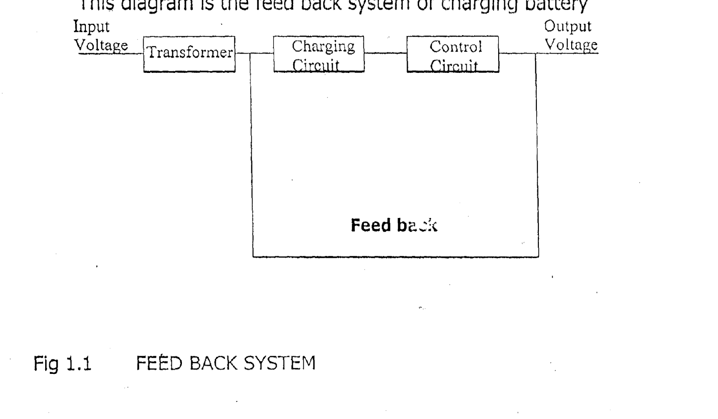

Fig. 1.1: Feed Back System

CHAPTER TWO
2.0 STAGES INVOLVED IN CHARGING CIRCUIT USED
There are categories stages involved in the circuit used. These are, the input stage, rectifying stage, smoothing stage and the output stage. The figure below shows the block diagram of individual stage involved in the circuit used.
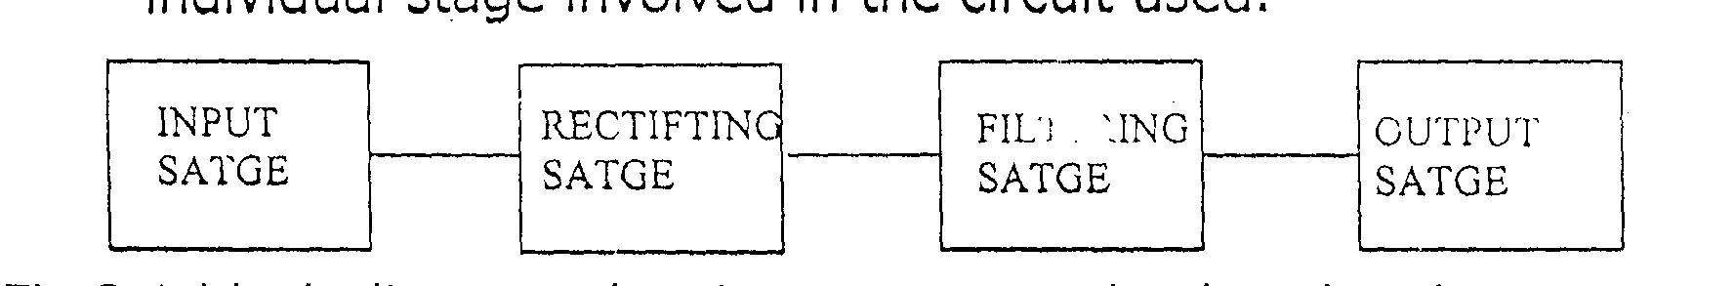

Fig 2.1: Block diagram showing stages involved in the charging circuit used

INPUT STAGE: - This is the stage through which power is being supplied from Electrical mains source of 230v, 50Hz to the circuit. Transformation of voltage is also takes place in this stage
RECTIF(ING STAGE: -In this stage conversion is take place where an alternating current (a.c) is being converted to direct current (d.c) through the means of rectifying diode in form of bridge rectifier
FILTERING STAGE: - In this stage, the remaining a.c component after rectification (i.e ripples) are filtered to give a more perfect direct current
OUTPUT STAGE: This is final stage in which the output terminal of the battery charger is connected to the battery to be charged.

Fig 2.2 (a) and (b) below show the arrangement of transformer voltages transformation and wave form produced in voltage transformation respectively.

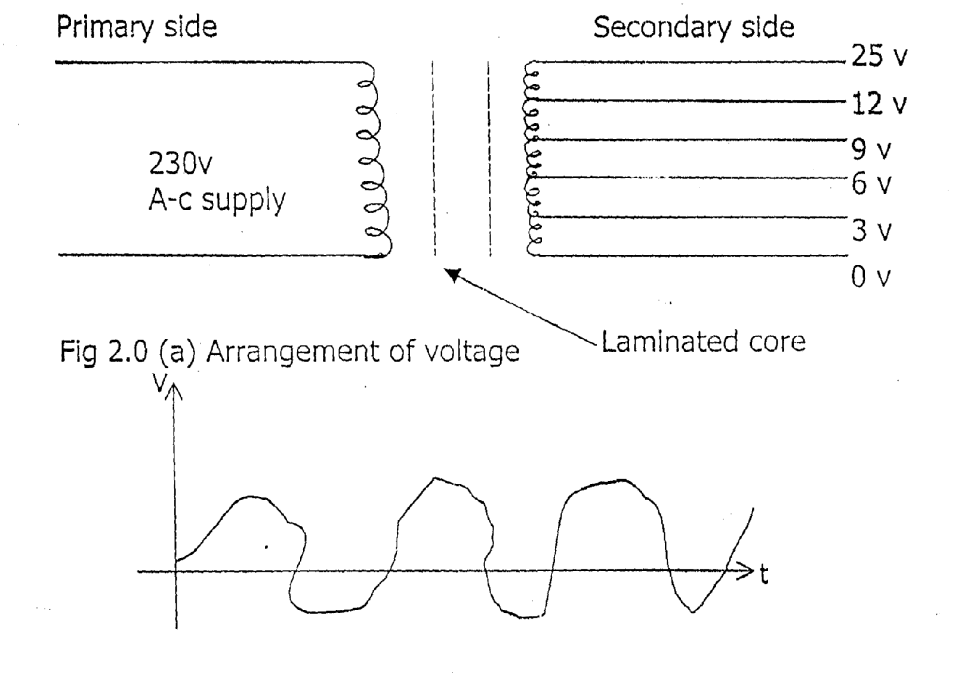
Fig 2.1 (b) wave form produced in voltage transformation

2.1 POWER SUPPLY
The source of electrical power supply is from the National Electric Power Authority (N EPA) or Power Holding Company Of Nigeria (PHCN) the supply is in form of alternating current and voltage. The supply voltage is 230 volts, which is being stepped down by step down transformer to 25v, 12v 9v, 6v, and 3v respectively. And the frequency of the supply still remain constant 50Hz.
2.2 VOLTAGE TRANSFORMATION
In voltage transformation a transformer is needed which is made up of magnetic core and several copper winding. The transformer used for this project is a step down transformer which consist of two separate windings, primary winding and secondary winding. These two winding share a common magnetic circuit i.e they are electro — magnetically coupled the primary coil is connect to time varying voltage source while. the secondary coil is connected to the load circuit. The ability to receive power at one voltage or current level and deliver it at other voltage or current level is the most unique feature which can be used to power the circuit that are isolated from the main power supply.
The magnetic core is made up of laminated metal sheets stamped together to provide a high performance so as to link magnetic field that develop at primary winding to the secondary winding. The transformer used is tapped at different point to give different voltage level and also to enable the voltage to be varied. The gauge of the wire used for the primary side is 25mm², which that of the secondary side is 19mm².
The turns on each side of the transformer are determined by using the transformation formulae
N1 = V1
N2 V2
Where N1 — The number of turns on the primary windings
N2 — The number of turns on the secondary windings
V1 — The primary voltage which is 230v
V2 — The tapped voltage at the secondary sides of the transformer, which are 25v, 12v, 9v, 5v, and 3v,

2.3 VOLTAGE RECTIFICATION
It is important to convert the alternating current to a direct current because charging of batteries is achieved through a direct current. This current can only be obtained from an alternating supply by means’ of rectifying diodes which is a device that allow current flow in only one directing i.e unidirectional way.
There, are two types of ratification which are half wave rectification, which consists of only one diode and full wave rectification, which consists of two diode or four diodes also known as bridge rectifier. But in this project, the type of rectification used is full wave rectification, a bridge rectifier which is incorporate to the a.c supply to obtain d.c as shown in diagram below.

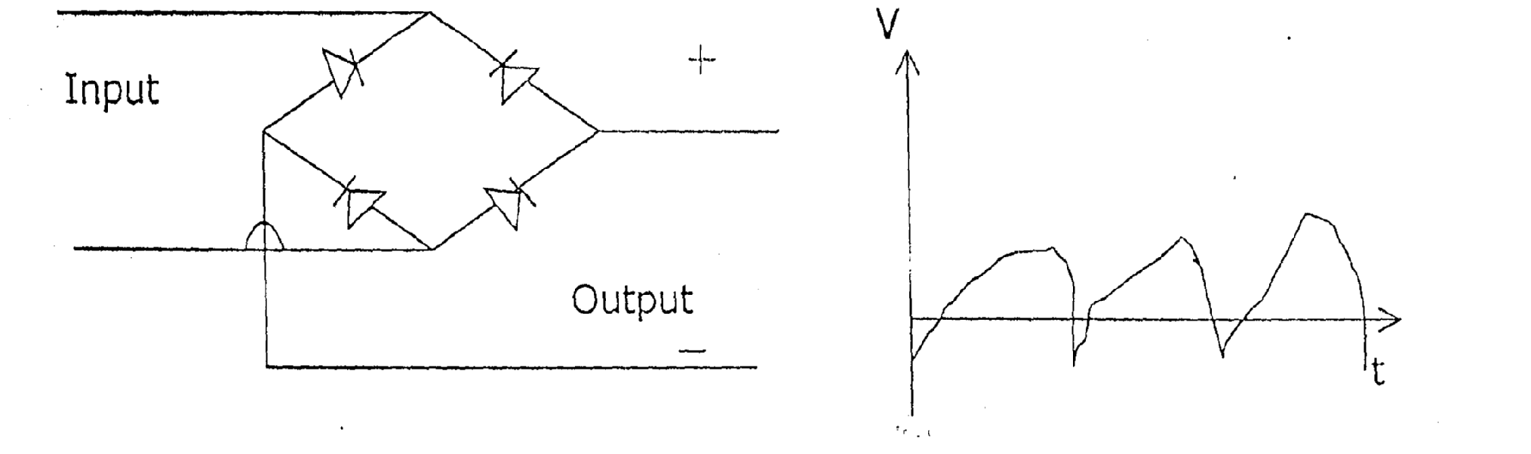
Fig. 2.2 (a) Bridge rectifier Fig. 2.2 (b) Was form produced by full wave rectification

2.4 VOLTAGE SMOOTHING
This is a process by which the alternating current components or ripples remaining after rectification are filtered with the use of a capacitor to give a more perfect direct current.

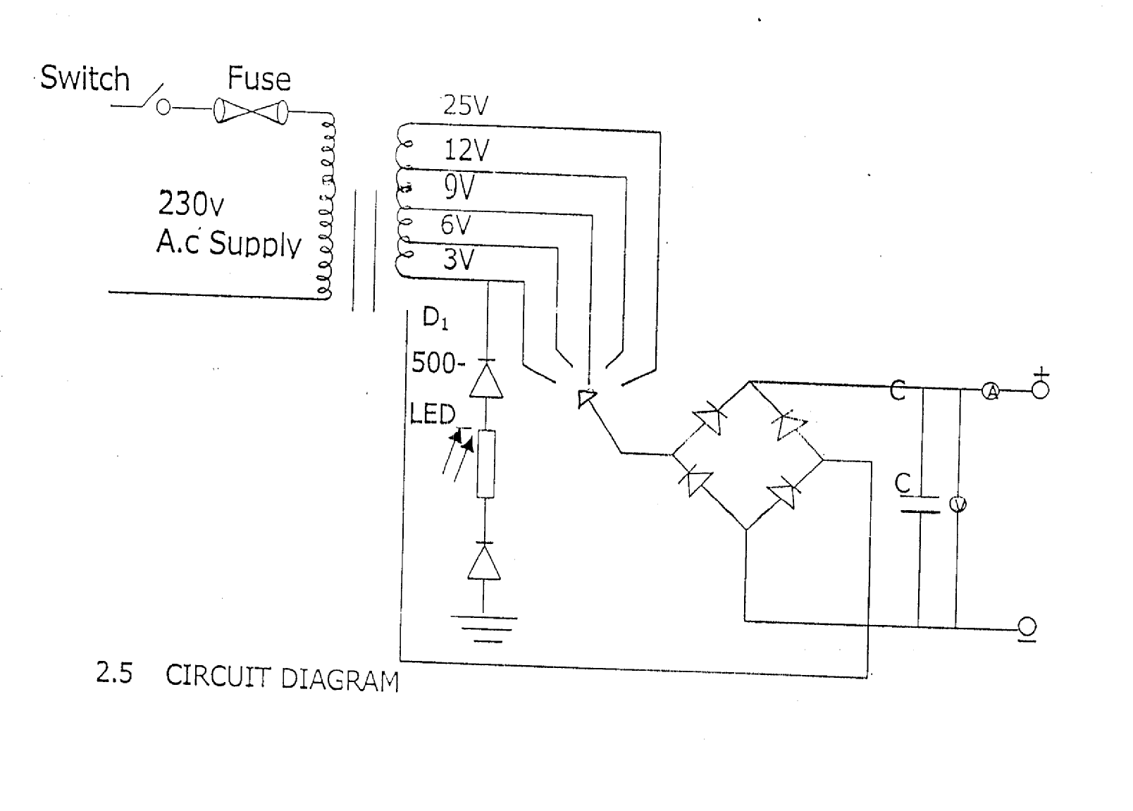

2.5 Circuit Diagram

CHAPTETHR THREE
3.0 TRANSFORMER
A transformer is a static electrical machines or device that transfer electrical energy from one circuit to another through inductively coupled electrical conductors. Transformer is made up of magnetic core and several copper windings and the windings are divided into primary and secondary winding he ability to receive power at one voltage or current level and delivers it at some other voltage / current level is the most unique feature of transformer and they can be used to power circuit that are isolated to control voltage and power system and they are used in cen1cal engineering for impedance matching The essential points of a transformer are primary winding which energize t:he coil from an external voltage while in secondary winding which is used to deliver power to an external load the magnetic core which is made up of laminated metal sheets stamped together to provide a high performance impedance so as to liked magnetic field developed in the primary winding to all forms of the secondary winding.
3.1 THE FORMER AND THE LAMINATED IRON CORE
The former is the insulated material used in winding the coils, It is normally plastic that can withstand a fairly high temperature which is show in the diagram 3.1 (a) while laminated iron core is made up of small amount of carbon steel and iron stamped together. This lamination is insulated from one another to reduce eddy current. The diagram also show In fig 3.1 (b).

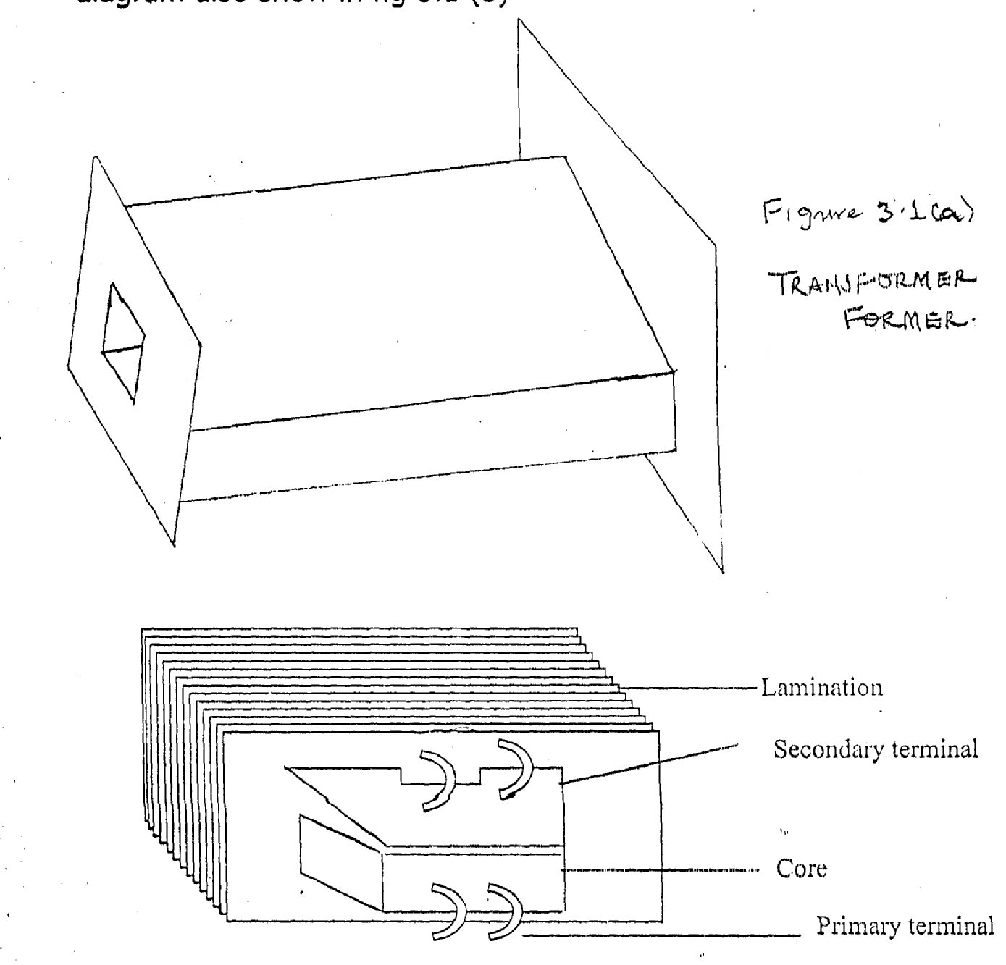

LAMINATED IRON CORE
Figure 3.1b LAMINATED IRON CORE
3.2 TRANSFORMER RATIO WINDING
The transformer turns ratio consists of two or more winding interlined by a mutual magnetic field. The transformer turns ratio is the ratio of primary turns and secondary turns. This shown in fig 3.2
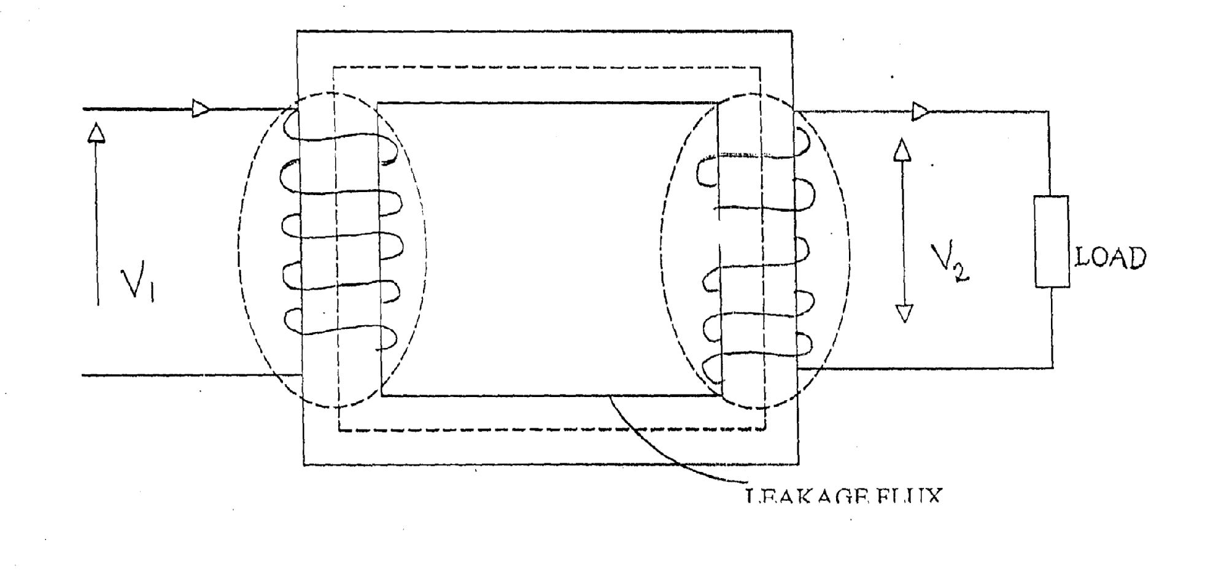

V1 — primary voltage
V2 — secondary voltage
Np — primary winding turns
Ns — secondary winding turns
Q—flux in webber
The value of induced e.m,f E n a winding of N turns is given by E = NdQ where dO is the rate at charge of flux linkages with the turn.
V2 N2 11
V1 N1 12

The ratio of the e,m.f under open circuit condition on no load may be ‘replaced by the voltage across the winding terminals, since, V= El and = V2
Therefore, V2 = V1 = N2
N1

3.3 TRANSFORMER RATING
Rating of transformer could be best determined by knowing the rate at which the heat generated by the internal losses can be dissipated. Since the prevalent loss in a transformer is copper loss, then, the rating of a transformer is “current limited” because of this, transformer are rated in volt amperes. In power transformer, the multiple KVA and MVA are used, Hence transformer rating VA = V2 V1 (full load) where 12 is the full load secondary current for the purpose of this project VA rating is the transformer used, As we are mandated to achieve a current of (0-10A), 25v as such, ruling of the transformer is V2 I2 25 x 10 = 25A. The approximate volt ampere is 250 VA or 0.025KVA. hence the project has 250V, L
3.4 TRANSFORMER RATIO
This is the ratio of input voltage V1 to that of the output voltage V2 and is determined by the ratio of the winding turns. Suppose, a transformer has an input voltage Vito be 80v, secondary voltage 160v and as primary number of turns up to be 300 turns and as secondary number of turns Ns:
Ns
300 : 600
1 : 2

This denotes a step up transformer as Ns > Np similarly if the source voltage is 200v and the output voltage is 200v with primary winding number 1000 turns and that of secondary to be 500 turns, the ratio at the transformer will be
100 : 500
2 : 1
This denotes step up transformer as NP > Ns => Ns < Np

3.5 PRINCIPLES OF OPERATION
The primary is connected to an alternative flux will produced whose amplitude will depend on the primary voltage and number of turns. This flux (mutual) will linked the other winding (the secondary) and induces a voltage in it, whose value will depends on the number of secondary winding almost any desired voltage ratio or ratio of transformer are obtained.
The above operation is obtained if an air core is used but it will be obtained much more effectively with a core of iron or other ferromagnetic material cause most of the flux will be confined to a definite path linking both winding and thus having a much higher permeability to that of air such transformer is called an iron core transformer and virtually all transformers are iron core type

3.6 TYPES OF TRANSFORMER
There are two major types of transformer namely, power transformer and instrument transformer Instrument transformer are divided into two, VIZ voltage and current transformer this depend on the parameter which they step down. Power transformer also classified that made up the following practical; auto transformer, center-tapped transformer and double wound transformer. ‘Power transformer could either be s:e o step down depending on its winding configuration on both primary and secondary side respectively.

3.7 LAMINATION
A practical iron circuit has a certain amount of power loss because of induced eddy current power loss in the on circuit using good engineering design, it is possible to minimize this power loss in power transformer by constructing the iron circuit with thin iron arranged properly culled lamination. The lamination use in this project is in thin sheet of guage 22.
3.8 IMPORTANCE OF LAMINATION
When laminate it increases the resistance of the iron core to the flow of eddy current, so that the induced eddy current in the core is reduced, as most of the flux are confined to e core and therefore links both winding. Its sometimes, the total gross sectional area of the iron circuit is not reduced so that the magnetic flux density is in charge. The laminations are isolated from one another by a very thin coat of varnish (or oxide) on one side of each lamination.
The following are the types of lamination: - letters L, letters E and I. The shell type of transformer uses E and I combination of lamination while the core type I transformer uses either a combination of L and I. The shaper of the thin iron used for lamination determines its shape. In this project work construction I²_{S} shape was used.

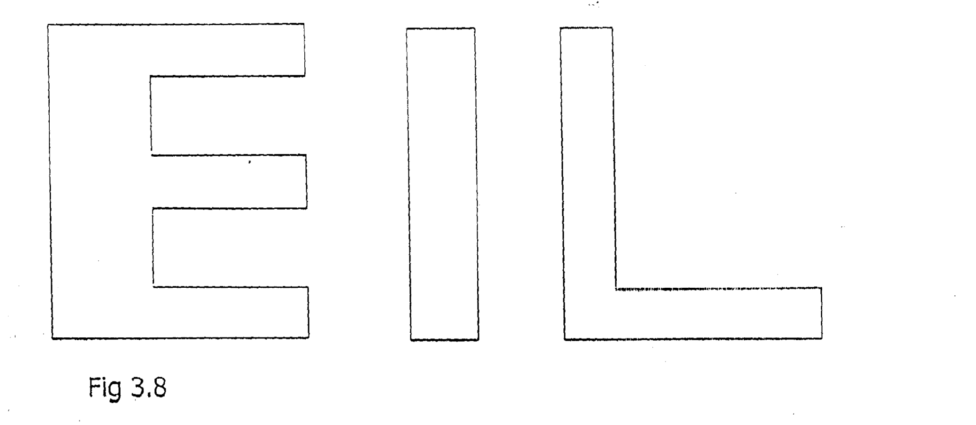
Fig. 3.8
3.9 TRANSFORMER DESIGN
In designing a transformer, the following parameter should be consider:-
Number of primary turns — N1
Number of secondary turns — N2
Primary current — 11
Secondary current— 12
Coefficient of coupling — K
Magnetomotive force — MMF
Mutual inductance — M
Relevance of the magnetic at — S
Mutual inductance - M= KN1N2
S
And MMF =N2 12
Since the magnetizing force is the same through out in the coil
then,
N1 11 = N2 12
I1 = N2 12
N1
11 = N2
12 N1
Also, EMF — produced in the primary is given by El =
4.44F1OMIN and e.m.f linking the secondary is given by E2 =
4.44OF2M2N2
4.44F1OMTN1 El
4.44F2OM2N2 E2
Since the maximum flux and frequency are the same
i.e OM1 = OM2 and F1 = F2
then, = E1 N1
E2 N2
So, E₁= N1 O and E2= N₂ O
E E

E1=N1 O/ E
N2 O E

Rate of change of flux is same in both windings, therefore,
El = N1
E2 N2

Now, Having known the principle of operation of particular equipment, it is possible to determine design values of it using good engineering design

CHAPTER FOUR
CONSTRUCTION
4.0 The construction work on any electrical/electronics equipment includes the main construction work on the circuit and the casing. The construction of this project was carried out inside the casing and not on Vero — board the component used in the construction was arranged properly as indicated on the circuit diagram Effective soldering was made from point to point so as to Avoid any fault due to improper soldering.
The construction work carried out can be categorized into two units. These units are mounted in the casing specially designed for the project.
4.1 COMPONENT TESTING
The testing of components used was done to make sure that all the components used are in good condition.
The test is carried on every component in the circuit such as switch, capacitor transformer and diode.
TEST ON SWITCH: - This was tested ohmmeter with two probes to the switch terminals to check its continuity, which was found to be okay.
TEST ON CAPACITOR: - Capacitor was tested with ohmmeter and it was found good because it defected initially and later going down which shows that it charges and then discharges.
TEST ON TRANSFORMER: - The transform was tested at the output side with voltmeter to make sure that the output voltages are of the require values.
TEST ON DIODE:- This was tested with analogue multi — meter which indicated that the diode conducts only in the forward direction.
4.2 COMPONENTS ARRANGEMENT
The arrangement of component in this project were from the left to right starting with switch and fuse connected to the primary terminal of the transformer. A bridge rectifier was connected to the secondary side of the transformer. Capacitor was connected very close to the bridge rectifier in parallel for the filtering and smoothing purposes.
Also a d.c voltmeter to indicate the charging voltage is connected in parallel with the rectifier, and a d.c ammeter to indicate the charging current is also connected in series with the rectifier.

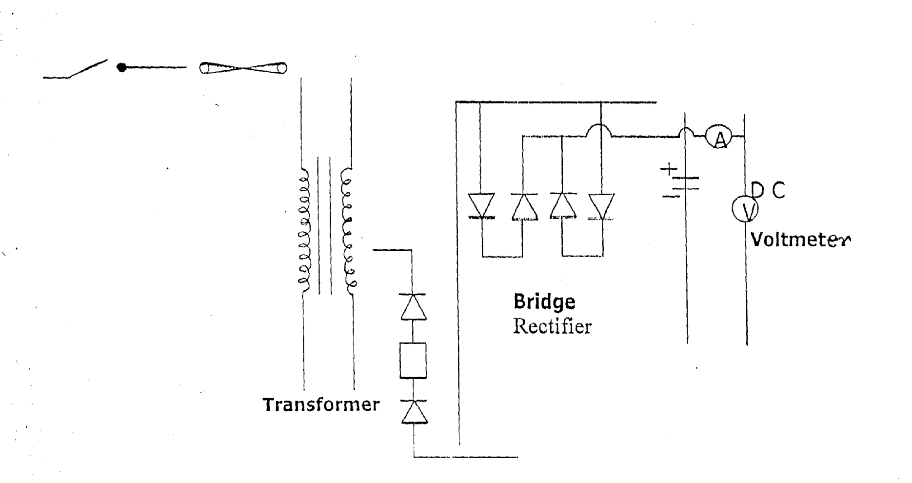

4.3 CONNECTIONS OF FAN REGULATOR TO THE TRANSFORMER
This was done by connecting the fan regulator to the secondary side of the main transformer the striating of the secondary winding to the one side of the bridge rectifier and then, the common point of the fan regulator to the other side of the diode bridge rectifier. This enhances the variation of output voltage from the secondary side of the main transformer with the tapping 9v, 12v, and 25v depending on the battery to be charged.

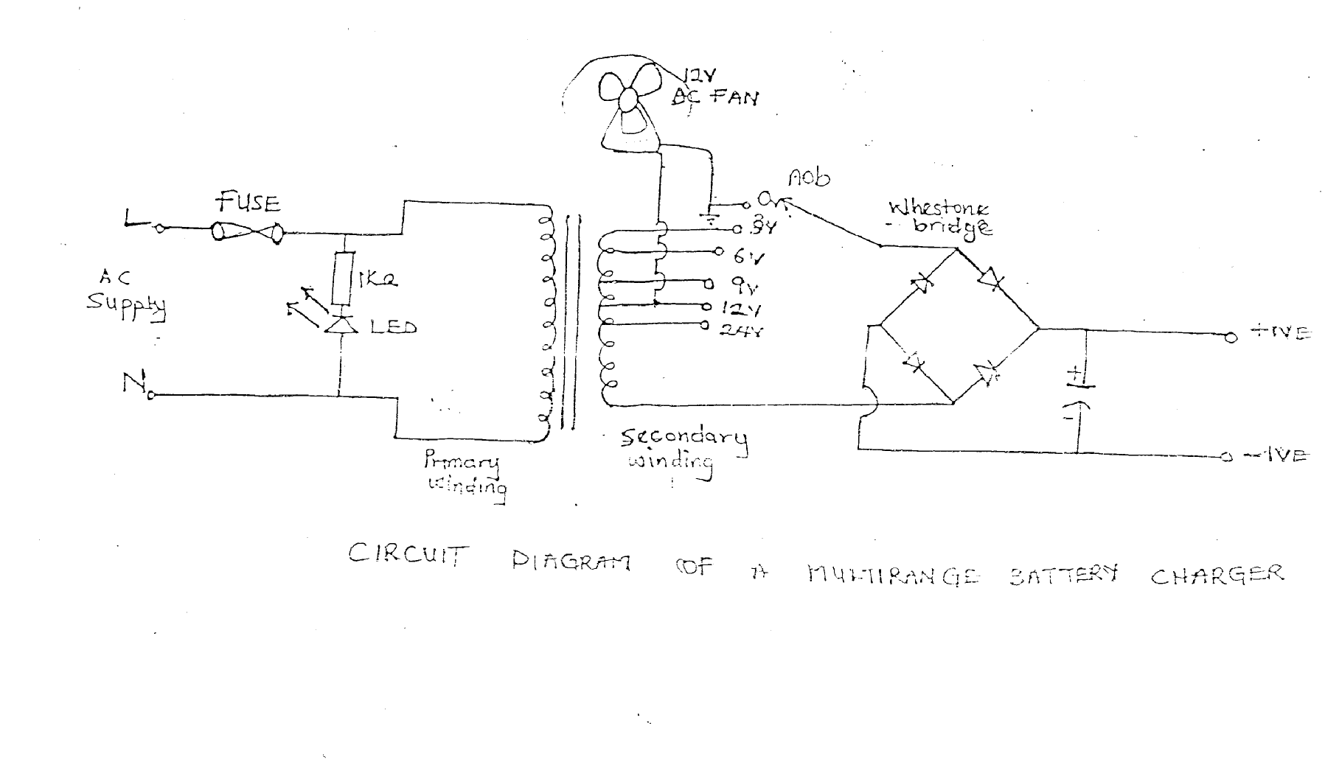

4.4 CONNECTION OF CAPACITOR TO THE BRIDGE RECTIFIER AND BRIDGE RECTIFIER TO THE FAN REGULATOR
The capacitor is connected to the D.C output of the rectifier as used in the diagram below and it’s acts as a smoothing capacitor which smoothes and filters the ripples from the rectifier to reasonable level in the circuit.
The bridge rectifier contains four diode connected in star shaped and is capable of withstanding more than 30 amperes without breakdown. The diode has four pins , two at which are of the alternating current input and the other two for direct current output

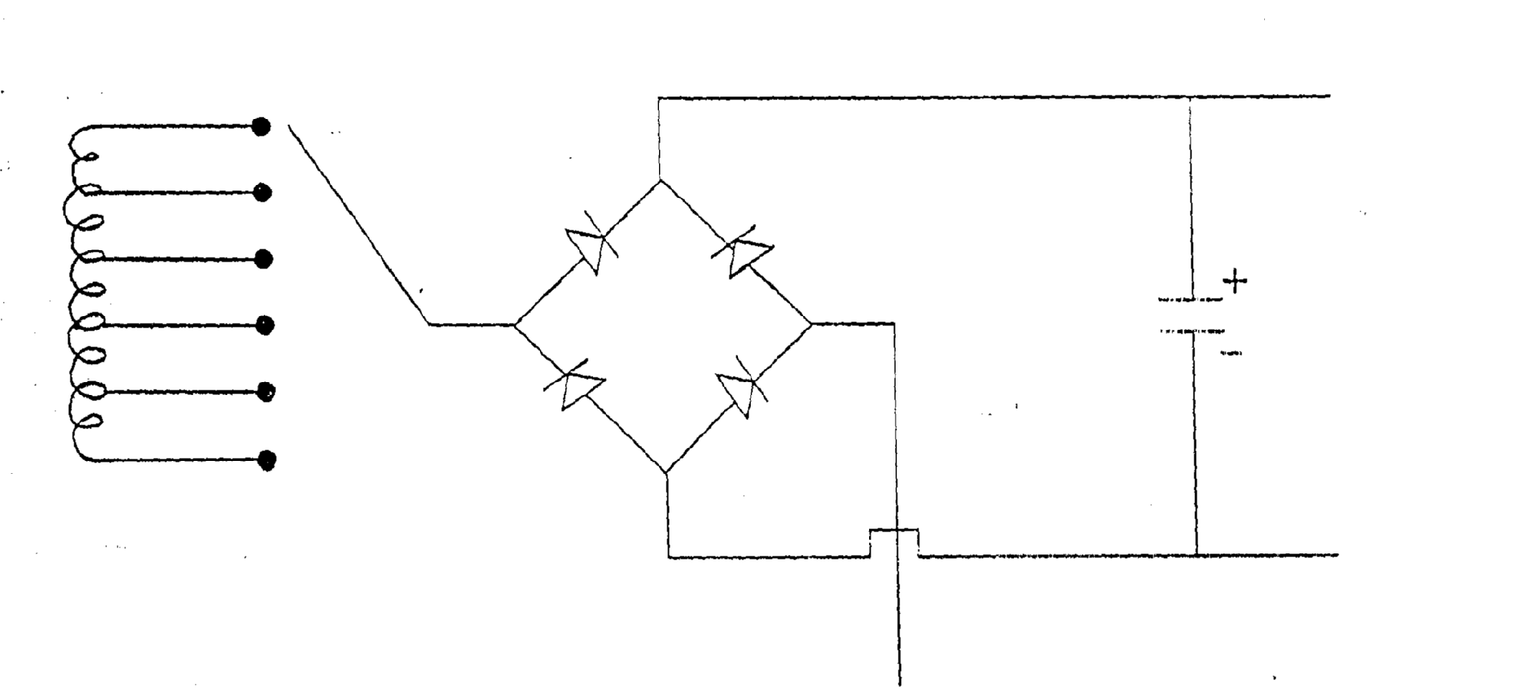
4.5 CONNECTION OF LED TO TRANSISTOR AND CONNECTION IN FUSE
The light emitting diode (LED) is connected in parallel to the circuit to indicate output power position (of ON and OFF). The fuse is connected to the line conductor of the 230v A.C supply as a means of protection of the circuit, from excessive current, with a switch to make and break the circuit the figure below shows connection in fuse.
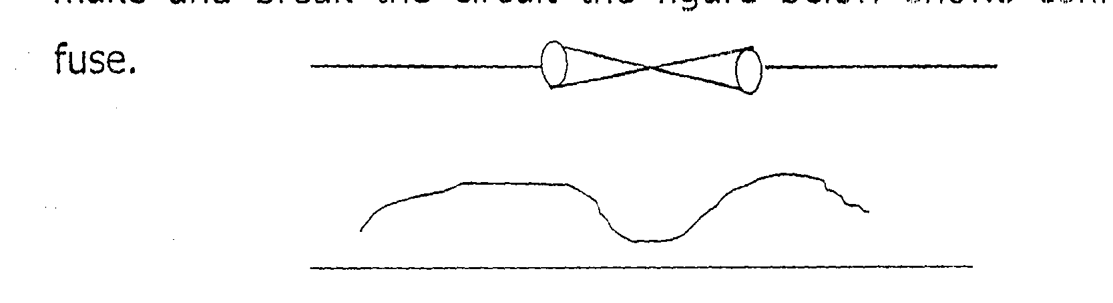

4.6 CONNECTION OF MEASURING INSTRUMENT TO THE CIRCUIT AND CONVERTING OF RESISTOR TO THE CIRCUIT
The measuring instrument which are ammeter and voltmeter.
The ammeter is connected in series used to measure the output current and the voltmeter is connected in parallel used to measure the output voltage respectively. The resistor used are connected in with the diode and light emitting diode as shown in the diagram below. The series resistor is used to limit some of the current why led operates on a very low current.

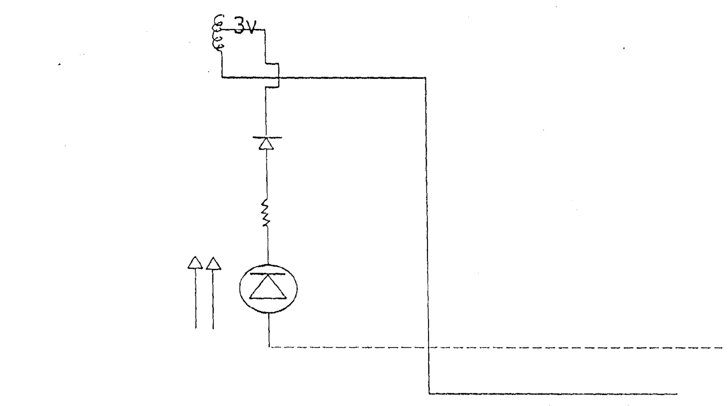

4.7 SOLDERING METHOD AND PRECAUTION
Having properly arranged the components soldering was the next step. Soldering is the method of joining two or more component together to give a firm joint that is mechanically strong and electrical continuous. For effective soldering the following soldering defects must be avoided.
- No solder: - This occurs when a joint is left completely unsoldered.
- Insufficient solder: - these can cause partial contact and to avoid this there must be enough solder at the joint to form good filler between the connecting point.
- Dry joint and overheating must also be avoided for a good soldering, it must have the following characteristics, which are.
- Free of holes, scars and spite
- After soldering the outline of the conductor must be left clearly and have bright shinning appearance finally, when soldering heat must not be two much on the components to be soldered, otherwise, the components might be damaged
4.8 CASING AND FINAL COUPLING
In construction of cabinet (casing), there are many factors to be considered such as the size of cabinet, mounting position of component, component ventilation, cabinet movement: and painting.
Taking into consideration the size of the transformer constructed and other component us d made the cabinets. This was done so as to give enough room. For the accommodation of all the components, the cabinet is rectangular in shape with six (6) sides, which are the following:-
Length Width
Front view 25cm 18cm
The back view 25cm 18cm
The two sides view 25rm 15cm
The top view 35m 18cm
The base view 35cm 18cm
Fan is constructed at the back of the casing to provide air cooling (Ventilation) for the transformer and other Components used.
The front cover contains components such is voltmeter, ammeter, control variable switch, limp indicator and the output terminals at the back of the casing
4.9 PROBLEM ENCOUNTERED AND COST ESTIMATION
The construction of battery charger is as easy as being provided in the circuit. But some of the problems encountered during the construction is that of malfunction of the component such as diode capacitor, resistor etc.
None availability of some components used also posed problem, because component such as d.c ammeter, d.c voltmeter are not easy to get in the market. Since we are unable to get these components we need to travel from one place a another to buy thorn which increased the cost of the project.
However, in view of all the problem being enumerated above, we will suggest that Polytechnic Authority and the Government should try to assist the final year students in form of financial aid just because not all the parents are economically buoyant to provide all the needs of their children at school. In times of state bursary, they should let this circulate to all the students because during our time in us to collect bursary form, obtain Nakks receipt e.t.c but at last, we won’t see our name.

COST ESTIMATION (ENGINEERING BILL OF QUANTITY)
Before undertaking any project it is necessary to consider the overall cost. In order to avoid stoppage of the project you want to embark on the table below shows the cost of the materials used for the project. Table one
S/N | Quantity | Description | Rate | Amount (N)
1 | 1 | D.C Voltmeter | 800.00 | 800.00
2 | 1 | D.C Ammeter | 1,200.00 | 1,200.00
3 | 1 | Cord | 250.00 | 250.00
4 | 1 | Transformer | 2,500.00 | 2,500.00
5 | 1 | Capacitor | 50.00 | 50.00
6. | 4 | Jack Plug & Socket | 25.00 | 100.00
7 | 1 | Diode | 150.00 | 150.00
8. | 1 | Fan regulator | 200.00 | 200.00
9. | 1 | Switch | 60.00 | 60.00
10. | 2 yards | Cable | 50.00 | 100.00
11 | 1 | Fuse | 40.00 | 40.00
12. | 2 | Clip | 75.00 | 150.00
13. | 1 | Casing |  | 1,500.00
 |  |  |  | 1,500.00
TOTAL |  |  |  | 7,000.00

CHAPTER FIVE
CONCLUSION AND RECOMMENDATION
5.1 Conclusion
In the construction of battery charger, there are some factors need to be consider that contributed to the success and perfect working of it. Practically, the construction of the battery charger especially the circuit used needs careful arrangement of the components. Handling and proper soldering of the component should be done carefully.
The components could also lead to dart ne by mishandling of the components and become waste. The clear example is the conducting lead of rectifier and the transformer, which need to he carefully soldered.
In order to ensure a proper working of the constructed battery charger and that it actually deliver the correct voltage to the battery on charger a voltmeter is connected in parallel with the charging circuit to obtain readings, so also an ammeter is the reading of charging current when the circuit is connected to the battery (load).
Lastly, it is a fact that anybody undergoing construction work may have a plan to employ and that the person should not be rigid on one particular method as this may waste lot of useful time during construction.

5.2 Recommendation
This project is recommended for all organization and industry using D.C power and charging component.
Also, to all student wishing to embark on this type of project should have of in their mind that most of this component can fail any time so one should not rely on any of the components student should also understand that how to put the circuit tight because the circuit assigned for you may not be the type needed.
Lastly, over confidence should not be owed since constructions of a project need careful handling, and planning is very important. This project is recommended to all students in technological engineers studying power or electronics as an option and to all powerhouses.

REFERENCES
Donnelly E.L. (1973): Electrical Installation theory and practice. Third edition, publisher Edward Arnold publishing limited London. (86-89).

Edward Hughes (1987): Electrical technology, Fifth Edition, publisher, Longman, England. (388-389) (675-676).

Adeife T.O. (1996). Electronics Engineering Fundamentals. First Edition, Publisher: Ademola Printing Press, Oshogbo (46-49).

Cambridge Consultants (1969): Instruction Manual on Electrical maintenance. first edition, publisher: The Engineering Industrial Training Board, Watford. (241-244).

