APPLICATION OF ORDINARY LEAST SQUARE METHOD ON EXCHANGE RATE
BY
IDRIS HABEEB OLAYIWOLA ND/23/STA/FT/0108
ABDULRASHEED BARAKAT OMOWUMI ND/23/STA/FT/0107
IBRAHIM KAOSARAT OPEYEMI ND/23/STA/FT/0030
AYINDE SAIDAT ND/23/STA/FT/0073

A PROJECT SUBMITTED TO THE DEPARTMENT OF STATISTICS, INSTITUTE OF BASIC AND APPLIED SCIENCES, KWARA STATE POLYTECHNIC, ILORIN

IN PARTIAL FULFILMENT OF THE REQUIREMENTS FOR THE AWARD OF NATIONAL DIPLOMA (ND) IN STATISTICS.

JUNE, 2025

Certification
This is to certify that this project was carried out by IBRAHIM KAOSARAT OPEYEMI with Matriculation Number ND/23/STA/FT/0030. The project has been read and approved as meeting part of the requirement for the award of Higher National Diploma in Statistics.

_________________ _________________
Salami O.O Date
Project Supervisor

_________________ _________________
Mrs. Elepo T.A Date
Head of Department

_________________ _________________
External Examiner Date

DEDICATION

I dedicated this project to the maker of my life who created me . He that has being my strength in time of weakness (Almighty Allah ) for His protection throughout my days in school and my wonderful family (My parents , brothers & sisters) for their parental support for my education .

Lastly , I am dedicating this project to the coming generation who are actually waiting for the manifestation of our lives .

ACKNOWLEDGEMENT

I thank Almighty Allah for his grace, guidance,and strength throughout the period of my study and the successful completion of this project

I would like to express my sincere appreciation to my supervisor (Mr salami O.O) for his support patience and valuable contribution to this work

My deepest gratitude goes to my wonderful parents for their unwavering love, prayers, encouragement and sacrifices.your support has been my greatest strength,and I am forever thankful.

Special thanks to my dear brothers (saheed ,Qodir )for their love and motivation and also my friends and colleagues especially (Aminat,Ayomide , Kereemat ) whose support and companionship have meant so much throughout this journey.

To everyone who contributed in one way or the other to the success of this project,I say a heartfelt thank you

TABLE OF CONTENT
Title Page 1
Certification 2
Dedication 3
Acknowledgement 4
Table of Content 5
CHAPTER ONE 6
- Introduction 6
1.1 Aim and Objectives 7
1.2 SIGNIFICANCE OF THE STUDY 8
1.3 SCOPE OF STUDY 8
1.4 LIMITATION OF STUDY 8
CHAPTER TWO
2.0 Literature Review 9
CHAPTER THREE
3.0 RESEARCH METHODOLOGY 13
3. 1 Introduction 13
3.2 method of Data Collection 14
3.3 Feature of time series 16
3.4 Concepts of Time series 17
3.5 Assumptions of Time-Series Analysis 20
3.6 Components of Time Series 22
3.7 Models for Time Series Analysis 23
3.8 Estimating Model Parameters 25
CHAPTER FOUR
4.0 Data Presentation and Analysis 28
4.1 Data Presentation 28
4.2 Data Analysis 33
CHAPTER FIVE
5.0 Summary of Findings and Conclusion 36
5.1 Summary of Findings 36
5.2 Conclution 36
Reference 37
CHAPTER ONE
- INTRODUCTION
Exchange rate is a major variable in the general economic policy making both in developed and developing economies as its appreciation or depreciation affects the performance of other macroeconomic variable and its attainment of macroeconomic objective cannot be over emphasized. A very strong exchange rate is a reflection of a strong and viable economy while on the other hand; a very weak exchange rate is a reflection of a very weak and vulnerable economy. In the light of its importance, every country pays so much attention to the appropriateness of her foreign exchange policy. As a result, governments, especially in the developing economies over the years have adopted different exchange rate management policies with a view to achieve realistic and stable exchange rate. Thus, most of these countries including Nigeria experienced high exchange rate fluctuation which translates into high degree of uncertainty (Ajao and Igbokoyi, 2013).
Nigerian pound in sympathy with the British pound. Two major reasons accounted for this reluctance. First, a considerable share of the country's resources was being diverted to finance the war. And second, there was the apprehension that devaluation of the Nigerian pound would only raise domestic prices of imports without any appreciable impact on exports, which were still largely primary products. Rather than devalue the Nigerian pound, the monetary authorities decided to quote the Nigerian currency in reference to the US dollar. In addition, they impose severe restrictions on imports as well as strict administrative controls on foreign exchange.
The determination of appropriate and sustainable exchange rate in Nigeria has not been an easy task to both the government and policy makers. Before the introduction of the Structural Adjustment Programme (SAP) in 1986, Nigerian currency was said to be overvalued and that was why it was opened to market forces of demand and supply in 1986 to determine its real value. Since the devaluation that followed till date, the Nigeria’s exchange rate policies have not yet been appropriate or able to accomplish the desired objectives. It would be recalled that after experimenting with flexible exchange rate policies since 1986 through Second-tier foreign exchange market (SFEM), Dutch Auction System (DAS), Modified Dutch Auction System (MDAS), Weighted Dutch Auction System (WDAS), etc., and punctuated by fixed exchange rate (1994-1998), the monetary authorities found it necessary to revert to fixed exchange rate policy in 2008. It soon neglected that and opted for currency redenomination which was rejected. There was the re-introduction of the DAS in 2002 as a result of the intensification of the demand pressure in the foreign exchange market and the persistence in the depletion of the country’s external reserves. Also, there was the introduction of the wholesale DAS in 2006 which further liberalized the market in an attempt to evolve a realistic exchange rate of the Naira, and finally the managed float exchange rate system which was introduced in June, 2016. The evolution of the foreign exchange market in Nigeria up to its present state was influenced by a number of factors such as the changing pattern of international trade, institutional changes in the economy and structural shifts in production.
The behavior of the naira exchange rate under each system was markedly different volatile in some and fairly stable (but unrealistic) in others. Management of the exchange rate in Nigeria. The concern with exchange rate management policy in Nigeria can be traced back to 1960 when the country became politically independent, even though the Central Bank of Nigeria and the Federal Ministry of Finance had come into being two years earlier. There are a variety of ways and reasons for classifying subsequent developments in Nigeria's exchange rate policy. One classification would put such developments into two phases, namely, a passive phase and an active phase. Yet another binary classification, which is essentially equivalent to the foregoing, is the pre-structural adjustment and post structural adjustment division in exchange rate policy developments. A classification that seems

1.1 AIM AND OBJECTIVES:
The aim of the research is to study the rate of exchange of GB pounds currency, using Time series analysis, while the Objectives are to:
- Obtain the time series plot of the monthly GB pounds currency data
- To test for the stationarity of the data
- To fit the appropriate model for the series
- To forecast for future values of the rate of exchange in GB pounds over the next five years

1.2 SIGNIFICANCE OF THE STUDY
Monetary foreign exchange is said to be an important element in the economic growth and development of a developing nation because the policies influence the economic activities and to a large extent, dictate the direction of the macro-economic variables in the country.

1.3 SCOPE OF STUDY
The research work which study the roofing sheet quality the life span cover some selected and common roofing sheets commonly used in the roofing during construction of shelters.

1.4 LIMITATION OF STUDY
In the course of the research work some constructions were encounter such as access to data identification of roofing sheet types, the data used is a published data from the source of Central Bank of Nigeria (CBN), which is limited from 2010-2020
CHAPTER TWO
2.0 LITERATURE REVEIW
The behavior of the naira exchange rate under each system was markedly different volatile in some and fairly stable (but unrealistic) in others. Management of the exchange rate in Nigeria. The concern with exchange rate management policy in Nigeria can be traced back to 1960 when the country became politically independent, even though the Central Bank of Nigeria and the Federal Ministry of Finance had come into being two years earlier.
According to Amartya Sen.(1999)” There are a variety of ways and reasons for classifying subsequent developments in Nigeria's exchange rate policy. One classification would put such developments into two phases, namely, a passive phase and an active phase. Yet another binary classification, which is essentially equivalent to the foregoing, is the pre-structural adjustment and post structural adjustment division in exchange rate policy developments. A classification that seems to capture the historical sequence more closely, however, would divide exchange rate management into five periods or stages. Stage I: Fixed parity between the Nigerian pound and the British pound In the first period of exchange rate policy in Nigeria, which spanned the year 1960-1967 there was a one-to-one relationship between the Nigerian pound (Ne) and the British pound sterling (Se). This fixed parity lasted until the British pound was devalued in 1967. Because of the Nigerian civil war which was going on at the time, the monetary authorities did not consider it expedient to devalue the Nigerian pound in sympathy with the British pound. Two major reasons accounted for this reluctance.
Ahmad .G. (2000) reported that, a considerable share of the country's resources was being diverted to finance the war. And second, there was the apprehension that devaluation of the Nigerian pound would only raise domestic prices of imports without any appreciable impact on exports, which were still largely primary products. Rather than devalue the Nigerian pound, the monetary authorities decided to quote the Nigerian currency in reference to the US dollar. In addition, they impose severe restrictions on imports as well as strict administrative controls on foreign exchange. Stage II: Fixed parity between the Nigerian pound and the American dollar the second period of Nigeria's exchange rate policy lasted from 1967 to 1974.
Akogun, B. (2003). analyzed the determinants of the nominal exchange rate in Croatia by using the bounds testing (ARDL) approach to co-integration. The results indicated the existence of a stable co-integration relationship between the observed macroeconomic variables and the nominal exchange rate, whereby an increase in the majority of the variables led to an exchange rate appreciation. Thus, the determination of the nominal exchange rate in Croatia primarily depends on the external factors that affect domestic economy. It was however recommended that the results obtained can be useful to policy makers in making monetary policy decisions in keeping the exchange rate stable.The variables used in the study include; government expenditure, money supply, domestic debt and external debt. The study employed the ARDL model to examine the relationship between the variables. The findings revealed that there exist positive relationship between government expenditure and exchange rate volatility.
Emiray and Rodriguez (2003) applied various time series models including a linear model with stable deterministic seasonality, a linear model with seasonal unit roots, seasonal autoregressive integrated moving average (SARIMA) model, periodic AR model, and structural time series model. They used Canadian air passengers’ monthly data and concluded that the simple models perform better in the short-term, while flexible and adoptable complex models work better in the long-term. Also, the original country of the passengers, the flight type (domestic, trans-border, and international), the performance measure, and the forecasting horizon influence the forecasting performance of the models.
Morzuch(2004) investigated the models proposed by Chan and Chu (2014) along with two of their own, to forecast the inbound tourist arrivals to Singapore. They worked on within sample performance of the competing models and also the post-sample performance. They found that the winter’s three-parameter model outperforms the ARIMA model based on the within-sample results, and the ARIMA model outperforms the Winters three-parameter model based on post-sample results.
Chu (1999) incorporated the fractionally integrated autoregressive moving average (ARFIMA) models into Singapore’s tourism forecasting and compared the accuracy of forecasts with previous studies.
The Purchasing Power Parity (PPP) approach to the exchange rate determination was and continues to be a very influential way of thinking about the exchange rate. The PPP posits that the exchange rate between two currencies would be equal to the relative national level prices. The PPP derives from the assumption that in the world there exists the law of one price. This law states that identical goods should be sold at identical prices. The law of one price implies that exchange rate should adjust to compensate for price differentials across countries (Hoontrakul, 1999). Notwithstanding, the infraction to this law often engendered by transportation and handling charges, it is generally believed that the law is plausible. Accordingly, the absolute PPP stipulates that the absolute level of the exchange rate is that which causes traded goods and services to have same price in all countries when measured in the same currency. There is however very little empirical support for the absolute PPP due to the rather strong influence of transportation costs and trade barriers at keeping prices from equalizing across geographical locations, and the effect of the differences in the composition and relative importance of various goods on each country’s price level determination (Bell, W.R 2012). The Portfolio Balance approach views the exchange rate as resulting from a process of financial equilibrium in the economy. Such financial equilibrium results from a simultaneous equilibrium in the individual financial asset markets, that is, when the amount of each asset desired to be held is the amount that is actually held. Three of such markets are considered very important here, domestic money or monetary base, domestic bonds and foreign bonds. Three equilibrium prices emerge from the attainment of this financial equilibrium: equilibrium price of each asset, the equilibrium interest rate in the country and the equilibrium exchange rate. The exchange rate emerges from this model because any portfolio switches between the domestic assets and the foreign asset necessitates new demand for foreign exchange noted that the approach disregards the fundamentals of trade in its calculations and this may be a source of inexplicable changes in the exchange rate.

CHAPTER THREE
3.0 RESEARCH METHODOLOGY
3.1 INTRODUCTION
Data collection is the process of gathering information for the purpose of investigation or inquires. Most often the information we need for such investigation are not readily available either because they are not documented or are scattered in various documents. Data collection is a very important stage in every statistical investigation, in fact, the method employed in the collection of data determines to a large extend the source of the enquiry. There are two sources of data collection we have primary and secondary sources and also two types of data which are primary and secondary data. The type of data are used in this research is the secondary data.
Data is said to be obtained from primary source if it represents the raw material of an investigation. Such data are the most original and authentic data that is not obtained from primary source are said to be obtained from secondary source, they are not original or material which has undergone some sort of statistical treatment, at least once for a certain purpose. Data collected from primary and secondary sources are referred to as primary and secondary data respectively. But based on this research, the data used is obtained from a secondary source published by Central Bank of Nigeria (CBN) on GB pounds from 2010 to 2020

3.2 METHODS OF DATA COLLECTION
There are many techniques or methods of data collection. The most important among these are discussed as follows:
- Interview method: By this method, data are collected from the informants by trained agents called enumerators. These agents visit the informants in their houses or offices, in the markets or on the streets as the case may be, asked the necessary questions and enter the replies in special blank called schedule. This method has some advantage and disadvantages as follows:

Advantages
- It is easy to conduct
- It gives no room for malpractice
- It is good for planning purposes
Disadvantages
- Very expensive
- Possibility of missing people in their houses is high

- Questionnaire method: By the questionnaire method, a list of questions which seeks response to a number of pertinent questions of interest to the investigator. The importance of a good questionnaire cannot be over-emphasized. There are two types of questionnaires which are structural (close-ended) and the unstructured (open-ended) questionnaire.

Advantages
- It is easy to conduct
- It gives no room for malpractice
Disadvantages
- Very expensive
- The right answer may not be not given

- Registration Method: This is a method whereby data are collected by keeping records of events. Immediately they occur or soon after their occurrence. By this method, information is collected through registration of births, deaths, marriages, divorces, immigration and emigration, motor accidents, industrial accidents and many more. It is more efficient in developed countries than in the developing once. This method provides valuable record of social charges over time.

- Documentary Method: The use of documentary sources is very important in the planning stage of collecting data from any of the source primary or secondary. It is of no useful hurrying into field without consulting any official or private.

3.2.1 Time Series
A time series is a series of observations, y_{t}, recorded sequentially and uniformly in time, t, of a particular phenomenon. The initial observation is considered recorded at t= 1 and the final observation at t = T. consequently, observations range from y₁ to yt. The units of measurement depend on the phenomenon being observed and can be any unit of time (e.g. decade, year, hour, minute, second, etc).A typical of time series graph is shown in
3.2.2 Discrete and continuous
Time series can be either discrete or continuous. A continuous time series occurs when the observed data, y_{t} values, has values continuously through time, t. Whereas, discrete time series occur when the observed data, y_{t}, has values only at fixed time intervals, r, such that { y_{t} : t= 1,1+r, …, T-r, T}. A discrete time series May arise when either continuous data are recorded discretely (e.g. temperature measured once per day), accumulative values of observations are of interest (e.g. rainfall over a week), or the phenomenon observed is actually discrete (e.g. length of a queue for a day)

3.2.3 Deterministic and Stochastic
An important feature of time series data is the dependence on time order. A time series observation at y_{t} may partially or fully depend on previous observations, y_{t-1,} y_{t-2,} etc. Fully dependent time series are referred to as deterministic as their future behavior can be predicted exactly using only past observations. However, in practice, these are unlikely to occur as observations also partially depend on exogenous factors [47, page 2921). Such time series only partially dependent on past observations are referred to as stochastic since the exogenous factors appear to behave randomly.
Objectives of Time series
- To use past behaviors of variables to predict future occurrence or even
- It helps to adjust or put into process under control
- The behaviors of variables enable us to iron inter year variation
- The use of graphical representation gives proper description of the series

3.3 Feature of time series
- Trends: A trend is the general behavior of a series over a given length of time. They can be for example, either upward or downward, strep or slight, exponential or linear, and may also change over time
- Seasonality: A time series exhibits seasonal behaviors when observations at regular time periods are significantly different from those otherwise, Seasonal affects, often referred to us cyclical, may change over time
- Irregularity: Time series are often affected by events which seem to occur randomly, such as strikes, government decisions, natural disasters, war. Economic and financial time series according to Chatfield (10), are especially affected. A stochastic or random event at time t is usually evident from a significant change in observations, and may not only affect the current observation y_{t} but also subsequent observation y_{t+1}
- Conditional Heteroskedasticity: Often, particularly in econometric and financial time series [29. 10], irregularities cluster together and successive observations exhibit sharp changes. These are generally referred to as "volatility clusters" [29]. Frequently, sequences of highly volatile observations are followed by sequences of low volatility, or conversely, observations with low volatility are followed by highly volatile sequences
- Non-Linearity: A different average change between successive observations in a time series usually indicates non-linear behaviour. That is, a series may either increase at a faster rate than it falls or, alternatively, fall more rapidly than increase. Enders suggests a number of economic time series should display non-linearity [20]. Quite often, these will either fall sharply and rise slowly (e.g. industrial output) or rise sharply and fall slowly (e.g. unemployment rate)(29).Chapter

3.4 Concepts of Time series
3.4.1 Mean and Expectation
The mean for a particular observation, y_{t}, at time t is given by
μ (t) = E(y_{t})
where t=1, ..., T and E(y_{t}) is the expectation function which calculates the expected value of observation y_{t}
3.4. 2 Variance
The variance for a particular observation y_{t} at time t is given by
𝞂²(t)= E[(y_{t} - μ (t)]²
where μ (t)]is the mean at time t and E () is the expectation function. if the variance is constant for all t, then it will be given by 𝞂²

3.4.3 Autocovariance
The autocovariance function (abbreviated acf) measures the dependency between two variables generated from the same stochastic process. Consider the observations y_{t} and y_{t+r} generated by a stochastic process and separated by time intervals. The acf is then given by
γ(ᵣ) = COV (y_{t}, y_{t+r}) = E[(y_{t} - μ (t))( y_{t+r -} μ (t + ᵣ)]
3.4.4 Stationarity
A process, y_{t} , is said to be strictly stationary, also referred to as strongly stationary if and only if the joint distribution of (y_{t+t1,} …, y_{t+tr} ) is the same as the joint distribution of (y_{t1,} …, y_{tr}) for every (t,t₁, ᵣ, t_{n}) [ 33]
However, often in practice a weaker definition for stationarity is used and is defined
μ_{t} = μ for all t
COV (y_{t}, y_{t+r}) = γ(ᵣ) for all t
That is, the mean does not depend on time and the autocovariance depends only on the time interval. Such processes are referred to as weakly stationary or second under stationary
3.4.5 Disturbances
A phenomenon’s irregularities may be incorporated as disturbance, or errors, into a time series model via a random process, a. If it has zero mean and constant variance
E(_{ᵋt}) = 0
E(_{ᵋt}) = 𝞂²
and is independent across time:
E(_{ᵋt ᵋr}) = 0 for all t not equal zero
then they are inferred to as white noise or simply noise. Often, _{ᵋt} is assumed to be generated from a Normal distribution, demoted by
_{ᵋt} ~ N(μ, 𝞂²)
Where μ is the Mean and o² is the variance. Generally, it is assumed μ = 0
3.5 Assumptions of Time-Series Analysis
1. Theoretical Issues: The usual cautions apply with regard to causal inference in time-series analysis. Only with random assignment to treatment conditions, control of extraneous variables, and manipulation of the intervention(s) can cause reasonably be inferred when differences associated with an intervention are observed. Quasi-experiments are designed to rule out as many alternative sources of influence on the DV as possible, but causal inference is much weaker in any design that falls short of the requirements of a true experiment.
2. Practical Issues: -The random shocks that perturb the system are considered to be independent and normally distributed with mean zero and constant variance over time. Contingencies among scores over time are part of the model that is developed during identification and estimation. If the model is good, all sequential contingencies are removed so that you are left with the randomly distributed shocks. The residuals, then, are a reflection of the random shocks: independent and normally distributed, with mean zero and homogeneity of variance. It is expressly assumed that there are correlations in the sequence of observations over time that have been adequately modeled. This assumption is tested during the diagnostic phase when remaining, as yet unaccounted for patterns are sought among the residuals. Outliers among scores are sought before modeling and among the residuals once the model is developed. A model is developed and then normality of residuals is evaluated in time-series analysis. Examine the normalized plot of residuals for the model before evaluating an intervention.
3. Normality of Distributions of Residuals: -Transform the DV if residuals are non- normal. The normalized plot of residuals is examined as part of the diagnostic phase of modeling, the usual square root, logarithmic, or inverse transformations are appropriate in the event of non-normally distributed residuals.
4. Homogeneity of Variance and Zero Mean of Residuals: After the model is developed, examine plots of standardized residuals versus predicted values to assess homogeneity of variance over time. Consider transforming the DV if the width of the plot varies over the predicted values. McCleary and Hay (1980) recommend a logarithmic transformation to remedy heterogeneity of variance.
5. Independence of Residuals: -During the diagnostic phase, once the model is developed and residuals are computed, there should be no remaining autocorrelations or partial autocorrelations at various lags in the ACFs and PACFs. Remaining autocorrelations at various lags signal other possible patterns in the data that have not been properly modeled. Examine the ACFs and PACFs for other patterns and adjust the model accordingly.
6. Absence of Outliers: -Outliers are observations that are highly inconsistent with the remainder of the time-series data. They can greatly affect the results of the analysis and must be dealt with. They sometimes show up in the original plot of the DV against time, but are often more noticeable after initial modeling is complete. Examine the time-series plot before and after adjusting for autocorrelation and seasonality to identify obvious outliers. Unfortunately, there are no concrete guidelines to determine how discrepant a case must be to be labelled an outlier in a time-series analysis (Cryer, 1986, p. 250). An outlier is dealt with in the usual manner by checking the original data for errors, deleting the observation, replacing the observation with an imputed value, and so on. SAS ARIMA has a procedure to
detect changes in the level of the response series that are not accounted for by the model
7. Characteristic Movement of Time Series: Time series graph is a graph that describes a point moving with the passage of time. Time series reveals many characteristics movement of variation, some or all of which are present to varying degrees. Analysis of such movements is of great values in many connections, one of which is the problem of forecasting future movements. These characteristic movements have four components which are:
i. Trend
ii. Cyclic movement
iii. Seasonal movement
iv. Irregular movement

3.6 Components of Time Series
The characteristics movements of time series may be classified into four types, often called the components of time series.
1. Long Term or trend: These refer to the general direction in which the graph of a time series appears to be going over a long interval of time. It refers to the general tendency of the time series data to increase or decrease over a long period of time.
- The study of trend enables us to have a general idea about the pattern of behavior of the phenomenon under consideration.

- By isolating trend values from a given time series, we can study the short-term and irregular movements.
- The study of trend enables us to compare two or more time series over different periods of time and to draw important conclusion about them. Gupter (1981).
2. Cyclic Movement or Cyclic Variation: These refer to the long-term oscillations, or swing, but a trend time or curve. These cycles, as they are sometimes called, may or may not be periodic, that is, they may or may not follow exactly similar patterns after equal interval of time.
3. Seasonal Movement or Seasonal Variation: These refer to the identical or almost identical patterns that a time series appear to follow during corresponding months or quarter of successive years. The main objective of studying seasonal variations is the establishment of the seasonal patterns which helps in planning future operating and formulating policies.
4. Irregular or Random Movement: In addition to the influence of long term and short-term forces, every time series is subjected to occasional influences, which may occur just once, or several times, but without any pattern or regularity, although it is ordinary assumed that such irregularities produce variations that last only a short time.
3.7 Models for Time Series Analysis
There are two mathematical models which are commonly used for the decomposition of a time series into its components. These are:
- Additive Model: According to this model, a time series is the sum of its four components, symbolically
Y = T+S+C+1
Where, Y denotes the result of the fur components
T denotes trend component
S denotes seasonal component
C denotes irregular component.
This model assumes that all components of time series are independent of one another. For example, it assumes that trend has no effect on the seasonal and cyclic components, nor do seasonal swings have any influence on cyclical variation and vice versa. This model also assumes that the different components are absolute quantities expressed in original units and can take positive and negative values.
2. Multiplicative Model: According to this model, a time series is the product of its four components, symbolically
Y=TSCI
In this model only trend is expressed in terms of original values, while the seasonal and cyclic components are expressed as relatives or percentages. This model assumes that the four components of a time series are due to different causes, but they are necessary and they can affect each another.
Estimation of Seasonal Variable: Seasonal Index
To determine the seasonal factor S in the time series equation, we must estimate how the data in the time series vary from month to month throughout a typical year. Various methods are available for computing a seasonal index, which include the following:
1. The average-percentage method: In this method, we express the data for each as percentages of the averages of the year. The percentages for corresponding month of different years are then averaged, the resulting 12 percentages gives seasonal index.
2. The percentage trend, or ratio-to-trend method: In this method, the trend for each month is calculated by the method of least squares. We express the data for each month as percentage of monthly trend value. An appropriate average of the percentage for corresponding months given the required index.
3. The percentage moving-average, or ratio-to-moving average method: In this method, we compute a 12-month moving average. Since the result thus obtained fall between the successive months instead of the middle of the month (which is where the original data fall), we compute a 2-month moving average of this 12- month moving average. After doing this, we express the original data for each
month as a percentage of the 12-month cantered moving average that corresponds to the original data. The percentages for the corresponding months are then average, given the required index.
The ratio-to-trend and ratio-to-moving average method are employed in this research work to estimate the seasonal index and to forecast for future values.
Depersonalization of Data
If the original data are divided by the corresponding seasonal index number, the resulting data are said to be DE seasonalized, or adjusted for seasonal variation. Such data still include trend, cyclic and irregular movement.

3.8 Estimating Model Parameters
Estimating the values of parameters in models consists of estimating the parameter(s) from an auto-regressive model or the T parameter(s) from a moving average model. As indicated by McDowall et al. (1980) and others, the following rules apply:
1. Parameters must differ significantly from zero and all significant parameters must be included in the model.
II. Because they are correlations, all auto-regressive parameters must be between land 1. If there are two such parameters (p-2) they must also meet the following requirements:
Φ₁+ Φ₂ <1
and
Φ₂ – Φ₁ < 1
These are called the bounds of stationarity for the auto-regressive parameter(s)
3. Because they are also correlations, all moving average parameter must be between -1 and 1.
If there are two such parameters (q=2) they must also meet the following requirements:
Φ₁+ Φ₂ <1
and
Φ₂ – Φ₁ < 1
These are called the bounds of invertibility for the moving average parameter(s).
Yt = a+bt
Where Y, is the trend value at time (t), a and b are constants to be estimated, t is the time in days, weeks, month etc. the trend value is then multiplied by the seasonal index.
i.e. Forecast = trend x seasonal index

CHAPTER FOUR
4.0 DATA PRESENTATION AND ANALYSIS
This chapter presents the data and the statistical techniques used to analyze the data is Time series analysis.
4.1 DATA PRESENTATION
MONTHS/YEARS | GB POUNDS
JAN 2010 | 239.96
FEB 2010 | 232.66
MAR 2010 | 223.26
APR 2010 | 217.36
MAY 2010 | 219.42
JUN 2010 | 219.42
JUL 2010 | 227.02
AUG 2010 | 232.94
SEP 2010 | 232.86
OCT 2010 | 237.62
NOV 2010 | 232.78
DEC 2010 | 236.92
JAN 2011 | 242.81
FEB 2011 | 243.95
MAR 2011 | 249.16
APR 2011 | 250.11
MAY 2011 | 248.14
JUN 2011 | 242.51
JUL 2011 | 247.53
AUG 2011 | 224.48
SEP 2011 | 239.15
OCT 2011 | 243.27
NOV 2011 | 246.98
DEC 2011 | 246.92
JAN 2012 | 249.34
FEB 2012 | 248.03
MAR 2012 | 242.42
APR 2012 | 243.66
MAY 2012 | 244.87
JUN 2012 | 250.86
JUL 2012 | 250.45
AUG 2012 | 248.69
SEP 2012 | 251.56
OCT 2012 | 248.72
NOV 2012 | 241.10
DEC 2012 | 234.75
JAN 2013 | 238.34
FEB 2013 | 241.11
MAR 2013 | 235.64
APR 2013 | 241.35
MAY 2013 | 251.43
JUN 2013 | 250.86
JUL 2013 | 250.76
AUG 2013 | 255.13
SEP 2013 | 256.59
OCT 2013 | 257.81
NOV 2013 | 258.95
DEC 2013 | 260.67
JAN 2014 | 262.41
FEB 2014 | 263.29
MAR 2014 | 265.93
APR 2014 | 260.12
MAY 2014 | 254.06
JUN 2014 | 250.27
JUL 2014 | 249.96
AUG 2014 | 262.86
SEP 2014 | 254.39
OCT 2014 | 274.79
NOV 2014 | 295.60
DEC 2014 | 294.24
JAN 2015 | 304.79
FEB 2015 | 306.06
MAR 2015 | 306.41
APR 2015 | 307.21
MAY 2015 | 302.55
JUN 2015 | 302.26
JUL 2015 | 299.38
AUG 2015 | 295.39
SEP 2015 | 283.62
OCT 2015 | 281.79
NOV 2015 | 280.40
DEC 2015 | 282.07
JAN 2016 | 286.33
FEB 2016 | 328.53
MAR 2016 | 388.37
APR 2016 | 406.13
MAY 2016 | 401.08
JUN 2016 | 375.71
JUL 2016 | 379.49
AUG 2016 | 381.39
SEP 2016 | 376.32
OCT 2016 | 381.17
NOV 2016 | 378.13
DEC 2016 | 386.92
JAN 2017 | 395.04
FEB 2017 | 391.57
MAR 2017 | 397.36
APR 2017 | 396.08
MAY 2017 | 408.57
JUN 2017 | 403.25
JUL 2017 | 404.45
AUG 2017 | 410.48
SEP 2017 | 422.35
OCT 2017 | 427.40
NOV 2017 | 427.26
DEC 2017 | 428.38
JAN 2018 | 412.23
FEB 2018 | 406.64
MAR 2018 | 402.76
APR 2018 | 394.24
MAY 2018 | 399.86
JUN 2018 | 395.87
JUL 2018 | 389.40
AUG 2018 | 395.53
SEP 2018 | 399.02
OCT 2018 | 404.28
NOV 2018 | 400.18
DEC 2018 | 393.98
JAN 2019 | 388.93
FEB 2019 | 382.80
MAR 2019 | 373.26
APR 2019 | 376.06
MAY 2019 | 388.43
JUN 2019 | 395.63
JUL 2019 | 402.83
AUG 2019 | 401.22
SEP 2019 | 397.96
OCT 2019 | 403.79
NOV 2019 | 447.92
DEC 2019 | 443.96
JAN 2020 | 452.17
FEB 2020 | 476.54
MAR 2020 | 500.38
APR 2020 | 494.18
MAY 2020 | 494.71
JUN 2020 | 503.49
JUL 2020 | 511.67
AUG 2020 | 397.96
SEP 2020 | 403.79
OCT 2020 | 447.92
NOV 2020 | 443.96
DEC 2020 | 452.17
Source: Central Bank of Nigeria
4.2 DATA ANALYSIS
Table 4.2 : Model Summary
Model Summary^{b}
Model | R | R Square | Adjusted R Square | Std. Error of the Estimate
1 | .932ª | .868 | .867 | 30.401
From the above table the R value which is the correlation value shows that there is a very strong relationship in the change in time (year, month) and the exchange rate of Pounds to naira and the adjusted R squared shows that 86.7 % of the variation of exchange rate of naira to pounds is explained by the change in time.
Table 4.3 Analysis of variance
ANOVAª
Model |  | Sum of Squares | df | Mean Square | F | Sig.
1 | Regression | 788170.045 | 1 | 788170.045 | 852.821 | .000^{b}
1 | Residual | 120144.895 | 130 | 924.191
1 | Total | 908314.940 | 131
Table 4.3 above shows that the model is adequate with the P-value <0.0001 which is less than the level of significant.

Table 4.3: Coefficient table
Coefficientsª
Model |  | Unstandardized Coefficients |  | Standardized Coefficients | t | Sig.
 |  | B | Std. Error | Beta | t | Sig.
1 | (Constant) | 190.352 | 5.322 |  | 35.765 | .000
1 | Time | 2.028 | .069 | .932 | 29.203 | .000
From the above table with the P-value = <0.001 and the t statistic value 29.203 shows that there is significant relationship between the time change and the exchange rate of naira to pounds.
Model Estimation
Pounds = 190.352 + 2.028*time
The above model shows that in one unit increment in the time there will be an increment in the exchange rate of pound to naira by 2.028
ASSUMPTION TEST
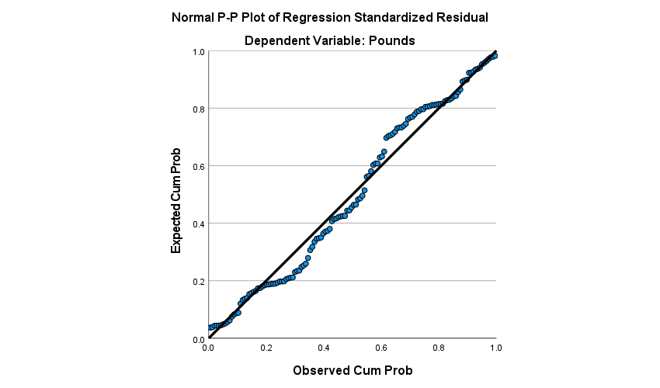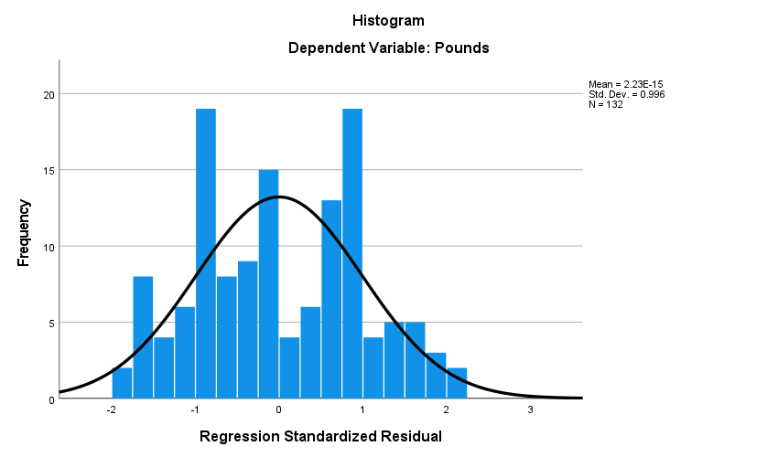

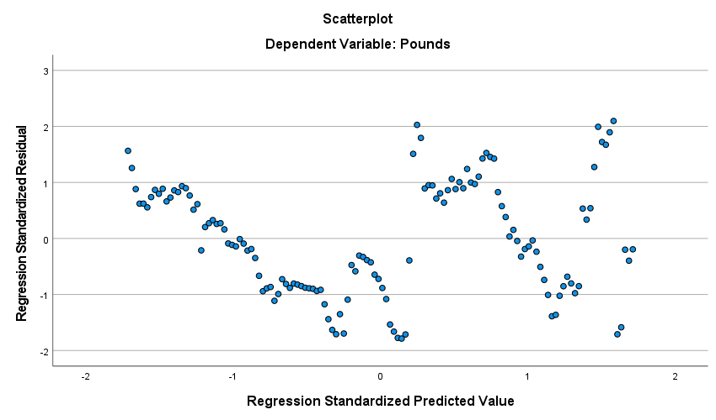

CHAPTER FIVE
5.0 SUMMARY OF FINDINGS AND CONCLUSION
5.1 SUMMARY OF FINDINGS
The findings revealed that R value which is the correlation value shows that there is a very strong relationship in the change in time (year, month) and the exchange rate of Pounds to naira and the adjusted R squared shows that 86.7 % of the variation of exchange rate of naira to pounds is explained by the change in time. There is adequacy in the model with the P-value <0.0001 which is less than the level of significant P-value = <0.001 and the t statistic value 29.203 shows that there is significant relationship between the time change and the exchange rate of naira to pounds. Based on the fitted model, Pounds = 190.352 + 2.028*time shows that in one unit increment in the time there will be an increment in the exchange rate of pound to naira by 2.028
5.2 Conclusion
In conclusion there is a very strong relationship in the change in time (year, month) and the exchange rate of Pounds to naira furthermore, in one unit increment in the time there will be an increment in the exchange rate of pound to naira by 2.028

REFERENCES
Amartya Sen.(1999)” statistical journal on foreign exchange and its application to Life Expectancies”. John Wiley and Sons printing press, New York
Ahmad .G. (2000). On the relation between the expected values and the vitality of the nominal excess return on stock. The journal of finance 48(5):1779-1801
Ajao and Igbokoyi. (2013) forecasting and time series: An applied approach. Third Edition. M.J medal, New York
Akogun, B. (2003). Identification of periodic autoregressive moving average models a thesis submitted to the graduate school of natural and applied science of Middle East technical university page 127.
Bell, W.R (1984). An introduction to forecasting with time series models. Insurance: mathematics and economics volume 3, page 241-255.
Bowermen, B.L an O’Connell, R.T. (1993) forecasting and time series: An applied approach. Third Edition.
Brockwell, G.E.P, and Davis, R.A (2002). An introduction to time series and forecasting, Second Edition. Springe, New york: Springer university press.
Bloom and Sachs(2009) ”Special Bulletin on GB pounds in British by Y.K printing press
Bloom and Canning E.A , (2003)” journal on Abridge life tables in demography using Time Series Analysis” Uppsala University. Swede edition by eddie printing press.
Chan and Chu (2014). Time series analysis. Singapore Medical Journal Retrieved from Hoglin, Phillip, J. Time series Analysis and Accession Optimization of Prior Enlisted United States.
Chu (1999); The vitality of the nominal excess return on stock. The journal of finance management 48(5):1779-1801 published by Y.K press, Sweeden
Emiray and Rodriguez (2003), Distribution of the estimator for autoregressive time series with a unit root. Journal of American statically association. 54: 159-178
Ginsburg e’tal (2017), Measure of Life expectancies in sweden. Springer printing press limited in AJCC Series staging manual, New York.
Grossman (1972). Time series analysis. Singapore Medical Journal Retrieved from Hoglin, Phillip, J. Time series Analysis and Accession Optimization of Prior Enlisted United States.
Hontrakul (1999) Clinical practice and follow-up of patients with early breast cancer, J medal press in England.
Morzuch (2004), World British Pounds from the bulletin of world health organization (WHO). 83, 171-177.

