DESIGN AND IMPLEMENTION OF CREDIT CARD VALIDATION SYSTEM USING LUHN ALGORITHM

BY
AMUSAT RISQOT
HND/23/COM/FT/0184

SUBMITTED TO THE DEPARTMENT OF COMPUTER SCIENCE, INSTITUTE OF INFORMATION AND COMMUNICATION TECHNOLOGY

KWARA STATE POLYTECHNIC, ILORIN.
IN PARTIAL FULFILLMENT OF THE REQUIREMENTS FOR THE AWARD OF HIGHER NATIONAL DIPLOMA (HND) IN
COMPUTER SCIENCE

JUNE, 2025.

CERTIFICATION
This is to certify that this project was carried out by ADAM ROQEEB ADEWALE
of Matriculation Number: HND/23/COM/FT/0183 in the Department of Computer Science, Institute of Information Communication Technology, Kwara State Polytechnic, Ilorin, Kwara State.

…………………………………. ….………………………
MR. BOLAJI-ADETORO, D. F. Date
Project Supervisor

…………………………………. ….………………………
MR. OYEDEPO, F. S. Date
Head of Department

…………………………………. ….………………………
External Examiner Date

DEDICATION
We dedicate this project work to Almighty God who inspired us and directed our ways during our academic stay in the polytechnic.

ACKNOWLEDGEMENT
All praise is due to Almighty God the Lord of universe. We praise him and thank him for giving me the strength and knowledge to complete my HND program and also for my continued existence on the earth.
I appreciate the utmost effort of my supervisor, Mr Bolaji-Adetoro D.F. whose patience, support and encouragement have been the driving force behind the success of this research work. He gave useful corrections, constructive criticisms, comments, recommendations, advice and always ensures that an excellent research is done. Our sincere gratitude goes to Head of Department and other members of staff of the Department of Computer Science, Kwara State Polytechnic, Ilorin, for their constant cooperation, constructive criticisms and encouragements throughout the programmed.
Special gratitude to our parents, who exhibited immeasurable financial, patience, support, prayers and understanding during the period in which we were busy tirelessly on our studies, special thanks go to our lovely siblings
Our sincere appreciation goes to our friends and classmates.

TABLE OF CONTENTS
Title page i
Certification ii
Dedication iii
Acknowledgements iv
Table of contents v
Abstract vi
CHAPTER ONE: GENERAL INTRODUCTION
1.1 Introduction 1
1.2 Statement of the Problem 2
1.3 Aim and Objectives 3
1.4 Significance of the Study 3
1.5 Scope of the Study 3
1.6 Organization of the Report 4
CHAPTER TWO: LITERATURE REVIEW
2.1 Review of Related Works 5
2.2 Review of General text 9
2.3 Historical Background of Bank 10
CHAPTER THREE: RESEARCH METHODOLOGY AND ANALYSIS OF THE SYSTEM
  - Research Methodology 13
  - Analysis of the Existing System 14
  - Problem of the Existing System 15
  - Analysis of the Proposed System 15
  - Advantage of the Propose System 16
CHAPTER FOUR: DESIGN, IMPLEMENTATION AND DOCUMENTATION OF THE SYSTEM
  - Design of the System 17
    - Output Design 17
    - Input Design 19
    - Database Design 21
    - Procedure Design 22
  - Implementation of the System 22
    - Choice of programming language 22
    - Hardware support 22
  - System Documentation 23
    - Operating the System 23
    - Maintaining of the System 23
CHAPTER FIVE: SUMMARY CONCLUSION AND RECOMMENDATION
5.1 Summary 24
5.2 Conclusion 25
5.4 Recommendations 25
References 26
APPENDICES
Algorithm (if any)
Abtract
Credit card validation system (sample of master and visa card) using luhn algorithm is a system that will serve as a more reliable and effective means of requesting and validating of credit card. It is discovered that customers faced various problems such as queuing up during credit request and validation, delay in processing of validation form, unavailability of some key staff while processing card validation. This has led delay of credit card validationand inability to complete the tedious manual process of request. This research work therefore focused on the implementation of credit card validation system to minimize the shortcomings of the existing system. Hence the proposed system will be develop in Software Application which makes use of the following C# (CSHARP) as the programming language due to its user friendliness while MYSQL is used as the back end (Database).

CHAPTER ONE
GENERAL INTRODUCTION
  - BACKGROUND OF THE STUDY
Credit card acceptance enables merchants to sell goods and services to customers who increasingly choose electronic forms of payment over other payment types. During the last decade, debit card transactions grew rapidly in most advanced countries. Credit cards have increasingly become the preferred methods for consumers to pay for goods and services, making these forms of electronic payments an indispensable way for merchants big and small to conduct business. The trend of rising usage is predicted to continue for some time. Credit card transactions surpassed more than 50% of all non-cash transactions by 2006, up from 42% in 2003, according to a tri-annual study by the Federal Reserve. This research work will be of benefit to all banking system which will allow every user to generate and validate their credit card easily and of help to individual which easy their stress of not visiting the bank hall all time for card credit card validation and pin generation. Hence system will be develop as software i.e. C# (CSHARP) for the structural design and validating, and MYSQL database as the back end, (Pooja&Dhande, 2019).
The credit card business got momentum in the sixties and a number of banks entered the field in a big way. Credit card culture is an old hat in western countries. In India, it is relatively a new concept that is fast catching on. The present trend indicates that the coming years will witness a burgeoning growth of credit cards which will lead to a cashless society. Credit has become an important vehicle of trade promotion. Credit cards provide convenience and safety to the buying process. One of the important reasons for the popularity of credit cards is the sea change witnessed in consumer behaviour. Credit cards enable an individual to purchase products or services without paying immediately. The buyer only needs to present the credit cards at the cash counter and sign the bill. Credit card can, therefore, be considered as a good substitute for cash or cheques (Yogesh & MrSushil, 2020).
A credit card, as the name indicates, enables the cardholder to enjoy credit from the issuing bank for a specific period after the purchase. During this period, the cardholder is allowed to use the card for incurring further expenses. A bankcard is used to make an electronic withdrawal from funds on deposit in a bank, as in purchasing goods or obtaining cash advances. Credit cards are one of the most popular forms of payment for consumer goods and services in the United States (BulomineRegi, 2020).
Credit card is a beneficial financial instrument which helps consumers to get financial resources for current consumption redeemable in future date. The first type of credit card was made on 8th February, 1950. It was known as the Diners club card. These diners card were used for the credit purchase which was issued in the early twentieth century in the USA. These cards were basically used for travelling and entertainment purpose. Later on it gave the idea of an international card that can be used for credit purchase around the world. Due to this, credit card emerged at a very fast pace around the globe. Most of the studies on credit cards have been done in developed economies. Credit cards are popular as a medium for exchange of transactions. (Sheikh et al., 2020).
Credit cards make it easy for the household and personal spending to take place even in many developing countries. The benefit of using credit card which attracts most of the customers is its acceptability around the globe. It also relieves the need to carry much cash, maintains an accurate purchase record, facilitates refunding of merchandize, it entertains customers by awarding attractive reward points which can be redeemed and in case of theft it gives an option to reverse the transaction. Apart from all the benefits listed above there is a major drawback of credit card is that it leads to a common habit known as “Compulsive Buying”. Consumers of credit cards become victim of excessive purchase on debt that has an adverse impact such as addictive shopping and unnecessary debt. Multiple research proved that a card holder would spend more compared to using cash in an identical situation (Prelec&Semeter, 2017).
1.2 STATEMENT OF THE PROBLEM
The method of card validation is very tedious in the sense that to obtain a card there is need to go to bank hall and fill form customer will past through some tedious procedure just to validate card and it’s time consuming. Several applications has been developed using window base to generate and validate customer credit card which customer need to go to the bank hall to activate. To make card request, validation and pin generation easier for all bank easier, this platform will be suitable in the sense that for every customer who want to request for card or generate pin can do that on this platform without any stress or waste of time or delay.
1.3 AIM AND OBJECTIVES
The aim of this research is to design and implement credit card validation system using luhn algorithm, the objectives are:
- To create a software application that will allow users to make request of card and generate pin without going to bank.
- To create a software application platform that will allow users to make validation for card and in order generate pin at any time and without waste of time.
- To design a well suitable software application that will make customer more comfortable while making request and validation for card or pin generation.
- To create a software application that will reduce redundancy while making request for card.
- To design a software application that will be users friendly and interactive between the users and the platform.
1.4 SIGNIFICANCE OF THE STUDY
This research work will be of benefit to all banking system which will allow every user to generate and validate their credit card easily and of help to individual which easy their stress of not visiting the bank hall all time for card credit card validation and pin generation. The project will be significant to the management as it ease their transaction. This is one big problem in which banks are facing when it’s come to card request and validation, there is always a large number of customers waiting while they make request and validating for card.
1.5 SCOPE AND LIMITATION OF THE STUDY
The scope of this project will be focus mainly on the design of an application platform that will cater for card generation and validation without visiting any bank. This project does not cover any mode of payment for card request and pin generation for users. The scope of this project will be focus mainly on the design of an application platform that will cater for the efficient of card validation without going to bank and more so pin can also be generated from this platform with visiting bank, and this platform provide adequate security for users wholes want to generate there security pin and those who want to make request for the card (i.e. master and visa card etc.).
1.6 ORGANIZATION OF THE STUDY
For easy study and proper understanding of this project write-up, It is planned and organized into five chapters. The description of what each chapter contains is explained below:
Chapter One: This contains an Introduction to the whole write-up, the problem of the study, aims and objectives of the study, the significant of the study, the scope and limitation of the study, and organization of the report.
Chapter Two: It focuses on the literature review of the study, organization of the board of director, computerization of the current state of the art.
Chapter Three: It presents data collection method employed, analysis of data and existing system, advantages of the proposed system, design and implementation, programming language used with reasons, hardware and software support.
Chapter Four: It deals with the system design implementation and documentation, design of the system, output design, input design, file system, procedural design, and documentation of the new system.
Chapter Five: This centres the summary, experienced gained, recommendation and conclusion.

CHAPTER TWO
LITERATURE REVIEW
2.1 REVIEW OF RELATED PAST WORK
BulomineRegi (2020) present an article on “CREDIT CARD - a way to generate legitimate money for payments” Credit card features, advantages and disadvantages. It helps the reader to enrich themselves in knowing about credit card in detail. Credit cards enable an individual to purchase products or services without paying immediately. The buyer only needs to present the credit cards at the cash counter and sign the bill. Credit card can, therefore, be considered as a good substitute for cash or cheques. A Credit card is a card or mechanism which enables cardholders to purchase goods, travel and dine in a hotel without making immediate payments. The main objective of this paper is to identify and study the advantages and disadvantages of using credit card. From this paper, it is observed that credit card is boon if the credit cardholder used with special care, otherwise the cardholder has to face deficit in their course of time.
Agarwal & Zhang (2020) wrote a review on “A review of credit card literature: perspectives from consumers” Examining consumers’ behaviours in choosing and using credits cards, this report was commissioned to present an empirical review of the credit card market, with the intention of providing insight for policy implementers in consumer protection within the UK market. We review the literature on credit card consumption from the perspectives of economics, finance, marketing and psychology.
Sheikh & et al., (2020) writes a paper on “Credit Default Mining Using Combined Machine Learning and Heuristic Approach”. Predicting potential credit default accounts in advance is challenging. Traditional statistical techniques typically cannot handle large amounts of data and the dynamic nature of fraud and humans. To tackle this problem, recent research has focused on artificial and computational intelligence based approaches. In this work, we present and validate a heuristic approach to mine potential default accounts in advance where a risk probability is precomputed from all previous data and the risk probability for recent transactions are computed as soon they happen. Beside our heuristic approach, we also apply a recently proposed machine learning approach that has not been applied previously on our targeted dataset. As a result, we find that these applied approaches outperform existing state-of-the-art approaches.
Pooja et al (2019) writes a paper on “A Review Paper on Credit Card Management System using Java Application”. The Credit Card Management System is a Windows based application that takes care of the complete internal Card Processing activities of a Bank (management and maintenance of cards). It is suitable for the management of Debit Cards, Credit Cards as well as Smart Cards. It mainly involves the maintenance and management of card - related information in a Bank. This product caters to all the Credit, Debit and smart card based function of a bank like Registration of Customer for card issue, Opening Card Accounts for the registered customer. Creation of Cards for registered customers, Hot Carding, making the Card ready for Embossing by creation of Card Data file etc. The Card Management System could interact with an external Card Transaction System, thereby making the Card related information maintained by the bank, up-to-date. The purpose is to build a Card Management System which provides complete card processing, to meet the needs of full-fledged Credit card and Debit card based ATM or Point of Sale network.
Dinesh et al (2021) writes an article on “Credit Card Fraud Detection System” The credit card has become the most popular mode of payment for both online as well as regular purchase, in cases of fraud associated with it are also rising. Credit card frauds are increasing day by day regardless of the various techniques developed for its detection. Fraudsters are so expert that they generate new ways for committing fraudulent transactions each day which demands constant innovation for its detection techniques. Most of the techniques based on Artificial Intelligence, Fuzzy logic, neural network, logistic regression, naïve Bayesian, Machine learning, Sequence Alignment, decision tree, Bayesian network, meta learning, Genetic Programming etc., these are evolved in detecting various credit card fraudulent transactions.
Yashvi& et al., (2019) writes a paper on “A Comparative Analysis of Various Credit Card Fraud Detection Techniques”Fraud is any malicious activity that aims to cause financial loss to the other party. As the use of digital money or plastic money even in developing countries is on the rise so is the fraud associated with them. Frauds caused by Credit Cards have costs consumers and banks billions of dollars globally. Even after numerous mechanisms to stop fraud, fraudsters are continuously trying to find new ways and tricks to commit fraud. Thus, in order to stop these frauds we need a powerful fraud detection system which not only detects the fraud but also detects it before it takes place and in an accurate manner. We need to also make our systems learn from the past committed frauds and make them capable of adapting to future new methods of frauds. In this paper we have introduced the concept of frauds related to credit cards and their various types. We have explained various techniques available for a fraud detection system such as Support Vector Machine (SVM), Artificial Neural Networks (ANN), Bayesian Network, K- Nearest Neighbour (KNN), Hidden Markov Model, Fuzzy Logic Based System and Decision Trees. An extensive review is done on the existing and proposed models for credit card fraud detection and has done a comparative study on these techniques on the basis of quantitative measurements such as accuracy, detection rate and false alarm rate. The conclusion of our study explains the drawbacks of existing models and provides a better solution in order to overcome them.
Yogesh & Chavan (2018) writes an article on“ A Review On Credit Card Fraud Detection Using BLAST-SSAHA Method” In the current days, with, the usage of credit cards has increased radically due to its varied benefits. The mode of payment through credit card has made people’s life easy for both online and ordinary purchases and thus widespread. This enormous usage of credit card leads to different frauds. Due to the rise and rapid growth of E-Commerce, use of credit cards for online purchases has dramatically increased and it caused an explosion in the credit card fraud. As credit card becomes the most popular mode of payment for both online as well as regular purchase, cases of fraud associated with it are also rising. In real life, fraudulent transactions are scattered with genuine transactions and simple pattern matching techniques are not often sufficient to detect those frauds accurately. This system seeks to investigate the current debate regarding the credit fraud in the banking sector and vulnerabilities in online banking and to study some possible remedial actions to detect and prevent credit fraud. The system reveals lots of channels of fraud in online banking which are increasing day by day. These kinds of fraud are the main barriers for the e-business in the banking sector. This system also gives the details of a survey of various techniques used in credit card fraud detection mechanisms and evaluates each methodology based on certain design criteria.
Rehab et al., (2020) wrote a paper on “Online Credit Card Fraud Prevention System for Developing Countries”Electronic commerce has gained a rapid growth and it has a significant impact on market of all the countries. Credit Card has become a de facto standard for online payments. This increase use of credit card has raised fraudulent practices across the world. There are no secure well defined ways to deal with credit card frauds in developing countries. This research focuses on “card not present” fraud in developing countries. Existing techniques of developed countries have been studied and a new system is proposed which consists of “predefined checks” and data is transmitted by using a pair of symmetric keys. After observing the attributes of fraudulent and non-fraudulent transactions “checks” have been proposed. The proposed system was tested on a data set and it successfully detected both fraudulent and non-fraudulent transactions.
Syed & et al., (2021) writes a paper on “Inspecting the Dynamics Leading towards Credit Card usage: An Empirical Inquiry form Pakistan’s Credit Card Industry”.The aim of this research is to identify the factors responsible for the usage and adoption of credit card. It’s an explanatory research, structured questionnaire was used to collect the data. Moreover, non-probability convenience sampling method was used. Research findings indicates that awareness has the highest impact in creating a huge market for credit card. Also, cost factor is correlated with the usage of credit card; there exists a relationship between these two variables. Moreover, the providers of this service should lower the interest rate. The facilities provided by the bank like easy access to money, availability of cash and international acceptance is another feature that should be more focused. Individual’s life style and religious aspect has the lowest impact and have the weakest relation with the usage of credit cards. This research will help the consumer bankers, to develop an improved product proposition and better communication plan.
Phylis et al., (2020) writes an article on “CONSUMER AND CREDIT CARDS” Research in the area of consumer credit card attitude and behavior has provided an abundance of literature in the business, psychology, and public policy fields. Beginning in the 1960s, the work revolved around descriptive characteristics and evolved as scholars probed deeper by investigating relationships between credit cards and psychological constructs, and the need for consumer policy. While the scope of credit card research has broadened, there is a need to pause and reflect on what we actually know about the phenomenon, given its proclivity in society. This paper identifies the empirical research conducted over the past four decades in order to provide insights and recommendations for additional research. A total of 537 refereed journal articles from 8 databases were reviewed and evaluated within specific parameters related to credit cards, with a final working sample of 103 journal article published between1969 and 2012. Emerging trends are identified and suggestions for future research are provided.
2.2 REVIEW OF GENERAL TEXT
Credit and debit cards have increasingly become the preferred methods for consumers to pay for goods and services, making these forms of electronic payments an indispensable way for merchants big and small to conduct business. The trend of rising usage is predicted to continue for some time. Credit and debit card transactions surpassed more than 50% of all non-cash transactions by 2006, up from 42% in 2003, according to a tri-annual study by the Federal Reserve. Thus, as time passes, it’s no surprise cash has lost out to almost every form of electronic payments in stores. Cash transactions, at 10 per month, represented 26% of a customer’s in-store purchases, down from 39% in 1999, according to a 2008 study by Hitachi Consulting and BAI. Credit cards decreased over the time period, from 22% to 19% transactions per month -- while debit cards continued their rise, accounting for 14 transactions per month in 2010, or 42% of all purchases, up from 21% in 1999. On the Internet, it’s a similar story of dominance. Credit and debit cards made up 74% of all purchases in 2008 (Internet payment services – mainly PayPal – accounted for another 19%). And it’s just the beginning for growth in the category: e-commerce comprised just 3.3% of total retail sales in 2008, up from 2% in 2004. Credit Cards: The concept of a charge card dates back to the 1920s in the United States, when it was used to sell fuel to the nascent market of automobile owners. In 1938, companies started to accept each other’s cards. Yet it wasn’t until Bank of America Corp. launched “BankAmericard” in 1958 did the modern day concept of the credit card exist. This was the first product of revolving credit that was issued by a third-party bank and accepted by a large number of merchants. Until then, cards tended to be issued by merchants and were accepted by only a handful of other retailers. Later, a group of banks in 1966 issued Master Charge to compete with BankAmericard, the precursor to the Visa system. MasterCharge evolved into MasterCard, Visa and MasterCard were originally owned by groups of banks; they now have been spun off as separate,publicly-traded companies. Risk, from a cardholder perspective, is borne by the banks that use the brands on the cards they issue. In the credit card world, there are also card brands that act as issuers themselves American Express and Discover and those companies assume the risk of extending credit to their cardholders. However, since a 2004 Supreme Court ruling in Discover’s favor upheld a lower court’s ruling that Visa and MasterCard could not prevent their issuing banks from also issuing a Discover card, Discover and American Express have moved to create open loop environments where banks can issue their cards. Credit cards are accepted by most merchant types; historically, they were most frequently used for discretionary and luxury purchases such as travel and entertainment, department stores, and restaurants. They were also commonly used to purchase gasoline. In the 1980s and 1990s, they became a popular option for customers at discount stores, grocery stores and drug stores. Credit cardholders carry an average of four credit cards in their wallet, but use just 2.2 of them in a given month. Visa represents 43% of all general purpose cards carried, while MasterCard holds 36% of the market share. About 54% of cardholders pay their balances in full, versus 46% who carry a balance (these are also known as “revolvers”).

2.3 HISTORICAL BACKGROUNG OF NIGERIA BANKS
G. D. Paton Report
The period 1892 - 1952, there was an enquiry by the then colonial administration to investigate banking practice in Nigeria. The G. D. Paton Report which emanated from the enquiry was the basis for the first Banking Ordinance of 1952. The ordinance was designed to ensure orderly commercial banking and to prevent the establishment of unviable banks. A draft legislation for the establishment of Central Bank of Nigeria was presented to the House of Representatives in March, 1958. The Act was fully implemented on 1 July, 1959 when the Central Bank of Nigeria came into full operations.
Central Bank Act, 1958
The Central Bank Act, 1958 (as amended) and the Banking Decree 1969 (as amended) constituted the legal framework within which the CBN operates and regulates banks. The wide range of economic liberalization and deregulation measures following the adoption, in 1986, of a Structural Adjustment Programme (SAP) resulted in the emergence of more banks and other financial intermediaries. The Banks and Other Financial Institutions (BOFI) Decrees 24 and 25 of 1991, which repealed the Banking Decree 1969 and all its amendments, were, therefore, enacted to strengthen and extend the powers of CBN to cover the new institutions in order to enhance the effectiveness of monetary policy, regulation and supervision of banks as well as non-banking financial institutions. Unfortunately in 1997, the Federal Government of Nigeria enacted the CBN (Amendment Decree No. 3 and BOFI (Amended)] Decree No. 4 in 1997 to remove completely the limited autonomy which the Bank enjoyed since 1991.
The 1997 amendments
The 1997 amendments brought the CBN back under the supervision of the Ministry of Finance. The Decree made CBN directly responsible to the Minister of Finance with respect to the supervision and control of bank and other financial institutions, while extending the supervisory role of the bank to other specialised Banks and Financial Institutions. The amendment placed enormous powers on the Ministry of Finance while leaving the CBN with a subjugated role in the monitoring of the financial institutions with little room for the Bank to exercise discretionary powers.
The 1998 amendments
The CBN (Amendment) Decree No. 37 of 1998 which repealed the CBN (Amended) Decree No. 3 of 1997. The Decree provided a measure of operational autonomy for the CBN to carry out its traditional functions and enhances its versatility.
The CBN Act, 2007
The current legal framework within which the CBN operates is the CBN Act of 2007 which repealed the CBN Act of 1991 and all its amendments. The Act provides that the CBN shall be a fully autonomous body in the discharge of its functions under the Act and the Banks and Other Financial Institutions Act with the objective of promoting stability and continuity in economic management. In line with this, the Act widened the objects of the CBN to include ensuring monetary and price stability as well as rendering economic advice to the Federal Government.
The BOFI (Amendment) Decree, 1998
Furthermore, the regulatory powers of the CBN were strengthened by the Banks and other Financial Institutions (Amendment) Decree No. 38 of 1998 which repealed BOFI (Amendments) Decree No. 4 of 1997. Through the amendments, the CBN may vary or revoke any condition subject to which a license was granted or may impose fresh or additional condition to the granting of a license to transact banking business in the country.
By the Decree, the CBN's powers on banks, specifically those relating to withdrawal of licenses of distressed banks and appointment of liquidators of these banks, including the NDIC was restored.
The 1999 amendment
The BOFI (Amendment) Decree No. 40 of 1999 makes the provisions relating to failing banks applicable to other financial institution. It also empowers the Governor of the CBN to remove any manager or officer of a failing bank or other financial institution.
The Money and Capital markets
The CBN has also taken responsibility for nurturing the money and capital markets. In furtherance of this, the CBN introduced treasury bills in 1960, treasury certificate in 1968, and facilitated the establishment of Lagos Stock Exchange in 1961 and the capital issue committee now known as the Securities & Exchange Committee in the early 1970s.

CHAPTER THREE
METHODOLOGY AND ANALYSIS OF THE SYSTEM
3.1 RESEARCH METHODOLOGY
Method of data collection refers to the practices and techniques in research used to gather, process, and manipulate information that can then be used to test ideas and theories about social life. Types of methodologies include interview, textbooks and internet research. The main type of method employed in this system is observation on the ways in which message is been sent and not known may be it delivered or not. The method is achieved through the following steps:
ADAPTATION OF LUHN ALGORITHM WITH THE SYSTEM
GENERATE user’s Credit Card Number
GET user’s Credit Card Number
SET total to 0
LOOP backward from the last digit to the first one at a time
IF the position of the current digit is even THEN
DOUBLE the value of the current digit
IF the double value is more than 9 THEN
SUM the digit of the double value
ENDIF
SUM the calculates value and the total
ELSE
SUM the current digit and the total
ENDIF
END Loop
IF total% 10==0 THEN
SHOW Number is Valid
ELSE
SHOW Number is Invalid
ENDIF
The propose system will be develop in Web Application which makes use of C# (CSHARP) as the programming language while MYSQL is used as the back end (Database)
The method employee used in gathering the required data for a project work are enumerated below.
REVIEW OF RELATED DOCUMENT: previous project of similar topic were consulted studied which gave a lot of aid in the write-up and the coding
INTERNET: this has been the most useful method used in almost every stage of the project design.
CONSULTATION OF LIBRARY BOOKS: a lot of books in the library were consulted .such book that deal with my Card request administration.
PEER DISCUSSIONS: a lot of networking ideals and wireless connection tips were been gotten through peer discussion among programmer friends.
Analysis is a detailed study of the various operations performed by a system and their relationship with the previously existing system and also with the inside and outside of the system with a view to understanding the possible problems and ease of design of a new system or its feasibility and viability.
3.2 ANALYSIS OF THE EXISTING SYSTEM
The existing system of bank card request and validation system in the banks has been strictly manual oriented. Physical files are still used to make customers request and collection of bank cards. Customers still have need of queue to request for their cards. The index system of filling is still in use and cases of loss of files where customers who are lucky enough to detect on time.
Although, as it could be said of several other offices, facilities like computer system, printer, and scanner are in most of the offices but were for the usual office automation like world processing, data processing graphics and other related operations peculiar to stand alone system.
3.3 PROBLEMS OF THE EXISTING SYSTEM
There are a lot of drawbacks that can be identified with the use of the existing manual system, especially as the number of people turning to banks and customer’s absorption into department is rapidly increasing. Some of these identified problems include:
- Open access to private information by unauthorized users.
- Slow information processing speed.
- Time consuming tasks of card request and pin generation.
- Updating of card records is often cumbersome and sometimes impossible

3.4 ANALYSIS OF THE PROPOSED SYSTEM
The proposed system combines the vast benefit of computers with the large storage and maintainable capabilities of a centralized database for information storage and accessibility. The system also borrows the concept of distributed processing, by allowing the bankers to register new customers, request for bank card and validation within a day; allows also it will allow customer to connect their bank verification number (BVN) to their different account with ease. The system will reduce to a bearable minimal the physical exchange of information and problems of insecurity, loss of files associated with the existing system.
In short, the proposed system will eliminate or at its least, reduce to a bearable minimal the problem associated with the existing manual and stand alone system. The new system is however limited in designed and implementation for use in all banks specifically a single departmental operation. This is however intentional be implemented by the department. As a result of time constraints, some advanced features planned to be added could not be implemented but the project has been wisely planned and designed to be "Open-Ended", as such, there is wide prevision for improvement with many of the jobs half done to ease development (i.e with just little modification, addition and adjustment). It is designed to support extensibility and maintainability.
3.5 ADVANTAGES OF THE NEW SYSTEM OVER THE EXISTING SYSTEM
The new system has been designed to eliminate almost all the identified problems of the system. Since the designer is fully part of the existing system, the system has been thoroughly investigated and solutions have been completely incorporated into the new system.
The few of the numerous advantages of the new has included:
- Elimination of data insecurity
- Distribution of entry points to eliminate time-consuming and overhead tasks of secretary and registration officers doing all the input tasks.
- Reduction/elimination of the risk of file loss
- Revision for redundancy check
- Easy retrieval and storage of customers record
- Saves time that could have been wasted filing and indexing in manual file system method Unlimited storage capability
- Data integrity and consistency are guaranteed
- Access to shared resources is provided with no need for duplication of resources and physical relocation of user.
- Information is structured to allow quick analysis and decision making.

CHAPTER FOUR
4.1 DESIGN OF THE SYSTEM
System designs calls for the creativity of the analyst. Therefore, creating an acceptable design, the system analyst must exclude all prejudice.
The design of the system is the approach of work out how best computers together with other resources may be applied to perform data storage, management and retrieval for decision making.
4.1.1 OUTPUT DESIGN

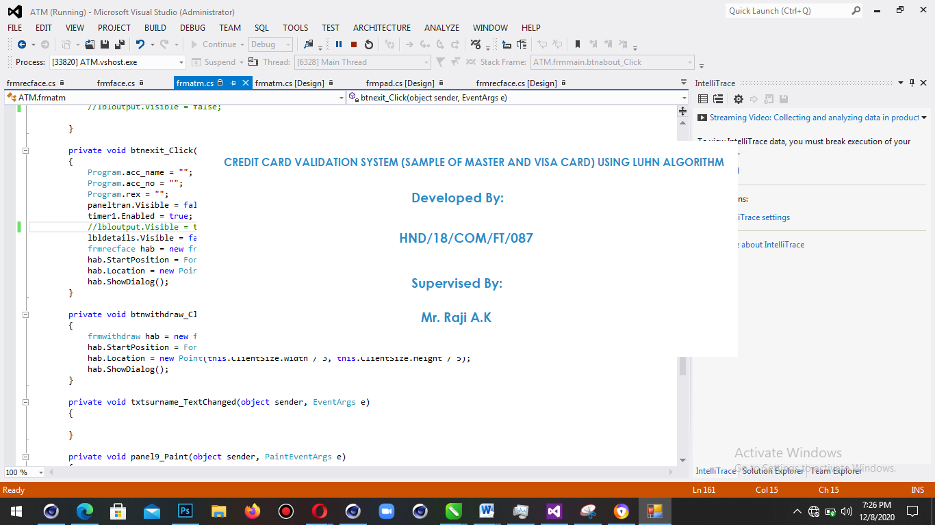
MR. BOLAJI-ADETORO D.F
HND/23/COM/FT/184

Figure 1: Dashboard Page Screenshot

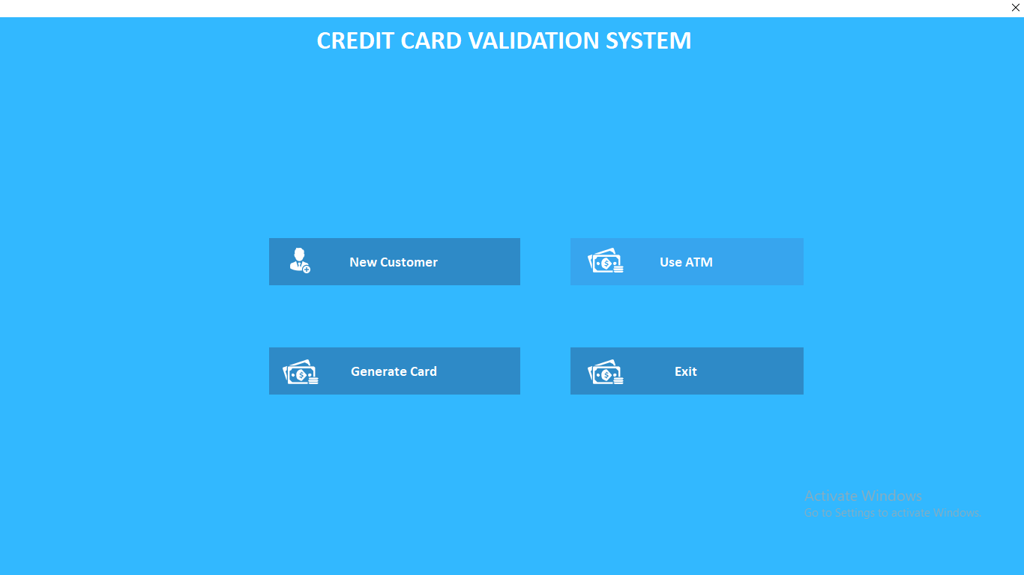
Figure 2: View Student Page Screenshot

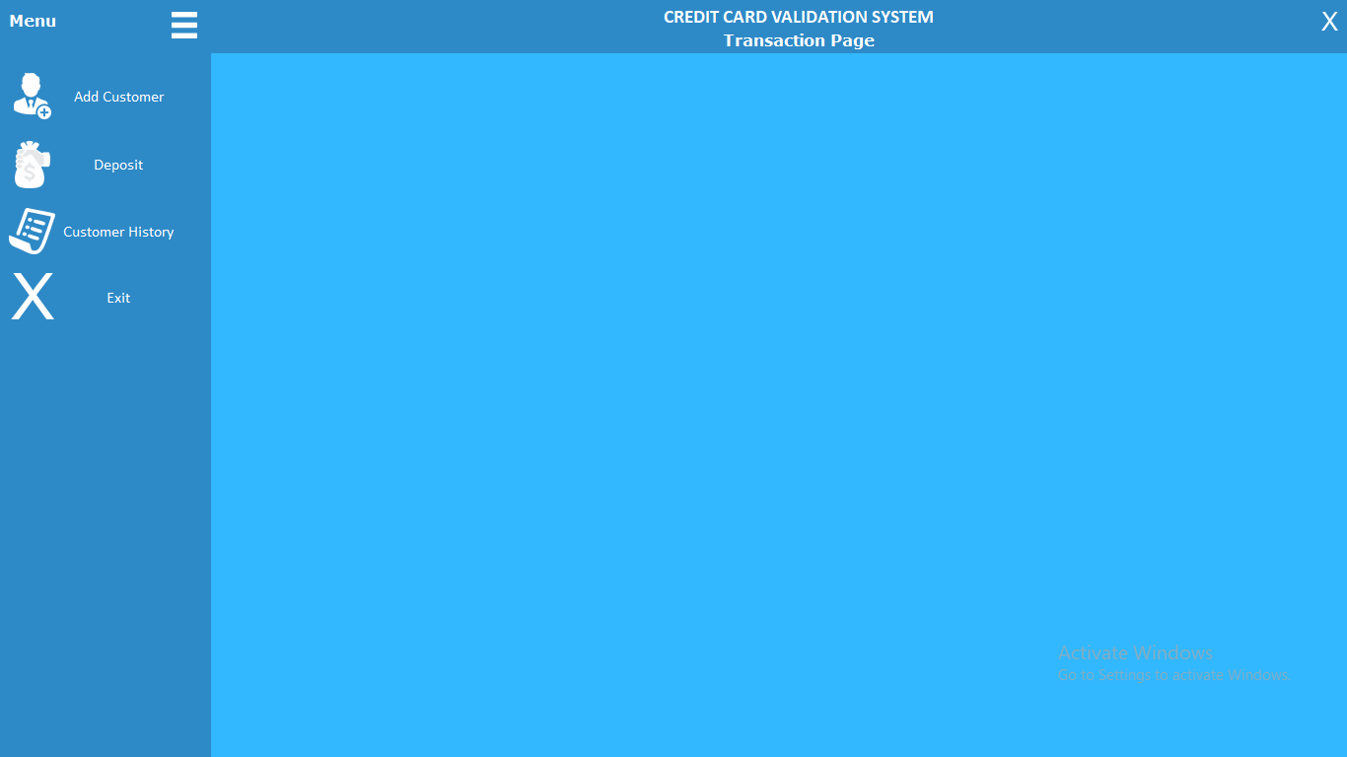

Figure 3: Display Window to View Class, Gender and Year Screenshot

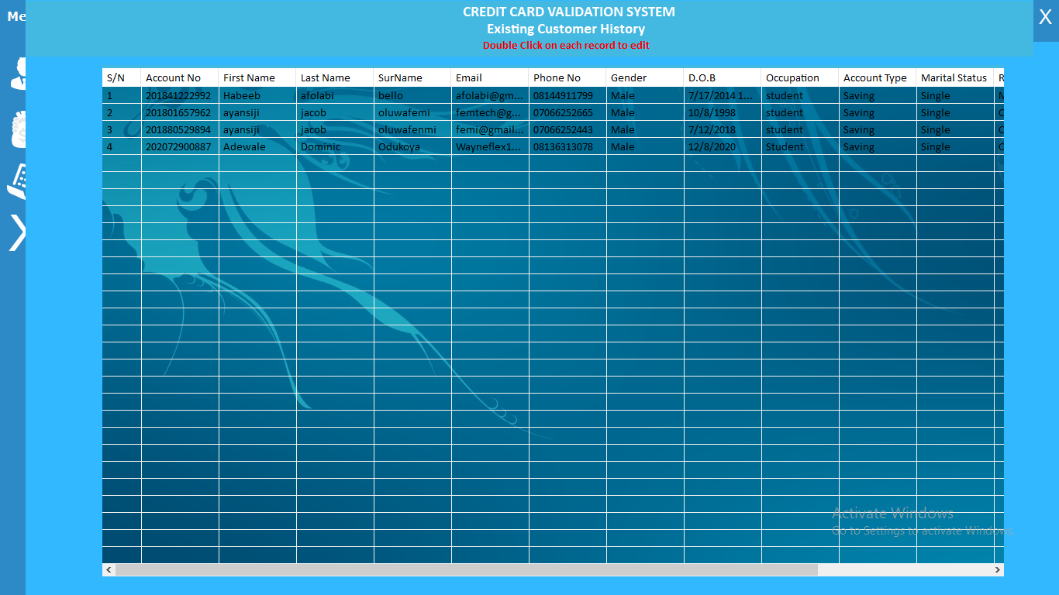
Figure 4: View Staff Page Screenshot

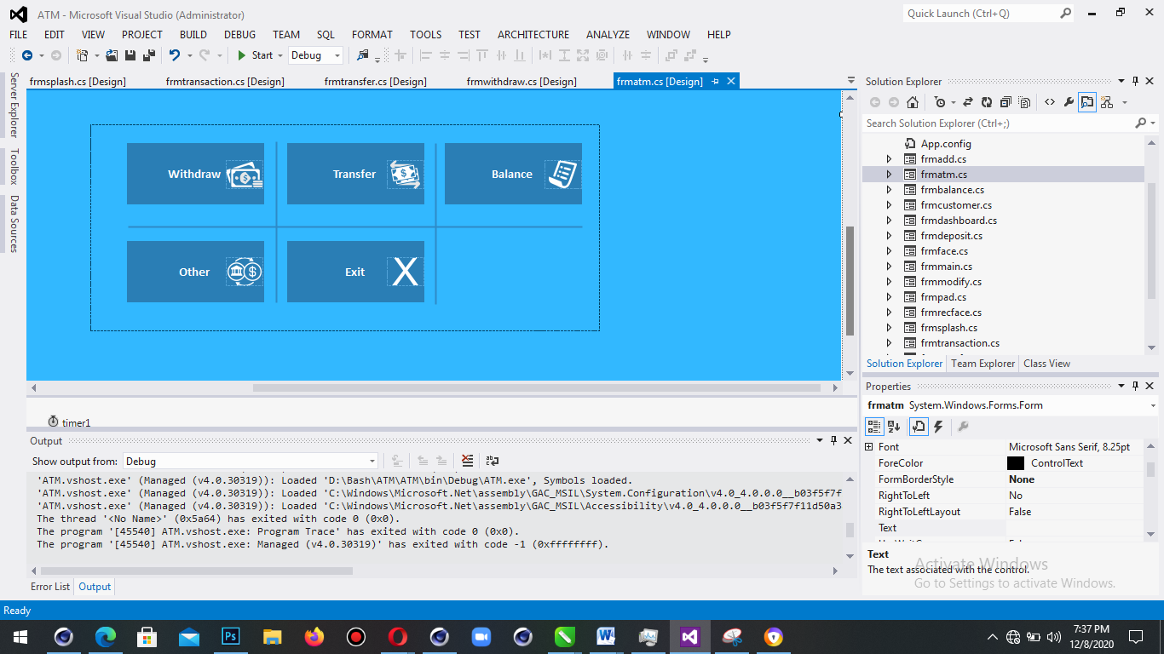

Figure 5: Subject Added Display Window Page Screenshot

4.1.2 INPUT DESIGN
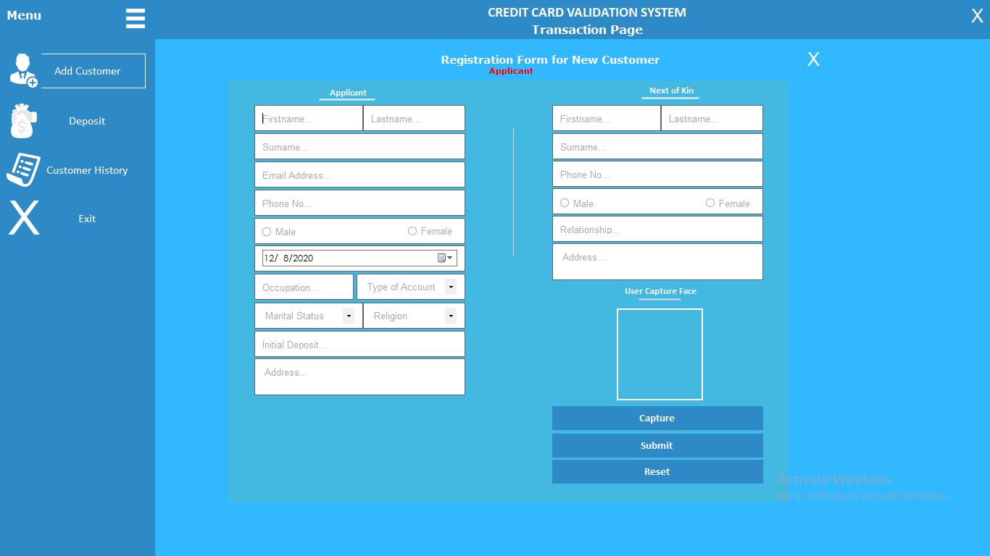

Figure 7: Login Page Screenshot

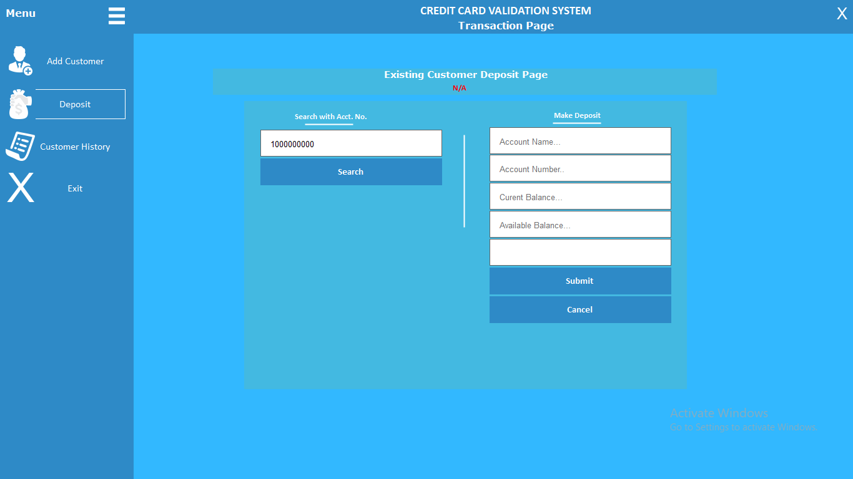

Figure 8: Add Student Page Screenshot.

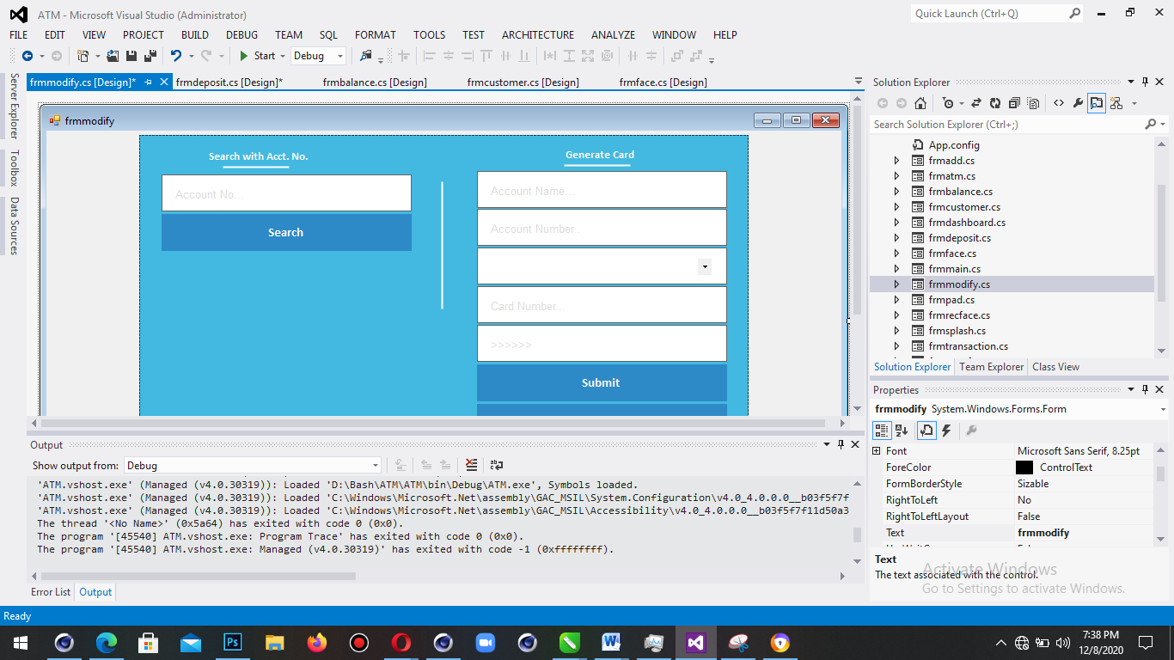

Figure 9: Add Staff Page Screenshot

Figure 10: Add Subject Page Screenshot

4.1.3 DATABASE DESIGN

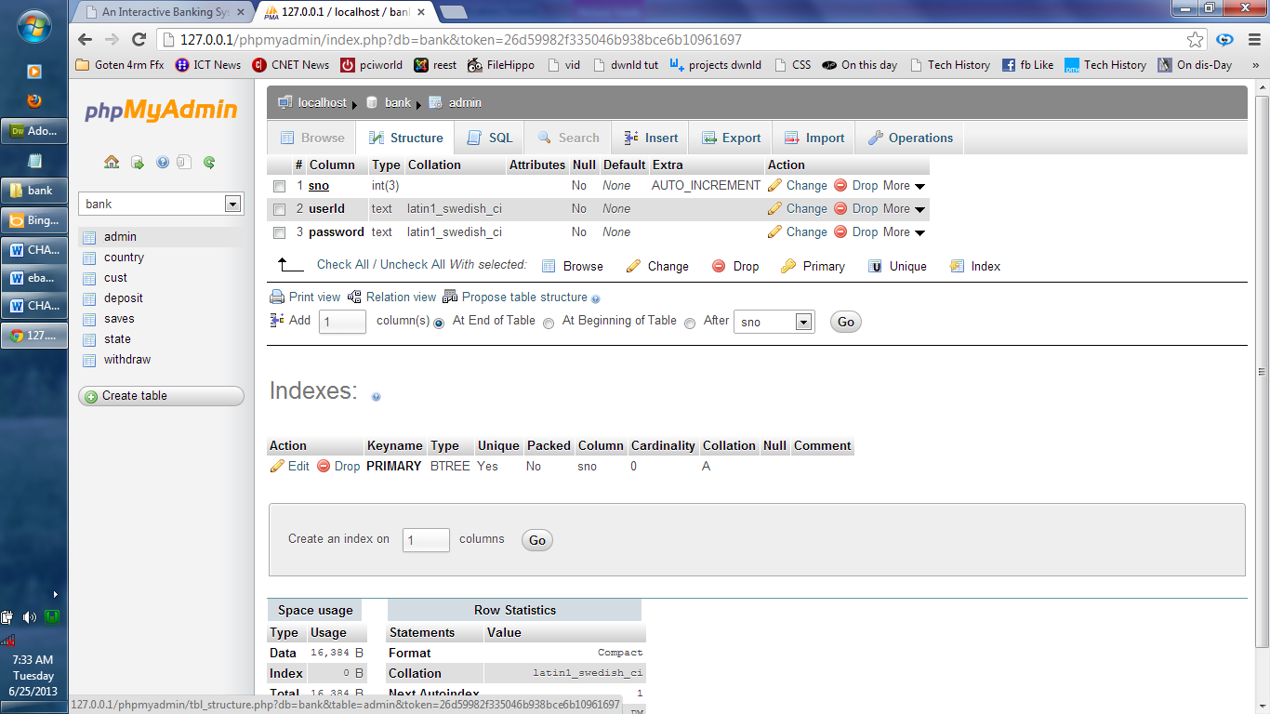
Table 4.1: The administrator table in phpmyadmin
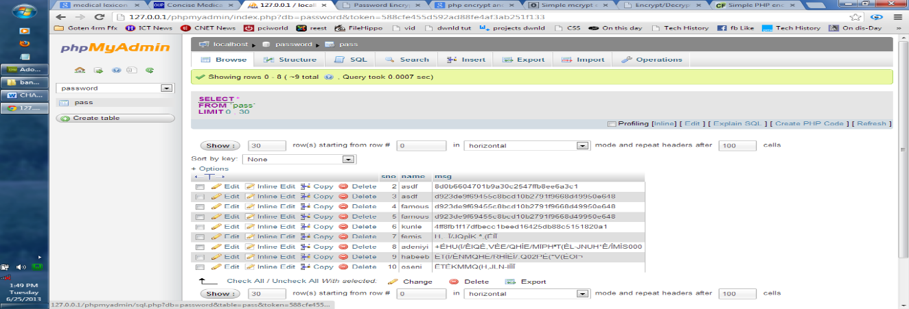
Table 4.2: The Students Report Table Structure
4.1.4 PROCEDURE DESIGN
The procedural design describes the system generally. It describes the various main programs in the system as well as the relationship that exist between all subprograms included. The procedural designs in this new system are of 5 menus of which each menu has it sub menu.
The application also contains several modules of which each module has its own specific function. The purpose of dividing the program into modules is because it enhances maintainability, readability and easy debugging.
4.2 SYSTEM IMPLEMENTATION
4.2.1 CHOICE OF PROGRAMMING LANGUAGE
C# is the chosen programming language for the implementation of the proposed system because of its pedagogy and open source help when needed. As well it has a support for variety of database application like sql server, sqllite, mysql, and Microsoft access but Microsoft Access is selected.
4.2.2 HARDWARE SUPPORT
The computer configuration required to run the software is;
Computer/memory processor PC with a 48dx, MHZ or Pentium, Intel or higher processor required.
Memory: 16GB of RAM
Cache memory:512KB
Hard disk Minimum size : 500GB
Recommended : 40GB
Virtual Memory :62Bits
Cache memory :512KB
Floppy disk drive :1.44MB
4.2.3 SOFTWARE SUPPORT
The software support for the design of the proposed system involves operating system, Microsoft visual studio, MYSQL as well as an anti-virus software which prevents the system from being infected by virus.

4.2.4 IMPLEMENTATION TECHNIQUES USED IN DETAILS
The system will be implemented using the parallel approach. This approach is considered because it ensure that the new system is tested alongside with the old system to ensure the effectiveness and efficiency of the system.

4.3 SYSTEM DOCUMENTATION
4.3.1 PROGRAM DOCUMENTATION
The system must be used as instructed according to the hardware and software supports so as to make optimal use of it.
4.3.2 OPERATING THE SYSTEM
- Click start on the computer desktop
- Select all programs
- Select any browser e.g internet Explorer, Mozilla Firefox, Google Chrome e.t.c
- Type the url (Uniform Resource Locator) of the system into the address bar (localhost/password/)
4.3.3 MAINTAINING THE SYSTEM
The following instructions must be strictly adhere to in other to make efficient use of the system. Install an anti-virus and always make sure it is usually updated to.

CHAPTER FIVE
SUMMARY AND CONCLUSION
5.1 SUMMARY
The project discusses development of a web based application for the operation of a bank focusing on the banking operations on Card Request and pin generation. The major operation of the bank worked upon is the customers’ account transaction, which involves the opening of an account for a new customer, recording cash deposit and withdrawal, checking account balance and providing a well organized report for the database records for all transaction performed.
The mode and ways of obtaining a secured network communication between the branches of the bank is explained. The project as well, lay emphasis on all types of bank card request nad pin generation for easy access
Some advantages of the new system developed is stated are stated and the method of implementation to achieve the maximum functionalities of the program.
5.2 EXPERIENCE GAINED AND PROBLEMS ENCOUNTERED
Through the process of carrying out the project I was opened up to many experiences that I know nothing about before. Networking as an area I only heard of many time before now but time had been taken to carry out any research on anything related to this field.
A project work cannot start and come to an end without having the researcher passed through certain difficulties or problems. The major problem encountered in the course of this project is the reluctance of the Bank staff to provide basic information about some crucial aspect of the operations and some strategies behind their network system among their respective branches as they consider is confidential and too professional to be revealed to researchers even for academic purpose.

5.3 CONCLUSIONS
The proposed application is based on local area network system for performing some banking operations. The implementation method of this application is something very important. There is no way an application can efficiently perform it functions without strictly considering the requirements for proper implementation of the program. The hardware and software requirements of the program are stated in the project.
An application of this nature is needed by a bank to solve many of their problems involving wire communication failure, which in turn leads to customers’ dissatisfaction and inefficiency in the work output of the bank staff.
5.4 RECOMMENDATIONS
For further research work to be carried out. I hereby suggest the following
- Design and implementation of an Online Website for information dissemination for the Banks.
- Information should be made available to people through the administrator so that their will be easy and quick access to information.

REFERENCES
BulomineRegi S(2020) present an article on “CREDIT CARD - A Way to Generate Legitimate Money for Payments” Asst. Professor, Department of Business Administration (BBA), St.Xavier’s College (Autonomous), Palayamkottai, Tirunelveli, Tamilnadu- 627002, INDIA
Dinesh L, et al., (2021) Writes an article on “Credit Card Fraud Detection System” 2 Department of Computer Engineering, SSBT COET, Bambhori, Jalgaon (M.S.), India.
Ismail, et al., (2020) writes a paper on “Inspecting the Dynamics Leading towards Credit Card usage: An Empirical Inquiry form Pakistan’s Credit Card Industry”.
Yogesh et al., (2020) writes an article on “A Review On Credit Card Fraud Detection Using BLAST-SSAHA Method”.
Pooja M. et al., (2019) writes a paper on “A Review Paper on Credit Card Management System using Java Application”. International Journal of Engineering Science and Computing, April 2019 Assistant Professor2 Department of CSE D.R.G.I.T&R, Amravati, India
Sheikh Rabiul et al., (2016) writes a paper on “Credit Default Mining Using Combined Machine Learning and Heuristic Approach”.Tennessee Technological University Cookeville, U.S.A sislam42@students.tntech.edu.
Sumit and Jian (2020) wrote a review on “A review of credit card literature: perspectives from consumers”Low Tuck Kwong Professor, Departments of Economics, Finance and Real Estate Research Director, CAMRI and Senior Fellow, ABFER Research Associate, IRES, CQF, CBE and RMI National University of SingaporeSyedFaheemHasanBukhari, Ayesha
Rehab et al., (2020) wrote a paper on “Online Credit Card Fraud Prevention System for Developing Countries” Electronic commerce has gained a rapid growth and it has a significant impact on market of all the countries.
Yashvi Jain, et al., (2019) writes a paper on “A Comparative Analysis of Various Credit Card Fraud Detection. Techniques International Journal of Recent Technology and Engineering (IJRTE) ISSN: 2277-3878, Volume-7 Issue-5S2, January 2019

SYSTEM FLOWCHART
Start
Splash Screen
Stop
Login
Main Menu
Register
Withdraw History
Credit Card Request
Withdraw
Cash
Credit Card History
View History
Logout
Generate Credit Pin

WELCOME PAGE
Open Database

Open Database

Stop
Display all welcome page details
Start

LOGIN
Yes
Start
Enter Username and Password
Is any field empty
Is Username and Password Correct
Main Menu
Return
Invalid Username and Password
All field are required to proceed
Open Database

Close Database

REGISTER
Close Database
Open Database
Save to Database
All Field are Required to Proceed
Display User Details
Is any Field Empty
?
Enter Registration Details
Return
Start
Yes
No

CREDIT CARD REQUEST
Request for Credit Card
Return
Start

Open Database

Close Database

GENERATE CREDIT PIN
Return
Close Database
Generate Credit Pin
Open Database
Start

VIEW HISTORY
Open Database

Display History
Start

Withdraw History
Result Report

Close Database

Return

LOGOUT
Yes
Start
Do you want to Logout?
Return
Click on Login
Welcome Page
Main Menu
Open Database

Close Database

SOURCE CODE
<?php defined('BASEPATH') OR exit('No direct script access allowed');
class Auth extends MY_Controller {

function __construct() {
parent::__construct();
$this->lang->load('auth', $this->Settings->language);
$this->load->library('form_validation');
$this->form_validation->set_error_delimiters($this->config->item('error_start_delimiter', 'ion_auth'), $this->config->item('error_end_delimiter', 'ion_auth'));
$this->load->model('auth_model');
$this->load->library('ion_auth');
}

function index() {
if (!$this->loggedIn) {
redirect('login');
}
}

function users() {
if (!$this->loggedIn) {
redirect('login');
}
if (!$this->Admin) {
$this->session->set_flashdata('warning', lang("access_denied"));
redirect($_SERVER["HTTP_REFERER"]);
}

$this->data['error'] = (validation_errors()) ? validation_errors() : $this->session->flashdata('error');
$this->data['users'] = $this->site->getAllUsers();
$bc = array(array('link' => '#', 'page' => lang('users')));
$meta = array('page_title' => lang('users'), 'bc' => $bc);
$this->data['page_title'] = lang('users');
$this->page_construct('auth/index', $this->data, $meta);
}

function profile($id = NULL) {
if (!$this->ion_auth->logged_in() || !$this->Admin && $id != $this->session->userdata('user_id')) {
$this->session->set_flashdata('warning', lang("access_denied"));
redirect($_SERVER["HTTP_REFERER"]);
}
if (!$id || empty($id)) {
redirect('auth');
}

$this->data['title'] = lang('profile');

$user = $this->ion_auth->user($id)->row();
$groups = $this->ion_auth->groups()->result_array();
$this->data['csrf'] = $this->_get_csrf_nonce();
$this->data['user'] = $user;
$this->data['groups'] = $groups;

$this->data['error'] = (validation_errors()) ? validation_errors() : $this->session->flashdata('error');
$this->data['password'] = array(
'name' => 'password',
'id' => 'password',
'class' => 'form-control',
'type' => 'password',
'value' => ''
);
$this->data['password_confirm'] = array(
'name' => 'password_confirm',
'id' => 'password_confirm',
'class' => 'form-control',
'type' => 'password',
'value' => ''
);
$this->data['min_password_length'] = $this->config->item('min_password_length', 'ion_auth');
$this->data['old_password'] = array(
'name' => 'old',
'id' => 'old',
'class' => 'form-control',
'type' => 'password',
);
$this->data['new_password'] = array(
'name' => 'new',
'id' => 'new',
'type' => 'password',
'class' => 'form-control',
'pattern' => '^.{' . $this->data['min_password_length'] . '}.*$',
);
$this->data['new_password_confirm'] = array(
'name' => 'new_confirm',
'id' => 'new_confirm',
'type' => 'password',
'class' => 'form-control',
'pattern' => '^.{' . $this->data['min_password_length'] . '}.*$',
);
$this->data['user_id'] = array(
'name' => 'user_id',
'id' => 'user_id',
'type' => 'hidden',
'value' => $user->id,
);

$this->data['id'] = $id;
$this->data['stores'] = $this->site->getAllStores();
$this->data['page_title'] = lang('profile');
$bc = array(array('link' => site_url('users'), 'page' => lang('users')), array('link' => '#', 'page' => lang('profile')));
$meta = array('page_title' => lang('profile'), 'bc' => $bc);
$this->page_construct('auth/profile', $this->data, $meta);
}

public function captcha_check($cap) {
$expiration = time() - 300; // 5 minutes limit
$this->db->query("DELETE FROM captcha WHERE captcha_time < " . $expiration);

$sql = "SELECT COUNT(*) AS count FROM captcha WHERE word = ? AND ip_address = ? AND captcha_time > ?";
$binds = array($cap, $this->input->ip_address(), $expiration);
$query = $this->db->query($sql, $binds);
$row = $query->row();
if ($row->count == 0) {
$this->form_validation->set_message('captcha_check', lang('captcha_wrong'));
return FALSE;
} else {
return TRUE;
}
}

//log the user in
function login() {

$this->form_validation->set_rules('identity', $this->lang->line("identity"), 'trim|required');
$this->form_validation->set_rules('password', $this->lang->line("password"), 'required');
if ($this->form_validation->run() == true) {
$remember = (bool) $this->input->post('remember');

if ($this->ion_auth->login($this->input->post('identity'), $this->input->post('password'), $remember)) {
if ($this->Settings->mmode) {
if (!$this->ion_auth->in_group('admin')) {
$this->session->set_flashdata('error', lang('site_is_offline_plz_try_later'));
redirect('logout');
}
}

$this->session->set_flashdata('message', $this->ion_auth->messages());
redirect('');
} else {
$this->session->set_flashdata('error', $this->ion_auth->errors());
redirect('login');
}
} else {

$this->data['error'] = (validation_errors()) ? validation_errors() : $this->session->flashdata('error');
$this->data['message'] = $this->session->flashdata('message');
$this->data['page_title'] = lang('login');

$this->load->view('auth/login', $this->data);
}
}

function reload_captcha(){
$this->load->helper('captcha');
$vals = array(
'img_path' => './uploads/captcha/',
'img_url' => site_url() . 'uploads/captcha/',
'img_width' => 150,
'img_height' => 34,
);
$cap = create_captcha($vals);
$capdata = array(
'captcha_time' => $cap['time'],
'ip_address' => $this->input->ip_address(),
'word' => $cap['word']
);
$query = $this->db->insert_string('captcha', $capdata);
$this->db->query($query);

echo $cap['image'];
}

function logout($m = NULL) {
$logout = $this->ion_auth->logout();
$this->session->set_flashdata('message', $this->ion_auth->messages());
redirect('login');
}

function change_password() {
if (!$this->ion_auth->logged_in()) {
redirect('login');
}

