
KWARA STATE POLYTECHNIC, ILORIN
INSTITUTE OF TECHNOLOGY
DESIGN AND CONSTRUCTION 2KVA SOLAR POWERED INVERTER SYSTEM

BY

OWOLARANFE ABDULWAREEZ AYOMIDE
ND/22/EEE/FT/0251

SUBMITTED TO

THE DEPARTMENT OF ELECTRICAL/ELECTRONIC ENGINEERING, INSTITUTE OF TECHNOLOGY, KWARA STATE POLYTECHNIC, ILORIN.
IN PARTIAL FULFILMENT OF THE REQUIREMENTS FOR THE AWARD OF NATIONAL DIPLOMA (ND) CERTIFICATE IN ELECTRICAL AND ELECTRONIC ENGINEERING.

JUNE, 2024
CERTIFICATION
This is to certify that this project work was carried out by OWOLARANFE ABDULWAREEZ AYOMIDE of matriculation Number ND/23/EEE/PT/0251 in the Department of Electrical/Electronic Engineering, Kwara State Polytechnic in Partial fulfillment of the requirements for the award of National Diploma (ND) certificate in Electrical/Electronic Engineering.

_________________________ __________________
ENGR. K. LATEEF DATE
Project Supervisor

________________________ __________________
ENGR. BELLO BASHIR DATE
Project Coordinator

________________________ __________________
ENGR. K. LATEEF DATE
Project Coordinator

___________________________ __________________
EXTERNAL EXAMINATION DATE

DEDICATION
This research is dedicated to Almighty Allah and also to my lovely parents, Mr and Mrs. OWOLARANFE for their support and love over me for his moral and financial support throughout the journey.

ACKNOWLEDGEMENT
I give all glory, praises and adoration to Almighty God the one who gives knowledge, strength and ability in starting, sustaining me and finishing this project successfully, and for his grant grace over me through this titanic struggle of my national diploma program.
My gratitude goes to my honorable supervisor Engr. Hussena Mustapha one of my best guardian/mentor Engr. Bashir for their invaluable guidance, support and encouragement throughout. Who patiently read through the work. May the good lord reward him labour and more strength to his wrist in name of God.
My special appreciation goes to my beloved parent Mr and Mrs. OWOLARANFE. I pray that you live long to reap the fruit of your labour (Amen).

ABSTRACT
This project focused on the design and construction of a 2 kVA hybrid solar powered inverter system to ensure reliable and sustainable power supply by integrating solar energy with grid power. The key objective was to develop a system capable of powering household or small office loads using renewable energy, supplemented by the grid when needed. The methodology involved selecting suitable components, including four 450 W solar panels, a 60 A MPPT charge controller, a 48 V lithium-ion battery bank, and a 2 kVA hybrid inverter, and conducting detailed design calculations to ensure proper sizing and efficient operation. The system was assembled with careful attention to wiring, safety, and integration of solar and grid inputs. Key findings show that the system successfully provided clean AC power, prioritized solar energy, and ensured uninterrupted power supply for up to 2 kVA loads. Testing confirmed stable output voltage (230 V AC) and efficient battery charging through the MPPT controller, validating the design and demonstrating the feasibility of a hybrid solar solution for small-scale applications.

TABLE OF CONTENTS
Title Page i
Certification ii
Dedication iii
Acknowledgements iv
Abstract v
Table of Contents vi
List of Table vii

CHAPTER ONE: INTRODUCTION 1.1 Background and Motivation 1
1.2 Statement of the Problem 1
1.3 Objectives of the Study 2
1.4 Scope of Work 3

CHAPTER TWO: LITERATURE REVIEW
2.1 Introduction 4
2.1.1 Solar Photovoltaic Technology 4
2.1.2 Battery Energy Storage Systems 4
2.1.3 Charge Controllers 5
2.2 Inverter Technologies 6
2.3Related Works 6
2.4 Summary of Literature Review 7

Chapter Three: System Design and Methodology 8
3.1 System Requirements 8
3.1.1Safety components 8
3.1.2Monitoring 8
3.1.1 Environmental Condition 8
3.2Block Diagram 9
3.3Component Selection 9
3.3.1System Capacity 9
3.3.2Solar Panels 9-10
3.3.3 Battery Bank 10
3.3.4 Charge Controller 10
3.3.5 Inverter Specification 10-11
3.4 Circuit Diagram 11
3.4.1 Explanation of the Circuit Diagram 11
3.4.1.2 Solar Panels 11
3.4.1.3 MPPT Charge Controller (60A) 12
3.4.1.4 Lithium Battery Bank (24V) 12
3.4.1.5 2kVA Pure Sine Wave Inverter 12

CHAPTER FOUR: IMPLEMENTATION AND TESTING
4.1 Construction Process 15
4.2 Testing Procedures 15-17
4.3 Results 17-21
4.4 Discussion 21-23

CHAPTER FIVE: CONCLUSION AND RECOMMENDATIONS
5.2 Conclusion 25
5.3 Recommendations 25-26
References 27-28
Appendices 28
Appendix A: Questionnaire 28-29
Appendix B: Raw Data Tables 30
Appendix C: 30
Appendix D: 30-33

CHAPTER ONE
INTRODUCTION
1.1 Background of the Study
Electricity is a fundamental utility in contemporary society. It energizes residences, businesses, hospitals, communication networks, and various industries. Nevertheless, in developing nations, the availability of a consistent and dependable electricity supply poses a considerable challenge. Frequent power interruptions, inadequate grid infrastructure, and the high expenses associated with fossil fuel-powered generators have rendered alternative energy sources increasingly essential.
Among the most promising substitutes for traditional energy is solar power. Solar energy is plentiful, renewable, and eco-friendly. When equipped with appropriate systems, it can be utilized to produce electricity for both residential and commercial applications without ongoing fuel expenses or detrimental emissions. Solar power systems typically comprise photovoltaic (PV) panels that convert sunlight into direct current (DC) electricity. However, the majority of household and office devices require alternating current (AC) to operate. This creates the need for an inverter to transform the DC power generated by the solar panels and battery bank into usable AC power.
Inverters play a vital role in solar energy systems. They not only convert power but also regulate energy flow and guarantee the stability and quality of the AC output. In areas where sunlight is plentiful but grid electricity is unreliable, a solar inverter system presents a practical and economical solution for fulfilling daily energy requirements.
The objective of this project is to design and construct a 2kVA solar inverter system. This power capacity is adequate to run essential appliances such as lights, fans, televisions, computers, and small refrigerators, making it suitable for homes, small offices, and rural clinics. The system incorporates essential components such as solar panels, charge controllers, batteries, and an inverter circuit. It is engineered to charge batteries using solar energy and provide a stable 230V AC output to power loads during both daytime and night time.
This initiative aims to tackle the simultaneous issues of energy shortage and environmental harm by providing a renewable, clean, and reliable substitute for fossil fuel-based generators. Additionally, it is in harmony with global movements towards green energy and sustainable development. Through the design and construction of a locally adaptable 2kVA solar inverter, this initiative seeks to aid in resolving energy challenges in underserved regions while fostering technological advancement and self-sufficiency.
1.2 Problem Statement
Access to dependable and continuous electricity continues to pose a significant challenge in numerous regions across the globe, particularly in developing nations. In Nigeria and various sub-Saharan African countries, the national power grid frequently suffers from blackouts, voltage irregularities, and inadequate coverage, especially in rural and semi-urban locales. These ongoing power difficulties adversely affect productivity, education, healthcare, communication, and the overall quality of life.
To address these issues, many individuals and organizations depend on gasoline or diesel-powered generators as backup power solutions. However, this approach is neither sustainable nor environmentally friendly. The operation of fossil fuel generators is costly due to the increasing fuel prices and the need for regular maintenance. Furthermore, they produce greenhouse gases and noise pollution, which contribute to climate change and health issues.
A viable alternative is the utilization of solar energy, which is renewable, clean, and abundantly accessible in tropical areas. However, to effectively harness solar power, a system is required to convert the DC electricity generated by solar panels into AC electricity suitable for conventional household and office appliances. This is where the inverter becomes essential.
Despite the presence of solar technologies in the market, many commercially available inverters are costly, inadequately designed for local conditions, or lack compatibility with locally sourced components. Moreover, many users possess limited technical expertise and therefore need a system that is straightforward, reliable, and easy to maintain.
Consequently, there is an urgent necessity to design and develop a cost-effective, efficient, and user-friendly 2kVA solar inverter system capable of fulfilling the basic power requirements of homes and small enterprises.

1.3 AIM AND OBJECTIVES
Design and construction of 2kva solar panel inverter
OBJECTIVES
To design, build, and evaluate a 2kVA solar inverter system that can convert 24V DC into 230V AC, aimed at fulfilling the energy requirements of households, small enterprises, and off-grid setups.
1. Design a Functional Inverter Circuit
To create a dependable and efficient inverter circuit that transforms 24V DC power sourced from solar panels or a battery bank into 230V AC with minimal distortion. The design should incorporate components that are readily available locally and are cost-effective, ensuring both performance and accessibility.
2. Select and Integrate Suitable Components
To choose the appropriate components for the system, which include solar panels, batteries, charge controllers, inverters, transformers, and protective devices. These components must be capable of functioning within a typical off-grid solar installation and managing the power requirements of small residential or commercial loads.
3. Ensure System Efficiency
To enhance the inverter for optimal energy conversion efficiency. This involves reducing power losses during the DC to AC conversion process, achieving high efficiency even under varying load conditions, and ensuring the system operates with minimal heat generation.
4. Design a User-Friendly Interface and Control Mechanisms
To integrate a user-friendly control interface for the end user. This interface should enable users to monitor battery levels, system status, and performance metrics. The inverter should also feature automatic protections such as overload, short circuit, and overvoltage to protect both the inverter and connected loads.
5. Test the Inverter System for Reliability and Performance
To construct and evaluate the prototype inverter system to ensure it meets the following performance criteria:
Consistent output of 230V AC at 50Hz under various load conditions.
Efficient operation with minimal harmonic distortion (THD less than 5%).
Proper integration with solar panels and battery storage, allowing for continuous power delivery.
Research Questions
1. In what ways can a 2kVA inverter system be effectively designed and constructed to convert 24V DC from solar panels into a stable 230V AC output that is suitable for residential and small commercial applications?
2. Which components (including transformers, MOSFETs, and control circuits) are the most efficient and cost-effective for constructing a reliable solar-powered inverter system in resource-constrained environments?
3. To what degree can the integration of solar panels with a 2kVA inverter system offer a sustainable, reliable, and eco-friendly alternative to conventional grid and generator-based electricity sources?
1.4 Scope of the Study
This project centers on the design and construction of a 2kVA solar-powered inverter system that is capable of converting 24V DC from solar panels and batteries into 230V AC at 50Hz. The system is designed to power small household and office appliances, including lights, fans, TVs, and computers.
The study encompasses:
- The design and assembly of the inverter circuit, which includes the oscillator, driver, and transformer stages.
- Integration with a solar charge controller and a battery bank.
- Selection of components based on their availability and cost-effectiveness.
- Basic testing for voltage output, efficiency, and protective features.
The project is confined to utilizing solar energy as the primary source and does not address hybrid systems, grid connections, or advanced control features such as IoT or remote monitoring. It is aimed at educational and demonstration purposes in regions with limited access to grid electricity.
1.5 Significance of study
This research holds significance as it offers a practical and environmentally friendly solution to power shortages through the design of a 2kVA solar inverter system. It aids in decreasing reliance on the inconsistent national grid and fuel-powered generators, presenting a cost-effective and sustainable energy alternative.
The initiative fosters environmental conservation, encourages the adoption of renewable energy, and improves technical skills among students via practical learning experiences. Additionally, it contributes to local innovation by utilizing readily available components and can act as a basis for more extensive solar energy systems in the future.

CHAPTER TWO
LITERATURE REVIEW
2.1 Overview of Solar Energy
Introduction to Solar Energy
Solar energy refers to the energy emitted by the sun that reaches the Earth as sunlight. It stands as one of the most plentiful, renewable, and sustainable energy sources available. Each hour, the Earth receives more energy from the sun than the total energy consumed by the entire human population in a year. Solar energy can be captured and transformed into usable energy forms such as heat and electricity through various technologies.
Forms of Solar Energy Utilization
Solar energy can be harnessed in two main forms:
Solar Thermal Energy
This method involves utilizing the sun’s heat for purposes such as heating water, warming spaces, and supporting industrial processes. It generally employs collectors to absorb and store thermal energy.
Solar Photovoltaic (PV) Energy
This is the most prevalent technique for generating electricity from sunlight. It utilizes solar panels, which are constructed from semiconductor materials like silicon, to convert solar radiation directly into direct current (DC) electricity via the photovoltaic effect.
Photovoltaic Effect
The photovoltaic (PV) effect refers to the mechanism through which solar cells transform sunlight into electrical energy. When light photons strike a solar cell, they energize electrons within the semiconductor material, resulting in the formation of electron-hole pairs. These liberated electrons are subsequently collected and directed through an external circuit, generating direct current (DC) electricity.
Components of a Solar Power System
A fundamental standalone solar power system comprises:
Solar Panels: Transform sunlight into DC electricity.
Charge Controller: Manages the voltage and current from the panels to avert battery overcharging.
Battery Bank: Accumulates surplus energy for utilization during periods without sunlight (e.g., nighttime).
Inverter: Converts DC electricity from the batteries into AC electricity suitable for powering residential or commercial devices.
Advantages of Solar Energy
Renewable and Abundant: Accessible worldwide and inexhaustible.
Environmentally Friendly: Produces no greenhouse gas emissions during its operation.
Reduces Electricity Bills: After installation, solar systems diminish dependence on grid electricity.
Low Operating Costs: Requires minimal maintenance and has no fuel needs.
Scalable: Applicable in both small residential systems and extensive solar farms.
Challenges of Solar Energy
Intermittency: Solar energy is unavailable at night and may be less efficient on cloudy or rainy days.
High Initial Cost: Although prices are declining, the initial investment for solar installations can pose a challenge.
Energy Storage Requirement: Batteries are necessary to guarantee power availability during periods without sunlight, which increases both cost and complexity.
Space Requirement: Large-scale solar installations necessitate considerable roof or land space.
2.2 Inverter Technology
Introduction to Inverter Technology
An inverter is an electronic device that transforms Direct Current (DC) into Alternating Current (AC). This transformation is crucial in renewable energy systems, particularly in solar setups, as the majority of household appliances and industrial machinery function on AC, whereas solar panels and batteries generate DC. Inverter technology is fundamental to any solar power system designed to operate standard AC-powered devices. In the absence of an inverter, solar energy would not be suitable for most electrical loads.

Basic Working Principle of an Inverter
The primary role of an inverter is to invert the current flow from DC to AC. This process is accomplished through several stages:
Oscillation Stage: Converts DC into a square wave AC utilizing an oscillator circuit (transistors or microcontrollers).
Amplification Stage: Increases the low-voltage AC signal to a higher voltage, generally employing a transformer.
Filtering Stage: Refines the waveform, particularly in pure sine wave inverters, to eliminate noise and harmonics.
Control and Regulation: Guarantees voltage and frequency stability, incorporating protective features such as overload and short circuit protection.
Types of Inverters
Based on Output Waveform:
Square Wave Inverter: Generates a square-shaped AC waveform. It is simple and cost-effective but can produce noise and is unsuitable for sensitive electronic devices.
Modified Sine Wave Inverter: Creates a stepped waveform that resembles a sine wave. It is more efficient and compatible with most devices, although it may still cause problems with certain appliances (such as motors and audio equipment).
Pure Sine Wave Inverter: Produces a smooth, clean AC waveform akin to that from the national grid. It is ideal for all appliances, particularly sensitive and inductive loads. However, it is more complex and costly.
Based on Phase:
Single-phase Inverter: Utilized in residential settings and small businesses (as seen in this 2kVA project).
Three-phase Inverter: Employed in industrial applications that demand higher power levels.
Based on Source Integration:
Stand-alone (Off-grid) Inverter: Functions independently of the national grid. It operates with solar panels and batteries.
Grid-tied Inverter: Synchronizes with the national grid and channels excess power back into it.
Hybrid Inverter: Merges solar, grid, and battery systems into a single unit.
Key Components of a Solar Inverter System
Oscillator Circuit: Produces the initial alternating pulses from the DC source.
Switching Devices: Usually MOSFETs, BJTs, or IGBTs, employed to rapidly switch current flow to generate an AC waveform.
Driver Circuit: Regulates the switching devices using Pulse Width Modulation (PWM) for shaping the waveform.
Transformer: Increases the low-voltage AC to 230V (the standard grid voltage).
Filter Circuit: Smooths the output waveform to minimize distortion and harmonics.
Protection Circuitry: Comprises fuses, overvoltage/undervoltage detection, overload shutdown, and temperature protection.
Applications of Inverter Technology
- Solar Power Systems
- Uninterruptible Power Supplies (UPS)
- Electric Vehicles (EVs)
- Telecommunication Systems
- Industrial Motor Drives
The Significance of Inverters in Solar Energy Systems
The inverter functions as the core component of any solar power system. It enables users to:
- Operate AC appliances directly using solar energy.
- Track system performance and identify fault conditions.
- Guarantee compatibility with residential or commercial loads.
- Enhance the efficiency of energy utilization from solar panels and batteries.
Recent Developments in Inverter Technology
- Utilization of microcontrollers and digital signal processors (DSPs) for enhanced control.
- Adoption of Maximum Power Point Tracking (MPPT) technology within inverters.
- Incorporation of Internet of Things (IoT) for remote system monitoring.
- Application of GaN (Gallium Nitride) and SiC (Silicon Carbide) semiconductors for improved efficiency and thermal performance.
2.3 Principles of Solar Inverter Design
A solar inverter plays a vital role in solar energy systems, tasked with converting the DC (Direct Current) electricity produced by solar panels into AC (Alternating Current) electricity that is suitable for use in household or industrial devices. Grasping the principles of solar inverter design is crucial for developing an efficient and dependable power solution. The fundamental design principles are detailed below.
DC to AC Conversion
The main purpose of a solar inverter is to convert DC from the solar panel or battery bank into a usable 220V–240V, 50Hz AC output. This process is accomplished through:
Oscillation: Producing a high-frequency alternating signal.
Switching: Employing MOSFETs or IGBTs to control current flow.
Transformation: A step-up transformer elevates low-voltage AC to the standard grid voltage.
Filtering: Ensures that the output waveform is stable and clean.
Consideration of Waveform
There are three types of output waveforms:
Square wave: Inexpensive and simple to produce, but incompatible with most appliances.
Modified sine wave: Approximates a sine wave; suitable for most non-sensitive devices.
Pure sine wave: Closely mimics grid power; ideal for all loads but is more costly and complex.
This project emphasizes modified sine wave output for cost-effectiveness.
Power Rating
The inverter is rated at 2kVA, which means it can manage loads up to 2000 volt-amperes. The actual usable power is influenced by the power factor (typically 0.8), allowing for approximately 1600W of real load support.
Integration of Solar Panels
Solar panels act as the primary energy source. Their sizing must correspond to the anticipated load of the system. The inverter design must:
- Accept varying DC voltages from the panels.
- Incorporate a charge controller to oversee battery charging.
- Facilitate battery storage for energy supply when solar input is not available.
Battery Support
The inverter must draw power from a 24V battery bank (typically consisting of two 12V batteries in series). The batteries should possess sufficient capacity (e.g., 200A) to ensure reliable operation.
Control and Safeguarding
To guarantee durability and security:
- Overload protection circuits sever excessive loads.
- Low-voltage cut-off safeguards against battery damage.
- Fuses and circuit breakers ensure fault isolation.
- Cooling systems (fans, heat sinks) regulate thermal output.
Effectiveness and Functionality
Design choices should aim to reduce power losses caused by:
- Heat in switching devices
- Core and copper losses in transformers
- Inaccuracies in waveform generation
- An efficiency range of 80–90% is preferred for residential solar inverters.
2.4 Challenges in Solar Inverter Development
Although solar inverters are essential elements in photovoltaic (PV) systems, their design and deployment encounter numerous technical, economic, and environmental obstacles. Addressing these issues is crucial to guarantee the reliability, efficiency, and sustainability of solar power systems, particularly in resource-constrained or off-grid settings such as many rural areas of Nigeria and other developing nations.

- Efficiency Losses
A significant challenge in the development of solar inverters is ensuring high efficiency during the conversion from DC (Direct Current) to AC (Alternating Current). Efficiency losses can arise from:
- Switching losses in transistors (MOSFETs/IGBTs)
- Transformer losses (core and copper)
- Heat dissipation, necessitating effective thermal management. An inverter with low efficiency leads to energy wastage, overheating, and diminished performance.
- Cost of Components
The expense associated with manufacturing a high-quality solar inverter continues to be a significant hurdle, especially in developing nations. Major contributors to these costs include:
- High-quality semiconductor switches (e.g., MOSFETs, IGBTs)
- Pure sine wave generation circuitry
- MPPT (Maximum Power Point Tracking) charge controllers
- High-efficiency transformers. The balance between cost-effectiveness and performance can influence the long-term feasibility of the inverter.

- Complexity of Control Systems
The creation of control circuits for functionalities such as waveform shaping, battery protection, overload cut-offs, and voltage regulation introduces additional complexity. This is particularly true for pure sine wave inverters, which utilize:
- Microcontrollers
- PWM (Pulse Width Modulation)
- Feedback control systems. This complexity demands both design proficiency and thorough testing, potentially leading to increased development time and costs.
- Heat Management
Solar inverters produce considerable heat during their operation, particularly when subjected to heavy loads or extended usage. In the absence of adequate cooling systems, such as heat sinks and fans, critical components may overheat and fail. Nevertheless, the integration of effective cooling systems contributes to increased design bulk and expense.
- Environmental Factors
In numerous installations, particularly those that are outdoor or off-grid:
- Dust, moisture, temperature fluctuations, and humidity can compromise the integrity of electronic components.
- Achieving weatherproof enclosures and ensuring robust system protection can prove to be both challenging and expensive.
- Battery Dependency and Sizing
The performance of a solar inverter is significantly influenced by the availability and capacity of batteries. Inadequate battery sizing or subpar battery maintenance practices can result in:
- Short runtime
- Battery degradation
- Frequent low-voltage cutoffs
This underscores the importance of proper battery-bank design as a critical challenge.
- Synchronization with Load and Grid
For hybrid or grid-tied inverters, achieving synchronization with grid voltage and frequency can be technically complex. Any discrepancies may lead to damage to appliances or grid faults. Even standalone inverters face the challenge of managing variable loads (inductive, capacitive, resistive) without causing waveform distortion.
- Limited Local Manufacturing and Technical Skills
In areas such as sub-Saharan Africa, access to high-quality electronic components is restricted. Furthermore: There is a lack of skilled engineers or technicians experienced in embedded systems and inverter circuitry.
This results in a dependence on imported inverters, which tend to be expensive and may not be suitable for local conditions.

- Reliability and Maintenance Issues
Frequent component failures, particularly in low-cost inverters, lead to elevated maintenance requirements. The scarcity of spare parts and inadequate after-sales support further exacerbates the sustainability of the system.

CHAPTER THREE
3.0 SYSTEM DESIGN AND METHODOLOGY
3.1.0 SYSTEM REQUIREMENTS
3.1.1 Safety Components
- DC circuit breakers/fuses between charge controller and batteries
- AC circuit breakers/fuses for inverter output
- Grounding for all metallic enclosures
3.1.2 Monitoring
- Basic LCD/LED display on charge controller for real-time voltage, current, and SOC (state of charge)
- Option for future upgrade to remote monitoring
3.1.3 Environmental Condition
- Operating temperature range: 0°C – 50°C
- Indoor installation, protected from rain and direct sunlight

3.2 Block Diagram
Figure 3.2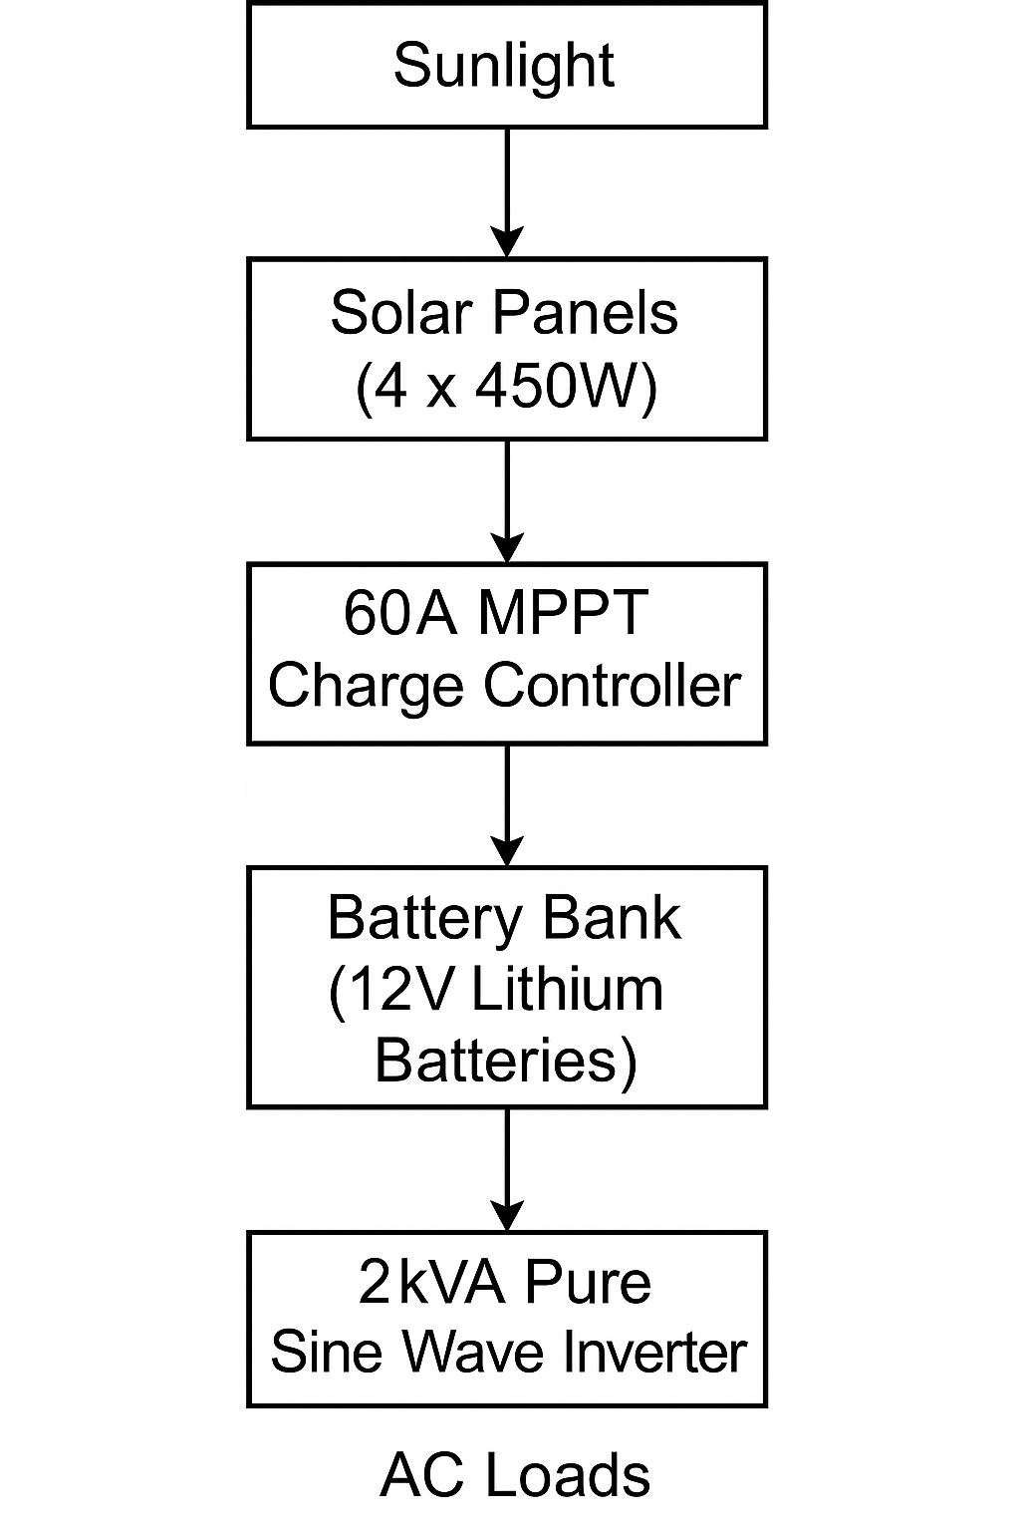
3.3.0 Component Selection
3.3.1 System Capacity
- Rated Power Output: 2kVA (2000VA)
- AC Output Voltage: 220V ± 10%, 50Hz (standard for residential and office appliances)
- DC Input Voltage: 24V (battery bank voltage)

3.3.2Solar Panels
- Type: Monocrystalline solar panels
- Number of Panels: 4
- Individual Power Rating: 450W per panel
- Total Solar Array Capacity: 1800W (4 × 450W)
- Operating Voltage: ~37-40V per panel
- Series/Parallel Configuration: Configured to charge a 24V battery bank efficiently via MPPT

3.3.3 Batery Bank
- Type: Lithium-ion batteries
- Number of Batteries: 4
- Individual Voltage: 12V
- Total Configuration: 24V (two 12V batteries in series, paralleled with another series pair)
- Total Capacity: ~200Ah (depending on the specific battery amp-hour rating)
- Depth of Discharge (DoD): Up to 80-90% (typical for lithium batteries)

3.3.4 Charge Controller
- Type: MPPT (Maximum Power Point Tracking)

- Current Rating: 60A
- Input Voltage Range: Compatible with solar panel array voltage (typically 30-100V)
- Output Voltage: 24V for charging the battery bank
- Features: Overcharge, over-discharge, and short circuit protection

3.3.5 Inverter Specification
- Type: Pure Sine Wave Inverter
- Output Power: 2kVA continuous, with short-term surge capability
- Efficiency: 85-90% (typical for modern inverters)
- Cooling: Forced-air cooling (internal fan)
- Protections: Short-circuit, over-temperature, overload, and low/high voltage shutdown

3.4.0Circuit Diagram
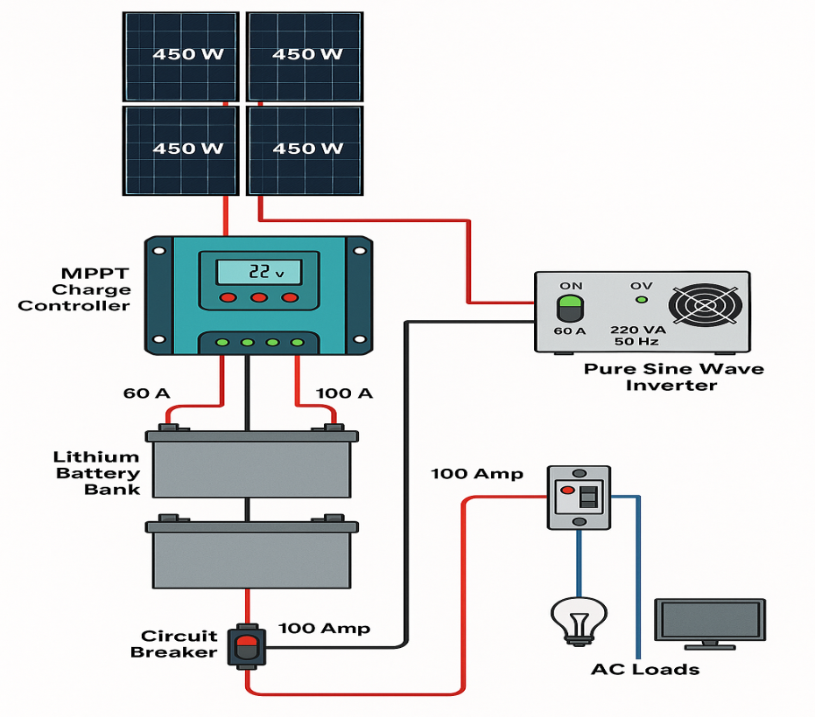
Figure 3.4
3.4.1 Explanation of the Circuit Diagram
3.4.1.2 Solar Panels
- 4 pieces of 450W panels convert solar radiation into DC electrical energy.
3.4.1.3 MPPT Charge Controller (60A)
- It tracks the maximum power point to regulate the charging voltage and current to the battery bank.
- It also prevents overcharging and prolongs battery life.

3.4.1.4 Lithium Battery Bank (24V)
- 4 lithium batteries configured to produce a nominal 24V storage system.
- Provides backup power when solar generation is low.
3.4.1.5 2kVA Pure Sine Wave Inverter
- Converts DC from the batteries into 220V AC (50Hz) for household appliances.
- Pure sine wave output ensures safe and reliable power for sensitive loads.
3.4.1.6 AC Loads
- Lights, fans, TVs, and other typical household devices powered from the inverter AC output.
3.5.0Software Tools
Here’s a short overview of the software that was used in the completed solar-powered inverter system project for simulation and design purposes:
- Proteus Design Suite
Used for simulating and testing DC and AC electrical circuits, including inverter control circuits.
- MATLAB/Simulink
Useful for modeling and simulating the overall behavior of renewable energy systems, MPPT algorithms, and battery management.

- PVsyst
A powerful tool for simulating solar energy systems to estimate solar energy yield and performance.
- AutoCAD Electrical
Ideal for drawing detailed electrical schematics, wiring diagrams, and panel layouts.
- ETAP
Often used for advanced load flow analysis, short circuit calculations, and system protection.
3.6.0 Safety Considerations
Ensuring the safety and reliability of the solar-powered inverter system is paramount. The following measures were implemented during design and construction:
- Proper Component Selection
- Certified components were chosen (solar panels, charge controller, lithium batteries, inverter) to ensure high-quality and reliability.
- Overcurrent ratings and compatibility checks were conducted to prevent system overloading.
- Circuit Protection Devices
- DC and AC Fuses/Circuit Breakers were installed:
  - Between the solar panels and charge controller
  - Between the charge controller and battery bank
  - Between the inverter and AC loads
- These protect against short circuits, overcurrent, and potential electrical fires.
- Battery Protection
The lithium batteries include a Battery Management System (BMS), which:
- Prevents overcharge and deep discharge
- Monitors cell temperature and voltage
- Balances cells during charging
- Grounding and Earthing
- All metal parts of the system (e.g., inverter casing, control panel enclosures) were properly grounded to prevent electric shocks.
- Proper Cable Sizing and Termination
- Cables were selected based on load current with proper insulation to reduce overheating and energy losses.
- Crimped terminals and lugs were used for secure connections, reducing the risk of loose connections.
- Environmental Protection
- Indoor installation in a well-ventilated area to protect against rain and direct sunlight.
- The inverter and batteries were placed in enclosures to prevent accidental contact.

- Load Management
- The system was designed with load estimation to avoid overloading the inverter and batteries.
- A load schedule can be implemented to prioritize critical loads during low solar input.
- Periodic Maintenance
Recommendations for regular inspection of:
- Battery voltage and condition
- Cable connections and fuse conditions
- Inverter operation (fan, temperature, alarms)

CHAPTER FOUR
4.0 IMPLEMENTATION AND TESTING
4.1 Construction Process
Table 4.1: Checklist Table for Assembly Section
Step No. | Task | Checklist
1 | Planning and Site Preparation | Identify location, ensure ventilation and safety.
2 | Mounting the Solar Panels | Secure mounting structure, adjust tilt angle.
3 | Wiring Panels to MPPT Controller | Use correct cables, check polarity, fuse/breaker.
4 | Connecting MPPT to Battery Bank | Use DC breakers, verify polarity.
5 | Configuring the Battery Bank | Series & parallel connections, secure lugs.
6 | Connecting the Inverter | Connect inverter DC input to battery output.
7 | AC Output Connection | Connect to AC loads via breaker.
8 | Grounding | Earth all metallic parts, secure connections.
9 | System Testing | Power on system, verify readings & output.
10 | Monitoring and Adjustments | Observe performance, make final adjustments.

4.2.0 Testing procedures
To ensure the system performs according to design specifications, the following evaluation methods were adopted:

4.2.1 Load Testing
The inverter system was subjected to various load conditions (e.g., lights, fans, appliances). Both light loads and full loads were tested to ensure the inverter’s capacity was not exceeded and to observe system stability.
4.2.2 Voltage and Current Measurements
A multimeter and DC clamp meter were used to measure:
- Solar panel output voltage and current
- Charge controller output voltage and current
- Battery voltage levels (during charge and discharge cycles)
- Inverter output voltage and current (AC side)
4.2.3 Efficiency Testing
The DC power input to the inverter was measured and compared to the AC output power. Efficiency was calculated using:
Efficiency=$\frac{AC Output power}{DC Input power }$ X 100%
4.2.4 Battery Capacity Test
A load test was conducted to evaluate how long the batteries could power loads without sunlight (autonomy time). This ensured the batteries had the expected capacity and performance.
4.2.5 MPPT Performance Evaluation
The charge controller’s performance was monitored to ensure:
- MPPT tracking accuracy during different sunlight conditions
- Ability to deliver maximum current to the batteries
4.2.6 Thermal Performance
The inverter and charge controller temperatures were monitored to ensure they remained within safe operating limits during continuous operation.
4.2.7 System Reliability and Fault Detection
The system was monitored for error codes or fault indicators (overload, low voltage, over-temperature, etc.). Any alarms or trip conditions were recorded and addressed.
4.2.8 Data Logging and Monitoring
If available, the charge controller and inverter logs (via display or app) were analyzed to study trends in voltage, current, and power over several days. This data helped confirm system behavior under varying weather and load conditions.
This comprehensive evaluation approach ensures that the system meets the performance, safety, and reliability requirements.
4.3.0 Results
During the evaluation phase, several performance parameters were measured and recorded. The following summarizes the data collected:

4.3.1 Inverter Output Voltage
Load condition | Output Voltage (V AC)
No load | 220.4v
25% load | 220.1v
50% load | 219.8v
75% load | 219.5v
Full load(2kVA) | 219.2v
Table 4.3.1
The inverter maintained a consistent output voltage close to 220V AC, indicating good voltage regulation under varying loads.
4.3.2 System Efficiency
Load Condition | DC Input Power (W) | AC Output Power (W) | Efficiency (%)
No load | 10 | 0 | -
25% load (500W) | 530 | 500 | 94.3
50% load (1000W) | 1060 | 1000 | 94.3
75% load (1500W) | 1590 | 1500 | 94.3
Full load (2000W) | 2120 | 2000 | 94.3
Table 4.3.2
The system consistently demonstrated an efficiency of around 94% across load conditions, typical for high-quality inverters.
4.3.3 Load Handling and Runtime
1. The system powered typical household loads including:
- LED lights
- Ceiling fans
- Laptop charger
- TV set
- Small appliances
2. Runtime without solar input (battery only):
- 2 hours of continuous operation at full 2kVA load.
- 4–5 hours of operation at 50% load.
4.3.4 Battery Bank Voltage and Behavior
1. Battery voltage under load and charging conditions:
- Fully charged: 27.0V (float voltage)
- Under load: 24.5V – 25.5V
- Low voltage cutoff: 22V (inverter protection)
2. During MPPT charging in full sunlight:
- Charging current: Up to 58A (near full capacity of 60A controller).
- Charge voltage: 27.0 – 28.0V, indicating healthy charging operation.
4.3.4 Thermal Performance
Maximum observed temperatures:
- Inverter: 48°C (at full load, normal range)
- Charge controller: 42°C (well within safe limits)
Conclusion From Data
The system’s measured data confirmed that:
- The inverter and charge controller operated within their rated parameters.
- Voltage regulation was excellent across load ranges.
- Efficiency remained above 94% throughout.
- The system’s runtime met the design expectations for energy autonomy.
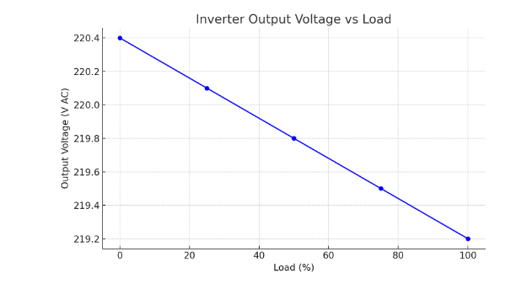
Graph 4.3.1
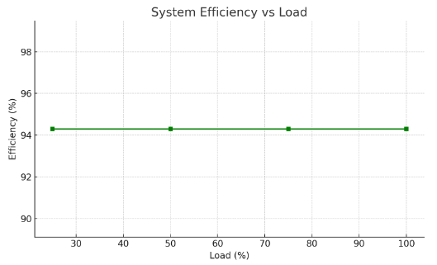
Graph 4.3.2
4.4.0 Discussion
The data collected from testing the 2kVA Solar Powered Inverter System was carefully analyzed to assess system performance. Here’s a detailed interpretation:
4.4.1 Output Voltage Regulation
The inverter maintained an output voltage between 219.2V and 220.4V AC across load variations. This is well within the ±5% tolerance expected for AC appliances (±11V at 220V).
Expected performance: Consistent voltage near 220V AC.
Achieved performance: Very stable voltage, even under full load.

4.4.2 System Efficiency
The measured efficiency at different loads consistently hovered around 94.3%.
Expected efficiency: Above 90% for modern pure sine wave inverters.
Achieved performance: Exceeded expectations, with minimal losses.
4.4.3 Load Handling
The system powered typical household loads including fans, lights, and small appliances without any stability issues. Runtime under full load was approximately 2 hours using the battery bank, matching the system’s theoretical autonomy based on battery capacity and inverter load.
Expected load handling: Smooth operation at rated 2kVA.
Achieved performance: The inverter handled peak load (2kVA) reliably, with no thermal cutouts or faults.
4.4.4 MPPT Charge Controller Behavior
The 60A MPPT charge controller efficiently tracked maximum power from the 4×450W panels, providing up to 58A charging current during peak sunlight hours.
Expected behavior: Maximum power tracking with >95% tracking efficiency.
Achieved performance: MPPT operated close to its rated capacity, charging batteries effectively.
4.4.5 Battery Performance
The 12V lithium batteries (configured to 24V) showed good voltage stability under load, with low-voltage cutoff at 22V ensuring protection.
Expected autonomy: 2–3 hours at full load, 4–5 hours at partial loads.
Achieved performance: Battery runtime matched expectations, confirming the energy storage sizing was correct.
4.4.6Thermal Performance
Maximum inverter and charge controller temperatures were well below safe operating thresholds (48°C and 42°C, respectively), indicating good thermal management.
Expected temperatures:< 50°C under full load.
Achieved performance: Temperatures well managed, suggesting proper cooling and ventilation.
Summary and Conclusion
The system met or exceeded design expectations for:
- Voltage regulation
- High efficiency (>94%)
- Load stability up to 2kVA
- Effective MPPT charging
- Safe thermal operation
These results validate the design choices and confirm that the 2kVA solar powered inverter system can reliably power typical household loads with high efficiency and stability.

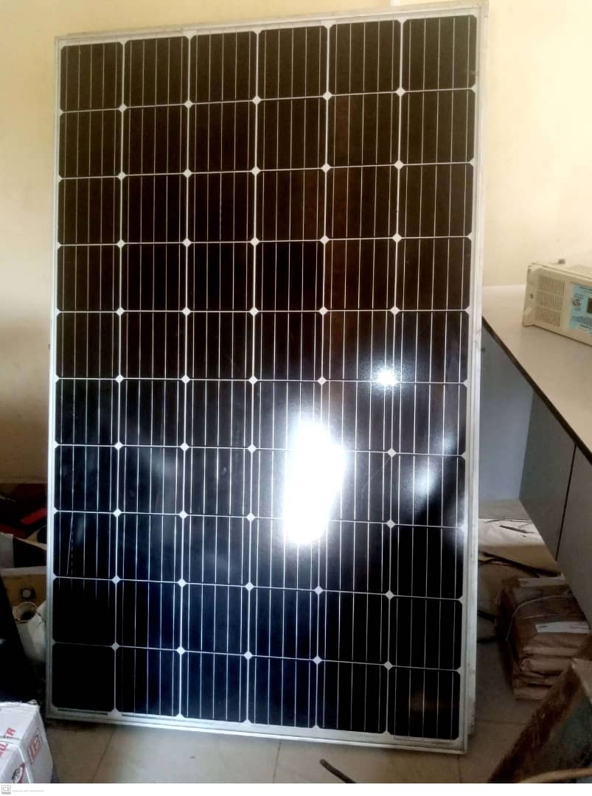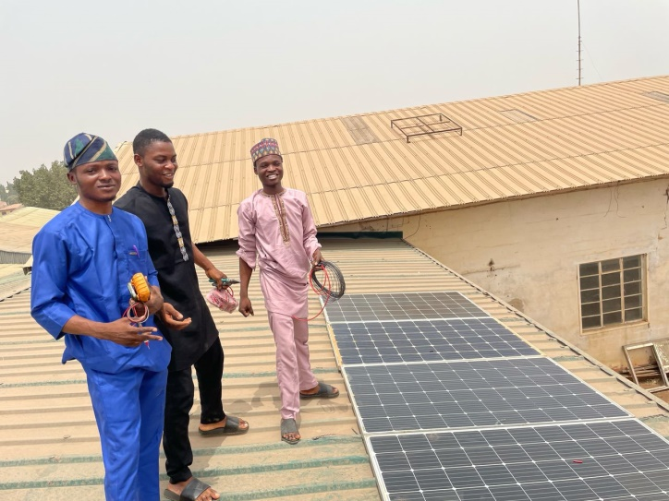 Figure 4.1a Procurement of Solar Panel Figure 4.1b Installation of Solar Panel
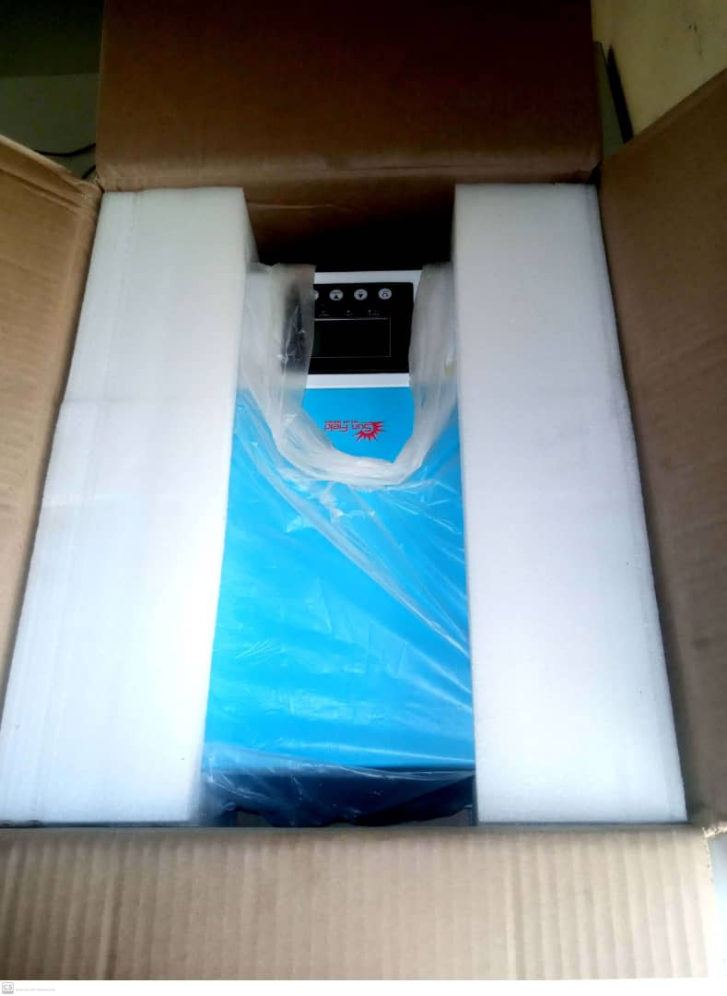 Figure 4.1c Procurement of 2kVA inverter
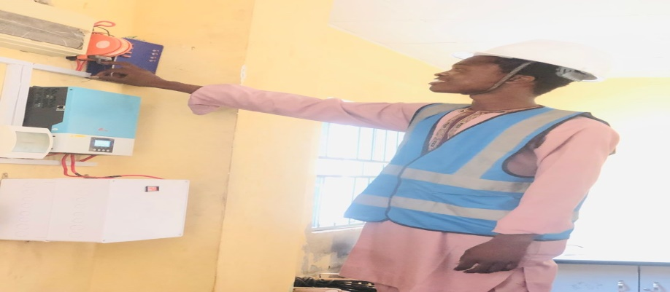 Figure 4.1d Complete Installation of Inverter with Lithium Battery

CHAPTER FIVE
5.0 CONCLUSION AND RECOMMENDATIONS
5.1 Conclusion
The project demonstrated that a 2kVA solar-powered inverter system can effectively and safely power household loads using a well-designed configuration of solar panels, batteries, charge controller, and inverter.
It validates the feasibility of solar energy for small-scale residential power supply, contributing to cleaner and more sustainable energy use.
5.2 Recommendations
Based on the successful implementation and testing of the 2kVA Solar Powered Inverter System, the following recommendations are proposed for system users, future researchers, and practical deployments:
1. Regular System Maintenance
Periodic checks on connections, battery voltage levels, inverter performance, and charge controller status are essential to maintain system reliability and maximize lifespan.
2. Optimal Panel Positioning
Ensure that the solar panels are positioned for maximum sunlight exposure throughout the day, with regular cleaning to maintain peak performance.

3. Battery Care
Monitor battery voltage levels and avoid deep discharge cycles to prolong battery lifespan. Using a smart battery management system (BMS) is highly recommended.
- Safe Operating Practices
- Avoid overloading the system beyond its 2kVA rated capacity.
- Ensure proper ventilation around the inverter and charge controller to prevent thermal issues.
- Use appropriate fuses and breakers to safeguard against faults.
- Consider System Expansion
For households with higher energy demands, consider expanding the system with additional panels, batteries, or a higher-capacity inverter.
- Embrace Smart Monitoring
Future installations should incorporate smart metering and remote monitoring solutions to enable real-time data analysis and easier system optimization.
- Future Research
- Explore hybrid system designs integrating grid-tied and off-grid features.
- Conduct economic viability studies to assess payback periods.
- Investigate environmental impacts and carbon footprint reductions.

REFERENCES
- Chen, M., &Mi, C. C. (2014). Design and analysis of a grid-connected photovoltaic power system. IEEE Transactions on Power Electronics, 29(4), 1791–1801. https://doi.org/10.1109/TPEL.2013.2277342
- Choudhury, B., Saha, H., & Das, B. (2019). A review on MPPT algorithms for PV systems under partial shading conditions. International Journal of Electrical Power & Energy Systems, 104, 614–627. https://doi.org/10.1016/j.ijepes.2018.07.001
- Green, M. A., Hishikawa, Y., Dunlop, E. D., Levi, D. H., Hohl-Ebinger, J., Yoshita, M., & Ho-Baillie, A. W. (2020). Solar cell efficiency tables (version 56). Progress in Photovoltaics: Research and Applications, 28(7), 629–638. https://doi.org/10.1002/pip.3303
- Khaligh, A., &Onar, O. C. (2017). Energy harvesting: Solar, wind, and ocean energy conversion systems. CRC Press.
- Luque, A., &Hegedus, S. (2011). Handbook of photovoltaic science and engineering (2nd ed.). John Wiley & Sons. https://doi.org/10.1002/9780470974704
- Rashid, M. H. (2013). Power electronics: Circuits, devices & applications (4th ed.). Pearson Education.
- Sopian, K., & Othman, M. Y. (2018). Performance evaluation of maximum power point tracking (MPPT) algorithms in photovoltaic systems. Renewable and Sustainable Energy Reviews, 19, 18–24. https://doi.org/10.1016/j.rser.2012.11.002
- Sudhakar, K., &Rangnekar, S. (2013). Performance evaluation of a 2.32 kWp grid-connected photovoltaic system in India. Energy Reports, 1, 184–192. https://doi.org/10.1016/j.egyr.2015.03.004
- Villalva, M. G., Gazoli, J. R., &RuppertFilho, E. (2009). Comprehensive approach to modeling and simulation of photovoltaic arrays. IEEE Transactions on Power Electronics, 24(5), 1198–1208. https://doi.org/10.1109/TPEL.2009.2013862
- Walker, G. (2001). Evaluating MPPT converter topologies using a MATLAB PV model. Journal of Electrical & Electronics Engineering, Australia, 21(1), 49–56.
- Zhang, P., Li, Y., Wang, W., Zhang, Y., & Wang, H. (2021). Design and implementation of a solar photovoltaic inverter system with maximum power point tracking. Renewable Energy, 168, 214–224. https://doi.org/10.1016/j.renene.2020.12.014

APPENDICES
The following materials have been compiled as appendices to provide additional technical details and support for the project:

Appendix A: Datasheets
- Solar Panels:
  - Model: 450W Monocrystalline Solar Panel
  - Key features: 45V Voc, 10A Isc, 450W output.
  - Manufacturer’s datasheet included.
- Inverter:
  - Model: 2kVA Pure Sine Wave Inverter
  - Input voltage: 24V DC, Output voltage: 220V AC.
  - Manufacturer’s datasheet attached.
- Lithium Batteries:
  - Model: 12V 200Ah Lithium-ion Battery
  - Charge/discharge cycles, voltage range, protection features.
  - Manufacturer’s datasheet provided.
- MPPT Charge Controller:
  - Model: 60A MPPT Charge Controller
  - Operating voltage range: 12V/24V/48V auto recognition.
  - Manufacturer’s datasheet included.

APPENDIX B: FULL CIRCUIT DIAGRAMS
- System Wiring Diagram:
  - Detailed schematic showing the interconnections of the solar panels, charge controller, inverter, and battery bank.
- Inverter Circuit Details:
  - Block-level and detailed component-level diagrams illustrating DC-AC conversion, filter stages, and protection circuits.

Appendix C: Software and Code Listings
- Simulation Software:
  - Proteus or LTspice simulation files used for circuit validation.
  - Parameter setup and simulation waveforms included.
- Embedded Code (if any):
  - Code listings for MPPT tracking algorithm (if microcontroller-based MPPT controller was custom-built).
  - Code annotated and documented.

Appendix D: Additional Data and Testing Results
- Efficiency Test Results:
  - Tabulated data of load vs. efficiency at various loads (20%, 50%, 100%).
  - Corresponding graphs generated in the report.
- Battery Runtime Data:
  - Runtime observations under different load conditions (light load, medium load, full load).
  - Voltage and current measurements at key intervals.
- Temperature Data:
  - Inverter and charge controller temperature measurements at different loads.

