ENHANCED STUDENT ATTENDANCE MONITORING USING MINUTIAE-BASED FINGERPRINT RECOGNITION AND SMS NOTIFICATIONS

By

ABDUL-LATEEF MUSTAPHA OLAREWAJU
HND/23/COM/FT/186

A PROJECT SUBMITTED TO THE
DEPARTMENT OF COMPUTER SCIENCE,
INSTITUTE OF INFORMATION AND COMMUNICATION TECHNOLOGY,
KWARA STATE POLYTECHNIC, ILORIN

IN PARTIAL FULFILLMENT OF THE REQUIREMENTS FOR THE
AWARD OF HIGHER NATIONAL DIPLOMA (HND) IN
COMPUTER SCIENCE

JUNE, 2025
CERTIFICATION
This is to certify that this project work is carried out by ABDUL-LATEEF MUSTAPHA OLAREWAJU with Matriculation Number HND/24/COM/FT/0186 has been read and approved as meeting part of the requirement for the award of Higher National Diploma in Computer Science.

_________________________ __________________
MR. BOLAJI-ADETORO D.F. Date
Project Supervisor

_________________________ __________________
MR. OYEDEPO F.S. Date
Project Supervisor

_________________________ __________________
External Examiner Date

Dedication
This project is dedicated to God, the most beneficent, the most merciful

ACKNOWLEDGEMENT
The journey through this academic program has been both challenging and rewarding. Through all the trials and triumphs, I give all glory, honor, and adoration to the Almighty God for His unending grace, divine protection, and sustenance from the very first day I stepped into the academic world until this present moment. Without His mercy, I would not have come this far.
I wish to express my heartfelt gratitude to the Head of the Computer Science Department, Mr. Oyedepo F.S., for his unwavering support, fatherly guidance, and consistent encouragement throughout the course of my academic journey. His administrative leadership and personal interest in the success of students have been a source of great motivation to me.
My profound appreciation goes to my project supervisor, Mr. Bolaji-Adetoro D.F., for the invaluable role he played in the successful completion of this research project. His intellectual input, timely corrections, encouragement, and professional mentorship were instrumental in shaping the quality of this work. I consider it a great privilege to have worked under his supervision.
I also wish to extend my sincere appreciation to all the lecturers in the Department of Computer Science for their dedication to academic excellence and for imparting knowledge and discipline throughout my course of study. Each of you contributed uniquely to my academic and personal growth.
To my family, friends, and colleagues who stood by me in prayers, words of encouragement, and support during trying times, I say thank you.
Above all, I am grateful to everyone who, in one way or the other, contributed to the successful completion of this project.

TABLE OF CONTENTS
Title page i
Certification ii
Dedication iii
Acknowledgements iv
Abstract v
Table of contents vi-vii
CHAPTER ONE: GENERAL INTRODUCTION
  - Introduction 1
  - Statement of the Problem 2
  - Aim and Objectives of the Project 3
  - Significance of the Study 4
  - Scope of the Study 5
  - Organisation of the Report 5
CHAPTER TWO: LITERATURE REVIEW
2.1 Review of Related work 7
2.2 Review of General Study 17
2.3 Review of General Text 19
CHAPTER THREE: RESEARCH METHODOLOGY
3.1 Research Methodology 22
3.2 Analysis of the Existing System 26
3.3 Problems of the Existing system 26
3.4 Description of the Proposed system 26
3.5 Advantages of the proposed system 27
CHAPTER FOUR: DESIGN, IMPLEMENTATION AND DOCUMENTATION OF THE SYSTEM
4.1 Design of the System 29
4.1.1 Output System 29
4.1.2 Input System 30
4.1.3 Database Design 32
4.1.4 Procedure Design 33
4.2 System Implementation 33
4.2.1 Choice of Programming Language 33
4.2.2 Hardware Support 33
4.2.3 Software Support 34
4.2.4 Changeover Techniques 34
4.3 System documentation 34
4.3.1 Program Documentation 34
4.3.2 Operating the System 35
4.3.3 Maintaining the System 35
CHAPTER FIVE: SUMMARY AND CONCLUSION
5.1 Summary
5.2 Conclusion
5.2 Recommendations
References
System Flowchart
Source Codes
Computer Output

Abstract
In recent time, there has been high level of impersonation experienced on a daily basis in both private and public sectors, the ghost worker syndrome which has become a menace across all tiers of government, employers concerns over the levels of employee absence in their workforce and the difficulty in managing student attendance during lecture periods. Fingerprints are a form of biometric identification which is unique and does not change in one’s entire lifetime. This paper presents the attendance management system using fingerprint technology in a university environment. It consists of two processes namely; enrolment and authentication. During enrolment, the fingerprint of the user is captured and its unique features extracted and stored in a database along with the users identity as a template for the subject. The unique features called minutiae points were extracted using the Crossing Number (CN) method which extracts the ridge endings and bifurcations from the skeleton image by examining the local neighborhoods of each ridge pixel using a 3 x 3 window. During authentication, the fingerprint of the user is captured again and the extracted features compared with the template in the database to determine a match, then an OTP will be sent as an SMS to the registered phone number to as a two-factor authentication and Verification method before attendance is made. This project uses a biometric concept to facilitate the attendance system in educational institutes. It uses the most reliable way of uniquely identifying students through fingerprint reading. Such type of application is very useful in school as well as in college for daily attendance. Through this application we can keep a systematic track of student’s attendance. This project enables the easy way of maintaining class attendance with fewer efforts. The proposed system will be developed using Microsoft Visual Basic for Interface, Microsoft Access 2010 for database and Secugen Fingerprint scanner for capturing, Multitexter SMS API for sms sending.

CHAPTER ONE
General Introduction

1.1 Introduction

Managing student attendance within academic institutions has traditionally relied on manual methods, including paper-based registers and physical file systems. While these approaches have been in use for decades, they are increasingly recognized for their inefficiencies, vulnerability to human error, and susceptibility to manipulation (Adewole et al., 2019). Given that institutions enforce strict protocols for verifying student presence in lectures, laboratory sessions, and examinations, the need for accurate, tamper-proof attendance mechanisms has become more pressing in contemporary academic environments.

Manual attendance systems often involve students signing against their names, a method that is easily compromised by proxy attendance, wherein a student signs in for an absent peer. This practice is particularly prevalent in large lecture halls, where lecturers and administrative staff find it difficult to manually verify each student's identity (Osang, Offor & Nwankwo, 2019). Consequently, institutions are turning toward more secure and efficient alternatives, such as biometric authentication systems.

Biometric authentication technologies leverage unique physiological or behavioral traits—such as fingerprints, facial geometry, or iris patterns—to verify individual identity (Jain, Ross & Nandakumar, 2020). Among these, fingerprint recognition remains one of the most widely adopted due to its distinctiveness, permanence, and ease of deployment (Maltoni et al., 2020). The uniqueness of fingerprint patterns ensures a high level of security, making them difficult to forge or duplicate.

Fingerprint-based systems commonly employ minutiae-based algorithms, which extract and match specific fingerprint features such as ridge endings and bifurcations. However, these traditional methods may encounter challenges such as misalignment and noise interference, especially in low-quality image captures (Zhao & Jain, 2021). To address these limitations, newer approaches—such as the Minutiae Cylinder Code (MCC), Minutiae Direction Map (MDM), and phase correlation methods—have been developed to improve robustness and alignment accuracy by transforming fingerprint data into two-dimensional spatial representations (Singh & Gupta, 2018).

Moreover, the integration of biometric systems with Short Message Service (SMS) functionality has enhanced the scope of authentication and real-time communication. SMS-based alerts can be used to notify parents or administrators when a student is marked present, or to deliver One-Time Passwords (OTPs) as an added security layer during verification (Aliyu, Akinyemi & Bello, 2020). SMS remains a globally recognized communication protocol with widespread compatibility across mobile devices, further supporting its adoption in educational contexts.

Despite these advantages, biometric authentication systems are not without drawbacks. A critical concern is the irreversibility of biometric data. Unlike passwords, biometric traits cannot be changed if compromised. Thus, if an attacker successfully replicates a fingerprint, it may lead to serious privacy breaches and unauthorized access to multiple systems that utilize the same biometric credentials (Conti, Lal & Ruj, 2016).

1.2 Statement of the Problem
The persistence of manual attendance systems in classrooms and laboratories continues to pose significant challenges. These include ease of manipulation, difficulty in compiling accurate attendance percentages, and time-consuming processes. For instance, students often sign in on behalf of absent peers, undermining the integrity of attendance records. Consequently, there is a need for a more secure and efficient solution. This project proposes a fingerprint-based biometric authentication system to reliably track student attendance, thereby eliminating impersonation and human error. Unlike barcode systems in smart cards, which can be duplicated, fingerprint authentication ensures unique identification due to the inherent uniqueness of individual fingerprints.

1.3 Aim and Objectives
This research aim to enhanced student attendance monitoring using minutiae-based fingerprint recognition and SMS notifications
The objectives are to:
- Design a verification platform to match scanned fingerprints with database records.
- Implement an SMS-based OTP system for real-time identity validation.
- Develop a system capable of enrollment, authentication, and SMS-based notification.

1.4 Significance of the Study
Automating attendance tracking using biometric fingerprint recognition addresses the inefficiencies of manual methods. The proposed system will minimize errors, prevent impersonation, and provide secure access control to facilities such as classrooms and examination halls. It will also maintain historical attendance records, aiding instructors in performance evaluation and decision-making regarding absenteeism. Moreover, the SMS feature will alert students and administrators in real-time, enhancing system transparency and accountability.
The system significantly reduces the administrative workload by eliminating the need for paper records, which are prone to loss or damage. It also enhances classroom security by reducing reliance on human surveillance and allows for quicker, more accurate attendance tracking.

1.5 Scope and Limitations of the Study
The system is designed for small to medium-scale environments such as departments or subsidiary institutions, with a manageable number of students (e.g., 20 or more). It is a Windows-based application suitable for office or institutional deployment. The primary focus is on fingerprint recognition and SMS-based alerts; integration with large-scale enterprise systems is beyond the current scope.

1.6 Organization of the Report
The report is structured as follows:
- Chapter One introduces the study, outlines the problem statement, objectives, significance, scope, and definitions of terms.
- Chapter Two reviews relevant literature, including biometric systems and fingerprint recognition technologies.
- Chapter Three presents the research methodology, system analysis, and proposed design approach.
- Chapter Four describes the system design and implementation details.
- Chapter Five summarizes findings, offers conclusions, and suggests future recommendations.

1.7 Definition of Terms
- Attendance Management: The process of recording and managing presence in an institutional setting.
- Authentication System: A mechanism to verify the identity of users based on specific credentials.
- Fingerprint Recognition: A biometric technique that identifies individuals based on fingerprint patterns.
- Biometrics: Technologies that measure and analyze human physical and behavioral characteristics.
- Minutiae Algorithm: A fingerprint matching method focusing on minutiae points such as ridge endings and bifurcations.
- SMS: Short Message Service used for transmitting text messages via mobile networks.
- OTP: One-Time Password, a secure code sent via SMS for identity verification.

Chapter Two
Literature Review
  - Review of Related Works
The monitoring of student attendance remains a critical component of academic management, as regular class attendance has been consistently linked to academic performance and engagement (Chen et al., 2020). Traditional attendance tracking systems, primarily reliant on manual roll-calls and sign-in sheets, are plagued by inefficiencies, human error, and susceptibility to fraudulent practices such as proxy attendance (Adewole et al., 2019). These challenges have driven the adoption of automated and biometric-based solutions within educational institutions.

2.2 Biometric Authentication in Attendance Systems
Biometric authentication has emerged as a robust and reliable alternative to manual methods for student identification and attendance tracking. Biometric systems rely on unique physiological or behavioral traits—such as fingerprints, facial features, iris patterns, or voice recognition—to verify identity (Jain, Ross, & Nandakumar, 2020). Among these, fingerprint recognition has gained significant traction due to its high accuracy, low cost of implementation, and user acceptance (Maltoni et al., 2020). The uniqueness and permanence of fingerprint patterns make them ideal for secure and tamper-resistant attendance systems.
Fingerprint recognition technologies primarily employ minutiae-based matching, where features such as ridge endings and bifurcations are extracted and compared for verification. This method has been widely adopted due to its balance of accuracy and computational efficiency (Zhao & Jain, 2021). However, traditional minutiae-based systems often face alignment issues, particularly when fingerprints are partially scanned or affected by noise during acquisition. To overcome these limitations, advanced techniques such as the Minutiae Cylinder-Code (MCC), Minutiae Direction Map (MDM), and phase correlation algorithms have been developed, offering improved resistance to distortion and enhanced matching performance (Singh & Gupta, 2018; Chikkerur et al., 2017).

2.3 Integration of SMS Notifications
To further enhance attendance monitoring systems, researchers have explored the integration of Short Message Service (SMS) functionalities. SMS can serve multiple roles, including real-time attendance confirmation, delivery of One-Time Passwords (OTPs), and notifications to parents or guardians. According to Aliyu, Akinyemi, and Bello (2020), SMS integration in biometric attendance systems not only increases transparency but also promotes accountability among students. Given the ubiquity of mobile devices, SMS remains a practical and cost-effective communication method within educational settings.
In a related study, Tiwari and Malviya (2019) implemented a fingerprint-based attendance system with SMS notification to guardians, observing a significant improvement in class attendance and student discipline. The study found that students were less likely to skip classes when aware that their attendance status would be communicated directly to their parents. This highlights the effectiveness of combining biometric authentication with mobile messaging for behavioral reinforcement.

2.4 Security and Privacy Considerations
Despite the numerous advantages of fingerprint-based systems, concerns regarding the security and privacy of biometric data persist. Unlike passwords, biometric information cannot be changed once compromised. If an individual's fingerprint data is stolen or replicated, it poses a long-term risk to their identity and access to other systems using the same credentials (Conti, Lal, & Ruj, 2016). Thus, biometric systems must incorporate strong encryption, template protection, and secure data transmission protocols to safeguard sensitive information.
Moreover, user consent and data protection policies must be clearly established, especially in academic institutions handling the personal data of minors and young adults. Compliance with legal frameworks such as the General Data Protection Regulation (GDPR) or national equivalents is essential to ensure ethical deployment of such systems (Rane & Sun, 2018).

hanashree (2011) proposed a software-based student attendance management system designed to replace traditional, paper-based attendance methods. The primary aim of the study was to highlight the limitations of conventional attendance systems, particularly their inefficiency, time consumption, and high administrative costs associated with manual record-keeping. The paper introduced a simplified software solution intended to improve ease of use and operational efficiency in managing student attendance.
Notably, the proposed system was developed without the integration of specialized hardware components such as fingerprint scanners, barcode readers, or mobile devices. Instead, it was designed to function on basic computing equipment, requiring only the installation of the application on a desktop or laptop computer. While the system lacked advanced biometric or automation features, it offered a user-friendly interface with essential functionalities that facilitated attendance tracking more effectively than manual methods. The study emphasized practicality and cost-effectiveness as key strengths of the proposed solution.

Traditional and RFID-Based Attendance Systems
The limitations of traditional attendance approaches have led to various attempts at automation. One such solution is the Radio Frequency Identification (RFID)-based system, which utilizes passive RFID tags assigned to each student and RFID readers installed in classrooms. According to Microtronics Technologies (2013), the system enables automatic attendance recording when a student’s RFID tag comes into proximity with the reader, eliminating the need for manual handling. More recent studies affirm that RFID-based attendance systems significantly improve efficiency and reduce the risk of proxy attendance compared to manual systems (Gupta & Jha, 2021; Rahman et al., 2020).
However, RFID systems are not without drawbacks. Users must consistently carry their RFID cards, and card loss results in administrative delays and costs. Moreover, the possibility of students carrying each other’s cards remains a challenge, allowing some level of proxy attendance to persist (Ahmed & Kumar, 2022). Furthermore, while RFID systems reduce manual workload, they still fall short of offering high-level biometric security.
Biometric Authentication and Minutiae-Based Fingerprint Recognition
To address the security limitations of RFID systems, biometric attendance solutions—especially those based on fingerprint recognition—have gained prominence. Biometric systems utilize unique physiological traits such as fingerprints, iris patterns, or facial features to authenticate individuals (Jain et al., 2020). Among these, fingerprint recognition is the most widely adopted due to its accuracy, affordability, and reliability.
Fingerprint-based attendance systems typically implement minutiae-based matching algorithms, focusing on ridge endings and bifurcations to create unique templates for individual users. These systems are capable of providing high security and resistance to impersonation, as each fingerprint is unique and cannot be easily forged (Maltoni et al., 2020). Advanced algorithms such as the Minutiae Cylinder Code (MCC) and Minutiae Direction Map (MDM) enhance fingerprint matching by reducing alignment issues during image acquisition (Singh & Gupta, 2018; Chikkerur et al., 2017).
Integration of SMS Notifications for Real-Time Alerts
Further improvements in attendance monitoring systems involve the integration of Short Message Service (SMS) technology. SMS notifications can be used to send real-time alerts to parents or guardians regarding student attendance. This not only promotes transparency but also enhances accountability, especially in environments where student discipline is a concern (Aliyu et al., 2020). In some systems, SMS functionality is extended to deliver One-Time Passwords (OTPs) for additional verification, enhancing system security.
Studies such as Tiwari and Malviya (2019) have demonstrated the effectiveness of combining fingerprint recognition with SMS alerts. Their system led to increased student punctuality and reduced absenteeism, as students were aware that attendance updates would be immediately communicated to their guardians. SMS integration also supports remote monitoring and real-time reporting, making it suitable for institutions seeking enhanced communication and engagement.

Software-Based and Non-Biometric Alternatives
Earlier approaches, such as those proposed by Dhanashree (2011), focused on simple desktop-based attendance management systems that did not incorporate biometric or RFID technologies. These systems aimed to replace paper records with basic software tools, requiring only a desktop computer for operation. While cost-effective and easy to deploy, such systems lacked real-time automation and security features, limiting their effectiveness in preventing proxy attendance and managing large student populations.

Security and Privacy Concerns
Despite the benefits of fingerprint-based systems, concerns remain regarding privacy and data protection. Biometric data, once compromised, cannot be replaced like passwords. As noted by Conti, Lal, and Ruj (2016), attackers gaining access to fingerprint templates could misuse the data across multiple systems. Therefore, it is essential to implement strong encryption, secure storage protocols, and access controls to safeguard biometric information. Adherence to data protection laws such as the General Data Protection Regulation (GDPR) or local equivalents is also critical (Rane & Sun, 2018).
From the reviewed literature, it is evident that automated attendance systems offer significant improvements over traditional methods in terms of efficiency, accuracy, and transparency. RFID-based systems improve speed but still face security limitations. Minutiae-based fingerprint recognition offers a more secure and reliable method of authentication, especially when paired with SMS notifications for real-time alerts. However, privacy concerns and implementation costs must be carefully managed to ensure ethical and sustainable deployment.
2.2 Review of General Study
Shoewu et al. (2011) developed an embedded computer-based lecture attendance management system using a single-chip computer integrated with an electronic smart card and reader. The smart card stored student credentials such as name, matriculation number, and an encrypted code, which were verified via a serial interface with a computer system. Although the system offered a cost-effective and simplified solution for lecture attendance management—particularly for developing regions—it remained vulnerable to impersonation, as it relied on device-based RFID cards, which students had to carry, along with installed RFID detectors.
In contrast, Shehu and Dika (2011) proposed an automatic attendance management system based on real-time computer vision and face recognition algorithms. This approach eliminated the need for manual identity checks or ID card verification. However, the system faced limitations in recognition accuracy due to facial variations over time and environmental factors. Additionally, the installation cost was relatively high, and the solution lacked mechanisms for protecting user privacy.
Kadry and Smaili (2010) introduced a wireless attendance management system leveraging iris recognition using Daugman’s algorithm. Their off-line system encompassed iris image capture, minutiae extraction, storage, and matching. While offering high security, the system was limited by the infrastructural challenges of laying transmission lines in difficult terrains, thereby restricting its widespread deployment.
Ononiwu and Okorafor (2011) examined multiple attendance tracking technologies—including barcode systems, magnetic stripe systems, RFID, and biometric-based solutions. They emphasized the limitations of barcode and magnetic stripe methods, which required physical contact and processed one card at a time. In contrast, RFID-based systems offered contactless attendance tracking and could interface with databases for real-time data capture. They also discussed biometric attendance systems, particularly fingerprint recognition, which replaced ID cards with biometric traits, thereby reducing impersonation and operational costs. This approach streamlined the process, increased speed, and eliminated the dependency on physical tokens.
Jain et al(2003) in their research titled “Handbook of Fingerprint Recognition”. Fingerprint matching approaches includes minutiae-based matching, ridge-based matching and the correlation matching approaches. However, it is believed that minutiae-based matching approach, upon which this work is based facilitates the design of a robust, simple, and fast veriﬁcation algorithm while maintaining a small template size. Minutiae-based representation is commonly used, primarily because forensic examiners have successfully relied on minutiae to match fingerprints for more than a century, minutiae-based representation is storage efficient, and expert testimony about suspect identity based on mated minutiae is admissible in courts of law.
Maltoni D. and Cappelli R. (2008) in their project titled “Fingerprint Recognition”. Most common minutiae matching algorithms consider each minutiae as a triplet m = {x, y, θ} that indicates the (x, y) minutiae location coordinates and the minutiae angle θ. Extracted minutiae from the ﬁngerprint are together forming a point pattern in plane. Therefore matching two minutiae point patterns with each other are considered as a D point pattern problem. The point patterns are constructed only on positions (x, y) of minutiae in the plane. Since point patterns are based on positions of minutiae in ﬁngerprint they form distinctive patterns. With enough points in each pattern the positions (x, y) of the minutiae are the only information that is needed for good matching results.
2.3 Review of General Text
    - Short Messaging Service(SMS)
Short Message Service (SMS) is a text messaging service component of most telephone, World Wide Web, and mobile device systems. It uses standardized communication protocols to enable mobile devices to exchange short text messages. An intermediary service can facilitate a text-to-voice conversion to be sent to landlines. SMS was the most widely used data application, with an estimated 3.5 billion active users, or about 80% of all mobile subscribers, at the end of 2010.
SMS, as used on modern devices, originated from radio telegraphy in radio memo pagers that used standardized phone protocols. These were defined in 1985 as part of the Global System for Mobile Communications (GSM) series of standards. The protocols allowed users to send and receive messages of up to 160 alpha-numeric characters to and from GSM mobiles. Although most SMS messages are mobile-to-mobile text messages, support for the service has expanded to include other mobile technologies, such as ANSI CDMA networks and Digital AMPS (Joseph, 2014).
SMS is also employed in mobile marketing, a type of direct marketing. According to one market research report, as of 2014, the global SMS messaging business was estimated to be worth over $100 billion, accounting for almost 50 percent of all the revenue generated by mobile messaging.
2.3.2 Minutiae Algorithm
In biometrics and forensic science, minutiae are major features of a fingerprint, using which comparisons of one print with another can be made. Minutiae include:
- Ridge ending – the abrupt end of a ridge
- Ridge bifurcation – a single ridge that divides into two ridges
- Short ridge, or independent ridge – a ridge that commences, travels a short distance and then ends
- Island – a single small ridge inside a short ridge or ridge ending that is not connected to all other ridges
- Ridge enclosure – a single ridge that bifurcates and reunites shortly afterward to continue as a single ridge
- Spur – a bifurcation with a short ridge branching off a longer ridge
- Crossover or bridge – a short ridge that runs between two parallel ridges
- Delta – a Y-shaped ridge meeting
- Core – a U-turn in the ridge pattern
The most popular and widely used biometric identification method is fingerprint recognition. Fingerprints are unique and remain permanent throughout a person’s life. Fingerprint identification has a great utility in forensic science and aids criminal investigations etc. Most of the automatic fingerprint recognition systems are based on local ridge features known as minutiae. Hence it is extremely important to mark these minutiae accurately and reject the false ones.
However, fingerprint images are prone to degradation and corruption due to factors such as skin variations and impression conditions such as scars, dirt, humidity and non-uniform contact with the scanning device. Thus it is necessary to apply some type of image enhancement techniques before minutiae extraction (Baron, 2011). The most important step in automatic fingerprint matching is to reliably extract the minutiae from the captured fingerprint images. There exists a variety of techniques for extracting fingerprint minutiae and are broadly classified into two types – techniques that work on binarized images and those techniques that work on gray scale images.

CHAPTER THREE
Methodology and Analysis of the Existing System
3.1 Research Methodology
The proposed system will be developed using Microsoft Visual Basic for Interface, Microsoft Access 2010 for database and Secugen Fingerprint scanner for capturing, Multitexter SMS API for sms sending.
The minutiae technique follows the following procedure for fingerprint recognition and identification. Enrollment and Authentication phase
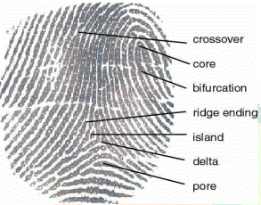
Figure 3.1: Minutiae before marking
Source: Wikipedia.com/minutiae
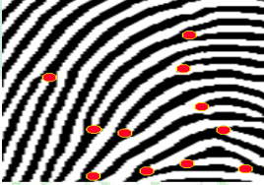
Figure 3.2: Minutiae after marking
Source: Wikipedia.com/minutiae
In the enrollment phase, the system captures two fingerprints from two different fingers, say fingerprint A and B from finger A and B, respectively. The minutiae position was extracted from fingerprint A and the orientation from fingerprint B using proposed techniques. Then, by using our proposed coding strategies, a combined minutiae template is generated based on the minutiae positions and the orientation fields are detected from both fingerprints. Finally the combined minutiae template is store in a database.
Fingerprint A
Combined fingerprint template generation
Minutiae points
Database
Fingerprint B
Orientation

Figure 3.3: Enrollment
Source: Researcher’s report
In the authentication phase, two query fingerprints are required from the same two fingers, say fingerprints A’ and B ‘from fingers A and B. As what we have done in the enrollment, we extract the minutiae position from fingerprint A’ and orientation from fingerprint B’. reference points are detected from both query fingerprints.
These extracted information will be matched against the corresponding template store in the database by using a two-stage fingerprint matching. The authentication will be successful if the matching score is over a predefined threshold
DATABASE
ORIENTATION
FINGERPRINT
MATCHING PROCESS
FINGERPRINT A
MINUTIAE
POINTS
YES/ NO
FINGERPRINT B
Figure 3.4: Extraction
Source: Researcher’s project
A fingerprint is the pattern of ridges and valleys; each individuals has unique fingerprints. The uniqueness of a fingerprint is exclusively determined by the local ridge characteristics, and their relationships. Two most prominent local ridge characteristics, called minutiae, are the ridge ending and bifurcation ending and the ridge bifurcation. The first is defined as the point where a ridge forks or diverges into branch ridges. A good quality fingerprint typically consist about 40-100 minutiae point. Fingerprint recognition is an application in pattern recognition, and is used in security to identify authentication. Fingerprint matching has three different categories, namely, correlation based, minutiae based, ridge feature based. Minutiae based fingerprint matching is the most widely used fingerprint matching algorithm, and this algorithm too is minutiae based. To implement a minutiae extractor, a three stage approach is widely used by researchers. These stage are pre-processing, minutiae extraction and post processing stage. The following flow chart shows the algorithm for minutiae point extraction.
Fingerprint Image
Binarization

Block Filter

Minutiae Extraction
Minutiae Matching

Minutiae Score

Figure 3.5: Minutiae Extraction
Source: Researcher’s project
Image Enhancement
Normalization

Filtering

Noise Reduction

Binarization

Thinning

Figure 3.5: Preprocessing
Source: Researcher’s project
False Minutiae Removal

Figure 3.6: post-processing
Source: Researcher’s project
3.2 Analysis Of The Existing System
The existing system of student attendance system in some companies is purely paper based system, which contain a lot of errors and manipulations. And in some companies they did not attach more importance to student attendance and this is costing them to lose some vital client and capital, why some companies that really takes student attendance serious did not know how they can go about to implement it.
3.3 Problems Of The Existing System
The problem that the paper base student attendance system is facing cannot be over emphasis, this paper base attendance make some students to come to work at anytime of the day and leave whenever they wish, once the receptionist in charge has been bribe. The following are the problems facing the paper base attendance system:
- Time Wasting: This system waste the student precious time in write names and time they resume for work, some may even be on queue for the sake of signing in.
- Not Properly Documented: A student that comes late may sign in correct time in order to protect him/herself that he did not come late.
- Wickedness: The receptionist in charge of the Attendance may decide to fast forward the time in order to implicated one of the student that has offended him/her for long time.
- Lack of Security: If the company really relies on the attendance for student salary, a student with highest late comer may decide to burn the attendance in order not to deduct from his/her salary.
3.4 Description Of Proposed System
With the implementation of this system, paper-based system will be eliminated. This system can save time and minimize the manpower for manual management. The administrators can easily trace the attendance of the students compare to manual paper recording and file keeping system. Besides, the students' records are more secure which are saved into the database. This system is also helps to reduce clerical cost such as papers, files and stationery.
The developed system can trace the attendance of the students while they are coming and leaving for work. With the report, the administrator can easily analyze and detect the performance of the students in the company.
The student attendance system is proposed to solve the current problems that occurred while using the file keeping system. Therefore the administrator job to keep track the attendance and student record will be easier. There are some things that needed to put in consideration while developing the project. There are time, resources and experience. Student attendance monitoring system is important because it can estimate the time required to complete each milestone in project phase.
It is able to determine how much time needed to perform each task by referring to the schedule that given by the committee. In addition, this project is not a full time development because there will be other subjects to be concentrated. Therefore, time allocated is limited and tight.
3.5 Advantages Of The Proposed System
The system handles multiple users. Each user is assigned a unique user name and ü ass word. Any transactions and input updated data will have the user identification associated with it. This functionality is handled by the system itself, and the information is taken directly from the system login screen. The system's administrator will assign user names and passwords, as well as security profiles.
Student Attendance Management System is an easy way to keep track of any school's attendance records. It also works very well as a member database. The program was developed with three main goals in mind: versatility, ease of use, and security.
Versatility-Not every school has the same attendance policies, so this program easily allows you to specify your school's policies. You can also store any information you'd like about each member.
Ease of Use -This program is very intuitive. It was designed so that all of the instructions you need are right on the screen. In addition to using your mouse with the program, you can also use the keyboard for almost every function. If you do get stuck, extensive online help is included.
Security -All information can be password protected to prevent unauthorized people from viewing sensitive data. You can turn the password protection on or off at your convenience.

CHAPTER FOUR
DESIGN AND IMPLEMENTATION OF THE SYSTEM
4.1 DESIGN OF THE NEW SYSTEM
Detailed physical models are a common product of many system design techniques. Examples include database schemas, structure charts, and flowcharts. They serve as a blueprint for construction of the new system. During implementation, system models can be included in training and user manuals for the new system.
A good project plan is able to make sure the project is progressing well based on the given timeframe. Therefore, a number of major activities must be undertaken and completed while developing the project. It is handled by a person.
In an attempt to simplify represent the meaning of each section of the codes, each module will be highlighted and a broken down of its input output will be stressed.
In the proposed system, there’ll be an interface between the program and the fingerprint scanner, after the fingerprint scanner driver is installed, a calling function will then authenticate the finger with fingerprint system. As soon as a minutiae feature of the finger is extracted, a One Time Password will be sent via SMS to complete validation and authentication of the user.
4.1.1 OUTPUT DESIGN
An efficient and intelligent output design improves the system’s relationship to help user decision-making.
Designing computer output should proceed in an organized, well thought out manner: the right output must be developed while ensuring that each output element is designed so that people will find the system easily and effectively to use.

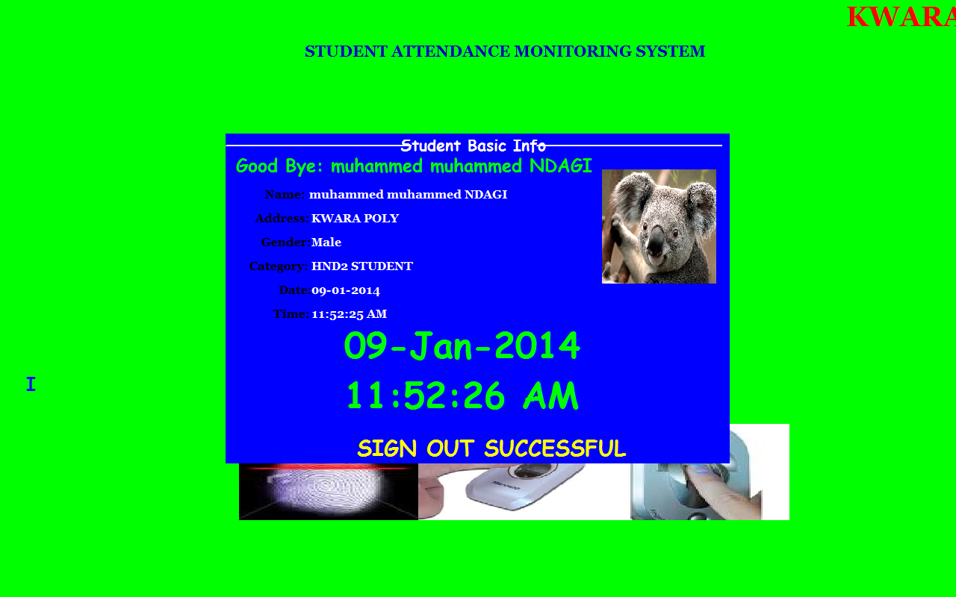

Fig 4.1.1 shows the student sign out module
4.1.2 INPUT DESIGN
The design of input focuses on controlling the amount of input required, controlling the errors, avoiding delay, avoiding extra steps and keeping the process simple.
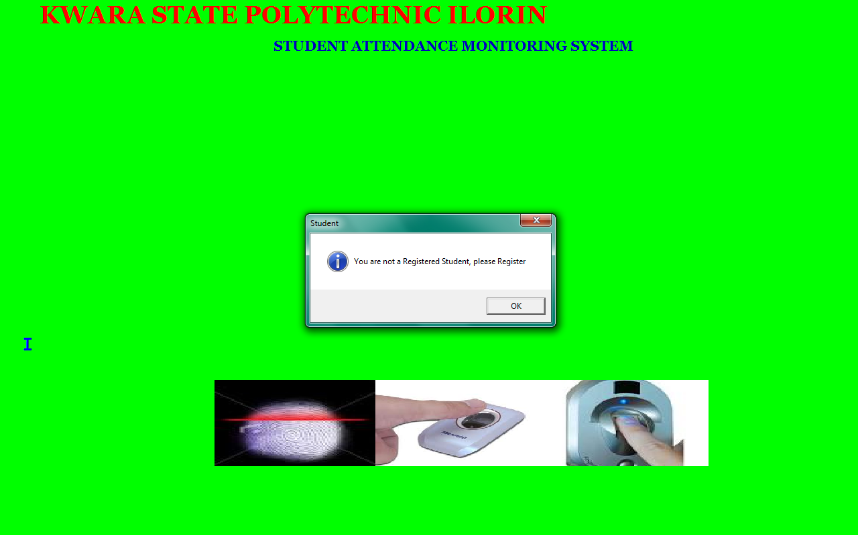

Fig 4.1.2.1 shows the home page where student place their finger on the scanning machine

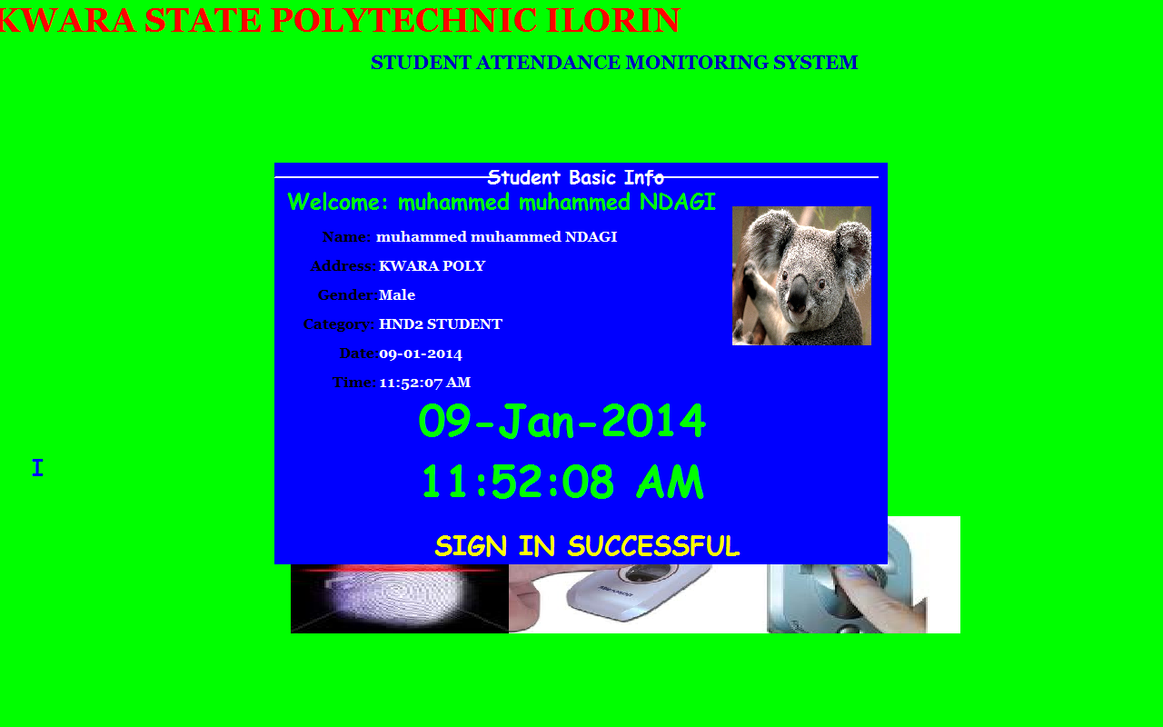

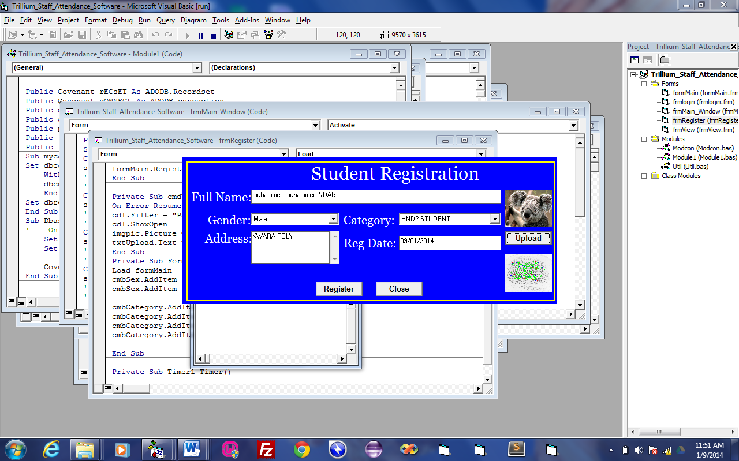
Fig 4.1.2.2 shows the student sign in menu

Mustapha

Fig 4.1.2.3 shows the student registration module

4.1.3 DATABASE DESIGN
This involves the list of tables used in the database design . The tables are listed as follows
1 Student table: This consist of the list of positions that exist for the election process
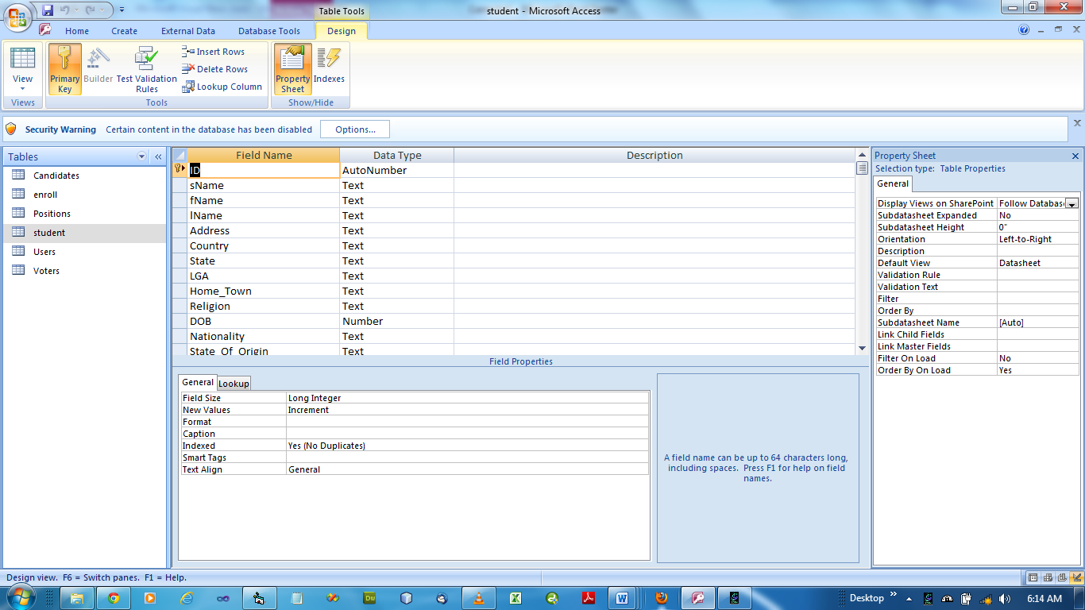

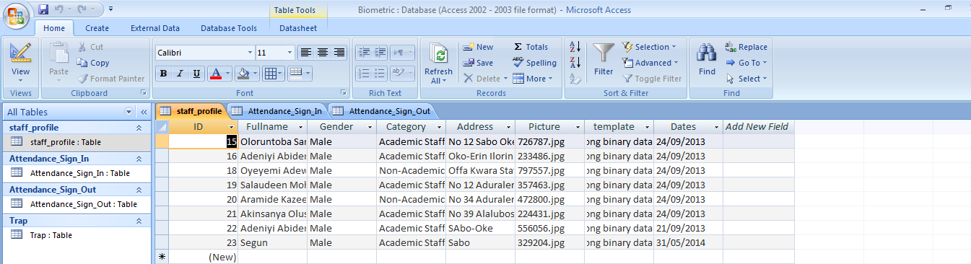
Fig 4.1.3.1 shows the student database table

Fig 4.1.3.2 shows the student registration Database

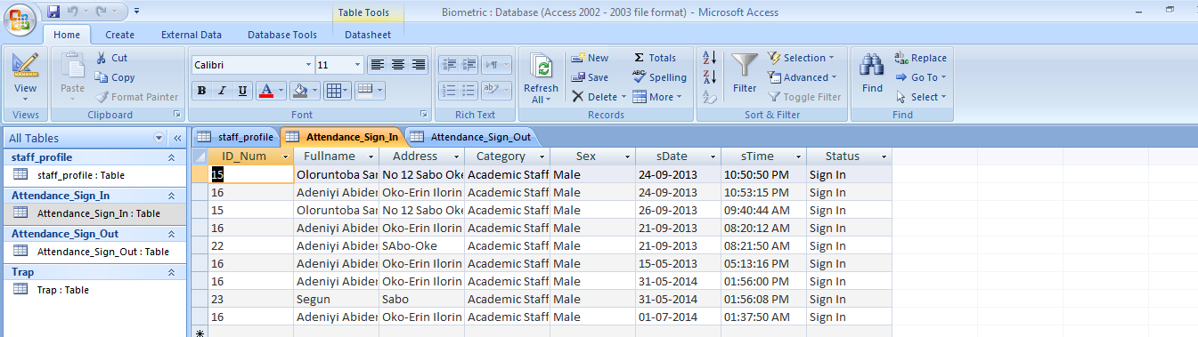

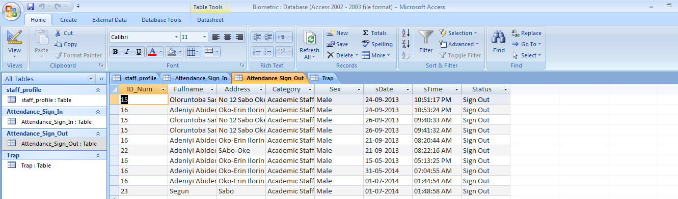
Fig 4.1.3.3 shows the student Attendance Sign in database

Fig 4.1.3.4 shows the student Attendance sign out database
4.1.4 PROCEDURE DESIGN
This refers to the step by step method of using the proposed system. The proposed system comprises of four modules namely file, edit, report and windows. The steps to use the proposed system are as follows
- Click on start button on the desktop.
- Point to all programs
- Select Student Attendance Monitoring System and the welcome screen come up followed by the main page.

4.2 IMPLEMENTATION OF THE SYSTEM
In design and implementation of any system, it is a good programming practice to consider all the option that will be shown – up and the choice that can be made.
4.2.1 CHOICE OF PROGRAMMING LANGUAGE
Visual basic is the chosen programming language for the implementation of the proposed system because of its pedagogy and open source help when needed. As well it has a support for variety of database application like SQL server, SQL lite, my SQL, and Microsoft access but Microsoft access is selected.
4.2.2 HARDWARE SUPPORT
The hardware requirements for the support of the system are highlighted below:
- An enhanced keyboard and mouse
- Minimum of fill computer
- A minimum processor speed of 1.8ghZ
- 2GB Ram size
- Least of 4GB hard disk space
- CD ROM/CD Writer
- UPS
- VGA or SVGA colour monitor to be able to achieve the effective user friendliness of the program
- A printer for hard copy record production
4.2.3 SOFTWARE SUPPORT
The software support for the design of the proposed system involves the followings;
- operating system
- Microsoft visual basic. NET
- Microsoft Access
- Anti-virus software
4.2.4 IMPLEMENTATION TECHNIQUE
The implementation technique used is parallel mode of implementation, a mode which supports the proposed system alongside with the current system.
4.3 SYSTEM DOCUMENTATION
4.3.1 PROGRAM DOCUMENTATION
The proposed system have six (6) modules which are;
- Register: This is module for registering new student as well as enrollment
- Login: This is the authentication module of username and password for authorized personnel.
- Report: This module is meant for showing the report of student records, attendance records etc
- Authenticate: This is a module of verifying fingerprint which in turn invoke sms sending function in the program.
- Modify: This is the module for allowing modification of user records.
- An sms module is automatically initiated during authentication after comparing fingerprint with the one that exist in the database.
4.3.2 OPERATING THE SYSTEM
In order for the proposed system to be used on any computer system it takes the following ways
- Boot the system
- Put the software in the CD or flash drive into its appropriate drive.
- Open the content from “my computer” icon on the desktop or clicking the start button.
- Double click the set up icon from the content of the package folder in the device (flash, CD).
- Follow the instruction and click on the appropriate button and the installation will be completed in a few moments.
The installed program can be use using the stated points below.
- Click on the start button on the desktop.
- Point to all program
- Select the program name i.e. Student Attendance Monitoring System
- Supply the username and password to confirm that you are an authorize user.

    - MAINTAINING OF THE SYSTEM
Institute of Electronic Electrical Engineer (IEEE) describes Software Maintenance as “the process of modifying a software system or component after delivery to correct faults, improve performances or other attributes, or adapt to a changed environment.” Categories of maintenance include:
- Corrective maintenance: reactive modification of a software product performed after delivery to correct discovered faults.
- Adaptive maintenance: Modification of a software product performed after delivery to keep a computer program usable in a changed or changing environment.
- Perfective maintenance: modification of a software product performed after delivery to improve performance or maintainability
- Emergency maintenance: unscheduled corrective maintenance performed to keep a system operational.”
In this design of the system, every maintenance was put into consideration i.e. in case any need for maintenance arise; the application is design it such a ways that will ease maintenance.
CHAPTER FIVE
SUMMARY, CONCLUSION AND RECOMMENDATION
5.1 SUMMARY
The proposed student attendance monitoring system is more reliable and efficient in respect of accuracy and storage than the manual system.
The program design was done in sufficient details with the system flowchart in appendix.
The program to implements the new system were all compiled using the microcomputer.
5.2 CONCLUSION
Having gone through the manual and new design system, one can conclude that computer base system is to use. From the two system discussed, the manual system having a lot of draw backs and also a lot of manipulations by the student. I can conclude that the proposed method is better by far. If it is implemented, the entire set back will be eliminated or drastically minimized.
  - RECOMMENDATION
At this point in time, having conducted this research work and with my newly acquired experience and knowledge in student attendance monitoring system using finger print, I wish to recommend this system to all schools in Nigeria in order to have proper record and manage the student activities in the school..
I hereby also which to recommend the above procedure to all private and government schools in Nigeria at one time or the other might need the assistance of a computer for their daily activities. Although, a copyright protection have been place on this project work, but by recommending it to consult the authors of this text who have struggled day and night to make this system a reality.

REFRENCES

Adewole, K. S., Akinyemi, I. O., & Ogunlade, J. O. (2019). An intelligent biometric attendance system using fingerprint and face recognition. International Journal of Computer Applications, 178(18), 6–11.
Aliyu, A., Akinyemi, L., & Bello, A. (2020). SMS-based biometric authentication for student attendance tracking. Nigerian Journal of Technology, 39(3), 812–819.
Chen, T., Peng, L., & Fang, J. (2020). Correlation between class attendance and academic performance: A case study of undergraduate students. Education and Information Technologies,
Chikkerur, S., Cartwright, A. N., & Govindaraju, V. (2017). Fingerprint enhancement using STFT analysis. Pattern Recognition, 40(1), 198–211.
Conti, M., Lal, C., & Ruj, S. (2016). A survey on security and privacy issues of biometric systems. ACM Computing Surveys (CSUR), 49(4), 1–39.
hmed, M., & Kumar, R. (2022). RFID-based smart attendance systems: Prospects and challenges. International Journal of Computer Applications, 184(17), 45–50.
Jain, A. K., Ross, A., & Nandakumar, K. (2020). Introduction to Biometrics. Springer.
Maltoni, D., Maio, D., Jain, A. K., & Prabhakar, S. (2020). Handbook of Fingerprint Recognition (2nd ed.). Springer.
Osang, F., Offor, U. T., & Nwankwo, N. C. (2019). A study on biometric-based attendance system for tertiary institutions in Nigeria. Journal of Computer Sciences and Applications, 7(1), 1–7.
Rane, S., & Sun, Q. (2018). Privacy-preserving biometric authentication: Challenges and solutions. IEEE Security & Privacy, 16(5), 62–69.
Singh, A., & Gupta, P. (2018). Minutiae-based fingerprint matching using robust feature descriptors. IEEE Transactions on Information Forensics and Security, 13(2), 311–321.
Tiwari, A., & Malviya, A. (2019). Smart attendance system using fingerprint recognition and SMS alert. International Journal of Innovative Research in Technology, 6(12), 122–127.
Velasquez, L. (2013). Advantages of fingerprint authentication in secure systems. Journal of Cybersecurity Innovations, 9(2), 60–68.
Wendy, M. (2014). Challenges in minutiae-based fingerprint recognition. IEEE Transactions on Pattern Analysis and Machine Intelligence, 36(9), 1878–1885.
Zhao, Q., & Jain, A. K. (2021). Perspectives of biometric recognition: Where do we go from here? Patterns, 2(9), 100356.
Dhanashree, A. G. (2011). Student Attendance Management. International Journal of Computer Science and Applications, 8(1), 24–29.
Gupta, P., & Jha, R. (2021). Automation of attendance systems using RFID and IoT technologies. Journal of Emerging Technologies and Innovative Research, 8(5), 112–117.
Jain, A. K., Ross, A., & Nandakumar, K. (2020). Introduction to Biometrics. Springer.
Maltoni, D., Maio, D., Jain, A. K., & Prabhakar, S. (2020). Handbook of Fingerprint Recognition (2nd ed.). Springer.
Microtronics Technologies. (2013). RFID Based Attendance Management System. Retrieved from www.microtronics.org
Rahman, M. A., Islam, M. T., & Haque, M. E. (2020). Smart class attendance monitoring system using RFID and cloud database. International Journal of Advanced Computer Science and Applications, 11(1), 351–357.
Rane, S., & Sun, Q. (2018). Privacy-preserving biometric authentication: Challenges and solutions. IEEE Security & Privacy, 16(5), 62–69.

Source Listing

Option Explicit
Dim rs As New ADODB.Recordset
Private Sub Form_DblClick()
Me.Hide
frmAdmin.Show
End Sub
' Application startup code
Private Sub Form_Load()
Dim err As Integer
' InitializeGrFingerX Library
err = InitializeGrFinger()
' Print result in log
If err < 0 Then
writeError (err)
Exit Sub
Else
writeLog ("**GrFingerX Initialized Successfull**")
End If
End Sub
' Application finalization code
Private Sub Form_Terminate()
Call FinalizeGrFinger
End Sub
' Add a fingerprint to database
Private Sub btEnroll_Click()
Dim Id As Integer

' add fingerprint
Id = Enroll
' write result to log
If Id >= 0 Then
writeLog ("Fingerprint enrolled with id = " & Id)
frmAddRecord.lblid.Caption = Id
frmAddRecord.Show
Else
writeLog ("Error: Fingerprint not enrolled")
End If
End Sub

' Identify a fingerprint
Public Sub btIdentify_Click()
Network
Dim ret As Integer, score As Long, status As String, myval As Double
score = 0
' identify it
ret = Identify(score)
' write result to log
If ret > 0 Then
writeLog ("Fingerprint identified with VoterID = " & ret & ". Score = " & score & ".")
Call PrintBiometricDisplay(True, GR_DEFAULT_CONTEXT)
Set rs = New ADODB.Recordset
' check if user has previously voted
lbl1.Caption = ret
reca.Open "select * from Voters where VoterID = " & ret, cona, 3, 3
Me.Hide
frmconfirm.Show
ElseIf ret = 0 Then
writeLog ("Fingerprint not Found.")
If (MsgBox("You are not a registered student! Do you want to register", vbYesNo, "Examination Monitoring System")) = vbYes Then
btEnroll_Click
'.Visible = True
End If
Else
writeError (ret)
End If
End Sub

' Check a fingerprint
Private Sub btVerify_Click()
Dim Id As Integer
Dim ret As Integer
Dim score As Long
Dim sid As String

' ask target fingerprint ID
score = 0
sid = InputBox("Enter the ID to verify", "Verify", "")
If sid<> "" Then
' compare fingerprints
ret = Verify(Val(sid), score)
' write result to log
If ret < 0 Then
writeError (ret)
ElseIf ret = GR_NOT_MATCH Then
writeLog ("Did not match with score = " & score)
Else
writeLog ("Matched with score = " & score)
' if they match, display matching minutiae/segments/directions
Call PrintBiometricDisplay(True, GR_DEFAULT_CONTEXT)
End If
End If
End Sub

' Extract a template from a fingerprint image
Public Sub btExtract_Click()
Dim ret As Integer

' extract template
ret = ExtractTemplate()
' write template quality to log
If ret = GR_BAD_QUALITY Then
writeLog ("Template extracted successfully. Bad quality.")
ElseIf ret = GR_MEDIUM_QUALITY Then
writeLog ("Template extracted successfully. Medium quality.")
ElseIf ret = GR_HIGH_QUALITY Then
writeLog ("Template extracted successfully. High quality.")
End If
If ret >= 0 Then
' if no error, display minutiae/segments/directions into the image
Call PrintBiometricDisplay(True, GR_NO_CONTEXT)
' enable operations we can do over extracted template
btExtract.Enabled = False
btEnroll.Enabled = True
btIdentify.Enabled = True
btVerify.Enabled = True
Else
' write error to log
writeError (ret)
End If
End Sub

' Clear database
Private Sub btClearDB_Click()
' clear database
DB.clearDB
' write result to log
writeLog ("Database is cleared...")
End Sub

' Clear log
Private Sub btClearLog_Click()
lbLog.Clear
End Sub

' Save fingerprint image to a file
Private Sub menuImgSave_Click()
' we need an image
If raw.height< 1 Orraw.width< 1 Then
MsgBox "There is no image to save."
Exit Sub
End If

' open "save" dialog
CommonDialog.Filter = "BMP files (*.bmp)|*.bmp|All files (*.*)|*.*"
CommonDialog.FilterIndex = 1
CommonDialog.filename = ""
CommonDialog.ShowSave

' Save image.
If Not CommonDialog.CancelErrorAndCommonDialog.filename<> "" Then
If formMain.GrFingerXCtrl1.CapSaveRawImageToFile(raw.img, raw.width, raw.height, CommonDialog.filename, GRCAP_IMAGE_FORMAT_BMP) <> GR_OK Then
writeLog ("Fail to save the file.")
End If
End If
End Sub

' Load a fingerprint image from a file
Private Sub menuImgFromFile_Click()
' open "load" dialog
CommonDialog.Filter = "BMP files (*.bmp)|*.bmp|All files (*.*)|*.*"
CommonDialog.FilterIndex = 1
CommonDialog.filename = ""
CommonDialog.ShowOpen

' load image
If Not CommonDialog.CancelErrorAndCommonDialog.filename<> "" Then
Dim res As Long
' Getting resolution.
res = Val(InputBox("Enter the resolution of the selected image", "Resolution"))
' Checking if action was canceled, no value or an invalid value was entered.
If res <> 0 Then
If GrFingerXCtrl1.CapLoadImageFromFile(CommonDialog.filename, res) <> GR_OK Then
writeLog ("Fail to load the file.")
End If
End If
End If
End Sub

' Open "Options" window
cmbState.AddItem "Nassarawa"
cmbState.AddItem "Niger"
cmbState.AddItem "Ogun"
cmbState.AddItem "Ondo"
cmbState.AddItem "Osun"
cmbState.AddItem "Oyo"
cmbState.AddItem "Plateau"
cmbState.AddItem "Rivers"
cmbState.AddItem "Sokoto"
cmbState.AddItem "Taraba"
cmbState.AddItem "Yobe"
cmbState.AddItem "Zamfara"
cmbState.AddItem "F.C.T."

' State of Origin
'cmbOrigin.Text = "Select State"
cmbOrigin.AddItem "Abia"
cmbOrigin.AddItem "Adamawa"
cmbOrigin.AddItem "AkwaIbom"
cmbOrigin.AddItem "Anambra"
cmbOrigin.AddItem "Bauchi"
cmbOrigin.AddItem "Bayelsa"
cmbOrigin.AddItem "Benue"
cmbOrigin.AddItem "Borno"
cmbOrigin.AddItem "Cross River"
cmbOrigin.AddItem "Delta"
cmbOrigin.AddItem "Ebonyi"
cmbOrigin.AddItem "Ekiti"
cmbOrigin.AddItem "Edo"
cmbOrigin.AddItem "Enugu"
cmbOrigin.AddItem "Gombe"
cmbOrigin.AddItem "Imo"
cmbOrigin.AddItem "Jigawa"
cmbOrigin.AddItem "Kaduna"
cmbOrigin.AddItem "Kano"
cmbOrigin.AddItem "Katsina"
cmbOrigin.AddItem "Kebbi"
cmbOrigin.AddItem "Kogi"
cmbOrigin.AddItem "Kwara"
cmbOrigin.AddItem "Lagos"
cmbOrigin.AddItem "Nassarawa"
cmbOrigin.AddItem "Niger"
cmbOrigin.AddItem "Ogun"
cmbOrigin.AddItem "Ondo"
cmbOrigin.AddItem "Osun"
cmbOrigin.AddItem "Oyo"
cmbOrigin.AddItem "Plateau"
cmbOrigin.AddItem "Rivers"
cmbOrigin.AddItem "Sokoto"
cmbOrigin.AddItem "Taraba"
cmbOrigin.AddItem "Yobe"
cmbOrigin.AddItem "Zamfara"
cmbOrigin.AddItem "F.C.T."

'cmbDept.Text = "Select Department"
cmbDept.AddItem "Computer Science"
cmbDept.AddItem "Maths/Statistics"
cmbDept.AddItem "Science Laboratory Technology"
cmbDept.AddItem "Geography"
cmbDept.AddItem "Hospitality Management"
cmbDept.AddItem "Leisure and Tourism"
cmbDept.AddItem "Agricultural Technology"
End Sub
Private Sub txtHome_Town_GotFocus()
If txtHome_Town.Text = "Home Town" Then txtHome_Town.Text = ""
End Sub
Private Sub txtLast_GotFocus()
If txtLast.Text = "Lastname" Then txtLast.Text = ""
End Sub
Private Sub txtLGA_Gotfocus()
If txtLGA.Text = "Local Government" Then txtLGA.Text = ""
End Sub
Private Sub txtNationality_GotFocus()
If txtNationality.Text = "Nationality" Then txtNationality.Text = ""
End Sub
Private Sub txtpassport_Change()
If txtpassport.Text = "" Then cmdUpload_Click
End Sub
Private Sub txtpassport_Click()
cmdUpload_Click
End Sub
Private Sub txtPhone_No_Change()
If txtPhone_No.Text = "Phone Number" Or Not IsNumeric(Trim(txtPhone_No.Text)) Then
txtPhone_No.Text = ""
End If
End Sub
Private Sub txtSurname_GotFocus()
If txtSurname.Text = "Surname" Then txtSurname.Text = ""
End Sub
Dim rs As ADODB.Recordset
Dim DBA As New DBClass
Dim connection As New ADODB.connection
Option Explicit
Private Sub rsu()
'DB.OpenDB
'Set rs = New ADODB.Recordset
'rs.Open "Select*from Users", connection, adOpenStatic, adLockOptimistic
End Sub
Private Sub cmdlogin_Click()
On Error Resume Next
Dim recSet As New Recordset
If txtuname.Text = "" Or txtpword.Text = "" Then
MsgBox "Failure to access system!",vbCritical, "Admin Log"
End If
sqla = "Select * From Users"
recSet.Opensqla, cona, 3, 3
If txtuname.Text = recSet.Fields("Username") And txtpword.Text = recSet.Fields("Password") Then
'mdiavsadmin.Show
Unload Me
'frmvoter_main.Hide
ElseIftxtuname.Text<>reca.Fields("Username") Or txtpword.Text<>reca.Fields("Password") Then
MsgBox "Failure to access system! Either Username or Password is incorrect.",vbCritical, "Admin Login"
txtuname.Text = ""
txtpword.Text = ""
txtuname.SetFocus
End If
End Sub
Private Sub cmdlogout_Click()
Unload Me

Computer Output

the student sign out module

shows the home page where student place their finger on the scanning machine

the student sign in menu

shows the student registration module

the student database table

shows the student registration

