KWARA STATE POLYTECHNIC, ILORIN, NIGERIA

EFFECT OF RICE-HUSK ASH AS SAND MOLD ADDITIVE ON THE TENSILE STRENGTH OF AN ALUMINIUM ALLOY

BY

ADAM FAWAS MOBOLAJI
ND/23/MEC/PT/106

JULY, 2025

KWARA STATE POLYTECHNIC, ILORIN, NIGERIA

EFFECT OF RICE-HUSK ASH AS SAND MOLD ADDITIVE ON THE TENSILE STRENGTH OF AN ALUMINIUM ALLOY

BY

ADAM FAWAS MOBOLAJI
ND/23/MEC/PT/106

A Project Report Submitted to the Department of Mechanical Engineering, Institute of Technology, Kwara State Polytechnic, Ilorin in Partial Fulfilment of the Requirements for the Award of National Diploma (ND) in Mechanical Engineering

JULY, 2025

DECLARATION
We hereby declare that this project titled Effect of rice-husk ash as sand mould additive on the tensile strength of an aluminium alloy is our own work and has not been submitted by any other person for any qualification at any higher institution. We also declared that the information provided therein are ours and those that are not, are properly acknowledged.

ADAM FAWAS MOBOLAJI
Signature and Date
ADELABU OLAKUNLE ABDULLAHI
Signature and Date
ARANLOYE FERANMI OLAMIDE
Signature and Date
ABDULFATAI ABDULQUDUS
Signature and Date
ABDULKAREEM ABDULLATEEF ABIODUN
Signature and Date
BELLO ABDULRASHEED
Signature and Date

ISMAIL BABATUNDE YUSUF
Signature and Date

JOSEPH CHINEDU MICHEAL
Signature and Date

CERTIFICATION
This is to certify that the project titled Effect of rice-husk ash as sand mould additive on the tensile strength of an aluminium alloy was carried out by Adam Fawas Mobolaji. The project has been read and approved as meeting the requirements for the award of National Diploma (ND) in Mechanical Engineering in the Department of Mechanical Engineering, Institute of Technology, Kwara State Polytechnic, Ilorin.

Engr. IDREES ABDULQADIR Date
Supervisor

Engr. ABDULGANIYU ISSA Date
Project Co-ordinator

Engr. AYANTOLA ABDULWAHEED Date
Head of Department

External Examiner Date

DEDICATION
This research project work is dedicated to Almighty God, our parents, family, friends, colleagues, brothers and sisters.

ACKNOWLEDGEMENT
I wish to acknowledge the support received from my family members, siblings, friends and those that indirectly contributed to the success of the research project from beginning to the end.

TABLE OF CONTENTS
FRONT PAGE…………………………...………………………………….1
TITLE PAGE………………………………………………………………….1
DECLARATION………………………………………………………..2
CERTIFICATION..…………………………………..……………….……3
DEDICATION……………………………………………………………...4
ACKNOWLEDGEMENT..………………………………………………..5
TABLE OF CONTENTS…………………………………………………..6
ABSTRACT...……………………………….……………………………..7
CHAPTER ONE.……………………………………………..............…..8
1.1 Introduction………………………...…………………………...…..8
1.2 Problem Statement…………………....………………………...…..9
1.3 Aim and Objectives…………………………..………………...…..9
CHAPTER TWO………………..………..………………..................…..10
2.1 Literature Review...…………………………..………………...…..10-11
2.2 Background of the Study………………………….…………...…..12
CHAPTER THREE…………………………….…………………..........13
3.1 Methodology...…............………...…………………………...…..13-16
CHAPTER FOUR……………………………..…............……......…..17
4.1 Results and Discussion……………………………………...…..17
CHAPTER FIVE…………………...………..........………..……...…..18
5.1 Conclusion and Recommendations………....……………...…..18
REFERENCES……………………...….............……..…………...…..19

ABSTRACT
Aluminium, due to its suitable mechanical properties in manufacturing industries as an engineering material, is widely used. The effectiveness and efficiency of cast aluminium alloy depend greatly on various casting methods and the additives in the sand mould. This study investigated the effect of sand mould additive (Rice-Husk Ash) on the tensile strength of the cast Aluminium alloy. The additive was varied at 0%, 2%, 3%, 4%, 5% and 6%. After cooling and machining, the samples were subjected to a tensile strength test. The result shows significant differences in the tensile strength properties of the cast samples.

CHAPTER ONE
1.1 INTRODUCTION
Sand casting technique is one of the most versatile means of producing metals by melting process. However, sand casting products properties are largely influenced by the performance of the sand mould from which the metal is being cast. The moulding sand is depended on its compositions. Sand mould compositions include silica sand (river sand), binder, additives and water in different compositions. Additives are usually added to sand to make it suitable for use as foundry sand during casting operation. Some of these additives such as synthetic resins, like Furan resin and phenol-formaldehyde resins which are usually added to improve the moulding sand properties are hazardous and are not environmentally friendly. Moreover, these binder systems are too sophisticated and expensive for foundries in developing countries like Nigeria that have abundant natural raw materials but without needed advanced technologies for proper use of the resources. In this regard, this project is aimed at developing a cheap and eco-friendly additive using rice-husk ash for enhancement of the moulding sand properties with the intent of determining its influence on the tensile strength of sand cast aluminium alloy. The outcome of this project will recommend a composition of the moulding sand for application in Nigerian foundries.

1.2 PROBLEM STATEMENT
Additives are usually added to sand to make it suitable for use as foundry sand during casting operation. Some of these additives such as synthetic resins, like Furan resin and phenol- formaldehyde resins are hazardous, not eco-friendly and high cost of importation.
1.3 AIM AND OBJECTIVES
The aim of this project is to evaluate the effect of rice-husk ash as sand mould additive on the tensile strength of aluminium alloy. The objectives are:
- To prepare the sand mould and characterized physical and mechanical properties of the sand.
- To evaluate the tensile strength of the sand mould cast.

CHAPTER TWO
2.1 LITERATURE REVIEW
To improve the cast product qualities, several researchers have suggested using synthetic resins and few on agricultural wastes like snail shells and shear butter shell as additives in mould sand. Meanwhile, the effect of the sand mould additives mixture on casted aluminium, particularly heat-treated aluminium cooled in air has not been well explored. Some previous published research studies are; Ikebudu et al. [3] investigated the effect of green sand mixture with dextrin additives on the mechanical properties of aluminium 6351. The results were improved to obtain optimum proportions of the mixtures to give effective results, and from the best possible validation values, 5 percent water content, 12 percent bentonite, and 8.85 percent dextrin organic additive was found to be the optimized solution that gave the most effective hardness at (40.4GSS and 112PN), while 3 percent water, 12 percent bentonite clay, and 9 percent dextrin organic additive displayed the most effective toughness at (30.4GSS and 112PN) (41.9GSS and 96.10PN). Investigation was conducted by Kumar et al. [6] on the effect of additives on the mechanical properties during the casting of 6351 aluminium. These different additives (tamarind powder, starch powder, coal dust) were utilized in varying percentages. Starch power of 1% content in sand increases the compressive strength of mould which increases the tensile stress of all alloys when compared to tamarind powder and coal dust according to the test result.
2.2 BACKGROUND OF THE STUDY
The desire to produce light-weight parts with near net shape in industry has become highly researchable topics. Casting as of today is one of the most important manufacturing process widely in used. Casting is used for making intricate shapes which are difficult or too expensive to make by other methods. Casting process is vast and is carried out on almost all metals. Aluminium alloys are widely used for hundreds of compositions by all commercial casting processes including green sand, dry sand, composite mould, plaster mould, investment casting, permanent mould, etc. Aluminium alloys have excellent mechanical properties which include high strength, low density, durability, machine-ability and others required in manufacturing industries. These alloys are used in advanced applications due to their combinations, availability and relatively low cost as compare to competing materials. There are many process parameters affecting properties of final casted product but the additives presents in sand significantly impact final casted products. Additives are added to moulding components to improve surface finish, dry strength, refractoriness, and cushioning properties. Recently, additives are gaining greater application in sand mould preparation. Apart from intrinsic properties of molten metal such as fluidity, composition, segregation, etc., which affects the soundness of the cast produced, mould properties also play prominent role in determining the soundness of a casting. Other factors that may affect the heat storage capacity of sand mould includes; composition of mould material, the moisture content and mould temperature. Sand casting accompanying advantage over others includes; wide range of cast-able sizes, flexibility to mechanization, ease of handling and cost effectiveness.
2.3 SCOPE OF THE PROJECT
The scope of the project is to investigate the effects of adding rice husk ash to sand moulds for aluminium alloy casting so as to evaluate the tensile strength of the resulting alloys. It would also include studying the casting process itself, including the rheological properties of the moulding materials, the casting defects, and the microstructure of the casting. The research would be limited to the use of specific types of aluminium alloys and casting processes, but it would still provide valuable insights into these materials in casting. One more additional aspect of the scope of the project is to study the economic feasibility of using rice husk ash as sand mould additive.

CHAPTER THREE
3.1 MATERIAL AND EXPERIMENTAL METHODOLOGY
3.1.1 MATERIALS
Natural sand employed in the preparation of the green sand mould was taken from the riverbank in the Asa river along Amilengbe area of Ilorin, Nigeria. The sand sample used was sieved with a 63 µm sieve to separate the substance from deleterious substance. Aluminium alloy ingot from used Aluminium window frames was obtained at Ipata Oloje market Ilorin, Nigeria. The additive, rice- husk ash (RHA) (Figure 1c) added to the sand mould is sourced from Alhaji Mashood Ricemill Oja Gboro, in Ilorin, Nigeria. This is a waste material that can cause environmental pollution.
Figure1.Sand mould additive: (a) River sand (b) Aluminium alloy (c) Rice-husk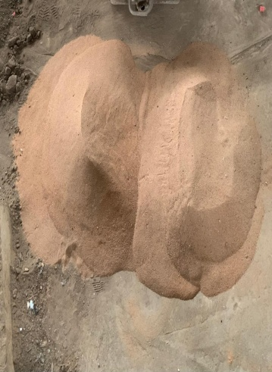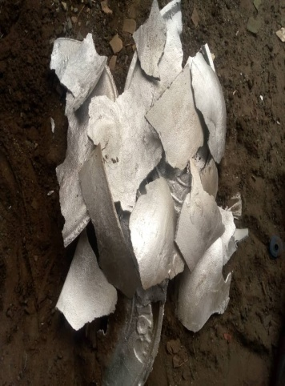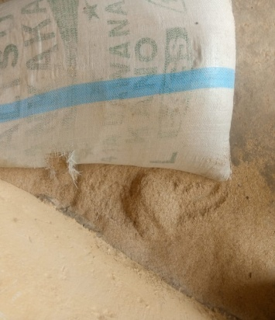

3.1.2 MATERIAL PREPARATION
A 15kg rice-husk was openly burnt into ashes, packed and heated in air- tight furnace at 1000 degree Celsius for six hours. The material (rice-husk ash) was stored separately in the air-tight oven for later use in the preparation of the sand moulds.
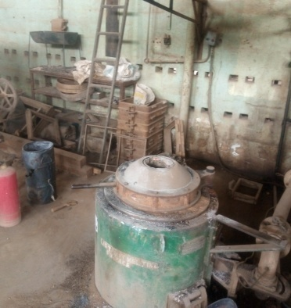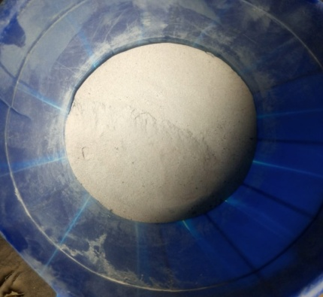
3.1.3 PREPARATION OF SAND MOULD
The mixing of silica sand and the additive took place manually and the different percentage values of the additive used in mould making process is as shown in Table 1. The silica sand (river sand) together with the binder (termite mould) was first grinded, mixed and then divided into six portions. Each prepared sand mould portion as a mass 21317.35g (21.32kg) with the addition of various weight percentages of additive. 6 moulds were prepared for this experiment; the first box consists of sand mould without the additive while the other 5 moulds consist of sand mould plus various percentages of the additive. Since the pattern used for this experimentation is not a split pattern (120mm by 15mm hollow pipe), 5 mould patterns were inserted vertically into each moulding box which implied that each mould would have five samples and the total number of 30 aluminium alloy samples were produced. Subsequently, mould patterns were removed and the sand acquired its shape for the casting process.

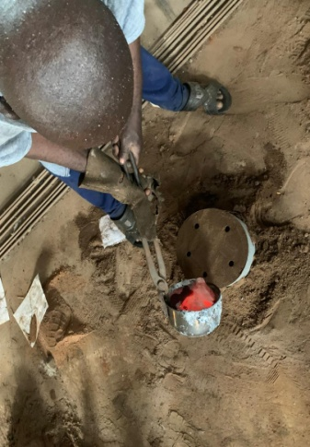s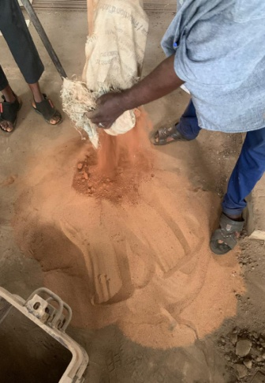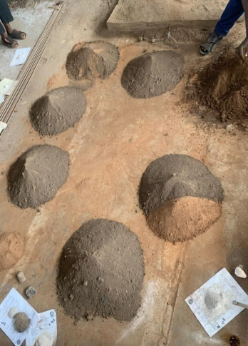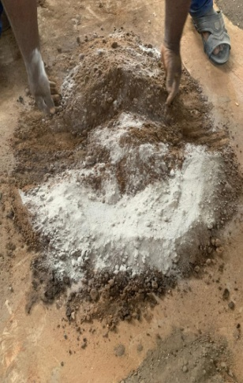
Sample | Sand (% weight) | Rice husk ash (% weight)
A | 100 (21.32kg) | 0
B | 98 (20.89kg) | 1 (0.21kg)
C | 97 (20.68kg) | 2 (0.43kg)
D | 96 (20.46kg) | 3 (0.65kg)
E | 95 (20.25kg) | 4 (0.88kg)
F | 94 (20.04kg) | 5 (1.11kg)
Table 1.1
3.1.4 CASTING
The aluminium ingot was melted at a maximum temperature of 735°C in a crucible furnace. 20 kg of aluminium was melted and the molten metal was tapped from the furnace, and then poured into the hollow cavities in each prepared mould. After 10 minutes of solidification, the cast alloy samples were shaken out (dismantled) of the mould. Samples of the cooled cast aluminium alloy are shown below.
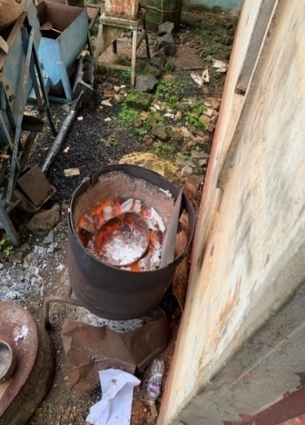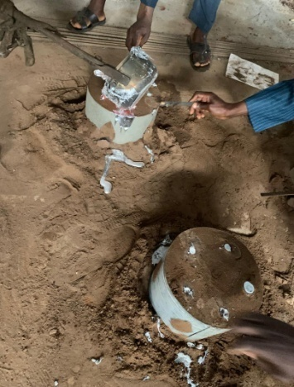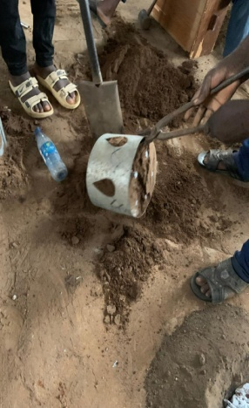
3.1.5 TENSILE STRENGTH TESTS
The samples of cast aluminium alloy from the moulds with and without additive were machined each into standard specimens according to ASTM E8 specifications for tensile strength test (Figure 4). Thirty specimens were produced (five specimens from each of the six different moulds as shown in table 1) for the tests. One sample each from the samples will be tested on tensile strength.

CHAPTER FOUR
4.1 RESULTS AND DISCUSSION

4.11 Analysis of tensile properties
This is a measure of the maximum amount of pulling or stretching that the sample can withstand without being permanently damaged. It is a measure of how much tension the sample can withstand. This is done through the use of universal testing machine. The machine gradually applied increased load on the sample until it begins to deform as shown in the table 4.3.

FIGURE 4.7: Tensile Strength Test Chart

FIGURE 4.8: Tensile Strain Test Chart

CHAPTER FIVE
5.0 CONCLUSION AND RECOMMENDATIONS

5.1 CONCLUSION
Based on the results of the moulding sand properties from the Asa River in this study and the aluminium samples casts, the following conclusions are made:
The tensile strength and strain properties of the aluminium alloy decrease as the percentage of the RHA increases.

5.2 RECOMMENDATION
For further research work on this topic, it is recommended that other additives can be added at varying percentages to know its effects.

REFERENCES
- Sani A. Salihu, Abdullahi Usman and I. Y. Suleiman. 2020.Effect of variation of different additives on some selected properties of silica sand mould for aluminium castingsJournal of Engineering and Technology Research
- Adeyemi G.J, Jimoh O.R, Stephen J.T. 2022. Influence of Sand Mould Additives on Tensile Properties of Aluminium (6061) Alloy Cooled in Different Media. American Journal of Mechanical and Industrial Engineering
- Ikebudu, K. O., Onyegirim, S. K. and Udeorah, P. I. 2021. Effect of green sand mixture with dextrin additives on mechanical properties of aluminum 6351. Global Journal of Engineering and Technology Advances.
- Kumar, S. Gandotra, S., Kumar, S. Nripjit and Tripathi, H. 2016. Investigate the effect of additives on mechanical properties during casting of 6351 aluminum. MATEC Web of Conferences.
- Ayoola, W. A., Adeosun, S. O., Sanni, O. S. and Oyetunji, A. 2012. Effect of casting mold on mechanical properties of 6063 aluminum alloy, Journal of Engineering Science and Technology.
- Dharshan B. G., Hareesha N. G. &Ananthapadmanabham, K. C. 2018. Effect of additives on chromite sand mold for aluminum castings, National Conference on Engineering of Materials through Energetic Particles (NCEMEP).
- Sivareddy, D. V. 2016. Effect of Iron Oxide on Mechanical Properties of Green Sand Mould. International Journal of Engineering Research.
- Seidu, S. O. and Kutelu, B. J. 2014. Effects of additives on some selected properties of base sand. Journal of Minerals and Materials characterization and Engineering.
- Karim, H., Al-Recaby, M. and Nsaif, M., 2018. Stabilization of soft clayey soils with sawdust ashes. In MATEC Web of Conferences, EDP Sciences.
- Adebayo, A., Stephen, J. T. and Adeyemi, G. J. 2018. Effects of Local Cooling Media on the Mechanical Properties of Heat Treated Mild Steel. European Journal of Engineering and Technology Research.

