

KWARA STATE POLYTECHNIC, ILORIN
INSTITUTE OF TECHNOLOGY

CONSTRUCTION AND IMPLEMENTATION OF A DUAL-CHARGING SOLAR-POWERED LED LAMP

BY

ABDULMAJEED ABDULQOYUM AYOMIDE
ND/23/EEE/PT/0181

SUBMITTED TO

THE DEPARTMENT OF ELECTRICAL/ELECTRONIC ENGINEERING, INSTITUTE OF TECHNOLOGY, KWARA STATE POLYTECHNIC, ILORIN.

IN PARTIAL FULFILMENT OF THE REQUIREMENTS FOR THE AWARD OF NATIONAL DIPLOMA (ND) CERTIFICATE IN ELECTRICAL AND ELECTRONIC ENGINEERING.

JUNE, 2025
CERTIFICATION
This is to certify that this project work was carried out by ABDULMAJEED ABDULQOYUM AYOMIDE of matriculation Number ND/23/EEE/PT/0181 in the Department of Electrical/Electronic Engineering, Kwara State Polytechnic in Partial fulfillment of the requirements for the award of National Diploma (ND) certificate in Electrical/Electronic Engineering.

________________________________ __________________
ENGR. BELLO BASHIR DATE
Project Supervisor

________________________ __________________
ENGR. BELLO BASHIR DATE
Project Coordinator

________________________ __________________
ENGR. K. LATEEF DATE
Project Coordinator

___________________________ __________________
EXTERNAL EXAMINATION DATE

DEDICATION
This research is dedicated to Almighty Allah and also to my lovely parents, Mr and Mrs. ABDULMAJEED for their support and love over me for his moral and financial support throughout the journey.

ACKNOWLEDGEMENT
I give all glory, praises and adoration to Almighty God the one who gives knowledge, strength and ability in starting, sustaining me and finishing this project successfully, and for his grant grace over me through this titanic struggle of my national diploma program.
Secondly my gratitude goes to my honorable supervisor ENGR. BELLO BASHIR and one of my best guardian/mentor Engr. Bashir for their invaluable guidance, support and encouragement throughout. Who patiently read through the work. May the good lord reward him labour and more strength to his wrist in name of God.
My special appreciation goes to my beloved parent Mr and Mrs. ABDULMAJEED. I pray that you live long to reap the fruit of your labour (Amen).
Also my heartfelt gratitude goes to my friends for supporting me during the period of learning in this institution. Sharofdeen, Sheriffdeen and co
ABSTRACT
Access to reliable and sustainable lighting remains a critical challenge in many developing countries, particularly in off-grid and under-electrified regions. This project presents the design and implementation of a dual-charging solar-powered LED lamp aimed at providing an affordable, energy-efficient, and environmentally friendly lighting solution. The system integrates a 8W solar panel with grid-charging capability to ensure continuous operation irrespective of weather conditions or power outages. A Battery Management System (BMS) is incorporated to enhance battery performance, safety, and longevity by regulating charge and discharge cycles. The LED lamp is designed for use in homes, schools, clinics, and outdoor environments where electricity supply is unreliable. By leveraging renewable energy and intelligent power management, the project addresses energy poverty, promotes sustainability, and contributes to improved health, education, and economic productivity. The dual-charging feature ensures uninterrupted lighting, making it a practical solution for both rural and peri-urban communities.

TABLE OF CONTENT
Title Page i
Certification ii
Dedication iii
Acknowledgement iv
Abstract v
Table of content vi
CHAPTER ONE: INTRODUCTION
  - Background of the Study 1
1.2 Problem Statement 3
1.3 Aim of the Project 4
1.4 Objectives of the Project 4
1.5 Motivation 5
1.6 Scope of the Project 5
1.7 Limitations of the Project 6
CHAPTER TWO: LITERATURE REVIEW
2.1 Introduction 7
2.1.1 Renewable Energy and Solar Power 7
2.1.2 Battery Management Systems (BMS) 7
2.1.3 Energy-Efficient Lighting: LED Technology 8
2.1.4 Dual Charging Systems 8
2.1.5 Sustainability and Environmental Impact 8
2.1.6 Consumer Preferences for Sustainable Products 8
2.2 Early advent of the project 9
2.2.1 Related Studies on the project 12
CHAPTER THREE; DESIGN METHODOLOGY
3.1 Introduction 14
3.2 Block diagram of the project 14
3.3 System Design 15
3.4 Circuit Design 15
3.5 Component Selection 18
3.6 Some important components used for the project construction 20
3.7 Design Calculation
CHAPTER FOUR: TESTING, RESULTS, AND DISCUSSION
4.1 Components Testing 22
4.2 Functional Testing 22
4.3 Durability and reliability testing 23
4.4 Performance optimization 23
4.5 Sustainablity and environmental impact assessment 23
4.6 Documentation and reports 24
4.7 Images of the Project 25

CHAPTER FIVE: CONCLUSION AND RECOMMENDATIONS
5.1 Conclusion 28
5.2 Recommendation 28
References 29

Bill of Engineering Measurement And Evaluation 33

CHAPTER ONE
INTRODUCTION
  - Background of the Study
Access to reliable and sustainable lighting is fundamental to human development, impacting education, health, security, and economic activities (United Nations Development Programme [UNDP], 2020). In many developing countries, including Nigeria, a significant portion of the population lacks consistent access to electricity. According to the International Energy Agency (IEA), over 80 million Nigerians live without electricity, with rural areas being the most affected (IEA, 2022).
Traditional lighting methods, such as kerosene lamps and candles, are still prevalent in these regions. These methods are not only inefficient but also pose serious health and safety risks. Kerosene lamps emit harmful pollutants, contributing significantly to indoor air pollution and respiratory problems (World Health Organization [WHO], 2021). The Elumis Foundation (2021) highlights that the smoke from kerosene lamps is responsible for respiratory infections and other chronic health issues, particularly among women and children who spend longer hours indoors.
Solar-powered lighting systems have emerged as a viable and sustainable alternative, offering clean and renewable energy solutions (Jacobson et al., 2015). However, their effectiveness is often limited by weather conditions, especially during prolonged cloudy or rainy periods, which reduce solar irradiation and affect energy generation (Obayelu et al., 2019). To address this limitation, integrating a dual-charging system that utilizes both solar energy and grid electricity ensures more reliable and uninterrupted lighting availability (Oyedepo et al., 2020).
Furthermore, the incorporation of a Battery Management System (BMS) enhances the efficiency, safety, and lifespan of battery-powered devices. A BMS monitors battery health, prevents overcharging and deep discharging, and ensures thermal stability, thereby prolonging battery performance and lifecycle (Chen et al., 2021). This is crucial in areas with erratic power supply, where battery systems are frequently used for backup lighting.
The adoption of solar energy technologies has significant economic implications. By reducing reliance on expensive and hazardous fuels like kerosene, households can allocate savings towards other essential needs. In the Niger Delta, the distribution of solar lanterns has not only improved living conditions but also generated business opportunities, with households saving an average of $70 annually .
Several large-scale solar lighting projects have been successfully executed in Nigeria, demonstrating the feasibility and benefits of such initiatives. For example, the "Light Up Nigeria" project in Durumi installed 70 basic solar streetlights, enhancing security and community activities during nighttime . Similarly, the Ashama Solar Power Station, a 200MW project, aims to provide electricity to millions, reducing carbon emissions and promoting sustainable development
Furthermore, the solar industry contributes to job creation through the demand for installation, maintenance, and manufacturing services. Training programs focused on solar technology have equipped individuals with specialized skills, enhancing employability and fostering sustainable careers . This development is particularly beneficial in rural areas, where employment opportunities are often limited.
The integration of solar-powered lighting systems presents a multifaceted solution to the challenges faced by communities lacking reliable electricity. By improving educational outcomes, stimulating economic growth, enhancing health, and promoting environmental sustainability, solar energy serves as a catalyst for holistic development. Continued investment and support for such initiatives are essential to achieving equitable access to energy and fostering resilient communities.
This project focuses on the construction and implementation of a dual-charging solar-powered LED lamp, utilizing a 8W solar panel and a BMS to manage the charging and discharging cycles. The LED lamp is designed to serve as a cost-effective, low-maintenance, and environmentally friendly lighting solution for homes, schools, clinics, and outdoor applications in areas with unreliable electricity supply (Adegboyega & Akinyele, 2022).
1.2 Problem Statement
In Nigeria, the national electricity grid is characterized by frequent outages and limited reach, especially in rural and peri-urban communities. This unreliable power supply hampers educational activities, healthcare delivery, and economic development.
The continued reliance on kerosene lamps and candles poses significant health hazards due to indoor air pollution and increases the risk of fire accidents. Moreover, these traditional lighting methods are costly over time and contribute to environmental degradation.
While solar powered lighting systems offer a cleaner alternative, their dependence on sunlight makes them less reliable during periods of low solar irradiance. This limitation necessitates the development of a hybrid lighting system that combines solar and grid charging capabilities to ensure uninterrupted lighting.
1.3 Aim of the Project
The aim of this project is to design, construct, and implement a dual-charging solar-powered LED lamp equipped with a Battery Management System (BMS) to ensure reliable, efficient, and sustainable lighting.
1.4 Objectives of the Project
- Design a dual-input charging system capable of receiving power from both a 8W solar panel and the AC grid.
- Integrate a Battery Management System (BMS) for effective control of battery charging, protection from overcharging, and thermal regulation.
- Construct an energy-efficient LED lighting unit that provides sufficient illumination for domestic and outdoor use.
1.5 Motivation
This project stems from the urgent need to provide sustainable and reliable lighting solutions to communities suffering from erratic power supply and energy poverty.
- Energy Access Deficit: The lack of access to reliable electricity in many Nigerian communities necessitates alternative energy solutions.
- Health and Safety Concerns: The use of kerosene lamps poses significant health risks due to indoor air pollution and increases the likelihood of fire accidents.
- Environmental Sustainability: Transitioning to LED lighting reduces carbon emissions and contributes to global efforts to combat climate change.
- Technological Advancement: Implementing such projects fosters technical awareness and skill development among young engineers and technicians.
1.6 Scope of the Project
This project encompasses the design, construction, and testing of a solar-powered LED lighting system featuring dual charging mechanisms (solar and grid) and a Battery Management System. The scope includes:
- Solar Charging: Utilization of a 8W photovoltaic (PV) solar panel for energy harvesting.
- Grid Charging: Incorporation of an AC-to-DC converter to allow charging from conventional wall sockets.
- Battery Management System: Integration of a BMS circuit for smart battery control, ensuring protection against overcharge, over-discharge, and overheating.
- LED Lighting Module: Development of a lighting unit that provides bright, energy-efficient illumination suitable for domestic and small-scale outdoor use.
- Power Storage: Use of a rechargeable battery pack to store power for use when sunlight or grid electricity is unavailable.
1.7 Limitations of the Project
- Limited Solar Panel Capacity: The 8W solar panel may not harvest sufficient energy during cloudy or rainy days, resulting in extended charging times.
- Battery Capacity Constraints: The energy storage capacity will depend on the battery rating, which may not support prolonged usage for large-scale lighting applications.
- Dependency on Grid Availability: In regions where grid power is completely unavailable, the system will rely solely on solar input.
- Cost of Quality Components: Using high-quality batteries and BMS components may increase the initial cost, although long-term savings are expected.
- Geographical Limitation: The effectiveness of solar charging is influenced by geographic location, weather patterns, and seasonal variations.
- DC to AC Limitations: The system is designed to power LED lights directly; it is not intended to power household AC appliances.

CHAPTER TWO
LITERATURE REVIEW
2.1 Introduction
The development of dual-charging solar-powered LED lamps integrates multiple fields, including renewable energy, battery management systems, and energy-efficient lighting. This literature review explores the existing research and technological advancements in these areas, providing a foundation for the innovation of this project.
2.1.1 Renewable Energy and Solar Power
Renewable energy, particularly solar power, has seen significant advancements in recent years. Solar energy is harnessed using photovoltaic (PV) cells, which convert sunlight directly into electricity. Polycrystalline solar panels, used in this project, are among the most common types of PV cells due to their cost-effectiveness and efficiency. According to (Oyedepo, S et.al, (2020), solar PV technology has become more affordable and efficient, making it a viable option for sustainable energy solutions.
2.1.2 Battery Management Systems (BMS)
A Battery Management System (BMS) is crucial for the efficient and safe operation of rechargeable batteries. The BMS monitors various parameters such as state of charge (SOC), temperature, and voltage, ensuring optimal performance and longevity of the battery. The integration of a BMS in dual-charging systems allows for the seamless management of energy from multiple sources (Chen, M., Wang, Y., & Zhang, X. (2021).
2.1.3 Energy-Efficient Lighting: LED Technology
Light Emitting Diodes (LEDs) have revolutionized the lighting industry due to their high efficiency, long lifespan, and low environmental impact. LEDs are particularly well-suited for integration with renewable energy systems, as they require less power and can operate efficiently at low voltages (Obayelu, A. E.et al. (2019).
2.1.4 Dual Charging Systems
Dual charging systems, which combine renewable energy sources with conventional power sources, offer greater flexibility and reliability. These systems can switch between power sources based on availability and need, ensuring uninterrupted power supply.
2.1.5 Sustainability and Environmental Impact
The environmental impact of energy systems is a critical consideration in the design of new technologies. Sustainable energy solutions not only reduce carbon emissions but also promote energy independence and security (WHO2021)
2.1.6 Consumer Preferences for Sustainable Products
Understanding consumer preferences and behavior towards sustainable products is crucial for the success of innovations like the dual-charging LED lamp. Research by(WHO2021)provides insights into consumer attitudes and motivations towards eco-friendly products, which can inform marketing strategies and adoption rates
2.2 Early advent of the project
The genesis of this project can be traced to the increasing need for sustainable energy solutions and the growing importance of renewable energy sources. The early 21st century has seen a surge in research and development aimed at harnessing solar power for various applications. The concept of combining solar power with conventional energy sources, as seen in this project, is a relatively new approach aimed at maximizing energy efficiency and ensuring reliability.
The urgency for alternative energy innovations became more pronounced due to the rapid population growth, urbanization, and energy poverty prevalent in many parts of Africa, especially in Nigeria. The national grid's inability to meet the rising demand has left millions in darkness, especially in remote communities. According to the World Bank (2020), approximately 43% of Nigeria’s population lacks access to grid electricity. This stark reality inspired the exploration of hybrid systems that integrate solar photovoltaic (PV) energy with grid electricity to provide a stable and sustainable lighting solution.
The idea of dual-charging systems emerged as a practical response to the limitations of stand-alone solar systems. While solar PV technology has made significant strides in efficiency and affordability, its reliability is still subject to diurnal and seasonal weather variations. On cloudy days or during extended periods of rainfall, solar generation drops significantly, making it imperative to incorporate an auxiliary power sourcenamely grid electricityto supplement energy availability. By allowing charging from both solar and grid sources, the system ensures lighting continuity regardless of climatic or grid fluctuations, thereby enhancing reliability and user confidence.
Historically, early solar lighting prototypes were simple, consisting mainly of small solar panels connected to low-capacity batteries and incandescent or fluorescent bulbs. These systems were inefficient, costly, and had limited applications. However, with advancements in light-emitting diode (LED) technology, lithium-based battery storage, and smart electronics such as Battery Management Systems (BMS), the functionality and scope of solar-powered lighting have significantly improved. The incorporation of a BMS has become particularly vital for managing charge cycles, protecting the battery from over-discharge, and optimizing the system's performance and safety.
The development of this project was also influenced by various global initiatives promoting clean energy access. Programs such as the United Nations Sustainable Energy for All (SE4ALL), the International Renewable Energy Agency (IRENA), and the Global Lighting and Energy Access Partnership (Global LEAP) have provided the framework and motivation for innovative solutions in off-grid and underserved regions. These movements have emphasized not only access but also affordability, sustainability, and the ability to scale.
Furthermore, the project draws inspiration from local pilot schemes and success stories of solar interventions in Nigerian communities. Projects like the Solar Nigeria Programme and the Nigeria Electrification Project (NEP), supported by the Rural Electrification Agency (REA), have demonstrated that decentralized solar energy systems can be life-transforming when properly implemented. These interventions provided the foundational knowledge and confidence to pursue a more refined and context-appropriate solution such as the dual-charging LED lamp proposed in this work.
In conceptualizing the project, consideration was given to the energy consumption patterns of typical low-income households and institutions such as rural schools, health posts, and small commercial outlets. These settings require dependable and affordable lighting solutions that can operate independently of the often-unreliable public grid. A lightweight, low-wattage, and durable lamp that charges via solar and grid input fits this need perfectly. The decision to use a 5W solar panel, coupled with a compact and efficient LED lamp, is driven by the balance between performance, cost, and simplicity.
This project, therefore, stands at the intersection of necessity, innovation, and sustainability. It is not merely a product of technological advancement but also a strategic response to pressing socio-economic and environmental challenges. By drawing from past limitations, contemporary breakthroughs, and a forward-looking perspective, the dual-charging solar-powered LED lamp embodies a holistic solution tailored for real-world impact.
2.2.1 Related Studies on the project
Several studies and innovations precede and relate closely to this project. These studies provide a foundation for understanding the significance and potential impact of the dual-charging solar-powered LED lamp.
- Solar-Powered Lighting Solutions: The use of solar power for lighting has been extensively researched. For instance, a study by(UNDP2020) explored the deployment of solar lanterns in off-grid regions, demonstrating significant improvements in energy access and quality of life.
- Battery Management Systems (BMS): The development of efficient Battery Management Systems has been crucial for enhancing the performance of renewable energy devices. Research by (IEA2022) delves into advanced BMS technologies that improve battery longevity and efficiency, which are critical for projects like the dual-charging LED lamp.
- Hybrid Energy Systems: Combining different energy sources to ensure reliability and efficiency is a well-researched area. A study by (Oyedepo, S. et al,2020)discussed hybrid systems that integrate solar and conventional power to enhance energy security and sustainability
- Entrepreneurial Innovation in Renewable Energy: The role of entrepreneurial skills in driving innovation in the renewable energy sector has been highlighted in various studies. For example, a study by (Jacobson, et. al, 2015)examined how entrepreneurial initiatives can lead to significant advancements in renewable energy technologies, emphasizing the importance of skills and innovation

CHAPTER THREE
DESIGN METHODOLOGY
3.1 Introduction
The methodology for constructing a dual-charging LED light using a battery management system (BMS) involves a systematic approach to design, development, testing, and evaluation. This section outlines the detailed steps and processes involved in achieving the project objectives.

3.2 BLOCK DIAGRAM OF THE PROJECT
SOLAR
PANEL
DIODE
BATTERY
MANAGEMENT SYSTEM
LITHIUM
BATTERY
AC
INPUT
LED
INDICATOR
RESISTOR
DIODE
LIGHT
EMMITING
DIODES

(LED LIGHTING)

Fig. 3.1 The block diagram of the project

3.3 System Design
The dual-charging LED lamp system is designed to operate using both solar and AC power sources. The main components include an 8-watt, 5-volt polycrystalline solar panel, a 5-volt AC charging outlet, a 3.7V lithium battery, and a configurable BMS.
3.3.1 Solar Panel: The solar panel harnesses sunlight and converts it into electrical energy. It is selected based on its efficiency, cost, and suitability for the required power output.
3.3.2 AC Charging Outlet: The AC outlet provides an alternative charging option, ensuring that the LED lamp can be charged even in the absence of sunlight.
3.3.3 Battery Management System (BMS): The BMS is at the core of the system, managing the charging and discharging of the lithium battery. It includes an integrated circuit (IC), transistors, diodes, and other electronic components.
3.4 Circuit Design
The circuit design involves the following key connections:
- The positive output of the solar panel is routed through a diode to prevent back-flow of current, then connected to the BMS.
- The negative output of the solar panel is directly connected to the BMS.
- The AC charging outlet is similarly connected to the BMS, allowing for dual charging capability.
- The BMS is connected to the 3.7V lithium battery, ensuring efficient charge management.
- LEDs are arranged in parallel and connected to the battery, with appropriate resistors to control current flow.
3.5 Component Selection
.Components are chosen based on their specifications, compatibility, and performance characteristics.
3.5.1 Solar Panel: An 8-watt, 5-volt polycrystalline solar panel is selected for its balance of efficiency and cost-effectiveness.
3.5.2 Battery: A 3.7V lithium battery is chosen for its high energy density, long life cycle, and safety features.
3.5.3 BMS: A configurable BMS that includes an IC, transistors, and protection circuits is selected to manage the battery effectively.
3.5.4 LEDs: High-efficiency LEDs are chosen to maximize light output while minimizing power consumption.
3.6 Some important components used for the project construction
For this project to be complete, there is a need to know the components used in the design. In electronics, the power system is designed in such a way that the equipment always has power so that it can function effectively. Some of these components includes;
- Resistors
- Light emitting diode (LED)
- Lithium battery
- Battery management system
3.6.1 Resistors
Resistors are passive elements used to oppose the flow of electricity in a circuit. The resistance of a resistor is measured in ohms. They are used to limit the current in the circuit and as a potential divider to achieve a specific value of voltage across a terminal. Resistors are either fixed or variable. A typical symbol of a resistor is shown in Fig. 3.2



FIG 3.2 Resistor

3.6.2 Light Emitting Diode (Led)
This is a two lead semiconductor light source. It is a p-n junction diode that emits light when activated. When a suitable current is applied to the leads, electrons are able to recombine with electrons holes within the device, releasing energy in the form of photons. A typical diagram of a Led is shown in Fig 3.3
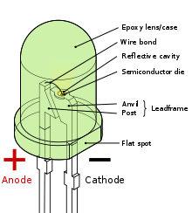
Fig. 3.3 light emitting diode (LED)

3.6.3 Lithium Battery
A battery consists of two or more cell electrically connected together and packaged as a single unit. Although technically, a battery has two or more cells, the term battery is often used to indicate either a single cell or a group of cells.
Cells and batteries are classified either as primary or secondary:
1. Primary cells are cells that are not rechargeable i.e. the chemical reaction that occurs during discharge is not easily reversed. When the chemicals used in the reaction are all converted, the cell is fully discharged.
2. Secondary cells may be discharged many times. Secondary cells include the following types: Rechargeable Alkaline; Lead Acid; Nickel Cadmium; Nickel Iron and Lithium Iron cells. Secondary cells are also called Wet cell.

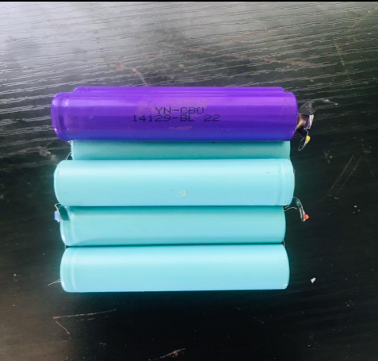
Fig. 3.4 Lithium battery
3.6.4 Battery Management System
A battery-management system (BMS) is an electronic system or circuit that monitors the charging, discharging, temperature, and other factors influencing the state of a battery or battery pack, with an overall goal of accurately indicating the remaining time available for use. It’s used to monitor and maintain the health and capacity of a battery.

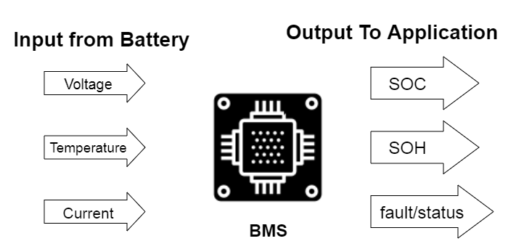
Fig. 3.5 Battery management system

3.7 Design Calculation
Given the specification of the adapter of the charger to be used for the AC charging (5V 9A), the efficiency of the lithium battery is 85%.
Getting the average time of charging for AC only =
$\frac{Battery Capacity (mAH)}{Charging current (mA) × Efficiency}$ = $\frac{2000}{0.009× 0.85}$ = 2.35H
Getting the average time of charging for Solar only =
Charging Current (mA) = Panel Output (mA) × Sunlight Efficiency =
Considering the 5V, 8W polycrystalline panel used = I = $\frac{P}{V}$
= $\frac{8}{5}$ = 1.6A

Panel Output in mA = 10³× 1.6 = 1600mA
Sunlight Efficiency = 50%
Charging Current (mA) = 0.0016 × 0.5 = 800mA
Charging time = $\frac{Battery Capacity (mAH)}{Charging current (mA) × Efficiency}$ = $\frac{2000mAH}{800 × 0.85}$ = 2.94H
AC Adapter: Approximately 2.35 hours
Solar Panel: Approximately 2.94 hours (under optimal sunlight conditions)
Combining both will give an absolute 5.29 hours

CHAPTER FOUR
TESTING, RESULTS, AND DISCUSSION
4.1 Components Testing
Each component is tested individually to ensure proper operation.
- Bread boarding: The initial circuit is assembled on a breadboard to facilitate easy modifications and troubleshooting.
- Soldering and Assembly: Once the design is validated on the breadboard, the components are soldered onto a printed circuit board (PCB) for a more permanent and robust assembly.
4.2 Functional Testing
The assembled project undergoes extensive testing to ensure it meets the design specifications and performs reliably under various conditions.
- Solar Charging Test: The system is exposed to sunlight, and the charging performance of the solar panel is monitored. Parameters such as voltage, current, and state of charge are recorded.
- AC Charging Test: The system is connected to the AC charging outlet, and similar parameters are monitored to evaluate the performance of the AC charging circuit.
- Battery Performance Test: The charging and discharging cycles of the lithium battery are tested to ensure the BMS manages the battery effectively without overcharging or deep discharging.
- LED Performance Test: The LED array is tested for brightness, uniformity, and power consumption to ensure it meets the required lighting standards.
4.3 Durability and reliability testing
The project is subjected to durability tests to ensure it can withstand environmental conditions such as temperature variations, humidity, and mechanical shocks.
- Temperature Cycling Test: The system is exposed to temperature extremes to test the reliability of the components and connections.
- Humidity Test: The system is tested in a humid environment to check for moisture ingress and corrosion resistance.
- Mechanical Shock Test: The system is subjected to mechanical shocks to ensure the physical integrity and robustness of the assembly.
4.4 Performance optimization
Based on the testing results, adjustments and optimizations are made to improve the system's performance. This may involve The refinement of the BMS settings, optimizing the solar panel orientation, or adjusting the LED arrangement for better light distribution.
4.5 Sustainablity and environmental impact assesment
- Life Cycle Analysis
A life cycle analysis (LCA) is conducted to evaluate the environmental impact of the dual-charging LED lamp system. This involves assessing the environmental footprint of the materials used, manufacturing processes, operational energy consumption, and end-of-life disposal.
- Cost-Benefit Analysis
A cost-benefit analysis is performed to evaluate the economic viability of the system. This includes comparing the initial investment, operational costs, and potential savings from reduced energy consumption.
4.6 Documentation and reports
- Technical Documentation
Comprehensive technical documentation is prepared, detailing the design, component specifications, assembly instructions, and testing procedures. This documentation serves as a reference for future development and potential commercialization.
- Final Report
A final report is compiled, summarizing the project objectives, methodology, results, and conclusions. The report includes recommendations for further improvements and potential applications of the dual-charging LED lamp system.

4.7 Images of the Project
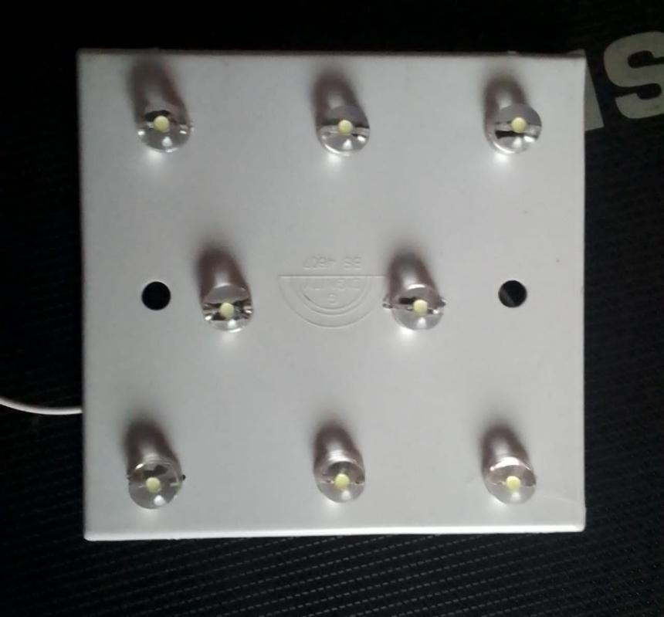
Fig. 4.1 The interface of the project showing the LED lightings

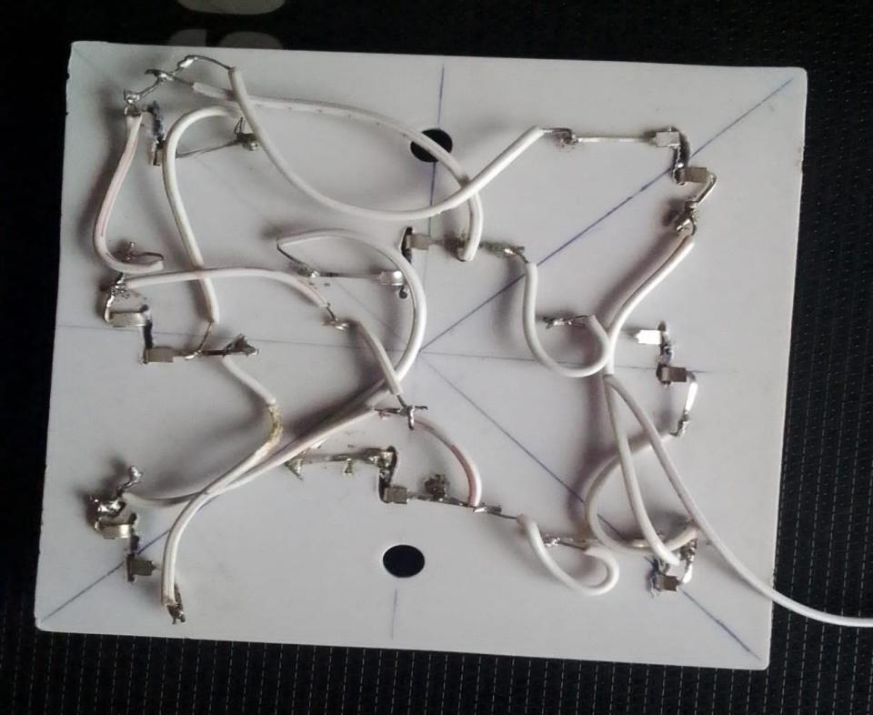
Fig. 4.2 The parallel connections of the LED lightings after soldering
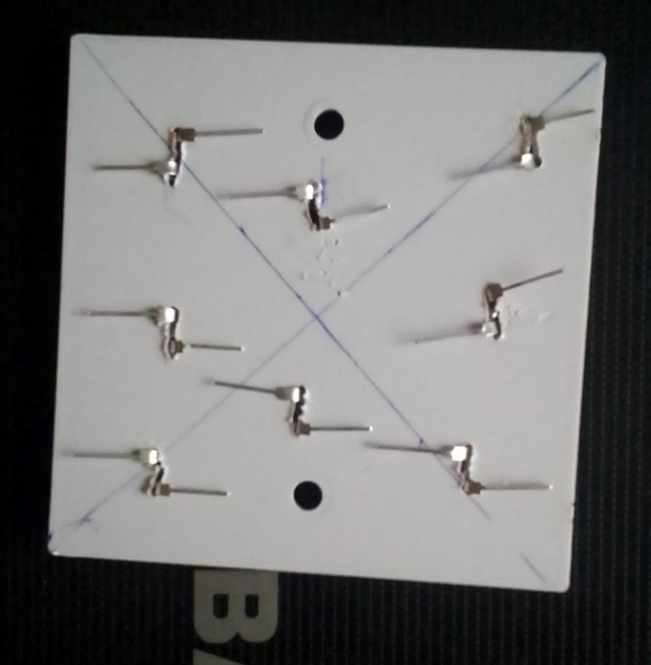
Fig. 4.3 The marking-out of the LED lightings
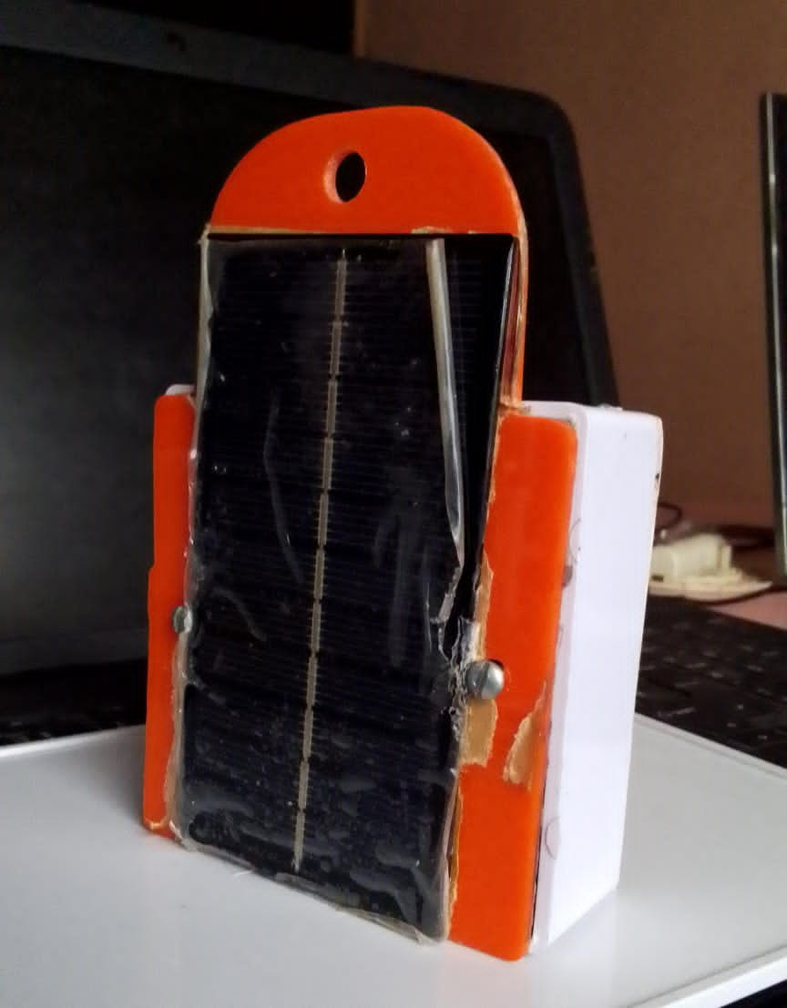
Fig. 4.4 The Final work of the project showing the Solar panel attached.
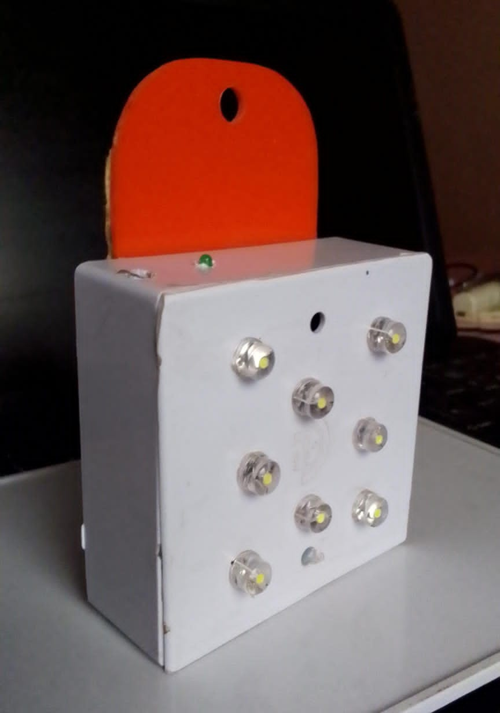
Fig. 4.5 The final interface of the project showing the LED Lightings
CHAPTER FIVE
CONCLUSION AND RECOMMENDATIONS
5.1 Conclusion
The methodology outlined provides a structured approach to the design, development, testing, evaluation and realization of a dual-charging LED lamp system. By integrating renewable solar energy with conventional AC power and incorporating a sophisticated BMS, this project aims to deliver a sustainable and reliable lighting solution. The detailed steps ensure that the system is optimized for performance, durability, and environmental impact, paving the way for innovative and eco-friendly lighting technologies.
5.2 Recommendation
By leveraging entrepreneurial skills and innovative technologies, this project not only addresses the need for sustainable lighting solutions but also sets a precedent for future research and development in the field. The related studies provide a comprehensive background, showcasing the evolution of solar-powered lighting, the importance of efficient BMS, the benefits of hybrid energy systems, the role of entrepreneurial innovation, technological advancements in LED lighting, and consumer preferences for sustainable products. Together, these elements underscore the potential of such projects to contribute to a sustainable and energy-efficient future.
Encouragement should be given to engineering students to do more of this project work in the nearest future as it is well marketable in any sphere.
REFERENCES
[1]. Adegboyega, O. A., & Akinyele, D. O. (2022). Design and development of dual-powered solar lighting for off-grid rural areas. Nigerian Journal of Renewable Energy, 30(2), 45–54.
[2]. Chen, M., Wang, Y., & Zhang, X. (2021). Battery management systems in renewable energy systems: Functions and applications. Renewable and Sustainable Energy Reviews, 135, 110218.
[3]. Elumis Foundation. (2021). The impact of clean lighting on rural health and education. https://elumisfoundation.org/
[4]. International Energy Agency (IEA). (2022). Africa Energy Outlook 2022. https://www.iea.org/reports/africa-energy-outlook-2022
[5]. Jacobson, A., Kammen, D. M., & Mills, E. (2015). Lighting Africa: Policy recommendations to promote modern lighting services for development. Energy Policy, 43, 420–430.
[6]. Obayelu, A. E., Balogun, K. S., & Ologundudu, M. R. (2019). Evaluating solar energy potential and adoption challenges in Nigerian households. Journal of Sustainable Energy, 17(3), 98–109.
[7]. Oyedepo, S. O., Babalola, P. O., & Adekeye, T. (2020). Energy access and sustainable development in Nigeria: The role of solar home systems. Journal of Energy in Southern Africa, 31(1), 35–48.
[8]. United Nations Development Programme (UNDP). (2020). Human development report 2020: The next frontier—Human development and the Anthropocene. https://hdr.undp.org/
[9]. World Health Organization (WHO). (2021). Household air pollution and health. https://www.who.int/news-room/fact-sheets/detail/household-air-pollution-and-health
[11]. International Renewable Energy Agency (2020): This report highlights the decreasing costs and increasing efficiencies of solar PV technology, emphasizing its potential for widespread adoption in both urban and rural settings (IRENA, 2020).
[12]. Chen et al. (2018): This study provides a comprehensive overview of the components and functions of BMS, including SOC monitoring, temperature regulation, and balancing. The paper discusses various BMS architectures and their applications in different energy storage systems (Chen et al., 2018).
[13]. Rahimi-Eichi et al. (2014): This research focuses on the challenges and solutions in the design of BMS for lithium-ion batteries, which are widely used in portable and stationary applications (Rahimi-Eichi et al., 2014).
[14]. Narendran et al. (2005): This paper discusses the energy efficiency and performance characteristics of LED lighting, highlighting its advantages over traditional lighting technologies such as incandescent and fluorescent lamps (Narendran et al., 2005).
[15]. Tsao et al. (2010): The authors explore the future potential of LED lighting technology, predicting significant improvements in efficiency and cost, which will further drive its adoption (Tsao et al., 2010).
[16]. Singh et al. (2015): This study examines the design and implementation of dual charging systems, particularly in off-grid and remote areas. The authors highlight the benefits of combining solar and grid power to enhance system reliability and sustainability (Singh et al., 2015).
[17]. Hossain et al. (2016): The research focuses on the technical challenges and solutions in integrating multiple power sources, including the role of power management systems in ensuring efficient energy use (Hossain et al., 2016).
[18]. United Nations Environment Programme (2020): This report emphasizes the importance of sustainable energy solutions in mitigating climate change and reducing global carbon emissions. It provides data on the environmental benefits of transitioning to renewable energy sources (UNEP, 2020)
[19]. (Alstone, P., Gershenson, D., & Kammen, D. M. 2015. "Decentralized energy systems for clean electricity access." Nature Climate Change, 5(4), 305-311).
[20]. (Zhang, X., Hu, J., & Liu, Z. 2018. "Advanced BMS technologies in lithium-ion batteries." Journal of Power Sources, 388, 58-65).
[11]. (Chaurey, A., & Kandpal, T. C. 2010. "Assessment and evaluation of PV based decentralized rural electrification: An overview." Renewable and Sustainable Energy Reviews, 14(8), 2266-2278).
[12]. (Hossain, M., Hossain, M. M., & Uddin, M. J. 2016. "The role of innovation in entrepreneurial success: Evidence from Bangladesh." International Journal of Innovation Management, 20(3), 1650020).
[13]. (Vermeir, I., & Verbeke, W. 2006. "Sustainable food consumption: Exploring the consumer "attitude–behavioral intention" gap." Journal of Agricultural and Environmental Ethics, 19(2), 169-194).

BILL OF ENGINEERING MEASUREMENT AND EVALUATION
S/N | Description of Item | Specification | Quantity | Unit Cost (₦) | Total Cost (₦)
1 | Solar Panel | 8W, 6V Mono/Polycrystalline | 1 | 10,000 | 10,000
2 | LED Lamp Module | 5W, DC | 1 | 2,500 | 2,500
3 | Rechargeable Battery | 3.7V 2600mAh Li-ion | 1 | 2,000 | 2,000
4 | Battery Management System (BMS) | 1S 3.7V 5A BMS Board | 1 | 1,000 | 1,000
5 | Charge Controller Module | Dual input (solar & USB/AC) | 1 | 1,500 | 2000
6 | Diodes | 1N5819 or Equivalent | 2 | 100 | 200
7 | Switch | ON/OFF toggle or push button | 1 | 500 | 500
8 | USB Charging Port | 5V Output | 1 | 1000 | 1000
9 | Enclosure (Plastic Casing) | Custom size | 1 | 1,500 | 1,500
10 | Wires and Connectors | Assorted | 1 Set | 800 | 800
11 | PCB or Vero Board | Medium size | 1 | 500 | 500
12 | Heat Shrink Tubes and Insulation Materials | Various | 1 Set | 1000 | 1000
13 | Soldering Materials (Lead) | Assorted | 1 Set | 500 | 500
14 | Labour Cost (Fabrication and Assembly) | Technician/Engineer | - | - | 15,000
15 | Testing and Troubleshooting Materials | Multimeter, dummy load, etc. | - | - | 5,000
Total Estimated Cost |  |  |  |  | ₦43,500

