DEVELOPMENT OF A MINUTIAE-BASED FINGERPRINT AUTHENTICATION SYSTEM FOR STUDENT ATTENDANCE MONITORING WITH SMS ALERTS

By

GBADAMOSI QUDUS JIBOLA
HND/23/COM/FT/205

A project submitted to the
Department of Computer Science,
Institute of Information and Communication Technology,
Kwara State Polytechnic, Ilorin

In Partial fulfillment of the requirements for the
Award of Higher National Diploma (HND) in
Computer Science

July, 2025
CERTIFICATION
This is to certify that this project work is carried out by GBADAMOSI QUDUS JIBOLA with Matriculation Number HND/24/COM/FT/205. The project has been read and approved as meeting part of the requirement for the award of Higher National Diploma in Computer Science.

_________________________ __________________
MR. BOLAJI-ADETORO D.F. Date
Project Supervisor

_________________________ __________________
MR. OYEDEPO F.S. Date
Project Supervisor

_________________________ __________________
External Examiner Date

Dedication
This project is dedicated to God, the most beneficent, the most merciful

ACKNOWLEDGEMENT
The journey through this academic program has been both challenging and rewarding. Through all the trials and triumphs, I give all glory, honor, and adoration to the Almighty God for His unending grace, divine protection, and sustenance from the very first day I stepped into the academic world until this present moment. Without His mercy, I would not have come this far.
I wish to express my heartfelt gratitude to the Head of the Computer Science Department, Mr. Oyedepo F.S., for his unwavering support, fatherly guidance, and consistent encouragement throughout the course of my academic journey. His administrative leadership and personal interest in the success of students have been a source of great motivation to me.
My profound appreciation goes to my project supervisor, Mr. Bolaji-Adetoro D.F., for the invaluable role he played in the successful completion of this research project. His intellectual input, timely corrections, encouragement, and professional mentorship were instrumental in shaping the quality of this work. I consider it a great privilege to have worked under his supervision.
I also wish to extend my sincere appreciation to all the lecturers in the Department of Computer Science for their dedication to academic excellence and for imparting knowledge and discipline throughout my course of study. Each of you contributed uniquely to my academic and personal growth.
To my family, friends, and colleagues who stood by me in prayers, words of encouragement, and support during trying times, I say thank you.
Above all, I am grateful to everyone who, in one way or the other, contributed to the successful completion of this project.

TABLE OF CONTENTS
Title page i
Certification ii
Dedication iii
Acknowledgements iv
Abstract v
Table of contents vi-vii
CHAPTER ONE: GENERAL INTRODUCTION
  - Introduction 1
  - Statement of the Problem 2
  - Aim and Objectives of the Project 3
  - Significance of the Study 4
  - Scope of the Study 5
  - Organisation of the Report 5
CHAPTER TWO: LITERATURE REVIEW
2.1 Review of Related work 7
2.2 Review of General Study 17
2.3 Review of General Text 19
CHAPTER THREE: RESEARCH METHODOLOGY
3.1 Research Methodology 22
3.2 Analysis of the Existing System 26
3.3 Problems of the Existing system 26
3.4 Description of the Proposed system 26
3.5 Advantages of the proposed system 27
CHAPTER FOUR: DESIGN, IMPLEMENTATION AND DOCUMENTATION OF THE SYSTEM
4.1 Design of the System 29
4.1.1 Output System 29
4.1.2 Input System 30
4.1.3 Database Design 32
4.1.4 Procedure Design 33
4.2 System Implementation 33
4.2.1 Choice of Programming Language 33
4.2.2 Hardware Support 33
4.2.3 Software Support 34
4.2.4 Changeover Techniques 34
4.3 System documentation 34
4.3.1 Program Documentation 34
4.3.2 Operating the System 35
4.3.3 Maintaining the System 35
CHAPTER FIVE: SUMMARY AND CONCLUSION
5.1 Summary 37
5.2 Conclusion 37
5.2 Recommendations 37
References
System Flowchart
Source Codes
Computer Output

Abstract
In recent time, there has been high level of impersonation experienced on a daily basis in both private and public sectors, the ghost worker syndrome which has become a menace across all tiers of government, employers concerns over the levels of employee absence in their workforce and the difficulty in managing student attendance during lecture periods. Fingerprints are a form of biometric identification which is unique and does not change in one’s entire lifetime. This paper presents the attendance management system using fingerprint technology in a university environment. It consists of two processes namely; enrolment and authentication. During enrolment, the fingerprint of the user is captured and its unique features extracted and stored in a database along with the users identity as a template for the subject. The unique features called minutiae points were extracted using the Crossing Number (CN) method which extracts the ridge endings and bifurcations from the skeleton image by examining the local neighborhoods of each ridge pixel using a 3 x 3 window. During authentication, the fingerprint of the user is captured again and the extracted features compared with the template in the database to determine a match, then an OTP will be sent as an SMS to the registered phone number to as a two-factor authentication and Verification method before attendance is made. This project uses a biometric concept to facilitate the attendance system in educational institutes. It uses the most reliable way of uniquely identifying students through fingerprint reading. Such type of application is very useful in school as well as in college for daily attendance. Through this application we can keep a systematic track of student’s attendance. This project enables the easy way of maintaining class attendance with fewer efforts. The proposed system will be developed using Microsoft Visual Basic for Interface, Microsoft Access 2010 for database and Secugen Fingerprint scanner for capturing, Multitexter SMS API for sms sending.

CHAPTER ONE
General Introduction

1.1 Introduction
Managing student attendance in academic institutions has traditionally relied on manual methods such as paper-based sheets and file systems. These conventional approaches, although long-standing, present several limitations, including inefficiency, susceptibility to errors, and ease of falsification (Seth, 2009). Institutions usually enforce specific standards for attendance verification in lectures, laboratory sessions, and examinations, thereby necessitating accurate and reliable record-keeping mechanisms.
The use of paper sheets often involves students signing their names to confirm presence, a process vulnerable to fraudulent practices such as proxy attendance—where one student signs on behalf of another. This problem is particularly rampant in large classes where verifying each student manually is both time-consuming and inefficient (Seth, 2009).
Biometric technologies have emerged as viable alternatives to the traditional manual clocking systems. Biometric authentication involves using distinct physical or behavioral traits of individuals—such as fingerprints, facial features, or iris patterns—for identification or verification purposes (Ismail, 2009). Among these, fingerprint recognition has gained widespread acceptance due to its uniqueness, consistency, and ease of use. The uniqueness of fingerprints makes them virtually impossible to replicate, offering a secure method of authentication (Velasquez, 2013).
Fingerprint recognition is commonly implemented using minutiae-based algorithms, which focus on specific points in the fingerprint such as ridge endings and bifurcations. However, traditional minutiae-based methods often face challenges in aligning fingerprint images due to the possibility of lost or spurious minutiae during acquisition (Wendy, 2014). To address this, more recent techniques such as the Minutiae Direction Map (MDM) and phase correlation algorithms have been proposed. These methods transform fingerprint data into 2D image spaces, thereby enhancing alignment and matching accuracy (Bion, 2012).
Furthermore, integrating biometric systems with Short Message Service (SMS) adds another layer of security by sending One-Time Passwords (OTP) for verification during attendance marking. SMS is a widely adopted communication protocol used globally in mobile devices, making it a practical tool for real-time notifications (Paul, 2013).
Despite its advantages, biometric authentication has its drawbacks. Unlike passwords, biometric data such as fingerprints cannot be changed if compromised. Therefore, if an attacker successfully replicates a fingerprint, it could potentially be used to gain unauthorized access across multiple systems that employ fingerprint authentication (Ruth, 2013).

1.2 Statement of the Problem
The persistence of manual attendance systems in classrooms and laboratories continues to pose significant challenges. These include ease of manipulation, difficulty in compiling accurate attendance percentages, and time-consuming processes. For instance, students often sign in on behalf of absent peers, undermining the integrity of attendance records. Consequently, there is a need for a more secure and efficient solution. This project proposes a fingerprint-based biometric authentication system to reliably track student attendance, thereby eliminating impersonation and human error. Unlike barcode systems in smart cards, which can be duplicated, fingerprint authentication ensures unique identification due to the inherent uniqueness of individual fingerprints.

1.3 Aim and Objectives
This research aims to develop a fingerprint-based student attendance monitoring system with SMS alert functionality using a minutiae-based algorithm. The objectives are to:
- Design a verification platform to match scanned fingerprints with database records.
- Implement an SMS-based OTP system for real-time identity validation.
- Develop a system capable of enrollment, authentication, and SMS-based notification.

1.4 Significance of the Study
Automating attendance tracking using biometric fingerprint recognition addresses the inefficiencies of manual methods. The proposed system will minimize errors, prevent impersonation, and provide secure access control to facilities such as classrooms and examination halls. It will also maintain historical attendance records, aiding instructors in performance evaluation and decision-making regarding absenteeism. Moreover, the SMS feature will alert students and administrators in real-time, enhancing system transparency and accountability.
The system significantly reduces the administrative workload by eliminating the need for paper records, which are prone to loss or damage. It also enhances classroom security by reducing reliance on human surveillance and allows for quicker, more accurate attendance tracking.

1.5 Scope and Limitations of the Study
The system is designed for small to medium-scale environments such as departments or subsidiary institutions, with a manageable number of students (e.g., 20 or more). It is a Windows-based application suitable for office or institutional deployment. The primary focus is on fingerprint recognition and SMS-based alerts; integration with large-scale enterprise systems is beyond the current scope.

1.6 Organization of the Report
The report is structured as follows:
- Chapter One introduces the study, outlines the problem statement, objectives, significance, scope, and definitions of terms.
- Chapter Two reviews relevant literature, including biometric systems and fingerprint recognition technologies.
- Chapter Three presents the research methodology, system analysis, and proposed design approach.
- Chapter Four describes the system design and implementation details.
- Chapter Five summarizes findings, offers conclusions, and suggests future recommendations.

1.7 Definition of Terms
- Attendance Management: The process of recording and managing presence in an institutional setting.
- Authentication System: A mechanism to verify the identity of users based on specific credentials.
- Fingerprint Recognition: A biometric technique that identifies individuals based on fingerprint patterns.
- Biometrics: Technologies that measure and analyze human physical and behavioral characteristics.
- Minutiae Algorithm: A fingerprint matching method focusing on minutiae points such as ridge endings and bifurcations.
- SMS: Short Message Service used for transmitting text messages via mobile networks.
- OTP: One-Time Password, a secure code sent via SMS for identity verification.

Chapter Two
Literature Review
  - Review of Related Works
2.1.1 Student Attendance Management
In her study, Dhanashree (2011) emphasizes the growing necessity to replace traditional student attendance systems with software-based solutions due to their inefficiency, high processing time, and excessive paperwork. The main objective of her work was to highlight the limitations of manual attendance-taking methods and to present an improved system that simplifies the management of attendance records using desktop-based software.
According to the author, the proposed system does not require any specialized hardware such as biometric scanners, barcode readers, or mobile phones. Instead, it relies solely on basic infrastructure—a desktop or laptop computer—thus making it highly accessible and cost-effective. The software, once installed, allows academic staff to record and manage attendance using a user-friendly graphical interface. The system comprises two primary modules: the admin module, which facilitates class management, and the report module, which is responsible for generating attendance reports (Dhanashree, 2011).
Findings from the study indicate several advantages of this approach. The system significantly reduces the workload of academic staff by automating some aspects of attendance recording. It also offers cost efficiency by minimizing paper usage, which is a major component of the traditional system. Furthermore, its simplicity ensures minimal training is required for users, and since it uses a local database, it eliminates concerns about internet connectivity or server-related issues.
Despite these benefits, the solution has notable limitations. The system still requires lecturers to manually input student attendance data for each session, thus failing to fully eliminate human involvement. While the transition from manual to computerized input does reduce paperwork, it does not significantly save time. Moreover, since the lecturers are responsible for entering the data, there is potential for data manipulation—such as falsifying attendance for frequently absent students. Additionally, the software is limited in functionality and does not support advanced features like biometric authentication, real-time tracking, or integration with other institutional systems (Dhanashree, 2011).

2.1.2 RFID-Based Attendance Management System
Attendance management remains a critical administrative task in educational institutions and workplaces, where accurate record-keeping is essential. Traditional methods such as manual signing or roll-calling are time-consuming, error-prone, and susceptible to manipulation. To address these challenges, several studies have explored automated alternatives, among which the use of Radio Frequency Identification (RFID) technology is prominent.
According to a study on RFID-based attendance systems, the primary objective was to replace the conventional manual attendance process with a more efficient and automated system using RFID technology. The authors assert that the system is well-suited for both student and employee attendance tracking (Author, Year). The proposed solution consists of two core components: the RFID module, which includes RFID tags or cards assigned to individuals, and the reader module, which detects these tags when brought into proximity.
The RFID reader uses non-contact detection, allowing it to automatically log attendance when a valid RFID tag is placed near it. This feature minimizes human interaction, thereby increasing the system's reliability and transparency. The RFID system eliminates the need for physical attendance sheets and enables real-time updates to a centralized database, which can be accessed on-site or remotely through networked computers (Author, Year).

Results and Findings
The RFID-based attendance system presents several strengths. Primarily, it is a fully automated system, significantly reducing manual labor and minimizing human error. Unlike traditional methods that involve circulating attendance sheets or manual logbooks, this system allows students or employees to register their attendance merely by presenting their RFID cards, thereby saving time and improving efficiency.
Moreover, the system improves data accuracy and integrity, as the information is captured digitally and stored in a central database. The uniqueness of each RFID tag ensures that only authorized individuals can record attendance, potentially reducing instances of proxy attendance or buddy punching (Author, Year). The interface also allows for instant visibility of attendance records, which can aid timely administrative decisions.

Discussion
Despite its benefits, the RFID-based system has certain limitations. A major concern is the dependency on physical RFID cards. Individuals must carry their cards at all times to be registered by the system. Loss or damage of these cards requires reissuance, which can be time-consuming and may incur additional costs. In institutions where students attend multiple classes daily, this could lead to attendance discrepancies if cards are misplaced.
Furthermore, while the system attempts to prevent fraudulent attendance, it cannot fully eliminate misuse, such as when a student carries a peer’s RFID card to class. Additionally, the absence of manual override functions—such as allowing lecturers to input attendance in exceptional situations—limits the system’s flexibility, potentially disadvantaging honest students facing technical issues (Author, Year).
In conclusion, while RFID-based attendance systems offer a robust and automated alternative to traditional methods, their effectiveness largely depends on policy enforcement, user compliance, and the integration of supplementary measures to address potential misuse.
2.1.3 Subramaniam H. et al., (2013); “Bar Code Scanner Based Student Attendance System (SAS)”.
Introduction: This journal paper main objectives had concerned about to replace the non-automated attendance record system with the barcode scanner technology in order to record and manage the student attendance records more efficiently and effectively. As mentioned in the journal paper, RFID-based technology and biometric-based technology is sometime too costly to implement into a school since it requires purchasing of certain hardware in order to get the system work. Compare to both RFID-based technology and biometric-based technology, barcode technology obviously shown that it is cheaper than both the technology. So through the journal paper, barcode scanner attendance system had been introduced to improve the admin staff managing process such as process daily, weekly and yearly student attendance report. In the barcode scanner technology, student will be issued a student card for each of them with the barcode displayed on the card for a scanning purpose every time they attend the classes. Student attendance status will be automatically checked and record into the system once lecturer scan their student card with barcode scanner. From the journal paper, we can get to know that the attendance system using barcode scanner technology is much better than the traditional attendance system in school as the lecturer just requires to scan the barcode of the student cards as prove that the student attend the class.
Results and Findings: From the journal paper, there are some strength that can be found in the attendance system that using barcode scanner technology. First of all, the system provide a report modules which allow the lecturer to generate daily, weekly and monthly report that do not requires them to manually calculate the percentage of attendance of each individual student. This is definitely will speed up the processing speed of report generation as compared to the current existing system as well as assist 15 the lecturer/admin staff in obtain more accurate and efficient student attendance information. In addition, as mentioned, the barcode scanner system also provide a functionality which is if the student does not meet the attendance requirements, the system will automatically generate warning letter to the student to be deliver to their parent. Besides that, barcode scanner requires less cost development compare to the RFID technology and biometrics technology as the hardware equipment cost of the barcode scanner system is slightly cheaper than both the hardware equipment cost of RFID technology and biometrics technology. Other than that, it can minimize the mistake that may occur by human errors since it is almost a fully-automated system which just highly depends on the barcode scanner.
Discussion: However, there is some drawback that can found from the solution in using barcode scanner technology in the attendance system. First of all, the system will require the student to have their student card with the unique barcode displayed on their student card every time they attend a class. So sometime if the student forgot to bring their student card along with them while go to the class which may cause the lecturer will need to go to the office to ask the admin staff to change their student attendance status. It is because lecturer is not authorized to manually key-in the student attendance as the system will automatically update the student attendance status into database after scan the student card. In addition, although the system allow the admin staff to generate warning letter if the student does not meet the attendance requirements, however, the generated warning letter will be given to the student and then pass it to their parent through the student themselves without giving an instant message or email to their parent. So, student may end up with just throw away the letter and pretending that they already surrender the warning letter to their parents.
2.1.4 Mohammad A. et al., (2013); “Integrated System for Monitoring and Recognizing Students during Class Session”
Introduction: It had known that the attendance system using face recognition is more efficient than other student attendance system methods. As mentioned in the journal paper, it is because they believe that the face recognition method is the most accurate and fastest method among the biometric attendance system. The journal paper main objectives had concerned about to replace the manual attendance record system with the face recognition technology in order to eliminate the waste of using paper and response time from students. As mentioned in the journal paper, face detection is the best among all the biometric attendance system because face can represent the identity of an individual. In the journal paper, it has mentioned that the picture of whole class will be taken by classroom’s camera and upload to the system to do face filtering and then the attendance of the student will be checked automatically by the system once the face matching of a student is successfully performed. The system also allows the lecturer to drag and drop their student’s picture into the system if the system failed to recognize their student face. From the journal paper, we can get to know that the attendance system using face recognition technology is much better than the manual attendance system in school as the lecturer just requires to active the classroom’s camera that allocated inside the classroom in order to capture the picture of whole class.
Results and Findings: From the journal paper, there is some strength that can be found in the attendance system that using face recognition technology. First of all, the system provides a high security feature since the face recognition will only start to record attendance by perform face filtering after the lecturer has login using their ID and password and capture the picture of whole class. Every student attendance will not be recorded before the lecturer uploads the picture and it makes the system security become more convenient. Next, sometimes the student face may not be recognize by the face detection system but the system provide a good features which let lecturer to upload the student photo that used to match the photo of the student stored in the database. By having this features, student who does not recognized by the face detection would also be able to take the attendance. In addition, as mentioned in the article paper, the system will reduce the percentage of fake attendance or maybe almost zero chances for student to make a fake attendance since everyone have a different look as their unique identity. Because of this, lecturer does not need to double check the attendance every time in order to prevent fake attendance as the face recognition can solve this problem automatically.
Discussion: However, there is some drawback that can found from the solution in using face recognition technology in the attendance system. First of all, the system will require the lecturer to manually upload photo to the system in order to complete the attendance through face recognition process. Since nowadays people talking about mobility and automation, manually control is not a best solution for the system as it still can be improved. Next, although it has provided the report features, but the report only can produce immediately after the attendance has done. User is not able to print again if the report is lost. Although the record is backed up to the database server, but there is no web services provided for the user to print the report and it cause the user have to manually retrieve the data from the database server if they want to print the report again. In additional, the hardware for the face recognition is too expensive to implement at the every class as it makes the system become invaluable anymore. The university has to prepare one CCTV hardware and extra computer to handle the face recognition as the lecturers need to use it to upload the attendance records. Besides that, face recognition attendance system sometime may unable to capture all the face in the classroom as well as if a class got twins brother, the face recognition attendance system will more likely to match the wrong student identity.
2.1.5 Kadry S. et al., (2010); “Wireless Attendance Management System based on Iris Recognition”
Introduction: Due to the rapid evolvement on technology, iris recognition had successfully implemented to some applications for use in verification and identification. Reason of implementation of iris recognition in attendance system is because of it can obtain easily, unalterable, unique, and etc. like any other biometrics method. The journal paper main objectives had concerned about to apply the biometrics to wireless attendance management system to make the user’s attendances more easily and effectively. From the journal paper, we can get to know that iris recognition is one of the ways to make the attendance of students/staffs to be manageable in more effective and automated ways. In the iris recognition, the system will requires to acquire the iris image of students/staffs and store inside the database after go through several process by the system. The journal paper also had mentioned that the use of traditional methods in attendance management system such as magnetic card, barcode scanner, identification card, and etc. is unable to avoid those students/staffs to fake their attendance since cards can be easily separated from the owners.
Results and Findings: From the journal paper, there is some strengths can be found in the attendance system that implement the iris-recognition feature. First of all, the greatest advantage of this method is that iris recognition is irreplaceable and it is unique for everyone. Other than that, iris is placed behind the cornea and eyelid which make it always protected from the external environments not like other biometric methods. For example, people may accidentally damage their face, voice, and etc. due to any reason which may cause the system unable to recognize him/her anymore. In this situation, it will cause the user unable to make use of the data anymore due to the verification failure. Besides that, implementation of iris-recognition in the attendance system will definitely improve the attendance of the staffs/students in class/company. In short, for the long-term effects, it will definitely help improve the staff morale, increase the work efficiency, and create a good business image of the company. On the other hand, for students, it will help in reduce the poor attendance of the student and make them attend all the classes obediently. In addition, the journal paper had mentioned the implementation of wireless technique (Bluetooth, Wi-Fi, and etc.) rather than the wired-based which can help in reduce the risk of malfunctions of the background wired-based machine as the iris-recognition will be performed wirelessly.
Discussion: However, there is some drawback that can be found in the solution in implement the wireless iris recognition attendance system. First of all, the startup cost in implementing this attendance system to the company/university will be a burden as the hardware devices for the iris recognition is quite expensive compare to any other biometric recognition devices. In addition, although wireless technique is used in this attendance system which means to be replace and reduce the risk of malfunction of wired-based machine. However, implementation of wireless technique will requires high transmission speed of network in order to verify the students/staffs identify. Without the high transmission speed, it will take time to verify the students/staffs identities as the data will continuously transmit between the data server and the device for attendance verification.
2.1.6 Reda A. et al., (2011); “A Low-cost Remote Attendance Tracking System for Developing Regions”
Introduction: From the journal paper, it had mentioned that many existing systems only focused on tracking the attendance of students or patients rather than the lecturers or workers. Besides that, the attendance system techniques introduced in the journal paper are combination of voice recognition technology and location tagging in obtaining the attendance of the remote staffs. The main objectives of the journal paper had concerned about tracking the attendance of remote agents (such as lecturers, employees, and etc.) rather than the participants (such as students, patients, and etc.) by using low-cost methods. As mentioned in the article, the system will be developed in mobile platform in order to reduce the hardware cost in obtaining the attendance of the remote agents. In addition, location tagging tools will be implemented to the system as well to track the location of the remote agents while they make verification for their attendance. Other than that, among all the biometric forms, voice recognition can be known as the less privacy-sensitive forms of verification.
Method:
Results and Findings: From the journal paper, there is some strength that can be found in the attendance system that using voice recognition technology. First of all, the attendance system mentioned in the journal paper is for tracking the attendance of remote agents rather than the students. The system was developed in the mobile platform in order to reduce the deployment costs which mean the company do not need to supply additional hardware devices in order to mark the attendance of the remote agents which provide them cost-effectiveness. In short, remote agents only need to verify their attendance through their own mobile devices by send their voice and with the combination of location tagging tools which also offer them with simplicity in using the system. Besides that, voice recognition is known as the less privacy-sensitive forms of verification compared to other biometric forms such as fingerprint, palm-print, and etc. So, remote agents do not need to worry so much about the loss of privacy issue in sending their voice for verification.
Discussion: However, there is some drawback that can be found from the solution in using voice recognition technology in the attendance system. First of all, the system will require the remote agents to have a smart phone in order to verify their attendance since the system was developed in mobile platform. Other than that, the cellular network must be available in using this system since it will take the attendance remotely and Global Positioning System (GPS) will be required in order to track the location of the users while they verify their attendance. Although nowadays mostly everyone will have at least a smartphone device, but there is still small area of people who do not have smartphone as well as the network coverage issue. Hence, this will cause difficulty for those people who do not have smartphone or cellular network to verify their attendance. Other than that, it is still possible for voice recognition technology to occur errors in verification as voice can be easily affected by the body condition. For example, sore-throat may temporarily affect a person’s voice which causes that person unable to verify his/her attendance and noise in the surrounding may also increase errors to the verification as well. Therefore, voice recognition is not the best biometric forms to be apply to the system in tracking the attendance of the students in the university as biometric methods must guarantee the permanency of the data. 2.1.7 Talaviya G. et al., (2013); Wireless Fingerprint Based College Attendance System Using Zigbee Technology
Introduction: It had been known that the attendance system using fingerprint recognition is more efficient than the manual attendance system since it provide more automation in managing the attendance of the students. As mentioned in the journal, previously, there are some works such as RFID-based and facial recognition had been done in improving the method of managing the student attendance, but, cost of hardware of facial recognition method is very high compared to the fingerprint recognition method. The journal paper main objectives had concerned about to make use of fingerprint-based attendance system in marking the attendance of the students who attending the classes for purpose to save the time taken to record down every students attendance and fasten the report generation. In the fingerprint recognition technology, students will require to register their fingerprint into the database for future matching while they attend every class. Other than that, hardware required in implementing the fingerprint attendance system can be easily acquired compare to other biometric method as fingerprint recognition is very common in use nowadays in the community.
Results and Findings: From the journal paper, there is some strength that can be found in the attendance system that using fingerprint recognition technology. As mentioned in the journal paper, fingerprint can be known as one of the most accurate and successful biometric forms for verify identity of students. First of all, the system had provide the report generation module which will automatically send to few parties such as Head of Department (HOD), lecturers, and student’s parent regarding their attendance status in the specified days. Due to the provided report generation features, it can help speed up the report generation without needing the lecturers to key-in the attendance of the students before the system allows them to generate the report. 3 At the same time, it will also help in reducing the errors occur for the report generated as the report will be compiled automatically based on the attendance record obtained in very class. In addition, due to the uniqueness of the fingerprint, buddy signing will be able to eliminate since they will be unable to mark the attendance on behalf of their friends.
Discussion: However, there is some drawback that can found from the solution in using fingerprint technology in the attendance system. First of all, the journal paper had mentioned that they did not provide manual key-in feature in their attendance system which means those students who come late to the class with reason will still consider absent since manually key-in is not provided. Other than that, the journal paper does not mention that the admin can set the period that considers the student is late to class. The journal paper only mentioned that the system will not update the student attendance record that came late to the class after 0 minutes by default. However, not all university/college have the same policy which mean some university/college will consider their students late to class after 15 minutes. Since this feature is not included in the system, then it will still cause the inaccuracy data in the student attendance records.

2.2 Review of General Study
Shoewu O. et al (011) in a thesis titled “Embedded Computer-Based Lecture Attendance Management System” proposed an embedded computer-based lecture attendance management system where a single-chip computer based subsystems (an improvised electronic card and the card reader) were interfaced serially to the serial port of the digital computer. The electronic card is a model of a smart card containing the student identity (ID-Name, Matriculation Number and five pin encrypted code). The student ID is authenticated by the card reader which compares the entrance code with the encrypted code on the card swiped through the card reader. The student is granted and/or denies specific lecture attendance based on the result of the comparison by the backend software system running on the PC to which the card reader is serially interfaced. The system though provided a simplified, low cost embedded computer based system solution to the management of lecture attendance problem in developing countries but does not eliminate the risk of impersonation. The system is devise-based in which students have to carry RFID cards and also the RFID detectors are needed to be installed.
Shehu V. and Dika A. (011) in their research “Using Real Time Computer Vision Algorithms in Automatic Attendance Management Systems.” proposed a real time computer vision algorithms in automatic attendance management systems using Computer vision and face recognition algorithms and integrating both into the process of attendance management. The system eliminates classical student identification such as calling student names, or checking respective identification cards, but still lacks the ability to identify each student present in class thereby providing a lower recognition rate because facial images are subject to change between the time of enrolment and time of verification and also poses a bigger financial burden during installation and does not offer any privacy protection.
Kadry S. and Smaili M. (2010) in their research titled “Wireless Attendance Management System based on Iris Recognition.” Explained that a wireless attendance management system based on iris recognition was proposed using Daugman’s algorithm. The system uses an off-line iris recognition management system that can finish all the process including capturing the image of iris recognition, extracting minutiae, storing and matching but it is difficult to lay the transmission lines where topography is bad.
Ononiwu G. C and Okorafor G. N (2011) in their thesis titled “Radio Frequency Identification (RFID) Based Attendance System With Automatic Door Unit” ascerted that, The barcode attendance system requires that every employee is issued a badge/card in which there is a barcode. In order to check into or out of the company, the badge/card is swapped on the time clock, and the data is captured by the clock. In the magnetic stripe attendance system, data is encoded in the magnetic stripe of the employee card. When the card, is swiped through the employee time clock, the information in the card’s magnetic stripe is recorded by the time clock. This system reads one card at a time and also requires contact with the reader. Radio-frequency identification (RFID) is a technology that uses radio waves to transfer data from an electronic tag, called RFID tag or label, attached to an object, through a reader for the purpose of identifying and tracking the object. The ID cards of the employees is embedded with RFID tag which is read by a reader. This RFID system is interfaced to a database through a computer. Each employee uses an RFID card and the reader records the data when the employee enters or exits. In biometric Attendance system, there is attendance software that is paired with a time clock for employees which uses biometric technology for authentication purposes. When these systems are in use, the employees can use their biometric data such as finger prints for clocking in and clocking out. This method has the great benefit that the entire process is easy as well as quick. Other advantages include elimination of the cost previously incurred in getting the employees cards.
Jain et al(2003) in their research titled “Handbook of Fingerprint Recognition”. Fingerprint matching approaches includes minutiae-based matching, ridge-based matching and the correlation matching approaches. However, it is believed that minutiae-based matching approach, upon which this work is based facilitates the design of a robust, simple, and fast veriﬁcation algorithm while maintaining a small template size. Minutiae-based representation is commonly used, primarily because forensic examiners have successfully relied on minutiae to match fingerprints for more than a century, minutiae-based representation is storage efficient, and expert testimony about suspect identity based on mated minutiae is admissible in courts of law.
Maltoni D. and Cappelli R. (2008) in their project titled “Fingerprint Recognition”. Most common minutiae matching algorithms consider each minutiae as a triplet m = {x, y, θ} that indicates the (x, y) minutiae location coordinates and the minutiae angle θ. Extracted minutiae from the ﬁngerprint are together forming a point pattern in plane. Therefore matching two minutiae point patterns with each other are considered as a D point pattern problem. The point patterns are constructed only on positions (x, y) of minutiae in the plane. Since point patterns are based on positions of minutiae in ﬁngerprint they form distinctive patterns. With enough points in each pattern the positions (x, y) of the minutiae are the only information that is needed for good matching results.
2.3 Review of General Text
    - Short Messaging Service(SMS)
Short Message Service (SMS) is a text messaging service component of most telephone, World Wide Web, and mobile device systems. It uses standardized communication protocols to enable mobile devices to exchange short text messages. An intermediary service can facilitate a text-to-voice conversion to be sent to landlines. SMS was the most widely used data application, with an estimated 3.5 billion active users, or about 80% of all mobile subscribers, at the end of 2010.
SMS, as used on modern devices, originated from radio telegraphy in radio memo pagers that used standardized phone protocols. These were defined in 1985 as part of the Global System for Mobile Communications (GSM) series of standards. The protocols allowed users to send and receive messages of up to 160 alpha-numeric characters to and from GSM mobiles. Although most SMS messages are mobile-to-mobile text messages, support for the service has expanded to include other mobile technologies, such as ANSI CDMA networks and Digital AMPS (Joseph, 2014).
SMS is also employed in mobile marketing, a type of direct marketing. According to one market research report, as of 2014, the global SMS messaging business was estimated to be worth over $100 billion, accounting for almost 50 percent of all the revenue generated by mobile messaging.
2.3.2 Minutiae Algorithm
In biometrics and forensic science, minutiae are major features of a fingerprint, using which comparisons of one print with another can be made. Minutiae include:
- Ridge ending – the abrupt end of a ridge
- Ridge bifurcation – a single ridge that divides into two ridges
- Short ridge, or independent ridge – a ridge that commences, travels a short distance and then ends
- Island – a single small ridge inside a short ridge or ridge ending that is not connected to all other ridges
- Ridge enclosure – a single ridge that bifurcates and reunites shortly afterward to continue as a single ridge
- Spur – a bifurcation with a short ridge branching off a longer ridge
- Crossover or bridge – a short ridge that runs between two parallel ridges
- Delta – a Y-shaped ridge meeting
- Core – a U-turn in the ridge pattern
The most popular and widely used biometric identification method is fingerprint recognition. Fingerprints are unique and remain permanent throughout a person’s life. Fingerprint identification has a great utility in forensic science and aids criminal investigations etc. Most of the automatic fingerprint recognition systems are based on local ridge features known as minutiae. Hence it is extremely important to mark these minutiae accurately and reject the false ones.
However, fingerprint images are prone to degradation and corruption due to factors such as skin variations and impression conditions such as scars, dirt, humidity and non-uniform contact with the scanning device. Thus it is necessary to apply some type of image enhancement techniques before minutiae extraction (Baron, 2011). The most important step in automatic fingerprint matching is to reliably extract the minutiae from the captured fingerprint images. There exists a variety of techniques for extracting fingerprint minutiae and are broadly classified into two types – techniques that work on binarized images and those techniques that work on gray scale images.

Chapter Three
Methodology and Analysis of the Existing System
3.1 Research Methodology
The proposed system will be developed using Microsoft Visual Basic for Interface, Microsoft Access 2010 for database and Secugen Fingerprint scanner for capturing, Multitexter SMS API for sms sending.
The minutiae technique follows the following procedure for fingerprint recognition and identification. Enrollment and Authentication phase
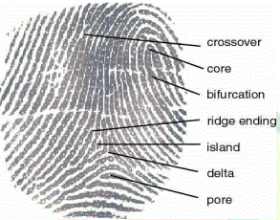
Figure 3.1: Minutiae before marking
Source: Wikipedia.com/minutiae

Figure 3.2: Minutiae after marking
Source: Wikipedia.com/minutiae
In the enrollment phase, the system captures two fingerprints from two different fingers, say fingerprint A and B from finger A and B, respectively. The minutiae position was extracted from fingerprint A and the orientation from fingerprint B using proposed techniques. Then, by using our proposed coding strategies, a combined minutiae template is generated based on the minutiae positions and the orientation fields are detected from both fingerprints. Finally the combined minutiae template is store in a database.
Fingerprint A
Combined fingerprint template generation
Minutiae points
Database
Fingerprint B
Orientation

Figure 3.3: Enrollment
Source: Researcher’s report
In the authentication phase, two query fingerprints are required from the same two fingers, say fingerprints A’ and B ‘from fingers A and B. As what we have done in the enrollment, we extract the minutiae position from fingerprint A’ and orientation from fingerprint B’. reference points are detected from both query fingerprints.
These extracted information will be matched against the corresponding template store in the database by using a two-stage fingerprint matching. The authentication will be successful if the matching score is over a predefined threshold
DATABASE
ORIENTATION
FINGERPRINT
MATCHING PROCESS
FINGERPRINT A
MINUTIAE
POINTS
YES/ NO
FINGERPRINT B

Figure 3.4: Extraction
Source: Researcher’s project
A fingerprint is the pattern of ridges and valleys; each individuals has unique fingerprints. The uniqueness of a fingerprint is exclusively determined by the local ridge characteristics, and their relationships. Two most prominent local ridge characteristics, called minutiae, are the ridge ending and bifurcation ending and the ridge bifurcation. The first is defined as the point where a ridge forks or diverges into branch ridges. A good quality fingerprint typically consist about 40-100 minutiae point. Fingerprint recognition is an application in pattern recognition, and is used in security to identify authentication. Fingerprint matching has three different categories, namely, correlation based, minutiae based, ridge feature based. Minutiae based fingerprint matching is the most widely used fingerprint matching algorithm, and this algorithm too is minutiae based. To implement a minutiae extractor, a three stage approach is widely used by researchers. These stage are pre-processing, minutiae extraction and post processing stage. The following flow chart shows the algorithm for minutiae point extraction.
Fingerprint Image
Binarization

Block Filter

Minutiae Extraction
Minutiae Matching

Minutiae Score

Figure 3.5: Minutiae Extraction
Source: Researcher’s project
Image Enhancement
Normalization

Filtering

Noise Reduction

Binarization

Thinning

Figure 3.5: Preprocessing
Source: Researcher’s project
False Minutiae Removal

Figure 3.6: post-processing
Source: Researcher’s project

3.2 Analysis Of The Existing System
The existing system of student attendance system in some companies is purely paper based system, which contain a lot of errors and manipulations. And in some companies they did not attach more importance to student attendance and this is costing them to lose some vital client and capital, why some companies that really takes student attendance serious did not know how they can go about to implement it.
3.3 Problems Of The Existing System
The problem that the paper base student attendance system is facing cannot be over emphasis, this paper base attendance make some students to come to work at anytime of the day and leave whenever they wish, once the receptionist in charge has been bribe. The following are the problems facing the paper base attendance system:
- Time Wasting: This system waste the student precious time in write names and time they resume for work, some may even be on queue for the sake of signing in.
- Not Properly Documented: A student that comes late may sign in correct time in order to protect him/herself that he did not come late.
- Wickedness: The receptionist in charge of the Attendance may decide to fast forward the time in order to implicated one of the student that has offended him/her for long time.
- Lack of Security: If the company really relies on the attendance for student salary, a student with highest late comer may decide to burn the attendance in order not to deduct from his/her salary.
3.4 Description Of Proposed System
With the implementation of this system, paper-based system will be eliminated. This system can save time and minimize the manpower for manual management. The administrators can easily trace the attendance of the students compare to manual paper recording and file keeping system. Besides, the students' records are more secure which are saved into the database. This system is also helps to reduce clerical cost such as papers, files and stationery.
The developed system can trace the attendance of the students while they are coming and leaving for work. With the report, the administrator can easily analyze and detect the performance of the students in the company.
The student attendance system is proposed to solve the current problems that occurred while using the file keeping system. Therefore the administrator job to keep track the attendance and student record will be easier. There are some things that needed to put in consideration while developing the project. There are time, resources and experience. Student attendance monitoring system is important because it can estimate the time required to complete each milestone in project phase.
It is able to determine how much time needed to perform each task by referring to the schedule that given by the committee. In addition, this project is not a full time development because there will be other subjects to be concentrated. Therefore, time allocated is limited and tight.
3.5 Advantages Of The Proposed System
The system handles multiple users. Each user is assigned a unique user name and ü ass word. Any transactions and input updated data will have the user identification associated with it. This functionality is handled by the system itself, and the information is taken directly from the system login screen. The system's administrator will assign user names and passwords, as well as security profiles.
Student Attendance Management System is an easy way to keep track of any school's attendance records. It also works very well as a member database. The program was developed with three main goals in mind: versatility, ease of use, and security.
Versatility-Not every school has the same attendance policies, so this program easily allows you to specify your school's policies. You can also store any information you'd like about each member.
Ease of Use -This program is very intuitive. It was designed so that all of the instructions you need are right on the screen. In addition to using your mouse with the program, you can also use the keyboard for almost every function. If you do get stuck, extensive online help is included.
Security -All information can be password protected to prevent unauthorized people from viewing sensitive data. You can turn the password protection on or off at your convenience.

Chapter Four
Design and Implementation of the System
4.1 DESIGN OF THE NEW SYSTEM
Detailed physical models are a common product of many system design techniques. Examples include database schemas, structure charts, and flowcharts. They serve as a blueprint for construction of the new system. During implementation, system models can be included in training and user manuals for the new system.
A good project plan is able to make sure the project is progressing well based on the given timeframe. Therefore, a number of major activities must be undertaken and completed while developing the project. It is handled by a person.
In an attempt to simplify represent the meaning of each section of the codes, each module will be highlighted and a broken down of its input output will be stressed.
In the proposed system, there’ll be an interface between the program and the fingerprint scanner, after the fingerprint scanner driver is installed, a calling function will then authenticate the finger with fingerprint system. As soon as a minutiae feature of the finger is extracted, a One Time Password will be sent via SMS to complete validation and authentication of the user.
4.1.1 OUTPUT DESIGN
An efficient and intelligent output design improves the system’s relationship to help user decision-making.
Designing computer output should proceed in an organized, well thought out manner: the right output must be developed while ensuring that each output element is designed so that people will find the system easily and effectively to use.

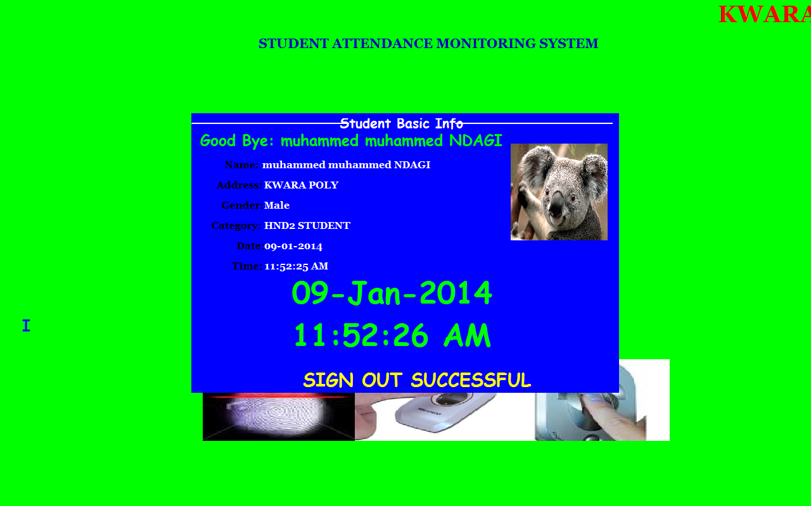

Fig 4.1.1 shows the student sign out module
4.1.2 INPUT DESIGN
The design of input focuses on controlling the amount of input required, controlling the errors, avoiding delay, avoiding extra steps and keeping the process simple.
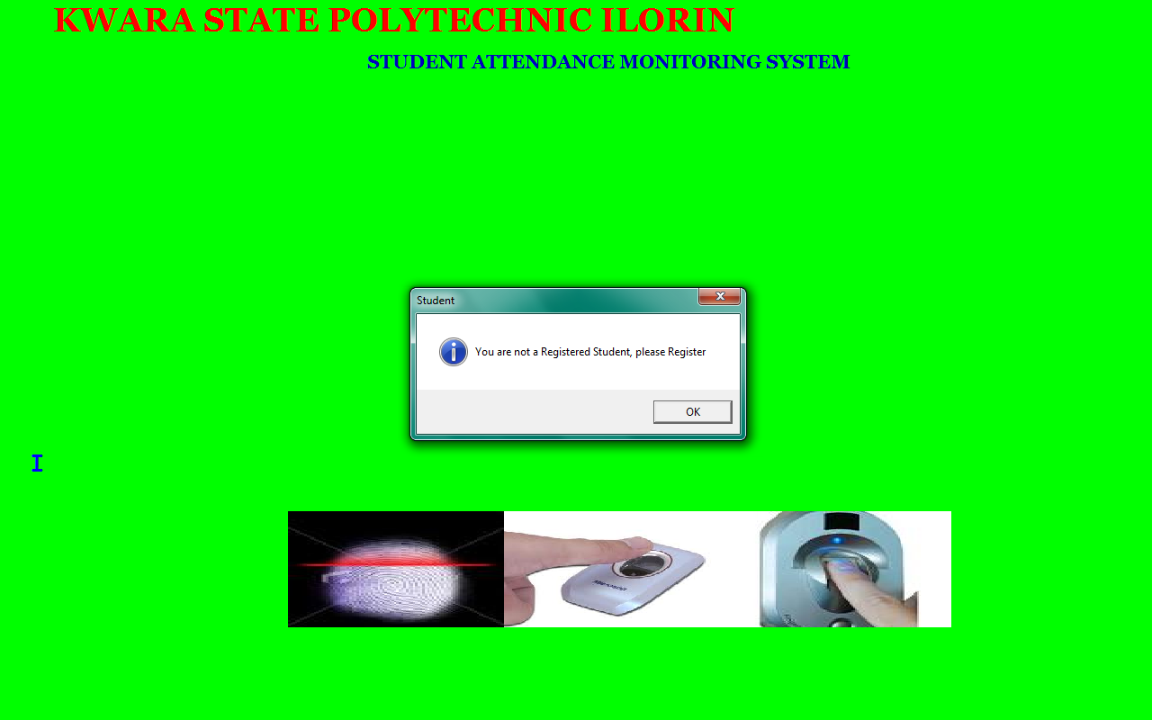

Fig 4.1.2.1 shows the home page where student place their finger on the scanning machine

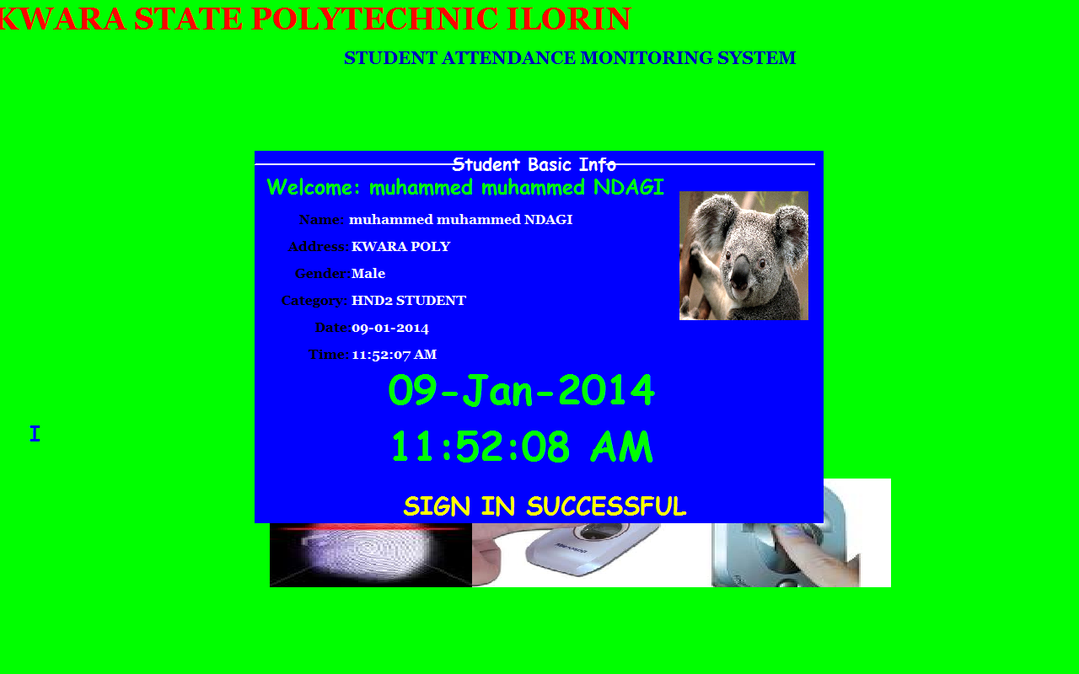

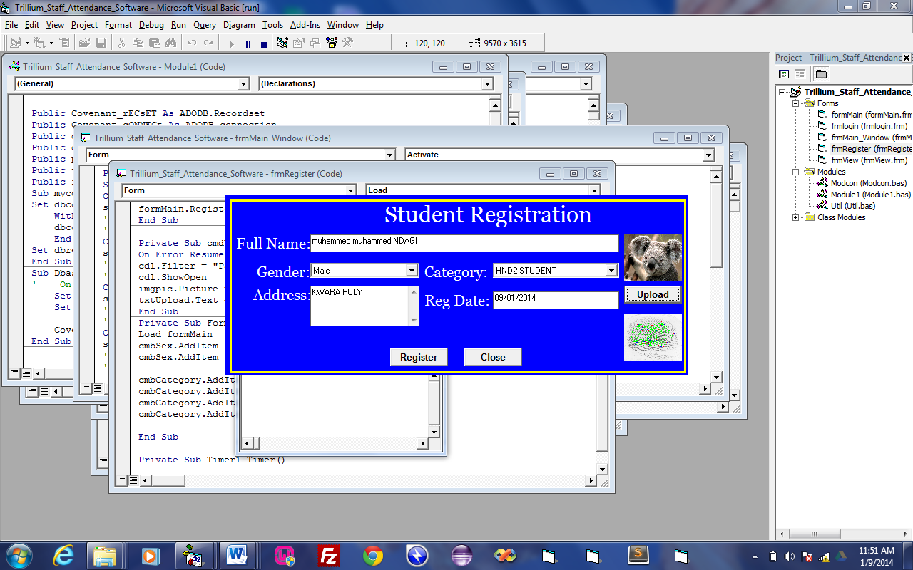
Fig 4.1.2.2 shows the student sign in menu

Fig 4.1.2.3 shows the student registration module

4.1.3 DATABASE DESIGN
This involves the list of tables used in the database design . The tables are listed as follows
1 Student table: This consist of the list of positions that exist for the election process
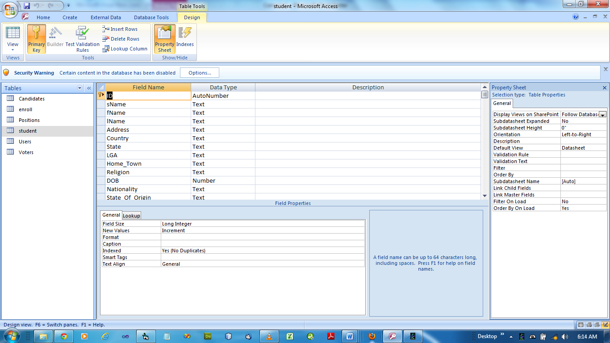

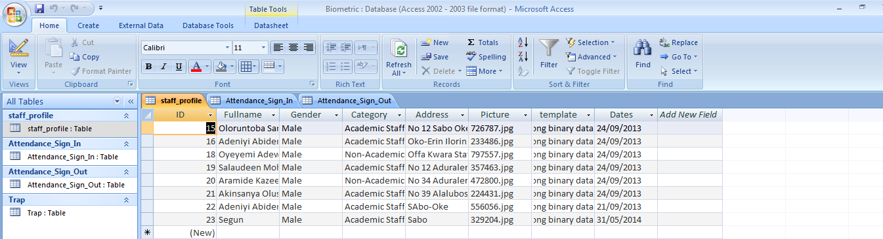
Fig 4.1.3.1 shows the student database table

Fig 4.1.3.2 shows the student registration Database

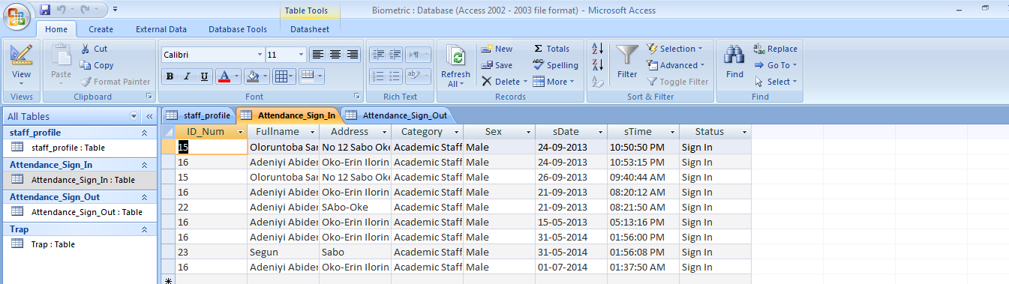

Fig 4.1.3.3 shows the student Attendance Sign in database
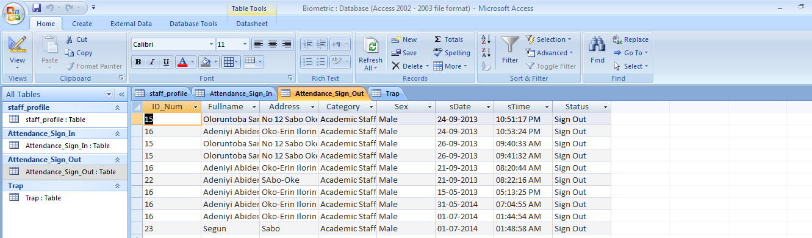

Fig 4.1.3.4 shows the student Attendance sign out database
4.1.4 PROCEDURE DESIGN
This refers to the step by step method of using the proposed system. The proposed system comprises of four modules namely file, edit, report and windows. The steps to use the proposed system are as follows
- Click on start button on the desktop.
- Point to all programs
- Select Student Attendance Monitoring System and the welcome screen come up followed by the main page.
4.2 IMPLEMENTATION OF THE SYSTEM
In design and implementation of any system, it is a good programming practice to consider all the option that will be shown – up and the choice that can be made.
4.2.1 CHOICE OF PROGRAMMING LANGUAGE
Visual basic is the chosen programming language for the implementation of the proposed system because of its pedagogy and open source help when needed. As well it has a support for variety of database application like SQL server, SQL lite, my SQL, and Microsoft access but Microsoft access is selected.
4.2.2 HAREWARE SUPPORT
The hardware requirements for the support of the system are highlighted below:
- An enhanced keyboard and mouse
- Minimum of fill computer
- A minimum processor speed of 1.8ghZ
- 2GB Ram size
- Least of 4GB hard disk space
- CD ROM/CD Writer
- UPS
- VGA or SVGA colour monitor to be able to achieve the effective user friendliness of the program
- A printer for hard copy record production
4.2.3 SOFTWARE SUPPORT
The software support for the design of the proposed system involves the followings;
- operating system
- Microsoft visual basic. NET
- Microsoft Access
- Anti-virus software
4.2.4 IMPLEMENTATION TECHNIQUE
The implementation technique used is parallel mode of implementation, a mode which supports the proposed system alongside with the current system.
4.3 SYSTEM DOCUMENTATION
4.3.1 PROGRAM DOCUMENTATION
The proposed system have six (6) modules which are;
- Register: This is module for registering new student as well as enrollment
- Login: This is the authentication module of username and password for authorized personnel.
- Report: This module is meant for showing the report of student records, attendance records etc
- Authenticate: This is a module of verifying fingerprint which in turn invoke sms sending function in the program.
- Modify: This is the module for allowing modification of user records.
- An sms module is automatically initiated during authentication after comparing fingerprint with the one that exist in the database.
4.3.2 OPERATING THE SYSTEM
In order for the proposed system to be used on any computer system it takes the following ways
- Boot the system
- Put the software in the CD or flash drive into its appropriate drive.
- Open the content from “my computer” icon on the desktop or clicking the start button.
- Double click the set up icon from the content of the package folder in the device (flash, CD).
- Follow the instruction and click on the appropriate button and the installation will be completed in a few moments.
The installed program can be use using the stated points below.
- Click on the start button on the desktop.
- Point to all program
- Select the program name i.e. Student Attendance Monitoring System
- Supply the username and password to confirm that you are an authorize user.

    - MAINTAINING OF THE SYSTEM
Institute of Electronic Electrical Engineer (IEEE) describes Software Maintenance as “the process of modifying a software system or component after delivery to correct faults, improve performances or other attributes, or adapt to a changed environment.” Categories of maintenance include:
- Corrective maintenance: reactive modification of a software product performed after delivery to correct discovered faults.
- Adaptive maintenance: Modification of a software product performed after delivery to keep a computer program usable in a changed or changing environment.
- Perfective maintenance: modification of a software product performed after delivery to improve performance or maintainability
- Emergency maintenance: unscheduled corrective maintenance performed to keep a system operational.”
In this design of the system, every maintenance was put into consideration i.e. in case any need for maintenance arise; the application is design it such a ways that will ease maintenance.

CHAPTER FIVE
SUMMARY, CONCLUSION AND RECOMMENDATION
5.1 SUMMARY
The proposed student attendance monitoring system is more reliable and efficient in respect of accuracy and storage than the manual system.
The program design was done in sufficient details with the system flowchart in appendix.
The program to implements the new system were all compiled using the microcomputer.
5.2 CONCLUSION
Having gone through the manual and new design system, one can conclude that computer base system is to use. From the two system discussed, the manual system having a lot of draw backs and also a lot of manipulations by the student. I can conclude that the proposed method is better by far. If it is implemented, the entire set back will be eliminated or drastically minimized.
  - RECOMMENDATION
At this point in time, having conducted this research work and with my newly acquired experience and knowledge in student attendance monitoring system using finger print, I wish to recommend this system to all schools in Nigeria in order to have proper record and manage the student activities in the school..
I hereby also which to recommend the above procedure to all private and government schools in Nigeria at one time or the other might need the assistance of a computer for their daily activities. Although, a copyright protection have been place on this project work, but by recommending it to consult the authors of this text who have struggled day and night to make this system a reality.

Bion, R. (2012). Biometric technologies and fingerprint matching techniques. Journal of Computer Applications, 14(3), 45–52.
Ismail, A. (2009). Biometric systems for human recognition. International Journal of Biometrics, 2(2), 101–110.
Paul, S. (2013). A comprehensive guide to SMS technology. Mobile Communications Review, 7(1), 22–30.
Ruth, T. (2013). Security risks of biometric authentication. Journal of Information Security, 11(4), 189–198.
Seth, F. (2009). Manual attendance systems: Issues and challenges. Education Technology & Society, 5(2), 76–84.
Velasquez, L. (2013). Advantages of fingerprint authentication in secure systems. Journal of Cybersecurity Innovations, 9(2), 60–68.
Wendy, M. (2014). Challenges in minutiae-based fingerprint recognition. IEEE Transactions on Pattern Analysis and Machine Intelligence, 36(9), 1878–1885.
Dhanashree, A. G. (2011). Student Attendance Management. International Journal of Computer Applications

Source Listing

Option Explicit
Dim rs As New ADODB.Recordset
Private Sub Form_DblClick()
Me.Hide
frmAdmin.Show
End Sub
' Application startup code
Private Sub Form_Load()
Dim err As Integer
' InitializeGrFingerX Library
err = InitializeGrFinger()
' Print result in log
If err < 0 Then
writeError (err)
Exit Sub
Else
writeLog ("**GrFingerX Initialized Successfull**")
End If
End Sub
' Application finalization code
Private Sub Form_Terminate()
Call FinalizeGrFinger
End Sub
' Add a fingerprint to database
Private Sub btEnroll_Click()
Dim Id As Integer

' add fingerprint
Id = Enroll
' write result to log
If Id >= 0 Then
writeLog ("Fingerprint enrolled with id = " & Id)
frmAddRecord.lblid.Caption = Id
frmAddRecord.Show
Else
writeLog ("Error: Fingerprint not enrolled")
End If
End Sub

' Identify a fingerprint
Public Sub btIdentify_Click()
Network
Dim ret As Integer, score As Long, status As String, myval As Double
score = 0
' identify it
ret = Identify(score)
' write result to log
If ret > 0 Then
writeLog ("Fingerprint identified with VoterID = " & ret & ". Score = " & score & ".")
Call PrintBiometricDisplay(True, GR_DEFAULT_CONTEXT)
Set rs = New ADODB.Recordset
' check if user has previously voted
lbl1.Caption = ret
reca.Open "select * from Voters where VoterID = " & ret, cona, 3, 3
Me.Hide
frmconfirm.Show
ElseIf ret = 0 Then
writeLog ("Fingerprint not Found.")
If (MsgBox("You are not a registered student! Do you want to register", vbYesNo, "Examination Monitoring System")) = vbYes Then
btEnroll_Click
'.Visible = True
End If
Else
writeError (ret)
End If
End Sub

' Check a fingerprint
Private Sub btVerify_Click()
Dim Id As Integer
Dim ret As Integer
Dim score As Long
Dim sid As String

' ask target fingerprint ID
score = 0
sid = InputBox("Enter the ID to verify", "Verify", "")
If sid<> "" Then
' compare fingerprints
ret = Verify(Val(sid), score)
' write result to log
If ret < 0 Then
writeError (ret)
ElseIf ret = GR_NOT_MATCH Then
writeLog ("Did not match with score = " & score)
Else
writeLog ("Matched with score = " & score)
' if they match, display matching minutiae/segments/directions
Call PrintBiometricDisplay(True, GR_DEFAULT_CONTEXT)
End If
End If
End Sub

' Extract a template from a fingerprint image
Public Sub btExtract_Click()
Dim ret As Integer

' extract template
ret = ExtractTemplate()
' write template quality to log
If ret = GR_BAD_QUALITY Then
writeLog ("Template extracted successfully. Bad quality.")
ElseIf ret = GR_MEDIUM_QUALITY Then
writeLog ("Template extracted successfully. Medium quality.")
ElseIf ret = GR_HIGH_QUALITY Then
writeLog ("Template extracted successfully. High quality.")
End If
If ret >= 0 Then
' if no error, display minutiae/segments/directions into the image
Call PrintBiometricDisplay(True, GR_NO_CONTEXT)
' enable operations we can do over extracted template
btExtract.Enabled = False
btEnroll.Enabled = True
btIdentify.Enabled = True
btVerify.Enabled = True
Else
' write error to log
writeError (ret)
End If
End Sub

' Clear database
Private Sub btClearDB_Click()
' clear database
DB.clearDB
' write result to log
writeLog ("Database is cleared...")
End Sub

' Clear log
Private Sub btClearLog_Click()
lbLog.Clear
End Sub

' Save fingerprint image to a file
Private Sub menuImgSave_Click()
' we need an image
If raw.height< 1 Orraw.width< 1 Then
MsgBox "There is no image to save."
Exit Sub
End If

' open "save" dialog
CommonDialog.Filter = "BMP files (*.bmp)|*.bmp|All files (*.*)|*.*"
CommonDialog.FilterIndex = 1
CommonDialog.filename = ""
CommonDialog.ShowSave

' Save image.
If Not CommonDialog.CancelErrorAndCommonDialog.filename<> "" Then
If formMain.GrFingerXCtrl1.CapSaveRawImageToFile(raw.img, raw.width, raw.height, CommonDialog.filename, GRCAP_IMAGE_FORMAT_BMP) <> GR_OK Then
writeLog ("Fail to save the file.")
End If
End If
End Sub

' Load a fingerprint image from a file
Private Sub menuImgFromFile_Click()
' open "load" dialog
CommonDialog.Filter = "BMP files (*.bmp)|*.bmp|All files (*.*)|*.*"
CommonDialog.FilterIndex = 1
CommonDialog.filename = ""
CommonDialog.ShowOpen

' load image
If Not CommonDialog.CancelErrorAndCommonDialog.filename<> "" Then
Dim res As Long
' Getting resolution.
res = Val(InputBox("Enter the resolution of the selected image", "Resolution"))
' Checking if action was canceled, no value or an invalid value was entered.
If res <> 0 Then
If GrFingerXCtrl1.CapLoadImageFromFile(CommonDialog.filename, res) <> GR_OK Then
writeLog ("Fail to load the file.")
End If
End If
End If
End Sub

' Open "Options" window
cmbState.AddItem "Nassarawa"
cmbState.AddItem "Niger"
cmbState.AddItem "Ogun"
cmbState.AddItem "Ondo"
cmbState.AddItem "Osun"
cmbState.AddItem "Oyo"
cmbState.AddItem "Plateau"
cmbState.AddItem "Rivers"
cmbState.AddItem "Sokoto"
cmbState.AddItem "Taraba"
cmbState.AddItem "Yobe"
cmbState.AddItem "Zamfara"
cmbState.AddItem "F.C.T."

' State of Origin
'cmbOrigin.Text = "Select State"
cmbOrigin.AddItem "Abia"
cmbOrigin.AddItem "Adamawa"
cmbOrigin.AddItem "AkwaIbom"
cmbOrigin.AddItem "Anambra"
cmbOrigin.AddItem "Bauchi"
cmbOrigin.AddItem "Bayelsa"
cmbOrigin.AddItem "Benue"
cmbOrigin.AddItem "Borno"
cmbOrigin.AddItem "Cross River"
cmbOrigin.AddItem "Delta"
cmbOrigin.AddItem "Ebonyi"
cmbOrigin.AddItem "Ekiti"
cmbOrigin.AddItem "Edo"
cmbOrigin.AddItem "Enugu"
cmbOrigin.AddItem "Gombe"
cmbOrigin.AddItem "Imo"
cmbOrigin.AddItem "Jigawa"
cmbOrigin.AddItem "Kaduna"
cmbOrigin.AddItem "Kano"
cmbOrigin.AddItem "Katsina"
cmbOrigin.AddItem "Kebbi"
cmbOrigin.AddItem "Kogi"
cmbOrigin.AddItem "Kwara"
cmbOrigin.AddItem "Lagos"
cmbOrigin.AddItem "Nassarawa"
cmbOrigin.AddItem "Niger"
cmbOrigin.AddItem "Ogun"
cmbOrigin.AddItem "Ondo"
cmbOrigin.AddItem "Osun"
cmbOrigin.AddItem "Oyo"
cmbOrigin.AddItem "Plateau"
cmbOrigin.AddItem "Rivers"
cmbOrigin.AddItem "Sokoto"
cmbOrigin.AddItem "Taraba"
cmbOrigin.AddItem "Yobe"
cmbOrigin.AddItem "Zamfara"
cmbOrigin.AddItem "F.C.T."

'cmbDept.Text = "Select Department"
cmbDept.AddItem "Computer Science"
cmbDept.AddItem "Maths/Statistics"
cmbDept.AddItem "Science Laboratory Technology"
cmbDept.AddItem "Geography"
cmbDept.AddItem "Hospitality Management"
cmbDept.AddItem "Leisure and Tourism"
cmbDept.AddItem "Agricultural Technology"
End Sub
Private Sub txtHome_Town_GotFocus()
If txtHome_Town.Text = "Home Town" Then txtHome_Town.Text = ""
End Sub
Private Sub txtLast_GotFocus()
If txtLast.Text = "Lastname" Then txtLast.Text = ""
End Sub
Private Sub txtLGA_Gotfocus()
If txtLGA.Text = "Local Government" Then txtLGA.Text = ""
End Sub
Private Sub txtNationality_GotFocus()
If txtNationality.Text = "Nationality" Then txtNationality.Text = ""
End Sub
Private Sub txtpassport_Change()
If txtpassport.Text = "" Then cmdUpload_Click
End Sub
Private Sub txtpassport_Click()
cmdUpload_Click
End Sub
Private Sub txtPhone_No_Change()
If txtPhone_No.Text = "Phone Number" Or Not IsNumeric(Trim(txtPhone_No.Text)) Then
txtPhone_No.Text = ""
End If
End Sub
Private Sub txtSurname_GotFocus()
If txtSurname.Text = "Surname" Then txtSurname.Text = ""
End Sub
Dim rs As ADODB.Recordset
Dim DBA As New DBClass
Dim connection As New ADODB.connection
Option Explicit
Private Sub rsu()
'DB.OpenDB
'Set rs = New ADODB.Recordset
'rs.Open "Select*from Users", connection, adOpenStatic, adLockOptimistic
End Sub
Private Sub cmdlogin_Click()
On Error Resume Next
Dim recSet As New Recordset
If txtuname.Text = "" Or txtpword.Text = "" Then
MsgBox "Failure to access system!",vbCritical, "Admin Log"
End If
sqla = "Select * From Users"
recSet.Opensqla, cona, 3, 3
If txtuname.Text = recSet.Fields("Username") And txtpword.Text = recSet.Fields("Password") Then
'mdiavsadmin.Show
Unload Me
'frmvoter_main.Hide
ElseIftxtuname.Text<>reca.Fields("Username") Or txtpword.Text<>reca.Fields("Password") Then
MsgBox "Failure to access system! Either Username or Password is incorrect.",vbCritical, "Admin Login"
txtuname.Text = ""
txtpword.Text = ""
txtuname.SetFocus
End If
End Sub
Private Sub cmdlogout_Click()
Unload Me

Computer Output

the student sign out module

shows the home page where student place their finger on the scanning machine

the student sign in menu

shows the student registration module

the student database table

shows the student registration

