BAKERY

BY

SANUSI MUHAMMED MEGIDA
ND/22/ARC/FT/054

BEING A RESEARCH PROJECT SUBMITTED TO THE DEPARTMENT OF ARCHITECTURAL TECHNOLOGY, INSTITUTE OF ENVIRONMENTAL STUDIES (IES), KWARA STATE POLYTECHNIC ILORIN, KWARA STATE

IN PARTIAL FULFILLMENT OF THE REQUIREMENT FOR THE AWARD OF NATIONAL DIPLOMA (ND) IN ARCHITECTURAL TECHNOLOGY

MAY, 2025

CERTIFICATION
This is to certify that this research project has been read and approved as meeting the requirement of Award of National Diploma (ND) in Architectural Technology, Institute of Environmental Studies, Kwara State Polytechnic, Ilorin.

__________________ ___________________
ARC. FAMILUA O.S. DATE
(Project Supervisor)

__________________ ___________________
ARC. FAMILUA O.S. DATE
(Project Coordinator)

__________________ ___________________
ARC. TOMORI J.M. DATE
(Head of Department)

DEDICATION
This project work is dedication to Almighty Allah the omnipotent, omnipresent, and omniscience for his blessings, protection and guidance over me. Also this project is dedicated to my parents for their love and support financially and spiritually, we are indeed grateful.
ACKNOWLEDGEMENT
All praise and adoration is due to Almighty Allah for His unlimited blessings, grace, mercies, and who has also been my rock and source of inspiration throughout this project.
Am using this moment to acknowledged the support and guidance of my Amiable project supervisor (ARC. FAMILUA O.S.) I pray May Almighty Allah reward him abundantly, bless him and his family endlessly and also grant him sufficient health AMEEN.
I must not fail to appreciate my lovely father MR. MEGIDA for their guidance and support throughout my education, their expertise and encouragement were invaluable, May Almighty Allah let you live long to reap the fruit of your Labour AMEEN.
My appreciation also goes to all my family and friends who have helped me grow and learn, May Allah bless them for their kindness, patience, and wisdom.
Once again am grateful to GOD for his mercies, loves, and care for the greatest opportunity he gave me to accomplish the task of being a graduate ALHAMDULILLAH

TABLE OF CONTENTS
Title Page i
Certification ii
Dedication iii
Acknowledgment iv
Table of Contents v
CHAPTER ONE
1.1 Introduction to Bakery 1
1.2 Types of Bakeries 1
1.3 Bakery Products 1
1.4 Bakery Equipments 1
1.5 Bakery Operations 2
1.6 Aims and Objectives 3
1.7 Historical Background 4
1.8 History of Baking 5
Conclusion 5
Reference 6
CHAPTER TWO
2.1 The Bakery Review 7
2.2 Bakery Typology 7
2.3 Problems Associated with Bakeries Typology as Buildness Types 8
2.4 Here are some Solutions to the Architectural Problems Associated with
Bakery Typology 10
CHAPTER THREE
3.1 Hence are some Case Studies as the Following 12
3.2 Architectural Related Merits and Demerits of a Bakery
CHAPTER FOUR
4.1 Here are some Typographical and Environmental Conditions for Selected
Area in a Bakery 25
4.2 Here are some Analysis of the Topographic and Environmental Conditions
of the Bakery Site 26
4.3 Spatial / Function Criteria 28
4.4 Appraisal of a Bakery in Terms of Spaces, Size and Relationship 29
4.5 Bakery Equipment and their Functions 30
4.6 Conceptual Development of a Bakery 31
4.7 Approach to Design Realization Design Concept at the Different level
of Design for Baker 33
CHAPTER FIVE
5.1 Approach to Design Realization 35
5.2 Design concept at the different level of design for bakery 35
5.3 User Experience (UX) Design Level 36
5.4 Technology and Environmental Criteria for Bakery 36
5.5 Legal Issues and Planning Regulations for Bakery 37
5.6 Behavioural Patterns and Considerations in a Bakery 38
5.7 Conclusion on Bakery Design and Realization 39
5.8 Recommendation 39
Reference 41

CHAPTER ONE
1.1 INTRODUCTION TO BAKERY
A bakery is traditionally defined as a place where bread, cakes pies, cookies or nay flour – based foods are baked and sold.
1.2 TYPES OF BAKERIES
- Retail Bakery: Sells baked good directly to consumers
- Wholesale Bakery: Supplies baked goods to restaurants, cafes and other food establishments.
- Artisanal Bakery: Focuses on traditional baking methods and high – quantity ingredients.
- Industrial Bakery: Uses automated equipment and mass production techniques.
1.3 BAKERY PRODUCTS
- Cakes: Weeding cakes, birthdays cakes and other specialty cakes
- Bread: leaves, rolls, banquettes etc.
- Pastries: croissants, Danishes, and other flaky, sweet treats
- Pies: Fruit pies, meat pies and other sweet filliness
- Cookies: Sweet biscuits, often packaged for retail sale.
1.4 BAKERY EQUIPMENTS
- Ovens: deck ovens, rack ovens and conveyor lost ovens.
- Mixers: industrial mixers for large – scale dough production
- Dough preparation equipment: dough shelters, dough rounder’s, and baking products
- Baking pans: sheet pans, cake pans, and other specialized pans.
1.5 BAKERY OPERATIONS
- Ingredient sourcing: procuring high – quality ingredient, such as flour sugar and yeast.
- Dough preparation: mixing kneading, and proofing dough
- Baking: loading ovens, monitoring temperatures, and baking products
- Finishing: decorating, packaging and preparing for sale.
Advantages and Disadvantages
Advantages
- Creativity: Baking allows you to combine creativity and commerce, and you can be imaginative with your recipes.
- Control over finances: you can directly influence your cost and revenue and decide where to spend and how to price.
- Flexibility: you can scale your business up or down, and you can choose your hours. For example, you could start as a boutique bakery and cater expand to full scale bread bakery.
- Diverse reeve streams: you can sell baked goods retail, offer catering services, distribute to local businesses and take custom orders.
- Low startup cost: home bakeries can have lower initial costs than lower initial cost than commercial bakers.
Disadvantages
- Lons hours: bakery owners often work lonshours.
- High stress: running a bakery can be stressful.
- Expensive ingredients: ingredients for baking can be expensive
- High startup and running costs: the cost of starting and running a bakery can be high.
- Volatile profits: profits for a bakery can fluctuate
1.6 AIMS AND OBJECTIVES
- Customer loyalty: develop a program to build customer loyalty
- Expansion: consider opening new locations
- E-commence: launch an online store
- Community engagement: connect with the local community
Business aims and objectives can be financial or non-financial. For example, a business aim could be to make a certain amount of profit, while an objective could be to make a certain amount of profit each month.
Some other things to consider when starting a bakery include:
- Writing a business plan
- Getting funding
- Filling of permits
- Choosing a bakery style
- Leasing a location
- Ordering equipment
- Designing the layout \hiring staff
- Advertising
- Hosting a grand opening
1.7 HISTORICAL BACKGROUND
The origin of bakeries dates back to times, with evidence of bread-making found in ancient civilizations such as:
- Ancient Egypt (around 2500bce). Egyptians baked bread for both practical and ceremonial purposes.
- Ancient Greece (around 500 bce): Greeks established public bakeries, and bread became a staple food
- Ancient Rome (around 100bce). Romans further developed baking techniques and established bakeries throughout their empire.
The modern concept of bakeries emerged during the middle ases in Europe particularly in:
- Medieval England (around 1200CE): Bakeries became a common feature in towns and cities.
- Renaissance Europe (around 1500CE): Bakeries explained their offerings to include pastries, cakes and other treat.
The industrial revolution brought significant changes to the baking industry, with the introduction of:
- Mechanized mixing and kneading (around 1800CE): Made the baking process more efficient.
- Ovens and baking equipment (around 1900CE): Improved baking quality and consistency.
1.8 HISTORY OF BAKING
According to “The Oxford Companion to American Food and Drink” by Andrew F. Smith, baking dates back to Ancient Egypt around 2500BCE. The Egyptians developed a sophisticated system of baking, using yeast to leaven bread.
CONCLUSION
In conclusion, bakeries play a vital role in communities around the world, providing fresh bread, pastries and other sweet treats.

REFERENCES
Smith, A.F. (2007). The Oxford Companion to American Food and Drink. Oxford University Pre.
Powell (2013). The Bakery: A suide to setting up and running a successful bakery. Routledge.
Rubel W. (2011): Bread A Global History. Reaktion Books.
MC Clements, D.J. (2020). The future of Food. How science and technology are changing the way eat. Esceiver.

CHAPTER TWO
2.1 THE BAKERY REVIEW
In “Bread: A global History” by William Rubel, the author notes that bakeries often serve as community gathering spaces, where locals can come together to enjoy fresh bread and pastries.
Modern – Day Bakery
According to “The future of Food: How science and technology are changing the way we eat” by David Julian McCements, Modern – Day bakeries are incorporations new technologies and ingredients to create innovative baked goods.
2.2 BAKERY TYPOLOGY
- Retail Bakeries
- Traditional Bakery: Offers a wide variety of bread, pastries and cakes
- Specialty bakery: focuses on specific types of baked goods, such as artisanal bread or cupcakes.
- Artisanal bakery: emphasizes high – quality, hand crafted baked goods.
- Wholesale bakeries
- Commercial Bakery: supplies baked goods to large scale food service providers.
- Food service bakery: provides baked goods to restaurants cafes, and other food services establishment.
- Industrial bakery: produces large quantities of baked goods for mass distribution.
- Hybrid Bakeries
- Bakery café: compbines a bakery with a café or coffee shop.
- Bakery restaurant: offers a full menu of food n addition to baked goods.
- Baker – market: sells baked goods alongside other specify foods.
- Online bakeries
- E-commerce bakery: sells baked goods online for delivery or pickup
- Subscription based bakery: offers regular deliveries of baked goods to customers.
2.3 PROBLEMS ASSOCIATED WITH BAKERIES TYPOLOGY AS BUILDNESS TYPES
Functional Problems
- Ventilation and odour control: bakeries require proper ventilation systems to remove heat moisture and odor from the baking process.
- Space constraints: bakeries often require large spaces for equipment, storage, and production, which can be challenging in urban areas.
- Equipment layout: the layout of equipment such as ovens, mixers and refrigerators can be complex and require careful planning.

Environmental Problems
- Energy consumption: bakeries require significant amounts of energy for equipment, lighting and heading cooling systems.
- Water usage: bakeries use large amounts of water for cleaning, mixing and other process.
- Waste management: bakeries generate significant amounts of waste, including packaging materials food waste and cleaning supplies.
Health and Safety Problems
- Food safety: bakeries must maintain strict food safety protocols to prevent contamination and food borne illness.
- Occupational health: bakers may be exposed to hardous materials, such as flour dust, and must precautions to prevent injuries.
- Fire safety: bakeries are risk of fires due to the use of heat – producing equipment and flammable material.
Urban Planning Problems
- Zoning regulations: bakeries may be subject to zoning regulations that restrict that location or operations.
- Noise pollutions: bakeries can generate significant noise from equipment and operations.
- Traffic and parking: bakeries may attract significant foot traffic and require adequate parking facilities.
Architectural Problems
- Designing for flexibility: bakeries require design to accommodate changing production needs equipments
- Material pollutions: bakeries require durable, easy to clean materials for walls, floors and conter tops.
- Natural light: bakeries often require natural light for tasks such as decorating and quality control.
2.4 HERE ARE SOME SOLUTIONS TO THE ARCHITECTURAL PROBLEMS ASSOCIATED WITH BAKERY TYPOLOGY
Designing for Flexibility
- Modular design: design the bakery with modular components, such as movable partition and flexible equipment layouts.
- Multi-functional spaces: design spaces that can serve multiple functions, such as a retail area that also serves as a cares.
- Adaptable systems: install adaptable system such as adjustable shelving and modular ductwork
Material Selection
- Durable finishes: specify durable, easy to clean finishes, such as stainless steel, ceramic tile, and epoxy-loated floors.
- Non-slip flooring: install non-slip flooring to prevent slips and falls.
- Heat – resistant materials: use heat – resistant materials, such as refractory brick and insulated panals, heat ovens and other heat sources.
Natural Light
- Clerestory windows: install clerestory windows to bring natural light into the bakery.
- Skylights: use skylights to provide natural light and reduce the need for artificial lighting.

CHAPTER THREE
3.1 HENCE ARE SOME CASE STUDIES AS THE FOLLOWING
- Omuiyadun (Kwara/Nigeria )
- Operation: Retail bakery with a focus on sourdough bread.
- Challenge: managing high demand and maintaining product quality
- Solution: implemented an automated bread-making system and expanded production facilities
- Result: increased production capacity and maintained product quality.
- 50/50 Bread Bakery (Kwara/Nigeria)
- Operation: Industrial Bakery Producing frozen bread and pastries
- Challenge: Reducing energy consumption and environmental impact.
- Solution: implemented energy efficient ovens and refrigeration systems and introduced sustainable packaging
- Result: Reduced energy consumption by 20% and minimized environmental impact.
- The Bakery at Wegmas (Rochester, USA)
- Operation: In – store bakery within a supermarket chain.
- Challenges: providing a wide range of freshly baked products while maintains quality and consistency.
- Solution: implemented centralized bakery production system and introduces a variety of automated equipment.
- Result: Increased product variety and maintained quality and consistency.
- COBS Bread (Canada)
- Operation: Franchise bakery with multiple locations.
- Challenge: Maintaining consistency and qualities across multiple locations.
- Solution: Implemented a centralized training progamme and introduced standardization production procedures.
- Result: Maintained consistency and quality across multiple locations.
3.2 ARCHITECTURAL RELATED MERITS AND DEMERITS OF A BAKERY
Merits
- Natural lighting: large window allow natural light to enter illuminating the bakery and showcasing the products.
- Ventilation: proper ventilation system render heat, moisture and odours, maintaining a comfortable environment for customers and staff.
- Open layout: an often layout allows customers to see the baking process creations a sense of transparency and authencity.
- Display cases: attractive display cases showcases baked goods enticing customers and creating a visual appealing atmosphere.
Demerits
- Heat and moisture: Bakeries separate heat and moisture, which can lead to union for table temperatures and humidity level if not properly managed.
- Noise: mixers, ovens and other equipment can separate significant noise, potentially disturbing nearby residents of business.
- Odors: bakeries can produced strong odors, which may be nuisance to neighboring businesses or residents if not properly ventilated.
- Space constraints: bakeries often require specialized equipment, which can take up significant space, limiting the area available for customer or storage.
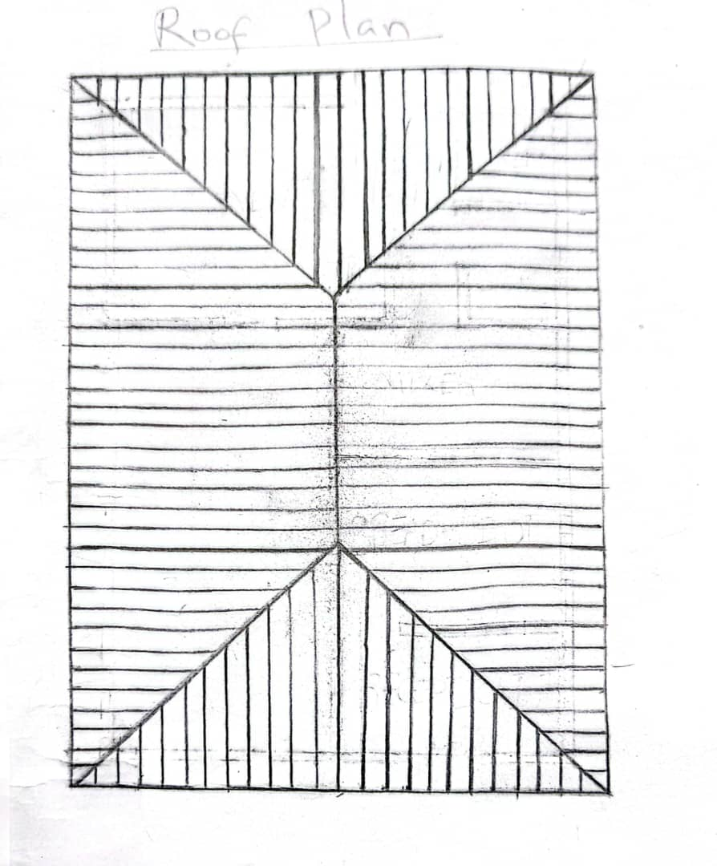
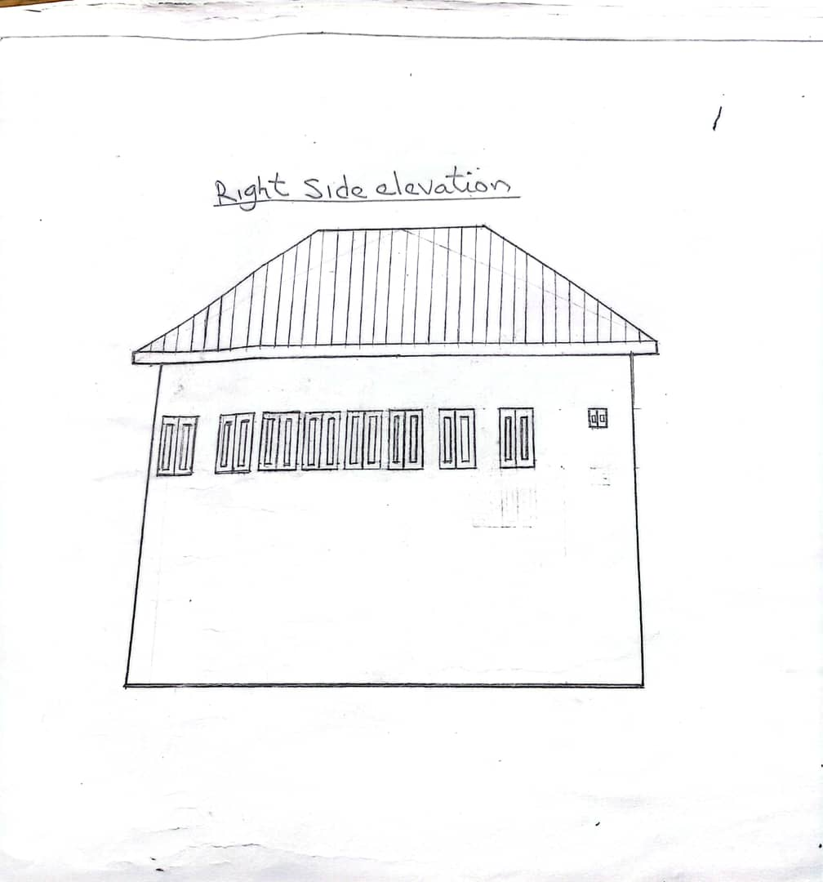

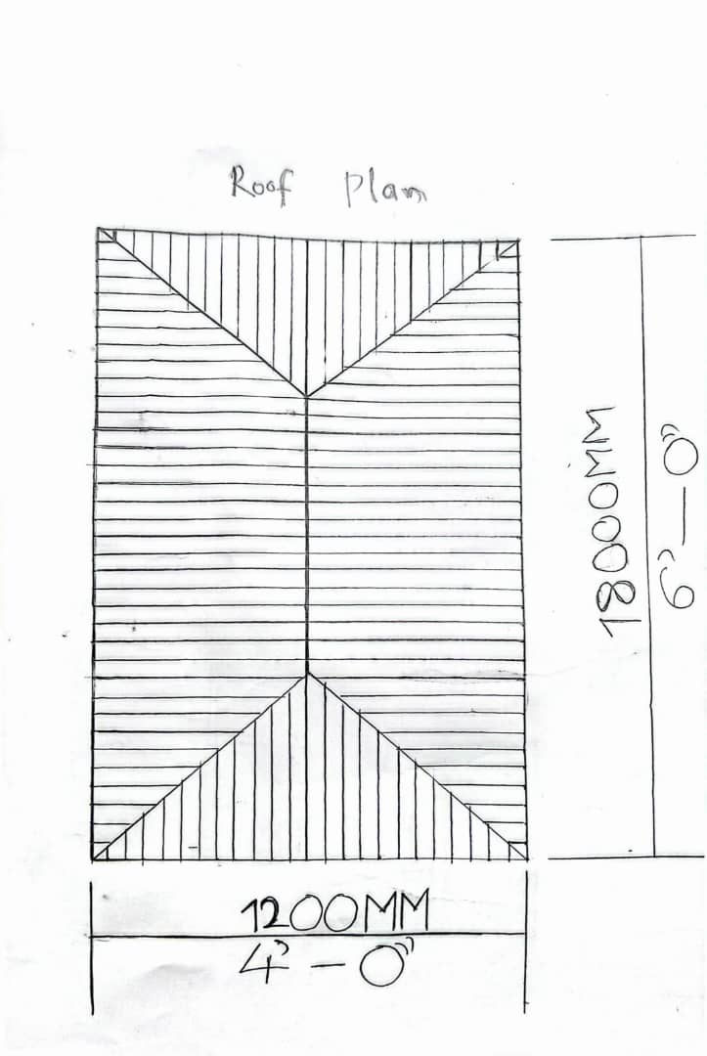
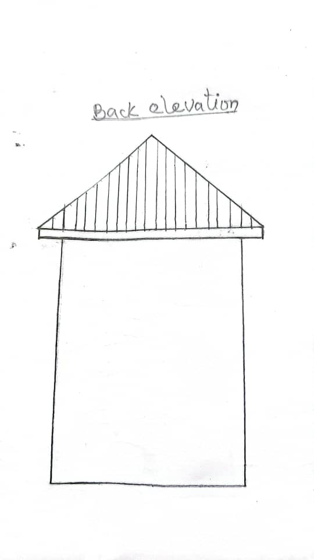
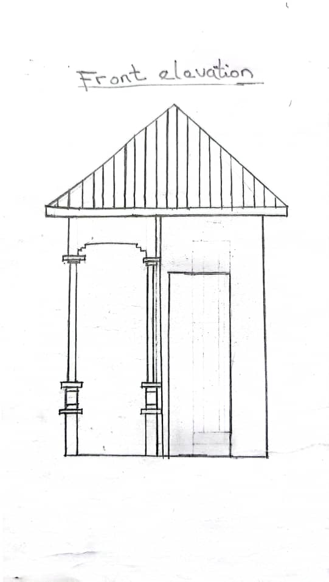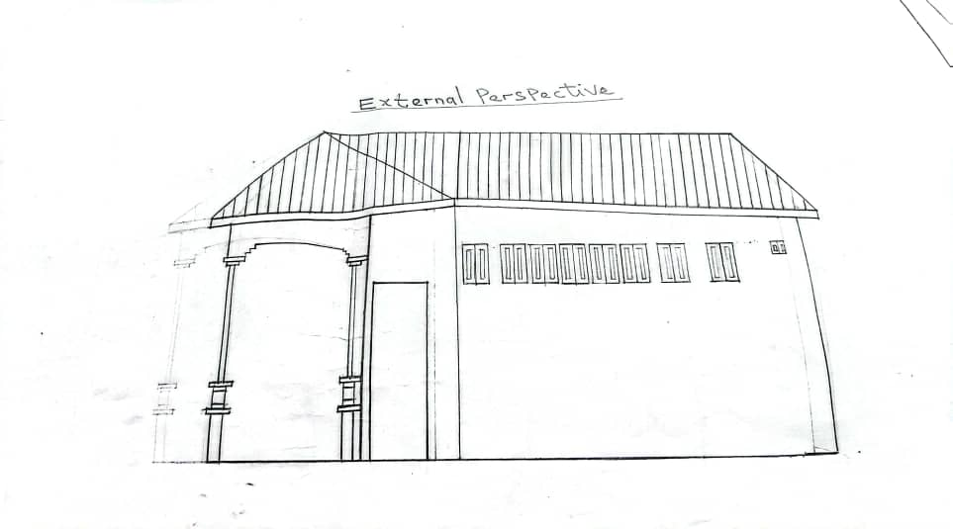
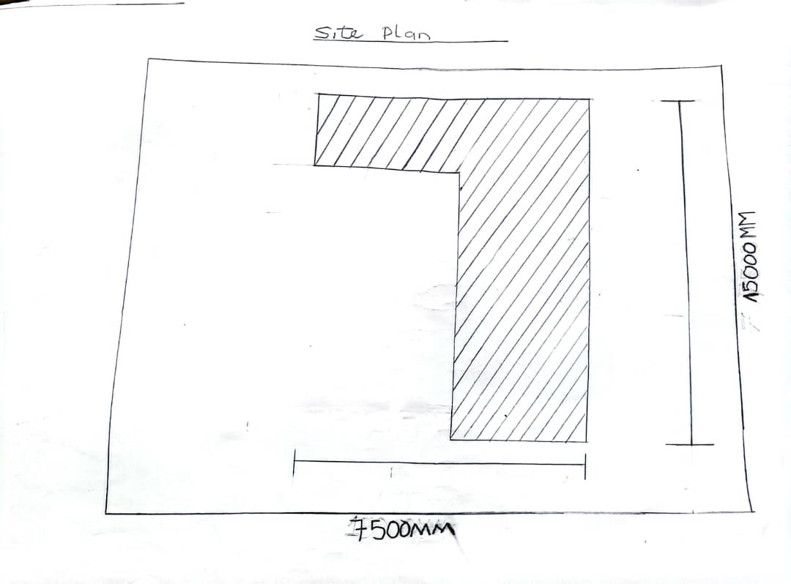
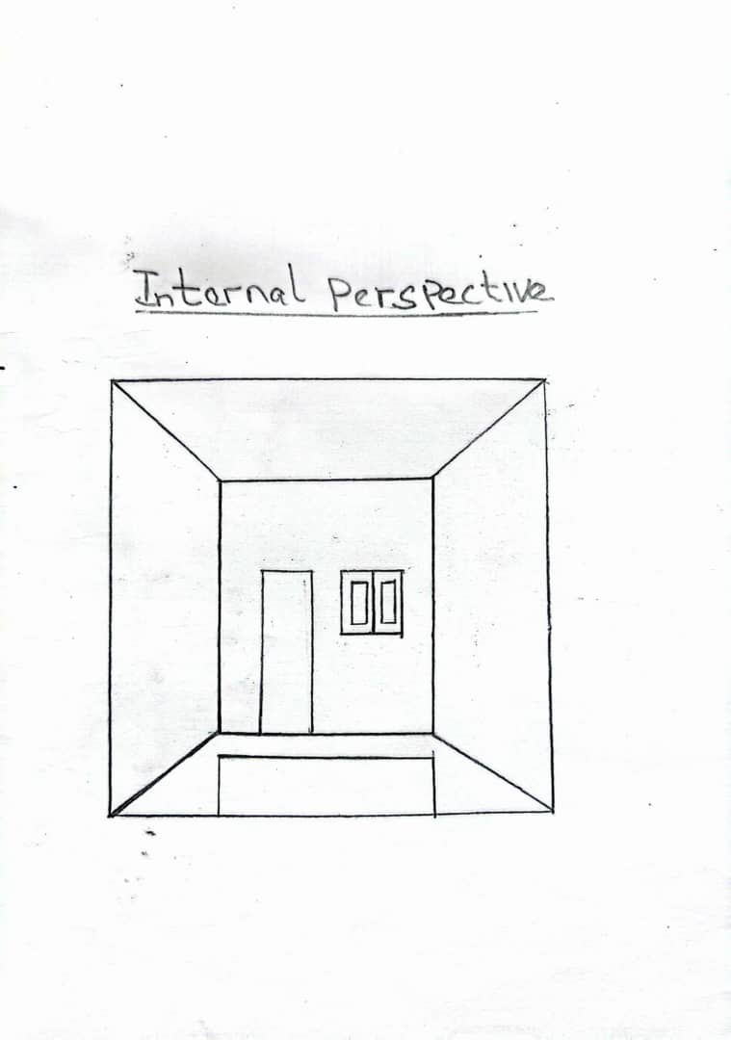
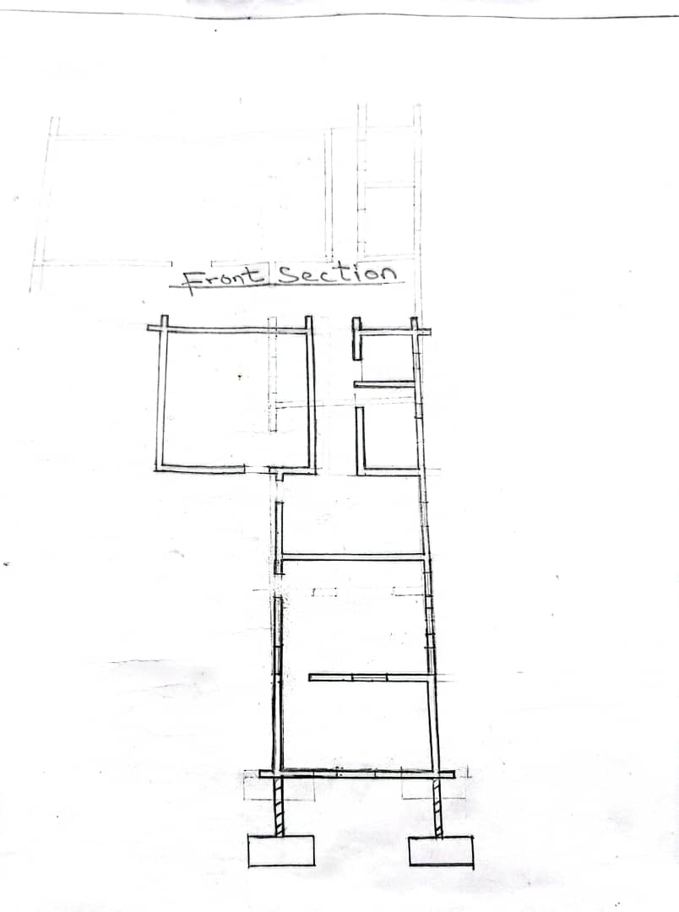
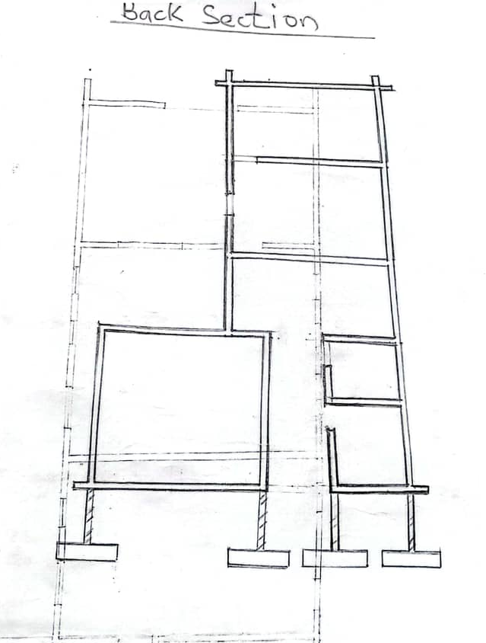

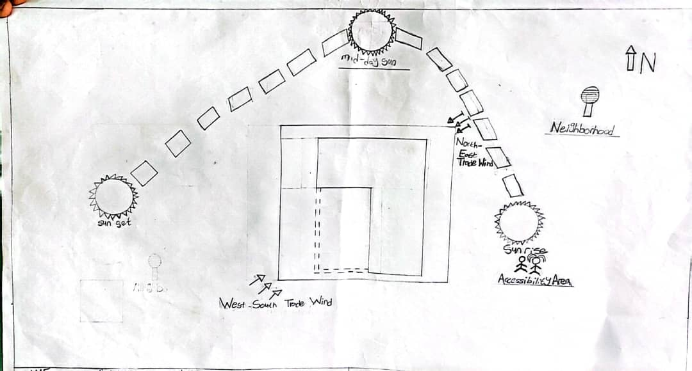
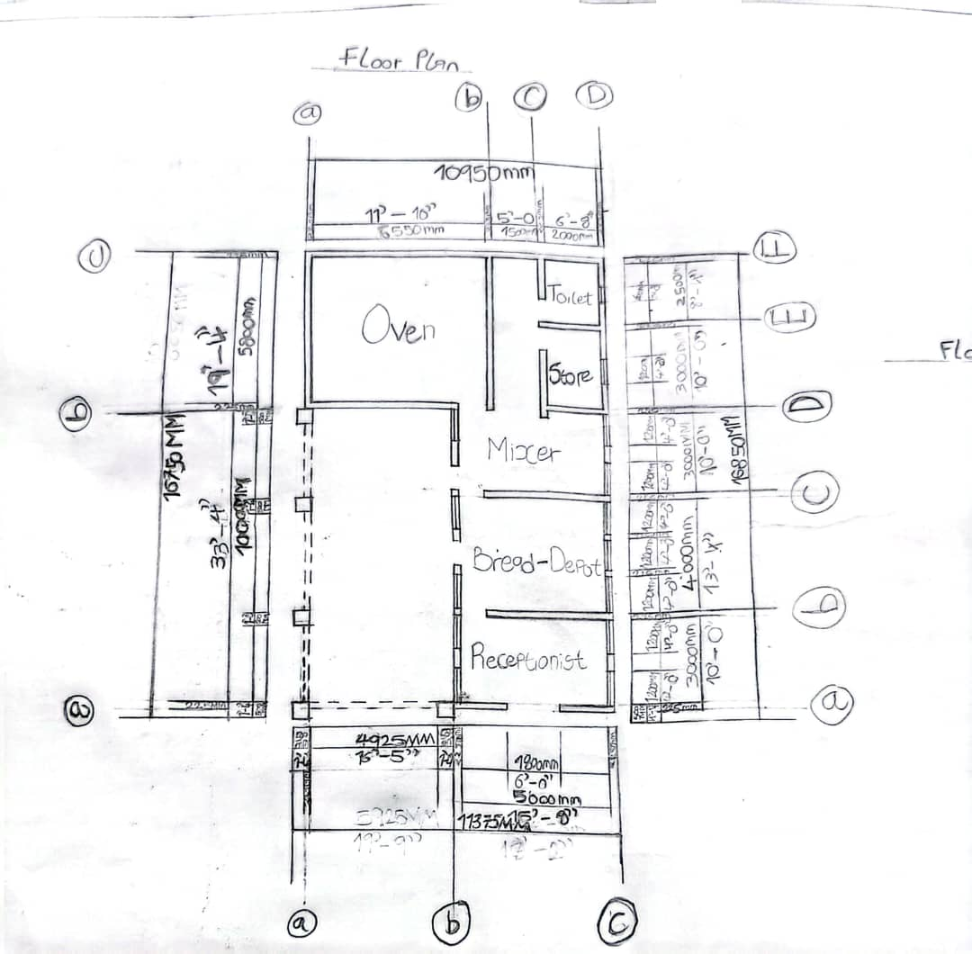

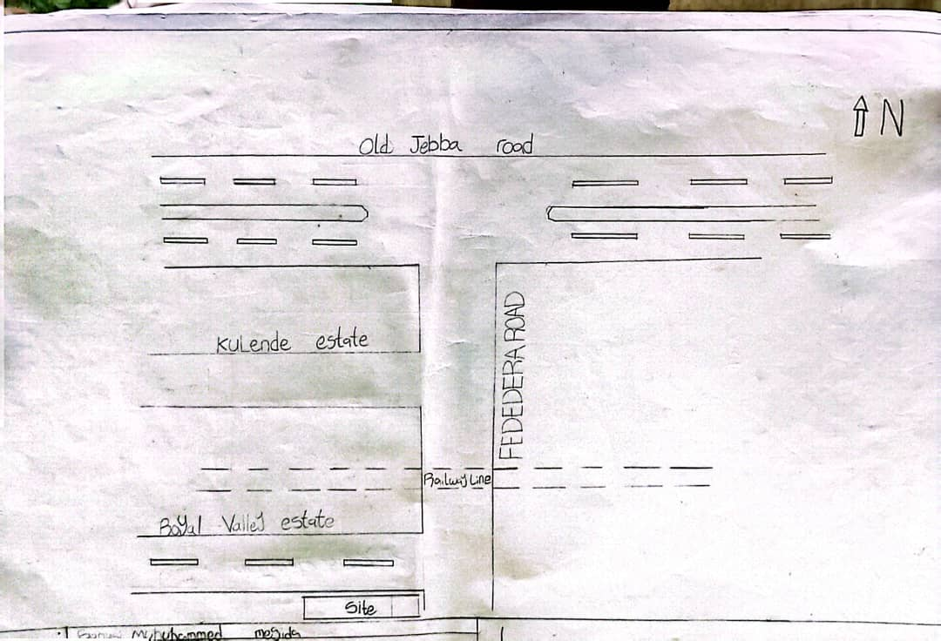

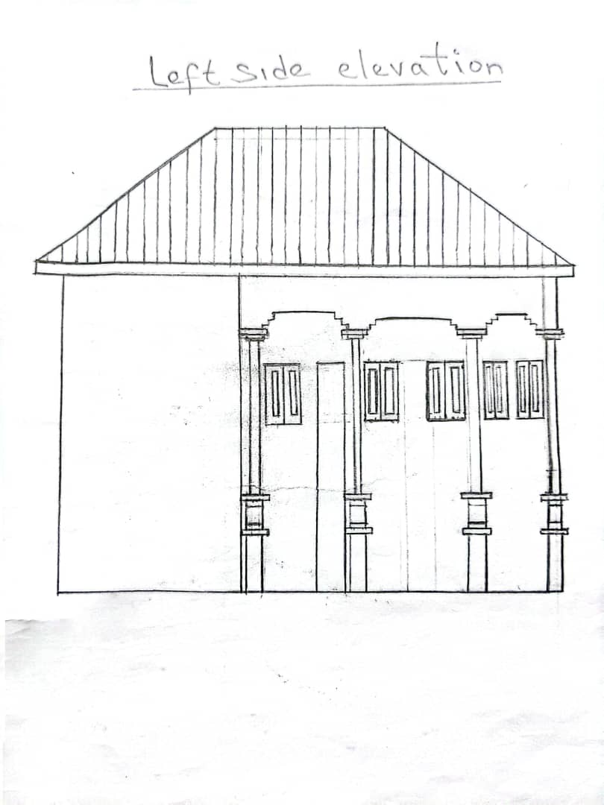
CHAPTER FOUR
4.1 HERE ARE SOME TYPOGRAPHICAL AND ENVIRONMENTAL CONDITIONS FOR SELECTED AREA IN A BAKERY
Perception and Retail Area
- Natural light: Adequate natural light to showcase products and create a welcoming atmosphere.
- Temperature: comfortable temperature range (18 - 22ºcl / 64 – 72ºF) for customers.
- Humidity: moderate humidity (40 – 60%) to maintain product freshness.
- Noise level: moderate noise level (50 – 60dB) to facilitate customer (70 – 80dB) to facilitate communication.
Production Area
- Natural light: Limited natural light to prevent product spoilage and maintain a consistent environment.
- Temperature: (Controlled temperature range (18 – 20^{0c}C/ 64 – 17⁰F) for optimal dough proofing and baking.
- Humidity: high humidity (60 – 80%) to maintain dough consistency and prevent drying.
- Noise level: higher noise level (70 – 80dB) due to equipment operation.

Packaging and Dispatch Area
- Natural Light: Limited natural light to prevent product spoilage and maintain a consistent environment.
- Temperature: controlled temperature range (18 – 25ºC / 64 – 17^{O}F) for staff.
- Humidity: Moderate humidity (40 – 60%) to prevent moisture damage to packaging.
- Noise level: moderate noise level (50 – 60dB) to facilitate communication.
Storage Area
- Natural Light: Limited Natural light to prevent product spoilage.
- Temperature controlled temperature range (100lg⁰C / 50 – 59ºF) for optimal product storage.
- Humidity: low humidity (30 – 50%) to prevent moisture damage to products.
- Noise level: low noise level (30 – 40dB) to facilitate relaxation.
4.2 HERE ARE SOME ANALYSIS OF THE TOPOGRAPHIC AND ENVIRONMENTAL CONDITIONS OF THE BAKERY SITE.
Topographic Condition
- Elevation: The Bakery site is located at an elevation of 500meters above sea level, which is relatively flat and even.
- Scope: The site has a gentle scope of 1-2% which allows for easy drainage and accessibility.
- Aspect: The site faces north, providing natural shade and protection form harsh sunlight.
Environmental Conditions
- Climate: The bakery site is located in temperature climate zone with moderate temperatures (15 – 25⁰C) and humidity levels (50 – 10%).
- Air Quality: The site is located in an area with good air quality, with low levels of pollutants and part particulate matter.
- Water Availability: the site has access to a reliable water supply with a nearby water treatment plant and a network of pipes for distribution.
Implications for Bakery Operations
- Energy Efficiency: The site’s climate and aspect allow for natural ventilation and lighting and heating / coolings.
- Water conservation: The site’s access to a reliable water supply and waste management system allows for efficient use of water resources.
- Food safety: the site’s good air quality, stable soil type, and waste management system reduce the risk of contamination and ensure a safe environment for food production.
- Accessibility: the site’s gentle slope and flat elevation provide easy accessibility for staff, customers and delivery vehicles.
The bakery in question is located at the royal valley estate Ilorin coloring about half plot of land area, and it is own by a client named ololade (50 – 50 Bakery).
4.3 SPATIAL / FUNCTION CRITERIA
Layout and Circulation
- Clear work flow: separate areas to receiving storage, preparation, baking, packaging and dispatch.
- Efficient circulation: minimize walking distance and ensure easy movement between areas.
- Adequate aisle space: maintain 3 – 4 feets of aisle space for comfortable movement.
Production Area
- Mixing and preparation: for mixing measuring, and preparation ingredients.
- Baking: for ovens, proofers, and baking equipment.
- Packaging: for relieving and inspection ingredients.
Retail and Display
- Retail area: for displaying and selling baked goods.
- Display cases: for showcasing products.
- Point of sales (POS): for checkout area.
Employee Facilities
- Lockers and storage: for employee storage
- Restrooms: from employee and customers.
Safety and Accessibility
- Emergency exits: ensure clear exit routes and accessibility, emergency exits.
- Fire suppression: Install fire suppression system and maintain. Clear access to fire extinguisher.
Utilities and Service
- Electrical: Ensure sufficient power supply for equipment and lighting
- Plumbing: provide access to water and drainage for cleaning and equipment
4.4 APPRAISAL OF A BAKERY IN TERMS OF SPACES, SIZE AND RELATIONSHIP
Production Area
- Mixing and preparation Area: (17 – 70sq. ft) with adequate counter space, sink and utensil storage.
- Oven and baking area: (20 – 20sq.ft) with commercial – grade ovens, proofers and baking equipment.
- Cooling and packing area: (18 – 13sq. ft) with refrigeration units, packaging materials and labeling equipment.
Retail and Sales Area
- Display and sales area: (17 – 10sq. ft) with attractive display cases, shelving and point of sale equipment.
Support Areas
- Storage and inventory: (6 – 10sq.ft) with seating, tables, lockers and amenities.

Relationships and Workflow
- Production to retail: easy access between production and retail area to facilitate efficient production transfer and display.
- Retail to customer: clear sightline and navigation sightlines and navigation between retail and customer experience.
- Storage to production: convenient access between storage and production areas to streamline inventory management and reduce waste.
Additional Consideration
- Natural lighting and ventilation: adequate natural lighting and ventilation throughout the bakery to enhance working conditions and product quality.
- Safety and sanitation: compliance with health and safety regulations, including proper waste disposal, chains schedules.
4.5 BAKERY EQUIPMENT AND THEIR FUNCTIONS
Mixing equipment
- Mixers: mix and blend ingredients together (e.g. spiral mixers, planetary mixers).
- Dough conditioners: control dough temperature and consistency.
- Blenders: blend ingredients together (eg. Flour, sugar, spices).
Baking Equipment
- Deck Oven: bake multiple trays of products at once
- Rack ovens: bake large quantities of products on multiple racks.
- Conveyor ovens: continuously bake products on a conveyor belt
Cooling and packaging equipment
- Cooling racks: cool baked products quickly and evenly.
- Packaging machines: automate packaging of baked goods (e.g. bread slices, baggers).
Preparation Equipment
- Dough sheeters: roll out dough to uniform thickness
- Dough dividers: divide dough into equal portions.
Cleaning and sanitation equipment
- Dish washers: clean and sanitize utensils, equipment and dishes.
- Sanitizing tunnels: sanitize products and equipment
4.6 CONCEPTUAL DEVELOPMENT OF A BAKERY
Concept Name: 50/50 Bakery
Tagline: “Rise to the Occasion”
Concept Statement: 50 – 50 bakery is a warm and inviting bakery that combines traditional baking techniques with modern flavors and presentation. Our mission is to provide high – quality, freshly baked goods that bring people together and make every occasion special.
Target Market
- Demographics: Foodies, young professionals, families with children
- Psychographic: people who value quality, freshness, and uniqueness in their food choices
- Location: urban or suburban areas with high foot traffic.
Menu
- Bread: artisanal breads, sour dough, baguettes
- Pastries: croissants, danishes, muffing scones.
- Cakes: custom cakes for special occasions, cupcakes, cake pops
Store Design
- Layout: open layout with visible baking area, display cases, and seating
- Materials: wood, brick, glass, and stainless steel
Branding
- Loso: Custom – designed loso featuring a stylized letter “F” made from flour
- Packaging: custom – designed bags, boxes and labels featuring the flour and co. logo.
- Social media: active presence on instagram, facebook and twitter
Marketing Strategies
- Grand Opening: Host a grand opening even with discounts give – away and sampling.
- Loyalty program: implement a loyalty program that rewards customer for repeat purchases.
- Partnerships: partner with local businesses and organizations to offer custom baking services and promotions.

Operations
- Baking schedule: Bake throughout the day to ensure freshness and variety.
- Staffing: hire experience bakers, sales staff and management
- Inventory management: implements an inventory management system to track ingredients and supplies.
4.7 APPROACH TO DESIGN REALIZATION DESIGN CONCEPT AT THE DIFFERENT LEVEL OF DESIGN FOR BAKER
Architectural Level
- Industrial chic: exposed brick, metal beam and reclaimed wood created a rustic, industrial atmosphere.
- Warm and inviting: use natural material, warm lighting and easy textures to create welcoming ambiance.
- Modern and sleek: clean lines, minimal décor and a predominantly white color scheme create a modern and sleek look.
Interior Design Level
- Bakery case focus: design the space around bakery case, highlights the fresh – baked goods.
- Cozy Nooks: create inviting seating areas for customers to relax and enjoy their treats
- Modern and sleek: clean lines, minimal décor and a predominantly while color scheme create a modern and sleek cook.
Product Design Level
- Bakery Case Focus: Design the space around the bakery case, highlighting the fresh baked goods.
- Cozy nooks. Create inviting seating areas for customers to relax and enjoy their treats
- Exposed kitchen: open up the kitchen to showcase the baking process, creating a sense of transparency and authencity.
Graphic Design Level
- Loso and Branding: Develop a distinctive loso and branding that reflects the bakery’s value and personality.
- Menu design: create menu that are easy to navigate, visually appealing, and showcase the bakery’s offering and events.

CHAPTER FIVE
5.1 APPROACH TO DESIGN REALIZATION
5.2 DESIGN CONCEPT AT THE DIFFERENT LEVEL OF DESIGN FOR BAKERY
Architectural level:
- Industrial chic: exposed brick, metal beams and reclaimed wood create a rustic, industrial atmosphere.
- Warm and inviting: Use natural material, warm lighting and cozy textures to create a welcoming ambiance.
- Modern and sleek: clean lines minimal discor, and a predominantly white color scheme create a modern and sleek look.
Interior Design Level
- Bakery case focus: design the space around the bakery case, highlighting the fresh baked goods.
- Cozy nooks: create inviting seating areas for customers to relax and enjoy their treats.
- Modern and sleek: clean lines, minimal diecor and a predominantly white color scheme create a modern and sleek look.
Product Design Level
- Bakery case focus: design the space around the bakery case, highlighting the fresh – baked goods.
- Cozy nooks: create inviting seating area for customers to relax and enjoy their treats.
- Social media graphics: design engaging social media graphics that graphics that show case the bakery products, promotions and events.
5.3 USER EXPERIENCE (UX) DESIGN LEVEL
- Streamlined ordering: design an intuitive ordering process, both in – store and online, to reduce wait times and improve customer satisfaction.
- Way finding: create clear signase and visual clues to help customers navigate the bakery and find what they are cooking for.
- Engaging atmosphere: design an immersive atmosphere that encourages customers to linser relax, and enjoy their bakery experience.
5.4 TECHNOLOGY AND ENVIRONMENTAL CRITERIA FOR BAKERY
Technology Criteria
- Automation: Automated mixing, proofing and baking systems to improve efficient and consistency.
- Energy – efficient equipment: energy efficient ovens, refrigerators and lighting systems to reduce energy consumption.
- Computerized control systems: computerized control systems for temperature, humidly to ensure precise control and consistency.

Environmental Criteria
- Sustainable ingredients: use of sustainable, locally soured, and organic ingredients to reduce environmental impact.
- Energy efficiency: implementation of energy efficient systems such as LED lighting and solar panels, to reduce energy consumption.
- Water conservation: implementation of water – saving measures, such as low – flow faucets and grey water reuse systems.
5.5 LEGAL ISSUES AND PLANNING REGULATIONS FOR BAKERY
Business Registration and Licenses
- Business registration: register your bakery as a sole proprietorship, partners, or limited company.
- Food business operation (FBO) license: Obtain an FBO license from your local authority to operate a food business.
Planning Regulation
- Zoning laws: ensure your bakery location comply with local zoning laws and resucontions.
- Use class: if converting an existing building to a bakery, obtain permission for a change of use.
Health and safety regulations
- Food safety and hygiene: comply with food safety and hygiene regulations, including proper food handling, storage and disposal.
- File safety: ensure your bakery meets fire safety standards, including proper ventilation, fire alarms, and extinguishers.
Insurance and liability
- Public liability insurance: obtain public liability insurance to protect against claims of injury or properties damage.
- Product liability insurance: secure product liability insurance to protect against claims.
Other regulations
- Labeling and packaging: comply with labeling and packaging regulations, including proper labeling of ingredients, allergens and nutritional information’s.
5.8 BEHAVIOURAL PATTERNS AND CONSIDERATIONS IN A BAKERY
Customer behaviour
- Impulse purchases: customers may buy more than planned due to appealing products or promotions.
- Loyalty: regular customers may develop a strong attachment to specific bakery items or staff.
Staff behaviour
- Customer service: friendly, attentive staff can create a welcoming atmosphere and build customer loyalty.
- Teamwork: effective communication and collaboration among staff members ensure smooth operations.
Operational Considerations
- Cleanliness and safety: maintaining a clean and safe environment is crucial for customer health and satisfaction.
- Product variety and quality: Offering a range of high – quality products can attract and retain customers.
Marketing Strategies
- Social media: utilizing social media platform to showcase products, share behind – the scenes content, and engage with customers can half build a loyal following.
- Promotions and discounts: offering limited time promotions or discounts can attract new customers and encourage repeat business.
5.7 CONCLUSION ON BAKERY DESIGN AND REALIZATION
A well – designed bakery can enhance customer experience, improve efficiency and increase sales.
5.3 RECOMMENDATION
Design Phase
- Define the concept: determine the bakery’s theme, target audience and brand identify.
- Asses the space: evaluate the location, size and layout to optimize workflow and customer flow.
- Create a layout: design a functional layout that includes display cases, production areas and storage.
- Choose materials: select materials that are durable, easy to clean and align with the brand’s aesthetic.
Realization Phase
- Hire experienced professionals: work with architects, designers and contractors who have experience in bakery and construction.
- Plan for equipment: ensure that the design accommodates necessary equipment, such as evens, mixers, and display cases.
- Consider sustainability: incorporate eco-friendly practices and materials to reduce the bakery’s environment impact.
- Test and refine: test the design and make adjustment as needed to ensure a smooth and efficient operation.

REFERENCE
“Bread: A Bakers Book of Techniques and Recipes” By Jeffrey Hamelman (2004) (pg 30 – 35).
“Trust and Crumb” by Peter Reinhard (1998) (pg 21 – 24).
“The Bread Baker’s Apprentice” by Peter Reinhart (2001) (Pg 55 – 57)
“Flour Water Slat Yeast” by Keh Forkish (2012) (Pg 25 – 34, 40 – 53).

