DESIGN OF STAFF CLOCKING SYSTEM USING FINGERPRINT

BY:

OKUTAGIDI MALIK OLAMILEKAN
HND/23/COM/FT/0196

SUBMITTED TO THE
DEPARTMENT OF COMPUTER SCIENCE, INSTITUTE OF INFORMATION AND COMMUNICATION TECHNOLOGY KWARA STATE POLYTECHNIC, ILORIN.

IN PARTIAL FULFILLMENT OF THE REQUIREMENT FOR THE AWARD OF HIGHER NATIONAL DILOPMA (HND) IN COMPUTER SCIENCE.

July, 2025.

CERTIFICATION
This is to certify that this project work was carried out by OKUTAGIDI MALIK OLAMILEKN with matriculation number HND/21/COM/FT/0196 in the department of Computer Science, institute of Information and Communication Technology, Kwara State Polytechnic Ilorin, Kwara State.

________________________ ______________________
MR SADIQ K. ABUBAKAR DATE
SUPERVISOR

________________________ ______________________
MR OYEDEPO, F. S DATE
(HEAD OF DEPARTMENT)

________________________ ______________________
EXTERNAL EXAMINER DATE

DEDICATION
This project is dedicated to God for his infinitive mercy on me and for making me see the end of this program, Higher National Diploma (HND) and for his divine wisdom, knowledge and understanding throughout the academic sessions.

ACKNOWLEDGEMENT
All praise goes to the almighty Allah for giving me strength, inspiration, guidance and knowledge to complete this Higher National Diploma (HND) programme, without him nothing would have been possible.
My sincere appreciation goes my lovely parent MR & MRS OKUTAGIDI for their immeasurable support and to my supervisor in person of Mr. Sadiq Kolawole who has been a great help through moral support and guidance to me throughout this project work, may Allah bless him, Amin.
A big thank you is also said to all my lectures in the department of computer science for their effort on impacting knowledge on me and I also thank the non-teaching staff for helping me in one way or the other.

TABLE OF CONTENTS
TITLE PAGE i
CERTIFICATION PAGE ii
DEDICATION iii
ACKNOWLEDGMENT iv
TABLE OF CONTENTS v
ABSTRACT vi
CHAPTER ONE: GENERAL INTRODUCTION
  - BACKGROUND TO THE STUDY
  - STATEMENT OF THE PROBLEM
  - AIM AND OBJECTIVES
  - SIGNIFICANCE OF THE STUDY
  - SCOPE OF THE STUDY
  - DEFINITION OF TERM
  - ORGANIZATION OF REPORT
CHAPTER TWO: LITERATURE REVIEW
2.1 REVIEW OF PAST WORK
2.2 REVIEW OF GENERAL TEXT
2.3 HISTORICAL BACKGROUND
CHAPTER THREE: METHODOLOGY AND ANALYSIS OF THE SYSTEM
3.1 RESEARCH METHODOLOGY
3.2 ANALYSIS OF DATA AND THE EXISTING SYSTEM
3.3 PROBLEM OF THE EXISTING SYSTEM
3.4 DESCRIPTION OF THE PROPOSED SYSTEM
3.5 ADVANTAGES OF THE PROPOSED SYSTEM
CHAPTER FOUR: DESIGN AND IMPLEMENTATION OF THE SYSTEM
4.1 DESIGN OF THE SYSTEM
4.1.1 OUTPUT DESIGN
4.1.2 INPUT DESIGN
4.1.3 DATABASE DESIGN
4.1.4 PROCEDURE DESIGN
4.2 SYSTEM IMPLEMENTATION
4.2.1 CHOISE OF PROGRAMING LANGUAGE
4.2.2 HARDWARE SUPPORT
4.2.3 SOFTWARE SUPPORT
4.2.4 IMPLEMENTATION TECHNIQUES
4.3 SYSTEM DOCUMENTATION
4.3.1 PROGRAM DOCUMENTATION
4.3.2 OPERATING THE SYSTEM
4.3.3 MAINTAINING OF THE SYSTEM
CHAPTER FIVE: CONCLUSIONS AND RECOMMENDATIONS
5.1 SUMMARY
5.2 CONCLUSION
5.3 RECOMMENDATION
REFERENCE
REFERENCES

Abstract
The level of impersonation as well as the ghost worker syndrome in recent times is enormous, in both the private and the public sector. Therefore, there is need for a new system which will wipe out all this enumerated issues. The human body has the privilege of having features that are unique and exclusive to each individual. This exclusiveness and unique characteristic has led to the field of biometrics and its application in ensuring security in various fields. A system insusceptible to impersonation, that provide dependable and efficient means of taking staff attendance record with the use biometrics captures to provide perpetrators with the uniqueness of biometrics will help organization/institution keep good and accurate record of their staff punctuality.

CHAPTER ONE
GENERAL INTRODUCTION
1.1 BACKGROUND OF THE STUDY
Employee clocking systems are time system used by organization to accurately record the time each employee of the organization resumes and leaves office every day. The clock have evolved with time and companies still need some sort of system that they can use employees payroll and ensure that the employees are paid for each hour they worked. Today, employee use swipe cards with a negative stripe through a slot that reads their name and records the time every time they clock in or out, much like the old punch clock system of long ago. At the end of a work week, the main system, computes the total hours worked for every employee and prints it out on a spread sheet. This rids the conventional system of human error, making it much more efficient.
Many are now using a computerized employee time system as it help them keep track of the time their employees resume work on a daily basis. Many organizations still use the manual time clocking system which they feel is easy but is not secured and their might be a possible loss of staff clocking information. Many organizations make use of swipe or smart card as a means of clocking system. Sometimes, the magnetic strip on the back of a card may get damaged. When the employee swipes the card, the machine may not register it. (Belden, 2009)
Such inadequacy is corrected in the computer time clock system. Even with the advent of computer software and advanced time keeping techniques, the principle of the employee time clock remains the same. This research expresses the hourly employees will always need a way to keep track of their time and organizations will need logical ways to monitor and records an employee’s time to ensure productivity. The method used in data collection during the course of research of this project is through the use of internet and direct observation gathered from source on Computer Security System using biometrics. Information’s are gathered based on the available resources extracted from the research methodology. Hence, in the research the use of information technology communication (ICT) is reviewed by proposing a system that improves services. (Martin, 2008)
The language used in designing this proposed system is Visual Basic6.0 programming language with a link to the database with the use of Microsoft Access.
1.2 STATEMENT OF PROBLEM
In the existing system, when staff come to work, they clock in using registers i.e. a book where the write their names, post, time in and time out. This register can be lost or damaged by fire; water etc. Inadequacies of the manual time clock system, the problem encountered by the staff reservation section, the impact of this software reservation section, the impact of this software design is not entirely perfect and the company policy forbids employees from punching or swiping for each other and both employees stand a chance of losing their jobs if caught.

1.3 AIM AND OBJECTIVES OF THE STUDY
The aim of this research is to develop a staff clocking system using fingerprint to enable the organization to check mate their resumption time to office. The objectives are as follow:
- Provide potential uses with the customize option of using both input device.
- Develop an application package using Microsoft visual studio to enable staff clock in and clock out.
- Develop a robust database application using Microsoft visual studio.

1.4 SIGNIFICANCE OF THE STUDY
The significance of the proposed system is to make use of technology enabled methods to monitor staffs using their unique traits. The system will help override the shortcomings of the existing system in terms of security and safety of staff data and clocking data. It will staff as a means of reference for staff disciplinary committee if a staff is suspected for lateness or absent.

1.5 SCOPE OF THE STUDY
The scope of the proposed system is to capture staff data which will be securely saved on the system and can only be accessed and authenticated using each employee’s fingerprint. It will also record the time an employee clock in to work and the time he / she clock out.

1.6 ORGANIZATION OF THE REPORT
This project work is divided into five chapters and below are the description of what each chapter contains.
Chapter One describes the background of the project, statement of the problem, project aim and objective, significance of the project, report outlines, definition of term.
Chapter Two talks about the review of the past work related to work, review of general test, comparison of system development process models, comparison of application manage used, comparison of relationship database management system, summary
Chapter Three deals with the research methodology, analyzing of the existing system, flowchart of the existing system, problem of the existing system, description of the proposed system, flowchart of the proposed system, advantages of proposed system, summary.
Chapter Four includes design of the system, output system, input system, database design, procedure design, implementation of the system, choice of programming language, hardware support, change over techniques, student documentation, documentation of the program, operating system, maintaining the system and summary.
Chapter Five deals with the conclusion, recommendation and reference

1.7 DEFINITON OF TECHNICAL TERMS
i. Biometrics: is physiological or behavioral characteristics unique to individuals, this Include Fingerprint, hand geometry, handwriting, iris, retinal, vein and voice.
ii. Biometric Verification: is any means by which a person can be uniquely identified by evaluating one or more distinguishing biological traits.
iii. Scanner: is a device for examining, reading, or monitoring something in particular..
iv. Fingerprint sensor: is an electronic device used to capture a digital image of the fingerprint pattern.
v. Rapid Application: Development is a concept that products can be developed faster and of higher quality.

CHAPTER TWO
LITERATURE REVIEW
2.1 REVIEW OF RELATED WORK
2.1 REVIEW OF PAST WORKS
According to Joseph, et al, 2017, developed a system on "Staff Monitoring System Using Biometric" Millions of naira is been lost annually in organizations across Nigeria as a result of poor services been rendered to various clients in organizations, this is due to the facts that proper attendance management system is not in place in various organizations across the country. The management of staff's attendance record daily has become a difficult challenge. The effort required in generating monthly report and also knowing the cumulative numbers of staffs has become a major task as manual assessment produces errors, and also it is time consuming. For the stated reason, an effective electronic staff attendance system using fingerprint is introduced in this work. This system will take attendance electronically with the aid of a fingerprint scanner (fingerprint device) and the attendance records are stored in the application storage unit (database). Attendance is marked after staff identification. For identification of staff, a fingerprint scanner is used. This process eradicates the need for stationary materials for record keeping; this will eliminate the issues of impersonation. This paper proposes the use of fingerprint biometric system to eliminate the problem being faced by traditional paper and pencil attendance register being provided in organizations.
According to Akinduyite, 2013, worked on "Fingerprint-Based Attendance Management System" reported that In recent time, there has been high level of impersonation experienced on a daily basis in both private and public sectors, the ghost worker syndrome which has become a menace across all tiers of government, employers concerns over the levels of employee absence in their workforce and the difficulty in managing student attendance during lecture periods. Fingerprints are a form of biometric identification which is unique and does not change in one’s entire lifetime. This paper presents the attendance management system using fingerprint technology in a university environment. It consists of two processes namely; enrolment and authentication. During enrolment, the fingerprint of the user is captured and its unique features extracted and stored in a database along with the users identity as a template for the subject. The unique features called minutiae points were extracted using the Crossing Number (CN) method which extracts the ridge endings and bifurcations from the skeleton image by examining the local neighborhoods of each ridge pixel using a 3 x 3 window. During authentication, the fingerprint of the user is captured again and the extracted features compared with the template in the database to determine a match before attendance is made. The fingerprint-based attendance management system was implemented with Microsoft’s C# on the. NET framework and Microsoft’s Structured Query Language (SQL) Server 2005 as the backend. The experimental result shows that the developed system is highly efficient in the verification of users fingerprint with an accuracy level of 97.4%. The average execution time for the developed system was 4.29 seconds as against 18.48 seconds for the existing system. Moreover, the result shows a well secured and reliable system capable of preventing impersonation.
According to Chiwa and Musa (2014) developed a system on "Secured Employee Attendance Management System Using Fingerprint "reviewed in their work an effective employee attendance management system using fingerprint is introduced. It is used to managed the attendance of employees in any organization. All organizations and institutions are established to achieve specific objectives or goals. The identification and authentication of employee is very necessary for achieving any objective or goal. To identify and authenticate the identity of an individual employee by their names, ID numbers and signatures only are not enough, because any one can misuse other's identity and this type of problem occur very often. Fingerprint can be applied for recognizing any person, because human fingerprints are unique to each person and can be regarded as some sort of signature, certifying the person's identity. This method of employee identification and authentication will improve the attendance of employees thereby improving security, productivity and skill which will in turn improve the progress of organizations.
Taiwo, et al, 2019, worked on "Development of Lecture Attendance System for Staff Performance Rating in a Tertiary Institution using Fingerprint Technology" Managing time attendance of staff in organizations has proven to be a challenging endeavor. Manual methods have been proposed in capturing employees’ attendance but there are inadequacies in measuring the performance of employees. This paper aims at promoting staff efficiency at work by developing a secure attendance management system for use in tertiary institutions via two subsystems; Fingerprint biometrics as a method of identification and authentication and Question-Answering module for staff performance rating. The system uses staff fingerprints stored in the database upon registration for carrying out the process of attendance and validate staff lectures’ requirements. It is accentuated by creating a question-answering module that allows students to answer some questions on each available and registered staff, hence, giving a more concentrated content about staff’s activities within the school. The evaluation was carried out based on the matching efficiency and attendance accuracy of the proposed system. The proposed system performed excellently with 98.51% attendance accuracy based on the high successful staff identification recorded. Hence, staff performance rating was generated, thereby creating an avenue for determining promotion grounds.

2.1.1 CLIENT/ SERVER BASED ATTENDANCE SYSTEM
Client-server architecture can be considered as a network environment that exchanges information between a server machine and a client machine where server has some resources that can be shared by different clients. Using the concept of Client-Server Architecture, It allows the company to monitor their employees’ attendance from their other branches on real-time based. TMS Client-Server Attendance System is one of the most standardized attendance systems using the concept of Client-Server Architecture. This contains 2 modules which are client module and server module. In the client module, it has features such as:
i) Client Login
For the Client Login page, employee has to key in their Employee Code and Password in order to enter the main page of the system.
ii) Punch in &out
Employee used a barcode scanner to punch in and punch out their attendance. Information scanned from barcode will be sent to the system and displayed as the employee data.

2.1.2 SMART CARD ATTENDANCE SYSTEM
Attendance system enable accurate management and tracking of staff attended hours against a schedule, roster of activity or daily and weekly contract hours, ensuring that staff are accurately measured and paid correctly. The purpose of this system is to record employee's clocking data to replace conventional manual time punch clock. This computerized system provides an easy and accurate way of keeping track of the attendances of employees. There are four modules created in smart card attendance system which are staff attendance, member registration, visitor login and issue dispatch notes. Apart from these four main modules, this system also provides the function to generate staff attendance report.
AplusMyKad is one of the attendance system that using smartcard. MyKad is the official identity card of Malaysian. When MyKad is inserted into Aplus Smart Card Reader, the computer will immediately capture the Mycard individual information such as card holder’s name, identity card number, address and time.

2.1.3 FINGERPRINT ATTENDANCE SYSTEM
Fingerprint can be considered as the oldest method and most reliable and popular human characteristics that are widely used for individual identification and verification in the field of biometric technology. Fingerprint is unique because it is believed that no two people will have the same fingerprint pattern in the world.
FingerFlex is an example of fingerprint biometric time attendance system that helps to automate data collection and process timesheets faster. This system can prepare attendance report faster for organizations of any size. Besides that, it can eliminate buddy-punching and improve overall workforce punctuality. The main functions of FingerFlex Time Attendance System are listed below:
i) One Touch Fingerprint Biometric Time Clock
No password or cards is necessary, Fingerprint Time Attendance will identify staff clocking in and clocking out just by the fingerprint.
ii) Flexible Schedule Management
This system can also manage work groups and time shifts required. It can cater all the time management requirements and manage different working hours for different groups.
iii) Monitor Abnormality
This system has a trigger alert system on monitoring people who are coming late consistently. Companies can set their own rules for late attendance and the system will alert them.
v) Generate Report
All the time attendance report generated by the system can be viewed and can be used for payroll calculation or to generate report.

2.2 INTRODUCTION TO BIOMETRIC SYSTEM
Biometrics is an automatic method for identifying a person on the basis of some biological or behavioral characteristic of the person. Many biological characteristics, such as fingerprints, and behavioral characteristics, such as voice patterns, are distinctive to each person. Therefore, biometrics is more reliable and more capable in distinguishing between a specific individual and an impostor than any technique based on identification (ID) document or a password. The word biometrics comes from the Greek bios (life) and metrikos (measure).
In computer technology, biometrics relates to identity-confirmation and security techniques that rely on measurable, individual biological characteristics. For example, fingerprints, handprints, or voice patterns might be used to enable access to a computer, to a room, or to an electronic commerce account. In general, there are three levels of computer security schemes. Level 1 relies on something a person carries, such as an ID badge with a photograph or a computer cardkey. Level 2 relies on something a person knows, such as a password or a code number. Level 3, the highest level, relies on something that is a part of a person’s biological makeup or behavior, such as a fingerprint, a facial image, or a signature.

2.2.1 FINGERPRINT
Fingerprint identification, known as dactyloscopy, or hand print identification, is the process of comparing two instances of friction ridge skin impressions (see Minutiae), from human fingers or toes, or even the palm of the hand or sole of the foot, to determine whether these impressions could have come from the same individual. The flexibility of friction ridge skin means that no two finger or palm prints are ever exactly alike in every detail; even two impressions recorded immediately after each other from the same hand may be slightly different. Fingerprint identification, also referred to as individualization, involves an expert, or an expert computer system operating under threshold scoring rules, determining whether two friction ridge impressions are likely to have originated from the same finger or palm (or toe or sole).
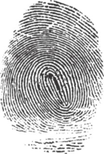
An image of a fingerprint created by the friction ridge structure
An intentional recording of friction ridges is usually made with black printer's ink rolled across a contrasting white background, typically a white card. Friction ridges can also be recorded digitally, usually on a glass plate, using a technique called Live Scan. A "latent print" is the chance recording of friction ridges deposited on the surface of an object or a wall. Latent prints are invisible to the naked eye, whereas "patent prints" or "plastic prints" are viewable with the un-aided eye. Latent prints are often fragmentary and require the use of chemical methods, powder, or alternative light sources in order to be made clear. Sometimes an ordinary bright flashlight will make a latent print visible.
When friction ridges come into contact with a surface that will take a print, material that is on the friction ridges such as perspiration, oil, grease, ink or blood, will be transferred to the surface. Factors which affect the quality of friction ridge impressions are numerous. Pliability of the skin, deposition pressure, slippage, the material from which the surface is made, the roughness of the surface and the substance deposited are just some of the various factors which can cause a latent print to appear differently from any known recording of the same friction ridges. Indeed, the conditions surrounding every instance of friction ridge deposition are unique and never duplicated. For these reasons, fingerprint examiners are required to undergo extensive training. The scientific study of fingerprints is called dermatoglyphics.
Intervention of computer and a fingerprint scanner which is also one of the peripheral devices of a computer system.
2.3 BIOMETRIC SYSTEMS AND FORMS
Automatic personal identification is the process by which a biometric system associates a particular person with a specific identity. Identification may be in the form of verification or recognition. In verification the system authenticates a claimed identity. In other words, the system verifies a claim that a person is who he or she says he or she is. In recognition the system determines the identity of a given person from a database of persons known to it. In other words, the system determines who the person is without that person specifying a name.
FORMS
- Facial Recognition
The most familiar biometric technique is facial recognition. Human beings use facial recognition all the time to identify other people. As a result, in the field of biometrics, facial recognition is one of the most active areas of research. Applications of this research range from the design of systems that identify people from still-photograph images of their faces to the design of systems that recognize active and changing facial images against a cluttered background. More advanced systems can recognize a particular individual in a videotape or a movie.
Researchers base the patterns used for facial recognition on both specific and general features. The specific features include the location and shape of facial attributes such as the eyes, eyebrows, nose, lips, and chin. More generally, they employ an overall analysis of the facial image and a breakdown of the image into a number of component images. Researchers are unsure whether the face itself, without any additional information, is sufficient for the accurate recognition of one person in a large group of people. Some facial recognition systems impose restrictions on how the facial images are obtained, sometimes requiring a simple background or special lighting.
- Finger Print
Human beings have used fingerprints for personal identification for centuries, and they have used them for criminal investigations for more than 100 years. The validity of fingerprints as a basis for personal identification is thus well established.
A fingerprint is the pattern of ridges and furrows on the surface of a fingertip. No two persons have exactly the same arrangement of patterns, and the patterns of any one individual remain unchanged throughout life. Fingerprints are so distinct that even the prints of identical twins are different. The prints on each finger of the same person are also different.
The level of detail in fingerprint images scanned into a biometric system depends on several factors. They include the amount of pressure applied to the fingertip during image scanning, the presence of any cuts or other deformities on the fingertip, and the dryness of the skin. Therefore, any unusual or prominent features on a fingertip, the endings of the fingerprint ridges, and ridge bifurcations, or branches—collectively known as minutiae—are all used in a biometric system based on fingerprint identification.
The development of solid-state sensors for fingerprint scanning may soon make the cost of incorporating a fingerprint-based biometric device affordable in many applications, such as laptop computers and cellular telephones. Consequently, researchers expect fingerprint identification to be the leading biometric technique in the near future. One problem with fingerprint technology is its acceptability in society, because fingerprints have traditionally been associated with criminal investigations and police work. Another problem is that the fingerprints of a small fraction of the population may be unsuitable for automatic identification because the prints may be deformed as a result of aging, some genetic condition, or environmental reasons.
- Hand Geometry
A variety of measurements of the human hand can be used as biometric characteristics. These include hand shape, the lengths and widths of the fingers, and the overall size of the hand. Biometric devices based on hand geometry have been installed at many locations around the world. Hand-reader systems are used at some prisons in the United States and the United Kingdom to track the movement of inmates. The United States Immigration and Naturalization Service use hand-reader systems at several major U.S. airports for the rapid admittance of frequent foreign travelers into the United States. The hand-geometry technique is simple, relatively easy to use, and inexpensive. The main disadvantage of this technique is that it does not distinguish well between the hands of different people. In other words, the system can easily determine if a particular hand shape belongs to a specified individual but cannot reliably determine if a particular hand shape belongs to one of several individuals. Hand geometry information may vary over the lifespan of an individual, especially during childhood, when rapid growth can drastically change hand geometry. In addition, the presence of jewelry or limited dexterity as a result of arthritis may make it difficult for a system to extract correct hand geometry information. Biometric systems based on hand geometry are large in size, so they cannot be used in applications with limited space, such as laptop computers.
- Retinal Pattern Recognition
The retina is the innermost layer of the eye. The pattern formed by veins beneath the surface of the retina is unique to each individual. This pattern is a reliable biometric characteristic.
Researchers acquire digital images of retinal patterns by projecting a low-intensity beam of visible or infrared light into a person’s eye and scanning an image of the retina. For a fixed portion of the retina to be used for identification, the person undergoing the scan must gaze into an eyepiece and focus on a predetermined spot. The amount of user cooperation required for a retinal scan makes this technique unacceptable in many applications. On the other hand, a large number of biometric devices based on retinal scans have been installed in prisons and other highly secure environments. The primary disadvantage of this biometric technique is that retinal scanners are expensive.
- Iris-Based Identification
The iris is the colored part of the eye. It lies at the front of the eye, surrounding the pupil. Each iris is unique, and even irises of identical twins are different. The complex structure of the iris carries distinctive information that is useful for identification of individuals. Early results of research on the accuracy and speed of iris-based identification have been extremely promising. These results indicate that it is feasible to develop a large-scale recognition system using iris information. Furthermore, the iris is more readily imaged than the retina.
- Signature Recognition
Each person has a unique style of handwriting and, therefore, a unique signature. One problem with signature recognition is that the signature of a particular individual may vary somewhat. Despite the variations, researchers have designed a few successful systems for signature-based authentication. Biometric devices based on signature verification are reasonably accurate, but not accurate enough to recognize specific individuals in a large population. However, signature verification is reliable enough to be used in place of a PIN in accessing automated teller machines (ATMs).
There are two approaches to identification based on signature verification: static and dynamic. Static signature verification uses only the geometric (shape) features of a signature, such as the degree of slant, breadth and height of letters, and space between lines, letters, and words. Dynamic signature verification uses both geometric features and dynamic features, such as the speed a person writes and the pressure of the writing implement. Dynamic verification requires a special pen. It is resistant to forgery, as it is virtually impossible for a forger to replicate both the shape of a signature and the speed and pressure with which another person signs his or her name. An inherent advantage of a signature-verification system is that the signature is already an acceptable form of personal identification. It can therefore be incorporated easily into existing business processes, such as credit card transactions.
- Voice Recognition
Like signature, speech is mostly a behavioral characteristic. However, speech has some biological aspects that make speech characteristics similar for all people. These similarities are due to the relatively similar shape and size of individuals’ vocal tracts, mouths, nasal cavities, and lips, all of which help produce the sounds of speech. The speech of a specific individual is distinctive but may not contain sufficient information to be of value in large-scale recognition.
Voice recognition is based on either a text-dependent speech input or a text-independent speech input. A text-dependent system verifies the identity of an individual on the basis of the utterance of a fixed predetermined phrase, such as the person’s name. A text-independent system verifies the identity of a speaker regardless of what he or she says. Text-independent voice recognition is more difficult than text-dependent verification but offers more protection against fraud. Speech-based features are sensitive to factors such as background noise and the emotional and physical state of the speaker. In addition, some people are extraordinarily skilled at mimicking other people’s voices. This popular perception of the vulnerability of voice recognition may be a reason why speech-based authentication is not widely used in high-security applications.

CHAPTER THREE
METHODOLOGY AND ANALYSIS OF THE EXISTING SYSTEM
3.1 RESEARCH METHODOLOGY
This section describes the formulation of a research design and methodology adopted to achieve the stipulated goals for the study. After considering the objectives of the study, the level of information security all over the world, the limitations and the scope, the researcher felt the appropriateness for adopting online based research by browsing bountiful materials that are available on the World Wide Web through the use of search engines such as google.com.

3.2 ANALYSIS OF DATA AND THE EXISTING SYSTEM
The existing system (the use of attendance list) though to some organizations that have few staff it is durable, but to organizations with large number of staff and personnel it possesses a lot of threat and stress.

3.3 PROBLEMS IN THE EXISTING SYSTEM
The problems faced in the existing system are:
- Loss of list: The list of attendance might be lost due to lack of storage properly.
- Damage:The attendance list might be damage with water or fire.

3.4 DESCRIPTION OF THE PROPOSED SYSTEM
In the proposed system, information about a particular staff will have been saved into the database or if the organization has an existing database then they pool staff information from there. When a staff comes to work, he / she clocks in to work using a fingerprint machine which displays the staff information and register the time he / she clocks in and it does the same process during clock / sign out.

3.5 ADVANTAGES OF THE PROPOSED SYSTEM
  - ACCURACY: it is enhanced using computerized approach, thereby mastering decision making perfect.
  - MAINTAINABLE: it can be adopted for use at any time.
  - SECURITY OF DATA: data to be processed or information stored on the system is secured from an unrecognized user i.e. hackers will find it difficult to view both sensitive and normal information.
  - FAST PROCESSING: it takes a very short time to retrieve information of the user once the fingerprint matches with the primary key in the database.
  - LESS LABOUR REQUIREMENT: with the application of the proposed system, labor requirement is tremendously reduced to its minimal.

CHAPTER FOUR
DESIGN AND IMPLEMENTATION OF THE SYSTEM
4.1 DESIGN OF THE SYSTEM
The staff attendance system is developed to complement the existing manual staff attendance system. This allows staff to make registration and able them to clock in and clock out.
The process used on designing the system includes:
- input design
- output design
- database design
- procedure design

4.1.1 OUTPUT SYSTEM
Output is the result obtained from the processed data. It specified how the information is to be arranged. It depends on what data is supplied.
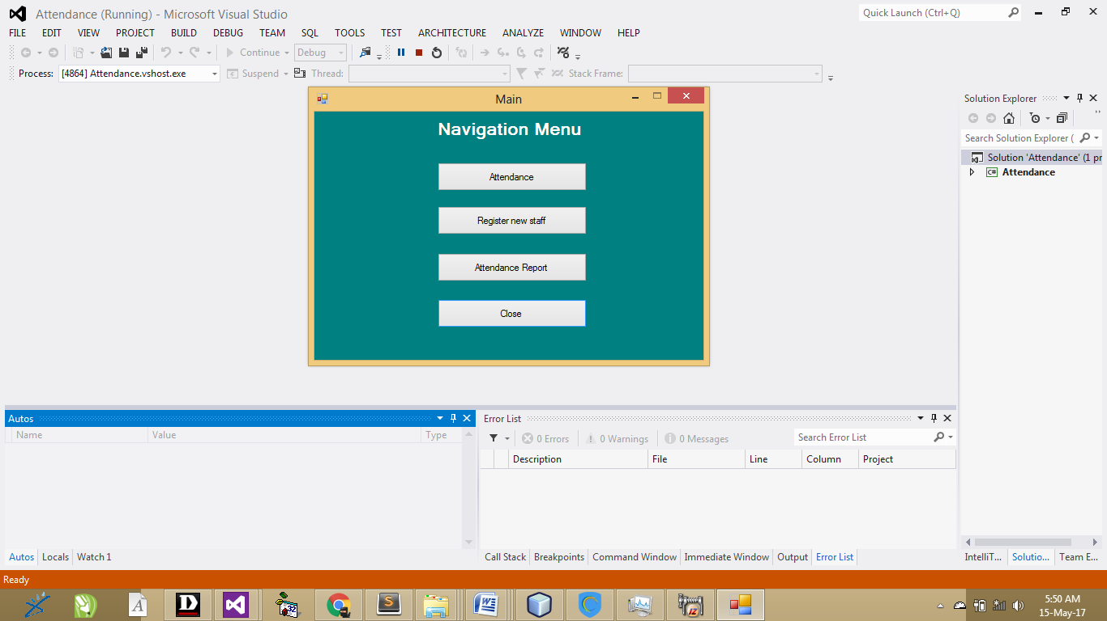
Fig 4.1: Main Menu: This is the main menu for this application. This is the second page to be displayed after splash screen. It contains four modules which includes attendance, register new staff, attendance and close.
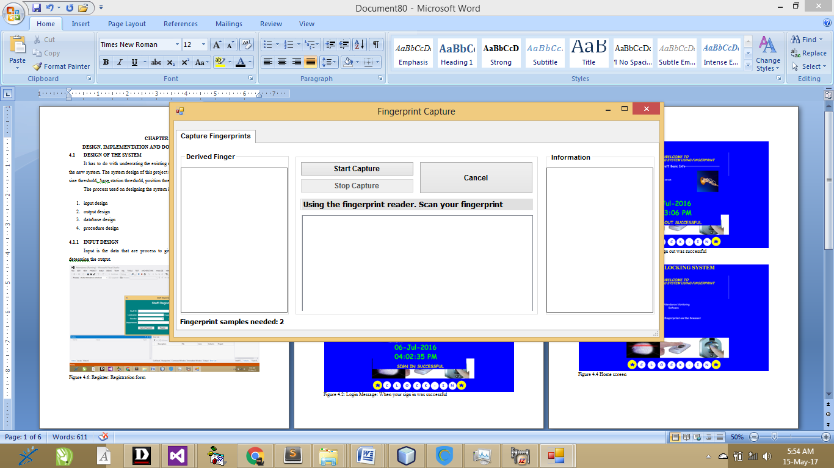
Fig 4.2: Finger capture: This is the platform that is been displayed when the user want to make the thumb during registration. User will have to initialize the fingerprint application by clicking on the start capture and place the thumb finger for capturing
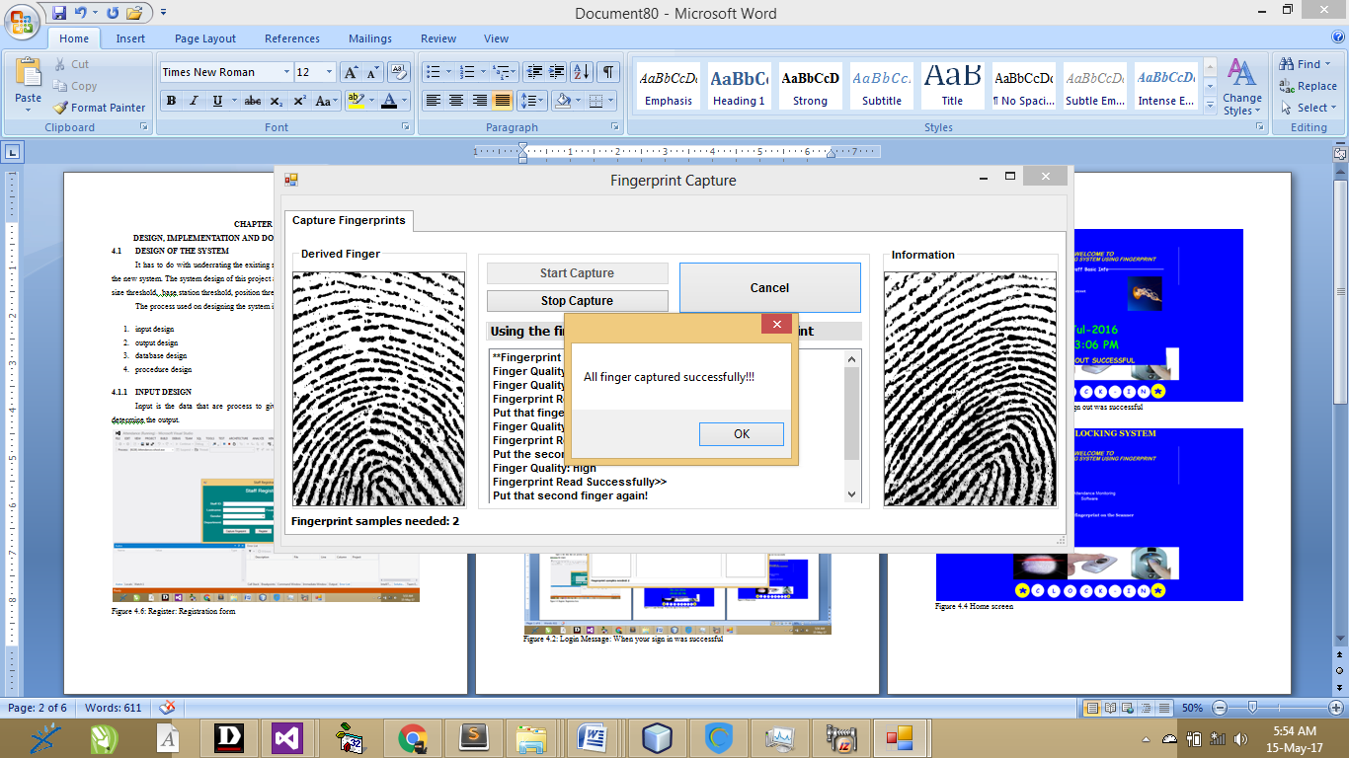
Fig 4.3: Captured finger print: This is the result that will be displayed after a successful finger print captured. After the 2 thumb fingerprint is been captured successfully the information will be save automatically.
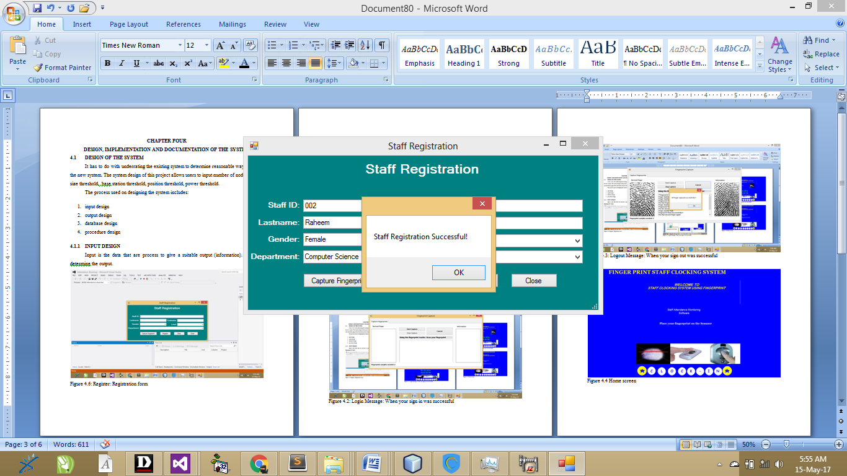
Fig 4.4 Registration Status: This is shown after a successful registration is made. Staff information is been entered here.

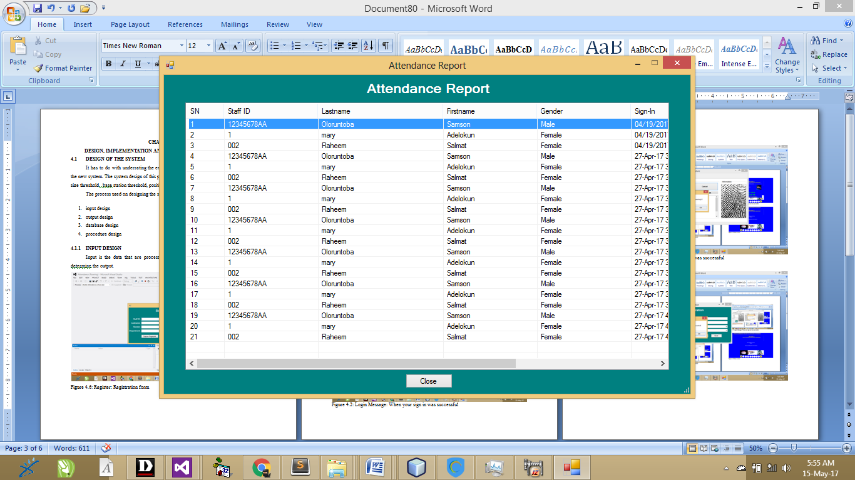
Fig 4.5: Report: This is the report of the attendance captured. This table shows all field been captured during registration and also displayed the captured clocking time
4.1.2 INPUT SYSTEM
Input is the data that are process to give a suitable output (information). It always determine the output.
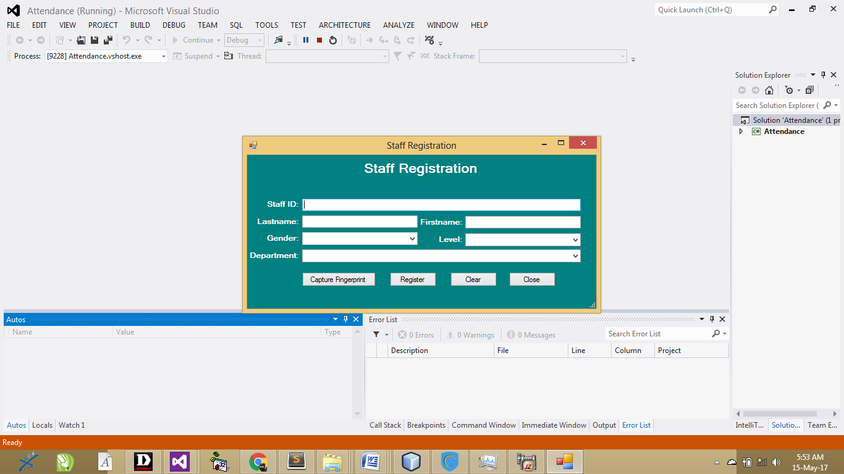
Fig 4.6: Register: This registration form is been used by the staff for registration. Staff information is been entered here so as to verify their information when clocking in
4.1.3 DATABASE DESIGN
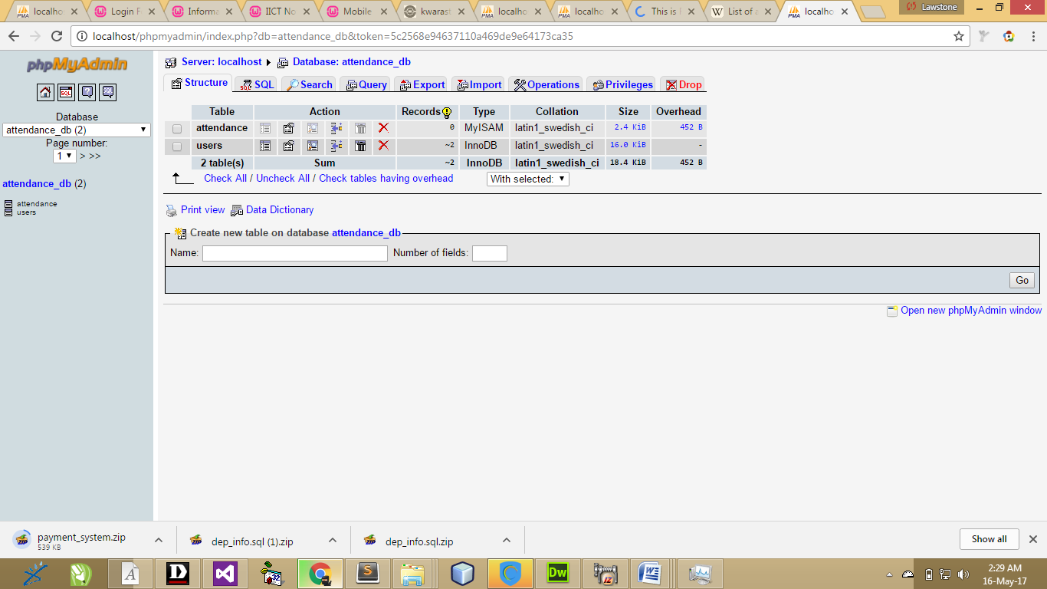
Fig 4.7: Attendance Database: This database handled the staff information for both data and clocking in
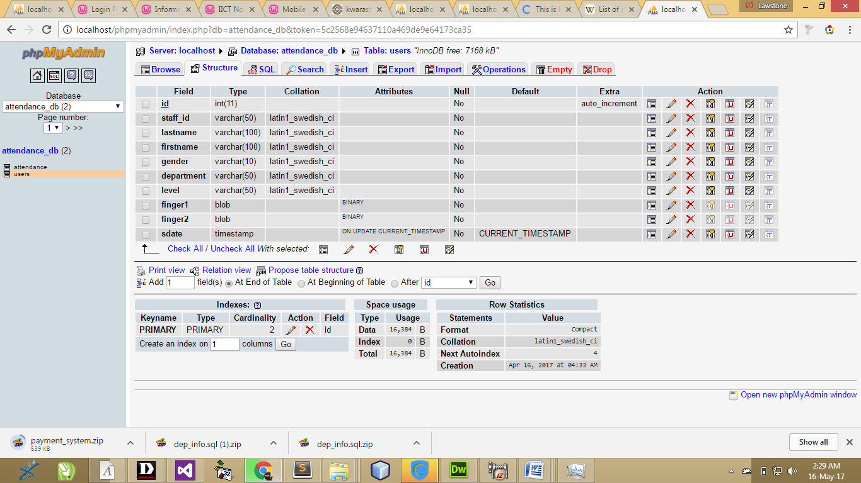
Fig 4.8: User Table: This table handles the information of each staff who use the platform to make registration
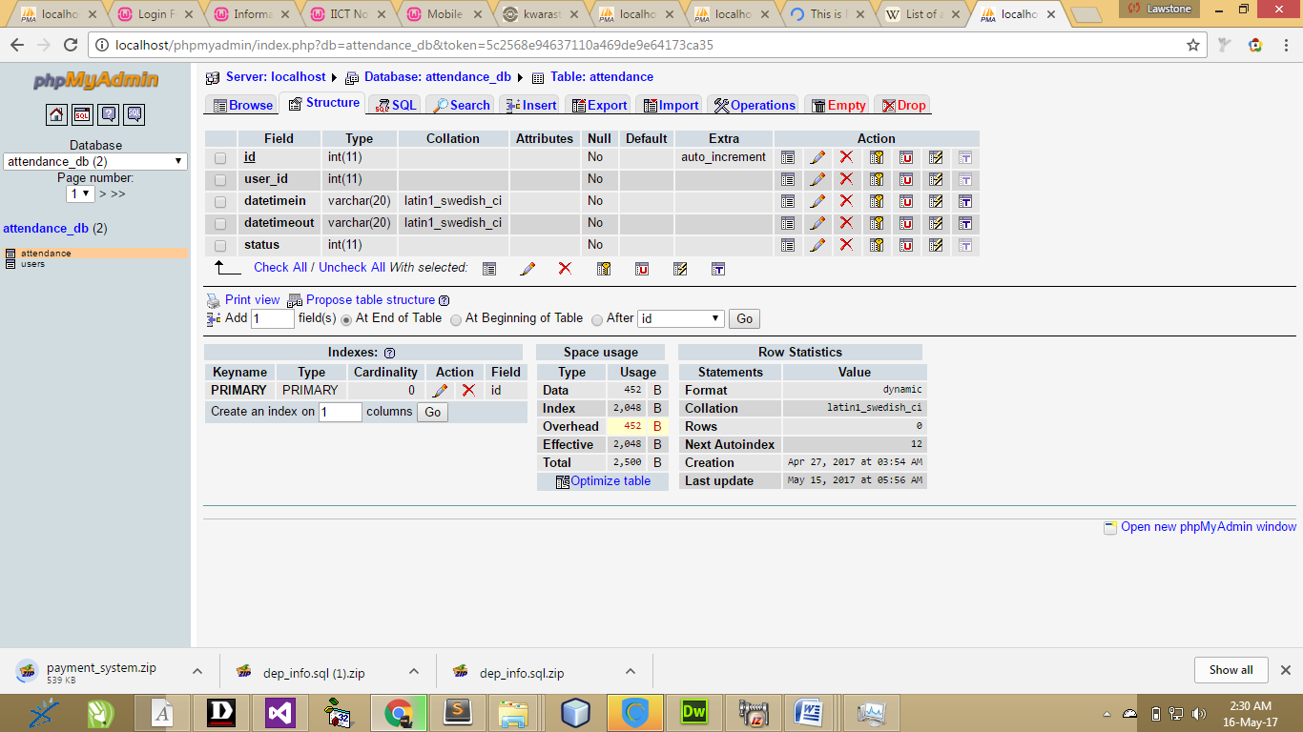
Figure 4.9: attendance Table: This table handles the clocking time and date of each staff

4.1.4 PROCEDURE DESIGN
The system consists of the splash screen, registration page and output or status of the staff signin or signout response.
System analysis is the process examining an existing system to the designing and the implementation of the new system entirely.
Hence, the act of developing any computer application involved carrying out system study and converting them into a form that can be easily programmed into the computer by providing the input design, the files within the output design and the linkage between them.
This refers to the ways in which the proposed system will be used and the steps are as follows:
- insert the disc into the system cd-rom
- Open the content from “my computer” icon on the desktop or clicking the start button.
- Double click the set up icon from the content of the package folder in the device (flash, CD).
- Follow the instruction and click on the appropriate button and the installation will be completed in a few moments.
Using the software after installation
- Click start on the computer desktop
- Select all programs
- Select staff_attendance
- Wait for the splash screen to finish loading
Enter username and password to begin using the software

4.2 IMPLEMENTATION OF THE SYSTEM
4.2.1 CHOICE OF PROGRAMMING LANGUAGE
The programming language used is VB.Net 2010. Visual Basic is a tool that allows you to develop Windows (Graphic User Interface - GUI) applications. The applications have a familiar appearance to the user.
Visual Basic is event-driven, meaning code remains idle until called upon to respond to some event (button pressing, menu selection). Visual Basic is governed by an event processor. Nothing happens until an event is detected. Once an event is detected, the code corresponding to that event (event procedure) is executed. Program control is then returned to the event processor.
Some Features of Visual Basic
- Full set of objects - you 'draw' the application
- Lots of icons and pictures for your use
- Response to mouse and keyboard actions
- Clipboard and printer access
- Full array of mathematical, string handling, and graphics functions
- Can handle fixed and dynamic variable and control arrays
- Sequential and random access file support
- Useful debugger and error-handling facilities
- Powerful database access tools
- ActiveX support
- Package & Deployment Wizard makes distributing your applications simple

4.2.2 HARDWARE SUPPORT
The requirement for the implementation of this proposed system are the following:
- Computer system must have at least 2.0GHZ speed for the processor
- 2.0GHZ RAM or higher
- At least 20GB and above hard disc or hard drive
- At least Pentium III and above board configuration

4.2.3 CHANGE OVER TECHNIQUES
Pilot technique:
The new system is run alongside the old system, but only processes some of the data. For example a supermarket might try out a new stock control system on one till in a store, with all sales at this till being recorded by both the old and new systems. Sales at this till may take longer, but the amount of effort required is less than that for a parallel changeover. The results produced by the two systems can be compared to see if the new system appears to work. As the new system is only being used with a small amount of data, problems that might result from processing a realistically large volume of data might not be noticed.

4.2.4 STUDENT DOCUMENTATION
i. register
ii. Login
iii. Logout
iv. Edit
4.3.1 DOCUMENTATION OF THE PROGRAM
It has to do with the installation and usage of the new system.
After the program has been well tested with input that the output has already been known, the next is to install the software in to the computer system for use.
The process of installing are been stated below
- Insert the CD into the system through the CD-ROM after the computer is switch on
- Locate the CD drive directory in my computer and click it to open
- After open, locate setup.exe, and then click to install the program by following the necessary step in installing the program.
- Ensure full installing of the software for effective operation of the system.
After the program has been fully install. The next thing is to locate the package install to put it into operation, to locate the package for expiration purpose the following step are to be taking
v. Click on start menu from task bar. Then select all program
From the display sub option, select by locating the software installed named temperament/ personality check to load the software.
4.3.2 MAINTAINING THE SYSTEM
- Keeping the system free from virus so as not to corrupt the program installed on the system.
- Having an updated anti-virus.

CHAPTER FIVE
CONCLUSION AND RECOMMENDATION
5.1 SUMMARY
Biometrics refers to metrics related to human characteristics. Biometrics authentication (or realistic authentication) is used in computer science as a form of identification and access control. It is also used to identify individuals in groups that are under surveillance.
Biometric identifiers are the distinctive, measurable characteristics used to label and describe individuals. Biometric identifiers are often categorized as physiological versus behavioral characteristics. Physiological characteristics are related to the shape of the body. Examples include, but are not limited to fingerprint, palm veins, face, DNA, palm print, hand geometry, iris recognition, retina and odor/scent. Behavioral characteristics are related to the pattern of behavior of a person, including but not limited to typing rhythm, gait, and voice. Some researchers have coined the term behaviometrics to describe the latter class of biometrics.
More traditional means of access control include token-based identification systems, such as a driver's license or passport, and knowledge-based identification systems, such as a password or personal identification number. Since biometric identifiers are unique to individuals, they are more reliable in verifying identity than token and knowledge-based methods; however, the collection of biometric identifiers raises privacy concerns about the ultimate use of this information.
5.2 CONCLUSION
The study designed and implemented a convenient and practical attendance management system. The system was designed and implemented so that using automatic attendance check is possible without additional actions or spending time for attendance. For this Beacon transmitter’s must be installed in each lecture halls but recently Beacon transmitter costs are relatively low in the system can be established with low cost. The biggest characteristics of this system are that for attendance of the student the attendance is acknowledged as soon as the student enters the lecture hall of their course which means the professor does not have to spend time to check the attendance of the students, and it is convenient and practical because the student also does not have to do any additional actions for attendance. Also this system recognizes student and professor modes by the smart phone number and it can be used more conveniently because there is no necessary additional action to register as student or professor. It is planned to use the system designed and implemented in the study on University classes to comparatively analyze the convenience and recognition rates of each attendance method, and it is planned to conduct verification and supplementation about the effectiveness through surveying the students that participated in the lectures.

5.3 RECOMMENDATION

The scope of the proposed system is to capture staff data which will be securely saved on the system and can only be accessed and authenticated using each employee’s fingerprint. It will also record the time an employee clock in to work and the time he / she clock out.

From all Attendance management system, it is observed that system is being developed only for attendance is being taken. Whereas researcher planned to use RF technology for two purposes, one is for attendance taking and second is for detecting Use of mobile phone in the class room. So there is no chance for use of mobile phone while lectures is going on, it will improve the students concentration on lecture rather than the mobile phone activities. The objective of proposed system are to improve the attendance in the class and also improve the physical concentration on the lecture instead of unwanted use of mobile phone activities.

REFERENCE
Akerlof, G. (1970). "The Attendance for “University Of California”: Quality Uncertainty and the Record Mechanism."
Anderson, L. R. and J. M. Mellor (2008). "Predicting records handling with an experimental measure of risk preference." Journal of security measures.
Annear, P. L., D. Wilkinson, et al. (2007). Study of Education Access to Learning Services for the Poor in Cambodia. Phnom Penh, Cambodia Ministry of Education, RMIT University.
Barsky, R. B., F. T. Juster, et al. (1997). "Preference Parameters and Behavioral Heterogeneity: an Experimental Approach in the Education and Retirement Study." The Quarterly Journal of School.
Bellemare, C. and B. S. Shearer (2006). Sorting, Incentives and Risk Preferences: Evidence from a Field Experiment.
Case, A., D. Lubotsky, et al. (2002). "Educational Status and the School in Childhood: The Origins of the Gradient.
Cawley, J. and T. Philipson (1999). "An Empirical Examination of Information Barriers to Trade in School."

PROGRAM FLOWCHART
File
Start
Open database
Accept student details
Is details complete
Save to Database
Close database
Stop
Display registration

NO
YES

Attendance
Start
Accept student Id
Is student Id correct
Mark attendance
Close database
Open database
Stop
YES
NO

FROM REGISTER
YES
NO
Start
Input register data base
Select upload
Process picture
Place your thumb
Select option
Is opt register ?
Stop
Display reg successful
Open database

Close database

FROM LOGIN
Open database

START
PLACE YOUR FINGER PRINT
IS FINGER PRINT A REGISTERED USER ?
RETURN TO HOME SCREEN
STOP
DISPLAY NOT A REGISTER USER
DISPLAY STAFF DETAILS

DISPLAY LOGIN SUCCESSFUL
YES
NO
Close database

FROM LOGOUT
YES
NO
START
PLACE YOUR FINGER PRINT
IS FINGER PRINT REGONGNISED ?
DISPLAY STAFF DETAILS
DISPLAY LOG OUT SUCCESSFUL
RETURN TO HOME SCREEN
STOP
YOU ARE NOT A REGISTER USER
Open database

Close database

