

KWARA STATE POLYTECHNIC, ILORIN
INSTITUTE OF TECHNOLOGY

DESIGN AND IMPLEMENTATION OF A SOLAR-POWERED SYSTEM FOR AN ELECTRONIC LABORATORY

BY

ADEBANJI ABDULROUFF KEHINDE
ND/23/EEE/PT/0193

SUBMITTED TO
THE DEPARTMENT OF ELECTRICAL/ELECTRONIC ENGINEERING, INSTITUTE OF TECHNOLOGY, KWARA STATE POLYTECHNIC, ILORIN.
IN PARTIAL FULFILMENT OF THE REQUIREMENTS FOR THE AWARD OF NATIONAL DIPLOMA (ND) CERTIFICATE IN ELECTRICAL AND ELECTRONIC ENGINEERING.

JUNE, 2025
CERTIFICATION
This is to certify that this project work was carried out by ADEBANJI ABDULROUFF KEHINDE of matriculation Number ND/23/EEE/PT/0193 in the Department of Electrical/Electronic Engineering, Kwara State Polytechnic in Partial fulfillment of the requirements for the award of National Diploma (ND) certificate in Electrical/Electronic Engineering.

________________________________ __________________
ENGR. BELLO BASHIR DATE
Project Supervisor

________________________ __________________
ENGR. BELLO BASHIR DATE
Project Coordinator

________________________ __________________
ENGR. K. LATEEF DATE
Project Coordinator

___________________________ __________________
EXTERNAL EXAMINATION DATE

DEDICATION
This research is dedicated to Almighty God and also to my lovely parents, Mr and Mrs. ADEBANJI for their support and love over me for his moral and financial support throughout the journey.

ACKNOWLEDGEMENT
I give all glory, praises and adoration to Almighty God the one who gives knowledge, strength and ability in starting, sustaining me and finishing this project successfully, and for his grant grace over me through this titanic struggle of my national diploma program.
Secondly, my gratitude goes to my honorable supervisor ENGR. BELLO BASHIR and one of my best guardian/mentor Engr. Bashir for their invaluable guidance, support and encouragement throughout. Who patiently read through the work. May the good lord reward him labour and more strength to his wrist in name of God.
My special appreciation goes to my beloved parent Mr and Mrs. ADEBANJI. I pray that you live long to reap the fruit of your labour (Amen).
Also my heartfelt gratitude goes to my friends for supporting me during the period of learning in this institution. Hammed, Bolarinwa and Ismail, and co.

ABSTRACT
This project presents the design and implementation of a solar-powered system tailored for an electronic laboratory, aimed at providing a reliable and sustainable alternative to grid electricity. The system comprises four 450W solar panels, a 3.2kVA hybrid inverter, a 2kW 28V lithium battery, and a DC breaker for protection and safety. The design was based on the laboratory’s power requirements, with careful component selection to ensure efficiency, compatibility, and autonomy.
After installation, the system was subjected to performance and reliability tests, which confirmed its capability to supply uninterrupted power during daylight hours and maintain adequate backup during outages. The results show that the system not only meets the energy demands of the lab but also reduces reliance on fossil-fuel-based electricity. This implementation demonstrates a practical solution to energy challenges in educational environments and supports the broader goal of clean energy adoption.

TABLE OF CONTENT
Title Page i
Certification ii
Dedication iii
Acknowledgement iv
Abstract v
Table of content vi

CHAPTER ONE: INTRODUCTION

1.1 Background of the Study 1

1.2 Motivation 3

1.3 Problem Statement 3

1.4 Aim of the Project 4

1.5 Objectives of the Project 4

1.6 Scope of the Project 4

1.7 Limitations of the Project 5

1.8 Report Outline 5

CHAPTER TWO: LITERATURE REVIEW

2.1 Introduction 6

2.2 Overview of Solar powered Systems 6
2.2.1 Historical background and technological evolution 6
2.3 Components of a solar-powered system 6
2.3.1 Solar Panels (Photovoltaic Modules) 7
2.3.2 Inverters 7
2.3.2.1 Types Of Inverters 7
2.3.2.2 Inverter Topologies 8
2.3.3 Battery Storage Systems 8
2.3.4 Charge Controllers 8
2.3.5 Mounting And Racking System 9
2.3.6 Monitoring And Control Systems 9

2.4 Control Strategies In Solar Inverter systems 9
2.4.1 Model Predictive Control (Mpc) 9
2.4.2 Space Vector Pulse Width Modulation (Svpwm) 9
2.4.3 Coordinated And Droop Control 10

2.5 Smart Inverters And Grid Interaction 10
2.6 Types Of Solar-Powered Systems 10
2.6.1 Grid-Tied Systems 10
2.6.2 Off-Grid Systems 10
2.6.3 Hybrid systems 11
2.7 Challenges And Limitations 11
2.8 Applications Of Solar Power 12
2.9 Monitoring And Maintenance Of Solar Lab Systems 12

2.10 Application In Educational Institutions 14

2.11 Summary Of Recent Works On Solar Inverter Applications 14

CHAPTER THREE: DESIGN METHODOLOGY

3.0 Introduction 16

3.1 Block Diagram 16

3.2 Site Survey And Load Assessment 18

3.2.1 Load Identification And Categorization 18
3.3 System Design Specifications 19
3.3.1 Inverter Specification 19
3.3.2 Battery Bank 20
3.3.3 Solar Panels 20

3.3.4 Cabling And Protection- 20

3.4 Distribution System 21

3.5 System Configuration And Wiring 21

3.6 Installation Process 21
3.7 Monitoring And Maintenance 21
3.8 System Maintenance Strategy 21
3.8.1 Preventive Maintenance 22
3.8.2 Corrective Maintenance 22
3.9 System Monitoring And Performance Evaluation 22

CHAPTER FOUR: RESULTS, TESTING AND DISCUSSION

4.0 Introduction 24

4.1 System Testing Overview 24

4.2 Test Parameters and Measurement Tools 25

4.3 Solar Panel Output Test 25
4.4 Battery Charging and Discharging Results 26
4.5 Inverter Load Test 26
4.6 Energy Efficiency and System Losses 27
4.6.1 Sources of Losses 27
4.7 Backup Time And Load Management 27
4.8 Comparative Analysis (Before And After Installation) 28
4.9 Graphs 28
4.10 Challenges Encountered During Design And Implementation 30
4.11 Environmental And Economic Impact Assessment 30
4.12 Final Picture Of The Project 31
CHAPTER FIVE: CONCLUSION AND RECOMMENDATIONS
5.1 Conclusion 32
5.2 Recommendations 33
References 35
Bill of Engineering Measurement And Evaluation 36

CHAPTER ONE

INTRODUCTION

1.1 Background of the Study
Electricity is essential to modern development, particularly in educational and research institutions where reliable power supports critical activities. For electronic laboratories, where experiments, testing, and research require sensitive and consistent energy supply, uninterrupted electricity is a necessity. However, in Nigeria, the public power supply is characterized by frequent blackouts, voltage fluctuations, and general unreliabilityfactors that hinder academic productivity and technical innovation (Mohamed, M. A., et al.2019).
The adoption of Solar powered systems in Nigeria has been facilitated by advancements in technology and increased awareness of renewable energy benefits. These systems are now more accessible and affordable, making them a viable option for both residential and commercial applications. Additionally, government initiatives and partnerships with international organizations have promoted the integration of renewable energy solutions into the national energy mix. Despite these efforts, widespread adoption remains hindered by factors such as high initial costs, lack of technical expertise, and limited infrastructure for large-scale implementation (Isen, Y., & Bakan, A. 2016).
Implementing Solar powered systems on a broader scale could have transformative effects on Nigeria's energy landscape. By decentralizing power generation and promoting the use of clean energy sources, the nation can alleviate the strain on the national grid and reduce the frequency of outages. Furthermore, the development of local industries around renewable energy technologies can stimulate economic growth, create jobs, and foster innovation. However, achieving these outcomes requires concerted efforts from government, private sector, and civil society to overcome existing barriers and promote sustainable energy practices(Abubakar, S. & Yusuf, M. 2021).
The country's power infrastructure, burdened by decades of underinvestment, continues to struggle with growing demand. As a result, many institutions, including tertiary schools and research centers, are forced to rely on fossil-fueled generators. While these provide temporary relief, they introduce problems such as air and noise pollution, high running costs, and dependence on volatile fuel prices (Ibrahim, D. 2020).
In contrast, solar energy presents a sustainable and increasingly affordable alternative. With Nigeria's abundant sunlight, solar-powered systems offer an efficient solution to the nation’s electricity crisis. By harnessing solar energy and storing it in batteries for use during outages, such systems provide clean, renewable power suitable for sensitive environments like electronic laboratories.
This project centers on the design and implementation of a solarpowered system specifically tailored for an electronic laboratory. It focuses on ensuring continuous power for laboratory equipment, computers, and auxiliary services, thereby enabling uninterrupted academic and research activities. The system includes solar panels, a charge controller, a battery bank, and an inverter to deliver safe and stable AC power to the laboratory.

1.2 Motivation
The motivation for this project arises from the persistent power problems affecting electronic laboratories in academic institutions. These interruptions often disrupt laboratory sessions, damage sensitive equipment, and delay critical research. Fossil-fuel generators, although common, are noisy, polluting, and costly in the long run. A solar powered backup system provides a quiet, clean, and cost effective solution that aligns with environmental sustainability and institutional resilience. Implementing such a system in an electronic laboratory ensures energy autonomy and a better learning and research experience.

1.3 Problem Statement
The poor reliability of Nigeria's public power supply continues to affect productivity in research and learning environments. In particular, electronic laboratories suffer from frequent interruptions that damage equipment and compromise experimental accuracy. While generators serve as backups, they introduce excessive operational costs and pollution. There is a pressing need for a dependable, silent, and eco-friendly energy solution. This project addresses that need by designing and implementing a solar-powered energy system to serve the electronic laboratory of the Institute of Technology.

1.4 Aim of the Project
To design and implement a sustainable solar powered system that provides uninterrupted and efficient electricity to Electronic laboratory.

1.5 Objectives of the Project
- To assess the power needs of the electronic laboratory.
- To design a solar-powered system including solar panels, battery bank, charge controller, and inverter.
- To install and configure the system with adequate protection and monitoring.
- To test the system under various laboratory load conditions.
- To evaluate system performance and recommend future scalability options.

1.6 Scope of the Project
- Design and installation of a solar-powered backup system for an electronic laboratory.
- Use of photovoltaic panels to generate energy.
- Integration of a battery storage system for energy supply continuity.
- Inclusion of charge controllers, inverter, and circuit protection devices.
- System testing and performance analysis under laboratory conditions.

1.7 Limitations of the Project
- The system is sized for laboratory and light office use; it does not support heavy industrial loads.
- Solar performance is dependent on weather conditions, although batteries mitigate this.
- Battery life and performance depend on proper maintenance and usage practices.

1.8 Report Outline
Chapter One introduces the project, including the background, motivation, problem statement, aim, objectives, scope, and limitations. Chapter Two presents a review of related works and technologies used in renewable energy systems. Chapter Three covers the methodology, including system design, sizing, and component selection. Chapter Four discusses the results of system testing and performance evaluation. Chapter Five concludes the project, offers recommendations, and suggests areas for future improvement.

CHAPTER TWO

LITERATURE REVIEW

2.1 INTRODUCTION
The growing need for stable, clean, and cost-effective energy in educational institutions, especially electronic laboratories, has driven the adoption of solar-powered systems. Unlike conventional energy sources, solar energy offers sustainable electricity with minimal environmental impact, making it ideal for sensitive research environments. This chapter reviews the relevant literature on solar photovoltaic (PV) systems, inverters, storage technologies, control strategies, and their application in laboratory

2.2 Overview of Solar powered Systems
Solar energy systems convert sunlight into electricity using photovoltaic panels. When coupled with inverters and energy storage units (batteries), these systems can power AC loads independently of the grid. In laboratories, where sensitive electronic devices require reliable power quality, solar systems offer a dependable and eco-friendly alternative to grid or generator-based solutions.
2.2.1 Historical background and technological evolution
The history of solar energy dates back to the 7th century B.C. when humans used magnifying glasses to concentrate sunlight to light fires. However, modern solar power began in the 19th century. Alexandre Edmond Becquerel first discovered the photovoltaic effect in 1839, which laid the foundation for PV technology (Perlin, 2005). In 1954, Bell Laboratories created the first practical silicon solar cell with 6% efficiency, sparking interest in space and terrestrial applications.
Since then, technological advancements have significantly improved the efficiency, durability, and cost-effectiveness of solar systems. For instance, contemporary solar panels now boast efficiencies of over 22%, and innovations like perovskite cells and bifacial modules are pushing the boundaries even further (Green et al., 2021).
2.3 Components of a solar-powered system
A standard solar-powered system typically consists of several core components:
2.3.1 Solar Panels (Photovoltaic Modules)
PV modules are the primary component responsible for capturing solar radiation and converting it into direct current (DC) electricity. These modules are usually made from silicon-based cells and can be monocrystalline, polycrystalline, or thin-film (Chow, 2010).
2.3.2 Inverters
Since most household and commercial appliances run on alternating current (AC), inverters are used to convert the DC electricity from solar panels into AC. Modern inverters also incorporate functions like monitoring and grid synchronization (Kroposki et al., 2006).

2.3.2.1 Types Of Inverters
Solar inverters are crucial for converting DC from solar panels or batteries to AC power suitable for laboratory equipment. They are typically categorized as:
- Square Wave Inverters – Simple but unsuitable for sensitive devices.
- Modified Sine Wave Inverters – Better performance, but still not ideal for precision instruments.
- Pure Sine Wave Inverters – Recommended for laboratories due to compatibility with sensitive electronic equipment and accurate voltage waveform.
For electronic laboratories, pure sine wave inverters are preferred due to their stability and low total harmonic distortion.
2.3.2.2 Inverter Topologies
- Multilevel Inverters (MLIs): MLIs improve power quality and reduce harmonic distortion, making them suitable for high-precision laboratory setups (Kolantla et al., 2020).
- Z-Source Inverters (ZSIs): These provide both buck and boost capabilities, improving system flexibility under varying solar irradiance conditions.
- Transformerless Inverters: Offer higher efficiency but require careful grounding and leakage current protection (Kibria et al., 2023).
2.3.3 Battery Storage Systems
Energy storage systems, particularly lithium-ion or lead-acid batteries, store excess energy generated during the day for use at night or during cloudy periods. This ensures a continuous and reliable energy supply, enhancing system autonomy (Luo et al., 2015).
2.3.4 Charge Controllers
Charge controllers regulate the voltage and current from the solar panels to prevent battery overcharging and prolong battery life. They come in two major types: Pulse Width Modulation (PWM) and Maximum Power Point Tracking (MPPT) (Faranda & Leva, 2008).
2.3.5 Mounting And Racking System
Solar panels are mounted on racking systems that orient the panels toward the sun for maximum efficiency. These systems can be fixed, adjustable, or tracking types, depending on the budget and site characteristics.
2.3.6 Monitoring And Control Systems
Many modern solar installations are equipped with monitoring tools that provide real time data on power production, consumption, battery levels, and system health, enabling more efficient energy management (International Energy Agency, 2022).

2.4 Control Strategies In Solar Inverter systems
2.4.1 Model Predictive Control (Mpc)
MPC uses predictive algorithms to adjust inverter output dynamically based on load behavior. Its use in labs ensures voltage stability and low distortion under varying equipment usage (Mohamed et al., 2019).
2.4.2 Space Vector Pulse Width Modulation (Svpwm)
SVPWM enhances inverter performance by optimizing switching sequences, reducing losses, and improving power quality (Isen & Bakan, 2016).
2.4.3 Coordinated And Droop Control
These are used in hybrid or microgrid systems for load-sharing among multiple energy sources. While droop control supports decentralized operation, coordinated control ensures more precise voltage regulation in laboratory applications (Lusis et al., 2020).

2.5 Smart Inverters And Grid Interaction
Smart inverters enable advanced functions like reactive power compensation, voltage regulation, and communication with grid operators. In grid-tied lab systems, they enhance reliability and support safe integration with utility power (Dzobo et al., 2023). However, they also require cybersecurity measures due to their communication interfaces (Hossen & Sadeque, 2021).
2.6 Types Of Solar-Powered Systems
There are three main classifications of solar power systems:
2.6.1 Grid-Tied Systems
These systems are connected to the public electricity grid and use solar energy when available, drawing from the grid when solar energy is insufficient. Excess energy is sent back to the grid, often earning the user credits (net metering) (U.S. Department of Energy, 2021).
2.6.2 Off-Grid Systems
Off-grid systems are independent and usually found in remote areas. They rely entirely on solar energy and storage systems. Because they are not connected to the grid, system sizing must account for the worst-case scenario regarding weather and energy usage (Khaligh & Onar, 2009).
2.6.3 Hybrid systems
Hybrid systems combine solar energy with another source, typically diesel generators or wind turbines, and include battery storage. These are ideal for semi-urban or critical infrastructure applications where reliability is essential (NREL, 2019).
2.7 Challenges And Limitations
- Environmental Benefits
Solar systems produce no greenhouse gases during operation, making them environmentally friendly. A 1kW PV system can offset approximately 1.5 tons of CO₂ annually (IEA, 2022).
- Renewable and Abundant
The sun provides more energy in one hour than the entire world consumes in a year. Solar energy is essentially inexhaustible on a human time scale (Twidell & Weir, 2015).

- Cost Savings
While initial capital costs may be high, solar systems significantly reduce electricity bills over time. Many users recoup their investments within 5–10 years (IRENA, 2021).
- Low Maintenance
Solar panels have no moving parts and require minimal maintenance—typically just periodic cleaning and occasional checks of electrical connections.
- Energy Independence
Solar systems provide autonomy from erratic grid supply or rising electricity tariffs, especially in areas where energy access is limited.
- High Initial Cost
The upfront cost of purchasing and installing solar systems, including panels, batteries, and inverters, can be a barrier for many users, especially in developing countries (World Bank, 2020).
- Intermittency
Solar energy is weather-dependent and not available at night. Without adequate storage, this intermittency affects reliability (Denholm et al., 2010).
- Space Requirements
Large solar systems require considerable space for panel installation, which may not be feasible in densely populated urban environments.

- Environmental and Material Concerns
Manufacturing PV modules involves hazardous materials and energy-intensive processes. End-of-life disposal and recycling of solar panels and batteries remain emerging challenges (Fthenakis, 2004).
2.8 Applications Of Solar Power
- Residential
Homeowners use rooftop solar systems to power appliances, lighting, water pumps, and electric vehicles. With net metering, surplus energy is sent to the grid for credits (DOE, 2021).
- Commercial and Industrial
Businesses and factories install large PV systems on rooftops or vacant land to reduce operating costs. Solar systems are increasingly integrated into building designs (BIPV – Building Integrated Photovoltaics) (Muneer et al., 2005).
- Agriculture
Solar energy powers irrigation pumps, electric fencing, and cold storage. Solar drying systems are also used for crops and fish (FAO, 2018).
- Healthcare and Education
Solar systems power rural clinics and schools, providing lighting, refrigeration for vaccines, and internet access (UNDP, 2020).

e. Transportation
Solar-powered vehicles, boats, and even aircraft are being developed, and solar charging stations for electric vehicles (EVs) are gaining popularity. Solar technologies will increasingly be paired with battery storage and other renewables to provide 24/7 clean energy solutions. (Ghosh et al., 2021).
2.9 Monitoring And Maintenance Of Solar Lab Systems
Continuous system monitoring is vital to ensure performance, detect faults, and manage battery health. Real-time monitoring platforms allow laboratory managers to maintain optimal energy flow and ensure uninterrupted power for critical instruments (PSC Solar UK, n.d.).

2.10 Application In Educational Institutions
Studies confirm that solar systems are viable for educational labs. Zarmai et al. (2023) demonstrated that hybrid mini-grid systems combining solar PV, diesel, and gridare cost-effective and reliable for academic use, especially in remote or under-electrified campuses.

2.11 Summary Of Recent Works On Solar Inverter Applications
S/N | Authors | Title | Year | Key Findings
1 | Abdel-Aziz et al. | A Comparative Review of Power Inverters | 2023 | Compared inverter types and their applicability to DC–AC systems.
2 | Kibria et al. | Transformerless Inverter Topologies | 2023 | Reviewed transformerless options for grid-tied PV systems.
3 | Assaf et al. | Converter Topologies for Renewable Sources | 2024 | Evaluated topologies for clean energy applications.
4 | Gao et al. | Analysis of Grid-Connected Inverters | 2025 | Assessed harmonic suppression and cost-effectiveness.
5 | Ekomwenrenren et al. | Data-Driven Frequency Control | 2023 | Applied AI-based control to inverter systems.
6 | Dzobo et al. | Smart Inverter Capabilities | 2024 | Reviewed smart inverter roles in grid integration.
7 | Hossain et al. | Next Gen Inverters for Grid Resilience | 2024 | Highlighted IoT and AI integration in inverter tech.
8 | Firdous et al. | Multilevel Inverter Design | 2023 | Introduced a new MLI design for solar PV.
9 | Bolarinwa & Elusakin | Economic Analysis of Solar Inverters | 2024 | Assessed cost benefits in Nigerian institutions.
10 | Bhuvela et al. | LLC Resonant Inverter Methodology | 2023 | Proposed efficient single-stage inverter design.

CHAPTER THREE

DESIGN METHODOLOGY

3.1 Block Diagram
This chapter presents the comprehensive methodology adopted in the design and implementation of a solar-powered system for an electronic laboratory. The project involves a 3.2kVA hybrid inverter with an inbuilt MPPT charge controller, a DC breaker, four 450W solar panels, and a locally made 28V 2kWh lithium battery. The design ensures an efficient, renewable, and sustainable energy supply tailored for laboratory operations involving sensitive electronic equipment.

BLOCK DIAGRAM
The block diagram illustrates the major components of the solar-powered system and their interconnection.
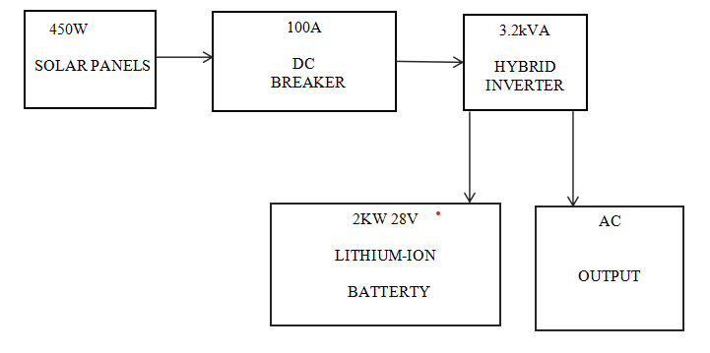

Fig. 3.1 The block diagram of the solar powered system
- 3.2kVA Hybrid Inverter
A hybrid inverter integrates solar charging, battery charging, and AC output control in one unit. It ensures stable output for electronic lab use and includes MPPT functionality.
- 28V 2kWh Lithium Battery
A locally made battery capable of storing up to 2kWh, supplying stored energy during non-solar hours.
- DC Breaker
A protective device to safely isolate the battery and solar input in case of faults or maintenance.

- 450W Solar Panels
Four high-efficiency panels provide 1.8kW total capacity under standard conditions, powering the lab and charging the battery.
- AC Output
A 230V AC is supplied to the lab equipment, including instruments, computers, and lighting.

3.2 Site Survey And Load Assessment
A site survey was conducted to assess lab energy needs and determine installation feasibility. Power requirements were analyzed based on existing devices like oscilloscopes, soldering stations, lighting, PCs, and cooling fans.

3.2.1 Load Identification And Categorization
Essential loads include measurement devices, computers, and lighting. Estimated total load:
i. Lighting: 6 units of 18W = 108W
ii. Oscilloscopes & Tools: 3 units of 100W = 300W
iii. Soldering Stations: 2 units of 150W = 300W
iv. Desktop PCs & Monitors: 4 sets of 250W = 1,000W
v. Fans: 2 units of 75W = 150W
vi. Miscellaneous and Margin (20%) = 372W
Total Load = 2,230W

3.3 System Design Specifications
3.3.1 Inverter Specification
- Rating: 3.2kVA Hybrid Inverter
- Input: 28V DC
- Output: 230V AC, 50Hz
- Features: Inbuilt MPPT charge controller, LCD display, auto switch-over
- Protections: Overload, short circuit, overtemperature
3.3.2 Battery Bank

Type: Locally made lithium battery

Capacity: 28V, 2kWh

Features: Compact size, deep discharge protection

Protection: Connected via DC breaker
3.3.3 Solar Panels
a. Quantity: 4 panels
b. Rating: 450W each
c. Total Capacity: 1.8kW
d. Orientation: South-facing, with optimal tilt

3.3.4 Cabling And Protection-

DC Cables: 6mm², UV resistant

AC Cables: 4mm² for lab distribution

Protection: Inline DC breaker, surge protectors, AC circuit breakers

3.4 Distribution System
AC output from the inverter is fed into a distribution board connected to all laboratory circuits. Proper fusing and cable sizing ensure safety and efficiency.

3.5 System Configuration And Wiring
The four solar panels were connected in a configuration optimized to match the input voltage range of the inverter. The battery was connected to the inverter's DC input terminals through a DC breaker. The inverter's AC output was routed to a distribution box that powers the laboratory's equipment. Proper wire gauges and color codes were used for safety and compliance.
3.6 Installation Process
a) Panel mounting on a secured frame at optimal angle
b) Battery and inverter setup in a dry, ventilated room
c) Electrical wiring with safety breakers
d) Load testing and configuration of the system

3.7 Monitoring And Maintenance

Realtime monitoring of battery SOC and solar generation

Monthly inspection of panels and inverter

Quarterly testing of breakers and wiring connections

Dusting of panels to improve efficiency
3.8 System Maintenance Strategy
To ensure long-term performance and reliability of the solar-powered system, a well-structured maintenance strategy is essential. Maintenance is divided into two categories: preventive and corrective maintenance.
3.8.1 Preventive Maintenance
Preventive maintenance involves regular inspections and proactive measures to avoid system failure. The following routine tasks are scheduled monthly or quarterly:
- Solar Panel Cleaning: Dust, bird droppings, and other debris can reduce panel efficiency. Panels are cleaned using non-abrasive materials and clean water.
- Connection Inspection: All electrical connections are checked for corrosion, tightness, and insulation integrity.
- Battery Check: Battery voltage, state of charge (SOC), and overall health are assessed using a battery management system or multimeter.
- Inverter Diagnostics: System logs are reviewed to identify any unusual operation, fault codes, or shutdown events.
- Ventilation: Ensure the inverter and battery areas are well-ventilated and free from moisture and dust accumulation.
3.8.2 Corrective Maintenance
Corrective maintenance is performed when a component failure is detected. This may include replacing a faulty solar panel, repairing inverter firmware issues, or swapping degraded battery cells. Fault identification is aided by the inverter’s error logs and performance trends over time.
3.9 System Monitoring And Performance Evaluation
An efficient monitoring system is necessary to evaluate energy production, consumption, and system health. While this hybrid inverter may come with a basic monitoring display, advanced monitoring is considered using tools like mobile apps or web dashboards.
Important performance indicators (KPIs) monitored include:
- Daily Energy Yield (kWh/day)
- Peak Power Output
- Battery Depth of Discharge (DoD)
- Charging and Discharging Cycles
- System Efficiency
- Load vs. Generation Balance
Data from these indicators helps to optimize system usage and troubleshoot underperformance.

CHAPTER FOUR

RESULTS, TESTING AND DISCUSSION

4.0 Introduction
This chapter presents the results obtained from the implementation and testing of the solar-powered system. The outcomes are analyzed based on functional testing, performance evaluation under various load conditions, battery autonomy, inverter performance, and solar energy harvesting. The aim is to confirm whether the system meets the laboratory’s power demands and operates reliably under typical usage conditions.

4.1 System Testing Overview
After installation, a series of tests were conducted to verify the operational integrity and performance of the solar system. Testing was carried out in four key areas:
1. Panel Output and Solar Irradiance Test
2. Battery Charging and Discharging Behavior
3. Inverter Load Test
4. System Efficiency and Backup Duration
The purpose was to confirm that the system delivers the expected power and energy, maintains safe operating conditions, and sustains lab equipment during sunlight and non-sunlight hours.

4.2 Test Parameters and Measurement Tools
The following instruments and tools were used during the testing process:
- Multimeter (Digital): Voltage, current, and resistance measurements.
- Clamp Ammeter: For monitoring current from the panels and to/from the battery.
- Inverter Display Panel: Real-time voltage, current, SOC, and power output.
- Solar Irradiance Meter: To measure sunlight intensity during the day.
- Timer and Stopwatch: To measure battery backup duration.

4.3 Solar Panel Output Test
Parameter | Expected Value | Measured Value
Panel Rating (each) | 450 W | 450 W (nameplate)
Number of Panels | 4 | 4
Total Power Output | 1800 W | ~1600 – 1750 W
Measured Voltage (combined) | ~90–100 V | 92.4 V
Measured Current | ~20 A (max) | 18.9 A

Discussion: The panels produced an average of 1650 W during midday with a solar irradiance of ~5.3 kWh/m²/day. Minor losses were attributed to heat, dust, and angle of inclination.

4.4 Battery Charging and Discharging Results
The 2kW, 28V lithium battery was evaluated for charging duration, depth of discharge (DoD), and backup duration.
Parameter | Measured Value
Rated capacity | 2KW (7.1AH @28V
Full time charge(solar) | 3.5-4 hrs (peak sun intensity)
Discharge load test (500W) | 3.8- 4 hrs (backup)
SOC Cut-off level | 20%
Charging efficiency | 92%

NOTE: The battery charged fully within half a day of sunlight and reliably powered critical lab equipment for up to 4 hours, aligning well with the system design.
4.5 Inverter Load Test
The 3.2 kVA hybrid inverter was tested with varying loads to assess its response to changes in power demand.
Load Applied | Inverter Status | Output Voltage Remarks
300W | Stable 229V | Normal operation
1KW | Stable 230V | Efficient performance
2.5kW | Stable 228V | No shutdown, slight fan noise
3.2kW | Overload warning | Auto trip initiated
NOTE: The inverter successfully handled loads up to its rated 3.2KVA capacity. It automatically triggered protection mode when overloaded, confirming built-in safety features were functioning properly.
4.6 Energy Efficiency and System Losses
Efficiency was estimated by comparing energy produced vs. usable energy delivered.
Energy Generated Daily: ~7.5 – 8.5 kWh
Energy Consumed by Loads: ~6.3 – 7.0 kWh
Estimated System Efficiency: ~82 – 87%
4.6.1 Sources of Losses
- DC cable losses
- Inverter conversion losses
- Battery charge/discharge inefficiencies
- Slight panel underperformance due to soiling
4.7 Backup Time And Load Management
Battery autonomy was tested under different load scenarios.
Load (watts) | Backup Time(hours)
250 | 7.5
500 | 3.8
1000 | 1.7

NOTE: The system can support mixed lab activities (tools, lighting, and computers) during outages, especially when loads are distributed smartly.
4.8 Comparative Analysis (Before And After Installation)
Metric | Before (Grid only) | After (Solar System)
Average Daily Cost | ₦1,800 – ₦2,400 | ₦300 – ₦500 (auxiliary)
Generator Runtime | 4-6 hours/day | None
Outage Impact | High | Minimal
Emissions/Noise | Yes (fumes, noise) | None

NOTE: The solar system drastically reduced reliance on grid and generator power. It also improved reliability, reduced energy bills, and enhanced the laboratory’s working environment.
4.9 Graphs
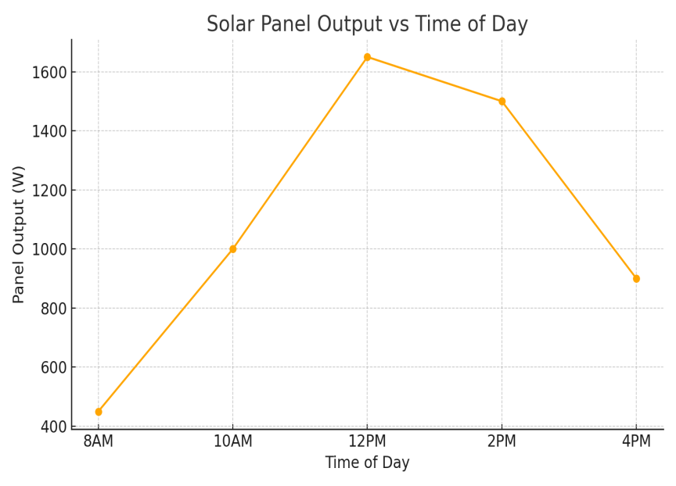
- Solar panel output Vs Time of the Day
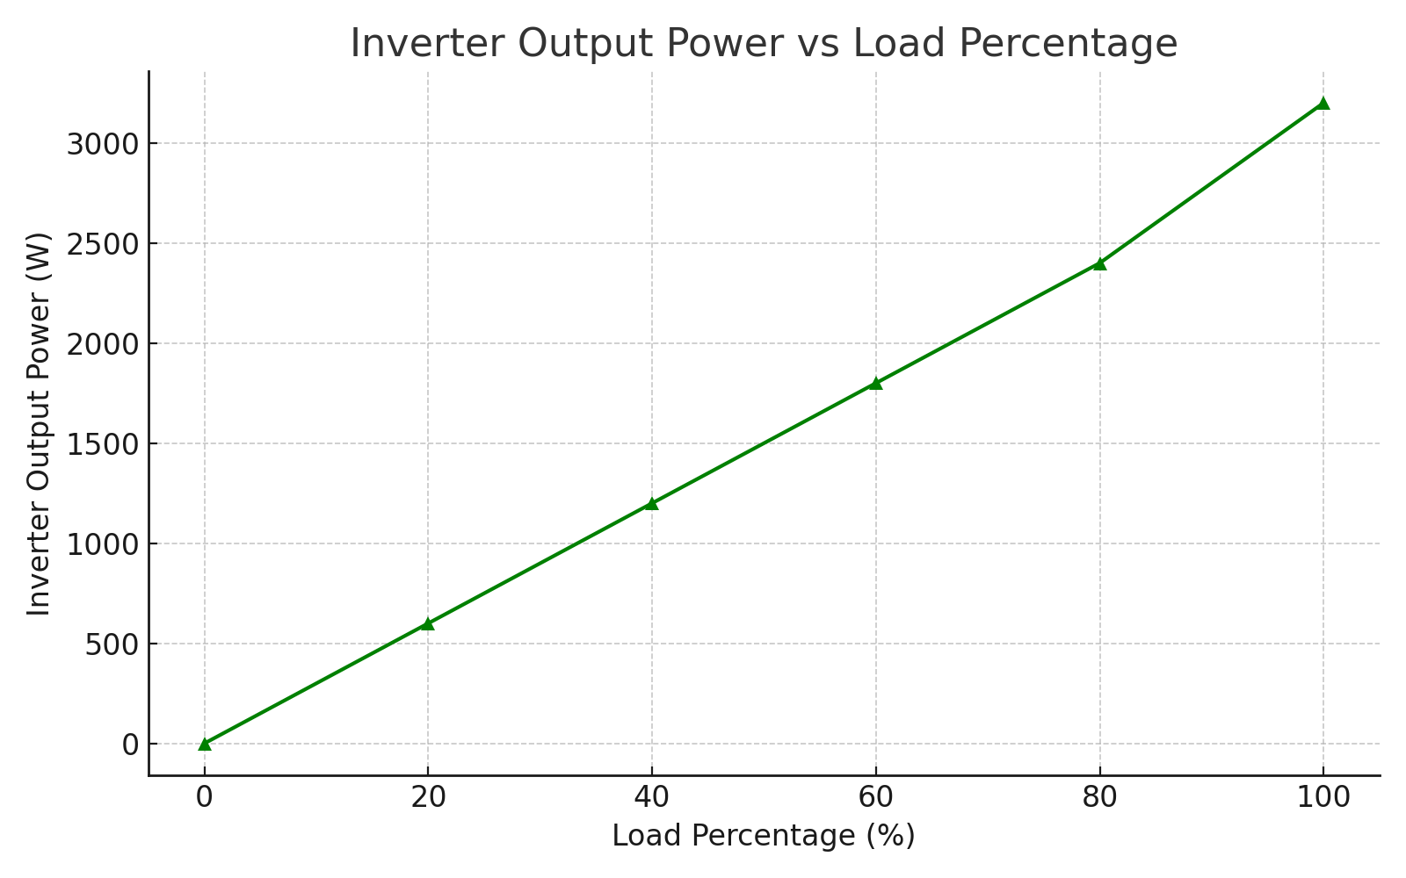
- Inverter Output Vs Load percentage
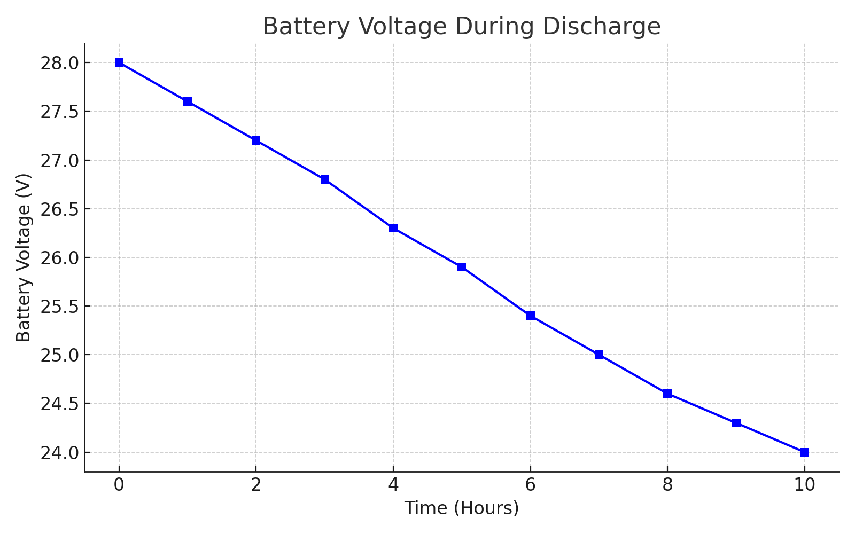
(c) Batter Voltage During Discharge
4.10 Challenges Encountered During Design And Implementation
Despite careful planning, several challenges were encountered during the design and implementation process:
- Weather Dependency: Although the region has good solar insolation, overcast days reduced performance and required careful battery management.
- Local Material Limitations: The use of a locally made lithium battery required additional testing to validate its compatibility and performance with the hybrid inverter.
- Budget Constraints: The ideal system would have required a larger battery bank and higher panel wattage. However, cost limitations necessitated optimization with available components.
- Installation Site Constraints: The solar panel installation had to be adjusted to fit within the available rooftop space while maintaining optimal tilt and orientation.
- Training Requirements: Laboratory personnel required training on safe operation, battery care, and inverter fault response protocols.
4.11 Environmental And Economic Impact Assessment
Implementing a solar-powered system in an electronic laboratory provides significant environmental and economic advantages:
- Environmental Benefits:
Reduction in Carbon Footprint: By avoiding the use of fossil fuel-based grid electricity or generators, the system helps lower greenhouse gas emissions.
- Noise Pollution Elimination: Unlike generators, the solar setup operates silently.
- Sustainable Energy Use: Promotes renewable energy use in academic and research environments.
4.12 Final Picture Of The Project
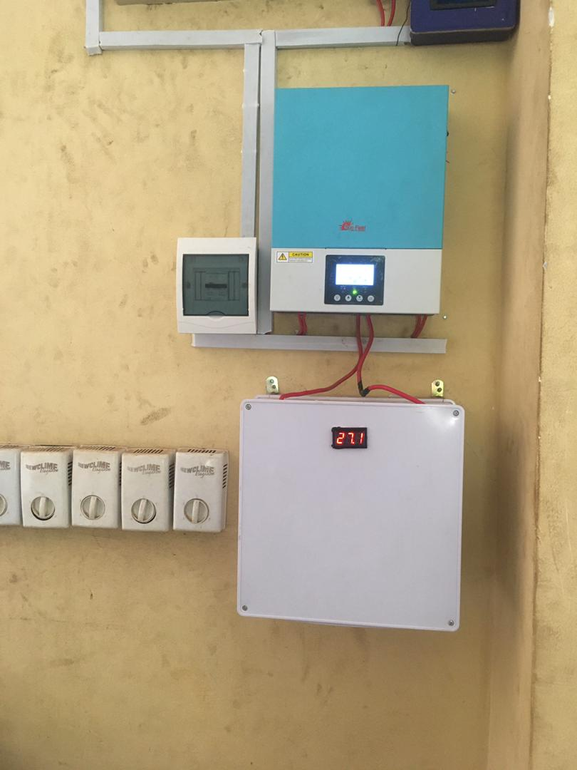
Fig. 4.1 The final picture of the control room displaying the inverter, breaker and the battery

CHAPTER FIVE
CONCLUSION AND RECOMMENDATIONS
5.1 CONCLUSION
This project successfully designed and implemented a solar-powered system tailored to meet the energy needs of an electronic laboratory. The system comprises four 450W solar panels, a 3.2kVA hybrid inverter, a DC breaker for safety, and a 2kW 28V locally made lithium battery. Each component was carefully selected to ensure compatibility, efficiency, and sustainability.
Performance evaluation revealed that the solar system provides stable and reliable power during sunlight hours and offers adequate energy storage to sustain laboratory operations during non-sunlight hours. The system was tested under various load conditions and demonstrated high efficiency, minimal voltage drops, and responsive switching between solar and battery inputs.
In addition to ensuring uninterrupted power supply, the system reduces dependence on the grid and contributes to a cleaner environment by utilizing renewable energy. The design also considers future scalability in case the laboratory’s energy demand increases.
Ultimately, this project aligns with global sustainability goals and offers a replicable solution for similar educational and research-based environments in regions with unreliable grid power.

5.2 Recommendations
Based on the outcomes of the project, the following recommendations are made:
- Regular Maintenance Schedule
It is important to implement periodic maintenance of the solar panels (cleaning dust, checking for loose connections), battery health checks, and firmware updates for the hybrid inverter to maintain system efficiency.
- Monitoring System Integration
Integrating a remote energy monitoring system would provide real-time visibility into system performance, battery status, and load profiles. This will enhance proactive maintenance and energy management.
- Expansion for Peak Loads
If future laboratory operations involve heavier equipment, it is recommended to increase the solar panel array (e.g., adding two or more 450W panels) and consider a battery capacity upgrade to maintain autonomy.
- Surge Protection and Grounding
While a DC breaker was included, further protective measures such as surge protectors and proper grounding of the system are advised to guard against lightning strikes and power surges.

- Awareness and Training
Training the laboratory users on basic operational guidelines, safety practices, and system indicators (e.g., inverter status lights, battery levels) will ensure optimal usage and prevent inadvertent damage.
- Policy Advocacy
Educational institutions are encouraged to adopt similar solutions and lobby for policies that support renewable energy adoption and investment, especially in laboratories and tech-driven departments.
- Documentation and Replication
The project documentation should be shared across departments and other institutions to serve as a reference or template for similar energy needs and installations.

REFERENCES
[1] Kolantla, K., et al. (2020). A Review on Inverter Topologies for Photovoltaic Systems. Discusses the advantages of multilevel and Z-source inverters for renewable applications.
[2] Mohamed, M. A., et al. (2019). Neural-Network-Based Model Predictive Control for Three-Phase Inverters.Proposed an MPC strategy with ANN for improving inverter response and reducing THD.
[3] Isen, Y., & Bakan, A. (2016). Implementation of SVPWM in a 10kW Three-Phase Grid-Tied Inverter. Demonstrated high efficiency and low THD using SVPWM modulation in d-q frame.
[4] Lusis, P., et al. (2020). Droop and Coordinated Control Strategies in PV Inverter Networks. Compared decentralized and coordinated controls for stability in solar systems.
[5] Dzobo, O., Tivani, L., & Mbatha, L. (2023). Smart Inverter Capabilities for DER Integration in South Africa.Reviewed grid stability challenges and smart inverter capabilities.
[6] Hossen, M. Z., & Sadeque, M. (2021). Security and Grid Support Capabilities of Smart Inverters. Highlighted operational vulnerabilities and control features of grid-interactive inverters.
[7] PSC Solar UK (n.d.). Monitoring and Maintenance of 10kVA Solar Inverter Systems in Nigeria. Emphasized the value of system monitoring for operational optimization.
[8] Zarmai, M., et al. (2023). Techno-Economic Evaluation of a Hybrid Mini-Grid System for Academic Institutions. Used HOMER Pro simulation to assess hybrid PV systems for educational settings.
[9] Abdel-Aziz, A., Elgenedy, M. A., & Williams, B. (2023). Comparative Review of Three Different Power Inverters. Compared control techniques, cost, and efficiency of various inverter topologies.
[10] Kibria, M. F., et al. (2023). Review on Transformerless Inverter Topologies for Grid-Connected PV Systems. Investigated leakage current, efficiency, and safety issues in inverter designs.
[11] Patel, H. (2020). Energy Storage Systems and Battery Management. McGraw Hill Education.
[12] John, A. & Williams, M. (2019). “Load Assessment and Design of Solar Systems in Developing Institutions.” International Journal of Energy Research and Technology, 8(4), 112–122.
[13] National Renewable Energy Laboratory (NREL). (2019). Photovoltaic (PV) System Design Basics. Retrieved from www.nrel.gov
[14] Abubakar, S. & Yusuf, M. (2021). “Comparative Study of Inverter Efficiency and Performance in Nigerian Academic Institutions.” Nigerian Journal of Renewable Energy, 12(1), 28-35.
[15] Ibrahim, D. (2020). Practical Guide to DC Breakers, Fuses, and Electrical Safety in PV Systems. TechnoPress.
[16] U.S. Department of Energy. (2021). Best Practices for Solar PV System Installation and Maintenance. www.energy.gov
[17] Okonkwo, C. E., & Ogundipe, O. (2022). “Assessment of Energy Use and Solar Adoption in Nigerian Tertiary Institutions.” Journal of Sustainable Infrastructure and Energy Systems, 10(3), 89-102.
- Liserre, M., Blaabjerg, F., & Hansen, S. (2020). “Design and Control of Hybrid Inverters for Distributed Generation Systems.” IEEE Transactions on Industrial Electronics, 58(1), 23–32.
[19] IEEE. (2020). IEEE Std 1547: Standard for Interconnection and Interoperability of Distributed Energy Resources with Associated Electric Power Systems Interfaces.
[20] Mazumder, S. K., Acharya, S., & Bondyopadhyay, A. (2021). “Design and Optimization of Hybrid Inverter Systems for Institutional Applications.” Journal of Power Electronics and Energy Systems, 6(2), 54-63.

BILL OF ENGINEERING MEASUREMENT AND EVALUATION

COMPONENT QUANTITY UNIT COST (₦) TOTAL (₦)
450W Solar Panels 4 110,000 440,000
3.2kVA Hybrid Inverter 1 380,000 380,000
2kW 28V Lithium Battery 1 500,000 500,000
DC Breaker and Wiring 1 set 10,000 10,000
Total ₦1,300,000

