

PROJECT REPORT

ON

ROUTE SURVEY OF MANDALA/AWE TO ADIGONGO, MORO LOCAL GOVERNMENT AREA,
ILORIN, KWARA STATE

BY:
ADEDEWE VIVIAN ODUNAYO
HND/23/SGI/FT/0115

BEING A RESEARCH PROJECT SUBMITTED TO THE
DEPARTMENT OF SURVEYING AND GEO-INFORMATICS
INSTITUTE OF ENVIRONMENTAL STUDIES

IN PARTIAL FUFILMENT OF THE REQUIRMENT FOR THE AWARD OF HIGHER NATIONAL DIPLOMA (HND) IN SURVEYING AND GEO-INFORMATICS

MAY 2024

CERTIFICATE

I hereby certify that all the information contained in this project report was obtained as a result of the observations and measurements made by me on the field and that the survey was executed in accordance with survey rules, regulations and departmental instructions.

………………..……………………….
ADEDEWE VIVIAN ODUNAYO
DATE ………………………………

CERTIFICATION

This is to certify that ADEDEWE VIVIAN ODUNAYO with Matric No HND/23/SGI/FT/0115 has satisfactorily carried out the survey duties contained in
this project report under my instructions and direct supervision.
I hereby declare that he has conducted himself with the due diligence, honesty and sobriety on the said duties.

…. …………………………………… DATE: …………………………
SURV. R.O ASHONIBARE
(SUPERVISOR)

…. …………………………………… DATE: …………………………
SURV. ISAU IBRAHIM ABIMBOLA
(H.O.D)

…. …………………………………… DATE: …………………………
SURV. R. AWOLEYE (PROJECT COORDINATOR)

………………………………………. DATE: …………………………
EXTERNAL SUPERVISOR

DEDICATION
This project is dedicated to God Almighty and to my Parents MR. AND MRS. ADEDEWE.

ACKNOWLEDGEMENTS
To God be the glory, I owe God a lot for the preservation of my life throughout my stay in school. Also, I thank him for the success of this program.
Special thanks to my supervisor SURV.R.O ASHONIBARE by explaining every aspect of the project and write ups. I also thank him for his encouragement, recommendation and full support towards the success of this project. To all the department Lecturers, I say thank a very big thanks for your fatherly advice and support sir.
My appreciation goes to all my friends whom I will mention few of them MARY, ESTHER, OLAITAN, ALICE, DAMILOLA, NAOMI, FEMI, ZUGLOOL and SAMMUEL, and to my one and only love OLATUNDE SHOREMI.
My sincere appreciation goes to one and my only loving and caring mummy MADAM BISTOLAD OBAINO, MUMMY TOYIN, MUMMY MARY and the entire family members for their concern and generosity throughout my stay in school, May Almighty God reward you all.
To my priceless jewel, my Hero and my irreplaceable.
Also, I want to extend my gratefulness to my group members for their endurance and mutual understanding. I thank all my course mates as well, for their understanding throughout the course.

ADEDEWE VIVIAN ODUNAYO MAY 2025

ABSTRACT
This project was centred on route survey, design and volume computation of Mandala/Awe to Adigongo village Moro Local Government Area Ilorin Kwara state, Nigeria. The project was executed in order to provide relevant information on the route for construction purpose. The survey operations was carried out to achieve the aim; which included reconnaissance, marking of chainage distance, establishment of controls and data capture(geometric and attribute) along the route using a single frequency South Galaxy G1 (GNSS receiver), Together with Topcon (ES-103) total station. The final coordinates were used to produce detail, a profile and cross-section plan, the designing of the route was also done and the volume of earthwork for cut and fill was calculated. Lastly, plans showing the aforementioned drawings were produced in softcopy and hardcopy formats after which a comprehensive technical report was written on the executed project. I hereby recommend that the survey information obtained as well as the route design carried out in the course of this project execution should be used in the construction and rehabilitation of the said route.

TABLE OF CONTENTS
Title page..................................................................................................................…i
Certificate..................................................................................................................…ii
Certification.............................................................................................................….iii
Dedication..............................................................................................................…...iv
Acknowledgements....................................................................................................…v
Abstract.........................................................................................................................vi
Table of contents..........................................................................................................vii
list of tables...................................................................................................................ix
list of figures..................................................................................................................x
CHAPTER ONE..........................................................................................................1
1.0 Introduction.............................................................................................................1
1.1 Background to the study..............….......................................................................2
1.2 Statement of the Problem.....................................................................................…2
1.3 Aims and Objectives................................................................................................3
1.3.1 Aim…….......................................................…....................................................3
1.3.2 Objectives………………………………………………………………………3
1.4 Project specifications...............................................................................................4
1.5 Significance of the project..................................................................….................4
1.6 Scope of the Project……………………………………………………………….5
1.7 Personnel.................................................................................................................5
1.8 Study Area...............................................................................................................6
CHAPTER TWO...................................................................................................… .7
2.0 Literature review..................................................................................................…7
CHAPTER THREE..............................................................................................….16
3.0 Methodology..........................................................................................................16
3.1 Reconnaissance......................................................................................................16
3.1.1 Office planning....................................................................................................17
3.1.2 Field reconnaissance...........................................................................................17
3.2 Data Acquisition……........................................................................................…19
3.2.1 Equipment Used..................................................................................................19
3.3.1.1 Hardware Used.................................................................................................20
3.3.1.2 Software used...................................................................................................20
3.3.2 Control Check.....................................................................................................20
3.3.3 Selection of Station.............................................................................................22
3.4 Field Observation………..................................................................................….22
3.4.1 Longitudinal/Profilling........................................................................................22
3.4.2 Cross Section/Detailling.................................................................................….22
CHAPTER FOUR......................................................................................................23
4.0 Data processing and result analysis........................................................................23
4.1 Data Processing Procedure……………………………………………………….23
4.2 Total Station data downloading and manipulations.......……................................23
4.3 Data Editing………………………………….................................................…..24
4.4 Design and Volume Calculations ……...........................................................…..24
4.4.1 Profile Generation ..........… ..................................................................…25
4.4.2 Calculation of the Volume of the Earthwork .............................................…26
4.4.3 Cut and Fill Analysis ….................................................................................26
4.5 Information presentation/Plan Production …....................................................26
4.5.1 Detail Plan……………......................................................................................27
4.5.2 Longitunal Profile……..……………….........................................................…27
4.5.3 Cross-Section…............................................................................................…..27
CHAPTER FIVE........................................................................................................28
5.0 Costing, Summary, problems encountered, recommendations and conclusion….28
5.1 Project Costing…………………………………………………………………...28
5.2 Summary ...................................................................................................…..…..33
5.3 Problems encountered ......................................................................................33
5.4 Recommendation........................................................................................………33
5.5 Conclusion.................................................................................….….…………...34
References..........................................................................................………………..35
Appendix.............................................................................................…………...…..36
LIST OF TABLES
Table 3.1: coordinates of existing ground controls used….........................................14
Table 3.3.2.1: showing the collected co-ordinates of the controls.......………......…..21
Table 3.3.2.2: The observed coordinate of the controls.…....................................….21
Table 3.3.2.3:.showing the Comparison of observed and computed data ..................21

LIST OF FIGURES
Fig 1.1 Diagram showing location of the study area................................................….6
Fig 3.1 Recce Diagram……………………………………………………………….18
Fig 3.2An Illustration diagram of peg………………………………………………..19

CHAPTER ONE
1.0 INTRODUCTION
1.1 BACKGROUND TO THE STUDY
Engineering Surveying is one of the branches of surveying which from the general express for any survey work carried out in connection with construction engineering and building project, it is a large scale topographical map survey which the basis for design of engineering works such as highways, railways, canals, tunnels, dams, pipelines and transmission lines.
In the word of engineering and environmental studies, surveying has been recognized as the inevitable operation been described as be the bedrock of every meaningful development. The greater part of its responsibility is seen from the various types of surveying which are all geared toward promoting route ways, convenience, accessibility and spatial declination of both natural and social environment. In addition, surveying means the activities of planning, designing, constructions, development and rehabilitation of roads, depending on the survey data required by the surveyor.
Route survey which is an aspect of engineering survey may be defined as the survey operation that is done for the establishment of the horizontal and vertical alignment of transportation facilities. It involved: planning, design and setting out of any route such as railways, highways, pipelines and canals etc. as obtained by a surveyor and it also involved the proper assessment of natural and man-made features.
In addition, this type of survey should be applied when there is need for alignment, expansion, or rehabilitation at any existing route (road) e.g. for traffic purposes. The reason is that route survey provides a plan/map that shows the alignment, details, profile and cross sectional leveling which depicts the nature of the terrain of a given strip of land which serves the purpose of location, design and construction of route networks.
Good road network is one of the basic amenities needed by human being as movement is one of the characteristics of living things. There are needs for people to move from one place to the other and transportation of goods and services. Therefore for any meaningful development in a country, good road is a must.
1.2 SIGNIFICANT OF THE PROJECT
It was discovered that the route from Mandala/Awe to Adigongo village moro Local government Ilorin, Kwara State, had been badly eroded and full of potholes; also, the road is found to be too narrow and needed to be extended considering the volume of traffic plying the road. Rehabilitation of this road should be carried out in other to increase its carrying capacity thereby increase the physical development and human activities therein. Due to these, certain information about the road must be acquired which calls for route survey so as to get the baseline data necessary for the road design.
The main aim of this project is:
To carry-out Route Survey of Mandala/Awe to Adigongo Village road in Moro local government area, Ilorin, Kwara State
1.3 AIM(S) AND OBJECTIVES
1.3.2 OBJECTIVES
In actualization of the said aim of the project, the following objectives
Were followed sequentially:
- Reconnaissance which include office planning and field reconnaissance.
- Identification of existing features and adjoining roads.
- Stability of the ground controls to be use for orientation.
- Determination of centre line and marking of chainages along the centre line at an interval of 25m.
- Marking out some selected points for the cross-sectioning at intervals of 8m, 4m to the right and left on the profile and also the edges of drainage was marked.
- Leveling to determine the height of some selected points along the road.
- Detailing by the use of Topcon (ES-103) total station
- Plan production (graphical representation of the horizontal, vertical and cross sections ) drawn with appropriate scale.
- Reports write up.

1.4 PROJECT SPECIFICATIONS
The following are the specification to be ascertained in the project:
Traverse must commence on two coordinated (known) controls and closed on another set of two coordinated controls which must be confirmed undisturbed by necessary measurement (control checks).
Establishing traverse points by using pegs together with nails and bottle corks.
Spirit leveling must commence on a known benchmark and closed back on another known benchmark. Formulae for its misclosure are ±24mm√k, where ‘k’ is the total distance covered in kilometers.
Leveling must be observed at every 25m intervals on the centre line and at 6.50m intervals on both sides of the centre line for the cross sectioning. Edges of drainage at both sides should be heightened.
Fixing of relevant features to enhance assessment and necessary composition for good interpretation of plan.
Setting out curve by using Total Station (Topcon ES-103). within third other survey.
The accuracy of the project must fall within the order of the project.
1.5 SCOPE OF THE PROJECT
The entire project covered the following:-
Reconnaissance (both office planning and field reconnaissance).
- Data acquisition:
(a) Selection of stations.
(b) Traverse angular observation and data recording.
(c) Linear measurement with the aid of Dumpy Level.
(d) Topcon TotalStation for traverse centre line and adjacent sides (longitudinal or profile and cross sectioning).
(e) Fixing of details by tacheometry method.
(iii)Computations to determine:
(a) Horizontal coordinates (i.e. x and y coordinates)
(b) Vertical coordinates (i.e. z coordinates) by level reduction.
(c) Setting out angles and distance for the curve.
2. Data analysis i.e. comparing result obtained with the required accuracy.
3. Data presentation :
(a) Production of horizontal alignment (i.e. plan showing existing features and the propose route).
(b) Production of longitudinal section plan
(c) Production of cross section plan
(d) Project report writing: - This involves writing of detail report in connection with entire project done in conformity with the outline given by the project supervisor.

1.6 PERSONNEL
The underlisted students of HND II 2024/2025 set are the personnel that participated in the execution of this project. They are:
ADEDEWE VIVIAN ODUNAYO HND/23/SGI/FT/0115 ( WRITTER)
PIUS RACHEAL NAOMI HND/23/SGI/FT/0087
OMOLABI MARVELOUS TAIWO HND/23/SGI/FT/0089
FADUMILA KAYODE OLUWATUBOSUN HND/23/SGI/FT/0082
MOHAMMED NAFISAT HND/23/SGI/FT/0088
Akinpelu Olashile Ridwan HND/23/SGI/FT/0085
AHMED SAHEED TOYYIB HND/23/SGI/FT/0084
ADEDEWE VIVIAN ODUNAYO HND/23/SGI/FT/0115
YAKIN RAUF OLUWAFEMI HND/22/SGI/FT/0118
1.7 PROJECT AREA
The project site is the route of Mandala/Awe to Adigbongbo Village Moro Local Government Area Ilorin Kwara State. It cover approximately 3.5km extent of land. With geographical coordinates of :
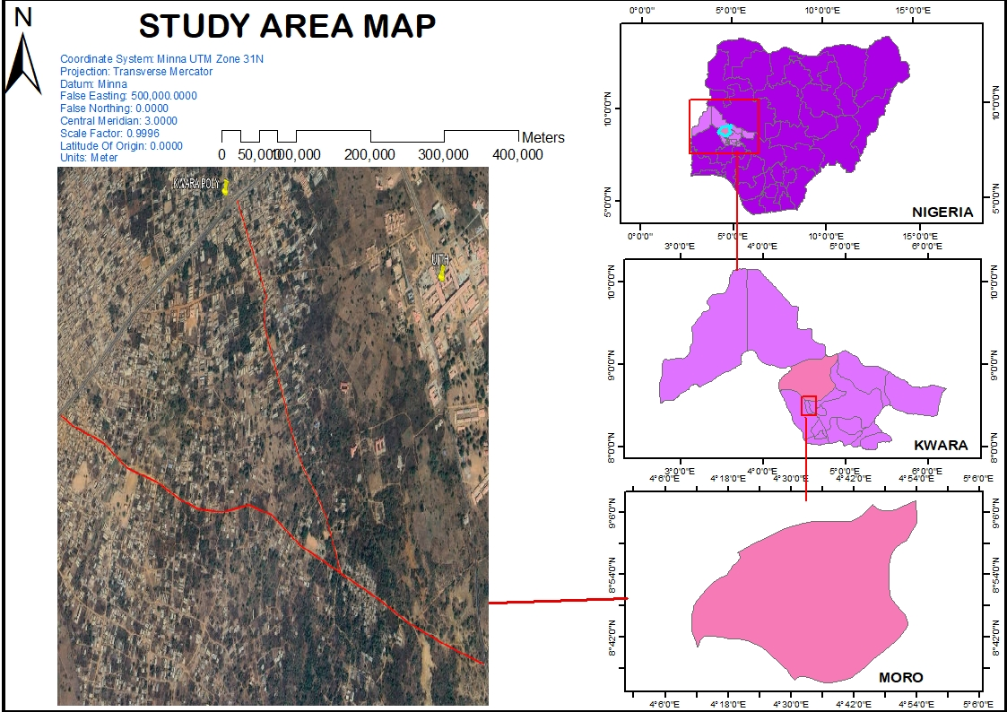
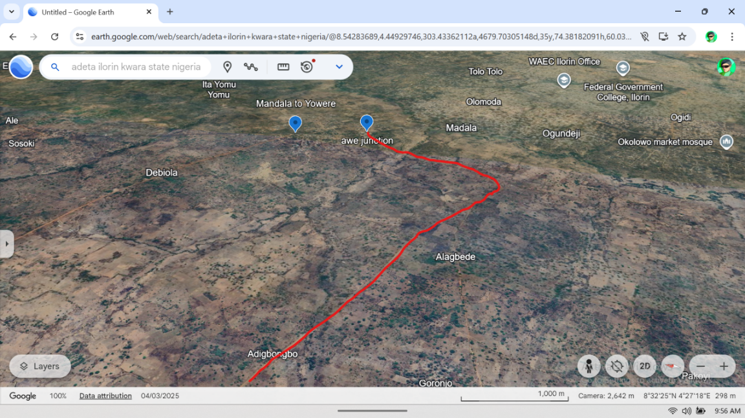
Long. 004°28’07”
Lat. 008°32’55”
Long. 004°28’07”
Lat. 008°32’55”

Fig 1.1: Study Area
Source:-GoogleEarth

CHAPTER TWO
2.0 LITERATURE PREVIEW
Transportation is the movement of people and goods from one location to another. Throughout history, the economic wealth and military power of a people or a nation have been closely tied to efficient methods of transportation. Transportation provides access to natural resources and promotes trade, allowing a nation to accumulate wealth and power.
Transportation is vital to a nation’s economy. Reducing the costs of transporting natural resources to production sites and moving finished goods to markets is one of the key factors in economic competition
Transportation systems and the routes being used have greatly influenced both how and where people live. The route of the transportation system could be inland waterways, air, road, railway, tunnel, etc. Before transportation can come into existence, adequate documentation of the route through spatial information cannot be underestimated during the planning stage.
Surveying is very important for planning and as well for acquisition of the required data for route alignment, with special attention on road network, for rehabilitation and construction of roads.
Route Surveying is such a survey exercise that requires all field works and calculations made for the purpose of locating and constructing a cross country social utilities such as highways, railways, canals, transmission lines and pipelines. This involves the determination of the ground configuration and location of physical features (naturals and man-made) along the route, establishing the line on the ground and computing the volume of earthwork.
The main purpose of any route survey is to:
- Select one or more tentative general route for the roadway or utility
- Gather enough information about the general route to make it possible for the route designers to select the final location of the route, and
- Mark this final location selected from the available options.
With these purpose, route survey usually entails reconnaissance, preliminary and final-location survey phases that satisfy respectively, each of the purposes given above. Sometimes, the prevailing circumstances may preclude the requirement to perform all three phases; for example if a new road or utility line is to be constructed on a military installation, having a well-marked vertical and horizontal control networks and up-to-date topographic maps and utility maps, then the reconnaissance and preliminary survey phases may not necessarily be required.
Maury (1969) explained route surveying as the constructional processes and procedures involved in the production and the design of a route, such as roads, pipelines, railways and transmission lines. Hence, the improvement in the economy has constituted tremendous increase in population of vehicles, advancement in construction technology, trained professionals and emergence of caterpillars. Therefore, it becomes necessary to contract safer and more comfortable and serviceable roads.
Punmia (2005) explained route surveying in one of his quotations as surveys along a comparatively narrow strip of territory for the location, design and construction of any route of transportation, such as highways and railroads, aqueducts, canals and flumes, pipeline for water, sewage, oil and gas, cableways, belt conveyors and power, telephone and telegraph transmission line is called ‘ROUTE SURVEY’. At this stage, it must be noted that the examples mentioned above cannot design themselves until some methods are used to make them refined.
It is worthy to note the construction of roads in Nigeria dated back to decades ago or during colonial era; roads are commonly found narrow till now, few are found serviceably and their horizontal and vertical alignment are much influenced by their topography. The road construction was then constrained by non-availability of earth moving equipment, limited funds, no skillful personnel and fewer numbers of vehicles on roads.
Anderson and Mikhail (1985) said that; route survey as well as topographical and construction surveys are necessary for location and construction of transportation lines such as highways, railways, canals, transmission lines and pipelines.
The execution of route survey entails four (4) basic processes as far as data acquisition is concerned. These could be outlined as follows;
- Traversing
- Leveling
- Detailing
- Curve designation
Traversing as defined by Ramsey (1977), is the establishment of point on the earth surface by determining its bearing and distance from another known point. Also, traversing consists of measurement of angles between successive lines (or bearing of each line) and length of each line, giving the coordinate of the first station, the bearing of the first line, and the coordinates of all successive point can be calculated.
Allan (1980) described traversing as the determination of length and direction of line between points in a sequential order on the earth surface in order to establish the position of point. It has a series of control points (stations) each one been intervisible with its adjacent station chosen to fulfill the demand of the survey, the line joining the stations being traverse has series of connected straight lines whose lengths and directions have been determined.
Basak (2000), defined leveling as the art of determining the relatives vertical height of different points on the surface of the earth, therefore in leveling, the measurement are taken only in vertical plane. The newly determined heights of points are referenced to a predetermined datum of known height.
Clark (1977) explained profile leveling as term used to describe the fieldwork involved in surveying, a longitudinal section of route to be surveyed; the profile leveling may be at regular interval such as 25m or 30m which would be a continuous process until the closing station is reached. Clark also explained that cross-section leveling is the level run to determine the height of points on both sides of the centre line.
There are various methods by which details could be fixed in surveying, these are:
- Tachometry method
- Chain survey method
- Plane table survey method
- Compass survey method
Vincent Tao (2000), stressed that “the construction of a highway route could be done using mobile mapping system which involves mounting more than one camera on a mobile platform”. Thus, from the explanations above, it can be inferred that the survey of a long route centre will be more easily done with the use of advanced techniques e.g. remote sensing and photogrammetric method.
More so, certain procedures or method are used when carrying out a route survey explained by Basak (1994) that when the question of constructing a new road for public demand or some strategic reasons arises, the procedures to be taken are:
- To find the necessity for the existence of the road
- The marking of the tentative alignment
- The reconnaissance survey
- Preliminary location survey traverse
- Final location survey and report
He further explained that the tentative alignments are marked on the general map and contour map and contour map of the area through which the route is expected to pass.
Meanwhile, in every construction work, the surveyor stands to perform certain roles and also must be familiar with some procedures of the work at hand as at the time of execution.
In view of the foregoing, Anderson (1985) stressed that “In order to plan and perform, the surveyors needed to acquire the data of a route survey and the surveyor must be familiar with the following:
- The geometry of horizontal and vertical control and how they are used in the route alignment procedure.
- The methods of acquiring terrain data utilized in route design.
- The procedures followed in processing terrain data to obtain earth work volumes
- Establishment on the ground, a system of staves both in plane and elevation, from which measurement of earth work and structures can be taken conveniently by the construction force
- Giving lines and grades as needed either to replace stakes disturbed by construction or to reach additional points on the structure itself.
- Making measurements necessary to verify the location of completed part of the structure as-built survey.
In addition to the above, the surveyor in concern must also learn or be familiar with the reasoning and interpretation of maps, the symbols and signs, scales, directive, locations etc. certain parameters therefore are necessary to explain routes e.g. cross section, longitudinal sections, curves and setting out etc.
Duggal (2006) defined curves as arcs with some finite radius, provided between intersecting straights to gradually negotiate a change in direction. He classified as horizontal or vertical curves, the former being in the horizontal plane and the latter in the vertical plane.
According to a U.S based website homepage, circular curves are used to join intersecting straight lines (or tangents), they are usually assumed to be concave. It was explained that horizontal curves are classified into four (3) major types i.e. simple curve, compound curve and reverse curve.
Furthermore, it was explained that laying out circular curves must follow the following procedures.
- Select tangents and general curves making sure you meet minimum radius criteria.
- Select specific radii spiral and calculate important points using formulae or table, those needed for design, plans and lab requirements.
- Station alignment as curves are encountered
- Determine super and runoff for curves and put in table.
More so, he further stressed that the elements of a circular curve are point of intersection, tangent, point of curve, point of tangent, radius, long chord, external ordinate, internal ordinate, curve length, and the apex angle. He also said that a curve may be designated either by its radius or degree of curve.
In his quest to explain the methods of setting out of circular curves, he said that the various linear methods of setting out a simple circular curve are;
- Offsets from the long chord
- Perpendicular offsets from the tangents
- Radial offsets from the tangent
- Successive bisection of arcs
- Offsets from the chord produced
He also said that the angular methods are:
Rankine method of deflection angle, one Theodolite method
- Two Theodolite method
- Tachometric method
In the laying out of simple curves, some obstacles are usually encountered, on this note; Duggal (2006) explained that the obstacles in laying out simple curves are:
- When the complete curve cannot be set out from point of curves i.e. obstruction to vision
- Obstacles to chaining
- When the point of intersection is inaccessible
He explained that a compound curve is a combination of two or more simple circular curves with different radii.
According to The Transit, New Zealand State Highway Geometric Design Manual May, 2005. A horizontal road alignment is a usually series of straights (tangents) and circular curves. Transition curves are often used to join straight sections smoothly into circular curve sections.
A curve should normally be used whenever there is a change of direction in a road alignment and must be of sufficient length to avoid the appearance of a kink in the road alignment.
Small changes in alignment are not usually noticed by drivers and in some cases it might not be necessary to provide a curve between adjacent straight tangent sections of road, provided they do not produce a kinked road alignment.
Horizontal road alignments without significant straight sections are described as curvilinear. A curvilinear alignment normally has:
- long, large radius circular curves, with or without spiral transitions, and
- Occasionally, other types of curves which conform to polynomial mathematical relationships.
Curvilinear alignment is most suited to dual carriageway roads but can also be successfully used on two-lane roads in flat and undulating terrain, providing overtaking provisions are not impaired. The horizontal curves of a curvilinear alignment are generally of large radius and:
- do not normally restrict overtaking opportunities,
- help reduce headlight glare, and give drivers a better perception of the speed of approach of opposing vehicles.
Makanjuola (1998) in his write up said principally because of employment opportunities, there have been a continued migration of people from the rural areas to the big urban centers, the result of this is higher road traffic and congestion. This is a very big factor causing most highways route reconstructions.
Asere (1998) also said that the situation of roads today indicate that while the construction of roads were conceived, vital parameters in the final execution of the roads were not taken into account.
He further explained that “the use of multiple culverts instead of bridges in areas of heavy rainfall is very inappropriate, construction of specific bridges in place of washed culverts are suggested to minimized or stop the reoccurrence of the type of disaster witnessed on these roads”.
2.2 CONCEPT OF ROUTE SURVEYING
Route surveying refers to the process of determining the most suitable path for constructing transportation infrastructure. It involves detailed fieldwork, data acquisition, and computation of earthwork volumes to ensure safe, efficient, and cost-effective road alignments (Maury, 1969). According to Punmia (2005), route surveying is conducted along a narrow strip of land to define the horizontal and vertical alignment of highways, pipelines, and other linear infrastructure projects.
The primary objectives of route surveying include:
- Selecting the most feasible route for the transportation project.
- Gathering sufficient topographical and spatial data to aid in design and construction.
- Establishing control points, profiles, and alignments for accurate execution of the project.
The execution of a route survey typically involves reconnaissance, preliminary survey, and final location survey. Each stage is crucial for ensuring the accuracy and feasibility of the project (Anderson & Mikhail, 1985).

2.3 CHALLENGES IN ROUTE SURVEYING
Despite advancements in surveying technology, several challenges affect route surveying and road construction, particularly in developing countries like Nigeria. These include:
- Poor road planning: Many roads are designed without adequate consideration of topography and environmental factors (Asere, 1998).
- Inadequate equipment: Limited access to modern surveying tools such as GPS, drones, and GIS affects accuracy.
- Lack of skilled personnel: Shortage of trained surveyors and engineers leads to inefficiencies in route alignment and construction.
- Environmental constraints: Swamps, mountains, and water bodies pose significant challenges in route selection and construction.

2.4 MODERN TECHNIQUES IN ROUTE SURVEYING
Technological advancements have improved the efficiency and accuracy of route surveying. These include:
- GPS and GIS Mapping: Provides high-precision location data for route alignment.
- Remote Sensing and Drones: Enables quick data collection over large areas.
- Mobile Mapping Systems: Uses cameras and sensors to capture real-time spatial data for highway design (Vincent Tao, 2000).

2.5 HOW THIS STUDY INTEND TO ACHIEVE ITS AIM
To achieve the objectives of this project, the following approach will be adopted:
- Data Collection:
- Conduct field surveys using Total Station and GPS for accurate data acquisition.
- Utilize GIS software for spatial analysis and mapping of the proposed route.
- Perform leveling and detailing to determine terrain features and elevation profiles.
- Data Analysis:
- Process collected data using AutoCAD Civil 3D and GIS tools for route alignment design.
- Apply mathematical models to compute earthwork volumes and curve parameters.
- Route Selection and Design:
- Evaluate multiple route options based on topography, environmental factors, and economic feasibility.
- Design the final route alignment, incorporating safety measures and engineering standards.
- Validation and Recommendations:
- Compare results with existing road networks to assess accuracy.
- Provide recommendations for improving route surveying methodologies in Nigeria.

2.6 CONTRIBUTION OF THIS STUDY TO LITERATURE.
- This study contributes to existing knowledge by:
- Evaluating the effectiveness of modern surveying techniques in route alignment.
- Identifying the challenges associated with traditional route surveying methods.
- Proposing improved methodologies for accurate and cost-effective route surveying.
- Providing a case study on route surveying applications in Nigeria’s transportation sector.

2.7 CONCLUTION
This chapter has reviewed the principles, methods, and challenges of route surveying, as well as advancements in modern techniques. The study aims to apply these concepts to improve route alignment and road construction efficiency. By integrating traditional surveying methods with modern technologies, this research will contribute to more effective and sustainable transportation planning.
This revised version includes:
A clearer structure with subheadings for readability.
Your study’s contribution to literature.
A detailed explanation of how you intend to achieve the project’s aim.
CHAPTER THREE
3.0 METHODOLOGY
Methodology comprises of the method and procedure employed in executing the project both in office and on the field. The method adopted for this project was based on the principle of surveying which was working from whole to part, aim at acquiring reliable and accurate data needed for the computation and presentation of information in form of a plan.
The procedure adopted in carrying out the project followed a pattern in which one step leads to another, for easy execution and for the aims and objectives of the project to be realized, it was planned as under listed;
- Reconnaissance survey
- Chainage marking
- Control establishment
- Data acquisition
- Data downloading and processing
- Data analysis
- Road design
- Information presentation
3.1 RECONNAISSANCE
This is a very important aspect of surveying that involves planning and preliminary inspection of the area before the commencement of the actual data acquisition of the project site, this is done for the purpose of planning on how to execute the project, fixing stations, locating controls etc. its importance to the actual survey operation that cannot be underestimated as it enable it to give the best method to carry out the task.
The two phases of reconnaissance are;
- Office planning
- Field reconnaissance
3.1.1 OFFICE RECONNAISANCE
This involved the office work carried out before the actual field work. This aspect involved the computation and study of the available information the project site as this helped in yielding result within the expected accuracy. It comprises of the following
- Understanding the purpose of the survey from the project instructions.
- Obtaining the specification for the accuracy required leading to the choice of a suitable scale.
- Deciding the method to be employed for the measurement.
- The kind of instruments to be used in executing the project.
The coordinates of control stations around the project area were collected from the SOUTH GALAXY G1 (GNSS receiver).
Table 3.1 coordinates of the existing ground control used origin (U.T.M)
Control id | Easting  (Nm) | Nothing (Nm) | Height (m)
BM1 | 661425.0232 | 945950.9002 | 324.7349
BM2 | 661402.8991 | 945939.4238 | 324.8356
BM3 | 661457.0369 | 945934.9219 | 324.0516

3.1.2 FIELD RECONNAISSANCE
The field reconnaissance was done after the office planning it involved a visitation to the project site by all the group numbers to have a pre requisite knowledge of how it looks like and how the field operations would be carried out.
During the visit the control pillars planned to be used were located, traverse stations which were to form the traverse framework were selected and marked using pegs and nails, inter visibility between successive traverse station were ensured.
At the end of the visit, a sketch diagram known as “recce diagram” showing the physical appearance of the project site was drawn.
To sum up the reconnaissance facilitated the planning and execution of the actual survey as it was taking into consideration the possible problems that are likely to be encountered, how such problems can be overcome or reduced to the barest minimum.
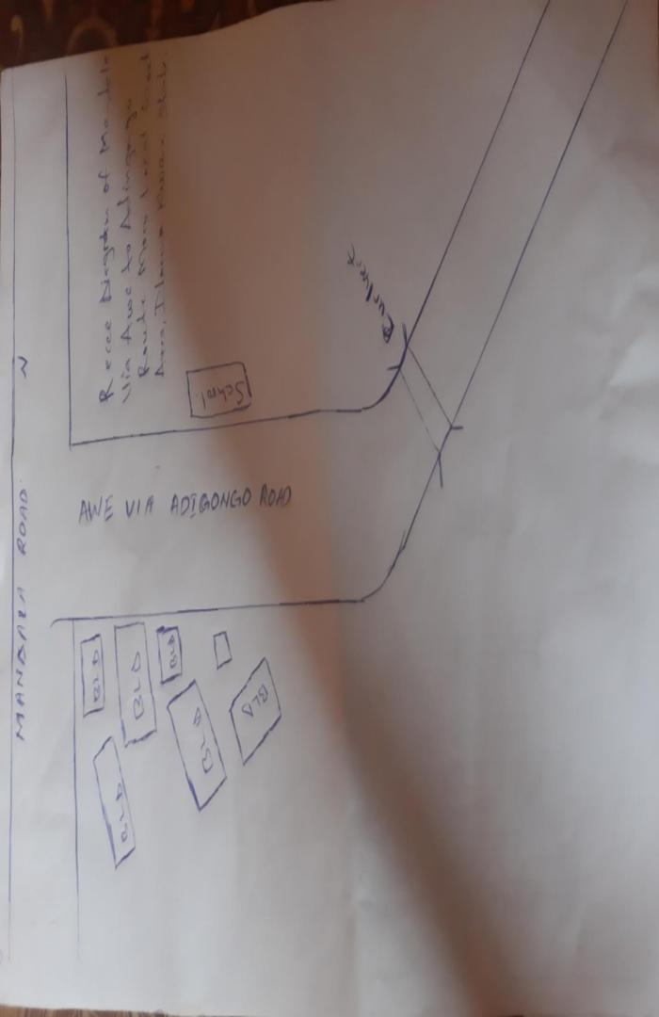
Fig. 1 Field Recci diagram Mandala Via Awe to Adigongo Route.

3.2 A TYPICAL PEG USED
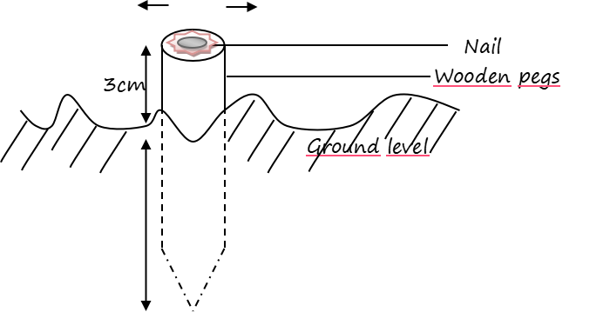
Fig 3.2 An Illustration diagram of peg
3.3 DATA ACQUISITION
This entails all activities involved in the collection of data for the successful execution of the project. This was carried out in chronological order using mode digital surveying equipment such that: they were coordinated using Topcon(ES-103) total station, the position of the center line was determined using Topcon(ES-103) total station and also both national and man-made features were observed and determined.
3.3.1 EQUIPMENT USED
- Topcon (ES-103) total station
- Tripod stand
- S50mm steel tape
- 5m packet tape
- Plumb pop
- Nails with crown corks
- Downloading cables
- Writing materials
3.3.1.1 HARDWARE USED
The hardware used for this project includes.
- Laptop computer for data processing
- An Hp desk set for the printing of hard copy
3.3.1.2 SOFTWARE USED
- Note pad
- Microsoft excel 2010
- Civil cad 2010
- Hp printer devices

3.3.2 CONTROL CHECK
The essence of carrying out the operation was to ascertain the reliability of all the controls used for the project whether they were in situ. The check was carried out by setting total station instrument on BM1 and all the necessary temporary station adjustment(i.e catering; leveling and focusing) was carried out, the reflector at back station on BM2 was then bisected, read and recorded, the instrument was turn to fore station BM3 and the reflector was also bisected read and recorded and on getting to every 500m interval where there are 2 benchmarks on the both side of the road same procedures where adopted in until the end of the road.
The coordinates obtained were compared with the coordinates extracted from the use of SOUTH GALAXY G1(GNSS receiver) which the result shows that the discrepancy was very little and lower than the allowable standard for the specification of this project which shows that BM1, BM2 and BM3project were reliable enough for the third order survey project given.
Table 3.3.2.1 showing the collected co-ordinates of the controls
STATION | EASTING (Nm) | NORTHING (Nm) | DISTANCE (M) | BEARING
BM1 | 661425.0232 | 945950.9002 | 324.7349
BM2 | 661402.8991 | 945939.4238 | 324.8356 | 179⁰14’ 9”
BM3 | 661457.0369 | 945934.9219 | 324.0516 | 24⁰27’ 53”
Source: Supervisor (May 2025)
Table 3.3.2.2 showing the observed co-ordinates of the controls
STATION | EASTING (Nm) | NORTHING (Nm) | DISTANCE (M) | BEARING
BM1 | 661425.0232 | 945950.9002 | 324.7349
BM2 | 661402.8991 | 945939.4238 | 324.8356 | 179⁰14’ 9”
BM3 | 661457.0369 | 945934.9219 | 324.0516 | 24⁰27’ 53”
The included angle = bearing of bm2 to bm1 minus bearing of bm2 to bm3

Table 3.3.2.3.showing the Comparison of observed and computed data
 | Bearing | Back dist (m)
Computed value | 179⁰ 14’ 09” | 220.590
Observed value | 24⁰ 27’ 53” | 14.6427
Error | 00⁰01’ 06” | 0.006

For the control points, the allowable heights misclosure were lesser than obtained misclosure for each control point. There, the set of controls (bm1, bm2and bm3) were in situ vertically and could be used as benchmark for height determination of profile and cross sectional points.
3.3.3 SELECTION OF STATION
The station selected were ensured to be inter visible to each other, accessible and firmly pegged to the ground with wooden pegs and bottle corks carrying mills at the centre point to denotes its exact point on the earth surface.
3.4 FIELD OBSERVATION
3.4.1 HORIZONTAL ALIGNMENT
This way carried out on loops with the aid of Topcon (ES-103) total station which has the capability to capture all the three dimensional (3d) terrain characteristics (easting, northing and height) concurrently. To control swing, the observation we carried out by commencing it on a set of controls and ending on another control from loops.
The instrument was set up on Bm2 and the reflector was placed on Bm1and the orientation was performed, the reflector was placed at change 0+000, which was the starting point of the route survey. The chainage 0+000 served as nail.
The target (reflector) was properly leveled and the coordinate of all the changes in the direction were observed and recorded in the internal memory of the instruments; other points which were visible from this instrument station were bisected and coordinated. This was done repeatedly until the entire section of the route was covered.
3.4.2 LONGITUDINAL / PROFILING
This was carried out with the aid of Topcon (ES-103) total station as well. The instrument was set on Bm2 and the reflector was placed on Bm1and the orientation was at every 25m interval. Whenever the target from the instrument station is too far and cannot be sighted from the instrument which might affect the accuracy of data, another stations were coordinated station where same procedures were repeated until all the data were captured.
12cm
3cm
Nail
Ground level
Wooden pegs

CHAPTER FOUR
4.0 DATA PROCESSING AND RESULT ANALYSIS
4.1 DATA PROCESSING PROCEDURE
This is the process that follows downloading of data into the computer system. It is the manipulation of data into a more used form. Data processing includes numerical calculation, classification of data and the transmission of data from one place to another.
This stage involves downloading of the acquired data on field from the digital equipment (total station) to the personal computer for further processing.
The data obtained using Topcon(ES-103) total station were downloaded in sequential arrangement. After successful download and process using notepad for sorting them into desired arrangements.
The file was opened and point data were displayed. This was then copied to Microsoft excel environment for further processing.
On Microsoft excel, data were prepared for scripting purpose in AutoCad. A small program was written to prepare point and text scripts files.
The coordinates obtained were x,y,z format which were used for plotting the routes longitudinal profile and cross sections.
4.2 TOTAL STATION DATA PROCESSING
The downloaded data from the total station was further edited using Microsoft excel, the final copy was saved as text file containing x,y,z coordinates of all points observe in the field.
4.3 DATA EDITING
Data editing is done using the Microsoft excel. The following steps are followed to edit our data in the project:
- The Microsoft excel was lunched.
- Click on file, the click on “all file” and select the group data.
- On open “test import wizard”, select “delimitated” and click on next.
- Select comma, tap and space then click on next. All the co-ordinates will be arranged then click on finish.
Cut and copy and put them in its appropriate positions if there is any misclosure.

4.4 DESIGN AND VOLUME CALCULATIONS
The design of the route was done after the creation of the longitudinal profile. The longitudinal profile was created using AutoCAD Civil 2012. The steps in the creation of the longitudinal profile are as follows:
- The Centerlines of the entire data is first extracted and arranged in Microsoft Excel and saved with the extension txt.
- The AutoCAD Civil 2012 Software is launched.
- A new project is created and named
- The Units icon is clicked to set the units of the drawing as follows:
- Length
- Type- Decimal
- Precision- three (3) places (i.e., 0.000)
- Insertion Scale
- Units to scale inserted content- Meters
- Angle
- Type- Deg/Min/Sec
- Precision- 0d00’00”
- The Clockwise Box below is clicked

- The Direction icon below is clicked and a direction control dialogue box is opened. The North is selected.
- The icon Points is clicked, the point settings are selected. The Coordinates icon is clicked to select the method of data arrangement (i.e., Easting-Northing). The type of Marker is also selected.
- Under the point icon, the import/export point icon is selected.
- The import point’s icon is selected. A dialogue box opens, the format in which the data is arranged is selected (E.g., ENZ (space delimited)). Also, the source file where the data is saved and ok is clicked to continue.
- The points are imported and are joined with the polyline drawing icon on the AutoCAD Civil 2012 Environment. The OSNAP (object snap) below the AutoCAD Civil 3D 2012 Environment is switched on so as to highlight the endpoints for ease of joining the points.
- On the Alignment icon, the icon define from polyline is selected.
- The line is clicked and where the alignment is to start is also clicked; a dialogue box opens and the alignment is named.
- On the Alignment icon, the station label settings is clicked; the station label increment, station tick increment and the station label offset are edited appropriately. The perpendicular labels and plus sign location are also clicked. Then the station labels are also created.
- The Terrain is created by clicking on the Terrain icon, Terrain Model Explorer is selected. A dialogue box opens; a new surface is created and named. The point files are added, the format in which it is arranged is selected as well as the file where it is located. The surface is built by right clicking on it and select build. When the surface is built, the dialogue box is closed.

4.4.1 PROFILE GENERATION
On the Profile icon, sampling is selected and import is clicked. The Tangent Labels, Vertical Curve Labels and the Vertical Grid Lines values are edited appropriately. The created surface is made current by clicking on surfaces and set current surface. The profile is sampled by clicking on existing ground, sample from surface and accepting the beginning and ending stations. Then the profile is created by clicking on create profile, full profile is selected; a dialogue box opens where the grid height is adjusted and ok is clicked.
When the profile is created, the route is designed by first creating the Tangents along the route and the Vertical Curves are created by selecting the incoming and outgoing tangents and inserting the K- Value (see appendix).

4.4.2 CALCULATION OF THE VOLUME OF EARTHWORK
One of the applications of survey products (profile and cross section) is in determining the estimate of the volume or quantity of earthworks, it is necessary to know the volume of materials which would be required to cut and to fill in road construction. For the scope of this project, the volume and fill were determined from the cross section using AutoCAD land development software. This is done also for subsequent cross-sections and the volume is cumulatively summed up to obtain the final cut and fill (see appendix)

4.4.3 CUT AND FILL ANALYSIS
This is an important aspect in route survey data analysis. The volume of earthwork needed can be calculated to a high degree of accuracy. It helps in the area of project costing to determine earthwork and materials quantity. The cut and fill table is shown in the appendices. The total cut was estimated to be 16803.12m3 while the total fill is estimated to be 10563.82m3. Having subtract the total fill from the total cut, therefore, the volume of material needed to be cut is 6239.30m3
Refer to the appendix for the entire cut and fill data (Appendix).

4.5 INFORMATION PRESENTATION/ PLAN PRODUCTION
The adjusted coordinates (X, Y, Z) were plotted in AutoCAD Civil 2012 Environment to generate the centerline of the road, longitudinal profile and cross-section. The details were also plotted.

4.5.1 DETAIL PLAN
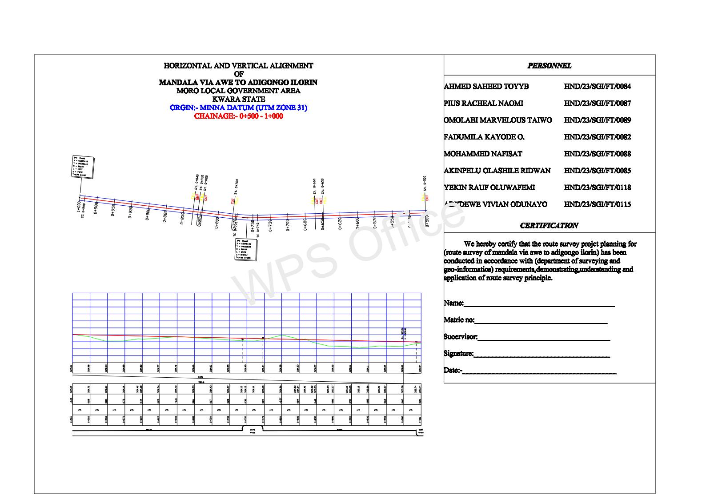
The essence of obtaining a detail plan is to provide a platform for horizontal curve and alignment design for the road expansion/rehabilitation. Geometric information is also shown on the detail plan making a vivid representation of the land mass for easy understanding of the route.

4.5.2 LONGITUDINAL PROFILE
Profile was generated to provide vertical height/terrain information along a route for vertical alignment/curve design. It provides a vivid picture of the terrain and decisions of where to cut or fill was determined. It provides information such as the grade percent, tangent points, existing level and formation level.
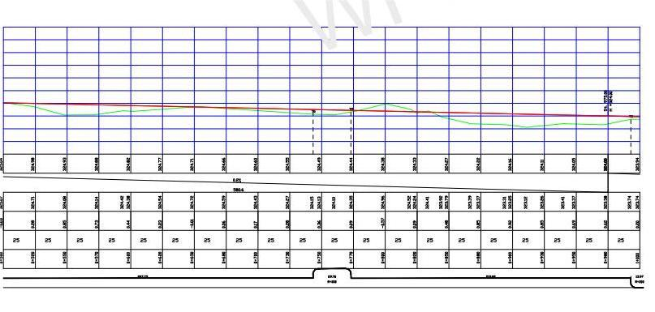

4.5.3 CROSS-SECTIONS
Cross-section depicts the terrain information across the road chainage. Information such as the height of existing and proposed center line and embankments were shown. The cross-section parameters were used to generate the area and hence, volumes of earthwork in cut and fill analysis (see appendix).

Earth drain Earth drain

Concrete drain

Earth drainage was used throughout except where we have culvert, concrete drainage was used 150m before and 150m after each culvert, the culvert used was 800mm by 800mm because the volume of the water that will be flowing there is much. The concrete drainage used was 0.10cm thick and 0.60cm by 0.60cm for easy flowing of waters.

Having carried out the flying method to checks on the linear accuracy of the closing control, it was discovered that the linear accuracy conforms with third order accuracy which show that the closing controls could still be used for this project.

CHAPTER FIVE

5.0 COSTING, SUMMARY, PROBLEM ENCOUNTERED, RECCOMENDATIONS AND CONCLUSION
5.1 PROJECT COSTING
To achieve this, the various project parameters were considered and their cost calculated to arrive at the total cost of the project. The costs are determined according to the project phases which are as follows;
- Reconnaissance
- Field operation
- Data Processing
- Information presentation

Each of these aspects was cost based on the following components
- Personnel
- Equipment
- Transportation
- Accommodation
- Beaconing

COST AND ESTIMATION
1(a) RECONNAISSANCE

Duration (Estimated number of days = 2)
Personnel Daily Rate ₦ Amount ₦
1 Senior Surveyor 25,814.00
1 Technical Officer 20,542.00
4 Skill Laborers 5,078.00

1(b) Transportation
Field Vehicle + Driver
Mechanic + Fuel 20,162.24

1(c) Accommodation Feeding

Feeding for six person ₦10,000.00
TOTAL COST FOR RECONNAISSANCE ₦153,339.28

FIELD OPERATIONS
Duration Estimated (Number of days) = 1
2(a) MONUMENTATION

Personnel Daily₦Amount ₦
1 Assistant Tech. of Officer 18,542.00
2 Labourers 4,076.00
3,000 Standard pegs 400.00
Transportation
Field vehicle + Driver
Mechanic + Fuel 20,162.24
Basic Tools (Digger, Shovels,
trowels, nail, hammer etc.) 15,000.00
TOTAL COST OF MONUMENTATION ₦1,261,856.24

3(a) DATA ACQUISITION
Duration estimated number of days = 5 days
Personnel Daily Amount
₦₦

1 Surveyor 25,814.00
1 Assistant Surveyor 23,571.00
4 Labourers 5,078.00
Sub Total ₦348,485.00
3(b) EQUIPMENT LEASING
1 Total Station 20,000.00
(With its accessories) 2500.00
5 Ranging Poles 500.00 2,500.00
4 Cutlasses 1500.00 6,000.00
Sub Total ₦31,000.00

ACCOMMODATION/FEEDING

5Days 30,000.00 -150,000.00
Sub Total ₦150,000,00

TRANSPORTATION
Field Vehicle + Driver 5 Days
Mechanic + Fuel 20,162.24 - 100,811.2

TOTAL COST OF DATA ACQUISITION ₦630,296.2
4. DATA PROCESSING AND PRODUCT GENERATION
Duration (Estimated number of days = 3 days)
Personnel Daily ₦Amount ₦
1 Surveyor 25,814.00 - 77,442.00
1 Computer Analyst 20,000 - 60,000.00
1 Computer hardware 5,000.00 - 15,000.00
Total ₦152.442.00

5. PLOTTING/TECHNICAL REPORTS
Duration (Estimated number of days = 2 days)
Personnel Daily ₦Amount ₦
1 Surveyor 25,814.00 - 51,628.00
1 CAD Operator 10,000.00 - 20,000,00
1 Clerical Officer 6,000 - 12,000.00
Total 83,628.00
- ROUTE DESIGN
Duration estimated number of days = 2days
Personnel Daily ₦Amount ₦
1 Surveyor 25,814.00 - 51,628.00
1(one)Cad operator 3,000.00 - 6,000.00
1 (one)Computer hardware 10,000.00 - 20,000.00
Software used 10,000.00 - 20,000.00
Sub Total ₦97,625.00
7. PLAN PRINTING
Duration estimated number of days = 2days
QuantityRate ₦Amount ₦
10 copies computer printing 1,000.00 - 10,000.00
7 copies of report 5,000.00 - 35,000.00
Binding 2,500 - 17,500.00
Sub Total ₦62,500.00

COST OF PROJECT EXECUTION ₦2,971,181.75
CONSULTAT FEES 20% OF TOTALCOST OF PROJECT ₦148,559.0875
CONTINGENCE 5% OF TOTAL COST OF PROJECT ₦594,236.35
VAT = 5% OF TOTAL COST OF PROJECT ₦594,236.35
TOTAL COST OF PROJECT ₦4,308,213.5375

5.2 SUMMARY
The project centered on route survey which is a type of survey under the broad engineering survey. It outlined the techniques, equipment's and personnel involved in executing the project and thereby producing the plan showing the route details, longitudinal and cross-sectional plotting of the project site. The data acquisition was achieved in the field using Topcon (ES-103) total station and .
The data collected were downloaded into the computer system using respective downloading softwares (Topcon Geo-office, Link, Hcloder, and HcRinex) connected through downloading cables. A digital cartographic software like AutoCAD Civil 3D Land Desktop Companion 2010 software was also used.
Upon successful processing and plotting using the collected data, there was an output both in softcopy and hardcopy format and finally there was a comprehensive report on all the activities involved during the project execution.

5.3 PROBLEMS ENCOUNTERED
The major problems encountered on the field are as follows:
- The first problem encountered was a delay in the allocation of instruments to be used on though we later found a way out from other groups and the project work started immediately.
- Insufficient ground controls along the project site and the only way out was to establish enough controls along that route using DGPS and those controls established were used for the orientation and proper execution of the project exercise.
- Congested traffic of vehicles and obstructions from packed vehicles and pedestrians along the route caused some delays but due to enough patience, we solved the problem.

5.4 RECOMMENDATIONS
Having completed the project successfully, I hereby recommend the following:
- More modern surveying equipment's should be budgeted for and purchased by the school for effective and productive practical tasks. This will ensure that project is carried out within the stipulated period of time.
- The department should make available good telecommunication gadgets to students for effective communication when working on site especially during project exercise.

5.5 CONCLUSION
From the analysis of result obtained in chapter four of the project write-up, it could be vividly seen that the project was carried out in accordance with engineering survey specifications which is a third order survey project.
Also, the field and office works were carefully and properly carried out in accordance with survey rules, regulations and specifications of this project.
Furthermore, I was able to acquire better knowledge and experience which will keep me in good stand as a technologist in Survey profession.
Despite the problems encountered on site and during the project exercise, the aim of the project was achieved.

REFERENCES
Anderson, J.M and Mikhail (1985) Introduction to Surveying. Mc. Graw-Hill Republic of Singapore, Pp.525, 526.
Allan A.L (1980) Advance Surveying, 2nd Edition, Great Britain, Pitman Press, P. 168
Basak (2000) Setting Out (A Guide for Site Engineers), Canada, Canada Publishing Limited, Pp. 312.
Brinker R.C and Wolf P.R (1977) Elementary Surveying, 6th Edition, New York, IEP-A Donnseley Publisher Fifth Av, Pp. 3.
Clark (1977) Plan and Geodetic Surveying for Engineers, 26th Edition, C and S Publishing, P. 312. Clark (1977):
Duggal S.K (2006) Volume One, Tata McGraw-hill Publishing Company Limited, 4th Reprint 2006.
Makanjuola S.A (1988) Factors Affecting Optimal Use of Highway System, Vol. 5, no 1 & 2, Pp. 92-99.
Punmia B.C, Jain K.A and A.K (2005) Surveying volume I, New Delhi Laxim Publication ltd pp 367-368.
Ramsey J.P (1977) A Textbook on Land Surveying, 2nd Edition, Great Britain, Pitman Press, Pp. 312-319.
The Transit (2005) New Zealand State Highway Geometric Design Manual.
Vincent Tao (2000) Highway Mobile Mapping International Manual, Canada, University of Calgary.

APPENDIX
POINT ID EASTING NORTHING HEIGHT

tbm1 661425.0232 945950.9002 324.7349
tbm2 661402.8991 945939.4238 324.8356
0+00 661442.200 945926.970 324.735
0+25 661420.000 945938.470 324.836
0+50 661398.690 945951.520 324.052
0+75 661378.780 945966.520 324.381
0+100 661359.372 945982.380 324.975
0+125 661339.530 945997.580 324.401
0+150 661319.190 946012.120 324.517
Bld1 661298.380 946025.970 324.721
Bld2 661220.130 946039.130 324.038
ep1 661255.720 946052.050 325.034
0+175 661234.310 946064.960 325.367
0+200 661212.910 946077.870 325.296
0+225 661191.370 946097.560 325.744
0+250 661169.380 946102.460 325.889
0+275 661147.310 946114.200 325.735
0+300 661125.240 946125.950 325.836
0+325 661100.170 946137.690 325.052
epl2 661038.110 946149.440 325.381
0+350 661059.090 946161.280 325.975
0+375 661037.130 946173.240 325.401
0+400 661015.220 946165.270 325.517
0+425 660993.310 946197.310 324.721
0+450 660971.400 946209.350 324.038
tbm3 661457.0369 945934.9291 324.0516
tbm4 659614.397 946950.4665 325.3805
epl3 660949.490 946221.300 324.034
sch1 660927.600 946233.430 324.367
sch2 660275.670 946245.470 324.296
0+475 660883.760 946257.510 324.744
0+500 660661.840 946282.230 324.735
0+525 660618.840 946295.060 324.836
0+550 660787.490 946308.077 324.052
0+575 660776.140 946321.080 324.381
0+600 660754.860 946334.190 324.975
0+625 660733.920 946347.850 324.401
tbm5 659610.4873 946908.8838 325.975
tbm6 657863.5358 947370.1275 325.407
0+650 660713.372 946362.080 323.517
0+675 660693.220 946376.870 323.721
rd1 660673.400 946392.120 323.038
rd2 660653.620 946407.400 323.034
0+700 660633.830 946422.680 323.367
0+725 660614.050 946437.960 323.296
0+750 660594.180 946453.140 323.744
0+757 660574.100 946468.030 323.889
0+800 660553.810 946482.610 323.735
0+825 660533.310 946496.950 323.836
0+850 660512.610 946510.970 323.052
0+875 660491.720 946524.690 323.381
0+900 660470.620 946538.110 323.975
0+925 660449.340 946551.230 323.401
0+950 660427.880 946564.040 323.517
0+975 660406.230 946576.550 323.721
1+000 660384.410 946588.750 323.038
1+025 660362.410 946600.630 323.034
cul1 660340.250 946612.190 324.167
cul2 660317.930 946623.450 324.296
cul3 660295.550 946634.590 324.344
cul4 660273.170 946645.740 324.459
tbm7 660267.0369 946661.9219 323.554
tmb8 660257.0389 946663.9219 324.612
1+050 660250.790 946656.880 323.735
1+075 660228.410 946668.030 323.836
1+100 660206.030 946679.170 323.052
1+125 660183.660 946690.320 323.381
1+150 660161.280 946701.460 323.475
1+175 660138.880 946712.580 325.401
1+200 660115.600 946721.650 323.517
1+225 660092.050 946730.040 323.721
1+250 660068.500 946738.430 323.738
1+275 660044.950 946746.820 323.804
1+300 660021.400 946755.210 323.817
1+325 659997.850 946763.600 323.826
1+350 659974.300 946771.990 323.844
1+375 659950.750 946780.380 323.871
1+400 659927.370 946789.230 324.035
1+425 659904.320 946798.910 324.036
1+450 659881.640 946809.410 324.052
1+475 659859.250 946820.550 324.081
1+500 659836.900 946831.740 324.175
1+525 659814.540 946842.930 324.201
1+550 659792.180 946854.100 324.417
1+575 659769.700 946865.040 324.721
1+600 659747.090 946875.700 325.038
1+625 659724.340 946886.070 325.046
1+650 659701.470 946895.160 325.267
1+675 659678.470 946905.970 325.316
tbm8 661457.0369 945934.921 324.0516
tbm9 661461.1865 945967.091 324.9271
1+700 659655.350 946915.480 325.744
1+725 659632.120 946924.710 325.889
1+750 659632.120 946924.710 325.889
1+775 659585.310 946942.290 326.003
1+800 659561.740 946950.630 326.052
1+825 659538.080 946958.690 326.081
1+850 659514.310 946966.440 326.123
1+875 659490.450 946973.900 326.154
1+900 659466.500 946981.060 326.047
1+925 659442.460 946987.920 326.026
1+950 659418.360 946994.570 326.018
1+975 659394.260 947001.220 325.998
2+000 659370.150 947007.880 325.982
2+025 659346.050 947012.500 325.886
tbm10 659337.091 947014.378 325.873
tbm11 65935.981 947018.285 325.859
2+050 659321.950 947021.140 325.844
2+075 659297.850 947027.780 325.829
2+100 659273.690 947034.200 325.798
2+125 659249.450 947040.310 325.736
2+150 659225.130 947046.130 324.052
2+175 659200.750 947051.640 325.381
2+200 659176.290 947056.840 325.975
2+225 659151.780 947061.740 325.401
2+250 659127.200 947066.330 325.317
2+275 659102.570 947070.610 325.276
2+300 659077.900 947074.620 325.288
2+325 659053.210 947078.580 325.263
2+350 659028.530 947082.540 325.206
2+375 659003.840 947086.500 325.174
2+400 659003.840 947090.460 325.144
2+425 658979.160 947090.460 325.089
2+450 658954.480 947094.420 324.935
2+475 658929.790 947098.380 324.896
2+500 658905.110 947102.340 324.852
2+525 658880.420 947106.300 324.791
2+550 658855.740 947101.260 324.775
tbm12 658849.440 947114.252 324.729
tbm13 658838.195 947118.239 324.712
2+575 658831.050 947114.220 324.701
2+600 658806.370 947118.180 324.617
2+625 658781.580 947121.360 324.591
2+650 658756.620 947122.800 324.582
2+675 658731.670 947124.400 324.534
2+700 658706.790 947126.760 324.467
2+725 658881.990 947129.890 324.296
2+750 658657.290 947133.780 324.644
2+775 658632.630 947137.870 524.889
2+800 658607.970 947141.960 324.935
2+825 658583.300 947146.060 325.036
2+850 658558.640 947150.150 325.052
2+875 658533.980 947154.250 325.281
2+900 658509.320 947158.340 325.375
2+925 658484.650 947162.430 325.401
2+950 658459.990 947166.530 325.517
tbm14 658447.981 947168.590 325.542
tbm15 658439.695 947169.611 325.663
2+975 658435.330 947170.620 325.721
3+000 658410.670 947174.720 325.838
3+025 658386.020 947178.910 325.934
3+050 658361.500 947183.790 326.067
3+075 658337.150 947189.440 326.196
3+100 658312.980 947210.840 326.244
3+125 658289.030 947202.990 326.389
3+150 658265.310 947210.880 326.435
3+175 658241.840 947219.500 326.536
3+200 658218.440 947228.300 326.652
3+225 658194.890 947236.670 326.681
3+250 658171.160 947244.550 326.775
3+275 658147.300 947252.020 326.801
3+300 658123.430 947259.440 326.817
3+325 658099.560 947266.860 326.921
3+350 658075.680 947274.290 327.002
3+375 658051.810 947281.710 327.014
3+400 658027.940 947289.130 327.067
3+425 658004.060 947296.550 327.146
3+450 657980.080 947303.600 327.174
3+475 657955.970 948731.200 327.189
3+500 657931.850 947316.790 327.235
tbm12 657918.640 947304.190 327.251

