INFLUENCE OF SLANGS IN HIP HOP MUSICS ON THE MODE OF COMMUNICATION AMONGST KWARA YOUTHS

BY

ZAKARIYAH DAHOOD ADEMOLA
HND/23/MAC/FT/0515

BEING A RESEARCH PROJECT SUBMITTED TO THE DEPARTMENT OF MASS COMMUNICATION, INSTITUTE OF INFORMATION AND COMMUNICATION TECHNOLOGY, KWARA STATE POLYTECHNIC, ILORIN.

IN PARTIAL FULFILMENT OF THE REQUIREMENT FOR THE AWARD OF HIGHER NATIONAL DIPLOMA (HND) IN MASS COMMUNICATION DEPARTMENT.

MAY, 2025.

CERTIFICATION

This is to certify that this research work on has been read and approved as meeting the requirement for the award of Higher National Diploma (HND) Mass Communication Department, Institute of Information and Communication Technology, Kwara State Polytechnic, Ilorin.

_______________________________ ______________________
MRS. OLOLU H.T DATE
(Project Supervisor)

_______________________________ ______________________
MR. OLUFADI A.B DATE
(Project Coordinator)

_____________________________ ______________________
MR. OLOHUNGBEBE F.T. DATE
(Head of Department)

_____________________________ ______________________
EXTERNAL SUPERVISOR DATE

DEDICATION
This project is dedicated to Almighty God, who is the source of all knowledge, wisdom and understanding. Also, my lovely parents. May Almighty God bless them abundantly and make them reap the fruit of their hard labour (Amin).

ACKNOWLEDGEMENT
I would like to also extend my heartfelt gratitude and appreciation to all those who have contributed to the successful completion of my final year project for the Higher National Diploma (HND) program. This project has been an incredible journey, and I could not have accomplished it without the support and guidance of numerous individuals.
First and foremost, I would like to express my deepest thanks to my project supervisor, Mr. Ololu H.T for his invaluable guidance, expertise, and unwavering encouragement throughout the entire project. His insightful feedback and constructive criticism have been instrumental in shaping the direction and quality of my work.
I extend my deepest gratitude to my beloved parents Mr.& Mrs. Zakariyah, and my wonderful siblings Sheikh Yusuf Olatunji, Ibrahim Bolakale, Sulyman Olayinka, Sis Maryam Iyabo, Sis Ajarat Tunrayo, Sis Zainab Bolanle, Sis Busayo, and my gallant comrade Ega for their unconditional love, unwavering belief in me, endless encouragement and support physically, spiritually, morally and financially. Their constant support, patience, and understanding have been the driving force behind my accomplishments, and I am forever grateful.
I am also deeply indebted to the departmental lecturers starting from HOD. Mr Olohungbebe F.T Dr. Saadudeen A.A, Mr. Ibraheem A.F, Mr. Yisa I.O, Mr. Olufadi A.B and staff at the Department of Mass Communication whose dedication to teaching and commitment to excellence have greatly enriched my learning experience. Their profound knowledge and passion for their respective fields have been a constant source of inspiration for me.
My sincere appreciation goes to my friends and classmates Governor Popoola (Alanu Mekunnu), Alfa Abubakar, Omolola, Mutiat, Kifayat, Islamiyah, Fatimoh, Abike, and co who have stood by me during this challenging period. Their unwavering support, brainstorming sessions, motivation and friendly banter have made this journey not only academically fulfilling but also immensely enjoyable.
Furthermore, I would like to acknowledge the contributions of the participants and individuals who generously shared their time, insights, and experiences to make this project possible. Your willingness to participate and provide valuable information has been crucial in ensuring the accuracy and reliability of my research.
Lastly, to all those who have played a part, big or small, in shaping this project, please accept my sincere thanks. Your support, encouragement, and guidance have been instrumental in the successful completion of my final year project and I am deeply grateful for that.

ABSTRACT
This project aims to explore the impact of slangs derived from Hip Hop music on the mode of communication among Kwara youths. Hip Hop music, with its unique blend of rhythm, lyrics, and cultural expressions, has gained significant popularity among the youth in Nigeria, influencing various aspects of their lives, including language and communication patterns. This study intends to delve into the evolution, adoption, and usage of slangs derived from Hip Hop music and examine their influence on the language and communication preferences of Nigerian youths.
To achieve this objective, quantitative methods research approach will be employed, combining qualitative and quantitative methodologies. Firstly, a comprehensive literature review will provide insights into the historical context, cultural significance, and linguistic impact of Hip Hop music on Nigerian society. This review will serve as a foundation for understanding the evolution and adoption of slangs from Hip Hop music within Nigerian youth culture.
Furthermore, a quantitative survey will be conducted to collect data on the frequency of slang usage and its correlation with other variables such as age, gender, education level, and regional background. This survey will help establish statistical patterns and trends, enabling a better understanding of the widespread adoption of Hip Hop slangs and its influence on the communication style of Nigerian youths.
The findings of this research project will provide valuable insights into the impact of Hip Hop music on language and communication patterns within Nigerian youth culture. The study's outcomes may have implications for language preservation, education, and cultural awareness, contributing to a broader understanding of how music genres can shape and transform linguistic practices and youth culture.

TABLE OF CONTENTS
Title page
Certification
Dedication
Acknowledgements
Abstract
Table of Contents
CHAPTER ONE
1.0. INTRODUCTION
1.1 BACKGROUND OF THE STUDY
1.2 STATEMENT OF THE PROBLEM
1.3 OBJECTIVES OF THE STUDY
1.4 RESEARCH QUESTIONS
1.5 SCOPE OF THE STUDY
1.6 SIGNIFICANCE OF THE STUDY
1.7 DEFINITION OF TERMS
CHAPTER TWO
2.0 LITERATURE REVIEW
2.1 CONCEPTUAL FINDINGS
2.2 EMPIRICAL STUDIES
2.3 THEORETICAL FRAMEWORK
​CHAPTER THREE
3.0. RESEARCH METHODOLOGY
3.1 RESEARCH DESIGN
3.2 RESEARCH METHOD
3.3 POPULATION OF THE STUDY
3.4 SAMPLING TECHNIQUES
3.5 SAMPLE SIZE
3.6 DATA COLLECTION INSTRUMENT
3.7 VALIDITY AND RELIABILITY OF RESEARCH INSTRUMENT
3.8 DATA ANALYSIS METHODS
CHAPTER FOUR
4.0 INTRODUCTION
4.1 DATA ANALYSIS (QUESTIONNAIRES)
4.2 ANALYSIS OF RESEARCH QUESTIONS
4.3 DISCUSSION FINDINGS
CHAPTER FIVE
5.1 SUMMARY
5.2 CONCLUSION
5.3 RECOMMENDATION
REFERENCES

CHAPTER ONE
1.0 INTRODUCTION
1.1 Background to the Study
Adolescence is a period when young people experience significant changes and youths experience series of modifications in their emotional, mental and physical maturity. It is a phase or stage when a youth meets externally influencing factors that is capable of affecting his or her mental inclinations and actions.
They adapt to the trends visible in their social environment which adulates youthful adventures and exuberance. As such, one external factor that has proven to have an indelible effect on the youth is hip hop music’s that are released daily on the internet and projected on radio and TV cable stations.
Adolescent period is a complex maturational and developmental process which varies across individual and cultures. Successful passages through this period to adulthood result in biological maturity, a secure sense of self, the ability to enjoy close friendships and group belonging, and the mental capacity to deal with the onslaught of life’challeges (Kruger et al 2020). However, failure to manage adequately this physical, emotional, cognitive, and moral unfolding of adolescence by parent and guidance can lead to a deviant identity and behavior anomalies. (Lahey et al., 2019) when children are younger, their family, cultures, and religion greatly influence moral decision-making.
Music has always been very important in the lives of people throughout all ages and it has been opined that youths are particularly fond of listening to music probably more than any other age grade or category.
Otunoye, (2018) with the fame and success in Nigerian music industry, it is expected that music will bring people together, encourage harmonious living, improve peoples health and wellbeing as well as instill confidence, resilience, and arose the spirit of humility, hard work, hope and godliness through lyrics of wisdom (smith, 2016)
Nigerian youths like their counterparts all over the world spend a lot of time listening to musics and watching music videos, particularly popular music called hip hop which mostly expresses obscenity and vulgar lyrics that affects moral behaviour and mode of communication. Most of them come in contact with this art every day on Internet and TV station cables.
In an age and society where aggressive material culture is invading every segment of the society, the manifold problems and ills in the society is seen in the general moral decadence and escalating crime- rates. Unfortunately, musical contents of the hip-hop genre, constitutes part of the medium through which many of these concepts and values are expressed and disseminated.
This is seen in the existence of deviant music contents where drugs, promiscuity, hooliganism, violence and defiance to constituted authority are being celebrated. As a result of the fact that youths spend a lot of time watching and listening to musics, they invariably come in contact with music of this nature, through which these deviant values and concepts are expressed and propagated.
In Sierra Leone, Fofana (2019) believes that hip hop musicians provide incitement for street gangsters who fuel drugs and violence in the streets of Freetown through the lyrics and content of their music. According to Schwartz and Fouts (2015) and Morre and Baker (2018), a correlation exists between musical preferences and behavioral patterns in people as well as among adolescents, in European and North American societies.
It is believed that the encompassing effect that hip hop music video have on its consumer is directly dependent on its content. Television remains the most referred media channel or platform that adolescents use the most. It accounts for 4.5 hours out of the 11 hours that they spend daily viewing media content. (Rideout, Foehr, Roberts, 2017).
Today, Television content is garnished with a lot of decadent and sexual content some of which are packaged in hip hop music videos with slangy expressions. The typical Nigerian hip hop music video devalues the human person rather than seeking to educate or entertain its viewers hence it creates the strong potential for similar traits to be observed in the teenagers that view them.
Strong sexual content is deliberately packaged into various hip hop music videos which when eventually showcased on television show a strong relationship with the negative adolescent behaviors that are prevalent amongst today’s youth. Such behaviours account for the reasons why there is a high rise in adolescent pregnancy, drug abuse, and alcohol abuse, use of explicit language among youths, sexually transmitted diseases and infections like AIDS.
The United Nations (UN) labeled (AIDS) as a major global threat facing the human race and adopted stopping and mitigating the further spread of the HIV/AIDS Virus as one of the United Nation’s Millennium Development Goals (UNAIDS, 2002). But this has not done much in limiting the spread of the menace. Therefore, youths are in danger of contracting the disease through exposure to hip hop music.
The effects of Nigerian hip hop music slangs on youths has become such an essential societal issue that can no longer be over looked or treated with levity; not just because of how easily widespread the effects can be on adolescents but because of its obvious impact on the behavior of today’s youth (Gbadeyan, 2008).
Today’s communication technology aids Nigerians to gain access to the internet by use of satellite television and mobile technology (social media). Nigerian teenagers while growing into youth stage have access to these communication devices and technology and as a result of incessant exposure to the media accessed from these devices, they are easily influenced in multifarious ways which includes how they behave, dress and communicate.
Hip hop Music videos introduce various fashion trends which are popular among adolescents in Nigeria such as immoral acts like sagging, piercing, wearing tattered and unclad cloths.
Sexual and violence related contents of Nigeria musical videos of hip hop genre that attracts are viewed mostly via mobile communication devices connected to the internet, cable and satellite television. The incessant interaction of adolescents with the media is indeed more widespread in today’s youths than it has ever been in time past.
Seiter (2005), opined that though the internet provides unlimited access to information which in turn makes the 21st century youth more informed and exposed, however its disadvantages has made the researcher question if internet exposure to the youth is actually a blessing or a curse to their developmental process.
The demerits of the hip hop music contents have outweighed its advantages as parents and families were neither prepared for the massive changes it brought to the society nor ‘taught’ how to prepare for the advent of satellite television and the effects that it would have on their families.
Children who are usually extremely fascinated by the exciting programs and the pictures que quality of the foreign programs shows on satellite television have been innocently exposed to raunchy music contents with the first flip of the remote into a musical television station.
With a compendium of music channels whose content seems to be dominated by hip hop musics and its videos, channels like Trace, MTV and Channel O has become the primary agent of socialization because parents unassumingly allowed mobile and satellite technology into their homes without understanding the power of hip hop music content that the children view through them. While they sat next to their children guarding them from physical intruders who never walk into the doors of the home to influence their children they underestimated the power and potency of the media. Little did they know that right before their watchful eyes, the claws of digital media has stolen the minds of the resulting to developing new habits and learning new cultures.
Formatively, youthfulness is an opportunity to try out new personalities picked up from public figures and role models found outside the youth's immediate environment, i.e. guardians and family. By using hip-hop culture as their tool of evangelism, these role models frequently depicted in prevalent media sell their philosophies and ideologies through melodic recordings from the hip-hop scenes that contain verses embedded with brutality, curse language and imagery that supports debasement of ladies.
The Hip hop music genre is a major style of music dominant in music culture especially among adolescents. Since the approach of the music video in 1981, music and music recordings have gone as an inseparable unit, and the impacts of music recordings on youth have consistently been a subject of research and discussion. The rational explanation for the consistent relevance of this topic has been rightly explained by Arnett (2002), who noted that:
A typical music video ... features one or more men performing while beautiful, scantily clad young women dance and writhe lasciviously. Often the men dance, too, but the women always have fewer clothes on. The women are mostly just props. They appear for a fraction of a second, long enough to shake their butts a couple of times, and then the camera moves on
Truth be told, the worry about standard hip-hop music and music videos sexualized portrayals of scantily clothed ladies specifically is ubiquitous to the point that the U.S. Congress held a unique hearing in September 2007 tending to the issue (Abrams, 2007). The Kaiser Family Foundation (2001) has it that teenagers chief source of obtaining information about sexuality and sexual health is chiefly from the entertainment media.
Unfortunately, majority of previous researches have focused more on sexually explicit music videos and its effects on Nigerian or African adolescents with the intention to compare and determine if this phenomenon reported by scholars in Europe and America applies to Nigerian adolescents and if so then to what extent.
It is against this backdrop therefore, that this study intends to investigate the effects of hip hop music on the mode of communication of Nigerian youths using Ilorin East, Kwara state youths as a case study.
1.2 STATEMENT OF PROBLEM
As of late, there has been a gigantic worry over the moral decadence in Nigeria which seems to be common among average Nigeria teenagers and youth. Trends and patterns of culture found in Nigerian hip hop music videos seem to have emerged in their mode of communication, self-expression and appearance, method of dressing and sexual orientations that isn't steady with known Nigerian cultural practices.
Indigenous or traditional values that were intended to mold and shape the total conduct of the Nigerian teenagers and youth are being abandoned for western culture that hold no semblance to ours and seems to erode the last fiber of morality left in our youth.
With the fame and success in the Nigerian music industry, the number of Nigerian Hip hop musics and music videos seems to be exponentially increasing on music channels like MTV base, Trace Naija and Sound City.
The concern is that these musics are churned out in the most creatively artistic way possible but the lyrics seems to have a morally denting effect on the fragile mind of the Nigerian youths who are quick to learn, imbibe and copy slangs they hear in Nigerian hip hop music because they believe it’s the new 'cool'.
The impact of Nigeria hip hop music video among youths has given rise to a myriad of habits which are nothing but vulgarity and use of slangs, profane language.
In Nigeria today, the youths have been brain washed to think more of other peoples’ culture of music aired on various satellite media that are produced overseas. About 97 percent of such foreign music has violent and romantic content. Many Nigerian youth get their phones and other personal digital assistants (PDAs) like MP3, Ipad loaded with thousands of Nigerian hip hop music which might contain harsh and brutal languages like “fuck you”, son of bitch, kiss my ass among others.
This research however, aims to examine the influence of Nigerian hip hop music on the mode of communication of Kwara youths.

1.3 OBJECTIVES OF THE STUDY
The broad objective of this study is to examine the influence of slangs in Hip-Hop music on the mode of communication of Nigerian youths. The specific objectives are:
- To investigate how slangs in hip hop musics affects the lives of Kwara youths.
- To investigate the influence of slangs in Nigerian hip hop musics on the moral behaviour of youths in Kwara.
- To identify the prospect and problems of slangs in hip hop musics on Kwara youths and the society.
- To examine how slangs in hip hop musics has affected the mode of communication of Kwara youths.
- To investigate the level of exposure of slangy hip hop musics to the Kwara youths.
1.4 RESEARCH QUESTIONS
How do slangs in Nigerian hip hop musics affect the lives of Nigerian youths?
How do slangs in Nigerian hip hop musics influence the moral behaviour of youths in Nigeria?
What are the prospects and problems slangs in Nigerian hip hop musics on Nigerian youths and society?
How has slangs in Nigerian hip hop musics affected the mode of communication among youths in Nigeria?
What are the main source(s) of exposure of slangy hip hop musics to the youths in Nigeria?
1.5 SCOPE OF THE STUDY
This study will be carried out among selected youths in Ilorin, Kwara state to know the role of Nigeria Hip-Hop music slangs on their mode of communication. How the youths in Ilorin are influenced by Hip hop content (slangs) generated by the Nigerian media industry.
The prime focus of this research will be in youths within the ages of 18 to 39 and the study will last for the period of 2 - 4 weeks.
1.6 SIGNIFICANCE OF THE STUDY
This study will be a significant endeavor to music researchers, as well as individuals or non-governmental organizations seeking evidence-based research and analysis for proper mentoring of youths.
The outcome of the research will also add to the insufficient studies on the influence of Nigerian Hip hop music slangs and youth’s mode of communication. It will also serve as a baseline study for future researchers and students who are interested in this particular area of research.
1.7 OPERATIONAL DEFINITION OF TERMS
Within the context of this research, the following terms are defined as follows;
Nigerian Hip-Hop: A style of popular music of US black and Hispanic origin adopted by Nigeria musicians, featuring rap with an electronic backing.
Kwara State Hip-Hop: Its always exciting to delve into local music scenes and their culture influence. Kwara State is known for its vibrant music scene, with a strong emphasis on hip hop and Afrobeag.
Communication: Music has the unique ability to communicate emotion, ideas, and cultural values in ways that words alone cannot.
Music: Vocal or instrumental sounds (or both) combined in such a way as to produce beauty of form, harmony, and expression of emotion.
Slangs: Language outside of conventional usage.
Mode of communication: The way in which one speaks in interaction with others.
Youth: The part of life following childhood; the period of existence preceding maturity.

CHAPTER TWO
2.0 LITERATURE REVIEW
2.1. CONCEPTUAL REVIEW
Youths, Music Preferences and Youths Mode of Communication.
It has to be noted that virtually all the available literature on the musical preferences and communication patterns of youths have been drawn from the studies carried out in Europe, Canada and the United States of America. This is because there is a parity of literature on the topic of music in Africa.
Youth is a crucial stage in the development of an individual, as it is difficult to teach and refine character after which they've grown from adolescent stage. It is therefore, of utmost importance to pay attention to phenomena that influence and empower the capabilities of youths in developing potentials and resources that fosters or deter their commitment to social, cultural and material transformation and development.
As a result of the heightened sensitivity and inquisitiveness of youths, they could seek answers to life’s puzzles from music, and its lyrics, which are readily available to them.
Halle (2003), argues that as a result of the emotional conflict and unrest caused by the developmental challenges of adolescence, there is an increased demand for mood regulation by the youths. Unfortunately, mood regulatory strategies are not yet fully developed at this stage, hence the importance of placing any and all possible resources for coping at their disposal.
Music, which is also a mood regulator, comes in handy as it is readily and easily available. It is at this stage that the foundation for coping in adult life is laid. By the middle teens, an increased mastery of the use of effective coping techniques is usually achieved.
Juslin and Sloboda (2019), Sherer and Zentner (2019), and Juslin and Laukka (2022), posits that the importance of music lies with its power to evoke emotions. This is seen in the subjective experience of people in the ability of music to heal, make people happy or sad, rejuvenate body and spirit, comfort and achieve many other feats. Many scholars indicate that the preferred genres by youths are consistent in the following themes that reflect their deep emotional needs and state of mind: love, autonomy, identity and sexuality. These are reflected in their melody, harmony, intensity, rhythm, song text, instrumentation, social setting and presentation. Also the preferred music genres may change over time in order to meet these demands.
There is a general consensus on the correlation between musical preferences and behavioral patterns which mode of communication of youths is inclusive as held by many scholars including, Delsing, Bogt, Engels and Meeus (2007), North and Hargreaves (2007), Schwartz and Fouts (2009), Moore and Baker (2009) and Lamont and Webb (2009).
It is argued by scholars that; for the fact that youths are drawn to music that express their inner feelings, youth that are likely to be involved in deviant behaviours (use of hard drugs, use of slangy words, hooliganism, sexual promiscuity, excitement seekers without considering the risks involved and defiance to constituted authority) are those who experience strong negative emotions stimulated by music that they constantly listen to. In other words, since their emotions are deviant they are drawn to deviant music which stimulates them to act out their inner feelings. They are thus more likely to take part in deviant behaviors and imbibe in their daily communication what they hear from these musics. They suggest that music does not cause antisocial behaviours, but preferences of antisocial music may indicate underlying emotional disturbances and psychological vulnerability.
By listening to particular music constantly, the thought processes are excited, thereby stimulating certain behavioral patterns. Carpentier, Knobloch and Zillman (2019), note a strong relationship between habitual rebelliousness, defiance, disinhibition and hostility, and the amount of time spent listening to music with defiant themes. They linked the preference of defiant music to lack of restraint, hostility, and the ability to initiate rebelliousness rather than being provoked into it.
Baker and Bor (2015), insists that the evidence of this concept is circumstantial. African scholars, such as Okafor (2005) and Agu (2008), postulate that song texts are more important and influential than other aspects of music. Instrumentation, intensity, rhythmic patterns and mode of performance are also viewed as significant in influencing behavioral patterns. Thus, while scholars concur that there is a strong link between personality and music preferences, they differ on the cause and effect.
Having noted the power of the cultural, social and physical environments to condition values, attitudes and conducts of individuals, it is germane therefore to recognize that music also plays a very important role in behavioral patterns, particularly mode of communication of individuals. This is especially so, since cultural associations of music is an essential factor in the appreciation of music. The development of musical taste in youths is not entirely due to the music sound alone. The social, emotional, physiological, psychological and cultural dimensions are also involved in the formative influences on musical preferences of young adult.
Music, being a catharsis, is used by youths in the expression of their personalities. It follows therefore, that youths are likely to be attracted to music that reflect their personality, aspirations and experiences. Thus they have affinity to such genres that project their personalities. On the other hand, since they spend a lot of their time listening to music, the themes of these songs naturally influence them. Accordingly, listening to music whose song text has accepted moral codes, by the rebellious youth will likely influence him to more moderate behavioral patterns. Conversely, listening to music with deviant themes will aggravate behavior.
text is seen by most scholars as an influential and most important singular aspect of music. Language which is incorporated into music is very important because it affects and sometimes determines thought processes. This greatly influences the way the world is viewed by the youths, and consequently, the generation of values, attitudes, communication and behavioral patterns.
2.1.1 Adolescence and Youth Identity
Adolescence constitutes an integral part of the developmental stage of a youth. At this stage, the youth experiences identity crises as different factors compete in determining the identity that will eventually be formed in the adolescent. This new formed identity affects the society as a whole. During adolescence, the youth experience a state of introspection where time is spent not only examining one’s conscious feelings, thought and decisions but also the individual experiment with different social roles and rules. (Reference) Erickson (Year) believes that for the adolescent to effectively develop and make it through the maze of youth successfully, is largely dependent on the individual’s ability to develop a stable identity as opposed to the post-modernist point of view which firmly believes that identity is unstable.
Conventionally speaking, the adolescent stage could be developmentally understood as the stage between infancy and adulthood. In this context of development, the adolescent stage begins with a combination of physical and social elements.
Meyer is of the opinion that the adolescent period may span from an age range of 18 years to 25 years, depending on the socio-political factors in the environment which the adolescent is being found to be making developmental (Larson, 2002). Disputably, the psychological perspective on the stipulated period estimated for the development of an adolescent has been expanded in various societies. There seem to be a consistent trend in the fact that adolescents in the western world have more prolonged tertiary education, get married much later in life and a lengthened pause before joining the labor market (Larson, 2002).
Jensen (2003), defines cultural identity as a structure of nation and opinion of a certain community that is ratified and installed as the modus operandi by their daily routines. Thus, globalization is a very pivotal reason why adolescents adopt more cultural identities. Jensen (2003) further explained that the universal environment differs from the kind of environment Eric Erickson refers to in his theory which explains how a youth would have to pass through eight different stages if he must healthily develop from infancy to adulthood. The deliberate and unintended influence of various cultures might micro wave the process of identity formation for the youth. The process of attaining adulthood with the above premise is certain and explainable as the meanings derived from individual experiences becomes a major factor in our ability to see and understand the world from that individual’s perspective.
2.1.2 Music and Identity
One theory that has reinforced majority of research work previously done on music and the youth’s identity is the social identity theory. (Tarrant & North, 2009; Tarrant, North & Hargreaves, 2011). Tarrant et al (2011) is of the opinion that the period of adolescence might be the appropriate period to take more careful look at social groupings among peers; especially as peer group play a central role in the process by which adolescent socialize and form buddy groups. In their studies, they opined that an individual’s music genre preferences served as a major factor that determined his/her social grouping. Hence adolescent create peer groups which fraternize based on music taste and preference.
Furthermore, Tarrant et al (2011), conducted a research project that showed that adolescents use peer groups to fraternize. The research results validated the opinion that youths saw other adolescents who shared the same taste in music with them as having more endearing traits than peers that had divergent taste in music. (Tarrant et al, 2001b).
2.1.3 Hip Hop and its development in Nigeria
Music is almost as old as man himself and has existed for as long as man has dwelled together in groups or societies. Knowledge gained through music stays so long in the memory that it is believed to last till death (Ojukwu, 2009). Nigeria has a rich culture that her people are proud of and passed down from generation to generation. Its varied cultural heritage derives from the mixture of its ethnic groups with Arabic and Western Europe influences. The country combines traditional culture with international urban sophistication. This much is reflected in their music and dance. The music and dance patterns of individual communities distinguish them from another. However, the western kind of music is been inculcated and so Nigerians too have rap, pop, reggae kind of music. (Thomas, 2013). In music, words or lyrics are being used to tell stories but now images of men and women are symbolically used in telling stories aside from the lyrics of the song. Music production is now accompanied with people who either choreograph or mime along with. This is done mostly on-stage performance. (Thomas 2013). These differences give spice and live to music videos.
The importance of hip hop music in the Nigerian context is virtually impossible to properly articulate. It is among the ancient art forms in Nigerian culture and has been known to serve diverse functions as it can be engaged in multifarious ways to fit into the Nigerian tradition. Hip hop music has had many different uses, from a creative outlet to being used to tackle societal issues. Also, Nigerian hip hop music can be used for celebration and entertainment purposes like the Up-tempos beats played for the night clubs especially those sang by artists like Davido, Don Jazzy, Wizkid. Also, Nigerian hip hop music can be used for relaxation like in the case of the mid-tempo songs used to set a calmer tone and used for cruise control. Some examples worthies of mention are Banky W and Niyola. The effects and usefulness of Nigerian hip hop music cannot be overemphasized. There is something almost spiritual and ethereal about Nigerian hip hop music that makes it gripping to the Nigerian adolescent or even addictive. It is therefore important that music of a society represents the cultural values of that society.
According to the Guardian Newspaper, (2017), some of the effects music has had on the Nigerian youth include increase in promiscuity as in the instance of the hip hop song bang, bang, bang by Femi Kuti. Some Nigerian hip hop music also promotes loose morals as in the instance of the hip hop track Kondo by Dagrin. It also increases the knowledge and intake of both hard and soft (recreational drugs) as in the case of the hip hop track science student by Olamide. Nigerian hip hop music has been credited with popularizing negative trends like internet fraud as in the case of Maga don pay by Olu Maintain. Scholars have opined that Nigerian music has also been a chief cause of the decadence in the country’s value system. It is believed that the control and perception of the value system has eroded to a much more deplorable state and this is reflected in facets of the Nigerian value system that border on violence, fashion, socialization habits and seeking shortcuts.
2.2 THEORETICAL FRAMEWORK
2.2 1 Social learning theory
Social Learning Theory (SLT) (Bandura, 1969, 1973, 1977, 1986; Bandura & Walters, 1963) provides a vast explanation for a wide range of behavioral outcomes which involves mode of communication; the desirable and undesirable inclusive. It includes the behavioral and cognitive approaches to theoretical and practical learning. SLT attempts to transcend the shallow perspective opined by the early behaviorists. (e.g., N. Miller & Dollard, 1941; Skinner, 1938, 1953) Cognitive learning suggests that psychological factors exist which affects human behavior. However, SLT opines that human behavior is determined by environmental factors and not just cognitive and psychological factors. Thus, SLT assumes the resultant of a combination psychological and environmental factors combined influence the advancement of specific behavior in humans.
SLT reinforces the need to pay attention to the crystallization of behaviors, penchants and emotions. It sees an interactive synergy among the cognitive, environmental and behavioral influences.
SLT can be best defined with these principles.
- Observational learning: This happens when the behavior that is being modeled is organized/structured, rehearsed symbolically then eventually ratified. The behavior being modeled is then retained by such behavior then coded into images, labels and words.
- Adoption: The behavior being modeled then becomes strengthened when its outcomes are valued by the individual and seen as important thereby sure to lead him to a desirable or expected outcome.
- Integration: The observer has greater chances of integrating the behavior he/she is modeling when the model in question has characteristics which are similar to the observer. SLT outlines four basic requirements for modeling and learning new behavior.
- Attention to the modeling events occurring in the environment and the traits or features of those events that influence the observer’s attention (perceptual set, level of arousal, emotion)
- Retention, here the cognitive members are trying to remember what was observed and is then coding, organizing and running through it at cognitive level.
- Reproduction, here the individual’s ability to replicate the behavior that was observed is put to test which includes the observation of the stages of self-reproduction of the behavior and feedback on the extent of accuracy of the behavior.
- Motivation, here there is a self-reinforcement of the behavioral consequences that justifies wanting such behavior.
Rotter’s (1954) efforts and contributions to the social learning theory focused on trying to avoid negative consequences like the possibility of engaging in a certain behavior if that behavior would eventually yield negative outcomes and the fortification of that behavior if that behavior would eventually lead to positive outcomes. Bandura expanded on the social learning concepts of Rotter and N. Miller and Dollard (1941).
SLT still possess some limitations especially when it comes to explaining behaviors that have been learned in certain conditions. For instance, it is possible that a child could be found committing a crime he has never observed someone else commit. In today’s world, the possibility of this occurring is highly unlikely. The process of modeling and observing a behavior can be rather subtle. Many situations will certainly determine the individual’s exposure to prospective models. The significant feature here worthy of note is that once this behavior has been embraced, internally coded and even reproduced in a way that it results to some kind of positive reinforcement. Then the behavior in question will continually be produced. The final point of the behavior might then occur owing to a number of situations, one of which could be the punishments that accrues as a result of the behavior and/or other negative concerns that the individual perceives to be undesirable.
2.3.2 Theory of Planned Behavior (TPB)
The theory of planned behavior (TPB) was developed by Ajzen (1989, 1991, and 2001) and is popularly perceived as an extension of the theory of reasoned action (Ajzen & Fishbein, 1980; Fishbein & Ajzen, 1975). The theory of reasoned action opines that the motivation to take action on a certain behavior is largely reliant on the way the person appraises the behavior in question. If the individual appraises the action as positive and if they believe that others would applaud them as they perform the behavior (subjective norm). TPB builds its constructs on the theory of reasoned action with the perspective that no behavior is deliberately carried out but rather they lie on a range which spans from total control to complete lack of control. The theory opines that the degree of control is determined by internal factors (emotions, cognitive skills, knowledge) and external factors (situations or environment). TPB is therefore based on the connection that exists between attitudes and behaviors. Behaviors have three kinds of beliefs and cognitive outcomes guiding them; they are:
- Behavior beliefs: This refers to beliefs about the possible or expected outcome of behavior which produce either a satisfactory or unsatisfactory attitude towards that behavior (outcome).
- Normative beliefs: This refers to beliefs that the individual considers to be obtainable in his environment. These beliefs result in the extent of social pressure on the individual to comply or subjective norm (outcome) the adolescent feels his peers want him or her to perform outside.
- Control beliefs: These are beliefs about how easy or difficult it is to act out a certain behavior resulting in the extent of perceived behavioral control (outcome). The concept of perceived control in TPS is almost the same as the concept Bandura describes as the concept of self-efficacy. This concept holds that it is possible for an individual to successfully perform a behavior only under certain conditions.
Every one of these afore mentioned beliefs and outcome factors the individuals attitude towards the behavior. Subjective norm and perceived behavioral control all combine to decide the behavioral intention. For instance, the subjective norms level of favorability is directly dependent on how favorable the attitude towards the behavior in question is; which also determines the extent of perceived control and eventually the probability of the intention to perform that action.
A classic case study would be the illicit use of the Marijuana drug. The intention to smoke marijuana, get to a state of frenzy or inject methamphetamine into his system is further strengthen when the individuals involved believe that no bad thing will happen as a result of their actions and also that they can handle the drugs they take. Drug users believe that there will be a powerful feeling that will accompany the experience gotten from being high (behavioral beliefs). They perceived value in using peers who adhere to a normative belief that a “rush” and shared euphoria is worth everything. The behavior and attitude toward the behavior is further strengthened when users believe that peers expect them to function well (stay cool) in an impaired condition (subjective norm). The behavior of illicit drug abuse is further advanced and reinforced when the outcome is “handling the situation okay” and the experience of power is connected with the thought “I’m so freaking’ high and I’m doin’ it” (control belief).
Nigeria Hip-Hop Musics
- Immoral sexual words
- Vulgar words
- Unpleasant slangy expressions.

SLT learning and modeling behavior
- Attention
- Retention
- Reproduction
- Motivation
Three principles help define SLT
- Observational Learning
- Adoption of model behavior
- Integration of Model behaviour
TPB beliefs and cognitive outcome
- Behavioural beliefs
- Normative beliefs
- Control beliefs
Audio Channels
- Radio
- Mobile phones
- Laptops
- Music download sites (Apple music, Audiomark, etc).
Youths Behavior
- Slangy expressions while interacting with friends.
- Slangy expressions while having a formal conversation (E.g; Lecturer and student).
  - EMPIRICAL REVIEW
Bello (2016) in his research article titled, An Assessment of Slang and Mobile Phone Message Language Use by Senor Secondary Students in Kwara State, Nigeria: A Case for Sustainable Education Advancement, talked about how mobile phones language and slangs are being used amongst students of secondary schools. The finding revealed that a high significant difference existed between the usage of standard British English, which was being used by a few students and mobile phone message languages which was being used by majority of the students. Bello (2016) then recommended that teachers should strive to promote the use of the standard British English, by discouraging the use of mobile phone message’s slangs during communication acts. Odogwu (2018) in her research work titled sociolinguistic analysis of slangy expressions in Nigerian pidgin, examined Nigeria slangy expressions in a sociolinguistic way, by way of being a participant observer of conversational discourses in everyday context. The researcher gathered linguistic data that were analyzed by using the descriptive research methodology. A total of 33 slangy expressions were analyzed contextually and referentially and the researcher concluded that every individual speaker poses a variety of slangy expression, and that individuals choose from them in response to the situation that demands for it. Gow (2009) in the research work titled Mood and meaning of music video: The dynamics of audiovisual synergy, attempted to locate music video’s affective power through its aural and visual images and examine the relationship between music video imageries. The position paper provided a sense of manner in which music videos interact to influence television viewers. The analysis revealed that rather than merely illustrating or amplifying music themes, visual images can highlight particular feelings and emotions within the spacious universe of affective possibilities surrounding a song. Ahmed (2019) in the research article titled Women slang: A study of some selected female students of Usman Danfodiyo University, Sokoto examined women slang among students of the university and explored slang usage by using survey and observation research method for the research. The researcher found that women are being put in some kind of situations that make them fear uttering some words that the society might perceive as a taboo, as such, they develop new slangs to represent those kinds of words.
2.4 SUMMARY
It can be rightly inferred from the literature that has been reviewed above that (Nigerian) hip hop music slangs have a number of effects on the mode of communication of youths. But much work needs to be done about the efficacy of the work being done by the national music censorship board in other to purge lewd music slangs out of the market. Also, there is need for music producers to understand the ethics of the profession and try to make music’s that will portray the image of Nigeria in a positive light and no parent will shun their ch ildren for singing them. This will go a long way to boost the reputation of the industry as a whole. The knowledge and application of theories of planned behavior and social learning will go a long way to help producers and artists of Nigerian music’s to bear in mind that the content of the music they produce speaks volumes about their personal brand image and the corporate reputation of the music video industry in Nigeria. The next chapter discusses the methodology of this research work.

CHAPTER THREE
3.0 RESEARCH METHODOLOGY
INTRODUCTION
This third chapter will attempt to describe the method employ both in data analysis and in data collection. The chapter discusses the following population of the study, instrument for data, validation of research instrument, population of the study, research design, sample size, sampling techniques, reliability of research instrument method of analysis and presentation of data.
It presents a set of guidelines for this study and states explicitly the sampling procedures to be adopted, the stages involved, and other procedures anticipated in the methodological design phase.
3.1 RESEARCH DESIGN
This refers to the skeletal structure or the architectural blueprint of a research process. The study design here takes cognizance of the type, timeline and purpose of research as proposed by Barbie (2013). This research piece adopts a descriptive-explanatory and cross-sectional survey design. This implies firstly, that the purpose would be both to describe certain features of the population using data collection and also explain relationships and associations between and among selected variable. Secondly, it is cross-sectional because the fieldwork would be conducted within a short period of time on different respondents without any attempt to check for changes in trends over time. Finally, it’s survey research; which implies the use of Questionnaire.
3.2 RESEARCH METHOD
This study used a consensual qualitative research method to investigate the influence of slangs in hip hop music on the mode of communication amongst Kwara youths.

3.3 POPULATION OF THE STUDY
The study population consists of selected male and female youths in Kwara East, Ilorin, Kwara state. For the inclusion criteria, the respondents needed would be included, while concerning the exclusion criteria, the respondents not needed for the study would be excluded. In other words, only the classes chosen would be considered for the study.

3.4 SAMPLING TECHNIQUE
Sampling involves simple random and purposive selection of sample for the study. Purposively, youths in Gambari, Oke-Ose, Zango and Poly gate are the unit of analysis and simple random sampling will be used to select 25 youths each from the selected areas making a total sample size of 100 youths.
3.5 SAMPLE SIZE
The selection of the sample size of this study employed multi-stage sampling methods and these help to generate unique insight into the phenomenon under investigation.
The total sampling size is 100.
3.6 DATA COLLECTION INSTRUMENT
The instrument used for data collection in this study is questionnaire on the influence of slangs in hip hop music on the mode of communication of Nigerian youths.
The questionnaire is made of two sections: A and B. Section A seek demographic information such as school, age, sex, status, while Section B is designed to obtain youths responses to the effect of the influence of slangs in hip hop music on the mode of communication of Nigerian youths.
3.7 VALIDITY AND RELIABILITY OF INSTRUMENTS
In order to authenticate the instruments used for this study, content validity will be adopted to ensure that the study instruments measured exactly what it was designed to measure. This will be achieved by the contribution of knowledgeable persons who are conversant with the subject matter. Also, the reliability of the research instruments was conducted by administering the instruments to a replica of the proposed study population.
DATA COLLECTION METHOD (s)
The study is based on possible source of data which is primary source. The primary data for this study consist of raw data generated from responses to questionnaires by the youths.
3.8 DATA ANALYSIS METHOD (S)
After retrieval of the questionnaires, an analysis based on the objectives and hypothesis stated using the Statistical Package for Social Scientists.
Data generated through these instruments (i.e. Questionnaire) go through the following stages:
- Coding of all returned questionnaires
- Imputing of corresponding cumulative grade point average on each questionnaire filled
- Creation of the questionnaire template using SPSS (version 22)
- Imputation of data
- Cleaning of imputed data
- Organization of data
- Manipulation and presentation of the survey data
- Analyses and interpretation of data.
Data analyses will be carried out at univariate levels (charts and frequency distribution tables) and vicariate levels (chi square) at significant level of 0.05%.

CHAPTER FOUR
DATA ANALYSIS, PRESENTATION AND DISCUSSION OF FINDINGS
4.1 INTRODUCTION
This segment of data presentation and analysis focuses on responses obtained from 100 respondents in different areas of Ilorin on the Influence of slangs in Hip Hop music on the mode of communication of Nigerian youths. The instrument was an 18-item questionnaire divided into two sections. Section A focused on demographic variables; while section B had questions on thematic variables and Influence of slangs in Hip Hop music on the mode of communication of Nigerian youths. Details of data obtained from the survey are p resented below.
4.2 DEMOGRAPHIC INFORMATION OF RESPONDENTS
This study tried to assess the perception of youths on the Influence of slangs in Hip Hop music on the mode of communication of Nigerian youths. Given this introduction, the following table presents the demographic information of the respondents.
Table 1: Gender of Respondents
Variable | Frequency | Percentage (%)
Male | 52 | 52%
Female | 48 | 48%
Total | 100 | 100%
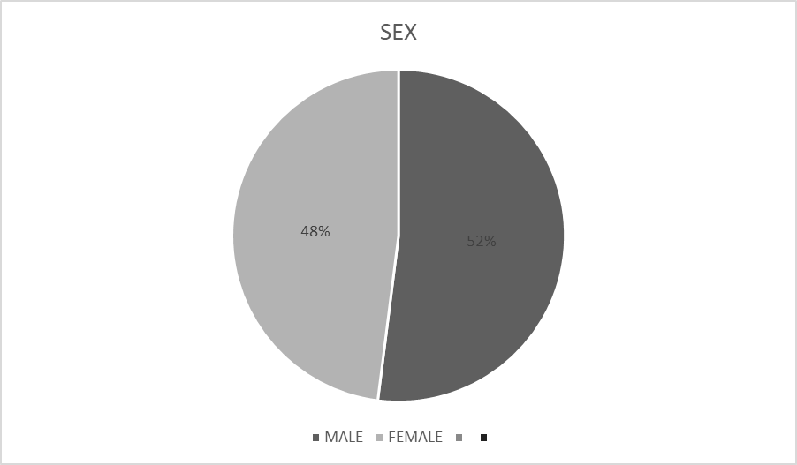
From the above table and chart, majority of the respondents gender (52%) were male and the rest of (48%) respondents were male.
Table 2: Age of respondents
Variable | Frequency | Percentage (%)
18 – 24 | 56 | 56%
25 – 29 | 33 | 33%
30 – 39 | 11 | 11%
Total | 100 | 100%

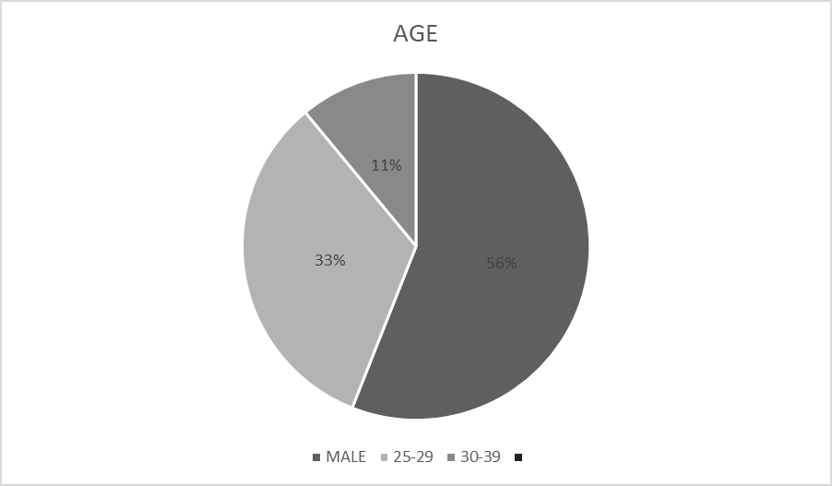
The above table indicates that majority of the respondents are within the range of 18 - 24 with (56 respondent i.e. 56%). Thirty three (33) representing 33% were 25 - 29, while 30 - 39 were the minority respondents with eleven (11) which represents 11%. This implies that youths between the age of 18 - 24 are more exposed to Nigerian Hip Hop music..
Table 3: Marital status of respondents.
Variable | Frequency | Percentage (%)
Married | 26 | 26%
Single | 67 | 67%
Divorced | 7 | 7%
Total | 100 | 100%
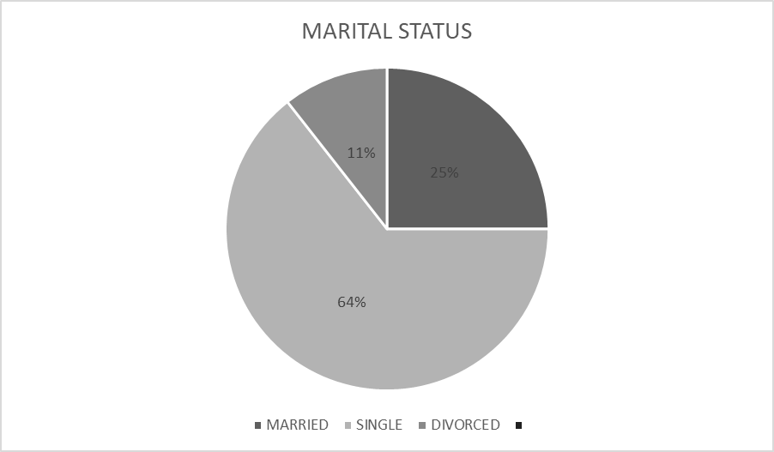
Table 3 and the chart indicate that 67% or 67 respondents were single. Twenty six representing 26% respondents were married while 7 respondents representing 7% were divorced.
Table 4: Educational level of respondents
Variable | Frequency | Percentage (%)
SSCE | 28 | 28%
ND | 20 | 20%
HND | 38 | 38%
BSC | 14 | 14%
Total: | 100 | 100%

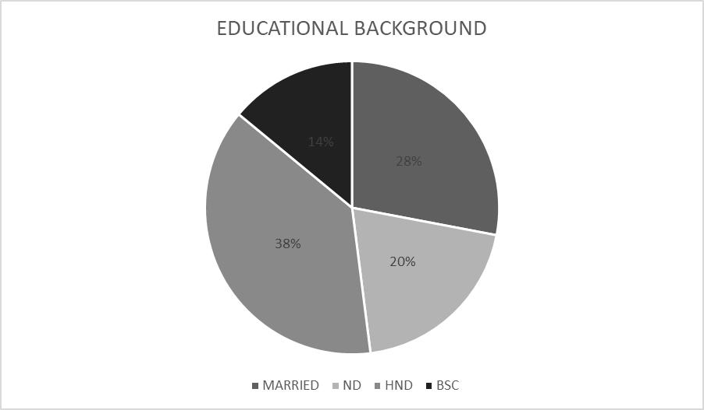
Table 4 and the chart indicate that 28 respondents representing 28% were SSCE holders, 20 which is (20%) were ND holders. Thirty-eight respondents representing 38% were HND holders, while the least respondents with 14 respondents representing 14% were BSc holders.
Table 5: Occupation of respondents.
Variables | Frequency | Percentage (%)
Civil Servant | 26 | 26%
Trader | 23 | 23%
Students | 51 | 51%
Total | 100 | 100%
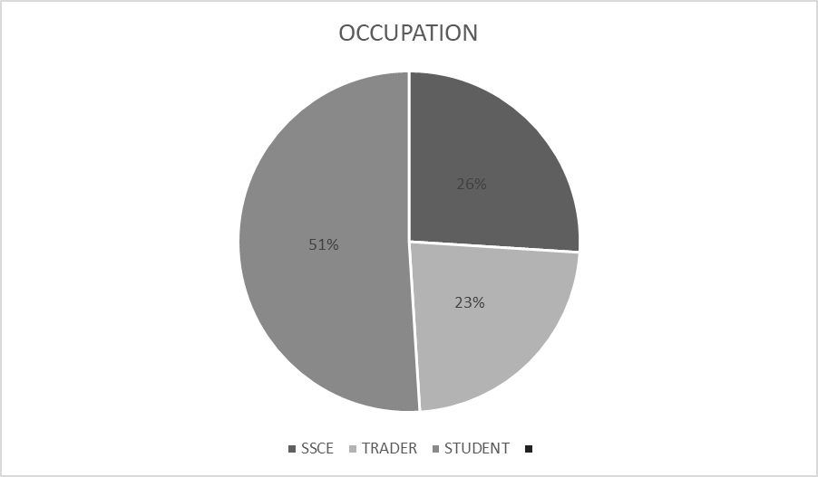
The above table and chart shows that 26 or 26% were Civil servants, 23 representing 23% were traders while 52 with 52% were students.
Table 6: Are you conversant with Nigerian Hip Hop music?
Responses | Frequency | Percentage (%)
Yes | 66 | 66%
No | 34 | 34%
Total | 100 | 100%
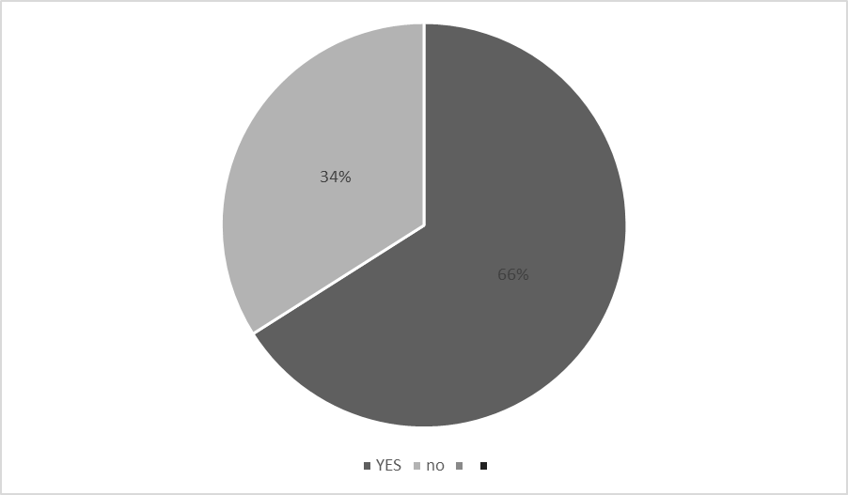
Information was sought on how conversant the respondents are with Nigerian Hip Hop music. As indicated in Table 6, the majority of the respondents (66 or 66%) indicated that they are conversant with Nigerian Hip Hop music. Thirty our (34) respondents representing 34% indicated that they are not conversant with Nigerian Hip Hop music. The survey result thus indicates that the level of Nigerian youth exposure to Hip Hop music was high and this is likely to affect their mode of communication.
Table 7: How often do you listen to Nigerian Hip Hop music?
Responses | Frequency | Percentage (%)
Always | 66 | 66%
Sometimes | 34 | 34%
Total | 100 | 100%
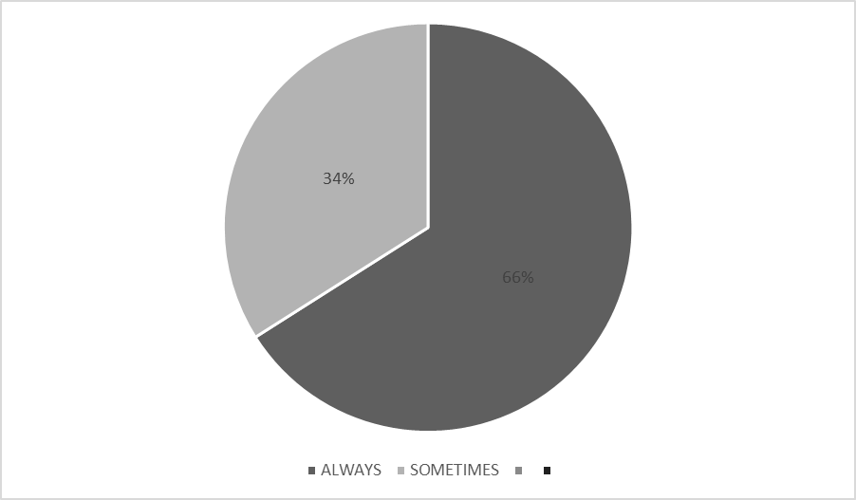
Table 7 and the chart indicates that majority of the respondents, representing (66 or 66%) always listen to Nigerian Hip Hop music. Thirty-four (34) respondents representing 34% indicated that they sometimes listen to Nigerian Hip Hop music.
Table 8: Most of the Nigerian Hip Hop music you listen to have slangs in them.
Responses | Frequency | Percentage (%)
Strongly agree | 51 | 51%
Agree | 35 | 35%
Strongly disagree | 9 | 9%
Disagree | 2 | 2%
Neutral | 3 | 3%
Total | 100 | 100%
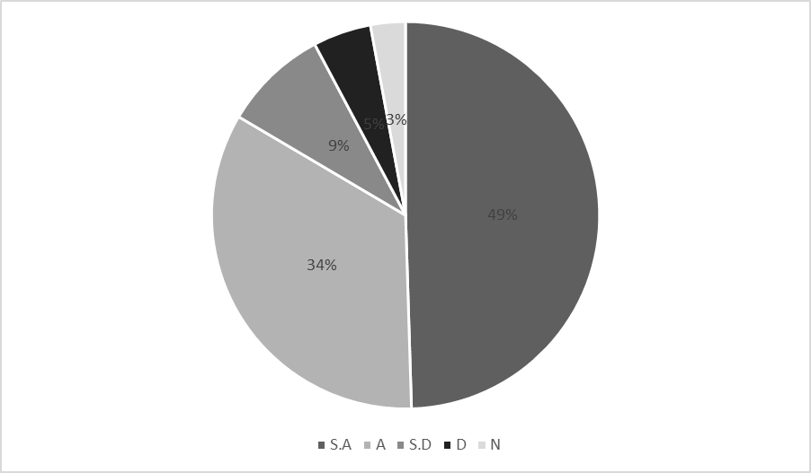
It can be seen from Table 8 and chart above that majority of the respondents (51 or 51%) strongly agreed that most of the Nigerian Hip Hop music they listen to has slangs in them. Thirty-five (35) respondents, representing 35% also agreed to this. Nine (9) respondents’ hat is equivalent to 9% strongly disagreed and 2 respondents which is 2% disagreed that most of the Nigerian Hip Hop music they listen to has slangs in them. While 3 respondents (3%) claimed neutral. This implies that respondents are aware that the Nigerian Hip Hop music they listen to has slangs or slangy expression in them.
Table 9: Do you think Hip Hop music has influenced the way Nigerian youth communicate with each other?
Responses | Frequency | Percentage (%)
Yes | 55 | 55%
No | 12 | 12%
Not really | 33 | 33%
Total | 100 | 100%
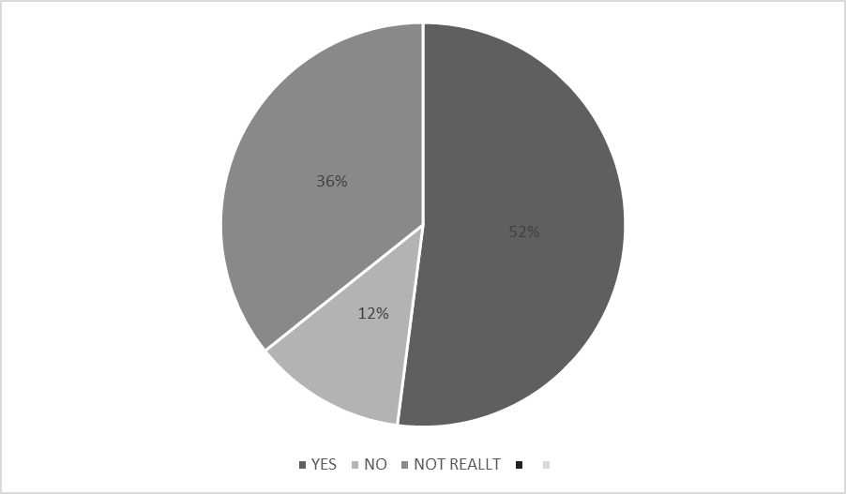
Table 9 and chart indicate that the majority of the respondents, representing (55 or 55%) agreed that Hip Hop music has influenced the way Nigerian youth communicate with each other. Thirteen (13 - 13%) respondents disagree with the statement that Hip Hop music has influenced the way Nigerian youth communicate with each other. Total of thirty-three (33 - 33%) were undecided on whether Hip Hop music has influenced the way Nigerian youth communicate with each other. This analysis shows that Hip Hop music influence e way Nigerian youth communicate with each other.
Table 10: Have you noticed the use of slangs in Hip Hop music in everyday conversations of Nigerian youth?
Responses | Frequency | Percentage (%)
Yes | 74 | 74%
No | 26 | 26%
Total | 100 | 100%
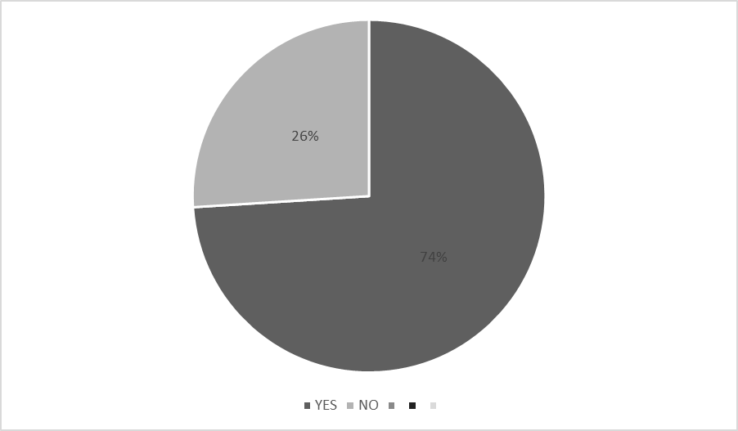
Information was sought from the respondents on whether they have noticed the use of slangs from Hip Hop music in everyday conversations of Nigerian youths.
Table 10 indicates and chart that the majority of the respondents (74 or 74%) affirmed that they have noticed the use of slangs from Hip Hop music on everyday conversations of Nigerian youths. Total of twenty-six (26 - 26%) respondents answered that they have not noticed the use of slangs from Hip Hop music n everyday conversations of Nigerian youths. The analysis made it known that slangs from Hip Hop music has been noticed in everyday conversations of Nigerian youths.
Table 11: Do you use slangs from Hip Hop music in your conversation?
Responses | Frequency | Percentage (%)
Yes | 49 | 49%
No | 18 | 18%
Not really | 33 | 33%
Total | 100 | 100%

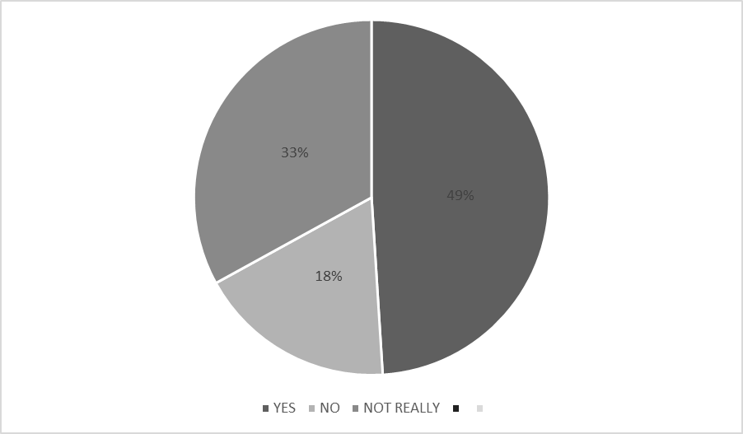
Table 11 and chart indicate that the majority of the respondents, representing 49%, agreed that they use slangs from Hip Hop music in their conversation. Eighteen (18) respondents representing 18% of the overall respondent answered that they do not use slangs from Hip Hop music in their conversation. While thirty-three respondents (33 - 33%) answered that they do not really use slangs from Hip Hop music in their conversations. The analysis shows that majority of the respondents agreed that they make use of slangs from Hip Hop music in their conversation.
Table 12: Have you observed any negative consequences of using slangs from Hip Hop music in communication among Nigerian youths?
Responses | Frequency | Percentage (%)
Yes | 46 | 46%
No | 18 | 18%
Not really | 36 | 36%
Total | 100 | 100%
Information was sought from the respondents on whether they have observed any negative consequences of using slangs from Hip Hop music in communication among Nigerian youths. Data analyzed reveal that 46% which is 46 respondents affirmed that they have observed negative consequences of using slangs from Hip Hop music in communication among Nigerian youths. On the contrary, eighteen (18) respondents which represents 18% answered to have not observed any negative consequences of using slangs from Hip Hop music in communication among Nigerian youths, and thirty-six (36) respondents which represents 36% have not really observed any negative consequences of using slangs from Hip Hop music in communication among Nigerian youths. All these are demonstrated in the table and chart above.
Table 13: Do you think the use slangs from Hip Hop music in communication affects the perception of Nigerian youths in the society?
Responses | Frequency | Percentage (%)
Yes | 51 | 51%
No | 23 | 23%
Not really | 26 | 26%
Total | 100 | 100%

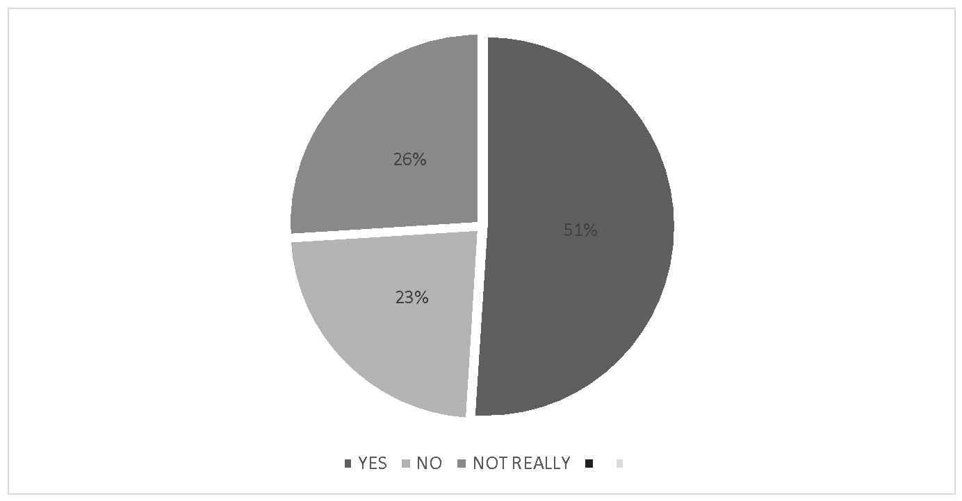
Table 13 and chart revealed that an overwhelming majority of the respondents (51 constituting 51%) affirmed that the use of slangs from Hip Hop music in communication affects the perception of Nigerian youths in the society. However, 23 respondents or 23% disagree that the use of slangs from Hip Hop music in communication among Nigerian youths could affect their perception in the society. The remaining 26 respondents, constituting 26% do not really think the use of slangs from Hip Hop music in communication affects the perception of Nigerian youths in the society.
Table 14: Have you personally faced any challenges or misunderstandings when using slangs from Hip Hop music in communication?
Responses | Frequency | Percentage (%)
Yes | 49 | 49%
No | 29 | 29%
Not really | 22 | 22%
Total | 100 | 100%

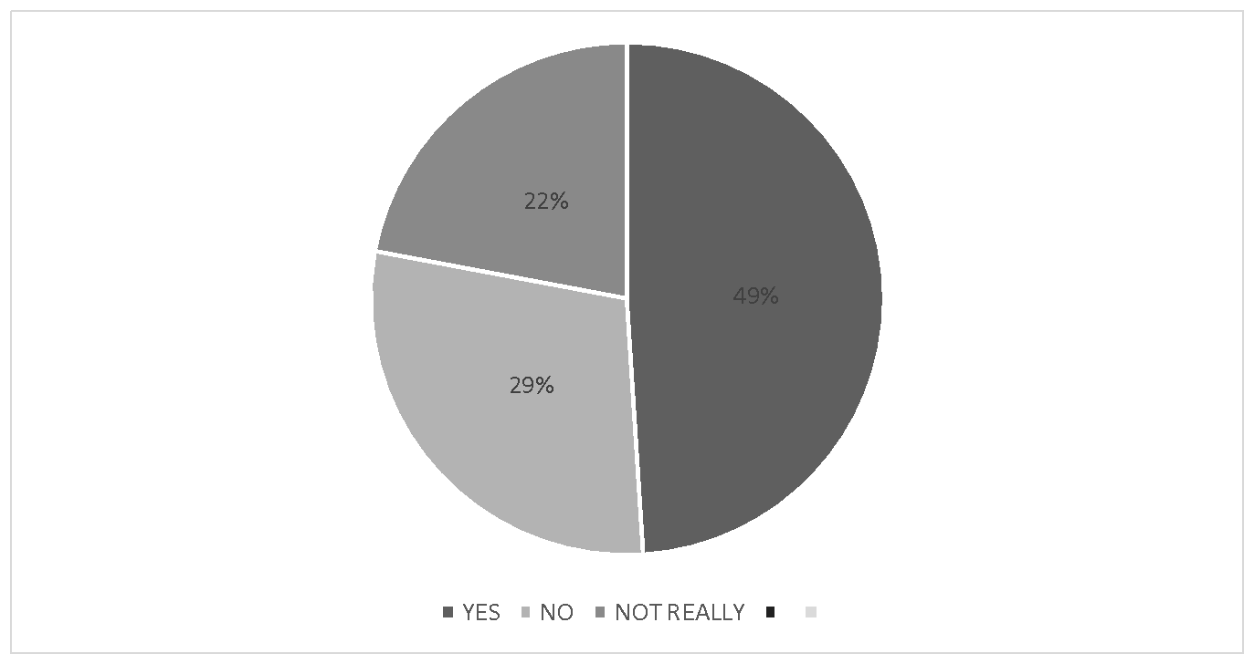
Information was sought on whether respondents have personally faced any challenges or misunderstandings when using slangs from Hip Hop music in communication.
Table 14 and chart indicate that 49 respondents, constituting 49%% agreed to have faced challenges or misunderstandings when using slangs from Hip Hop music in communication. Twenty-nine (29) respondents, representing 29% answered to have not faced any challenges or misunderstandings, while e rest of the respondents constituting 22% chose not really. The result of the analysis having 'Yea' as the highest percentage shows that most respondents have personally faced challenges or misunderstandings when using slangs from Hip Hop music in communication.

Table 15: It is important for Nigerian youths to strike a balance between using slangs from Hip Hop music and maintaining proper communication skills.
Responses | Frequency | Percentage (%)
Strongly agree | 48 | 48%
Agree | 31 | 31%
Strongly disagree | 9 | 9%
Disagree | 3 | 3%
Neutral | 9 | 9%
Total | 100 | 100%

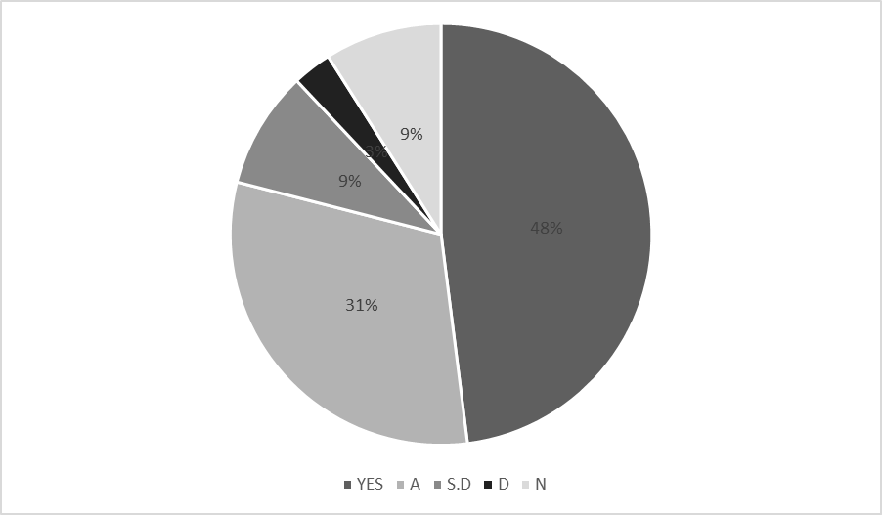
Table 15 indicates that the majority of the respondents (48 or 48%) strongly agreed that it is important for Nigerian youths to strike a balance between using slangs from Hip Hop music and maintaining proper communication skills. Thirty-one (31) respondents representing 31% agreed that it is important for Nigerian youths to strike a balance between using slangs from Hip Hop music and maintaining proper communication skills. However, 9 respondents representing 9% strongly disagreed and 3 respondents constituting 3% disagreed to it. The remaining 9 respondents representing 9% were neutral on the issue.
Table 16: Do you believe that the influence of slangs from Hip Hop music on communication among Nigerian youths is a temporary trend?
Responses | Frequency | Percentage (%)
Yes | 40 | 40%
No | 21 | 21%
Not really | 39 | 39%
Total | 100 | 100%

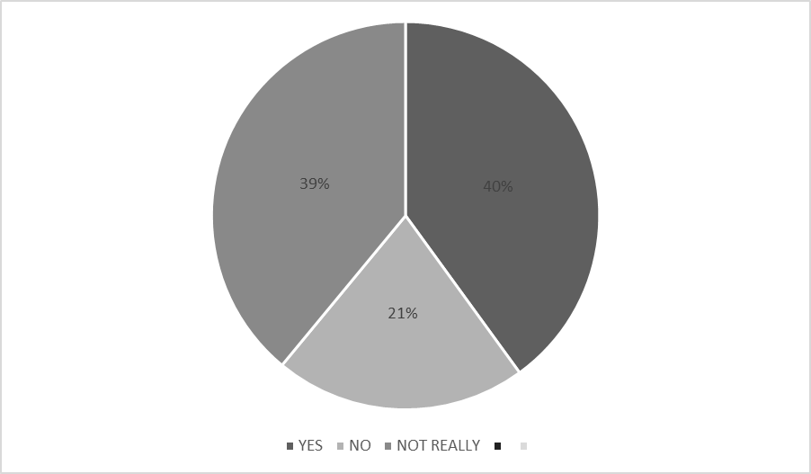
Table 16 indicates that the highest percentage of respondents (40 or 40%) believed that the influence of slangs from Hip Hop music on communication among Nigerian youths is a temporary trend. Twenty-one (21) respondents representing 21% do not believe that it is a temporary trend. While Thirty-nine (39) representing 39% do not really believe that it is a temporary trend.

Table 17: To what extent do you think slangs in Hip Hop music affect the moral behaviour of youths in Nigeria?
Responses | Frequency | Percentage (%)
Very High | 38 | 38%
High | 36 | 36%
Very Low | 11 | 11%
Low | 5 | 5%
Moderate | 10 | 10%
Total | 100 | 100%

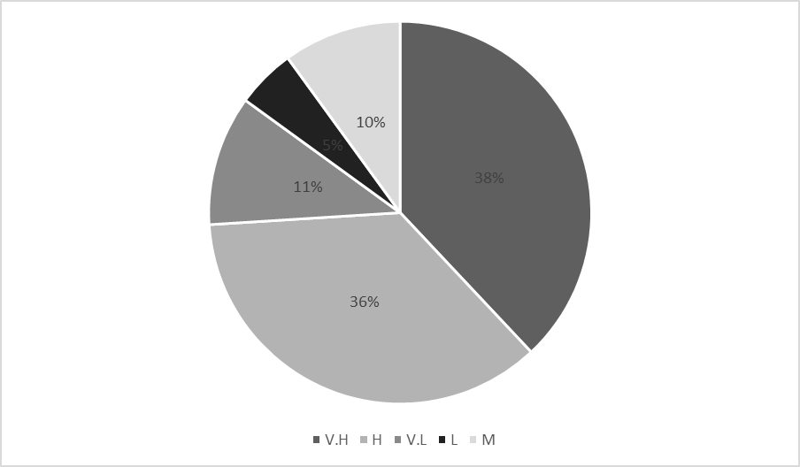
Table 17 shows that the majority of the respondents (38 or 38%) affirmed that the extent which slangs in Hip Hop music has affected the moral behaviour of youths in Nigeria are very high. Thirty-six (36 - 36%) also affirmed that the extent which slangs in Hip Hop music has affected the moral behavior of youths in Nigeria is high On the flipside, 11 and 5 respondents representing 11% and 5% respectively answered that it is very low and low. The remaining 10% answered that the level is moderate.
Table 18: What is the main source(s) of exposure to slangy Hip Hop music to Nigerian youths?
Responses | Frequency | Percentage (%)
Radio | 17 | 17%
Television | 19 | 19%
Internet | 64 | 64%
Total | 100 | 100%

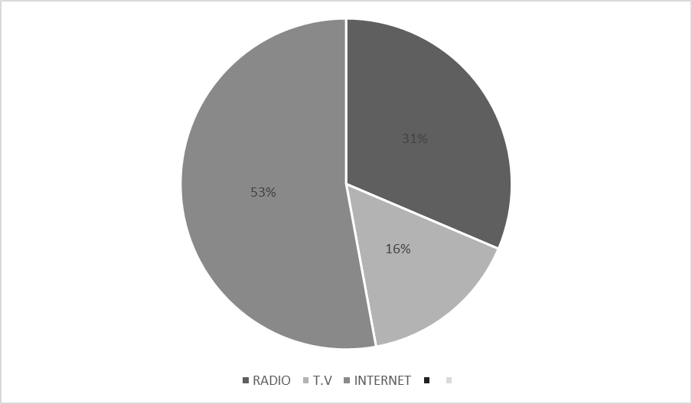
Table 18 and chart shows that an overwhelming percentage of respondents, 64 or 64% chose the internet as the source of exposure to slangy Hip Hop music to Nigerian youths. 19 respondents constituting 19% chose television is the source, while 17 respondents that makes 17% chose radio to be the source of exposure of slangy Hip Hop music to Nigerian youths.

4.3 DISCUSSION OF FINDINGS
This section discusses the findings of the study in relation to the research questions raised.
Answer to research question one: How do slangs in Hip Hop music affect the lives of Nigerian youths?
The study found that the majority of the respondents agreed that slangs in Hip Hop music has negative consequences n communication among Nigerian youths as the data in table 12. This shows that Nigerian youths have been experiencing negative consequences because of the use of slangs from Hip Hop music in their communication.
Supporting this fact, Chukwuemeka William Ukoha iin his paper titled "The Influence of Hip Hop Music on the Youths of Nigeria," discusses the impact of Hip Hop culture on Nigerian youth. He argues that while Hip Hop can provide a platform for artistic expression, social commentary, and cultural identity, the uncritical adoption of slangs from Hip Hop music can lead to a decline in the mastery of formal language and hinder effective communication skills among Nigerian youth.
Answer to research question 2: How does slangs in Nigerian hip hop music influence the moral behaviour of youths in Nigeria?
From the researchers’ field survey 2023, the study found that majority of the respondents affirms that slangs in Hip Hop music has highly affected the moral behaviour of youths in Nigeria as the data in table 17.
Supporting this fact, Omotoso, O. A. (2014) in the paper "Music as a Tool for Moral Instruction: A Study of Nigerian Hip-Hop," Omotoso discusses the content and influence of Nigerian Hip Hop lyrics on the moral values and behavior of youth. The author suggests that certain lyrical themes and expressions may have a negative impact on morality, such as glorifying violence and materialism.
Answer to research question three: What are the prospects and problems of in Hip Hop music on Nigerian youth and society?
The study sought to know if the use of slangs from Hip Hop music affects the perception of Nigerian youths in the society. From analyzed data (table 13), it indicates that majority of them affirmed that the use of slangs from Hip Hop music affects the perception of Nigerian youths in the society.
Answer to research question four: How has slangs in Nigerian hip hop music affected the mode of communication among youths in Nigeria?
The study also discovered that slangs in Hip Hop music has highly influenced the way Nigerian youths communicate with each other. It is evident from the data presented in table 9.

Answer to research question five: What are the main sources (s) of exposure of slangy Hip Hop music to the youths in Nigeria?
With the data presented in table 18, it is evident that overwhelming percentage of the respondents chose internet to be the main source of exposure of slangy Hip Hop music to Nigerian youth.

CHAPTER FIVE
SUMMARY OF FINDINGS, CONCLUSION AND RECOMMENDATIONS
5.0 INTRODUCTION
This chapter presents the summary, conclusions made from the findings and the recommendations of the study. The summary relates to the synopsis of all the previous chapters while the conclusion and recommendation drawn were focused on addressing the questions of the study.
The first chapter of this study covers the Background of the study, statement of problem, research questions, and objectives, significance of the study, Definitions of key terms.
The chapter two covers the conceptual framework, theoretical framework and empirical review.
The chapter three covers the research design, population of the study, sample size and sampling techniques, method of data analysis, instrument for data collection, validity and reliability, method of data analysis and limitation of the methodology.
Chapter four covers with data presentation, analysis and interpretation. The chapter also covers the discussion of the findings.
5.1 SUMMARY
This study investigates the influence of slangs in Nigerian hip hop music on the mode of communication among Nigerian youths. The study aims at identifying how slangs that are used in Hip Hop music has affected the day-to-day conversation of youths in Nigeria. It also aims at identifying the main source(s) of exposure of slangy Hip Hop music to Nigerian youth. It also aims at investigating the influence of slangs from Nigerian hip hop music on the moral behaviours of youths in Nigeria as well as explaining the aspects of youths moral behaviour that are most affected by slangs from Nigerian hip hop music. To achieve these objectives, it employed survey method to gather data. It used the descriptive survey analysis. Simple random sampling was used to select 100 respondents in Ilorin which is the unit of analysis. The main source(s) of exposure of Nigerian hip hop music to youths in the internet which can be accessed through portable hand-held devices, and this music are gotten through audio/video streaming sites and social media sites such as Instagram, Facebook, Twitter etc. Also, slangs from Nigerian hip hop music significantly impact negatively on the moral behaviour of youths in the society. Finally, the areas of youths behaviour mostly affected by the slangs from Nigerian hip hop music include the communication among peers,
5.2 CONCLUSION
The main source(s) of exposure of slangs from Nigerian hip hop music to youths in Nigeria are portable hand-held devices e.g. phone, iPad and tablets which give them access to audio/video streaming sites e.g. Audio Mack, YouTube Music, Spotify and social media sites like Facebook, twitter, Instagram.
The viewing of Nigerian hip hop music though entertaining has a huge negative impact on the moral behaviour of the youths. Slangs from Nigerian hip hop music significantly impact negatively on the mode of communication of the youths.
The areas of youth’s behaviour mostly affected by the slangs from Nigeria hip hop music include the behaviour amongst peers, this is when a youth is not able to communicate without the use of any slang adopted from most Nigerian hip hop music, and this is not allowed in an official gathering. While it has been established reasonably by this study that slangs from hip hop music especially the foreign and Nigeria made ones are at variance with acceptable moral value of youths.
5.3 RECOMMENDATIONS
The National Broadcasting Commission (NBC) should become more thorough with the screening of what nature of music.
Also, parents should ban the use of hip hop music slangs among their children while growing up as this is where the problem begins.
Furthermore, students should be educated on the dangers of being engrossed with slangs from hip hop music and its effect in their mode of communication and academic pursuit. In place of slangy hip hop music, they can familiarize themselves with other morally acceptable music that is more beneficial and less harmful to their communication skill. Music that celebrates vulgar words and undermine morals of the African culture should not be encouraged.
The government should censor inappropriate sites in Nigeria. They can contact IT specialists with the support of owners of YouTube Facebook and Instagram in such a way that adolescents will no longer have access to these sites without parental guidance. China for example created their own model of these apps to guide its citizens from corruption. Nigeria can do same.

Religious institutions are not left out. It is their duty to vehemently present the dangers of using vulgar words embedded in slangs from hip hop music to youths. This is because, most youths respect what their religious leader says more than their parents and teachers in some cases.
In conclusion, if stakeholders, government, parents, religious institutions, schools and so on can come together to combat/educate youths on the right path, the impact of slangs from hip hop music will be reduced significantly thereby protecting the future leaders of Nigeria.

REFERENCES
Ajzen I (1991). The theory of planned behavior. Organizational Behavior and Human Decision Processes.;50:179–211.
Ajzen I(1991). The theory of planned behavior. Organizational Behavior and Human Decision Processes. 1991; 50:179–211.
Ajzen I, Fishbein M (1980). Understanding attitudes and predicting social behavior: Attitudes, intentions, and perceived behavioral control. Englewood Cliffs, NJ: Prentice Hall
Bakagiannis, S., & Tarrant, M. (2006). Can music bring people together? Effects of shared musical preference on inter-group bias in adolescence. Scandinavian Journal of Psychology, 47, 129- 136.
Baker, D. F. and Bor, W. (2008). Can Music Preference Indicate Mental Health Status in Young People? Australian Psychiatry, 16 (4) 284 – 288.
Baldwin, D.L. (2004). Black Empires, white desires: The spatial politics of identity in the age of Hip Hop. In M. Foreman, & M. A. Neal (Eds). That’s the joint: The Hip Hop Studies Reader (pp. 159-176). New York & London: Routledge.
Bandura, A. & Walters, R. (1963). Social Learning and Personality Development. New York: Holt, Rinehart & Winston.
Bandura, A. (1969). Principles of Behavior Modification. New York: Holt, Rinehart & Winston.
Bandura, A. (1973). Aggression: A Social Learning Analysis. Englewood Cliffs, NJ: Prentice-Hall.
Bandura, A. (1977). Social Learning Theory. New York: General Learning Press.
Bandura, A. (1986). Social Foundations of Thought and Action. Englewood Cliffs, NJ: Prentice-Hall.
Jensen, L. A. (2003). Coming of age in a multicultural world: Globalization and adolescent identity formation. Applied Developmental Science, 7 (3), 189- 196.
Juslin, P. N. and Sloboda, J. A. (2001). Music and emotion: theory and research. New York: Oxford University Press.
Sherer, K. R. and Zentner, M. R. (2001). Emotional effects of music: production rules. In P. N Juslin and J. A. Sobodan (Eds.). Music and emotion: theory and research. ( pp 361 – 392). New York: Oxford University Press.
Tarrant, M. (2002). Adolescent peer groups and social identity. Journal of Social Development. 11 (1), 110- 123.
Tarrant, M., North, A.C., & Hargreaves, D. J. (2000). English and American Adolescents’ reasons for listening to music. Psychology of Music, 28, 166- 173.
Tarrant, M., North, A.C., & Hargreaves, D. J. (2001). Youth Identity and music. In R. Macdonald., D. Hargreaves., & D. Miell (Eds.), Musical identities (pp.134- 151). Oxford University Press.
Tarrant, M., North, A.C., & Hargreaves, D. J. (2001a). Social categorization, Self-esteem and the estimated musical preferences of male adolescents. The Journal of Social Psychology, 141, 565-581.
Odogwu, C. (2018). Sociolinguistic analysis of slangy expressions in Nigerian pidgin. Journal of
Language and Linguistic Studies, 14(4), 32-43.
Delsing, M. T., Bogt, T. M., Engels, C. M., Meeus, H. J., (2007). Adolescents’ music preferences and personality Characteristics. European Journal of Personality. 22 (2), 109 – 130. http://onlinelibrary.wiley.com/doi/10.1002/per.665
Schwartz, K. D. and Fouts, G. T. (2009). Music preferences, personality style and developmental issues of adolescents. Journal of Youth and Adolescence. 32 (3), 205 – 213. http://link.springer.com/article/10.1023%2FA%3A1022547520656?LI=true
Moore, C. C. and Baker, F. A. (2009). Musical preferences of Argentines living in Australia. Voices: A World Forum for Music Therapy. Vol.9 (1), 7 – 20.

QUESTIONNAIRE

Dear Respondents,
I am a student of the Department of Mass Communication, Kwara state polytechnic, Ilorin. I am conducting research on the topic 'INFLUENCE OF SLANGS IN HIP HOP MUSICS ON THE MODE OF COMMUNICATION AMONGST KWARA YOUTH'.
I humbly request that you help me answer the following questions as honestly as possible, and assure you that all information supplied shall be used for academic and shall be kept confidential.
Please, tick (✓) the answer you consider appropriate.
SECTION A
Bio-Data of Respondents
- Sex: Male ( ) Female ( )
- Age: 18-24 ( ) 25-29 ( ) 30-39 ( )
- Marital status: Married ( ) Single ( ) Divorced ( )
- Qualification: SSCE ( ) ND ( ) HND ( ) BSC ( )
- Occupation: Civil Servant ( ) Trader ( ) Student ( )
SECTION B
Questions from the Research Questions
- Are you conversant with Nigerian Hip Hop music?
Yes ( ) No ( )
- How often do you listen to Nigerian Hip Hop music?
Always ( ) Sometimes ( )
- Most of the Nigerian Hip Hop music you listen have slangs in them.
Strongly Agree ( ) Agree ( ) Strongly Disagree ( ) Agree ( ) Neutral ( )
- Hip Hop music has influenced the way Nigerian youths communicate with each other?
Strongly Agree ( ) Agree ( ) Strongly Disagree ( ) Agree ( ) Neutral ( )
- Have you noticed the use of slangs from Hip Hop music n the everyday conversations of Nigerian youths?
Yes ( ) No ( )
- Do you use slangs from Hip Hop music in your own conversation?
Yes ( ) No ( ) Not really ( )
- Have you observed any negative consequences of using slangs from Hip Hop music in communication among Nigerian youths?
Yes ( ) No ( ) Not really ( )
- Do you think the use of slangs from Hip Hop music in communication affects the perception of Nigerian youths in society?
Yes ( ) No ( ) Not really ( )
- Have you personally faced any challenges or misunderstandings when using slangs from Hip Hop music in communication?
Yes ( ) No ( ) Not really ( )
- It is important for Nigerian youths to strike a balance between using slangs from Hip Hop music and maintaining proper communication skills?
Strongly Agree ( ) Agree ( ) Strongly Disagree ( ) Agree ( ) Neutral ( )
- The influence of slangs from Hip Hop music on communication among Nigerian youths is a temporary trend.
Strongly Agree ( ) Agree ( ) Strongly Disagree ( ) Agree ( ) Neutral ( )
- To what extent do you think slangs in Hip Hop music affects the moral behaviour of youths in Nigeria?
Very High ( ) High ( ) Low ( ) Very Low ( ) Moderate ( )
- What are the main source(s) of exposure of slangy Hip Hop music to Nigerian youths?
Radio ( ) Television ( ) Internet ( )

