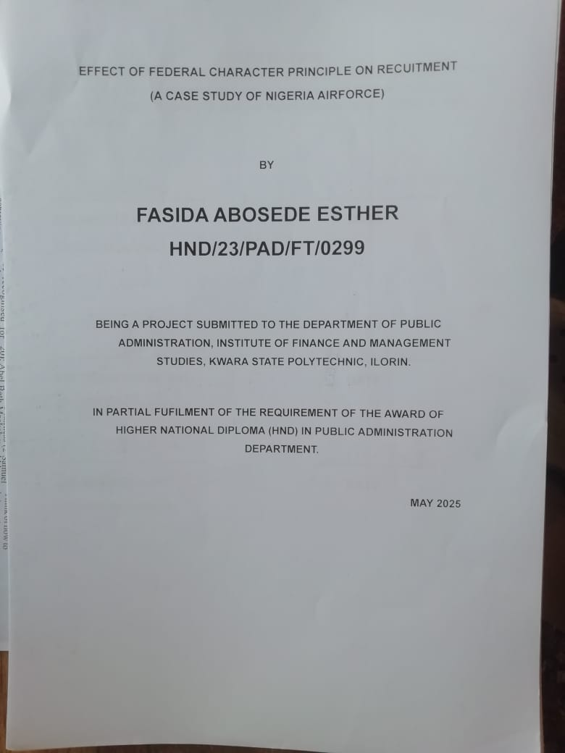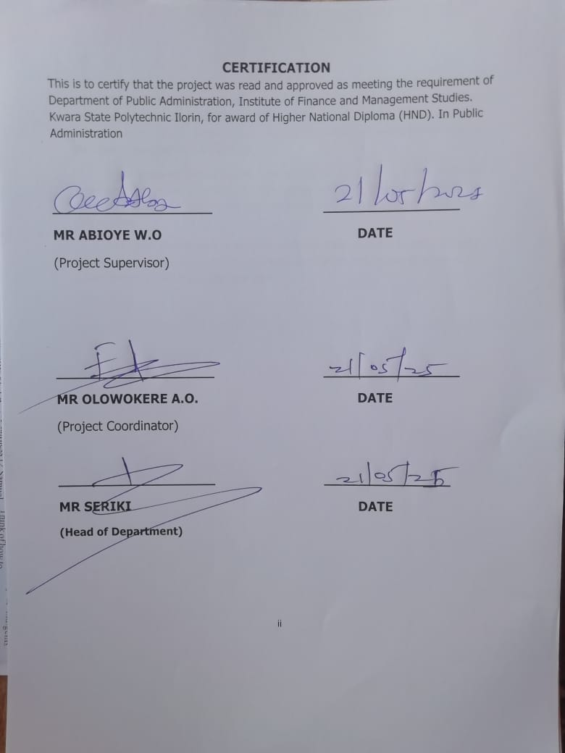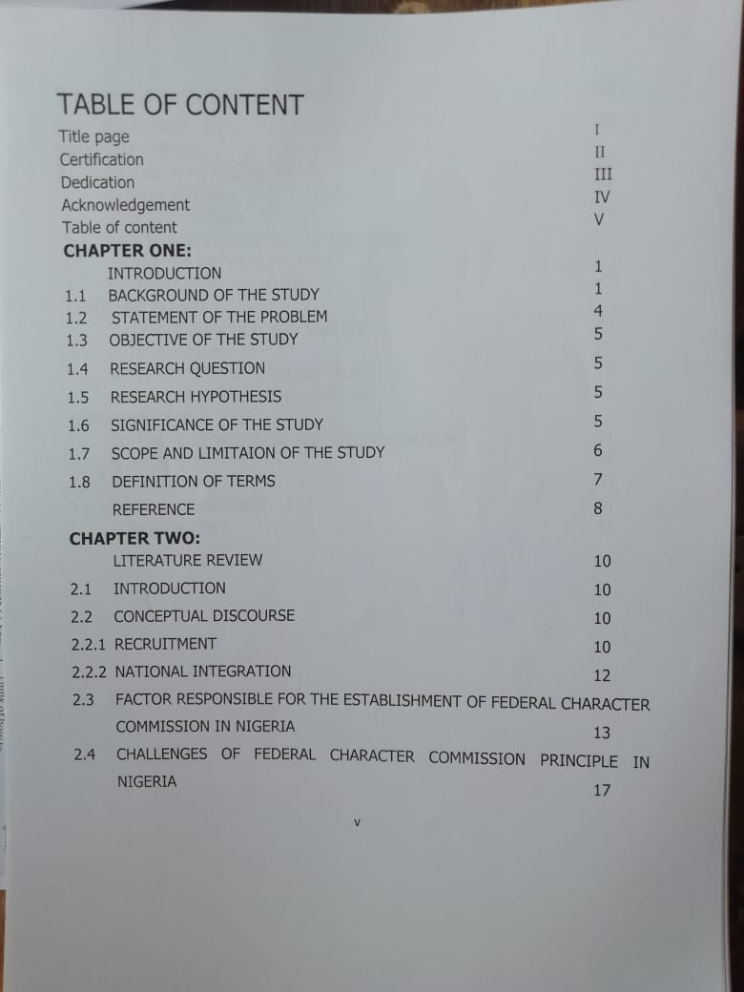
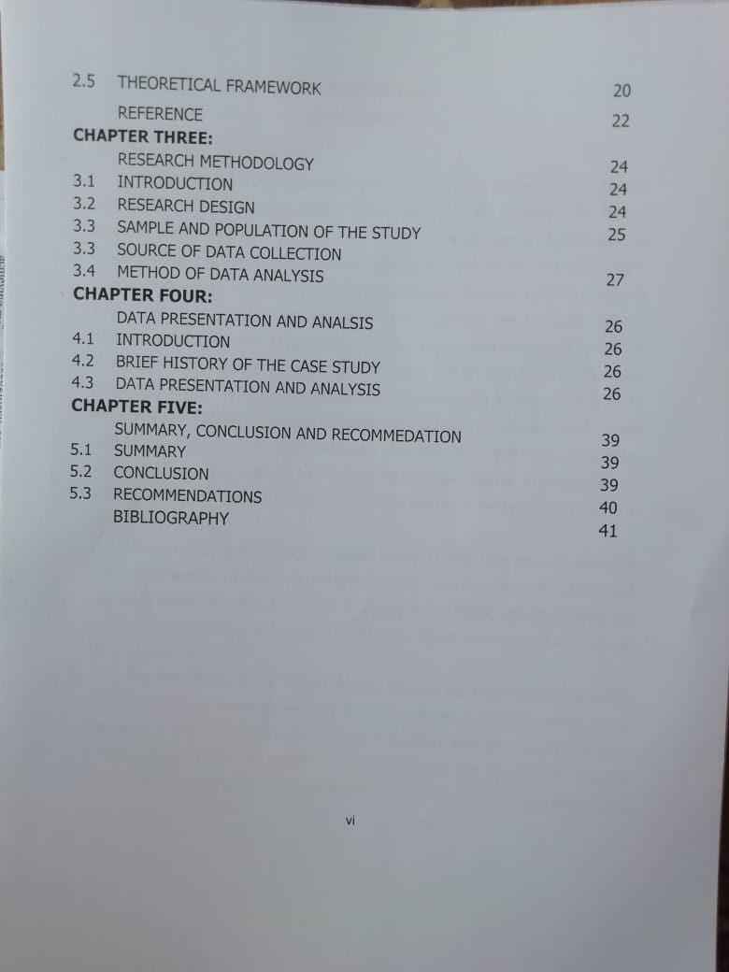
CHAPTER ONE
INTRODUCTION
1.1 Background to the Study
Federal Character Principles constitute a set of policies designed by the Nigeria government to integrate the diverse ethnic groups in the country. The federal character principle which was enshrined in the 1979 Constitution of Nigeria seeks to ensure equitable representation of ethnic, religious and geographic diversities of the country in the public service. The introduction of federal character policies in Nigeria is to foster unity, peace, equal access to state resources and promotion of the integration of the less advantaged states for better improvement and good conditions of having in the country (Bamidele and Ikulege, 2004). The Federal Character Commission (FEC) is a Federal Executive body established by Act No. 34 of 1996 to implement and enforce the Federal Character Principles of fairness and equity in the distribution of public posts, socio-economic amenities and infrastructural facilities among the federating units of the Federal Republic of Nigeria. The provision of sections 14 and 153 of constitution further empowers the commissions to operate in a democratic setting
Section 14(3) of the 1979 Constitution defines Federal Character as distinctive desire of the peoples of Nigeria to promote national unity, foster national loyalty and give every citizen of Nigeria a sense of belonging to the nation notwithstanding the diversities of ethnic origin, language or religion as a desire to do nourish and harness the diversification.
The Federal Republic of Nigeria. Section 14 (3) of the 1999 Constitution of the Federal Republic of Nigeria states that: The composition of the government of the Federation or any agencies and the conduct of its affairs shall be carried out in such a manner us to reflect the federal character of Nigeria and the need to promote national unity, and also to command national loyalty, thereby ensuring that there shall be no predominance of persons from a few states or from a few ethnic or other sectional groups in that government or in any of its agencies
Section 217 (3) provides that the composition of the officer corps and other ranks of the Armed Forces of the Federation shall reflect the federal character of Nigeria. Various other provisions were made in the constitution to ensure that the federal character principle becomes operative in the political process (Nnoli, 1996 cited in Adeosun, 2011). Section 147 states that in the appointment of Ministers, the president shall reflect the federal character of Nigeria provided that in giving effects to the provision aforesaid, the president shall appoint at least one Minister from each state who shall be an indigene of such state (Nnoli, 1996 cited in Adeosun, 2011).
Moreover, Section 171 provides that appointment by the President into the offices of the Secretary to the Government of the Federation, Head of Service of the Federation, Ambassadors, or the principal representatives abroad, Permanent Secretary or other Chief Executive in any Ministry or Department of the Federal Government, or any office on the personal staff of the President shall have regard to the federal character of Nigeria and the need to promote national unity. Section 153 of the 1999 Nigeria Constitution establishes the Federal Character Commission, as a federal executive body, empowered in Section 8(1) of the Third Schedule of the Constitution to oversee and monitor the implementation of the Federal character clauses. The primary mandate of the Commission is to work out an equitable formula subject to the approval of the National Assembly for the distribution of all cadres of posts in the public service of the Federation and of the States, the armed forces of the Federation, the Nigeria Air Force and other security agencies. Government owned companies and parastatals of the States.
The federal character principle is anchored on the distinctive desire of the people of Nigeria to promote national unity, foster national loyalty and give every citizen of Nigeria a sense of belonging to the nation notwithstanding the diversities of ethnic origin, culture, language or religion which may exist and which it is their desire to nourish and harness to the enrichment of the Federal Republic of Nigeria (Afigbo, 1989). The federal character was also introduced for equitable sharing of posts and even distribution of natural and economic resources (Ezenwa, 1987 and Heirmexy, 2011). The idea of Federal Character Principles thus suggests an attempt to build a nation where equal opportunities abound and where every individual must feel that he has equal chance to participate without bias of ethnic affiliation (Talih, 1987).
Federal character is both a reaction as well as a system. It is a positive reaction to correct those practices of the past, especially in the conduct of public management which tended to exploit the diversities of the nation and by so doing cause ill will. Also it is a reaction to those practices which tended to reflect selfish and parochial consideration, especially those negative forces which placed self-interests above national interest. The federal character principles involve a deliberate plan to construct means of ensuring the proper distribution of amenities and government projects in the country. The principle of federal character was formulated and put into use by successive governments in Nigeria to address and hopefully mitigate the problem of diversity so as to ensure a peaceful, stable and united Nigeria.
Nigeria is a federal society with 36 component states, with a population of over 160 million people segmented into over 250 ethnic groups which makes an arrangement that could accommodate the different segments of the country in the public bureaucracy without any segment feeling marginalized such as federal character a necessity (Gberevbic, 2012). Before the adoption of federal character, Nigeria had introduced quota system into the public service in 1958 with the aim of ensuring equitable representation of various groups in the country (Tonwe an Oghator, 2009). The project investigates the extent to which federal character principle has been adopted in the recruitment of personnel into the Nigeria Air Force.

1.2 Statement of the Problem
The Federal Character Principle has been introduced into the recruitment of personnel into the federal institutions to ensure fairness, Justice and equities to different multi-ethnic state in Nigeria there has been assumed gross misconduct in the area of employment contrary to the federal character principle because of nepotism by those in authority in the Ministries and Parastatals in Nigeria. Federal Ministry of Interior was accused of recruiting personnel in to the Nigeria Air Force on the basis of nepotism and favorism without minding the effect on fairness and equity, even when the federal character principle is observed, the institution assumed not to consider the efficiency of the candidates as long as they are relatives, and will not follow the due process thereby cutting corners in the recruitment exercise.
That was why Senator Anyanwu for example, lamented that lgbos are not in leadership of the Nigeria Air Force. Nigeria Armed Forces, Nigeria Air. Senator Samuel Nnaemeka Anyanwu, Chairman, Senate Committee on Ethics and privileges, representing Imo East has decried the absence of the federal Character principle n President Buhari’s appointments which has Sidelined the lgbos in the scheme of things. Claiming that President is in fact setting a very dangerous precedent for Nigeria by his non-adherence to the federal character principles, the government has failed completely because they have never respected the constitution; they have not respected federal character (23 April 2017; The Sun News Paper).
The issue of quota system is not left out in our national life, there have been many policies to that effect and institutions set up to correct the perceived anomalies regarding formulae for recruitment of the populace into the available vacancies in the federal civil/public service. Many sections in Nigeria have been complaining of being cheated in the appointment and recruitment process in the county at large, these sections pointed to a lot of mediocrity in the Nigeria federal civil public services.
The above describes the challenges in the implementation of the Federal Character Principle in Nigeria in connection to fairness, Justice and equity in Nigeria. There are lots of works on the Federal Character Commission and Principle (Bamidele 2004, Ikulege 2004, Muhammed 1998, Olaopa 2012, Ezeibe 2013, Ezenwa 1987, Heirmexy 2011, Afigbo 1989, Aderonke 2013) but none has focused on the study of the Nigeria Air Force. This work shall fill this gap by assessing the extent to which the principles have been implemented in the Nigeria Air Force.
1.3 Objectives of the Study
The objectives of this study are to:
i. nexamine the issues associated with recruitment procedures in the Nigeria Air Force,
ii. study the extent to which the Federal Character Principle has promoted
equity in the recruitment procedures into Nigeria Air Force;
iii. examine how the Federal Character Principle affected employee
efficiency in the Nigeria Air Force; and
iv. examine how federal character principle has contributed to national
integration.
1.4 Research Questions
i. What are the issues associated with recruitment procedures in the Nigeria Air Force?
ii. To what extent has the Federal Character Principle has promoted equity in the recruitment procedures of the Nigeria Air Force? iii. How does the Federal Character Principle affect the efficiency of employees in the Nigeria Air Force? and iv. To what extent has the Federal Character Principle in Nigeria contributed to national integration
1.5 Significance of the Study
This study on the application, of federal character principle for recruitment into the Nigeria Air Force is of immense benefit to different institutions, especially those institutions that need employment related data for their routine activities. From the research, Federal Ministry of Interior can tell if the federal character principle is observed in every batch of recruitment conduct by different federal agencies and whether such recruitment is orderly conducted through the help of Federal Character Commission.
Again, by studying this report, the federal Bureau of Statistic can collate and manage data on employment-unemployed in the Nigeria Air Force. The result of this study would help to establish the extent to which national integration is being promoted in Nigeria. The study would serve as reference material for further study on the Federal Character Principle in Nigeria.
1.6 Scope and Limitations of the Study
This research work is focused on the impacts of federal character principle on recruitment equity within the Nigeria Air Force Federal Character was adopted to deal with the problem of geo-political imbalance, marginalization, and discrimination. The study shall also identify the issues associated with Federal Character Principle in the recruitment of personal into the Nigeria Air Force.
The limitations for this study include time and financial constraints as well as non-availability of some documents that are relevant to this study.
1.7 Definition of Terms
i. Federal Character: Federal character as a deliberate design to accommodate less dominant (Olagunju, 1987). ii. Federal Character Principle: The federal character principles are aimed at ensuring amongst the component units had as its very heart the eschewing of all forms of group imbalance in public institutions and affairs (Obiyan and Akindele, 2002). iii. Recruitment: Recruitment refers to the overall process of attracting, selecting and appointing suitable candidates for jobs (Either permanent or temporary) within an organization (Tola Kolapo, 2005).
iv. Equity: A fairness and impartiality towards all concerned, bascd on the principles of evenhanded dealing. Equity implies giving as much advantage, consideration or latitude to. one party as it 1s given to another and equity means the quality of being fair and impartial (Ladipo, 1992),
v. Quota: Tyson and York (1982) defines quota as a device used to check the over-loading of a particular job or vacant job opportunities by people from a particular ethnic origin. If properly applied, it allows for even representation of people from different background and geographical zones of a country or state.

REFERENCES
Adamolekun, L. (2008). "Let us Debate Federalism'". The vanguard Newspaper, March p.17.
Adeosun .B (2011), Federal Character Principle and National Integration: A Critical Appraisal, International Journal of Politics and Good Governance,; 2(2.4): 1-13.
Agbodike, C. C. (1998). "Federal Character Principles and National lntegration" In Amuwo, K. Et al (eds). Federalism and Political Resructuring in Nigeria Ibadan: Spectrum Books..
Aligbo, A. E. (1989). "Federal Character" Its meaning and History. in Ekeh, P. P.& Osaghae, E. E. (eds),. Federal Character and Federalism in Nigeria. (pp 3-18). Ibadan: Heinemann Educational Books.
Bamidele and Ikulegbe (2004). Federal Character and National Integration, NIPSS Conference Proceeding. Bello, M. L. (2012). Federal Character as a Recipe for National Integration: The Nigerian Paradox. International Journal of politics and Good Governance. 3 (3). Pp 1-17.
Biobele, R. B. (2007). Problems of Recruitment in Civil Service: Case of the Nigerian Civil Service. African Journal of Business Management 1 (6). Pp 142-153.
Bodunrin, P. (1989). "Federal Character and Social Justice" in P.P Ekeh and E.E. Osaghac (eds) Federal Character and Federalism in Nigeria, Ibadan: Heinemann Educational Books.
Braton J. and Gold J. (2007). Human Resource Management. Theory and Practice. Basingstoke; Macmillan Palgrave. Constitution Drafting Committee. Report of the Constitution Drafting Committee.
David Plotke (1997). "Representation is Democracy, Constellation, 4:19-34.
Development Publishers. Vol.1. Lagos, Nigeria: Federal Ministry of
Dye, T.R. (1997) Understanding Public Policy. New Jersey: Prentice Hall
Easton, D (1965). A Systems Analysis of Political Life. New York: Wiley.
Echikwonyc, R. A. and Beetseh, K. (2011). The Role of Public Policy Making and Development In Nigeria Journal of Social Science and "Public Policy, Volume 3, March 2011. Pp 3 -64.
Ekeh, P. P. (1989). The Structure and Meaning of federal Character in the Nigerian Political System. In Ekeh, P. P. & Osaghae, E. E. (cds). Federal Character and Federalism in Nigeria. (pp 19-44). Ibadan: Heinemann Educational Books.
Ekhator, V. E. (2002). Rudiments of Public Administration. Lagos: Joyce Graphic Printer and Publisher.
Federal Character Commission, 1996, '1st Annual Report'.
Federal Character Panel seeks balanced ltsekiri, ljaw representation,
Information, Printing Division; 1977.
Jos, Plateau Stale.
Nnamdi Azikiwe (1943), Political Blue Print of Nigeria, Lagos: African Book Company
Nwosu, H. N (1977) Political Authority and the Nigerian Civil Service Enugu: Fourth Dimension Publishers Olagunju, T (1987). "Federal Character and National Integration, Conference
Proceedings, National Institute for Policy and Strategic Studies ( NIPSS)
Robert, G. (2005), Recruitment and Selection, London: Institute of Personnel
Suberu R.I & Diamond, I (2004), Institutional Design Ethnic Conflict Management and democracy in Nigeria. Retrived online. Tonwe, D.A and Oghator, E.O (2009). The Federal Character Principle and Democratic Stability in Nigeria in Ola, R.F & Tonwe, D.A (eds) (2009). Nigerian Administration (pp230-256). Lagos Amfitop Books.
Ugo S.C & Ukpere W.I.U (2012). Policy of the Federal Character Principle and Conflict Management in Nigeria Federalism African Journal of Business Management 6(23). Pp 6771-6780.
www.ngruguardiannes 04/08/05.
CHAPTER TWO
LITERATURE REVIEW AND THEORETICAL FRAMEWORK
2.1 Introduction
This chapter undertakes a review of available literature ot some selected authorities on the subject matter to bring into limelight, the current stages ol knowledge on the concepts.
2.2 Conceptual Clarification
2.2.1 Recruitment
The concept of recruitment has been variously defined by several scholars and organizational managers alike. Croft (1996:93) defines recruitment as "the analysis of a job and the features the organization will look for in a potential employee and attracting candidates to apply to the organization and the offering of various terms and conditions of employment to a chosen potential employee. This definition views recruitment is encompassing the process of attracting qualified prospective candidates to apply for jobs as well as choosing the best for appointment to the organization, Recruitment is conceived here to include selection. Fatiregun (1992:24) Cited in Onah (2003) opines that recruitment is the process of assessing a Job, announcing the vacancy, arousing and stimulating people to apply. According to Cole (2002:31), the principal purpose of recruitment is to attract sufficient and suitable potential employees for vacancies in the organization To Peretomode and Peretomode, (200129) recruitment is integral part of human resources and involves the process of identifying and attracting or encouraging potential applicants with needed skills to fill vacant positions in an organization.
From the foregoing, recruitment is a fundamental personnel function that involves analysis of job openings, discovery of pools of suitable prospective candidates, encouraging as well as attracting them to apply to the organization. It is the process that provides an organization with as many qualified job applicants as possible from where the organization selects those that meet the job requirements of available positions. It is instructive to note that unless recruitment is soundly conceived, there can be little hope for securing and building a formidable first rate workforce.
Butler (199) defines recruitment as encompassing the array of organizational practices and decisions used to affect the number or types of individuals who are willing to apply for, or to accept, employment in a given vacancy Thus defined, recruitment combines with selection and placement procedures to bring people into positions, specified by some type of job analysis, that were previously untilled. If, through recruitment, a large number of candidates can be identified for a particular position, selection procedures may be used to determine which are most likely to pass the test provided by future performance evaluations; it is thus possible to skin the cream of the top of the applicant pool. But if recruiting yields only just enough people to fill vacancies, there will be a long way from the cream level. Successful recruiting thus is the sin-qua-non for successful selection and staffing. Without it, organizations will not have the human resources to implement their strategies effectively (Miner, 1995)
Griffin (1997) defines recruitment to mean, "Securing the right people for particular jobs, and it may take the form of advertising tor large groups of employees or tracking' out a lightly skilled individual for specific work". This means that not any person with paper qualification is eligible for recruitment. A choice has to be made on who is the right candidate for a particular post. This is very important due to the fact that it is through this process that the government or organi1zation can achieve its sets of goals and objectives. According to Monday and Noe (2005) "recruitment is a process of attracting individuals on a timely basis, in sufficient numbers and with appropriate qualifications, developing their interest in an organization and encouraging them to apply for jobs within it". This shows clearly that recruitment exercises are not conducted all year round but at a designated time when the need arises.
The need arises as a result of vacant positions created by those who left the service as a result of their retirement, withdrawal from the service or other reasons. During this process, courts are made to inform the applicants fully about the selection criteria or the required competencies that will lead to effective performance, as well as career opportunities the organization can provide the employee. Clear knowledge of the job helps the potential employees to put in their best when employed because it 1s only when you know what you are going to do that you can understand not only how to do it but how to do it best (Yaro, 2014).
2.2.2 National Integration
National integration is the awareness or a common identity amongst the citizens of a country. It means that though citizens belong to different castes, religions, regions and speak different languages, they still recognize themselves as one. This kind of integration is very important in the building of a strong and prosperous nation. National integration can also be seen as the process whereby several desperate groups within a given territorial are united together or cooperate under conditions which do not appear to permit satisfaction of their system needs in any other way (Fatile & Adejuwon, 2012 in Aderonke, 2013:16). It implies unity in diversity. According to Elaigwu (1987) Aderonke (2013:32), National Integration is determined by the degree to which members and groups in a plural society adapt to the demands of national existence while co- existing harmoniously.
On the practical note, national integration is a process, not an end in itself and it is usually affected by contending social forces. It is a process leading to political cohesion and sentiments of loyalty toward a central political authority and institutions by individuals belonging to different social' groups or political units. It is a process whereby political actors in distinct national setting are persuaded to shift their loyalties, expectations and political activities towards a new centre, whose institution possess or demand jurisdiction over preexisting nation-state (Ogunojemite, 1987; Oyeleye, 1987 in Aderonke, 2015:45). Shona (2005) in Okorie and Greg (2013:65) also notes that, National Integration is the awareness of a common identity amongst the citizens of a country. Nigeria is a country with about 280 ethnic nationalities distinctively isolated in terms of religion, languages.
National integration implies that we should de-emphasize these differences and promote such policies that could unite Nigeria, Some of the policies aimed at achieving national intcgration according to Alapiki (2005) in Okorie and Greg (2013:24) include the introduction of Federal Character Commission (FCM), Unity Schools, National Youth Service Corps (NYSC), State and Local Government Creation and Quota System. It seems that despite all these policy measures, achieving national integration and unity in among the various ethnic and religious groups has been a mirage. No wonder, Aderonke (2013:35) posits that the ability of the state to resolve or regulate the recurring crises and to create an enabling environment where the people's respect and love for their nation is enhanced would definitely affect the tempo of the national integration positively.
2.3 Factors Responsible for the Establishment of Federal Character Commission
2.3.1 Ethnic-Region Inequalities, Governance and Conflict
Nigeria's population, estimated at 140 million (National population Commission, 2005), is made up between 250 and 400 ethnic groups depending on the criteria used for defining the ethic group. This ethic group is broadly divided into ethnic "majorities and ethnic “minorities. The numerically and politically major groups are the Hausa-Fulani of the North, the Yoruba of the southwest, and the lgbo of the southeast (Afolayan, 1983:32). In 1962 to 1963 censures, then population of Nigeria was 55,653,821. This censure has the Hausa-Fulani domination the North with 29.9 million people (that is 25.5%). The western region of this period had been divided into two regions, the western and the mid-west. While the western region dominated by the Yoruba's was inhabited by 10.2 million people (that is, 19.2) the mid-west comprising Edo, Ika lbo, Urhobo, Itsekiri, Ijaw, etc. minority group had 2.5 million. Lagos had (675,352) inhabitant amounting to 9.55% of the country's total population (Ugoh, 2005:26) the numerical and hegemonic strength of these three ethnic groups within the Nigeria federation has meant that Nigeria has a tripodal ethnic structure with each of the three majority ethnic group constituting a pole in competition for political and economic recourse (Jibril, 1991:32).
Tripodal ethnic structures are inherently unstable: especially compared to countries like Tanzania which as a fragmented ethnic structure. In Tanzania, no ethnic group 13 more than 12% of the population (Nyang and Julius, 2006), so alliance building is the norm in the political, By contrast, ethnic's politics in Tripodal Nigeria is often conflictual as each of the three hegemonic group tries to build up sufficient alliances to ensure it preponderance, or prevent its being marginalized by competing alliances. The interplay between communal identities and administrative boundaries has led to 8 major cleavages in Nigeria politics life (Mustapha, 1986), the most important of which are: the cleavages between the three majority group on the one hand and the 350-odd minority ethnic group on the other; between the North and the Southern (1953 census and 2005 census); between the 36 state of the federation and the 6 Zones, three in the north and three in the south, into which they are grouped; and finally, between different religion affiliations. Some of those cleavages overlap; for example, the southeast zone overlaps with lgbo ethnicity and Christian religion affiliation while the northwest zone coincides with Hausa- Fulani Ethnicity and the Islamic faith. The ethnic, religion, and religious associated with economic liberalization, has disproportionately affected the north (Adamu, 2003:45). Another index of economic inequality is preponderance of Lagos in banking operation. Lagos accounted for 48%of all deposits and 69% of all loans in 2006%, while the three northern zones combined accounted for only 10.79% of deposit and 8.5%% of loans (Soludo, 2007).
Structurally embedded social inequalities correspond to the educational and economic inequality (Stewart, 2008). Within the context of widespread national poverty, it can be righty argued that extreme poverty and ill-being are a distinctly northern phenomenon. The ten poorest states are in the northern levels are in the southern zones (Federal Republic of Nigeria, 2001). Conal Bask Nigeria data suggest that between 1980 and 2004, poverty increase from 199% to 35% The population of the south-south, 13% and 27% in the south-east and 13% to 43% in the south-west. Over the same period, in the north-central, poverty ballooned from 35% of the population to 72% in 2004.
In north-east, it went from 36% to 726 while in the north-west the trend was from 38% to 71% (Soludo, 2007). Access to social amenities like education, sanitation, and health services closely correspond to the poverty trends. For example, in 1995, while 29% of new form in the south-west were not immunized, the corresponding figure for the north-west was 66% in the north-west only25% of pregnant woman used clinic compared with 85% in the south-east (FOS, 1995/1996). Similarly, the material mortality rate in the north-east is 93.9% higher than the level in the south-west (Galadanchi, 2007:49).
In fact, these systematic and overlapping inequalities which made Nigeria born into different ethno-regional groups to expect every different qualities of life and thus, material undermining the basis for a common citizenship. As expected, the combination of: (a) a Tripodal ethnic structure, (b) deep cleavages and (c) systematic educational, economic, and social inequalities have led to a conflict-ridden political system within which different ethno-religion blocs struggle for advantage. As a result, Nigeria is develop characterized by political and bureaucratic inequalities. Nigeria never develop a common nationalist movement or a single nationalist icon like Nkrumah in Ghana or Mandela in South Africa. Instead, Nigeria nationalist kept one eye in the British colonialist and the other on their ethnic and regional competitors from other part of the divided country.
According to Kirk-Green (1975:89) fear has been constant in tension and
confrontation in political Nigeria. Not the physical fear of violence, not the spiritual fear of discrimination but the psychological fear of discrimination, of domination It is the fear of not getting one's fair share, one's desert (Kirk-Green 19759), This contact fear of being short change by competing alliances has led to one some have relented to as 'aggressive ethnicity’ (O'Connell, 1967:34).The 1945 period had witnessed a scramble for bureaucratic appointment along with much confrontation over the ethno-regional composition of various governments agencies. The north was deeply suspicions of southern domination, even of the Northern regional bureaucracy, and there by developed a strategy political containment. To protect themselves in the north, Northern politician promoted the 'Northernization’ policy in the 1950s, even when official colonia policy was 'Nigerialisation (Kwanashic, 2002).
At the federal level, Northern politician South to inject Northern civil servant into the federal bureaucracy, usually at the higher levels. At the Same time there was intense conflict and competition between Igbo and Yoruba elites for access to Various federal institutions. While Azikiwe assert that "the gold of Africa as especially created the lgbo nation to lead the children ot Alica to the bondage of the ages (Ayandele, 1974), a Yoruba political accused the lgbo of striving might and main to penetrate the western (Yoruba) economy there by exploiting ore wealth and riches for the benefit of themselves (post und Vickers, 1973). In the federal institution an agency, accusation and center-accusation of nepotism and "tribalism' between the three groups were rampant. Nigeria's post-colonial experience is clear proof that social cleavage has bureaucratic consequences, the minority ethnicities were caught in the interstices of the majority scramble for bureaucratic dominance.
Bureaucratic inequality have generally favored southern zones and the ethnic group as they are over-represented in the directorate and technocratic cadres of the federal bureaucracy, while executive inequalities have tended to favor the northern zones and ethnicities who tended to dominate the federal cabinet (Mustapha, 2009:16). However, the legislative arm has tended to be more balance in composition for most years possibly because of the more direct nature of representation implicit in the electoral process and constituency delineation. The Judicial arm was, up to mid-1980, largely dominated by foreigner and southerners. Conflicts and suspicion over these skewed distributional of educational, economics, social, bureaucratic and the political resources contributed in no small measure of the eventual collapse oI the Fint republic in 1966, the recourse to the military rule, and the Civil war of 1967 to 1970, during which over one million people died. From 1966, the military tried to reform the political and bureaucratic systems by making them more inclusive. These reforms utility led for the Federal Character Principle (FCP).
2.4 Challenges of Federal Character Principle in Nigeria
So far, application of the principle shows that it is not capable of resolving the problem of national suspicion among the ethnic groups, it has failed in its objective of redressing the imbalanced in the structure und ethnic domination in government and other public institutions so that national integration could be achieved. It has so far failed to prevent inter-ethnic conflicts and centripetal agitations in Nigeria, for instance, beside the Boko Haram group who want to carve a Caliphate 1tn the North-East, there is Arewa
Consultative Forum, for the Hausa-Fulani and others in the North; from the South-South, there are "Ex-Agitators/militants and the ljaw Youth Council (OYC); from the West, the Afenifere and Oduduwa People Congress (OPC) speak for the Yorubas, as the Ohanaeze- Ndigbo presents Igbo's interest. Also, Movement for the Actualization of Sovereign State of Biafra (MASSOB), an Igbo ‘radical’ group recently went on air through "Radio Biafra" in pursuant of the "Actualization’ in their name. Those who are against the application of this alternative action not oblivious of the fact that federal character is a "fine idea in principle, but the practice is rick, they are aware integration to be achieved and Sustained there must be policies or some sort of ethnic arithmetic must be ensured in Nigeria's national representative institutions.
But they are opposed to a remedy worse than the disease" (Osifeso, 2011:34), Federal character was supposed to benefit the "underprivileged" but as Ojo (2999;19) opined, it was designed for the benefit of the ruling class in the Nigerian context, result disempowerment of powerless, Hence, it made nonsense of the shesks and bslanesa embedded in the original arrangement resulting in geometric diffusion of mediossily public service ineptitude, and manifest decline in public morale (Suheru 2001 in Osifeso 2011:15). Echoing the defect in this policy, Osifeso (2011:19) argued that the principle is engendering federal instability rather than integration that it was intended serves. Thus, the policy has merely promoted ethnic and sectional consciousness, that "no unity can result where the application of the principle discriminates Nzainst on group and favors another, the principle is even predicated on false premise, Its objective is to achieve distributive justice, the equality of states, This according to Ojo (2009) amounts to injustice because it is not feasible;
States are not equal in population and they are far from being
equal too in the size of the pool of eligible candidates for
appointments. There is no greater Inequality than the equal
treatment of unequal (Ojo in Osifeso 2011:25),
Another factor that militates against the effectiveness was fear of domination arising from competition for political power at the center and control of administrative system loading to the institutionalism of federal character principle with the intention of ensuring fairness in public service and addressing ethnic domination. But its application has appeared to be incapable of resolving the problem it was meant to solve. Its opponents argue that the federal character principle sacrifices merit for mediocrity. It also emphasizes on the factors that disunite us (Nigerians). Such factors like language, religious and ethnic affiliation have been the factors that disunite the people over the years.
Many Nigerian experts and analysts are kicking against the application of federal Character principles especially now that Nigerians (both the leaders and the led) are determined to change by shifting the paradigm from the business as usual which has crippled the naturally endowed nation's effort to develop. For instance, the vice president of the Federal Republic of Nigeria, Professor Yemi Osinbajo has advised that merit should be given paramount consideration as a criterion in the appointment of persons into public offices instead of federal character. He asserts that in the selection of players for Nigeria's national football team, Nigerians expect the best to be chosen by the
team manager or the coach in order to get the desired results. At that instance, nobody considers where a player or players come from. All they expect of the coach are players who merit places in the team and can get results? Speaking further, the Vice President said "I don't take my health tor granted. So when going for a medical doctor, I go for the best not considering which part of the country ne doctor comes from. I we take government seriously, we must as Nigerians look for, merit before federal character (This day live, 30 August, 2015).
In the same vein, a current Nigerian senator, Ben Murray Bruce has said the application of federal character and the quota system in the country has impeded national development. According to Senator Bruce: Nigeria must make progress though tribe and tongue may differ. The only way to do this is by saying goodbye to ethnicity and hello to merit, consider the progress that Nigeria made before the quota system (1960-66) and the retrogression we have made since 1960 till date. The difference is clear. Federal character cannot make an electrical power station work; it can't make refinery' work. Only merit can ensure this. As a result of federal character, Nigeria Airways went from 30 aircraft to bankruptcy and a debit of over $60m by the year 2000. Quota system and federal character lead to a sense of entitlement in beneficiaries and resentment in others Merit is a better way of life (Eniola, 2015:29).
2.5 Theoretical Framework
2.5.1 Representative Bureaucracy Theory
Representative bureaucracy theory was propounded by William A. Niskanen (1971). The theory was propounded to solve crisis in the public service recruitment in order to ensure administrative and political harmony, especially for the third world countries. Representative bureaucracy means restructuring the public bureaucracy such that their staffs are drawn from e s that make up the society. William Niskanen, Jr. has observed that: Most of the literature on bureaucracy, from Confusions to Weber precedes from an organic concept of the state. that is, concept of a state for which the preferences of individual are subordinated to certain organic goals of the state.
This theory resulted in administrative accountability as well as political harmony which may be interpreted as difficult objectives of political and administration stability and changes of government. This theory explicates the operations of government recruitment issues especially in most developing democracies. Also, there has been a growing concern about the powers of bureaucrats and their use and misuse of discretion Consequently, in the last forty to fifty years, a number of organizational, legislative and judicial measures and reforms have
been developed for orderliness in the control or bureaucracy for efficiency.
The main premise of this theory which is based on British experiences is that public servants will be responsible if they share the same social background as the politician, a situation which will lead to political harmony as well as both public and civil servants act as interested agents of the political class. The application of the representative bureaucracy theory becomes appropriate in this research in that the federal public servants has do with leadership, role arrangement, articulation, and adjudication which in turn involves representative bureaucracy arrangement to ensure efficiency in the discharge of their services to the public. to this end, the application of representative bureaucratic theory to this research is based on its assumption that human actions are find in various public services positions and that they are associated with their positions on the basis of experiences and equal representation as inserted in the federal character principle in Nigeria which necessitated the establishment of Federal Character Commission (FCC).

REFERENCES
Adamolekun, L. (2008). "Let us Debate Federalism'". The vanguard Newspaper, March p.17.
Agbodike, C. C. (1998). "Federal Character Principles and National lntegration" In Amuwo, K. Et al (eds). Federalism and Political Resructuring in Nigeria Ibadan: Spectrum Books.
Aligbo, A. E. (1989). "Federal Character" Its meaning and History. in Ekeh, P. P.& Osaghae, E. E. (eds). Federal Character and Federalism In Nigeria. (pp 3-18). Ibadan: Heinemann Educational Books.
Bamidele and Ikulegbe (2004). Federal Character and National Integration, NIPSS Conference Proceeding. Bello, M. L. (2012). Federal Character as a Recipe for National Integration: The Nigerian Paradox. International Journal of politics and Good Governance. 3 (3). Pp 1-17.
Biobele, R. B. (2007). Problems of Recruitment in Civil Service: Case of the Nigerian Civil Service. African Journal of Business Management 1 (6). Pp 142-153.
Bodunrin, P. (1989). "Federal Character and Social Justice" in P.P Ekeh and E.E. Osaghac (eds) Federal Character and Federalism in Nigeria, Ibadan: Heinemann Educational Books.
Braton J. and Gold J. (2007). Human Resource Management. Theory and Practice. Basingstoke; Macmillan Palgrave. Constitution Drafting Committee. Report of the Constitution Drafting Committee.
Deosun AB, Federal Character Principle and National Integration: A Critical Appraisal, International Journal of Politics and Good Governance, 2011; 2(2.4): 1-13.
Easton, D (1965). A Systems Analysis of Political Life. New York: Wiley.
Echikwonyc, R. A. and Beetseh, K. (2011). The Role of Public Policy Making and Development In Nigeria Journal of Social Science and "Public Policy, Volume 3, March 2011. Pp 3 -64.
Ekeh, P. P. (1989). The Structure and Meaning of federal Character in the Nigerian Political System. In Ekeh, P. P. & Osaghae, E. E. (cds). Federal Character and Federalism in Nigeria. (pp 19-44). Ibadan: Heinemann Educational Books.
Ekhator, V. E. (2002). Rudiments of Public Administration. Lagos: Joyce Graphic Printer and Publisher.
Ezeani, O (2006) Fundamental of Public Adiministration Enugu. Snap Press Ltd.
Federal Character Commission, 1996, '1st Annual Report'.
Federal Character Panel seeks balanced ltsekiri, ljaw representation,
Information, Printing Division; 1977.
Jos, Plateau Stale.
Nnamdi Azikiwe (1943), Political Blue Print of Nigeria, Lagos: African Book Company
Nwosu, H. N (1977) Political Authority and the Nigerian Civil Service Enugu: Fourth Dimension Publishers Olagunju, T (1987). "Federal Character and National Integration, Conference
Proceedings, National Institute for Policy and Strategic Studies ( NIPSS)
Robert, G. (2005), Recruitment and Selection, London: Institute of Personnel
Suberu R.I & Diamond, I (2004), Institutional Design Ethnic Conflict Management and democracy in Nigeria. Retrived online. Suleiman S. (2009). Why the Public Sector is Inefficient, Niger Delta Standard Newspaper, may 2-3, p.33 Tonwe, D.A and Oghator, E.O (2009). The Federal Character Principle and Democratic Stability in Nigeria in Ola, R.F & Tonwe, D.A (eds) (2009). Nigerian Administration (pp230-256). Lagos Amfitop Books.
Ugo S.C & Ukpere W.I.U (2012). Policy of the Federal Character Principle and Conflict Management in Nigeria Federalism African Journal of Business Management 6(23). Pp 6771-6780.
www.ngruguardiannes 04/08/05.
CHAPTER THREE
RESEARCH METHODOLOGY
3.1 Introduction
In order to gather useful data for this study, a case study is adopted, this is in line with Hentz (2007), position that a case study can be used to connect a phenomenon to life or social contexts. For the purpose of elaborate and detailed case descriptions needed in this study. Archival method is also used for effective data gathering from secondary sources.
Such sources include: Federal Character Commission Handbook, National Bureau of Statistics documents, Federal Republic of Nigeria Official Gazette, and Schemes of Service for Nigeria Air Force., Articles, Journals and text books among others.
3.2 Research Design
This research work makes use of descriptive type of survey research. Hence, the purpose of questionnaire was to gather information on the "Federal Character Principle of Recruitment Equity in Nigeria: Nigeria Air Force in focus"
3.3 Population of the Study
The word "population used in this research refers to the entire group, members, objects and elements which are of interest to the research work. The target population of this research comprises the Federal Character Commission and Nigeria Air Force, in Abuja and Ilorin.
3.4 Sample and Sampling Procedure
In this study, the sample size for this research work will be based on random-sampling method. It is hoped that through these methods, the diverse elements of the different people in the Federal Character Commission and Nigeria Air Force. in Abuja and Ilorin. Will
be given equal chance to represent the entire population and will ensure true representation. Hence, the sample size that will be chosen will be determined by Taro Yamani (1976).
3.5 Research Instrument
The main instruments in this research are structured questionnaires and published documents from Federal Character Commission; National Bureau of Statistic. Federal Republic of Nigeria official Gazettes, Schemes of Service for Nigeria Air Force. Articles, Journals Text Books among others as well as thoughts relevant to the topic of study of scholars both locally and internationally.
3.6 Procedure for Collection of Data
In carrying out this research work; data are collected in a retrospective manner while the secondary data were also gathered from documentary and multiple sources due to the nature of this work. The researcher administered the questionnaire personally to all respondents in all categories that were involved in the study. The researcher guided and rendered assistance to the respondents where necessary as regards the filling of questionnaire to collect the information needed. For easy retrieval of the questionnaire, the researcher personally collected the questionnaire from the respondents alter completion.
3.7 Method of Data Analysis
The researcher adopted simple percentage statistics to analyze and examine the impact of federal character principle of recruitment equity in Nigeria within the confines of the Federal Character Commission, Nigeria Air Force, Ilorin.

CHAPTER FOUR
DATA PRESENTATION AND ANALYSIS
4.1 Introduction
This chapter focuses on the presentation, analysis and interpretation of the findings of the research.
4.2 Brief History of Nigeria Air Force.
The Nigeria Air Force was officially established by a statutory Act of Parliament in April 1964 to serve four main purposes namely: To achieve a full complement of the military defense system of the Federal Republic of Nigeria both in the air and on the ground to ensure a fast versatile mobility of the Armed Forces.
4.3 Data Presentation and Analysis
4.3.1 Bio Data of Respondents
Table 4.3.1 Bio Data
Sex | Frequency | Percentage
Male | 143 | 76.1%
Female | 45 | 23.9%
Total | 188 | 100%
Age | Frequency | Percentage
20-30 | 4 | 2.1%
31-40 | 98 | 52.1%
41-50 | 45 | 23.9%
51-60 | 25 | 13.3%
61-above | 16 | 8.5%
Total | 188 | 100%

8
Education | Frequency | Percentage
SSCE | 5 | 2.7%
ND/NCE | 23 | 12.2%
HND/B.sc | 120 | 63.8%
Master | 38 | 20.2%
Phd | 2 | 1.1%
Total | 188 | 100%
Marital Status | Frequency | Percentage
Married | 133 | 70.7%
Single | 47 | 25.0%
Divorced | 8 | 4.3%
Total | 188 | 100%

Source: Researcher’s Field Survey, 2024
In terms of the sex of the respondents, there is an overwhelming preponderance of males. The table shows seventeen-six point one (76.1%) in male while twenty-three point nine (23.9) in female. The table also displays the age group of the respondents: the figure indicates that individuals between the ages of 31-40 years constitute most of the response in this survey with fifty-two point one (52.1%) percent. Individual between the age of 4l-50 were also widely represent with a response of twenty- three point one (23.9%) percent. Two
one (2.1%) percent constitute between ages of 20-30, thirteen point three (13.3%) constitute between ages of 51-60 while eight point five (8.5%) represents individuals between ages of 60 and above.
The able also displays educational qualification of the respondents; most of the respondents sixty-eighty (63.8%) percent have qualification up to the university and polytechnic level. This is followed by twenty (20.2%) percent of respondents, who hold Master, twelve point two (12.2%) respondents hold NCE/ND; two point seven (2.7%) percent respondents hold SSCE while one point one (1.1%) hold Ph.D. Therefore from indication, all educational levels were duly represented in this questionnaire. Additionally, the table also displays marital status which seventy point seven (70.7%) percent respondent have married; twenty-five point zero (25.0%) percent respondent are yet to marry while four point three (4.3%) percent respondents recorded divorced rate.
4.3.2 Information on the Issues Associated with Recruitment Procedures in Nigeria Air Force
Variables 1-6 in this section was tailoring to seek information regarding the respondents’ opinion on the issues associated with recruitment in Nigeria Air Force. The six (6) questions in this section capture issues associated with recruitment procedure in Nigeria Air Force.

Table 4.3.2 Breakdown of Responses Issues Associated with Recruitment Procedures in Nigeria Air Force.
Research Question | Opinion | % | Means | SD | Remark | Total
1.Political affiliation is one of the major yardsticks in securing employment in to the Nigeria Air Force | Strongly Agreed  Undecided  Disagreed  Strongly  Disagreed | 50  80  16  14  28 | 2.4 | 1.3 | Agreed | 188
2. Employment is usually granted to some family and friend members within the Nigeria Air Force | Strongly Agreed  Undecided  Disagreed | 60  72  8
 | Strongly  Disagreed | 21  27 | 2.3 | 1.4 | Agreed | 188
3. Godfathers have taking over merit in the recruitment procedures in the Nigeria Air Force | Strongly Agreed  Undecided  Disagreed  Strongly  Disagreed | 91  47  4  23  23 | 2.1 | 1.4 | Strongly  Agreed | 188
4. certificate does not matter as criteria of getting federal character job | Strongly Agreed  Undecided  Disagreed  Strongly  Disagreed | 110  30  6  18  24 | 2.0 | 1.5 | Strongly  Agreed | 188
5. Those in authority have extorted Nigerians in securing employment into the Nigeria Air Force | Strongly Agreed  Undecided  Disagreed  Strongly  Disagreed | 4  10  77  87 | 2.2 | 0.9 | Strongly  Agreed | 188
6. selection interview is just a matter of formality in the Nigeria Air Force | Strongly Agreed  Undecided  Disagreed  Strongly  Disagreed | 124  39  7  11  7 | 1.6 | 1.0 | Strongly  Agreed | 188

Source: Researcher’s Field Survey, 2024
Table 4.1.2 Finding from the first statement demonstrates affirmation responses regarding the opinion. Eighty (80%) percent agreed with notion and fifty (50%) percent strongly agreed. However, twenty-eight (28%) percent out of one hundred eighty-eighty (188) respondents chose strongly disagreed while fourteen (14%) percent disagreed. Only sixteen (16%) percent of the total population is undecided on the issues.
In item 2, seventy-two (72%) percent agreed with the statement and sixty (60) percent strongly agreed. However, twenty-seven (276) percent chose strongly disagreed while twenty-one (21%) percent disagreed, only eighty (8%) percent undecided. Indications from item 3 in the table also prove that ninety-0ne (91%) percent of the respondents strongly agreed and fourth-seven (47%6) respondents agreed with this notion while twenty-three (23%) percent strongly disagreed and twenty-three (23%) percent also disagreed, only four (4%) percent undecided.
In item 4, responses indicate that one hundred and ten (110%) percent respondents strongly agreed and thirty (30%) percent agreed while eighteen (18%) percent disagreed and twenty-four (24%) percent disagreed, only six (6%) undecided. Also results in the item 5, eighty-seven (876) percent of respondents strongly disagreed and seventy-seventy (779%) percent disagreed while ten (10%) percent undecided, ten (10%) percent agreed as well and only four (4%) percent strongly disagreed.
Furthermore, in item 6, responses indicate that one hundred and twenty-four (124%) percent strongly agreed and thirty-nine (396) percent agreed while eleven (11%) disagreed, seven (7%) percent strongly disagreed and only seven (7%) percent undecided.
4.3.3 Information on the Equity in the Recruitment Procedures in Nigeria Air Force.
The variable in this section were designed to capture the opinion of respondents on the equity in the recruitment procedures in Nigeria Air Force.
Table 4.3.3 Equity in the Recruitment Procedures in the Nigeria Air Force.
Research Question | Opinion | % | Means | SD | Remark | Total
1.Federal character commission has made it easy for various geo-political zones to be fully represented in the recruitment into Nigeria Air Force | Strongly Agreed  Undecided  Disagreed  Strongly  Disagreed | 28  13  17  77  53 | 2.4 | 1.4 | Disagreed | 188
2. Federal character commission advocates sharing of employment and post based on federal character principles | Strongly Agreed  Undecided  Disagreed  Strongly  Disagreed | 24  16  8  81  59 | 2.2 | 1.3 | Disagreed | 188
3. All tendencies of discrimination are eliminated in the recruitment into Nigeria Air Force | Strongly Agreed  Undecided  Disagreed  Strongly  Disagreed | 18  21  4  58  87 | 2.0 | 1.3 | Strongly  Disagreed | 188
4. Federal character principle is applied in the recruitment of personnel into the Nigeria Air Force | Strongly Agreed  Undecided  Disagreed  Strongly  Disagreed | 19  14  4  40  111 | 1.8 | 1.4 | Strongly  Disagreed | 188

Source: Researcher’s Field Survey, 2024
The table above showed that seventy-seven (77%) percent respondents disagreed with notion and fifty-three (53%) percent strongly disagreed. However, twenty-eight (28%) percent strongly agreed, thirteen (13%) percent agreed and seventeen (17%) percent undecided. Indications from item 2 in the table also prove that eighty-one (8196) percent disagreed to the question and fifty-nine (59%%) percent chose strongly agreed. However, twenty-four (24%) percent strongly agreed, sixteen (16%) percent agreed and eight (8) percent undecided.
In item 3, eighty-seven (87%) percent strongly disagreed and fifty-eight (586) percent disagreed while twenty-one (216) percent agreed, eighteen (186) percent chose strongly agreed while four (4%) percent chose undecided. Also, results in item 4 shows that one hundred and eleven (111%) percent chose strongly disagreed while fourth (40%) percent disagreed, nineteen (19%) percent strongly agreed and fourteen (14%) percent agreed only four (4%) percent respondents undecided.
4.3.4 Information on how the Federal Character Principles affected Employee Efficiency in the Nigeria Air Force Variables 1-4 in this section was to seek information regarding the respondents’ opinion maybe the principles affect the employee efficiency or not. The table illustrates responses
Research Question | Opinion | % | Means | SD | Remark | Total
1.Federal character principle has made Nigeria Air Force to be responsive | Strongly Agreed  Undecided  Disagreed  Strongly  Disagreed | 26  13  15  77  57 | 2.3 | 1.4 | Disagreed | 188
2. Officers in the Nigeria Air Force have a positive attitude to work. | Strongly Agreed  Undecided  Disagreed  Strongly  Disagreed | 20  16  8  83  61 | 2.2 | 1.3 | Disagreed | 188
3. Only competent individuals are employed into Nigeria Air Force | Strongly Agreed  Undecided  Disagreed  Strongly  Disagreed | 17  17  3  58  93 | 1.9 | 1.3 | Strongly  Disagreed | 188
4. The application of federal character principle does not reduce Criminal record | Strongly Agreed  Undecided  Disagreed  Strongly  Disagreed | 16  13  6  39  114 | 1.8 | 1.3 | Strongly  Disagreed | 188

Source: Researcher’s Field Survey, 2023
A high percentage of the respondents seventy-seven (77%) percent disagreed on federal character principle has made Nigeria Air Force. to be responsive while fifty-seven (57%) percent strongly disagreed while twenty-six (26%) percent strongly agreed, thirteen (13%) percent agreed only fifteen (15%) percent respondents undecided.
Item 2, eighty-three (83%) percent respondents disagreed, sixty (61%%) percent strongly disagreed while twenty (20%) percent strongly agreed, sixteen (16%) percent agreed while eight (8%) percent undecided.
Responses from item 3, ninety-three (93%) percent strongly disagreed, fifty-eighty (58%) percent disagreed while seventeen (17%) percent strongly agreed and seventeen (17%) percent agreed only three (3%) percent undecided.
An indication from item 4 in the table shows that one hundred and fourteen (1 14) strongly disagreed, thirty-nine (39%) percent disagreed while sixteen (16%) strongly disagreed, thirteen (13%) percent agreed and six (6%) percent undecided. 4.3.5 Contribution of the Principle to National Integration
Items | Opinion | % | Means | SD | Remark | Total
1.Nigerians now see themselves as one within the Nigeria Air Force due to the federal character principle | Strongly Agreed  Undecided  Disagreed  Strongly  Disagreed | 26  14  15  79  54 | 2.4 | 1.3 | Disagreed | 188
2. The interest of all states in the recruitment into Nigeria Air Force has been fully represented by Federal Character Commission | Strongly Agreed  Undecided  Disagreed  Strongly  Disagreed | 22  17  6  81  62 | 2.2 | 1.3 | Disagreed | 188
3. Equal quota in the recruitment procedure of Nigeria Air Force has ensured nation unity. | Strongly Agreed  Undecided  Disagreed  Strongly  Disagreed | 17  18  4  59  90 | 2.0 | 1.3 | Strongly  Disagreed | 188
4. Federal character principle in Nigeria Air Force ensure no tribe is poorly represented. | Strongly Agreed  Undecided  Disagreed  Strongly  Disagreed | 18  15  6  37  112 | 1.9 | 1.4 | Strongly  Disagreed | 188
5. Little or no importance is given to the ethnic background of employees in the Nigeria Air Force | Strongly Agreed  Undecided  Disagreed  Strongly  Disagreed | 4  8  7  34  135 | 1.5 | 0.9 | Strongly  Disagreed | 188

Source: Researcher’s Field Survey, 2024
A high percentage of the respondents seventy-nine (79%) percent disagreed while fifty-four (54%) percent strongly disagreed. Twenty-six (26%) percent responder is chose strongly agreed and fifteen (15%) percent respondents undecided only fourteen (14%) percent agreed. In item 2, eight-one (81%) percent respondents disagreed, sixty-two (62%) percent respondents strongly agreed while seventeen (17%) percent agreed and twelve (12%) strongly agreed only six (6%) percent undecided.
In item 3, respondents are asked equal quota in the recruitment procedure of Nigeria Air Force. has ensured national unity. Ninety (90%) percent strongly disagreed, fifty-nine (69%) percent disagreed, eighteen (18%) agreed while seventeen (17%) strongly agreed and four (4%) percent undecided. Also results in item 4 shows that one hundred and twenty (112%) percent strongly disagreed, thirty-seven (37%) percent disagreed, eighteen (18%) percent strongly agreed, fifteen (15%) percent agreed and six (6%) percent chose undecided. On whether little or no importance 1s given to the ethnic background of employees in the Nigeria Air Force., one, hundred and thirty-five (35%) percent respondents strongly disagreed while thirty-four (34%) disagreed. Eighty (80%) percent agreed, four (4%) percent strongly agreed and seven (o) percent respondents ch0se undecided

CHAPTER FIVE
SUMMARY, CONCLUSION AND RECOMMENDATIONS
5.1 Summary of Findings
The issues associated with recruitment procedures in the Nigeria Air Force were examined by using the first objective, first research question. The finding of the study revealed that there is political godfathers and political affiliation in the recruitment of Nigeria Air Force. Federal character principle not implemented while recruiting citizens into Nigeria Air Force and this bring incompetence citizens to the agency. This argument goes in line with the findings of Adebayo (1991:169) who noted that one of the banes of the Nigeria n Public Service is the recruitment of Medicare or totally unsuitable candidates in preference to candidates of high merit. When the federal character principle is observed, the efficiency of the candidates is not always considered and will not follow the due process thereby cutting corners in the recruitment process.
5.2 Conclusion
The study concluded that the recruitment and appointments in the public services in line with federal character principle or quota system is to open door to nepotism and does not bring national integration among various geo-political zone in Nigeria. And this invariably indicate that federal character principle was not totally applicable in the recruitment of personnel into Nigeria Air Force. The results from this study make it clear that there is constraint in the describe employment among various ethnic groups in the Nigeria Air Force it also concluded that there is no total equity in the recruitment cerise of the personnel in the Nigeria Air Force. However, it's observed that one of the obstacles of the Nigerian Public Service the recruitment of un sui table candidates in preference to candidates of high merit Lack of proper qualification or training is therefore. a contribute actor to e inefficiency in the federal jobs. Therefore, one would want to say that the application of the federal character principle can only work if and only when there’s compulsory and quality education for all Nigerians in order to improve the level of political, economic, social and cultural awareness of the citizenry, the method of recruitment could be free and fair for the most qualified candidates, and promotion of national unity through sustainable development of all the federating units n area of infrastructural facilities and general welfare of the citizenry.
5.3 Recommendations
Political office holder and other top government functionaries should minimize or stop constant interference with recruitment and selection of staff in the public service. Staff recruitment and selection in the public service, should not be based on the skills of the applicants alone. Positive attitude should also he considered as well. The right attitude not only benefits the employee but also maintains workplace morale and improves overall performance that benefits both the employee as well as the organization as a whole. Public service employers should be cautious in choosing recruitment and selection methods as well as assessing the predictive value of the methods in order to maintain credibility among applicants. the parameters considered before employment should be sound, not based and up to date.

BIBLIOGRAPHY
Adamolekun, L. (2008). "Let us Debate Federalism'". The vanguard Newspaper, March p.17.
Adebayo A. (1 986). Principle and practice of public Administration in Nigeria (Revised ed). Ibadan : Spectrum Books Ltd Ademolekun, L. (1983). Public Administration: A Nigerian and comparative perspective.
Agbodike, C. C. (1998). "Federal Character Principles and National lntegration" In Amuwo, K. Et al (eds). Federalism and Political Resructuring in Nigeria Ibadan: Spectrum Books.
Aligbo, A. E. (1989). "Federal Character" Its meaning and History. in Ekeh, P. P.& Osaghae, E. E. (eds),. Federal Character and Federalism n Nigeria. (pp 3-18). Ibadan: Heinemann Educational Books.
Anderson, J.E (1975). Public Policy Making. Praeger Publishers Inc.
Bamidele and Ikulegbe (2004). Federal Character and National Integration, NIPSS Conference Proceeding. Bello, M. L. (2012). Federal Character as a Recipe for National Integration: The Nigerian Paradox. International Journal of politics and Good Governance. 3 (3). Pp 1-17.
Biobele, R. B. (2007). Problems of Recruitment in Civil Service: Case of the Nigerian Civil Service. African Journal of Business Management 1 (6). Pp 142-153.
Bodunrin, P. (1989). "Federal Character and Social Justice" in P.P Ekeh and E.E. Osaghac (eds) Federal Character and Federalism in Nigeria, Ibadan: Heinemann Educational Books.
Braton J. and Gold J. (2007). Human Resource Management. Theory and Practice. Basingstoke; Macmillan Palgrave. Constitution Drafting Committee. Report of the Constitution Drafting Committee.
David Plotke (1997). "Representation is Democracy, Constellation, 4:19-34.
Deosun AB, Federal Character Principle and National Integration: A Critical Appraisal, International Journal of Politics and Good Governance, 2011; 2(2.4): 1-13.
Development Publishers. Vol.1. Lagos, Nigeria: Federal Ministry of
Dye, T.R. (1997) Understanding Public Policy. New Jersey: Prentice Hall
Easton, D (1965). A Systems Analysis of Political Life. New York: Wiley.
Echikwonyc, R. A. and Beetseh, K. (2011). The Role of Public Policy Making and Development In Nigeria Journal of Social Science and "Public Policy, Volume 3, March 2011. Pp 3 -64.
Ekeh, P. P. (1989). The Structure and Meaning of federal Character in the Nigerian Political System. In Ekeh, P. P. & Osaghae, E. E. (cds). Federal Character and Federalism in Nigeria. (pp 19-44). Ibadan: Heinemann Educational Books.
Ekhator, V. E. (2002). Rudiments of Public Administration. Lagos: Joyce Graphic Printer and Publisher.
Ezeani, O (2006) Fundamental of Public Adiministration Enugu. Snap Press Ltd.
Federal Character Commission, 1996, '1st Annual Report'.
Federal Character Panel seeks balanced ltsekiri, ljaw representation,
Information, Printing Division; 1977.
Jos, Plateau Stale.
Nnamdi Azikiwe (1943), Political Blue Print of Nigeria, Lagos: African Book Company
Nwosu, H. N (1977) Political Authority and the Nigerian Civil Service Enugu: Fourth Dimension Publishers Obikeze, S.O. and Obi, E. A. (2004): Public Administration in Nigeria: A Development approach. Onitsha Book Point Ltd. Olagunju, T (1987). "Federal Character and National Integration, Conference
Proceedings, National Institute for Policy and Strategic Studies ( NIPSS)
Robert, G. (2005), Recruitment and Selection, London: Institute of Personnel
Suberu R.I & Diamond, I (2004), Institutional Design Ethnic Conflict Management and democracy in Nigeria. Retrived online. Suleiman S. (2009). Why the Public Sector is Inefficient, Niger Delta Standard Newspaper, may 2-3, p.33 Tonwe, D.A and Oghator, E.O (2009). The Federal Character Principle and Democratic Stability in Nigeria in Ola, R.F & Tonwe, D.A (eds) (2009). Nigerian Administration (pp230-256). Lagos Amfitop Books.
Ugo S.C & Ukpere W.I.U (2012). Policy of the Federal Character Principle and Conflict Management in Nigeria Federalism African Journal of Business Management 6(23). Pp 6771-6780.

