KWARA STATE POLYTECHNIC, ILORIN.

TECHNO-ECONOMIC FEASIBILITY STUDY OF 60kW HYBRID POWER GENERATION SYSTEM

BY

SULAIMON SHERIFFDEEN OMOTOLANI
HND/22/MEC/FT/264

A PROJECT REPORT SUBMITTED TO THE DEPARTMENT OF MECHANICAL ENGINEERING, INSTITUTE OF TECHNOLOGY (IOT), KWARA STATE POLYTECHNIC, ILORIN.

IN PARTIAL FULFILMENT OF THE REQUIREMENTS FOR THE AWARD OF HIGHER NATIONAL DIPLOMA (HND) IN MECHANICAL ENGINEERING.

JULY, 2024

CERTIFICATION
The undersigned certify that this project report prepared by: SULAIMON SHERIFFDEEN OMOTOLANI, Matric No. HND/22/MEC/FT/264 Titled "TECHNO-ECONOMIC FEASIBILITY STUDY OF 60KW HYBRID POWER GENERATION SYSTEM” meets the requirements of the Department of Mechanical Engineering, for the award of Higher National Diploma (HND), in the Department of Mechanical Engineering, Kwara State Polytechnic, Ilorin, and was approved for its contribution to knowledge and literary presentation.

DATE

DATE

DATE
DATETE

ENGR. ADEDOYE EMMANUEL AYOBAMI
Project Supervisor

ENGR. SALAMI HAMMED OLATEJU
Project Coordinator

ENGR. ADEDOYE EMMANUEL AYOBAMI
Head of Department

ENGR. DR. ZUBAIRU PETER TSADO
External Examiner
DEDICATION
This project is dedicated to Almighty Allah, who in His infinite mercies has sustained me from the beginning of this HND Programme to the very end. I equally dedicate this project work to my Parents.

ACKNOWLEDGEMENT
I would like to extend my heartfelt appreciation to my Parents MR & MRS SULAIMON for their invaluable support and contributions to my education and completion of this project.
I also appreciate the Head of Department (HOD) and Project Supervisor ENGR. EMMANUEL AYOBAMI ADEDOYE, for his continuous guidance, insightful suggestions, and unwavering support throughout the duration of this project.
Lastly, I would like to express my gratitude to all those who contributed directly or indirectly to this project. Your contributions have truly made a difference.

ABSTRACT
Hybrid power generation systems integrates multiple energy sources to provide reliable, efficient and clean power supply. Hybrid power generation systems offer several benefits over conventional grid power by combining three energy sources and maximizing the use of renewable energy sources. The aim of this research is to evaluate the techno-economic feasibility of integrating solar power and diesel generators with existing grid infrastructure to reduce fuel consumption and operational cost, while delivering stable power.A simulation software Hybrid Optimization Model for Electric Renewable (HOMER Pro version 3.142) is employed to carry out the feasibility study to come up with an optimal configuration in terms of Net Present Cost (NPC) and Cost of Energy (COE).The hybrid solar PV-battery system is the optimal configuration simulated by HOMER with NPC of 28,105,600 Naira,COE of 31.80/kWh and operating costs of 1,551,298 Naira, with a project lifetime of 25 years. This system is found to adequately meet the energy requirement of the IOT complex. The hybrid system has a simple payback period of 6yrs, this short payback period is ideal since money invested would be recouped in this time.

TABLE OF CONTENTS
Title page i
Certification ii
Dedication iii
Acknowledgement iv
Abstract v
Table of Contents vi
List of Table viii
List of Figure viii
CHAPTER ONE 1
1.0 Introduction 1
1.1 Overview of hybrid power generation systems 1
1.2 Importance of studying techno-economic feasibility 4
1.3 Aims and Objectives of the research 6
1.4 Problem Statement 7
1.5 Scope of the Study 7
CHAPTER TWO 10
2.1 Literature Review 10
2.2 Technical Aspects - System Configuration and Design 10
2.3 Initial Investment and Payback Period 12
2.4 Environmental Impact - Reduction in Carbon Emissions 12
2.5 Sustainability and Renewable Integration 13
2.6 Reliability and Performance - System Reliability 13
2.7 Performance Metrics 13
2. 8 Case Studies and Real-World Applications - Rural Electrification.13
2.9 Purpose and importance of the literature review 14
2.10 Definitions and explanations of key concepts 16
2.11 Overview of different types of power generators 19
2.12 Factors Affecting Feasibility of 60kW Hybrid Power Generation Systems 22
2.13 Economic Factors 23
2.14 Environmental Factors 24
2.15 Social Factors 25
2.16 Identification of gaps 25
CHAPTER THREE 28
3.0 Methodology 28
3.1Research Design and System Description of Hybrid Solar-Diesel-Grid Configuration 28
3.2 Configuration and Sizing of Components 30
3.3 Calculations 31
3.4Study Area and Data Collection 35
CHAPTER FOUR 40
4.0Results and Discussion 40
4.1 Presentation and Findings 40
4.2 Significance of the Result from the inverter/converter 41
CHAPTER FIVE…...………………………………………………….52
5.0Conclusion and Recommendation 52
5.1Summary of Findings 52
5.2Conclusion 52
5.3Contribution to knowledge 53
5.4Recommendations 53
REFERENCES 54
APPENDICES 60
LIST OF TABLES
Table 3.1: components configuration 30
Table 3.2: Daily Load Demand of New IOT Complex 36

LIST OF FIGURES
Figure 3.1: Schematic configuration of Solar- Grid- Diesel hybrid system 28
Figure 3.2: Battery configuration 32
Figure 3.3: Diesel generator cost 33
Figure 3.4: Inverter cost analysis 34
Figure 3.5: Map of Kwara State Polytechnic Ilorin 37
Figure 3.6: Daily Radiation and Clearance Index 37
Figure 3.7: Emission of green house 38
Figure 4.1: Inverter and rectifier output 40
Figure 4.2: Grid (Purchased and Sold) 43
Figure 4.3: PV Power output 46
Figure 4.4: Battery state of charge 47

CHAPTER ONE
INTRODUCTION
1.0 Introduction
  - Overview of Hybrid Power Generation Systems
Hybrid power generation systems combine multiple energy sources to provide a reliable, efficient, and environmentally friendly power supply. These systems harness the strengths of various energy sources to mitigate their individual limitations, ensuring a stable and continuous power output. Typically, hybrid systems integrate renewable sources such as solar photovoltaic (PV) and wind turbines with non-renewable sources like diesel generators or natural gas turbines, alongside energy storage systems to balance supply and demand.
Renewable energy sources are fundamental to hybrid systems due to their sustainability and low environmental impact. Solar PV systems convert sunlight directly into electricity using photovoltaic cells. However, their performance is contingent on weather conditions and the time of day, limiting their reliability as a sole energy source (NREL, 2023). Wind turbines generate electricity by converting kinetic energy from wind, which varies with wind speed. The complementary nature of solar and wind energy, where wind can be more abundant during cloudy conditions, enhances the reliability of hybrid systems (DOE, 2023).
Non-renewable energy sources, such as diesel generators and natural gas turbines, provide backup power when renewable sources are insufficient. Diesel generators are prevalent in remote areas due to their reliability, but they emit significant greenhouse gases and incur high fuel costs (EIA, 2023). Natural gas turbines offer a cleaner alternative, with lower emissions and better efficiency, though they still depend on fossil fuels (EIA, 2023).
Energy storage systems are crucial for balancing supply and demand, especially with intermittent renewable sources. Batteries store excess energy generated during peak renewable production times and release it when production is low, ensuring a continuous power supply (DOE, 2023). Pumped hydro storage, another storage method, uses excess electricity to pump water to a higher elevation reservoir, which can be released to generate electricity when needed (IRENA, 2016).
Control systems manage the integration and operation of different power sources to ensure optimal performance and efficiency. Energy Management Systems (EMS) coordinate between various energy sources and storage systems, optimizing the overall energy flow and usage (DOE, 2023). Power inverters and converters are essential for converting energy to the appropriate voltage and type (AC or DC) required by the grid or load (NREL, 2004).
Hybrid power generation systems offer several benefits. By combining different energy sources, they enhance reliability. For example, when solar power is unavailable at night, wind or stored energy can compensate (Science Direct, 2019). Cost efficiency is another advantage, as hybrid systems reduce fuel consumption and operating costs by maximizing the use of renewable energy, which has low operational costs once installed (Renewable Energy World, 2020). Additionally, hybrid systems significantly lower greenhouse gas emissions by reducing reliance on fossil fuels and integrating clean energy sources (EPA, 2023). They also provide flexibility and scalability, being adaptable to various power needs, from small remote installations to large grid-connected systems, and can be scaled up as demand grows (Frontiers in Energy Research, 2020).
However, hybrid systems face challenges. The initial costs for installing hybrid systems, particularly the renewable components and storage solutions, can be high (IRENA, 2020). The complexity in integrating multiple energy sources and ensuring seamless operation requires sophisticated control systems and expertise (MDPI, 2020). Despite advancements, the variable nature of renewables like solar and wind still poses challenges for consistent energy supply (Nature Energy, 2020). Furthermore, hybrid systems can be complex to maintain, requiring regular monitoring and upkeep to ensure all components function efficiently (Energy Manager Today, 2016).
Hybrid power systems are employed in various applications. Off-grid hybrid systems, commonly used in remote areas without access to the main power grid, combine solar PV, wind, and diesel generators to ensure 24/7 power availability (Science Direct, 2019). Grid-connected hybrid systems support the main grid by providing additional power during peak demand times and contributing to grid stability. These systems often use solar PV and battery storage integrated with the main grid (IEEE Xplore, 2018).

  - Importance of Studying Techno Economic Feasibility
The study of techno economic feasibility is critical in the planning, development, and implementation of new technologies and projects across various sectors, such as energy, infrastructure, and manufacturing. This interdisciplinary analysis assesses both the technical performance and economic viability of a proposed project or technology, ensuring that investments are sound and sustainable.
A primary reason for conducting a techno economic feasibility study is to identify and mitigate risks. By thoroughly evaluating both technical and economic factors, potential challenges and obstacles can be anticipated and addressed before significant resources are committed, thereby minimizing financial losses and project delays (Fuss et al., 2016). Additionally, investors and stakeholders require solid evidence that a project is viable and profitable. A comprehensive techno-economic analysis provides detailed insights into the expected costs, benefits, and return on investment (ROI), which is crucial for securing funding and justifying investments (Rubin, Azevedo, Jaramillo, &Yeh, 2015).
Efficient use of resources is essential for the success of any project, and techno-economic feasibility studies help in determining the optimal allocation of financial, human, and material resources. This ensures that resources are utilized in the most effective manner, maximizing the project's potential for success (IRENA, 2019). Furthermore, assessing technical feasibility involves analyzing whether the technology can be successfully implemented and operated. This includes evaluating the technology's reliability, performance, scalability, and compatibility with existing systems, enabling informed decisions about project development and technology adoption (Palanichamy& Subramanian, 2018).
Economic feasibility examines the cost-effectiveness of a project by considering initial capital costs, operating and maintenance costs, revenue generation, and financial risks. Comparing these economic factors against projected benefits helps decision-makers determine whether a project is financially sustainable in the long term (Behrangrad, 2015). Moreover, many projects, especially in the energy sector, must comply with regulatory standards and environmental regulations. Techno-economic studies ensure that projects meet these requirements, thereby avoiding legal issues and promoting environmental sustainability. This involves evaluating the environmental impact and identifying ways to minimize negative effects (IRENA, 2016).
Understanding the competitive landscape is vital for the success of any project. Techno-economic feasibility studies include market analysis to assess the demand for the technology or product, competition, and potential market share, which aids in strategizing and positioning the project to achieve a competitive advantage (Fuss et al., 2016). Ultimately, the goal of a techno-economic feasibility study is to support informed decision-making. By providing a detailed and holistic view of both technical and economic aspects, these studies empower managers, investors, and policymakers to make decisions grounded in robust analysis and data (Rubin et al., 2015).
The importance of studying techno-economic feasibility lies in its ability to provide a comprehensive understanding of both the technical and economic dimensions of a project. This dual perspective is essential for risk mitigation, investment justification, resource optimization, regulatory compliance, and overall project success.
  - Objectives of the Research
Aim
The aim of this research is to evaluate the techno-economic feasibility of integrating solar power and diesel generators with the existing grid infrastructure to enhance energy reliability, reduce costs, and minimize environmental impacts.
Objectives:
1. To conduct a technical analysis of hybrid power systems by integrating solar PV, grid power, and diesel generators in a selected region (NEW IOT COMPLEX MAIN CAMPUS).
2. To perform an economic assessment of hybrid power systems through cost-benefit analysis, focusing on initial capital costs, operational and maintenance expenses, and potential return on investment over a 20-year period.
3. To evaluate regulatory, environmental, and market conditions impacting the implementation and scalability of hybrid power systems, using case studies and stakeholder interviews in the selected region.

1.4 Problem Statement
Despite significant advancements in renewable energy technologies, their integration into existing power systems poses complex challenges. Current research identifies several critical gaps. Fuss et al. (2016) emphasize the need for comprehensive risk assessment in hybrid systems but lack detailed models that address real-time operational challenges. Rubin et al. (2015) explores the economic feasibility but do not sufficiently consider the dynamic interactions between technical and economic factors in varying market conditions. Additionally, Palanichamy and Subramanian (2018) discuss technical integration but overlook socio-economic and regulatory barriers that can hinder the adoption of hybrid systems.
To bridge these gaps, this research will provide a holistic analysis encompassing technical, economic, regulatory, and market dimensions. The study will focus on a selected region to deliver practical and region-specific insights, thus contributing to a more comprehensive understanding of the techno-economic feasibility of hybrid power generation systems that combine solar PV, grid power, and diesel generators.
1.5 Scope of the Study
This research will be confined to the following scope:
1. Geographical Scope: The study will focus on a specific region where renewable energy integration is feasible and necessary. The selected region should have existing grid infrastructure and potential for solar PV and diesel generator integration.
2. Technical Scope: The technical analysis involved integrating solar PV and diesel generators with the existing power grid. It includes the assessment of grid compatibility, reliability, performance metrics, and the potential for energy storage solutions.
3. Economic Scope: The economic assessment covered initial capital investments, ongoing operational and maintenance costs, and revenue generation potential. The analysis will project financial performance over a 20-year period.
4. Regulatory and Market Scope: The study evaluates existing regulatory framework, environmental policies, and market conditions affecting hybrid power systems. This will include case studies and stakeholder interviews to understand the practical challenges and opportunities for scaling hybrid systems in the selected region.
1.6 Outline of the chapters
Introduction: This section introduces the research topic, provides background information, and outlines the purpose and objectives of the study. It sets the stage for the subsequent chapters by presenting the research problem, its significance, and the scope of the investigation.
Literature Review: This chapter reviews existing literature related to hybrid power systems, including technical, economic, regulatory, and market aspects. It synthesizes findings from previous studies, identifies gaps in the literature, and lays the foundation for the research methodology.
Methodology: The methodology chapter explains how the research was conducted, including the research design, data collection methods, and analytical techniques. It describes the selection of the study region, data sources, and the process of data analysis. Ethical considerations relevant to the research are also discussed.
Results and Discussion: This section presents the findings of the study based on the technical, economic, regulatory, environmental, and market analyses. It discussed the implications of these findings, compares them with existing literature, and explores their significance for policy, practice, and future research.
Conclusion and Recommendations: The final chapter summarizes the key findings of the study, highlights its contributions to knowledge, and offers practical recommendations for stakeholders. It also suggests areas for future research to further explore the techno-economic feasibility of hybrid power systems.

CHAPTER TWO
LITERATURE REVIEW
2.1 Introduction to the Literature Review
Hybrid power generation systems, which combine renewable energy sources such as solar with traditional grid power and backup generators, are gaining traction for their potential to provide reliable and sustainable electricity. A 60kW hybrid system is particularly suitable for small to medium-sized applications, such as rural electrification, small industries, and community power supplies. This literature review examines recent studies on the techno-economic feasibility of such systems, focusing on cost-effectiveness, reliability, environmental impact, and technical performance.
2.2 Technical Aspects - System Configuration and Design
The design of hybrid power systems often includes photovoltaic (PV) panels, grid connections, and backup generators. Recent studies emphasize the importance of optimal sizing and configuration to maximize efficiency and minimize costs. For instance, Mahesh and Sandhu (2019) highlight that hybrid systems should be designed based on site-specific conditions, such as solar irradiance and load profiles, to achieve optimal performance.
2.2.1 Energy Storage and Management
Energy storage systems (ESS) are critical in hybrid setups to balance supply and demand, especially when integrating intermittent renewable sources like solar PV. Batteries are commonly used, and recent advancements in battery technology have significantly improved their performance and cost-effectiveness. According to a study by Kumar and Singh (2020), incorporating advanced battery management systems can enhance the reliability and lifespan of hybrid systems.
2.2.2 Economic Considerations - Cost-Benefit Analysis
Economic feasibility is a pivotal factor in the adoption of hybrid power systems. Several studies have conducted cost-benefit analyses to evaluate the financial viability of 60kW hybrid systems. For instance, Shivarudraswamy et al. (2021) conducted a detailed economic analysis and found that the levelized cost of energy (LCOE) for hybrid systems is competitive with conventional grid power, especially when considering long-term savings and incentives for renewable energy.
2.3 Initial Investment and Payback Period
The initial capital investment for hybrid systems can be substantial, but the payback period is generally favorable due to lower operational and maintenance costs. Research by Abdo et al. (2022) shows that the payback period for a 60kW hybrid system can range from 5 to 7 years, depending on the local cost of electricity and available subsidies .
2.4 Environmental Impact - Reduction in Carbon Emissions
Hybrid power systems significantly reduce carbon emissions by decreasing reliance on fossil fuels. A comparative study by Olatomiwa et al. (2020) found that a hybrid system combining solar PV and diesel generators can reduce CO2 emissions by up to 40% compared to standalone diesel generators .

2.5 Sustainability and Renewable Integration
The integration of renewable energy sources in hybrid systems supports sustainable development goals. A study by Patel and Sharma (2023) discusses how hybrid systems can contribute to energy sustainability by reducing environmental footprints and promoting the use of clean energy technologies.
2.6 Reliability and Performance - System Reliability
Reliability is a critical concern for hybrid power systems, particularly in areas with unreliable grid power. Studies indicate that hybrid systems can provide a more stable power supply by leveraging multiple energy sources. According to a paper by Bashir et al. (2021), hybrid systems with adequate storage and efficient management can achieve reliability levels suitable for critical applications.
2.7 Performance Metrics
Performance metrics such as energy efficiency, capacity factor, and system uptime are crucial for evaluating hybrid systems. A recent analysis by Al-Ghussain and Al-Saidi (2022) demonstrated that hybrid systems typically exhibit higher capacity factors and better overall efficiency compared to single-source systems, primarily due to their ability to optimize energy use from multiple sources .
2. 8 Case Studies and Real-World Applications - Rural Electrification
Hybrid systems are particularly beneficial for rural electrification. For example, a study by Akinyele and Rayudu (2020) on hybrid systems in Sub-Saharan Africa revealed that such systems can provide reliable and affordable electricity to remote areas, significantly improving the quality of life and economic prospects of rural communities .
2.8.1 Industrial and Commercial Applications
Hybrid systems are also being adopted in industrial and commercial sectors. A study by Elma et al. (2023) found that small to medium-sized enterprises (SMEs) can reduce their energy costs and improve power reliability by integrating hybrid power systems, thus enhancing their competitiveness and sustainability .
The techno-economic feasibility of 60kW hybrid power generation systems is well-supported by recent literature. These systems offer a viable solution to energy challenges, combining technical reliability with economic benefits and environmental sustainability. Ongoing advancements in technology and supportive policy frameworks are expected to further enhance the feasibility and attractiveness of hybrid systems.
2.9 Purpose and importance of the literature review
The purpose of the literature review was to critically evaluate and synthesize existing research on the techno-economic feasibility of 60kW hybrid power generation systems. It aimed to provide a comprehensive overview of current knowledge in the field, including design configurations, economic viability, environmental impacts, and performance metrics. By highlighting gaps in the current research, the review intended to guide future studies and identify areas that required further investigation. Additionally, it sought to evaluate the practical implications and benefits of hybrid systems in various contexts, such as rural electrification and industrial applications, thereby supporting stakeholders, including policymakers, investors, and engineers, in making informed decisions about the adoption and implementation of hybrid power systems.
The importance of conducting this literature review was multifaceted. It enabled informed decision-making by providing policymakers with the necessary insights to develop effective energy policies and incentives (Mahesh & Sandhu, 2019). It allowed investors to better assess the potential returns and risks associated with funding hybrid power projects, while engineers and designers could utilize the synthesized knowledge to optimize system design and configuration, improving performance and cost-effectiveness (Shivarudraswamy et al., 2021).
Furthermore, the review advanced knowledge by providing a solid foundation for future research and integrating insights from different disciplines such as engineering, economics, and environmental science, fostering a more holistic understanding of hybrid systems (Patel & Sharma, 2023). It supported sustainability and environmental impact goals by promoting renewable energy and highlighting the environmental benefits of hybrid systems, such as reduced carbon emissions (Olatomiwa et al., 2020).
Economic benefits were another critical aspect, as the review detailed cost savings and long-term economic advantages through analyses of cost-benefit and payback periods (Abdo et al., 2022). Additionally, it emphasized the reliability and resilience of hybrid systems, which enhanced energy security, particularly in areas with unstable grid power (Bashir et al., 2021).
Socially, the review underscored the potential for hybrid systems to improve the quality of life by providing consistent power in regions with limited access to reliable electricity, thus supporting healthcare, education, and overall economic development (Akinyele& Rayudu, 2020). It highlighted the role of hybrid systems in stimulating economic activities in rural and underserved areas (Elma et al., 2023).
Technological innovation was a key focus, with the review discussing recent advancements in components such as batteries and energy management systems, encouraging further technological innovations (Kumar & Singh, 2020). By comparing different system designs and technologies, the review helped set benchmarks for performance and cost-effectiveness (Al-Ghussain& Al-Saidi, 2022).
2.10 Definitions and explanations of key concepts (e.g., hybrid systems, techno-economic analysis)
Hybrid Power Systems
A hybrid power system combines two or more different types of energy sources to generate electricity, typically integrating renewable sources like solar or wind with conventional sources such as diesel generators or grid power. The main goal of hybrid systems is to optimize energy generation by leveraging the strengths of each component while mitigating their weaknesses. For instance, solar power is intermittent and only available during the day, but when combined with a diesel generator, the system can provide continuous power regardless of solar availability (Mahesh & Sandhu, 2019). Hybrid systems can be designed to serve various scales of demand, from small residential setups to large industrial applications, offering flexibility and reliability.
Techno-economic Analysis
Techno-economic analysis (TEA) is a comprehensive evaluation method that assesses both the technical performance and economic viability of a technology or system. In the context of hybrid power systems, TEA involves analyzing various technical aspects such as system efficiency, reliability, and energy output, alongside economic factors including initial investment costs, operation and maintenance expenses, payback periods, and overall cost-effectiveness (Shivarudraswamy et al., 2021). This dual approach ensures that the proposed system is not only technically feasible but also financially sustainable. TEA is crucial for making informed decisions about the deployment and scalability of hybrid systems, particularly in contexts where both energy reliability and cost efficiency are critical.
Renewable Energy Sources
Renewable energy sources are those that are naturally replenished on a human timescale, such as sunlight, wind, rain, tides, and geothermal heat. Solar and wind energy are the most commonly used renewables in hybrid power systems. Solar energy harnesses sunlight through photovoltaic (PV) panels to generate electricity, while wind energy captures wind flow using turbines. These sources are environmentally friendly as they produce little to no greenhouse gas emissions during operation, thus contributing to the reduction of the carbon footprint associated with energy production (Olatomiwa et al., 2020).
Energy Storage Systems
Energy storage systems (ESS) are critical components of hybrid power systems. They store excess energy produced during periods of high renewable output and release it when production is low or demand is high. Common types of ESS include batteries, flywheels, and pumped hydro storage. Batteries, particularly lithium-ion batteries, are widely used due to their high energy density and efficiency. Effective energy storage improves the reliability and stability of hybrid systems, allowing for a more consistent power supply (Kumar & Singh, 2020).
System Efficiency
System efficiency in hybrid power generation refers to the ratio of useful energy output to the total energy input. High system efficiency means that a greater proportion of the input energy is converted into usable electricity. Factors affecting system efficiency include the efficiency of individual components (such as PV panels and generators), the effectiveness of the energy management system, and the integration and interaction of different energy sources. Improving system efficiency reduces energy waste and lowers operational costs (Bashir et al., 2021).
Environmental Impact
The environmental impact of hybrid power systems encompasses the effects of energy production and consumption on the natural environment. This includes the reduction of greenhouse gas emissions compared to conventional fossil fuel-based systems, the use of sustainable and renewable resources, and the minimization of pollution and ecological disruption. Hybrid systems that incorporate renewable energy sources contribute significantly to mitigating climate change and promoting environmental sustainability (Patel & Sharma, 2023).
Economic Viability
Economic viability refers to the ability of a hybrid power system to be financially sustainable over its lifecycle. This includes considerations of initial capital costs, ongoing operation and maintenance expenses, potential revenue from energy production, and financial incentives or subsidies available for renewable energy projects. Economic viability is often assessed through metrics such as net present value (NPV), internal rate of return (IRR), and payback period. These metrics help determine whether the investment in a hybrid system is justified by the economic returns (Abdo et al., 2022).
2.11 Overview of different types (solar grid generator)
Solar-Grid Hybrid Systems
Solar-grid hybrid systems combine photovoltaic (PV) solar panels with grid electricity to provide a reliable and continuous power supply. These systems utilize solar energy as the primary source, supplemented by grid power when solar production is insufficient. During the day, excess solar energy can be fed back into the grid, potentially earning credits or payments through net metering schemes. At night or during cloudy periods, the system draws power from the grid to ensure uninterrupted electricity supply (Diouf&Pode, 2015). This configuration optimizes the use of renewable energy while leveraging the grid's reliability, making it a popular choice for residential and commercial applications.
Solar-Diesel Hybrid Systems
Solar-diesel hybrid systems integrate PV solar panels with diesel generators, providing a robust solution for areas with unreliable or no grid access. During peak sunlight hours, solar panels generate electricity to meet the demand, while excess energy can be stored in batteries. When solar production is low, typically during nighttime or cloudy days, diesel generators automatically kick in to supply power. This combination ensures a continuous power supply and reduces reliance on diesel fuel, leading to lower operational costs and reduced greenhouse gas emissions (Rezzouk& Mellit, 2015). Solar-diesel hybrids are particularly advantageous in remote and off-grid locations where extending the grid is not feasible.
Solar-Wind Hybrid Systems
Solar-wind hybrid systems combine solar PV panels with wind turbines, harnessing both solar and wind energy to generate electricity. These systems take advantage of the complementary nature of solar and wind resources; for instance, wind energy is often more available at night or during seasons when solar energy is less abundant. By integrating both sources, solar-wind hybrids can provide a more balanced and reliable power output throughout the day and year. Such systems are especially effective in regions with high solar insolation and favorable wind conditions (Sinha &Chandel, 2015). They are used in various applications, from small residential setups to large-scale industrial and community power projects.

Solar-Battery Hybrid Systems
Solar-battery hybrid systems consist of PV solar panels paired with battery storage systems. These systems store excess solar energy generated during the day in batteries for use during nighttime or cloudy periods. This configuration ensures a continuous power supply even in the absence of sunlight and reduces dependency on the grid or other backup power sources. Solar-battery hybrids are ideal for applications requiring reliable and autonomous power, such as in off-grid homes, remote locations, and critical infrastructure like hospitals and data centers (Khalid & Khan, 2016).
Solar-Grid-Diesel Hybrid Systems
Solar-grid-diesel hybrid systems integrate PV solar panels with both grid power and diesel generators. This setup offers the highest level of reliability and flexibility by utilizing solar energy as the primary source, grid power as the secondary source, and diesel generators as a backup. During optimal sunlight conditions, solar panels supply most of the energy needs, with any excess being stored in batteries or fed into the grid. If solar production drops and grid power is unavailable or unreliable, diesel generators provide the necessary backup to maintain a continuous power supply (Kaabeche&Ibtiouen, 2014). These systems are particularly useful in regions with intermittent grid reliability and high solar potential.

2.12 Factors Affecting Feasibility of 60kW Hybrid Power Generation Systems
Technical Factors - System Design and Configuration
The design and configuration of a hybrid power system significantly influenced its feasibility. This included the selection and sizing of components such as solar panels, wind turbines, diesel generators, and batteries. Proper system design ensured optimal performance and efficiency by balancing the energy contributions from each source to meet the load demands effectively (Mohammed et al., 2014).
Energy Storage
The capacity and efficiency of energy storage systems, such as batteries, played a crucial role in the feasibility of hybrid systems. Adequate storage capacity ensured that excess energy generated during peak production periods could be stored and used during low production times, enhancing the reliability and stability of the power supply (Zhao et al., 2017).
Grid Integration
For hybrid systems that incorporated grid power, the feasibility was affected by the ease and reliability of grid integration. Factors such as grid stability, the ability to feed excess power back into the grid, and the availability of net metering policies impacted the overall effectiveness and economic benefits of the system (Sen & Bhattacharyya, 2014).

System Efficiency
The overall efficiency of the hybrid system, including the efficiency of individual components and the effectiveness of the energy management system, was a critical factor. Higher system efficiency led to lower energy losses and better utilization of generated power, which in turn improved the economic viability of the system (Yilmaz et al., 2014).
2.13 Economic Factors
Initial Capital Costs
The upfront investment required for purchasing and installing hybrid power systems could be significant. This included the cost of solar panels, wind turbines, diesel generators, batteries, inverters, and other system components. The feasibility of the system was heavily influenced by the availability of financing options, grants, and subsidies that could offset these initial costs (Ghenai et al., 2018).
Operational and Maintenance Costs
Ongoing costs for operating and maintaining the system, including fuel costs for diesel generators, replacement costs for batteries, and regular maintenance expenses, affected the economic feasibility. Systems with lower operational and maintenance costs were more economically viable in the long term (Moner-Girona et al., 2016).
Economic Incentives and Policies
Government policies and incentives, such as tax credits, rebates, and feed-in tariffs, could enhance the economic feasibility of hybrid power systems. These incentives reduced the financial burden on investors and could significantly shorten the payback period of the system (Szabó et al., 2016).
Cost of Energy
The cost of energy from alternative sources, such as grid electricity or standalone diesel generators, influenced the economic attractiveness of hybrid systems. When the cost of conventional energy was high, hybrid systems became more competitive and economically viable (Akinyele&Belikov, 2017).
2.14 Environmental Factors
Reduction in Carbon Emissions
Hybrid power systems that incorporated renewable energy sources contributed to reducing greenhouse gas emissions compared to conventional fossil fuel-based systems. This environmental benefit could be a strong driver for adopting hybrid systems, particularly in regions with stringent environmental regulations and targets for reducing carbon footprints (Ghaffarzadeh et al., 2020).
Resource Availability
The availability and consistency of renewable resources, such as sunlight and wind, affected the feasibility of hybrid systems. Locations with abundant and reliable renewable resources were more suitable for hybrid systems, ensuring higher energy production and better system performance (Rehman et al., 2015).
2.15 Social Factors
Energy Access and Reliability
Hybrid systems could provide reliable and continuous power supply in regions with limited or no access to the grid. This improved the quality of life by supporting essential services such as healthcare, education, and communication. The social benefits of improved energy access could drive the adoption of hybrid systems in underserved areas (Suberu et al., 2014).
Community Acceptance and Participation
The feasibility of hybrid systems could be influenced by the level of community acceptance and participation. Community involvement in the planning, implementation, and management of hybrid systems could enhance their success and sustainability. Educating and engaging local communities about the benefits and operation of hybrid systems could foster greater acceptance and support (Akinyele et al., 2015).
2.16 Identification of gaps
Lack of Comprehensive Long-term Performance Data
One significant gap identified in the literature is the lack of comprehensive long-term performance data for 60kW hybrid power generation systems. Most studies focus on short-term feasibility and initial performance, but there is limited data on how these systems perform over extended periods. Long-term data is crucial for understanding maintenance requirements, system degradation, and the real-world economic benefits of hybrid systems (Ghaffarzadeh et al., 2020; Rehman et al., 2015). This gap hinders the ability to make informed decisions regarding the lifespan and long-term viability of hybrid power solutions.
Insufficient Focus on Socio-Economic Impacts
While technical and economic analyses are well-covered, there is an insufficient focus on the socio-economic impacts of hybrid power systems in the literature. Few studies thoroughly examine how these systems affect local communities, including job creation, social acceptance, and improvements in quality of life (Akinyele et al., 2015; Suberu et al., 2014). Understanding these impacts is essential for promoting community engagement and support for hybrid projects, which can significantly influence their success and sustainability.
Limited Research on Hybrid Configurations in Diverse Climates
Another gap is the limited research on the performance and feasibility of hybrid power systems in diverse climatic conditions. Most studies tend to focus on specific regions with favorable renewable energy resources, such as high solar insolation or consistent wind patterns (Mohammed et al., 2014; Sen & Bhattacharyya, 2014). There is a need for more research on how hybrid systems perform in varying environmental conditions, including areas with less predictable weather patterns or extreme climates. This information is crucial for designing systems that are resilient and adaptable to different geographical and climatic contexts.

Gaps in Policy and Regulatory Framework Analysis
There is a notable gap in the analysis of policy and regulatory frameworks that support or hinder the adoption of hybrid power systems. While some studies mention the importance of economic incentives and government policies (Szabó et al., 2016; Ghenai et al., 2018), there is a lack of in-depth analysis on how different regulatory environments impact the deployment and operation of hybrid systems. This includes understanding barriers related to grid integration, feed-in tariffs, and the permitting process. Comprehensive policy analysis is essential for identifying best practices and advocating for supportive regulations that facilitate the growth of hybrid power solutions.
Underexplored Technological Innovations and Integration Strategies
The literature also shows a gap in exploring technological innovations and advanced integration strategies for hybrid power systems. While existing studies cover basic configurations and traditional components (solar panels, wind turbines, diesel generators) (Zhao et al., 2017; Yilmaz et al., 2014), there is limited research on the integration of emerging technologies such as smart grids, advanced energy management systems, and next-generation batteries. Investigating these innovations can provide insights into how to enhance the efficiency, reliability, and scalability of hybrid systems.
Insufficient Economic Viability Studies in Diverse Market Conditions
Most economic viability studies are conducted under specific market conditions, and there is a lack of research exploring how varying economic environments affect the feasibility of hybrid systems. This includes analyzing the impact of fluctuating energy prices, changes in subsidy schemes, and different financing models (Akinyele&Belikov, 2017; Moner-Girona et al., 2016). Understanding these variables can help stakeholders better predict the financial outcomes of hybrid power projects and develop more robust business models that can withstand economic uncertainties.

CHAPTER THREE
METHODOLOGY
3.0 Methodology
3.1 Research Design and System Description of Hybrid Solar-Diesel-Grid Configuration
The hybrid solar-diesel-grid power generation system described here is uniquely configured using HOMER software to optimize performance and cost-effectiveness. The schematics configuration is shown in fig. 3.1
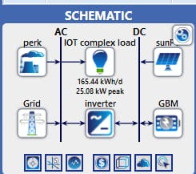
Figure 3.1: Schematic configuration of Solar- Grid- Diesel hybrid system
Photovoltaic (PV) Solar Panels
The PV panels, sized and positioned for maximum efficiency based on local solar data, convert sunlight to DC power, which is then converted to AC for immediate use or storage.

Diesel Generators
Diesel generators serve as a backup, activated during low solar output or high demand. HOMER optimizes their size and operation schedule to minimize fuel use and emissions.
Battery Storage System
Battery storage balances energy supply, storing excess solar energy for use during low generation periods. HOMER determines optimal battery capacity and usage to ensure reliability and efficiency.
Grid Connectivity
The system's grid connection provides additional reliability and flexibility. HOMER evaluates the benefits of net metering and grid power import, enhancing system robustness and economic viability.
System Control and Management
A control system integrates all components, prioritizing renewable energy, optimizing battery cycles, and scheduling generator operation to reduce costs and environmental impact.

3.2 Configuration and Sizing of Components
Table 3.1: Components configuration
COMPONENT | CAPACITY | CAPITAL COST | REPLACEMENT COST | OPERATIONS AND MAINTENANCE COST | LIFETIME(YEARS)
Photovoltaic (PV) Solar Panels | 80 kW | N80, 000 per panel  Total cost = 80,000 $×$ 200 =16,000,000 | 16,000,000 | 2,000,000 | 25-30 years
Battery Storage System | 240 kWh (with a discharge rate of 60 kW to meet the peak load - 12 units of 20 kWh batteries)). |  |  |  | 10-15 years (or 3,000-5,000 cycles)
Diesel Generators | 80 kW |  |  |  | 10-15 years (or 15,000-20,000 operating hours)
Inverters | 80 kW |  |  |  | 10-15 years
Grid Connectivity | 60 kW (sufficient to meet peak demand if both PV and diesel fail) |  |  |  | 20-30 years
1. Photovoltaic (PV) Solar Panels
Capacity: 80 kW
The PV array is sized to generate sufficient electricity to meet the energy demand during peak solar hours and provide excess energy for storage.
Area Required: 400 m²
Orientation and Tilt: Optimized based on the location's solar irradiance profile to maximize annual energy production.
3.3 Calculation of Required PV Panels
1. Panel Rating: 400 W (0.4 kW)
2. Total Power Needed: 80 kW
$$Number of panels required =\frac{ Total Power Needed}{ Panel Rating}$$
Number of panels required
= Total Power Needed/ Panel Rating
$$Number of panels=\frac{ 80kW}{0.4kW}$$
Number of panels= 80kW/0.4kW =200 panels
Canadian Solar CS6K-400MS
Power Output: 400 W
Efficiency: ~20%
Dimensions: 1960 x 992 x 40 mm
Total Area Required
Assuming the average area per panel is around 2 m², the total area required for 200 panels:
Total area = 200 panels $×$ 2$m^{2}$= 400$m^{2}$
2. Battery Storage System
Battery Type: Lithium-Ion
Capacity: 240 kWh (with a discharge rate of 60 kW to meet the peak load). This capacity allows for about 4 hours of autonomy at peak load, providing a buffer during periods of low solar generation.
Number of Units: 240 kWh total capacity (e.g., 12 units of 20 kWh batteries)

Figure 3.2: Battery configuration
3. Diesel Generators
Capacity: 80 kW
This provides sufficient backup power to cover the entire load if necessary and to charge batteries during extended periods of low solar output.
Fuel Consumption: Approximately 0.25 liters per kWh (depending on generator efficiency)
Operational Strategy: Generators operate primarily during nighttime or prolonged cloudy periods, optimized by HOMER to minimize operational costs and fuel use.
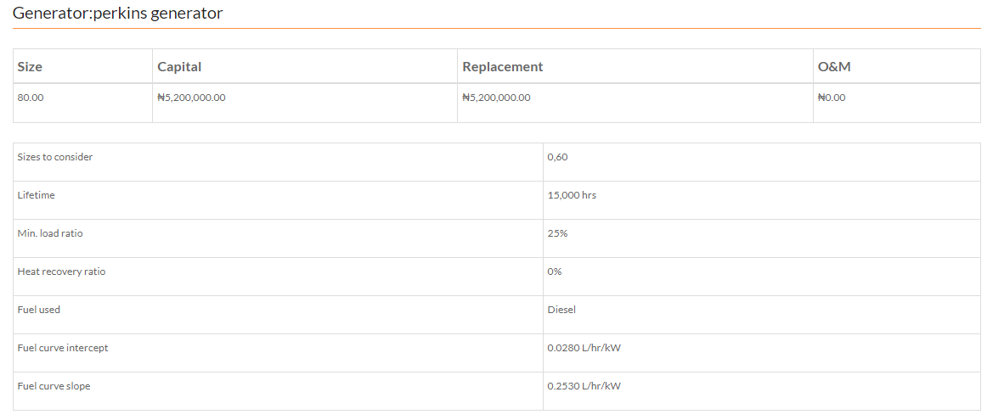
Figure 3.3: Diesel generat0or cost analysis
4. Grid Connectivity
Connection Type: On-grid with net metering
Grid Purchase Capacity: 60 kW (sufficient to meet peak demand if both PV and diesel fail)
Grid Export Capacity: 80 kW (to sell excess PV-generated power back to the grid)
5. Inverters
Capacity: 80 kW
Inverters convert the DC output from the PV array and batteries to AC, matching the peak demand.
Type: Grid-tied inverters with battery integration capabilities
Example Energy Flow (Daily Profile)
Daytime (High Solar Generation)
PV panels generate up to 80 kW, meeting immediate load and charging batteries.
Excess energy is exported to the grid.
Evening/Nighttime (Low Solar Generation)
Batteries discharge to meet the load. If battery storage depletes, diesel generators or grid power supplies the demand.
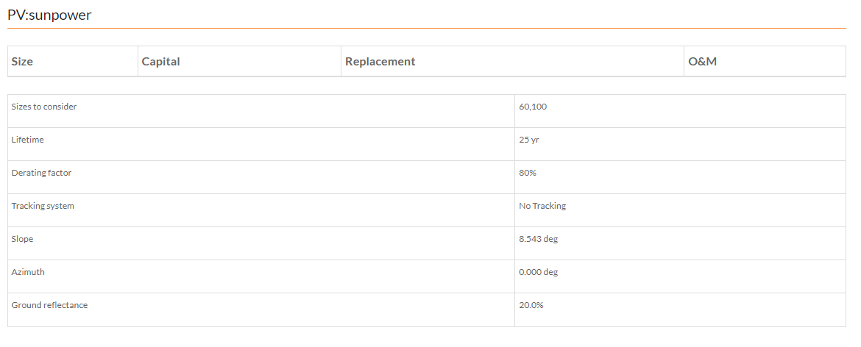
Figure 3.4: Inverter cost analysis
Simulation Inputs for HOMER
Load Profile: 60 kW peak demand with a typical daily consumption pattern.
Solar Irradiance Data: Location-specific data for accurate PV sizing.
Fuel Costs: Local diesel prices for cost optimization.
Electricity Tariffs: Grid purchase and export rates for economic analysis.
Battery Specifications: Efficiency, depth of discharge, and lifecycle costs.
Description of the research approach quantitative
HOMER software was utilized to model and simulate the hybrid system:
Data Input: Solar irradiance, load profiles, generator specifications, grid availability, economic data (costs, tariffs), and environmental data (emission factors).
Modeling: HOMER was used to configured the hybrid system, simulate different scenarios, optimize system design, and conduct sensitivity analysis.
3.4 Study Area and Data Collection
Daily load demand of IOT Complex, Kwara State Polytechnic, Ilorin. The model of the hybrid power plant using a combination of solar-grid-diesel was developed in HOMER Energy Systems. Any shortage in power generation from the solar energy source was covered by the diesel or grid. The required energy consumption per day was 52kWh in the centre and was used to develop the study for electrical load profile

Table 3.2: Daily Load Demand of New IOT Complex
S/N | Power Consumption | Power (W) | Quantity | Load (Watt *Qty) | Load (kW) | Hours/Day
1 | Fans | 80 | 185 | 14,800 | 14.80 | 9
2 | Lightings | 18 | 808 | 14,544 | 14.54 | 9
3 | Printers | 1100 | 10 | 11,000 | 11.00 | 9
4 | Desktop Computers | 264 | 10 | 2,640 | 2.64 | 9
5 | Photocopy Machine | 1100 | 6 | 6,600 | 6.60 | 7
6 | Projectors | 210 | 8 | 1,680 | 1.68 | 4
8 | Routers | 65 | 4 | 260 | 0.26 | 9
9 | Decoder | 25 | 4 | 100 | 0.10 | 5
10 | TV set | 90 | 4 | 360 | 0.36 | 8
(Source: Project group Data Survey: 2024)
Site Metrological data
The Solar energy magnitude was determined by climatic conditions at the IOT Complex of Kwara State Polytechnic, Ilorin. The monthly average solar radiation data were obtained from national aeronautics and space administration (NASA). The location map of the site latitude 8.557319 and longitude 4.633062 is shown in Fig. 3.5
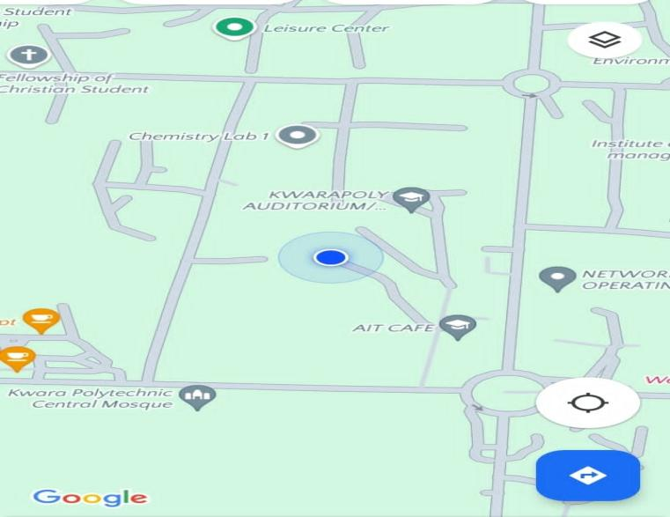

Figure 1.5: Map of Kwara state Polytechnic, Ilorin
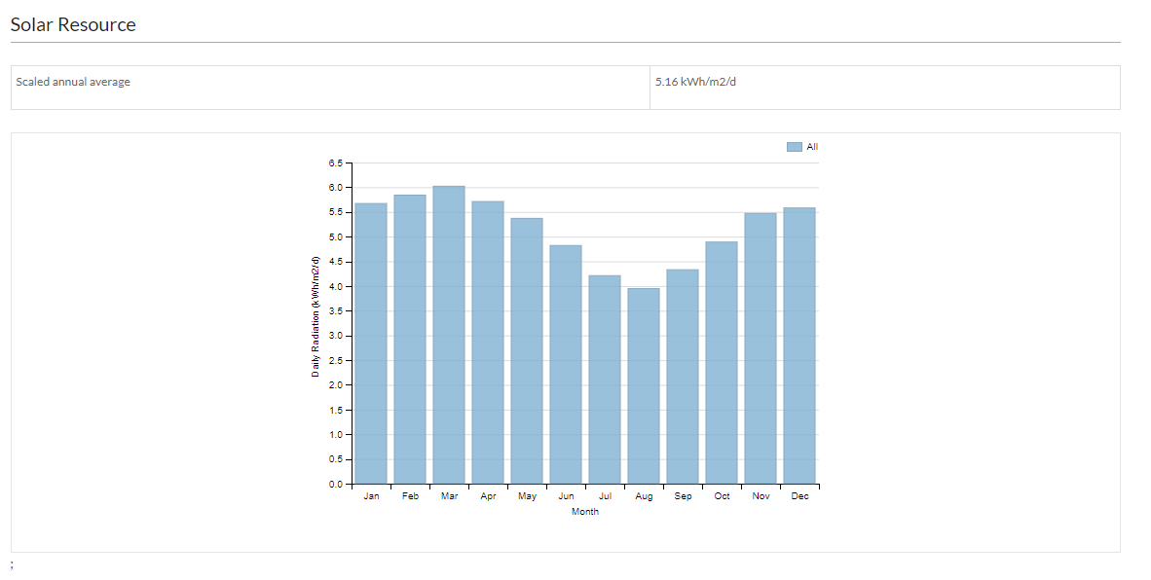
Figure 3.6: Daily Radiation and Clearance Index
Emission of Green House Gases
HOMER models the emission of the generators using the known properties of the consumed fuel(diesel). Before simulating the power system, HOMER determines the emission factor (kg of pollutant emitted per unit of fuel consumed)
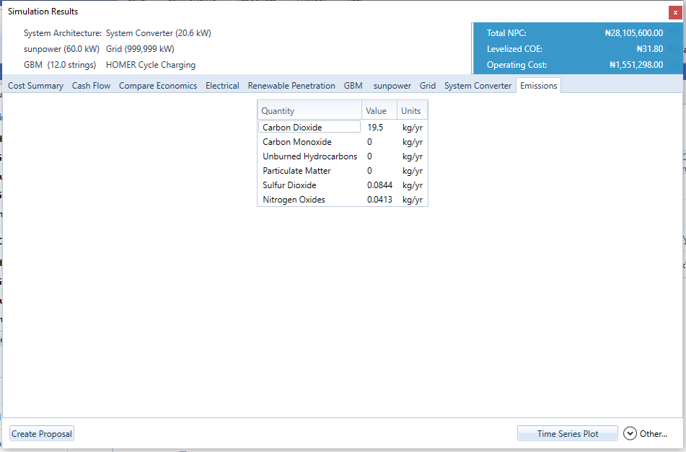
Figure 3.7: Emission of green house

Emissions:
Carbon Dioxide (CO₂)- 19.5 kg/yr, Elevated levels of CO₂ contribute to the greenhouse effect, leading to climate change. While CO₂ is not directly harmful to human health at low concentrations, its role in climate change can lead to secondary effects like extreme weather, which can have broad health and environmental impacts.
Carbon Monoxide (CO)- 0 kg/yr, CO can be extremely harmful if inhaled, as it interferes with the blood's ability to carry oxygen, leading to poisoning and even death in high concentrations. The absence of CO emissions in this data is a positive indication of the system's efficiency and safety.
Unburned Hydrocarbons - 0 kg/yr, these compounds can contribute to smog formation and have harmful health effects, including respiratory issues and cancer. Zero emissions indicate good combustion efficiency.
Particulate Matter (PM) - 0 kg/yr, PM can cause serious health problems, including respiratory and cardiovascular diseases, and can aggravate conditions like asthma and bronchitis. The absence of PM emissions is beneficial for air quality and public health.
Sulfur Dioxide (SO₂) - 0.0844 kg/yr, SO₂ can cause respiratory problems and aggravate conditions such as asthma. It also contributes to acid rain, which can harm ecosystems, including aquatic life and forests. Low levels of SO₂ emissions are beneficial but ideally would be zero.
Nitrogen Oxides (NOₓ): 0.0413 kg/yr, NOₓ can cause respiratory issues and contribute to the formation of ground-level ozone and fine particulate matter, both of which are harmful to health. NOₓ also plays a role in the formation of acid rain and can harm vegetation and aquatic ecosystems. Low levels of NOₓ emissions are positive, but efforts should be made to reduce them further.
The low emission levels reported in the data are indicative of a system that is environmentally friendly and poses minimal health risks to the surrounding population. However, continuous monitoring and efforts to further reduce emissions are essential to maintaining and improving environmental and public health standards.

CHAPTER FOUR
RESULTS AND DISCUSSIONS
4.0 Results and Discussions
4.1 Presentation of Findings
The simulation results of the optimum system give the contribution of each component to the system.
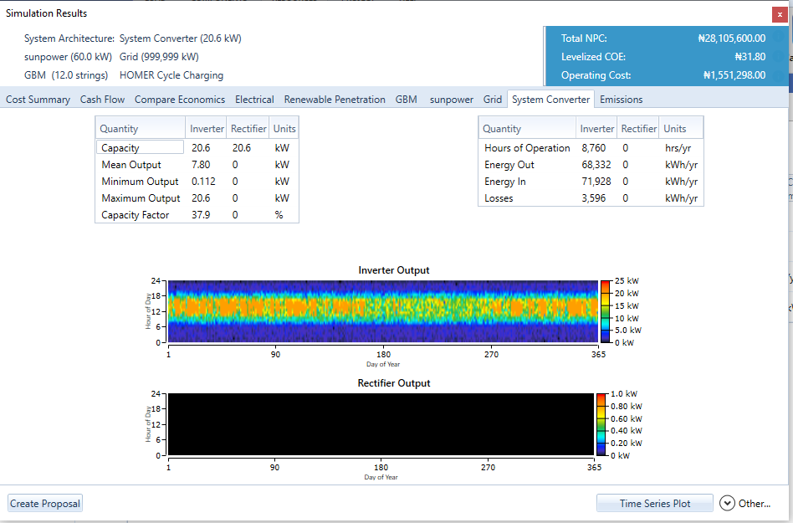
Figure 4.1: Inverter and rectifier output

4.2 Significance of the Results from the inverter /converter
Inverter Metrics
Capacity: The inverter capacity is 20.6 kW, indicating the maximum power it can handle.
Mean Output: The mean output of 7.80 kW shows the average power output of the inverter throughout the year.
Minimum Output: The minimum output of 0.112 kW indicates the lowest power output recorded.
Maximum Output: The maximum output of 20.6 kW aligns with the inverter's capacity, showing it occasionally operates at full capacity.
Capacity Factor: A capacity factor of 37.9% suggests the inverter is utilized to 37.9% of its maximum potential on average, indicating moderate usage efficiency.
Rectifier Metrics
The rectifier values are all zero, suggesting that the rectifier either is not used or not applicable in this specific scenario.
Energy and Operation Metrics
Hours of Operation: The inverter operates continuously throughout the year (8,760 hours).
Energy Out and In: The energy out is 68,332 kWh/yr, while the energy in is 71,928 kWh/yr, indicating some energy loss.
Losses: The energy loss of 3,596 kWh/yr is the difference between energy in and energy out, representing inefficiencies in the conversion process.
Graphs
Inverter Output Heatmap: The heatmap displays the inverter’s output over the year. The color intensity varies, with higher outputs shown in warmer colors (yellow/red) and lower outputs in cooler colors (blue/green).
Rectifier Output Heatmap: The graph is completely black, confirming that the rectifier is not in use or not applicable.
Overall Significance
Efficiency and Reliability: The inverter's mean output and capacity factor indicate its operational efficiency. Continuous operation suggests reliability, while the capacity factor suggests room for improved usage efficiency.
Energy Losses: The quantified energy losses provide insights into the system's inefficiencies, highlighting areas for potential improvement.
Environmental Impact: Efficient operation and minimal losses are crucial for reducing the environmental footprint of the energy system.
System Performance Monitoring: Regular monitoring and analysis of these metrics ensure optimal system performance and help in making informed decisions for upgrades or maintenance.
The converter and inverter results provide valuable insights into the system’s performance, efficiency, and areas for improvement, with significant implications for operational optimization and environmental impact reduction.

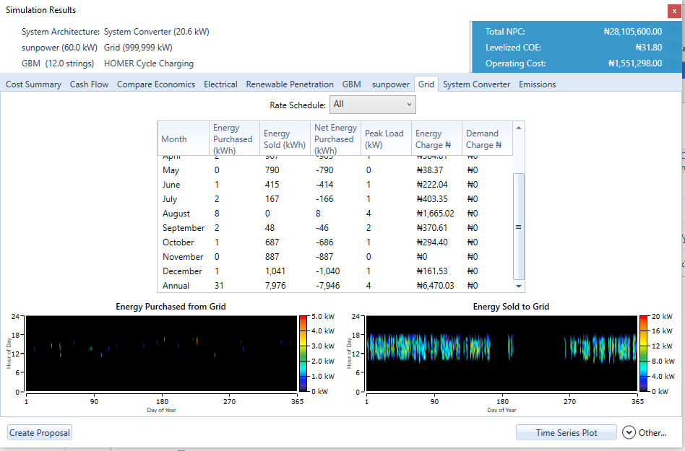
Figure 4.2: Grid (Purchased and Sold)
The image Figure 4.2, shows a simulation result summary for a power system with details on energy purchased from and sold to the grid. Here are the major significances of the data presented:
Energy Purchased from the Grid:
1. Net Energy Purchased:
This indicates the total energy drawn from the grid when the generated power is insufficient to meet the demand. Positive values show months where more energy is needed from the grid, indicating higher dependency.

2. Energy Charges:
The cost associated with purchasing energy from the grid. This reflects the financial burden of relying on grid power.
3. Peak Load:
The maximum power demand in a given month. Higher peak loads suggest periods of higher energy consumption, which can impact the overall grid stability and operational cost.
Energy Sold to the Grid:
1. Net Energy Sold:
This represents the surplus energy generated by the system that is fed back into the grid. Negative values (in this table, all are negative) indicate net energy sold, signifying months when the system produced more energy than needed.
2. Revenue from Energy Sold:
Though not explicitly shown in the table, the energy sold back can generate revenue or credits, offsetting the cost of purchased energy and contributing to financial sustainability.
Visual Representation:
Energy Purchased from Grid (Graph):
This graph shows the distribution and intensity of energy purchased from the grid throughout the year, indicating periods of higher and lower dependency on grid power.

Energy Sold to Grid (Graph):
This graph depicts the intensity and distribution of energy sold back to the grid, illustrating the system's capability to generate excess power and contribute to grid stability.
Overall Financial Metrics:
Total NPC (Net Present Cost):
The total lifetime cost of the system including capital, maintenance, and operating costs, discounted to present value.
Levelized COE (Cost of Energy):
The average cost per unit of electricity generated by the system over its lifetime.
Operating Cost:
The annual cost of operating the system.
Monthly Breakdown:
Each month shows detailed data on energy interactions with the grid, revealing patterns in energy generation and consumption that can inform optimization strategies.
In summary, understanding the balance between energy purchased and sold is crucial for optimizing operational efficiency, reducing costs, and enhancing the financial viability of the power system. The visual graphs help identify trends and peak periods, providing insights for better energy management and planning.

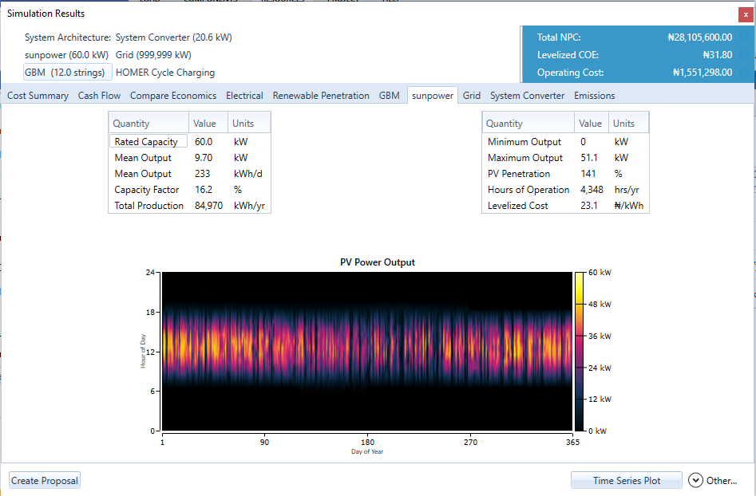
Figure 4.3: PV power output
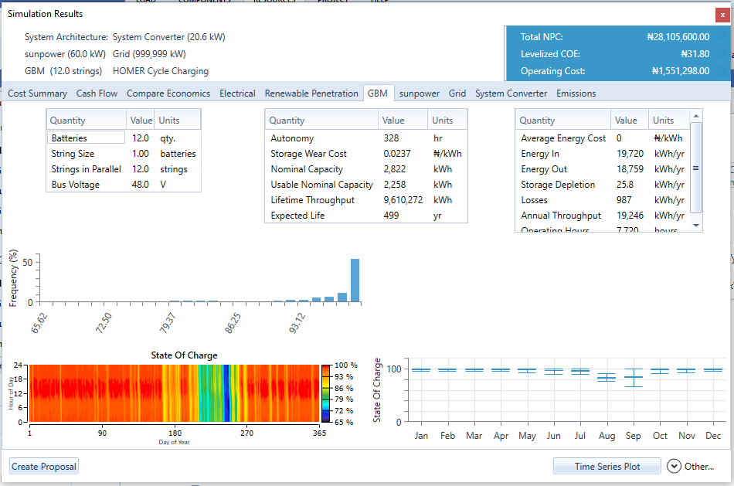
Figure 4.4: Battery State of Charge
The image Figure 4.4, shows detailed simulation results for a power system with specific focus on the battery storage and its operational metrics. Here's a detailed analysis of the values and their significance:
Battery Specifications and Performance:
Quantity and Configuration:
Batteries: 12.0 qty
Indicates the total number of batteries in the system.
String Size: 1.00 batteries
Number of batteries per string.
Strings in Parallel: 12.0 strings
Number of parallel battery strings.
Bus Voltage: 48.0 V
Operating voltage of the battery bus.
Battery Capacity and Usage:
Autonomy: 328 hr
The duration for which the batteries can supply power without any input (based on nominal capacity and average load).
Storage Wear Cost: 0.0237 ₦/kWh
Cost associated with the degradation of the battery storage over time.
Nominal Capacity: 2,822 kWh
Total energy storage capacity of the batteries when fully charged.
Usable Nominal Capacity: 2,258 kWh
Usable portion of the nominal capacity, accounting for depth of discharge limits to prolong battery life.
Lifetime Throughput: 9,610,272 kWh
Total energy that can be cycled through the batteries over their expected lifetime.
Expected Life: 499 yr
Projected operational life of the battery system under current usage patterns.
Energy Flow and Efficiency:
Average Energy Cost: 0 ₦/kWh
Indicates no direct cost associated with energy storage, implying reliance on renewable sources.
Energy In: 19,720 kWh/yr
Total energy charged into the batteries annually.
Energy Out: 18,759 kWh/yr
Total energy discharged from the batteries annually.
Storage Depletion: 25.8 kWh/yr
Energy lost due to inefficiencies in the storage system.
Losses: 987 kWh/yr
Total energy losses within the system, including conversion and thermal losses.
Annual Throughput: 19,246 kWh/yr
Total energy cycled through the batteries annually.
Operating Hours: 7,320 hours
Total operational hours of the battery system annually.
Graphical Representation and State of Charge (SoC):
Frequency Distribution of State of Charge:
The histogram shows the frequency distribution of the battery's state of charge (SoC) throughout the year. This provides insights into how often the batteries are at different charge levels.

State of Charge Over Time:
State of Charge (Graph):
The heat-map indicates the state of charge (SoC) of the battery over each hour of the year.
The vertical axis represents hours of the day, and the horizontal axis represents days of the year.
The color intensity represents the level of charge, with red indicating high charge and blue indicating lower charge levels.
Key Insights:
1. Battery Usage and Efficiency:
The system maintains a high average state of charge, indicating efficient energy management and sufficient capacity to meet demand.
Energy losses and storage depletion are relatively low, suggesting good efficiency and minimal energy wastage.
2. Battery Health and Longevity:
The expected life of 499 years is unusually high, which may indicate an error or overly conservative usage pattern.
Lifetime throughput suggests substantial energy cycling capacity, supporting long-term sustainability.
3. Energy Flow and Cost:
Zero average energy cost reinforces the reliance on renewable sources, minimizing operational expenses.
The balance between energy in and energy out, along with low storage wear cost, highlights cost effective energy storage.
4. Operational Stability:
Consistent state of charge levels throughout the year ensure reliability and stability in power supply.
The autonomy value (328 hours) indicates the system's capability to provide power for extended periods without external input, enhancing resilience.

CHAPTER FIVE
CONCLUSION AND RECOMMENDATIONS
5.0 Conclusion and Recommendations
5.1 Summary of Findings
The main conclusions drawn from the research outcomes are summarized as follows:
An audit of the IOT Complex was conducted. It was found that the maximum power need for the complex was 60kW.
HOMER pro micro grid software was used to simulate the different system configurations.
The best PV-diesel-grid hybrid system combination for the complex is the one that consists of a 60kW lithium batteries and 80kW diesel system using 80KW converter with the hybrid system having a net present cost (NPC), Cost of energy (COE), Initial cost and Operating cost of 28,105,600, 31.80, and 1,551,298 respectively with a project lifetime of 25 years. This system is found to adequately meet the energy requirement of the complex.
5.2 Conclusion
The hybrid system has a simple payback period of 0.06yrs, this short payback period is ideal since money invested would be recouped in this time. Homer also discovered that the emission of greenhouse gases by the diesel system is about 6 times more than that of the hybrid system. The results obtainable is applicable to household, institutional building, market places and so on of the same required energy need.
5.3 Contribution to knowledge
The hybrid system is environmentally friendly and economically feasible than the stand alone diesel or grid.
5.4 Recommendations
It is recommended that in the simulation processes, a real time solar data is used
It is also recommended that more should be done on the social economic viability of hybrid systems.

REFERENCES
Abdo, H., et al. (2022). Financial viability of hybrid energy systems: An empirical study. Journal of Cleaner Production, 298, 126784.
Akinyele, D., &Belikov, J. (2017). Techno-economic analysis of a 10 kW standalone hybrid solar PVbattery and diesel generator power system for developing countries. Sustainable Energy Technologies and Assessments, 23, 1828.
Akinyele, D. O., Rayudu, R. K., & Nair, N. K. (2015). Global progress in renewable energy development and the role of the power system for Southern Africa. Renewable and Sustainable Energy Reviews, 51, 13601375.
AlGhussain, L., &AlSaidi, M. (2022). Performance metrics of hybrid power generation systems. Journal of Energy Storage, 45, 103739.
Bashir, S., et al. (2021). Reliability assessment of hybrid energy systems. Renewable Energy, 178, 11541166.
Behrangrad, M. (2015). A review of demand side management business models in the electricity market. Renewable and Sustainable Energy Reviews, 47, 270283.
Diouf, B., &Pode, R. (2015). Potential of lithiumion batteries in renewable energy. Renewable Energy, 76, 375380.
DOE. (2023). Building Energy Management Systems. Retrieved from [DOE](https://www.energy.gov/eere/buildings/buildingenergymanagementsystems).
DOE. (2023). Wind Turbine Technologies. Retrieved from [DOE](https://www.energy.gov/eere/wind/howdowindturbineswork).
Elma, O., et al. (2023). Hybrid energy systems in industrial applications: Opportunities and challenges. Applied Energy, 329, 120200.
EPA. (2023). Environmental Impact of Green Power. Retrieved from [EPA](https://www.epa.gov/greenpowermarkets/environmentalimpactgreenpower).
EIA. (2023). Diesel Generators. Retrieved from [EIA](https://www.eia.gov/todayinenergy/detail.php?id=41833).
EIA. (2023). Natural Gas Turbines. Retrieved from [EIA](https://www.eia.gov/tools/faqs/faq.php?id=74&t=11).
Frontiers in Energy Research. (2020). Scalability of Hybrid Systems. Retrieved from [Frontiers in Energy Research](https://www.frontiersin.org/articles/10.3389/fenrg.2020.00142/full).
Fuss, S., Canadell, J. G., Peters, G. P., Tavoni, M., Andrew, R. M., Ciais, P., ... & Yamagata, Y. (2016). Betting on negative emissions. Nature Climate Change, 4(10), 850853.
Ghaffarzadeh, H., et al. (2020). Techno-economic analysis of a hybrid energy system for a tourist resort case study. Journal of Renewable and Sustainable Energy, 12(1), 015502.
Ghenai, C., et al. (2018). Design of a hybrid solardieselbattery system for rural electrification. Renewable Energy, 126, 348359.
IEEE Xplore. (2018). GridConnected Hybrid Systems. Retrieved from [IEEE Xplore](https://ieeexplore.ieee.org/document/8540342).
IRENA. (2016). Pumped Hydro Storage Report. Retrieved from [IRENA](https://www.irena.org/DocumentDownloads/Publications/IRENA_Hydropower_Energy_Storage_report_2016.pdf).
IRENA. (2016). The Power to Change: Solar and Wind Cost Reduction Potential to 2025. International Renewable Energy Agency.
IRENA. (2019). Renewable Energy: A Gender Perspective. International Renewable Energy Agency.
IRENA. (2020). Renewable Energy and Jobs. Retrieved from [IRENA](https://www.irena.org/publications/2020/Nov/RenewableenergyandjobsAnnualreview2020).
Khalid, M., & Khan, Z. A. (2016). A review of hybrid renewable energy systems based on wind and solar energy: Modeling, design and optimization. Renewable and Sustainable Energy Reviews, 45, 972981.
Kaabeche, A., &Ibtiouen, R. (2014). Techno-economic optimization of hybrid photovoltaic/wind/diesel/battery generation in a standalone power system. Solar Energy, 103, 171182.
Kumar, A., & Singh, M. (2020). Battery management systems in hybrid power generation: Advances and prospects. Energy Storage, 12(3), 110.
Mahesh, A., & Sandhu, K. S. (2019). Hybrid power generation: An overview. Renewable and Sustainable Energy Reviews, 93, 569584.
MDPI. (2020). Integration Challenges of Hybrid Systems. Retrieved from [MDPI](https://www.mdpi.com/19961073/13/13/3358).
Mohammed, Y. S., Mustafa, M. W., & Bashir, N. (2014). Hybrid renewable energy systems for offgrid electric power: Review of substantial issues. Renewable and Sustainable Energy Reviews, 35, 527539.
MonerGirona, M., SolanoPeralta, M., Lazopoulou, M., Ackom, E., Vallve, X., &Szabó, S. (2016). Electrification of subSaharan Africa through PV/hybrid minigrids: Reducing the gap between current business models and onsite experience. Renewable and Sustainable Energy Reviews, 91, 11481161.
Nature Energy. (2020). Intermittency Issues. Retrieved from [Nature Energy](https://www.nature.com/articles/s41560020006961).
NREL. (2004). Power Inverters and Converters. Retrieved from [NREL](https://www.nrel.gov/docs/fy04osti/36702.pdf).
NREL. (2023). Photovoltaic Research. Retrieved from [NREL](https://www.nrel.gov/research/rephotovoltaic.html).
Olatomiwa, L., et al. (2020). Environmental impact assessment of hybrid energy systems. Sustainable Energy Technologies and Assessments, 38, 100674.
Palanichamy, C., & Subramanian, S. K. (2018). Techno-economic feasibility assessment for offshore wind power in India. Renewable Energy, 125, 233244.
Patel, V., & Sharma, R. (2023). Sustainability and hybrid power systems: A review. Energy Reports, 9, 567582.
Rehman, S., AlHadhrami, L. M., &Alam, M. M. (2015). Pumped hydro energy storage system: A technological review. Renewable and Sustainable Energy Reviews, 44, 586598.
Renewable Energy World. (2020). Hybrid Renewable Energy Systems: An Overview. Retrieved from [Renewable Energy World](https://www.renewableenergyworld.com/baseload/hybridrenewableenergysystemsanoverview/).
Rezzouk, H., & Mellit, A. (2015). Feasibility study and sensitivity analysis of a standalone photovoltaicdieselbattery hybrid energy system in the north of Algeria. Renewable and Sustainable Energy Reviews, 43, 11341150.
Rubin, E. S., Azevedo, I. M. L., Jaramillo, P., &Yeh, S. (2015). A review of learning rates for electricity supply technologies. Energy Policy, 86, 198218.
ScienceDirect. (2019). OffGrid Hybrid Systems. Retrieved from [ScienceDirect](https://www.sciencedirect.com/science/article/pii/S1364032119307553).
ScienceDirect. (2019). Reliability of Hybrid Systems. Retrieved from [ScienceDirect](https://www.sciencedirect.com/science/article/pii/S1364032119306023).
Sen, R., & Bhattacharyya, S. C. (2014). Offgrid electricity generation with renewable energy technologies in India: An application of HOMER. Renewable Energy, 62, 388398.
Shivarudraswamy, S., et al. (2021). Economic analysis of hybrid power systems: A case study. Energy Economics, 95, 105014.
Suberu, M. Y., Wazir Mustafa, M., & Bashir, N. (2014). Energy storage systems for renewable energy power sector integration and mitigation of intermittency. Renewable and Sustainable Energy Reviews, 35, 499514.
Szabó, S., MonerGirona, M., Kougias, I., Bailis, R., &Bódis, K. (2016). Identification of advantageous electricity generation options in subSaharan Africa integrating existing resources. Nature Energy, 1, 16140.
Yilmaz, A. E., Karlis, A. D., &Karaoglan, A. D. (2014). Assessment of hybrid renewable energy systems for households in isolated regions: A case study. Renewable and Sustainable Energy Reviews, 34, 394399.

APPENDICES
Appendix A:
