DESIGN AND IMPLEMENTATION OF ELECTRONIC LIBRARY SYSTEM MANAGEMENT

Presented By:
FATOKI SAMSON OPEYEMI
ND/23/COM/PT/0088

Submitted to the
DEPARTMENT OF COMPUTER SCIENCE,
INSTITUTE OF INFORMATION AND COMMUNICATION TECHNOLOGY (IICT), KWARA STATE POLYTECHNIC, ILORIN

IN PARTIAL FULFILMENT OF THE REQUIREMENTS FOR THE AWARD OF NATIONAL DIPLOMA IN COMPUTER SCIENCE

JULY, 2025

APPROVAL PAGE
This is to certify that this Project was carried out by FATOKI SAMSON OPEYEMI with Matric Number: ND/23/COM/PT/0088 has been read and approved by the Department of Computer Science, Kwara State Polytechnic Ilorin, in Partial Fulfillment of the requirement for the award of National Diploma (ND) in Computer Science.

______________________
Mr. Saka _________________
Project Supervisor Date

______________________ _________________
Mr. Oyedepo, F.S
Head of Department Date

______________________ _________________
External Examiner Date

DEDICATION
This project is dedicated to Almighty Allah

ACKNOWLEDGEMENT
We are immensely grateful to everyone who supported me throughout my final year project. This project would not have been possible without the guidance, support, and encouragement of many individuals.
First and foremost, we would like to express my deepest gratitude our project supervisor, in person of MR.SAKA for his unwavering support, insightful advice, and constructive feedback throughout the development of this project. His expertise and patience were invaluable, and his commitment to our success has been a constant source of motivation.
we would also like to extend my thanks to our Management and lecturers in the Department of Computer Science, Kwara State Polytechnic Ilorin, Kwara State, Ilorin. Their dedication to teaching and their passion for the subject matter have greatly influenced my academic journey and inspired us to pursue this project.
We are particularly thankful to our family and friends for their continuous encouragement and understanding. Their belief in our abilities provided me with the confidence to overcome challenges and persevere through difficult times.
Special thanks to our colleagues and fellow students for their camaraderie and for fostering a collaborative and stimulating environment. The discussions and brainstorming sessions we shared have been incredibly beneficial.
Thank you all.

TABLE OF CONTENT
Title page i
Approval Page ii
Dedication iii
Acknowledgement iv
Table of Content v-vii
Abstract viii
CHAPTER ONE: Introduction
1.1 Background to the Study 1-4
1.2 Statement of the Problem 4
1.3 Aim and Objectives 4-5
1.4 Methodology 5
1.5 Scope of the Study 5-6
1.6 Limitation of the Study 6
1.7 Operational Definition of Term 6-7
1.8 Organization of the Project 8
CHAPTER TWO: LITERATURE REVIEW 9
2.1 Review of Related works 9-12
2.2. Review of Related Concepts 13
2.2.1 Overview of Educational Technology 13-15
2.2.2 User Interface UI Design 15-17
2.2.3 Overview on System Security 17-18
- 2.2.3.1 Component of System Security 18-19
2.2.4 Overview of Conflict Resolution on Allocation System 20
2.2.5 Real-Time System 20
CHAPTER THREE: Research Methodology 21
3.1 Description of Existing System 21-22
3.2 Problem of Existing System 22-23
3.3 Description of Proposed System 24
3.3.1 Advantages of then Proposed System 24-25
3.4 Feasibility Study 25
3.5 System Architecture 26
CHAPTER FOUR: System Design and Implementation 28
4.1 System Design 28
4.2 System Requirement 28
4.2.1 Hardware Requirement 28
4.2.2 Choice of Programming Language 28-29
4.3 Installation of the Application 30
4.3.1 Installing the Web Server 31
4.3.2 using XAMPP 31-32
4.3.3 Setting Up MySQL Database 32
4.3.4 Testing the Application 32
4.4 Implementation Interface 33-34
4.5 System Analysis/Flowchart 35-38
CHAPTER FIVE: SUMMARY, CONCLUSION

AND RECOMMENDATION 39
5.1 Summary 39
5.2 Conclusion 39-40
5.3 Recommendations 53-41
References 42-44

ABSTRACT
This research focuses on the design and implementation of an Online Library Management System (OLMS) aimed at addressing the inefficiencies and limitations of traditional manual library management methods. The existing manual systems are time-consuming, error-prone, and inadequate in meeting the growing demands of modern libraries. By automating key functions such as book cataloging, member registration, book issuance, returns, and reporting, the OLMS enhances operational efficiency, accuracy, and user satisfaction. The study follows a structured methodology encompassing requirement analysis, system design, implementation, testing, and deployment. Advanced technologies such as HTML, CSS, JavaScript, PHP, and MySQL, are employed to develop a scalable, secure, and user-friendly web-based interface. The system aims to provide remote access, robust data security, and real-time reporting capabilities. Key findings indicate that the OLMS significantly reduces manual workload, minimizes errors, improves resource accessibility, and supports data-driven decision-making. Despite challenges in integration and initial adoption, the system demonstrates substantial potential in transforming traditional library management practices. The study concludes that an OLMS is a viable solution to modernize library operations, making them more efficient and user-centric, thus meeting the evolving needs of educational institutions and research centers.
Keywords: Management System, Manual System & Automated
CHAPTER ONE
INTRODUCTION
1.1 BACKGROUD TO THE STUDY
The rapid advancement of information and communication technology has fundamentally reshaped how knowledge is created, stored, and disseminated across the globe. One major outcome of this technological progression is the emergence and widespread adoption of electronic library systems. Traditionally, libraries were characterized by physical buildings filled with shelves of books, periodicals, and other materials. However, modern needs for instantaneous access to information, remote learning, and digital collaboration have driven the transition towards electronic library system management (Okunlaya & Aderibigbe, 2022)..
An electronic library system is a digital platform designed to facilitate the collection, organization, management, and retrieval of information resources. Unlike traditional libraries where operations are manually intensive, electronic libraries automate tasks such as cataloging, searching, issuing, and returning resources (Adedoyin & Soyemi, 2023).
The efficiency offered by these systems is unparalleled, allowing users to access library materials from anywhere in the world at any time. With the increase in online learning modalities and the globalization of education, electronic libraries have become indispensable tools for maintaining academic competitiveness and ensuring equitable access to information resources. The demand for electronic library systems surged particularly during and after the COVID-19 pandemic, where remote learning became the standard rather than the exception (Ibrahim & Zayyanu, 2023).
Students, researchers, and staff now expect seamless access to digital resources without the limitations of physical boundaries. Consequently, academic institutions are investing heavily in digital infrastructures that support flexible, scalable, and secure library systems. An effective electronic library system must feature a user-friendly interface, advanced search capabilities, resource categorization, and robust security protocols to protect intellectual property and user data. Several benefits arise from the implementation of electronic library systems. They enhance operational efficiency by automating repetitive tasks such as indexing, tracking borrowing histories, overdue management, and generating usage reports (Ogunlade & Oseni, 2022).
Environmental sustainability is another key advantage associated with the deployment of electronic library systems. The traditional model of printing catalogs, periodicals, and various notices consumes a significant amount of paper, contributing to deforestation and environmental degradation. By adopting electronic systems, institutions promote a greener environment and demonstrate a commitment to sustainable development goals (SDGs) (Adewole et al., 2022).
Artificial intelligence (AI) and machine learning algorithms are expected to enhance search functionalities, recommend resources to users based on past behavior, and even automate cataloging and indexing processes (Ibrahim & Ogundele, 2023).
1.2 STATEMENT OF THE PROBLEM
Presently, transaction of books in the institutional libraries have been done manually in most cases, thereby taking more time for transaction like borrowing of books or return of books and also searching of member and books. Series of problems occur as a result of this thereby resulting to inefficient library management. In most cases as a result of human error there maybe loss and damages of records due to not using a computerized system in the library. Nevertheless, the difficulty in the searching of books which could be termed to be inadequacy in book Management is a problem in the manual library thereby causing inefficiency and time consuming in the library.
Also, the problem of space consuming erupts after the number of records become large the space for physical storage of file and records also increases if no computerized system is implemented as well as the issue of cost. Due to problem of lack of prompt information retrieval and time wastage in using the library. In addition, due to the cumbersome, in this project computer approach will be used to solve these problems. Each of the manual procedure will be analyzed.
1.3 AIM AND OBJECTIVES OF THE STUDY
The main aim of the research work is the design and implementation of an electronic library system. This research work will create a platform where users can access the library content without considering opening or closing time of the library.
The main objectives of this project are:
- To design a web-based library management system that can be accessed remotely.
- To implement functionalities for managing books in automated way.
- To ensure data security and integrity.
- To provide a user-friendly interface for librarians and library members.

1.4 SCOPE OF THE STUDY
The scope of this study encompasses the design and implementation of an Online Library Management System (OLMS) aimed at automating and enhancing the efficiency of library operations. This system will manage key functions such as book cataloging, member registration, book issuance, returns, and fine calculations. It will include a user-friendly web interface accessible to librarians, administrators, and members, allowing for remote access and efficient management of library resources. The OLMS will integrate advanced search capabilities, enabling users to search for books by title, author, genre, and ISBN. It will ensure data security and integrity through robust authentication protocols and encryption measures, protecting sensitive information from unauthorized access. The system will also generate comprehensive reports on library activities, including book circulation, overdue items, and user engagement, facilitating data-driven decision-making for library management.
1.5 LIMITATION OF THE STUDY
this study encountered certain limitations that could influence the scope, generalizability, and overall impact of its findings. First, the study was constrained by limited financial resources. Budgetary restrictions affected the scale of system development, restricting the use of advanced features such as real-time cloud synchronization, artificial intelligence-based recommendation systems, and multilingual support. Consequently, some functionalities that could have enhanced the system’s performance and user experience were either scaled down or omitted entirely. Secondly, time constraints posed a significant limitation. The project was conducted within a predefined academic timeframe, which limited extensive user testing and feedback cycles. As a result, although basic functionality was thoroughly tested, there was insufficient time to carry out long-term usability studies or deploy the system across multiple institutions for broader evaluation. This affects the ability to make inferences about how the system would perform under different conditions or within larger user populations.
1.7 DEFINITION OF TERM
1. Online Library Management System (OLMS): A web-based software application designed to automate and streamline various library operations, including book cataloging, member registration, book issuing, returns, and reporting. The OLMS provides a user-friendly interface accessible to librarians, administrators, and members, facilitating remote access and efficient management of library resources.
2. Book Cataloging: The process of systematically organizing and describing library materials, including books, periodicals, and multimedia items, to facilitate efficient searching and retrieval. In the context of the OLMS, book cataloging involves entering and storing book information such as title, author, genre, ISBN, and availability status in the system's database.
3. Member Registration: The process of enrolling individuals as library members, allowing them to access library services and borrow materials. Member registration in the OLMS involves capturing and storing member details such as name, contact information, and membership status for administrative and communication purposes.
4. Book Issuance and Returns: The procedures for lending books to members and recording their return. In the OLMS, book issuance involves updating the availability status of books, recording transaction details, and setting due dates. Returns entail updating the status of returned books, calculating any fines incurred, and updating transaction records accordingly.
5. Reporting: The generation of analytical reports and statistics based on library activities and usage data. In the OLMS, reporting functionality enables administrators to track book circulation, overdue items, member activities, and other key metrics to inform decision-making and strategic planning.
6. Scalability: The ability of the OLMS to handle increasing volumes of data, users, and transactions without compromising performance or functionality. A scalable system can accommodate growth and changes in usage patterns over time while maintaining optimal performance levels.
7. Data Security: Measures implemented to protect sensitive information stored in the OLMS from unauthorized access, alteration, or disclosure. Data security features may include encryption, secure authentication mechanisms, access controls, and regular backups to ensure the integrity and confidentiality of library data.
1.8 ORGANIZATION OF THE PROJECT
This researched Work is divided into Five Chapter as follows: -
CHAPTER ONE: Introduction
This chapter will discuss on Background of the study, Statement of the problem Aim and Objectives of the study, Methodology, Scope of the Study, Limitation of the Study, Operational Definition of terms and Organization of the project. All this outlining the detailed objectives to achieve the main goals of this research work.
CHAPTER TWO: Literature Review
This chapter will focus on the past researched (Review of related literature), Overview of Design of Online Library Management System.
CHAPTER THREE: Research Methodology
This stage will evaluate the Description of Existing System, Problem of Traditional System, Description of proposed system and Architectural Design of proposed system
CHAPTER FOUR: Design and Implementation of the System
This chapter will emphasize on Overall Design of the research work (Design and Implementation of Online Management System)
CHAPTER FIVE: Summary, Conclusion, Future Research, References
This breakdown will provide a clear structure for this research work, each chapter will focus and contributes to the overall understanding of Design and Implementation of Online Library Management System.

CHAPTER TWO
LITERATURE REVIEW
2.1 REVIEW OF RELATED WORK
Okunlaya and Aderibigbe (2022) discussed the transition from traditional libraries to electronic systems, highlighting the operational efficiency, space savings, and accessibility benefits associated with digital libraries. Their study emphasized the importance of user-centered design and recommended that modern library systems incorporate intuitive interfaces, real-time updates, and multi-device compatibility to meet users’ evolving expectations.
Adedoyin and Soyemi (2023) examined the integration of digital library services in academic institutions. Their research identified key success factors for electronic libraries, including robust metadata management, automated cataloging, and secure digital rights management. They also stressed the importance of system scalability, allowing libraries to expand their collections and user base without significant overhauls.
Zayyanu (2023) addressed the post-pandemic surge in remote learning and the need for virtual library services. Their findings showed that electronic libraries played a crucial role in ensuring educational continuity during periods of campus closures. They noted that the success of electronic library systems heavily depends on strong digital resource curation, reliable access platforms, and continuous system maintenance.
Adewole et al. (2022) explored the environmental sustainability impacts of electronic libraries, noting that reducing reliance on printed materials contributes significantly to sustainable development goals. Their study recommended that institutions invest in fully digital repositories and minimize physical book acquisitions where possible, balancing academic needs with environmental considerations.
Edewor and Aregbesola (2023), who highlighted increasing cyber threats to digital academic resources. They proposed incorporating advanced security mechanisms such as encryption, multi-factor authentication, and regular system audits. Their study further emphasized that user education in cybersecurity practices is essential for safeguarding library systems.
Ogunlade and Oseni (2022) focused on automation in library services, emphasizing the reduction of manual work through automated cataloging, user registration, resource lending, and overdue notifications. They found that automation significantly enhanced library efficiency but warned that poor system design could alienate users unfamiliar with digital platforms.
2.2 REVIEW OF RELATED CONCEPT
Okunlaya and Aderibigbe (2022) described an electronic library as a collection of information resources that exist in digital form and are accessible through electronic means such as computers and mobile devices. Unlike traditional libraries that rely on physical books and media, electronic libraries provide users with immediate access to e-books, journals, articles, audio-visual materials, and databases, enhancing accessibility and allowing institutions to cater to a wider and more diverse audience.
Adedoyin and Soyemi (2023) emphasized that a fundamental element in managing an electronic library is the use of a Library Management System (LMS), which automates core operations such as cataloging, user registration, borrowing, returning, and overdue notifications. In an electronic context, it must also handle the uploading, indexing, and retrieval of digital materials while ensuring that access is controlled and resources are protected.
Ogunlade and Oseni (2022) further highlighted that effective electronic library systems are heavily reliant on robust Database Management Systems (DBMS), which store, manage, and retrieve bibliographic data, user information, and transaction records efficiently. They pointed out that modern electronic libraries often use relational databases like MySQL and PostgreSQL, but with emerging needs for scalability and handling multimedia content, many are moving toward NoSQL databases.
Edewor and Aregbesola (2023) explained that in managing access to digital resources, authentication and authorization mechanisms are crucial. Authentication ensures that only legitimate users can access the system, while authorization controls the actions each user is allowed to perform within the platform. Ajayi and Ajibola (2022) stated that efficient search and retrieval systems allow users to find relevant information quickly through indexing, keyword searches, and the use of metadata filters such as author, title, and subject. They argued that without efficient retrieval, the usability of an electronic library system would be severely compromised.
2.2.1 Benefits of Electronic Resources in Library Operations and Services.
Okunlaya and Aderibigbe (2022) observed that electronic resources have significantly improved the accessibility of library services, enabling users to retrieve information anytime and anywhere without the physical limitations of a traditional library setting. Through digital platforms, users can access e-books, e-journals, databases, and multimedia content remotely, which enhances learning flexibility and research productivity.
Adedoyin and Soyemi (2023) emphasized that electronic resources reduce the physical space required for libraries to store materials. Traditional libraries often require extensive shelving and storage areas, but digital collections are stored electronically, freeing up physical space for other critical functions such as collaborative study areas and digital learning labs. They further noted that electronic resources contribute to cost savings in the long term by minimizing expenses related to the acquisition, maintenance, and preservation of physical materials.
According to Ogunlade and Oseni (2022), the integration of electronic resources in library operations enhances the speed and efficiency of information retrieval. Users can perform keyword searches across thousands of documents in seconds, a task that would take considerably longer in a traditional library setting. This speed empowers users to conduct comprehensive research and complete academic tasks more efficiently.
Ibrahim and Zayyanu (2023) pointed out that the availability of electronic resources promotes collaborative learning and knowledge sharing. Many digital libraries and online databases provide tools that allow users to annotate documents, share resources, and engage in collaborative research projects across geographical boundaries, which is vital in today’s globalized educational environment.
Edewor and Aregbesola (2023) highlighted that electronic resources ensure the preservation and security of rare and fragile documents. Digitizing valuable manuscripts, historical documents, and special collections protects them from physical deterioration while making them widely accessible to researchers and scholars. This approach not only conserves heritage materials but also democratizes access to information that was once restricted to specific locations.
Ajayi and Ajibola (2022) discussed the flexibility offered by electronic resources in terms of multimedia integration. Unlike print resources, electronic materials can incorporate audio, video, animations, and interactive elements that enhance learning and cater to diverse learning styles. This multimedia approach is particularly beneficial for users with different educational needs, including those with disabilities.
Olowu and Oguntunde (2022) stressed that electronic resources also facilitate efficient library management and operational effectiveness. Automation of cataloging, circulation, acquisition, and user management tasks streamlines workflow processes, reduces administrative burdens, and improves overall service delivery. As a result, librarians can focus more on supporting users' academic and research needs rather than being overwhelmed by manual processes.
Furthermore, Ukwuoma and Ebhohimen (2023) observed that electronic resources contribute to environmental sustainability by reducing the need for paper-based materials, thus helping to conserve trees and minimize waste. In an era where climate change and environmental conservation are critical global issues, libraries that prioritize electronic resources demonstrate a commitment to sustainability goals.
Adewole, Ibrahim, and Yusuf (2022) stated that the scalability of electronic resources allows libraries to easily expand their collections without the constraints of physical space. New digital materials can be added effortlessly to online databases, ensuring that libraries can continuously update and diversify their collections to meet evolving academic and research demands.
2.2.2 Management and Maintenance of Electronic Resources in Academic Libraries
The growth of research in all fields of human endeavor is becoming increasingly detailed and sophisticated. Undergraduate students are yet to fully realize the fact that the library has a great role to play in the provision of information necessary for their day to day research. Moreover, the library acts as a medium of getting the latest scientific and technological information either in print or electronic form. Academic libraries collect a variety of materials for preservation and use by the library patrons. Okunlaya and Aderibigbe (2022) emphasized, electronic resources are essential in supporting academic research and learning. However, their effective management requires a systematic approach to organization, preservation, and continuous update to meet the evolving needs of students, faculty, and researchers.
Adedoyin and Soyemi (2023) pointed out that one of the primary challenges in managing electronic resources is the necessity of maintaining up-to-date cataloging and metadata standards. This includes accurately classifying digital resources to ensure users can easily locate and retrieve them. Effective metadata management facilitates the seamless integration of resources into library discovery systems, helping users to search, filter, and access materials with precision. Automated cataloging systems and digital repositories play a pivotal role in ensuring that electronic resources are cataloged efficiently and effectively.
In addition to cataloging, Ogunlade and Oseni (2022) emphasized the importance of managing licenses and subscriptions for electronic resources. Academic libraries typically invest in a range of subscription-based services, such as online databases, journals, and e-books. Proper license management ensures compliance with copyright regulations, while also controlling the costs associated with these subscriptions. This aspect of management requires continuous monitoring of renewals, subscription terms, and the negotiation of favorable terms with vendors.
Edewor and Aregbesola (2023) further highlighted that maintaining the technical infrastructure of electronic resources is a key aspect of management. This includes ensuring that the hardware, software, and network infrastructure used to support digital resources are secure, up-to-date, and capable of handling increasing amounts of data. Libraries must also ensure that their systems are scalable, especially with the growing demand for cloud-based resources and services. Regular system upgrades, vulnerability assessments, and data backups are vital to prevent data loss and minimize the impact of system failures.
Ajayi and Ajibola (2022) discussed the role of staff training in the management and maintenance of electronic resources. Library staff must be proficient in using digital tools, managing electronic resources, and providing user support. Training programs should focus on improving staff expertise in navigating electronic resource management systems, troubleshooting technical issues, and assisting library users with accessing and utilizing digital content. Furthermore, Ajayi and Ajibola (2022) suggested that libraries should invest in continuous professional development to ensure that staff remain current with new technologies and trends in the electronic resource management field.
Ibrahim and Zayyanu (2023) argued that preservation strategies are integral to the management of electronic resources. Unlike physical resources, digital materials are susceptible to technological obsolescence, format degradation, and data corruption. Implementing proper digital preservation strategies is essential to ensuring that electronic resources remain accessible in the long term. Regular data migration to updated formats, employing redundancy measures to prevent data loss, and creating archives for backup copies are critical aspects of digital preservation. Ibrahim and Zayyanu (2023) also noted that academic libraries must collaborate with digital preservation initiatives and follow established standards such as the OAIS (Open Archival Information System) model to ensure the long-term viability of their digital collections.
Olowu and Oguntunde (2022) emphasized that effective user support services are a crucial component of managing electronic resources. Libraries must provide users with access to help desks, instructional guides, and troubleshooting assistance for navigating electronic resources. This can be achieved through the development of user-friendly portals and comprehensive user guides that help users maximize their use of digital resources. Additionally, libraries should regularly solicit feedback from users to identify issues and areas for improvement in the management of electronic resources.
Ukwuoma and Ebhohimen (2023) discussed the need for libraries to monitor usage statistics to assess the effectiveness of electronic resources and make informed decisions regarding renewals, cancellations, and acquisitions. Usage statistics provide valuable insights into how often resources are accessed, which resources are most popular, and which may be underutilized. By analyzing these metrics, libraries can make data-driven decisions to optimize resource management and allocate funds to the most needed resources.
2.2.3 Effects of Use of Electronic Resources on Undergraduate Students.
Ajayi and Ajibola (2022) highlighted that one of the primary benefits of electronic resources is the increased accessibility they offer. Undergraduate students can access academic content anytime, anywhere, which removes the time and location constraints that often accompany physical library materials. This 24/7 accessibility promotes self-directed learning, allowing students to engage with course materials outside the classroom and during off-hours, which is particularly beneficial for students with busy schedules or those studying part-time.
Adedoyin and Soyemi (2023) emphasized that electronic resources enhance the research capabilities of undergraduate students by providing access to a vast array of academic materials that would be difficult to obtain in traditional library settings. Digital resources enable students to quickly search for relevant information, compare multiple sources, and access up-to-date publications that are crucial for research projects, assignments, and dissertations. The ability to search across multiple databases and resources also improves the comprehensiveness of students' research.
Moreover, Ogunlade and Oseni (2022) noted that the use of electronic resources encourages the development of digital literacy skills among undergraduate students. In order to effectively navigate and utilize these resources, students must develop competencies in information retrieval, critical evaluation of digital materials, and the use of various academic tools such as citation managers. This not only enhances their research capabilities but also prepares them for the demands of the modern digital workplace, where digital literacy is increasingly important.
Ibrahim and Zayyanu (2023) observed that the availability of multimedia content, such as videos, podcasts, and interactive tutorials, significantly enhances students' learning experiences. These resources cater to various learning styles, particularly benefiting students who may struggle with traditional text-based materials. Visual and auditory learners can engage more effectively with content, improving their understanding and retention of complex subjects. Ibrahim and Zayyanu (2023) further pointed out that multimedia resources can foster greater student engagement, making learning more interactive and enjoyable.
Edewor and Aregbesola (2023) argued that the extensive use of electronic resources could potentially lead to information overload for undergraduate students. With the sheer volume of online materials available, students may find it overwhelming to sift through vast amounts of information to identify relevant and reliable sources. This overload can hinder students' ability to focus and may lead to difficulties in organizing and synthesizing information for assignments or research papers. As a result, students may require additional guidance on how to effectively manage and use electronic resources.
Olowu and Oguntunde (2022) discussed the effects of electronic resource use on academic performance. They found that students who regularly engage with digital resources tend to perform better academically. The ease of accessing relevant and high-quality materials supports their understanding of course content and enables them to produce well-researched papers and projects. However, they cautioned that the lack of face-to-face interaction and over-reliance on digital materials could also lead to a decrease in students' critical thinking and problem-solving skills, which are often developed through classroom discussions and collaborative learning.
Furthermore, Ukwuoma and Ebhohimen (2023) pointed out that while electronic resources offer unparalleled convenience and efficiency, they also introduce challenges related to time management and self-discipline. Undergraduate students may struggle to balance their use of digital materials with other academic and personal responsibilities. Without proper time management skills, students may become distracted by non-academic online content or procrastinate in completing assignments.
Adewole, Ibrahim, and Yusuf (2022) concluded that the use of electronic resources contributes significantly to the academic success of undergraduate students. They noted that electronic resources facilitate active learning by allowing students to engage with up-to-date research and explore academic topics more deeply than traditional textbooks or printed materials would allow. The continuous availability of digital resources promotes a more flexible and personalized learning environment, supporting the diverse needs of students.

2.2.4 Challenges Facing the Use of Electronic Resources in Academic Libraries
Okunlaya and Aderibigbe (2022) noted that the use of electronic resources in academic libraries has revolutionized the learning experience for undergraduate students. These resources, including e-books, academic journals, online databases, and multimedia content, have made academic materials more accessible and flexible, offering significant advantages to students’ academic performance and research efficiency.
Ajayi and Ajibola (2022) highlighted that one of the primary benefits of electronic resources is the increased accessibility they offer. Undergraduate students can access academic content anytime, anywhere, which removes the time and location constraints that often accompany physical library materials. This 24/7 accessibility promotes self-directed learning, allowing students to engage with course materials outside the classroom and during off-hours, which is particularly beneficial for students with busy schedules or those studying part-time.
Adedoyin and Soyemi (2023) emphasized that electronic resources enhance the research capabilities of undergraduate students by providing access to a vast array of academic materials that would be difficult to obtain in traditional library settings. Digital resources enable students to quickly search for relevant information, compare multiple sources, and access up-to-date publications that are crucial for research projects, assignments, and dissertations. The ability to search across multiple databases and resources also improves the comprehensiveness of students' research.
Moreover, Ogunlade and Oseni (2022) noted that the use of electronic resources encourages the development of digital literacy skills among undergraduate students. In order to effectively navigate and utilize these resources, students must develop competencies in information retrieval, critical evaluation of digital materials, and the use of various academic tools such as citation managers. This not only enhances their research capabilities but also prepares them for the demands of the modern digital workplace, where digital literacy is increasingly important.
Ibrahim and Zayyanu (2023) observed that the availability of multimedia content, such as videos, podcasts, and interactive tutorials, significantly enhances students' learning experiences. These resources cater to various learning styles, particularly benefiting students who may struggle with traditional text-based materials. Visual and auditory learners can engage more effectively with content, improving their understanding and retention of complex subjects. Ibrahim and Zayyanu (2023) further pointed out that multimedia resources can foster greater student engagement, making learning more interactive and enjoyable.
Edewor and Aregbesola (2023) argued that the extensive use of electronic resources could potentially lead to information overload for undergraduate students. With the sheer volume of online materials available, students may find it overwhelming to sift through vast amounts of information to identify relevant and reliable sources. This overload can hinder students' ability to focus and may lead to difficulties in organizing and synthesizing information for assignments or research papers. As a result, students may require additional guidance on how to effectively manage and use electronic resources.
Olowu and Oguntunde (2022) discussed the effects of electronic resource use on academic performance. They found that students who regularly engage with digital resources tend to perform better academically. The ease of accessing relevant and high-quality materials supports their understanding of course content and enables them to produce well-researched papers and projects. However, they cautioned that the lack of face-to-face interaction and over-reliance on digital materials could also lead to a decrease in students' critical thinking and problem-solving skills, which are often developed through classroom discussions and collaborative learning.
Ukwuoma and Ebhohimen (2023) pointed out that while electronic resources offer unparalleled convenience and efficiency, they also introduce challenges related to time management and self-discipline. Undergraduate students may struggle to balance their use of digital materials with other academic and personal responsibilities. Without proper time management skills, students may become distracted by non-academic online content or procrastinate in completing assignments.
Adewole, Ibrahim, and Yusuf (2022) concluded that the use of electronic resources contributes significantly to the academic success of undergraduate students. They noted that electronic resources facilitate active learning by allowing students to engage with up-to-date research and explore academic topics more deeply than traditional textbooks or printed materials would allow. The continuous availability of digital resources promotes a more flexible and personalized learning environment, supporting the diverse needs of students.

CHAPTER THREE
RESEARCH METHODOLOGY
3.1 DESCRIPTION OF EXISTING SYSTEM
The existing system for library management in many institutions is primarily manual and paper-based, involving significant human intervention to handle day-to-day operations. This traditional approach includes several processes such as book cataloging, member registration, book issuance and returns, and reporting, all of which are performed manually by library staff. Below is a detailed description of the current system's components and workflows:
1. Book Cataloging: In the manual system, books are cataloged by library staff who physically enter details like title, author, genre, ISBN, and location into a paper register or basic computer spreadsheets. This process is time-consuming and prone to human errors, leading to inaccurate records and difficulties in locating books.
2. Member Registration: New members are registered by filling out paper forms with their personal details. Library staff then manually enter this information into a membership register or simple electronic database. This approach is inefficient and can result in data entry errors, making it challenging to maintain accurate and up-to-date member records.
3. Book Issuance and Returns: When a member wants to borrow a book, the staff checks the availability manually, records the transaction in a register, and notes the due date. Upon return, the due date is checked, and any overdue fines are calculated and recorded manually. This process is labor-intensive and slow, often leading to long wait times for users and potential inaccuracies in tracking borrowed books and fines.
4. Reporting: Generating reports in a manual system involves aggregating data from various paper registers and spreadsheets. This process is laborious and error-prone, making it difficult for library administrators to obtain timely and accurate insights into book circulation, member activities, and other key metrics. Consequently, decision-making and strategic planning are hindered.
5. Accessibility and User Experience: Users must visit the library physically to search for books, borrow, and return them. This limitation affects accessibility, particularly for those who cannot frequently visit the library, such as remote students or researchers.
6. Data Security and Integrity: The manual system lacks robust security measures to protect sensitive information. Paper records are vulnerable to physical damage, loss, and unauthorized access, while basic electronic databases lack encryption and other security protocols, risking data breaches.
7. Scalability: As the library's collection grows and the number of users increases, the manual system becomes increasingly cumbersome and inefficient. It struggles to handle larger volumes of data and transactions, leading to operational bottlenecks and decreased service quality.
3.2 PROBLEM OF EXISTING SYSTEM
Having the overview knowledge of the existing system, the following are its problem
- Loss of Data: A lot of paper works are needed for the safe keeping of the details of books borrowed by a registered user.
- Time Wasting: User time are wasted as a result of searching for a book that has been borrowed by a user whose record cannot be traced on the paper records.
- Error Prone: The existing system of operation is prone to error.
- Tedious: It is tedious because it must take a routine
- Processing Speed: The processing speed is very low resulting into low output.

User Returning Book
User borrowing Book
The Library / Librarian
Fig. 3.2: Model of the Existing System

3.3 DESCRIPTION OF THE PROPOSED SYSTEM
The proposed Library booking and lending system is a web-based application used by an administrator (Librarian) as an alternative means of record keeping of the books stored in the library. It has the following features.
- The administrator registers the applicant with their name as the first and last name, matriculation number, department etc. and a username is being suggested by the user alongside a login password which is to be used for log in by the registered user
- An applicant is allowed to log into the system with his name and generated password which is given at the point of registration.
- The administrator goes into the report to view the details of a particular

The Librarian
User Computer
Library User
Librarian Computer
Fig. 3: Model of the proposed system

3.3.1 Advantages of Proposed system
Certain merits have been associated with the proposed system which enhances the design of the system. Some of which are stated below:
- It will save time. The process of lending books will not be done in batch;
- User’s logon information is properly secured;
- It is very simple and smart. Users Can borrow and return books anywhere;
- Much energy is not required for assessment;
- Anybody can access the platform.
3.4 FEASIBILITY STUDY
This research work is of great importance as it helps the students to electronically sell and buy items. In course of realizing the aim of this study, the following feasibility studies were carried out;
- How can this study meet the targets and demands of the users
- Who are the targeted users
- How can users benefit from this study
- How many users can logon to the platform at a time
- How many users can borrow book at a time
In regard to the above studies, the research work made adequate provision to handle the above problems. Practically and theoretically, this project has proven to be possible and achievable.

3.5 SYSTEM ARCHITECTURE DESIGN
The design and analysis conducted were divided into three sections. These are;
- Admin interface design
- User interface design
- The Database designs
    - The Admin Interface Design
The design of the system involves an admin interface which is responsible for keeping track of the user’s activities within and around the platform. The admin also is charged with the responsibility of uploading new books and making it visible to other users in terms of lending. The admin can also delete or remove any user who is found not obeying the terms and condition of the system. The modules that make up the admin interface are; Admin Login, and admin panel.
- Admin Login: this form is designed to enable the admin of the system to login so as to access the platform in other to know what is happening and as well as the books available. Once login is successful, the admin can also add products supplied by the users.
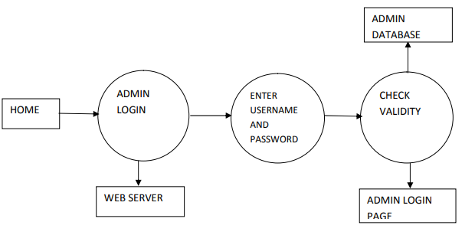
Fig. 4 Admin login Interface
- Admin Panel: this interface is designed to enable the admin monitor everything that is going on within the system. In this interface, the admin can keep track of the user logs, books available, membership approval, user accounts etc.
ADMIN PANEL
UPDATE USER RECORD
UPDATE COPIES OF A BOOK
ADD A NEW BOOK
PENDING BOOK REQUEST
PENDING REGISTRATION

    - The User Interface
Fig.3.5: Admin Panel Design

3.5.2 User Interface Design
This interface is specially designed for users who wish to purchase item(s) from the platform. Before any user will purchase an item, he/she must be registered on the platform. The modules that make up the User interface are; user sign up and user Login interface.
- User Sign Up: this interface is designed to enable users to be registered on the platform. The user will supply all the relevant information on an input field through the keyboard input device.

Sign Up
Password

User Name

Mobile No
Address

Email

Last Name

Middle Name

First Name
Fig. 6 User signup Interface
- User Login Interface: when a user has successfully registered on the platform, this interface will enable him to login to the system and make any possible purchase of his / her choice.

Username

Password

User Login
Login

Fig. 7 User Login Interface

3.5.3 The Database Design
The design of the database was done with MYSQL. During the design, the following consideration was done;
- The total number of tables that will be required to store all the tabular data.
- These tables are designed considering the data items to be stored with respect to their field names.
3.5.4 Output Specification and Design
The output design was based on the inputs. The report generated gives a meaningful output. These outputs can be generated as softcopy or printed in hard copy.
3.5.5 Input Specification and Design
The program is designed with the principle of GIGO (garbage in, garbage out) – That is, it returns every single data sent by the user after processing is done. The input forms are designed generally based on the necessary data that needs to be entered into the system. The data are captured through the keyboard and stored on an SQL database.

3.5.6 File Design
MySQL relational database was used in the development of the system. This is because SQL relational database avoids data duplication, avoids inconsistent records, easier to change data and data format. The database for this system comprises of the following tables admin, category, customers, logs, order, order- details, payment, products, sales, sales details, users and supplier. Their structures are as follows;

CHAPTER FOUR
SYSTEM IMPLEMENTATION AND DOCUMENTATION
The objective of system implementation is to ensure that the system is working effectively and efficiently as expected. It also involves the putting of the newly proposed system into operation. This chapter looks at how the system will be implemented to achieve the purpose for which it was designed. The project was designed using PHP (Hypertext Pre-processor) as the main Scripting Language, Bootstrap to style the interface and MySQL server as the database server, and XAMP as the web server. The application can be accessed using any web browser.
4.1 SYSTEM REQUIREMENTS
The minimum requirement for the implementation of this system will be discussed in this section.
    - Hardware Requirements
- Processor: At least 500MHZ Pentium 111-class processor
- Hard Disk : At least 1 GB of available space required on system drive
- Display: super VGA (1024 x 768) or higher resolution display with 256 colours
- RAM : 2GB Minimum
4.2 CHOICE OF PROGRAMMING LANGUAGE
A program is a series of instructions given to a computer or similar devices to perform or solve a given task. These instructions are written on the computer in a language the computer understands.
As it was stated above, this system was built with PHP programming language and it was designed on HTML. The database software used was MySQL managed by phpMyadmin. These tools and others that were used during this project are stated below:
1. PHP: It is a server-side scripting language, and is a powerful tool for making dynamic and interactive Web pages quickly. It was the best choice of scripting languages to use for a very flexible project as this. PHP was used to code the functionality of the system by leveraging the Notepad++ framework. PHP version 5.4.4 was the version used.
2. HTML and CSS: Hypertext Markup Language and Cascading Style Sheet are tools used in development and creation of web pages that run mostly on web browsers. They were used to develop the frontend design and user interface of the system.
3. SQL: SQL (structured query language) is a standard language for accessing databases. SQL is used to access and manipulate data in: MySQL, SQL Server, Access, Oracle, Sybase, DB2, and other database management systems.
4. MySQL: The MySQL database management system served as the database for building and testing the system. It also served as the platform where all data used in the application could be manipulated.
5. phpMyAdmin: This tool was used to manage the MySQL databases over the web and locally on your computer. It provided an easy interface to carry out SQL operations on the database. I worked with phpMyadmin version 1.8.0.
6. XAMPP: Xampp is an Open-source web server solution comprises of basic components such as Apache HTTP, MYSQL, PHP or Perl languages. It was used in this project as the local server in developing and testing the system.
The reasons why PHP and MySQL are used for the development of the new system are due to the followings:
- It’s secure: MySQL’s flexible system of authorization allows some or all database privileges (for example, the privilege to create a database or delete data) to specific users or groups of users. Passwords are encrypted.
- MySQL is a fast, easy-to-use RDBMS used for databases on many Web sites. Speed was the developers’ main focus from the beginning.
- It supports large databases. MySQL handles databases up to 50 million rows or more. The default file size limit for a table is 4GB, but you can increase this (if your operating system can handle it) to a theoretical limit of 8 million terabytes (TB).
- It’s customizable. The open source GPL license allows programmers to modify the MySQL software to fit their own specific environments.
4.3 INSTALLING THE APPLICATION
Installation simply means deploying the web application on a local host server and making it accessible to the end users. The installation discussed in this section applies to how the web programs are to be started. To run this web program successfully, the following application should be put in place;
- Microsoft operating system versions such as Xp, vista, windows 7, windows 8 etc
- A text editor IDE is needed. This could be Notepad ++, Notepad or Sublime Text Editor(recommended)
- A local host server such as XAMP.
4.3.1 Installing the Web Server
A web server is required to provide components that will enable the web applications to run. For this project, XAMP is used and it is the recommended web server. XAMP is an open-source server and it can be downloaded from Apache and friends page via http://xamp.sf.net . After the download is complete, it can be installed using the following steps:
- Open the downloads folder to locate xampp
- Install xampp software into the root directory of any of your local disk(i.e. C)
- After the installation, confirm that the Apache and MySQL are started. This can be confirmed from the XAMP control panel. To locate the control panel – go to start menu, - click on programs and look for Apache friends. When you hover the mouse on it, Xamp pops up, click on XAMP to get to the XAMP control panel.
- To confirm that XAMP is working, go to your web browser and type localhost
- Copy lm folder to the htdocs directory located on the C drives. i.e. c:\xampp\htdocs
- To confirm that the application is working, go to your web browser and type http://localhost/lm/index.php. if the index page of the application appears, it means it was successfully copied and is working
4.3.2 Using XAMPP
The duty of the apache web server is to host and display web applications’ output to the web browser that requested it. It is important to note that both the web browser and the web server can exist on the same machine due to design and testing purposes as it is in the case of this project. The web server, its utilities and the web browser must be present either together on the same machine for a web application to be complete. The web browser is needed to retrieve user data from the host server (Apache HTTP server) over the internet or a local area network. It receives the HTML codes for the contents of the current page it is accessing and interprets the codes to produce the interface for the system. It also provides an interface through which data can be collected from the user and sent to the server.
4.3.3 Setting Up MySQL Database
The MySQL database setup is relatively easy. This can be achieved in two ways;
- By writing SQL codes
- By using PhpMyAdmin application interface. It is controlled entirely by SQL commands.
4.3.4 Testing the Application
Testing means compiling and then running the web application on any web platform that launches and receives HTTP request to see how the application works. Testing ensures that the application works properly according to system specifications. These web programs are built with a good interactive user interface. To access the system simply logon to http://localhost/lm/index.php
4.4 IMPLEMENTATION INTERFACE

This is comprised of various layouts or design of the proposed system.

Fig. 44: Home Page Interface

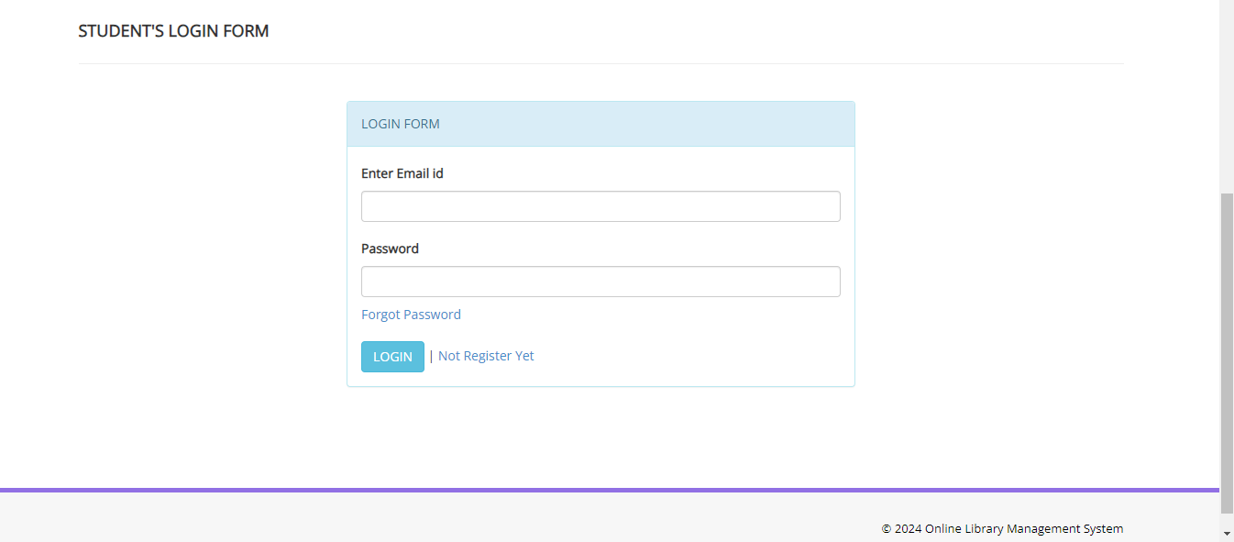

Fig. 44: Student Login Interface

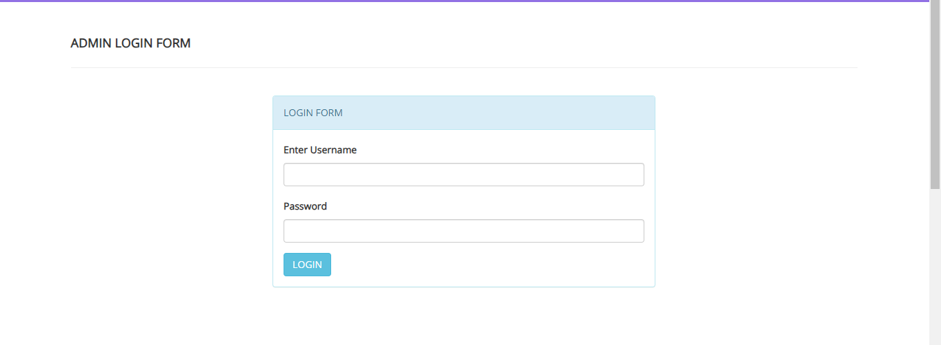

Fig. 4.4 Admin Login Interface

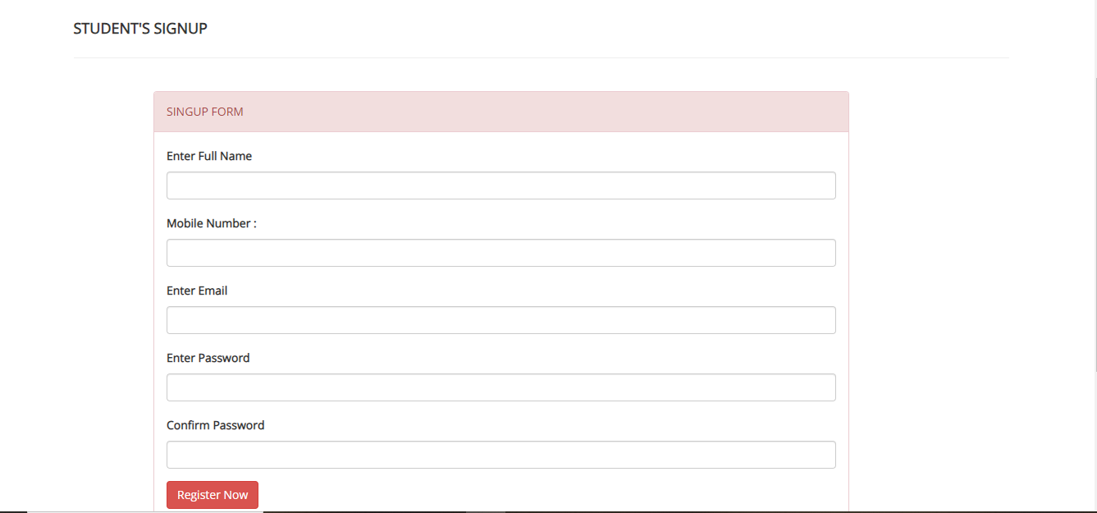
Fig. 4.4: Student Sign Up Page

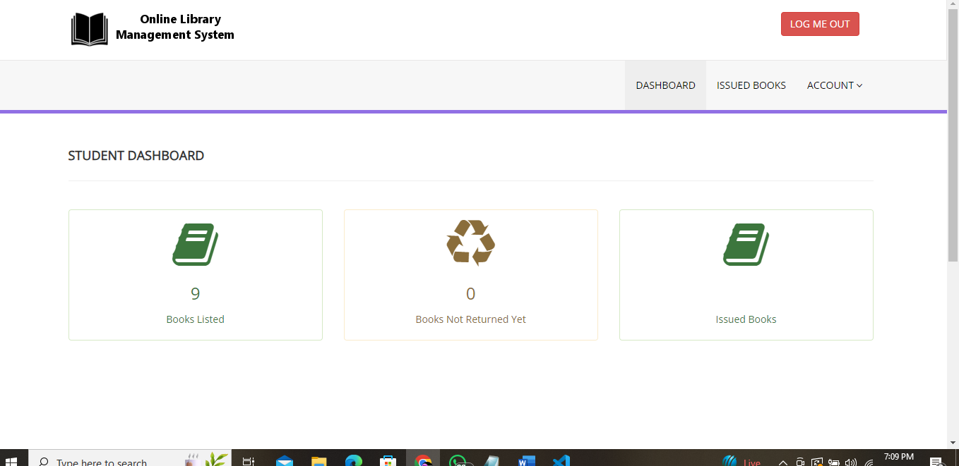

Fig. 4.4: Student Dashboard

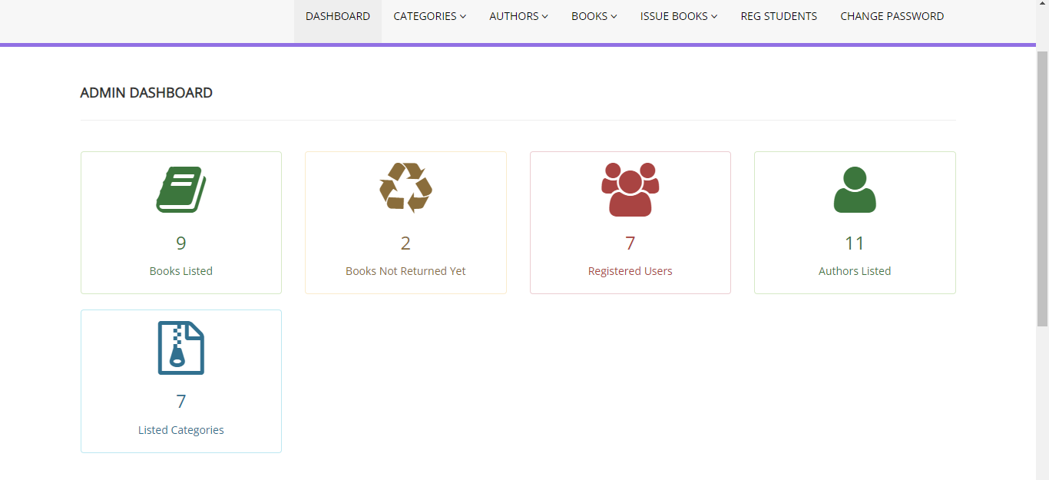
Fig 15: Admin Dashboard

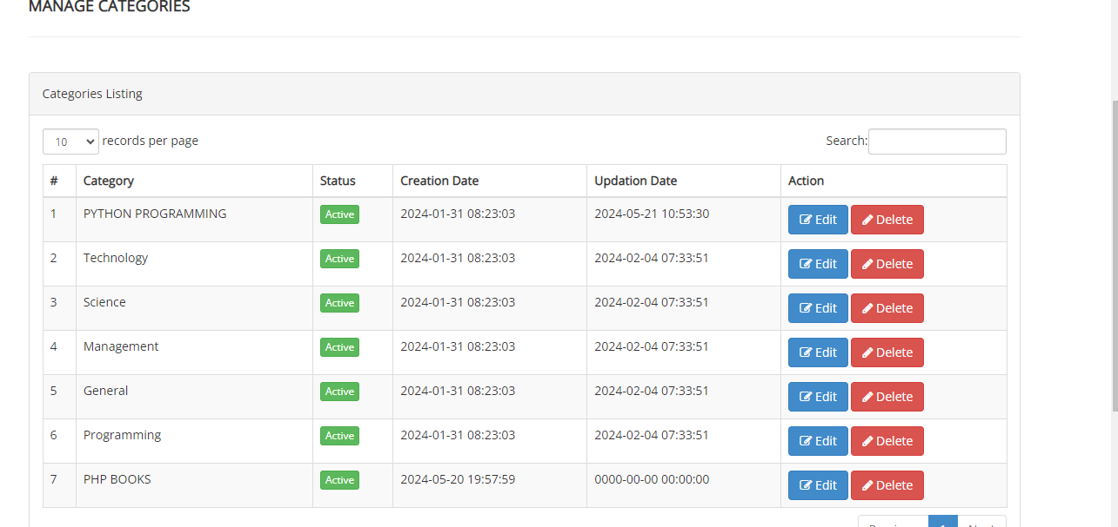

Fig. 4.4: Available Book Dashboard

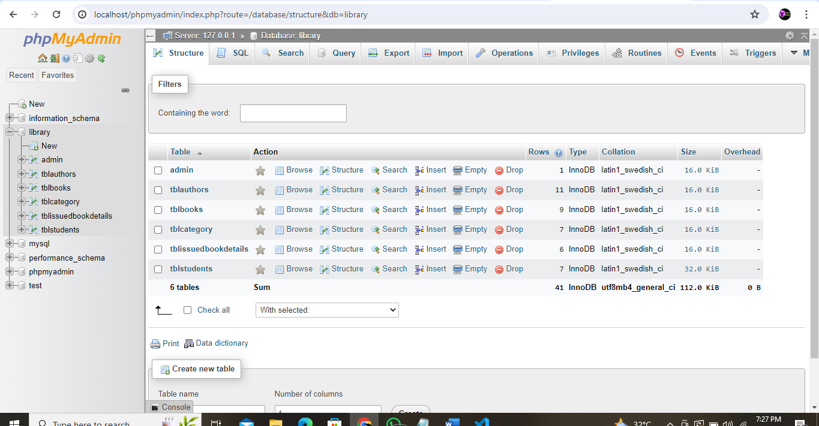

Fig. 4.4: Database System Interface

CHAPTER FIVE
SUMMARY, CONCLUSION AND RECOMMENDATION
5.1 SUMMARY
The quest to make life easier and processing faster has led to computerization of various processes. Computer technology has transformed so many sectors especially the educational sector in no small measure. In an effort to foster technology driven education, a Library Management System has been developed to manage all library operations such as borrowing, returning of books etc.
5.2 CONCLUSION
During the development of the Web-based Library booking and lending system, the researcher had encountered a lot of problems and difficulties, most especially in attaining the objectives that I’ve situated in my proposal. The web-based library booking and lending system have features that need full attention and should be deeply scrutinized. The creation of system’s database requires enough period of time to be perfectly established, because all the needed information requires good critical thinking and thorough analysis before placing them altogether. The arrangement of the gathered information was planned carefully to easily trace its relationships which connects from one table to another and to avoid disordered database set-up. As we’ve demonstrated the system to the intended end-users namely the administrator, the librarian and students, they affirmed that such innovation in school’s library system is efficient since it provides a more intuitive and functional features that lessens their time and effort in making different library processes and transactions. Based from the findings and analysis of results, this capstone project was able to meet all its objectives and answered its problems cited in Chapter 1;
- Book searching is faster and time-and-effort saving.
- Borrowed books are always monitored as well as the due dates.
- Generating reports is faster and time-and-effort saving.
- Important library records are placed in a secured storage.
- Human errors are avoided and transactions are reliable
5.3 RECOMMENDATION
After a long period of analyzing and beyond the achieved objectives of the proposed system, we present some recommendations which will be helpful and useful for the school’s existing system and to make it more stable, efficient and reliable. School should pay more attention in improving the Web-based Library Management System of the school so that all the processes and transactions will be automated and enhanced so that the time and effort of both the students and librarians in dealing with library transactions will be lessen. First thing that we recommend is monitoring of the number of students that will enter the library should be recorded by the system. We also recommend that sending of notification to users should be enhanced, and should be improved by implementing an SMS sending algorithm through the use of internet. It is also recommended that further study about the system will be conducted to verify the efficiency and reliability of the system. For the record, once the book is searched, the whole content of the book should be available for reading online to its registered users.

REFERENCES
Okunlaya & Aderibigbe (2022). A survey of e-book awareness and usage amongst students in an academic library. In: Proceedings of International Conference of Multidisciplinary Information Sciences and Technologies, Merida, 25-28 October, Available at: http://strathprints.strath.ac.uk/2280/1/strathprints002280.pdf.
Adedoyin & Soyemi (2023). The status of ICT facilities in Nigeria public libraries. Coal City Libraries, 2(122), 13-31.
Ibrahim & Zayyyanu (2023). Usage of electronic resources by undergraduate at the Reedeemer’s University, Nigeria. International Journal of Library and Information Science, 5(10),319-324.
Ogunlade & Oseni. (2022). Availability, accessibility and use of information and communication technologies by undergraduates in Nigerian universities: What role for university library? A paper presented at the 45th Natural Conference of Nigerian Library Association, Uyo on 9th - 14th September, 2022.
Adewole et al., (2022). Self-efficacy and use of electronic information as predictors of academic performance. Online Electronic Journal of Academic and Special Librarianship, 8(2), 1-17.
Ibrahim & Ogundele, I.E. (2023). Libraries and information management in Nigeria. Maiduguri: Ed-Linform Services.
Okunlaya & Aderibigbe (2022). Use of library: a practical approach. Owerri, Nigeria: Springfield Publishers.
Adedoyin & Soyemi. (2023). Audio visual resources availability and use for library services among colleges of education in Lagos State, Nigeria. International Journal of Library and Information Science, 5(10), 417-425.
Zayyanu. (2023). Library and information science text for Africa. Ibadan: Third World Information Services Limited.
Adewole et al. (2022). Information and knowledge management in the Digital age: Concepts, technologies and African perspectives. Ibadan. Third World Information Services Limited.
Edewor and Aregbesola (2023). Globalized database: availability and utilization of internet resources for teaching and research by academic staff of Babcock University. Program on Policy, Conflict and Strategic Studies International Journal Series, 1(1), 10-20.
Ogunlade & Oseni (2022) Awareness, accessibility and use of electronic databases among academic staff of Babcock University Business School. Kuwait Chapter of Arabian Journal of Business Management and Review, 3(6), 40-48.
Okunlade & Aderibigbe (2022) Acquisition of electronic resources in a library consortium: Some obstacles to its implementation in Africa. Conference, Library Consortia Standing Conference of African University Libraries, Western Area. Proceedings of SCAULWA 2022 Library Consortia Standing Conference of African University Libraries, Western Area.

