COMPUTER BASED POPULATION CENSUS INFORMATION SYSTEM

BY
ADENIYI ENOCH ADELAYO
HND/23/COM/FT/0379

SUBMITTED TO THE DEPARTMENT OF COMPUTER SCIENCE,
INSTITUTE OF INFORMATION AND COMMUNICATION TECHNOLOGY
KWARA STATE POLYTECHNIC, ILORIN.

IN PARTIAL FULFILLMENT OF THE REQUIREMENTS FOR THE AWARD OF NATIONAL DIPLOMA (ND) IN
COMPUTER SCIENCE

June, 2025.

CERTIFICATION
This is to certify that this project work was carried out by ADENIYI ENOCH ADELAYO with Matriculation Number: HND/23/COM/FT/0379 in the department of Computer Science, Institute of Information and Communication Technology, Kwara State Polytechnic Ilorin, Kwara State.

…………………………………. ….………………………
MR. MURTALA, K. Date
Project Supervisor

…………………………………. ….………………………
MR. OYEDEPO F. S. Date
Head of Department

…………………………………. ….………………………
External Examiner Date

DEDICATION
I dedicate this project work to Almighty God who inspired me and directed my ways during my academic stay in the polytechnic.

ACKNOWLEDGEMENT
All praise is due to almighty God the lord of universe. I praise him and thank him for giving me the privilege, strength and knowledge to complete my HND programme and also for continued existence on the earth.
I appreciate the utmost effort of my supervisor, Mr. Murtala K. whose patience, support and encouragement have been the driving force behind the success of this research work. He gave useful corrections, constructive criticisms, comments, recommendations, advice and always ensure that an excellent research is done. My sincere gratitude goes to Head of Department and other members of staff of the Department of computer science, Kwara state polytechnic, Ilorin, for their constant cooperation, constructive criticisms and encouragement throughout my programme.
Special gratitude to my parents, who exhibited immeasurable financial, support and prayers.
My special gratitude to a brother like a friend Mr. Sato Phillip who has been supportive both spiritually, financially for me and understanding during the period in which I was busy tirelessly on my studies, special thanks go to my friends Halidu, Adekunle, Elizabeth, Aminah thanks so much for your support and prayers.
My special gratitude goes to everyone who has contributed to success of my studies in Kwara state polytechnic, Ilorin.

TABLE OF CONTENTS
Title page i
Certification ii
Dedication iii
Acknowledgements iv
Table of contents v
Abstract vi
CHAPTER ONE: GENERAL INTRODUCTION
1.1 Background to the Study 1
1.2 Statement of the Problem 4
1.3 Aim and Objectives 4
1.4 Significance of the Study 5
1.5 Scope of the Study 6
1.6 Organization of the Report 6
1.7 Definition of Technical Term 6
CHAPTER TWO: LITERATURE REVIEW
2.1 Review of Related Works 10
2.2 Review of General Texts 10
2.3 Overview of Loan Management 11
CHAPTER THREE: METHODOLOGY AND ANALYSIS OF THE SYSTEM
  - Research Methodology 16
  - Analysis of the Existing System 17
  - Problem of the Existing System 17
  - Analysis of the Proposed System 17
  - Advantage of the Propose System 18
CHAPTER FOUR: DESIGN AND IMPLEMENTATION OF THE SYSTEM
  - Design of the System 21
    - Output Design 23
    - Input Design 23
    - Database Design 23
    - Procedure Design 23
  - Implementation of the System 23
    - Choice of programming language 24
    - Hardware support 24
    - Software Support 25
  - System Documentation 25
    - Operating the System 26
    - Maintaining of the System 27
CHAPTER FIVE: SUMMARY CONCLUSION AND RECOMMENDATION
5.1 Summary 27
5.2 Conclusion 29
5.4 Recommendations 30
References 31
Source code 32

ABSTRACT
The researcher chose to research on this topic “Computer Based Census Management System” because of its relevance to the society. Meanwhile, the manual method so far has its attendant problem of being tedious. The researcher, in order to solve this time consuming, monotonous, and repetitive manual census activities went into a thorough study of the existing system. In the report proper, the Structured System Analysis and Design Methodology (SSADM) was adopted and explained. The high level model of the proposed system was also designed and displayed in a format easily understandable to the user. The high level model of the proposed system was designed architecturally and detailed designed through its separate components. There were four modules in all, each taking care of specific function like: the staff management module that maintains records about the staff; the department management module manages information about departments in the commission; the register person, the register states, and the register LGA modules that do the actual registration of individuals. Finally, the parallel change over methodology was adopted to enable the commission compare the results of the two systems (old and new) before implementation.
CHAPTER ONE
GENERAL INTRODUCTION
1.1 BACKGROUND OF THE STUDY
Population census information system is at the centre of all population activities. Population census is the complete process of collecting, compiling, evaluating, analyzing and publishing demographic, economic and social data of all persons in a country or area at a specific time. To make a successful census exercise, the people for whom the arrangement has been made must properly be educate and fully informed about the arrangements. In other words publicity, public enlightenment and education on the subject of census are unavoidable pre-conditions for a successful exercise. This duty though significant, is only additional to the National Population Commission (NPC). The commission can therefore not commit much of its resources to it, for cannot handle the assignment professionally the way the media do. This is because the most potent strategies and the technical format for effective publicity of any event belong to and remain with the media. What this suggests is that the NPC has no option but to evolve, nurture, cherish and sustain a cordial relationship between the media.
Census has been a reliable exercise from time, from where government rely for decision-making, and aids for administration and planning. According to Robert M. Groves, (2010) Director of the United States Census Bureau;
“Just like we cannot survive without roads and bridges, the country does not function well without an updated census to distribute funds to areas that most need them and to support community decisions and their own future.”
The increasing complexity of modern life means a greater need to plan housing, schools, roads, transportation, and a vast range of social and economic requirement for nation. This cannot be done without a detailed count of the population. Census is being officially managed by some organizations or government, for example the National Population Commission (NPC). The installation of computer in these organizations or bodies that manages census information will assist not only in fast-recording information but also in solving certain problems, which cannot be easily resolved manually. The human resource of any enterprises are considered to be their most valuable assets, if they are properly harnessed and are well motivated to perform their assigned tasks in such a manner as to enhance the enterprises goals and objectives. Therefore, adequate population records will provide all the necessary information that is associated with people, which include the size of the population, age structure, educational attainment, labour force and socio-economic characteristics, unlike in the manual method which makes access to data and information very tedious. The integration of different databases so that these databases can be merged and processed together and mainly other reasons, prompted the researcher to develop software for this organization, National Population Commission (NPC).
The National Population Commission had a long history spanning over four decades. The nucleus of the agency was the National Census Board which conducted the 1973 Census and headed by the late Justice Adetokunbo Ademola. It was an ad-hoc body and became the National Population Bureau after the exercise.
However, the Commission had existed in its present form as a permanent and autonomous body with constitutional power since 1981 when the late Alhaji Abdulrahman Okene was inaugurated as Chairman with members drawn from 19 states of the federation by former President Shehu Shagari. The Commission never conducted a census.
Following the military takeover of 31st December 1983 and the suspension of the 1979 Constitution, the Commission was dissolved and it reverted to National Population Bureau headed by a director.
Consequently, in 1989, the present Commission was re-established as an independent and autonomous body led by Alhaji Shehu Musa, CFR and the Commission conducted its first census in 1991. The establishment of the Commission was further reinforced in accordance with section 153 (J) of the 1999 Constitution of the Federal Republic of Nigeria as one of the Federal Executive Bodies. Thereafter, the Commission under the chairmanship of Chief Samu’ila Danko Makama conducted another but first Population and Housing Census in 2006.
The Commission has repositioned itself under the current leadership of Hon. Nasir Isa Kwarra to deliver the first digital Population and Housing Census in Nigeria later this year. The present Commission is made up of a chairman and 37 members, drawn one from each State and the Federal Capital Territory, Abuja. It has offices in the 36 States and the Federal Capital Territory, Abuja as well as in the 774 LGAs of Nigeria.
The National Population Commissiosn (NPC) has its based from Calabar from where it was called “Bureau of Population”. In 1988, it became imperative that Akwa Ibom was deed fit for it establishment. As at then, Mr. Isaac Udoukpong was the Head and as Acting Assistant Director, and as at this time, the commission office was located at No. 2 oku street in Uyo Local Government Area of Akwa Ibom State.
In 1990, the name “Bureau Of Population” was changed to National Population Commission (NPC) in preparation for the 1991 National Census Exercise. After the 1991 census, Mr. N. A. Nsudu took over as the state director. The present state Director is Mr. Benjamin Isaac Nda-Obong. Mr. Francis Mosses Ekpo is the Honorable Commissioner representing Akwa Ibom Satae at the board of the commission. He works here in Akwa Ibom state and also in Abuja. Mr. Mfoniso Umoden is the head of population management while Mrs. Mercy Darnley is the comptroller in NPC Uyo L.G.A office.
In November 2012, Chief Iheama Duru was appointed the chairman of National Population Commission. She has 37 commissioners working her, one from each state of the country and F.C.T inclusive. Finally, the office of the NPC is located at No. 15 Akpan Essien Lane in Uyo L.G.A of Akwa Ibom state.
1.2 STATEMENT OF THE PROBLEM
In ancient days, National Population Commission (NPC) usually process their data or records manually, which makes the whole work so boring, delaying and cannot keep up-to-date records or data. Storage facility was too poor and cannot give a genuine and accurate result at the end of the exercise because they will be carrying data from one place to another. There is always a tendency for NPC to lose their records and data collected during the programmed and their result cannot be accurate or reliable at the end of the exercise.
Since this has been their problems before now, there is a way out before 2016 population census begins, which is to set up a competent computer for the storage of information gathered by designing a data base system for their used. This data base system will solve their problems of saving, retrieving, and compiling, keeping up-to-date data and for easy use in case of emergency need. Finally their staff has to be train on how to operate the propose system.
1.3 AIM AND OBJECTIVES OF THE STUDY
The aim of the this project is to ensure the citizen have database online
The objectives of this study are summarized as follows:
- To develop computerized software that automatically stores and retrieves all information on human population.
- To develop a reliable system that could be used in collecting data/information on human population.
- To develop a system that will support direct access to the specific and required information
1.4 SIGNIFICANCE OF THE STUDY
Since Population census Information System is very important, especially with the proposed 2016 census that is up coming, the significance of this study is to assist in the following areas:
- EDUCATION: Data collection from population census will assist government in determining
- The number of people who can read and write.
- The level of educational status for the literate.
- The number of school age children who are presently not in school
- The number of schools to be provided.
- HEALTH: Data collected will assist government at all-levels in planning for the information on
- Numbers of people and their health needs
- The amount of money budgeted for health needs
- The number of hospitals to be provided.
- ASSESSMENT OF DEVELOPMENT PROGRAMS: Data collected will provide basis for evaluation of various development programs undertaken by the government.
- EMPLOYMENT: This will assist in establishing the levels of employment/unemployment for future planning and for job creation by providing the following information:
- Number of employed persons and type of work
- Distribution of unemployed persons
- Number of persons in schools that will require employment in the near future.
1.5 SCOPE AND LIMITATION OF THE STUDY
Since this topic population Census Information system is very wide, the scope of this research work is only on head counting and is within Uyo local Government Area with estimated villages under National Population Commission (NPC) uyo.
1.6 ORGANIZATION OF THE STUDY
This project research is divided into five chapters: chapter one will provide the general introduction of the population census information system, statement of the problems, objectives, significance, scope/limitation of the study and definitions of terms used. Chapter two will consists of the review of the related literature. Chapter three will be system analysis and design, chapter four will be system testing and implementation. And chapter five will give the summary, recommendations and conclusion of the whole project.

1.7 DEFINITION OF TERMS USED IN THE STUDY
- For the purpose of clarity in this research project work, and to avoid any geographical area at a particular time.
- CENSUS: The source of the word “census” is from the verb ‘censere’ which means contrary to what is expected, not ‘to count’ but rather ‘to assess’ or ‘to estimate’ (The Encyclopedia American, 1951). Census is therefore the procedure of systematically acquiring and recording information about the members of a given population.
- POPULATION INFORMATION: It is an act and process of creating awareness, enlightenment and educating the general public in population activities methods (Ahmed Hameed NPC 1991 Analysis).
- SYSTEM: The term “system” originates from the Greek term systema, which means to “place together”. System is defined as a collection of related components that interact to perform a task in order to accomplish a goal.
- POPULATION DATA: Is the collection of facts and figures in relation to the demographic structures of a nation.
- ENUMERATION AREA DEMARCATION (EAD): Is the division of the entire land area of the country into small units that a pair of enumerators can conveniently cover within the period.
- COMPUTER: Is an electronic machine that can accept data, process data and generate a result.
- DEMOGRAPHIC: This is the statistical data of a population, especially those showing average age, income, education etc.
confusion on the use of words, the following terms is given definition.
- POPULATION: This refers to the total number of people living within a

CHAPTER TWO
REVIEW OF THE RELATED LITERATURE
2.0 INTRODUCTION
This literature review is based on work of scholars has population census information system. Many books have been written on population census, how will it be conducted and explain why census is necessary.
Although numerous estimates of the Nigerian population were made during the colonial period, the first attempt at a nationwide census was during 1952-53. This attempt yielded a total population figure 31.6 million within the current boundaries of the country. This census has usually been considered an undercount for a number of reasons.
- Apprehension that the census was related to tax collection
- Political tension at the time in eastern Nigeria
- Logistical difficulties in reaching many remote areas
- Inadequate training of enumerators in some areas.
The extent of undercounting has been estimated at 10 percent or less, although accuracy probably varied among the regions. Despite its difficulties, the 1952-53 census has generally been seen as less problematic than any of its successors. Subsequent attempt to conduct a reliable post independence census have been mired in controversy, and only one has been officially accepted. The first attempt, in mid – 1962, was canceled after much controversy and allegations of over counting in many areas. A second attempt was officially accepted, also was encumbered with charges of inaccuracy and manipulation for regional and local political purposes. Indeed, the official 1963 figure of 55.6 million as total national population is consistent with a census of a decade earlier because it implies a virtually impossible annual growth rate of 5.8 percent.
In addition to likely inflation of the aggregate figure, significant intraregional anomalies emerge from a close comparison of the 1953 and 1963 figures. In portions of the Southeast, for example, the two sets of data imply that some nonurban local government areas (LGAs) had increased at a rate of almost 13 percent per year, while other neighboring areas experienced a minute growth rate of 0.5 percent per year. Despite the controversy, the results of the 1963 census were eventually accepted.
After the civil war of 1967-70, an attempt was made to hold a census in 1973, but the results were canceled in the face of repeated controversy. No subsequent nationwide census had been held as of 1990, although there have been various attempts to derive population estimates at a state or local level. Most official national population estimates are based on projections from the 1963 census.
The great improvements in transportation and accessibility, and in the level of education throughout the country, as well as the generalized acceptance of national coherence and legitimacy, favored the success of the fall 1991 census. It was to be conducted in about 250,000 enumeration areas by the National Population Commission, with offices in each of the country’s LGAs. To reduce possible controversy, religious and ethnic identification would be excluded from the census forms, and verification of state results would be handled by supervisors from outside the state. Some analysts believe that the effort to carry out a reliable census with perceived legitimacy might become an unexpectedly positive exercise, reinforcing a sense of shared nationhood and providing a model for the attempt to overcome regional and ethnic differences. ( Data as of June 1991, Sources: The Library of Congress Country Studies; CIA World Fact book ).
According to chief Samu’ila Danko Makama; former chairman National Population Commission (NPC). He explained that the commission mounted intense publicity for the 2006 population and housing census, and this went a long way to ensure its resounding success. In view of this, those who will be charged with the conduct of the future census should to at least sustain that level of publicity. The best means to achieve this aim is for the Public Affairs Department to be given enough funds and personnel to carry out its mission of spreading the census message to all corners of this country.
Census is necessary because information collected during a census is used to access the current welfare needs as well as to project future needs.

2.1 FUNCTIONS OF THE NATIONAL POPULATION COMMISSION
The National Population Commission is responsible for carrying out periodic censuses and producing population figures for Nigeria. Another remarkable aspect of the statutory function of the NPC which the commission concerned itself with is the Vital Registration Programme.
2.2 ORGANIZATION OF NATIONAL POPULATION COMMISSION.
The commission is divided into 4 units and 2 sub-units.
UNITS:
- Population management
- Cartography
- Administration
- Vital Registration
SUB-UNITS:
- Advocacy
- Accounting
POPULATION MANAGEMENT: This department is to conduct census and publish it. It is the heart beat of census.
CARTOGRAPHY: Cartography department are responsible for the drawing of map, that is the enumeration area demarcation map or prepare satellite images to be used during census. These maps are so carved out that it contains 450 to 500 people to enable the enumerators count within three days.
ADMINISTRATION: The role of the Administration department is to provide administrative assistance for the preparation of the documentation to other department of the commission. They manage, run the affairs of the commission properly and supervise the way the functions.
VITAL REGISTRATION: This department is responsible for the continuous and permanent recording or occurrences and characteristics of vital events such as births, deaths, still birth, marriages, annulment of marriage and naturalization.
ADVOCACY: This unit is under Population Management department, they are responsible for publications and defendant, they are the mouth piece of NPC.
ACCOUNTING: This unit is under Administration department, they are responsible for recording and reporting on all financial transactions of the commission. They collect data properly which help them to prepare financial reports that can be used for budgeting, forecasting and other decision making processes.
2.3 DEFINITION OF SYSTEM:
System is the collection of related component that interact to perform a task in order to accomplish a goal.
2.3.1 INFORMATION SYSTEM:
Information system could be defined technically as a set of integrated components that collect or retrieve, process, store and distribute information to support decision making and control in an organization.
2.3.2 TYPES OF INFORMATION SYSTEM
- TRANSACTION PROCESSING SYSTEM (TPS): Transaction processing system automate the handling of transactions, which are individual simple events in the life of an organization. It also supports the operational day-to-day activities of the organization.
- MANAGEMENT INFORMATION SYSTEM (MIS): This information system is being design to take the relatively raw data available through a TSP and convert them into a summarized and aggregated form for managers, usually in a report format.
- DECISION SUPPORT SYSTEM (DSS): This information system is design to help organization decision makers make decisions. DSS usually have three major components : a database, a model base and a dialogue module.
- The data base contains data relevant to the decision to be made.
- The model base contains one or more models that can be used to analyze the decision situation.
- The dialogue model provides a way for the decision maker, usually a non-technical manager, to communicate with the DSS.
By running the data and possible decisions through one or more models, the decision maker can compare possible solutions to the problem at hand.
- EXECUTIVE SUPPORT SYSTEM (ESS): This is another relatively new form of DSS. Executive support system is design specifically for high-level executives who:
- May not have many computer skills
- Have very little time to devote to any given situation.
An ESS is relatively easy to manipulate and usually provides graphical presentations on several different pre-defined topics.
- OFFICE AUTOMATION SYSTEM (OAS): Office automation are usually quite basic and include such tools as word processing and accounting information systems. Integrated office systems that include electronic mail, calendaring features and reminder files in addition to word processing are also available. Electronic mail (e-mail) allows office workers to send each other messages and files directly from their computers and is usually more convenient than trying to reach someone by the telephone. Calendaring features allow office workers to coordinate their schedules, to reserve conference rooms, and to schedules meetings. Reminder files provide a means for conveniently reminding ourselves of meetings and other commitments.
2.4 OLD METHOD OR MACHINE USED IN POPULATION CENSUS
This method is otherwise known as Manual Data Processing (MDP). The Manual Data Processing method is the method that makes use of the brain and hands only. It is done without the aid of complex machines. It may at best involve the use of some mathematical tables. This method was only suitable when dealing with very few data. As data became very many, error factor may increase. These errors may arise from fatigue, inadequate of knowledge or inability to cope with large number.
Though this manual data processing will be very cheap to operate, no reliance on electricity, no need of writing programs or buying packages, and it is economically where data are not voluminous. Then it is also prone to errors, information cannot be accessed on time and it can delay in processing of data.
2.5 NEW METHOD OR MACHINE USE IN POPULATION CENSUS
This method otherwise known as Electronic Data Processing (EDP) make use of computer which keeps records of information and data in a magnetic tapes and disks, CDs, flash etc. Though this method is expensive, information can easily be corrupted if it is not properly taken care of. But the process will be very fast, accurate, reliable and efficient.
2.6 USES OF COMPUTER IN POPULATION CENSUS
- Making use of computer will make their work very fast and clear.
- Data processed will be accurate and unique.
- It will make the information easily accessible.
- It will make their data and work very reliable.
- It will reduce fatigue of work.
2.7 DISADVANTAGES OF COMPUTER IN POPULATION CENSUS
- Information can be easily corrupted if it is not properly handle.
- Training has to be provided for the operator.
- It is very expensive to run and manage.
- Infrastructures and other facilities needs to be provided.
- It need constant power supply.

CHAPTER THREE
SYSTEM ANALYSIS AND DESIGN
3.0 INTRODUCTION
Most system (business or institution) is based on existing procedures. The first step of system study is usually to gather data from current operations and creates a specification for the new system replaces the old.
System Analysis is a step used in gathering data, information or report and presents it in a graphical or pictorial form.
System Design will describe how the proposed information or report will be deliver, which involves bringing together several part of system, which will serve as information unit determining what a system will do and how it will be done.
3.1 REVIEW OF EXISTING SYSTEM
During data collection, I discovered that in the existing system of NPC, data processing was done manually, which makes the work to be inaccurate and difficult. This was so because the larger the numbers of data, the more errors may arise from fatigue, inadequate knowledge or inability to cope with large numbers. Moreover, lost of data do occur due to movement from one place to another, and cannot be retrieve or access easily.
3.3 PROBLEMS OF EXISTING SYSTEM
Since the commission was using a manual method for data or information processing, they were faced with the following problems:
- Work deliverance and cannot keep up-to-date records or data
- Storage facilities was too poor and cannot give a genuine and accurate result at the end of the exercise
- Information and records collected during the program do get lost or misplaced
- Difficulties in retrieving information because of too much files and paper
- Results given at the end of the exercise where not accurate and reliable.

3.3 JUSTIFICATION OF THE NEW SYSTEM
The new system is justified because of the following capabilities of the system:
- Information can be access and retrieve easily
- It responses faster to the user without delay
- It eliminate data redundancy; this is because each data has a unique identification
- Information can be stored in a floppy/hard disk to reduce stress
- It provides backup and data recovery procedure to ensure data safety.
3.4 SYSTEM DESIGN
System design is very important in every software development. At this stage, the developer puts every factor into consideration while making the design. In the course of the design, the system has to be design in a way that will describes how a proposed information system will be delivering in the input requirement, output requirement and system flow chart.
3.4.1 INPUT DESIGN: Input design deals with the process of developing method for two or more modules in a system to connect and communicate. These modules can apply to hardware and software which gives the interface between a user and a machine.
3.4.2 OUTPUT DESIGN: The output design was based on the input. It is the result or outcome of the input, which gives a meaningful report to the organization (NPC).

3.5 FILE STRUCTURES
APPLICANT FILE STRUCTURE

S/N | FIELD NAME | DATA TYPE | DESCRIPTION | FIELD LENGTH
1 | Applicant ID | Number | Applicant Identification | 5
2 | Surname | Text | Applicant surname | 15
3 | First Name | Text | Applicant first Name | 15
4 | Middle Name | Text | Applicant middle Name | 15
5 | DOB | Date/Time | Applicant Date Of Birth | 10
6 | Gender | Text | Gender of applicant | 6
7 | Address | Text | Address of applicant | 20
8 | Town | Text | Town of Applicant | 15
9 | L.G.A | Text | Applicant local Government Area | 15
10 | State | Text | Applicant state of origin | 10
11 | Occupation | Text | Occupation of Applicant | 15
12 | Disability | Text | Applicant Disability | 15
13 | Religion | Text | Religion of Applicant | 15
14 | Employment status | Text | Employment status of  Applicant | 10
15 | Mother’s maiden Name | Text | Applicant mother’s maiden name | 20
16 | Educational Attainment | Text | Applicant educational attainment | 20
17 | Marital status | Text | Marital status of applicant | 10
18 | Numbers of Children | Number | Numbers of Children | 50
Table 1: Applicant File Structure

STAFF FILE STRUCTURE
S/N | FIELD NAME | DATA TYPE | DESCRIPTION | FIELD LENGTH
1 | Staff name | Text | Name of Staff | 15
2 | Sex | Text | Sex of Staff | 6
3 | Age | Number | Age of Staff | 2
4 | Address | Text | Address of Staff | 20
5 | E-mail | Text | Staff e-mail | 15
6 | DOB | Date/Time | Staff Date of Birth | 10
7 | Phone-Num | Number | Staff Phone Number | 11
8 | Marit Stat | Text | Staff Marital Status | 10
9 | Approval-Date | Text | Staff Date of Appointment | 15
10 | Uname | Text | Staff User Name | 15
11 | Pword | Text | Staff Password | 15
Table 2: Staff File Structure
3.6 PROGRAMMING LANGUAGE
The choice of programming language used in this project work is Visual Basic 6.0. One of the advantages of VB is it’s graphical interface which makes it ideal for a beginning programmer and it doesn’t take long to create your first program. If you are used to dragging and dropping in a windows program, you can build on that knowledge to drag and drop menus, forms and other parts to create an application.
Finally, VB allows one to create a software interface and write code in an easy-to-use graphical environment.

CHAPTER FOUR
DESIGN, IMPLEMENTATION AND DOCUMENTATION OF THE SYSTEM
4.1 DESIGN OF THE SYSTEM
The proposed system is designed in modules with each modules working together to perform the goal of lecture delivery of a particular program in order to enhance the performance of the existing system as earlier above. The ability to analyze and give focus to the system is explained in the following formats which are output design, input design, and procedure design. 78The implementation of the new system occurs when the old system is replaced by the new one. The new system is implemented using Microsoft Visual Basic 6.0 programming language. This is because the programming language has the advantage of easy development, with V.B, developers/programmers can build, debug and code in a graphical environment with interactive help and context-sensitive help menus.
4.1.2 INPUT DESIGN
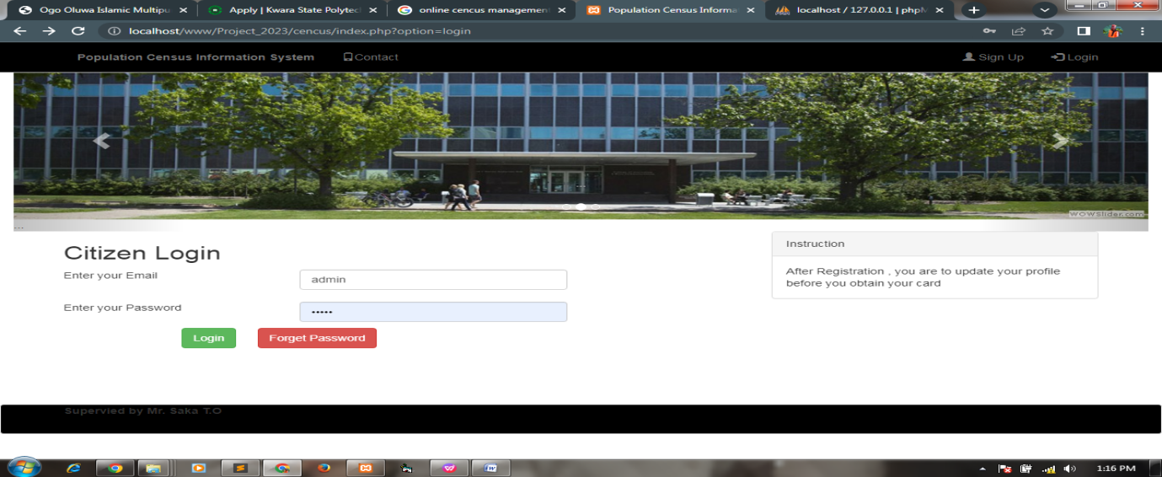
Fig. 4.1: Login Form
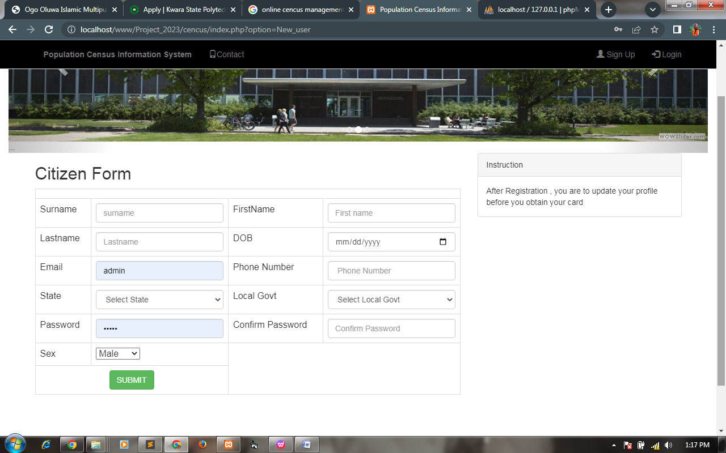
Fig. 4.2: Output Design
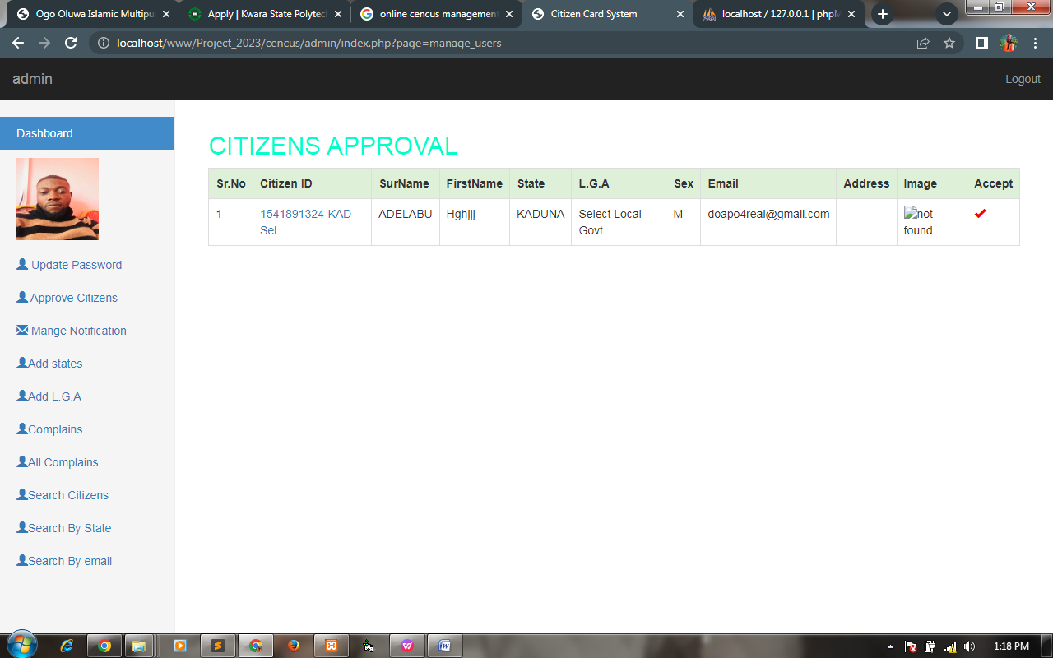
Fig. 4.3: Main form
4.1.3 DATABASE DESIGN
This refers to the tables used in the proposed system. The database design for the proposed system is as shown below
4.1.4 PROCEDURE DESIGN
The procedure design refers to the construct of the whole program i.e. how each section functions individually and collectively as a whole to make up the whole execution of the program work/operate according to specification.
The system contains four submenus, each submenu having difference form and they are control by modules.
The system allow user to register as a member to be able to log on into the system, the user also is allow to view is profile, so also to edit its information if necessary.
4.2 SYSTEM IMPLEMENTATION
The design system depends on the capabilities and power of the computer on which the application system is installed. However, selecting a choice of application support (Hardware and Software) depends much on;
- How readily the user is to interfere with the computer
- Cost and benefits
- Managements support for changes
Hence, choosing the appropriate hardware and software will enhance the performance of the system.
A most important requirement on which the running of the program basically depends on is the provision of internet facility. So any system that must run this program must be connected ready.
4.2.1 CHOICE OF PROGRAMMING LANGUAGE
The system was designed with HTML, CSS and PHP for interface design and MYSQL for database provision for querying the database Dbases the database management system.
During the analysis of the programming language to be use, various language where examine but web Application were chosen because they are server side programming language. Web Application where decided to be use due to the following reason
1. HTML and CSS is easy to understand during designing
2. It can be easily manipulate in other to design a user friendly environment
3. It can be easily manipulate with Mysql in access for database reference.
4.2.2 HARDWARE SUPPORT
The hardware requires for the effective running of the system are as follows:
1. A voltage stabilizer of not less than 240 volts.
2. Processor of about 2.0GHz
3. RAM OF 2.0GHz
4. A modem (Modulator Demodulator)
5. A UPS
6. A standby generator
7. A split air conducting unit
8. Anti-spark devices to protect the system against spark and lightening.
9. Computer system
4.2.3 SOFTWARE SUPPORT
The software requirements are as follow
1. A network operating system windows NT from Microsoft, Novell Netware.
2. DBM either Access
3. Mysql as the query language to query the database.
4. wampserver
4.2.4 IMPLEMENTATION TECHNIQUES USED IN DETAILS
These deals with the processes and steps taking to put the system into use, before the system can be fully employed into the system, some training might have been done by the user of the application if he or she is a computer illiterate, because the user might be a computer illiterate, so also the system might have also been use.
Since the work of an expert cannot be eliminated from the system, the computerized system will have to work hand in hand with the expert in the field.
4.3 SYSTEM DOCUMENTATION
After the program has been well tested with input that the output has already been known, the next is to install the software in to the computer system for use.
The process of installing are been stated below
After the program has been fully install. The next thing is to locate the package install to put it into operation, to locate the package for expiration purpose the following step are to be taking .
4.3.1 PROGRAM DOCUMENTATION
Proper and adequate documentation is part of the quality of a good program hence to work with the software. You click on start button then locate all programs and click on ORGANIZATION-Chat the home screen, input password and username; the chat page will be display and it would list all available friends, green to indicate online friends and red to indicate offline friends. So you can select any menu from the list provided in other to perform any operation you desired to perform.
4.3.2 OPERATING THE SYSTEM
To operate the system, the following algorithm must be followed:-
* Switch the System on
* Allow it to boot and load all the startup data and variables
* Click on start menu
* select the package name “ORGANIZATION-Chat” and wait for the application to load.
From the list of menu that appears on the application main page, user can select any one to navigate and carry the operation of the menu item.

4.3.3 MAINTAINING THE SYSTEM
Built-in safeguards of the system to prevent illegal or accidental alteration of the data files. Provisions to store completed transactions, balances, and statements safely and to restore this information if necessary, ability of the software to accurately recover from an accidental or improper shutdown.
The features of the system meet the needs of the social network in an appropriate fashion. Integration refers to how well the different components of the system can communicate with each other, thus allowing data sharing and reducing the need for multiple entries of data (the need to input the same data into different parts of the system).
4.5 REQUIREMENT OF THE NEW SYSTEM
The system requirements are divided into hardware and Software.
Hardware requirements include: System unit with a processor speed of 1.8GHZ (Pentium IV), a memory (RAM) of size 128 MB and a hard disk of 20 GB or 40 GB. Mouse and Keyboard, a laser jet printer, uninterrupted power supply (UPS) and monitor with resolution of 1280x1024 and refresh rate of 85HZ.
Software requirements include: A windows operating system (windows XP and Microsoft Access 2000 or MS Access XP and Norton Antivirus).
4.6 DOCUMENTATION / PROCEDURE
The main purpose of this is to eradicate various problems affecting the existing (manual) system. This computerized system of population registration applies various techniques and methods to correct the problem areas in the existing system in the following ways:
- With the help of the flowchart, Applicant details can be access easily and also provides for timely accurate population registration.
- Also to eradicate fraudulent outs. The computerized system applies the use of password. This password is a secrete code which allows only authorized users to gain access to an information. With this system, population records are secured.
- It also enables population registration to be accurate and reliable.
- In the storage aspect, the mew system is better than the old or existing system which normally results to loosing of data because of carrying from one place to another. In the new system, information and data’s are stored in the hard disk and this information can be copied into a removable storage media as a backup of the information and then preserved for future purposes.
This system allows the user to sort for applicant information by doing the following: On the registration form click on the command button “Applicant Details”, enter the applicant identification number then OK. This will display all details/information of the applicant.
4.7 MAINTENANCE AND REVIEW OF SYSTEM
To keep the life span of any system, it has to be maintained with proper care. So system maintenance and review involves adjustment and improvement of the system, by conducting system audit and periodic evaluations and by making changes based on new conditions.
For the proper maintenance of the system, information system must be monitored to ensure that it is successful. This maintenance and review of system includes not only keeping the machinery running, but also in updating and upgrading the system to keep pace with new products, services, users, government regulations and other requirement.

CHAPTER FIVE
SUMMARY, CONCLUSION AND RECOMMENDATIONS
5.1 SUMMARY
Population Census Information is an event of public interest and assignment that calls for collaboration between the NPC and individuals as well as groups and institution of Nigeria. It is necessary because information collected during a census is used to access the current welfare needs as well as to project future needs.
In order to eradicate various problems affecting the existing system, it is being replaced by a computerized system. This computerized system of population registration applies various techniques and methods to correct the problem areas in the existing system, thereby making NPC to have an accurate and reliable result.
5.2 CONCLUSION
This research work has offered me the opportunity to contribute to population census information system. Since population census information is an event of public interest and assignment that calls for collaboration between the NPC and individuals as well as groups and institution of Nigeria. I have discovered that the success of an accurate information system is based on the level of management efficiency. If NPC fails to make it data storages and retrieval system efficient, they will not succeed.
Therefore, a computerized system has been created in order to replace manual method of data processing.
5.3 RECOMMENDATION
Training should be organized for the usage of the new system. This is very essential, especially if the user do not have knowledge of computer appreciation.
The training must be supervised by the system designer/ programmer and presentation of the new system must be carried out.

REFERENCES
Future Information Technology and Management Engineering (FITME) 2: 329-332. Retrieved 29 November 2013.
Kendal, S. L.; Creen, M. (2007). An introduction to knowledge engineering, London: Springer.
LANCASTER, F. W, (1998). Information Retrieval Systems: Characteristics, Testing and Evaluation, Wiley, New York.
Michael S. (1995): Data Analysis: an Introduction, Sage Publications Inc,
Perry, Marc J., Paul J. (2001). Population Change and Distribution: Census 2000 Brief.
Preston, S. (2000). Demography: Measuring and Modeling Population Processes. Blackwell Publishing.
Schutt, K. (2006). "Investigating the Social World: The Process and Practice of Research". SAGE Publications.
Siegal, S. (2002). Applied Demography: Applications to Business, Government, Law, and Public Policy. San Diego: Academic Press.
Taylor, M, Russel, F. and ball, R. (1992): Management Information System. McGraw-Hill, London.
The Library of Congress country Studies; CIA World Factbook. (1991) “Visual Basic”: Computer Sciences; Hughes, Stephen; Vol. 4, Macmillan: USA, 2002.
Wattenberg, J. (2004), How the New Demography of Depopulation Will Shape Our Future. Chicago.

SOURCE CODE
<?php
include('connection.php');
session_start();

?>
<html>
<head>
<title>Population Census Information System</title>
<link rel="stylesheet" href="css/bootstrap.css"/>
<script src="js/jquery_library.js"></script>
<script src="js/jquery-1.11.2.min.js"></script>
<script src="js/bootstrap.min.js"></script>
</head>
<body>
<nav class="navbar navbar-default navbar-fixed-top" style="background:#000">
<div class="container">

<ul class="nav navbar-nav navbar-left">
<li><a href="index.php"><strong>Population Census Information System</strong></a></li>

<li><a href="#"><span class="glyphicon glyphicon-phone"></span>Contact</a></li>

</ul>

<ul class="nav navbar-nav navbar-right">
<li><a href="index.php?option=New_user"><span class="glyphicon glyphicon-user"></span> Sign Up</a></li>
<li><a href="index.php?option=login"><span class="glyphicon glyphicon-log-in"></span> Login</a></li>
</ul>

</div>
</nav>

<div class="container-fluid">
<!-- slider -->
<div id="carousel-example-generic" class="carousel slide" data-ride="carousel">
<!-- Indicators -->
<ol class="carousel-indicators">
<li data-target="#carousel-example-generic" data-slide-to="0" class="active"></li>
<li data-target="#carousel-example-generic" data-slide-to="1"></li>
<li data-target="#carousel-example-generic" data-slide-to="2"></li>
</ol>

<!-- Wrapper for slides -->
<div class="carousel-inner" role="listbox">
<div class="item active">
<img src="images/url.jpg" alt="...">
<div class="carousel-caption">
...
</div>
</div>
<div class="item">
<img src="images/url.jpg" alt="...">
<div class="carousel-caption">
...
</div>
</div>

<div class="item">
<img src="images/highlightnews.jpg" alt="...">
<div class="carousel-caption">
...
</div>
</div>
...
</div>

<!-- Controls -->
<a class="left carousel-control" href="#carousel-example-generic" role="button" data-slide="prev">
<span class="glyphicon glyphicon-chevron-left" aria-hidden="true"></span>
<span class="sr-only">Previous</span>
</a>
<a class="right carousel-control" href="#carousel-example-generic" role="button" data-slide="next">
<span class="glyphicon glyphicon-chevron-right" aria-hidden="true"></span>
<span class="sr-only">Next</span>
</a>
</div>
<!-- slider end-->
</div>
<div class="container">
<div class="row">
<!-- container -->
<div class="col-sm-8">
<?php
@$opt=$_GET['option'];

if($opt!="")
{
if($opt=="complete")
{
include('com.php');
}
else if($opt=="contact")
{
include('contact1.php');
}

else if($opt=="New_user")
{
include('registration.php');
}

else if($opt=="forget")
{
include('for.php');
}
else if($opt=="login")
{
include('login.php');
}
}
else
{
echo "<h2>Welcome Screen</h2>

<strong>Welcome to Computer Based Population cencus <br>Information System. Obtain a your NPC Identification Number </strong>";
}
?>

</div>
<!-- container -->

<div class="col-sm-4">
<div class="panel panel-default">
<div class="panel-heading">Instruction</div>
<div class="panel-body">

After Registration , you are to update your profile before you obtain your card
</div>
</div>

</div>
</div>

</div>

<br/>
<br/>
<br/>
<br/>

<!-- footer-->

<nav class="navbar navbar-default navbar-bottom" style="background:black">
<div class="container">

<ul class="nav navbar-nav navbar-left">
<li><strong style="text color: white; text-align: center;">Supervied by Mr. Saka T.O</strong></li>

</ul>

</div>
</nav>
<!-- footer-->

</body>
</html>

<script type="text/javascript">
$(document).ready(function()
{
// function to get all records from table
function getAll(){

$.ajax
({
url: 'getstate.php',
data: 'action=showAll',
cache: false,
success: function(r)
{
$("#display").html(r);
}
});
}

getAll();
// function to get all records from table

// code to get all records from table via select box
$("#getProducts").change(function()
{
var id = $(this).find(":selected").val();

var dataString = 'action='+ id;

$.ajax
({
url: 'getstate.php',
data: dataString,
cache: false,
success: function(r)
{
$("#display").html(r);
}
});
})
// code to get all records from table via select box
});
</script>
<?php
require('connection.php');
extract($_POST);

//$f = substr('string', 1);

if(isset($save))
{
//check user alereay exists or not
//$sql=mysqli_query($conn,"select * from student where matric_no='$mat'");

//$r=mysqli_num_rows($sql);

$c_email=mysqli_query($conn,"select * from citizen_login where email='$email'");

$y_email=mysqli_num_rows($c_email);

if($y_email==true)
{
$err= "<font color='red'>This user already exists <a href='com.php'> Login</a></font>";
}

else
{

if (strlen($pass) < 8) { $err= "<font color='red'>Password is too weak. It must be atleast 8 characters </font>"; }
else {
if($pass==$cpass)
{

$up="insert into citizen_login(email,pass) values('$email','$pass')";
mysqli_query($conn,$up);}

else {$err= "<font color='red'>Password does not match <a href='com.php'> Login</a></font>";}

//$name = strtoupper($name);
$a=time();
//$state ="LAGOS";
//$loc ="APAPA";
$s_find=mysqli_query($conn,"SELECT * from state where cat_id='$state' ");
$n_state=mysqli_fetch_array($s_find);
$state_name =$n_state['cat_name'];
$b = substr($state_name, 0,3);
$c = substr($loc, 0,3);
$d= $a."-".$b."-".$c;
$name = strtoupper($name);
$fname = strtoupper(substr($fname, 0,1)). strtolower(substr($fname, 1));
$lname = strtoupper(substr($fname, 0,1)). strtolower(substr($fname, 1));
$query="insert into citizen(citizen_id,name,fname,lname,dob,mobile,state,local,email,sex) values('$d','$name','$fname','$lname','$dob','$tel','$state_name','$loc','$email','$sex')";
mysqli_query($conn,$query);

//$_SESSION['user'] = $mat;
$err="<font color='blue'>Registration successfull !!</font>";
//header('location:index.php?option=complete');

}
}
}
?>

<h2>Citizen Form</h2>
<?php
//for ($i=1; $i < 5; $i++) {

//echo $sum;
?>

<form method="post" enctype="multipart/form-data">
<table class="table table-bordered">
<Tr>
<Td colspan="4" align="center"><?php echo @$err;?></Td>
</Tr>

<tr>
<td>Surname</td>
<td><input type="name" class="form-control" name="name" placeholder="surname" required/></td>
<td>FirstName</td>
<Td><input type="name" class="form-control" name="fname" placeholder="First name" required/></td>
</tr>
<tr>
<td>Lastname</td>
<td><input type="name" class="form-control" name="lname" placeholder="Lastname" required/></td>
<td>DOB</td>
<Td><input type="date" class="form-control" name="dob" placeholder="Date of Birth" required/></td>
</tr>
<tr>
<td>Email</td>
<td><input type="email" class="form-control" name="email" placeholder=" Email" required/></td>
<td>Phone Number</td>
<Td><input type="tel" class="form-control" name="tel" placeholder=" Phone Number" required/></td>
</tr>
<tr>
<td>State</td>
<td><select name="state" class="form-control" id="getProducts"><option value="showAll" selected="selected">Select State</option>
<?php
$stmt =mysqli_query($conn,'SELECT * FROM state');
while($row=mysqli_fetch_assoc($stmt))
{
extract($row);
?>
<option value="<?php echo $cat_id; ?>"><?php echo $cat_name; ?></option>
<?php
}
?>
</select></td>
<td>Local Govt</td>
<Td id="display"></td>
</tr>
<tr>
<td>Password</td>
<td><input type="password" class="form-control" name="pass" placeholder="Password" required/></td>
<td>Confirm Password</td>
<Td><input type="password" class="form-control" name="cpass" placeholder="Confirm Password" required/></td>
</tr>
<tr>
<td>Sex</td>
<Td><select name="sex"><option value="M">Male</option><option value="F">Female</option></select></td>
</tr>
<tr>
<Td colspan="2" align="center">
<input type="submit" class="btn btn-success" value="SUBMIT" name="save"/>
</td>
</tr>
</table>
</form>
</body>
</html>

