DEVELOPMENT OF AN INTERNET PROTOCOL DETECTION MOBILE APPLICATION

BY

ADELEYE FAVOUR OLUWAFUNMILAYO
HND/23/COM/FT/0280

A PROJECT REPORT SUBMITTED TO THE
DEPARTMENT OF COMPUTER SCIENCE
INSTITUTE OF INFORMATION AND COMMUNICATION TECHNOLOGY, KWARA STATE POLYTECHNIC ILORIN

IN PARTIAL FULFILLMENT OF THE REQUIREMENT FOR THE AWARD OF HIGHER NATIONAL DIPLOMA (HND) IN COMPUTER SCIENCE

2025
CERTIFICATION
This is to certify that this project was carried out by Adeleye Favour Oluwafunmilayo with Matriculation Number HND/23/COM/FT/0280 in the department of Computer Science, Institute of Information and Communication Technology, Kwara State Polytechnic, Ilorin.

------------------------------------- ----------------------
MR. ISIAKA O. S. Date
(Project Supervisor)

--------------------------------- ----------------------
MR. OYEDEPO F.S. Date
(Head of Department)

----------------------------------- ---------------------
External Supervisor Date

DEDICATION
This project is dedicated to the creator of the earth and universe, the Almighty God. It is also dedicated to my mother Mrs Adeleye for her moral and financial support.

ACKNOWLEDGEMENT
All praise is due to almighty God the Lord of the universe. I praise Him and thank Him for giving me the strength and knowledge to complete my HND programme and also for my continued existence on the earth.

I appreciate the utmost effort of my supervisor, MR. ISIAKA O. S. whose patience, support and encouragements have been the driving force behind the success of this research work. He took time out of her tight schedules to guide me and go through this project. He gave useful corrections, constructive criticisms, comments, recommendations, advice and always ensures that an excellent research is done.
My sincere gratitude goes to Head of the Department and other members of staff of the department of Computer Science, Kwara State Polytechnic, Ilorin for their constant cooperation, constructive criticisms and encouragements throughout the programme.

Special gratitude to my parents, who exhibited immeasurable financial, patience, support, prayers and understanding during the period in which I was busy tirelessly on my studies.

My sincere appreciation goes to my family and friends May God almighty ease all their affairs.

TABLE OF CONTENTS
PAGE
TITLE PAGE i
CERTIFICATION ii
DEDICATION iii
ACKNOWLEDGEMENT iv
TABLE OF CONTENTS v – vi
ABSTRACT vii
CHAPTER ONE: GENERAL INTRODUCTION
  - INTRODUCTION 1
  - STATEMENT OF THE PROBLEM 2
  - AIM AND OBJECTIVES OF THE STUDY 2
  - SIGNIFICANT OF THE STUDY 3
  - SCOPE OF THE STUDY 3
  - ORGANIZATION OF THE REPORT 3
CHAPTER TWO: LITERATURE REVIEW
2.1 REVIEW OF RELATED PAST WORK 4
2.2 REVIEW OF GENERAL TEXT 5
2.3 TCP SEGMENT FORMAT 6
2.3.1 IP DATAGRAM 7
2.3.2 HTTP PROTOCOL 8
2.4 HISTORICAL BACKGROUND OF TCP/IP 9
CHAPTER THREE: METHODOLOGY AND ANALYSIS OF THE EXISTING SYSTEM
3.1 RESEARCH METHODOLOGY 11
3.2 ANALYSIS OF THE EXISTING SYSTEM 11
3.3 PROBLEMS OF THE EXISTING SYSTEM 11
3.4 DESCRIPTION OF THE PROPOSED SYSTEM 11
3.5 ADVANTAGES OF THE PROPOSED SYSTEM 12
CHAPTER FOUR: DESIGN AND IMPLEMENTATION OF THE SYSTEM
4.1 DESIGN OF THE SYSTEM 13
4.1.1 OUTPUT DESIGN 13
4.1.2 INPUT DESIGN 15
4.1.3 DATABASE DESIGN 16
4.1.4 PROCEDURE DESIGN 17
4.2 IMPLEMENTATION OF THE SYSTEM 17
4.2.1 CHOICE OF PROGRAMMING LANGUAGE 17
4.2.2 HARDWARE REQUIREMENTS 18
4.2.3 SOFTWARE REQUIREMENTS 18
4.2.4 IMPLEMENTATION TECHNIQUE USED IN DETAILS 18
4.3 DOCUMENTATION OF THE SYSTEM 18
4.3.1 PROGRAM DOCUMENTATION 18
4.3.2 OPERATING THE SYSTEM 19
4.3.3 MAINTAINING THE SYSTEM 19
CHAPTER FIVE: SUMMARY, CONCLUSION AND RECOMMENDATION
5.1 SUMMARY OF THE FINDING 20
5.2 CONCLUSION 20
5.3 RECOMMENDATION 20
REFERENCES 21
FLOWCHARTS 22
SOURCE CODE LISTING 28
ABSTRACT
IP Detection System is a program that detects Internet Protocol (IP) when a specific input is given on the internet, even though it makes it simpler for crackers and trackers to discover the IP through websites. IP detection system is an online application that requires you to register with the site before you can use it, and you may be required to present various documents before access to the site is given. Many people and organizations require this application, but the stress and time commitment keep them away. Some IP detection sites may even tell you that you must subscribe (pay) before they will provide you access to the site. This project aims to create an IP detection system on a mobile phone in which you will only supply the name of the website and the application will fetch you the IP of that Web address, the name of the Hosting server, and will also tell you if the Web address is invalid, which is handled by the Website Validation System. Netbeans 7.4, JDK 7.1, Oracle Emulator 3.2, Dreamweaver, and the languages Java and PHP will be utilized to construct the system.

CHAPTER ONE
GENERAL INTRODUCTION
  - INTRODUCTION
Today, the Internet is an essential part of our daily lives, with many important and critical services such as banking, shopping, transportation, health, and communication relying partially or entirely on the Internet and most Internet Protocol Addresses (IP Address). The number of hosts connected to the internet by creating a website has risen to nearly millions, and there are now more than one billion Internet users. As a result, any disruption in the operation of the Internet can be extremely inconvenient for the majority of us. Because the Internet was originally designed for openness and scalability without much regard for security, malicious users can exploit the internet's design flaws to wreak havoc on its operation via a specific web address or IP address. And some websites are used by fraudsters whose host server is unknown, putting some business or transaction sites, as well as internet users, in a bind. This research will be regarded as an IP detection tool for an organization or individual who wishes to track a specific IP address on purpose if fraud was discovered via a website Uniform Resource Locator (URL) without stress on a mobile phone (Ananny, Strohecker & Biddick, 2010).
Wireless communication has grown in popularity in recent years; one of the main benefits of wireless technology is mobility, which allows mobile users to move from one network to another while keeping their permanent IP address. This maintains transportation and high-level connections while on the move. The Internet Engineering Task Force "IETF" established Mobile IP as a standard protocol to provide an efficient and scalable mechanism for mobile nodes on the internet. Mobile IP environments are most common in wireless networks, where users must transport their devices across multiple networks with different IP addresses. This can also be used in 3G networks to provide transparency when internet user x switches between cellular towers. Cell phones, PDAs, GPS, and handheld devices are examples of wireless devices that have rapidly evolved. Cell phones allow users to move freely, and Personal Digital Assistants (PDAs) allow users to access email from any location. The Global Positioning System (GPS) can pinpoint a device's location anywhere in the world. Wireless technology is expected to expand in terms of features and functions in the coming years (Bollenet, 2004).
  - STATEMENT OF THE PROBLEM.
IP Detection System is a web application that requires you to register with the site before you can use it, and you will be required to present various documents before access to the site is granted. Many people and organizations require this application, but the stress and time commitment keep them away. In fact, some IP Detection sites will tell you that you must subscribe (pay) before you can use the site.
1.3 AIM AND OBJECTIVES OF THE STUDY
The study's aim is to create an IP Detection System on a Mobile Phone that detects Internet Protocol (IP) when a certain Web address is entered. This aim is accomplished by the following objectives:
- To develop a system that will make work easier for cracker to locate a specific IP address through the website name.
- To develop a system that will help organization to know a website to be filtered in their router so that their staffs will not be able to visit some dangerous website.
- To develop a system that will validates a web address may be the web address is valid or not.
- To develop a system that will help in locating a host server of a particular website when the need arises.
1.4 SIGNIFICANCE OF THE STUDY
The proposed systems are intended to meet the needs of an IP tracer organization as well as any other organization that may need to trace an IP address via a web address and its host server in the future.
1.5 SCOPE OF THE STUDY
The scope of this research is to detect and validate a website's IP address, which will reveal the host server, IP address, and whether or not the website is valid.
1.6 ORGANISATION OF THE REPORT
This project is divided into five separate chapters. The first chapter describes the introduction, problem statement, goals and objectives, significance of the study, scope and limitations, and report organization. The second chapter discusses a review of relevant literature, IP spool system prerequisites, and an overview of the IP system under consideration. The third chapter examines the existing system description as well as the benefits of the proposed system and methodologies. The fourth chapter deals with system design, which includes the output, database, and procedure design of the system, implementation, which includes the hardware and support, and documentation, which includes how to use the system and system maintenance. The final chapter discusses the report's summary, conclusion, and recommendations.

CHAPTER TWO
LITERATURE REVIEW
  - REVIEW OF RELATED PAST WORK
Rahman & Hatem (2011) described and analyzed the security issues introduced by mobile IP, as well as compared various existing methods for securing mobile IP. Mobile IP addressed the internet protocol's mobility issue by allowing mobile users to move from one network to another while maintaining their permanent IP address. One of the more difficult tasks in mobile IP networking is securing mobile IP, especially when mobile devices register their care-of address with the home agent. Security threats to mobile IP campus intranets include denial-of-service attacks, passive eavesdropping, reply attacks, and session stealing.
According to Ayorkor & David (2010), the MVOIP protocol is platform independent and can be used for any Voice over IP application. MVOIP is currently based on the OpenH323 project's open-source implementation of the H.323 standard. Our implementation runs on a DHCP-enabled Windows 2000 platform that, in order to function as a mobile host, must have a Lucent "Gold" 802.11-compliant network interface card and be within range of any 802.11-compliant wireless network that supports the Dynamic Host Configuration Protocol (DHCP). A non-mobile MVOIP host can be any Windows 2000 platform that is connected to the Internet and running the MVOIP software. Hosts participating in a call communicate about mobility using MVOIP messages, specifically the "Mobility Alert" and "IP Update" messages. When a network address change occurs, the mobile host sends these messages to the non-mobile host, allowing the communicating endpoints to directly hand off ongoing calls as soon as the need for such a handoff is detected, without the intervention of a third party, such as a mobility agent/server. This reduces hand-off latency for ongoing calls, which is critical for real-time applications.
Hoang & Pham (2016) defined Distributed Denial of Service (DDoS) is a type of attack that causes a computer or network system to overload, causing the system to be unable to provide the service or to shut down. While a DoS attack is typically launched from a single or small number of sources, a DDoS attack is launched from a large number of sources spread across the Internet. In a true DDoS attack, network service servers are "flooded" with a massive amount of requests sent from controlled hosts (also known as zombies or bots) dispersed throughout the networks. When the number of requests exceeds a certain threshold, the server becomes overburdened and unable to handle incoming requests. As a result, legitimate users are unable to access the servers' services. The Hot-IP/DDoS detector deployed on the target network router is responsible in the proposed model for capturing and processing all IP packets sent to service servers. To find destination IPs with a high occurrence frequency, the detector employs the sliding window method on the IP packet stream. Count-Min is the method used in the detector to find IPs with a high occurrence frequency.
2.2 REVIEW OF GENERAL TEXT
Qiang's (2013) Mobile applications are becoming the preferred "gateways" connecting users to networking services, owing to the rapid adoption of mobile devices and the widespread deployment of mobile networks. Although mobile devices' CPU capabilities are approaching those of off-the-shelf PCs, the performance of mobile networking applications lags far behind. One of the primary reasons is that most mobile applications are unaware of the unique characteristics of mobile networks, resulting in inefficient network and device resource utilization. To improve the user experience for most mobile applications, it is necessary to delve into the critical network components along network connections, such as mobile networks, smartphone platforms, mobile applications, and content partners. Through network-aware resource adaptation approaches, we hope to improve the performance of mobile network applications.
Chakraborti (2014) discussed business. Mobility has expanded the reach over the years. Mobile devices were initially used as consumer devices. However, businesses all over the world have wisely taken the plunge and begun to use ubiquitous technology to manage their employees as well as reach out to their customers. While the mobile ecosystem has evolved over time, the increased exposure of mobility in the enterprise framework has resulted in a greater emphasis on the security aspects of it. While much emphasis has been placed on network security, this paper discusses the approach that can be taken at the Mobile application layer to reduce risk to enterprises.
2.3 TCP SEGMENT FORMAT
The Internet Protocol/Transmission Control Protocol is a protocol that is widely used in day-to-day internet communication. TCP Segment and IP Datagram are two names for this Protocol. TCP is a data communication protocol that is reliable, connection-oriented, and acknowledged. The TCP protocol operates on a byte stream. TCP segments are the segments of data that flow between hosts. Using proper sequence numbers, this protocol ensures reliable data communication between two nodes. Using Positive Acknowledgement with Retransmission (PAR) technology, the protocol ensures reliable data communication. When it does not receive an acknowledgement from the destination, PAR resends the data.
When it is stated that a protocol is connection-oriented, it means that the two peers using the TCP application should have a connection when transferring data. In the process of connection orientation, a process known as "handshake" is performed. When node A wants to communicate with node B, it first sends a SYN (Synchronization) segment containing the IP address of node B. When the SYN segment arrives, node B responds with the SYN+ACK segment, which contains the IP address of Port B. When the SYN+ACK segment arrives at node A, it establishes the connection before sending the ACK segment with the data to node B. This is known as a three-way handshake (Lojack and Mukesh, 2013).
TCP is a Transmission Control Protocol that allows two nodes to communicate in a secure manner. It specifies the Source and Destination Port addresses, as well as the sequence and acknowledgement numbers. The protocol can provide reliable communication between the two nodes by utilizing these fields. The initial sequence number specifies the position of the data segment as well as the acknowledgement number that the sender of the segment expects.
The number of 32-bit words in the TCP header is specified by offset. Reserved is a 6-Bit field set aside for future use. The control bits field is used to control the connection between the two ports. The urgent pointer field must be supplied when the control bit is set to URG. The field window specifies the number of octets. The checksum is a control field that encompasses both the header and data fields.
2.3.1 IP DATAGRAM
The protocol used to communicate between two peers over the internet is IP Datagram. When two peers are directly connected, a TCP protocol can perform a successful transmission. The IP Datagram facilitates the flow of a TCP segment between two computers on the network by validating the source and destination IP addresses. By validating the destination address, the IP datagram forwards the packet directly to the host. When it is unable to determine the destination address, it forwards the packet to a gateway, which then forwards it to the destination. It can provide dependable delivery by incorporating transmission protocols such as the Transmission Control Protocol and the User Datagram Protocol. The IP datagram can communicate reliably over the network by importing any of these protocols.
Version is a field that indicates the IP frame's version (IPv4, IPv6). IHL is the maximum length of an IP header that can be used to extend an IP datagram. Type of service is a field that can be used to specify the type of service that the IP datagram expects. Total length is the length of a datagram in octets up to 65,535. The identification field was designed to look like fragmented packets. The flag field indicates whether or not the packet has been fragmented. If the flag field is set to one, it indicates that it has more fragments; if it is set to zero, it indicates that it is the last fragment. When a packet is fragmented, the fragmented offset indicates the position in the datagram. Time to live is a field that indicates how long an IP packet can stay in the network. If the TTL field is set to zero, the packet is discarded. When passing from one HOP to another, the TTL value is reduced.
The protocol specifies the type of protocol used in the data portion, for example, TCP or UDP. Header checksum is a field that is primarily for the header; if the header is changed, the header checksum value must be calculated again. The fields source address and destination address contain information about the IP addresses of the source and destination machines. Options is a field that contains additional options. Padding is a field filled with zeros to make the size of the header a 32 bit multiple (Patel Krishna and Harshadbhai, 2013). To communicate successfully over the network, the TCP segment relies on the IP datagram. The IP datagram, on the other hand, ensures that the packets arrive at their destination.
2.3.2 HTTP PROTOCOL
The Hypertext Transfer Protocol (HTTP) is the most commonly used protocol in day-to-day internet communications. The HTTP protocol operates at the application layer and is suitable for hypermedia information systems. Since 1990, the HTTP protocol has been used to transfer data between the server and the client. HTTP communication takes the form of MIME-like messages, and protocol communication takes the form of the TCP/IP protocol. Port 80 is the standard HTTP communication port. However, communication is not restricted to this port. Other ports may be used for communication by the HTTP protocol, depending on the requirements. HTTP 1.1 is the current protocol version, and it uses the same port for many request/response exchanges.
HTTP 1.0, the older version of the HTTP protocol, uses different ports for each request/response exchange. HTTP protocol communication takes the form of request/response messages. Request is a message in which a client requests information from the server and the server responds in response format. The URI (Uniform Resource Identifier) strings are used in HTTP communication and go by a variety of names, including www addresses, Universal Document identifiers, and Uniform Resource identifiers. The URI is a formatted string that is used to locate a resource by name or location. HTTP is a protocol for locating network resources (Persia & Abdul Rahman, 2011).
2.4 HISTORICAL BACKGROUND OF TCP/IP
TCP/IP was originally designed to meet the data communication requirements of the United States Department of Defense (DOD). In the late 1960s, the US Department of Defense's Advanced Research Projects Agency (ARPA, now known as DARPA) formed a partnership with US universities and the corporate research community to develop open, standard protocols and multi-vendor networks. ARPANET, the first packet switching network, was planned collaboratively by the participants. ARPANET's first experimental four-node version went live in 1969.
The Network Control Protocol was used to connect these four nodes at three different locations via 56 kbit/s circuits (NCP). The experiment was a success, and the trial network evolved into a functional operational network known as the "ARPA Internet." Vinton G. Cerf and Robert E. Kahn proposed a new set of core protocols for the ARPANET in a paper in 1974. TCP/IP Internet Protocol Suite was the official name for the set of protocols, which was abbreviated from the names of the network layer protocol (Internet protocol [IP]) and one of the transport layer protocols (Transmission Control Protocol [TCP]). TCP/IP is a set of network standards that define how computers communicate as well as a set of conventions for connecting networks and routing traffic.
The initial specification went through four versions before reaching version 4 in 1979. IP is a connectionless protocol that primarily addresses and routes packets between network devices. A connectionless session is one in which no session is established before data is exchanged. Because packet delivery is not guaranteed, IP is quite unreliable. When attempting to deliver a packet, IP uses what is known as a 'best effort' approach. A packet may be lost, delivered out of sequence, duplicated, or delayed along the way. If such a packet must traverse an Ethernet network, it must be divided into IP packets no longer than 1500 bytes in length.

CHAPTER THREE
METHODOLOGY AND ANALYSIS OF THE EXISTING SYSTEM
3.1 RESEARCH METHODOLOGY
This project created a Mobile Phone IP Detection System that includes IP Detection, Website Validation, About Us, and Exit. IP Detection is a module that accepts a web address from the user and displays its IP address, Web Validation accepts a web address and checks whether the web address (URL) exists or not, About Us displays information about the developers, and Exit is used to exit the application.
3.2 DESCRIPTION OFTHE EXISTING SYSTEM
IP Detection System is a web application that was created to obtain a website's IP address and validate the site. These systems enable users to present a type of document and obtain sufficient information based on the site they wish to investigate and it is based on terms and conditions. Some IP Detection sites will require you to subscribe (Pay) before they will allow you to use the site.
3.3 PROBLEMS OF THE EXISTING SYSTEM
- It takes time to receive an IP address for a specific web address.
- Before access to the site is granted, a large number of documents will be required.
- Website validation is performed by contacting the website's host server.
- Payment problems
3.4 DESCRIPTION OF THE PROPOSED SYSTEM
The primary method used in this system is observation of the methods by which messages are sent and whether or not they are delivered. These methods include:
- An IP detection system on a mobile phone is proposed to detect internet protocol when a specific web address is supplied.
- To determine whether a web address is valid or not.
- To assist in locating a host server for a specific website when the need arises.
- To assist organizations in determining which websites should be filtered in their router so that their employees do not have access to potentially harmful websites.
- The proposed system is written in Java and PHP. Java is an object-oriented programming language with an enhanced interface design and a class library that allows programmers to communicate with hardware, whereas PHP is a programming language that is easily accessible to communicate with a web page.
3.5 ADVANTAGES OF THE PROPOSED SYSTEM
The proposed system has the following advantages:
- It validates a web address.
- ii. It checks and retrieves the website's IP address.
- iii. It assists the user in determining the host server of a specific website.

CHAPTER FOUR
IMPLEMENTATION AND DOCUMENTATION OF THE SYSTEM
4.1 DESIGN OF THE SYSTEM
The proposed system is designed in modules, with each module working together to achieve the goal of IP detection of a specific website in order to improve the performance of the existing system mentioned earlier. The ability to analyze and focus on a system is explained in three formats: output design, input design, and procedure design.
4.1.1 OUTPUT DESIGN
The output to be obtained from the proposed system is depicted below.
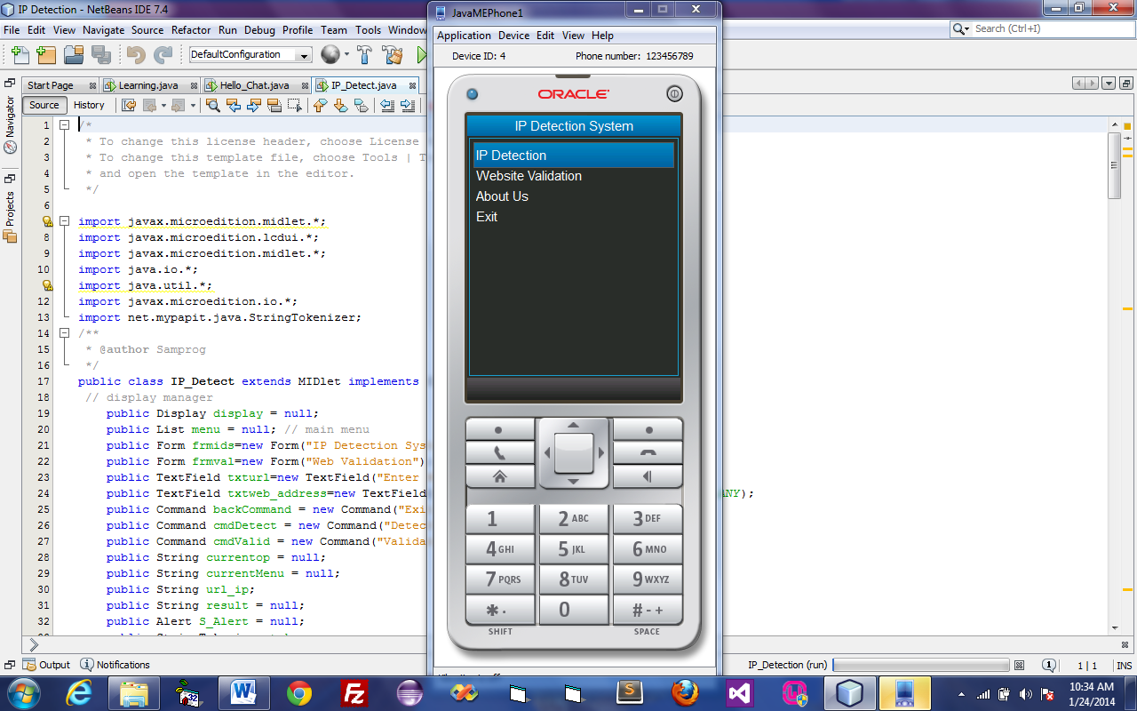
Figure 4.1: This is the Main Menu, from which the user can select any option, such as detecting IP addresses, website validation, about us, and exit.
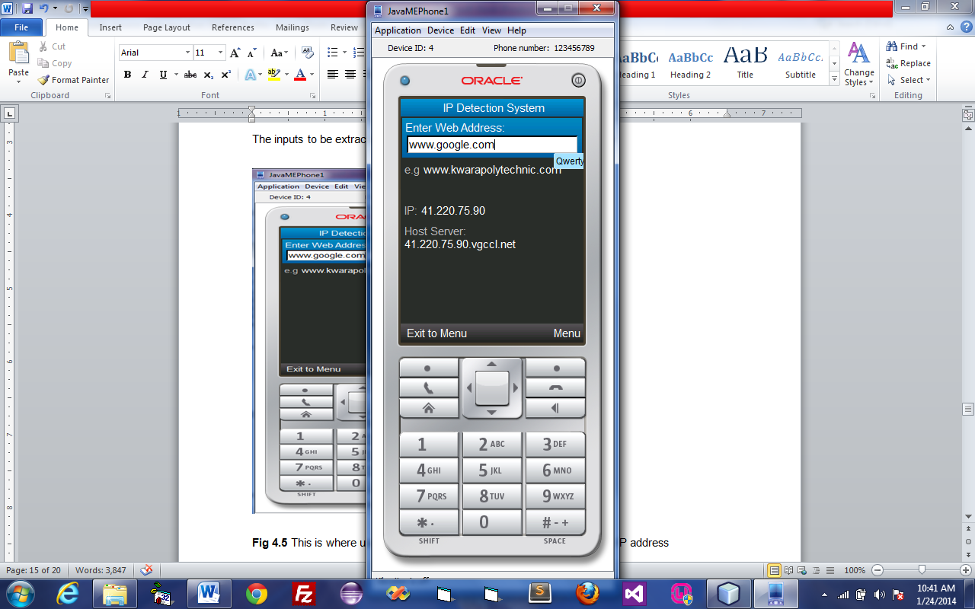
Figure 4.2: This is the output of the IP address and the hosting server of the input website, obtained by providing the desired website to obtain the IP address of the input web address.

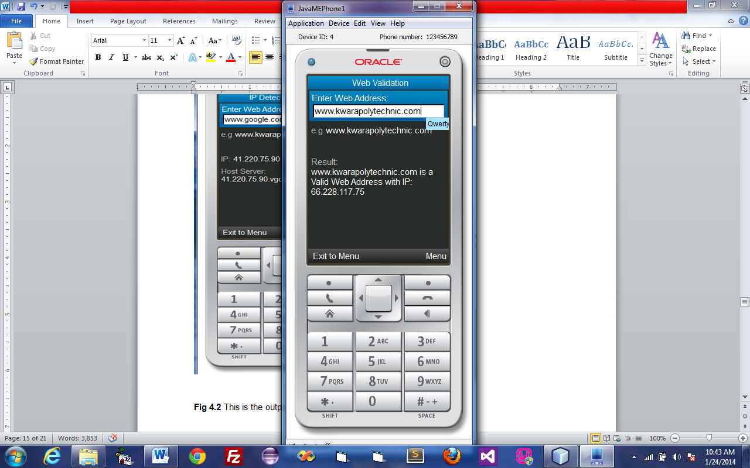
Figure 4.3: This is a location where web addresses are validated, and the web address supplied to the input field is www.kwarapolytechnic.com, which exists.

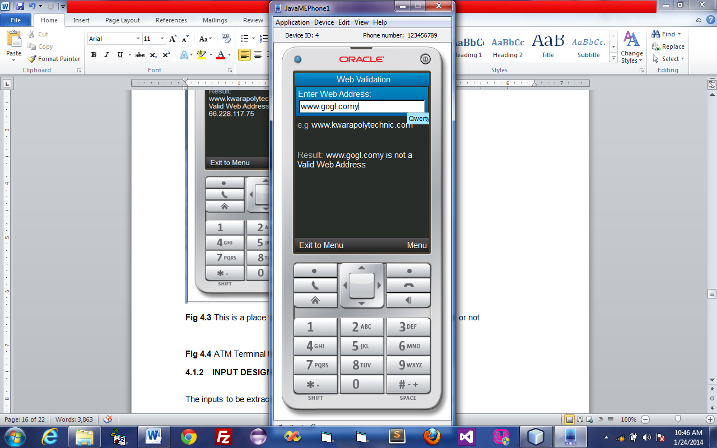
Figure 4.4: This is a place where web address is been validated and the name of the web address supply to the input field is www.gogl.comy which is not in existence.
4.1.2 INPUT DESIGN
The following are the inputs to be extracted from the proposed system.
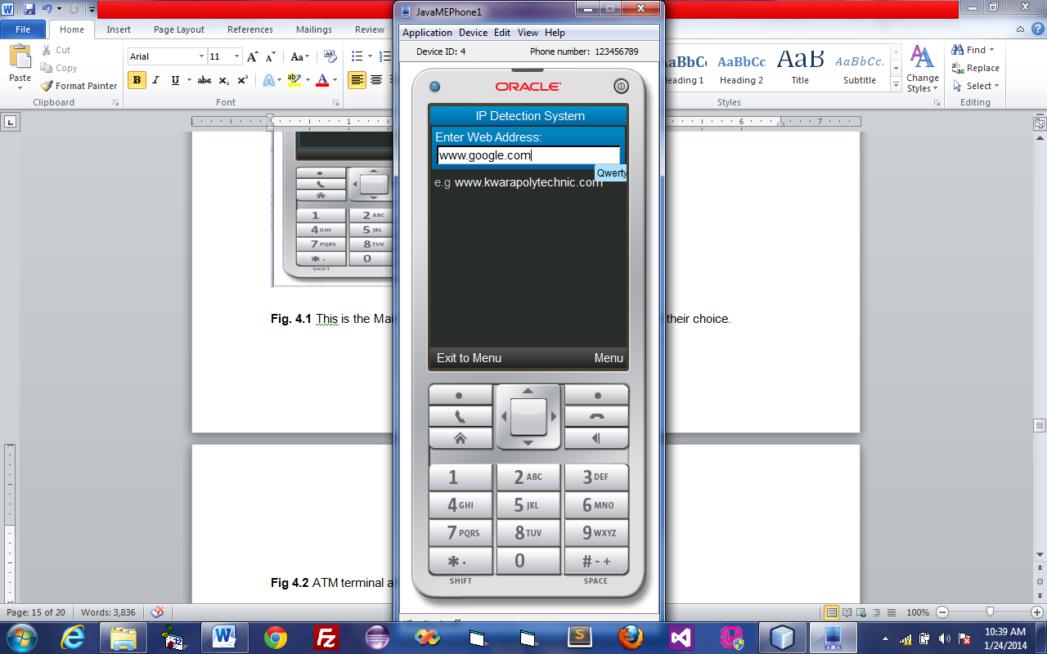
Figure 4.5: This is where the user enters the web address in order to obtain the IP address and hosting server of the website by typing the desired web address, which is www.google.com.
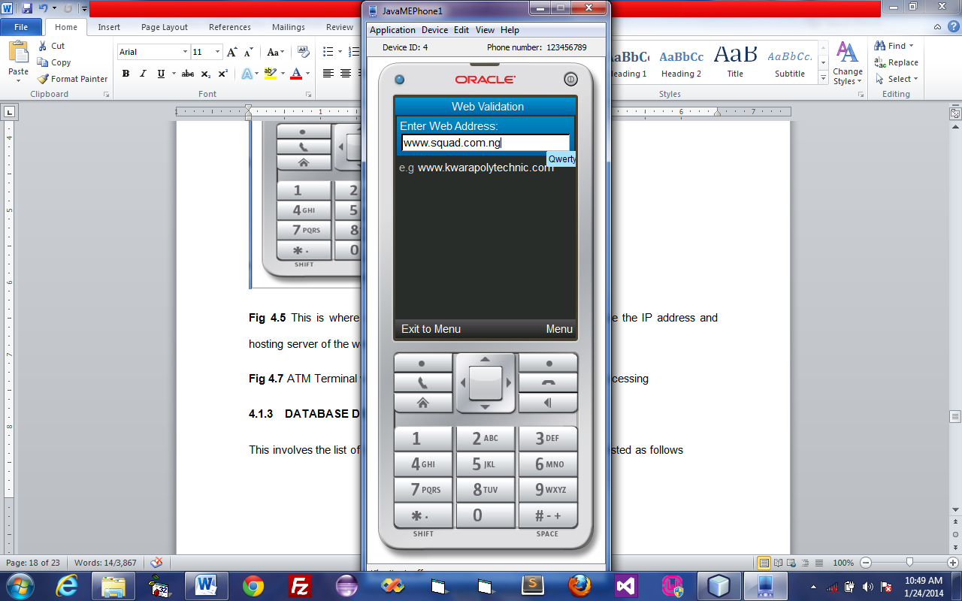
Figure 4.6: This is where the user enters the web address to validate it by typing the desired web address, and the web address used for testing is www.squad.com.ng.
4.1.3 DATABASE DESIGN
A database table is used to store file-related information. This application makes use of the MySQL database. The files and their respective modes of access, as well as the data they contain, are listed below:

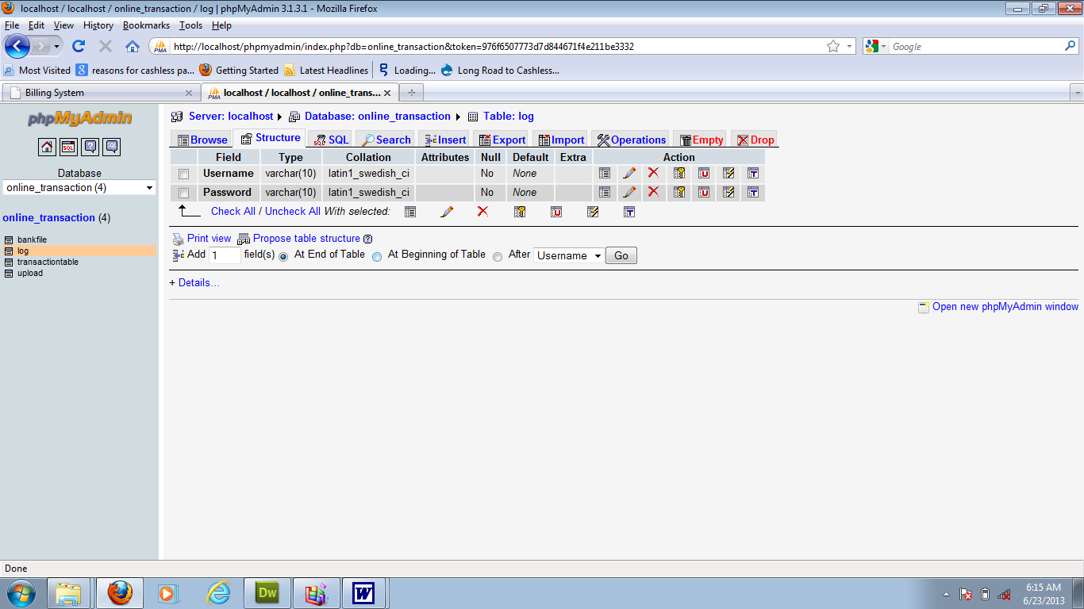

Figure 4.7: Admin Login Table structure

4.1.4 PROCEDURE DESIGN
This refers to the method of using the proposed system in a step-by-step manner. The proposed system is made up of four modules, which are as follows:
- IP Detection
- Website Validation
- About Us, and
- Exit.
4.2 IMPLEMENTATION OF THE SYSTEM
4.2.1 CHOICE OF PROGRAMMING LANGUAGE
The proposed system is written in Java and PHP. Java is an object-oriented programming language with an enhanced interface design and a class library that allows programmers to communicate with hardware, whereas PHP is a programming language that is easily accessible to communicate with a web page.

4.2.2 HARDWARE SUPPORT
The following hardware is required for the project to be completed successfully:
- Monitor,
- CPU,
- Keyboard,
- Mouse,
- Printer,
- Mobile Phone, and
- Uninterrupted power supply (UPS).
4.2.3 SOFTWARE SUPPORT
The software support for the proposed system's design includes:
- Windows operating system,
- Netbeans 7.3,
- JDK 7.1,
- Oracle emulator SDK3.2
- Anti-virus software that guards against virus infection.
4.2.4 IMPLEMENTATION TECHNIQUE USED IN DETAILS
The implementation technique used is parallel mode implementation, which supports the proposed system in addition to the current system.
4.3 DOCUMENTATION OF THE SYSTEM
4.3.1 PROGRAM DOCUMENTATION
Program documentation entails compiling all of the documents associated with the application and compiling them into an operation manual. In this case, make every effort to ensure that the documents are as clear as possible and that the purpose or scope of programming is clear and concise. This application has been designed to be easy to maintain and modify if necessary, or even in the case of the application developer.
4.3.2 OPERATING THE SYSTEM
The program can be used in accordance with the guidelines outlined below.
- Download the JAR and JAD files to your mobile device (except Android user)
- After that, install the JAR or JAD file that you downloaded.
- Launch the program and follow the on-screen instructions.
4.3.3 MAINTAINING THE SYSTEM
The system is adaptable enough to accommodate any future changes that may be required if the need arises.
CHAPTER FIVE
SUMMARY, CONCLUSION AND RECOMMENDATION
5.1 SUMMARY
Using information technology, an IP Detection system on a mobile phone can be used for high security authentication with greater convenience, accuracy, and efficiency, even when you need to know an IP address of a specific website or the host server of the website, and especially when you want to confirm whether a web address is valid or not. In this study, I designed and built an IP detection system on a mobile phone prototype using Java as the front end and PHP as the back end. The system has excellent features such as a user-friendly interface and a dual operating environment on a networked system.
5.2 CONCLUSION
If the situation calls for it, an IP detection system on a mobile phone can be considered. Creating a good system is critical to the system's success in order to avoid system failures and gain widespread acceptance as the best method available. Ten characteristics are required for a good IP detection system on a mobile phone. Accuracy, verifiability, security, convenience, flexibility, dependability, consistency, and social acceptance are some of them. Designers must use these characteristics as a foundation when analyzing, designing, implementing, and maintaining standards.
5.3 RECOMMENDATION
I hereby recommend the system as a starting point for upcoming developers who want to work on an IP Detection system on a mobile phone.

REFERENCE
Ananny, S., Coppersmith, D., Hong, S. J. & Hosking, M., (2014). Partitioning nominal attributes in decision trees, mobile app and knowledge discovery, 3.
Ayorkor, R. & David, P., (2010). Mobile Voice over IP (MVOIP). An Application-level Protocol for Call Hand-off in Real Time Applications.
Hoang, B. & Pham, C. (2016). A Review on Hot-IP finding methods and its application in early DDoS target detection cyber security lab, posts and telecommunications. Institute of Technology, Hanoi 100000, Vietnam 2 VNPT Software, Hanoi 100000, Vietnam; phamkyit@gmail.com.
Lerdorf, R. (2007). GSM-Based mobile tele-monitoring and management system for inter cities public transportations. International Conference on Industrial Technology (ICIT), Sharjah, UAE.
Lojack, B. & Mukesh, P.R. (2013). Real time web based vehicle tracking using GPS. World Academy of Science, Engineering and Technology.
Montaser D. et al. (2012). Intelligent anti-theft and tracking system for automobiles. Teknologi, Malaysia.
Harshadbhai, P.K. (2013). Design of global positioning system (GPS) and global system for mobile communications (GSM) based vehicle location and tracking system. Limda, Vadodara, India.
Telecom, P. & AbdulRahman, T. (2011). Intelligent fleet management system with concurrent global positioning system (GPS) & global system for mobile communications (GSM) real-time positioning technology. Teknologi, Malaysia.
Rahman, V. & Hatem, F. (2011). Security issues with mobile IP. Technical report, IDE1107.
ShyamRamanath, T., Sudharsan, A. & PelixUdhayaraj, U. (2010). Drunken driving and rash driving prevention system. International Conference on Mechanical and Electrical Technology (ICMET 2010), Chennai, India.
PROGRAM FLOWCHAT

Help
STOP
VALIDATE WEB ADDRESS
ABOUT
IP DETECTION
START
Main Menu

MAIN MENU FLOWCHART
START
OPEN DATABASE
SELECT

IP DETECTION

VALIDATE WEB ADDRESS
IS IT ABOUT?
HELP
CLOSE DATABASE
STOP
IS IT HELP?
ABOUT
Yes
IS IT VALIDATE WEB ADDRESS?

IS IT IP DETECTION?

Yes
Yes
Yes
No
No
No
No

IP DETECTION FLOWCHART

START
OPEN DATABASE
ENTER WEB ADDRESS TO DETECT
IS ANY FIELD EMPTY?
ENTER WEB ADDRESS TO PROCEED
DETECT IP
CLOSE DATABASE
RETURN
DISPLAY WEBSITE CONTENT
Yes
No

VALIDATE WEBSITE FLOWCHART
START
OPEN DATABASE
ENTER WEB ADDRESS TO DETECT
IS ANY FIELD EMPTY?
ENTER WEB ADDRESS TO PROCEED
CLOSE DATABASE
RETURN
CHECK VALIDITY
DISPLAY WEB STATUS
Yes
No

ABOUT FLOWCHART

START
OPEN DATABASE
DISPLAY ABOUT IP DETECTION
CLOSE DATABASE
RETURN

HELP FLOWCHART
START
OPEN DATABASE
DISPLAY HELP CONTENT
CLOSE DATABASE
RETURN

SOURCE CODE LISTING
* To change this template, choose Tools | Templates
* and open the template in the editor.
* idsmain.java
* Created on 16-Jan-2020, 14:28:17
import java.io.IOException;
import java.util.logging.Level;
import java.util.logging.Logger;
public class idsmain extends db {

/** Creates new form idsmain */
public idsmain() {
initComponents();
}

/** This method is called from within the constructor to
* initialize the form.
* WARNING: Do NOT modify this code. The content of this method is
* always regenerated by the Form Editor.
*/
@SuppressWarnings("unchecked")
// <editor-fold defaultstate="collapsed" desc="Generated Code">
private void initComponents() {

jButton1 = new javax.swing.JButton();
setDefaultCloseOperation(javax.swing.WindowConstants.EXIT_ON_CLOSE);

jButton1.setText("Monitor Network");
jButton1.addActionListener(new java.awt.event.ActionListener() {
public void actionPerformed(java.awt.event.ActionEvent evt) {
jButton1ActionPerformed(evt);
}
});

javax.swing.GroupLayout layout = new javax.swing.GroupLayout(getContentPane());
getContentPane().setLayout(layout);
layout.setHorizontalGroup(
layout.createParallelGroup(javax.swing.GroupLayout.Alignment.LEADING)
.addGroup(layout.createSequentialGroup()
.addGap(190, 190, 190)
.addComponent(jButton1, javax.swing.GroupLayout.PREFERRED_SIZE, 227, javax.swing.GroupLayout.PREFERRED_SIZE)
.addContainerGap(173, Short.MAX_VALUE))
);
layout.setVerticalGroup(
layout.createParallelGroup(javax.swing.GroupLayout.Alignment.LEADING)
.addGroup(layout.createSequentialGroup()
.addGap(119, 119, 119)
.addComponent(jButton1, javax.swing.GroupLayout.PREFERRED_SIZE, 54, javax.swing.GroupLayout.PREFERRED_SIZE)
.addContainerGap(137, Short.MAX_VALUE))
);

java.awt.Dimension screenSize = java.awt.Toolkit.getDefaultToolkit().getScreenSize();
setBounds((screenSize.width-606)/2, (screenSize.height-348)/2, 606, 348);
}// </editor-fold>

private void jButton1ActionPerformed(java.awt.event.ActionEvent evt) {

ProcessBuilder p = new ProcessBuilder("jConsole");
try {
p.start();
} catch (IOException ex) {
Logger.getLogger(idsmain.class.getName()).log(Level.SEVERE, null, ex);
}
}
public static void main(String args[]) {
java.awt.EventQueue.invokeLater(new Runnable() {
public void run() {
new idsmain().setVisible(true);
}
});
}

// Variables declaration - do not modify
private javax.swing.JButton jButton1;
// End of variables declaration

}

