IMPACT OF BUSINESS ETHICS ON ORGANIZATIONAL PERFORMANCE
(A CASE STUDY OF TUYIL PHARMACEUTICAL COMPANY, ILORIN)

BY
OLADITI JOSEPH PROMISE
HND/23/BAM/FT/231

BEING A RESEARCH PROJECT SUBMITTED TO THE DEPARTMENT OF BUSINESS ADMINISTRATION AND MANAGEMENT, INSTITUTE OF FINANCE AND MANAGEMENT STUDIES.
IN PARTIAL FULFILLMENT OF THE AWARD OF HIGHER NATIONAL DIPLOMA (HND) IN BUSINESS ADMINISTRATION AND MANAGEMENT, KWARA STATE POLYTECHNIC, ILORIN KWARA STATE.

JUNE, 2025

CERTIFICATION
This project work has been examined and approved as meeting the requirements of Department of Business Administration and Management, Institute of Finance and Management Studies, Kwara State Polytechnic, Ilorin, Kwara State. In Partial Fulfillment of the Requirement for the Award of Higher National Diploma (HND) in Business Administration and Management

________________________ _____________
DR. MUHAMMED. A DATE
(PROJECT SUPERVISOR)

___________________________ _____________
MR. UMAR BOLOGI DATE
(PROJECT CO-ORDINATOR)

__________________________ _____________
DR. ABDUSSALAM F. A DATE
(HEAD OF DEPARTMENT)

__________________________ _____________
(EXTERNAL EXAMINER) DATE

DEDICATION

ACKNOWLEDGEMENT

TABLE OF CONTENTS
Title Page
Certification
Dedication
Acknowledgment
Table of Contents
CHAPTER ONE: INTRODUCTION
1.1 Background to the study
1.2 Statement of the problem
1.3 Objectives of the Study
1.4 Research Questions
1.5 Research Hypothesis
1.6 Significance of the Study
1.7 Scope of the Study
1.8 Definition of terms
CHAPTER TWO:
2.0 Introduction
2.1 Conceptual Framework
2.2 Theoretical Framework
2.3 Empirical review
2.4 Gaps in literature

CHAPTER THREE: METHODOLOGY
3.0 Introduction
3.1 Research method
3.2 Research design
3.3 Population of the study
3.4 Sample size and sample techniques
3.5 Method of data collection
3.6 Instrument of data collection
3.7 Validity of research instruments
3.8 Reliability of research instruments
CHAPTER FOUR: DATA PRESENTATION, ANALYSIS AND INTERPRETATION
4.0 Introduction
4.1 Data analysis and presentation
4.2 Demographic characteristics of respondents
4.3 Test of hypothesis
CHAPTER FIVE:
SUMMARY, CONCLUSION AND RECOMMENDATIONS
5.1 Summary
5.2 Conclusion
5.3 Recommendations
References

CHAPTER ONE
1.0 INTRODUCTION
1.1 BACKGROUND TO THE STUDY
Business ethics is necessary for organizational sustainability because business organizations are important not only in themselves but also because of their contributions to the growth of the economic system and the benefits they bring to the people who are the consumers of goods and services. Business is often the basis of economic decisions and functional management for the progress of the economy. The economy is organized into a variety of functional institutions. This involves the individuals and organizations which not only use the factors of production to make goods and services available to consumers but which also help to protect and conserve ethics. One of the major functional institutions is the business organization which includes the manufacturer, the banker, and the transporter, among others. These organizations require the enforcement of business ethics for success and sustainability. In broad terms, ethics are principles that explain what is good and right and what is bad and wrong and that prescribe a code of behavior based on such practical definitions.
On the other hand, business ethics provide standards or guidelines for the conduct and decision-making for the guidance of management and stakeholders. It is understood that in the absence of code of ethics, there is usually a lack of consensus about appropriate ethical principles, and different people use different ethical criteria to determine whether a practice or behavior is ethical or unethical. Even though business ethics are not the same thing as laws but laws and ethics are related in some specific ways and situations as both seeks to enforce compliance. Business ethics are necessary to ensure ethical business decision-making and to this extent more than 90 percent of global sustainable organizations have code of ethics and have huge regard to prevailing laws. A code of ethics is a formal statement of the organization’s ethics and values that is designed to guide the employees conduct in a variety of business situations. Business ethics relate to corporate credos like the popular Johnson & Johnson Credo. A corporate credo indicates a company’s responsibility to its stakeholders, such as individuals and groups who have an interest in the performance of the enterprise and how it uses its resources. Gomez-Mejia and Balkin (2018) posit that stakeholders include employees, customers, and shareholders. They state also that a corporate credo focuses on principles and beliefs that can provide direction in a variety of ethically challenging situations. Good corporate credos often emphasize corporate social responsibility (CSR) ethical corporate social responsibility (ECSR) good corporate governance (GCG) as well as the need for business profitability and sustainability. Sustainability is often confused with CSR, but the two are not the same. However, according to Wales (2017) marketing theory suggests that CSR is about brand, image reputation, cost reduction, risk management and access to capital. Therefore, achieving objectives in these directions will make any business sustainable, in which case it could be argued that sustainability may be an outcome of CSR. Organizational sustainability is directly linked to sustainable growth which encompasses a business model that creates value consistent with the long-term preservation and enhancement of financial, environmental, ethical and social capital. The essence of sustainability in an organizational context is the principle of enhancing the societal, environmental and economic systems within which a business operates. Organizational survival which may be explained as organizational sustainability stresses on the concept of shared values which state that companies will have to develop a broader sense of what value means to society as a whole. Kanter (2017) argues that companies increasingly not only want to make money but also to invest in the future while being aware of the need to build people and society. It is therefore eloquently argued that the growth, continuity and survival of any organization providing goods or services is highly dependent on the economic, environmental and social conditions in the communities in which it operates, and this then supports the lucid argument that the key aspects of business ethics are basic and foundational to organizational sustainability (Aupperle et al., 2019; Dolf, 2000; Aimkij et al., 2018).

1.2 STATEMENT OF THE PROBLEM
It is an established fact that Business Ethics plays a very significant role in organizational performance. Many modern organizations are faced with numerous challenges such as illegal and unethical behaviour in a number of business transactions. Managers are also faced with the challenge of evaluating the effect of this ethical behaviour on the performance of organizations in South-East, Nigeria. Many business managers operate their activities today, without keen interest of bothering whether their actions are right or wrong and the extent of employees understanding of the term ethics while the level of compliance is highly infinitesimal, (Oladunni 2018). David and James (2017) argued that the return of interest in business ethics that began in the 1970s was in realization that businesses could be tempted to act immorally and unethically whenever necessary in pursuit of profit. This interest grew rapidly in later years and almost reached a crescendo in the 2000s when it became clearer that many heavy global businesses like Enron collapsed for the most part, due to breaches in GCG and business ethics. It is now believed, more than ever before, that business ethics are also instrumental to the pursuit of long-term profit for the business, as well as prosperity and sustainability for the organization and society as a whole. Organizational sustainability thrives on integrity of the board of directors (BODs).
1.3 OBJECTIVES OF THE STUDY
The study was designed to explore the relationship between business ethics and organizational Performance. According to Amaeshi and Adi (2016), the success of organizations is contingent on balancing the social and ethical goals but many organizations argue that a business is an economic institution and that only economic values should determine its success. As organizations face competent and competitive players, the Nigerian business environment is now driven by advance competition brought about by globalization, deregulation of financial services, astronomical developments in Information and Communication Technology (ICT) among others to render services according to cost benefit criteria. Demaki (2017)
The following are Business ethics objectives as specified by Stanley (2012) in an organizational performance.
- To evaluate the impact of ethical climate on performance of manufacturing companies using Tuyil Pharmaceuticals industry as case study
- To investigate the effect of ethical standard on performance of Tuyil manufacturing company
- To determine the effect of ethical culture on performance of Tuyil manufacturing company under review

1.4 RESEARCH QUESTIONS
The following questions guided the study:
- To what extent has ethical climate affected the performance of manufacturing companies in Nigeria?
- How unethical standard does influenced the performance of manufacturing companies in Nigeria?
- How does culture influence the performance of the manufacturing company under review?
1.5 RESEARCH HYPOTHESES
Hoi: Ethical climate has no significant positive effect on the performance of manufacturing companies in Ilorin.
Hoii: Ethical standard does not enhance the performance of manufacturing companies in Ilorin
Hoiii: Ethical culture has no significant positive effect on performance of the manufacturing companies in Ilorin.
1.5 SIGNIFICANCE OF THE STUDY
This study will be of immense importance to management practitioners, business executives and scholars. First, it will be greatly beneficial to management practitioners in different areas of management on how an organization can use ethics as a tool for organizational success. It will also provide information for business executives and managers of all the organizations in south east, on how to achieve organizational success by adopting effective ethical practices. Finally, to scholars the study will be an addition to essential literature in this vital area of management strategy. Researchers will therefore use it extensively as a source document which will also stimulate further research in this area.

1.6 LIMITATIONS OF THE STUDY
- Time was a major limitation of this study. Appointment with respondents was a constraint because of their failure to comply with the appointment. There were excuses from some of the respondents. Notably, strong resistance was observed in case of interviews when collecting data and confidentiality but after discussion with some key respondents, they managed to provide necessary information needed in the study.
- Also, due to the unique cultural background of the people in the study area, the outcome of the study would be difficult to replicate in other places. Another limitation was that, the entire questionnaires given out were not retrieved for analysis.
- Financial constraint. There were so many requirements which were needed during the whole research exercise. The researcher did not have a sponsor to pay for the study. Therefore, he used his own meagre resources to meet the research expenses.

1.7 DEFINITION OF TERMS
The followings are the terms that feature more prominently in the study and they are explained here to avoid any miss-conception about them.
- ETHICAL CLIMATE: According to the classical definition by Victor and Cullen (1987), ethical climate may be defined as a set of shared perceptions of procedures and policies, both codified and informal, which shape expectations for ethical behavior within an organization or a company.
- ETHICAL STANDARD: Ethical standards refer to the principles that promote trust, good behavior, fairness and governing the conduct of a person.
- ETHICAL CULTURE: An ethical culture means a set of values that are shared and deeply held by an organisation. It's a mindset, where people understand the importance of acting in accordance with the law, as well as demonstrating respect for others.
- BUSINESS ETHICS:- Business ethics is a form of applied ethics or professional ethics, that examines ethical principles and moral or ethical problems that can arise in a business environment
- ORGANIZATION: An organization or organisation, is an entity—such as a company, an institution, or an association—comprising one or more people and having a particular purpose.
- BUSINESS:- A group of people or individuals who engages in trade, services or commercial activities with a view to make profit.
- ORGANIZATIONAL PERFORMANCE:- Organizational performance comprises the actual output or results of an organization as measured against its intended outputs.
- PRODUCT: - It is an offering made available by the marketers to the customers so that need or want may already exist, or it may be latest, that is, awaiting the development of the products to meet this need.

CHAPTER TWO
2.0 LITERATURE REVIEW
2.1 INTRODUCTION
This chapter discusses the literature of the study. The chapter begins by discussing the conceptual framework, which then presents the concepts of the variables used in the study. The chapter proceeds to present the theoretical framework, where related theories are discussed and the ones that are more related are adopted by the study. The chapter then concludes with a summary which summaries the entire discussions of the chapter.
Business ethics refers to contemporary organizational standards, principles, sets of values and norms that govern the actions and behavior of an individual in the business organization. Business ethics have two dimensions, normative business ethics or descriptive business ethics. As a corporate practice and a career specialization, the field is primarily normative (Stead, Worrell and Stead 2010). Academics attempting to understand business behavior employ descriptive methods. The range and quantity of business ethical issues reflects the interaction of profit-maximizing behavior with non-economic concerns.
Business ethics reflect the norms of each historical period. As time passes, norms evolve, causing accepted behaviors to become objectionable. Business ethics and the resulting behavior evolved as well. Business was involved in slavery, colonialism, and the cold war (Kingsolver 2008). The term 'business ethics' came into common use in the United States in the early 1970s. By the mid-1980s at least 500 courses in business ethics reached 40,000 students, using some twenty textbooks and at least ten casebooks supported by professional societies, centers and journals of business ethics (Berger & Easterly 2010).
2.2 CONCEPTUAL FRAMEWORK
2.2.1 Business Ethics
Organization began highlighting their ethical stature in the late 1980s and early 1990s, possibly in an attempt to distance themselves from the business scandals of the day, such as the savings and loan crisis. The concept of business ethics caught the attention of academics, media and business organization by the end of the Cold War. However, criticism of business practices was attacked for infringing the freedom of entrepreneurs and critics were accused of supporting communists (Cullather & Gleijeses 2016). This scuttled the discourse of business ethics both in media and academia. The Defense Industry Initiative on Business Ethics and Conduct (DII) was created to support corporate ethical conduct. This era began the belief and support of self-regulation and free trade, which lifted tariffs and barriers and allowed businesses to merge and divest in an increasing global atmosphere (Moon, 2001).
Business ethics is the search for a good way of ‘being’ as practiced by business organization, From the work of Blazovich and Smith, (2010) ,we understand that a business is ethical when it afflicts the least suffering to humans and nature, achieves the greatest net benefits to the society and enriches the capability of the system in which it functions. However Rothman (2004) believe that a firm maintains business ethics when it is fair in all its dealings with its proximate and remote stakeholders prepared to correct its mal-habits and nurtures an enduring virtuous corporate character. According to Berman, Wicks, Kotha, & Jones, (2012) a business becomes ethical by assuming the responsibility of translating the abstract ethical injunctions into series of obligations. Business ethics (also known as corporate ethics) is a form of applied ethics or professional ethics, that examines ethical principles and moral or ethical problems that can arise in a business environment. It applies to all aspects of business conduct and is relevant to the conduct of individuals and entire organizations (Business Ethics 2013). These ethics originate from individuals, organizational statements or from the legal system. These norms, values, ethical, and unethical practices are the principles that guide a business. They help those businesses maintain a better connection with their stakeholders (Ferrell, 2016).
2.2.2 Organization Performance
Organization performance has been the most important issues for every organization be it profit or nonprofit one. It has been very important for mangers to know which factors influence an organization’s performance in order for them to take appropriate steps to initiate them. However, defining, conceptualizing and measuring performance have not been easy task. Researchers among themselves have different opinions and definitions of performance, which remains to be a contentious issue among organizational researchers (Barney, 2008). For example, according to Javier (2007), as cited in Nikbin et al (2010), performance is equivalent to the famous 3Es (i.e. economy, efficiency and effectiveness) of a certain program me or activity.
However, according to Daft (2009), organizational performance is the organization’s ability to attain its goals by using resources in an efficient and effective manner. Quite similar to Daft (2009) Richardo and Wade (2010) defined organizational performance is the ability of the organization to achieve its goals and objectives. Organizational performance has suffered from not only a definition problem, but also from a conceptual problem. This is what Hefferman and Flood (2006) stated that as a concept in modern management, organizational performance suffered from problems of conceptual clarity in a number of areas. The first was the area of definition while the second was that of measurement. The term performance was sometimes confused with productivity. Productivity was a ratio depicting the volume of work completed in a given amount of time. Performance was a broader indicator that could include productivity as well as quality, consistency and other factors.
There are various ways to understand organization performance but in this thesis it has been judged upon the growth of the company and sales performance which lead towards the growth. Sales performance can be explained as all the activities or investment carried out in the firm in the given period of time. It can be measured by total amount of revenue collected for the goods sold. Growth revenue defines as total amount of money collected by the company for the goods they sold in a specific time and this amount is calculated before any expenses are subtracted. Effectiveness of the organization depends on the three basics performance determinants.
- Efficiency and process reliability
- Human resource and relations
- Innovation and adaptation to environment (Yuki et’al, 2006).
Efficiency is defined as a term practiced by organization or firm to use people and resources to carry out important operations in way which minimizes the costs. When the resources will be used in a proper way as compared to the competitors the cost of operation will decrease and the profit margin will increase. Efficiency is important when the competitive strategy of the firm offers products and services at lower rates than the competitors. Human resource relation is defined as trust, organizational commitment, collective identification and cooperation among the employees (Yuki and Tabler 2002). Innovative adaption includes increase in market share, sales growth from year to year, generating and maintaining loyal customer base. Organizational performance refers to ability of an enterprise to achieve such objectives as high profit, quality product, large market share, good financial results, and survival at pre-determined time using relevant strategy for action (Koontz and Donnell, 1993).
Organizational performance can also be used to view how an enterprise is doing in terms of level of profit, market share and product quality in relation to other enterprises in the same industry. Consequently, it is a reflection of productivity of members of an enterprise measured in terms of revenue, profit, growth, development and expansion of the organization. Organizational performance may be defined as the transformation of inputs into outputs for achieving certain outcomes. With regard to its content, performance informs about the relation between minimal and effective cost (economy), between effective cost and realized output (efficiency) and between output and achieved outcome (effectiveness) (Chen and Barnes, 2006). There is no general agreement in the literature on the criteria to be used in assessing the organizational performance (Bolman and Deal 2003; DeClerk, 2008; LaRue et al, 2014).
2.3 THEORETICAL FRAMEWORK
This research work is anchored on stakeholder theory. The inventor of Stakeholder Theory is R. Edward Freeman and his publications are Strategic Management – A Stakeholder Approach in 1984. Freeman (1984) argued in his seminal work introducing the term stakeholder theory that “systematic attention to stakeholder interests is critical to firm success”. The traditional definition of a stakeholder is “any group or individual who can affect or is affected by the achievement of the organization’s objectives” (Freeman, 1984). The definition has given a new idea of redefining an organization that what it should be like and Friedman & Miles (2006) explained that an organization is a composition of stakeholders, and purpose of an organization should be to be able to handle its own interests, viewpoints and requirements. It depends on the type of firm that stakeholders may include suppliers, customers, shareholders, community and environmental groups etc. Unexpected levels of problematic environment and changes that managers were facing became the reason for building this framework. It came into existence to address the concerns of the managers. The prevalence of this approach was quite high in the 80’s even though the idea was old. This term was firstly used in the 1960s during the genuine work done in Stanford Research Institute (Freeman et al. 2001). There has been a great amount of growth so far in the scope of this approach and recent researches conducted in the four sub-fields; Corporate Social Responsibility and Performance, Strategic Management, Normative theories of Business, Governance and Organizational Theory.
Simply put stakeholder theory of organization that those whose lives are touched by a corporation hold a right and obligation to participate in directing it Kotler and Keller, (2006). Therefore, they’re stakeholders in the company and their voices must contribute to corporate decisions. The five cardinal stakeholders mainly include but not limited to shareholders, workers, customers, suppliers, and community Kotler and Armstrong, (2008). It is therefore, upon the organizations before, during or after carrying out the business to be as transparent as possible; because this is an important value for those promoting stakeholder ethics. On the other hand Baker and Hart, (2008) assert that what’s certain is that stakeholder theory obligates business directors to appeal to all sides and balance everyone’s interests and welfare in the name of maximizing benefits across the spectrum of those whose lives are touched by the business. Business ethics is likely to loose its value if the stakeholders are not fully involved or left unawares to the facts. Donaldson and Presten (1995) in Freeman et al. (2001) described that Stakeholder theories could be divided into descriptive, instrumental and normative point of Views. The descriptive theory implies the stakeholders that a firm possesses; instrumental view entails the consideration of stakeholders by the organization and they remain successful and last but not the least normative approach focuses on the reason why a firm should take into consideration the stakeholders.
The objective of business ethic, both as an academic branch in business studies and as a managerial tool for practitioners, is to become aware of this relationship and understand how business activity influences society and vice-versa (Lantos, 2001). If CSR is applied properly in any organization, it will build a strong bond between the organization and its stakeholders in terms of more commitment, trust, customer loyalty and investments by the suppliers and stockholders thereby improving organizational growth (Maignan and Ferrell, 2004; Bhattacharya and Sen, 2004). A firm’s involvement and initiatives in social and environmental areas possess a great amount of importance in organizational growth. It shows the concern of a firm towards the internal and external environment and imposes a healthy effect in building a good image of the firm. The main core of the stakeholder theory is the belief that stakeholder relationships are the most important factor that managers have to take care of. However, business ethics addresses those responsibilities that a business needs to fulfill. We may conclude that both the concepts are interrelated but the level of abstraction differs on the subject of business ethics. The Stakeholder Theory is an effective gauge to measure the growth of a organizational (Quazi, 2003). The stakeholder model focuses primarily on the interests and concerns of the organization’s stakeholders over economic interests. From the stakeholder model perspective, the focus becomes how to please and build mutually beneficial relationship with the beneficiary community. Based on this assumption, it can be argued that the underlying philosophy for business ethics activities under the stakeholder model can produce positive attitude among employees thereby increasing their participation levels.
2.4 EMPIRICAL REVIEW
Nze (2016) analyzed the effect of Business ethics and CSR on corporate organization in Nigeria the study is a survey research. The study had a population size of 1318 out of which a sample of size of 307 was realized using Taro Yamene’s formula at 5% error to tolerance and 95% level of confidence. Instruments used for data collection were primarily questionnaire and interview. The total number of 307 copies of the, questionnaire were distributed while 280 copies were returned. Five hypotheses were tested using Pearson product moment correlation coefficient, Chi square (X2), Spearman’s rank correlation coefficient and Z- test statistical tools. The study found out that Banks engaged in ethical principles in order to improve their standard as well as the level of acceptance by the society: the impact of CSR such as better public image, customer loyalty, fewer regulatory problems and increased revenue contributed to organizational success. Recommendations are that Business ethics and CSR deserve greater attention and more commitment from corporate organisation, and they should formulate policies on ethics and CSR so as to provide a guide and channel efforts towards using them to achieving organizational success.
Anyim, Ufodiama, & Olusanya, (2018) research on Ethics standards and practices in Nigeria public sector. The study was conducted using government agencies and parastatals based in Lagos, Nigeria selected through proportionate stratified sampling technique; standardized measures were adapted and administered on the sample. The sampled elements for the study consisted of 200 respondents comprising senior, mid-level and junior employees selected from the agencies and parastatals using the proportionate random and stratified sampling technique. The data collected was analysed using Frequency distribution expressed in percentages and Chi-square (X2) statistics to test the hypotheses formulated for the study. Apart from the human resource department not being part of ethics infrastructure, the analysis of data also showed that there is no pro motion of ethics in the Nigeria public sector. The implications of the findings were discussed. Ebitu, Tom & Beredugo, (2015) investigated relevance of code of ethics on guiding the performance of service industry and examined also their compliance level on the established code of ethics. The study adopts descriptive research design while data were collated from 176 respondents cutting across selected Banks and GSM organization in Calabar, Cross River State. Our hypotheses were tested using Chi-square (X2) and all were supported by extant literatures. Results show that effective performance of service industry was dependent on code of ethics [X2cal = 18.082 > t 0.05 = 7.815] and that the compliance level of established code of ethics for service industry was high [X2cal = 13.801 > t 0.05 = 7.815]. Our findings therefore suggested that there should be specific procedures to always identify and deal with the issues of ethical misconduct; and it is important for organizations to increase punitive measures to violators of ethical codes.
2.5 ETHICAL CLIMATE
Ethical climate defines what correct behavior is and how ethical issues should be handled within organizations. For this reason, it plays a key role in organizational life. Ethical work climate represents a set of shared formal and informal perceptions of procedures and policies, which shape expectations for ethical behavior (Victor and Cullen, 1987, 1988). In recent years, researchers as well as practitioners have focused their attention on this construct, considering its direct influence both on individual and organizational outcomes and behaviors (for a recent review, see Newman et al., 2017). In particular, when comparing ethical climates that promote prosocial behavior with those suggesting more individualistic behavior, it emerges that the former are more strongly associated with work performance and employees’ positive attitudes and behaviors (e.g., Peterson, 2002; Briggs et al., 2012; Ehrhart and Raver, 2014; Mayer, 2014; Pagliaro et al., 2018). Thus, it seems crucial for organizations to understand the positive and negative consequences of different kinds of ethical climates in order (a) to avoid the associated financial and socio psychological costs and (b) to rely on those climates that, on the contrary, may increase employees’ positive relationship with the organization and positive behaviors
According to the classical definition by Victor and Cullen (1987), ethical climate may be defined as a set of shared perceptions of procedures and policies, both codified and informal, which shape expectations for ethical behavior within an organization or a company. Olson (1998) elaborated on this definition suggesting that ethical climate provides “the context in which ethical behavior and decision-making occurs” (p. 346). As such, ethical climate tracks behavioral guidelines that help individuals to understand what is acceptable rather than sanctionable within organizations.
2.6 ETHICAL STANDARD
Ethical standards refer to the principles that promote trust, good behavior, fairness and governing the conduct of a person. Principles which when followed will promote values such as trust, good behavior, fairness and/or kindness. One consistent set of standards that all companies follow does not exist but rather each company has the right to develop a set of standards which are meaningful to that particular organization. These standards are an important part of an organization’s culture. They establish the parameters of behavior that owners and top executives expect from employees and also from suppliers, at least to the extent of their relationship with the organization. A corporate governance system will put a lot of effort into communicating and enforcing these principles. This is mostly done through behavior modeling, which means that top executives should set the example of how lower-level employees should act Adeyemi et’al (2017). These principles should serve also as guidelines for decision-making processes to help employees align their personal criteria with the company’s perspectives as different ethical issues arise within normal business activities. This moral “compass” is crucial to maintain unethical behaviors down to a minimum, mostly in managerial positions.
2.7 ETHICAL CULTURE
An ethical culture means a set of values that are shared and deeply held by an organisation. It's a mindset, where people understand the importance of acting in accordance with the law, as well as demonstrating respect for others. In order to build an ethical culture, leaders must model the desired behaviour and reward it when employees display it. This can be accomplished through policies and procedures that reinforce what is expected, but also through training sessions that explain why ethics are important at (and beyond) work Kenov (2014).
In addition to being consistent with your policies and procedures around whistleblowing, you should also give attention to how you treat whistleblowers within your organisation — especially if they report concerns about wrongdoings internally rather than externally via an external whistleblower hotline or another reporting mechanism. If someone comes forward because she feels there is something wrong within her department or division—and then finds herself criticized or ignored by her leadership team—it’s unlikely that she will feel comfortable coming forward again if something else goes wrong later on down the line (unless she loses faith in management altogether).

2.8 SUMMARY OF THE CHAPTER
The chapter summarized the study in order to show or view the literature review.
Hence the chapter explains the meaning of Business ethics and its effect on Organizational performance.
The chapter explains the relevance of Business ethics and its effect on Organizational performance and also makes some provision in order to increase the sales of manufacturing company

CHAPTER THREE
RESEARCH METHODOLOGY
3.1 RESEARCH DESIGN
At this stage, this study is aimed at justifying the source of data to be used, and the type of data to be collected. As it well known, there are only two sources of data, primary and secondary source primary source are organization and people from whom fresh data are collected while secondary source primary source are organization and people from whom fresh data are collected while secondary source include text journals periodicals, company record and so on.
Therefore, for the purpose of this study or research questionnaire is prepared to collect information, from student or workers of Tuyil Pharmaceuticals Industry, Ilorin.
3.2 AREA OF THE STUDY
The research carried out in Ilorin metropolis of Kwara State. The study was designed to study the effect of business ethics on organizational performance using Tuyil Pharmaceuticals Industry, Ilorin as case study
3.3 POPULATION
This is concerned with who or what will be studied. The population of the study is that group (usually of people) about whom we want to be able to draw conclusion.
It is not possible in most studies to study all the people in the population of study. Therefore, the research design should state in clear terms what population of the study is all about, that is how large is the population if the population is not too large, is the researcher going utilize all elements in the population as his respondents or subject of study. And if the population is too large, is the researcher going to select a sample from the real population. The ideal thing to do by the researcher is to select sample form the study population if population is too large. The part of the population selected is called a sample. The targeted population is 58

3.4 SAMPLE AND SAMPLING PROCEDURE
The study adopted a random sampling technique; staffs of Tuyil Pharmaceuticals Industry, Ilorin were used to collect relevant data through gender, age, experience, educational qualification and others through the use of questionnaire.
The formula used for calculating sample size is:
n= $\frac{N}{1+Ne^{2}}$
Where n= sample size
N= Targeted population
E= level of significant (α=0.05)
Therefore, n= $\frac{N}{1+Ne^{2}}$
n= $\frac{58}{1+58{(0.05)}^{2}}$
n= $\frac{58}{1+58{(0.05)}^{2}}$
n= $\frac{58}{1+58{(0.05)}^{2}}$
n= 50
Therefore, A total of 50 staffs will be sample for the work through the sample random sampling technique to serve as a representative of the entire population.
3.5 INSTRUMENT OF DATA COLLECTION
The administration of instrument is basically concerned with the method of gathering data or information which is majority the primary data and secondary data.
Primary data are collected by the research usually for the first time specifically for the purpose, of soling the research problem.
The major methods of gathering primary data are observation, survey and experiment. In all the subject of the research project.
Secondary data may be collected from external source government and trade publication, news paper extract man to survey and internal sources such as customer billings, sales activity, inventory data and product costs.
3.6 VALIDATION OF THE INSTRUMENT
The items drawn covered both negative and positive perceptions treasury receipt, quality determination, total quality management.
In order to ensure content validity, the instrument developed was shown to the superior and experts in the field of business administrator in manufacturing industries to ascertain the instrument validity. Corrections were made by the experts and there was a general consensus among the expert consulted that the instrument had content of validity.
3.7 RELIABILITY OF THE INSTRUMENT
A plot test was carried out before actual data collection with the questionnaire will be administered twice within one month between the pre-test and post-test on a plot group by the researcher and return the questionnaire immediately but some that could not return it immediately might return it later the questionnaire will be administered to the staffs who were working in the industry.
If the response of the first administration of the instrument will be correlated 0.58, the value will be considered as reasonably high and so the instrument will be taken as reliable measure of the viable of interest.
3.8 METHOD OF DATA COLLECTION
The method adopted in conducting this research on “Effect of Business ethics on organizational performance” was through personal interview and company record.

INTERVIEW
Interview is a process of asking questions demanding immediate answer to each question through personal contact system.
Interview method was adopted as the foundation or collection vital information for the study. Some of the officials in charge of power preparation in the organization were interview as well as the some officer in some department.
PERSONAL OBSERVATION
Personal observation was involved during this research work. This involves spending some time with the source officer to observe how accounts are being prepared. Also some documents of Tuyil Pharmaceuticals Industry, Ilorin were also examined.

3.9 METHOD OF DATA ANALYSIS
In research, it is expected that a few lines would be devoted to how data are to be presented and analyzed. Immediately the questionnaires are returned from the respondents or data are collected through the interview, observation, experimentation or documentation, they are expected to be coded in order to make them presentable analytical purpose.
The essence of data analysis is to comment on the data objectively by bringing out what they mean and drawing conclusion in them.
In the process of caring out this study, data is collected through responses given in the questionnaire, where the questionnaire is a particularly flexible instrument it can yield information on the respondents doorstep, by telephone or through mail. Also for the sake of this research, Descriptive statistics will be employed to analyze the data obtained. The statistical method used to analyzed the data obtained is SPSS vs 23

CHAPTER FOUR
4.0 DATA PRESENTATION ANALYSIS AND INTERPRETATION
Research work cannot be complete until the finding of the researcher is presented, analyzed and interpreted in order to make it a useful tool and reference for the concerned people who are involved in decision making policy formulation as wells for the academic purpose. This chapter brings the summary of views of the respondents on the research questions through the use of questionnaires. In the course of the study fifty (50) questionnaires were administered at International Tobacco Company, Ilorin and fortunately all the questionnaire were returned representing 100% of the total questionnaires.
Descriptive statistics such as mean, frequency and Bar charts and Chi-square test will be employed for the analysis of the data using SPSS vs 23
4.1 DESCRIPTIVE STATISTICS
Table 4.1
Gender
 |  | Frequency | Percent | Valid Percent | Cumulative Percent
Valid | Male | 42 | 84.0 | 84.0 | 84.0
Valid | Female | 8 | 16.0 | 16.0 | 100.0
Valid | Total | 50 | 100.0 | 100.0
Source: Response of the questionnaire (2025)
Comment: Table 4.1 above shows the frequency and percentage of age distribution of the respondent, it could be seen clearly that Male workers has the highest frequency and percentage, the bar chart below also illustrated that:.
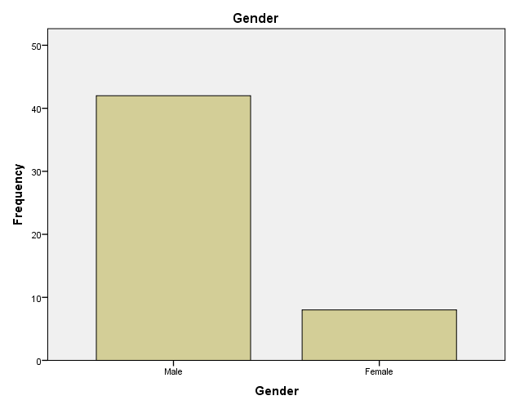
Fig 4.1
Table 4.2
Age
 |  | Frequency | Percent | Valid Percent | Cumulative Percent
Valid | < 20yrs | 4 | 8.0 | 8.0 | 8.0
Valid | 20-30yrs | 13 | 26.0 | 26.0 | 34.0
Valid | 30-40yrs | 28 | 56.0 | 56.0 | 90.0
Valid | 45 and above | 5 | 10.0 | 10.0 | 100.0
Valid | Total | 50 | 100.0 | 100.0
Source: Response of the questionnaire (2025)
Comment: Table 4.2 above shows the frequency and percentage of age distribution of the respondent, it could be seen clearly that workers within the age range of 30-40yrs has the highest frequency and percentage, the bar chart below also illustrated that:.
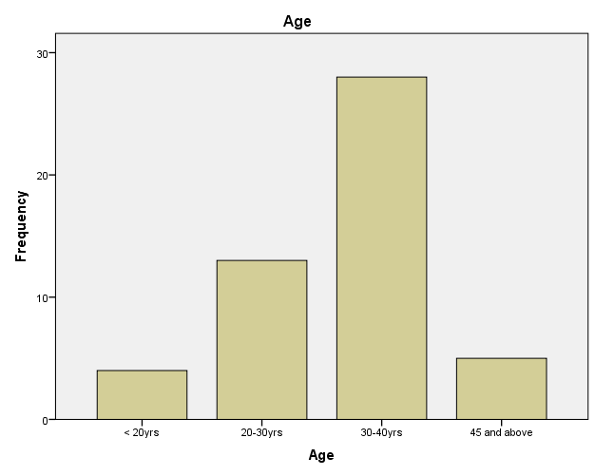
Table 4.3
Marital Status
 |  | Frequency | Percent | Valid Percent | Cumulative Percent
Valid | Single | 37 | 74.0 | 74.0 | 74.0
Valid | Married | 11 | 22.0 | 22.0 | 96.0
Valid | Divorce | 2 | 4.0 | 4.0 | 100.0
Valid | Total | 50 | 100.0 | 100.0
Source: Response of the questionnaire (2023)
Comment: Table 4.3 above shows the frequency and percentage of marital status of the respondent, it could be seen clearly that Single workers at Tuyil Pharmaceutical Industry has the highest frequency and percentage, the bar chart below also illustrated that:.
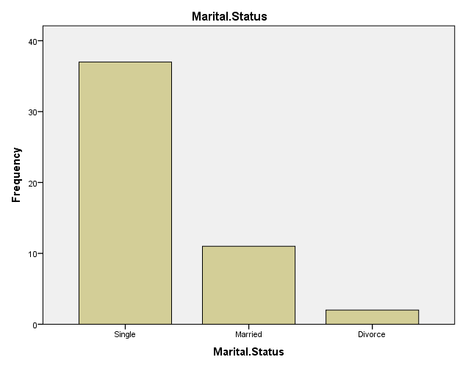
Table 4.4 Educational qualification
 | Frequency | Percentage (%)
WASSCE | 8 | 16
OND/NCE | 13 | 26
HND/B.SC | 25 | 50
M.SC and above | 4 | 8
Total | 50 | 100
Source: Response of the questionnaire (2025)
Comment: Table 4.4 above shows the frequency and percentage of educational qualification of the respondent, it could be seen clearly that workers with HND/BSC qualification has the highest frequency and percentage.

Table 4.5
Religion
 |  | Frequency | Percent | Valid Percent | Cumulative Percent
Valid | Islamic | 39 | 78.0 | 78.0 | 78.0
Valid | Christianity | 11 | 22.0 | 22.0 | 100.0
Valid | Total | 50 | 100.0 | 100.0
Source: Response of the questionnaire (2025)
Comment: Table 4.5 above shows the religion distribution of the respondent, it could be seen clearly that the percentage and frequency of Muslim workers in Tuyil Pharmaceutical Industry are more than Christian workers, the bar chart below also illustrated that:.
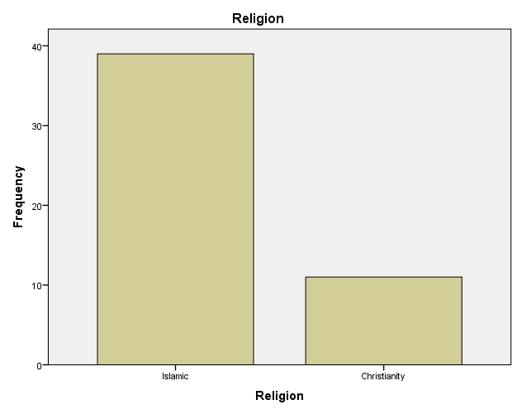

Table 4.6
Your Organization developed written code for business ethics
 |  | Frequency | Percent | Valid Percent | Cumulative Percent
Valid | Agree | 24 | 48.0 | 48.0 | 48.0
Valid | Strongly Agree | 14 | 28.0 | 28.0 | 76.0
Valid | Disagree | 8 | 16.0 | 16.0 | 92.0
Valid | Strongly Disagree | 4 | 8.0 | 8.0 | 100.0
Valid | Total | 50 | 100.0 | 100.0
Source: Response of the questionnaire (2025)
Comment: The table shows that 24, respondent representing 48% agreed that Organization develop written code for ethics, 28% strongly agreed, 8 respondents representing 16% disagreed and 8% disagreed. It is clear and obvious that Tuyil Pharmaceutical Industry, Ilorin developed written code for business ethics. The bar chart below also illustrated that
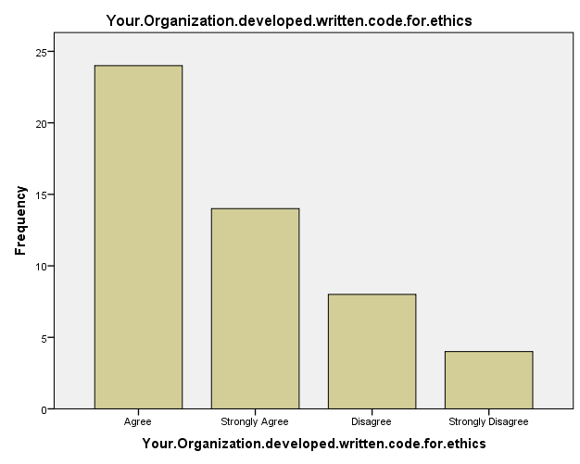

Table 4.7
Your Organization employs a chief ethics officer
 |  | Frequency | Percent | Valid Percent | Cumulative Percent
Valid | Agree | 15 | 30.0 | 30.0 | 30.0
Valid | Strongly Agree | 20 | 40.0 | 40.0 | 70.0
Valid | Disagree | 5 | 10.0 | 10.0 | 80.0
Valid | Strongly Disagree | 10 | 20.0 | 20.0 | 100.0
Valid | Total | 50 | 100.0 | 100.0
Source: Response of the questionnaire (2025)
Comment: The table shows that 20, respondent representing 40% strongly agreed that Organization employ a chief ethics officer, 15% agreed, 10 respondents representing 20% strongly disagreed and 10% disagreed. It is clear and obvious that Tuyil Pharmaceutical Industry, Ilorin employs a chief ethics officer. The bar chart below also illustrated that.
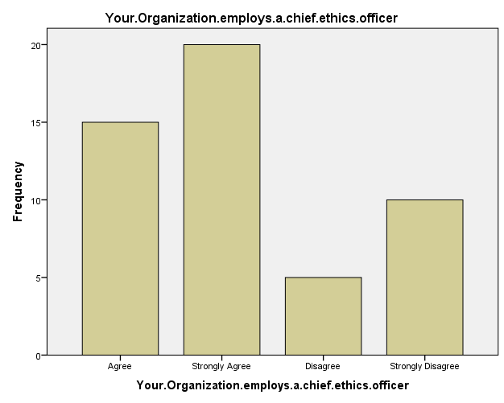

Table 4.8
Your Company code of business ethics are routinely reviewed
 |  | Frequency | Percent | Valid Percent | Cumulative Percent
Valid | Agree | 15 | 30.0 | 30.0 | 30.0
Valid | Strongly Agree | 26 | 52.0 | 52.0 | 82.0
Valid | Disagree | 5 | 10.0 | 10.0 | 92.0
Valid | Strongly Disagree | 4 | 8.0 | 8.0 | 100.0
Valid | Total | 50 | 100.0 | 100.0
Source: Response of the questionnaire (2025)
Comment: The table shows that 26, respondent representing 52% Strongly agreed that Company code of ethics are routinely reviewed, 30% agreed, 4 respondents representing 8% strongly disagreed and 10% disagreed. It is clear and obvious that Company codes of ethics are routinely reviewed in Tuyil Pharmaceutical Industry Ilorin. The bar chart below also illustrated that.
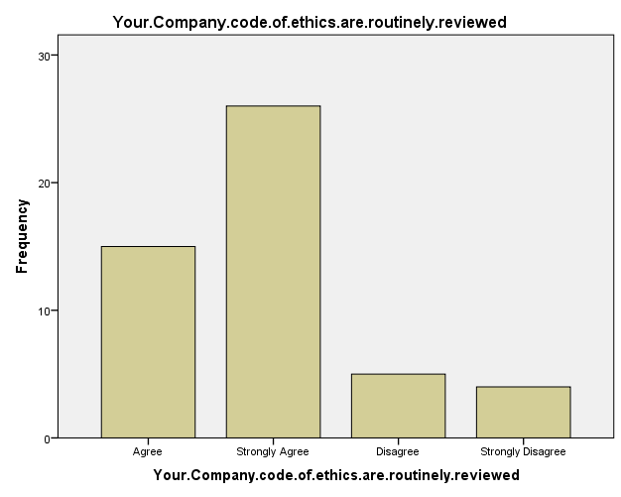

Table 4.9
Taking Disciplinary action when violate code of business ethics
 |  | Frequency | Percent | Valid Percent | Cumulative Percent
Valid | Agree | 27 | 54.0 | 54.0 | 54.0
Valid | Strongly Agree | 12 | 24.0 | 24.0 | 78.0
Valid | Disagree | 4 | 8.0 | 8.0 | 86.0
Valid | Strongly Disagree | 7 | 14.0 | 14.0 | 100.0
Valid | Total | 50 | 100.0 | 100.0
Source: Response of the questionnaire (2025)
Comment: The table shows that 26, respondent representing 52% Strongly agreed that Company code of ethics are routinely reviewed, 30% agreed, 4 respondents representing 8% strongly disagreed and 10% disagreed. It is clear and obvious that Company code of ethics are routinely reviewed in Tuyil Pharmaceutical Industry Ilorin
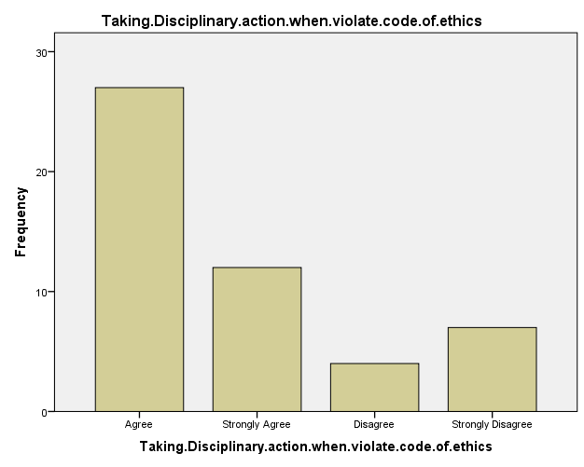
Table 4.10
Ethical behavior is a key component of organization
 |  | Frequency | Percent | Valid Percent | Cumulative Percent
Valid | Agree | 24 | 48.0 | 48.0 | 48.0
Valid | Strongly Agree | 14 | 28.0 | 28.0 | 76.0
Valid | Disagree | 8 | 16.0 | 16.0 | 92.0
Valid | Strongly Disagree | 4 | 8.0 | 8.0 | 100.0
Valid | Total | 50 | 100.0 | 100.0
Source: Response of the questionnaire (2023)
Comment: The table shows that 24, respondent representing 48% agreed that Ethical behavior is a key component of organization, 14% strongly agreed, 4 respondents representing 8% strongly disagreed and 16% disagreed. It is clear and obvious that Ethical behavior is a key component of organization
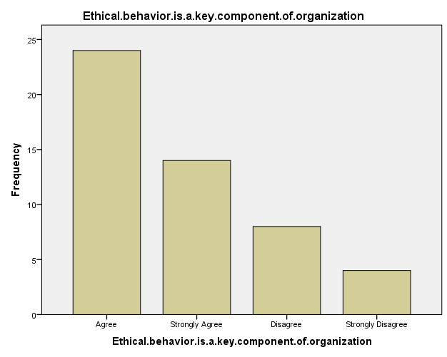
Table 4.11
Ethical behavior is part of criteria for promotion
 |  | Frequency | Percent | Valid Percent | Cumulative Percent
Valid | Agree | 15 | 30.0 | 30.0 | 30.0
Valid | Strongly Agree | 20 | 40.0 | 40.0 | 70.0
Valid | Disagree | 5 | 10.0 | 10.0 | 80.0
Valid | Strongly Disagree | 10 | 20.0 | 20.0 | 100.0
Valid | Total | 50 | 100.0 | 100.0
Source: Response of the questionnaire (2025)
Comment: The table shows that 15, respondent representing 30% agreed that Ethical behavior is part of criteria for promotion, 40% strongly agreed, 10 respondents representing 20% strongly disagreed and 10% disagreed. It is clear and obvious that Ethical behavior is part of criteria for promotion
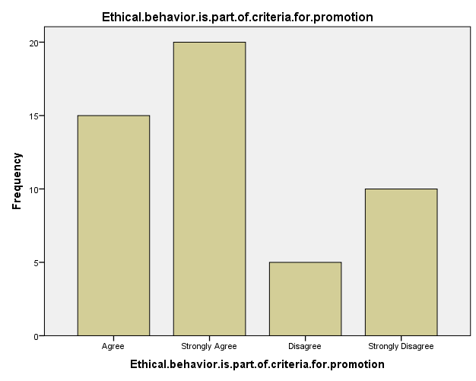

INFERENTIAL STATISTICS USING CHISQUARE TEST
- Chi square Formula
X² = (Fo-Fe)²
Fe
Where
- X² = chi-square
- Fo = observed frequency
- Fe = expected frequency

Question | Fo (Agree) | Fe (Disagree) | Total
Q1 | 5 | 45 | 50
Q2 | 30 | 20 | 50
Q3 | 35 | 15 | 50
Q4 | 45 | 5 | 50
Q5 | 49 | 1 | 50
Q6 | 39 | 11 | 50
Q7 | 35 | 15 | 50
Q8 | 25 | 25 | 50
Q9 | 30 | 20 | 50
Q10 | 30 | 20 | 50
Source: Survey view, 2025
E1, 5 = 323x50 = 32.3
500
E2, 30 = 323x50 = 32.3
500
E3, 35 = 323x50 = 32.3
500
E4, 45 = 323x50 = 32.3
500
E5, 49 = 323x50 = 32.3
500
E6, 39 = 323x50 = 32.3
500
E7, 35 = 323x50 = 32.3
500
E8, 25 = 323x50 = 32.3
500
E9, 30 = 323x50 = 32.3
500
E10, 30 = 323x50 = 32.3
500
E11, 45 = 323x50 = 32.3
500
E12, 20 = 323x50 = 32.3
500
E13, 15 = 323x50 = 32.3
500
E14, 5 = 323x50 = 32.3
500
E15, 1 = 323x50 = 32.3
500
E16, 11 = 323x50 = 32.3
500
E17, 15 = 323x50 = 32.3
500
E18, 25 = 323x50 = 32.3
500
E19, 20 = 323x50 = 32.3
500
E20, 20 = 323x50 = 32.3
500
Fo | Fe | Fo-Fe | (Fo-Fe)² | (Fo-Fe)²  Fe
5 | 32.3 | -27.3 | -745.29 | 23.0739
30 | 32.3 | -2.3 | -5.29 | 0.1638
35 | 32.3 | 2.7 | 7.29 | 0.2256
45 | 32.3 | 12.7 | 161.29 | 4.9934
49 | 32.3 | 16.7 | 278.89 | 8.6343
39 | 32.3 | 6.7 | 44.89 | 1.3897
35 | 32.3 | 2.7 | 7.29 | 0.2256
25 | 32.3 | -7.3 | -53.29 | 1.6498
30 | 32.3 | -2.3 | -5.29 | 0.1696
30 | 32.3 | -2.3 | -5.29 | 0.1638
45 | 18.5 | 12.7 | 161.29 | 8.7183
20 | 18.5 | 1.5 | 2.25 | 0.1216
15 | 18.5 | -3.5 | -12.25 | 0.6621
5 | 18.5 | -13.5 | -182.25 | 9.8513
1 | 18.5 | -17.5 | -306.25 | 16.5361
11 | 18.5 | -7.5 | -56.25 | 3.0405
15 | 18.5 | -3.5 | 12.25 | 0.6621
25 | 18.5 | 6.5 | 42.25 | 8.45
20 | 18.5 | -7.5 | -56.25 | 3.0405
20 | 18.5 | -7.5 | -56.25 | 3.0405
 |  |  |  | 94.8067

Hypothesis testing
First Hypothesis
Hoi: Ethical climate has no significant positive effect on the performance of manufacturing companies in Ilorin.
Not Hoi: Ethical climate has significant positive effect on the performance of manufacturing companies in Ilorin.
Level of Significant: α=0.05
Decision rule: Reject the null Hypothesis if F cal > F table
Conclusion: since F cal > F table (94.8067 > α=0.05), we hereby reject the null hypothesis and conclude that Ethical climate has significant positive effect on the performance of manufacturing companies in Ilorin.

Second Hypothesis
Hoii: Ethical standard does not enhance the performance of manufacturing companies in Ilorin
Not Hoii: Ethical standard enhance the performance of manufacturing companies in Ilorin
Question | Fo (Agree) | Fe (Disagree) | Total
Q1 | 5 | 45 | 50
Q2 | 30 | 20 | 50
Q3 | 35 | 15 | 50
Q4 | 45 | 5 | 50
Q5 | 49 | 1 | 50
Q6 | 39 | 11 | 50
Q7 | 35 | 15 | 50
Q8 | 25 | 25 | 50
Q9 | 30 | 20 | 50
Q10 | 30 | 20 | 50
Source: Survey view, 2025
E1, 5 = 323x50 = 32.3
500
E2, 30 = 323x50 = 32.3
500
E3, 35 = 323x50 = 32.3
500
E4, 45 = 323x50 = 32.3
500
E5, 49 = 323x50 = 32.3
500
E6, 39 = 323x50 = 32.3
500
E7, 35 = 323x50 = 32.3
500
E8, 25 = 323x50 = 32.3
500
E9, 30 = 323x50 = 32.3
500
E10, 30 = 323x50 = 32.3
500
E11, 45 = 323x50 = 32.3
500
E12, 20 = 323x50 = 32.3
500
E13, 15 = 323x50 = 32.3
500
E14, 5 = 323x50 = 32.3
500
E15, 1 = 323x50 = 32.3
500
E16, 11 = 323x50 = 32.3
500
E17, 15 = 323x50 = 32.3
500
E18, 25 = 323x50 = 32.3
500
E19, 20 = 323x50 = 32.3
500
E20, 20 = 323x50 = 32.3
500
Fo | Fe | Fo-Fe | (Fo-Fe)² | (Fo-Fe)²  Fe
5 | 32.3 | -27.3 | -745.29 | 23.0739
30 | 32.3 | -2.3 | -5.29 | 0.1638
35 | 32.3 | 2.7 | 7.29 | 0.2256
45 | 32.3 | 12.7 | 161.29 | 4.9934
49 | 32.3 | 16.7 | 278.89 | 8.6343
39 | 32.3 | 6.7 | 44.89 | 1.3897
35 | 32.3 | 2.7 | 7.29 | 0.2256
25 | 32.3 | -7.3 | -53.29 | 1.6498
30 | 32.3 | -2.3 | -5.29 | 0.1696
30 | 32.3 | -2.3 | -5.29 | 0.1638
45 | 18.5 | 12.7 | 161.29 | 8.7183
20 | 18.5 | 1.5 | 2.25 | 0.1216
15 | 18.5 | -3.5 | -12.25 | 0.6621
5 | 18.5 | -13.5 | -182.25 | 9.8513
1 | 18.5 | -17.5 | -306.25 | 16.5361
11 | 18.5 | -7.5 | -56.25 | 3.0405
15 | 18.5 | -3.5 | 12.25 | 0.6621
25 | 18.5 | 6.5 | 42.25 | 8.45
20 | 18.5 | -7.5 | -56.25 | 3.0405
20 | 18.5 | -7.5 | -56.25 | 3.0405
 |  |  |  | 94.8067

Conclusion: since F cal > F table (94.8067 > α=0.05), we hereby reject the null hypothesis and conclude that Ethical standard enhance the performance of manufacturing companies in Ilorin
Third Hypothesis
Hoiii: Ethical culture has no significant positive effect on performance of Tuyil manufacturing company in Ilorin
Not Hoiii: ethical culture has significant positive effect on performance of of Tuyil manufacturing company in Ilorin

Question | Fo (Agree) | Fe (Disagree) | Total
Q1 | 5 | 45 | 50
Q2 | 30 | 20 | 50
Q3 | 35 | 15 | 50
Q4 | 45 | 5 | 50
Q5 | 49 | 1 | 50
Q6 | 39 | 11 | 50
Q7 | 35 | 15 | 50
Q8 | 25 | 25 | 50
Q9 | 30 | 20 | 50
Q10 | 30 | 20 | 50
Source: Survey view, 2025
E1, 5 = 323x50 = 32.3
500
E2, 30 = 323x50 = 32.3
500
E3, 35 = 323x50 = 32.3
500
E4, 45 = 323x50 = 32.3
500
E5, 49 = 323x50 = 32.3
500
E6, 39 = 323x50 = 32.3
500
E7, 35 = 323x50 = 32.3
500
E8, 25 = 323x50 = 32.3
500
E9, 30 = 323x50 = 32.3
500
E10, 30 = 323x50 = 32.3
500
E11, 45 = 323x50 = 32.3
500
E12, 20 = 323x50 = 32.3
500
E13, 15 = 323x50 = 32.3
500
E14, 5 = 323x50 = 32.3
500
E15, 1 = 323x50 = 32.3
500
E16, 11 = 323x50 = 32.3
500
E17, 15 = 323x50 = 32.3
500
E18, 25 = 323x50 = 32.3
500
E19, 20 = 323x50 = 32.3
500
E20, 20 = 323x50 = 32.3
500
Fo | Fe | Fo-Fe | (Fo-Fe)² | (Fo-Fe)²  Fe
5 | 32.3 | -27.3 | -745.29 | 23.0739
30 | 32.3 | -2.3 | -5.29 | 0.1638
35 | 32.3 | 2.7 | 7.29 | 0.2256
45 | 32.3 | 12.7 | 161.29 | 4.9934
49 | 32.3 | 16.7 | 278.89 | 8.6343
39 | 32.3 | 6.7 | 44.89 | 1.3897
35 | 32.3 | 2.7 | 7.29 | 0.2256
25 | 32.3 | -7.3 | -53.29 | 1.6498
30 | 32.3 | -2.3 | -5.29 | 0.1696
30 | 32.3 | -2.3 | -5.29 | 0.1638
45 | 18.5 | 12.7 | 161.29 | 8.7183
20 | 18.5 | 1.5 | 2.25 | 0.1216
15 | 18.5 | -3.5 | -12.25 | 0.6621
5 | 18.5 | -13.5 | -182.25 | 9.8513
1 | 18.5 | -17.5 | -306.25 | 16.5361
11 | 18.5 | -7.5 | -56.25 | 3.0405
15 | 18.5 | -3.5 | 12.25 | 0.6621
25 | 18.5 | 6.5 | 42.25 | 8.45
20 | 18.5 | -7.5 | -56.25 | 3.0405
20 | 18.5 | -7.5 | -56.25 | 3.0405
 |  |  |  | 94.8067

Conclusion: since F cal > F table (94.8067 > α=0.05), we hereby reject the null hypothesis and conclude that ethical culture has significant positive effect on performance of of Tuyil manufacturing company in Ilorin

Discussion of findings
The analysis reveals that codes of ethics are routinely reviewed in Tuyil Pharmaceutical Industry Ilorin, also they agreed that Ethical behavior is a key component of organization and It is clear and obvious that Tuyil Pharmaceutical Industry, Ilorin developed written code for business ethics. Based on the Hypothesis, Ethical standard enhance the performance of manufacturing companies in Ilorin. The hypothesis result reveal Ethical climate has significant positive effect on the performance of manufacturing companies in Ilorin, Ethical standard enhance the performance of manufacturing companies in Ilorin and lastly ethical culture has significant positive effect on performance of of Tuyil manufacturing company in Ilorin.

CHAPTER FIVE
5.0 SUMMARY OF FINDINGS, CONCLUSION AND RECOMMENDATION
5.1 SUMMARY OF FINDINGS
This research work has source dealt extensively with, to the IMPACT OF BUSINESS ETHICS ON ORGANIZATIONAL PERFORMANCE; with a specific reference, to TUYIL PHARMACEUTICAL INDUSTRY, ILORIN. In the course of the study, it was found out that management, decision cannot be effective without authority can also enhance organization harmony, peace and stability coupled with this is that delegation of authority can boost the morale of the employees with that, organization can achieve affecting their performance positively. It was also found that many employees will like to spend more time, then actually at work in their suggestion are put into consideration in their various departments and organizations as a whole. Also, majority of the employee (respondents) were of the view like absenteeism, truancy etc. to the barest minimum in their departments.
Furthermore, superior employee (respondents) were of the view that they would like to delegate executive functions of the creative and innovation subordinates as well as delegating authority of their subordinates on areas that are mostly affecting their jobs and also organization that delegates successfully get much k work done others that do not delegate to its employees.
5.2 CONCLUSION
Finally, from foregoing, analysis of the findings, Ethical behavior has significant effect on manufacturing organization’ performance in Nigeria. While unethical standard practices had no significant impact on manufacturing organization’ performance in south-East Nigeria. Therefore the study concludes that business ethic had a positive significant effect on organizational performance.

5.3 RECOMMENDATION
In line with the findings of the study the following recommendations are made: 1. Decision makers should set use of ethical conducts as priority towards improving organization performance by set adequate resources and commitment to achieve this ends.
2. Manufacturing sector should have a workable system for identifying and resolving ethics problems. Such a system must be open, accessible and independent of the management bureaucracy and encourage whistle-blowing
3. Since the study established a significant positive association between culture and performance of manufacturing organization, managers should always pay attention to the ethical culture of their organization and ensure that all the activities and operations of the business are within the regiment of her ethical culture.
REFERENCES

Akanwa, P.U. and C.N. Agu, (2015). Business ethics and social responsibilities. In P. U. Akanwa, and C. N. Agu (Eds), entrepreneurship theory and practice in Nigeria. Owerri: Resource Development Centre, pp: 93 – 109.
Amadi, B., (2018). Listed companies henceforth must publish sustainability report – NSE. Westafrica Businesses, 5(270): 15.
Asika, N., (2019). Models and model building In research. In N. Asika (Ed), research methodology: A process approach. Lagos: Mukugamu & Brothers Enterprises. pp: 40 – 42.
Aupperle, K.E., A.B. Carroll and J.D. Hatfield, (2017). An empirical examination of the relationship between corporate social responsibility and profitability. Academy of Management Journal, 28(2): 446-463.Available at: https://doi.org/10.2307/256210.
Azorín, J.M. and R. Cameron, (2016). The application of mixed methods in organizational research: A literature review. Electronic Journal of Business Research Methods, 8(2): 95-105.
Blaga, S., (2015). Rethinking business sustainability. Review of Economics Studies and Research, 6(1): 5 – 12.
Cleary, R., (2018). Models as effective research tools. In D. M. Cavanagh and G. M. Rodwell (Eds), Dislogues in educational research. Darwin, NT: William Michael Press.
Cresswell, J., (2019). Research design: Qualitative, quantitative and mixed methods approaches. London: Sage Publication.
Dolf, M.C., (2017). Ethics and integrity awareness programme. Lagos: First Bank of Nigeria Plc.
Eccles, R., I. Ioannou and G. Serafeim, (2019). The impact of corporate culture of sustainability on corporate behavior and performance. Harvard Business School Working Paper No 12 – 033.
Edmondson, A. and S. McManus, (2017). Methodological fit in management field research. Academy of Management Review, 32(4): 1155 – 1179.
Ezeh, C., (2019). There is hardly an ideal board chairman. Saturday Sun, 16(842): 48.
Ezejelue, A., E.O. Ogwo and A. Nkeminebe, (2018). Basic principles in managing research projects. 2nd Edn., Port Harcourt: Education Books Ltd.
Friedman, M., (2017). A friedman doctrine: The social responsibility of business is to increase its profits. The New York Times Magazine, 13(33): 32-33.

