IMPACT OF EMPLOYEES’ COMMITMENT ON ORGANIZATION PERFORMANCE: A CASE OF ILORIN WEST LGA

ABSTRACT
This study aimed to assess the contribution of employees’ commitment on organization performance: a case study of ilorin West local government ., Ilorin. The study was conducted in Ilorin. The study was guided by the following specific questions (i) What are the influence of job security on employees’ commitment? (ii) What are the effects of employees’ motivation on organization performance? (iii) What could between relationship between employee satisfaction and organization performance? (iv) What might be the relationship between absenteeism and organization performance? In order to answer these questions several methods of data collection were used like questionnaires, focus group discussion and interview. The study revealed that there are influences of job security on employees’ commitment. The most identified influences were career stability by 31%, this was due to the fact that when the employees are assured of their position they will be able to work effectively and meet the organization requirements. Other influences identified were improvement of performance, family commitment and financial security. More so, about 96.5% (n=100) of respondents declared that job satisfaction is a critical factor to the overall productivity of the organization. Respondents pointed out that there is a positive correlation between employee’s job satisfaction and overall productivity of the organization. Therefore the study recommends that in order to attain efficiency and effective organisation performance employers should focus on reducing job dissatisfaction (working conditions, salary, supervision, relationship with colleagues), while on the other hand should use motivating factors such as achievement, recognition, responsibility and the work itself.

TABLE OF CONTENTS
CERTIFICATION ............................................................................................................ ii
COPYRIGHT ................................................................................................................... iii
DECLARATION .............................................................................................................. iv
DEDICATION ................................................................................................................... v
ACKNOWLEDGEMENT ............................................................................................... vi
ABSTRACT ..................................................................................................................... vii
TABLE OF CONTENTS ............................................................................................... viii
LIST OF TABLE ........................................................................................................... xiii
LIST OF FIGURE ......................................................................................................... xiv
LIST OF ABBREVIATIONS ........................................................................................ xv
CHAPTER ONE ............................................................................................................... 1
1.0 INTRODUCTION .................................................................................................. 1 1.1 Background to the study ...................................................................................... 1
1.2 Statement to the Research Problem ......................................................................... 4
1.3 Research Questions .................................................................................................. 5
1.4 Objectives to the Study ............................................................................................ 5
1.5 Research Hypothesis ......................................................................................... 5
1.6 Significance of the Study ......................................................................................... 5
1.7 Scope of the Study ................................................................................................... 6
CHAPTER TWO .............................................................................................................. 7
2.0 LITERATURE REVIEW ......................................................................................... 7
2.1 Introduction .............................................................................................................. 7
2.2 Conceptual definitions ............................................................................................. 7
2.2.1 Employee Performance ............................................................................................ 7
2.2.2 Organization ............................................................................................................. 7
2.2.3 Employee commitment ............................................................................................ 7 2.3 Theoretical literature Review ................................................................................... 8
2.3.1 Expectancy Theory of Motivation ........................................................................... 8
2.3.2 Labor Theory of Value ............................................................................................. 9
2.3.3 Adams’ Equity Theory ........................................................................................... 10 2.4 Model of commitment ............................................................................................ 11
2.4.1 Affective commitment dimension .......................................................................... 11
2.4.2 Continuance commitment dimension ..................................................................... 12
2.4.3 Normative commitment dimension ........................................................................ 14
2.5 Empirical literature review ..................................................................................... 15
2.5.1 Empirical literature review in the World ............................................................... 15
2.5.2 Empirical literature review in Africa ..................................................................... 18
2.7 Theoretical framework ............................................................................................. 23

CHAPTER THREE
3.0 METHODOLOGY ............................................................................ 24
3.1 Introduction .......................................................................................... 24
3.2 Research Design ..................................................................................... 24
3.3 Study area selection and criteria ............................................................................ 24
3.4 Population of the study .......................................................................................... 25
3.5 Sampling design ..................................................................................................... 25
3.6 Sample size............................................................................................................. 26
3.6 Data Collection Methods........................................................................................ 27
3.6.1 Secondary data (documentary review) ................................................................... 27
3.6.2 Primary Data .......................................................................................................... 27
3.7 Data collection tools ............................................................................................... 28
3.7.1 Questionnaire survey .............................................................................................. 28
3.7.1.1 Training of Research Assistants ............................................................................ 28
3.7.1.2 Questionnaire pre-testing ...................................................................................... 28 3.7.1.3 Administration of the questionnaires .................................................................... 29
3.7.2 Key informants interview .....................................................................................
3.9 Data Analysis ......................................................................................................... 30
3.10 Historical background of case study......................................................................... 30
CHAPTER FOUR ........................................................................................................... 32
4.0 RESULTS AND DISCUSSION ............................................................................... 32
4.1 Introduction ............................................................................................................ 32
4.2 Demographic Characteristics of Respondents ....................................................... 32
4.3 The Influence of Job Security on Employees’ Commitment ................................ 33
4.3.1 Career stability ....................................................................................................... 35
4.3.2 Improve performance ............................................................................................. 36
4.3.3 Family Commitment .............................................................................................. 37
4.3.4 Financial security ................................................................................................... 39
4.4 The Effects of Employees’ Motivation on Organization Performance .................. 39
4.5 Relationship between employee satisfaction and organization performance ........ 42
4.5.1 Employees Job satisfaction .................................................................................... 43
4.5.2 Findings from Ilorin West Local GovtMunicipal Director
............................................................. 44
4.5.3 Relationship between employee and organization ................................................. 45
4.5.4 Employee Satisfaction and Organizational Performance ....................................... 46
4.5.5 Organisational performance ................................................................................... 46
4.6 Relationship between absenteeism and organization performance ........................ 48
4.6.1 Consequences of absenteeism to individual ........................................................... 48
4.6.2 Consequences of absenteeism to co-worker .......................................................... 50
4.6.3 Consequences absenteeism to an organization ...................................................... 50
CHAPTER FIVE ............................................................................................................. 56

5.0 SUMMARY OF THE FINDINGS, CONCLUSION AND
RECOMMENDATIONS .................................................................................... 56
5.1 Introduction ............................................................................................................ 56
5.2 Summary of the Findings ....................................................................................... 56
5.3 Implication of the Study ......................................................................................... 57
5.4 Conclusion ............................................................................................................. 57
5.5 Recommendations .................................................................................................. 58
5.6 Limitation of the Study .......................................................................................... 59
5.6.1 Time constraint........................................................................................................ 59
5.6.2 Financial constraint ................................................................................................ 59
5.7 Areas for future research ........................................................................................ 60 REFERENCE .................................................................................................................. 61

APPENDICES ................................................................................................................. 66 LIST OF TABLE
Table 3.1 : Distribution of respondents and instruments employed in the study ..................... 27
Table 4.1 : Demographic Characteristics of Respondents ..................................................... 33
Table 4.2 : Chi-square test for the Influence of Job Security on Employees’
Commitment ....................................................................................................... 35
Table 4.3 : Chi-square test for the effects of employees’ motivation on organization
performance ........................................................................................................ 41
Table 4.4 : Respondents perception on employee satisfaction and organization p
erformance .......................................................................................................... 43
Table 4.5 : Consequences of absenteeism on organization performance ............................... 48
Table 4.6 : Consequences of Absenteeism ............................................................................ 53 LIST OF FIGURE
Figure 2.1 : Conceptual Framework ..................................................................................... 22
Figure 4.1 : Influence of Job Security on Employees’ Commitment ..................................... 34
Figure 4.2 : Job security improving Employee Performance................................................. 37 Figure 4.3 : Job security improving employee commitment to the family .............................. 38
Figure 4.4 : Effects of employees’ motivation on organization performance ......................... 40 LIST OF ABBREVIATIONS
ACC | Ilorin West Local GovtCity Council
FGD | Focus Group Discussion
HRM | Human Resources Management
LTV | Labor Theories of Value
SPSS | Statistical Package for Social sciences

CHAPTER ONE
1.0 INTRODUCTION

1.1 Background to the study
In today’s competitive world every organization is facing new challenges regarding sustained productivity and creating committed workforce (Addae, and Wang, 2006). Nowaday’s no organization can perform at peak levels unless each employee is committed to the organizations objectives. Hence, it is important to understand the concept of commitment and its feasible outcome. Commitment according to Armstrong-Stassen (gf2004) is not only a human relation concept but also involves generating human energy and activating human mind. Without commitment, the implementation of new ideas and initiatives will be compromised (Bakker, et al., 2003; ArmstrongStassen, 2004; Becker, 2009).
Human resource system can facilitate the development or organisational competencies through eliciting employees’ commitment to the firm (Chan, 2002; Bridger, et al., 2007). Hence organisations with a fit business strategy, structure and practices and policy might perform better. Cohen, (2007) prescribes “commitment” as a distinctive strategy for HRM whose positive effect will be felt. Human resource management is considered the backbone of all businesses. To improve the performance, organizations are trying to improve the performance of human capital. According to Daigle, (2007) there is lot of pressure on the management of the organization to turn into a friendlier one. Epitropaki, and Martin, (2005) and Gagné, et al., (2008) have found that the sense of employees’ obligation to organization become more positive when flexible time scheduling is being adopted by the organization.
It is necessary for every organization to have full level of its employee commitment in order to have outstanding performance on long term basis (Galais, and Moser, 2009).
In sub Sahara Africa employee satisfaction and organizational commitment are the causing factors of the low productivity of many companies (Galais, and Moser, 2009). Also according to Gellatly, et al., (2006) there was significant and positive relation between employee job satisfactions to the employee performance. And also Glazer and Kruse, 2008) showed that job satisfaction influence positively to the employee achievement. Where there is a high level of employee commitment, there will be low turnover and that employee will perform better with less absenteeism (Klein, et al., 2009).There is certain things that really affect employee commitment like: work load, less acknowledgement and less compensation. Dorgan (1994) defines commitment as the enhanced functional and operational performance, including quality as the main principal.
In Tanzania, Lambert, et al., (2008) examined facts of a positive correlation between organizational commitment and job performance. Low commitment has also been associated with low levels of morale. Non-committed employees may depict the organization in negative terms to outsiders thereby inhibiting the organization’s ability to recruit high-quality employees and decreased measures of altruism and compliance . Moreover, low commitment leads to high turnover and higher commitment leads to performance (Meyer, 2009; Meyer, and Parfyonova, 2010). In addition, job security enhances the level of commitment (Parfyonova, 2009).
Highly committed employee should have a weak intention to quit. Studies by Zickar, et al., (2004) and Vandenberghe, (2009) revealed a negative relationship between turnover intentions and organizational commitment. Whitener, (2001) have uncovered a positive relationship between commitment and job performance. Employees who are committed to their respective organization are more likely not only to remain with the organization but are also likely to exert more efforts on behalf of the organization and work towards its success and therefore are also likely to exhibit better performance that the uncommitted employees. Employee commitment can benefit organization in a number of ways such as it can improve performance; reduced absenteeism, and turnover thereby resulting in sustained productivity. Commitment to organization is positively related to such desirable outcomes as motivation and is negatively related to outcome as absenteeism and turnover (Grawitch, et al., 2007).). Employees with high level of organizational commitment provide a secure and stable workforce (Lambert, et al., 2008) and thus providing competitive advantage to the
organization.
The committed employee has been found to be more creative; they are less likely to leave an organization than those who are uncommitted .According to Arturo (2004) Sustained productivity improvement depends on the enterprise’s human capital (the skills, knowledge, competencies and attitudes that reside in the individual employee of the enterprise) and its social capital (trust and confidence, communication, cooperative working dynamics and interaction, partnership, shared values, teamwork, etc. among these individuals. A committed employee is perceived to be one who stays with the organization even in turbulent times, attends work regularly, protects company’s assets and shares company’s goal (Meyer and Allen, 1997).Therefore it is evident that for sustained productivity, employee commitment is an important factor.

1.2 Statement to the Research Problem
High labor turnover, absenteeism, poor motivation and low performance are some of the feature of employees’ low commitment in the organizations (Grawitch, et al., 2007).). Several academic researches on human resource management practices suggested that high commitment human resource practices increase organizational effectiveness by creating a condition whereby employees become highly motivated and involved in the organizational activities aimed at achieving organizational goals (Grawitch, et al., 2007; Meyer, 2009; Meyer, and Parfyonova, 2010). In sub Saharan Africa, commitment affect the personal life of employees which results in low performance of employees (Meyer, and Parfyonova, 2010). Aminah (2008) said that work and family conflict is inversely linked to employees’ performance. It is examined that work and family conflict decreases employee satisfaction, increases employees stress and decreases performance.
Moreover, recent studies have shown that high commitment practices can work well synergistically and a reflective of a general commitment strategy (Gagné, et al., 2008). Furtherm-ore, high commitment work practices do improve performance, labour productivity and the quality of service (Meyer, 2009). Despite a variety of studies into employees' performance on organizational, the majority of previous studies have focused on employee’s satisfaction to organization performance, very little is known about the contribution of employees’ commitment for either individuals or organizations performance, this is the focus of this study.

1.3 Research Questions
- What are the influence of job security on employees’ commitment?
- What are the effects of employees’ motivation on organization performance?
- What could be the relationship between employee satisfaction and organization performance? iv. What might be the relationship between absenteeism and organization performance?

1.4 Objectives to the Study
i. To identify the influence of job security on employees’ commitment ii. To explore the effects of employees’ motivation on organization performance iii. To examine the relationship between employee satisfaction and organization performance iv. To assess the relationship between absenteeism and organization performance
1.5 Research Hypotheses
1. H0: Job security does not have influence on employees’ commitment

1.6 Significance of the Study
The study will reveal and create awareness to the employees and employers on the importance of strengthening cooperation among the two. Again the study will show the extent to which employees’ commitment on organization improves the performance of the organization hence sustained productivity. Further, the study will also help to formulate the good guiding principles which could be used by organizations to improve relationship between employer and employees. Finally, the study will contribute to the existing literature and knowledge on holistic approach and conditions needed for employers to support their employees hence successful of the organization.

1.7 Scope of the Study
This study will examine the reason for employees’ commitment in the organization. Again the study will focus on the challenges of attaining sustainable productivity in Ilorin West Local Government. Also the study will identify the relationship between employee behavior and organization performance. Finally the study will recognize the influence of organization on inspiring employees’ performance.

CHAPTER TWO 2.0 LITERATURE REVIEW

2.1 Introduction
This chapter provides a critical look at existing research that is significant to this study. The subsection includes Conceptual definitions, Theoretical literature Review, Empirical literature review, Research Gap and lastly Conceptual Framework. The detail follows;

2.2 Conceptual Definitions q2.2.1Employee Performance
Employee Performance is defined as the attained outcome of actions with the skills of employees who perform in some situation (Prasetya & Kato, 2011). According to (Suhartini, 1995), employee performance is a mutual result of effort, ability, and perception of tasks.

2.2.2 Organization
An organization is a social unit, such as an institution or an association that has a collective goal and is linked to an external environment (Neubert and Wu, 2009).

2.2.3 Employee commitment
Employee commitment refers to the degree or extent to which workers of a given organization are bound both intellectually and emotionally to the organization. Employee commitment often stems from personal satisfaction (Armstrong-Stassen, 2004).

2.3 Theoretical literature Review
This section presents theories that are relevant to this study. This sub-section is divided into three theories. The first theory is the Expectancy Theory of Motivation which provides an explanation of why individuals choose one behavioral option over others. The second theory is about Labor Theory of Value and the third theory is Adams’ Equity Theory which attempt to explain the satisfaction that derives from the fairness and equality that a manager brings to his/her employees.

2.3.1 Expectancy Theory of Motivation
The Expectancy Theory of Motivation is best described as a process theory. It provides an explanation of why individuals choose one behavioral option over others. "The basic idea behind the theory is that people will be motivated because they believe that their decision will lead to their desired outcome" (Redmond, 2009). "Expectancy theory proposes that work motivation is dependent upon the perceived association between performance and outcomes and individuals modify their behavior based on their calculation of anticipated outcomes" (Chen & Fang, 2008). This has a practical and positive benefit of improving motivation because it can, and has, helped leaders create motivational programs in the workplace.
"This theory is built upon the idea that motivation comes from a person believing they will get what they want in the form of performance or rewards. Although the theory is not "all inclusive" of individual motivation factors, it provides leaders with a foundation on which to build a better understanding of ways to motivate subordinates" (AETC, 2008). Expectancy theory is classified as a process theory of motivation because it emphasizes individual perceptions of the environment and subsequent interactions arising as a consequence of personal expectations.
The theory states that individuals have different sets of goals and can be motivated if they believe that: There is a positive correlation between efforts and performance, Favorable performance will result in a desirable reward, and the reward will satisfy an important need.

2.3.2 Labor Theory of Value
The labor theories of value (LTV) are heterodox economic theory of value that argue the value of commodity is only related to the labor needed to produce or obtain that commodity and not to other factors of production (except as those elements can be regarded as embodied labor.) Presently the concept is most often associated with Marxian economics, although it appears as a foundation to earlier classical economic theorists.
When speaking in terms of a labor theory of value, without any qualifying adjective should theoretically refer to the amount of labor necessary to the production of a marketable commodity, including the labor necessary to the development of any real capital employed in the production. Both David Ricardo and Karl Marx attempted to quantify and embody all labor components in order to set the real price, or natural price of a commodity. The labor theory of value, as presented by Adam Smith, however, did not require the quantification of all past labor, nor did it deal with the labor needed to create the tools (capital) that might be employed in the production of a commodity. The Smith theory of value was very similar to the later utility theories in that Smith proclaimed that a commodity was worth whatever labor it would command in others (value in trade) or whatever labor it would "save" the self (value in use), or both. But this "value" is subject to supply and demand at a particular time.

2.3.3 Adams’ Equity Theory
Equity theory was first developed in 1962 by John Stacey Adams. It attempts to explain the satisfaction that derives from the fairness and equality that a manager brings to his/her employees. Equity theory places value on fair treatment, which is believed to be the major motivational factor among employees.
An individual will consider that he is treated fairly when he feels that the ‘ratio of his inputs to his outcomes’ is the same to other people around him. In this case, it would be acceptable for an employee who has much more work experience and who is a more senior colleague to receive higher compensation/salary for his/her job. On the other hand, if an employee feels that another individual who has the same qualifications and provides the same amount of efforts is earning more recognition or compensation, he will feel he’s treated unfairly and thus perform at a lower level on his tasks.
An employee who feels he is over-compensated may increase his effort. However, he may also change the perceptions of his inputs and feel a sense of superiority, which may lead to him decreasing his efforts instead.
Adam’s Equity theory reminds us that people are hugely concerned of the way they are treated in their surrounding environment, team and system. For this reason, they must be managed, controlled and treated fairly.

2.4 Model of Commitment

2.4.1 Affective commitment dimension
This represents the individual’s emotional attachment to the organization. According to Meyer and Allen (1997, p 11) affective commitment is “the employee’s emotional attachment to, identification with, and involvement in the organization”. Organizational members, who are committed to an organization on an affective basis, continue working for the organization because they want to (Meyer & Allen, 1991). Members who are committed on an affective level stay with the organization because they view their personal employment relationship as congruent to the goals and values of the organization (Beck & Wilson, 2000).
Affective commitment is a work related attitude with positive feelings towards the organization (Morrow, 1993). Sheldon (1971) also maintains that this type of attitude is “an orientation towards the organization, which links or attaches the identity of the person to the organization”. Affective commitment is the relative strength of an individual's identification with and involvement in a particular organization (Mowday et al, 1982).
The strength of affective organizational commitment is influenced by the extent to which the individual's needs and expectations about the organization are matched by their actual experience
(Storey, 1995). Tetrick (1995) also describes affective commitment as “value rationality-based organizational commitment, which refers to the degree of value congruence between an organizational member and an organization”.
The organizational commitment model of Meyer and Allen (1997) indicates that affective commitment is influenced by factors such as job challenge, role clarity, goal clarity, and goal difficulty, receptiveness by management, peer cohesion, equity, personal importance, feedback, participation, and dependability.
Affective commitment development involves identification and internalization (Beck & Wilson, 2000). Individuals’ affective attachment to their organizations is firstly based on identification with the desire to establish a rewarding relationship with an organization. Secondly, through internalization, this refers to congruent goals and values held by individuals and the organization. In general, affective organizational commitment is concerned with the extent to which an individual identifies with the organization (Allen & Meyer, 1990).

2.4.2 Continuance commitment dimension
The second dimension of the tri-dimensional model of organizational commitment is continuance commitment. Meyer and Allen (1997) define continuance commitment as “awareness of the costs associated with leaving the organization”. It is calculative in nature because of the individual’s perception or weighing of costs and risks associated with leaving the current organization (Meyer & Allen, 1997). Meyer and Allen (1991, p 67) further state that “employees whose primary link to the organization is based on continuance commitment remain because they need to do so”. This indicates the difference between continuance and affective commitment. The latter entails that individual’s stay in the organization because they want to.
Continuance commitment can be regarded as an instrumental attachment to the organization, where the individual's association with the organization is based on an assessment of economic benefits gained (Beck & Wilson, 2000). Organizational members develop commitment to an organization because of the positive extrinsic rewards obtained through the effort-bargain without identifying with the organization’s goals and values.
The strength of continuance commitment, which implies the need to stay, is determined by the perceived costs of leaving the organization (Meyer & Allen, 1984). Best (1994, p 71) indicates that
“continuance organizational commitment will therefore be the strongest when availability of alternatives are few and the number of investments are high”. This argument supports the view that when given better alternatives, employees may leave the organization.
Meyer et al (1990) also maintain that "accrued investments and poor employment alternatives tend to force individuals to maintain their line of action and are responsible for these individuals being committed because they need to". This implies that individuals stay in the organization, because they are lured by other accumulated investments which they could lose, such as pension plans, seniority or organization specific skills.
The need to stay is “profit” associated with continued participation and termination of service is a
“cost” associated with leaving. Tetrick (1995) support the profit notion by describing the concept continuance organizational commitment as “an exchange framework, whereby performance and loyalty are offered in return for material benefits and rewards”. Therefore, in order to retain employees who are continuance committed, the organization needs to give more attention and recognition to those elements that boost the employee’s morale to be affectively committed.

2.4.3 Normative commitment dimension
The last dimension of the organizational commitment model is normative commitment. Meyer and
Allen (1997) define normative commitment as “a feeling of obligation to continue employment”. Internalized normative beliefs of duty and obligation make individuals obliged to sustain membership in the organization (Allen & Meyer, 1990). According to Meyer and Allen (1991) “employees with normative commitment feel that they ought to remain with the organization”. In terms of the normative dimension, the employees stay because they should do so or it is the proper thing to do.
Wiener and Vardi (1980) describe normative commitment as “the work behavior of individuals, guided by a sense of duty, obligation and loyalty towards the organization”. Organizational members are committed to an organization based on moral reasons (Iverson & Buttigieg, 1999). The normative committed employee considers it morally right to stay in the organization, regardless of how much status enhancement or satisfaction the organization gives him or her over the years.
The strength of normative organizational commitment is influenced by accepted rules about reciprocal obligation between the organization and its members (Suliman & Iles, 2000). The reciprocal obligation is based on the social exchange theory, which suggests that a person receiving a benefit is under a strong normative obligation or rule to repay the benefit in some way (McDonald & Makin, 2000). This implies that individuals often feel an obligation to repay the organization for investing in them, for example through training and development.
Meyer and Allen (1991, p 88) argue that “this moral obligation arises either through the process of socialization within the society or the organization”. In either case it is based on a norm of reciprocity, in other words if the employee receives a benefit, it places him or her, or the organization under the moral obligation to respond in kindness.

2.5 Empirical Literature Review
This subsection provides a critical look at existing research that is significant to this study. The subsection includes Empirical literature review in the World. Empirical literature review in Africa and the empirical literature review in Tanzania. The details is as follows;-

2.5.1 Empirical literature review in the World
Performance is defined as the attained outcome of actions with the skills of employees who perform in some situation (Prasetya& Kato, 2011). According to (Suhartini, 1995), employee performance is a mutual result of effort, ability, and perception of tasks. Good performance is step towards the achievement of organizational aims. Hence more struggles are required to improve the organizational performance. Dharma (1991) said that performance is something that is done, or products formed and offered by a group of people. Swasto (1996) said that employee performance is the actions or the completion of errands that were done by individuals within specific period of time. Employee proficiency is usually supervised by using formal procedures such as: manager rating, evaluation with organizational objectives and peers assessment to make sure that employees are working for the development of the company.
According to Cummings and Schwab (1973), employer must prioritize the organizational objectives over his personal objectives. Bass & Avolio (1997) said that the individual and organizational performance is greatly affected by the efficient participation of leadership. Organizational success depends on active utilization of human resources. Employees are the assets of an organization. At another place Wall, Solam and Sobal; and Maritz (1995) remarks that valued organizations need efficient leaders.
According to Fiedler and House (1988); Maritz (1995), successful leadership helps in accomplishment of employees’ need which results in active performance. Kotler (1988) claims that growing significance of leadership in organizations is due to changes in business environment such as change in competitive forces and the desire for more involvement of total workforce. Cummings and Schwab (1973), claims that leadership is the most significant factor for judging the employee performance.
According to Maritz (1995) and Bass and Avolio (1997) leadership is the most significant factor for examining the employee performance. For an organization to be outstanding, it need to have an outstanding leadership and provides as a model for growing organizations. Jones and George (2000) notes that leaders are efficient when they influence their subordinates by effectively achieving the organizational objectives. According to Bass and Avolio (1997) leadership is the most important aspect for determining the organizational performance. Compensation is the major element that affects the employee performance. If employees are satisfied that organization is offering a good compensation then their motivation level is enhanced and as a result their performance to work also increases. Robbins (2001) said when employees feel happy about their compensation they are more motivated towards their work and the performance of the company also boosts.
Cameron and Pierce (1996) said that all organizations use pay, promotion and benefits to give confidence to better performing employees. Management of the organization often anticipates depending on the power and responsibility of such employees and these expectations are different from organization to organization. According to Shahzad, Bashir and Ramay, (2008) there is a direct link between employee performance and compensation practices.
Human resource management is considered the backbone of all businesses. To improve the performance, organizations are trying to improve the performance of human capital. Many researchers are trying to describe the relationship between organizational performance and the performance of employees. According to Cohen & Single (2001) there is lot of pressure on the management of the organization to turn into a friendlier one. Grover and Crooker (1995); and
Scandura and Lankau (1997) have found that the sense of employees’ obligation to organization become more positive when flexible time scheduling is being adopted by the organization.
Brandt, Krawczyk & Kalinowski (2008) examined that there exist a disagreement among personal life and employees’ performance. According to Ali and Baloch (1999) commitment affect the personal life of employees which results in low performance of employees. Aminah (2008) said that work and family conflict is inversely linked to employees’ performance. It is examined that work and family conflict decreases employee satisfaction, increases employees stress and decreases performance. A lot of research has taken place which holds that inverse relation exists between conflict and performance level of employees. Hence it is assumed that there is negative relation between conflict and performance level of employees in Pakistan.

2.5.2 Empirical literature review in Africa
Literature in Africa is evident that out of three commitment components, affective commitment has been mostly studied in past (Brunetto and Farr-Wharton, 2003). Many previous researchers have found positive relationship between affective commitment and employee performance (e.g. Meyer and Allen, 1996; Luchak&Gellatly, 2007; Hackett et. al, 1994; Caruana et al. 1997; Meyer et al.1989; Meyer et. al 2002).
Continuance commitment ensures employee’s bond with the organization based on the costs associated with leaving the organization (McGee and Ford, 1987), for example pension plans, seniority benefits, family concerns. In past, researchers have examined positive impact of continuance commitment on employee’s job performance. Suliman and Lies (2000) carried out a research on full time employees working in three companies of industrial sector in Jordan and explored that continuance organizational commitment has positive association with employee job performance.
Wood (1999) found that high performance is driven by high commitment. Fundamentally organizations in Africa believe that employees are the assets of the organizations instead of excessive baggage to the organization (Wood & Wall, 2002). According to this approach it is assumed that if organization treats its employees with respect and employees have voice in organizational decision making it improves performance of the employees (Wood & Wall, 2002). Commitment has different types and dimensions experienced by different people in the organization at different levels, the intensity may vary as per the affiliation with the organization (Elizur & Koslowsky, 2001). Commitment can be affective, normative, and continuance. The research by (Elizur & Koslowsky, 2001) concluded that employee involvement and commitment to the organizational goals and objectives are common in all high performance organizations.
Organizational commitment refers to the emotional attachment to the organization due to socialization and environmental factors (Elizur & Koslowsky, 2001). It is believed that employees at individual levels have different levels of commitment (Stallworth, 2003). According to Rego & Cunha (2008), the performance is not the only element leading to organizational commitment but there are also some other elements important for organizational growth and commitment, these elements are: spirituality at work place, team work approach and alignment of performance with the policies and goals of the organization.
Lee et al. (2008) found that employee commitment will go up when they feel affiliation with the organization and also when organization recognizes them as a part of organization. Recognition as a part of organizational success story will increase the commitment level and also the individual and organizational productivity. Lee et al. (2008) further states that impression of the organization outside the borders of organization also boasts the level of commitment and affiliation with the organization. At this stage the role stakeholders cannot be denied because the perceptions of stakeholders can affect the performance and attitudes of the employees.
It is also realized from the observation that these highly educated employees are the talent for the organization and if organization handles them in a wrong way may leads to the lack of commitment and intension to leave the organization (Tromp et al., 2010). Kelloway et al. (2010) are of the views that commitment can be developed through creating love and interest for the job employees performing in the organization. They further state that passion for doing the job and completing the task improves the employee commitment for the organization. They are of the concept that employees’ commitment is also beneficial for the employees in their own interest, as it provides them the chance to establish in the organization.

2.7 Theoretical Framework
The summary of conceptual framework for this study is illustrated in figure 2.1. It is therefore hypotheses that intervening variables (Family conflicts, Lack of Incentives, Management and Personal needs) are the one determining dependent variables (improve organizational performance or deteriorate organizational performance). It is thus perceived that the effectiveness of independent variable (employees’ commitment) on improving organization performance depends on how intervening variable (Family conflicts, Lack of Incentives, Management and Personal needs) nurtures the independent variable (employees’ commitment).
The positive outcome of intervening variables (Family conflicts, Lack of Incentives, Management and Personal needs) is therefore hypotheses to be a remedy of background variables resulting in improving organizational performance. While it is hypothesis that the negative influence of intervening variables will result to deterioration of organizational performance and this will regenerate the problem.

CHAPTER THREE 3.0 METHODOLOGY

3.1 Introduction
This Chapter deals with the description of the methods applied in carrying out the study. It is also organized under the following sub-topics:-study area selection and criteria, research design, sampling design, data collection approaches, and data analysis. It also includes data validity and reliability.

3.2 Research Design
Research design is the arrangement of conditions for collection and analysis of data in a manner that aims to combine relevance to the research purpose with economy in procedure (Kothari, 2004). The technique used in the study is non-experimental design. Non-experimental research does not involve a manipulation of the situation, circumstances or experience of the participants (Gravetter and Wallnau, 2000). Nonexperimental research gives an opportunity for one aspect of a problem to be studied in some depth within a limited time scale (O’Sullivan et al., 1989). This type of design is advantageous since it is a practical way of collecting information such as attitudes, opinions, experiences and expectations from the population and it sensitizes the researcher to unanticipated or unknown problems (O’Sullivan et al., 1989).

3.4 Population of the Study
A sampling frame represents the list of individuals to which a sample for study will be drawn and has the property that identifies every single element and include any in the sample with appropriate contact information. In this study the sampling frame were all employees in the office of KAM Holdings Nig.LTD, Ilorin. These was been picked on the assumption that they have sufficient knowledge on organization performance and employee performance

3.5 Sampling Design
Employees were sampled from KAM Holdings Nig.LTD, Ilorin register list using a systematic random sampling method. Systematic random sampling involved selecting the sample at regular intervals from the sampling frame that is from every n^{th} observation from a random order target population (Saunder et al., 2007; Kothari, 2004). Purposive sampling method was applied in the selection of key informants. Sampling took place from KAM Holdings Nig.LTD, Ilorin four departments namely, Education, Finance, Health and procurement. Key informants comprised of 4 top Municipal officers. Key informants have special knowledge and experience on relationship between employees’ commitment on organization performance. Key informants represented the population on unknown characteristics as well (Kothari, 2002).

3.6 Sample Size
The Sample size of this study was 104 employees who were picked randomly; this was due to heterogeneity of the population. According to Kothari (2004) the most important characteristic of a sample is not its size but the extent to which it is representative of the population; that is, the extent to which it accurately approximates the population. In a representative sample, what is true about the sample should also be true of the population. Systematic random sampling was chosen over other sampling methods because of higher degree of representativeness of the sample, sample is spread evenly over the population, less tedious, more time saving when using large population, and saves cost (Krishnaswami, 2003; Adam and Kamuzora, 2008).

Table 3.1 : Distribution of respondents and instruments employed in the study
Category of respondents | Number of respondents | Percentage
Education | 25 | 24%
Finance, | 25 | 24%
Health | 25 | 24%
Procurement | 25 | 24%
Head of units | 4 | 4%
Total | 104 | 100%
Source: Field Survey 2025.

3.6 Data Collection Methods
Both primary and secondary data were collected during the field survey. Combinations of three methods were used; questionnaire survey, interviews with key informant and documentary review.

3.6.1 Secondary data (documentary review)
Secondary data were collected from various documents such as books, journals and official reports available by visiting both published and unpublished relevant documents from the office of KAM Holdings Nig.LTD, Ilorin.

3.6.2 Primary Data
Primary data is a type of information that is obtained directly from first-hand sources by means of questionnaire surveys and interviews. These are the data that has not been previously published and is derived from a new or original research study and collected at the source. In this study the researcher used these data to collect information direct from the respondents.

3.7 Data collection tools

3.7.1 Questionnaire survey
Questionnaires containing open and closed ended questions were used. The open ended questions have the advantage of giving respondent room to give their own views and comments without being influenced by the researcher as opposed to closed ended ones (Malhotra, 1999). However closed-ended questions ask the respondents to choose from a list of responses and are good in collecting quantitative data and simplify data analysis (O’Sullivan et al., 1989). Before administering the questionnaires two tasks were accomplished, training of research assistants and questionnaire pre-testing. The tasks are detailed as follows.

3.7.1.1 Training of Research Assistants
Two local research assistants were recruited. They were recruited from the study area based on their level of education background and familiarity with the concerned community. The local research assistants were trained on how to interview respondents, probing techniques and filling of questionnaires accurately. The use of local research assistants aimed at reducing researcher biases; also helped in minimizing fear to respondents due to the fact that they are known hence encourages openness and confidence of respondents.

3.7.1.2 Questionnaire pre-testing
Questionnaire pre-testing aimed at testing questionnaire elicit response required, time, content relevancy and adequacy, wording, sequencing, quality aspects, train and test enumerators and appropriate procedure for administering questionnaire (Krishnaswami, 2003). Questionnaires were pre-tested to ten respondents from KAM Holdings Nig.LTD, Ilorin. This task helped to make necessary corrections, deletions, additions and changing in question wording and sequence to eliminate the imperfections discovered.

3.7.1.3 Administration of the questionnaires
Questionnaires were administered by the researcher and research assistants to employees of KAM Holdings Nig.LTD, Ilorin. The research team visited the selected respondents at their workplace.
This made the respondents not to fear because they were in their normal environment. A total of 100 employees were interviewed.

3.9 Data Analysis
Data analysis is the process of inspecting, learning, transforming and modeling data with the goal of highlighting useful information, suggesting conclusions and reporting decision making. Is a practice in which raw data is organized so that useful information can be extracted from it (Tabachnic, 2007). This section describes how data collected by different methods i.e. questionnaire survey and interviews were analyzed.
The edited and coded data obtained through questionnaire were subjected to analysis using statistical package for social sciences (SPSS), version 16 and MS excel. Responses were summarized into a number of different categories for entry into SPSS, the categories were identified after looking through the range of responses received from the respondent, and then each response categories were assigned number.
Before entering the information from the questionnaires into SPSS it was necessary to prepare a code book. This consisted of the summary of instruction that were used to convert the information obtained from each subject into a format that SPSS can understand.
The data collected from interviews were mainly qualitative in nature. Several social science researchers have pointed out that, qualitative data analysis has no one right way to proceed with analysis (Hesse-Biber and Leavy, 2004). Thus before analyzing interview data, the responses were categorized into various classes which are called categorical variable (Kombo and Tromp, 2006). By using impressionist summary technique, the researcher recorded the key issues of the interview; summarize the key findings from the frequent responses, and provide explanation, interpretation and conclusion of the findings (Kombo and Tromp, 2006).

3.10 HISTORICAL BACKGROUND 0F CASE STUDY
Ilorin West Local Government Area
Ilorin West local government was created in 1991 from the old Ilorin Local Government Area with Headquarters at Oja-Oba. The Local Government area has four districts 4 wards. It has an area of 105 km² and a population of 364,666 at the 2006 census. The major towns are Egbejila, Warrah Osin, Aremu, Ogidi, Oloje, Bani, and Adewole. Yoruba, Hausa and Fulani are the major languages spoken within the LGA.
Natural Resources such as Maize, Yam, Beans, Vegetables and Cassava grow in abundance in Ilorin South. While there are naturally occurring large mineral deposits of Granite, Clay and Kaolin.
The major festival in Ilorin South is the Yawo Dancers festival. Tourist attractions include the Old Alfa Alimi Mosque, Old Central Mosque, Oloje Poultry, Knitting of Cloth, Okuta Ilorin, Major Crutchley’s Grave,and the Emir Turbaning Mosque.

CHAPTER FOUR

4.0 DATA PRESENTATION AND ANALYSIS

4.1 Introduction
This chapter presents the findings and discusses results. The chapter is arranged into five main sections. The first section presents the demographic characteristics of the respondents. The second section assesses the Influence of Job Security on Employees’ Commitment. The third section highlights the Effects of Employees’ Motivation on Organization Performance. The fourth section examines the relationship between employee satisfaction and organization performance. The last section presents the relationship between absenteeism and organization performance.

4.2 Demographic Characteristics of Respondents
The demographic characteristics of the respondents are presented in Table 4.1. Results indicate that in education department about 64% of the respondents were male and 36% were female while in finance department 56% were males and 44% were females. In health department 64% were male and 36% were female while in procurement department 48% were male and 52% were females.
Overall, the majority of respondents were males (58% n=100) while females were 42%. As for age, the majority, 40% had the age group of 28-37; respondents within age group of 18-27 had 31% while other respondents of age group 38-47and above 48 had 18% and 11% respectively. Regarding the level of education the majority (46%) had attained university education while 39% of respondents had attained the level of diploma. The rest of respondents had education level above degree as 15% was realized. According to Duncan (2010), education is important in the development process. It helps society look at the social and ethical questions raised by new development policies and projects, ensuring that conservation long-term interests are given priority over short-term gains.

Table 4.1 : Demographic Characteristics of Respondents
Department  s | N | Sex % |  | Age % |  |  |  | Marita  l Status  % |  | Education %
Department  s |  | M | F | 18-27 | 28-37 | 38-47 | >48 | S | M | Diplom  a | Degree | >  Degre  e
Education | 25 | 64 | 36 | 36 | 40 | 20 | 4 | 68 | 32 | 36 | 48 | 16
Finance | 25 | 64 | 36 | 20 | 40 | 20 | 20 | 40 | 60 | 52 | 36 | 12
Health | 25 | 56 | 44 | 28 | 48 | 16 | 8 | 52 | 48 | 36 | 40 | 24
Procurement | 25 | 48 | 52 | 40 | 32 | 16 | 12 | 32 | 68 | 32 | 60 | 8
Average | 25 | 58 | 42 | 31 | 40 | 18 | 11 | 48 | 52 | 39 | 46 | 15
Source: Field Survey, 2025.

4.3 The Influence of Job Security on Employees’ Commitment
Respondents were asked to tell the Influence of Job Security on Employees’ Commitment at work places. Field data indicates that about 31% on average identified that job security influences employees’ career stability. This was due to the fact that when the employees are assured of their position they will be able to work effectively and meet the organization requirements.
More so, about 26% of respondents identified that job security helps to improve performance in the organization. Other respondents identified family commitment and financial security as the influence of job security on Employees’ Commitment in the organization by 20% and 16% respectively Figure 4.1 has the details.
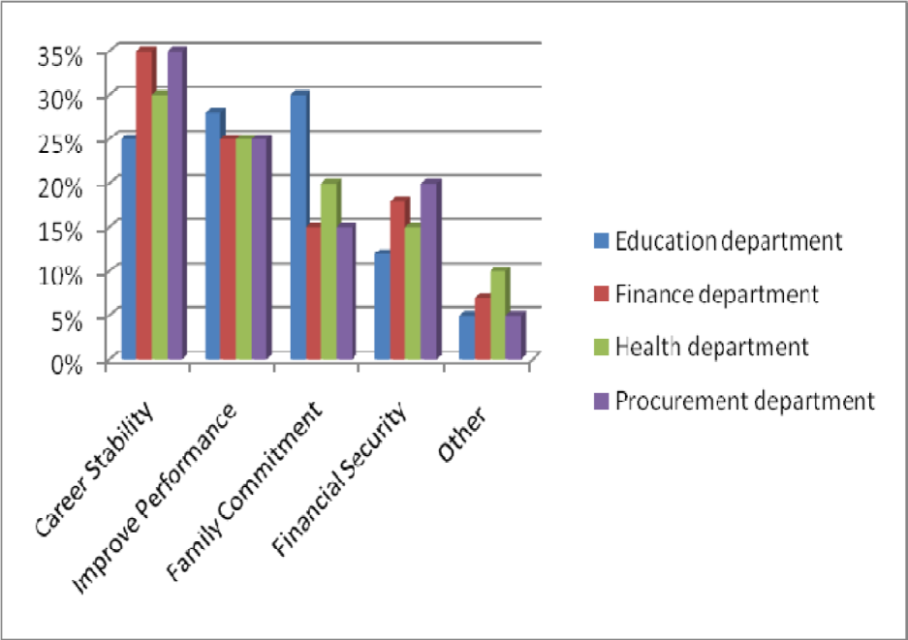

Figure 4.1 : Influence of Job Security on Employees’ Commitment
Source: Field Survey, 2025.
Because this study was aiming to identify if there was any influence of Job Security on
Employees’ Commitment. In order to identify the influence this study used chi-square as the test statistics because Chi-square is a statistical test commonly used to compare observed data with data we would expect to obtain according to a specific hypothesis. The chi-square test was used because is always testing the null hypothesis, which states that there is no significant difference between the expected and observed result. The 5% level of significance (alpha) was used as the methods of inference used to support or reject claims based on sample data.
The test was undertaken by using Statistical package of social sciences (SPSS) under the level of significance 5% i.eα = 0.05. The result shows that there is statistical difference of the variable under study (job security and employees’ commitment) because the value of P is less than 0.05 (see table 4.2).

Table 4.2 : Chi-square test for the Influence of Job Security on Employees’ Commitment
 | Value | df | Sig
Pearson Chi-Square | 17.691 | 15 | .000
Likelihood Ratio | 15.071 | 15 | .001
N of Valid Cases | 100
Source: field Survey,2025.
Job security is an employee's assurance or confidence that they will keep their current job. Employees with a high level of job security have a low probability of losing their job in the near future. Certain professions or employment opportunities inherently have better job security than others; job security is also affected by a worker's performance, success of the business and the current economic environment.
4.3.1 Career stability
According to field data, result shows that on average 31% of respondents indentified that job security influences employees’ career stability. It was further reviled that, employees who are stable tend to perform better than their compatriot. According to Pines &Yanai, (2001) Career stability makes employees to think suitably about their positive and negative aspects. All about their interest and their creativity becomes possible through properly analyzing themselves. Although, career stability is a situational factor and also varies from one individual to another.
However, its importance cannot be undermined. One of the basic ways to reach suitable stability in job is by keeping yourself refreshed and updated. A fresher approach towards your career may lead you to a longer and more progressive stay at your employment.

4.3.2 Improve performance
Field data indicates that 26% of respondents had views that job security influences employee to improve their work performance (Figure 4.2). According to field data the common known aspect of employee performance is employee recognition. During interview with KAM Holdings Nig.LTD, Ilorin it was reviled that annual employee appraisals aren't enough employees appreciate frequent and regular feedback. When you’re the government provides regular feedback, it motivates employees to maintain consistently good performance.
According to Pines &Yanai, (2001) employee performance is measured by looking at (i) Ability, The capacity to learn and perform the tasks required (ii) Standards, Expectations to achieve and guidelines by which to achieve them (iii) Knowledge and Skill, The information and expertise necessary to perform the job (iv) Feedback, Feedback from management that effectively communicates the status of the person’s performance, based on measurable guidelines and tools (v) Environment Acceptable working conditions, such as enough time and equipment to perform the job effectively and (vi)
Motivation Incentives in place that positively reinforce good performance,
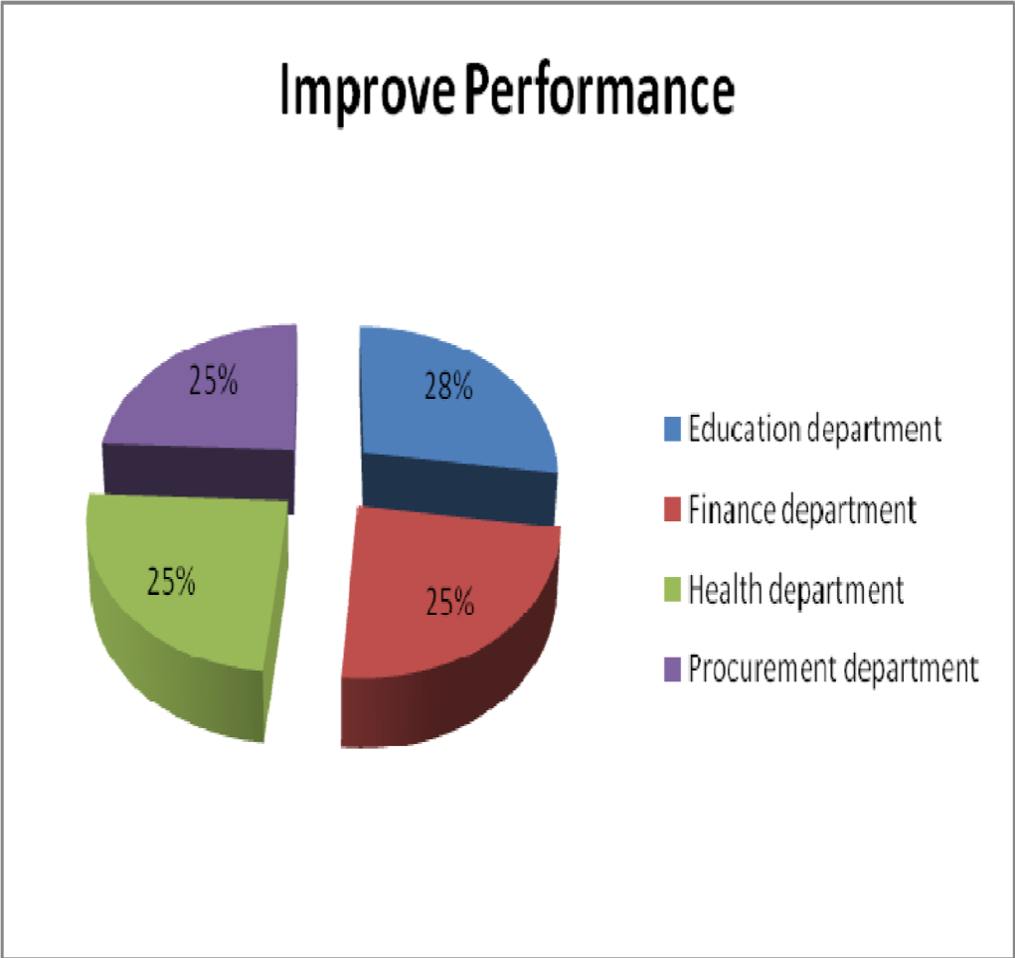

Figure 4.2 : Job security improving Employee Performance Source: Field data

4.3.3 Family Commitment
Field data indicate that on average 20% of respondents had views that job security enhances employees’ family commitment. This was due to the fact that many respondents who were interview considered the family as a reason why they are working. It was evidenced that workers working away from their family are not settled hence poor performance. Individuals are also susceptible to influence from their families of origin with regard to occupational choice and prioritizing work over family, or vice versa.
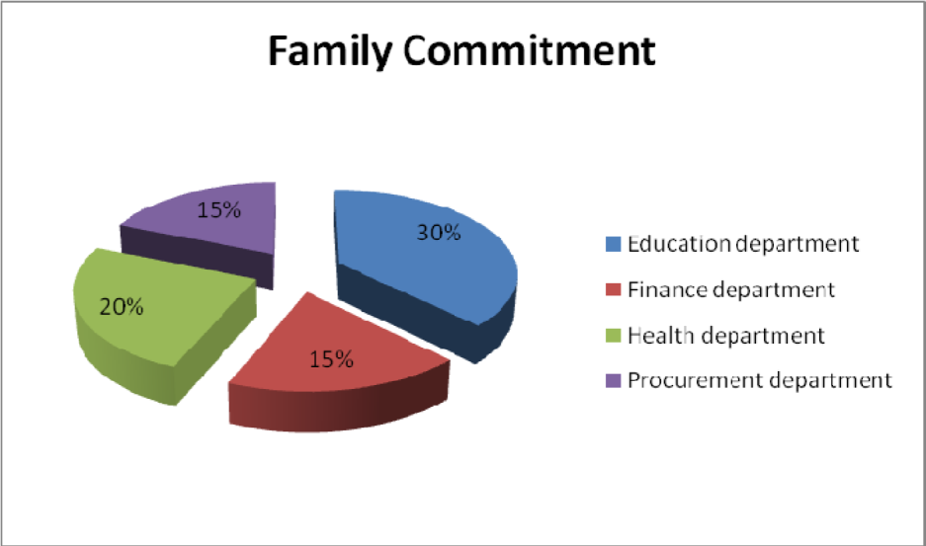

Figure 4.3 : Job security improving employee commitment to the family Source: Field data
Career opportunities, in the form of prospects for advancement within an organization or more generally in one’s chosen field, are impacted by family commitments and the use of flexible working practices designed to assist employees balance their work and home responsibilities. Family influence on career choice may also manifest itself unconsciously.
According to psychoanalytic theory, familial heritage plays a significant role in occupational choice. Individuals will tend to choose an occupation that enables them to satisfy needs that were unfulfilled in their childhood, and actualize dreams passed on to them by their family (Pines &Yanai, 2001).The desire for a balanced lifestyle between work and family also affects decisions to change jobs or accept a geographical transfer, and can help to shape employees’ intentions to depart an organization or an entire career.

4.3.4 Financial security
The study results show that 16% of respondents identified financial security as one of the factor influenced by job security in the organization (Table 4.1).According to respondents one of the first things to consider when determining whether to take a job employee might lose is the impact it will have on income. If employee are searching for a job and have several leads, taking the wrong job can cause them to miss out on other, better opportunities. On the other hand, if employee are in dire financial straits and are offered a high-paying job that lasts only a few months, the income earned there might be enough to help pay off debt and give employee breathing room to look for a new job. In this case, job stability is not important when compared to employees’ need for immediate income.

4.4 The Effects of Employees’ Motivation on Organization Performance
Respondents were asked on the effects of employees’ motivation on organization performance and the answers were limited to yes or no. Results (Figure 4.4), reveals that overall, the majority 64% argued that employee motivation affects organization performance. On department specifically the department of education commented that motivation was very important for the employees as it improves their performance hence improving organization performance as 75% was realized.
In health department respondents had different views on the effect of employees’ motivation on organization performance as its effect were 50:50. Some respondents had to say motivations helps employee to work efficiently and effectively whilst other respondents has to say that, “Employee motivation has no effect on organization performance because work performance is based on workers skills, accountability, performance appraisals, employee motivation, Employee satisfaction, compensation, Training and development and integrity”.
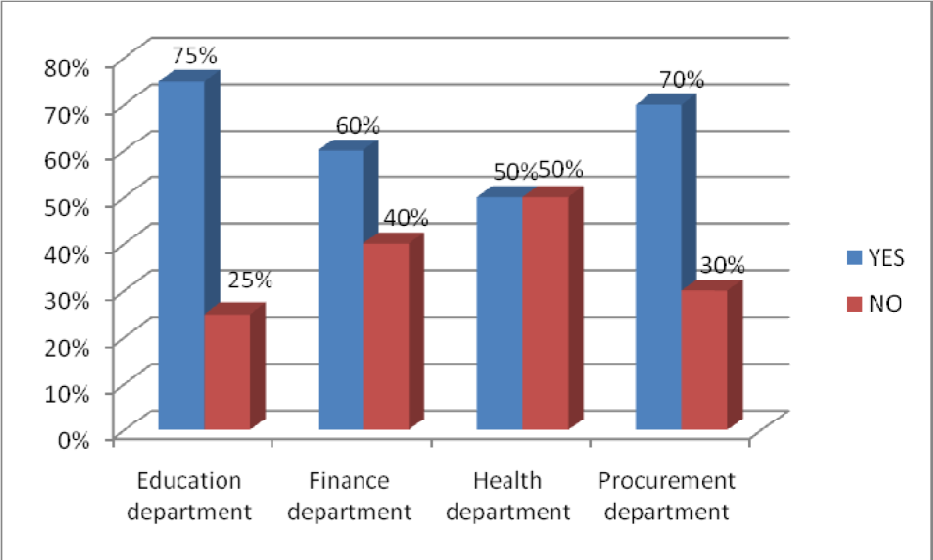

Figure 4.4 : Effects of employees’ motivation on organization performance Source: Field data
In the finance department 60% of respondents agreed that employees’ motivation has effect on organization performance while 40% of respondents did not see the effect of employee motivation on organization performance. The respondents argued that, job security works best as a motivator when employees see a connection between job retention and their own performance. It was further evidenced that Employees who don't fear for their jobs are more likely to perform at a higher level and feel greater commitment to an employer.
As pointed above that, chi-square is a statistical test commonly used to compare observed data with data we would expect to obtain according to a specific hypothesis. The chi-square test was used because is always testing the null hypothesis, which states that there is no significant difference between the expected and observed result.
In this case also the chi-square was used to test the Effects of employees’ motivation on organization performance. By using the level of significance 5% i.eα = 0.05. The result shows that there is no statistical difference of the variable under study (employees’ motivation and organization performance) because the value under observation is greater than 0.05 (see table
4.2).

Table 4.3 : Chi-square test for the effects of employees’ motivation on organization performance
 | Value | df | Sig
Pearson Chi-Square | 5.000 | 5 | .416
Likelihood Ratio | 5.912 | 5 | .315
N of Valid Cases | 100
Source: Field data
These results means, Employees’ Motivation has no significance effect on Organization Performance. In other words this study found that there was no significant relationship between employees’ motivation and organization performance.
However during interview with officials it was revealed that, Employee motivation is one of the policies of the government to increase effectual job management amongst employees in organizations as a motivated employee is responsive of the definite goals and objectives he/she must achieve, therefore he/she directs its efforts in that direction. Further argument was that motivation formulates an organization more successful because provoked employees are constantly looking for improved practices to do a work.
According to Pines &Yanai, (2001) employees want to earn reasonable salary and payment, and employees desire their workers to feel that is what they are getting. Money is the fundamental inducement; no other incentive or motivational technique comes even close to it with respect to its influential value (Sara et al, 2004). It has the supremacy to magnetize, maintain and motivate individuals towards higher performance. This view is supported by Frederick Taylor and his scientific management associate who describes money as the most fundamental factor in motivating the industrial workers to attain greater productivity.
4.5 Relationship between employee satisfaction and organization performance Traditionally, job satisfaction is the feelings a worker has about his or her job or job experiences in relation to previous experiences, current expectations, or available alternatives” Job satisfaction is a function of the general aura of the work environment. Several staffs leave their employer not because of poor salaries but because of lack of job satisfaction. According to the field data in Table 4.4, about 96.5% (n=100) of respondents declared that job satisfaction is a critical factor to the overall productivity of the organization. Respondents pointed out that there is a positive correlation between employee’s job satisfaction and overall productivity of the organization.
According to Brook (203), good work environment is the type of work environment that provides job satisfaction to employee. It is a situation where all the necessary conditions and facilities that will assist the employees to do his work are provided. This include as good and well-furnished offices with good communications and information technology network, working facilities and materials, good working atmosphere and open organizational climate, etc. In these situations, the employees will have a good image high esteem, he will love his job put in his best.

Table 4.4 : Respondents perception on employee satisfaction and organization performance

Respondents %

Educati Finan Healt Procurem

on ce h ent Variable description Average
 | n=25 | n=25 n=25 | n=25
Positive | 90 | 96 100 | 100 | 96.5
Negative 10 4 0 0 3.5
Total 100 100 100 100 100

Source: Field data,

4.5.1Employees Job satisfaction
Most respondents admits that Job satisfaction of employees plays a very vital role on the performance of an organization. It is essential to know as to how employees can be retained through making them satisfied and motivated to achieve extraordinary results.
Target and achievement depends on employee satisfaction and in turn contribute for organizational success and growth, enhances the productivity, and increases the quality of work.

4.5.2 Findings from Director of Personal Management
Discussion with Director revealed that, It is essential for an organization to exactly feel as to what employees feel, think, and wish and to discover and make strategies that how the staff dedication and commitment can be improved. Through this initiative business outcomes can be improved, productivity can be enhanced, commitment can get strengthened. Increasing staff satisfaction is very vital and important factor for the success of an organization. There is a cause and effect relationship between the employee’s job satisfaction and organizational performance. Employee’s satisfaction is a cause and the effect will be “how the organizational performance fosters”.
It is the general understanding that job satisfaction is an attitude towards job and organizational performance depends on staff satisfaction. Persons having high level of job satisfaction hold positive attitudes towards his or her job, while a person who is dissatisfied with his or her job holds negative attitudes about the job and even about the organization.
Discussion with Senior human resource officer revealed that employee satisfaction is closely related to productivity which is then related to firm profitability. Employee satisfaction has a positive persuade on organizational performance. Beside this, firm profitability has a reasonable non-recursive effect on employee satisfaction. Employee satisfaction plays a considerable role in enhancing the firm profitability and improving operational performance of organizations and quality of goods and services. There is no doubt in it that employee satisfaction is critical to attain quality and profitability in organization. Employee satisfaction impacts quality at industry, to achieve quality and profitability at organization, employee satisfaction is fundamental and without it, organization cannot think of being successful.

4.5.3 Relationship between employee and organization
An imperative relationship exists between employee and organization. This employee organization relationship plays an important role in success of any organization. There is a need of developments in it. Managers are believed to develop a role relationship in which actions and decisions should promote the interest of organization. Employee involvement and contributions in organization is outcome of the interest. The quality of employee organization relationship requires fulfillment of needs, quality of interaction, adaptability and identification. Employee empowerment is also an effective way of satisfying them. When employees are given employee empowerment, then it leads to job satisfaction.
Employee satisfaction is in fact job satisfaction. Job satisfaction is an important job organization factor. Both of them are significantly related. Therefore, it is necessary to maintain job satisfaction so that employees can be motivated.

4.5.4 Employee Satisfaction and Organizational Performance
The coefficient of correlation was applied to identify the impact of job satisfaction on organizational performance and it was calculated by using level of job satisfaction as the Xvariable (independent variable) and organizational performance as the Y-variable (dependent variable) for mentioned employee categories. The statistical techniques were used to determine the satisfaction of staff and organizational performance. The results and findings of research study are, there is a significant impact of job satisfaction on organizational performance. This research has demonstrated a strong positive correlation (r=0.64) between job satisfaction and organization performance.

4.5.5 Organizational performance
Finding form key informants revealed that organisational productivity and efficiency are attained by satisfying employees and being sensitive to both their physiological and socio-emotional needs in a holistic manner. Conversely, employee dissatisfaction resulting from poor workplace environments can also lead to a decrease in productivity leading to poor organisational performance (Chandrasekar, 2011).
It is important for management in organisations to create a work environment that facilitates higher employee satisfaction levels. This is because employee satisfaction has a stimulus effect on the loyalty and confidence of employees, improves the quality of outputs and also increases productivity (Surujlal & Singh, 2003; Yee et al., 2008). Satisfied employees tend to perceive that the organisation will be more satisfying in the long run, they care about the quality of their work and are more committed to the organisation, leading to a demonstration of organisational citizenship behaviours (Fraser, 2001; Sempane et al., 2002; Yoon & Suh, 2003).
Goslin (2005) is also of the opinion that satisfied employees have higher retention rates and are more productive. When employees are dissatisfied, their physical and mental health is negatively affected (Faragher, Cass & Cooper, 2005). Consequently, organisational performance will also deteriorate as more production time will be lost because dissatisfied employees are likely to take more leave (Judge, Piccolo, Podsakoff, Shaw & Rich, 2010; Shields, 2006); therefore, if steps are taken to improve employee satisfaction, overall success of the organisation is enhanced and the results can be reflected through happier employees, enhanced workforce productivity, reduced workdays and higher profits. This also typifies the importance of people in organisations, since people are the promoters of excellent organisational performance.
In the context of the service industry, substantial research evidence reveals that there is a positive association between employee satisfaction and customer satisfaction (Bernhardt, Donthu & Kennett, 2000; Wangenheim, Evanschitzky & Wunderlich, 2007). Providing employees with an outstanding internal working environment is likely to lead to satisfied employees who are both loyal to the organisation and are capable of providing customers with an exceptional service experience (Chi & Gursoy, 2009). Customers will naturally recognise and value the excellent service offered to them, leading to an exhibition of loyalty behaviours, such as repeat purchases and increased referrals (Koys, 2003). These behaviours suggest; therefore that satisfied employees will create satisfied and loyal customers, which will result in better organisational performance. It is important then for service organisations to direct sufficient resources towards employee satisfaction programmes.

4.6 Relationship between absenteeism and organization performance
Absenteeism is the term generally used to refer to unscheduled employee absences from the workplace. It is a habitual pattern of absence from a duty or obligation. Respondents were asked on what are the consequences of absenteeism on organization performance. The responses were limited to positive and negative consequences. According to the study results on Table 4.5, about 94.5% (n=100) of respondents said absenteeism have negative consequences on organization performance and few respondents about 5.5% (n=100) reported that absenteeism has positive consequences on organization performance.

Table 4.5 : Consequences of absenteeism on organization performance


Respondents %

Educati Finan Healt Procurem Variable description
on ce h ent Average
 | n=25 | n=25 n=25 | n=25
Negative consequences | 100 | 90 96 | 92 | 94.5
Positive consequences | 0 | 10 4 | 8 | 5.5
Total 100 100 100 100 100

Sources: Field data, 2023

4.6.1 Consequences of absenteeism to individual
The positive consequences of absenteeism, from the individual view point, seem relatively straightforward. According to results in Table 4.6, respondents said absenteeism is a form of withdrawal from Job-stress situations. If absence from work reduces stress, then it can be functional for the individual. In addition, much of our life is concerned with fulfilling such central non work-related roles as the parent role (when taking care of a sick child) or the marital role (when reducing marital stress). The valence and utility for performing many of these non workrole activities is likely to be strong. Completing these activities, which may require being absent from work, leads to positive benefits for the individual.
The negative consequences of absenteeism to the individual are fairly straightforward. They may include loss of pay and disciplinary action for the individual. A less obvious negative consequence concerns the process of altered job perceptions. When confronted with an absence, even the employee may develop a reason (attribution) or Justification for explaining the absence. The reason given may or may not correspond to why the employee was absent. If, over time, the Justificatlon or reason is rehearsed over other absence events and not controverted by any other information, we would expect that justification to become a permanent part of the individual's belief system. In the case of absenteeism, we would expect people to attribute the cause more to problems in their environment, such as a bad Job, bad supervisor, and so on. So, to the extent that absenteeism leads to negative beliefs about the job or job environment that are not based on the reality of the situation, I would say that absenteeism indirectly creates negative consequences for the individual.

4.6.2 Consequences of absenteeism to co-worker
Positive and negative consequences fall to the co-worker as summarized in Table 4.6. The absence of a worker may give co-workers a new opportunity to work on a different job, which would enhance job variety and skill development. In addition, if the work area is under staffed, there may be opportunities for overtime pay. On the negative side, the co-worker may have to do additional work, which is perceived as a burden, not a benefit. Overtime may be viewed as negative when it interferes with non work responsibilities. Accidents can occur when the coworker is confronted with an unfamiliar machine or set of job activities. If any of the above negative consequences occur, they are likely to lead to conflict with the absent worker on his or her return. In addition, if the co-worker observes high absenteeism in the work group, an inferential process may be evoked to explain this absenteeism. If, as discussed earlier, the attributions are made about negative environmental conditions, the co-worker might develop negative beliefs about the work environment although he or she is not absent.

4.6.3 Consequences absenteeism to an organization
Table 4.6 summarizes the positive and negative Consequences of absenteeism to an organization. Hiring, training, and paying additional workers and maintaining records for, administering, and enforcing an absenteeism program all represent costs to management of the organization. Absenteeism is a big barrier for any kind of organization because its effect on organization growth. As we all know that human resource is an important part of organization and without them we can’t imagine the organization.
Absenteeism means employee absent for the duty due to reason of sickness, social functions, death of relatives etc. Absenteeism of employees is normal but when ratio increase that directly effect on organization performance and also increases the cost and workload in organization. Absence control can often be an important step in the process of reducing business costs. Because of competitive pressures, companies can no longer afford to carry unnecessary absence that they may have tolerated in the past. Therefore, many companies are focusing on the issue of eliminating, or at least reducing, unnecessary levels of absence.
Unscheduled absences are costly to business. The inability to plan for these unexpected absences means that organizations hire last minute temporary workers, or pay overtime to their regular workers, to cover labor shortfalls; they may also maintain a higher staffing level regularly in anticipation of absences. Basically 3 types of cost (Productivity /administration/financial) are present for employees absenteeism that means cost is used for employee who work with organization.
Due to continuation of customer visit to an organization in case when staff is absent so problem increase and productivity affected. Absent staff place an extra burden on the whole organization. Time lost in the sourcing and training of new or replacement staff and morale and motivation issues can greatly decrease the productivity of staff.
Absenteeism also increases administrative cost and work load. It increases supervisory and administrative costs in the monitoring and management of absenteeism programme.
Absenteeism increased costs associated with securing replacement staff and salary costs for new or replacement staff. The study also found that extra pay for overtime to another employee’s effect on financial programme and cost of the organization.
Further more discussions with the key informants revealed that both negative and positive consequences of absenteesm to the organization performance as summarized in Table 4.6. According to key informants human resources are one of the most valuable resources of an organization and indeed an organization is nothing without human resources. Since every organization is made up of people, acquiring their services, developing their skills, motivating them to higher levels of performance and ensuring that they continue to maintain their commitment to the organization are essential to achieving organizational objectives. Getting and keeping good people is critical to the success of every organization, whether profit or non-profit, public or private. Maintaining employees is concerned with providing those working conditions that employees believe are necessary in order to maintain their commitment to the organization.
They further revealed that organizations have to realize that human resources are more valuable than other resources and that their proper management can tremendously help the organization maximize the utilization of other resources. Human Resources can also greatly influence the organization's performance and determine its achievement of the set objectives.

Table 4.6 : Consequences of Absenteeism
 | Positive Negative
Individual | - ReductIon of job-related • Loss of pay  stress  - Meeting of nonwork-role • Discpline, formal obligations and inormal
Co-workers | - Job variety •  - Skill development  - Overtime pay • | Increased work  load  •  Undesired overtime  Increased accidents  • Conflict with absent worker
Organizationmanagement • Greater job knowledge base • Decreased
in work force  • Greater labor-force  Flexibility • | productivity  Increased costs  •  More grievances
 | • Increased
accidents

Source: Field Survey,2023

Every organization success depends on its valuable assets “Employees”. So employee’s absenteeism is a major barrier for organization success. Absenteeism can be termed as an “illness” which may affect the internal structure of the organization, thus causing harm to the production process. So there is a need to control the situation, by taking a thorough and in-detail analysis to identify the critical reasons of absenteeism, which will help to create a proper Organizational Culture. While employers expect workers to miss a certain number of workdays each year, excessive absences can equate to decreased productivity and can have a major effect on company finances, morale and other factors.
The coefficient of correlation was applied to identify the impact of absenteesm on organizational performance and it was calculated by using absenteesm as the X-variable (independent variable) and organizational performance as the Y-variable (dependent variable) for mentioned employee categories. The statistical techniques were used to determine the absenteesm of staff and organizational performance. The results and findings of research study revealed that, there is a significant impact of absenteesm on organizational performance. This research has demonstrated a strong positive correlation (r=0.58) between absenteesm and organization performance.

4.7 Discussion of the Findings
Field data revealed that, Job security is an employee's assurance or confidence that they will keep their current job. Employees with a high level of job security have a low probability of losing their job in the near future. It was further evidenced that employee motivation affects organization performance. More so, it was revealed that that job satisfaction is an attitude towards job and organizational performance depends on staff satisfaction.
According to study conducted by Cole and Cole (2005), there is a positive correlation between the job attitudes of individuals and their performance. A meta-analysis conducted by Judge, Thoresen, Bono, and Patton (2001) also found a positive relationship between individual employee satisfaction and factors such as motivation, job involvement, organisational citizenship and job performance. In another metaanalysis conducted by Harter, Schmidt and Hayes (2002), it was found that there is a positive relationship between employee satisfaction and productivity, profit, turnover and customer satisfaction in nearly 8000 business units in 36 organisations across the five continents of the world.
Studies conducted by Schneider et al. (2003) and Zohir (2007) confirm that there is a positive correlation between overall employee satisfaction with the organisation’s financial and market performance. Corporate Leadership Council (2003) also conducted an employee satisfaction survey of over 40% of the companies that are listed in the top 100 of Fortune 500 companies. The study concluded that employee satisfaction, behaviour and turnover predicted the following year’s profitability, and that these are even more strongly correlated with customer satisfaction. A survey conducted by Price Waterhouse Coopers (2002) which involved several multinational companies sustains that employee satisfaction as well as decreased turnover are major contributors of longterm shareholder returns.

CHAPTER FIVE
5.0 SUMMARY OF THE FINDINGS, CONCLUSION AND

RECOMMENDATIONS

5.1 Introduction
This chapter presents the summary of the findings, implication of the study, conclusion, recommendations, limitations of the study and areas for future research.

5.2 Summary of the Findings
The main objective of this study is to assess on the contribution of employees' commitment on organizational performance in Ilorin West Local Govtcity council. To achieve this objective the researcher was guided by four research questions; (i) What are the influence of job security on employees’ commitment? (ii) What are the effects of employees’ motivation on organization performance? (iii) What could be the relationship between employee satisfaction and organization performance? (iv) What might be the relationship between absenteeism and organization performance?
Field data revealed that, Job security is an employee's assurance or confidence that they will keep their current job. Employees with a high level of job security have a low probability of losing their job in the near future. It was further evidenced that 64% of respondents argued that employee motivation affects organization performance. More so, it was revealed that job satisfaction is an attitude towards job and organizational performance depends on staff satisfaction.

5.3 Implication of the Study
Results on the study to assess on the contribution of employees' commitment on organizational performance in Ilorin West Local Govt council implies that;- Job security is an employee's assurance or confidence that they will keep their current job. Employees with a high level of job security have a low probability of losing their job in the near future. More so, job satisfaction is an important job organization factor, employee dissatisfaction resulting from poor workplace environments can also lead to a decrease in productivity leading to poor organisational performance.

5.4 Conclusion
The study observed that, organizations have to realize that human resources are more valuable than other resources and that their proper management can tremendously help the organization maximize the utilization of other resources. Human resources can also greatly influence the organization's performance and determine its achievement of the set objectives.
Every organization success depends on its valuable assets “Employees”. So employee’s commitment to the organization is a major factor for organization success. While employers expect workers to miss a certain number of workdays each year, excessive absences can equate to decreased productivity and can have a major effect on company finances, morale and other factors.

5.5 Recommendations
In order to attain efficiency and effective organization performance the following recommendations need to be implemented:
- Employers should focus on reducing job dissatisfaction (working conditions, salary, supervision, relationship with colleagues), while on the other hand should use motivating factors such as achievement, recognition, responsibility and the work itself.
- Employee participation and empowerment do not only enhance efficiency, growth and innovation but they also increase employee motivation and trust in the organization. If employees feel appreciated for their work and are involved in decision-making, their enhanced enthusiasm and motivation will lead to better productivity and loyalty.
- Absenteeism failure of individuals to report for work, primarily unscheduled or unanticipated absences. Not all such absences are “bad,” of course. Life happens: employees or members of their family become ill or unexpected events occur. Management must maintain its flexibility in responding to these. When factors in the organization or the workplace tend to increase unanticipated or unscheduled absences, however, absenteeism reduces productivity and becomes a management problem.
- Every organization success depends on its valuable assets “Employees”. So employee’s absenteeism is a major barrier for organization success. So there is a need to control the situation, by taking a thorough and in-detail analysis to identify the critical reasons of absenteeism, which will help to create a proper Organizational Culture.
- Management should evaluate employee suggestion scheme and use the feedback from the workforce to improve the organizational environment and fulfill their needs and skills.

5.6 Areas for future research
Future research should seek to enhance our understanding on the relationships between labour turnover and absenteeism in organizations and how they impact on organizations performance.

REFERENCE
Addae, H. M., and Wang, X. (2006). Stress at work: Linear and curvilinear effects of psychological-, job-, and organization-related factors: An exploratory study of Trinidad and Tobago. International Journal of Stress Management, Vol. 13, No. 4, 476–493
Armstrong-Stassen, M. (2004).The influence of prior commitment on the reactions of layoff survivors to organizational downsizing. Journal of Occupational Health PsychologyVol 9(1), January, pp. 46-60.
Baard, P. P., Deci, E. L., and Ryan, R. R. (2004). Intrinsic need satisfaction: A motivational basis of performance and well-being in two work settings. Journal of
Applied Social Psychology, 34, 10, pp. 2045-2068
Bakker, A. B., & Demerouti, E. (2006). The job demands–resources model: State of the art. Journal of Managerial Psychology.Vol. 22 No. 3,pp. 309-328
Bakker, A., Demerouti, E., de Boer, E., & Schaufeli, W. B. (2003).Job demands and job resources as predictors of absence duration and frequency.Journal of Vocational
Behavior. 62 (2003) 341–356
Becker, T. E. (2009). Interpersonal commitments. In H. J. Klein, T. E. Becker, & J. P. Meyer, C, (Eds.), Commitment in organizations: Accumulated wisdom and new directions. New York: Routledge/Taylor and Francis Group.
Bridger, R. S., Kilminster, S., & Slaven, G. (2007). Occupational stress and strain in the naval service: 1999 and 2004. Occupational Medicine,
Chan, D. (2002). Latent growth modeling. In F. Drasgow,& N. Schmitt (Eds.), Measuring and analyzing behavior in organizations: Advances in measurement and data analysis San Francisco, CA: Jossey-Bass.
Cohen, A. (2007). One nation, many cultures: A cross-cultural study of the relationship between cultural values and commitment in the workplace to in-role performance and organizational citizenship behavior. Cross-Cultural Research: The Journal of
Comparative Social Science, March 53: 387-417,
Elizur, D., & Koslowsky, M., (2001) “Values and organizational commitment”, International Journal of Manpower, Vol. 22 Iss: 7, pp.593 - 599
Epitropaki, O., & Martin, R. (2005). From ideal to real: A longitudinal study of the role of implicit leadership theories on leader–member exchanges and employee outcomes. Journal of Applied Psychology, Vol 90(4), July, 659-676.
Gagné, M., Chemolli, E., Forest, J., & Koestner, R. (2008). A temporal analysis of the relation between organisational commitment and work motivation. Psychologica
Belgica
Galais, N., & Moser, K. (2009). Organizational commitment and the well-being of temporary agency workers: A longitudinal study. Human Relations,
Gellatly, I. R., Meyer, J. P., & Luchak, A. A. (2006).Combined effects of the three commitment components on focal and discretionary behaviors: A test of Meyer and Herscovitch's propositions. Journal of Vocational Behavior, 29(3), 91-121.
Glazer, S., & Kruse, B. (2008).The role of organizational commitment in occupational stress models. International Journal of Stress Management, 15 (4), 329-344.
Grawitch, M. J., Trares, S., & Kohler, J. M. (2007). Healthy workplace practices and employee outcomes. International Journal of Stress Management, Vol 14(3), August, 275-293
Jamal, M. (2005). Short communication: Personal and organizational outcomes related to job stress and Type-A behavior: A study of Canadian and Chinese employees. Stress and Health.
Kelloway, E. K., Inness, M., Barling, J., Francis, L., Turner, N., (2010) “Loving one's job:
Construct development and implications for individual well-being”, Research in Occupational Stress and Well-being,
Klein, H. J., Molloy, J. C., & Cooper, J. T. (2009). Conceptual foundations: Construct definitions and theoretical representations of workplace commitments. In H. J.
Klein, T. E. Becker, & Meyer, J. P. (Eds.), Commitment in organizations: Accumulated wisdom and new directions Florence, KY: Routledge/Taylor and Francis Group.
Lambert, E. G., Hogan, N. L., & Griffin, M. L. (2008).Being the good soldier: Organizational citizenship behavior and commitment among correctional staff.
Criminal Justice and Behavior,
Manpower, 22(7), Wood, S., Wall, T., (2002) “Human Resource Management and
Business Performance”, in Warr, P. (Ed.), Psychology at Work, Penguin, London,
Meyer, J. P. (2009). Commitment in a changing world of work. In H. J. Klein, T. E. Becker, C. & Meyer, J. P. (Eds.), Commitment in organizations: Accumulated wisdom and new directions (pp. 37−68). Florence, KY: Routledge/Taylor and
Francis Group.
Meyer, J. P., & Parfyonova, N. M. (2010).Normative commitment in the workplace: A theoretical analysis and re-conceptualization. Human Resource Management Review.
Neubert, M. J., & Wu, C. (2009).Action commitments. In H. J. Klein, T. E. Becker, & J. P. Meyer (Eds.), Commitment in organizations: Accumulated wisdom and new directions (pp. 179−213). Florence, KY: Routledge/Taylor and Francis Group.
Parfyonova, N. (2009). Employee motivation, performance, and well-being: The role of managerial support for autonomy, competence and relatedness needs. Unpublished Doctoral Dissertation, Department of Psychology, The University of Western Ontario.
Stallworth, H.L., (2003) “Mentoring, organizational commitment and intentions to leave public accounting”, Managerial Auditing Journal, Vol. 20 Iss: 4, pp.383 - 393
Tromp, D.M., Rheede, A., & Blomme, R.J., (2010) “The relationships between psychological strain, organizational support, affective commitment and turnover intentions of highly educated hospitality employees”, Advances in Hospitality and Leisure,
Vandenberghe, C. (2009). Organizational commitments. In H. J. Klein, T. E. Becker, & J. P.
Meyer (Eds.), Commitment in organizations: Accumulated wisdom and new directions (pp.
99−135). Florence, KY: Routledge/Taylor and Francis Group.
Wasti, S. A. (2005). Commitment profiles: Combinations of organizational commitment forms and job outcomes. Journal of Vocational Behavior, April, 77-99,
Whitener, E. (2001). Do “high commitment” human resource practices affect employee commitment? A cross-level analysis using hierarchical linear modeling.Journal of Management, Volume 27, Issue 5, September, pp. 515–535.
Wood, S., (1999) “Human Resource Management and Performance”, International
Journal of Management Reviews,Volume 1, Issue 4, pages 367–413,
Zickar, M. J., Gibby, R. E., & Jenny, T. (2004).Job attitudes of workers with two jobs. Journal of
Vocational Behavior, 67, 290–30

APPENDICES

Appendix 1: Sample of Employees’ Questionnaire
- Name of the department ………………………….
- Level of education (Please Tick)
Form Six 1
Certificate 2
Diploma 3
Degree 4
Above Degree 5
- Gender (Please Tick)
Male 1
Female 2
- Age (Please Tick)
18-27 1
28-37 2
38-47 3
Above 48 4
- Marital status (Please Tick)
Single 1
Married 2
Separated 3
Divorced 4
- Is your organization performing well?
YES 1
NO 2
- How would you rate your organization performance?
Very high

High
1

Moderate 2
3 Low
4
Very Low 5
- Is there security at your work place?
Yes 1
No 2
1
- How do you 2 rate your satisfaction at your work place
3
Very high
4 High
Moderate
Low
Very Low 5
- If job satisfaction helping to improve organization performance?
Yes 1
No 2
- If Yes tell us how………………………………………………………….………
……………………………………………………………………………………..
- If No tell us why? …………………………………………………………………
……………………………………………………………………..………………

- If Low to Very Low, what could be the reasons? (mention at least three)
……………………………………………………………………………………
……………………………………………………………………………………
……………………………………………………………………………………
- Is there any effort to being done to attain sustainable productivity in your organization?
YES 1
NO 2
- If yes what are these efforts (mention four)
……………………………………………………………………………………
……………………………………………………………………………………
……………………………………………………………………………………
- If no, what could be the challenges of attaining sustainable productivity in your organization(mention at least three)
..................................................................................................................................
…………………………………………………………………………………… ……………………………………………………………………………………..
- Is there absenteeism at your organization?
YES 1
NO 2

- What is the influence of absenteeism on organization performance? ……………………………………………………………………………………
- Are you motivated at your work place?
YES 1
NO 2
- If yes how are you motivated?
……………………………………………………………………………………
……………………………………………………………………………………
- If NO why?
..........................................................................................................................
……………………………………………………………………………………
- How do you rate your performance at your organization (Please Tick)
Excellent 1 Very
Good 2
Good 3
Moderate 4
Poor 5
- If moderate to poor, what could be the reasons? (mention at least three)
……………………………………………………………………………………
……………………………………………………………………………………
- Is there any relationship between employee behavior and organization performance?
YES 1
NO 2
- If yes what kind relationship existing?
…………………………………………………………………………………......
……………………………………………………………………………………
……………………………………………………………………………………
- What behavior among these is affecting your organization (Please Tick)
Absenteeism 1
Turnover 2
Low Motivation 3
Family conflict 4
Other (specify)…………………
- What could be done by the employees in order to improve organization performance?
.................................................................................................................................
……………………………………………………………………………………
……………………………………………………………………………………
- In your own views what has to be done by the organization to improve
employees’ performance ……………………………………………….……….. ……………………………………………………………………………………

THE END
THANK YOU

Appendex 2: Sample interview Guide with Officiars
- What are the factors triggering employee performance?
- What are could be done to improve employee commitment to the organization??
- What are the influence of job security on employees’ commitment?
- What are the effects of employees’ motivation on organization performance?
- What could be the relationship between employee satisfaction and organization performance?
- What might be the relationship between absenteeism and organization performance?

