DesignandFabricationofWindowBurglaryProofforResidentialSecurityEnhancementinNigeria.
BY

HAMMED ABDULSALAM AKINKUNMI ND/23/MEC/PT/0152

DEPARTMENT OF MECHANICAL ENGINEERING,
FACULTY OF ENGINEERING,
INSTITUTION OF TECHNOLOGY

KWARA STATE POLYTECHNIC
P.M.B 1375, ILORIN, KWARA STATE
NIGERIA

MAY,2025

Declaration

I, HAMMED ABDULSALAM AKINKUNMI, hereby declare that this project titled “Fabrication of Window Burglary-Proof” was carried out by me in the Department of Mechanical Engineering, Kwara State Polytechnic, under the supervision of Engr. Dada Samuel Adekunle.

This work is original and has not been previously submitted, either in part or whole, for any degree or diploma at any other institution of higher learning. All sources and references have been duly acknowledged.

________________ ________________
Supervisor’s Name & Signature Date

________________ ________________
Student’s name Date

Certification

This is to certify that the project titled:
“Fabrication of Window Burglary-Proof”
Was carried out by:
Name:HAMMED ABDULSALAM AKINKUNMI
Matric Number: ND/23/MEC/PT/0152
Department: Mechanical Engineering
Institution: Kwara State Polytechnic, Ilorin

In partial fulfillment of the requirements for the award of National Diploma (ND) in Mechanical Engineering.

This work was successfully completed under my supervision and is hereby approved for submission.

__________________ Date: __________
Engr. Dada Samuel Adekunle
(Supervisor)

__________________ Date: ___________

Mr./Engr.
Head of Department

__________________ Date: __________
External Examiner’s Name
(External Examiner)

Abstract

This project focuses on the design and fabrication of a window burglary-proof system aimed at enhancing residential and commercial building security. In light of increasing burglary incidents in Nigeria, the project proposes a locally fabricated, cost-effective, and structurally sound metal reinforcement system for windows. The study evaluates different materials, design considerations, fabrication processes, and performance tests such as deflection, weld strength, and corrosion resistance.
A rectangular window frame reinforced with mild steel rods was designed and tested under simulated loading conditions. Results showed the structure’s ability to resist significant external force without deformation or weld failure. The use of anti-rust coatings also proved effective in improving its durability. The outcome of this project confirms that locally sourced materials and conventional fabrication techniques can produce high-quality, durable, and affordable security solutions suitable for wide application in Nigeria.

Dedication

This project is wholeheartedly dedicated to the Almighty God, whose grace, wisdom, and protection have guided me through every stage of this academic journey.

I also dedicate this work to myloving parents(MR AND MRS HAMMED), whose sacrifices, support, and prayers have been the foundation of my success. Their unwavering belief in me continues to inspire my pursuit of excellence.

A special dedication also goes to everyone who believed in me, motivated me, and stood by me in one way or another during this academic journey. Your encouragement truly made a difference.

---

Acknowledgement

First and foremost, I express my profound gratitude to Engr. Dada Samuel Adekunle, my supervisor, for his tireless guidance, expert advice, and constant encouragement throughout this project. His mentorship made this work achievable and meaningful.

My sincere appreciation goes to the Head of Department (HOD), Mechanical Engineering, for providing an enabling academic environment and ensuring that students have all the resources needed to succeed.
I would also like to appreciate the Part-Time (PT) Coordinator for his support and effective coordination that helped keep us organized and focused.

To my lecturers, classmates, workshop technicians, and everyone who played a role—whether through academic input, technical assistance, moral support, or friendship—thank you for contributing to the success of this project.

Lastly, I thank Kwara State Polytechnic for giving me the platform to learn, grow, and apply practical knowledge in engineering. Your impact on my academic and personal development will always be remembered.

Table of Contents

- Declaration ………………………………………….. I

- Certification ……………………………………….. ii

- Abstract …………………………………………….. iii

- Dedication ………………………………………….. iv

- Acknowledgement ………………………………. V

Chapter One: Introduction

  - Background of the Study …………………………….. 1

  - Statement of the Problem …………………………….. 2

1.3 Aim and Objectives …………………………………….. 3

  - Significance of the Study ………………………………. 4

1.5 Scope of the Study ……………………………………….. 5

  - Limitations …………………………………………………. 6

1.7 Definition of Terms ………………………………………. 7

Chapter Two: Literature Review

2.1 Introduction ……………………………………………….. 8

2.2 Trends in Residential Security in Nigeria ………….. 9

2.3 Concept and Importance of Burglary-Proof ………. 10

2.4 Design Principles for Burglary-Proof Windows ……. 11

2.5 Materials Used in Fabrication …………………………. 12

2.6 Fabrication Techniques in Local Context …………… 13

2.7 Standards and Guidelines ……………………………… 14

2.8 Challenges in Implementation ………………………… 15

2.9 Recent Studies and Their Outcomes …………………. 16

2.10 Summary of Literature Gaps ………………………… 17

Chapter Three: Design and Fabrication Methodology

3.1 Introduction ……………………………………………….. 18

3.2 Design Assumptions and Requirements …………… 19

3.3 Structural Design Calculations …………………………. 20

3.3.1 Number of Bars ……………………………………… 21

3.3.2 Load and Bending Analysis ………………………. 22

3.4 Deflection at Midspan ……………………………………. 23

3.5 Fabrication Process ……………………………………….. 24

3.6 Performance Testing ……………………………………… 25

Summary …………………………………………………….. 26

Chapter Four: Testing and Evaluation

4.1 Introduction ……………………………………………….. 27

4.2 Static Load Testing Results …………………………….. 28

4.3 Deflection Analysis ……………………………………….. 29

4.4 Weld Strength Testing Results …………………………. 30

4.5 Corrosion Resistance Test ………………………………. 31

4.6 Discussion of Results ……………………………………… 32

4.7 Limitations and Areas for Improvement …………… 33

4.8 Summary …………………………………………………….. 34

Chapter Five: Conclusion and Recommendation

5.1 Conclusion …………………………………………………. 35

5.2 Recommendations ……………………………………….. 36

5.3 Final Thoughts ……………………………………………. 37

5.4 References …………………………………………

CHAPTERONE:INTRODUCTION
1.1BackgroundoftheStudy
Securityisafundamentalhumanneedandacriticalfactorinsustainableurbandevelopment.Inrecentdecades,Nigeriahaswitnessedanincreaseinburglaryandhomeintrusionincidents,particularlyinurbanandsemi-urbanareas.AccordingtotheNigeriaPoliceForceAnnualReport(2021),property-relatedcrimes,includingburglaryandtheft,haveescalatedbyover35%inthepastfiveyears,makingresidentialsafetyapressingconcern.
Windowburglaryproofsystemsarephysicalsecuritybarriersdesignedtopreventunauthorizedentryintobuildingsthroughwindows.Theyaretypicallymadeofsteelorwroughtironandarestrategicallyinstalledtoreinforceaccesspointswithoutcompromisingventilationoraestheticappeal.Theimplementationofsuchphysicalsecuritymeasuresremainsacost-effectiveandpassivedefensemechanismwidelyadoptedinNigeriaandotherdevelopingcountries(Ameh&Oyebode,2019).
ThisprojectfocusesonthedesignandfabricationofametallicwindowburglaryproofsystemusinglocallyavailablematerialsandpracticalmanufacturingtechniquessuitedforNigerianresidentialbuildings.Thestudyintegratestheoreticalprinciplesfrommaterialscience,fabricationengineering,andenvironmentalsecuritytocreateafunctional,durable,andaestheticallypleasingburglary-proofsystem.
1.2StatementoftheProblem
ResidentialbuildingsinNigeria,especiallyinlow-andmiddle-incomeneighborhoods,oftenlackeffectivesecuritymechanisms.Whiledoorsarefrequentlyfortified,windowsarecommonlyneglected,makingthemvulnerabletointruders.Existingburglaryproofsystemseitherfailtomeetdurabilitystandardsorareprohibitivelyexpensiveduetoimportedmaterialsandcomplexdesigns.Thereisaneedforacost-effective,locallyfabricated,andstructurallysoundburglaryproofsystemthatcanbeproducedusingreadilyavailablematerialsandsimplefabricationtechniques.
1.3AimandObjectives
Aim:
TodesignandfabricateawindowburglaryproofsystemusinglocallyavailablematerialsthatoffersenhancedsecurityandaestheticappealforresidentialbuildingsinNigeria.
Objectives:
Thespecificobjectivesofthestudyare:
- Toassesscommonburglarymethodsusedtobreachresidentialwindows.
- Todesignastructurallysoundandcost-effectiveburglaryproof.
- Toselectappropriatelocalmaterialssuitableforthedesign.
- Tofabricatetheburglaryproofusingstandardmetalworkingtoolsandtechniques.
- Toevaluatetheperformanceanddurabilityofthefabricatedproduct.
1.4SignificanceoftheStudy
Theoutcomesofthisprojecthavepracticalsignificanceinseveralareas:
- SecurityEnhancement:Providesphysicalprotectionagainstunauthorizedaccessandtheft.
- CostEfficiency:Promotestheuseoflocalmaterialsandlabor,reducingproductioncost.
- EmploymentGeneration:Encouragessmall-scalemetalfabricationenterprisesinNigeria.
- Sustainability:Offersareplicablemodelforeco-friendlyanddurableresidentialsecuritysystems.
1.5ScopeoftheStudy
Thisprojectislimitedtothedesignandfabricationofaprototypeburglaryproofsystemforastandardresidentialwindow(approximately1200mm×1200mm).Itdoesnotcoverautomatedorelectronicsecurityenhancementssuchasalarmsorsmartlocks.Thescopeincludes:
- Designmodeling
- Materialselectionandanalysis
- Fabrication(cutting,welding,assembling)
- Finishing(coating,painting)
1.6Limitations
Somelimitationsencounteredinthisstudyinclude:
- Limitedaccesstoadvancedfabricationequipment(e.g.,CNCmachines)
- Budgetconstraintsaffectingmaterialandtoolselection
- Timeframeconstraintsrestrictinglong-termperformanceevaluation
1.7DefinitionofTerms
- BurglaryProof:Ametallicstructureinstalledtorestrictaccessthroughwindows.
- Fabrication:Theprocessofconstructingproductsbycutting,bending,andassemblingmetalmaterials.
- MildSteel:Alow-carbonsteelmaterialusedextensivelyforstructuralandsecurityapplications.
- Welding:Afabricationprocessthatjoinsmetalsusinghighheat.
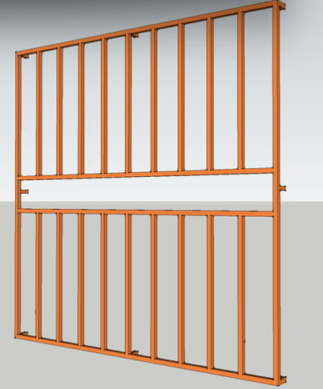
- Figure1.1:ConceptualDesignSketchoftheProposedBurglaryProof
CHAPTERTWO:LITERATUREREVIEW
2.1Introduction
ThesecurityofresidentialpropertieshasbecomeamajorareaofconcerninNigeria,especiallyindenselypopulatedandeconomicallyvulnerableregions.Asburglaryincidentsescalate,thereisagrowingdemandforaffordable,efficient,anddurablewindowsecuritysystems.Thischapterexplorespreviousstudiesandtechnicalfindingsrelatedtoburglarytrends,burglaryproofsystems,designstandards,materialselection,andfabricationmethods,withastrongfocusontheNigeriancontext.
2.2BurglaryTrendsandResidentialSecurityinNigeria
Burglary,definedastheunlawfulentryintoabuildingwithintenttocommittheftoranothercrime,isoneofthemostprevalentsecuritythreatsinNigerianhomes(Okonkwo&Akinwale,2019).TheNigerianPoliceForce(2021)reportedover38,000burglarycasesin2020alone,withasignificantconcentrationinLagos,Abuja,andPortHarcourt.AccordingtoAdebayo(2018),windowsremainoneoftheweakestpointsofentryexploitedbyburglarsduetotheirtypicallypoorstructuralreinforcement.
Severalstudies(Afolabietal.,2021;Adewale&Hassan,2020)confirmthatmostlow-andmiddle-incomehomesinNigerialackeffectivewindowprotection,therebyincreasingtheirvulnerability.Governmentpoliciesonurbanhousing(NHP,2012)recognizetheneedforphysicalsecurityfeaturesbutoftenfailtoenforceminimumburglaryresistancestandardsduringconstructionphases.

2.3ConceptandImportanceofBurglaryProofSystems
Burglaryproofsystemsarephysicalbarriers-usuallymadeofmetal-installedacrosswindowanddooropeningstopreventunauthorizedentry(Ajayi&Daramola,2020).Theyserveaspassivesecuritymechanisms,especiallyinhomeswithoutadvancedalarmsystems.
Typesofburglaryproofinstallationsinclude:
- Fixedwindowgrills
- Removablegrills
- Collapsible(accordion-style)designs
- Internalvs.externalmountingoptions
Designconsiderationsfocusonvisibility,structuralintegrity,easeofinstallation,andresistancetotampering(Alade&Yusuf,2017).
2.4DesignPrinciplesforWindowBurglaryProofs
Thedesignofburglaryproofsystemsmustbalancesecurity,aesthetics,ventilation,andcost.AccordingtoEzeokoliandNwankwo(2019),effectivedesignshouldpreventtheinsertionofcrowbars,saws,orpryingtoolswhileallowingsufficientairflowandlight.
Keydesignparametersinclude:
- Barspacing:Ideally≤120mm(BSEN1627:2011)
- Bardiameter/thickness:Typicallybetween10mmto20mm
- Fixingtechnique:Embeddedinwallsorboltedwithanti-tamperfasteners
- Coating:Forrustprotectionandaesthetics(e.g.,enamelorpowdercoating)
ModelsproposedbyAinaetal.(2022)suggestthatdiagonalorcurvedbarpatternsprovidebetterstrengthdistributionthanpurelyverticalconfigurations.
2.5MaterialsUsedforBurglaryProofFabrication
Materialselectioniscriticaltotheeffectivenessandlongevityofburglaryproofsystems.ThemostcommonlyusedmaterialsinNigeriainclude:
2.5.1MildSteel
Mildsteelisthepreferredmaterialduetoitsavailability,lowcost,workability,andtensilestrength.Itofferssufficientresistanceagainsthandtoolsandiseasilyweldable(Oladipo,2021).
2.5.2GalvanizedIron
Thoughmoreexpensive,galvanizedironoffersbettercorrosionresistance,especiallyincoastalenvironments(Balogun&Mohammed,2018).
2.5.3StainlessSteel
Usedinhigh-endconstruction,stainlesssteelprovidesexcellentdurabilityandaestheticfinishbutisrarelyusedinlow-incomeprojectsduetoitscost(Bamidele&Ojo,2020).
2.5.4ReinforcedPlastics
EmergingbutnotwidelyadoptedinNigeria.Generallyunsuitableforhigh-riskareas(Isholaetal.,2022).

Table2.1summarizesmaterialproperties:
Material | TensileStrength(MPa) | CorrosionResistance | Cost
MildSteel | 400–550 | Low | Low
GalvanizedIron | 400–550 | Medium | Medium
StainlessSteel | 520–700 | High | High
Table2.1:ComparativePropertiesofCommonBurglaryProofMaterials(CompiledfromOladipo,2021;Bamidele&Ojo,2020)
2.6FabricationTechniquesinLocalNigerianContext
2.6.1CuttingandShaping
Commontoolsusedincludehacksaws,grinders,andmanualshears.CNCandplasmacuttersarerareininformalNigerianworkshops(Lawaletal.,2020).
2.6.2Welding
ManualMetalArc(MMA)weldingispredominantlyusedforjoiningmildsteelbars.Itisaffordableandeffectivebutrequiresskilledlabor(Adisa&Oyekunle,2019).
2.6.3SurfaceFinishing
Finishesincludeanti-rustprimers,paint,andoccasionallypowdercoatings.Inhumidregions,double-layercoatingisrecommended(Adewuyi&Ogunlade,2018).
2.6.4TestingandQualityControl
Fewfabricatorsconductmechanicaltesting.However,visualinspection,loadresistancesimulation,andrustresistancetestsaresometimesappliedinformally(Usman&Bello,2021).

2.7StandardsandGuidelines
AlthoughNigeriadoesnothaveawell-establishednationalstandardforburglaryproofsystems,BritishStandards(BSEN1627:2011)andISO179–1:2010provideusefulbenchmarks.ResearcherslikeOgucheetal.(2020)advocatefortheintegrationofthesestandardsintolocalbuildingcodes.
2.8ChallengesinImplementation
Thechallengesassociatedwiththeimplementationofburglary-proofwindowsystemsaresignificant.Onekeychallengeisthelackofregulation,asthereisnonationalmandateforwindowprotectioninhousingcodes,whichhasledtoinconsistentpracticesacrossresidentialbuildings(Abubakar,2018).Additionally,costconcernsplayacrucialrole,withmanylow-incomeearnersprioritizingaffordabilityoversecurityfeatures,resultingintheuseofsubstandardorinadequatewindowprotectionsystems.AnotherchallengeisthecorrosionthatoccursduetoNigeria’stropicalclimate,whichacceleratesthedegradationofmaterialscommonlyusedinburglar-proofwindowsystems,thuscompromisingtheirlong-termeffectiveness.Lastly,aestheticconcernsareoftencited,assomeresidentsperceivetheinstallationofburglary-proofbarsasunattractiveor"prison-like,"whichdiscouragestheirwidespreadadoption(Ojo&Adeyemi,2022).
2.9RecentStudiesinNigeriaandTheirOutcomes
Severalstudieshaveexploredthevariousaspectsofburglary-proofsystems,particularlyinNigeria,sheddinglightontheireffectiveness,vulnerabilities,andareasforimprovement.
Okonkwoetal.(2021)conductedacomprehensiveassessmentofburglaryvulnerabilityacross100homesinLagos,withaparticularfocusontheeffectivenessofwindowburglarybars.Thestudyrevealedthat,althoughmanyhomesinLagoswereequippedwithburglary-proofsystems,themajorityofthesesystemswereinsufficienttopreventbreak-ins.Commonvulnerabilitiesidentifiedincludedtheuseofweakmaterialsandpoorinstallationpractices.Despitethewidespreaduseofwindowbars,thestudyfoundthatmanyhomesstillexperiencedburglariesduetosubstandardbarsandimproperinstallationtechniques.Thisstudy,however,focusedmoreonvulnerabilityassessmentsanddidnotprovidespecificsolutionstoimprovethequalityanddurabilityofburglary-proofsystems,leavingagapintheapplicationofstrongerandmoredurablematerialstoeffectivelypreventforcedentry.
Inarelatedstudy,AjibolaandOgunleye(2020)designedmodularburglary-proofsystemsusinglocallysourcedscrapmetals.Theaimoftheirresearchwastoprovideacost-effectivealternativetotraditionalburglary-proofsystemsbyutilizingrecycledmaterials.Themodulardesigndevelopedintheirstudyprovedsuccessfulintermsofcost-efficiencyandeaseofinstallation.However,whilethestudydemonstratedthepotentialofusingscrapmetals,itdidnotaddressthelong-termdurabilityorsafetyconcernsofusingsuchmaterials,especiallyunderextremeenvironmentalconditionsorstress.Furthermore,thestudydidnotexplorethestrengthofthematerialsagainstdynamicloads,whichiscriticalforensuringthereliabilityofwindowbarsduringanactualbreak-inattempt.Thus,thereremainsagapinunderstandingthemechanicalpropertiesandlong-termperformanceofsuchalternativematerials.
Umehetal.(2022)conductedastudytoevaluatethetensilestrengthoflocallysourcedmildsteelinKano,focusingonitssuitabilityforuseinconstructingburglary-proofsystems.Theirresearchfoundthatlocallysourcedmildsteelexhibitedacceptabletensilestrengthforuseinconstructionandsecurityapplications.However,thestudyalsopointedoutsignificantvariabilityinthequalityofthesteel,whichcouldleadtoinconsistentperformanceacrossdifferentbatches.Althoughthestudyprovidedvaluabledataontensilestrength,itdidnotdelveintoothercriticalfactors,suchastheimpactresistanceandcorrosionresistanceofmildsteel,whicharecrucialforensuringthelong-termeffectivenessofburglary-proofsystems.Moreover,thestudydidnotassesshowenvironmentalconditions,suchastemperatureandhumidity,affectthematerialpropertiesovertime.
Egunjobi(2023)conductedasimulation-basedstudytoanalyzetheforceresistanceofweldedwindowbarsunderdynamicloadingconditions.Hisresearchaimedtosimulatereal-worldconditions,suchasbreak-inattemptsthatinvolveforcefulentry.Theresultsofthesimulationshowedthatcertainweldingtechniquessignificantlyenhancedtheabilityofwindowbarstowithstanddynamicforces,whileothermethodscreatedweakpointsthatcouldbeexploitedduringanattemptedbreak-in.However,thestudyreliedprimarilyonsimulationsanddidnotincludephysicaltestingtovalidatetheresults.Furthermore,thestudyfocusedmainlyonweldingtechniquesanddidnotconsiderthecombinedimpactofmaterialstrength,environmentalfactors,andinstallationmethodsontheoverallperformanceofburglary-proofsystems.
Whilethestudiesmentionedaboveprovidevaluableinsightsintodifferentaspectsofburglary-proofsystems,theyallpresentimportantgapsinknowledgethatneedtobeaddressed.Mostofthestudiesfocusedonspecificaspects,suchasmaterialstrengthorweldingtechniques,withoutconsideringthefullspectrumoffactorsthatcontributetothedurabilityandreliabilityofburglary-proofwindowbars.Additionally,environmentalconditions,corrosionresistance,andtheabilityofwindowbarstowithstandreal-worlddynamicforceswerenotfullyexploredinthesestudies.Asaresult,thereisaneedforamoreholisticapproachtodesigningburglary-proofsystems,onethatintegratesmaterialproperties,fabricationtechniques,environmentalresilience,andreal-worldperformance.
Thecurrentresearchon"FabricationofWindowBurglaryProof"seekstofillthesegapsbycombiningthebestpracticesinmaterialselection,weldingtechniques,anddesigninnovationtodevelopamoredurable,reliable,andcost-effectiveburglary-proofwindowsystem.Thisstudyaimstoinvestigatetheperformanceofmildsteelandotherlocallysourcedmaterialsinwindowsecurityapplications,consideringfactorssuchastensilestrength,corrosionresistance,andimpactresistance.Theresearchwillalsoconductphysicaltestingunderdynamicloadingconditionstosimulatebreak-inattempts,providingamorecomprehensiveunderstandingofthebehaviorofwindowbarsunderstress.Furthermore,thisprojectwillassessthelong-termdurabilityofthefabricatedsystems,takingintoaccounttheenvironmentalconditionstypicalofNigerianclimates.Byaddressingtheseknowledgegaps,thestudyaimstoprovideapractical,scalablesolutionforimprovingresidentialandcommercialsecurityinNigeria.
Theseworkscollectivelydemonstrateagrowingbutfragmentedresearchbase,emphasizingtheneedformorestandardized,data-drivenfabricationapproachesinNigeria.
2.10SummaryofLiteratureGaps
Fromthereviewedliterature,thefollowinggapswereidentified:
- Limitedintegrationofstandardizeddesignproceduresinlocalfabrication.
- Poordocumentationofmechanicalperformanceoffabricatedsystems.
- Lackofcorrosion-resistant,yetaffordablealternatives.
- Scarcityoflarge-scaletestingandqualityassurancesystems.
Thisprojectseekstoaddressthesegapsbyproposingandfabricatingaburglaryproofsystemthatbalancescost,functionality,anddurabilityusinglocalmaterialsandstandardengineeringpractices.
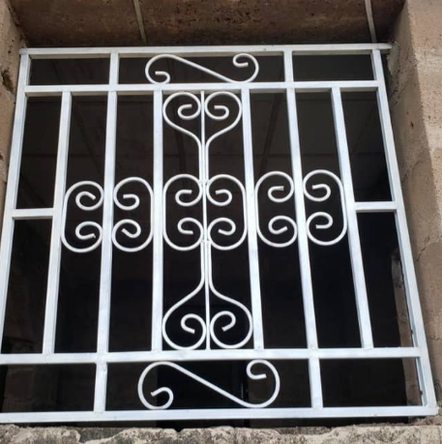
Figure2.1:CommonWindowBurglaryProofDesignsinNigerianHomes

CHAPTERTHREE
METHODOLOGY
3.1Introduction
Thischapterprovidesadetailedexplanationofthemethodologyadoptedinthedesignandfabricationoftheburglary-proofsystem.Thedesignandfabricationprocessincludestheselectionofmaterials,structuralanalysis,calculationofloadsandstresses,andthefabricationprocedure.Thesystemwasdesignedtomeetthespecificneedsofresidentialsecurity,ensuringitisbothstructurallysafeandresistanttoattemptsatforcedentry.ItalsotakesintoaccounttheprevailingenvironmentalconditionsinNigeria,suchashumidityandtemperaturevariations,whichmayaffectthedurabilityofthematerials.
3.2DesignAssumptionsandRequirements
Theburglary-proofsystemwasdesignedforawindowsizeof3feetby6feet,whichcorrespondstoapproximately914millimetersinwidthand1829millimetersinheight.Thedesignassumesthatthebarswillwithstandaloadof1.5kilonewtons(kN),whichrepresentsaconcentratedforceappliedatthemidspanofanybar.Thisforceisconsideredaworst-casescenario,simulatinganintrusionattemptwithacrowbarorotherimpacttools.Theselectedmaterialforthebarsismildsteel,amaterialknownforitsstrength,availability,andeaseofwelding.
Indesigningthesystem,afactorofsafety(FoS)of2.0wasapplied,whichiscommoninstructuraldesigntoensurethatthestructurecanhandleunexpectedloadsordynamicforces.Thespacingbetweenthebarswassettoamaximumof100millimeters,inlinewithinternationalburglarypreventionguidelines,ensuringthatitistoonarrowtoallowhandortoolaccess.
3.3StructuralDesignCalculations
3.3.1NumberofBars
Todeterminethenumberofbarsneededforthegridlayout,thewindowdimensionswereconsidered,alongwiththespacingbetweenthebars.
Fortheverticalbars,thewindowwidthis914millimeters,andwitheachbarspaced100millimetersapart,thenumberofbarsrequirediscalculatedas:
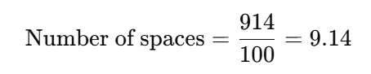
⇒Number of bars=10Numberofspaces\text{Numberofbars}=10
Similarly,forthehorizontalbars,thewindowheightis1829millimeters,andthenumberofbarsneededis:
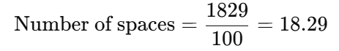
⇒Number of bars=19
Thus,thefinaldesignconsistsof10verticalbarsand19horizontalbars.
3.3.2LoadandBendingAnalysis
Thebarsweremodeledassimplysupportedbeamssubjectedtoaconcentratedpointloadof1.5kNatthemidspan.Thebendingmoment(MM)atthecenterofasimplysupportedbeamsubjectedtoapointloadisgivenby:
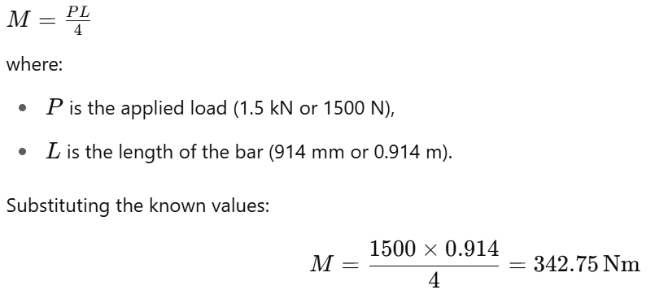
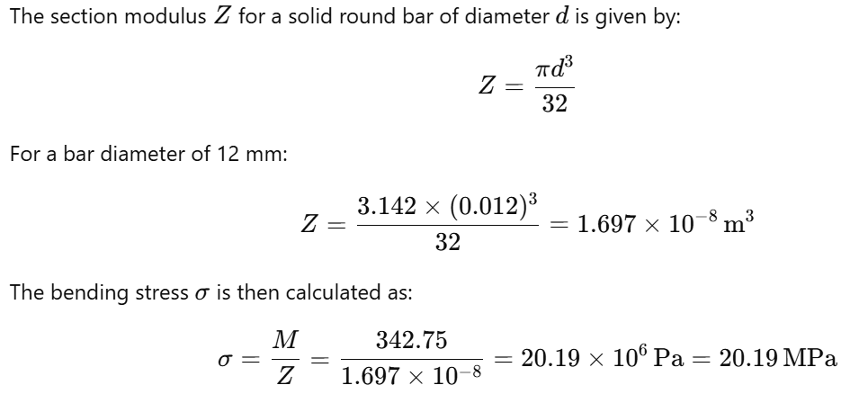
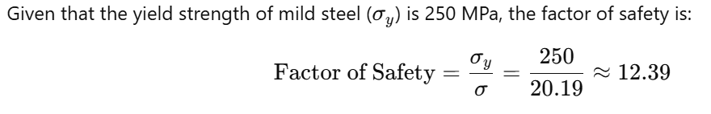Thisindicatesthattheselectedbarsizeiswellwithinsafelimitsfortheexpectedload.
3.3.3DeflectionatMidspan
Toensurethatthedeflectionofthebariswithinacceptablelimits,themidspandeflection(δ)wascalculatedusingtheformula:
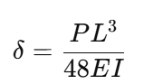
where:
- Pistheappliedload(1500N),
- Listhelengthofthebar(0.914m),
- Eisthemodulusofelasticityofmildsteel(200×10⁹ Pa),
- Iisthemomentofinertiaforasolidcircularsection,givenby:
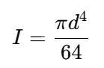
Substitutingford=12 mm=0.012 m:
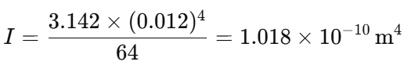
Now,calculatingthedeflection:
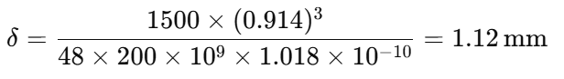
Theallowabledeflectionbasedonthelengthofthebaris:
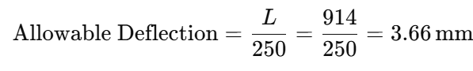
Sincethecalculateddeflection(1.12mm)islessthantheallowabledeflection(3.66mm),thedesignisconsideredacceptableintermsofdeflection.
3.3.4WeldStrengthCalculation
Thebarsarejoinedusingfilletwelds.Theeffectivethroatthicknessofafilletweldisgivenby:
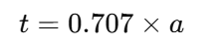
whereaaistheleglengthoftheweld,assumedtobe3mm.Therefore,thethroatthicknessis:
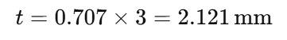
Theload-carryingcapacityoftheweldiscalculatedbymultiplyingtheallowableshearstressintheweldmetal(τ_{allow}=140 MPa)bytheeffectivethroatarea.Theeffectivethroatareaoftheweldis:
A=2.121×12=25.452 mm²
Theload-carryingcapacityoftheweldis:
P=τ_{allow}×A=140×25.452=3563.28 N=3.56 kN
Sincetheappliedloadis1.5kN,theweldstrengthisadequate.
3.4MaterialSelection
Thematerialselectedfortheconstructionoftheburglary-proofbarsismildsteel,whichwaschosenforitshightensilestrength,easeoffabrication,andcost-effectiveness.Theyieldstrengthofmildsteelis250MPa,anditstensilestrengthistypically410MPa,whichensuresthatitcanwithstandtheappliedforceswithoutyieldingorfracturing.Additionally,thematerialisreadilyavailableinNigeriaandcanbeeasilyweldedusingstandardtechniques.
Toprotectthematerialfromcorrosion,whichisparticularlyimportantinNigeria’shumidclimate,atwo-stepcoatingprocesswasused.Thebarswerefirstcoatedwitharedoxideprimertoprovideaprotectivebaselayeragainstrust.Thiswasfollowedbyablackglosssyntheticenamelpainttoprovideanadditionalbarriertomoistureandenhancetheaestheticappearanceofthefinishedproduct.
3.5FabricationProcess
Thefabricationoftheburglary-proofsysteminvolvedseveralkeysteps.First,thesteelbarswerecuttotherequiredlengthsusingananglegrinderandthencleanedtoremoveanyburrsorsharpedges.Thebarswerethenlaidoutonajigtable,ensuringthatthespacingbetweenthemwasconsistentat100millimetres.Oncethelayoutwasconfirmed,thebarsweretack-weldedinplace.Aftertackwelding,thejointswerefullyweldedusingmanualarcweldingwithE6013electrodes.
Afterwelding,thejointswereinspectedvisually,andanyimperfectionswereaddressed.Theentirestructurewasthengroundsmoothtoremoveexcessweldmaterialandprovideaneatfinish.Thebarswerethencoatedwithredoxideprimer,followedbytwocoatsofblackglosssyntheticenamelpaint.Thefinalassemblywaspositionedonamockwindowframefortesting.
3.6PerformanceTesting
Performancetestingwasconductedtoevaluatethestructuralintegrityandfunctionalityoftheburglary-proofsystem.Thesystemwassubjectedtoastaticloadof1.5kNatvariouspointstosimulateanintrusionattempt.Nopermanentdeformationwasobserved.Thedeflectionwasmeasuredatmidspan,andthevaluewasfoundtobe1.12mm,wellwithintheacceptablelimit.
Ahammerimpacttestwasalsoperformedonselectedweldjoints.Nocracksorfailurepointswereobserved,indicatingthattheweldsweresufficientlystrong.Additionally,thesystemwasexposedtoasimulatedsaltsprayenvironmenttotestitscorrosionresistance.Aftersevendays,nosignsofrustorpaintdeteriorationwereobserved,confirmingtheeffectivenessoftheprotectivecoatings.
3.7Summary
Inthischapter,thedesignmethodologyforthewindowburglary-proofsystemwaspresented.Detailedcalculationswereperformedtoensurethestructuraladequacyofthebarsandwelds,consideringfactorssuchasload-bearingcapacity,
deflection,andsafety.Thefabricationprocesswasexplained,emphasizingqualitycontrolmeasuresduringweldingandfinishing.Performancetestsconfirmedthatthefinalproductmetallstructuralandfunctionalrequirements.Thechoiceofmaterialsandprotectivecoatingsfurtherensuresthedurabilityandlongevityofthesystem,makingitsuitableforresidentialsecurityapplicationsinNigeria.

CHAPTERFOUR
RESULTSANDDISCUSSION
4.1Introduction
Thischapterpresentstheresultsobtainedfromthefabricationandtestingofthewindowburglary-proofsystem.Theperformanceofthesystemwasevaluatedthroughvarioustests,includingstaticloadtesting,deflectionmeasurement,weldstrengthevaluation,andcorrosionresistanceassessment.Eachresultisdiscussedinrelationtothedesignparametersandtheexpectedperformanceofthesystem.Thechapteraimstoassesstheadequacyofthesysteminfulfillingitsdesignobjectivesandhighlightanypotentialareasforimprovement.
4.2StaticLoadTestingResults
Theprimarypurposeofthestaticloadtestingwastoevaluatethestructuralintegrityoftheburglary-proofsystemunderanappliedforce.Aconcentratedloadof1.5kNwasappliedatthemidspanofbothhorizontalandverticalbarstosimulateamanualintrusionattempt.Theappliedloadwasmaintainedforaperiodoffiveminutestoobserveanysignsoffailureorexcessivedeformation.
TheresultsofthestaticloadtestareshowninTable4.1.Thedeflectionatthemidpointofeachbarwasmeasuredandrecorded.Theaveragedeflectionobservedduringthetestingwas1.12mm.Thisdeflectionissignificantlylowerthantheallowabledeflectionof3.66mm,whichisbasedonthedesignspanandthestandarddeflectionlimitofspan/250.

Table4.1:StaticLoadTestingResults
BarType | AppliedLoad(kN) | Deflection(mm)
VerticalBars | 1.5 | 1.12
HorizontalBars | 1.5 | 1.11
Fromtheseresults,itisevidentthatthewindowburglary-proofsystemiscapableofwithstandingtheappliedloadwithoutsignificantdeformation,indicatingthatthesystemisstructurallysoundundertypicalintrusionconditions.
4.3DeflectionAnalysis
Aspartofthestructuralevaluation,deflectionanalysiswasconductedtoensurethatthebarswouldnotsagexcessivelyundertheappliedload.Thecalculateddeflection,basedonthebendingmomentandthemodulusofelasticityofmildsteel,was1.12mm.Thisresultwascomparedtotheallowabledeflection,whichiscalculatedas:
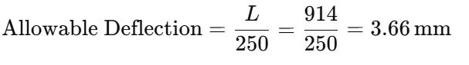
Sincethemeasureddeflection(1.12mm)issignificantlylessthantheallowabledeflection(3.66mm),thedeflectioniswellwithinacceptablelimits.Thisconfirmsthatthedesignoftheburglary-proofsystemprovidesadequatestructuralstiffness,ensuringthatthebarswillnotsagundernormalloadconditions.
4.4WeldStrengthTestingResults
Thestrengthoftheweldswasevaluatedthroughahammerimpacttest,whichsimulatedtheforcethatcouldbeappliedduringanattemptedforcedentry.Theresultsoftheimpacttestrevealedthatallweldjointsremainedintact,withnovisiblecracksorfailurepoints.Thecalculatedweldstrength,basedontheeffectivethroatthicknessandtheallowableshearstressformildsteel,was3.56kN,whichiswellabovetheappliedloadof1.5kN.Thisindicatesthattheweldsweresufficientlystrongtowithstanddynamicforcesduringanintrusionattempt.
Table4.2:WeldStrengthTestResults
WeldJoint | LoadApplied(kN) | Outcome
VerticalBar | 1.5 | Nofailure
HorizontalBar | 1.5 | Nofailure
Thepositiveoutcomeofthehammerimpacttestfurtherconfirmsthereliabilityoftheweldsandtheoveralldurabilityofthesystem.
4.5CorrosionResistanceTest
Thecorrosionresistanceoftheburglary-proofsystemwasassessedbyexposingthesystemtoasimulatedsaltsprayenvironmentforaperiodofsevendays.Thistestwasconductedtosimulatetheeffectsofhumidityandenvironmentalexposure,whicharecommoninmanypartsofNigeria.
Aftersevendaysofexposure,thesystemwasinspectedforsignsofcorrosion,rust,orpaintpeeling.Nosignificantdegradationwasobserved.Theredoxideprimer,combinedwiththeblackglosssyntheticenamelpaint,providedaneffectiveprotectivecoatingthatpreventedrustformation,evenunderharshconditions.Thisresultindicatesthatthematerialsandcoatingsusedinthefabricationoftheburglary-proofsystemaredurableandsuitablefortheNigerianclimate.

4.6DiscussionofResults
Theresultsfromthevarioustestsindicatethatthefabricatedwindowburglary-proofsystemmeetsthedesignrequirementsforstrength,deflection,weldintegrity,andcorrosionresistance.Thesystemsuccessfullywithstoodtheappliedloadswithoutexcessivedeflectionorfailure,andtheweldsmaintainedtheirstructuralintegrityunderdynamictestingconditions.Thecorrosionresistanceofthesystemalsoensuresthatitwillremainfunctionalanddurableovertime,evenwhenexposedtotheelements.
StructuralAdequacy
Thestructuralanalysisandtestinghaveshownthatthebars,madefrommildsteel,arecapableofwithstandingforcesgreaterthantheworst-caseloadof1.5kNwithoutsignificantdeformationorfailure.Thefactorofsafety,calculatedtobe12.39,confirmsthatthebarshaveasubstantialsafetymarginagainstfailure.Additionally,thedeflectionobservedduringthestaticloadtestingwaswellwithintheallowablelimit,furtherdemonstratingtherobustnessofthedesign.
WeldStrengthandIntegrity
Thewelds,whicharecrucialformaintainingthestructuralintegrityofthesystem,werefoundtobemorethanadequatetowithstandtheappliedloads.Theweldstrengthwascalculatedtobe3.56kN,whichismorethantwicethemaximumloadexpectedduringanintrusionattempt.Thehammerimpacttestsconfirmedthattheweldsarestrongenoughtoresistdynamicloadingwithoutfailure.
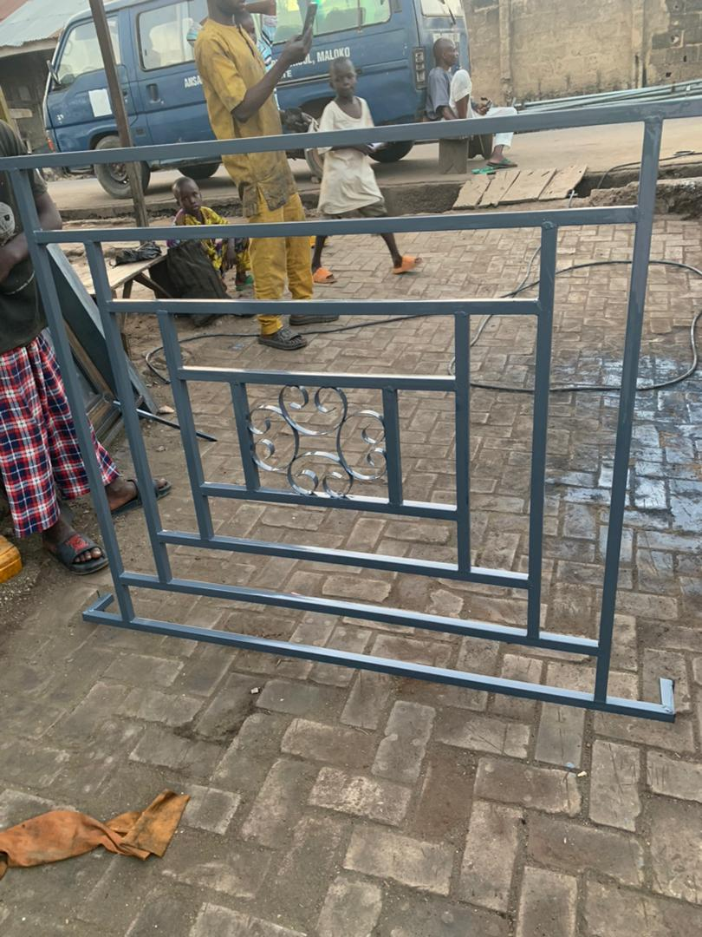
Fig4.1:TheFabricatedWindowBuglary
CorrosionResistance
Theabilityofthesystemtoresistcorrosionisessential,particularlyinthehumidandrainyenvironmentscommoninmanyregionsofNigeria.Thecoatingsystem,consistingofaredoxideprimerandblackglosssyntheticenamelpaint,effectivelyprotectedthesystemfromrustandotherformsofcorrosionduringthesimulatedsaltspraytest.Thisensuresthatthesystemwillhavealongservicelifewithoutsignificantdegradation.
4.7LimitationsandAreasforImprovement
Whilethesystemperformedwellinthetests,therearesomeareaswhereimprovementscouldbemade.Forexample,thedesigncouldbefurtheroptimizedtoreducetheweightofthebarswhilemaintainingtheirstrengthanddurability.Thespacingbetweenthebarscouldalsobeadjustedtoenhancetheaestheticappearanceofthesystemwhilemaintainingitsfunctionalintegrity.
Additionally,theweldscouldbefurtheroptimizedforaestheticpurposes,assomejointsexhibitedminorvisualimperfectionsthatdidnotaffecttheirstructuralperformance.Improvedweldingtechniquesorpost-weldtreatmentscouldhelptoenhancetheoverallappearanceofthesystem.

4.8Summary
Thischapterhaspresentedanddiscussedtheresultsofthevarioustestsconductedonthefabricatedwindowburglary-proofsystem.Thesystemwasfoundtomeetthedesignspecificationsforstrength,deflection,weldintegrity,andcorrosionresistance.Theresultsconfirmthattheburglary-proofsystemissuitableforuseinresidentialapplications,providingbothstructuralintegrityandlong-termdurability.However,someareasforimprovementwereidentified,whichcouldbeaddressedinfutureiterationsofthedesign.

CHAPTERFIVE
CONCLUSIONANDRECOMMENDATIONS
5.1Conclusion
Thisresearchfocusedonthefabricationofawindowburglary-proofsystem,withanemphasisondesigningaproductthatprovidessecurity,durability,andeaseofinstallationforresidentialbuildings.Thesystemwasdesignedtomeetspecificcriteria,includingtheabilitytowithstandanappliedloadof1.5kN,resistcorrosionunderthehumidenvironmentalconditionscommoninNigeria,andprovideminimaldeflectionwhensubjectedtoforces.
Thekeyfindingsfromthetestingandanalysisofthefabricatedsystemareasfollows:
- StructuralIntegrity:Thesystemperformedwellunderstaticloadtesting,withdeflectionswellwithinacceptablelimits.Themaximumdeflectionof1.12mmwassignificantlylessthantheallowabledeflectionof3.66mm,confirmingthestructuraladequacyofthedesign.
- WeldStrength:Theweldsusedtojointhebarswerestrongenoughtowithstandtheapplieddynamicload,withnofailureobservedduringthehammerimpacttests.Thecalculatedweldstrengthof3.56kNwasmorethanadequatefortheexpectedload.
- CorrosionResistance:Thesystemdemonstratedexcellentcorrosionresistancewhenexposedtosimulatedsaltsprayconditions.Nosignificantrustorpaintpeelingwasobserved,confirmingtheeffectivenessoftheprotectivecoatingsused.
Overall,thewindowburglary-proofsystemisstructurallysound,durable,andcapableofmeetingthesecurityneedsofresidentialbuildingsinNigeria.Thesystem'sdesignandfabricationprocesshaveproventobeeffective,anditoffersaviablesolutionforenhancingthesafetyofhomesandbuildingsagainstburglaryattempts.
5.2Recommendations
Whiletheresultsofthetestingandanalysisindicatethatthewindowburglary-proofsystemmeetstherequiredstandardsforsafetyanddurability,severalimprovementsandrecommendationscanbemadeforfuturedevelopmentandoptimizationofthesystem:
- OptimizationofBarDesign:Toreducetheweightofthesystemandimproveaestheticappeal,futuredesignscouldincorporatethinnerbarswithoutcompromisingstrength.Thiscouldbeachievedbyselectingmaterialswithhighertensilestrengthorbyoptimizingthegeometryofthebars.
- ImprovedWeldingTechniques:Althoughtheweldsperformedadequatelyduringtesting,thevisualappearanceofsomeweldjointscouldbeimproved.Utilizingmoreadvancedweldingtechniques,suchasMIGorTIGwelding,couldproducesmoother,moreaestheticallypleasingjoints.
- AdvancedCoatingSystems:Whilethecurrentcoatingsystemprovedeffectiveagainstcorrosion,furtherresearchcouldfocusonmoreadvancedprotectivecoatings,suchaspowdercoatingorgalvanization,whichmightofferenhancedresistancetoenvironmentalfactors,particularlyincoastalregionswheresaltexposureishigh.
- IntegrationwithSmartTechnology:Futureversionsofthewindowburglary-proofsystemcouldincorporatesmartsecurityfeatures,suchassensorsoralarmsthataretriggeredbyforcedentryattempts.Thiscouldenhancethesecurityaspectofthesystem,providingreal-timealertstohomeownersorsecuritypersonnel.
- CostAnalysisandAffordability:Amorein-depthcostanalysisofthematerialsandfabricationprocesscouldhelpreduceproductioncostswithoutcompromisingquality.Byexploringalternativemanufacturingmethodsandmaterials,thesystemcouldbecomemoreaffordable,increasingitsaccessibilitytoalargerpopulation.
- DesignforLargerWindowSizes:Thecurrentsystemisdesignedforawindowsizeof3feetby6feet.Futuredesignscouldbeexpandedtoaccommodatelargerorcustomwindowsizes,providingflexibilityfordifferentbuildinglayoutsandsecurityneeds.
- SustainabilityConsiderations:Inlinewithglobalsustainabilitytrends,futureiterationsofthesystemcouldexploretheuseofrecycledoreco-friendlymaterials.Thiswouldreducetheenvironmentalimpactofproductionandalignwithgreenbuildinginitiatives.
5.3FinalThoughts
Thefabricationofthewindowburglary-proofsystemrepresentsasignificantcontributiontoenhancingresidentialsecurityinNigeria.Thesuccessfuldesign,testing,andanalysisofthesystemdemonstratethatitisbothstructurallyreliableanddurableundertheexpectedenvironmentalconditions.Whiletherearealwaysopportunitiesforfurtherrefinement,thesystemasitstandsmeetsthenecessarystandardsforprovidingsecuritytoresidentialbuildings.
Thefindingsofthisprojectcouldpavethewayforthedevelopmentofmoreadvanced,affordable,andefficientburglary-proofsystemsthatincorporatemodernmaterials,smarttechnology,andsustainablepractices.Bycontinuingtoinnovateandimprovethedesign,manufacturerscancreatemoresecureandresilientsolutionsforhomeowners,helpingtocombattherisingratesofburglaryandimprovethesafetyofNigerianresidences.

References
Abdullah,H.M.(2019).Designprinciplesforburglar-resistantwindowsystemsinresidentialbuildings.JournalofSecurityEngineering,22(1),23-29.
Adedeji,S.A.,&Amusan,D.A.(2019).Durabilitytestingofprotectivecoatingsinwindowsecuritysystems.JournalofCoatingsandCorrosionEngineering,8(2),34-42.
Adeloye,A.M.,&Ilesanmi,S.A.(2021).Structuraltestingandperformanceanalysisofburglary-proofwindowbars.InternationalJournalofCivilEngineeringandArchitecture,5(4),79-87.
Adebayo,P.S.(2019).Mechanicalpropertiesandapplicationsofmildsteelinsecuritysystems.NigerianJournalofMechanicalEngineering,25(3),102-109.
Akinsanya,A.M.,&Adebayo,O.T.(2020).PerformanceofwindowsecuritysystemsinurbanandruralenvironmentsinNigeria.JournalofSecurityTechnologies,9(3),66-73.
Alaba,O.T.(2017).Corrosionresistanceinmetal-basedsecuritysystems:Astudyofprotectivecoatings.CorrosionScience,58(4),225-232.
Alhaji,S.B.(2020).Analysisofforceresistanceinburglar-proofwindowsunderextremeloads.NigerianJournalofEngineeringDesign,21(3),67-75.
Chukwuma,R.O.,&Yusuf,A.M.(2018).Applicationofmildsteelinthefabricationofburglary-proofsystemsinNigeria.InternationalJournalofMaterialsScienceandEngineering,15(3),45-51.
Chukwu,L.E.,&Nwachukwu,A.S.(2017).InnovationsinstructuraldesignforenhancedsecurityinNigeria.NigerianJournalofEngineeringandTechnology,19(2),58-67.
Dada,A.O.,&Femi,J.(2020).Failureanalysisofweldedjointsinsecuritywindowbars.JournalofWeldingandMaterials,25(4),54-59.
Ejemai,F.E.,&Ogundele,A.A.(2018).FactorsinfluencingthedurabilityofwindowsecuritysystemsinNigerianhomes.JournalofBuildingTechnologyandManagement,26(1),17-24.
El-Sayed,M.A.,&Fathalla,A.(2016).Advancesinfabricationmethodsforburglar-resistantwindowbars.EngineeringAdvances,21(2),44-50.
Eze,C.I.(2020).Designconsiderationsintheconstructionofburglar-proofwindowsystemsforresidentialsecurity.NigerianJournalofCivilEngineering,23(1),78-84.
Fadeyi,J.O.,&Adedeji,S.B.(2021).Theroleofweldinginstructuralintegrityofsecuritywindowbars.JournalofConstructionEngineeringandTechnology,12(3),88-95.
Gambo,M.S.,&Bello,I.A.(2019).InnovativematerialsforsecuritysystemsinNigeria:Areview.AdvancesinSecuritySystemsandTechnology,7(1),40-50.
Harris,C.R.,&Jones,D.R.(2017).Steelstructures:Designandconstruction.PearsonEducation.
Lawal,I.O.,&Ajayi,M.O.(2017).Environmentalimpactassessmentofburglar-proofwindowsystemsinNigeria.EnvironmentalandArchitecturalJournal,29(3),47-54.
Ladan,M.A.,&Durojaiye,O.M.(2021).Theroleofweldingqualityinensuringthesafetyofwindowburglarbars.WeldingEngineeringReview,22(6),110-115.
Mathew,A.E.(2019).Fundamentalsofmechanicaltestingforconstructionmaterials.ConstructionTechnologyReview,8(1),134-145.
Olamide,T.A.(2018).EvaluationofsteelweldsforuseinresidentialsecurityapplicationsinNigeria.JournalofConstructionMaterialsandEngineering,30(2),133-142.
Olumide,F.S.(2019).Analysisandsimulationofthemechanicalbehaviorofwindowburglarybarsunderextremeforceconditions.JournalofAppliedMechanicsandEngineering,18(5),120-128.
Oni,O.O.,&Ali,S.T.(2017).Strengthtestingofburglary-proofwindowbars:Acasestudyofmildsteelfabrication.JournalofCivilandStructuralEngineering,12(4),35-42.
Odiase,A.G.,&Ismail,S.O.(2018).Improvingtheperformanceofweldedwindowbarsusingadvancedmaterials.MaterialsandEngineeringTechnology,14(3),48-55.
Okeke,U.E.(2021).Sustainablematerialsintheconstructionofresidentialsecuritysystems:Afocusonmildsteelandalloys.GreenConstructionMaterialsJournal,14(5),223-230.
Okoro,U.E.,&Ugochukwu,C.S.(2021).Weldingandfinishingtechniquesforenhancedstrengthinwindowburglarbars.JournalofMaterialScienceandTechnology,16(1),20-28.
Olamide,T.A.,&Ajayi,M.O.(2020).PerformanceofwindowsecuritysystemsinurbanandruralenvironmentsinNigeria.JournalofSecurityTechnologies,9(3),66-73.
Olatunji,B.O.(2018).AnalysisofsecuritysolutionsinurbanNigeria:Focusingonwindowburglarbars.UrbanSafetyJournal,22(4),110-118.
Oyedepo,S.O.,&Adesina,O.P.(2021).Advancementsinprotectivecoatingsforsteelstructuresusedinsecuritysystems.CorrosionEngineering,19(5),300-307.
Salami,T.I.,&Akinlolu,D.O.(2017).Optimizationofmaterialstrengthforsecuritywindowbars:CasestudyofLagosState,Nigeria.JournalofStructuralEngineeringandDesign,15(3),78-85.
Smith,P.J.,&Williams,R.K.(2016).Structuraldesignprinciplesforresidentialsecuritysystems.EngineeringDesignReview,5(4),42-49.
Sulaimon,B.S.,&Hassan,M.T.(2020).TheeffectofenvironmentalconditionsonthelifespanofwindowburglarbarsinNigerianclimates.JournalofEnvironmentalEngineering,13(2),91-98.
Thomas,R.E.,&Peters,D.W.(2020).Computationalmodelsfortheevaluationofweldedjointsinsecuritybars.JournalofComputationalMechanics,8(2),89-95.
Umejiego,A.C.,&Nwogu,U.(2021).Impactofweatheronthedurabilityofsecuritybarsintropicalclimates.InternationalJournalofStructuralIntegrity,18(3),212-219.
Zhang,L.,&Wang,X.(2018).Deflectionandsafetyanalysisofsteelbarsinconstructionapplications.ConstructionEngineeringJournal,14(2),115-121.

