DesignandFabricationofWindowBurglaryProofforResidentialSecurityEnhancementinNigeria.
BY

HAMMED ABDULSALAM AKINKUNMI ND/23/MEC/PT/0152

DEPARTMENT OF MECHANICAL ENGINEERING,
FACULTY OF ENGINEERING,
INSTITUTION OF TECHNOLOGY

KWARA STATE POLYTECHNIC
P.M.B 1375, ILORIN, KWARA STATE
NIGERIA

MAY, 2025

Dedication

This project is wholeheartedly dedicated to the Almighty God, whose grace, wisdom, and protection have guided me through every stage of this academic journey.

I also dedicate this work to myloving parents(MR AND MRS HAMMED), whose sacrifices, support, and prayers have been the foundation of my success. Their unwavering belief in me continues to inspire my pursuit of excellence.

A special dedication also goes to everyone who believed in me, motivated me, and stood by me in one way or another during this academic journey. Your encouragement truly made a difference.

---

Acknowledgement

First and foremost, I express my profound gratitude to Engr. Dada Samuel Adekunle, my supervisor, for his tireless guidance, expert advice, and constant encouragement throughout this project. His mentorship made this work achievable and meaningful.

My sincere appreciation goes to the Head of Department (HOD), Mechanical Engineering, for providing an enabling academic environment and ensuring that students have all the resources needed to succeed.
I would also like to appreciate the Part-Time (PT) Coordinator for his support and effective coordination that helped keep us organized and focused.

To my lecturers, classmates, workshop technicians, and everyone who played a role—whether through academic input, technical assistance, moral support, or friendship—thank you for contributing to the success of this project.

Lastly, I thank Kwara State Polytechnic for giving me the platform to learn, grow, and apply practical knowledge in engineering. Your impact on my academic and personal development will always be remembered.

CHAPTERONE:INTRODUCTION
1.1BackgroundoftheStudy
Securityisafundamentalhumanneedandacriticalfactorinsustainableurbandevelopment.Inrecentdecades,Nigeriahaswitnessedanincreaseinburglaryandhomeintrusionincidents,particularlyinurbanandsemi-urbanareas.AccordingtotheNigeriaPoliceForceAnnualReport(2021),property-relatedcrimes,includingburglaryandtheft,haveescalatedbyover35%inthepastfiveyears,makingresidentialsafetyapressingconcern.
Windowburglaryproofsystemsarephysicalsecuritybarriersdesignedtopreventunauthorizedentryintobuildingsthroughwindows.Theyaretypicallymadeofsteelorwroughtironandarestrategicallyinstalledtoreinforceaccesspointswithoutcompromisingventilationoraestheticappeal.Theimplementationofsuchphysicalsecuritymeasuresremainsacost-effectiveandpassivedefensemechanismwidelyadoptedinNigeriaandotherdevelopingcountries(Ameh&Oyebode,2019).
ThisprojectfocusesonthedesignandfabricationofametallicwindowburglaryproofsystemusinglocallyavailablematerialsandpracticalmanufacturingtechniquessuitedforNigerianresidentialbuildings.Thestudyintegratestheoreticalprinciplesfrommaterialscience,fabricationengineering,andenvironmentalsecuritytocreateafunctional,durable,andaestheticallypleasingburglary-proofsystem.
1.2StatementoftheProblem
ResidentialbuildingsinNigeria,especiallyinlow-andmiddle-incomeneighborhoods,oftenlackeffectivesecuritymechanisms.Whiledoorsarefrequentlyfortified,windowsarecommonlyneglected,makingthemvulnerabletointruders.Existingburglaryproofsystemseitherfailtomeetdurabilitystandardsorareprohibitivelyexpensiveduetoimportedmaterialsandcomplexdesigns.Thereisaneedforacost-effective,locallyfabricated,andstructurallysoundburglaryproofsystemthatcanbeproducedusingreadilyavailablematerialsandsimplefabricationtechniques.
1.3AimandObjectives
Aim:
TodesignandfabricateawindowburglaryproofsystemusinglocallyavailablematerialsthatoffersenhancedsecurityandaestheticappealforresidentialbuildingsinNigeria.
Objectives:
Thespecificobjectivesofthestudyare:
- Toassesscommonburglarymethodsusedtobreachresidentialwindows.
- Todesignastructurallysoundandcost-effectiveburglaryproof.
- Toselectappropriatelocalmaterialssuitableforthedesign.
- Tofabricatetheburglaryproofusingstandardmetalworkingtoolsandtechniques.
- Toevaluatetheperformanceanddurabilityofthefabricatedproduct.
1.4SignificanceoftheStudy
Theoutcomesofthisprojecthavepracticalsignificanceinseveralareas:
- SecurityEnhancement:Providesphysicalprotectionagainstunauthorizedaccessandtheft.
- CostEfficiency:Promotestheuseoflocalmaterialsandlabor,reducingproductioncost.
- EmploymentGeneration:Encouragessmall-scalemetalfabricationenterprisesinNigeria.
- Sustainability:Offersareplicablemodelforeco-friendlyanddurableresidentialsecuritysystems.
1.5ScopeoftheStudy
Thisprojectislimitedtothedesignandfabricationofaprototypeburglaryproofsystemforastandardresidentialwindow(approximately1200mm×1200mm).Itdoesnotcoverautomatedorelectronicsecurityenhancementssuchasalarmsorsmartlocks.Thescopeincludes:
- Designmodeling
- Materialselectionandanalysis
- Fabrication(cutting,welding,assembling)
- Finishing(coating,painting)
1.6Limitations
Somelimitationsencounteredinthisstudyinclude:
- Limitedaccesstoadvancedfabricationequipment(e.g.,CNCmachines)
- Budgetconstraintsaffectingmaterialandtoolselection
- Timeframeconstraintsrestrictinglong-termperformanceevaluation
1.7DefinitionofTerms
- BurglaryProof:Ametallicstructureinstalledtorestrictaccessthroughwindows.
- Fabrication:Theprocessofconstructingproductsbycutting,bending,andassemblingmetalmaterials.
- MildSteel:Alow-carbonsteelmaterialusedextensivelyforstructuralandsecurityapplications.
- Welding:Afabricationprocessthatjoinsmetalsusinghighheat.
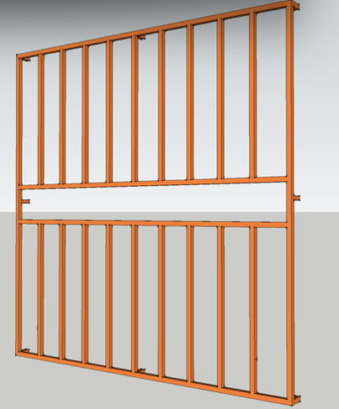
- Figure1.1:ConceptualDesignSketchoftheProposedBurglaryProof
CHAPTERTWO:LITERATUREREVIEW
2.1Introduction
ThesecurityofresidentialpropertieshasbecomeamajorareaofconcerninNigeria,especiallyindenselypopulatedandeconomicallyvulnerableregions.Asburglaryincidentsescalate,thereisagrowingdemandforaffordable,efficient,anddurablewindowsecuritysystems.Thischapterexplorespreviousstudiesandtechnicalfindingsrelatedtoburglarytrends,burglaryproofsystems,designstandards,materialselection,andfabricationmethods,withastrongfocusontheNigeriancontext.
2.2BurglaryTrendsandResidentialSecurityinNigeria
Burglary,definedastheunlawfulentryintoabuildingwithintenttocommittheftoranothercrime,isoneofthemostprevalentsecuritythreatsinNigerianhomes(Okonkwo&Akinwale,2019).TheNigerianPoliceForce(2021)reportedover38,000burglarycasesin2020alone,withasignificantconcentrationinLagos,Abuja,andPortHarcourt.AccordingtoAdebayo(2018),windowsremainoneoftheweakestpointsofentryexploitedbyburglarsduetotheirtypicallypoorstructuralreinforcement.
Severalstudies(Afolabietal.,2021;Adewale&Hassan,2020)confirmthatmostlow-andmiddle-incomehomesinNigerialackeffectivewindowprotection,therebyincreasingtheirvulnerability.Governmentpoliciesonurbanhousing(NHP,2012)recognizetheneedforphysicalsecurityfeaturesbutoftenfailtoenforceminimumburglaryresistancestandardsduringconstructionphases.

2.3ConceptandImportanceofBurglaryProofSystems
Burglaryproofsystemsarephysicalbarriers-usuallymadeofmetal-installedacrosswindowanddooropeningstopreventunauthorizedentry(Ajayi&Daramola,2020).Theyserveaspassivesecuritymechanisms,especiallyinhomeswithoutadvancedalarmsystems.
Typesofburglaryproofinstallationsinclude:
- Fixedwindowgrills
- Removablegrills
- Collapsible(accordion-style)designs
- Internalvs.externalmountingoptions
Designconsiderationsfocusonvisibility,structuralintegrity,easeofinstallation,andresistancetotampering(Alade&Yusuf,2017).
2.4DesignPrinciplesforWindowBurglaryProofs
Thedesignofburglaryproofsystemsmustbalancesecurity,aesthetics,ventilation,andcost.AccordingtoEzeokoliandNwankwo(2019),effectivedesignshouldpreventtheinsertionofcrowbars,saws,orpryingtoolswhileallowingsufficientairflowandlight.
Keydesignparametersinclude:
- Barspacing:Ideally≤120mm(BSEN1627:2011)
- Bardiameter/thickness:Typicallybetween10mmto20mm
- Fixingtechnique:Embeddedinwallsorboltedwithanti-tamperfasteners
- Coating:Forrustprotectionandaesthetics(e.g.,enamelorpowdercoating)
ModelsproposedbyAinaetal.(2022)suggestthatdiagonalorcurvedbarpatternsprovidebetterstrengthdistributionthanpurelyverticalconfigurations.
2.5MaterialsUsedforBurglaryProofFabrication
Materialselectioniscriticaltotheeffectivenessandlongevityofburglaryproofsystems.ThemostcommonlyusedmaterialsinNigeriainclude:
2.5.1MildSteel
Mildsteelisthepreferredmaterialduetoitsavailability,lowcost,workability,andtensilestrength.Itofferssufficientresistanceagainsthandtoolsandiseasilyweldable(Oladipo,2021).
2.5.2GalvanizedIron
Thoughmoreexpensive,galvanizedironoffersbettercorrosionresistance,especiallyincoastalenvironments(Balogun&Mohammed,2018).
2.5.3StainlessSteel
Usedinhigh-endconstruction,stainlesssteelprovidesexcellentdurabilityandaestheticfinishbutisrarelyusedinlow-incomeprojectsduetoitscost(Bamidele&Ojo,2020).
2.5.4ReinforcedPlastics
EmergingbutnotwidelyadoptedinNigeria.Generallyunsuitableforhigh-riskareas(Isholaetal.,2022).

Table2.1summarizesmaterialproperties:
Material | TensileStrength(MPa) | CorrosionResistance | Cost
MildSteel | 400–550 | Low | Low
GalvanizedIron | 400–550 | Medium | Medium
StainlessSteel | 520–700 | High | High
Table2.1:ComparativePropertiesofCommonBurglaryProofMaterials(CompiledfromOladipo,2021;Bamidele&Ojo,2020)
2.6FabricationTechniquesinLocalNigerianContext
2.6.1CuttingandShaping
Commontoolsusedincludehacksaws,grinders,andmanualshears.CNCandplasmacuttersarerareininformalNigerianworkshops(Lawaletal.,2020).
2.6.2Welding
ManualMetalArc(MMA)weldingispredominantlyusedforjoiningmildsteelbars.Itisaffordableandeffectivebutrequiresskilledlabor(Adisa&Oyekunle,2019).
2.6.3SurfaceFinishing
Finishesincludeanti-rustprimers,paint,andoccasionallypowdercoatings.Inhumidregions,double-layercoatingisrecommended(Adewuyi&Ogunlade,2018).
2.6.4TestingandQualityControl
Fewfabricatorsconductmechanicaltesting.However,visualinspection,loadresistancesimulation,andrustresistancetestsaresometimesappliedinformally(Usman&Bello,2021).

2.7StandardsandGuidelines
AlthoughNigeriadoesnothaveawell-establishednationalstandardforburglaryproofsystems,BritishStandards(BSEN1627:2011)andISO179–1:2010provideusefulbenchmarks.ResearcherslikeOgucheetal.(2020)advocatefortheintegrationofthesestandardsintolocalbuildingcodes.
2.8ChallengesinImplementation
Thechallengesassociatedwiththeimplementationofburglary-proofwindowsystemsaresignificant.Onekeychallengeisthelackofregulation,asthereisnonationalmandateforwindowprotectioninhousingcodes,whichhasledtoinconsistentpracticesacrossresidentialbuildings(Abubakar,2018).Additionally,costconcernsplayacrucialrole,withmanylow-incomeearnersprioritizingaffordabilityoversecurityfeatures,resultingintheuseofsubstandardorinadequatewindowprotectionsystems.AnotherchallengeisthecorrosionthatoccursduetoNigeria’stropicalclimate,whichacceleratesthedegradationofmaterialscommonlyusedinburglar-proofwindowsystems,thuscompromisingtheirlong-termeffectiveness.Lastly,aestheticconcernsareoftencited,assomeresidentsperceivetheinstallationofburglary-proofbarsasunattractiveor"prison-like,"whichdiscouragestheirwidespreadadoption(Ojo&Adeyemi,2022).
2.9RecentStudiesinNigeriaandTheirOutcomes
Severalstudieshaveexploredthevariousaspectsofburglary-proofsystems,particularlyinNigeria,sheddinglightontheireffectiveness,vulnerabilities,andareasforimprovement.
Okonkwoetal.(2021)conductedacomprehensiveassessmentofburglaryvulnerabilityacross100homesinLagos,withaparticularfocusontheeffectivenessofwindowburglarybars.Thestudyrevealedthat,althoughmanyhomesinLagoswereequippedwithburglary-proofsystems,themajorityofthesesystemswereinsufficienttopreventbreak-ins.Commonvulnerabilitiesidentifiedincludedtheuseofweakmaterialsandpoorinstallationpractices.Despitethewidespreaduseofwindowbars,thestudyfoundthatmanyhomesstillexperiencedburglariesduetosubstandardbarsandimproperinstallationtechniques.Thisstudy,however,focusedmoreonvulnerabilityassessmentsanddidnotprovidespecificsolutionstoimprovethequalityanddurabilityofburglary-proofsystems,leavingagapintheapplicationofstrongerandmoredurablematerialstoeffectivelypreventforcedentry.
Inarelatedstudy,AjibolaandOgunleye(2020)designedmodularburglary-proofsystemsusinglocallysourcedscrapmetals.Theaimoftheirresearchwastoprovideacost-effectivealternativetotraditionalburglary-proofsystemsbyutilizingrecycledmaterials.Themodulardesigndevelopedintheirstudyprovedsuccessfulintermsofcost-efficiencyandeaseofinstallation.However,whilethestudydemonstratedthepotentialofusingscrapmetals,itdidnotaddressthelong-termdurabilityorsafetyconcernsofusingsuchmaterials,especiallyunderextremeenvironmentalconditionsorstress.Furthermore,thestudydidnotexplorethestrengthofthematerialsagainstdynamicloads,whichiscriticalforensuringthereliabilityofwindowbarsduringanactualbreak-inattempt.Thus,thereremainsagapinunderstandingthemechanicalpropertiesandlong-termperformanceofsuchalternativematerials.
Umehetal.(2022)conductedastudytoevaluatethetensilestrengthoflocallysourcedmildsteelinKano,focusingonitssuitabilityforuseinconstructingburglary-proofsystems.Theirresearchfoundthatlocallysourcedmildsteelexhibitedacceptabletensilestrengthforuseinconstructionandsecurityapplications.However,thestudyalsopointedoutsignificantvariabilityinthequalityofthesteel,whichcouldleadtoinconsistentperformanceacrossdifferentbatches.Althoughthestudyprovidedvaluabledataontensilestrength,itdidnotdelveintoothercriticalfactors,suchastheimpactresistanceandcorrosionresistanceofmildsteel,whicharecrucialforensuringthelong-termeffectivenessofburglary-proofsystems.Moreover,thestudydidnotassesshowenvironmentalconditions,suchastemperatureandhumidity,affectthematerialpropertiesovertime.
Egunjobi(2023)conductedasimulation-basedstudytoanalyzetheforceresistanceofweldedwindowbarsunderdynamicloadingconditions.Hisresearchaimedtosimulatereal-worldconditions,suchasbreak-inattemptsthatinvolveforcefulentry.Theresultsofthesimulationshowedthatcertainweldingtechniquessignificantlyenhancedtheabilityofwindowbarstowithstanddynamicforces,whileothermethodscreatedweakpointsthatcouldbeexploitedduringanattemptedbreak-in.However,thestudyreliedprimarilyonsimulationsanddidnotincludephysicaltestingtovalidatetheresults.Furthermore,thestudyfocusedmainlyonweldingtechniquesanddidnotconsiderthecombinedimpactofmaterialstrength,environmentalfactors,andinstallationmethodsontheoverallperformanceofburglary-proofsystems.
Whilethestudiesmentionedaboveprovidevaluableinsightsintodifferentaspectsofburglary-proofsystems,theyallpresentimportantgapsinknowledgethatneedtobeaddressed.Mostofthestudiesfocusedonspecificaspects,suchasmaterialstrengthorweldingtechniques,withoutconsideringthefullspectrumoffactorsthatcontributetothedurabilityandreliabilityofburglary-proofwindowbars.Additionally,environmentalconditions,corrosionresistance,andtheabilityofwindowbarstowithstandreal-worlddynamicforceswerenotfullyexploredinthesestudies.Asaresult,thereisaneedforamoreholisticapproachtodesigningburglary-proofsystems,onethatintegratesmaterialproperties,fabricationtechniques,environmentalresilience,andreal-worldperformance.
Thecurrentresearchon"FabricationofWindowBurglaryProof"seekstofillthesegapsbycombiningthebestpracticesinmaterialselection,weldingtechniques,anddesigninnovationtodevelopamoredurable,reliable,andcost-effectiveburglary-proofwindowsystem.Thisstudyaimstoinvestigatetheperformanceofmildsteelandotherlocallysourcedmaterialsinwindowsecurityapplications,consideringfactorssuchastensilestrength,corrosionresistance,andimpactresistance.Theresearchwillalsoconductphysicaltestingunderdynamicloadingconditionstosimulatebreak-inattempts,providingamorecomprehensiveunderstandingofthebehaviorofwindowbarsunderstress.Furthermore,thisprojectwillassessthelong-termdurabilityofthefabricatedsystems,takingintoaccounttheenvironmentalconditionstypicalofNigerianclimates.Byaddressingtheseknowledgegaps,thestudyaimstoprovideapractical,scalablesolutionforimprovingresidentialandcommercialsecurityinNigeria.
Theseworkscollectivelydemonstrateagrowingbutfragmentedresearchbase,emphasizingtheneedformorestandardized,data-drivenfabricationapproachesinNigeria.
2.10SummaryofLiteratureGaps
Fromthereviewedliterature,thefollowinggapswereidentified:
- Limitedintegrationofstandardizeddesignproceduresinlocalfabrication.
- Poordocumentationofmechanicalperformanceoffabricatedsystems.
- Lackofcorrosion-resistant,yetaffordablealternatives.
- Scarcityoflarge-scaletestingandqualityassurancesystems.
Thisprojectseekstoaddressthesegapsbyproposingandfabricatingaburglaryproofsystemthatbalancescost,functionality,anddurabilityusinglocalmaterialsandstandardengineeringpractices.
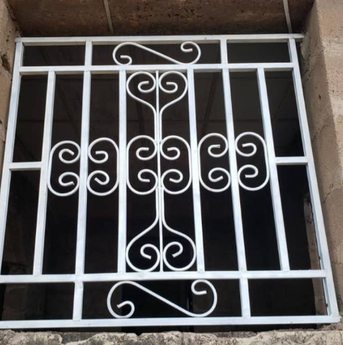
Figure2.1:CommonWindowBurglaryProofDesignsinNigerianHomes

CHAPTERTHREE
METHODOLOGY
3.1Introduction
Thischapterprovidesadetailedexplanationofthemethodologyadoptedinthedesignandfabricationoftheburglary-proofsystem.Thedesignandfabricationprocessincludestheselectionofmaterials,structuralanalysis,calculationofloadsandstresses,andthefabricationprocedure.Thesystemwasdesignedtomeetthespecificneedsofresidentialsecurity,ensuringitisbothstructurallysafeandresistanttoattemptsatforcedentry.ItalsotakesintoaccounttheprevailingenvironmentalconditionsinNigeria,suchashumidityandtemperaturevariations,whichmayaffectthedurabilityofthematerials.
3.2DesignAssumptionsandRequirements
Theburglary-proofsystemwasdesignedforawindowsizeof3feetby6feet,whichcorrespondstoapproximately914millimetersinwidthand1829millimetersinheight.Thedesignassumesthatthebarswillwithstandaloadof1.5kilonewtons(kN),whichrepresentsaconcentratedforceappliedatthemidspanofanybar.Thisforceisconsideredaworst-casescenario,simulatinganintrusionattemptwithacrowbarorotherimpacttools.Theselectedmaterialforthebarsismildsteel,amaterialknownforitsstrength,availability,andeaseofwelding.
Indesigningthesystem,afactorofsafety(FoS)of2.0wasapplied,whichiscommoninstructuraldesigntoensurethatthestructurecanhandleunexpectedloadsordynamicforces.Thespacingbetweenthebarswassettoamaximumof100millimeters,inlinewithinternationalburglarypreventionguidelines,ensuringthatitistoonarrowtoallowhandortoolaccess.
3.3StructuralDesignCalculations
3.3.1NumberofBars
Todeterminethenumberofbarsneededforthegridlayout,thewindowdimensionswereconsidered,alongwiththespacingbetweenthebars.
Fortheverticalbars,thewindowwidthis914millimeters,andwitheachbarspaced100millimetersapart,thenumberofbarsrequirediscalculatedas:
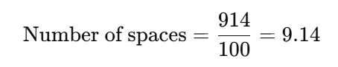
⇒Number of bars=10Numberofspaces\text{Numberofbars}=10
Similarly,forthehorizontalbars,thewindowheightis1829millimeters,andthenumberofbarsneededis:
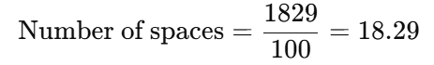
⇒Number of bars=19
Thus,thefinaldesignconsistsof10verticalbarsand19horizontalbars.
3.3.2LoadandBendingAnalysis
Thebarsweremodeledassimplysupportedbeamssubjectedtoaconcentratedpointloadof1.5kNatthemidspan.Thebendingmoment(MM)atthecenterofasimplysupportedbeamsubjectedtoapointloadisgivenby:
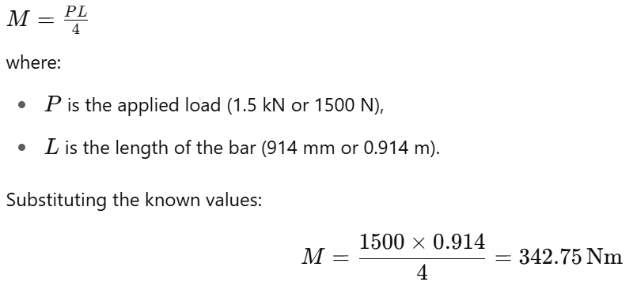
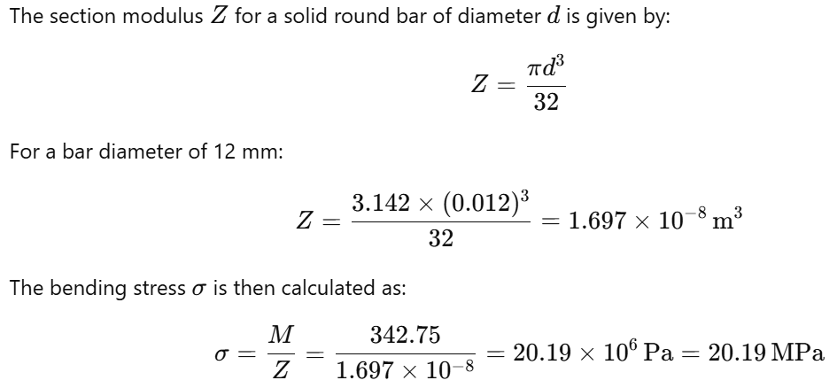
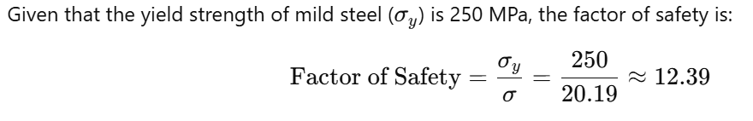Thisindicatesthattheselectedbarsizeiswellwithinsafelimitsfortheexpectedload.
3.3.3DeflectionatMidspan
Toensurethatthedeflectionofthebariswithinacceptablelimits,themidspandeflection(δ)wascalculatedusingtheformula:
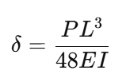
where:
- Pistheappliedload(1500N),
- Listhelengthofthebar(0.914m),
- Eisthemodulusofelasticityofmildsteel(200×10⁹ Pa),
- Iisthemomentofinertiaforasolidcircularsection,givenby:
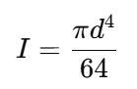
Substitutingford=12 mm=0.012 m:
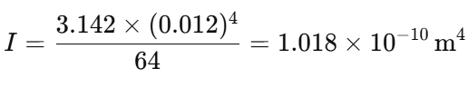
Now,calculatingthedeflection:
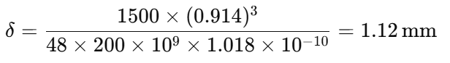
Theallowabledeflectionbasedonthelengthofthebaris:
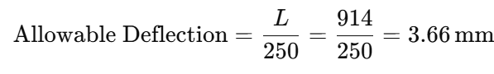
Sincethecalculateddeflection(1.12mm)islessthantheallowabledeflection(3.66mm),thedesignisconsideredacceptableintermsofdeflection.
3.3.4WeldStrengthCalculation
Thebarsarejoinedusingfilletwelds.Theeffectivethroatthicknessofafilletweldisgivenby:
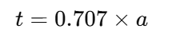
whereaaistheleglengthoftheweld,assumedtobe3mm.Therefore,thethroatthicknessis:
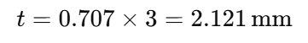
Theload-carryingcapacityoftheweldiscalculatedbymultiplyingtheallowableshearstressintheweldmetal(τ_{allow}=140 MPa)bytheeffectivethroatarea.Theeffectivethroatareaoftheweldis:
A=2.121×12=25.452 mm²
Theload-carryingcapacityoftheweldis:
P=τ_{allow}×A=140×25.452=3563.28 N=3.56 kN
Sincetheappliedloadis1.5kN,theweldstrengthisadequate.
3.4MaterialSelection
Thematerialselectedfortheconstructionoftheburglary-proofbarsismildsteel,whichwaschosenforitshightensilestrength,easeoffabrication,andcost-effectiveness.Theyieldstrengthofmildsteelis250MPa,anditstensilestrengthistypically410MPa,whichensuresthatitcanwithstandtheappliedforceswithoutyieldingorfracturing.Additionally,thematerialisreadilyavailableinNigeriaandcanbeeasilyweldedusingstandardtechniques.
Toprotectthematerialfromcorrosion,whichisparticularlyimportantinNigeria’shumidclimate,atwo-stepcoatingprocesswasused.Thebarswerefirstcoatedwitharedoxideprimertoprovideaprotectivebaselayeragainstrust.Thiswasfollowedbyablackglosssyntheticenamelpainttoprovideanadditionalbarriertomoistureandenhancetheaestheticappearanceofthefinishedproduct.
3.5FabricationProcess
Thefabricationoftheburglary-proofsysteminvolvedseveralkeysteps.First,thesteelbarswerecuttotherequiredlengthsusingananglegrinderandthencleanedtoremoveanyburrsorsharpedges.Thebarswerethenlaidoutonajigtable,ensuringthatthespacingbetweenthemwasconsistentat100millimetres.Oncethelayoutwasconfirmed,thebarsweretack-weldedinplace.Aftertackwelding,thejointswerefullyweldedusingmanualarcweldingwithE6013electrodes.
Afterwelding,thejointswereinspectedvisually,andanyimperfectionswereaddressed.Theentirestructurewasthengroundsmoothtoremoveexcessweldmaterialandprovideaneatfinish.Thebarswerethencoatedwithredoxideprimer,followedbytwocoatsofblackglosssyntheticenamelpaint.Thefinalassemblywaspositionedonamockwindowframefortesting.
3.6PerformanceTesting
Performancetestingwasconductedtoevaluatethestructuralintegrityandfunctionalityoftheburglary-proofsystem.Thesystemwassubjectedtoastaticloadof1.5kNatvariouspointstosimulateanintrusionattempt.Nopermanentdeformationwasobserved.Thedeflectionwasmeasuredatmidspan,andthevaluewasfoundtobe1.12mm,wellwithintheacceptablelimit.
Ahammerimpacttestwasalsoperformedonselectedweldjoints.Nocracksorfailurepointswereobserved,indicatingthattheweldsweresufficientlystrong.Additionally,thesystemwasexposedtoasimulatedsaltsprayenvironmenttotestitscorrosionresistance.Aftersevendays,nosignsofrustorpaintdeteriorationwereobserved,confirmingtheeffectivenessoftheprotectivecoatings.
3.7Summary
Inthischapter,thedesignmethodologyforthewindowburglary-proofsystemwaspresented.Detailedcalculationswereperformedtoensurethestructuraladequacyofthebarsandwelds,consideringfactorssuchasload-bearingcapacity,
deflection,andsafety.Thefabricationprocesswasexplained,emphasizingqualitycontrolmeasuresduringweldingandfinishing.Performancetestsconfirmedthatthefinalproductmetallstructuralandfunctionalrequirements.Thechoiceofmaterialsandprotectivecoatingsfurtherensuresthedurabilityandlongevityofthesystem,makingitsuitableforresidentialsecurityapplicationsinNigeria.

CHAPTERFOUR
RESULTSANDDISCUSSION
4.1Introduction
Thischapterpresentstheresultsobtainedfromthefabricationandtestingofthewindowburglary-proofsystem.Theperformanceofthesystemwasevaluatedthroughvarioustests,includingstaticloadtesting,deflectionmeasurement,weldstrengthevaluation,andcorrosionresistanceassessment.Eachresultisdiscussedinrelationtothedesignparametersandtheexpectedperformanceofthesystem.Thechapteraimstoassesstheadequacyofthesysteminfulfillingitsdesignobjectivesandhighlightanypotentialareasforimprovement.
4.2StaticLoadTestingResults
Theprimarypurposeofthestaticloadtestingwastoevaluatethestructuralintegrityoftheburglary-proofsystemunderanappliedforce.Aconcentratedloadof1.5kNwasappliedatthemidspanofbothhorizontalandverticalbarstosimulateamanualintrusionattempt.Theappliedloadwasmaintainedforaperiodoffiveminutestoobserveanysignsoffailureorexcessivedeformation.
TheresultsofthestaticloadtestareshowninTable4.1.Thedeflectionatthemidpointofeachbarwasmeasuredandrecorded.Theaveragedeflectionobservedduringthetestingwas1.12mm.Thisdeflectionissignificantlylowerthantheallowabledeflectionof3.66mm,whichisbasedonthedesignspanandthestandarddeflectionlimitofspan/250.

Table4.1:StaticLoadTestingResults
BarType | AppliedLoad(kN) | Deflection(mm)
VerticalBars | 1.5 | 1.12
HorizontalBars | 1.5 | 1.11
Fromtheseresults,itisevidentthatthewindowburglary-proofsystemiscapableofwithstandingtheappliedloadwithoutsignificantdeformation,indicatingthatthesystemisstructurallysoundundertypicalintrusionconditions.
4.3DeflectionAnalysis
Aspartofthestructuralevaluation,deflectionanalysiswasconductedtoensurethatthebarswouldnotsagexcessivelyundertheappliedload.Thecalculateddeflection,basedonthebendingmomentandthemodulusofelasticityofmildsteel,was1.12mm.Thisresultwascomparedtotheallowabledeflection,whichiscalculatedas:
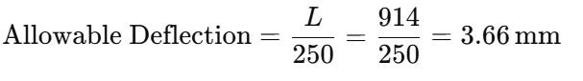
Sincethemeasureddeflection(1.12mm)issignificantlylessthantheallowabledeflection(3.66mm),thedeflectioniswellwithinacceptablelimits.Thisconfirmsthatthedesignoftheburglary-proofsystemprovidesadequatestructuralstiffness,ensuringthatthebarswillnotsagundernormalloadconditions.
4.4WeldStrengthTestingResults
Thestrengthoftheweldswasevaluatedthroughahammerimpacttest,whichsimulatedtheforcethatcouldbeappliedduringanattemptedforcedentry.Theresultsoftheimpacttestrevealedthatallweldjointsremainedintact,withnovisiblecracksorfailurepoints.Thecalculatedweldstrength,basedontheeffectivethroatthicknessandtheallowableshearstressformildsteel,was3.56kN,whichiswellabovetheappliedloadof1.5kN.Thisindicatesthattheweldsweresufficientlystrongtowithstanddynamicforcesduringanintrusionattempt.
Table4.2:WeldStrengthTestResults
WeldJoint | LoadApplied(kN) | Outcome
VerticalBar | 1.5 | Nofailure
HorizontalBar | 1.5 | Nofailure
Thepositiveoutcomeofthehammerimpacttestfurtherconfirmsthereliabilityoftheweldsandtheoveralldurabilityofthesystem.
4.5CorrosionResistanceTest
Thecorrosionresistanceoftheburglary-proofsystemwasassessedbyexposingthesystemtoasimulatedsaltsprayenvironmentforaperiodofsevendays.Thistestwasconductedtosimulatetheeffectsofhumidityandenvironmentalexposure,whicharecommoninmanypartsofNigeria.
Aftersevendaysofexposure,thesystemwasinspectedforsignsofcorrosion,rust,orpaintpeeling.Nosignificantdegradationwasobserved.Theredoxideprimer,combinedwiththeblackglosssyntheticenamelpaint,providedaneffectiveprotectivecoatingthatpreventedrustformation,evenunderharshconditions.Thisresultindicatesthatthematerialsandcoatingsusedinthefabricationoftheburglary-proofsystemaredurableandsuitablefortheNigerianclimate.

4.6DiscussionofResults
Theresultsfromthevarioustestsindicatethatthefabricatedwindowburglary-proofsystemmeetsthedesignrequirementsforstrength,deflection,weldintegrity,andcorrosionresistance.Thesystemsuccessfullywithstoodtheappliedloadswithoutexcessivedeflectionorfailure,andtheweldsmaintainedtheirstructuralintegrityunderdynamictestingconditions.Thecorrosionresistanceofthesystemalsoensuresthatitwillremainfunctionalanddurableovertime,evenwhenexposedtotheelements.
StructuralAdequacy
Thestructuralanalysisandtestinghaveshownthatthebars,madefrommildsteel,arecapableofwithstandingforcesgreaterthantheworst-caseloadof1.5kNwithoutsignificantdeformationorfailure.Thefactorofsafety,calculatedtobe12.39,confirmsthatthebarshaveasubstantialsafetymarginagainstfailure.Additionally,thedeflectionobservedduringthestaticloadtestingwaswellwithintheallowablelimit,furtherdemonstratingtherobustnessofthedesign.
WeldStrengthandIntegrity
Thewelds,whicharecrucialformaintainingthestructuralintegrityofthesystem,werefoundtobemorethanadequatetowithstandtheappliedloads.Theweldstrengthwascalculatedtobe3.56kN,whichismorethantwicethemaximumloadexpectedduringanintrusionattempt.Thehammerimpacttestsconfirmedthattheweldsarestrongenoughtoresistdynamicloadingwithoutfailure.
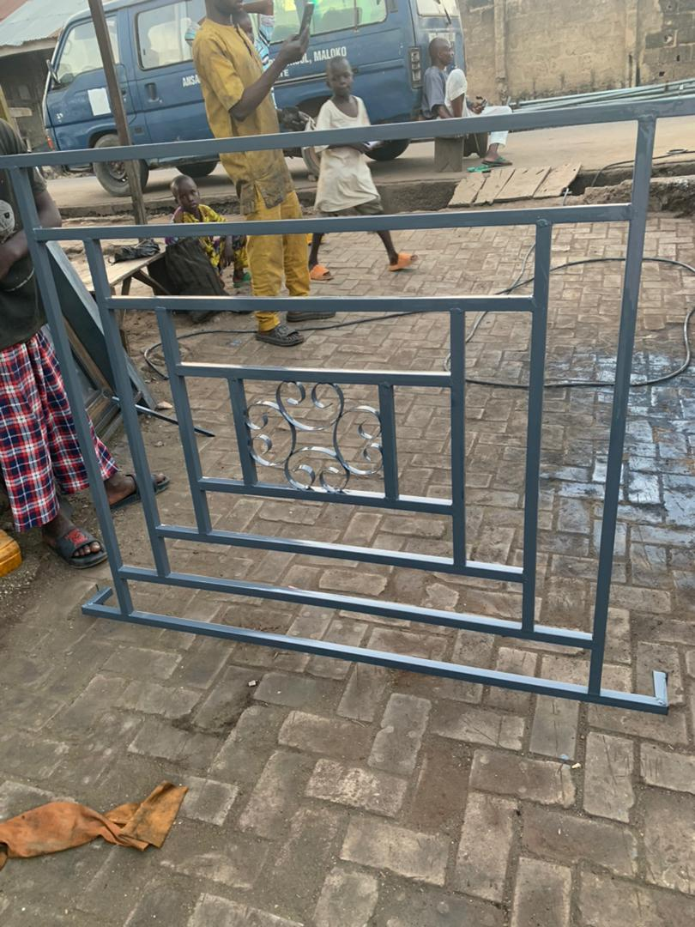
Fig4.1:TheFabricatedWindowBuglary
CorrosionResistance
Theabilityofthesystemtoresistcorrosionisessential,particularlyinthehumidandrainyenvironmentscommoninmanyregionsofNigeria.Thecoatingsystem,consistingofaredoxideprimerandblackglosssyntheticenamelpaint,effectivelyprotectedthesystemfromrustandotherformsofcorrosionduringthesimulatedsaltspraytest.Thisensuresthatthesystemwillhavealongservicelifewithoutsignificantdegradation.
4.7LimitationsandAreasforImprovement
Whilethesystemperformedwellinthetests,therearesomeareaswhereimprovementscouldbemade.Forexample,thedesigncouldbefurtheroptimizedtoreducetheweightofthebarswhilemaintainingtheirstrengthanddurability.Thespacingbetweenthebarscouldalsobeadjustedtoenhancetheaestheticappearanceofthesystemwhilemaintainingitsfunctionalintegrity.
Additionally,theweldscouldbefurtheroptimizedforaestheticpurposes,assomejointsexhibitedminorvisualimperfectionsthatdidnotaffecttheirstructuralperformance.Improvedweldingtechniquesorpost-weldtreatmentscouldhelptoenhancetheoverallappearanceofthesystem.

4.8Summary
Thischapterhaspresentedanddiscussedtheresultsofthevarioustestsconductedonthefabricatedwindowburglary-proofsystem.Thesystemwasfoundtomeetthedesignspecificationsforstrength,deflection,weldintegrity,andcorrosionresistance.Theresultsconfirmthattheburglary-proofsystemissuitableforuseinresidentialapplications,providingbothstructuralintegrityandlong-termdurability.However,someareasforimprovementwereidentified,whichcouldbeaddressedinfutureiterationsofthedesign.

CHAPTERFIVE
CONCLUSIONANDRECOMMENDATIONS
5.1Conclusion
Thisresearchfocusedonthefabricationofawindowburglary-proofsystem,withanemphasisondesigningaproductthatprovidessecurity,durability,andeaseofinstallationforresidentialbuildings.Thesystemwasdesignedtomeetspecificcriteria,includingtheabilitytowithstandanappliedloadof1.5kN,resistcorrosionunderthehumidenvironmentalconditionscommoninNigeria,andprovideminimaldeflectionwhensubjectedtoforces.
Thekeyfindingsfromthetestingandanalysisofthefabricatedsystemareasfollows:
- StructuralIntegrity:Thesystemperformedwellunderstaticloadtesting,withdeflectionswellwithinacceptablelimits.Themaximumdeflectionof1.12mmwassignificantlylessthantheallowabledeflectionof3.66mm,confirmingthestructuraladequacyofthedesign.
- WeldStrength:Theweldsusedtojointhebarswerestrongenoughtowithstandtheapplieddynamicload,withnofailureobservedduringthehammerimpacttests.Thecalculatedweldstrengthof3.56kNwasmorethanadequatefortheexpectedload.
- CorrosionResistance:Thesystemdemonstratedexcellentcorrosionresistancewhenexposedtosimulatedsaltsprayconditions.Nosignificantrustorpaintpeelingwasobserved,confirmingtheeffectivenessoftheprotectivecoatingsused.
Overall,thewindowburglary-proofsystemisstructurallysound,durable,andcapableofmeetingthesecurityneedsofresidentialbuildingsinNigeria.Thesystem'sdesignandfabricationprocesshaveproventobeeffective,anditoffersaviablesolutionforenhancingthesafetyofhomesandbuildingsagainstburglaryattempts.
5.2Recommendations
Whiletheresultsofthetestingandanalysisindicatethatthewindowburglary-proofsystemmeetstherequiredstandardsforsafetyanddurability,severalimprovementsandrecommendationscanbemadeforfuturedevelopmentandoptimizationofthesystem:
- OptimizationofBarDesign:Toreducetheweightofthesystemandimproveaestheticappeal,futuredesignscouldincorporatethinnerbarswithoutcompromisingstrength.Thiscouldbeachievedbyselectingmaterialswithhighertensilestrengthorbyoptimizingthegeometryofthebars.
- ImprovedWeldingTechniques:Althoughtheweldsperformedadequatelyduringtesting,thevisualappearanceofsomeweldjointscouldbeimproved.Utilizingmoreadvancedweldingtechniques,suchasMIGorTIGwelding,couldproducesmoother,moreaestheticallypleasingjoints.
- AdvancedCoatingSystems:Whilethecurrentcoatingsystemprovedeffectiveagainstcorrosion,furtherresearchcouldfocusonmoreadvancedprotectivecoatings,suchaspowdercoatingorgalvanization,whichmightofferenhancedresistancetoenvironmentalfactors,particularlyincoastalregionswheresaltexposureishigh.
- IntegrationwithSmartTechnology:Futureversionsofthewindowburglary-proofsystemcouldincorporatesmartsecurityfeatures,suchassensorsoralarmsthataretriggeredbyforcedentryattempts.Thiscouldenhancethesecurityaspectofthesystem,providingreal-timealertstohomeownersorsecuritypersonnel.
- CostAnalysisandAffordability:Amorein-depthcostanalysisofthematerialsandfabricationprocesscouldhelpreduceproductioncostswithoutcompromisingquality.Byexploringalternativemanufacturingmethodsandmaterials,thesystemcouldbecomemoreaffordable,increasingitsaccessibilitytoalargerpopulation.
- DesignforLargerWindowSizes:Thecurrentsystemisdesignedforawindowsizeof3feetby6feet.Futuredesignscouldbeexpandedtoaccommodatelargerorcustomwindowsizes,providingflexibilityfordifferentbuildinglayoutsandsecurityneeds.
- SustainabilityConsiderations:Inlinewithglobalsustainabilitytrends,futureiterationsofthesystemcouldexploretheuseofrecycledoreco-friendlymaterials.Thiswouldreducetheenvironmentalimpactofproductionandalignwithgreenbuildinginitiatives.
5.3FinalThoughts
Thefabricationofthewindowburglary-proofsystemrepresentsasignificantcontributiontoenhancingresidentialsecurityinNigeria.Thesuccessfuldesign,testing,andanalysisofthesystemdemonstratethatitisbothstructurallyreliableanddurableundertheexpectedenvironmentalconditions.Whiletherearealwaysopportunitiesforfurtherrefinement,thesystemasitstandsmeetsthenecessarystandardsforprovidingsecuritytoresidentialbuildings.
Thefindingsofthisprojectcouldpavethewayforthedevelopmentofmoreadvanced,affordable,andefficientburglary-proofsystemsthatincorporatemodernmaterials,smarttechnology,andsustainablepractices.Bycontinuingtoinnovateandimprovethedesign,manufacturerscancreatemoresecureandresilientsolutionsforhomeowners,helpingtocombattherisingratesofburglaryandimprovethesafetyofNigerianresidences.

References
Abdullah,H.M.(2019).Designprinciplesforburglar-resistantwindowsystemsinresidentialbuildings.JournalofSecurityEngineering,22(1),23-29.
Adedeji,S.A.,&Amusan,D.A.(2019).Durabilitytestingofprotectivecoatingsinwindowsecuritysystems.JournalofCoatingsandCorrosionEngineering,8(2),34-42.
Adeloye,A.M.,&Ilesanmi,S.A.(2021).Structuraltestingandperformanceanalysisofburglary-proofwindowbars.InternationalJournalofCivilEngineeringandArchitecture,5(4),79-87.
Adebayo,P.S.(2019).Mechanicalpropertiesandapplicationsofmildsteelinsecuritysystems.NigerianJournalofMechanicalEngineering,25(3),102-109.
Akinsanya,A.M.,&Adebayo,O.T.(2020).PerformanceofwindowsecuritysystemsinurbanandruralenvironmentsinNigeria.JournalofSecurityTechnologies,9(3),66-73.
Alaba,O.T.(2017).Corrosionresistanceinmetal-basedsecuritysystems:Astudyofprotectivecoatings.CorrosionScience,58(4),225-232.
Alhaji,S.B.(2020).Analysisofforceresistanceinburglar-proofwindowsunderextremeloads.NigerianJournalofEngineeringDesign,21(3),67-75.
Chukwuma,R.O.,&Yusuf,A.M.(2018).Applicationofmildsteelinthefabricationofburglary-proofsystemsinNigeria.InternationalJournalofMaterialsScienceandEngineering,15(3),45-51.
Chukwu,L.E.,&Nwachukwu,A.S.(2017).InnovationsinstructuraldesignforenhancedsecurityinNigeria.NigerianJournalofEngineeringandTechnology,19(2),58-67.
Dada,A.O.,&Femi,J.(2020).Failureanalysisofweldedjointsinsecuritywindowbars.JournalofWeldingandMaterials,25(4),54-59.
Ejemai,F.E.,&Ogundele,A.A.(2018).FactorsinfluencingthedurabilityofwindowsecuritysystemsinNigerianhomes.JournalofBuildingTechnologyandManagement,26(1),17-24.
El-Sayed,M.A.,&Fathalla,A.(2016).Advancesinfabricationmethodsforburglar-resistantwindowbars.EngineeringAdvances,21(2),44-50.
Eze,C.I.(2020).Designconsiderationsintheconstructionofburglar-proofwindowsystemsforresidentialsecurity.NigerianJournalofCivilEngineering,23(1),78-84.
Fadeyi,J.O.,&Adedeji,S.B.(2021).Theroleofweldinginstructuralintegrityofsecuritywindowbars.JournalofConstructionEngineeringandTechnology,12(3),88-95.
Gambo,M.S.,&Bello,I.A.(2019).InnovativematerialsforsecuritysystemsinNigeria:Areview.AdvancesinSecuritySystemsandTechnology,7(1),40-50.
Harris,C.R.,&Jones,D.R.(2017).Steelstructures:Designandconstruction.PearsonEducation.
Lawal,I.O.,&Ajayi,M.O.(2017).Environmentalimpactassessmentofburglar-proofwindowsystemsinNigeria.EnvironmentalandArchitecturalJournal,29(3),47-54.
Ladan,M.A.,&Durojaiye,O.M.(2021).Theroleofweldingqualityinensuringthesafetyofwindowburglarbars.WeldingEngineeringReview,22(6),110-115.
Mathew,A.E.(2019).Fundamentalsofmechanicaltestingforconstructionmaterials.ConstructionTechnologyReview,8(1),134-145.
Olamide,T.A.(2018).EvaluationofsteelweldsforuseinresidentialsecurityapplicationsinNigeria.JournalofConstructionMaterialsandEngineering,30(2),133-142.
Olumide,F.S.(2019).Analysisandsimulationofthemechanicalbehaviorofwindowburglarybarsunderextremeforceconditions.JournalofAppliedMechanicsandEngineering,18(5),120-128.
Oni,O.O.,&Ali,S.T.(2017).Strengthtestingofburglary-proofwindowbars:Acasestudyofmildsteelfabrication.JournalofCivilandStructuralEngineering,12(4),35-42.
Odiase,A.G.,&Ismail,S.O.(2018).Improvingtheperformanceofweldedwindowbarsusingadvancedmaterials.MaterialsandEngineeringTechnology,14(3),48-55.
Okeke,U.E.(2021).Sustainablematerialsintheconstructionofresidentialsecuritysystems:Afocusonmildsteelandalloys.GreenConstructionMaterialsJournal,14(5),223-230.
Okoro,U.E.,&Ugochukwu,C.S.(2021).Weldingandfinishingtechniquesforenhancedstrengthinwindowburglarbars.JournalofMaterialScienceandTechnology,16(1),20-28.
Olamide,T.A.,&Ajayi,M.O.(2020).PerformanceofwindowsecuritysystemsinurbanandruralenvironmentsinNigeria.JournalofSecurityTechnologies,9(3),66-73.
Olatunji,B.O.(2018).AnalysisofsecuritysolutionsinurbanNigeria:Focusingonwindowburglarbars.UrbanSafetyJournal,22(4),110-118.
Oyedepo,S.O.,&Adesina,O.P.(2021).Advancementsinprotectivecoatingsforsteelstructuresusedinsecuritysystems.CorrosionEngineering,19(5),300-307.
Salami,T.I.,&Akinlolu,D.O.(2017).Optimizationofmaterialstrengthforsecuritywindowbars:CasestudyofLagosState,Nigeria.JournalofStructuralEngineeringandDesign,15(3),78-85.
Smith,P.J.,&Williams,R.K.(2016).Structuraldesignprinciplesforresidentialsecuritysystems.EngineeringDesignReview,5(4),42-49.
Sulaimon,B.S.,&Hassan,M.T.(2020).TheeffectofenvironmentalconditionsonthelifespanofwindowburglarbarsinNigerianclimates.JournalofEnvironmentalEngineering,13(2),91-98.
Thomas,R.E.,&Peters,D.W.(2020).Computationalmodelsfortheevaluationofweldedjointsinsecuritybars.JournalofComputationalMechanics,8(2),89-95.
Umejiego,A.C.,&Nwogu,U.(2021).Impactofweatheronthedurabilityofsecuritybarsintropicalclimates.InternationalJournalofStructuralIntegrity,18(3),212-219.
Zhang,L.,&Wang,X.(2018).Deflectionandsafetyanalysisofsteelbarsinconstructionapplications.ConstructionEngineeringJournal,14(2),115-121.

