EFFECT OF TECHNOLOGICAL ADVANCEMENT ON PERFORMANCE OF BARBING SALON BUSINESS IN ILORIN METROPOLIS

BY

YUSUF TAOFEEK OLAMIDE
HND/23/BAM/FT/134

BEING A RESEARCH PROJECT SUBMITTED TO THE DEPARTMENT OF BUSINESS ADMINISTRATIONAND MANAGEMENT, INSTITUTE OF FINANCE AND MANAGEMENT STUDIES,
KWARA STATE POLYTECHNIC, ILORIN

IN PARTIAL FULFILMENT OF THE REQUIREMENTS FOR THE AWARD OF HIGHER NATIONAL DIPLOMA (HND) IN BUSINESS ADMINISTRATION AND MANAGEMENT

JUNE, 2025

CERTIFICATION
This is to certify that this research work has been read and approved as part of meeting the requirement for the award of Higher National Diploma in the Department of Business Administration and Management, Institute of Finance and Management Studies [IFMS], Kwara State Polytechnic, Ilorin, Kwara State.

_______________________ __________________
MR. IDRIS. A DATE
(PROJECT SUPERVISOR)

______________________ __________________
MR. ALIU B, U DATE
(PROJECT COORDINATOR)

______________________ __________________
Dr. ABDULSALAM. F. A. DATE
(HEAD OF DEPARTMENT)

______________________ __________________
EXTERNAL EXAMINER DATE

DEDICATION
This project is dedicated to almighty.

ACKNOWLEDGEMENT
I give thanks to ALMIGHTY ALLAH the everlasting God, the Lord of the universe, the Alpha of the day of judgment. I give gratitude to God for His infinite mercy and protection over me throughout my stay in this Great Institution (Kwara State Polytechnic, llorin). For giving me the wisdom and knowledge to write this project. I thank you lord for the successful completion of this project, I pray for more blessing (Amin).
My profound gratitude goes to my project supervisor, MR IDRIS A for his assistance throughout the project work. his stimulation, discussion and creative suggestion given to me with additional knowledge, profound my zeal throughout this project work. Am also grateful to the “Head of Department “DR ABUDL SALLAM FUNSHO
Also my profound gratitude goes to my parents Mr and Mrs. YUSUF I want to say a big jazakunmulahu kharan to them towards my education (HND) may u reap the fruits of your labor inshallah (Amin)
All thank b to almighty Allah for Everything.

TABLE OF CONTENTS
Tittle Page
Certification
Dedication
Acknowledgement
Table of Contents
Chapter One: Introduction
  - Background to the study
  - Statement of the problems
  - Research questions
  - Objectives of the study
  - Research hypothesis
  - Significance of the study
  - Scope of the study
  - Definition of terms
Chapter Two: Literature Review
2.1 Conceptual Clarification
2.2 Theoretical framework
2.3 Empirical Review
Chapter Three: Methodology
3.1 Introduction
3.2 Research design
3.3 Population of the study
3.4 sample size and Sampling techniques
3.5 Methods of data collection
3.6 Instrument of Data Collection
3.7 Method of data analysis
3.8 Historical background of the case study
Chapter Four: Data Presentation, Analysis and Interpretations
4.0 Introduction
4.1 Presentations of Data
4.2 Analysis of Data
4.3 Interpretation of Data
Chapter Five: Summary, Conclusion, Recommendations
5.1 Summary of finding
5.2 Conclusion
5.3 Recommendations
References
Questionnaire

ABSTRACT
The study focused on an Effect of technological advancement on Performance of Barbing Salon Business in Ilorin Metropolis with particular note on selected Barbing Salon in Ilorin.
The objectives of the study are:
- To evaluate the benefit of technology adopted in barbing salon business.
- To assess how technology influence the performance of barbing salon business.
- To establish the extent to which the application of technology influence the business performance.
Data were sourced from two principle sources primary and secondary data. Extensive literature review on textbooks, Journals, and other related materials were carried out. The population includes management and relevant staff and customers of selected Barbing Salon within Ilorin metropolis.
Data collected were presented analyzed and interpreted using charts, frequencies and percentages while the hypotheses were tested using SPSS.
Based on the analysis, the following findings were made. That barbing salon including the case organization is yet to fully adopt the importance of technology in designing an optimal combination of promotional mix to enhance its performance.
In view of above findings, the study concluded that; technical knowhow increases the technology application by barbers. The findings show that power supply has a significant effect on the productivity of barbing saloon. Finally it was processed from the study that research and development can positively enhance the economic development of the business. Barbers are ever ready to make an extra effort if they are satisfied with strategic decisions of their business. Technological advancement and adoption determines the performance of the business. The barbers should try as much as possible for their workers to understand and give them adequate trainings on how to make effective use of modern barbing tools so that there may be improvement in their performance.

CHAPTER ONE
INTRODUCTION
  - Background to the Study
The word "barber" comes from the Latin word "barba," meaning beard. A barber is people whose occupation is mainly to cut, dress, groom, style and shaves men's and boys' hair. In previous times, barbers (known as barber surgeons) also performed surgery and dentistry. With the development of safety razors and the decreasing prevalence of beards, in Anglophonic cultures, most barbers now specialize in cutting men's scalp hair as opposed to facial hair. In modern times, the term "barber" is used both as a professional title and to refer to hairdressers who specialize in men's hair. Historically, all hairdressers were considered barbers. In the 20th century, the profession of cosmetology branched off from barbering, and today hairdressers may be licensed as either barbers or cosmetologists. Barbers differ with respect to where they work, which services they are licensed to provide, and what name they use to refer to themselves. Part of this terminology difference depends on the regulations in a given location.
A barber's place of work is known as a "barbershop" or a "barber's". Barbershops are also places of social interaction and public discourse. In some instances, barbershops are also public forums. They are the locations of open debates, voicing public concerns, and engaging citizens in discussions about contemporary issues.
Technology refers to methods, system, and devices which are the result of scientific knowledge being used for practical purposes i.e. it is the practical application of knowledge especially in a particular area.
Our personal life is highly dependent on the technology that people have developed. Technology has advanced with years and it has changed the way we purchase products, the way we live, the way we communicate, the way we travel, the way we learn and so many changes have been brought about by these continuous technological advancements. As people’s demands and life style change, the demand for advancing the type of technology we use is high. It also helps businesses and organizations save time and cost of production, which has been an advantage to all business, they manage these advancements to gain competitive advantage.

A business management approach which looks at the business as a whole instead of on a division level. Business performance management entails reviewing the overall business performance and determining how the business can better reach its goals. This requires the alignment of strategic and operational objectives and the business’ set of activities in order to manage performance. Because business performance management seeks to aggregate available information, managers are more informed about the company’ position and are able to make better decisions.
1.2 Statement of the Problem
Inadequate sales are often given by entrepreneur, as major causes of their failure. A careful review of their circumstances often reveals perfectly ignorance or neglect of the adoption of appropriate technology for the business.
At times, barbing salons are very sure/ optimistic about sales (patronage) they concern the wrong notion that their goods will sell themselves, forgetting that even the best product, service still need to be stimulated in order to move out of the stores. In fact, the adoption of effective technology is an essential move to attract customers.
The above scenario applies to barbing salon despite the numerous advantages inherent is effective promotion, the availability of appropriate technology, the need to used technology, to higher competition in this industry, the use of effective tools by barbing salon in its operation is barely evident and is negatively imposture on its operation.
In view of the above, the study tried to appraise the effect of technology advancement on the performance of barbing salon in Ilorin metropolis.
1.3 Research Questions
The following are the research questions this study would aim to answer:
- How does power supply influence the productivity of the business?
- Does technical know-how improve the performance of the business?
- To what extent does technical know-how enhance productivity?
- How would power supply help the performance of the employee of an organization?

  - Objectives of the study
The main objective of this study is to analysis and evaluates the effect of technological advancement of the performance of barbing salon business. The secondary objects are as follows:
- To evaluate the benefit of technology adopted in barbing salon business.
- To assess how Technology, influence the performance of barbing salon business.
- To establish the extent to which the application of technology influences the business performance.
  - Research Hypothesis
H0₁: power supply does not significant impact on the business productivity.
H0₂: the technical know-how does not affect the technology application to the business.
H0₃: power supply does not have impact on the employee performance.
H0₄: technical know-how does not have impact on the business productivity.
  - Significance of the Study
Every business is normally set up with the goal of success. The study will be of great benefit to the operations of any firm at barbing industry. The study will show some of the cost effective and efficient promotion game plans that would be adopted to increase the performance of their service operation. The study will equally help Barbing Salon to better their operations in Ilorin metropolis. Consumers who patronize Barbing Salon will be better informed and educated not only on product sold but on their services. The study will act as a source of document to readers, who might find the study useful. Above all the study will benefit the researcher as it will provide the researcher with an in-depth knowledge and understanding in the area which could stir up further study.

Scope of the Study
The study which entails on advancement of technology on the performance of barbing hair care salon took an in-depth look at technology adopted by barbing salon. Again, the study is limited to Barbing Salon and its customers within Ilorin metropolis.

1.8 Definition of Terms
BARBER: a barber is a person whose occupation is to cut any type of hair, give shaves, and trim beards.
TECHNOLOGY: can be defined as the entities, both material and immaterial, created by the application mental and physical effort in order to achieve some value. It can also be refers to tools and machines that may be used to solve real-world problem.
ADVANCEMENT: is the act of advancing, i.e. promotion to a higher place or dignity.
BUSINESS PERFORMANCE: it can be defined as analytic processes that enable the management of a firm to achieve one or more pre-selected goals.
COMPETITIVE ADVANTAGE: can be defined as something that places a company or a person above the competition.
CHAPTER TWO
LITERATURE REVIEW
2.1 Introduction
This chapter examines previous literature related to the relationship between advancement of technology and performance of barbing salon business in Ilorin’ this chapter also explains empirical review i.e. past research on technology and business performance, theories and gaps in literature.
2.2 Conceptual frame-work
2.2.1 Technology
Technology is the sum of techniques, skills, methods, and processes used in the production of goods or services or in the accomplishment of objectives, such as scientific investigation. Technology can be the knowledge of techniques, processes, and the like, or it can be embedded in machines to allow for operation without detailed knowledge of their workings.
Systems (e. g. machines) applying technology by taking an input, changing it according to the system's use, and then producing an outcome are referred to as technology systems or technological systems.
The simplest form of technology is the development and use of basic tools. The prehistoric discovery of how to control fire and the later Neolithic Revolution increased the available sources of food, and the invention of the wheel helped humans to travel in and control their environment. Developments in historic times, including the printing press, the telephone, and the Internet , have lessened physical barriers to communication and allowed humans to interact freely on a global scale.
Technology has many effects. It has helped develop more advanced economies (including today's global economy) and has allowed the rise of a leisure class. Many technological processes produce unwanted by-products known as pollution and deplete natural resources to the detriment of earth's environment. Innovations have always influenced the values of a society and raised new questions in the ethics of technology. Examples include the rise of the notion of efficiency in terms of human productivity, and the challenges of bioethics.
Philosophical debates have arisen over the use of technology, with disagreements over whether technology improves the human condition or worsens it. Neo-Luddism , anarcho-primitivism , and similar reactionary movements criticize the pervasiveness of technology, arguing that it harms the environment and alienates people; proponents of ideologies such as transhumanism and techno-progressivism view continued technological progress as beneficial to society and the human condition.
2.1.2.1 Technological Advancement and Their Effect on Humanity
Our personal life is highly dependent on the technology that people have developed. Technology has advanced with years and it has changed the way we purchase products, the way we live, the way we communicate, the way we travel, the way we learn and so many changes have been brought about by these continuous technological advancements. As people’s demands and life style change, the demand for advancing the type of technology we use is high. Almost everything we use has been innovated to better standards, a good example is the ”Mobile Phone ”, the type of mobile phones we had in 1995 are no longer on demand in this century, the demands of mobile phone users have changed greatly, and this has resulted in the advancement of mobile phone technologies. Users of mobile phones demand simplicity and more functionality, which has forced mobile phone manufactures to develop computer minded smart phones, which are so easy to use, but also they come with more functionality compared to the type of mobile phones we used to have in the past.
In the past, only big successful companies would dominate the market because they could afford the expensive adverting Medias, like Television, to reach any target market. Small businesses typically don’t have fat budgets and find it hard to compete in any given profitable market. Now with advanced internet technologies, a small business can use most advanced internet marketing tools with a small budget which can range from $100 – $5000 to reach over 100,000 target customers.
2.1.3 Business performance
Business performance management is a set of performance management and analytic processes that enables the management of an organization's performance to achieve one or more pre-selected goals. Synonyms for "business performance management" include "corporate performance management (CPM)” and "enterprise performance management”. Gartner has officially retired the concept of, “CPM” and reclassified into, “financial planning and analysis (FP&A)” and, “financial close” to reflect two significant trends - increased focus on planning, and the emergence of a new category of solutions supporting the management of the financial close. Business performance management is contained within approaches to business process management.
Business performance management has three main activities:
- selection of goals
- consolidation of measurement information relevant to an organization’s progress against these goals
- interventions made by managers in light of this information with a view to improving future performance against these goals
Although presented here sequentially, typically all three activities will run concurrently, with interventions by managers affecting the choice of goals, the measurement information monitored, and the activities being undertaken by the organization. Because business performance management activities in large organizations often involve the collection and reporting of large volumes of data, many software vendors, particularly those offering business intelligence tools, market products intended to assist in this process. As a result of this marketing effort, business performance management is often incorrectly understood as an activity that necessarily relies on software systems to work, and many definitions of business performance management explicitly suggest software as being a definitive component of the approach.
In the past, owners have sought to drive strategy down and across their organizations, transform these strategies into actionable metrics, and use analytics to expose the cause-and-effect relationships that, if understood, could give insight into decision-making.
2.1.4 How Technology Improve Business performance
It goes without saying that there are essential technologies for business Imagine trying to reach a business that doesn’t have a phone system. Not too long ago, computers were not viewed as necessary. That didn’t stop savvy business owners as seeing that they would increase productivity, provide better customer service, and give them a serious competitive advantage. Today’s technology landscape provides even more technology options that can improve business performance. The technology that gets you there depends on your objectives. Here are five areas of business performance and the technology that can improve them:
2.1.4.1 Finances – lower costs and increase revenue
Software and service-based technologies can help identify and reduce bloated spending. For example, print management services can dramatically reduce an expense that typically eats up 1-3% of your revenue by setting controls and offering recommendations. Another example: the cloud. Cloud computing leverages off-site, virtual-based technology to store data and software applications that can be accessed from anywhere. It allows you to keep hardware costs to a minimum during times of expansion or contraction and can give you a great boost in security.
2.1.4.2 Operations – get the job done more effectively
As businesses grow, streamlining processes becomes a necessary priority to improve business performance. Today’s technology offers business process optimization through content management solutions and workflow software that allow businesses to restructure repetitive paper-based processes, like work order processing or accounts payable procedures. Modern communication systems also offer a way to improve operations, through calling integrated with video conferencing, instant messaging and emails, key communication can happen more rapidly.
2.1.4.3 Employee productivity – keep people productive no matter what happens
Today’s technology provides you with the ability to maintain normal operations in less-than-normal conditions. With data backup and disaster recovery services, you can quickly spring back to your feet after a disaster or outage, minimizing downtime and maximizing employees’ ability to get the job done. Technology can also improve productivity by eliminating time-consuming processes. For example, document management software can eliminate the need for data entry, filing and manual file retrieval while managed IT services lift the burden of routine maintenance and backup off of your limited internal IT resources.
2.1.4.4 Customer services – meets and exceed customer expectations
Providing customers with the quick, accurate service around the clock doesn’t need to cost you a huge overhead in staff. Contact centers give your company a professional face while providing customers the means to contact you using the method they prefer (email, chat, or phone). These contact centers can be available independently or as part of a unified communications system. Leveraging records management systems and phone system integration with your CRM provides your staff with access to the most up to date customer information as quickly as possible, accessible from almost anywhere.
2.1.4.5 Talent retention – create a more attractive workplace
Technology communicates a message to your employees. It sends the message that you’re solvent and “with the times,” or that you’re a sinking ship only being propped up by 10-year old computer towers. Giving employees the tools that make them more successful in their job is essential to maintaining top talent and keeping morale high during rough patches. Technology also affords you the ability to offer desirable perks that today’s workforce is seeking. For example, leveraging secure virtual private networks and hosted phones can give employees the flexibility to telework productively.
Technology undoubtedly improves business performance in multiple facets. Even a single technology can improve your business across a number of key performance indicators. By examining your objectives and setting the KPIs that matter for your organization, you can more easily select the technology that will advance your business and improve performance.
2.1.5 Ways to Differentiate Barber shop
There are numerous factors which can influence your barbershop’s chances of success, but as you’re getting started one of the most important is finding a way to differentiate it from the competition. Whether it’s a unique methodology that you employ, a specific type of hair that you work on, or exclusive products that you work with; making your barbershop stand out is important. The following are a few ideas that could help give your shop an edge above the competition.
2.1.5.1 Staff
One of the first ways to differentiate your barbershop is with the staff you hire. Hiring an entirely female staff sets a certain tone that can set your shop apart, for example. You could also hire staff members who have graduated from a particular institution, or only hire barbers with a certain amount of years of experience under their belt.
2.1.5.2 Methodology
It is worth taking the time to define your barber shop’s approach to hair cutting and styling. Will your shop focus primarily on classic shaving techniques using traditional tools such as straight razors, or will you offer a wide range of hair cutting, coloring, and styling services for men and women alike? What methods will be used in the shop to render these services? By choosing a particular approach or embracing a newer form of technology, you could help distinguish your shop from competitors.
2.1.5.3 Hair Styles
The hair styles you provide are another way to make your business stand out. Some barbershops are known for their classic cuts, such as the high and tight or military buzz cut. Others excel in trendy fashions for younger men. Another option is to provide alternative hairstyles, such as elaborate Mohawks and fades. As facial hair continues to grow in popularity, you could differentiate your barbershop by offering a wide range of facial hairstyles, from handlebar moustaches to neatly trimmed goatees.
2.1.5.4 Hair Products
Do you offer high quality hair products that customers can’t find down at the local pharmacy? You could forge an exclusive relationship with a certain brand to offer the full selection of products from their range. Perhaps you want your barbershop to be a sustainable, environmentally-friendly business, in which case you might provide organic hair care products with all-natural ingredients.
2.1.5.5 Extra Services
It’s the little things that can take an ordinary barber experience and transform it into something special. Small extras such as a brief head and shoulder massage, a complimentary coffee, or warm shaving cream can make going to the barbershop a real treat for customers. This often leads to positive online reviews and entices them to spread the word about your services.
These are just a few ideas that can help you get started when it comes to differentiating your shop. In today’s competitive barbering environment, it’s important to get ahead of the competition in as many ways as possible. Choosing a unique philosophy, style of hair cutting, or product line can give you the edge you need to attract the attention of new clients and keep them coming back for more.
2.1.6 Barbing Techniques
2.1.6.1 Barbering cutting techniques
As a barber, you need to know seven cutting techniques and their effect on hair:
- Clipper – a short, blunt, even finish.
- Clipper using attachment – a short, layered, blunt, even finish.
- Free hand clipper – a blunt, sculpted finish.
- Scissor cutting – a blunt, even finish (not a traditional barbering technique).
- Scissor over comb – a layered, blunt, even finish.
- Razor cutting – creates texturized hair, removes bulk, and gives you an uneven finish.
- Razor over comb – a layered, texturized, uneven finish.
2.1.6.2 Barbering haircut types
There are four different haircut types you need to learn about as a barber:
- Graduation – short back & side’s hairstyle, faded with length at the top.
- Increase layer – mullet hairstyle, shorter length at top getting longer at the bottom.
- Solid form – bob hairstyle, longer hair at top getting shorter in one length.
- Uniform layer – clipper cut, all same length.
2.1.6.3 Barbering techniques
These are four finishing techniques important to any barber:
- Nape shaping – the correct tapering for the hairstyle working with the hair-line to finish and shape the back.
- Line outs – to bluntly cut and shape the perimeter of the haircut (boxed).
- Free hand clipper – to sculpt and give a solid and precise finish.
- Clipper guard work – smooth graduation.
2.1.6.4 Blunt cutting and texturizing
You’ll use both of these techniques frequently in your barbering career:
- Blunt cutting – straight cut, blunt solid even finish, bulky result.
- Texturizing – feathered cut, thin uneven finish, and blended result.
2.1.7 Innovation in Barbing Salon Industry
We live in a world where technology is rapidly advancing. The advancement of technology brings a lot of good changes in every aspect of life but then there are also bad ones if we choose to use it wrongly. Technology has massively contributed to every industry available in the world. It saves time, enhances creativity, reduces workload and brings opportunity for innovations. But who could have thought such innovations would influence the barber industry. Here are some facts on how innovation has helped the barbering industry to rise.
The first innovation that I want to talk about is design ideas of a barber shop. Questions that will need to be considers are: What kind of theme do you want your barbershop to be based on (Sports, Workout, or Car)? Remember that your business will show you the type of person you are. A barber shop should be a place where customers will feel comfortable, a place where they would come to get off from their busy lifestyle and have a good time with friends and the service it gives. Innovation has played a big part on how barber shops these days’ looks like from fancy furniture, types of lighting, color and design of walls, and others. This will help create a memorable experience for customer and will do your business good.

Innovations are results of great ideas and these ideas can help businesses flourish. An impressive innovative idea which is known as mobile barbering services from door to door where the barber will come to the customer instead of the customer going to the barbershop for a cut. This is an idea that not a lot of barbers are doing due to the amount of time spent to travel from one appointment to another.
Innovation also involves the type of products and equipment used in providing your service. Products and tools used by barbers are designed to meet a simple mission: Provide good haircuts. A barber shop needs to be completely equipped by these things because without it, customers wouldn’t feel comfortable when the service is given. Equipment includes wire/wireless hair clippers, shavers, trimmers, scissor and chairs. Products include sanitizers, shampoo, hair dye colors, shaving cream and many more. These products and equipment are tools for effective innovations to make your business successful and give customers a service that is unforgettable.
These are some of the facts that I have come to know about the innovation influence in the barber industry. I hope that as the time goes on, technology would advance even more and therefore, we will be able to witness bigger changes in this industry. Without change there is no innovation, creativity, or incentive for improvement. Those who initiate change will have a better opportunity to manage the change that is inevitable.
2.3 Theoretical Review
There are various models of technology and business performance measurement, the following section gives a review of the associated theories and models. Some of these models are: Actor-Network Theory (ANT), balance Scorecard model, European Foundation for Quality Management (EFQM) and System Theory.
2.3.1 Actor-Network Theory (ANT)
ANT – posits a heterogeneous network of humans and non-humans as equal interrelated actors. It strives for impartiality in the description of human and nonhuman actors and the reintegration of the natural and social worlds. For example, Latour (1992) argues that instead of worrying whether we are anthropomorphizing technology, we should embrace it as inherently anthropomorphic: technology is made by humans, substitutes for the actions of humans, and shapes human action. What is important is the chain and gradients of actors' actions and competencies, and the degree to which we choose to have figurative representations. Key concepts include the inscription of beliefs, practices, and relations into technology, which is then said to embody them. Key authors include Latour (1997) and Callon (1999).
2.3.2 System Theory
This theory considers the historical development of technology and media with an emphasis on inertia and heterogeneity, stressing the connections between the artifact being built and the social, economic, political and cultural factors surrounding it. Key concepts include reverse salient when elements of a system lag in development with respect to others, differentiation, operational closure, and autopoietic autonomy. Key authors include Thomas P. Hughes (1992) and Luhmann (2000).
2.3.3 Balance Scorecard Model
Kaplan and Norton (1996) present the Balanced Scorecard model as a useful tool for the managers to obtain a competitive advantage. These days, organizations are competing into a complex environment where understanding the objectives and the way they can be achieved it’s vital. The Balanced Scorecard translates the mission and the organization strategy into a set of performance indicators that offers a model for the performance measurement system. The model assets the organizational performance through four perspectives: financial, clients, learning and growth and internal processes (Kaplan & Norton, 1996).
The indicators represent a balance between external indicators for stakeholders and the internal indicators of critical processes, innovation learning and development.
Financial

Vision & Strategy
Learning and Growth
Customer
Internal business
Processes

The Balance Scorecard Model
2.3 Empirical review
From an operations perspective, a BPM system is mainly perceived as a “set of metrics used to quantify both the efficiency and effectiveness of actions” (Neely et al., 1995); or as the reporting process that gives feedback to employees on the outcome of actions (Bititci et al., 1997). From a strategic control perspective, two different aspects of a BPM system can be identified. On one hand, it reflects the procedures used to cascade down those performance metrics used to implement the strategy within the organization (Gates, 1999). On the other hand, a BPM system is the system that not only allows an organization to cascade down its business performance measures, but also provides it with the information necessary to challenge the content and validity of the strategy (Ittner et al, 2003). From a management accounting perspective, a BPM system is considered to be synonymous with management planning and budgeting (Otley, 1999).
Bititci, Carrie & Mcdevitt 1997 “A performance measurement system is the information system which is at the heart of the performance management process and it is of critical importance to the effective and efficient functioning of the performance management system”. Also, Bourne, Neely, Mills & Platts 2003 “A business performance measurement system refers to the use of a multi-dimensional set of performance measures for the planning and management of a business”.
In the view of Forza & Salvador 2000 “A performance measurement system is an information system that supports managers in the performance management process mainly fulfilling two primary functions: the first one consists in enabling and structuring communication between all the organizational units (individuals, teams, processes, functions, etc.) involved in the process of target setting. The second one is that of collecting, processing and delivering information on the performance of people, activities, processes, products, business units, etc.”
Based on Kerssens-van Drongelen & Fisscher 2003 “Performance measurement and reporting takes place at 2 levels: (1) company as a whole, reporting to external stakeholders, (2) within the company, between managers and their subordinates. At both levels there are 3 types of actors: (a) evaluators (e.g. managers, external stakeholders), (b) evaluatee (e.g. middle managers, company), (c) assessor, which is the person or institution assessing the effectiveness and efficiency of performance measurement and reporting process and its outputs (e.g. controllers, external accountant audits)”

CHAPTER THREE
METHODOLOGY
3.1 Introduction
As it is indicated in the title, this chapter includes the methodology of this research proposal. In more details, in this part the researcher outlines the research strategy, the research method, the research approach; the methods of data collection, the selection of the sample, the research process, and the type of data analysis as well as the ethical consideration are all covered in this chapter.
3.2 Research Design
It is the blueprint for conducting the study that maximizes control over factors that could interfere with the validity of findings. Designing a study helps the researcher to plan and implement the study in a way that will help the researcher to obtain intended results, thus increasing the chances of obtaining information that could be associated with the real situation (Burn and Grove 2001). . Asika (2005) researches design means the structuring of investigation aimed at identifying variables and their relationship to one another. Thus, it describe how the investigation has been structured to enable the researcher generates relevant information to resolve the identified research problem. The survey and quantitative method was employed to collect data for the study.
3.3 Population of the Study
According to patterned (2003) target population consists of the people who we wish to describe using our sample. Approximately 200 staffs will be used as sampling size.
Based on this research work, the population for this study will be the employees of twenty selected barber shop, Ilorin, Kwara State (comprising at least 10 employees per shop).
3.4 Sample size and Sampling techniques
A sample is a subset of the individuals in a population. It is a procedure, where in fraction of the data is taken from a large set of data, and the inference drawn from the sample is extended to whole group.
Using scientific measure in arriving at the sample size. The researcher adopts Taro Yamane Formula:- Hence the formula entails a 95% confidence level at a point of 5% assumption

n = N
1 + N (e) ²
Where n = Sample size
N = Population of the study
e = Level of precision or Sampling Error or Tolerable error (5%) is
assumed

For example n = 200
1 + 200 (0.05)²

n = 200
1 + 200 (0.0025)
n = 200
1 + 0.5

n = 200 = 133 n = 130
1.5
3.4.1 Sampling Technique
Simple random sampling, systematic sampling, stratified sampling fall into the category of simple sampling techniques. Complex sampling techniques are used, only in the presence of large experimental data sets. In this study, simple random sampling technique was employed to select 10 staffs from each twenty shop used in the study. Also, purposive random sampling was used to select from various categories of staff available in the barber shop selected for the study.
3.5 Methods of Data Collection
Data collection is the process of gathering and measuring information on variables interest in an established systematic fashion that enable one answer stated research hypotheses and evaluate outcome.
(a) Primary Sources of Data: - This consists of personal interview, use of questionnaire, observation and focus group discussion. In this study both interview and design questionnaire was used to collect data from respondents.
(b) Secondary Sources of Data:-This consists of data collected through textbooks, journals, documentary, file and records and other relevant and important documents germane to the work. In this study, various scholastic works was consulted through textbooks, journals and official documents of the case study.
For the purpose of this study, data was source for using primary procedures of data collection and was done by construction and administering of the questionnaire needed for the study.
3.6 Instrument of data collection
The research instrument that was mainly used is the questionnaire which consists of two sections i.e. A and B, bio- data and questions respectively. This would enable the respondents gain freedom to express their reaction.
3.7 Method of Data Analysis
According to Bryman and Gramer (1997), data analysis seeks to fulfill research objectives and provide answers to research questions. The choice of analysis procedures depends on how well the techniques are suited to the study objective and scale measurement of the variables in question. The data collected through the questionnaire was analyzed through the use of descriptive statistics such as percentages, frequency counts and table in analyzing and interpreting some of the data that will be collected.
3.8. Historical background of the case study
In ancient Egyptian culture, barbers were highly respected individuals. Priests and men of medicine are the earliest recorded examples of barbers. In addition, the art of barbering played a significant role across continents. Mayan, Aztec, Iroquois, Viking and Mongolian civilizations utilized shave art as a way to distinguish roles in society and wartime. Men in Ancient Greece would have their beards, hair, and fingernails trimmed and styled by the κουρεύς ( cureus ), in an agora (market place) which also served as a social gathering for debates and gossip. Barbering was introduced to Rome by the Greek colonies in Sicily in 296 BC, and barbershops quickly became very popular centres for daily news and gossip. A morning visit to the tonsor became a part of the daily routine, as important as the visit to the public baths, and a young man's first shave ( tonsura) was considered an essential part of his coming of age ceremony. A few Roman tonsores became wealthy and influential, running shops that were favorite public locations of high society; however, most were simple tradesmen, who owned small storefronts or worked in the streets for low prices
Starting from the Middle Ages, barbers often served as surgeons and dentists. In addition to haircutting, hairdressing, and shaving, barbers performed surgery, bloodletting and leeching, fire cupping, enemas, and the extraction of teeth; earning them the name “barber surgeons". Barber-surgeons began to form powerful guilds such as the Worshipful Company of Barbers in London. Barbers received higher pay than surgeons until surgeons were entered into British warships during naval wars. Some of the duties of the barber included neck manipulation, cleansing of ears and scalp, draining of boils, fistula and lancing of cysts with wicks.
19th century- Barbershop in Bucharest ≈1842.
The barbershop also provides an opportunity for social contacts. Barbershops were influential at the turn of the 19th century in the United States as African American businesses that helped to develop African American culture and economy. According to Trudier Harris, "In addition to its status as a gathering place, the black barbershop also functioned as a complicated and often contradictory microcosm of the larger world. It is an environment that can bolster egos and be supportive as well as a place where phony men can be destroyed, or at least highly shamed, from participation in verbal contests and other contests of skill. It is a retreat, a haven, an escape from nagging wives and the cares of the world. It is a place where men can be men. It is a place, in contrast to Gordone's bar, to be somebody." Barbershops from black barbers at first mostly served wealthy caucasians. In the later part of the century they opened barbershops in black communities for serving black people. The average shop cost $20 to equip in 1880. It was about ten by twelve feet. A hair cut in 1880 would cost five or ten cents and shaving cost three cents.
Most modern barbershops have special barber chairs, and special equipment for rinsing and washing hair. In some barbershops, people can read magazines or watch TV while the barber works.
Despite the economic recession in 2008, the barbershop industry has seen continued positive growth. Recently there was a trial that had barbers check high blood pressure in barbershops and has a pharmacist meet and treat the patient in the barbershop, with positive results.

CHAPTER FOUR
DATA PRESENTATION, ANALYSIS AND INTERPRETATION

4.1 Introduction
This chapter presents and analyses the data collected from respondents during the research, into meaningful information and findings that will permit conclusion and recommendations on the subject matter.
4.2 Data Presentation, analysis and interpretation
Table 4.1 Analysis of Response rate
S/N | Administered questionnaire | Frequency | Percentage (%)
1 | Retrieved | 108 | 83.1
2 | Not retrieved | 22 | 16.9
 | Total | 130 | 100
Source: Field Survey, 2025.
All questions laid out in the interview and questionnaire was aimed at the effect of technological advancement on performance of barbing salon business in Ilorin metropolis.
The data collected was analyzed by using Statistical Package for the Social Sciences (IBM SPSS) for the frequency distribution and percentage table with the Bar chat graph. This helps to give a clear view of the situation and thus make an easy comprehension of the results obtained during course of this study.

Table 4.2 Gender
 |  | Frequency | Percent | Valid Percent | Cumulative Percent
Valid | Male | 108 | 90.8 | 100.0 | 100.0
Missing | System | 11 | 9.2
Total |  | 119 | 100.0
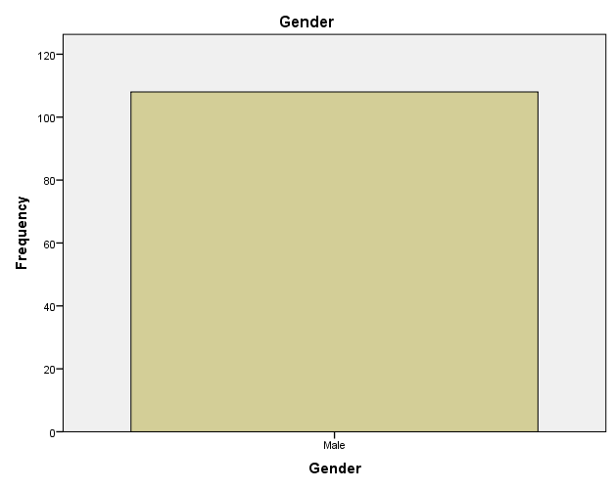
Figure 4.1 Gender

Table 4.3 Age
 |  | Frequency | Percent | Valid Percent | Cumulative Percent
Valid | 20 - 25 | 18 | 15.1 | 16.7 | 16.7
Valid | 26 -30 | 37 | 31.1 | 34.3 | 50.9
Valid | 31 - 35 | 31 | 26.1 | 28.7 | 79.6
Valid | 36 and above | 22 | 18.5 | 20.4 | 100.0
Valid | Total | 108 | 90.8 | 100.0
Missing | System | 11 | 9.2
Total |  | 119 | 100.0
Source: Field Survey, 2025.

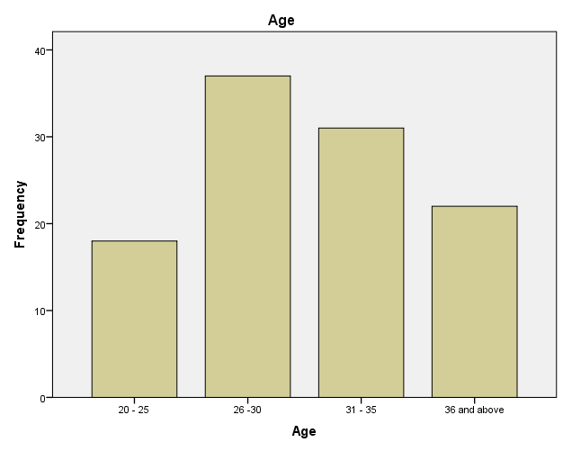
Figure 4.2 Age

Table 4.4 Years of experience
 |  | Frequency | Percent | Valid Percent | Cumulative Percent
Valid | 1 - 5 Years | 47 | 39.5 | 43.5 | 43.5
Valid | 6 - 10 Years | 33 | 27.7 | 30.6 | 74.1
Valid | 11 - 15 Years | 23 | 19.3 | 21.3 | 95.4
Valid | 16 and above | 5 | 4.2 | 4.6 | 100.0
Valid | Total | 108 | 90.8 | 100.0
Missing | System | 11 | 9.2
Total |  | 119 | 100.0

Source: Field Survey, 2025.

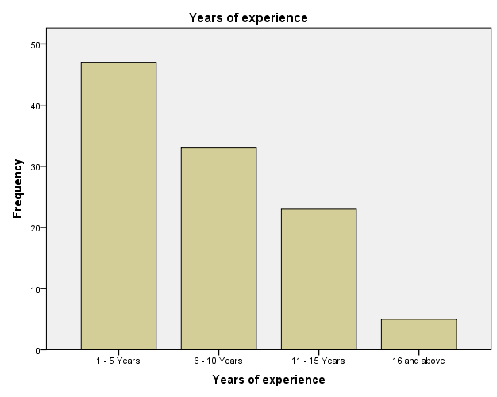
Figure 4.3 Years of experience

Table 4.5 Highest educational Qualification
 |  | Frequency | Percent | Valid Percent | Cumulative Percent
Valid | Primary Education | 10 | 8.4 | 9.3 | 9.3
Valid | Secondary Education | 22 | 18.5 | 20.6 | 29.9
Valid | HND/B.Sc | 31 | 26.1 | 29.0 | 58.9
Valid | M.Sc/PhD | 8 | 6.7 | 7.5 | 66.4
Valid | Others | 36 | 30.3 | 33.6 | 100.0
Valid | Total | 107 | 89.9 | 100.0
Missing | System | 12 | 10.1
Total |  | 119 | 100.0
Source: Field Survey, 2025.

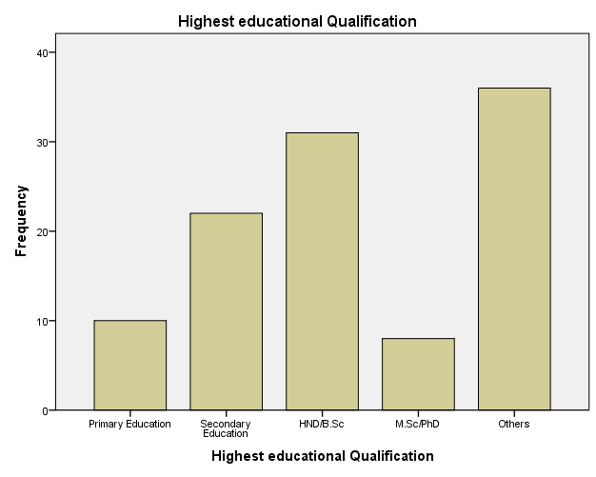
Figure 4.4 Highest educational Qualification

Table 4.6 Barbers experience lack of power supply in Ilorin metropolis which affect their mode of operation
 |  | Frequency | Percent | Valid Percent | Cumulative Percent
Valid | Strongly agree | 41 | 34.5 | 38.0 | 38.0
Valid | Agree | 34 | 28.6 | 31.5 | 69.4
Valid | Uncertainty | 19 | 16.0 | 17.6 | 87.0
Valid | Strongly disagree | 3 | 2.5 | 2.8 | 89.8
Valid | Disagree | 11 | 9.2 | 10.2 | 100.0
Valid | Total | 108 | 90.8 | 100.0
Missing | System | 11 | 9.2
Total |  | 119 | 100.0
Source: Field Survey, 2025.

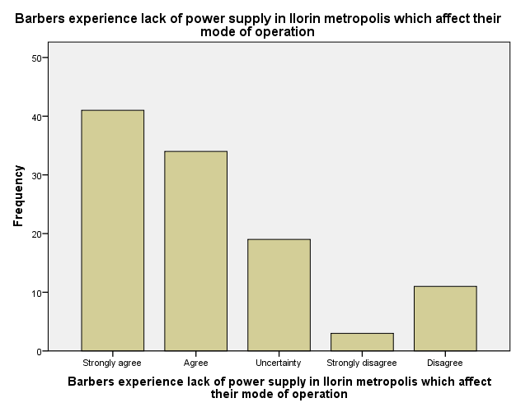
Figure 4.5 Barbers experience lack of power supply in Ilorin metropolis which affect their mode of operation

Table 4. 7 High rate of electricity tax discouraged many barbers in Ilorin metropolis to make use of power supply
 |  | Frequency | Percent | Valid Percent | Cumulative Percent
Valid | Strongly agree | 47 | 39.5 | 43.5 | 43.5
Valid | Agree | 29 | 24.4 | 26.9 | 70.4
Valid | Uncertainty | 12 | 10.1 | 11.1 | 81.5
Valid | Strongly disagree | 7 | 5.9 | 6.5 | 88.0
Valid | Disagree | 13 | 10.9 | 12.0 | 100.0
Valid | Total | 108 | 90.8 | 100.0
Missing | System | 11 | 9.2
Total |  | 119 | 100.0
Source: Field Survey, 2025.

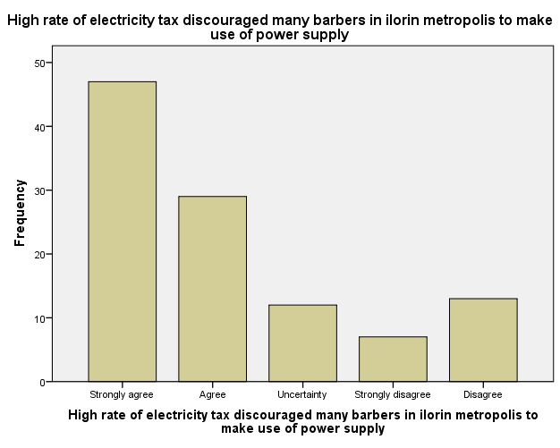
Figure 4.6 High rate electricity tax discouraged many barbers in Ilorin metropolis to make use of power supply.

Table 4.8 Power supply is very constant for work in Ilorin metropolis
 |  | Frequency | Percent | Valid Percent | Cumulative Percent
Valid | Strongly agree | 10 | 8.4 | 9.3 | 9.3
Valid | Agree | 16 | 13.4 | 14.8 | 24.1
Valid | Strongly disagree | 61 | 51.3 | 56.5 | 80.6
Valid | Disagree | 21 | 17.6 | 19.4 | 100.0
Valid | Total | 108 | 90.8 | 100.0
Missing | System | 11 | 9.2
Total |  | 119 | 100.0
Source: Field Survey, 2025.

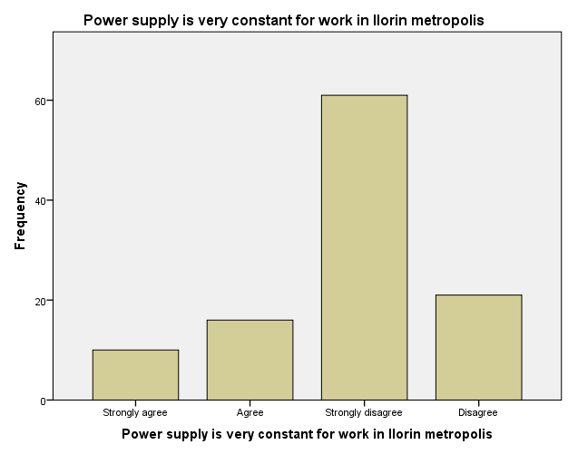
Figure 4.7 Power supply is very constant for work in Ilorin metropolis

Table 4.9 The sales of barbers are relatively high due to adequate power supply in the state.
 |  | Frequency | Percent | Valid Percent | Cumulative Percent
Valid | Strongly agree | 7 | 5.9 | 6.5 | 6.5
Valid | Agree | 12 | 10.1 | 11.1 | 17.6
Valid | Uncertainty | 7 | 5.9 | 6.5 | 24.1
Valid | Strongly disagree | 36 | 30.3 | 33.3 | 57.4
Valid | Disagree | 46 | 38.7 | 42.6 | 100.0
Valid | Total | 108 | 90.8 | 100.0
Missing | System | 11 | 9.2
Total |  | 119 | 100.0
Source: Field Survey, 2025.

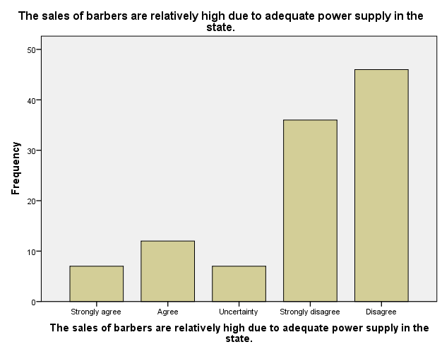
Figure 4.8 The sales of barbers are relatively high due to adequate power supply in the state.
Table 4.10 Many barbers in Ilorin metropolis make use of generators to perform their work.
 |  | Frequency | Percent | Valid Percent | Cumulative Percent
Valid | Strongly agree | 48 | 40.3 | 44.4 | 44.4
Valid | Agree | 43 | 36.1 | 39.8 | 84.3
Valid | Uncertainty | 3 | 2.5 | 2.8 | 87.0
Valid | Strongly disagree | 10 | 8.4 | 9.3 | 96.3
Valid | Disagree | 4 | 3.4 | 3.7 | 100.0
Valid | Total | 108 | 90.8 | 100.0
Missing | System | 11 | 9.2
Total |  | 119 | 100.0
Source: Field Survey, 2025.

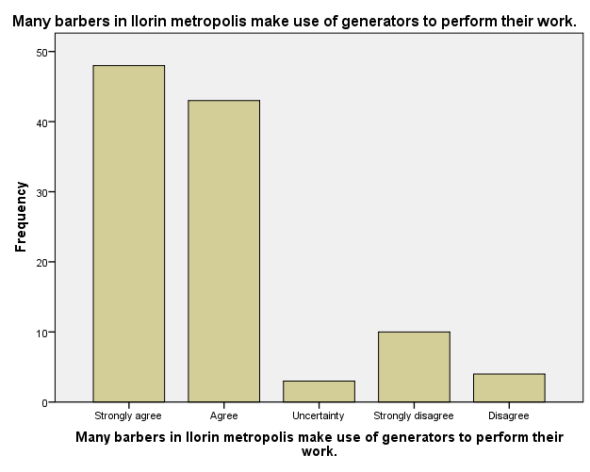
Figure 4.9 Many barbers in Ilorin metropolis make use of generators to perform their work.

Table 4.11 Research and development has been used mostly by barbers in their line of operation in the state.
 |  | Frequency | Percent | Valid Percent | Cumulative Percent
Valid | Strongly agree | 18 | 15.1 | 16.7 | 16.7
Valid | Agree | 17 | 14.3 | 15.7 | 32.4
Valid | Uncertainty | 24 | 20.2 | 22.2 | 54.6
Valid | Strongly disagree | 29 | 24.4 | 26.9 | 81.5
Valid | Disagree | 20 | 16.8 | 18.5 | 100.0
Valid | Total | 108 | 90.8 | 100.0
Missing | System | 11 | 9.2
Total |  | 119 | 100.0
Source: Field Survey, 2025.

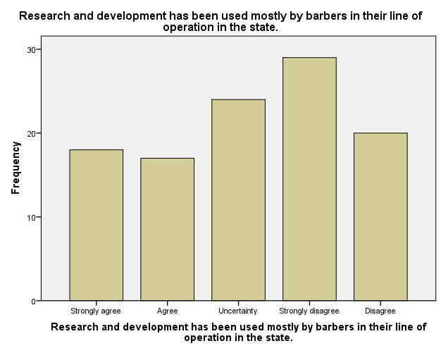

Figure 4.10 Research and development has been used mostly by barbers in their line of operation in the state.

Table 4.12 Many barbers in the state make use of research and development in order to change to modern ways of barbing
 |  | Frequency | Percent | Valid Percent | Cumulative Percent
Valid | Strongly agree | 13 | 10.9 | 12.0 | 12.0
Valid | Agree | 14 | 11.8 | 13.0 | 25.0
Valid | Uncertainty | 31 | 26.1 | 28.7 | 53.7
Valid | Strongly disagree | 27 | 22.7 | 25.0 | 78.7
Valid | Disagree | 23 | 19.3 | 21.3 | 100.0
Valid | Total | 108 | 90.8 | 100.0
Missing | System | 11 | 9.2
Total |  | 119 | 100.0
Source: Field Survey, 2025.
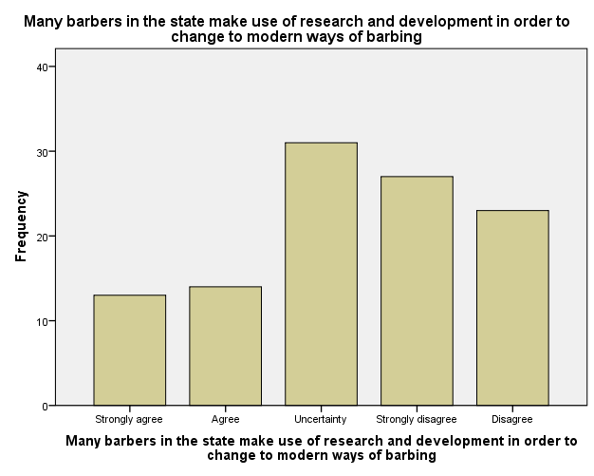
Figure 4.11 Many barbers in the state make use of research and development in order to change to modern ways of barbing.

Table 4.13 Technical know-how of many barbers in Ilorin is high.
 |  | Frequency | Percent | Valid Percent | Cumulative Percent
Valid | Strongly agree | 38 | 31.9 | 35.2 | 35.2
Valid | Agree | 31 | 26.1 | 28.7 | 63.9
Valid | Uncertainty | 20 | 16.8 | 18.5 | 82.4
Valid | Strongly disagree | 3 | 2.5 | 2.8 | 85.2
Valid | Disagree | 16 | 13.4 | 14.8 | 100.0
Valid | Total | 108 | 90.8 | 100.0
Missing | System | 11 | 9.2
Total |  | 119 | 100.0
Source: Field Survey, 2025.

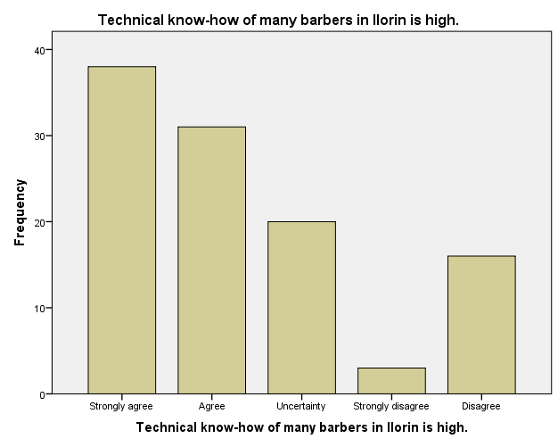
Figure 4.12 Technical know-how of many barbers in Ilorin is high.

Table 4.14 Technological advancement is one of the main reasons that attract customers.
 |  | Frequency | Percent | Valid Percent | Cumulative Percent
Valid | Strongly agree | 16 | 13.4 | 14.8 | 14.8
Valid | Agree | 40 | 33.6 | 37.0 | 51.9
Valid | Uncertainty | 17 | 14.3 | 15.7 | 67.6
Valid | Strongly disagree | 14 | 11.8 | 13.0 | 80.6
Valid | Disagree | 21 | 17.6 | 19.4 | 100.0
Valid | Total | 108 | 90.8 | 100.0
Missing | System | 11 | 9.2
Total |  | 119 | 100.0
Source: Field Survey, 2025.

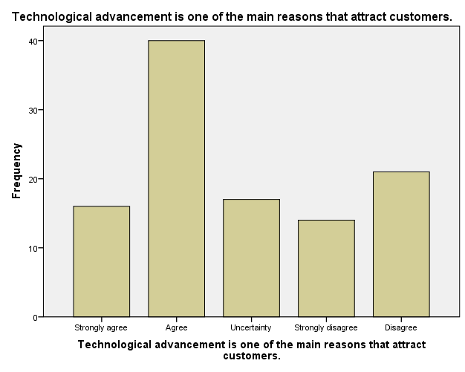
Figure 4.13 Technological advancement is one of the main reasons that attract customers.

Table 4.15 Sales rate in the barbing business is really high and enormous in Ilorin metropolis.
 |  | Frequency | Percent | Valid Percent | Cumulative Percent
Valid | Strongly agree | 24 | 20.2 | 22.2 | 22.2
Valid | Agree | 37 | 31.1 | 34.3 | 56.5
Valid | Uncertainty | 11 | 9.2 | 10.2 | 66.7
Valid | Strongly disagree | 16 | 13.4 | 14.8 | 81.5
Valid | Disagree | 20 | 16.8 | 18.5 | 100.0
Valid | Total | 108 | 90.8 | 100.0
Missing | System | 11 | 9.2
Total |  | 119 | 100.0
Source: Field Survey, 2025.

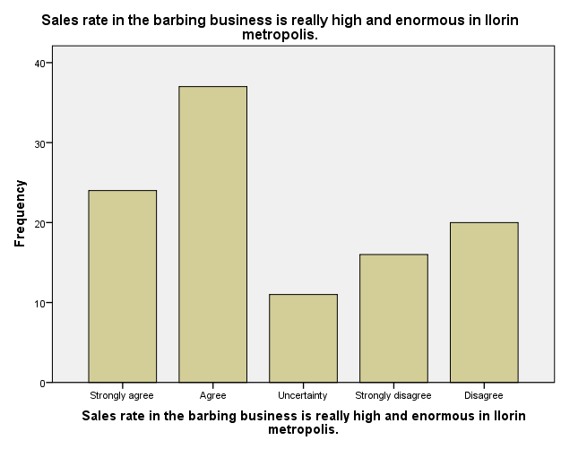
Figure 4. 14 Sales rate in the barbing business is really high and enormous in Ilorin metropolis.

Table 4.16 Many barbers have low sales despite making use of modern technologies to work
 |  | Frequency | Percent | Valid Percent | Cumulative Percent
Valid | Strongly agree | 5 | 4.2 | 4.6 | 4.6
Valid | Agree | 21 | 17.6 | 19.4 | 24.1
Valid | Uncertainty | 16 | 13.4 | 14.8 | 38.9
Valid | Strongly disagree | 28 | 23.5 | 25.9 | 64.8
Valid | Disagree | 38 | 31.9 | 35.2 | 100.0
Valid | Total | 108 | 90.8 | 100.0
Missing | System | 11 | 9.2
Total |  | 119 | 100.0
Source: Field Survey, 2025
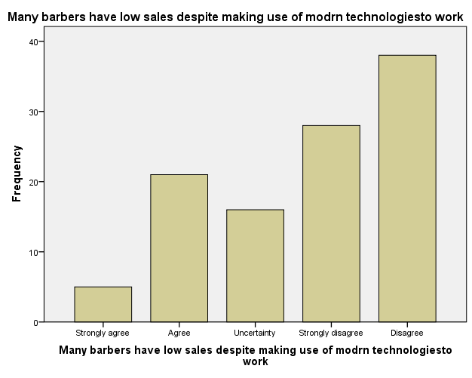
Figure 4.15 Many barbers have low sales despite making use of modern technologies to work.

Table 4.17 Inadequate sales is being affected due to lack of using modern appropriate technology to work.
 |  | Frequency | Percent | Valid Percent | Cumulative Percent
Valid | Strongly agree | 14 | 11.8 | 13.0 | 13.0
Valid | Agree | 20 | 16.8 | 18.5 | 31.5
Valid | Uncertainty | 12 | 10.1 | 11.1 | 42.6
Valid | Strongly disagree | 27 | 22.7 | 25.0 | 67.6
Valid | DIsagree | 35 | 29.4 | 32.4 | 100.0
Valid | Total | 108 | 90.8 | 100.0
Missing | System | 11 | 9.2
Total |  | 119 | 100.0
Source: Field Survey, 2025.

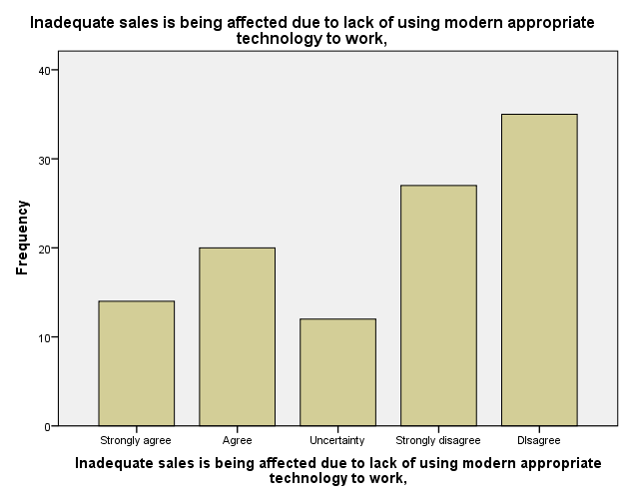
Figure 4.16 Inadequate sales is being affected due to lack of using modern appropriate technology to work.

Table 4.18 Many barbers in Ilorin has low customers to patronize them due to competitions of others.
 |  | Frequency | Percent | Valid Percent | Cumulative Percent
Valid | Strongly agree | 36 | 30.3 | 33.3 | 33.3
Valid | Agree | 33 | 27.7 | 30.6 | 63.9
Valid | Uncertainty | 13 | 10.9 | 12.0 | 75.9
Valid | Strongly disagree | 10 | 8.4 | 9.3 | 85.2
Valid | Disagree | 16 | 13.4 | 14.8 | 100.0
Valid | Total | 108 | 90.8 | 100.0
Missing | System | 11 | 9.2
Total |  | 119 | 100.0
Source: Field Survey, 2025.
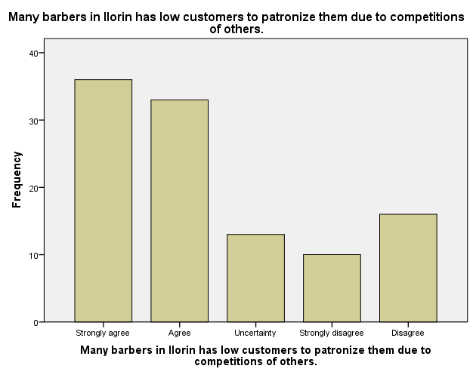
Figure 4.17 Many barbers in Ilorin has low customers to patronize them due to competitions of others.

Table 4.19 Adoption of modern technologies helps to attract new customers and leads to high turnover rate.
 |  | Frequency | Percent | Valid Percent | Cumulative Percent
Valid | Strongly agree | 42 | 35.3 | 38.9 | 38.9
Valid | Agree | 30 | 25.2 | 27.8 | 66.7
Valid | Uncertainty | 17 | 14.3 | 15.7 | 82.4
Valid | Strongly disagree | 3 | 2.5 | 2.8 | 85.2
Valid | Disagree | 16 | 13.4 | 14.8 | 100.0
Valid | Total | 108 | 90.8 | 100.0
Missing | System | 11 | 9.2
Total |  | 119 | 100.0
Source: Field Survey, 2025.

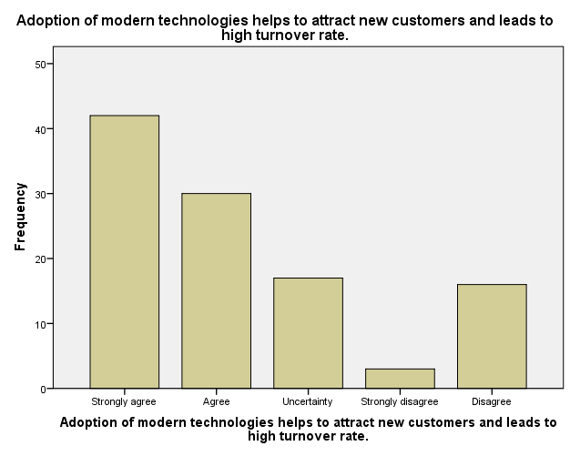
Figure 4.18 Adoption of modern technologies helps to attract new customers and leads to high turnover rate.

Table 4.20 Many barbers make efficient use of their working hours in order to make high sales in Ilorin metropolis.
 |  | Frequency | Percent | Valid Percent | Cumulative Percent
Valid | Strongly agree | 36 | 30.3 | 33.3 | 33.3
Valid | Agree | 34 | 28.6 | 31.5 | 64.8
Valid | Uncertainty | 13 | 10.9 | 12.0 | 76.9
Valid | Strongly disagree | 14 | 11.8 | 13.0 | 89.8
Valid | Disagree | 11 | 9.2 | 10.2 | 100.0
Valid | Total | 108 | 90.8 | 100.0
Missing | System | 11 | 9.2
Total |  | 119 | 100.0
Source: Field Survey, 2025.

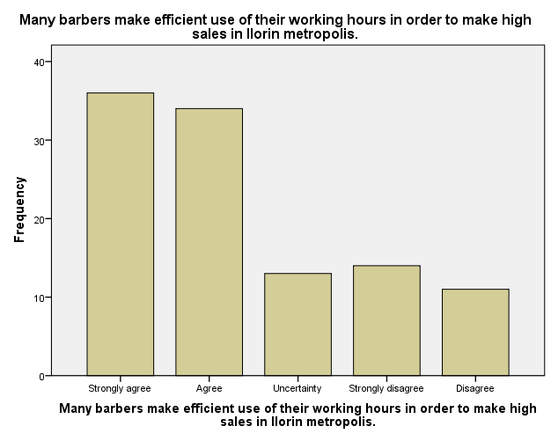
Figure 4.19 Many barbers make efficient use of their working hours in order to make high sales in Ilorin metropolis.

Table 4.21 Few barbers make efficient use of the available resources in the state.
 |  | Frequency | Percent | Valid Percent | Cumulative Percent
Valid | Strongly agree | 20 | 16.8 | 18.3 | 18.3
Valid | Agree | 37 | 31.1 | 33.9 | 52.3
Valid | Uncertainty | 26 | 21.8 | 23.9 | 76.1
Valid | Strongly disagree | 10 | 8.4 | 9.2 | 85.3
Valid | Disagree | 16 | 13.4 | 14.7 | 100.0
Valid | Total | 109 | 91.6 | 100.0
Missing | System | 10 | 8.4
Total |  | 119 | 100.0
Source: Field Survey, 2025.

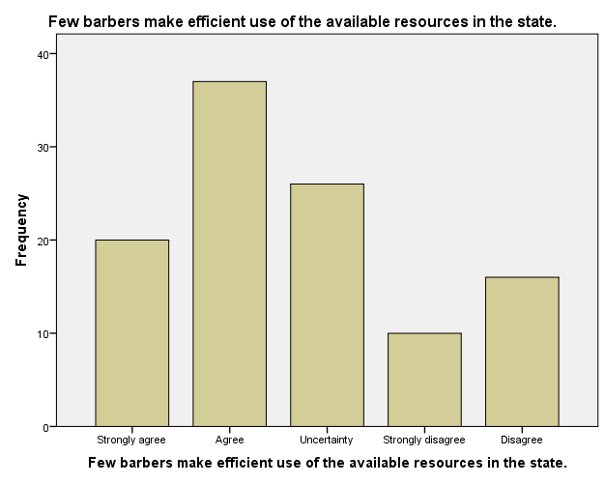
Figure 4.20 Few barbers make efficient use of the available resources in the state.

Table 4.22 There are sufficient infrastructural facilities that enable barbing business to strive well in the state.
 |  | Frequency | Percent | Valid Percent | Cumulative Percent
Valid | Strongly agree | 10 | 8.4 | 9.3 | 9.3
Valid | Agree | 18 | 15.1 | 16.7 | 25.9
Valid | Uncertainty | 31 | 26.1 | 28.7 | 54.6
Valid | Strongly disagree | 16 | 13.4 | 14.8 | 69.4
Valid | Disagree | 33 | 27.7 | 30.6 | 100.0
Valid | Total | 108 | 90.8 | 100.0
Missing | System | 11 | 9.2
Total |  | 119 | 100.0
Source: Field Survey, 2025.

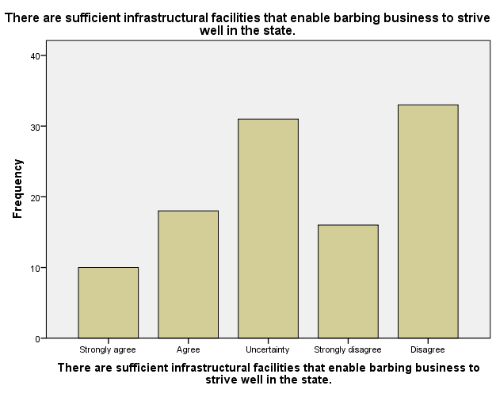
Figure 4.21 There are sufficient infrastructural facilities that enable barbing business to strive well in the state.

Table 4.23 Lack of time management affect the growth and survival of many barbing salons in the state
 |  | Frequency | Percent | Valid Percent | Cumulative Percent
Valid | Strongly agree | 27 | 22.7 | 25.0 | 25.0
Valid | Agree | 25 | 21.0 | 23.1 | 48.1
Valid | Uncertainty | 24 | 20.2 | 22.2 | 70.4
Valid | Strongly disagree | 13 | 10.9 | 12.0 | 82.4
Valid | Disagree | 19 | 16.0 | 17.6 | 100.0
Valid | Total | 108 | 90.8 | 100.0
Missing | System | 11 | 9.2
Total |  | 119 | 100.0
Source: Field Survey, 2025.

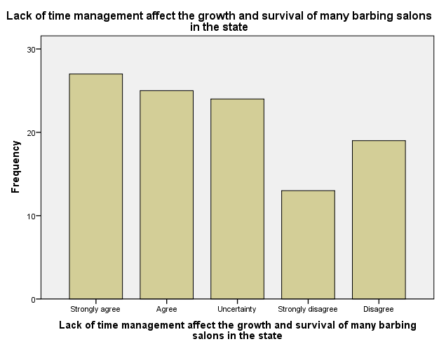
Figure 4.22 Lack of time management affect the growth and survival of many barbing salons in the state.

Table 4.24 Inefficiency of most barbers result to poor performance in the business.
 |  | Frequency | Percent | Valid Percent | Cumulative Percent
Valid | Strongly agree | 26 | 21.8 | 24.1 | 24.1
Valid | Agree | 32 | 26.9 | 29.6 | 53.7
Valid | Uncertainty | 15 | 12.6 | 13.9 | 67.6
Valid | Strongly disagree | 13 | 10.9 | 12.0 | 79.6
Valid | Disagree | 22 | 18.5 | 20.4 | 100.0
Valid | Total | 108 | 90.8 | 100.0
Missing | System | 11 | 9.2
Total |  | 119 | 100.0
Source: Field Survey, 2025.

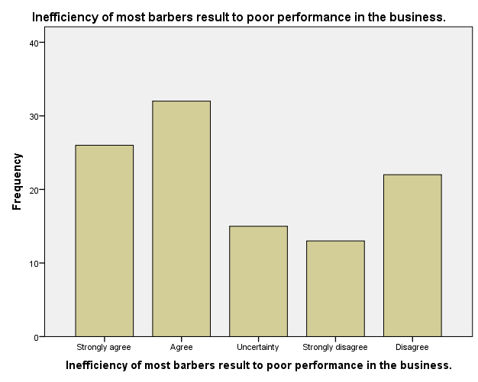
Figure 4.23 Inefficiency of most barbers result to poor performance in the business.
4.3 Test of Hypothesis
The data collected were analyzed by using one sample T-test. The decision rule for assessing if the test is significant (α = 0.05) is stated:
If p ≤ 0.05, the test is significant (the sample is significantly different than μ = 3)
If p > 0.05, the test is not significant (the sample is not significantly different than μ = 3)
Hypothesis I
H₀1: Power supply does not significant impact on the business productivity.
In view of this, values from table 4.9 which states that the sales of barbers are relatively high due to adequate power supply in the state.

One-Sample Statistics
 | N | Mean | Std. Deviation | Std. Error Mean
The sales of barbers are relatively high due to adequate power supply in the state. | 108 | 3.94 | 1.237 | .119

One-Sample Test
 | Test Value = 3
 | t | Df | Sig. (2-tailed) | Mean Difference | 95% Confidence Interval of the Difference
 |  |  |  |  | Lower | Upper
The sales of barbers are relatively high due to adequate power supply in the state. | 7.936 | 107 | .000 | .944 | .71 | 1.18

HYPOTHSIS II

H₀2: The technical know-how does not affect the technology application to the business.
In view of this, values from table 4.13

One-Sample Statistics
 | N | Mean | Std. Deviation | Std. Error Mean
Technical know-how of many barbers in Ilorin is high. | 108 | 2.33 | 1.374 | .132

One-Sample Test
 | Test Value = 3
 | t | Df | Sig. (2-tailed) | Mean Difference | 95% Confidence Interval of the Difference
 |  |  |  |  | Lower | Upper
Technical know-how of many barbers in Ilorin is high. | -5.042 | 107 | .000 | -.667 | -.93 | -.40

HYPOTHSIS III

H₀3: Power supply does not have impact on the employee performance
In view of this, values from table 4.6 which states that barbers experience lack of power supply in Ilorin metropolis which affect their mode of operation.
One-Sample Statistics
 | N | Mean | Std. Deviation | Std. Error Mean
Barbers experience lack of power supply in Ilorin metropolis which affect their mode of operation | 108 | 2.16 | 1.254 | .121

One-Sample Test
 | Test Value = 3
 | t | Df | Sig. (2-tailed) | Mean Difference | 95% Confidence Interval of the Difference
 |  |  |  |  | Lower | Upper
Barbers experience lack of power supply in Ilorin metropolis which affect their mode of operation | -6.981 | 107 | .000 | -.843 | -1.08 | -.60

HYPOTHSIS IV

H₀4: Power supply does not have impact on the employee performance
In view of this, values from table 4.19 which states that adoption of modern technologies helps to attract new customers and leads to high turnover rate.
One-Sample Statistics
 | N | Mean | Std. Deviation | Std. Error Mean
Adoption of modern technologies helps to attract new customers and leads to high turnover rate. | 108 | 2.27 | 1.392 | .134

One-Sample Test
 | Test Value = 3
 | t | Df | Sig. (2-tailed) | Mean Difference | 95% Confidence Interval of the Difference
 |  |  |  |  | Lower | Upper
Adoption of modern technologies helps to attract new customers and leads to high turnover rate. | -5.463 | 107 | .000 | -.731 | -1.00 | -.47

CHAPTER FIVE
SUMMARY, CONCLUSION AND RECOMMENDATIONS
5.0 Introduction
This chapter of this research work gives an overview of the whole research work as this starts with the summary of the work from the first chapter to the last chapter, the findings. This chapter will examine the theoretical and empirical findings as discovered by the researcher, the conclusion of the research work; recommendations proffered by the researcher as a way by which more research will have a benchmark or appoint of reference after this research work as to what is expected from them and finally suggestions for further studies will be put forward.
The purposes of this study, four hypotheses were put forward in the course of the research which was tested using correlation analysis.
5.1 SUMMARY OF FINDINGS
From the analysis of data presented, a number of findings were made from the study which examines the effect of technological advancement in performance of barbing salon business in Ilorin metropolis.
- The study found that Technical know-how has positively influenced the technology application in barbing business
- The findings show that power supply has a significant effect on the productivity of barbing business.
- Finally it was processed from the study that research and development can positively enhance the economic development of the barbing business.
5.2 CONCLUSION
The study was carried out to examine the effect of technological advancement in performance of barbing salon business in Ilorin metropolis. The findings of the study indicated that technical know-how increases the technology application by barbers. The findings show that power supply has a significant effect on the productivity of barbing saloon. Finally it was processed from the study that research and development can positively enhance the economic development of the business. Barbers are ever ready to make an extra effort if they are satisfied with strategic decisions of their business. Technological advancement and adoption determines the performance of the business. The barbers should try as much as possible for their workers to understand and give them adequate trainings on how to make effective use of modern barbing tools so that there may be improvement in their performance.
5.3 RECOMMENDATIONS
Based on the findings, the researcher recommended as follows;
- Barbers should provide the opportunity of training and development on modern barbing tools, these will provide such working environment to employees in which they will work easily and independently without feeling any burden.
- They should provide employee with a clear career path and career development opportunities by giving them training, seminars and workshops and this will increase their productivity in the business.
- They should make sure that their workers or staffs have the knowledge of the barbing and the business vision, mission and strategic.

REFERENCES

Abdel, K.H., Rowena, B. & Robyn, D. (2010). Understanding financial information used to
assess small firm performance, Qualitative Research in Accounting & Management, 7 (2), pp. 163-179.
Abrie, W. & Doussy, E. (2006). Tax compliance obstacles encountered by small and medium
enterprises in South Africa, Research Journal of School of Accounting Sciences, 14 (1), pp. 1-13.
Alattar, J.M., Kouhy, R. & Innes, J. (2009). Management accounting information in micro
enterprises in Gaza, Journal of Accounting and Organizational Change, 5 (1), p. 81.
Arinaitwe, J.K. (2006). Factors Constraining the Growth and Survival of Small Scale
Businesses. A Developing Countries Analysis, Journal of American Academy of Business, 8 (2), pp. 167-178.
Bayati, A. & Taghavi, A. (2007). The impacts of acquiring ISO 9000 certification on the
performance of SMEs in Tehran, The TQM Magazine, 19 (2), pp. 140-149.
Beck, T. & Demirguc-Kunt, A. (2006). Small and Medium Size Enterprise: Access to
Finance as a Growth Constraint, Journal of Banking & Finance, 30 (1), pp. 2931-2943.
Berger, A.N. & Udell, G.F. (2006). A more complete conceptual framework for SME
finance, Journal of Banking & Finance, 30 (11), pp. 2945-2966.
Cacciotti, G. and Hayton, J.C. (2015). Fear and Entrepreneurship: A Review and Research
Agenda, International Journal of Management Reviews, 17 (2), pp. 165-190.
Cant, M.C. & Wiid, J.A. (2013). Establishing the Challenges Affecting South African SMEs,
International Business & Economics Research Journal, 12 (6), pp. 707-716.
Chamberlain, D. & Smith, A. (2006). Recent Findings on Tax-Related Regulatory Burden on
SMMEs in South Africa. Working Paper 06/105, Development Policy Research Unit, University of Cape Town. Available at: http://www.thepresidency.gov.za/docs/pcsa/economic/smith1.pdf Accessed on 10 July 2014].
Christianson, D. (2003). The investment climate in South Africa – regulatory issues: some
insights from the high growth export oriented SME sector. Paper prepared for DFID, London.
Corruption Watch. (201)3. CPI 2013 – South Africa in the African context.15 July 2014.
Dalberg. (2011). Report on Support to SMEs in Developing Countries Through Financial
Intermediaries. Available at: http://www.eib.org/attachments/dalberg_sme-briefing-paper.pdf. Accessed on 21 July 2014.
Delmar, F. & Wiklund, J. (2008). The Effect of Small Business Managers’ Growth
Motivation on Firm Growth: A Longitudinal Study, Entrepreneurship Theory and Practice, 32 (3), pp. 437-457.
Department of Trade and Industry (DTI). (2005). Integrated Small Enterprise Development
Strategy: Unlocking the Potential of South African Entrepreneurs. DTI, Pretoria.
Ehlers, T. & Lazenby, K. (2007). Strategic Management: South Africa concept and cases.
2nd ed. Pretoria: Van Schaik.
Fang, N., Yuli, Z. & Hongzhi, X. (2009). Acquisition of resources, formal organization and
Entrepreneurial orientation of new ventures, Journal of Chinese Entrepreneurship, 1 (1), pp. 40-52.
Fatoki, O. & Garwe, D. (2010). Obstacles to the growth of new SMEs in South Africa: a
principal component analysis approach, African Journal of Business Management, 4 (5), pp. 729-738.
FinMark. (2010). FinScope South Africa Small Business Survey (2010). Available at:
http://www.finmark.org.za/wpcontent/ uploads/pubs/FS-Small-Bu siness_-reportFNL2.pdf. Accessed on 10 July 2014.
Gilley, K.M., Greer, C.R. & Rasheed, A.A. (2004). Human resource outsourcing and
organizational performance in manufacturing firms, Journal of Business Research, 57 (3), pp. 232-240.
Gunasekaran, A., Rai, B.K. & Griffin, M. (2011). Resilience and competitiveness of small
and medium size enterprises: an empirical research, International Journal of Production Research, 49 (18), pp. 5489-5509.
Haron, H., Said, S.B., Jayaraman, K. & Ismail, I. (2013). Factors Influencing Small Medium
Enterprises (SMES) in Obtaining Loan, International Journal of Business and Social Science, 4 (15), pp. 182-195.
Herrington, M., Kew, J. & Kew, P. (2010a). Tracking Entrepreneurship in South Africa: A
GEM Perspective. Available at: http://www.africanentrepreneur.com/images/library/pdf/GEM%20SA%202009%20-%20Tracking%20Entrepreneurship.pdf. Accessed on 15 July 2014.
Hisrich, R.D. & Drnovsek, M. (2002). Entrepreneurship and Small Business Research,
Journal of Small Business and Enterprise Development, 9 (2), pp. 172-222.
Ihua, U.B. (2009). SMEs Key Failure-factors: A Comparison between the United Kingdom
and Nigeria, Journal of Social Science, 18 (3), pp. 199-207.
Kolstad, I. & Wiig, A. (2015). Education and entrepreneurial success, Small Business
Economics, 44 (4), pp. 783-796.
Levy, M. & Powell, P. (2000). Information systems strategy in SMEs – An organizational
perspective, Journal of Strategic Information Systems, 9 (1), pp. 63-84.
Lotz, O. & Marais, L. (2007). Manufacturing enterprises and marketing planning in a mining
area of the North West Province, South Africa: lessons for local business support centres, Development Southern Africa, 24 (5), pp. 693-706.
Longenecker, J.G., Petty, J.W., Hoy, F. & Palich, L.E. (2012). Small Business Management,
An entrepreneurial emphasis. 16th ed. London: Thomson South Western.
Maswanganyi, N. (2014). Economy: Weak rand will fuel inflation, higher interest rates, says
Moodys, Business Day Live. Available at: http://www.bdlive.co.za/economy/2014/02/13/weak-rand-will-fuel-inflation-higherinterest-rates-says-moodys. Accessed on 03 June 2014.
Martin, G. & Staines, H. (2008). Managerial competencies in small firm, Journal of
Management Development, 13 (7), pp. 23-34.

QUESTIONNAIRE
INSTRUCTIONS:
Please respond to the questions objectively by ticking the appropriate box (√) and filling the gap provided against each question and leave the alternative box blank. You may as well express your opinion in response to each question as deemed fit. There is no right or wrong response.
SECTION A: DEMOGRAPHIC VARIABLES
Please tick () the correct answers to the questions below
1. Gender: Male ( ) Female ( )
2. Age: 20 – 25 years ( ) 26 – 30 years ( ) 31-35 years ( ) 36 years and above ( )
3. Years of Experience: 1-5 years ( ) 6-10 years ( ) 11-15 years ( ) 16 years and above ( )
4. Highest Educational Qualification: Primary education ( ) Secondary education ( ) HND/BSc. ( ) MSc/PhD ( ) others ( )
SECTION B: ITEMS ON RESEARCH QUESTIONS
Please indicate your level of agreement regarding the following statements which are intended to investigate the ‘Effect of technology advancement on the performance of barbing salon in Ilorin metropolis’. The following numbers indicate the following levels of acceptability:
1 = Strongly Agree, 2 =Agree, 3 = Uncertainty, 4 = Strongly Disagree, 5 = Disagree.
Please tick [√] only one box for each statement.

S/N | Power Supply | SA | A | N | SD | D
1 | Barbers experience lack of power supply in Ilorin metropolis which affect their mode of operation
2 | High rate of electricity tax discouraged many barbers in Ilorin metropolis to make use of power supply
3 | Power supply is very constant for work in Ilorin metropolis
4 | The sales of barbers are relatively high due to adequate power supply in the state
5 | Many barbers in Ilorin metropolis make use of generators to perform their work
 | Research and Development | SA | A | N | SD | D
6 | Research and development has been used mostly by barbers in their line of operation in the state
7 | Many barbers in the state make use of research and development in order to change to modern ways of barbing
8 | Technical know-how of many barbers in Ilorin is high
9 | Most barbers make use of new clippers and modern measures to work in the state
10 | Technological advancement is one of the main reasons that attract customers
 | Productivity | SA | A | N | SD | D
11 | Sales rate in the barbing business is really high and enormous in Ilorin metropolis
12 | Many barbers have low sales despite making use of modern technologies to work
13 | Inadequate sales is been affected due to lack of using modern appropriate technology to work
14 | Many barbers in Ilorin has low customers to patronize them due to competitions of others
15 | Adoption of modern technologies helps to attract new customers and leads to high turnover rate
 | Efficiency | SA | A | N | SD | D
16 | Many barbers make efficient use of their working hours in order to make high sales in Ilorin metropolis
17 | Few barbers make efficient use of the available resources in the state
18 | There are sufficient infrastructural facilities that enable barbing business to thrive well in the state
19 | Lack of time management affect the growth and survival of many barbing salons in the state
20 | Inefficiency of most barbers result to poor performance in the business

