THE UTILIZATION OF LIGHTWEIGHT CONCRETE INCORPORATING COCONUT SHELLS AS AGGREGATE MATERIALS.

INTRODUCTION
Concrete is the widely used number one structural material in the world today. The demand to make this material lighter has been the subject of study that has challenged scientists and engineers alike. The challenge in making a lightweight concrete is decreasing the density while maintaining strength and without adversely affecting cost (Basri.H. B et al., 2019).
Introducing new aggregates into the mix design is a common way to lower a concrete’s density. Normal concrete contains four components, cement, crushed stone, river sand and water. The crushed stone and sand are the components that are usually replaced with lightweight aggregates (Khedari et al., 2014).
Lightweight concrete is typically made by incorporating natural or synthetic lightweight aggregates or by entraining air into a concrete mixture. Some of the lightweight aggregates used for lightweight concrete productions are pumice, perlite, expanded clay or vermiculite, coal slag, sintered fly ash, rice husk, straw, sawdust, cork granules, wheat husk, oil palm shell, and coconut shell. (Mannan.M.A. and Ganapathy.C 2012).
There were many experimental works conducted to improve the properties of the concrete by putting new materials, whether it is natural materials or recycle materials or synthetic materials in the concrete mix. The additional material can be replacing the aggregate, cement or just as additive and one form of the additive is natural material. A large amount of agricultural waste was disposed in most of tropical countries especially in Asia for countries like Thailand, Philippine and Malaysia. If the waste cannot be disposed efficiently it will lead to social and environmental problem. The high cost of conventional building materials is a major factor affecting housing delivery in India. This has necessitated research into alternative materials of construction. There is an increasing interest in what happens to products at the end of their useful lives, so natural materials have an advantage in that they can biodegrade or be burnt in a carbon-neutral manner. Natural material like coconut shell and palm kernel shell are not commonly used in the construction industry but still are often dumped as agricultural wastes. However, with the quest for affordable housing system for both the rural and urban population of India and other developing countries, various proposals focusing on cutting down conventional building material costs have been put forward. One of the suggestions in the forefront has been the sourcing, development and use of alternative, non-conventional local construction materials including the possibility of using some agricultural wastes and residues as construction materials. As the natural fibers are agriculture waste, manufacturing natural product is, therefore, an economic and interesting option. Coconuts show a wide diversity in size, weight, shape and color, depending on genetic variety and maturity of the nut at harvest (Ohler, 2009).
Adeyemi, 1998 investigated, for one mix ratio (1:2:4) the suitability of coconut shell as substitute for either fine or coarse aggregate in concrete production. The comparative cost analysis and strength characteristic coconut shells of concrete produced using crushed, granular coconut shell as substitutes for conventional coarse aggregate. It was concluded that the coconut shell was suitable as low strength-giving lightweight aggregate when used to replace common coarse aggregate in concrete production (Olanipekun et al., 2016).
One such alternative is coconut shell (CS), which is a form of agricultural solid waste. It is one of the most promising agro wastes with its possible uses as coarse aggregate in the production of concrete. This has good potential to use in areas where crushed stones are costly. Statistical data of coconut production shows that, India is producing nearly 27% of total world production and the annual production of coconut is reported to be more than 12 million tons. Presently the coconut shell waste being used for making mosquito coils, angiopathies, etc. (www. Foodmarketexchange.com). Only few studies have been reported on use of coconut shells as aggregate in concrete (Olanipekun E.A.2016).
PROBLEM STATEMENT
The construction industry is facing a significant challenge in reducing its environmental footprint while meeting the increasing demand for building materials. Traditional concrete, a widely used building materials, has a high environmental impact due to its energy-intensive production process, greenhouse gas emissions, and waste generation. The depletion of natural resources, such as sand and gravel, used as aggregate materials in traditional concrete, is becoming a growing concern.
AIM
The aim of this project is to utilize lightweight concrete incorporating coconut shells as aggregate materials.
OBJECTIVES
- To investigate the effect of natural aggregate types on concrete strength.
- To optimize the mix proportion of coconut shell concrete.
- To determine the compressive strength of the materials.
JUSTIFICATION
Coconut shells are a waste product of the coconut industry, and utilizing them as aggregate materials reduces waste and promotes sustainability. Lightweight concrete made with coconut shells has a lower carbon footprint compared to traditional concrete, making it an environmentally friendly alternative.
SCOPE OF THE STUDY
The scope of the study is comprehensive, encompassing a literature review, experimental investigation, mix design and testing, and comparison with traditional concrete. The literature review will provide a comprehensive overview of existing research on the use of coconut shells as aggregate materials in concrete. The experimental investigation will involve testing the physical and mechanical properties of lightweight concrete made with coconut shells. The mix design and testing will focus on developing a suitable mix design for lightweight concrete incorporating coconut shells and evaluating its workability, compressive strength, and durability.

CHAPTER TWO

LITERATURE REVIEW

Studies have shown that coconut shells have a low density, ranging from 0.5 to 0.8g/cm³, making them suitable for lightweight concrete applications (Axelsson, 2012; Kumar, 2017). The compressive strength of coconut shell concrete has been reported to range from 10 to 30 MPa, depending on the mix design and curing conditions (Rafique, 2015); Sathishkumar, 2018).
The tensile strength of coconut shell concrete has been reported to range from 1 to 5 MPa (Kumar, 2017; Sathishkumar, 2018).
Normal concrete contains four components, cement, crushed stone, river sand and water. The crushed stone and sand are the components that are usually replaced with lightweight aggregates. Lightweight concrete is typically made by incorporating natural or synthetic lightweight aggregates or by entraining air into a concrete mixture. Some of the lightweight aggregates used for lightweight concrete productions are pumice, perlite, expanded clay or vermiculite, coal slag, sintered fly ash, rice husk, straw, sawdust, cork granules, wheat husk, oil palm shell, and coconut shell. (Basri.H.B et al., 2019, Khedari et al., 2020).
Presently in India, about 960 million tonnes of solid wastes are being generated annually as by-products during industrial, mining, municipal, agricultural and other processes. Of these 350 million tonnes are organic wastes from agricultural sources; 290 million tonnes are inorganic waste of industrial and mining sectors. However, it is reported that about 600 MT of wastes have been generated in India from agricultural sources alone (Asokan Pappu (2017). The new and alternative building construction materials developed using agro-industrial wastes have ample scope for introducing new building components that will reduce to an extent the costs of building materials. The high cost of conventional building materials is a major factor affecting housing delivery in India. In developing countries where abundant agricultural and industrial wastes are discharged, these wastes can be used as potential material or replacement material in the construction industry. One such alternative is coconut shell (CS), which is a form of agricultural solid waste. It is one of the most promising agro wastes with its possible uses as coarse aggregate in the production of concrete. This has good potential to use in areas where crushed stones are costly. Statistical data of coconut production shows that, India is producing nearly 27% of total world production and the annual production of coconut is reported to be more than 12 million tons. Only few studies have been reported on use of coconut shells as aggregate in concrete This paper discussed the physical properties of crushed coconut shell aggregate and the compressive strength of the concrete made with coconut shell coarse aggregate.

CHAPTER THREE

METHODOLOGY
INTRODUCTION
To achieve all stated objectives of this research, concrete was produced using a 1:2:4 mixing ratio because its more sensitive to variation in mix design and testing conditions and also when focusing on more general construction applications and potentially more pronounced effects of coconut shells. Various tests such as sieve analysis, slump test, compacting factor test, and compression strength test were conducted on the concretes.
MATERIALS AND APPARATUS
Coconut Shells (CS), Portland Limestone Cement (PLC) 42.5R compliant with BS 12 (1996), was utilized for creating concrete cubes as part of the research. In accordance with BS 3148 (1980), clean water from the laboratory was used, and fine aggregate (natural sand) compliant with BS 882 (1992) was employed. The coarse aggregate consists of crushed Coconut Shells.
Apparatus used for this research include: Stack of BS sieves, vernier caliper, weighing balance, shovel, slump cone, ruler, head pan, tamping rod, cube mold, spanners, compacting factor apparatus, engine oil, compression machine, hand trowel, scoop and curing tank.
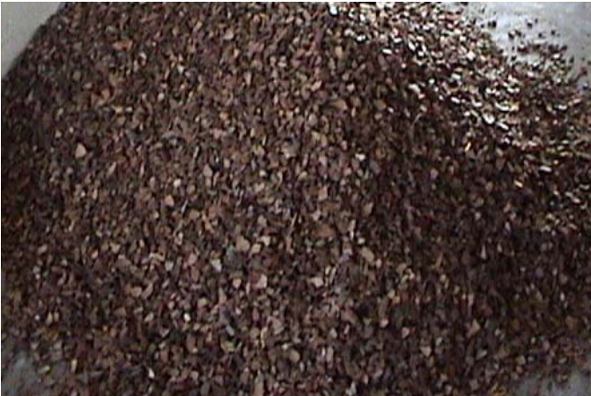
COCONUT SHELL: The Coconut Shell were brought from Oja gbooro market along Balogun Gambari road, Ilorin, Kwara State. It was dried in the sun in an open air and transported to Kwara State Polytechnic, Institute of Technology, Civil Engineering Laboratory. Plate 3.1 shows the Coconut Shells used in the research.
PLATE 3.1: COCONUT SHELL
After the Coconut Shell was crushed, then the particles were further ground and allowed to pass through sieve 90 µm (micron) and measured through Varner caliper. Plate 3.2 shows the Crushed Coconut Shell particle.
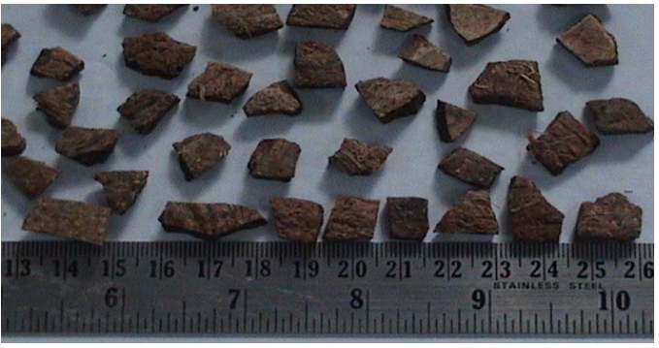

PLATE 3.2: CRUSHED COCONUT SHELL

AGGREGATE: The aggregates used are:
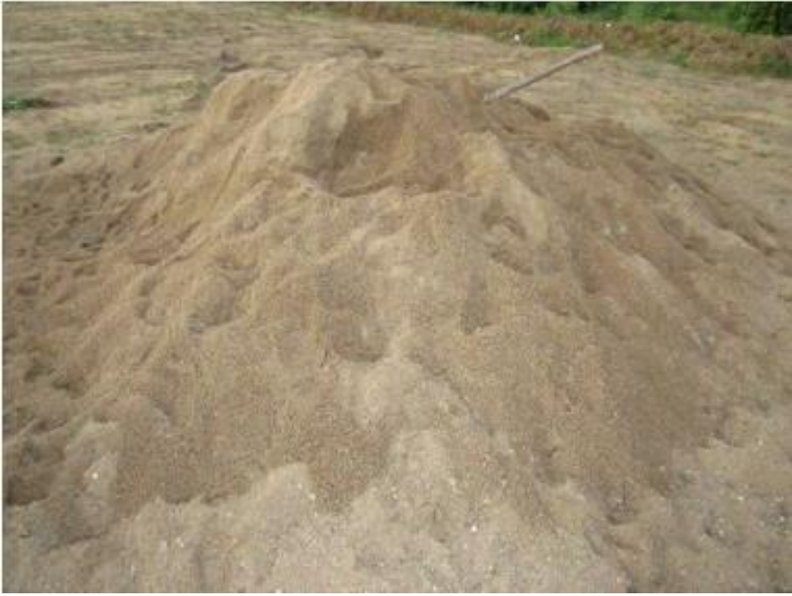
FINE AGGREGATE: The fine aggregate which was used for the project was obtained from Asa River, Ilorin. The fine aggregates pass through sieve 4.75mm, conforming to ASTM (2017).

PLATE 3.3: FINE AGGREGATE

WATER: The water used in this project is portable water conforming to BS EN1262 (2013), obtained from Kwara State Polytechnic, Ilorin, Kwara State.
CEMENT
The cement used is Portland Limestone Cement (PLC) conforming to BS 8500-2 (2015) which was bought at SEFRAZ Cement Ilorin, Kwara State.
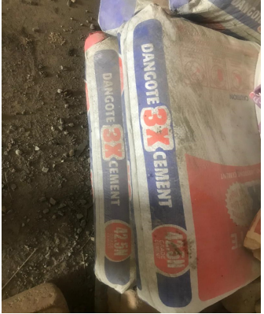

PLATE 3.4: DANGOTE CEMENT

SLUMP TEST
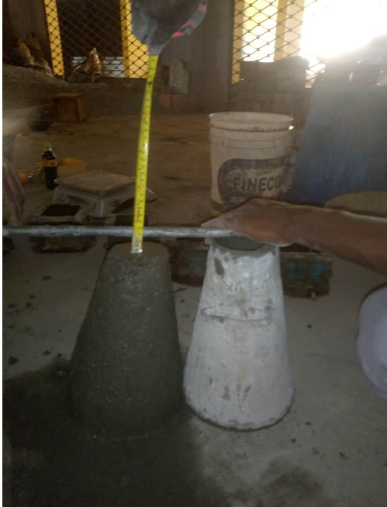
A slump test was conducted to measure the workability or consistency of fresh concrete with Coconut Shell as Coarse Aggregate. The slump cone was cleaned and lubricated with oil, then placed on a horizontal non-porous base then concrete was placed inside in four layers with each layer tamped 25 times with a tamping rod. Excess concrete was scraped away, and the cone was removed vertically. The difference in height of cone and specimen was then measured with a ruler to define the type of slump each concrete with different aggregate sizes possesses. The decrease in height at the center point was measured to nearest 5mm or 0.25 inch and it is known as ‘slump’. This test was carried out for all concrete mixes and the set-up is shown in Plate. 3.5.

PLATE 3.5: SLUMP TEST
MIX PROPORTION
All raw materials used in this investigation were locally obtained. These includes Portland Limestone cement confirming to standard code BS 8112-1995, river sand as fine aggregate and crushed coconut shell as coarse aggregate. The potable water was used for mixing and curing. After crushed the coconut shells, they were sieved and the aggregates passing 12.5mm sieve size was used for this investigation (Fig.1 and Fig.2). The physical and mechanical properties of the river sand, coconut shells aggregate and granite aggregates are shown in Table 1. The normal design procedures for ordinary conventional concretes are not applicable to the mix design of lightweight aggregate concrete for two reasons: -The water content of the cement paste in the fresh lightweight aggregate concrete mix is reduced progressively through absorption by the aggregate and therefore the water-cement ratio will also decrease, and -The compressive strength of lightweight aggregate concrete is not only influenced by the strength of the mortar but also by the aggregate used. Hence, it is recommended to go for trial mixes for designing lightweight concrete mix. For lightweight concrete, the cement is recommended in the range of 285–510 kg/m³. The concrete mix proportion obtained from the trials is 1:1.83:2.63. The mix proportion consists of 480 kg/m3 cement with the water / cement ratio of 0.5 All the ingredients of the mix were weighed and mixed in concrete mixture machine. Steel moulds were used for casting specimens Sides of the moulds and bottom of all the moulds were properly oiled for easy demoulding. The concrete was placed in the mould and proper care was taken for uniform compaction and surface finish.

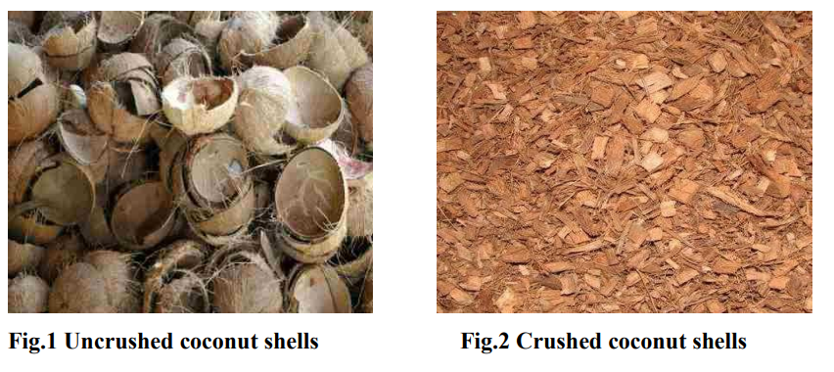

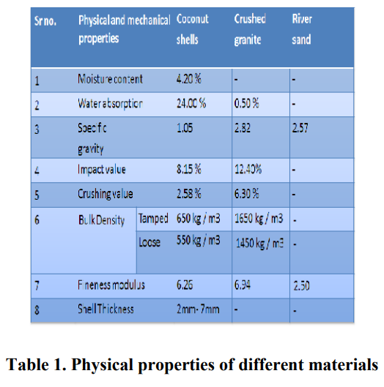

CHAPTER FOUR
RESULT AND DISCUSSION
The average moisture content and water absorption of the crushed coconut shell was found to be 4.20% and 24.00% respectively. Since the coconut shells are basically wood based and organic material and therefore moisture retaining capacity would be more compared with the crushed stone aggregates. Due to the high-water absorption of CS, the aggregates were pre-soaked for 24 hours in potable water prior to mixing and were in saturated surface dry (SSD) condition during mixing to prevent absorption of mixing water. The specific gravity under SSD condition of CS and crushed granite was found to be 1.05 and 2.82 respectively. The specific gravity for normal weight aggregate used in concrete ranges from 2.30 to 2.90. The aggregate impact value gives relative measure of the resistance of an aggregate to sudden impact or shock. The aggregate impact value should not be more than 45% by weight for aggregate used in concrete From Table 1, it can be observed that the aggregate impact value (AIV) and aggregate crushing value (ACV) of CS aggregates are much lower compared to the crushed stone aggregates. The slump obtained for the trial mix was 55 mm, which has showed that CS concrete has a medium degree of workability. The 28-day compressive strength of the concrete using coconut shell aggregate was found to be 29.3 N/mm² (Table 2) under full water curing. The compressive strength of concrete using coconut shell coarse aggregate was more than 27.2 N/ mm², which is a requirement for structural lightweight concrete.

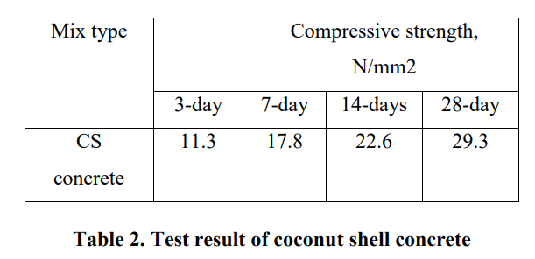

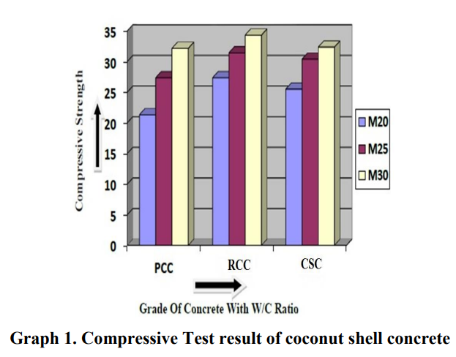

CHAPTER FIVE
CONCLUSION AND RECOMMENDATION
The following conclusion and recommendation which are drawn includes:
- The average moisture content and water absorption of the crushed coconut shell were found to be 4.20 % and 24.00 % respectively. The CS aggregates have higher water absorption because of higher porosity in its’ shell structure.
- The aggregate impact value and aggregate crushing value of CS aggregates were much lower compared to the crushed stone aggregate, which indicates that these aggregates have good absorbance to shock.
- The specific gravity under SSD condition of CS and crushed granite was found to be 1.05 and 2.82 respectively.
- The 28-day compressive strength of the concrete using coconut shell aggregate was found to be 29.3 N/mm2 under full water curing and it satisfies the requirement for structural lightweight concrete. It should, however, further investigations are required before it can be used as a building material.

REFERENCES
Basri H.B. et al (2019), “Concrete using waste oil palm shells as aggregate”, International Journal of Cement and Concrete research, pp 619-622.
E.A Olanipekun, K.O.Oluola,et al 2016. “A comparative study of concrete properties using coconut shell and palm kernel shell as coarse aggregates”,Building & environment 41, pp.297-301.
K.Gunasekaran, P.S.Kumar et al 2018,” Proceedings of International Conference on Advances in Concrete and Construction, ICACC-2018”, 2018, Hyderabad, India pp 450-459
Asokan Pappu (2017), “Solid wastes generation in India and their recycling potential in building materials”, International Journal of Building and Environment 42 (2017), pp 2311-2320.
Joseph Khedari et al (2021), “New lightweight composite construction materials with low thermal conductivity” International Journal of Cement & Concrete Composites, 65-70.
Mannan.M.A. and Ganapathy.C (2022), “Engineering properties of concrete with oil palm shell as coarse aggregate”, International Journal of Construction and Building Materials, pp 29-34.
Loehr RC (2018), “Pollution Control of agriculture”, 2nd edition, Orlando, FL: Academic Press: 1984.
Asokan Pappu (2017), “Solid wastes generation in India and their recycling potential in building materials”, International Journal of Building and Environment 42 (2017), pp 2311-2320.
Martirena J.F. (2018), “Use of Wastes of the Sugar Industry as Pozzolana In Lime-Pozzolana Binders: Study of The Reaction”, International Journal of Cement and Concrete Research, Vol. 28, No. 11, pp. 1525–1536, 2018.
Medjo Eko, R. and G. Riskowski.(2019), “A Procedure for Processing Mixtures of Soil, Cement, and Sugar Cane Bagasse”. Agricultural Engineering International: the CIGR Journal of Scientific Research and Development. Manuscript BC 99 001. Vol. III.
Turgut Ozturk and Muzaffer bayrakl (2015), “The possibilities of using Tobacco waste in producing Light Weight Concrete”, Agricultural Engineering International: the CIGR Ejournal,Vol.VII.Manuscript BC 05 006.August,2015.

