UTILIZATION OF RECYCLED PLASTIC WASTE AS AN AGGREGATE MATERIAL IN CONCRETE

ADEBANJO YUSUF ADEDEJI
HND/23/CEC/FT/0167

ABSTRACT
Disposal of large quantity of plastic bottle has emerged as an important environmental challenge, and its recycling is facing a big problem due to non-degradable nature. Due to plastic does not decompose biologically, the amount of plastic waste in our surroundings is steadily increasing. The proposed concrete which is made up by adding plastic bottle waste in crush form in sand bricks may help to reuse the plastic bottle waste as one of the additives material of bricks, and to help the disposal problem of plastic waste. The properties of sandcrete bricks which contain varying percentages of plastic were tested for compressive strength, water absorption and efflorescence. It shows that an appreciable improvement in the performance of bricks can be achieved by introducing crush type of plastic waste into sandcrete bricks. In view of utilization of plastic waste material for developing sustainable construction material, the present project reviews plastic waste materials in different compositions of 0% to 15% that were added to the raw material to develop plastic waste sandcrete bricks. The compression strength of the bricks is reviewed and recommendations are suggested as the outcome of the study. It was found that the reduction in compressive strength, due to replacement of sand by waste plastic bottle, is minimal and can be enhanced by addition of super plasticizer. The water absorption and efflorescence however showed excellent performance.
INTRODUCTION

General Introduction
Plastic is a very common material that is now widely used by everybody in this world. The term “plastic’’ is derived from the Greek word ''plastikos'', meaning fit for moulding. Plastics are versatile, hygienic, lightweight, flexible and highly durable. The world's first fully synthetic plastic was Bakelite, invented in New York in 1907, by Leo Baekeland who coined the term 'plastics'.
Many chemists have contributed to the materials science of plastics, including Nobel laureate Hermann Staudinger who has been called "the father of polymer chemistry" and Herman Mark, known as "the father of polymer physics.
Plastic is material consisting of a wide range of synthetic or semi-synthetic organic compounds of high molecular mass and often contain other substances that are malleable and so can be moulded into solid objects. Plastics are made from natural materials such as cellulose, coal, natural gas, salt,
crude oil, minerals and plants through the polymerization or polycondensation process. They are usually synthetic, most commonly derived from petrochemicals, however, an array of variants are made from renewable materials such as polylactic acid from corn or cellulosic from cotton linters.
Plastic can be divided into two major categories:
Thermosetting and Thermoplastic.
They are formed from polymers, the word “poly” means many & “mers” means monomers simply many monomers. Plastic is formed by polymerization. Most common types of synthetic organic
polymers are Low-Density Polyethylene (LDPE), High Density Polyethylene (HDPE), Polyvinyl Chloride (PVC), Polypropylene (PP), Polystyrene (PS), and Polyethylene Terephthalate (PET or PETE).
The Benefits of plastic are undeniable. The material is cheap, lightweight and easy to make. These qualities have led to a boom in the production of plastic over the past century. The quantity of recycle plastic waste is expanding rapidly which is a great threat for the environment. Worldwide, about 50 kg of plastic is produced annually per person, with production doubling every ten years.
In 2018, a survey by the Global Oceanic Environmental Survey (GOES) Foundation found that the ecosystem in seas and oceans may collapse in the next 25 years, potentially causing failure of terrestrial ecosystem and "very possibly the end of life on Earth”. The main agents of this prediction were hypothesized to be plastic. According to recent estimates 79% of the plastic waste ever produced now sits in landfills dumps or in the environment while 12% has been incinerates and only 9% has been recycled. When discarded in landfills or in the environment, plastic can take up to a thousand years to decompose.
The use of waste plastic bottles for the production of bricks is an optimal method to solve the problem of storing waste materials and to optimize the cost for the production of building materials. In this study, plastic bottle waste in bottle factory will be used to incorporate with sand, sand dust, cement and water to produce sandcrete bricks. The bricks will then be tested to study the compressive strength, water absorption and efflorescence.
In the recent past research, the replacement and addition have be done with the direct inclusion of
polyethylene or plastic fibre, polyethylene terephthalate (PET) bottles in shredded form, chemically treated polyethylene fibre, PET in aggregate form by replacing natural coarse aggregate. Most of replacements have been done by volume calculation, and showed the decreased in compressive strength as the plastic fibre increased. In this study, recycled plastic bottle will be introduced in crush form as the fibre. The replacement will be done by weight calculation instead of volume calculation.

Problem Statement.
With the increasing volume of plastic waste being generated worldwide, there is a growing need to find sustainable solutions for disposing of and recycling plastic materials. One potential solution is to use crushed plastic waste as an aggregate in building materials, such as sandcrete bricks. However, there is limited information available on the impact of using crushed plastic waste in sandcrete bricks on their structural properties.

Aim.
This project aim to utilize recycled plastic waste as an aggregate material in concrete.

Objectives.
- To determine the compressive strength, water absorption test and efflorescence test as per CSA A82 standard.
- To develop an efficient way to utilize the waste of plastic bottle which is a great threat for the sustainment of ecological balance
- To investigate the potential environmental and economic benefits of incorporating crushed plastic waste into sandcrete bricks.

Justification
The use of plastic waste in building materials has the potential to reduce the environmental and economic burden of plastic waste disposal, while also offering new opportunities for sustainable construction practices.

Scope of Study
The study will focus on assessing the structural properties of sandcrete bricks made with crushed plastic waste as a partial replacement of sand. Specifically, the study will investigate the compressive strength, water absorption test and efflorescent test of sandcrete bricks with varying proportions of crushed plastic waste (0%, 5%, 10% and 15% by weight). The effect of crushed plastic waste on the workability and drying shrinkage of sandcrete bricks will also be studied.

CHAPTER TWO

LITERATURE REVIEW

The use of waste materials in construction has been a topic of increasing interest in recent years, as the world seeks to address the growing problem of waste generation and disposal. Several studies have investigated the use of various types of waste materials, including plastic waste, in concrete and other building materials.
Umar et al (2021) investigated the effect of adding crushed plastic waste on the compressive strength and durability of concrete. They found that up to 20% replacement of sand with crushed plastic waste had a positive impact on concrete strength.
The increase in the popularity of using environmental friendly, low cost and lightweight construction materials in building industry has brought about the need to investigate how this can be achieved by benefiting to the environment as well as maintaining the material requirements affirmed in the standards. Brick is one of the most accommodating masonry units as a building material due to its properties. Attempts have been made to incorporate waste in the production of bricks such as the use of paper processing residues, cigarette butts, fly ash, textile effluent treatment plant (ETP) sludge, polystyrene foam, plastic fiber, straw, polystyrene fabric, cotton waste, dried sludge collected from an industrial wastewater treatment plant, rice husk ash, granulated blast furnace slag, rubber, craft pulp production residue, limestone dust and wood sawdust, processed waste tea, petroleum effluent treatment plant sludge, welding flux slag and waste paper pulp (Raut, S.P., R.V. Ralegaonkar and S.A. Mandavgane, 2011).
In (Zhang, L., 2013), it describes the used of various types of waste materials in different proportions and adopted different methods to produce bricks. Different tests were conducted on produced bricks to evaluate their properties following the various available standards. Compressive strength and water absorption are two common parameters considered by most researchers as required by various standards. It is noted that although many of the studied bricks made from waste materials meet the various standard requirements and a number of patents have been approved, so far commercial production and application of bricks from waste materials is still very limited. The limited production and application of bricks from waste materials is also related to the absence of relevant standards and the slow acceptance by industry and public. Standardization plays an important role in disseminating knowledge, exploiting research results and reducing time to market for innovations. Recently, in (Raju and R. Chauhan, 2014) mentioned that there are various research works have been done to find out the safe and environment friendly disposal of plastics. India generates 56 lakh tons of plastic waste annually, where Delhi accounting for staggering 689.5 tons a day. Approximately, 60% of total plastic waste is collected and recycled in the country per day and remain is uncollected and littered. Besides of that, concrete all over the globe has been utilized for the required infrastructure. Both materials consumptions are increasing day by day in their respective field. The inclusion of waste plastic in concrete by replacing or adding the concrete ingredients is one of the appropriate ways to dispose it. In term of costing, cost comparison of available walling materials in Makurdi metropolis showed that the use of bricks made from 45% sand and 5% cement resulted in a saving of 30%-47% when compared with the use of sand concrete blocks. While the use of fired clay bricks resulted in a savings of 19% per square meter of wall. The study therefore recommends the use of laterite bricks in Makurdi and other locations due to its more economical and environmental friendly than fired clay bricks (Hiremath, P.M., S. Shetty, P.G.N. Rai and T.B. Prathima, 2014).
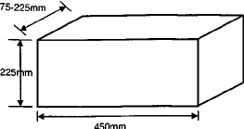
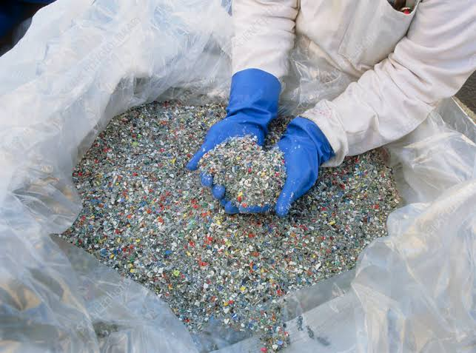
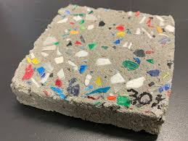
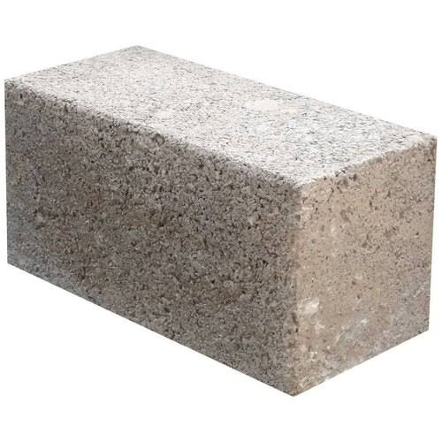

CHAPTER THREE

METHODOLOGY

Introduction
Sandcrete bricks were produced using a 1:4 cement-to-sand ratio by volume, with various proportions of crushed plastic waste added as aggregate. The plastic waste used was high-density polyethylene (HDPE) bottles, crushed to a size of less than 4.75mm. Four batches of sandcrete bricks were produced with 0%, 5%, 10% and 15% and of HDPE by weight of sand.
A total of 36 bricks were produced, with 9 bricks for each of the four batches.
Plastic waste preparation
The main objective of this project work is to develop an efficient way to utilize the waste of plastic bottle which is a great threat for the sustainment of ecological balance. The plastic bottles waste was collected from SEFRAZ Dynamic (M) located at Sango, Ilorin, Kwara State. The rejected bottles which have defects were collected and put into crusher to form small pieces. Then, the plastics were sieved to choose the smallest size. The steps are shown in Figure 1.
Figure 1: Plastic waste preparation

Sand Bricks preparation
The sand brick preparation was done at Civil Engineering Lab in Institute of Technology, Kwara State Polytechnic, Ilorin. The proportion of sand, sand dust and cement (9:9:4) were put into the mixer. Then, two buckets of water (ratio of 2) were poured and mixed up together. The plastics materials then were put into ratios and were mixed together with the raw materials. Finally, the mixture was put into the mold to form bricks.
Figure 2: Sand bricks preparation

Sand Bricks Testing
Three types of testing were conducted in this project research work, which is compression test as per BS 5628: Part 1: 1992, water absorption test and efflorescence test as per CSA A82 standard.

a) Compression test (BS 5628: Part 1: 1992):
This test is done to know the compressive strength of brick. It is also called crushing strength of brick. Generally, 4 specimens of bricks are taken to laboratory for testing and tested one by one. In this test, a brick specimen is put on crushing machine and applied pressure till it breaks. The ultimate pressure at which brick is crushed is taken into account. All nine brick specimens are tested one by one and average result is taken as brick's compressive/crushing strength. The procedures are explained in Figure 3.

Figure 3: Procedures for compression test
b) Water absorption test:
In this test, bricks are weighed in dry condition and let them immersed in fresh water for 24 hours. After 24 hours of immersion, those are taken out from water and wipe out with cloth. Then, brick is weighed in wet condition. The difference between weights is the water absorbed by brick. The percentage of water absorption is then calculated. The less water absorbed by brick the greater its quality. Good quality brick doesn't absorb more than 20% water of its own weight. The process is shown in Figure 4.
Figure 4: Water absorption test process

Procedures:
- Dry the specimen in a ventilated oven at a temperature of 105°C to 115°C till it attains substantially constant mass.
- Cool the specimen to room temperature and obtain its weight (M1) specimen too warm to touch shall not be used for this purpose.
- Immerse completely dried specimen in clean water at a temperature of 27+2°C for 24 hours.
- Remove the specimen and wipe out any traces of water with damp cloth and weigh the specimen after it has been removed from water (M2).
- Water absorption, % by mass, after 24 hours immersion in cold water as shown in equation 1.

c) Efflorescence test (CSA A82):
The presence of alkalis in bricks is harmful where it forms a gray or white layer on brick surface by absorbing moisture. To find out the presence of alkalis in bricks, this test is performed. In this test, a brick is immersed in fresh water for 24 hours. Then, it is taken out from water and allowed to dry in shade. If the whitish layer is not visible on surface, it proofs that absence of alkalis in brick. If the whitish layer visible about 10% of brick surface, then the presence of alkalis is in acceptable range. If that is about 50% of surface, then it is moderate. If the alkali’s presence is over 50%, then the brick is severely affected by alkalis.
Procedures:
- Distilled water to be filled in a dish of suitable size. The dish should be made of glass, porcelain or glazed stone ware.
- Place the end of the bricks in the dish, the depth of immersion in water being 25mm. Place the whole arrangements in a warm (for example, 20oC to 30oC) well ventilated room until all the water in the dish is absorbed by the specimen and the surface water evaporate.
- Cover the dish with suitable cover, so that excessive evaporation from the dish may not occur.
- When the water has been absorbed and bricks appear to be dry, place a similar quantity of water in the dish and allow it to evaporate as before.
Examine the bricks for efflorescence after the second evaporation and report the results as:
- NIL- When there is not perceptible deposit of efflorescence
- SLIGHT- Not more than 10% area of the brick covered with a thin deposit of salt.
- MODERATE- Covering up to 50% area of the brick.
- HEAVY- Covering 50% or more but unaccompanied by powdering or flacking of the brick surface.
- SERIOUS- When there is a heavy deposit of salts accompanied by powdering and/or flacking of the exposed surfaces.
Figure 5: Efflorescence test process

CHAPTER FOUR

RESULT AND DISCUSSION
Effect of Different Ratio of Plastic Waste on Compression Test
Table 1: Maximum load and compressive strength of different ratio of plastic waste
Sample | Weight (kg) | Density kg/m³ | Max load at crushing (kN) | Compressive strength (kN/m²)
0% | 2.60 | 1994.4 | 252.67 | 12404.03
5% | 2.42 | 1856.3 | 236.67 | 11618.56
10% | 2.40 | 1840.9 | 121.33 | 5956.31
15% | 2.10 | 1610.8 | 60.67 | 2978.39

From the compression test result, it is clearly showed that the value of compressive strength decreases as the ratio of plastic waste increase. The virgin (0% plastic waste) sand brick showed the highest value of compressive strength of 252.67kN. This followed by 5%, 10% and 15% plastic waste which are 236.67kN, 121.33kN and 60.67kN. The same goes to maximum load values as shown in Figure 6. The values decrease as the plastic waste ratio increase. This might be because of the plastic waste does not possess cementitious property. It does not bind well with the cement and thus the strength was subsequently reduced. Figure 5 shows the compressive strength versus plastic waste ratio. Due to the crushy nature of the grinded bottle waste, the strength was reduced with the increase in proportion of the waste. This result showed the same trend as the previous research for the flakes type of plastic waste conducted by (Arora, A. and U.V. Dave, 2013).

Effect of Different Ratio of Plastic Waste on Water Absorption Test
Table 2: Percentage water absorbed of different ratio of plastic waste
Sample | Weight before (Kg) | Weight after (Kg) | % Water absorbed
0% | 2.60 | 3.20 | 23.08
5% | 2.42 | 2.77 | 14.46
10% | 2.40 | 2.67 | 11.25
15% | 2.10 | 2.13 | 9.52

Water absorption test showed excellent performance of the plastic waste brick. As the plastic waste ratio increase, the percentage of water absorption decreases. The values range from 14.46% to 9.52%. The virgin bricks showed poor performance since it absorbed 23.08% of water. Good quality of bricks shall not absorb more than 20% of water. This concludes that the presence of plastic waste in the bricks helps on the performance of the bricks.
Effect of Different Ratio of Plastic Waste on Efflorescence Test
Table 3: Salt deposited of different ratio of plastic waste
Sample | NIL | SLIGHT | MODERATE | HEAVY | SERIOUS
0% | √
5% | √
10% | √
15% | √

The efflorescence test also showed the excellence performance of the sand bricks. There is no absence of grey or a white deposit was shown on its sand bricks surfaces for all ratios. It was showed that all of the sand bricks indicate no absence of soluble salts or alkali. From this test, we can conclude that no alkalis were presence in this sand brick.

CHAPTER FIVE
CONCLUSION AND RECOMMENDATIONS
Conclusions:
The comprehensive strength decreases with increasing waste plastic ratios. The virgin (0% plastic waste) sand brick showed the highest value of compressive strength of 252.67kN. This followed by 5%, 10% and 15% plastic waste which are 236.67kN, 121.33kN and 60.67kN. This may be attributed to the decrease in the adhesive strength between the waste plastic and the cement paste. It seems that the bonding between the plastic particles and the cement paste is weak. However, the mixes of sand bricks and plastics waste seems possible because water absorption less than 15% for all ratios. Furthermore, there are only slight salt/alkalis presence in the sand bricks mixes with plastic waste. The reduced compressive strength values of waste plastic bricks mixes show that it can be used only in situations that required low-degree workability. Such situations are numerous in civil engineering applications, namely, precast bricks, partition wall panels, canal linings, and so forth. Recommendation for further study, it will emphasize on grind the waste into fine powder and mix into such proportion to achieve maximum packing density. It may result to increase in compressive strength and binder, or plasticizer should be added to the mixture to increase the bind between plastic surface and cement particle.
Recommendation:
It is recommended that sandcrete bricks incorporating up to 15% crushed plastic waste by weight of sand be used in appropriate applications.
Construction companies and government agencies should consider incorporating crushed plastic waste into sandcrete bricks for appropriate applications such as non-load-bearing walls and partitions. This would help reduce the environmental impact of plastic waste and promote the circular economy.

REFERENCES
Arora, A. and U.V. Dave, 2013. Utilization of E-Waste and Plastic Bottle Waste in Concrete. International Journal of Students Research in Technology & Management, 1 (4): 398-406.
Rai, B., S.T. Rushad, B. Kr and S.K. Duggal, 2012. Study of Waste Plastic Mix Concrete with Plasticizer. ISRN Civil Engineering, 2012: 1-5.
Zhang, L., 2013. Production of Bricks from Waste Materials-A Review. Construction and Building Materials, 47: 643-655.
Hiremath, P.M., S. Shetty, P.G.N. Rai and T.B. Prathima, 2014. Utilization of Waste Plastic in Manufacturing of Plastic-Soil Bricks. International Journal of Technology Enhancements and Emerging Engineering Research, 2 (4): 102-107.
Raju and R. Chauhan, 2014. An Experimental Study on Strength Behaviour of Cement Concrete with Use of Plastic Fibre. National Conference on Advances in Engineering and Technology, pp: 30-34.
Raut, S.P., R.V. Ralegaonkar and S.A. Mandavgane, 2011. Development of Sustainable Construction Material Using Industrial and Agricultural Solid Waste: A Review of Waste-Create Bricks. Construction and Building Materials, 25 (10): 4037-4042.
http://www.iitk.ac.in/ce/test/IScodes/is.1077.1992.pdf
https://en.m.wikipedia.org/wiki/Highdensity_polyethylene
https://en.wikipedia.org/wiki/Plastic

