DESIGN AND IMPLEMENTATION COMPUTERIZED GRADE EVALUATION SYSTEM USING DECISION TREE ALGORITHM
(CASE STUDY OF UNIVERSITY OF ILORIN)

BY
LAWAL OLUWAFEMI EMMANUEL
ND/23/COM/PT/0182

A PROJECT SUBMITTED TO THE DEPARTMENT OF COMPUTER SCIENCE,INSTITUTE OF INFORMATION AND COMMUNICATION TECHNOLOGY, KWARA STATE POLYTECHNIC, ILORIN
IN PARTIAL FULFILLMENT OF THE REQUIREMENTS FOR THE AWARD OF NATIONAL DIPLOMA (ND) IN COMPUTER SCIENCE

JUNE, 2025

CERTIFICATION
This is to certify that this project research was carried out by LAWAL FEMI EMMAMUEL with matriculation number ND/23/COM/PT/0182, has beenread and approve as meeting part of the requirements for the award of National Diploma (ND)in Computer Science.

………………………………. ……………………………….
Dr. (Mrs.) OLUSI Date
Project Supervisor

………………………………. ……………………………….
Mr. Oyedepo, F. S. Date
Head of Department

………………………………. ……………………………….
External Examiner Date

DEDICATION
This project is dedicated to the creator of the earth and universe, the Almighty God. It is also dedicated to my parents for their moral and financial support.

ACKNOWLEDGEMENT
All praise is due to the Almighty God the Lord of the universe. We praise Him and thank Him for giving us the strength and knowledge to complete my ND programme and also for my continue existence on the earth.
We appreciate the utmost effort of our supervisor, Dr. (Mrs.) OLUSI, whose patience support and encouragement have been the driving force behind the success of this research work. She gave useful corrections, constructive criticisms, comments, recommendations, advice and always ensures that an excellent research is done. Our sincere gratitude goes to the Head of the Department Mr. Oyedepo, F. S. and other members of staff of the Department of Computer Science, Kwara State Polytechnic, Ilorin, for their constant cooperation, constructive criticisms and encouragements throughout the programme.
Special gratitude to our parents MR and MRS LAWAL who exhibited immeasurable financial, patience, support, prayers and understanding during the periods in which we were busy tirelessly in our studies. Special thanks go to all our lovely siblings.
Our sincere appreciation goes to our friends and classmate

TABLE OF CONTENTS
Title Page i
Certification ii
Dedication iii
Acknowledgements iv
Abstract v
Table of Contents vi
CHAPTER ONE: GENERAL INTRODUCTION
1.1 Background to the Study 1
1.2 Statement of the Problem 3
1.3 Aim and Objectives of the Study 4
1.4 Significance of the Study 4
1.5 Scope of the Study 5
1.6 Limitation of the Study 5
1.7 Defination of Terms 6

CHAPTER TWO: LITERATURE REVIEW
2.1 Review the related works 7
2.2 Description of Grade evaluation system 8
2.3 Overview of decision tree 8
2.4 Overview of grade evaluation with decision tree 9

CHAPTER THREE: RESEARCH METHODOLOGY AND ANALYSIS OF THE EXISTING SYSTEM
3.1 RESEARCH METHODOLOGY 10
3.2 Analysis of the existing system 11
3.3 Problem of the existing system 12
3.4 Description of the proposed system 13
3.5 Advantages of the proposed system 15

CHAPTER FOUR: DESIGN, IMPLEMENTATION AND DOCUMENTATION OF THE SYSTEM
4.1 Design of the System 21
4.1.1 Output Design 22
4.1.2 Input Design 24
4.1.3 Procedure Design 25
4.2 Implementation of the system 26
4.2.1 Hardware Support 28
4.3 Documentation of the system 29
4.3.1 Maintaining the System 31

CHAPTER FIVE: SUMMARY, CONCLUSION AND RECOMMENDATION
5.1 Summary 32
5.2 Conclusion 32
5.3 Recommendation 33
References
Appendices

ABSTRACT
This research work presents a computerized grade evaluation system that is developed to collect, process, and return the exams grades of student of the University of Ibadan. It discusses the design requirements, features, and implementation of the computerized grading system, as well as reactions from course faculty and staff members. The system is developed with numerous advantages over the analog grading methods, including scalability, real-time feedback on the status of grading, the reduced potential for human error in compiling grades, the ability for lecturers to grade remotely and to revise their grades after submission, the ability for course administrators to easily review grading results and remove statistical outliers from the score set, the ability to return both provisional and final grades to the course faculty, staff, and students in a timely manner, and the ability to archive and export grading data for future use. Although the online system is a clear improvement over paperbased grades.

CHAPTER ONE
INTRODUCTION
1.1 BACKGROUND OF THE STUDY
The log-istical problems associated with distributing, collecting, grading, and returning assignments and the difficulties in ensuring fairness and consistency in grading tends to increase non-linearly with the number of students enrolled in an academic program.Nowadays, we are living in an information age dependent upon digital Information retrieved from the internet. This Digital information is electronically interpreted,the results of the computer processed information. (Curtis et al., 2008) Different type of jobs relies mostly on the internet to getinformation, using it, managing it, and relaying information to others. Computers enable the efficient processing and storage of information.Computerized-assisted grading system will go a long way in guiding the grading process and compilation of final results among systems of any institution in Nigeria. Ekpenyong report that using computer-assisted grading systems during bulk students grading with large amount of students reduced the grading time by half compared to traditional hand grading without the help of the system (Ekpenyong, 2008). In addition to the “reduced time in grading assignments,” Czaplewski notes that computer-assisted grading system can lead to increased “validity and accuracy of grading – making grading more evenhanded,” increased feedback for students, and increased student satisfaction.This research work presents an online computerized system to assist in grading of students to improve the fairness, consistency, and efficiency of grading.
Many teachers feel that the time they take in recording and computing for the grades of their students is time that could be better spent elsewhere, like preparing lessons, researching or meeting with their students. With the advent of computer technology, more and more schools are takingadvantage of a variety of grading systems available both off-line and online that can help save time on administrative tasks and give teachers more time to attend to other important functions. However, a greater majority, especially small schools, government schools, and schools in remote areas, still utilize the manual method of recording and computing for the grades of the students.
This work provides a brief overview of the course, its deliverables, and the breakdown of the grades. It discusses the design requirements, features, and implementation of the online grading system. Finally, the current limitations and future development directions of the online grading system are discussed.

1.2 STATEMENT OF THE PROBLEM

The statement of the problem centers on addressing the inefficiencies and limitations inherent in traditional, manual, or less sophisticated computerized grading methods

These include time-consuming processes, potential for human error, difficulty in quickly analyzing large datasets, and a lack of personalized feedback for students. The manual system's inefficiency can lead to delays in providing students with their grades and academic performance insights. Moreover, it makes it difficult for educators to identify patterns and trends in student performance, which could inform instructional strategies and interventions

I. Inefficiency in Manual Processes: When tasks are repetitive, time-consuming, and prone to human error, computerization can streamline these processes.

ii. Data Management Challenges: Large volumes of data that are difficult to store, organize, and retrieve manually often benefit from computerized systems.

iii. Need for Speed and Accuracy: When speed and accuracy are critical, such as in financial transactions or scientific calculations, computers offer significant advantages.

iv. Communication and Collaboration Issues: If teams need better ways to communicate and share information, computerization can provide tools like email, shared documents, and project management software.

V. Cost Reduction: Computerization can reduce labor costs, minimize errors, and optimize resource use, leading to overall cost savings.

Vi. Lack of Scalability: When a business or process needs to grow but manual systems can't keep up, computerization provides a scalable solution.

Bio. Poor Decision-Making: If decisions are based on incomplete or outdated information, computerization can provide real-time data and analytics to support better choices.

Viii. Security and Compliance Concerns: When sensitive data needs protection or regulatory compliance is required, computerized systems offer enhanced security measures.
  - AIM AND OBJECTIVE OF THE STUDY

The main aim of the study is to develop a Computerized Grading Evaluation System for a University system. With the following objectives
- To design and develop a computerized grade evaluation system for recording of student’s name, grade level and section.
- Create a system that will be secured and maintain the integrity of data, which can be easily retrieved.

1.4 SIGNIFICANCE OF THE STUDY

The computerized grade evaluation system will provide convenience to teachers through the easier and faster way of recording information. Population of students is ever increasing in alleducational institution so great demand in teaching force is also becoming higher. The online Grade evaluation System is very essential and important for school’s operations and goals. The students are graded to measure their performance in their academic courses and knowledge. Teachers spend a lot of time to accurately compute the grades of the students using their calculators, and, in earlier times, teachers manually solve grades using the manual computations means which is always filled of errors.

A computerized grade evaluation system for University will provide a marked improvement in the way teachers’ record and compute for the grades of students.
- Faculty Teachers: Teachers’ would be able to record and compute for the grades of their students faster thereby lessening their workload and providing them with added time to attend to other functions. This in turn would improve their efficiency as teachers.
- School Administrators: School Administrators no longer have to re-compute the grades of each student to check on their accuracy. Student Reports such as grading results sheets and class records can be submitted on time and seamlessly.
- Students: Students can now look forward to better lessons since their teachers would have added time to prepare for them their lesson plans.

1.5 SCOPE OF THE STUDY
The scope of the research is focused on designing and implementing a computerized grade evaluation system for a University system .
  - DEFINITION OF TERMS
CGPA : Cumulative Grade Point Average (CGPA) is an assessment tool used to evaluate your academic performance.
Evaluation: the making of a judgement about the amount, number, or value of something; assessment.
Database: database, also called electronic database, is any collection of data, or information, that is specially organized for rapid search and retrieval by a computer
Software: An application program is a computer program designed to carry out a specific task other than one relating to the operation of the computer itself

CHAPTER TWO
LITERATURE REVIEW
2.1 REVIEW OF RELATED WORKS
Evaluation gives an important yard stick to judge the quality of students. It plays a vital role in the educational system. It also offers motivation and a sense of purpose to both teachers and students to achieve set goals. (Mazza et al., 2004) The word examination has come to be associated with stress and anxiety. The practice of teaching and learning which is thought to be meaningful for the student loses its joy because of these negative connotations of examination. The larger context of education is to train futuristic citizens for a meaningful and productive life in a globalised society.
There is a dire need to build up the education system even more so in a pluralistic society which addresses itself to a heterogeneous group. (Stephen, 2002) Evaluation is a means of recognizing the extent to which we have been successful in imparting such an education. Evaluation is an essential part of the educational process as some form of assessment is compulsory to determine the effectiveness of teaching learning processes and their assimilation by learners. External examinations „are largely inappropriate for the „knowledge society‟ of the 21stcentury and its‟ need for innovative problem solvers‟, Questions if not framed well, “call for rote memorization and fail to test higher-order skills like reasoning and analysis, lateral thinking, creativity and judgment. External exams make no allowance for different types of learners and learning environments and induce an in-ordinate level of anxiety and stress”. (NCF- Position paper on Examination Reforms) Schools start ranking students, on the basis of their marks, from as early as their preprimary years. Such an impel has several negative effects on learning.
Students, parents and society at large become anxious in the race to attain more and more marks in examinations which leads to an extremely stressful existence. (Tata, 2005) Moreover, while all out efforts are made to improve the reliability of examination, the human error cannot be avoided. This inadequacy can be overcome if the students are placed in ability bands that represent range of scores. This calls for a functional and reliable system of School-Based Evaluation. There was a need to look at the holistic assessment of a learner which also includes co scholastic area of Life Skills, Values and Attitudes, Games and Sports as well as Co-Curricular activities. The Continuous and Comprehensive Evaluation scheme seeks at addressing this in a holistic manner. A number of National Committees and Commissions in the past have consistently made recommendations regarding sinking emphasis on external examination and encouraging internal assessment through School-Based Continuous and Comprehensive Evaluation. Therefore, the CCE scheme brings about a paradigm shift from examination to effective pedagogy. The National Policy on Education 1986 (NPE) and Programme of Action 1992 (POA) also envisaged the recasting of the examination system and has, inter alia, suggested that grades be used in place of marks. National Curriculum Framework 2005(NCF) envisaged an evaluation system which would grade the students on their regular activities in the classroom and enable students to understand and focus on their learning gaps and learn through these as part of Formative Assessment. National Curriculum Framework 2005, while proposing Examination Reforms has also stated – “Indeed, Boards should consider, as a long-term measure, making the Class X Examination Optional, thus permitting students continuing in the same school(and who do not need a Board certificate) to take an internal school exam instead “. Hon‘ble Union Minister for Human Resource Development also announced- ―Push the process of examination reform in accordance with NCF 2005. This will include making the Class X examination optional, thus permitting students continuing in the same school (and who do not need a board certificate) to take an internal school assessment instead.
2.2 DESCRIPTION OF GRADE EVALUATION SYSTEM
A grade evaluation system is a structured framework used to assess, record, and communicate the academic performance of students. It serves as an essential tool in education by measuring how effectively learners have achieved the desired learning outcomes and by providing feedback for improvement. The primary purpose of a grade evaluation system is not only to assign scores but also to promote fairness, consistency, and transparency in the academic process.
The system is usually built upon several components. First, it incorporates multiple methods of assessment such as written examinations, quizzes, assignments, projects, presentations, laboratory work, and class participation. These elements ensure that students are evaluated on both theoretical knowledge and practical application. Each component is often given a specific weightage so that the final grade reflects a balanced performance. For example, examinations may carry 50% of the weight, assignments UI30%, and class participation 20% (Tata, 1995).
Grades are typically expressed through standardized scales. The most common formats include the percentage system, where marks are expressed out of 100; the letter grade system, where performance is classified into categories such as A, B, C, D, and F; and the grade point average (GPA) or cumulative grade point average (CGPA), where performance is represented numerically, usually on a scale of 4.0 or 10.0. Some modern institutions also use standards-based or competency-based systems, where grades are awarded according to mastery of specific skills or competencies rather than relative comparison with peers.
2.3 OVERVIEW OF DECISION TREE
Decision Tree can be used as the logic engine to evaluate students’ scores and assign grades automatically. It models the grading process as a sequence of decisions based on score ranges or performance criteria.
Role of Decision Tree in Grade Evaluation
- Classification Task → Students’ numerical scores (e.g., 0–100) are classified into categories like A, B, C, D, F.
- Rule Representation → Each branch of the tree represents a rule such as:
- If score ≥ 70 → Grade = A
- If 50 ≤ score < 70 → Grade = B
- If 40 ≤ score < 50 → Grade = C
- If score < 40 → Grade = F
- Automation → Eliminates manual grading, ensures consistency, and speeds up evaluation.
2.4 OVERVIEW OF GRADE EVALUATION WITH DECISION TREE
Grade evaluation is an essential aspect of any educational system, as it provides a standardized method of assessing and categorizing students’ performance. Traditionally, this process is carried out manually, which may introduce errors, inconsistencies, and delays. With the advancement of computerized systems, decision-making techniques such as Decision Trees can be applied to automate and standardize the grade evaluation process.
A Decision Tree is a machine learning and decision-making model that represents rules in a tree-like structure, where conditions are tested at decision nodes, and outcomes are assigned at leaf nodes. In a computerized grade evaluation system, Decision Trees provide a simple, transparent, and effective way to classify students’ scores into grade categories (e.g., A, B, C, D, F) (Benjamin, 2023).

CHAPTER THREE
RESEARCH METHODOLOGY
3.0 RESEARCH METHODOLOGY
This study adopts a design and development research, approach, focusing on building a software system that automates grade computation and evaluation. The methodology combines descriptive research (to understand existing grading challenges) and applied research (to develop and test the system).
Adopts an applied research design with an emphasis on design science methodology. The aim is to develop and implement a grade evaluation system that leverages decision tree algorithms for predicting and categorizing students’ performance. The methodology integrates both quantitative techniques (for data collection and model evaluation) and computational experiments (for system implementation and validation).
3.1 MATERIALS AND METHODS
DATA INPUT |  | PROCESS | INFORMATION
 |  | PROCESS | OUTPUT
 | Username | Computerized | Student Grades
 | Password | Computerized | Student Grades
 | Password | Grading System | Student Grades
 | Student | Grading System
 | Information
 | Student Grade
 | Component Rating

Figure 3.1: Proposed System Basic Diagram
 | Student |  |  | Component
REGISTRAR | Information |  | STUDENT |  | Scores |  | TEACHER
 |  |  |  |  | Component
 |  |  |  |  | Grade
Student |  | Grading System
Information |  |  |  |  |  | Subject
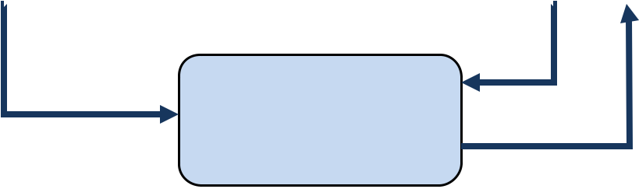

Grade
Figure 3.2: Proposed System Data Flow Diagram
The decision to implement it in the form of a database was informed by the realization that various types of data would need to be held, and a database has advantages over other forms of file systems. Such advantages include data consistency, data integration, data sharing, data independence, data control and minimal data redundancy (Tata, 2015).
Network capabilities were included to enable various users of the application to access it from their offices if attached to a network, rather than go to the computer room for every transaction
3.2 ANALYSIS OF THE EXISTING SYSTEM
Analysis of existing grade evaluation systems reveals a mix of traditional manual methods and older, less-efficient computerized systems. The design and implementation of a new computerized system that uses a decision tree algorithm aims to address the shortcomings of these older methods by providing a more efficient, accurate, and insightful grading process.
Implementation is the realization of an application, or execution of a plan, idea, model, design, specification, standard, algorithm, or policy. An implementation is a realization of a technical specification or algorithm as a program, software component, or other computer system through programming and deployment. Many implementations may exist for a given specification or standard. For example, web browsers contain implementations of World Wide Web Consortium-recommended specifications, and software development tools contain implementations of programming languages.
3.3 PROBLEMS OF THE EXISTING SYSTEM
Problem of existing grade evaluation systems, which can be either manual or traditional computerized, range from inefficiency and human error to a lack of deep predictive insight. A new system using a decision tree algorithm would address these issues by automating calculations, improving accuracy, and providing a data-driven approach to predicting student performance.
A primary problem of the existing computerized grade evaluation systems, particularly manual or traditional ones, is their inability to perform advanced predictive analysis and identify hidden patterns in student performance. While they automate basic tasks like calculating GPAs and generating reports, they lack the sophisticated insight provided by machine learning algorithms like decision trees.

Below are the problems associated with system grading method;
Existing grading systems face problems including inaccurate or limited measurement of student learning, fostering stress and anxiety, contributing to equity concerns through biases, and prioritizing compliance over curiosity. Furthermore, traditional methods can lead to a focus on rather than genuine understanding, provide inadequate and unusable feedback, and suffer from subjectivity and inconsistency across teachers and schools.
i. Oversimplification
Reducing complex learning to a single grade (like a letter or number) fails to capture the nuances of a student's growth, understanding, and skills.
ii. Inadequate Feedback:
Grades often don't provide actionable feedback that helps students understand what they did well or how to improve.
iii. Limited View of Learning:
Grades may not accurately reflect what a student has truly learned, only their ability to perform on specific tasks, potentially masking a lack of skill application despite high scores.

Requirements Gathering
Analysis of the Existing System
Implementation Using 4GT
Problems of the Existing System

Figure 3.3 Proposed Grading System Data Gathering Procedure Output
Although the school has a handful of computers donated to them, they still use the traditional way of maintaining files and records that are all manually done.
3.4 DESCRIPTION OF THE PROPOSED SYSTEM
The current system being implemented by University system is the traditional method of recording, calculating, and maintaining student grades and records. Everything is done manually.
Student information is written on paper forms during enrollment. The registrar prepares a list of official enrolled students and gives copies to the principal and to the teachers. The teachers write down the names of the students in their class records for every subject and section he or she is handling and enters the rating of the students for every grade component. The teachers manually compute the grade of the students using a calculator and submit their class records to the principal for checking.
The principal checks the grades one by one and if errors are found, the class record is returned to the teacher, who re-computes the grade and submit it again to the principal for checking. Correct and verified grades are then given back to the teacher to be submitted to the registrar who prepares the students’ report cards.
This type of system is very tedious and takes along time. Manually calculating, checking and re-computing the grades of students are very difficult and are and are very prone to human errors. Added to this is the money being spent by the school for paper files and forms, cabinets and other things needed to store student data and recordserrors are found, it goes back to the teacher concern to make the necessary changes. It then goes back again to the principal for checking. This cycle continues until all the grades have been verified to be correct.

 |  | SUBJECT GRADE
SUBJECTAVERAGEGRADESFORRECORDING | ERRONEOUSSUBJECTAVERAGEGRADE | COMPONENTS RATING
SUBJECTAVERAGEGRADESFORRECORDING | ERRONEOUSSUBJECTAVERAGEGRADE | COMPUTE SUBJECT AVERAGE
 |  | GRADE
 |  | SUBJECT AVERAGE GRADE
 |  | FOR CHECKING
 |  | PRINCIPAL | CHECKSUBJECT
 |  | PRINCIPAL | AVERAGE GRADE
 |  | ERRONEOUS
 |  | SUBJECT
 |  | AVERAGE GRADE | SUBJECT
 |  |  | AVERAGE
 |  |  | GRADES FOR
 |  |  | RECORDING
STUDENT |  | PARENTS
REPORT CARD |  | PARENTS
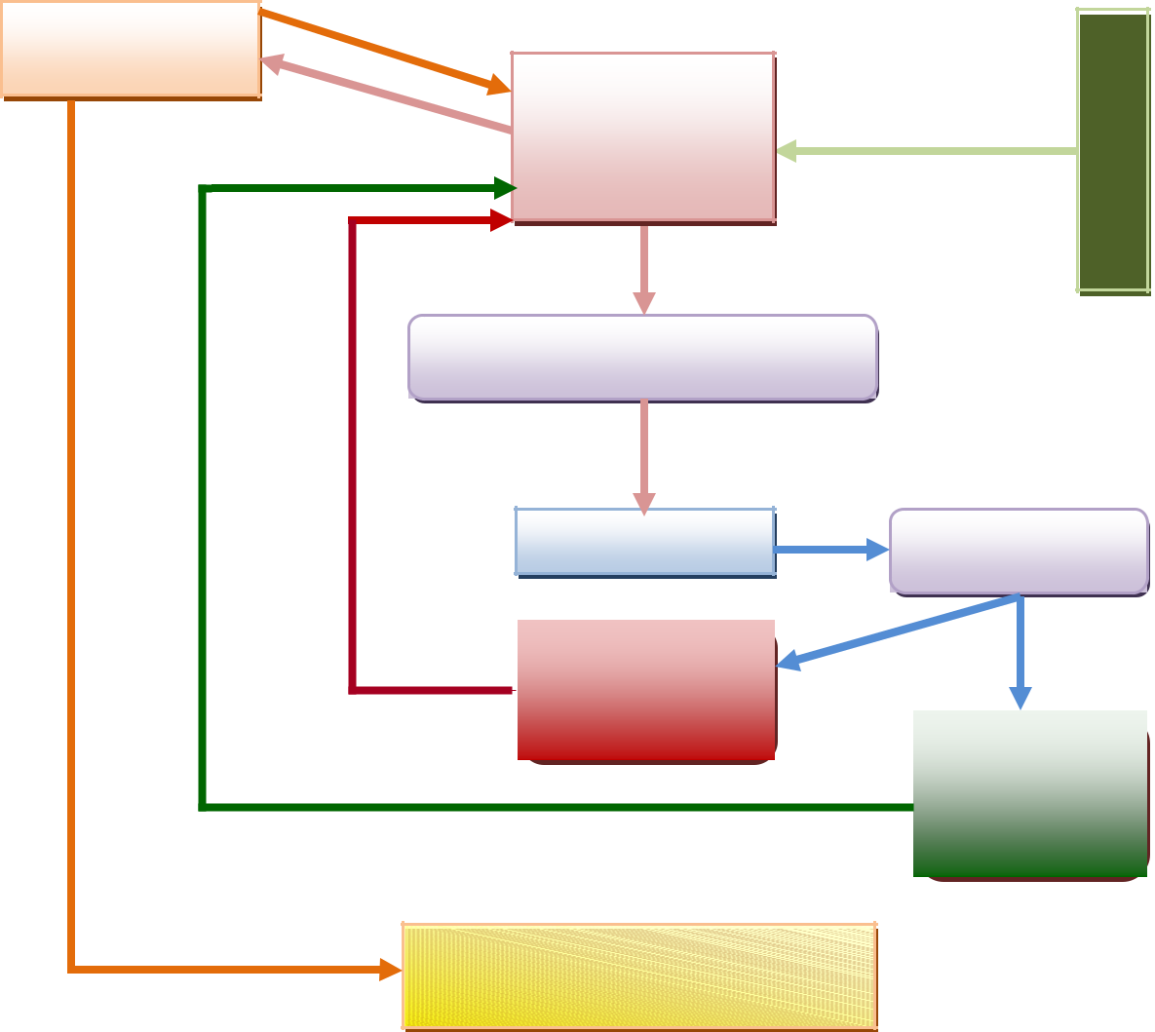

Figure 3.4: Data Flow Diagram

Accuracy of information
Aside from being time consuming,manual method of recording and computing for the grades of the student is prone to human error. More often than not, teachers rush through deadlines in the submission of grades and because of this, the accuracy of the grades are affected. The principal still has to double check each grade to ensure its accuracy.
3.5 ADVANTAGES OF THE PROPOSED SYSTEM
The ProposedSystem that we developed for University of system will be efficient in terms of time consuming, space and lessen the costs from their previous data base. Our proposed system has a security feature of which the admin and the teachers are the users by using the log-in form by typing the username and password. In general, our proposed system uses Microsoftoffice 2010 for our database and Microsoft ExcelVBA as the programming language for our developed system.
Using the data from the student information database, the teacher chooses a subject and enters the rating of the student in each grade component (module 2). The grades are stored in the subject’s database.
The grades stored in the subject’s database are then retrieved and used in computing for the grade of the student (module 3).
Data Dictionary
- Component Grade - the mark or rating given by the teacher to the different components scores, based on the performance of the student in these grade components.
- Component Scores – the scores obtained by the student in a particular subject component.
- Student Information – pertinent data about the student such as student’s name, address, birth date, parents’ name, etc.
- Student Information Database – the database where student information data are stored.
- Subject Database – the database where the component grades and subject grade are stored.
- Subject Grade - The grade of the student for the subject resulting from the subject grade computation process.

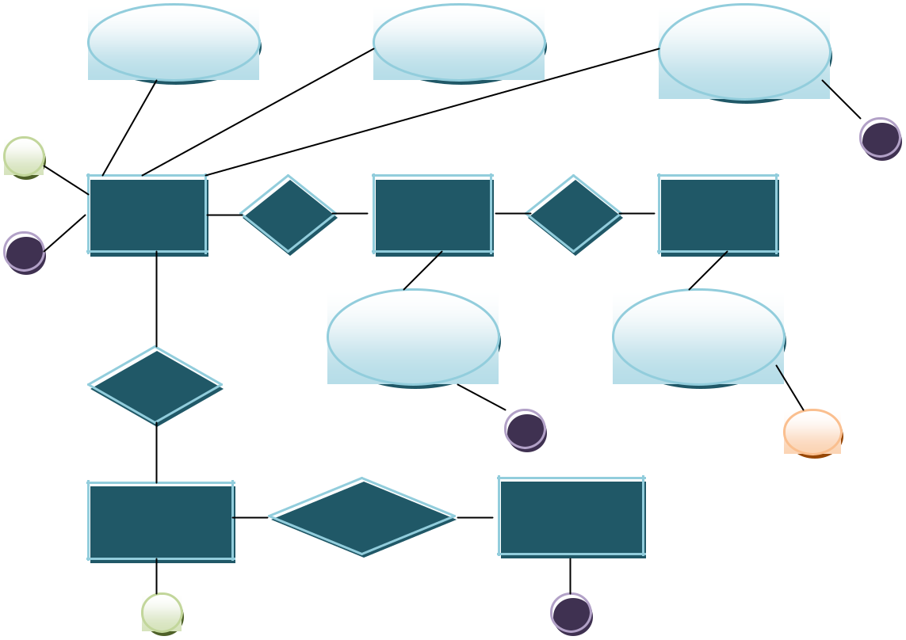
Username |  | Password |  | Component
 |  |  |  | Rating
C |  |  |  | H
TEACHER | HAS | SUBJECT | HAS | STUDENT
G
 |  | Subject |  | Student
 |  | Name |  | Name
RATES
 |  |  | F | E
COMPONENT |  | SUBMITS | SUBJECT
SCORES |  | SUBMITS | GRADE
D |  |  | I
Figure 3.5: Component Score and Subject Grading System

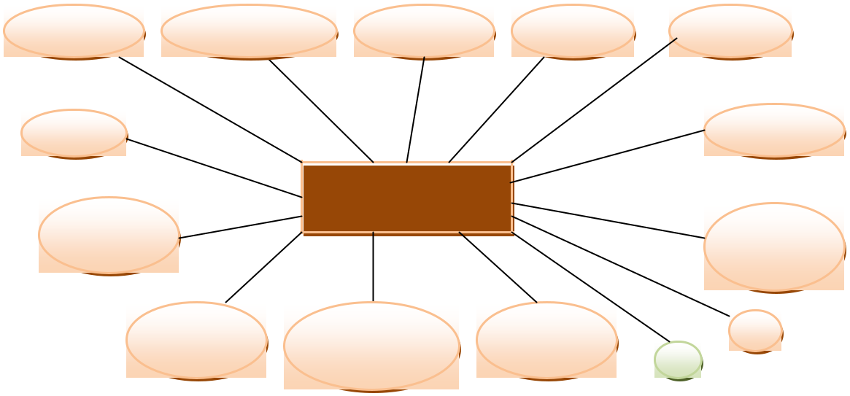

First Name Middle Name Last Name Gender Address

Age |  |  | Birth Date

Figure 3.6: Student Information

MAIN MENU
No
No
No
Yes
Grade Classification
Yes
Yes
Validated
Data Capture
Start
Display Option
Accept Option
Is Option Capture
Is Option Grace Classification
Is Option Validate
Stop

DATA CAPTURE
Close Dbase
No
Yes
Yes
No
Is Data Ok ?
Open Data Base
Stop
Exit
Save to Dbase
More ?
Accept Data

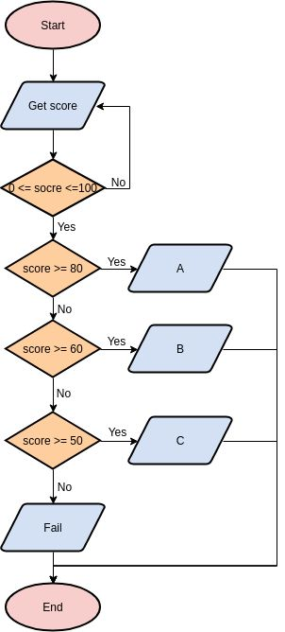
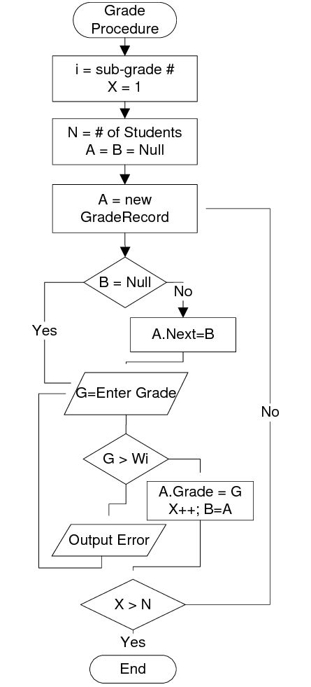
CHAPTER FOUR
DESIGN, IMPLEMENTATION AND DOCUMENTATION OF THE SYSTEM
4.1 DESIGN OF THE SYSTEM
This involves several stages, including system analysis, architectural design, algorithm integration, and implementation planning.
The System is designed to automate the evaluation of students’ academic performance using a decision tree algorithm. The goal is to reduce manual grading effort, standardize evaluation criteria, and provide predictive insights into student performance trends.
4.1.1 OUT PUT DESIGN
The Output Design focuses on how results are presented to users after the grade evaluation system has processed the input data using the decision tree algorithm. Outputs are central to the system’s usefulness—they must be accurate, easy to understand, and serve various user roles (Admin, Instructor, Student).
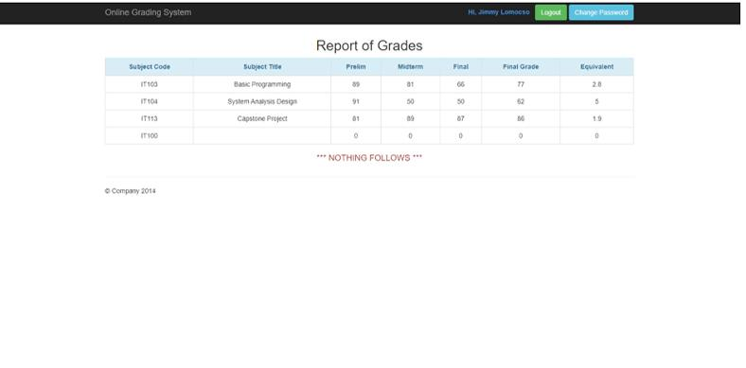
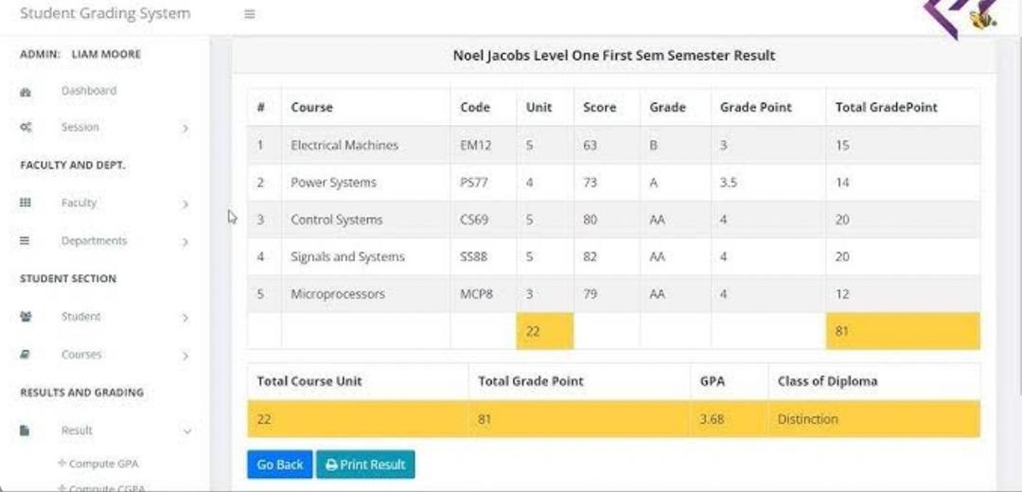
Figure 4.1 Output Design
4.1.2 INPUT DESIGN
This define how the system captures, validates, stores and pre-processes all inputs required to evaluate and classify student grades using a decision tree.
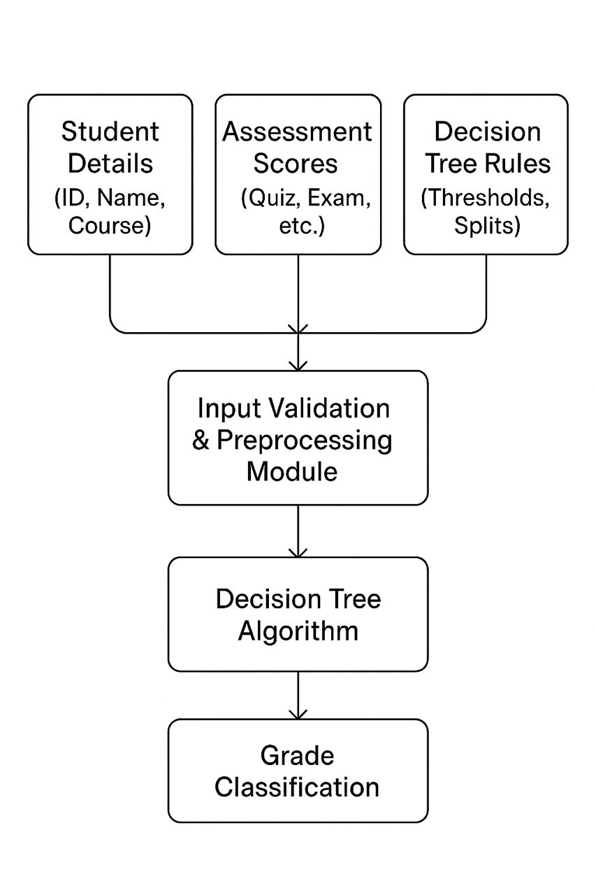
Figure 4.3: Input Design

4.1.3 PROCEDURE DESIGN
The procedure design for the computerized grade evaluation outline the Building of a system that evaluates and assigns final grades (or recommended grades, categories, pass/fail) for students by using a decision tree model. The system should support data entry, model training, prediction, explainability, and integration with school systems. Additionally This procedure encompasses several key phases from initial analysis to deployment and maintenance
4.2 IMPLEMENTATION OF THE SYSTEM
The implementation of the computerized grade evaluation system was carried out in a structured and modular manner, ensuring that each component of the system interacts seamlessly with others. The development process followed a systematic approach beginning with data preparation, model building, and integration of the decision tree algorithm, and culminating in the deployment of the system with a user-friendly interface and supporting database infrastructure.
4.2.1 HARDWARE SUPPORT
The devices (Teachers / Admins / Students)
i . Laptops / desktops / tablets / Chromebooks used to access the web UI or local client app.
Low-to-moderate specs are fine because heavy work is server-side.
ii .Peripherals
Scanners (A4, duplex), barcode readers, biometric readers (fingerprint), ID card printers, B/W or color printers.
iii . Power & physical protection
UPS for critical servers, rack cabinets, cooling, physical locks.
iv . Monitor and logging box
Optionally separate server for monitoring tools (Prometheus, ELK stack etc.).
4.2.2 SOFTWARE SUPPORT
i. UML (e.g., StarUML, Lucidchart, Draw.io) for use case diagrams, class diagrams, and ER diagrams.
ii. Database design tools (e.g., MySQL Workbench, ER/Studio) for schema planning.
iii. Wireframing/Prototyping (e.g., Figma, Balsamiq) to sketch user

4.3 DOCUMENTATION OF THE SYSTEM
This build a computerized system that evaluates student performance (assigns final grades, flags at-risk students, suggests interventions) using a decision tree classifier trained on historical student data. The system combines a web UI for faculty/staff, a REST API for model inference, a backend service for data management and model training, and a relational database for storage.
4.3.1 MAINTAINING THE SYSTEM
The System maintenance is not a one-time activity but an ongoing process that ensures the system continues to perform accurately, securely, and reliably after its initial design and implementation. Since this system directly influences academic outcomes and student records, its maintenance is critical for building trust among teachers, students, and administrators. The maintenance process involves not only fixing technical issues but also continuously monitoring, updating, and improving both the software infrastructure and the decision tree model that drives the grade evaluations.
At its core, system maintenance guarantees that the platform adapts to changes in institutional policies, grading standards, user needs, and data patterns. For example, if a school introduces a new grading component such as project-based assessments, the system must be updated to capture and process this new type of data. Similarly, if the accuracy of predictions begins to decline due to shifts in student performance patterns (known as data drift), the decision tree must be retrained with the most recent data. Without proper maintenance, the model could produce biased or inaccurate grades, leading to loss of confidence and potential disputes.

CHAPTER FIVE
SUMMARY, CONCLUSION AND RECOMMENDATIONS
5.1 SUMMARY
A computerized grade evaluation system automates the process of assessing student performance and assigning final grades. Using a Decision Tree algorithm provides interpretable, rule-based predictions (e.g., “IF attendance < 60% AND midterm < 40 THEN final grade = F”), which helps educators understand and justify outcomes. The system targets consistent grading, early identification of struggling students, and analytics for instructors and administrators.
Education systems worldwide rely on accurate, fair, and efficient methods for evaluating student performance. Traditionally, this evaluation has been conducted manually by instructors who calculate grades based on different assessment components such as assignments, quizzes, examinations, attendance, and participation. While manual methods are straightforward, they are also prone to human error, inconsistency, and delays. In large classes or institutions with thousands of students, manual grading and evaluation quickly become inefficient and difficult to manage. As a result, there is a growing need for computerized solutions that can streamline the process, enhance accuracy, and provide insights that manual grading cannot easily offer
5.2 CONCLUSION
In this work we have demonstrated the potential of intelligent computing in automating academic performance assessment. By leveraging decision tree models, the system not only evaluates grades with consistency and accuracy but also provides a transparent reasoning process that enables both educators and students to understand how evaluation outcomes are derived. This transparency fosters fairness, reduces human bias, and ensures that grading criteria are applied uniformly across all learners.
The research methodology demonstrates that a computerized grade evaluation system, when integrated with decision tree algorithms, is a reliable, efficient, and scalable solution for modern academic environments
5.3 RECOMMENDATIONS
We recommend designing a secure and auditable web application that collects student/course inputs, preprocesses them into features, trains and serves a decision-tree model (CART/C4.5/ID3 family), and provides explainable grade predictions + teacher review and analytics.
Purpose and scope
i. Purpose: Predict/assign student grade categories (A/B/C/D/F or numeric scores) using decision trees; support automated suggestions, analytics, and explanations for teachers/admins.
ii. Scope: Input academic records (assignments, tests, attendance), student demographics (optional), course metadata; output predicted grade band + feature-level explanation and confidence.
iii. User roles: Admin, Instructor, Student (view-only), Data Scientist / IT.

REFERENCE
Al-Barrak, M. A., & Al-Razgan, M. (2016). Predicting students’ performance through classification: A case study. Journal of Theoretical and Applied Information Technology, 93(2), 335–344.
Breiman, L., Friedman, J. H., Olshen, R. A., & Stone, C. J. (2016). Classification and Regression Trees. Wadsworth International Group.
Han, J., Kamber, M., & Pei, J. (2011). Data Mining: Concepts and Techniques (3rd ed.). Morgan Kaufmann.
Ibrahim, Z., & Rusli, D. (2017). Predicting students’ academic performance: Comparing artificial neural network, decision tree, and linear regression. In 21st Annual SAS Malaysia Forum.
Kotsiantis, S. B. (2012). Use of machine learning techniques for educational proposes: A decision support system for forecasting students’ grades. Artificial Intelligence Review, 37(4), 331–344. https://doi.org/10.1007/s10462-011-9234-x
Pressman, R. S., & Maxim, B. R. (2015). Software Engineering: A Practitioner’s Approach (8th ed.). McGraw-Hill.
Quinlan, J. R. (2010). Induction of decision trees. Machine Learning, 1(1), 81–106. https://doi.org/10.1007/BF00116251
Romero, C., & Ventura, S. (2010). Educational data mining: A review of the state of the art. IEEE Transactions on Systems, Man, and Cybernetics, Part C (Applications and Reviews), 40(6), 601–618. https://doi.org/10.1109/TSMCC.2010.2053532
Sommerville, I. (2016). Software Engineering (10th ed.). Pearson Education.
Witten, I. H., Frank, E., Hall, M. A., & Pal, C. J. (2016). Data Mining: Practical Machine Learning Tools and Techniques (4th ed.). Morgan Kaufmann.

APPENDIX B:
Source code
Index.php <?php include('config.php'); if(isset($_POST['submit'])){ $user = $_POST['user'];
$pass = $_POST['pass'];
$query = "select * from userdata where username='$user' and password='$pass'";
$r = mysql_query($query); if(mysql_num_rows($r) == 1){
$row = mysql_fetch_assoc($r);
$_SESSION['level'] = $row['level'];
$_SESSION['id'] = $row['username'];
$_SESSION['name'] = $row['fname'].' '.$row['lname'];
header('location:'.$row['level'].'');
}else{ header('location:index.php?login=0');
}
}
if(isset($_SESSION['level'])){ header('location:'.$_SESSION['level'].'');
}
?>
<!DOCTYPE html>
<html lang="en">
<head>
<meta charset="utf-8">
<meta http-equiv="X-UA-Compatible" content="IE=edge">
<meta name="viewport" content="width=device-width, initial-scale=1">
<meta name="description" content="">
<meta name="author" content="">
<link rel="icon" href="favicon.ico">
<title>Online Grading System</title>
<!-- Bootstrap core CSS -->
<link href="css/bootstrap.min.css" rel="stylesheet">
<link rel="stylesheet" href="css/font-awesome.min.css" />
<link rel="stylesheet" href="css/style.css" />
<!-- Custom styles for this template -->
<link href="jumbotron.css" rel="stylesheet">
</head>
<body>
<nav class="navbar navbar-inverse navbar-fixed-top" role="navigation">
<div class="container">
<div class="navbar-header">
<button type="button" class="navbar-toggle collapsed" data-toggle="collapse" datatarget="#navbar" aria-expanded="false" aria-controls="navbar">
<span class="sr-only">Toggle navigation</span>
<span class="icon-bar"></span>
<span class="icon-bar"></span><span class="icon-bar"></span>
</button>
<a class="navbar-brand" href="index.php">Online Grading System</a>
</div>
<div id="navbar" class="navbar-collapse collapse">
<form class="navbar-form navbar-right" role="form" action="index.php" method="POST">
<div class="form-group">
<?php if(isset($_GET['login'])): ?>
<label class="text-danger">Invalid Username/Password</label>&nbsp;
<?php endif; ?>
</div>
<div class="form-group">
<input type="text" placeholder="ID No." class="form-control" name="user" autocomplete="off">
</div>
<div class="form-group">
<input type="password" placeholder="Password" class="form-control" name="pass">
</div>
<button type="submit" class="btnbtn-success" name="submit">Sign in</button>
</form>
</div><!--/.navbar-collapse -->
</div>
</nav>
<!-- Main jumbotron for a primary marketing message or call to action -->
<div class="jumbotron">
<div class="container">
<h1>Welcome to Online Grading System</h1>
<p>UNIVERSITY OF IBADAN ONLINE GRADE INQUIRY SYSTEM</p>
<p><a class="btnbtn-primary btn-lg" href="#" role="button">Learn more &raquo;</a></p>
</div>
</div>
<div class="container">
<!-- Example row of columns -->
<div class="row">
<div class="col-md-4">
<h2 class="center"><i class="fa fa-users fa-5x"></i></h2>
<p><strong>Student Module</strong></p>
<p>Student will login using their ID no and password to view their grades.</p>
<p><a class="btnbtn-default" href="#" role="button">View details &raquo;</a></p>
</div>
<div class="col-md-4">
<h2 class="center"><i class="fa fa-table fa-5x"></i></h2>
<p><strong>Admin Module</strong></p>
<p>Administrator Module has all the priviledge of the system. The admin can manage the students and faculty information.</p>
<p><a class="btnbtn-default" href="#" role="button">View details &raquo;</a></p>
</div>
<div class="col-md-4">
<h2 class="center"><i class="fa fa-tasks fa-5x"></i></h2>
<p><strong>Faculty Module</strong></p>
<p>Faculty Module will be able to view their assigned class and view the students on that class.</p>
<p><a class="btnbtn-default" href="#" role="button">View details &raquo;</a></p>
</div>
</div>
<hr>
<footer>
<p>&copy; Company 2019</p>
</footer>
</div><!-- /container -->
<!-- Bootstrap core JavaScript
================================================== -->
<!-- Placed at the end of the document so the pages load faster -->
<script src="js/jquery.js"></script>
<script src="js/bootstrap.min.js"></script>
</body></html>
admin <?php include('include/header.php'); include('include/sidebar.php');
$r1 = mysql_query('select count(*) from student');
$count1 = mysql_fetch_array($r1);
$r2 = mysql_query('select count(*) from subject');
$count2 = mysql_fetch_array($r2);
$r3 = mysql_query('select count(*) from teacher');
$count3 = mysql_fetch_array($r3);
$r4 = mysql_query('select count(*) from userdata');
$count4 = mysql_fetch_array($r4);
?>
<div id="page-wrapper">
<div class="container-fluid">
<!-- Page Heading -->
<div class="row">
<div class="col-lg-12">
<h1 class="page-header">
Dashboard <small>Statistics Overview</small>
</h1>
<ol class="breadcrumb">
<li class="active">
<i class="fa fa-dashboard"></i> Dashboard
</li>
</ol>
</div>
</div>
<!-- /.row -->
<div class="row">
<div class="col-md-6">
<div class="panel panel-primary">
<div class="panel-heading">
<div class="row">
<div class="col-xs-3">
<i class="fa fa-bar-chart-o fa-5x"></i>
</div>
<div class="col-xs-9 text-right">
<div class="huge"><?php echo $count2[0]; ?></div>
<div>Subjects!</div>
</div>
</div>
</div>
<a href="subject.php">
<div class="panel-footer">
<span class="pull-left">View Details</span>
<span class="pull-right"><i class="fa fa-arrow-circle-right fa-2x"></i></span>
<div class="clearfix"></div>
</div>
</a>
</div>
</div>
<div class="col-md-6">
<div class="panel panel-green">
<div class="panel-heading">
<div class="row">
<div class="col-xs-3">
<i class="fa fa-users fa-5x"></i></div>
<div class="col-xs-9 text-right">
<div class="huge"><?php echo $count1[0]; ?></div>
<div>Students!</div>
</div>
</div>
</div>
<a href="studentlist.php">
<div class="panel-footer">
<span class="pull-left">View Details</span>
<span class="pull-right"><i class="fa fa-arrow-circle-right fa-2x"></i></span>
<div class="clearfix"></div>
</div>
</a>
</div>
</div>
<div class="col-md-6">
<div class="panel panel-yellow">
<div class="panel-heading">
<div class="row">
<div class="col-xs-3">
<i class="fa fa-user fa-5x"></i>
</div>
<div class="col-xs-9 text-right">
<div class="huge"><?php echo $count3[0]; ?></div>
<div>Teachers!</div>
</div>
</div>
</div>
<a href="teacherlist.php">
<div class="panel-footer">
<span class="pull-left">View Details</span>
<span class="pull-right"><i class="fa fa-arrow-circle-right fa-2x"></i></span>
<div class="clearfix"></div>
</div>
</a>
</div>
</div>
<div class="col-md-6">
<div class="panel panel-red">
<div class="panel-heading">
<div class="row">
<div class="col-xs-3">
<i class="fa fa-gear fa-5x"></i>
</div>
<div class="col-xs-9 text-right">
<div class="huge"><?php echo $count4[0]; ?></div>
<div>Users!</div>
</div>
</div>
</div>
<a href="users.php">
<div class="panel-footer">
<span class="pull-left">View Details</span>
<span class="pull-right"><i class="fa fa-arrow-circle-right fa-2x"></i></span>
<div class="clearfix"></div>
</div>
</a>
</div>
</div>
</div>
<!-- /.row -->
</div>
<!-- /.container-fluid -->
</div>
<!-- /#page-wrapper -->
<?php include('include/footer.php');
Student.php
<?php
include('../config.php');
$level = isset($_SESSION['level']) ? $_SESSION['level']: null; if($level == null){ header('location:../index.php'); }else if($level != 'student'){ header('location:../'.$level.'');
}
?>
<!DOCTYPE html>
<html lang="en">
<head>
<meta charset="utf-8">
<meta http-equiv="X-UA-Compatible" content="IE=edge">
<meta name="viewport" content="width=device-width, initial-scale=1">
<meta name="description" content="">
<meta name="author" content="">
<link rel="icon" href="favicon.ico">
<title>Online Grading System</title>
<!-- Bootstrap core CSS -->
<link href="../css/bootstrap.min.css" rel="stylesheet">
<link rel="stylesheet" href="../css/font-awesome.min.css" />
<link rel="stylesheet" href="../css/style.css" />
<link rel="stylesheet" href="mystyle.css" />
</head>
<body>
<nav class="navbar navbar-inverse navbar-fixed-top" role="navigation">
<div class="container">
<div class="navbar-header">
<button type="button" class="navbar-toggle collapsed" data-toggle="collapse" datatarget="#navbar" aria-expanded="false" aria-controls="navbar">
<span class="sr-only">Toggle navigation</span>
<span class="icon-bar"></span>
<span class="icon-bar"></span><span class="icon-bar"></span>
</button>
<a class="navbar-brand" href="index.php">Online Grading System</a>
</div>
<div id="navbar" class="navbar-collapse collapse">
<div class="navbar-form navbar-right">
<label class="text-primary">
Hi, <?php echo $_SESSION['name']; ?>&nbsp;&nbsp;
</label>
<a href="../logout.php"><button type="button" class="btnbtn-success" name="submit">Logout</button></a>
<button type="button" class="btnbtn-info" data-toggle="modal" datatarget="#changepass">Change Password</button>
</div>
</div><!--/.navbar-collapse -->
</div>
</nav>
<?php
include('grade.php');
$mysubject = $grade->getsubject();
?>
<div class="container" style="margin-top:60px;">
<!-- Example row of columns -->
<div class="row">
<div class="col-lg-12">
<h2 class="text-center">Report of Grades</h2>
<div class="">
<table class="table table-bordered">
<thead>
<tr class="alert alert-info">
<th class="text-center">Subject Code</th>
<th class="text-center">Subject Title</th>
<th class="text-center">Prelim</th>
<th class="text-center">Midterm</th>
<th class="text-center">Final</th>
<th class="text-center">Final Grade</th>
<th class="text-center">Equivalent</th>
<!--<th class="text-center">Units</th>-->
</tr>
</thead>
<tbody>
<?php foreach($mysubject as $row): ?>
<tr>
<td class="text-center"><?php echo $row['subject']; ?></td>
<?php $title = $grade->getsubjectitle($row['subject']);?>
<td class="text-center"><?php echo $title[0]['title']; ?></td>
<?php $mygrade = $grade->getgrade($row['id']); ?>
<td class="text-center"><?php echo $mygrade['prelim']; ?></td>
<td class="text-center"><?php echo $mygrade['midterm']; ?></td>
<td class="text-center"><?php echo $mygrade['final']; ?></td>
<td class="text-center"><?php echo $mygrade['total']; ?></td>
<td class="text-center"><?php echo $mygrade['eqtotal']; ?></td>
<!--<td class="text-center"><?php echo $title[0]['unit']; ?></td>-->
</tr>
<?php endforeach; ?>
</tbody>
</table>
<h4 class="text-center text-danger">*** NOTHING FOLLOWS ***</h4>
</div>
</div>
</div>
<!--
<div class="row">
<?php foreach($mysubject as $row): ?>
<div class="col-lg-4 gradeform">
<div class="form_hover " style="background-color: #428BCA;">
<p style="text-align: center; margin-top: 20px;">
<i class="fa fa-bar-chart-o" style="font-size: 147px;color:#fff;"></i>
</p>
<div class="header">
<div class="blur"></div>
<div class="header-text">
<div class="panel panel-success" style="height: 247px;">
<div class="panel-heading">
<h3 style="color: #428BCA;">Subject: <?php echo $row['subject'];?></h3>
</div>
<div class="panel-body">
<table class="table table-bordered">
<tr class="alert alert-danger">
<th>Prelim</th>
<th>Midterm</th>
<th>Final</th>
<th>FINAL GRADE</th>
</tr>
<?php $mygrade = $grade->getgrade($row['id']); ?>
<tr>
<td><?php echo $mygrade['prelim']; ?></td>
<td><?php echo $mygrade['midterm']; ?></td>
<td><?php echo $mygrade['final']; ?></td>
<td><?php echo $mygrade['total']; ?></td>
</tr>
</table>
<div class="form-group">
<?php $teacher = $grade->getteacher($row['teacher']); ?>
<label>Teacher: <?php echo $teacher;?></label><br />
<label>Semester: <?php echo $row['sem']?> Sem</label><br />
</div>
</div>
</div>
</div>
</div>
</div>
</div>
<?php endforeach; ?>
</div>-->
<!-- add modal for subject -->
<div class="modal fade" id="changepass" tabindex="-1" role="dialog" arialabelledby="mySmallModalLabel" aria-hidden="true">
<div class="modal-dialog modal-sm">
<div class="modal-content">
<div class="modal-header">
<h3>Change Password</h3>
</div>
<div class="modal-body">
<form action="password.php?q=changepassword&username=<?php echo $_SESSION['id'];?>" method="post">
<div class="form-group">
<input type="password" class="form-control" name="current" placeholder="Current Password" />
</div>
<div class="form-group">
<input type="password" class="form-control" name="new" placeholder="New Password" /></div>
<div class="form-group">
<input type="password" class="form-control" name="confirm" placeholder="Confirm Password" />
</div>
</div>
<div class="modal-footer">
<button type="button" class="btnbtn-default" data-dismiss="modal">Close</button>
<button type="submit" class="btnbtn-primary"><i class="fa fa-plus"></i> Change</button>
</form>
</div>
</div>
</div>
</div>
<hr>
<footer>
<p>&copy; Company 2014</p>
</footer>
</div><!-- /container -->
<!-- Bootstrap core JavaScript
================================================== -->
<!-- Placed at the end of the document so the pages load faster -->
<script src="../js/jquery.js"></script>
<script src="../js/bootstrap.min.js"></script>
</body>
</html>
Teacher.php
<?php
include('include/header.php'); include('include/sidebar.php');
$tmp = $_SESSION['id'];
$q = "select * from teacher where teachid='$tmp'";
$r = mysql_query($q);
$result = mysql_fetch_array($r);
$teachid = $result[0];
$r1 = mysql_query("select count(*) from class where teacher=$teachid"); $count1 = mysql_fetch_array($r1);
$r2 = mysql_query("select * from class where teacher=$teachid");
$students = 0;
while($row = mysql_fetch_array($r2)){
$id = $row['id'];
$r3 = mysql_query("select count(*) from studentsubject where classid=$id");
$count3 = mysql_fetch_array($r3);
$students = $students + $count3[0];
}
?>
<div id="page-wrapper">
<div class="container-fluid">
<!-- Page Heading -->
<div class="row">
<div class="col-lg-12">
<h1 class="page-header">
Dashboard <small>Statistics Overview</small>
</h1>
<ol class="breadcrumb">
<li class="active">
<i class="fa fa-dashboard"></i> Dashboard
</li>
</ol>
</div>
</div>
<!-- /.row -->
<div class="row">
<div class="col-lg-6 col-md-6">
<div class="panel panel-primary">
<div class="panel-heading">
<div class="row">
<div class="col-xs-3">
<i class="fa fa-bar-chart-o fa-5x"></i>
</div>
<div class="col-xs-9 text-right">
<div class="huge"><?php echo $count1[0];?></div>
<div>Subjects!</div>
</div>
</div>
</div>
<a href="subject.php">
<div class="panel-footer">
<span class="pull-left">View Details</span>
<span class="pull-right"><i class="fa fa-arrow-circle-right fa-2x"></i></span>
<div class="clearfix"></div>
</div>
</a>
</div>
</div>
<div class="col-lg-6 col-md-6">
<div class="panel panel-green">
<div class="panel-heading">
<div class="row">
<div class="col-xs-3">
<i class="fa fa-users fa-5x"></i></div>
<div class="col-xs-9 text-right">
<div class="huge"><?php echo $students; ?></div>
<div>Students!</div>
</div>
</div>
</div>
<a href="student.php">
<div class="panel-footer">
<span class="pull-left">View Details</span>
<span class="pull-right"><i class="fa fa-arrow-circle-right fa-2x"></i></span>
<div class="clearfix"></div>
</div>
</a>
</div>
</div>
</div>
<!-- /.row -->
</div>
<!-- /.container-fluid -->
</div>
<!-- /#page-wrapper -->
<?php include('include/footer.php');

