

KWARASTATE POLYTECHNIC, ILORIN

PROJECT SEMINAR PROPOSAL ON

DESIGN AND CONSTRUCTION OF 2 KVA SOLAR POWERED INVERTER.

ND/22/EEE/PT/0047 | ND/22/EEE/PT/0111 | ND/22/EEE/PT/0166
ND/22/EEE/PT/0048  ND/22/EEE/PT/0049 | ND/22/EEE/PT/0112  ND/22/EEE/PT/0113 | ND/22/EEE/PT/0167  ND/22/EEE/PT/0242
ND/22/EEE/PT/0050 | ND/22/EEE/PT/0114 | ND/22/EEE/PT/0243
ND/22/EEE/PT/0110 | ND/22/EEE/PT/00165 | ND/22/EEE/PT/0244

SUPERVISED BY ENGR. USMAN ABDULKAREEM
PRESENTED TO:
DEPARTMENT OF ELECTRICAL & ELECTRONIC ENGINEERING INSTITUTE OF TECHNOLOGY
KWARA STATE POLYTECHNIC, ILORIN

JANUARY, 2024

PROJECT OUTLINE

INTRODUCTION
- PROBLEM STATEMENT
- AIM
- OBJECTIVE
- SCOPE
- LITERATURE REVIEW
- METHODOLOGY
- CONCLUSION
- REFERENCES

INTRODUCTION

The global demand for renewable energy solutions has risen significantly due to the growing concerns over climate change, energy security, and the depletion of fossil fuels. Solar energy, being one of the most abundant and sustainable sources of energy, plays a crucial role in addressing these issues. A solar-powered inverter is an essential component in solar energy systems, converting the direct current (DC) output from solar panels into alternating current (AC), which is used by most electrical appliances.

This proposal aims to design and construct a 2 kVA solar-powered inverter. The inverter will
convert DC from a solar array into AC that can be used to power small to medium household
appliances or serve as a backup power system in areas with unreliable grid electricity.

PROBLEM STATEMENT

The primary challenge faced in many regions, especially rural areas, is the lack of reliable access to electricity from the grid. Solar energy offers a sustainable solution, but efficient and affordable inverters are often not readily available. Many inverters on the market are expensive, require high maintenance, or are not suited for small to medium-scale solar power systems. This project aims to design an affordable, efficient, and reliable solar-powered inverter with a capacity of 2 kVA, which will cater to the needs of homes and small businesses.

AIM

Design and construction of 2kVA solar powered inverter

OBJECTIVE

The main objectives of this project are:

- To design a 2 kVA solar-powered inverter that efficiently converts DC power from solar
panels to AC power.

- To construct the inverter using readily available and cost-effective components.

- To ensure that the inverter is efficient, compact, and reliable for residential or small commercial applications.
- To test and evaluate the performance of the inverter under various load conditions.

- To incorporate safety features such as over-voltage protection, short circuit protection, and thermal shutdown.

SCOPE

This project will involve:

- Designing the inverter circuit: This includes selecting suitable components (such as MOSFETs, diodes, capacitors, and transformers) and designing the overall topology of the inverter.
- Construction of the inverter: Assembling the components on a printed circuit board (PCB) and testing the circuit for functionality and performance.
- Solar panel integration: Ensuring the inverter is compatible with the DC output from a solar panel array, typically operating at 12V, 24V, or 48V DC.
- Testing and optimization: Conducting tests to ensure the inverter meets the required output specifications (220V AC, 50 Hz) and performs efficiently under different load conditions.
- Safety and protection features: Incorporating features such as over-voltage protection, under-voltage protection, over-temperature protection, and short circuit protection.

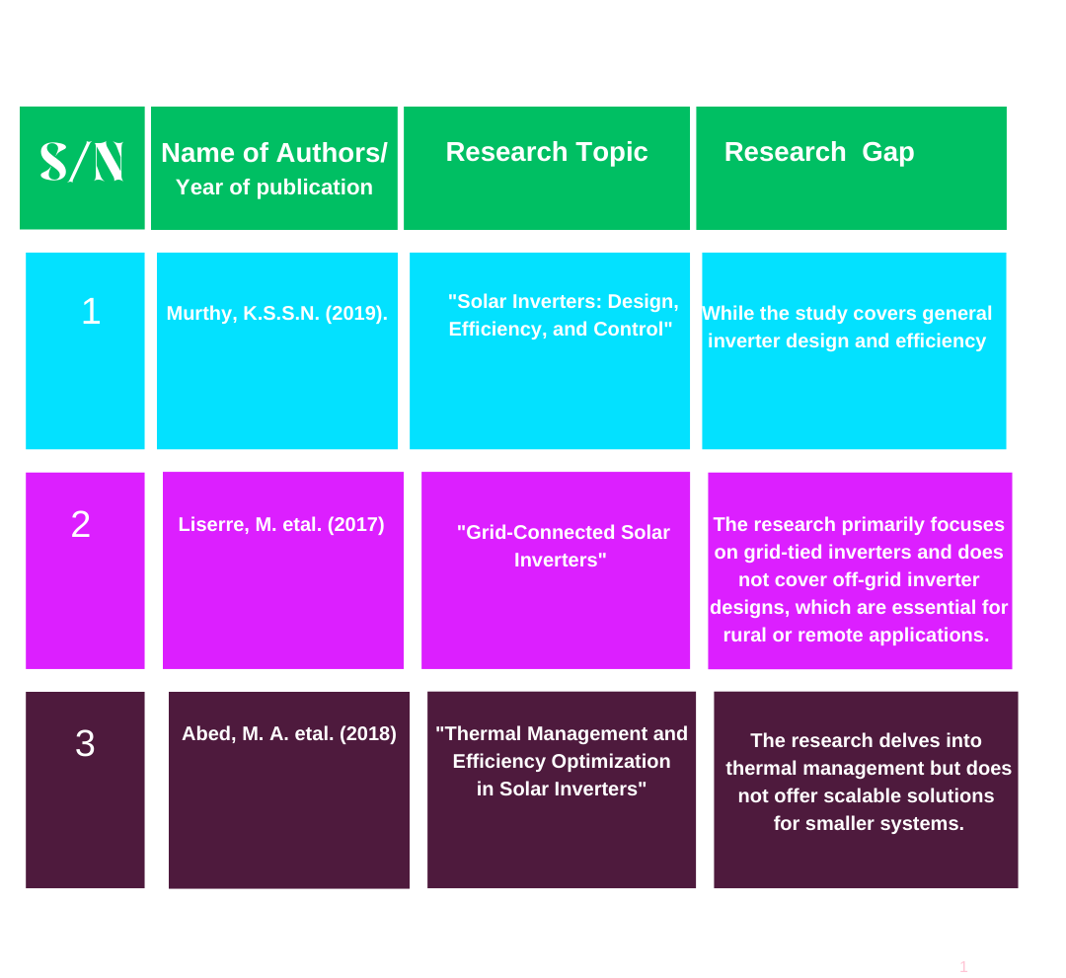LITERATURE REVIEW

METHODOLOGY
The methodology for the project will follow these stages:
- Literature Review & Conceptual Design:
Review existing solar inverter designs, focusing on efficiency, reliability, and cost-effectiveness. Define the system specifications and determine the technical approach based on the literature review.
- Detailed Design:
Using simulation tools (e.g., MATLAB, Simulink, or PSpice), design the electrical schematic and layout of the inverter. Identify the key components and design the control algorithm for the inverter's operation.
- Component Procurement:
Procure the necessary components such as microcontrollers, transformers, transistors, capacitors, resistors, etc.
- Prototype Construction & Testing:
Build the prototype and test it under a variety of conditions, measuring key parameters such as efficiency, voltage stability, current handling, and thermal performance.
- Final Assembly & Deployment:
Upon successful prototype testing, finalize the design and assembly of the complete inverter system.
- Performance Evaluation:
Perform long-term testing of the final product under solar irradiance and varying load conditions to ensure it meets performance requirements.
- Documentation & Training:
Create user manuals, maintenance guides, and offer training for end-users on how to use and maintain the inverter.

METHODOOGY DIAGRAM

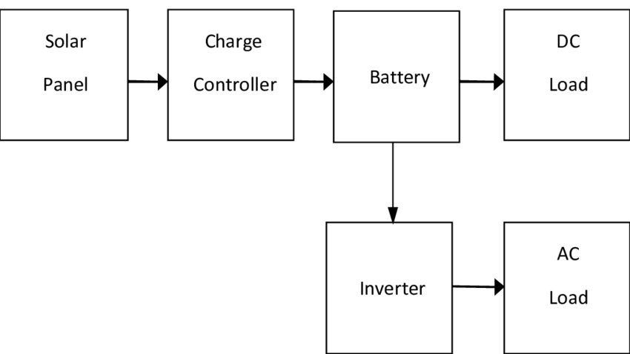

CONCLUSION
The design and construction of a 2kAV solar-powered inverter will contribute to the growing need for sustainable energy solutions. This project will provide an affordable, reliable, and efficient inverter for residential and small commercial applications, offering long-term benefits for energy users while reducing carbon footprints. Successful completion of this project will not only demonstrate technical proficiency but will also have a positive impact on energy accessibility and environmental sustainability.

REFERENCE
- Murthy, K.S.S.N. (2019). "Solar Inverters: Design,
Efficiency, and Control"

- Abed, M. A. etal. (2018). "Thermal Management and
Efficiency Optimization in Solar Inverters"

3. Liserre, M. etal. (2017). "Grid-Connected Solar Inverters"

