

TECHNICAL REPORT ON THE STUDENT INDUSTRIAL WORK

EXPERIENCE SCHEME (SIWES)

HELD AT:

OYO WEST LOCAL GOVERNMENT SECRETARIAL COMPLEX,

OJONGBODU OYO, P.M.B 1107.

OLATUNJI ABDUSSOMAD ADEMOLA

ND/23/CEC/PT/ 0020

DEPARTMENT OF CIVIL ENGINEERIING,

INSTITUTE OF TECHNOLOGY,

KWARA STATE POLYTECHNIC, ILORIN

SUBMITTED IN PARTIAL FULFILLMENT OF THE AWARD OF ORDINARY NATIONAL DIPLOMA (OND) IN CIVIL ENGINEERING

CERTIFICATION

This is to certify that this report is original to the author, ND/23/CEC/PT/0020 of the Department of Civil Engineering, institute of Technology, Kwara State Polytechnic, Ilorin and was supervised accordingly by ;

SIGNATURE OF THE SIWES SUPERVISOR

-----------------------------------------------------------------

SIGNATURE OF THE SIWES COORDINATOR

----------------------------------------------------------------

SIGNATURE OF THE HEAD OF DEPARTMENT

---------------------------------------------------------------

SIGNATURE OF THE HEAD OYO WEST MINISTRY OF WORK

--------------------------------------------------------------

ACKNOWLEDGEMENT

My Sincere thanks to the LORD, for his mercy and goodness during my
SIWES training. I am exceedingly grateful to be able to participate in this
SIWES program.
To my number one fan that always got my back, Mummy, thanks for all you
do. You are just the BEST. Cheers to more wins and milestones together,
the sky is the limit!
To my ever supportive sister, thanks for always been there for me. I am
blessed to have you ma.
To Engineer Kola the SIWES coordinator in Oyo State,Oyo west local Government Secretariat thank you for taking me as your Brother and making sure I get the of all you can offer. I promise to make you proud. To all my family, thanks for praying and looking out for me and helping in every way you can. I am glad to be part of this great family, thanks for always checking up on me. Together we can.
To Civil Engineering sets 2022/2023, thanks for information right on time
and cooperating as group. I see potential in this set and can’t wait to see
professional Engineers amidship us.

PREFACE

This is a report of four months industrial training which was done as
part of the requirement needed for the award of national diploma
certificate which was embarked upon by the technical student after my
first year of stay in school. It is also done to enable the student’s to be exposed the practical aspect of their curse of study and write down what I have gained during the training. The program is aimed at correcting the incompetence in the school leaving the scientific and technical in country

TABLE OF CONTENT

Title
Acknowledge
Preface
Table content

CHAPTER ONE
1.1 HISTORIAL BACKGROUND OF STUDENT INDUSTRIAL WORK EXPERIENCE SCHEME
1.2 AIMS AND OBJECTIVES

CHAPTER TWO
2.1 DESCRIPTION OF KWARA STATE MINISTRY OF WORKS
2.2 LOCATION AND BRIEF HISTORY OF OYO STATE MINISTRY OF WORKS AND TRANSPORT
2.3 DEPARTMENTS AND THEIR FUNCTIONS

CHAPTER THREE
3.1 TECHNICAL EXPERIENCE GAINED
3.1.1 CONSTRUCTION OF SURFACE DRAINAGE
3.1.2 STEPS IN CONSTRUCTION OF SURFACEDRAINAGE
3.1.3 GRADING
3.1.4 COMPACTION
3.1.5 PRIMING
3.1.6 KERBS.
3.1.7 PAVEMENTASPHALT
3.2.1 EQUIPMENT USED FOR ROAD CONSTRUCTION

CHAPTER FOUR
4.1 Recommendations
4.2 Conclusion
Reference

CHAPTER ONE

INTRODUCTION
1.1 HISTORIAL BACKGROUND OF STUDENT INDUSTRIAL WORK EXPERIENCE SCHEME

Students’ Industrial Work-experience Scheme (SIWES) is one of the Industrial Training Fund (ITF) programme which was introduced in 1974 due to the inability of engineering
and technology students in Nigeria universities and polytechnics to meet the practical aspects of their training. That is, the needs to enable students match their theoretical school knowledge with the practical aspect of their training in industry. The Training lasts for six months. According to Ekpenyong (2011), one of the principles underlying any industrial work experience scheme for students in institutions of learning is the desire to marry the practical with the theoretical learning which characterizes conventional classroom situations with a view to striking a balance between theory and practice. The author stressed further that it was in realization of this that the ITF when it
was established, set out to study the extent to which the theoretical knowledge that students in engineering technology and other allied fields in Nigerian institutions offering technology-based courses related to the kind of work experience expected of them by employers.
The result of the ITF survey showed a great disparity between students’ knowledge and their ability to apply it in relevant jobs. In order to bridge the gap between the two, the ITF in 1974 established a co-operative internship programme, which enabled students of technology to spend some part of their courses for relevant on the-job practical experiences in appropriate areas of the Nigerian industry (Ekpenyong, 2011). The author further stressed that the internship programme, SIWES, can therefore be seen as that which is intended to give Nigerian students studying occupationally related courses
experience that would supplement their theoretical learning as a well of equipping the students with the needed skills to function in the world of work.
This need to combine theoretical knowledge with practical skills in order to produce results in the form of goods and services or to be productive is the essence and rationale for industrial training, and a basic requirement for the award of B.Eng.

1.2 AIM AND OBJECTIVES
The Industrial Training Fund’s policy Document No. 1 of 1973 which established SIWES outlined the objectives of the scheme. The objectives are to:
1) It provides an avenue for students in institutions of higher learning to acquire industrial skills and experience during their course of study.
2) It exposes Students to work methods and techniques in handling equipment and machinery that may not be available in their institutions.
3) It makes the transition from school to the world of work easier and enhance students’ contact for later job placements and a chance to evaluate companies for which they might wish to work.
4) It provides students with the opportunities to apply their educational knowledge in real work and industrial situations, there by bridging the gap between theory and practice.
5) The programme teaches the students on how to interact effectively with other workers and supervisors under various conditions in the organization.

CHAPTER TWO

2.1 DESCRIPTION OF OYO STATE MINISTRY OF WORKS
Oyo state ministry of work is establish to oversee and supervise road projects, Structure and quality control for the Government. It has training Section which provides adequate technical knowledge for Students of Tertiary institutions. It also comes out for direct labour such as rehabilitation of road i.e. Road maintenance, Construction of Culverts pavement etc.

2.2 LOCATION AND BRIEF HISTORY OF KWARA STATE MINISTRY OF WORKS AND TRANSPORT
Oyo State ministry of works & transport is situated along Alaubosa Way, Oyo. It is a state Governmental organization, which was set up to control specific road and infrastructural activities for the development of both the Rural and Urban region of the state. The organization was first known as Public works cooperation since creation of oyo State in 1967, Until some years back when it was changes to ministry of work and Transport with the headquarter at oyo the state Capital. Oyo State Ministry of Works & Transport was meant for carrying out works on road such as Maintenance, developments of new route and construction of roads network.

2.3 DEPARTMENTS AND THEIR FUNCTIONS
1-Material Testing Unit: Is a laboratory where quality control and testing for construction has to be carried out in other to know the weight/strength of Materials used in construction, Such as Soil, reinforcement, and Cubes, etc.
2-Design Office Unit: The Unit is in charge of designing the projects work that
Government want to execute.
3-Survey Office Unit: It is a section where Professional Quantity and Land Surveyors are
delegated the duties to evaluate, value qualities and locate points for Constructional Purposes.
4-Construction/Maintenance Unit: It is a unit consisting of skilled persons to maintain existing works, such as Roads, Bridges etc. They are also the one that supervise the works of construction that is going on in the State i.e. the projects of Government, and it is also their duties to construct some infrastructure if it necessary.

2.4 DEPARTMENT AND DUTIES GIVEN
In Oyo state ministry of works and transport, I worked in the Construction/Maintenance unit as a student trainee. I worked alongside other engineers and foremen on site work. Moreover, the department is responsible for supervising all onsite and offsite constructions to monitor compliance with road general specification and safety regulations, and also coordinate and direct construction workers and w3subcontractors. The sector ensures quality construction standards and the use of proper construction techniques for every given project work.

CHAPTER THREE

3.1 TECHNICAL EXPERIENCE GAINED

3.1.1 CONSTRUCTION OF SURFACE DRAINAGE
The drainage system at the order end of the road of the road was extended. 10mm steel bars were used as the main bar and 8mm steel bar were used as the distribution bar. Blinding was done and to provide both side upstream and down-streams of drainage at the bottom of the embankment to prevent spreading and erosion of soil, a tie beam was constructed with the blinding. The bars were installed on the blind and propping of form work were carried out too. Laying of base/surface course continued till it was fully achieved and it was given an adequate compaction . casting of drainage walls were done with 1:2:4 concrete mix design.

3.1.2 STEPS IN CONSTRUCTION OF SURFACE DRAINAGE:
1. EXCAVATION OF TRENCH: The trench was excavated based on the leveling that was carried out by the surveyor with use of hand tools such as; pick axe, shovel, chisel hammer etc

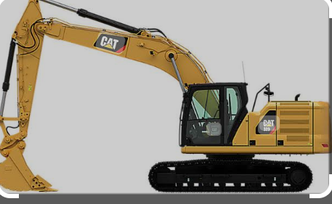

2. CUTTING, BENDING AND BINDING OF REINFORCEMENT: The reinforcement steel were cut and bent according to the specification in the structural drawing. The diameter of the bars that was used was 12mm.
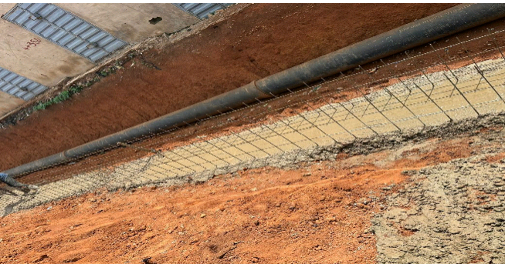

- ERECTION OF FORMWORK: The form work for the base of the drainage was first erected, after casting of the base, another form work was erected for the retaining walls at the sides.

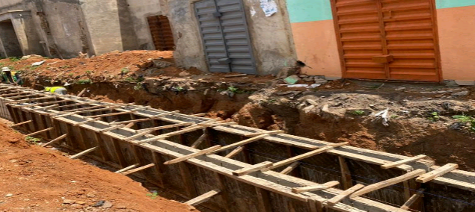

4. CONCRETING: This also referred to as casting. It is the process of working with freshly mixed concrete especially the placing of concrete. Before concreting some procedures were undertaken. Such procedures include;
a. MATERIAL SUPPLY AND STORAGE: This is the receiving on site of the basic materials namely cement, fine and coarse aggregate and storing them under satisfactory conditions. Cement is supplied in bags from and was stored on racks to prevent moisture penetration from the ground in a dry store free from draught which can introduce moist air and cause air set of the material. Cement should not be stored for a long time on the site.
b. BATCHING: Before mixing was carried out, the ingredient have to be in their correct proportion to enhance the quality of concrete. Volume batching was used in this process with the aid of head pan with a ratio of 1:2:4 and this was supervised by the site engineer.
c. MIXING: The purpose of mixing is to coat the surfaces of aggregate particles with cement paste and to make it a uniform mass. The quality of mixture depends on the accuracy of proportioning of the materials and the method of mixing. The mixing was carried out mechanically through the use of a Tilting Drum concrete mixer

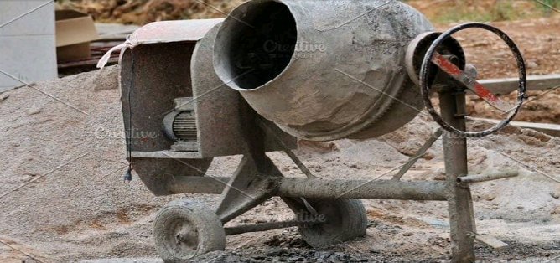

d. TRANSPORTATION: This involves the means of conveying concrete from the point of mixing to the point of placement. The choice of transportation depends on size and complexity of the site, weather condition and height of placement of the concrete. The mode of transportation used was manual method with the use of head pan and labour.
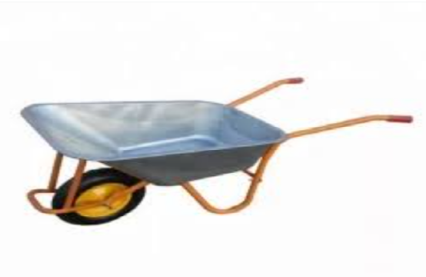
e. COMPACTING: The compacting of freshly placed concrete is to make it a unit mass by eliminating voids within it. The method and type of compacting given to concrete depend on the nature of work. Poker vibrator was used for the compacting of the concrete during the construction of drainage.
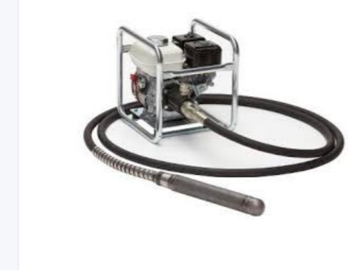
f. CURING: After the placing and compacting of the concrete it is allowed to
sufficiently harden for a day then the curing process comes in which involves the prevention of the evaporation of moisture in the concrete. The concrete was watered for 7 days with the use of hose pipe connected to a tank. This was done to avoid shrinkage of the concrete and cause a more permanent and durable material.
5. Back filling: This is the process of filling the sides of excavated portion after
concreting with laterite or other Earth material. The back filling was done
manually with the use of literate .

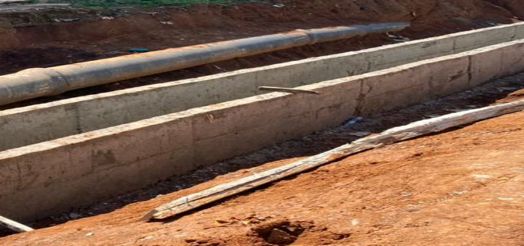

3.1.3 Grading:
This is done with use of grader. It helps in grading the road’s sub base course, literate excavated from borrow pits which was dump by the dump truck was used for filling where necessary. The road was wet afterwards by water truck in order to prevent dust and to increase the soil moisture content to enhance compaction.
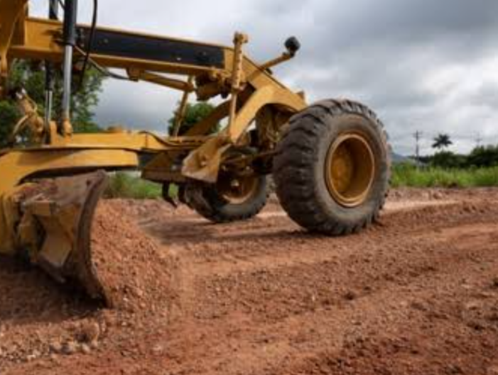

3.1.4 Compaction:
This process begins after begins after the road had been wet with water. The sub base i.e. the late-rite was being compacted to desired thickness which was done with the aim of anchoring maximum density in the soil in order to prevent settlement in the future.

3.1.5 Priming:
Priming entails introducing a bituminous binder into the previously compacted and untreated road surface. The binder penetrate into the pavement surface to stabilize the fines and turn the upper part into a hydrophobic layer several millimeter thick. The intended substance i.e. the bitumen was heated to a temperature of 140 0 c and the process of watering and compaction were repeated before priming started
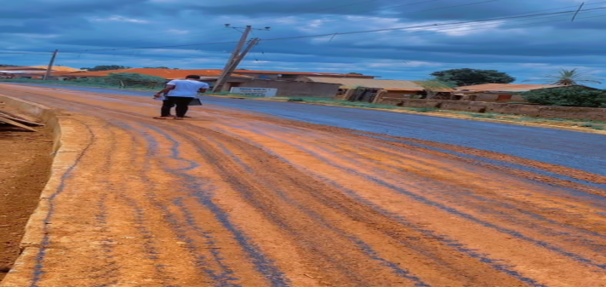

when priming began, the bitumen tray test was conducted by [Gambros soil and material testing laboratory] in order to measure the rate of spray and allow adjustments in speed of vehicle [ or gears] to be made for subsequent runs. Three different trays with different weight were placed beneath the vehicle i.e. on the right, center and left hand side of the outlet respectively. The outlet of the test goes thus
Location of tray | L.H.S | CENTER | R.H.S
Tray no | 1 | 2 | 3
weight of tray + bitumen | 745g | 700g | 745g
Weight of tray | 650g | 600g | 650g
Weight of bitumen | 95g | 100g | 95g
x-sectional area of tray | 0.09m² | 0.09m² | 0.09m²
Rate or spray | 1.06l/m² | 1.11l/m² | 1.06l/m²
Grade of bitumen | Priming | Priming
Temperature of spray | 140°c
Initial reading of meter | 130°c
Final reading of meter | 120°c
Average rate of Spray | 1.08 Liter per square meter | 1.08 Liter per square meter | 1.08 Liter per square meter
Grit sand [sharp sand] was spread on the bitumen in order to allow mobility on the road.

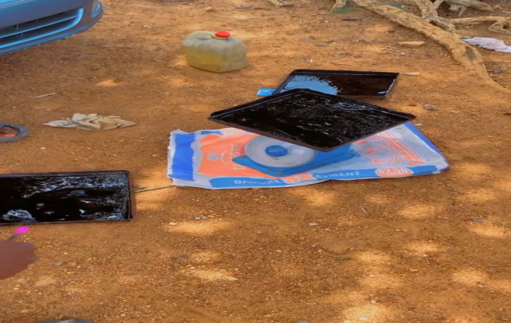

3.1.6 Kerbs:
At the intersection of the road i.e. [at the junction]. A sharp edge triangular kerbs arrangement took place. 120 pieces of kerbs were used which covers 56.1 meters in total and furthermore the grit sand were swept off the surface of the road as the laying of the base course was about commencing

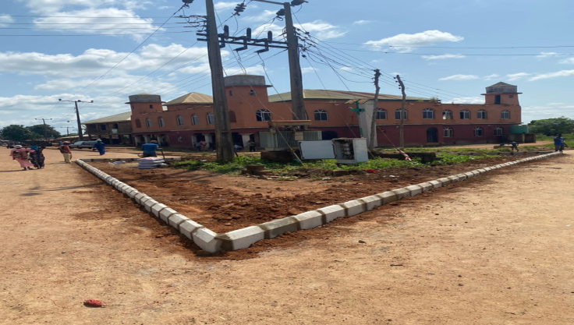

3.1.7 Pavement:
The pavement that was constructed was a flexible pavement by laying the base course/surface. Coles was sprinkled on the surface of the road which was wet once again then laying of asphalt began.

3.1.8 Asphalt:
The asphalt was laid by a paver to a thickness of 50cm i.e. 50mm which was later compacted to a thickness of 4cm [40mm] by the compactor. And the processes were been repeated subsequently the same way the truck conveying the asphalt took turn in depositing them into a paver once the previous one had been exhausted
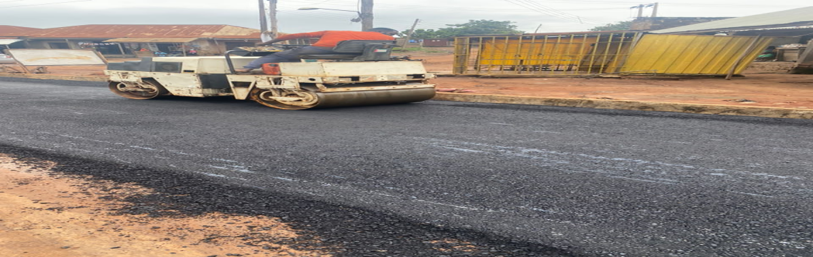
3.2.1 EQUIPMENT USED FOR ROAD CONSTRUCTION
i. Excavator: this consist of boom, stick, bucket and cab on rotating platform
known has the house. It is used for digging of trenches, material handling,
demolition etc.
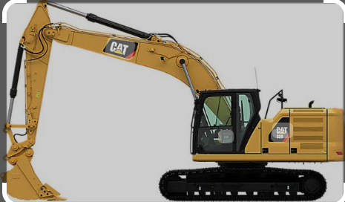

ii. Grader: It is used for cutting the slope of an embankment for smoothing grade level, and for spreading loose materials.


iii. Bulldozer: It is use for demolishing existing structures and also use for clearing a land in preparing for construction
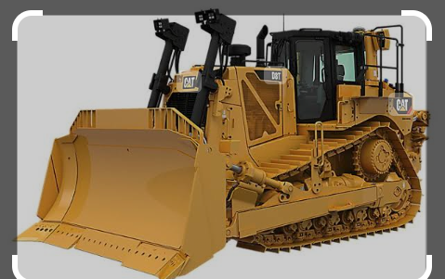

iv. Vibrating Roller: It is used to compact soil and also on asphalt during laying



.
V.Tar Boiler: This is used for heating/boiling tar for road construction.

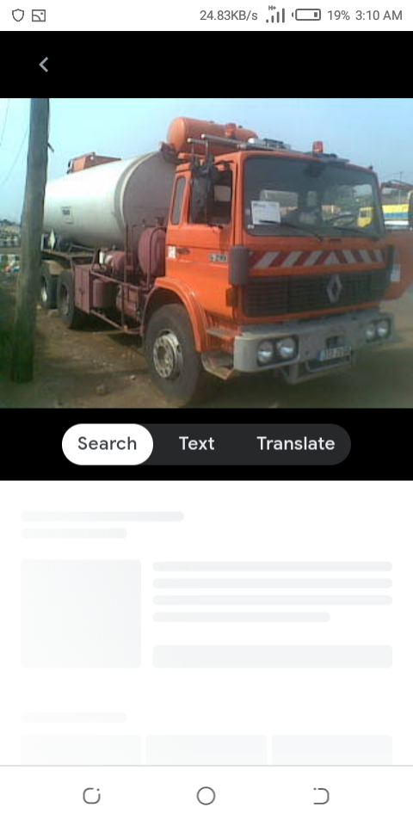
3.3.1 COMPONENT OF ROAD
1. Carriage way: This is designed mainly to allow vehicle to pass through different directions and also allow to move to and fro. The standard thickness of carriage ways is 3.
2. Shoulder: This is place along a particular road that is designed mainly for car park and the thickness is
3. Lay-bye: This is placed beside a particular road that is design mainly for resting and is normally located at both side of road.
4. Drainage: this is usually designed and located at both side of a road in order to ensure easy flow of water and also carry waste water from the surface of the road and the thickness is
5. Culvert: This is usually located at place where the runoff usually occur in a road and it usually occur on a road and is used to cross the passage of running water.
6. Kerbs: This is a line that is a mainly to divide a road to two equal parts.

CHAPTER FOUR

4.1 PROBLEMS ENCOUNTERED
1. Due to the heavy rainfall, there were days whereby petite activities took place, thus limiting work progress on site.
2. During my first few weeks, I had difficulties understanding a lot of the terms and terminologies that was used at the office because a lot of them were very new to me. This made it hard for me to follow the procedures

.REFERENCES

(Ekpenyong, 2011). Foundation of technical and vocational study
Kwara Students SIWES manual
httm//www.google.com

