CHAPTER FOUR

SYSTEM IMPLEMENTATION AND DISCUSSION

4.1 Assembly of the Hardware
The hardware assembly is the practical phase where all electronic components are physically connected, tested, and mounted to form a functioning anti-theft security gadget. This stage ensures that each component operates as intended and interacts seamlessly with others within the system.

4.1.1 Overview of Required Components
The following components are assembled for the project
Table 4: Overview of required components
Component | Description
PIR Motion Sensor | Detects movement within its infrared sensing range
Arduino Uno R3 | Serves as the microcontroller and system brain
Buzzer/Siren | Emits an audible alarm to alert and deter intruders
LED Indicators | Provide system status (power, armed, triggered)
9V Battery/Power Supply | Powers the entire system
Connecting Wires | Facilitates signal and power transmission
Breadboard or PCB | Temporary/permanent platform for connections
Casing/Enclosure | Protects internal components from damage
Pole Stand | Electron Pole that holds the gadget above the ground level
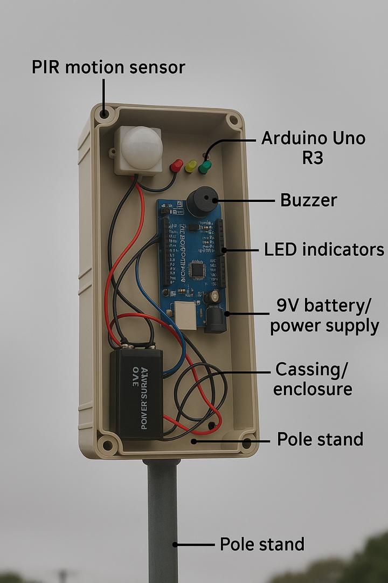
Figure 3: Complete Assembly of the component parts

4.1.2 Step-by-Step Assembly Process
- Microcontroller Setup
The Arduino Uno is fixed as the central controller.
A 9V battery or adapter is connected via the VIN and GND pins.
- Sensor Connection
The PIR sensor's VCC is connected to 5V on Arduino.
GND goes to GND, and OUT pin is connected to a digital I/O pin (e.g., D2).
- Buzzer/Siren Integration
One leg to digital I/O pin (e.g., D9), the other to ground.
Driven using a transistor if current exceeds Arduino output.
- LED Indicators
Connected with 220Ω resistors to digital pins for status display.
Colors used: Red (alert), Green (system OK), Yellow (armed).
- Testing on Breadboard
Before soldering to PCB, all components are first assembled on a breadboard.
Pin connections are verified, and short circuits are avoided.
- Final Soldering and Mounting:
After successful testing, components are soldered onto a Vero board or PCB.
The assembled board is then enclosed in a plastic casing for protection.

4.1.3 Safety and Assembly Considerations
Electrostatic precautions were taken to avoid damaging sensitive components.
Heat sinks were used during soldering to protect ICs.
Proper polarity and voltage ratings were strictly observed.
Wire management was employed to ensure neat and stable connections.

4.1.4 Assembly Outcome
The successful completion of the hardware assembly resulted in a compact and functional prototype. All modules communicate as expected, and the system can detect motion, activate alarms, and send alerts.

