
A TECHNICAL REPORT ON STUDENT
INDUSTRIAL WORK EXPERIENCE SCHEME (SIWES)
HELD AT:
SELPHERED ELECTRONIC AND ELECTRICAL COMPANY
AGBOOBA BESIDE OLUFIED FILLING STATION ILORIN KWARA STATE.
BY:
TANIMOLA OPEYEMI OLUWASEYI
MATRIC NO: ND/23/EEE/PT/0229

SUBMITTED TO :
DEPARTMENT OF ELECTRICAL/ELECTRONIC ENGINEERING. INSTITUTE OF TECHNOLOGY (I.O.T).
KWARA STATE POLYTECHNIC, ILORIN
IN PARTIAL FULFILLMENT OF THE REQUIREMENT FOR THE AWARD OF NATIONAL DIPLOMA (ND) CERTIFICATE IN ELECTRICAL AND ELECTRONIC ENGINEERING.
FROM AUGUST TO DECEMBER 2024

i
DEDICATION
This work is dedicated to the Almighty Allah, the giver of all things who gave me the opportunity to undergone this three months industrial training SIWES programme, it is also dedicated to my parent: Mr. & Mrs TANIMOLA

ACKNOWLEDGEMENT
All praises, honour and glory to Almighty Allah for his abundance blessing and proper protection over me with his support during SIWES and completed successfully. The giver of all knowledge for giving me the privileged and opportunity to finally put together these texts. I gratefully acknowledge the staffs of DEPARTMENT OF WORK UNIVERSITY OF ILORIN, ILORIN KWARA STATE, for the role played during my SIWES program and the knowledge which I gained during my SIWES programme with them. I also acknowledge the effort of my parents; Mr. and Mrs TANIMOLA

CHAPTER ONE

1.0 INTRODUCTION
As will all know that Electrical / Electronic engineering is divided into two options. We have power and machine (PM) secondly, Electronics telecommunication (ET)
This report consists of summary of some power and machine aspect which my experience is base on. Such as surface wiring, half conduit wiring and line construction.
1.1 BRIEF HISTORY OF STUDENTS WORK EXPERIENCE SCHEME (SIWES)
SIWES is the accepted skill training programme which forms part of the approved minimum academic standards in the various degree programme for all the Nigerian universities. It is an effort to bridge the gap existing between theory and practical of engineering and technology, science, agriculture, media management and other professional education programme in the Nigerian tertiary institutions.
The Students Industrial Work Experience Scheme (SIWES) was initiated in 1973 by the Industrial Training Fund (ITF). This was in response to the mandate given to the ITF through decree 47 of 1971, charging it with the responsibility of promoting and encouraging the acquisition of skills in the industry and commerce with the view to generating a pool of trained indigenous manpower sufficient to meet the need of the nation’s economy .The Industrial Fund (ITF) introduced the scheme for employers to be involved in the entire educational process of preparing student for employment in our various industries with the vision "To be the foremost skills training and development organization in Nigeria and one of the best in the world" and mission "To set and regulate training standards and offer direct training interventions in industrial and commercial skills training and development, using a corps of highly competent professional staff, modern techniques and technology". The scheme is a tripartite programme involving the students, the universities and industries (employers of labor). It is funded by the Federal government of Nigeria and jointly coordinated by the industrial training fund (ITF) and the National Universities Commission (NUC)
1.2 AIMS AND OBJECTIVES OF SIWES:
The aim of SIWES is to put students through the labour market for them to apply and incorporate their classroom knowledge into the working practice of engineering and technology and other fields.
The objectives of SIWES programme include:
- The opportunity of being familiarized and exposed to the mode of work, handling of the relevant machinery and equipment available in the discipline etc.
- An opportunity for the student to understand the reality and technicalities used in the business world that relate to their various disciplines or fields, thereby exposing them to practical levels and advanced learning of theoretical knowledge.
- To impact practical method of performing professional functions to undergraduate of the tertiary institutions
- Provision of an enabling environment where student can develop personal attributes such as critical thinking, creativity, leadership, time management, presentation skills and interpersonal skill and other.
- It make student appreciate the roles of their professions which enable them be a creators of change and contribute to grow of the economy and national development.
- It make student to be aware of the work related problems and enable them to see how they can solve the difficulties them all them selves

CHAPTER TWO
- 2.0 BRIEF HISTORY OF THE ORGANIZATION
- PSN BUILDING AHMEDU BELLO WAY GRA ILORIN was established in year 2006.
- The Chairman of the company has experience in SOLAR INSTALLATION especially in house and company he has works in many companies.
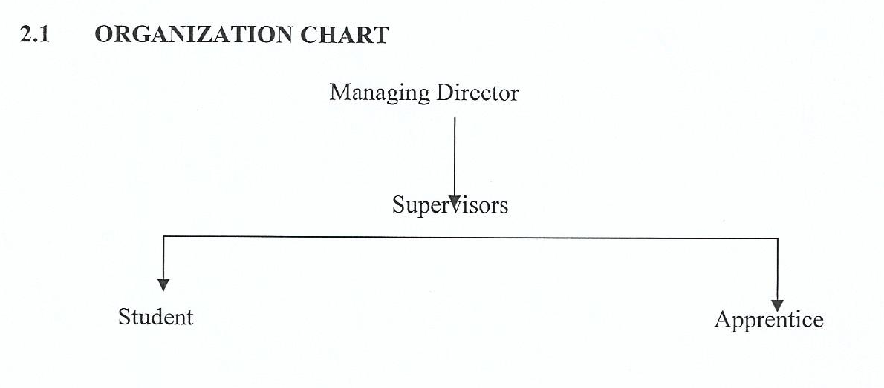

2.2 ELECTRICAL INSTRUMENT
In an Electrical / Electronic department, there are various instrument used to perform some function in our laboratory or working place or field in other to increase such as air working efficiently.
- MultiMeter Tester
- Screw Driver
- Soldering Iron
- Hammer
- Plier
Out of the instrument listed above, we are going to consider the ones am used to during the period of my SIWES programme, which are:
Fixing tape
Gloves
Tester
Testing lamp
Plier
Fixing tape
This is an important instrument used in half conduit wiring it is used for the passage of wires from one point to another for instance, passage of brass from switch control to centre light position.

GLOVE
It is used to prevent electrical shock especially when dealing with service of a house or when work with a conductor without insulator. Since will all know that the hazards of electric shock can clamed a life or paralyze muscles.
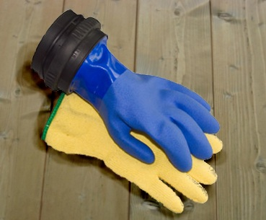

TESTER
It is use to the existence of light in any appliance

TESTING LAMP 3029-10MM2 3026-1.5MM2
It is use to test the existence of both live and neutral wire in any part of electrical installation.

HAMMER
It is use to fixed a clip with a nail on a wall in a surface wiring or for trucking pipe and creation of path for pipe on a wall in half conduit wiring.
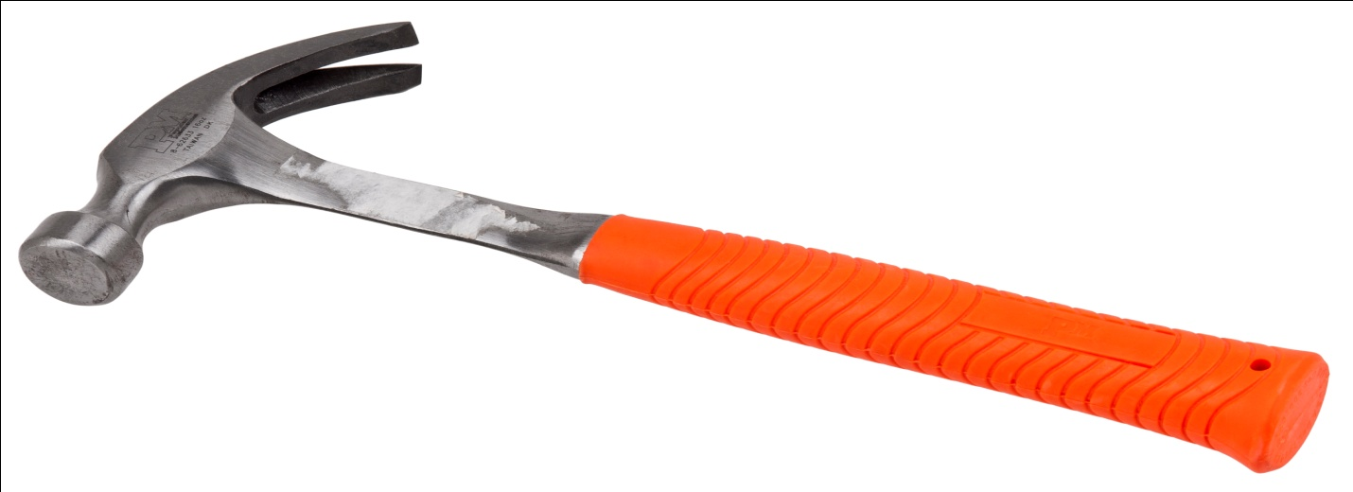

PLIER
It is useful in only wiring system to grip some wire together e.g. only life wire contains in a wall bracket
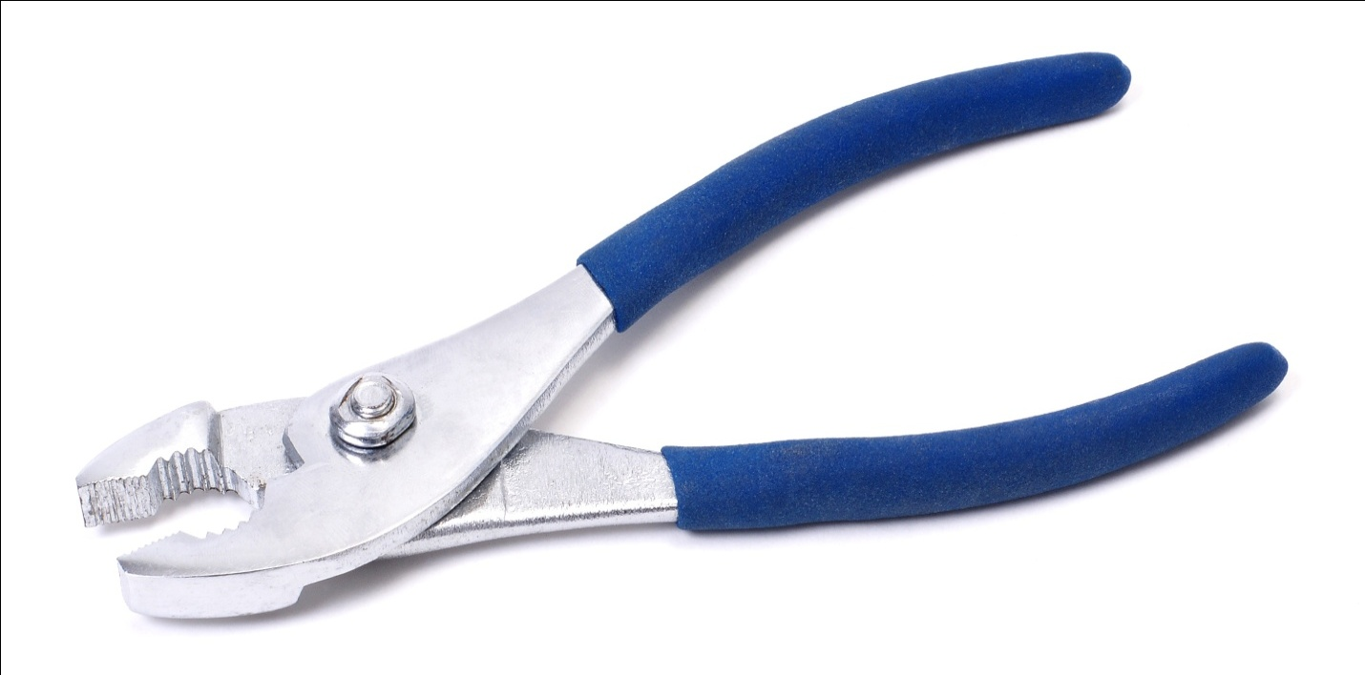
SPANNER
It is use to screw bolt and mitt especially when fixing tie strap to a pole when fixing tie strap to a channel or cross bar
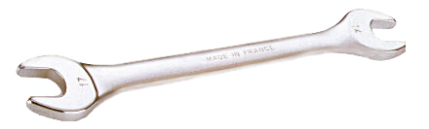
SCREW DRIVER
It is use to drive a screw to a socket or when fixing ceiling rose to a tie rod.
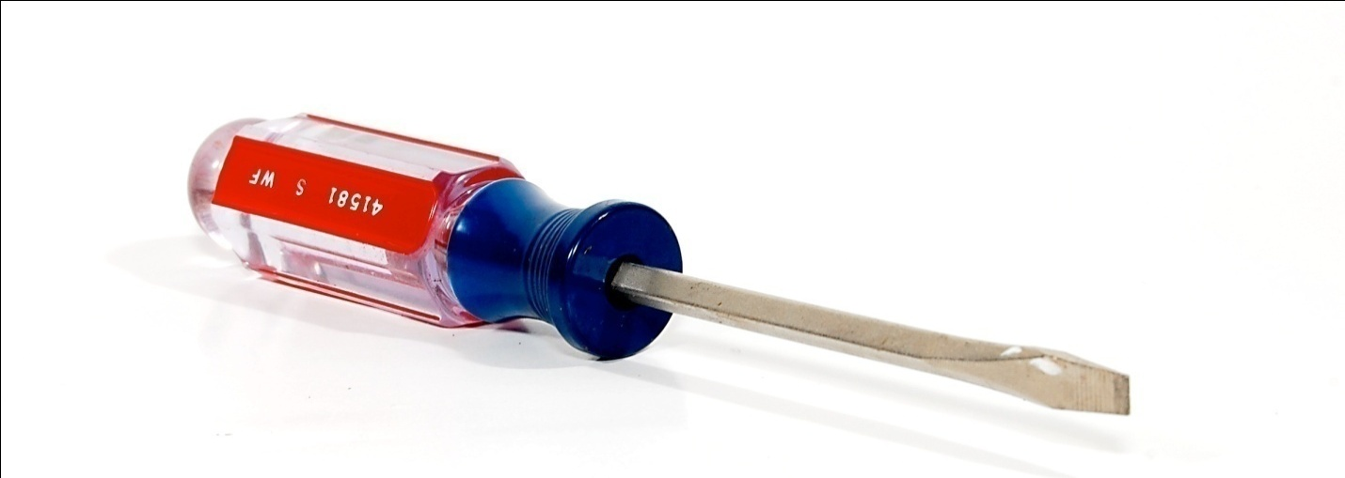

CHAPTER THREE
EXPERIENCED GAINED
3.1 Construction of t joint and main joint
A T-joint is formed by welding two pieces of metal that intersect at a 90-degree angle, creating a "T" shape. A main joint, often a butt joint, is a joint where two members are joined end-to-end. T-joints are commonly used in structural applications, while main joints are fundamental for connecting components.
T-Joint Construction:
- Orientation:
One plate is placed vertically, while the other is horizontal, forming the "T".
- Welding:
Fillet welds are typically used on both sides of the intersection. Groove welds or other weld types may be used depending on the application and material thickness.
- Purpose:
T-joints provide strong connections, often used in load-bearing applications like building frames and ship structures.
Main Joint Construction (Butt Joint):
- Orientation: Two members are butted together, end-to-end.
- Welding: Butt welds, which can be single or double-groove, are used to join the members.
- Purpose: Butt joints are fundamental for connecting components, especially when strong, full-penetration welds are needed.
Key Considerations:
- Joint Preparation:
Edge preparation, such as beveling or grooving, can be necessary to ensure proper weld penetration and strength, especially for thicker materials.
- Welding Process:
Various welding processes can be used, including MIG, TIG, and stick welding, depending on the materials and application.
- Material Thickness:
The thickness of the materials will influence the weld type and joint design.
In essence, T-joints provide strong connections at 90-degree angles, while main joints (butt joints) are fundamental for connecting components end-to-end.
3.2 Change disc In 33ka Line
To change a disc on a 33 kV line, you'll need to identify the type of insulator (suspension or strain), determine the number of discs required for the specific voltage, and then replace the faulty disc in the string with a new one, ensuring proper connections and tightening.
Elaboration:

- 1. Insulator Type:
33 kV lines commonly use suspension disc insulators or strain disc insulators. Suspension insulators are strung horizontally and typically used in the middle of the line, while strain insulators are used at the ends to handle tensile loads.
- 2. Number of Discs:
The number of discs in a string depends on the operating voltage and the type of insulator. For a 33 kV line, you might need 3 or 4 discs per string, but this can vary.
- 3. Replacing a Disc:
  - Safety First: Always ensure the power lines are de-energized and grounded before working on them.
  - Identify the Faulty Disc: Look for cracks, chips, or other signs of damage on the disc.
  - Remove the Disc: Use appropriate tools to loosen and remove the faulty disc from the string, being careful not to damage other parts of the insulator.
  - Install the New Disc: Insert the new disc into the string, making sure it is properly seated and connected to the other discs.
  - Tighten Connections: Use the appropriate torque wrench to tighten the connections, ensuring they are secure but not overtightened.
  - Verification: Inspect the installed disc for any issues and ensure the string is properly connected.

3.3 Replacing a power pole
Replacing a power pole involves digging a hole, fitting the new pole with necessary equipment, carefully detaching power lines from the old pole, raising and setting the new pole, backfilling the hole, and reattaching the power lines to the new pole. This process often involves specialized equipment and should be performed by trained professionals due to the inherent dangers of working with high-voltage power lines.
Steps:
- 1. Preparation:
  - Digging: A hole is dug next to the old pole, typically about 15% of the new pole's height.
  - Fitting: The new pole is fitted with necessary equipment like bolts, crossarms, insulators, ground wires, and arm braces.
- 2. Detaching and Removing the Old Pole:
  - Safety First: Power lines are carefully detached from the old pole using appropriate tools and safety equipment.
  - Removal: The old pole is removed after the lines are disconnected.
- 3. Installing the New Pole:
  - Raising and Setting: The new pole is carefully raised, guided into position, and set in the hole.
  - Backfilling: The hole is backfilled and tamped down.
- 4. Reattaching Power Lines:
  - Careful Transfer: The power lines are carefully moved and attached to the new pole's insulators using tie wires or clamps.
- 5. Final Steps:
  - Equipment Removal: Any remaining equipment on the old pole is detached and removed.
  - Final Check: Once all lines are securely attached, the crew ensures the new pole is stable and properly installed.
Important Considerations:
- Professional Expertise:
Due to the dangers of working with high-voltage power lines, power pole replacement is best left to qualified and experienced professionals.
- Safety:
Strict safety protocols must be followed throughout the process, including de-energizing the lines and wearing appropriate personal protective equipment.
- Permitting:
Depending on the location and specific circumstances, permits may be required for pole replacement.
- Coordination:
Coordination with the utility company may be necessary, particularly for temporary power shutoffs.

CHAPTER FOUR
4.1 Repairing of Fuse of 33kv Transformer
Repairing a 33kA transformer fuse typically involves disconnecting power, removing the old fuse, and installing a new one. The specific steps and tools required will depend on the type of fuse and transformer.
Steps:
- Safety First: Before any work on a transformer fuse, always disconnect power to both the primary and secondary sides. This can be done by unplugging the transformer or opening the appropriate circuit breakers.
- Locate the Fuse: Identify the fuse holder on the transformer.
- Open the Fuse Holder: The method for opening the fuse holder will vary depending on the type. Some may require a screwdriver, while others might have a twisting mechanism.
- Remove the Old Fuse: Carefully remove the old, blown fuse.
- Install the New Fuse: Ensure the new fuse is the correct type and rating for the transformer and insert it properly into the holder.
- Close the Fuse Holder: Reattach the fuse holder cover.
- Verify Power: After completing the fuse replacement, verify that the transformer is properly connected to the power supply and that the fuse has not blown again.
- Consider Professional Help: If you are not comfortable performing these steps, it's best to consult with a qualified electrician or transformer technician.
Important Considerations:
- Fuse Rating: Ensure you are using a fuse with the correct voltage and current rating for your transformer.
- Type of Fuse: Different transformers and applications use different types of fuses (e.g., drop-out fuses, pull-down fuses, etc.).
- Safety: Always prioritize safety when working with electrical equipment.
- Professional Advice: If you are unsure about any aspect of the repair, seek professional help.

CHAPTER FIVE

5.0 CONCLUSION

The student industrial work experience scheme (SIWES) had contributed to my exposure and training in the field of electrical and electronic engineering.
The programme had also enabled me to put into practice the knowledge gained in the classroom with the actual industrial experience and to develop a critical and realistic approach to problems and their solutions in the electric field.

5.1 RECOMMENDATION

The Student Industrial Work Experience Scheme (SIWES) is very interesting and planned. This programme gives me more practical experience of what we have been taught in class because it deals with practical aspect of the field in which I specialized. Moreover, am using this medium to advice government to establish more company and pass the student to this company on their own.
Finally, industrial experience should be given priority by the government.

