CHAPTER THREE
3.1 CASE Studies
Case Studies can be defined as the process of investigation or researching and analyzing an existing project in order to allow creating and improvement in a proposed project.
The need for case studies in this type of project is very important and cannot be over looked due to the following reason:
To have a board knowledge and detailed about the project you embarking on through careful study of the existing one.
To examine, evaluate the existing problem and how it was tackled by the processors in order to avoid such problems in the proposed design or often a better solution for both the future and present design.

3.2 Case Study One
NAME: Atenda Market
LOCATION: Agbaye, Dt. Sabo, Ogbomosho 212102, Oyo State

MERIT
- There is enough toilet for the workers
- It has cross ventilation

DEMERIT
- There is adequate water for cleaning and sanitation
- Drop and stepping
- The is not coal point
- There is not proper waste management
- The building is surrounded with bush
- It is not away from top the board meeting

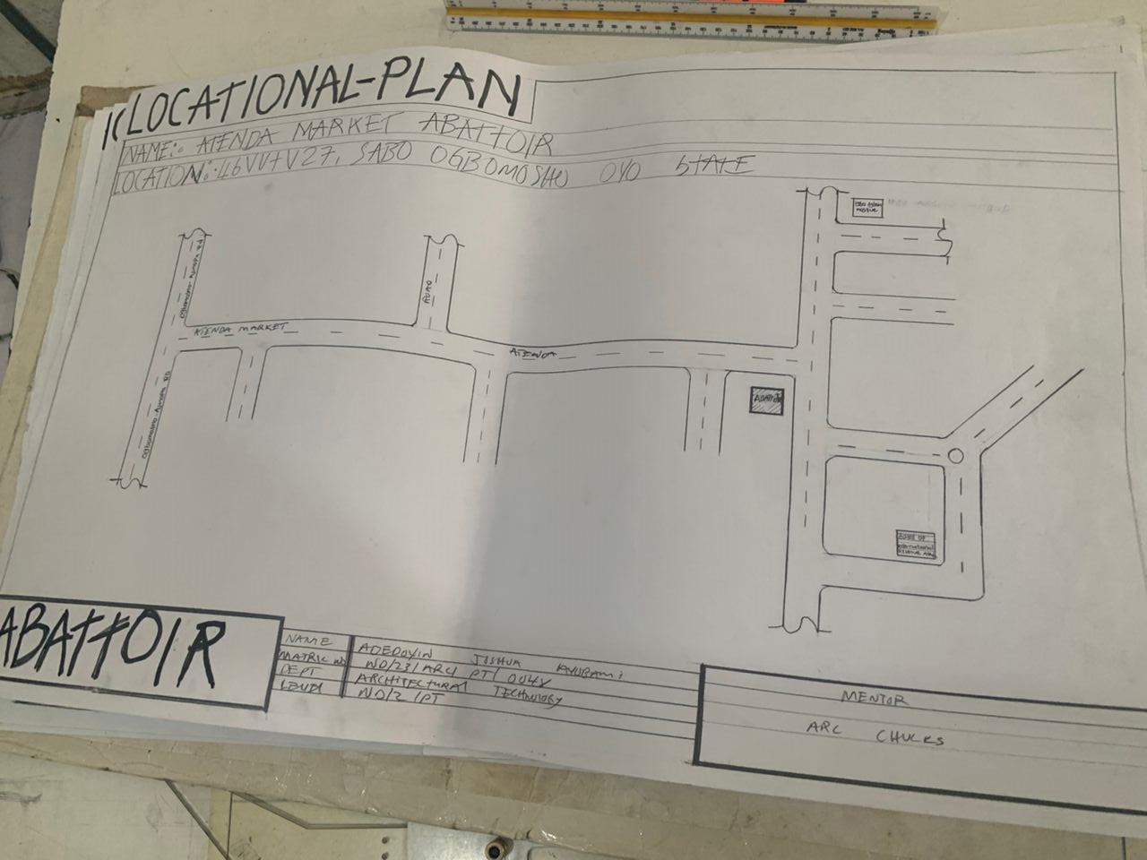

FIG 3.2.1 SITE LOCATIONAL
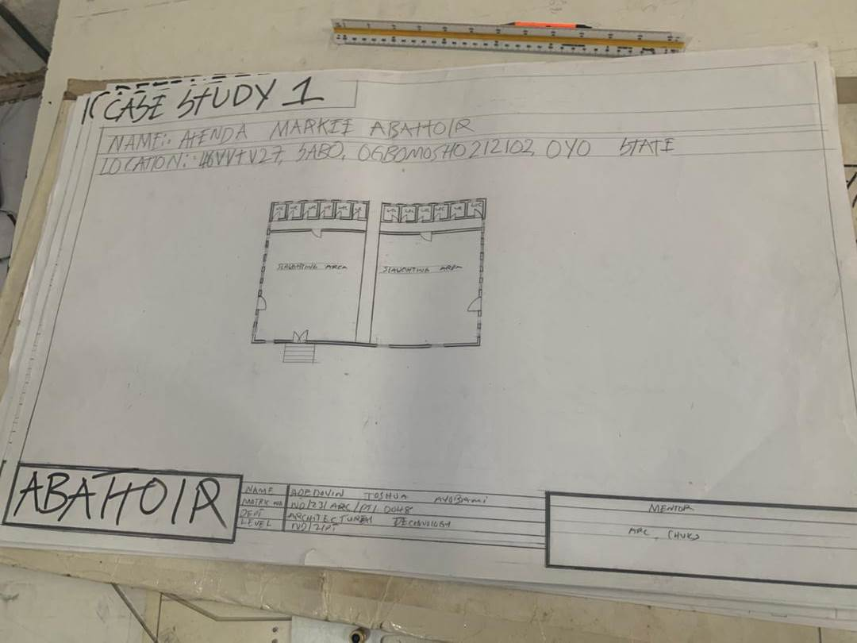

FIG 3.2.2 GROUND FLOOR PLAN

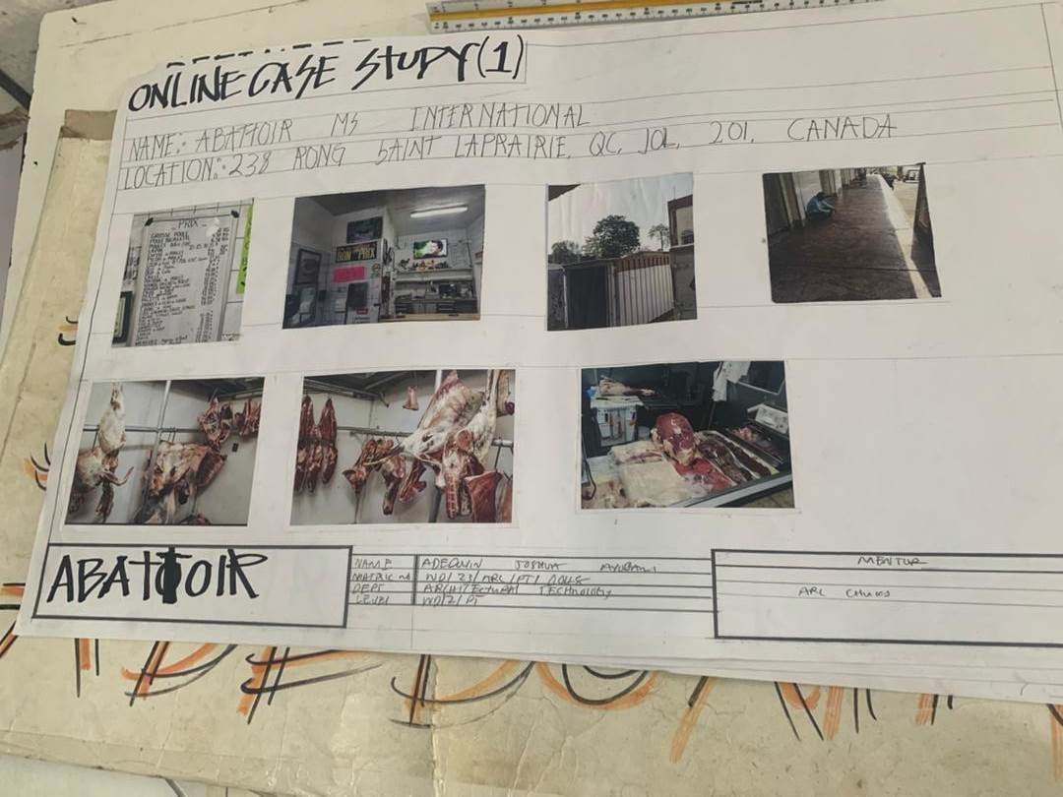

PLATE 3.2.1 SHOWING PICTURES VIEW

3.3 Case Study two
NAME: Sabo Abattoir
LOCATION: Osogbo Osun state.

MERIT:
- Durable and easy to clean
- Suitable lighting and climatic condition
- Cross ventilation

DEMERIT:
- Poor accessibility
- Poor waste disposal
- Poor landscaping
- Inadequate water supply
- Damp pollution

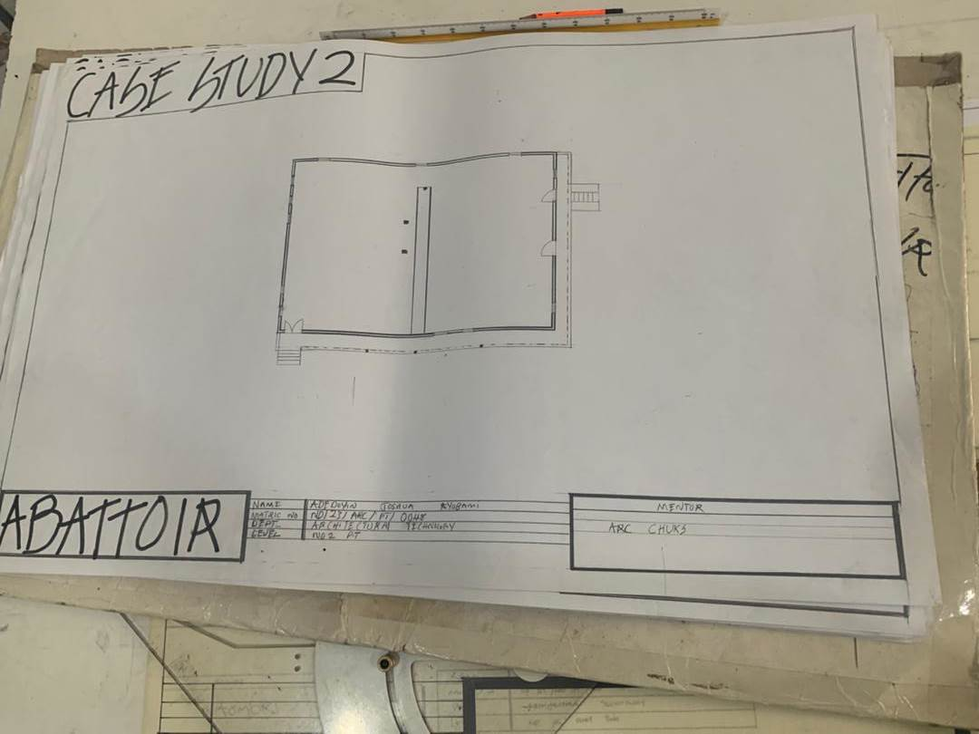

FIG 3.3.1 GROUND FLOOR LOCATIONAL

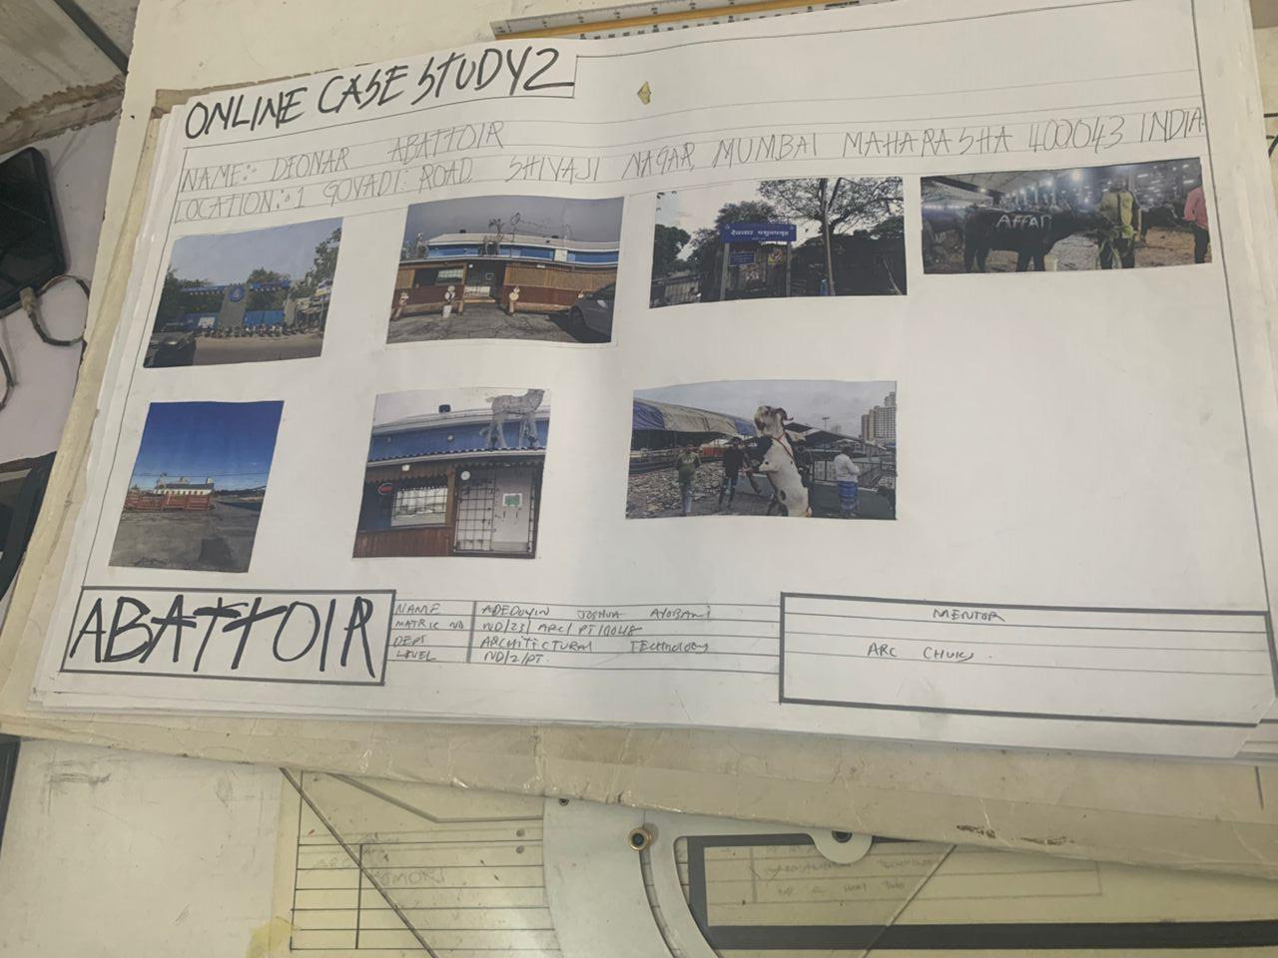

PLATE 3.3.1 SHOWING PICTURES VIEW

3.4 Case Study three
NAME: Dr Abubakar Sola Saraki Memorial Abattoir
LOCATION: SOBI BARACK ROAD, LORIN, KWARA STATE

MERIT
- It is easy to accessible from the road.
- The is well layout.
- It is room top board meeting.

DEMERIT
- Poor maintenance.
- Dump and stepping space.
- Untidy drying space.
- It is not well organized.
- Room for pressure expansion.

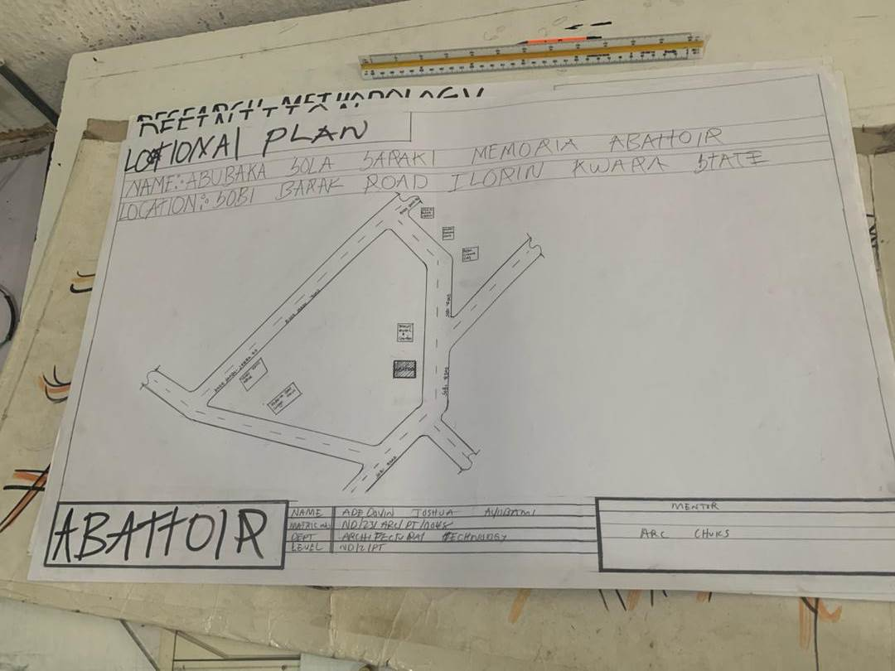

FIG 3.4.1 SITE LOCATION PLAN

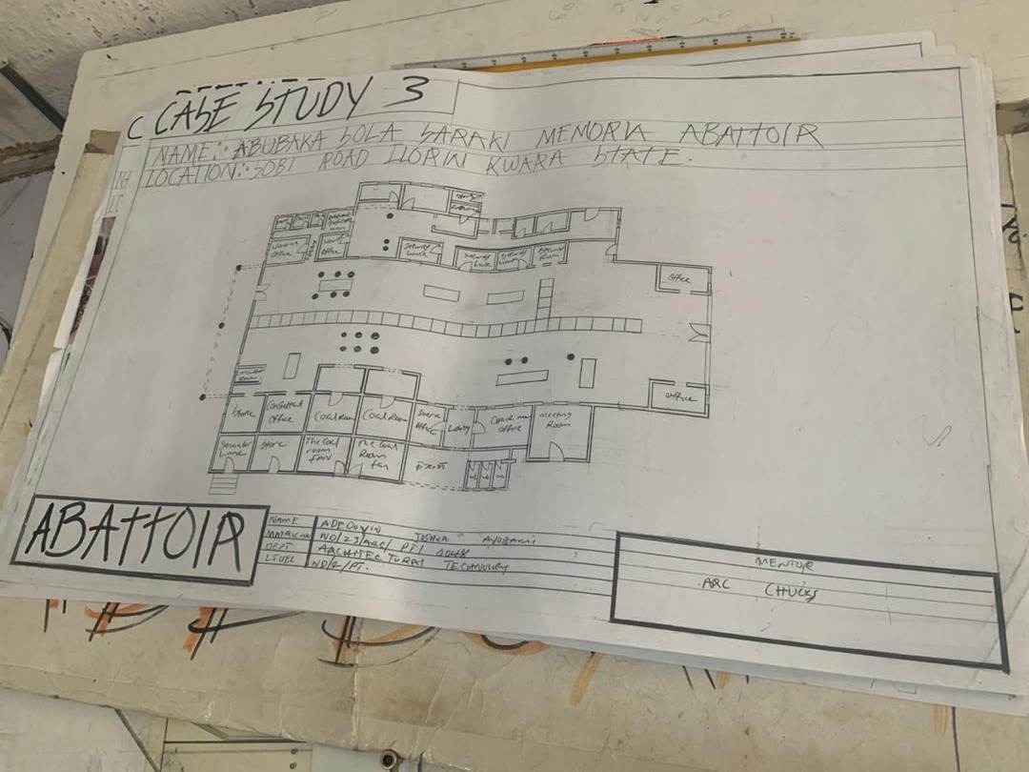

FIG 3.4.2 GROUND FLOOR LOCATIONAL

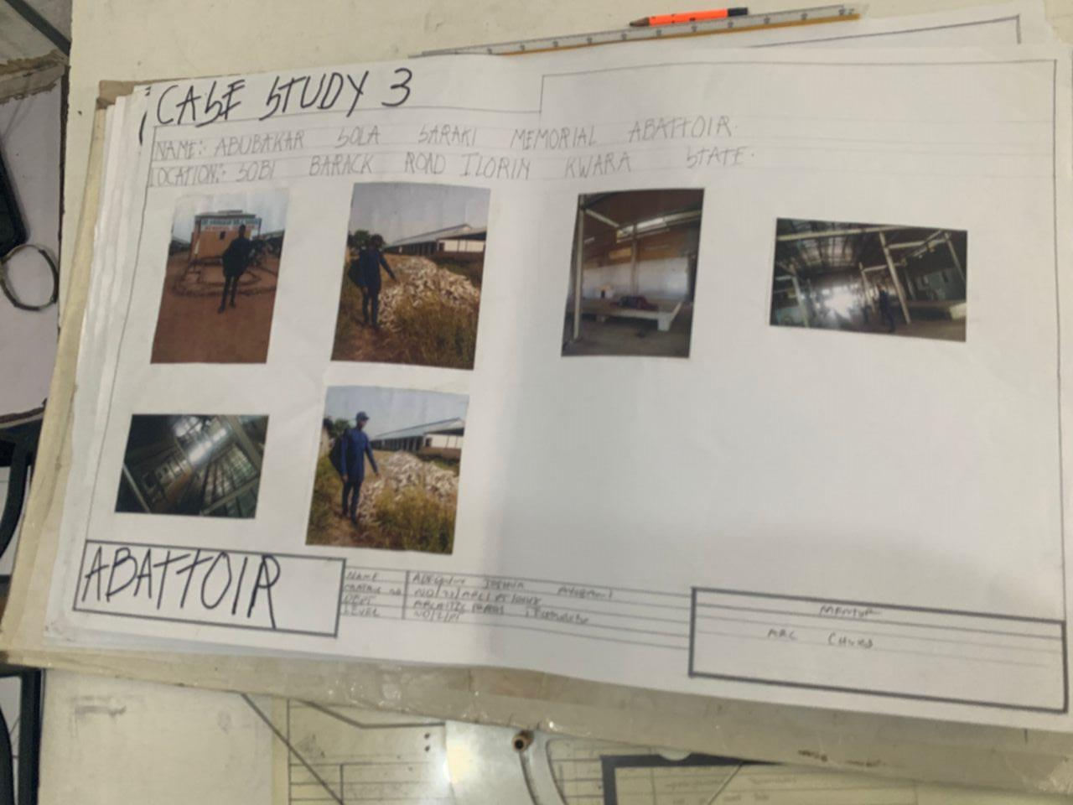

PLATE 3.4.3 SHOWING PICTURES

3.5 ONLINE Case Study 1
NAME: Abattoir international

LOCATION: At 238 kong saint lapraira qc jol 201 canada

PLATE 3.5.3 SHOWING PICTURES

3.6 ONLINE Case Study 2
NAME: Cabrera abattoir

LOCATION: At 122 no ave, haleah, florida united state

PLATE 3.6.1 SHOWING PICTURES

