CHAPTER FOUR
4.0 BACKGROUND OF THE SITE LOCATION TOWN

Geographic and Demographic Context

Eiyekorin is a small but rapidly developing town located within Asa Local Government Area of Kwara State, Nigeria. Kwara State lies in the North-Central geopolitical zone of Nigeria and shares boundaries with Kogi, Niger, Osun, Oyo, and Ekiti States.
The area is predominantly rural with pockets of urbanizing settlements. The topography of Eiyekorin is mainly flat with gentle undulating plains, making it suitable for various forms of development including agriculture, residential, and small-scale industrial activities.

The population of Eiyekorin, though modest, consists largely of the Yoruba ethnic group, with a mix of minority tribes. The community is known for its hospitality, cultural heritage, and agricultural activities. The main economic activities include farming (cassava, maize, yam), petty trading, and local crafts.

Historical Background
Eiyekorin, like many towns in Asa Local Government Area, has a history rooted in Yoruba traditional society. The name "Eiyekorin" translates to "Birds Sing" in Yoruba, reflecting the town’s natural, serene environment.
Historically, the area has served as a settlement for farmers and hunters who were drawn to the fertile lands and peaceful surroundings. The town's development has been gradual, with modern infrastructure slowly making its way into the community over the years.
The people of Eiyekorin uphold traditional Yoruba festivals, values, and cultural practices, while also embracing modernization. The local governance system reflects both the traditional rulers and the modern political structure of the Nigerian government.
GOALS OF THE PROPOSAL
The primary goals of the proposed development in Eiyekorin are:
- To stimulate economic growth by providing infrastructural development that will attract investment and create job opportunities.
- To improve the quality of life for the residents through the provision of essential services and facilities.
- To promote sustainable development by integrating environmental considerations into the planning and execution of projects.
- To preserve the cultural heritage of Eiyekorin while encouraging modernization and urban development.
- To serve as a catalyst for regional development within Asa Local Government Area and Kwara State as a whole.

4.1 SITE LOCATION/DESCRIPTION
- The proposed site is located within Eiyekorin, a strategic area accessible via local road networks connecting to major towns such as Omu-Aran, Ajase-Ipo, and the state capital, Ilorin.
- The site features a relatively flat terrain, which reduces the need for extensive land grading and makes it suitable for various types of development projects. It is bordered by farmlands, scattered residential structures, and is within reasonable proximity to basic amenities such as schools, markets, and healthcare centers.
- The site also benefits from a relatively stable and peaceful community, making it an ideal location for developments aimed at boosting both the local economy and social well-being.
- Access to transportation networks
- Availability of water supply
- Proximity to livestock sources
- Distance from residential areas to minimize public health risks
The proposed location aligns with planning regulations and provides an ideal setting for the development of a modern abattoir facility capable of meeting both current and future needs of the community and surrounding areas.
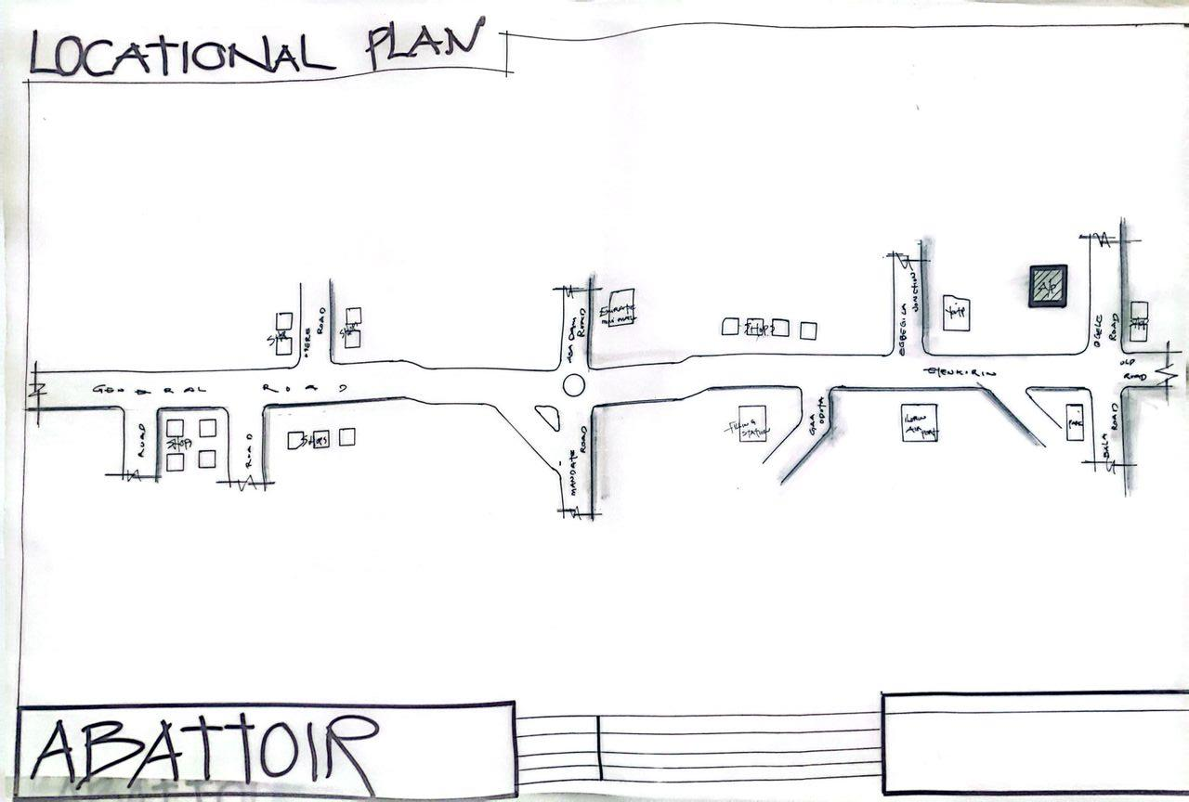
FIG 4.1 LOCATIONAL PLAN
The chosen site meets the following essential criteria:
- Accessibility: Easily accessible from major roads and transport systems.
- Proximity: Near residential areas and existing infrastructure.
- Social Infrastructure: Good access to water supply, electricity, communication, and emergency services.
4.2.1 SITE ANALYSIS/SITE INVENTORY
• Location: ogele eiyenkorin,Asa local government, kwara state.
• Orientation: The site’s shorter sides face east and south; the longer sides face east and west.
• Environmental Considerations: The site lies in a moderately busy area. Environmental noise is managed through:
- Natural Means: Tree planting and landscape buffers.
- Structural Design: Orientation to reduce exposure to noise and maximize ventilation.
- Mechanical Systems: Acoustic treatments and HVAC systems ensure internal comfort.
• Soil Type: Lateritic soil with good load-bearing capacity, suitable for foundation and structural works.
ventilation and artificial/structural devices. Natural, by adequate plantation, while opening are employ as artificial devices structure by proper structural orientation.
All the unwanted sound/noise which cannot be controlled structurally are controlled through mechanical means to increase the comfort of human life. The soil type is brownish nature underlined by sedimentary rock with good bearing capacity
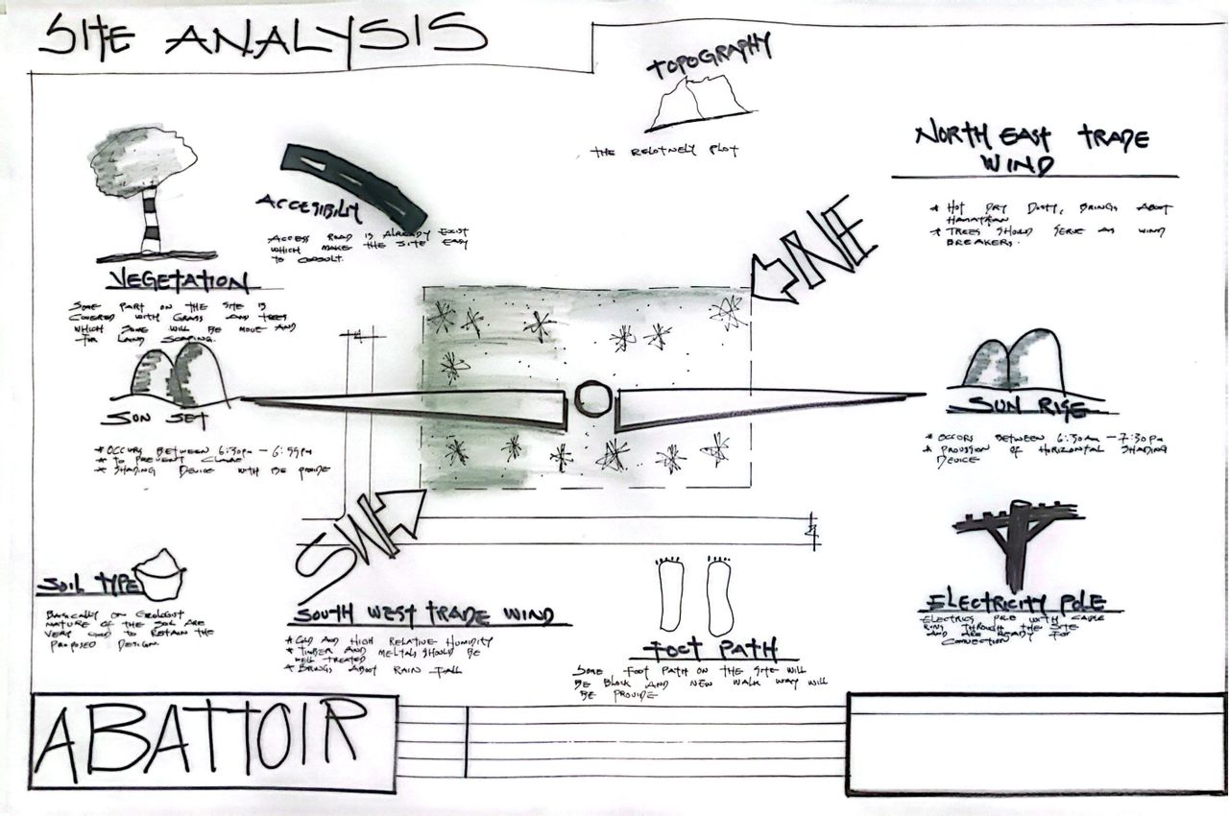

FIG; 4.2.1 SHOWIHG SITE ANALYSIS
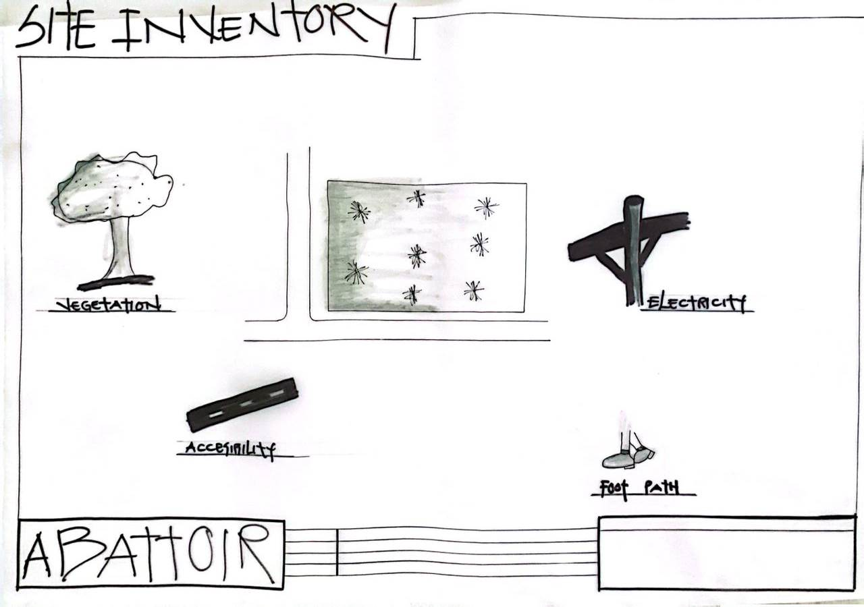
FIG; 4.2.2SHOW SITE INVENTORY

FIG; 4.2.3 SHOW SITE ZOINIG
4.3 GEOGRAPHIC/CLIMATIC DATA
Asa local govt experiences a tropical wet and dry climate, typical of southwestern Nigeria.
- Average Annual Temperature: ~25.5°C
- Annual Rainfall: Approx. 1400 mm

Climate Characteristics:
- Driest Month: December–January (8–15 mm rainfall)
- Wettest Months: May–October (200 mm+ per month)
- Temperature Range:
  - Warmest Month: March (~28°C)
  - Coolest Month: August (~22°C)
  - Annual Temperature Variation: ~5–6°C
THE CLIMATE GRAPH
The least amount of rainfall occurs in January. Average in this month is 9mm. most of the precipitation here falls in is average 1334mm.
THE TEMPERATURE
The temperature is the highest on average in March, at around 26.5. August is the coldest month, with temperature averaging 22.2°C
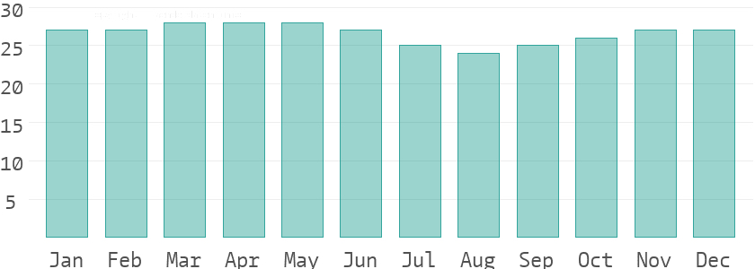
THE CLIMATE TABLE
The variation in the precipitation between the dries and wettest months is 229mm. throughout the year, temperatures vary by 4.3°C.
4.4 DESIGN CRITERIA
Design principles for the healthcare center include:
- Durability: Construction materials and finishes will be selected for strength and longevity under high usage.
- User Comfort: All users—including patients, staff, and visitors—should experience comfort through ergonomic design, air circulation, and lighting.
- Efficient Layout: Zones for reception, outpatient care, emergency response, inpatient services, labs, and administrative areas will be organized to allow efficient flow and accessibility.
- Sustainable & Practical Aesthetics: Focus on sustainable building materials, local craftsmanship, and a welcoming atmosphere without excessive decoration.
- Ventilation & Acoustic Control: Combination of natural ventilation (via courtyards and windows) and mechanical systems for noise control and climate regulation.
4.5 BRIEF
- Entrance
- Special part
- Supervisor office
- Material tools store
- Material coal store
- Control room
- Changing room
- Delivery room
- Meeting room
- Toilet
- Burning area
- Skinning area
- Security part
- Cooling area
- Packaging area

4.6 SPECIAL ALLOCATION/SCHEDULE OF ACCOMMODATION

| S/N | UNITS | LENGTH (m) | BREADTH (m) | AREA (m²) |
|-----|-----------------------|------------|-------------|------------|
| 1 | OFFICE | 4.8 | 2.4 | 12.0 |
| 2 | ENTRANCE | 7.0 | 3.0 | 21.0 |
| 3 | SECURITY POST | 5.0 | 5.0 | 25.0 |
| 4 | PAYMENT OFFICE | 5.0 | 5.0 | 25.0 |
| 5 | SUPERVISOR OFFICE | 5.0 | 5.0 | 25.0 |
| 6 | RECEPTION | 5.0 | 3.0 | 15.0 |
| 7 | CHOPPING AND SPLITTING| 5.0 | 5.0 | 25.0 |
| 8 | ETHANOL ROOM | 3.6 | 5.0 | 18.0 |
| 9 | CHILLER ROOM | 5.0 | 3.6 | 18.0 |
| 10 | TOILET | 1.8 | 4.0 | 7.2 |
| 11 | BURNING ROOM | 7.0 | 3.0 | 21.0 |
| 12 | SECURITY POST | 5.0 | 5.0 | 25.0 |
| 13 | COLD ROOM | 4.2 | 10.0 | 42.0 |
| 14 | VETERINARY BAY | 5.0 | 5.0 | 25.0 |
| 15 | FREEZING ROOM | 3.9 | 5.0 | 19.5 |
| 16 | SLAUGHTER ROOM | 4.0 | 5.0 | 20.0 |
| 17 | SKINNING ROOM | 3.9 | 5.0 | 19.5 |

TOTAL AREA: 375 m²

4.7 CONCEPTUAL DEVELOPMENT
The conceptual development of the proposed Abattoir stems from the urgent need to create a hygienic, efficient, and sustainable facility for the slaughtering, processing, and distribution of meat products within the community. In many parts of Nigeria, including Eiyekorin, Isin Local Government, Kwara State, traditional slaughter methods are still in practice, often under poor sanitary conditions that pose serious health risks to both consumers and the environment.
The design concept for the abattoir is anchored on the “Clean to Dirty” principle, which ensures a systematic flow of operations from the arrival of livestock to the final distribution of meat products, minimizing the risk of contamination. This principle divides the facility into distinct zones that include:
- Animal Reception and Holding Area:
This is where livestock is received and kept temporarily in holding pens under humane conditions with access to water and shade before slaughter. It ensures the animals are well-rested, which improves meat quality.
- Slaughtering and Bleeding Section:
This area is designed for humane slaughtering following Islamic Halal guidelines or conventional methods, depending on community needs. Efficient drainage and washable surfaces are incorporated to maintain hygiene.
- Processing and Dressing Zone:
This section is where carcasses are skinned, eviscerated, and cleaned. The design ensures separation between clean and dirty operations to reduce cross-contamination.
- Inspection and Chilling Area:
Veterinary inspection is a key component here to ensure that only healthy meat proceeds to the market. A cold room is provided to preserve meat before distribution.
- By-product Processing and Waste Management:
In line with environmental sustainability, the design includes a section for processing by-products (hides, blood, bones) and a dedicated waste treatment system such as a bio-digester or soak-away pits to handle effluent and solid waste responsibly.
- Administrative and Ancillary Spaces:
This includes offices, staff changing rooms, toilets, water supply facilities, storage areas, and parking spaces for delivery trucks.

