CHAPTER FOUR
4.0 PROJECT LOCATION
4.1 BRIEF HISTORICAL BACKGROUND OF OYO STATE
Oyo is a state in southwestern Nigeria. Its capital is Ibadan, the third most populous city in the country and formerly the second most populous city in Africa. Oyo State is bordered to the north by Kwara State for 337 km, to the southeast by Osun State for 187 km, partly across the River Osun, and to the south by Ogun State, and to the west by the Republic of Benin for 98 km. With a projected population of 7,976,100 in 2022, Oyo State is the sixth most populous in the Nigeria.
The vast majority of Oyo State residents are Yoruba. Nicknamed the "Pace Setter State", present-day Oyo State sits on territory formerly ruled by the Oyo Empire. The Oyo Empire was a Powerful Yoruba empire that ruled much of Oyo state and by extension major parts of Yoruba lands from c. 1300 to 1896. Built in the 1830s, the modern city of Oyo "New Ọyọ" (Ọ̀yọ́ Àtìbà) is considered a remnant of the imperial Oyo era to distinguish itself from the former capital to the north, 'Old Oyo' (Ọ̀yọ́-Ilé). Although the medieval great Oyo Empire collapsed in 1835, The Alaafin (owner and custodian of the palace) continues to serve a ceremonial role in the new city of Oyo in present Oyo state.
4.1.2 ECONOMY OF OYO STATE
The capital city of Ibadan, is the 3rd most populated city in Nigeria according to the 2006 official census. The state has the highest number of towns and cities mentioned in the top 50 most populous towns in Nigeria with Ibadan, Ogbomoso, Oyo, Saki and Iseyin all featuring in the list. The state economy remains largely agrarian, with the western city of Shaki being described as the state's breadbasket. Cassava, cocoa, and tobacco are among the most important crops to Oyo State's economy.
4.1.3 ORGANIZATION STRUCTRE
An organizational structure is a system that outline shows certain activities that are direct in order to achieve the goals of an organization. These activities can includes rules, roles and responsibilities. The organizational structure also determine show information flows between levels within the poultry farm.
4.2 LOCATION AND SETTING OF OYO STATE
Oyo State covers approximately an area of 28,454 square kilometers and is ranked 14th by size. The landscape consists of old hard rocks and dome shaped hills, which rise gently from about 500 meters in the southern part and reaching a height of about 1,200 metres above sea level in the northern part. Some principal rivers such as Ogun, Oba, Oyan, Otin, Ofiki, Sasa, Oni, Erinle and Osun River originate in this highland. The southern and southeastern parts of the state form a continuous plain.
Oyo State contains a number of natural features including the Old Oyo National Park, Agodi parks and gardens. In this location there was earlier habitat for the endangered African wild dog, Lycaon pictus; however, this canid is thought to have been locally extirpated at the present.
It was formed in 1976 from Western State, and included Ọsun State, which was split off in 1991. Oyo State is homogenous, mainly inhabited by the Yoruba ethnic group who are primarily agrarian but have a predilection for living in high-density urban centres. The indigenes mainly comprise the Oyos, the Oke-Oguns, the Ibadans and the Ibarapas, all belonging to the Yoruba family. Ibadan had been the centre of administration of the old Western Region since the days of British colonial rule.
Apart from Ibadan, other notable cities and towns in Ọyọ State include Ọyọ, Ogbomọsọ, Isẹyín-Okeogun, Ipapo-Okeogun, Kíṣì-Okeogun, Okeho-Okeogun, Saki-Okeogun, Igbeti-Okeogun, Igboho-okeogun [Igboho], Eruwa-Ibarapa, Iroko, Lanlate, OjeOwode-Okeogun, Sepeteri-Okeogun, Ilora-Oyo, Jobele-Oyo, Awe-Oyo, Ilérò-Okeogun, Okaka-Okeogun, Igbo Ora-Ibarapa, Idere
In 2024, Yoruba separatists unsuccessfully attempted to overthrow the state government in Ibadan.
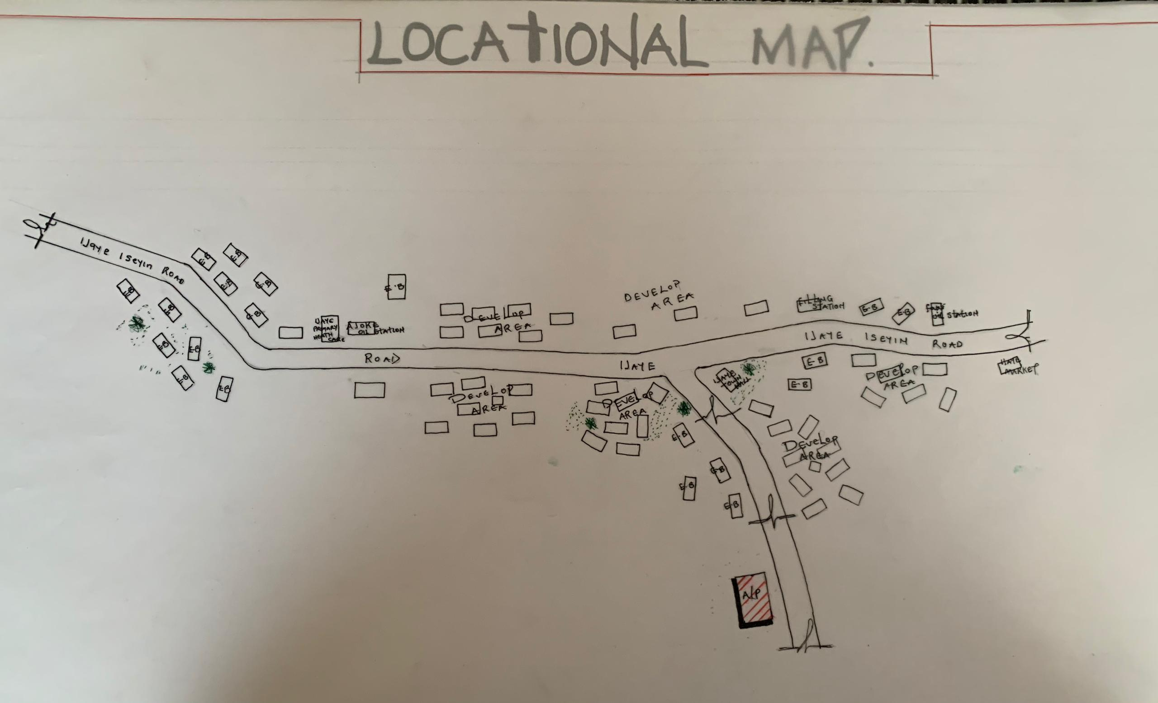

FIG 4.1; SHOWING SITE INVENTORY OF THE PROPOSED SITE
4.3 POPULATION
The population development of Oyo state as well as related information and services.
The current metro area population of Oyo in 2025 is 506,000, a 3.69% increase from 2024.
The metro area population of Oyo in 2024 was 488,000, a 3.61% increase from 2023.
The metro area population of Oyo in 2023 was 471,000, a 3.29% increase from 2022.
The metro area population of Oyo in 2022 was 456,000, a 3.4% increase from 2021.
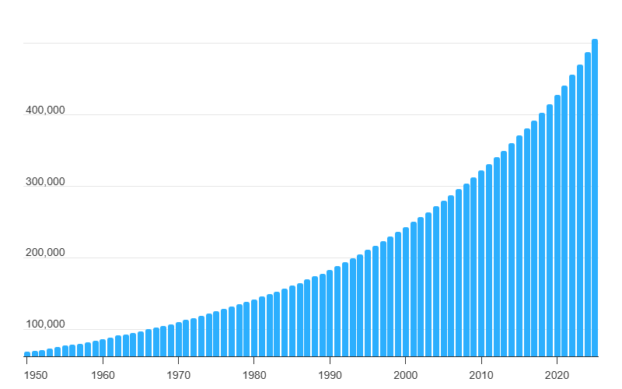
TABLE 4.1; SHOWING GENDER GROUP
4.4 SITE INVENTORY
In the proposed site, some shrubs will be retained on site. It used to reduce sky glare and also serve as soft landscape and wind breaker.
Presence of road network which would serve as a means of accessibility to the site. Presence of electricity pole which serve as source of electricity to the site. Some trees would be retained while some will be removed if they disrupt the construction of building.
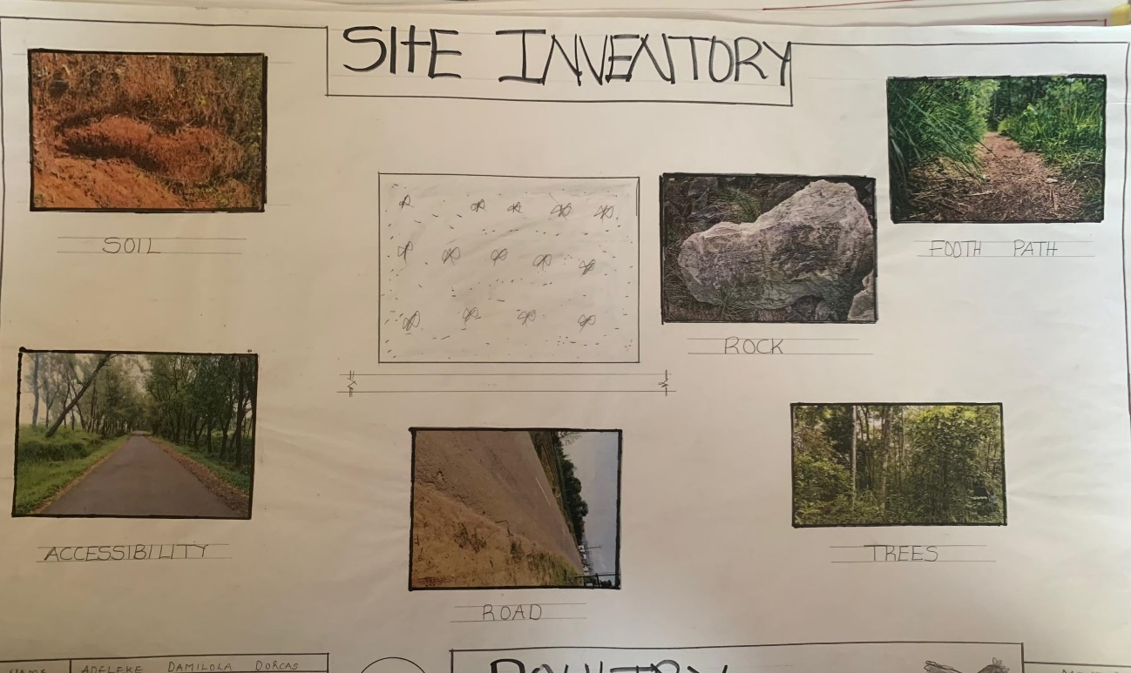
FIG 4.2; SHOWING SITE INVENTORY OF THE PROPOSED SITE
4.5 SITE ANALYSIS
The site is benefitted with loamy soil which is a very good soil for grass and shrubs. It has a gentle slope towards the south east. Some of the grasses, shrubs and trees on the site are to be retained to enhance landscape patter of the site while some are to be removed and replanted where necessary. The two noticeable winds are to be directed into the building using landscape pattern to improve ventilation. Noise generated from vehicle traffic is controlled through proper planning, good landscaping and proper orientation of building. Generally, all the feature on the site are best put into different uses to aid control through proper planning, landscape and orientation.

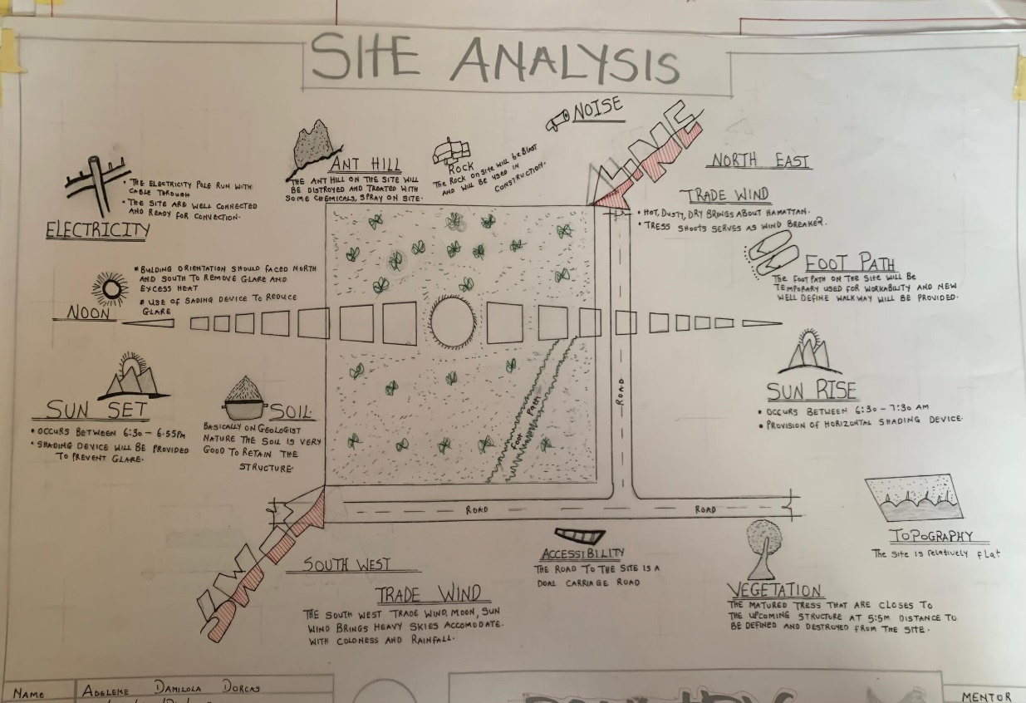
FIG 4.3; SHOWING SITE ANALYSIS OF THE PROPOSED SITE
4.5.1 SITE SELECTION/JUSTIFICATION
In the site selection provision is made for interesting facilities that worth emulating since the overall success and efficiency of any project depend not on the functionality of the design but also on a careful choice of site. The site of this project has been carefully selected which is located in the premises of Akinyele Local government in Ibadan, Oyo state. The proposed site is located at Ijaye Ibadan, Oyo state.
4.5.2 LOCATION
The site is located at along ijaye secondary school
4.5.3 ACCESSIBILITY
The site is easily accessible from the access road off from the main road that goes to ijaye/iseyin road. The site can also be reached through the access road that lead to ijaye.
4.5.4 INFRASTRUCTURAL FACILITIES
Facilities such as water electricity, telephone network and road network are all in oyo, hence it can easily be tapped to the proposed site.
4.5.5 TOPOGRAPHY
The topography of the land is gentle slope which can be filled and levelled up to balance round all the site levels.
4.5.6 SOIL STRUCTURE
It is made up of clayish laterite soil, which is good for building construction.
4.6 GENERAL CLIMATIC CONDITION
Oyo State generally experiences a tropical climate characterized by distinct wet and dry seasons. Temperatures typically range from 25°C (77°F) to 35°C (95°F) throughout the year. The wet season, with higher humidity, lasts from April to October, while the dry season occurs from November to March. Oyo State enjoys abundant sunshine, especially during the dry season.
4.6.1 RELATIVE HUMIDITY
Oyo State experiences relatively high humidity, particularly during the wet season.
4.6.2 WIND
There are two prevailing winds namely: The rain bearing south-west monsoon wind which blows across the Atlantic Ocean between the month of May and October. This is called wet season. The dusty north-east trade wind which laden with dust blows through the Sahara desert during the month of November to April with very title rainfall toward April. This is called the dry season and it brings along Harmattan during its driest period
4.6.3 TEMPERATURE
Average daily temperatures range from 25°C (77°F) to 35°C (95°F).
4.6.4 VEGETATION
The proposed site is covered with grasses few trees and shrubs. Some will be removed before the construction while some will be retain for ornamentation.
4.7 SOCIAL SERVICES
4.7.1 ROAD
There are only two access to the site
The southern access which serve as the main entrance and also main access road
4.7.2 WATER AND ELECTRICITY
There are pipe born water networks and borehole water which serves the habitant of Ibadan. There is electricity supply from NEPA that serve the Oyo state in general
4.8 DESIGN CRITERIA
There are three (3) methods of designing of any project which are: Function before form method
Form before function method Combination of Shapes
Designing projects, the function, before form method used in line with this method, the following are the design criteria for this project:
Functional: in term of functional requirement, the following design criteria must be considered.
Sustainability, Site and Location, Flexibility, Circulation, Accessibility, Organization, Maintenance, Environment and Services
4.9 DESIGN BRIEF
After research and planning, the next step in the series of the project programed is design itself. To achieve functional and well established design there must be a brief to work on. This brief depends generally on the scope of individual design. The brief of this project is therefore based on the various activities that take place in the Farm. To have enough brief for the proposed Poultry Farm, case studies were carried out on the existing Poultry Farm. The studies also give me the opportunity to know the nature of the various unit in the building and how they are related to each other.
4.10 DESIGN ANALYSIS
This is the process of itemizing units within the component of the entire design with a view to establishing a solid understanding and appreciation of the space relationships.
GROUND FLOOR PLAN; Entrance, Reception, Laboratory, Record room, Staff lounge, Store, First aid, Account office, Marketing department, sec, Manger office, Active office, Conference room, exist, w/c
NAME | S/N |  | LENGTH[m] | BREATH[m] | AREA[m]
ENTRANCE | 1 |  | 7.5m | 5.6m | 8.4m2
RECEPTION | 1 |  | 3.0m | 5.6m | 16.8m2
LABORATORY | 1 |  | 5.4m | 4.8m | 25.92m2
RECORD ROOM | 1 |  | 4.5m | 1.8m | 8.1m2
STAFF LOUNGE | 1 |  | 6.8m | 5.7m | 35.76m2
STORE | 3 |  | 1.8m | 3.6m | 19.44m2
FIRST AID | 1 |  | 3.6m | 5.1m | 18.36m2
ACCOUNT OFFICE | 1 |  | 3.3m | 3.6m | 22.88m2
MARKETING DEPT | 1 |  | 4.8m | 5.4m | 25.92m2
SEC-OFFICE | 1 |  | 2.4m | 5.4m | 12.96m2
MANAGER OFFICE | 1 |  | 4.5m | 5.4m | 24.3m2
ACITVE OFFICE | 1 |  | 3.3m | 3.3m | 10.89m2
CONFRERENCE ROOM | 1 |  | 6.0m | 4.8m | 28.8m2
GENERAL OFFICE | 1 |  | 6.0m | 10.0m | 60.0m2
EXIST | 2 |  | 1.2m | 1.8m | 4.32m2
W/C | 9 |  | 0.9m | 1.8m | 14.58m2
TOTAL |  | 329.43m2
TABLE 4.2; SHOWING SPACIAL ALLOCATION OF FLOOR PLAN
Necessary units in the building. A borehole system of water supply is to be adopted alongside the government supplied services and a storage facility is to be provided for effective management of water supply.
4.12 PLANNING PRINCIPLE
The planning principle is one of the most important aspects of any design. The planning of various units taking into consideration the activities performed in each unit, how they are related to one another and the users of the various units in the design. In respect to the above factors.

