CHAPTER THREE
3.1 CASE STUDIES
This is are search or an exercise that is carried out on existing building which is similar to the one researcher is writing on. The objective of a case study is to take a critical appraisal of existing related project with a view to identify the positive and negative aspect of such projects. It is only with time that a project can be adjusted so that it can be successful. The information obtained from the appraisal will guide the designer of new and similar project, the positive aspect of it shall be incorporated in the view proposal while attempts will be made to solve the problem of negative aspects. It is only through this that a designer can better enhance the quality and efficiency of building in the society. For a comprehensive analysis their case studies have been conducted.
3.2 SELETED CASE STUDIES
Case studies are of paramount important. It is an experimental research or analysis carried out on existing building or group of building functionally similar to the one which there search is working.
For any technical design to be meaningful there is always the need for preliminary research effort to be made on this proposal as a very necessary ground work.
The following case study of some poultry farm.
3.3 CASE STUDY ONE
- KENTIMAL FRAM
Location: FRM5, FPX, ERUWA ROAD,SHARPCONER,OLOGUNERU IBADAN, OYO STATE
OBSEVERATION
MERITS
- Availability of land for proper site zoining
- Natural Ventilation and Lighting Potential
- Environmental Learning Opportunity
DEMERITS
- Accessibility Challenges
- Environmental Impact Concerns
- Climatic Challenges (Heat & Rainfall)
- Infrastructure Deficiency.
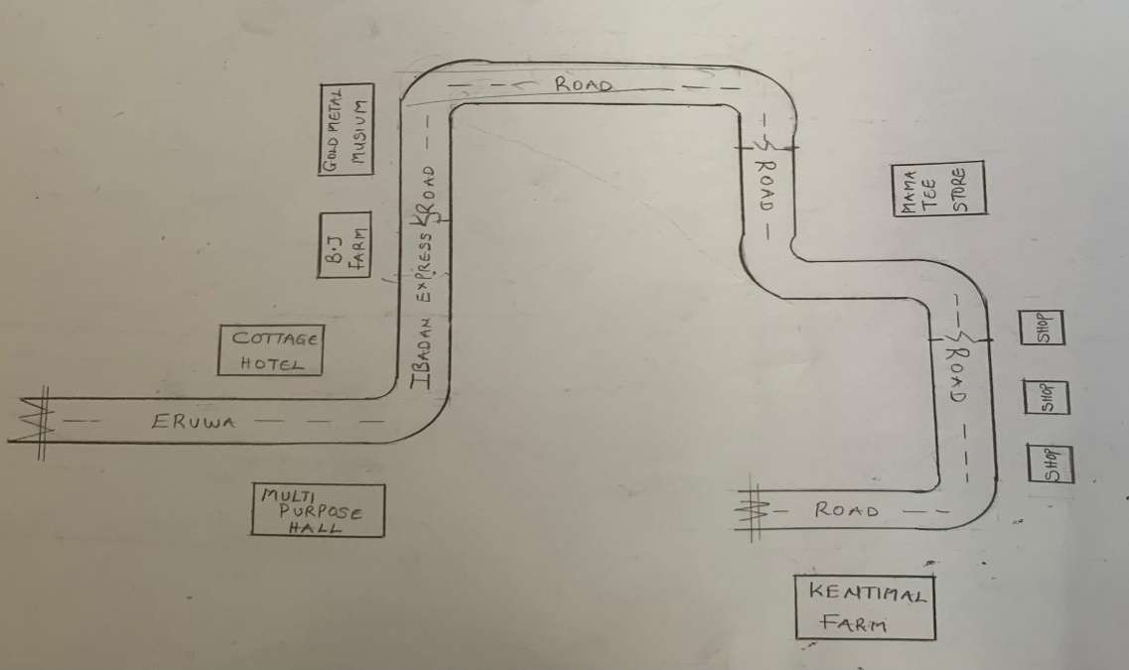
FIG3.1;SHOWING LOCATION PLAN OFCASE STUDY ONE
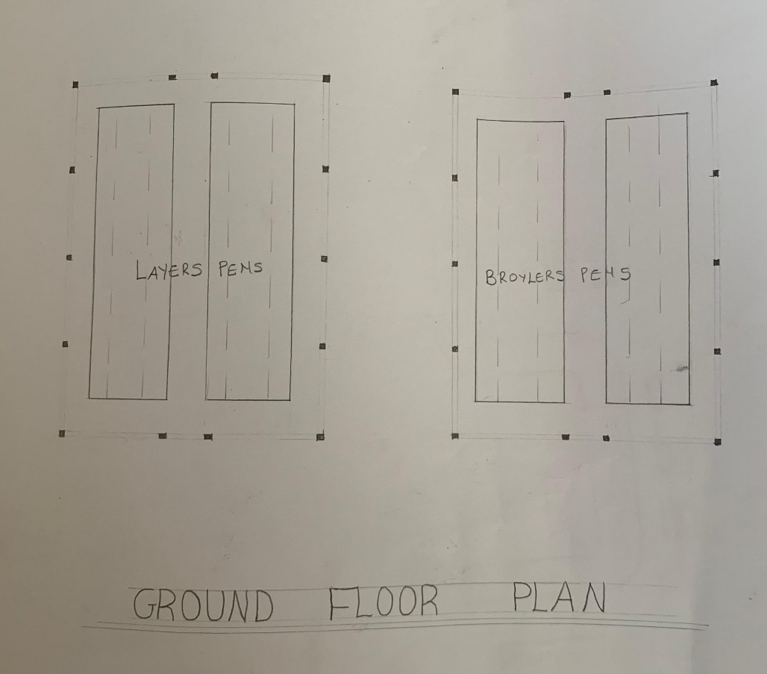
FIG3.2; SHOWING FLOOR PLAN OF CASE STUDY ONE
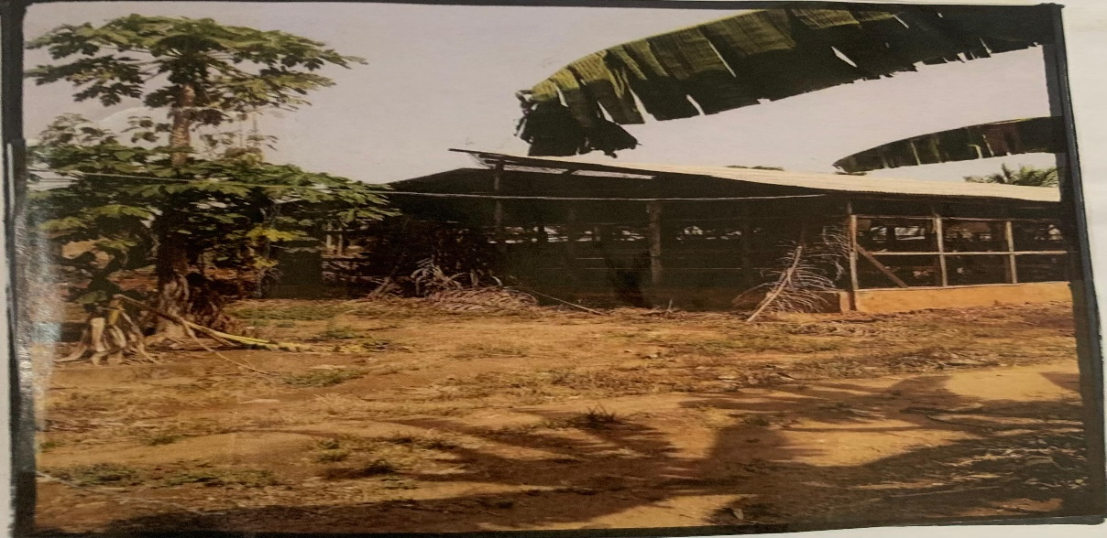

Plate3.1: SHOWING LEFT VIEW OF CASE STUDY ONE

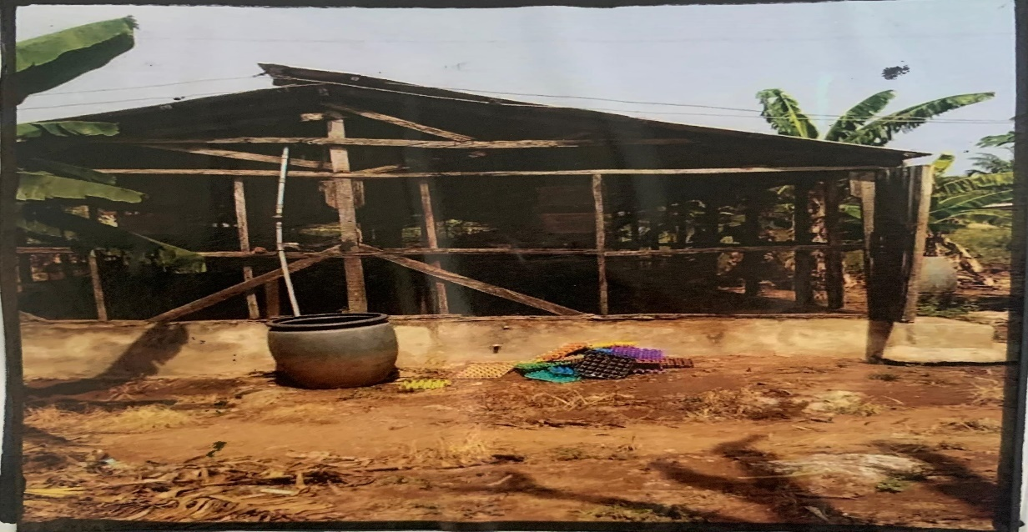
Plate3.2: SHOWING FRONT VIEW OF CASE STUDY ONE
3.3 CASE STUDY TWO
- HERITAGE POULTRY FARM
Location: ODEDA ABEOKUTA OGUN STATE
OBSERVATION
MERITS
- Spacious and Well-Organized Layout
- Good Road Network (Varies by Specific Location in Ogun)
- Moderate Topography
- Environmental Study Opportunity
DEMERIT
- Inconsistent Infrastructure (Depending on Location)
- Environmental Pollution Risks
- Climatic Factors (Rainfall & Heat)

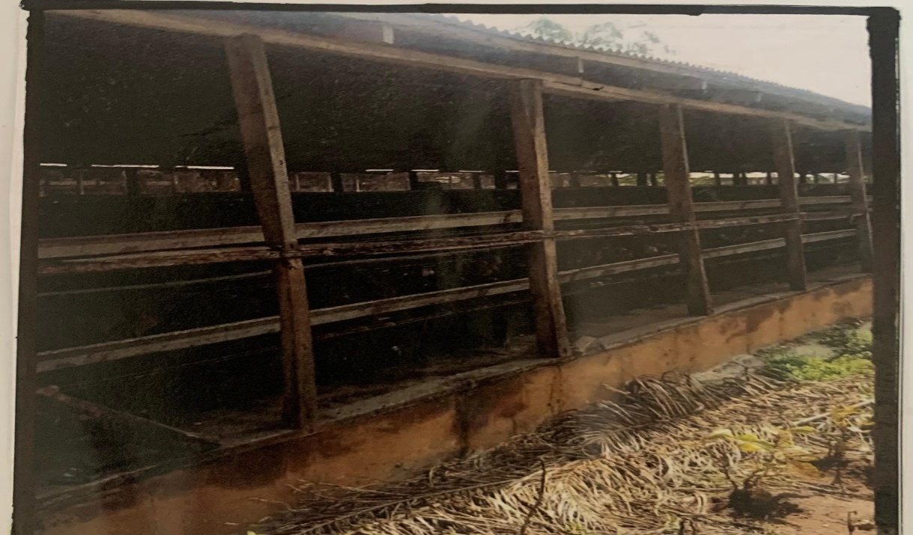
Plate3.3 SHOWING SIDE VIEW OF CASE STUDY TWO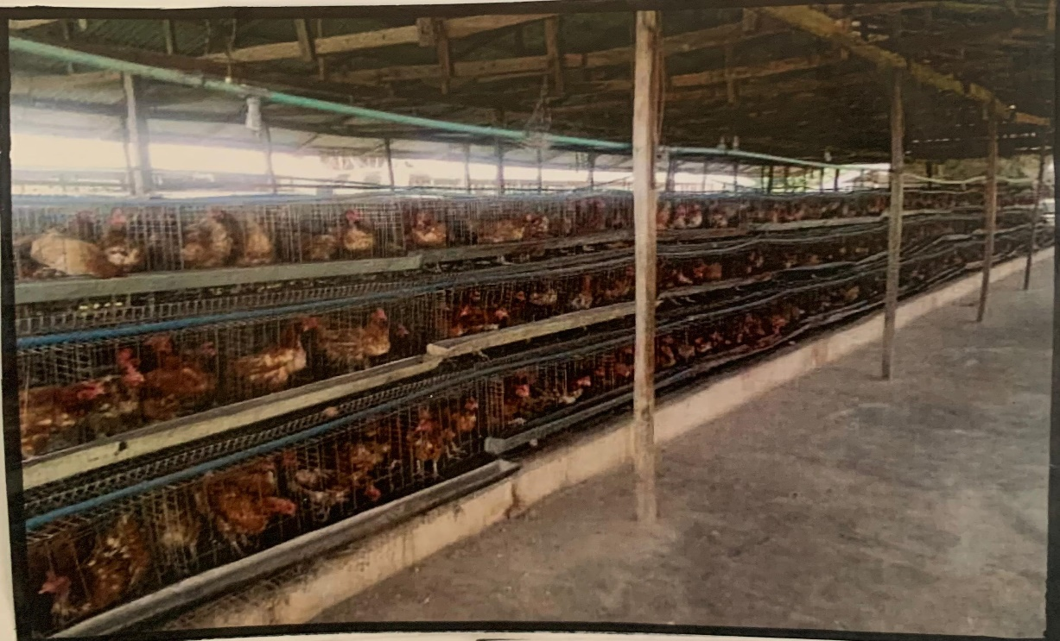
Plate3.4: SHOWING THE INSIDE OF CASE STUDY TWO
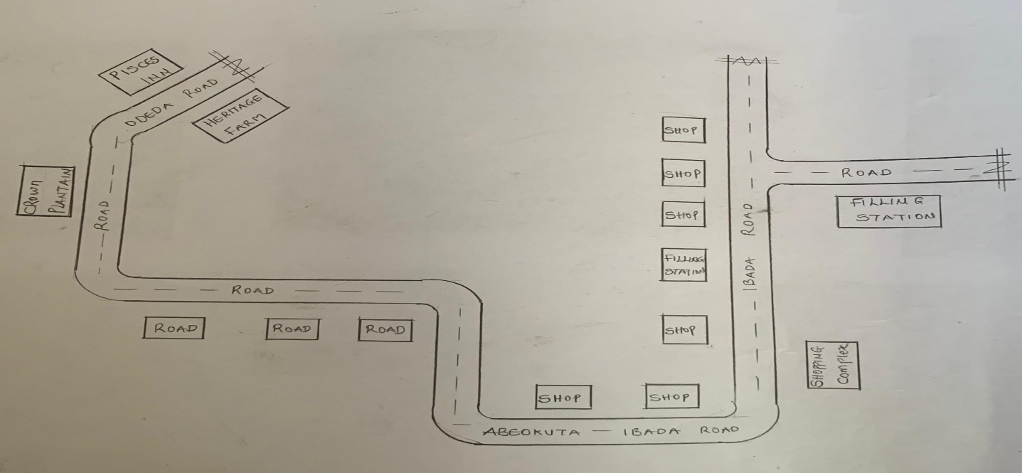
FIG3.3; SHOWING LOCATION PLAN OF CASE STUDY TWO
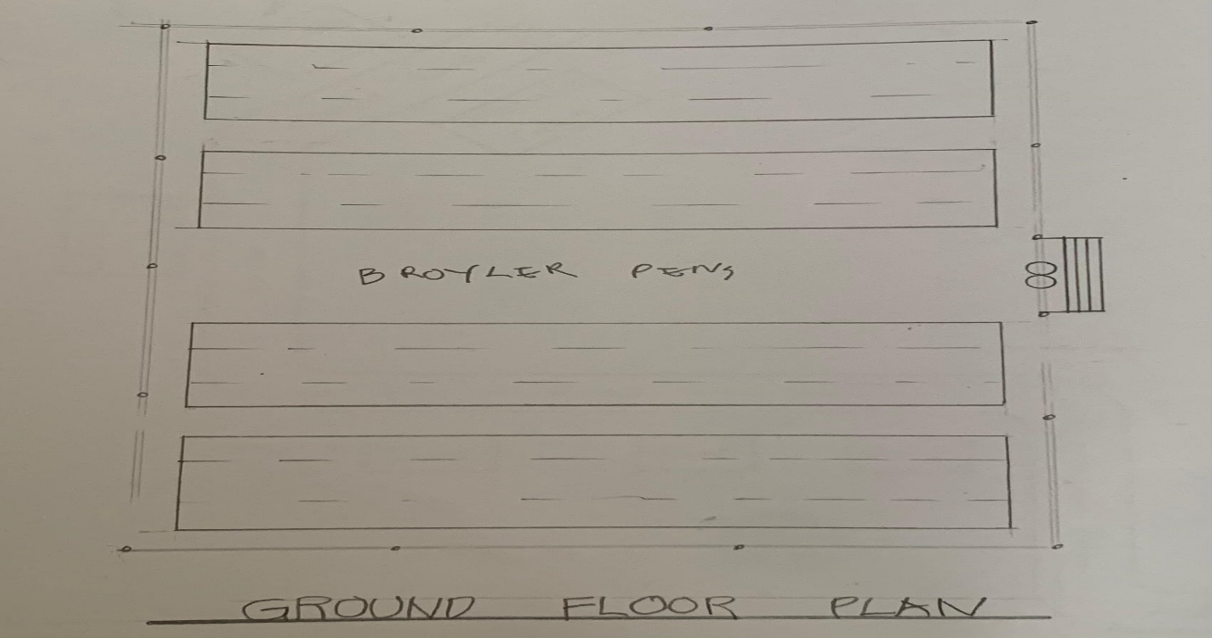
FIG3.4; SHOWING THE FLOOR PLAN OF CASE STUDY TWO

ONLINE CASE STUDY
- RAMGARH AGRO POULTRY FARM
Location: MURAM JHARKHAND KALAN 829122 INDIA
- WINCHESTER POULTRY AND LIVE STOCK

Location: WINCHESTAR ROAD,FAIR OAK EAST LEIGH SOSO UNITED KINGDOM
DEDUCTION FROM CASE STUDIES
During my visit to the poultry farm. I was opportunities to see what was obtain in the poultry farm, I made a proper studies of their related function and analysis were made to their present situation with the aim of incorporation with their merit in my own final proposal.
The following were deduce from my case study
- Critical Role of Ventilation and Orientation.
- Need for Sustainable Building Materials.
- Drainage is a Major Design Consideration.
- Importance of Proper Site Layout.
- Waste Management Requires Architectural Attention

